NIH LISTSERV Facility
User’s Guide

October 2001

Division of Network Systems and Telecommunications
NIH Center for Information Technology
National Institutes of Health
7550 Wisconsin Ave. Suite 416
Bethesda, MD 20892-9110

TABLE OF CONTENTS
Introduction 1
What is LISTSERV? 1
Who May Use LISTSERV? 1
Who’s Who On LISTSERV 1
About This Document 2
Using The Web Interface 3
The NIH LISTSERV Home Page 3
The NIH “List of Lists” 3
Login and Passwords 4
Confirming a Request for Confirmation 6
Browsing List Archives 7
Joining or Leaving a LISTSERV List Using the Web Interface 12
Changing Your Personal Subscription Options 14
Posting Messages to a List From the Web Interface 18
Other General User Functions 20
Instructions for General Users 20
Create a LISTSERV Password 21
What Lists Am I On? 21
Change My Subscriber Address 22
Unsubscribe From All Lists 24
For Further Information 26
Appendix A: Sending Mail To A List Via E-mail 27
Posting Via E-mail 27
Sending an E-mail Message to the List Owner 27
Appendix B: User Commands 28
Sending Commands To LISTSERV 28
Notational Conventions for Commands 28
Common LISTSERV Commands 29
Asking for Information 29
Modifying Your Personal List Settings 30
Other User Commands 31
Appendix C: General User FAQ (Frequently Asked Questions) 32
How do I find out what lists are available at NIH? 32
I can't find a particular list on the NIH Lists of Lists. I know the list exists. Why isn't it there? 32
How can I find mailing lists on a specific topic? 32
How do I subscribe to a LISTSERV list? 32
How do I unsubscribe from a LISTSERV list? 33
How do I send mail to a list? 33
Help! I'm trying to unsubscribe from a list, but LISTSERV is telling me I'm not subscribed. I've been getting mail from that list for years. What's wrong? 33
How do I stop my mail while I'm away from my office? 33
My email address has changed. How do I update it? 34
I subscribed to a list and I'm being inundated with mail. I'm interested in the list and don't want to unsubscribe. Any suggestions for lightening the load? 34
Why do I keep seeing mail from people on my list who are trying to unsubscribe? 34
Why did everyone on the list see a reply that I intended to be personal? 34
I sent an email message to several LISTSERV lists at once, but I only got one copy. I'm subscribed to all of the lists. What happened? 35
How can I contact the owner of a list? 35
I have a question you didn't answer here. Where can I get more help? 35

Introduction

What is LISTSERV?
LISTSERV is an electronic mailing list management tool that enables people with common interests to correspond via e-mail. LISTSERV lists are available at computer sites around the world. The National Institutes of Health (NIH) LISTSERV facility is run by the NIH Center for Information Technology. The NIH LISTSERV facility is currently running LISTSERV version 1.8d.
With LISTSERV, people who are interested in a specific topic can subscribe to a list that deals with that topic. Once subscribed, they can easily converse, via e-mail, with others who share that interest, or receive announcements about it. Whenever mail is sent to a list, LISTSERV automatically distributes copies to all list subscribers. The sender does not need to know the names and network addresses of all the subscribers, since that information is maintained by LISTSERV. There are LISTSERV machines all over the Internet. The NIH has its own LISTSERV machine, which currently hosts more than 1600 mailing lists.
LISTSERV was written by Eric Thomas and is the sole property of L-Soft International, Inc.

Who May Use LISTSERV?
Anyone with e-mail or World Wide Web access to the Internet may use LISTSERV. (At NIH, this includes anyone with a connection to NIHnet, e-mail software, and/or a Web browser.) Any employee of the Department of Health and Human Services (HHS) may create and “own” a list on the NIH LISTSERV Facility. Use of the NIH LISTSERV Facility is restricted to official government business.

Who’s Who On LISTSERV
LISTSERV users fall into three categories:
- subscribers users who send to and receive mail from the lists
- list owners responsible for the management of individual lists
- postmasters responsible for the operation and maintenance of
LISTSERV
Subscribers can join (“subscribe to”) lists; query and change their subscriber options; change their names as recorded by LISTSERV; and, of course, leave a list (“unsubscribe”).
List owners include any user who creates a list on the NIH LISTSERV Facility, or who takes over responsibility for an existing list. List owners are responsible for managing lists that they “own.”
List owners have considerable control over their lists. This includes the ability to add and remove subscribers; maintain and collect usage statistics; and suspend and resume distribution of mail and archive files. (Any HHS employee or registered NIH Computer Facility user may become a list owner. For further details on owning a list, please consult the NIH LISTSERV Facility List Owner’s Guide).
Items under the owner’s control include:
- who may join the list
- who knows about the list
- who may post to the list
- archiving of messages
The NIH LISTSERV Administrators have list owner authority for all lists on the NIH LISTSERV machine. In addition, they can stop and restart LISTSERV and maintain critical control files. E-mail the NIH LISTSERV Administrators at listmaster@list.nih.gov (“NIH LISTSERV Administrators” on the NIH Exchange Global Address List).

About This Document
This document contains information designed to assist general users of the NIH LISTSERV facility. Copies of this and other LISTSERV documentation may be viewed online or downloaded from the NIH LISTSERV Home Page (Figure 1) at the following URL:
http://list.nih.gov
Click on For General Users, then click Instructions for General Users, then select the desired document.

Using The Web Interface

The NIH LISTSERV Home Page
The easiest way to interact directly with LISTSERV is via LISTSERV’s World Wide Web interface. The Web “gateway” to LISTSERV is the NIH LISTSERV Home Page (Figure 1). The address is:
http://list.nih.gov
For those users who are familiar with using commands to communicate with LISTSERV, e.g., to subscribe to a list, you can still do this. For more information, please refer to Appendix B: User Commands.

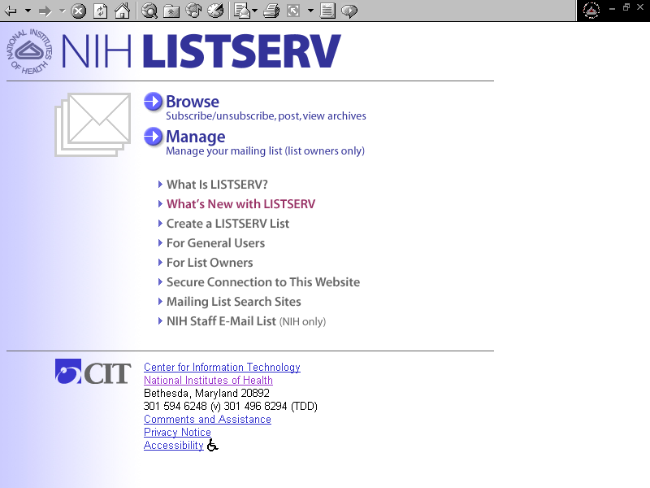

Figure 1: The NIH LISTSERV Home Page

The NIH “List of Lists”
An important part of the NIH LISTSERV website for general users of LISTSERV is the NIH “List of Lists” (Figure 2). From the List of Lists, you can (depending on the list settings) join or leave a list; modify your subscriber options; post to a list; and browse the list archives. To access the List of Lists, click the Browse button from the NIH LISTSERV Home page. There are three ways to find a particular list: 1) choose a letter from the alphabetic index; 2) type in a term or phrase to search for and click Go!; or 3) simply scroll down—the list is alphabetic. When you have found the desired list, click the list link.
If the desired list doesn't appear, the list owner may have designated it as confidential (a setting that allows the list owner to hide it from the List of Lists). You can still view a confidential list if you know its exact name. To view a confidential list, click on the "Access unlisted links" link directly under the alpha index. Type in the name of the desired list in the “List Name” box, then click Go! to begin the search. If you are prompted to log in, follow the steps. NOTE: some lists have restricted access, and you may not be allowed to access them even by logging in.

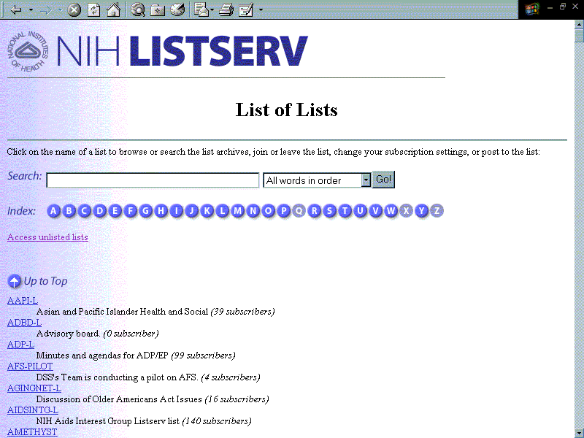
Figure 2: The NIH List of Lists

Login and Passwords
Some LISTSERV user functions now require you to log in. Whether login is required depends on the list settings. For example, if the owner of a list has decided that only list subscribers may see the list archives, LISTSERV will prompt you to log in to determine if you are a subscriber. If login is required, the LISTSERV Login Screen appears (Figure 3).
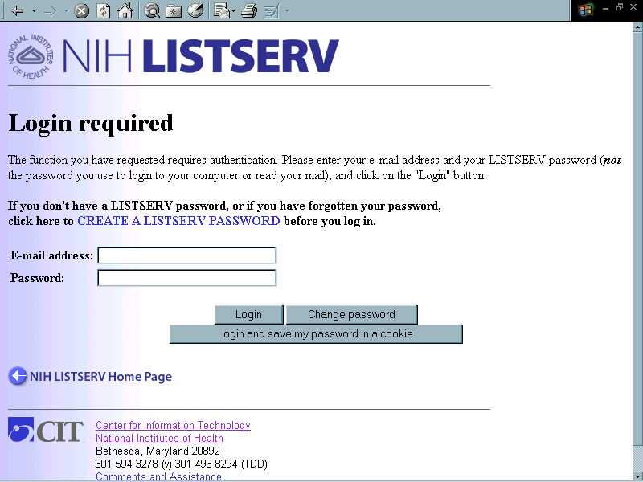
Figure 3: LISTSERV Login Screen
To log in, you’ll need a LISTSERV password. If you’re already on the LISTSERV Login Screen (it appears whenever you’re prompted to log in), click on the CREATE A LISTSERV PASSWORD link. If you’re on the LISTSERV Home Page, click For General Users, then click Create a LISTSERV Password. The “Create a LISTSERV Password" screen appears (Figure 4).

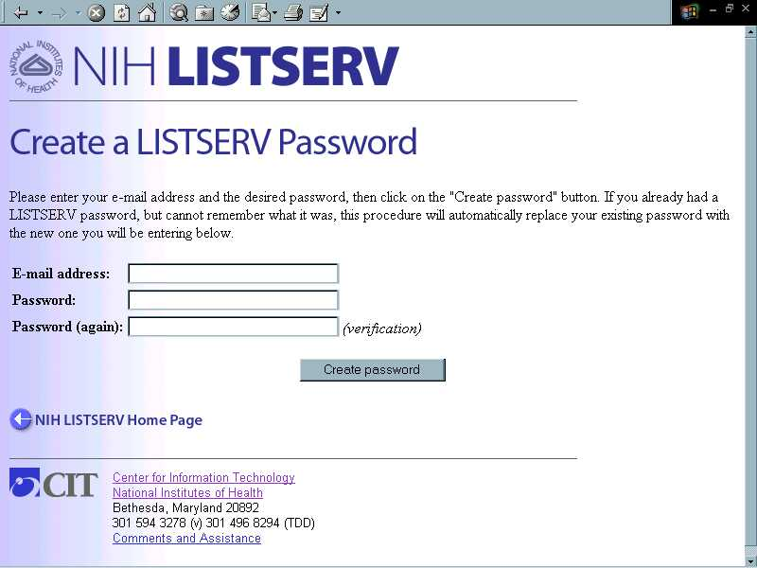

Figure 4: The "Create a LISTSERV Password" Screen
Fill in your e-mail address, and type in a password of your choosing. (LISTSERV asks you to type it twice to protect against misspellings.) Then click the Create Password button. LISTSERV acknowledges the request onscreen and sends a request for confirmation via e-mail. NOTE: before LISTSERV actually accepts your password, you must confirm the request (see next section).
When you use the web interface, LISTSERV “knows” you by the e-mail address with which you log in. Generally, your login address should be the same as your subscriber address for the list you wish to access. If you commonly use more than one e-mail address, you may wish to create a password for each address. (You may use the same password for multiple addresses, if you wish.)

Confirming a Request for Confirmation
To confirm the request for confirmation, bring up your e-mail software. (If you use more than one type of e-mail software, choose the one at which you receive mail at the address you used to create your LISTSERV password.) You should find a request for confirmation from LISTSERV (Figure 5) in your e-mail Inbox within a moment or two.

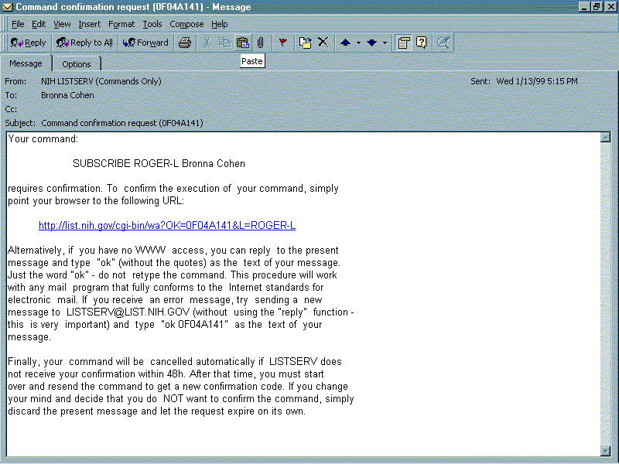
Figure 5: E-mail Request for Confirmation
There are two ways to confirm your subscription: by e-mail reply, or by web hyperlink.
To confirm by e-mail reply: Press the reply button in your e-mail and type the word OK in the body of the reply. Leave the subject intact. Send the message.
To confirm by web hyperlink: Find the text after the first paragraph of the request for confirmation that reads, “…point your browser to the following URL:”, followed by a web link. Click on the link to confirm the command. This should bring up your browser window, and you should see an acknowledgement that your new password has been accepted.
After confirming your password, press the BACK button in your browser to return to the LISTSERV Login Screen. You should now be able to log in using your new password. At this point, you should see the main archive page for the list you have selected (Figure 6).

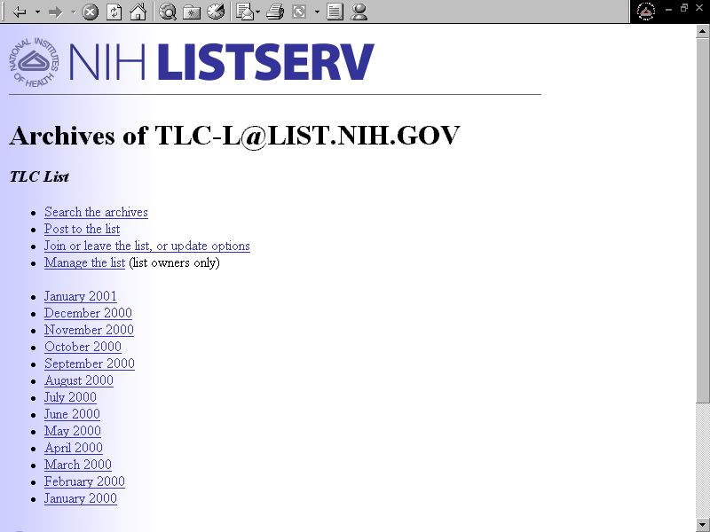

Figure 6: Main List Archive Screen

Browsing List Archives

What Are List Archives?
List archives are stored copies of all postings (messages sent) to a list. They are usually saved in files containing a month’s worth, or a week’s worth, of postings. The list owner decides whether archives should be kept; how long they should be kept; and who may access them.

Searching the Archives
To search messages in the list archives, click the Search the archives link on the main archive page for the desired list (see Figure 6, above). The “Search the (list name) List” screen appears (Figure 7).
Enter the relevant information for your search in the fields provided, then click the Start the search! button at the bottom of the screen. Note the highlighted terms on the search screen, such as Search for: and Substring search. These are links to online help topics. If a feature on the search screen is unclear, click on the link to read more about the feature.

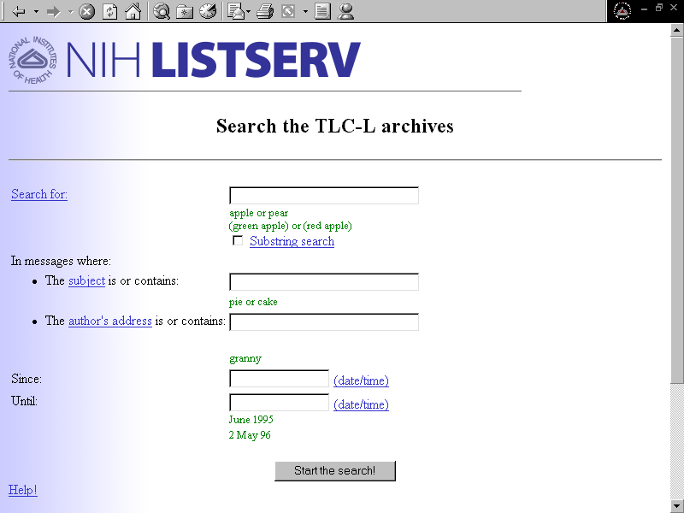
Figure 7: Archive Search Screen
When the search is complete, the results are displayed on the list's “Search Results” screen (Figure 8). Results include the number of matches, links to each of the matches found, and details about each match (date, time, subject). If no matches are found, click the Search again button to begin a new search.
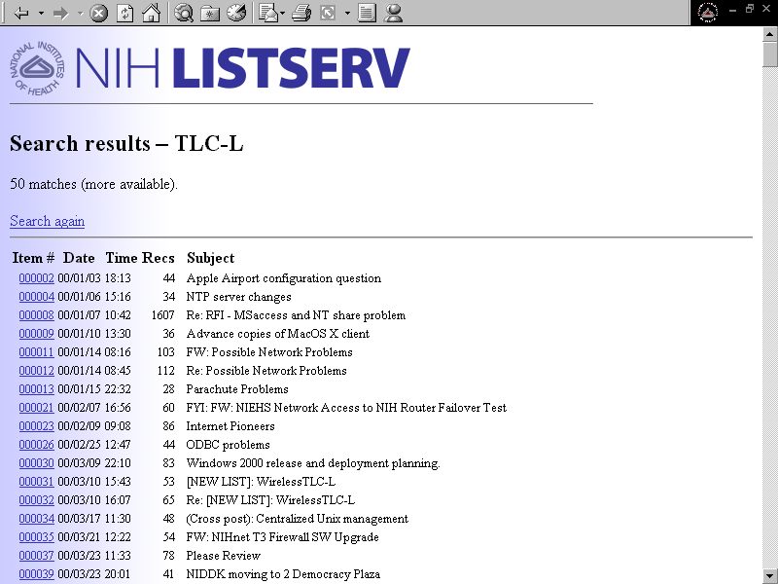
Figure 8: Search Results Screen
Click the link in the left column (“Item #”) to view full text of each message found in the search. The individual message is displayed, along with origin links to other archived messages (Figure 9).
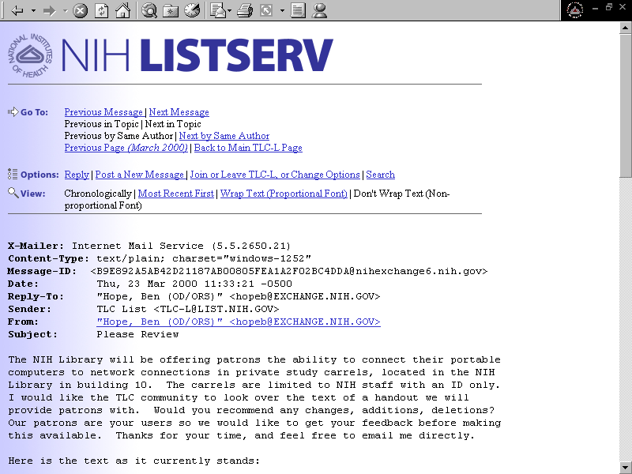

Figure 9: Full Text of Archive Message

Sorting and Viewing Archive Messages
To sort and view archive messages within a particular time period, click the link to the desired time period on the main list archive page (see Figure 6, above). The archive file for that time period is displayed, beginning with a table of contents that links to each individual message in the archive (Figure 10). Clicking the table of contents link for each message displays the link to the actual message, with the message's total number of lines in parentheses, and the name of the message's author.
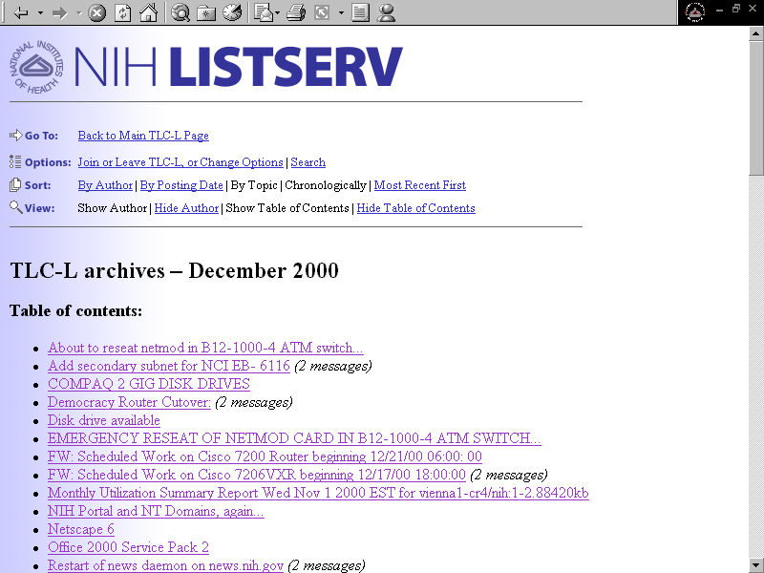

Figure 10: Sample Weekly Archive File
Five sorting options currently are available:
- By Author
- By Posting Date
- By Topic
- Chronologically
- Most Recent First
Additionally, four views are available:
- Show Author
- Hide Author
- Show Table of Contents
- Hide Table of Contents

Sorting by Author
Clicking the By Author link in the Sort menu displays a message link table of contents listed alphabetically by the author’s last name. Clicking the link for the desired author displays all that author’s messages, listed alphabetically by subject, for the specified time period.

Sorting by Posting Date
Clicking the By Posting Date link in the Sort menu displays a message link table of contents, grouped and listed by date posted, with the most recently posted messages listed last. Clicking the desired message link displays the message’s full detail (Figure 11).
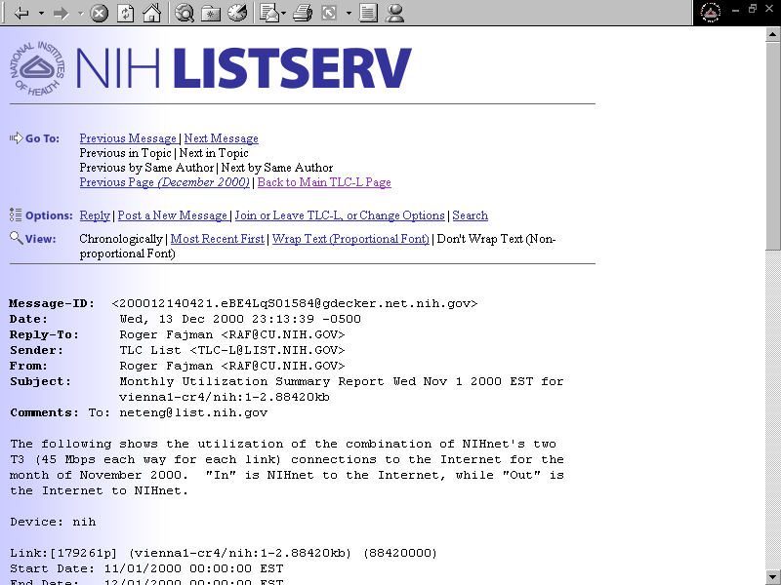

Figure 11: Message Detail

Sorting by Topic
Clicking the By Topic link in the Sort menu displays a message link table of contents listed alphabetically by subject. Clicking the desired message link in the table of contents displays message links listed alphabetically by subject (beginning with the message link you clicked), with the author’s name listed directly below the message link. Clicking the message link from this view displays the message’s full detail.

Sorting Chronologically
Clicking the Chronologically link in the Sort menu displays a message link table of contents listed alphabetically by subject. Clicking the desired message link from here displays a message link list. Clicking a message link from the list displays the message’s full detail. From this view, you may select several links on the Go To menu: Previous/Next Message; Previous/Next by Same Author; Previous Page (for archive date); Back to Main List Page.

Sorting by Most Recent First
Clicking the Most Recent First link in the Sort menu displays a message link table of contents listed alphabetically by subject. Clicking the desired message link from here displays a message link list. Clicking the message link from this view displays the message’s full detail. From this view, you may select several links on the Go To menu: Previous (more recent) Message/Next (less recent) Message; Previous (more recent) by Same Author/Next (less recent) by Same Author; Previous Page (for archive date); Back to Main List Page.

Show Author
Clicking the Show Author link in the View menu displays links to posted archive messages (by subject), showing the author’s name.

Hide Author
Clicking the Hide Author link in the View menu displays links to posted archive messages (by subject), without showing the author’s name.

Show Table of Contents
Clicking the Show Table of Contents link in the View menu displays links to posted archive messages, along with a table of contents for each message (by subject), either with or without the author’s name visible.

Hide Table of Contents
Clicking the Hide Table of Contents link in the View menu displays links to posted archive messages without a table of contents, either with or without the author’s name visible.

Browsing the Archives of Non-NIH Lists
L-Soft International, the owner of the LISTSERV technology, maintains a global Website called CataList. To search archives of lists outside of NIH, find your list on the CataList site, then either browse the available notebook archives by clicking on the various links, or choose “Search the Archives” to bring up a search page. (NOTE: you will only be able to access archives designated for public access by the list owner.) Other search sites for mailing lists also exist. To link to CataList or other search sites, point your Web browser at the NIH LISTSERV Home Page and click on Mailing List Search.

Joining or Leaving a LISTSERV List Using the Web Interface
To join or leave a list, first click the Join or leave the list, or update options link (Figure 12) from the main Archives screen for the list
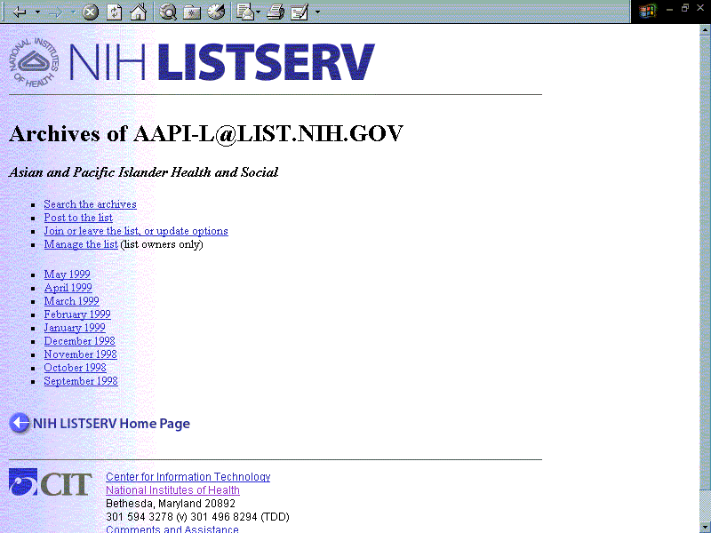

Figure 12: Main List Archive Screen
The Join or leave the (list name) list screen appears (Figure 13), displaying the user subscription form. Enter your e-mail address and your name, then select the list you want to join or leave. Select any one of the following options:
- Join the list
- Leave the list
- Leave all the lists
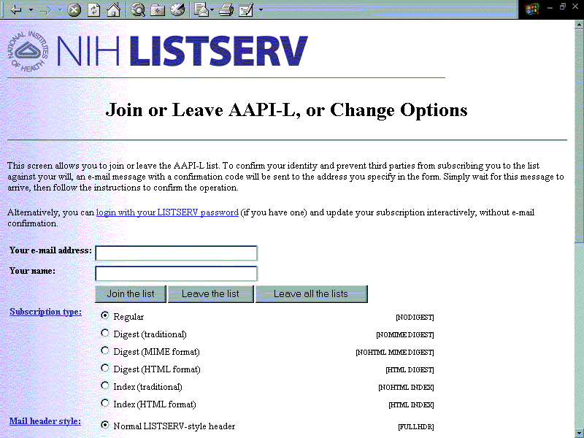
Figure 13: "Join or Leave the List, or Change Options" Screen
Select a Subscription type by clicking one of the following radio buttons:
- Regular (default)
- Digest (traditional)
- Digest (MIME format)
- Digest (HTML format)
- Index (traditional)
- Index (HTML format)
Select a Mail header style by clicking one of the following radio buttons:
- Normal LISTSERV-style header (default)
- LISTSERV-style, with list name in subject
- LISTSERV-style, short
- “Dual” (second header in mail body)
- Sendmail-style
Select Acknowledgements by clicking one of the following radio buttons :
- No acknowledgements
- Short message confirming receipt (default)
- Receive copy of own postings
Select a Miscellaneous item by clicking one of the following checkboxes:
- Mail delivery disabled temporarily
- Address concealed from REVIEW listing
When you have entered all information, click one of the following option buttons:
- Update options
- Leave (list name)
- Back to (list name) page

Changing Your Personal Subscription Options
Once you are subscribed to a list, you can use the LISTSERV User Web Interface to modify your subscription. Items that may be modified include your subscriber name and e-mail address, as well as your personal options settings for Subscription type, Mail header style, Acknowledgements, and Miscellaneous items (Figure 14). (Every subscriber has such settings—although in most cases they’re set to the default settings for the list—and is entitled to modify them.)
To modify your settings for a given list, click the Join or leave the list, or modify options link from the main Archives screen for the list (Figure 12, above). The "Join or leave the (list name) list, or modify options" screen appears (Figure 13, above), displaying the user subscription form. Click on the login with your LISTSERV password link in the second paragraph and follow the instructions to log in. If you don’t have a LISTSERV password, you’ll need to create one. For assistance, refer to the previous section, “Login and Passwords,” p. 4.
Once you’ve successfully logged in, LISTSERV will display your subscription options, subscriber name, and subscriber address for the list (Figure 14). (You may need to scroll down to see these.) To change your subscriber name or address, simply correct them onscreen. To alter your option settings, click the radio button for the desired setting. For more information on LISTSERV personal options settings, click on any highlighted term onscreen to access online help.
When you have completed your modifications, click the Update options button. A confirmation message will appear at the top of the screen, and the subscription form will display the updated subscription option settings.
Refer to Appendix B: “Modifying Your Personal List Settings,” p. 30, for more comprehensive information, including how to set personal options using e-mailed commands. Following are some general descriptions of various subscription option settings.
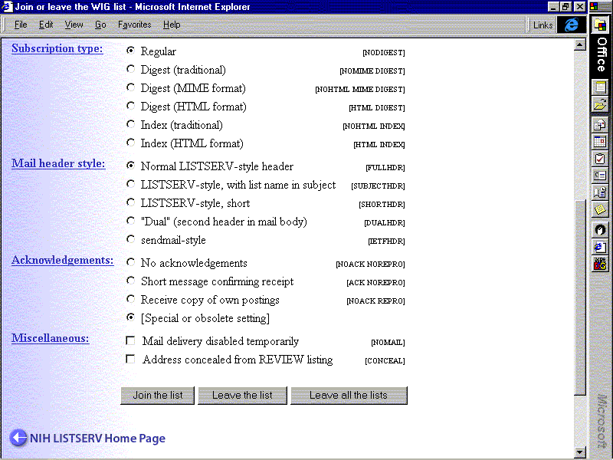

Figure 14: Subscription Option Settings

Subscription type

Regular
With a “regular” subscription, you receive individual postings immediately, as they are processed by LISTSERV.

Digest
With a “digest” subscription, you receive larger messages (called “digests”) at regular intervals, usually once per day or once per week. These “digests” are collections of individual list postings. Some lists are so active that they produce several digests per day. Digests are a good compromise between reading everything as it is posted and feeling like the list is clogging your mailbox with a multitude of individual postings.
There are three digest formats:
- Digest (traditional), a text-only format
- Digest (MIME format), a MIME format, which (with mail clients that understand MIME digests) “bursts” the individual messages out of the digest so that you can read them separately
- Digest (HTML format), an HTML format, which requires HTML mail clients

Index
With an “index” subscription, you receive short “index” messages at regular intervals, usually once per day or once per week. These “indexes” show you what is being discussed on the list, without including the text of the individual postings. For each posting, the date, the author's name and address, the subject of the message and the number of lines is listed. You can then download messages of interest from the server (the index contains instructions on how to do that).

An index subscription is ideal if you have a slow connection and only read a few hand-picked messages. The indexes are very short and you do not have to worry about long download times. The drawback of course is that you need to reconnect to order messages of interest from the server.
There are two index formats:
- Index (traditional), a plain text format
- Index (HTML format), an HTML format with hyperlinks

Mail header style
- Full headers (default setting for new lists): Normal LISTSERV-style "full" mail header, containing Internet routing information, MIME headers, and so forth.
- Subject headers: Normal LISTSERV-style full header, except that a “subject tag” is added to the subject line of mail coming from the list. If there is no subject tag defined in the list's configuration, the name of the list will be used. This is very useful for sorting and filtering mail.
- IETF or Sendmail-style headers: an advanced option that selects Sendmail-style headers, i.e. an exact copy of the original, incoming mail header with the addition of a 'Received:' line and of a 'Sender:' field. Some technical people prefer this type of header.
- Short headers (not recommended): LISTSERV-style, short, an advanced option with a header similar to the normal LISTSERV-style header except that Internet routing information and MIME headers are removed. (NOTE: this setting will cause problems with MIME attachments, which are the standard attachment format at NIH.)
- “Dual” headers (not recommended): LISTSERV-style short header, followed by a second copy of the header inside the message body. This second header shows what list the message is coming from ('Sender:'), the name and address of the person who posted it ('Poster:'), the poster's organization, if present, and the message subject. Dual headers are helpful if your mail client does not preserve the original return e-mail address. (NOTE: this setting will cause problems with MIME attachments, which are the standard attachment format at NIH.)

Acknowledgements
- No acknowledgements, in which LISTSERV will not send any acknowledgement at all when you post to the list. This is probably not a good setting unless you really do not want any feedback from LISTSERV as to whether or not your posting was received and distributed.
- Short message confirming receipt, which typically is the default setting, although it can be overridden by the list owner. If you choose this setting, LISTSERV sends you a short message whenever you post to the list, confirming the distribution of your message and telling you how many people it was sent to.
- Receive copy of own postings, a setting some people prefer over the short acknowledgement message. It tells LISTSERV to send you a copy of your own postings, so that you can see exactly how it appeared on the list (useful if you are behind an unreliable gateway or firewall).

Miscellaneous
- Mail delivery disabled temporarily, an option that toggles the receipt of mail from the list. You may want to disable mail delivery if you will be away from your mail for an extended period of time.
- Address concealed from REVIEW listing, an option that conceals you from the list of subscribers shown by the REVIEW command. Note that the list owner and the LISTSERV administrator can always get the complete list of subscribers, regardless of this setting. Nowadays, most lists are configured so that only the list owner can see the list of subscribers, but some lists still allow list members to get a listing of all list subscribers. Select this option if you are concerned about your e-mail address being viewed by others.
- Topics, an option for lists with topics enabled (if the Topics: section of the form is not visible, topics are not enabled). This section allows you to subscribe or unsubscribe to all, some, or none of the available topics.

Posting Messages to a List From the Web Interface
To post messages to a LISTSERV list via the web interface, click the Post to the list hyperlink from the Main Archive Screen for the desired list. The Compose a new message screen appears (Figure 15). Type the message’s subject in the Subject field. Type your name in the Your name field (the current user’s name may already appear in this field). Check the Mail a copy of the message to (user’s e-mail address) check box if you wish to have a copy of the message sent to your e-mail address. Tab down to the message box and begin composing your message.
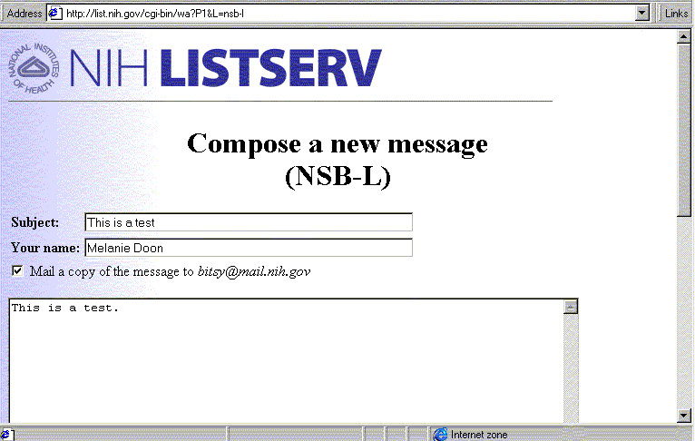

Figure 15: Compose a New Message Screen
When the message is complete, click the Send button at the bottom of the screen. A notice appears at the top of the Compose a new message screen, confirming that your message has been successfully posted to the desired LISTSERV list.
If you checked the box to send a copy of the message to your own e-mail address, it will appear in your mailbox shortly after the message is posted to the list. Depending on your personal subscription options, you may also receive a brief acknowledgement message that your message was posted to the list.
NOTE: only plain (ASCII) text messages may be sent when posting from the web. Attachments, special formatting, and message banners are lost. Messages with attachments or special formatting, or which require a message banner to be visible, must be posted from e-mail. (Message banners are "boilerplate" text attached at the top or bottom of all list mail. They may be set up by the list owner. For further information on this feature, please consult the L-Soft List Owner's Manual.)
ALSO NOTE: Many lists restrict posting to certain individuals or groups. Depending on the list settings, you may be prompted to log in, and/or you may not be allowed to post to the list.

Other General User Functions
A number of other functions, especially designed for general users of LISTSERV, are available via the LISTSERV Home Page. To access them, click For General Users from the LISTSERV Home Page. The following modified Home Page appears (Figure 16). Note that a drop-down list is now visible under For General Users. Each of the items on the drop-down list is a clickable link connecting you to a feature or utility especially designed for general users of LISTSERV. Each item is detailed in the following sections.
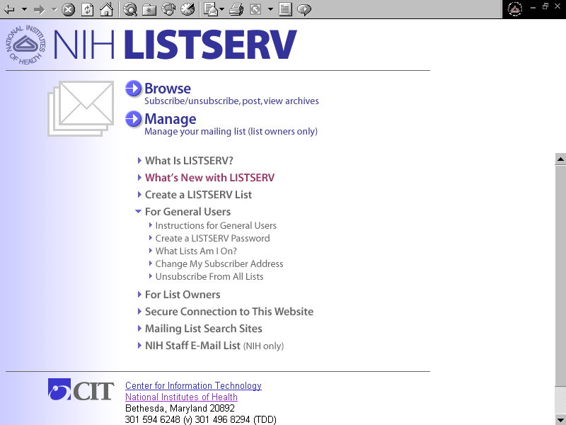
Figure 16. Functions for General Users

Instructions for General Users
To access instructions for LISTSERV general users, click Instructions for General Users on the drop-down list. The “Instructions for General Users” page appears (Figure 17).
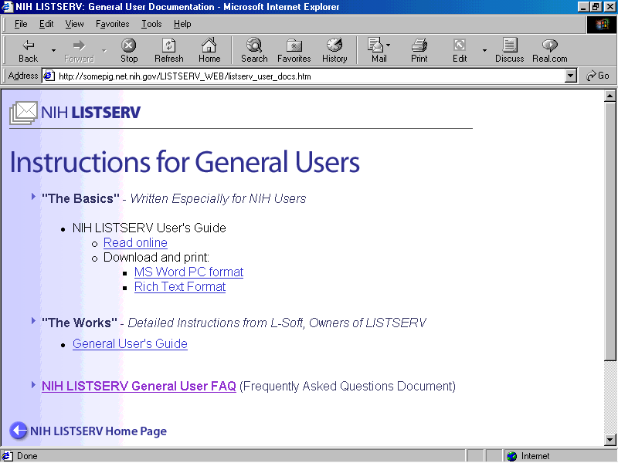
Figure 17. Instructions for General Users
The first section, entitled “The Basics,” contains links to the NIH LISTSERV User’s Guide, which is written specifically for General Users of the NIH LISTSERV Facility. You can browse the Guide online, or download a copy for printing. (NOTE: If you want a printed copy, please print out one of the downloaded versions, so that your copy is properly formatted with page numbers, cross-references, etc. The online version will not print as well.)
The second section, entitled “The Works,” provides links to the General Users Guide to LISTSERV written by L-Soft, the owners of the LISTSERV technology. It is very thorough and, of course, authoritative. Most NIH LISTSERV users will never need to access this information; however, it’s there if you wish to consult it.
The last item on the page is the NIH LISTSERV General User FAQ (Frequently Asked Questions Document). Hopefully, this is fairly self-explanatory.

Create a LISTSERV Password
This option is detailed above. See “Login and Passwords, p. 4.

What Lists Am I On?
This feature lets you ask LISTSERV what lists you are subscribed to at the address you supply. Login is required for this feature. If you do not have a LISTSERV password, you will need to create one. See “Login and Passwords, p. 4.
To access the feature, click What Lists Am I On? on the drop-down list. The LISTSERV Login screen appears (see Figure 3, above). When you log in, LISTSERV will return the names of all lists to which you are subscribed under the address with which you logged in, along with your subscriber options for each list.
NOTE: You may be subscribed to other lists under one or more alternate addresses, e.g., your NIH alias address. To find out if this is true for you, log in using any other addresses you know about. You will need to create a LISTSERV password, if you don’t already have one, for each alternate address you wish to query.

Change My Subscriber Address
Use this feature to change your subscriber address on a single list, or on all lists simultaneously.
To access the feature, click Change My Subscriber Address on the drop-down list. The “Change My Subscriber Address” page appears (Figure 18).
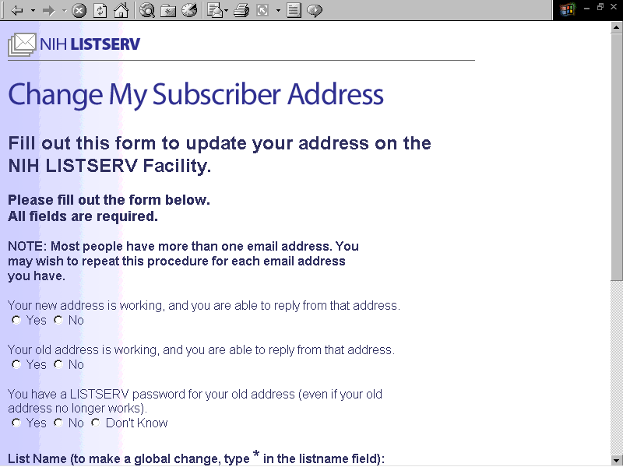
Figure 18a: Change My Subscriber Address
NOTE: Most people have more than one email address. You may wish to repeat this procedure for each email address you have.
Fill out the online form as follows:
Your new address is working, and you are able to reply from that address.
Check “yes” if your new address is working. If it is not yet operational, you will be asked to try your address change request again later.
Your old address is working, and you are able to reply from that address.
Check “yes” if you are still able to receive mail at your old address. If mail sent to your old address is being forwarded to your new address, check “no” here.
You have a LISTSERV password for your old address (even if your old address no longer works).
Check “yes” if you know that you have a LISTSERV password for your old address. If you do not, or you don’t know if you do, check “no.”
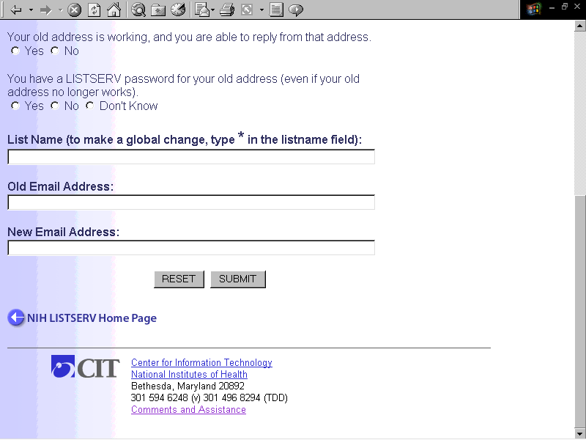
Figure 18b: Change My Subscriber Address (cont’d)
List Name (to make a global change, type * in the listname field):
To change your address on a specific list, type the list name here. To apply this change across all lists at NIH, type a star (*).
Old Email Address:
Type your old email address here.
New Email Address:
Type your new email address here.
Submit Button
When you have filled out the form completely, click Submit. You will be notified immediately concerning the status of your request.
Depending on the information you provide, you may be required to log in. If so, you will be given further instructions for how to proceed.

Unsubscribe From All Lists
Use this feature to unsubscribe (sign off) from all NIH LISTSERV lists.
To access the feature, click Unsubscribe From All Lists on the drop-down list. The "Unsubscribe From All Lists" page appears (Figures 19a and 19b).
Figure 19a: Unsubscribe From All Lists
Fill out the online form as follows:
Subscriber Name
Please fill in your full name.
Subscriber Phone Number
Please fill in your phone number (provide area code and full number if outside of NIH).
List all subscriber email addresses (e.g., Wylbur address, POP account, Helix account, NIH alias address). You may enter up to five addresses.
Most NIH employees have more than one email address. Try to include any other email addresses under which you might be subscribed.
First Email Address
You must supply at least one email address.
Second - Fifth Email Address
Supply any other email addresses under which you may be subscribed, e.g., NIH alias address, Helix address, POP or IMAP account, Wylbur Account, etc.
Figure 19b: Unsubscribe From All Lists
If you are NOT the subscriber, please explain why you are making this request (e.g., you are the email administrator and the user has left NIH)
If you are submitting this form on behalf of someone else, please state your reasons for doing so, so that we can ensure the request is appropriate.
The following questions should be filled out only if you are submitting the form for someone else.
Your Name (If different from above)
Please fill in your full name.
Your Phone Number (if different from above)
Please fill in your phone number (provide area code and full number if outside of NIH).
Your Email Address (if different from above)
Please fill in your email address.
Submit Button
When you have filled out the form completely, click Submit. You should see an onscreen acknowledgement that your request was submitted. Since the LISTSERV Administrators must approve and process your request, there may be a delay before the request is carried out. You will know that you have been unsubscribed from a list when you receive one or more acknowledgement messages from LISTSERV.

For Further Information
For further information concerning LISTSERV at NIH, please consult the NIH LISTSERV Home Page at the following URL:
http://list.nih.gov
List owners should also consult the related document, NIH LISTSERV Facility List Owner’s Guide. It contains the information necessary to create, maintain, and monitor lists on the NIH LISTSERV facility.
List owners may also consult with the LISTSERV Administrators online by sending e-mail to:
listmaster@list.nih.gov
If you are still experiencing difficulty, please contact the CIT Technical Assistance and Support Center (TASC) at 301-594-6248 and ask for LISTSERV support.

Appendix A: Sending Mail To A List Via E-mail
There are two ways to send mail, or "post" to a list: sending the message from the LISTSERV User Web Interface, or via e-mail. Posting from the Web Interface is detailed in “Posting Messages to a List From the Web Interface,” p. 18. For convenience, following are instructions for posting to a list via e-mail.
NOTE: You must use the e-mail method of posting to the list if you wish to include attachments with your message. (At present, the web interface accommodates only plain text.)

Posting Via E-mail

From your e-mail software, address an e-mail message to
listname@list.nih.gov
(substitute the name of the list for “listname” in the address). In the body of the e-mail, type the message to be posted. For example, if you were sending a message to the “TLC-L” list at NIH LISTSERV facility, you would send your mail to:
tlc-l@list.nih.gov
Mail sent to the list is received by LISTSERV and distributed to all list subscribers (unless they have set the NOMAIL option for that list).
Sending mail to a list should not be confused with sending commands to LISTSERV, which is described in ”Sending Commands To LISTSERV,” Appendix B, p. 28.

Sending an E-mail Message to the List Owner
There may be occasions when you wish to send e-mail to the owner of the list. You can do so, even if you don’t know who it is, by using the following formula. Address an e-mail message (substituting the name of the list for “listname”) to:
listname-request@list.nih.gov
Type the message as usual, and send. LISTSERV will automatically route your message to the list owner.

Appendix B: User Commands

Sending Commands To LISTSERV
Most common user functions, such as joining and leaving a list, changing subscriber options, and viewing list archives, are easily performed via LISTSERV’s new User Web Interface. Such functions were formerly performed via e-mailed commands to LISTSERV. Of course, e-mailed commands still work, and users who are familiar with e-mailing commands to LISTSERV may continue to do so.
LISTSERV accepts a variety of commands from users. LISTSERV commands may be used to subscribe to a list, to request information or help from LISTSERV, to unsubscribe, etc. Sending commands to a list should not be confused with sending mail to a list, which is described in the previous section, “Appendix A: Sending Mail To A List Via E-mail.“
To send commands to LISTSERV, address an e-mail message to:
listserv@list.nih.gov
Type the command(s) in the body of the e-mail message. Each line is treated as a separate command. Multiple commands may be sent in a single e-mail message. However, if LISTSERV encounters an invalid command, any commands that follow will not be executed. The subject line is ignored.

Notational Conventions for Commands
Italics. Italics are used to indicate that something is to be filled in, and not taken literally. For example, if you see the notation full_name, you should replace it with a name. For example, if the appropriate name for you was John Doe, you would enter John Doe, not full_name.
< > Enclosing something between “<” and “>” indicates it is optional and does not have to be included, as in:
full_name = first_name <middle_initial> surname
In the above example, the full_name and surname are required, but the middle_initial is optional.
| A “|” indicates a choice between two or more options. For example:

Editor-Header= Yes|No
means that Editor-Header requires an answer of either Yes or No.
CAPS The minimum acceptable abbreviation of a command is shown in UPPERCASE letters.

Common LISTSERV Commands
This section lists the most common LISTSERV user commands. Commands are listed in alphabetical order under each sub-section.

Subscribing and Unsubscribing

SUBscribe|SIGNUP listname full_name
Use the SUBscribe command to subscribe to a list. You will be automatically added to it if the list is open to the public. Depending on how the list is set up, your request may be forwarded to the list owner for approval, or it may be ignored by LISTSERV. It is not necessary to supply your full name if you have already signed up for another list on the same server. The name you provided on your first subscribe command will automatically be used for the new subscription. Also, once you are subscribed, you can issue a subscribe command to correct or change your name, regardless of whether the list is open to the public.

UNSubscribe|SIGNOFF <options>
Use UNSUBSCRIBE to cancel your subscription to the specified list. This is the counterpart of the SUBscribe command. Note that you can unsubscribe from any list to which you are subscribed, whether you subscribed to the list yourself or were added to it by the list owner.
Valid options:
listname from the specified list
* from all lists on that server
* (NETWIDE from all lists in the network

Asking for Information
LISTS <options>
The LISTS command lets you find out what lists are available, both at NIH and elsewhere. LISTSERV will respond by sending a list of lists via return
e-mail. The following options may be used:
Valid options:
(no option) local lists only, one line per list, returned in a file
Detailed local lists, detailed information returned in a file
Global “xyz” all known lists whose name or title contains “xyz”, one line per list, sent as a (LARGE!) file
QUERY <options>
The QUERY command displays your list subscription options for the specified list. Used with the * option, it tells you all the lists to which you are subscribed. Please refer to the SET command description for more details on the meaning of these options.
Valid options:
listname lists your personal settings for the specified list
* lists your personal settings for all lists to which you are subscribed
(on the server being queried)

REView listname
The REVIEW command sends you the detailed information about the specified list, including the list of subscribers, if the list owner has made that information public. Private lists cannot be reviewed by users who are not subscribed to the list. However, the header of the list (without subscriber information) will still be sent to you even if you are not authorized to review the list.

Modifying Your Personal List Settings
SET listname <options>
The SET command allows you to alter your personal settings for a specific list. If you wish, you may specify multiple options in a single command, as long as the command does not wrap to a second line. Previous settings will be retained unless specifically changed.
Valid options:
Mail/NOMail toggle receipt of list mail
ACK/NOACK/MSGack acknowledgements for postings
CONCEAL/NOCONCEAL hide yourself from REVIEW
REPro/NOREPro receive/don’t receive a copy of your own postings
DIGest/NODIGest receive postings in digest format
INDex/NOINDex receive postings in index format
Options for mail headers of incoming postings (choose one):
FULLhdr “full” mail headers
IETFhdr Internet-style headers
SHORThdr short (default) headers
DUALhdr dual headers, esp. useful for MS Mail users
SUBJECThdr “full” headers; list name inserted in subject line
Mail/NOMail indicates whether you want to receive mail from this list or not. “Mail” is the default, of course. (NOMail is a good choice for users going on extended leave who don’t want a full mailbox on their return.)
ACK/NOACK determines whether you receive an e-mail acknowledgement of your postings from LISTSERV. ACK indicates that you wish to receive an e-mail acknowledgement when you post to the list. NOACK directs the server not to send out any acknowledgement.
CONCEAL/NOCONCEAL hides/unhides the user’s name and e-mail address from the REVIEW command.
REPro/NOREPro controls whether or not the subscriber will get a copy of his or her own posts back from the list after they are processed.
DIGest/NODIGest causes the subscriber to receive all messages consolidated into one large posting per digest cycle (usually per day) rather than as multiple individual messages. A good solution for very busy lists.
INDex/NOINDex causes the subscriber to receive only one posting per digest cycle containing only an index of subject topics for all messages during that cycle. Similar to DIGEST; also a good solution for busy lists.

Other User Commands
REGISTER <options>
The REGISTER command registers your name with LISTSERV. (LISTSERV associates the name with your e-mail address.) Once you register with LISTSERV, you need not specify your name to subscribe to a list, as long as your e-mail address doesn’t change.
Valid options:
full_name tell your name to LISTSERV
OFF make LISTSERV forget your name

Appendix C: General User FAQ (Frequently Asked Questions)

How do I find out what lists are available at NIH?
Point your browser at the NIH LISTSERV Home Page at http://list.nih.gov and click "Browse" to see the NIH “List of Lists.” You can search for a list by keyword, or browse alphabetically.

I can't find a particular list on the NIH Lists of Lists. I know the list exists. Why isn't it there?
There are a couple of possibilities. The list may be confidential, meaning the list owner has decided to hide the list from public view. Confidential lists do not appear on the List of Lists. However, if you know the exact name of the list, you can view the list web page, if it has one (not all lists do, by the way). Click the "Access unlisted lists" link near the top of the List of Lists (it's just underneath the alphabetic index). Type in the exact name of the list in the "List Name" field, and press the GO button.
If you still cannot find your list, there are two likely reasons: 1) you are misspelling the list name, or 2) the list does not have archives, and therefore does not appear on the website. If you really get stuck, contact the LISTSERV Administrators at listmaster@list.nih.gov.

How can I find mailing lists on a specific topic?
On the NIH LISTSERV site, there is a search tool right at the top of the List of Lists. The search tool lets you look for specific keywords in the list name or list description.
In addition, there are a number of sites on the Web that allow you to search for mailing lists, not just at NIH but all over the world. We have links to several of them on the NIH LISTSERV Home Page. Point your browser at the NIH LISTSERV Home Page at http://list.nih.gov and click "Mailing List Search Sites." You will be connected to a page of links to search sites for mailing lists all over the world.

How do I subscribe to a LISTSERV list?
Send e-mail to listserv@list.nih.gov with the following text in the message body:
subscribe listname your name
where listname is the name of the list you wish to subscribe to, and your name is your name. (LISTSERV will get your e-mail address from the "From:" address of your e-mail message.)

How do I unsubscribe from a LISTSERV list?
To unsubscribe from a list, send e-mail to listserv@list.nih.gov with the following text in the message body:
unsubscribe listname
where listname is the name of the list.

How do I send mail to a list?
To send mail, or "post," to a list, address your e-mail message to:
listname@list.nih.gov
where listname is the name of the list to which you wish to post.

Help! I'm trying to unsubscribe from a list, but LISTSERV is telling me I'm not subscribed. I've been getting mail from that list for years. What's wrong?
Most NIH email users have multiple "synonymous" email addresses. You may think you're subscribed under a particular address when in fact you are subscribed under a different one. Or, your e-mail address may have changed since you subscribed. This can cause LISTSERV not to "recognize" you when you make a request.
Your best bet is to contact the list owner and ask for assistance. Send e-mail to:
listname-request@list.nih.gov
(where listname is the name of the list).

How do I stop my mail while I'm away from my office?
Send e-mail to listserv@list.nih.gov with the following text in the message body:
set listname nomail
To restart your mail, send the following message:
set listname mail

My email address has changed. How do I update it?
To change your address on a specific list, drop an email to the list owner at listname-request@list.nih.gov and ask for assistance.
To change your address on all NIH lists, point your browser at the NIH LISTSERV Home Page and click "For General Users," then click "Change My Subscriber Address" and fill out the online form.

I subscribed to a list and I'm being inundated with mail. I'm interested in the list and don't want to unsubscribe. Any suggestions for lightening the load?
Send e-mail to listserv@list.nih.gov with the following text in the message body:
set listname mail digest
LISTSERV will consolidate the mail from that list into a single large message, usually once a day. You can then check the list of topics at the beginning of the message, or use the "find" command of your e-mail software to search for specific terms.

Why do I keep seeing mail from people on my list who are trying to unsubscribe?
That's because people confuse LISTSERV's address with the list address. To send mail to everyone on a list, address it to listname@list.nih.gov (where listname is the name of the list), or post from the website. To send a command to LISTSERV (such as a request to unsubscribe from a list), address it to listserv@list.nih.gov.

Why did everyone on the list see a reply that I intended to be personal?
Some lists are set so that when you hit the reply button, your response automatically goes to the list. Next time you press the reply button, check the "To:" line of your response to see where it's going to be sent. If necessary, delete the "To:" address and type in the e-mail address of your intended recipient.

I sent an email message to several LISTSERV lists at once, but I only got one copy. I'm subscribed to all of the lists. What happened?
Chances are that you're seeing the effect of a recent change in how the NIH Microsoft Exchange system processes email. Microsoft recently added a filter designed to detect and eliminate "duplicate" messages. Here's how it makes your messages seem to disappear:
An email message is posted to several lists simultaneously. Joe is subscribed to several of the lists, and has an NIH Exchange account. Since Joe is subscribed to several of the lists, LISTSERV addresses several copies of the message to Joe, which are received by the NIH Exchange server. Since all the copies originated from the same message, they have the same Message ID (a unique identifier that is assigned to the message by the originator's email software or email server). The Exchange server "sees" these as duplicate copies, and forwards only the first one to Joe, discarding the rest. From the point of the Exchange server, this eliminates unnecessary load. Unfortunately, if you're the person "expecting" several copies of the message in order to verify that it went out properly, it can be unnerving.
This effect may be visible to recipients of list mail who use MS Outlook or MS Exchange email clients, or an email client (such as IMAP) that uses the NIH Exchange Hub as its mail server. Other mail systems may perform the same sort of duplicate elimination, although we are not aware of any at NIH that do. To make sure that the message actually reached all the lists to which it was sent, check the list archives.
Finally, it's worth noting that not all mail systems assign message-IDs to messages they send. So some duplicate messages from multiple lists (i.e., those sent from mail systems that don't assign message-IDs) may still appear in Exchange.

How can I contact the owner of a list?
To contact the owner of a list, send e-mail to listname-request@list.nih.gov (where listname is the name of the list), and ask for assistance.

I have a question you didn't answer here. Where can I get more help?
You can contact the NIH LISTSERV Administrators at listmaster@list.nih.gov.

