NIH LISTSERV Facility
List Owner’s Guide

March 2002
(Modified on February, 24, 2006)

Division of Network Systems and Telecommunications
NIH Center for Information Technology
10401 Fernwood Rd., Suite 3
National Institutes of Health
Bethesda, MD 20892-9110

TABLE OF CONTENTS
Introduction 1
What is LISTSERV? 1
Who May Use LISTSERV? 1
Who’s Who on LISTSERV? 1
About This Document 2
For Further Information 2
Becoming a List Owner 3
Setting Up a New List 3
Filling Out the Online Application Form 3
You’ve Created a List. Now What? 9
Sending Mail (Posting) to Your List 9
Advertising Your List 9
When to Ask for Help From the LISTSERV Administrators 10
The List Management Web Interface 11
The NIH LISTSERV Home Page 11
Accessing the List Management Interface 11
Login and Passwords 12
Managing Subscribers 15
Changing Your List Settings (Modifying the List Header) 17
Layout 25
Template Management 26
Bulk Operations 27
Sending Commands 29
Mail-Merge 30
Other List Owner Functions 31
Instructions for List Owners 31
Create a LISTSERV List 32
Create a LISTSERV Password 32
Delete a List 32
What Lists Do I Own? 34
Change a Subscriber Address 35
Rename a List 36
Extract Addresses from the Exchange Global Address List 38
Administering Your List Using Commands 43
Sending Commands to LISTSERV 43
The Importance of Your E-mail “From:” Address 43
How to E-mail a Command to LISTSERV 43
The QUIET Prefix 43
Command Conventions 44
General Commands 44
Archive Commands 46
FAQ (Frequently Asked Questions) 49

Introduction

What is LISTSERV?
LISTSERV is an electronic mailing list management tool that enables people with common interests to correspond via e-mail. LISTSERV lists are available at computer sites around the world. The National Institutes of Health (NIH) LISTSERV facility is run by the NIH Center for Information Technology (CIT). The NIH LISTSERV facility is currently running LISTSERV version 1.8d.
With LISTSERV, people who are interested in a specific topic can subscribe to a list that deals with that topic. Once subscribed, they can easily converse, via e-mail, with others who share that interest, or receive announcements about it. Whenever mail is sent to a list, LISTSERV automatically distributes copies to all list subscribers. The sender does not need to know the names and network addresses of all the subscribers, since that information is maintained by LISTSERV.
LISTSERV was written by Eric Thomas and is the sole property of L-Soft International, Inc.

Who May Use LISTSERV?
Anyone with e-mail or World Wide Web access to the Internet may use LISTSERV. (At NIH, this includes anyone with a connection to NIHnet, e-mail software, and/or a Web browser.) Any employee of the Department of Health and Human Services (HHS) may create and “own” a list on the NIH LISTSERV Facility. Use of the NIH LISTSERV Facility is restricted to official government business only.

Who’s Who on LISTSERV?
LISTSERV users fall into three categories:
- list owners responsible for the management of individual lists
- subscribers users who subscribe to a list and receive list mail
- postmasters responsible for the operation and maintenance of LISTSERV
List owners include any user who creates a list on the NIH LISTSERV Facility, or who takes over management of an existing list. List owners are responsible for lists that they “own”; each LISTSERV list must have at least one owner.
List owners have special privileges that give them a great deal of control over their lists. They can:
- add and delete subscribers
- stop and start mail
- suspend and resume list subscriptions
- review mail before it is posted
- determine who can join the list
- add and delete additional owners
- determine who can find out about the list
- determine who can post to the list
- set up list archives and decide who can see them
For further details on how to become a list owner, see “Setting Up a New List,” p. 3.
Subscribers can join or leave a list ("subscribe" and "unsubscribe"); view list archives; post to a list; query and change their personal subscriber options; and change their names and addresses as recorded by LISTSERV.
Postmasters have list owner authority for all lists on their LISTSERV server. In addition, they can stop and restart LISTSERV and maintain critical control files.

About This Document
This document contains the information necessary to create, maintain, and manage lists utilizing the NIH LISTSERV facility. Copies of this and other LISTSERV documentation may be viewed online or downloaded from the NIH LISTSERV Home Page at the following URL:
https://list.nih.gov
Click on For List Owners, then click Instructions for List Owners, then select the desired document.
Copies may also be obtained from the CIT Technical Assistance and Support Center (TASC) at 301-594-6248.

For Further Information
For further information concerning LISTSERV at NIH, please consult the NIH LISTSERV Home Page at the following URL:
https://list.nih.gov
If you are a list owner and are experiencing problems with your list, you may send e-mail to the NIH LISTSERV Administrators at the following address:
listmaster@list.nih.gov
If you are still experiencing difficulty, please contact TASC at 301-594-6248 and ask for LISTSERV support.

Becoming a List Owner
Any HHS employee (or registered NIH Computer Facility user) can set up a new list and become a list owner. List owners are responsible for managing lists that they “own.” Each LISTSERV list must have at least one owner who is willing to be responsible for the list. Lists with no owners (or owners who cannot be reached) may be terminated.

Setting Up a New List
The easiest way to set up a new list on the NIH LISTSERV facility is to complete the online application form. Point your browser at the LISTSERV Home Page at https://list.nih.gov, then click Create a LISTSERV List.
If you have questions about the application form or about the creation of a list in general, please contact TASC at 301-594-6248, or e-mail the NIH LISTSERV Administrators at listmaster@list.nih.gov.

Filling Out the Online Application Form

List Name
The recommended format of the list name is 6-15 alphanumeric characters of your choosing (hyphens are OK). (It is customary, but not required, to add "-L" to the end of the name to indicate that it is a mailing list.)
This name will be checked for uniqueness against all existing NIH list names.

List Description
Short description. Please supply a ONE-line description of the list, which can be up to 45 characters in length. This one-line description, along with the list name, is shown on the "list of lists" that appears on the LISTSERV website. It is also supplied by LISTSERV whenever a user issues a LIST command to LISTSERV to find out what lists are available. We recommend you include your agency title in your description, if appropriate.
Long description. Please supply a more complete description of the list. When a user issues a REVIEW command for your list, LISTSERV sends this description, along with other basic information about the list. We recommend you include your agency title in your description, if appropriate.

List Owner Information

Name, Address, ICD (or Agency, if not NIH), Phone, Fax
(self-explanatory)

Full e-mail address
If you plan on administering your list via e-mail, your owner address for the list must exactly match the "From:" address that appears on your outgoing e-mail, or LISTSERV will not recognize you as the owner once the list is set up. In most cases, your "From:" address is the same as your ACTUAL e-mail address, e.g., jonesp@odrockm1.od.nih.gov (NOT Paul_Jones@nih.gov).
POSSIBLE EXCEPTIONS: if you use e-mail software such as Eudora mail, which allows you to specify your "From:" address, AND you have specified your NIH directory alias as your "From:" address, you can use it as an owner address.
If you plan on administering your list via the NIH LISTSERV List Management Web Interface, you may use any valid e-mail address as your owner address. You will need to set up a LISTSERV password for that address (see “Login and Passwords,” p. 12, for details on setting up a password on the Web interface).

If not an HHS employee, please provide CIT Account/Initials or Helix UserID:
If you did not enter an NIH or other HHS e-mail address above, your application will not be accepted without either a Wylbur account/initials or a Helix account.

Please enter name and e-mail addresses for additional list owners, if desired:
(self-explanatory)

Receive owner mail (e.g., error messages, subscriber inquiries and requests)?
- YES
- NO
Receiving owner mail is mandatory for the primary list owner, but optional for any additional list owners. Check yes or no for each additional owner.

List Settings
Every list has settings that control the automatic “behavior” of the list. For example, your list settings determine whether list archives are kept, or who can subscribe to the list. Your responses to the following questions will determine the initial settings for your list. Nearly all settings can be changed by the owner after the list is created by modifying the list header (see “Changing Your List Settings (Modifying the List Header),” p. 17). For a more complete list of possible settings, see “List Control Keywords,” p. 18.
Will this list be used for announcements or discussions?
- DISCUSSION LIST
- ANNOUNCEMENTS ONLY (one-way communication)
Your response to this question determines who gets the response when a subscriber hits the "reply" button while reading list mail. Selecting DISCUSSION LIST will generally cause replies to go to the entire list. This setting is good for back and forth discussion among list subscribers. The ANNOUNCEMENTS ONLY setting is best for essentially one-way communication, i.e., for posting announcements to a group of subscribers. If a subscriber chooses to reply to a message, the reply will generally go to the original sender of the message only.
Please define the "service area" for your list (this determines the area from which subscription requests will be accepted).
- NIH ONLY - list for internal NIH use only
- HHS ONLY - list for internal HHS use only
- GLOBAL - list not limited to NIH or HHS
This question defines the service area from which subscription requests will be accepted by LISTSERV. Select NIH ONLY if your list will be for internal NIH use; only subscription requests from NIH e-mail addresses will be accepted by LISTSERV (NIH addresses are those that end in NIH.GOV, NCIFCRF.GOV, or CBER.FDA.GOV.). If you select NIH ONLY, you also have the option of limiting other settings to NIH ONLY, such as how widely the list will be visible, or who can view the list of subscribers (see following questions).
Select HHS ONLY if your list will be for internal HHS use; only subscription requests from HHS agency e-mail addresses will be accepted by LISTSERV (HHS addresses include all NIH addresses, as well as addresses ending in: DHHS.GOV; AHCPR.GOV; CDC.GOV; FDA.GOV; HCFA.GOV; HRSA.GOV; IHS.GOV; and SAMHSA.GOV). If you select HHS ONLY, you also have the option of limiting other settings to HHS ONLY, such as how widely the list will be visible, or who can view the list of subscribers (see following questions).
If you anticipate having subscribers from outside the NIH and HHS service areas, select GLOBAL.
How do you wish to handle subscription requests?
- CLOSED - owner must add and delete all subscribers; user subscription requests are rejected
- BY OWNER - user subscription requests are sent to owner for approval
- OPEN - anyone may submit a subscription request
This question defines how user requests to subscribe to the list are handled by LISTSERV. If subscription is CLOSED, only the owner may add or delete subscribers; all user subscription requests are rejected by LISTSERV. If subscription is BY OWNER, subscription requests from within the list's service area are forwarded to the list owner for approval. If subscription is OPEN, anyone in the list's service area may subscribe.

Who should be able to see your list of subscribers?
- OWNER - only list owner may view subscriber list
- PRIVATE - only list subscribers may view subscriber list
- SERVICE AREA - anyone in the "service area" of your mailing list may view subscriber list
This question determines who may view the list of subscribers (the output of the REVIEW command). If set to OWNER, only the list owner will be able to view the subscriber list. PRIVATE limits viewing to list subscribers only. SERVICE AREA limits viewing to the service area you selected above.
NOTE: If you selected GLOBAL as your service area, we recommend that you select PRIVATE or OWNER in this question in order to protect your subscriber list from spammers and other "nasties."
How widely do you want your list to be visible (i.e., does it appear on LISTSERV's "list of lists")?
- CONFIDENTIAL - list is essentially hidden; does not appear on "list of lists"
- SERVICE AREA - list is visible to anyone in the "service area" of your mailing list; does appear on "list of lists"
The response to this question determines whether, and how widely, LISTSERV publishes your list name and description. Depending on this setting, LISTSERV may or may not include your list on a composite "list of lists" available to users on the Web or by command; if you selected GLOBAL as your service area, the "list of lists" may be further publicized to various search sites on the Internet. Selecting CONFIDENTIAL will completely hide your list from the world. Selecting SERVICE AREA will cause your list to be visible within the SERVICE AREA you selected above.

Who should be able to post (send mail) to the list:
- OWNER - only the list owner may post to the list
- EDITOR - puts list under control of an editor who reviews all mail before it is posted
- PRIVATE - only list subscribers may post to the list
- SERVICE AREA - anyone in the "service area" of your mailing list may post to the list
Your response to this question defines who is allowed to send mail to your list.
Selecting SERVICE AREA allows anyone within the service area you selected above to post.
Selecting PRIVATE allows any list subscriber to post. NOTE, however, that with the PRIVATE setting, a subscriber may only post from the address at which he or she is subscribed to the list. For example, if Joe is subscribed as Joe.User@nih.gov, he will not be able to post to the list from another email account such as JoeU@aol.com.
Selecting EDITOR puts your list under control of an editor. This means that all list mail will be forwarded to the EDITOR for approval before it is posted to the list. Selecting OWNER means that only the owner of the list may post.

Do you wish to keep list archives (stored copies of all list postings)?
- Yes
- No
If you select "yes" for this question, LISTSERV will keep a copy of every posting sent to your list. These copies can be retrieved and viewed upon request.
NOTE: If you select "no" (i.e., choose not to create list archives), your list will not appear on the NIH website at all. This means that users will have to use emailed commands to join or leave the list.
How often should we archive your list postings?
- WEEKLY - archive file stored weekly
- MONTHLY - archive file stored monthly
- YEARLY - archive file stored yearly
This question will only appear if you previously indicated that you wish for list archives to be kept.
When LISTSERV creates list archives, it saves all list postings into files. Your answer to this question determines how often the files are saved and thus, indirectly, the size of the saved files. LISTSERV groups all postings during the interval you specify together into a single concatenated file and stores the file by date. Your choices are WEEKLY, MONTHLY, or YEARLY. The busier your list, the shorter the interval you should choose.

How long should we retain archive files for your list?

List archives are normally kept for 12 months. They can be retained for a longer or shorter period of time by entering the number of months in the field provided. If you want to retain all of your files indefinitely then enter “none” (without the quotes) in the field.

Who should be able to access the list archives?
- OWNER - only list owner may access archives
- PRIVATE - only list subscribers may access archives
- SERVICE AREA - only users in your service area may access archives
This question will only appear if you previously indicated that you wish for list archives to be kept.
This setting lets you specify who is allowed to read your list archives. A good rule of thumb is to limit this to the same group that was allowed to read the original messages when they were posted to the list. Your choices are OWNER (only the list owner may view), PRIVATE (only list subscribers may view), or SERVICE AREA (individuals may view within the service area you selected previously).
Please designate one or more editors. All editors specified will be able to post directly to the list. The list owner can post to the list by default, even if not designated as an editor.

E-mail address(es) of editor(s):
This question will only appear if you previously indicated that you wanted your list to be edited. You must specify at least one editor here. Fill in the editor's FULL e-mail address (see the WARNING under "List Owner Information," above, concerning NIH directory aliases). Any designated editor may post directly to the list (provided, of course, that he/she posts from the designated editor address).
How do you want LISTSERV to distribute postings to the editor(s) for approval?
- FIRST EDITOR ONLY - first editor approves all postings
- SHARED EDITING - all editors take turns approving postings
- ALL - all postings sent to all editors for approval
You have several choices regarding how LISTSERV distributes postings to the list editors for approval. If you select FIRST EDITOR ONLY, LISTSERV will send all postings for approval to the first editor on the list. If you select SHARED EDITING, LISTSERV will take turns distributing postings to each of the editors for approval. If you select ALL, LISTSERV will send each posting to all of the editors. (LISTSERV has built-in detection mechanisms to prevent duplicate postings.)
Do you wish to enable "hands-off" bounce processing for your list?
- YES
- NO
"Hands-off" bounce processing enables LISTSERV to automatically process virtually all delivery error notices (commonly called "bounces"). It utilizes LISTSERV's new passive probe feature, which monitors each subscriber address for responsiveness over a specified interval. Bad addresses are automatically deleted by LISTSERV and no intervention is needed by the list owner.
“Hands-off” bounce processing is extremely convenient, especially for large or busy lists. However, if your list has a specific, critical list of subscribers—such as the members of an important committee—this feature is not recommended.

IMPORTANT NOTICE TO LIST OWNERS
Since your list will be running on government-owned equipment, it must constitute a valid use of Federal funds. Once your list has been created, you will be responsible for its content. Although it is unlikely that users of your list would misuse Federal resources associated with its functioning, it is important that you remain aware of how it is being used. The NIH LISTSERV Administrator is available to provide guidance if you encounter any "awkward" situations during your role as list owner.
Pressing the submit button indicates that you understand this notice.

Submitting the Form
When you’ve filled out the entire application form, press the submit button at the very bottom to send it to the LISTSERV Administrators for processing. You should see a new page in your browser which contains the NIH LISTSERV logo and the following message:
Thank you!
Your application for a new list has been successfully submitted to the LISTSERV Administrator. List setup generally requires approximately one business day or less. You will be notified via e-mail when your list is operational.
If you do not see this acknowledgement page, chances are the form wasn’t submitted properly. Within one business day of completing the application, you and your co-owners, if any, should receive e-mailed notification that your list has been set up. If you do not receive such notification within 2 days after submitting your request, or if you require other assistance, please contact TASC at 301-594-6248, or send e-mail to listmaster@list.nih.gov.

You’ve Created a List. Now What?
- Create a LISTSERV password, if you don’t already have one. See “Login and Passwords," p. 12.
- Add subscribers to your list. You can do this one at a time (see “Managing Subscribers,” p. 15), or add multiple users at once (see “Bulk Operations,” p. 27). Or, you can publicize your list and wait for users to subscribe themselves.
- Once you have subscribers, you can send mail to your list.

Sending Mail (Posting) to Your List
From your email software, address an email message to listname@list.nih.gov (substitute the name of the list for "listname" in the address). In the body of the email, type the message to be posted. For example, if you were sending a message to the "TLC-L" list at NIH LISTSERV facility, you would send your mail to:
tlc-l@list.nih.gov
Mail sent to the list is received by LISTSERV and distributed to all list subscribers (unless they have set the NOMAIL option for that list).
Sending mail to a list should not be confused with sending commands to LISTSERV, which is described in “Sending Commands to LISTSERV,” p. 43.

Advertising Your List
Since NIH LISTSERV does not participate in Listserv Backbone, all NIH public Listserv lists will be only advertised on NIH LISTSERV web site. However, this issue is highly dependent on how NIH Listserv policy is operated.
If list owners would like their list(s) be advertised on the NIH Global Address List, the list’s should have Confidential= No. Otherwise, the list will not be advertised on NIH GAL even though list’s owners have set Confidential= Service.
For a newly created List, the process to advertise that list on the GAL could take more than 3 business days. It depends on the availability of NIH CES administrators.
The NEW-LIST project that was introduced to list’s owners on the previous document is now obsolete.

When to Ask for Help From the LISTSERV Administrators
LISTSERV is designed to be “self-service,” and list owners are expected to perform routine list maintenance, such as adding and deleting users or modifying the list header, on their own. As always, the LISTSERV Administrators are available to assist if you run into trouble. However, some circumstances require the intervention of the LISTSERV Administrators:
- The original owner has left, and you have been assigned to take over the list. There are no co-owners, and LISTSERV does not recognize you as an owner.
- You wish to start or stop archiving of your list (Notebook keyword).
- Your e-mail address has changed, and you didn’t add your new e-mail address to the header before the change occurred (you may be able to circumvent this problem—see “My e-mail address has changed, and now I can't access the list management page. ,” p. 54).
- You have a new list, and LISTSERV does not recognize you as the owner.
- You wish to terminate an existing list.
- You cannot figure out how to fix a problem after consulting the LISTSERV documentation.
To obtain assistance from the LISTSERV Administrators, please send e-mail explaining the problem to listmaster@list.nih.gov.

The List Management Web Interface

The NIH LISTSERV Home Page
The easiest way to interact directly with LISTSERV is via LISTSERV’s World Wide Web interface. The Web “gateway” to LISTSERV is the NIH LISTSERV Home Page (Figure 1). The address is:
https://list.nih.gov

Figure 1: The NIH LISTSERV Home Page

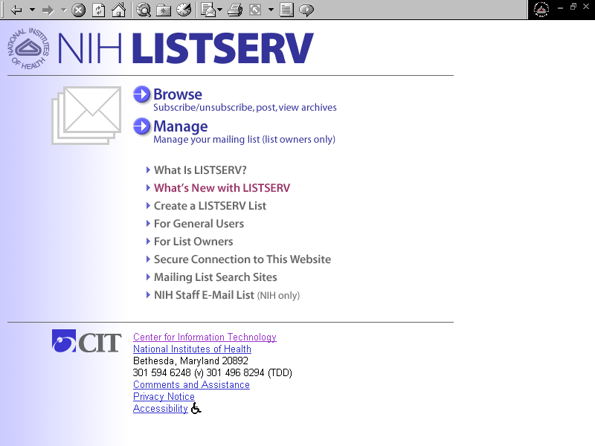

Accessing the List Management Interface
The portion of the website specifically designed for, and restricted to, list owners is called the List Management Interface. To access the List Management Interface, click MANAGE from the LISTSERV Home Page. You will be required to log in before you can proceed (Figure 2). Fill in your e-mail address and LISTSERV password, if you have one, then click the Login button. If you don’t have a LISTSERV password, or if you have forgotten your password, follow the instructions in the next section to create one.

Figure 2: LISTSERV Login Screen
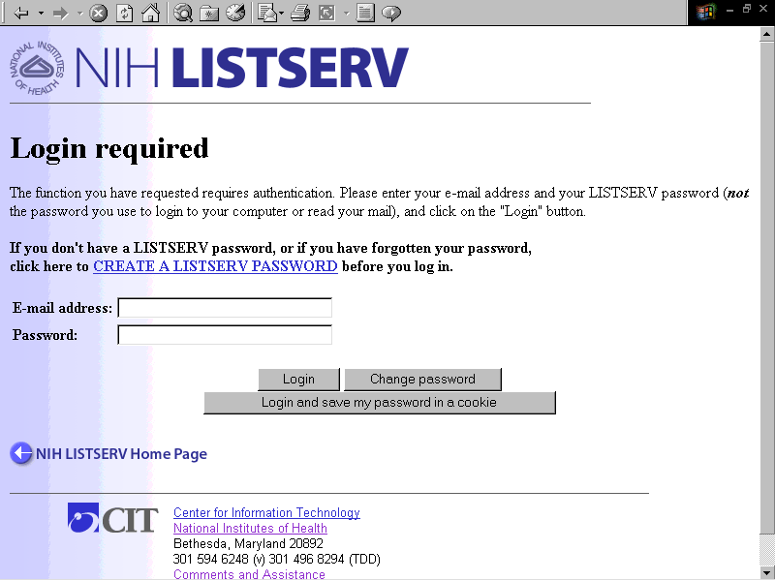

Login and Passwords
To log in, you’ll need a LISTSERV password. If you’re already on the LISTSERV Login Screen (Figure 2), click on the CREATE A LISTSERV PASSWORD link. If you’re on the LISTSERV Home Page, click For List Owners, then click Create a LISTSERV Password.
The “Create a LISTSERV Password” screen appears (Figure 3).

Figure 3: Create a LISTSERV Password Screen
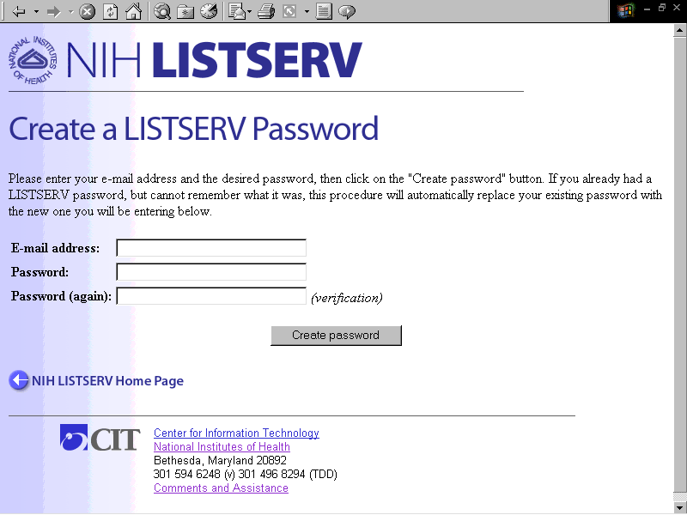
Fill in your e-mail address, and type in a password of your choosing. (LISTSERV asks you to type it twice to protect against misspellings.) Then click the Create Password button. LISTSERV acknowledges the request onscreen and sends a request for confirmation via e-mail. NOTE: before LISTSERV actually accepts your password, you must confirm the request (see next section).
When you use the web interface, LISTSERV “knows” you by the e-mail address with which you log in. Generally, your login address should be the same as your subscriber or owner address for the list you wish to access. If you commonly use more than one e-mail address, you may wish to create a password for each address. (You may use the same password for multiple addresses, if you wish.)

Confirming a Request for Confirmation
To confirm the request for confirmation, open your e-mail software. If you have more than one e-mail address, choose the one you used to create your LISTSERV password. You should find a request for confirmation from LISTSERV (Figure 4) in your e-mail Inbox within moments.
There are two ways to confirm your subscription: by e-mail reply, or by web hyperlink.
To confirm by e-mail reply: Press the reply button in your e-mail and type the word OK in the body of the reply, and DELETE EVERYTHING ELSE. Leave the subject intact, and send the message.
To confirm by web hyperlink: Find the text near the top of the request for confirmation that reads, “To confirm the execution of your command, simply point your browser to the following URL:”, followed by a web link. Click on the link to confirm the command. This should bring up your browser window, and you should see an acknowledgement that your new password has been accepted.

Figure 4: E-mail Request for Confirmation
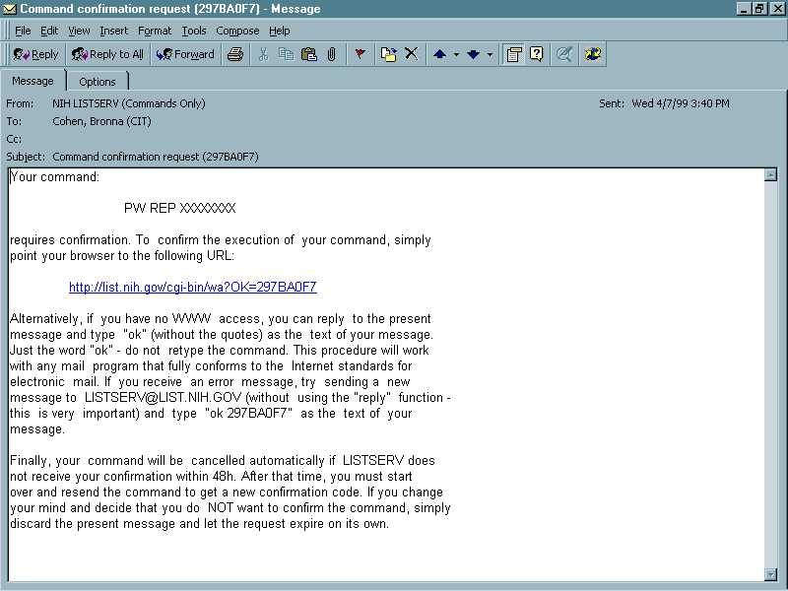
After confirming your password, click the BACK button in your browser, if necessary, to return to the LISTSERV Login Screen. You should now be able to log in using your new password. At this point, you should see the List Management Main Page (Figure 5).

Figure 5: The List Management Main Page
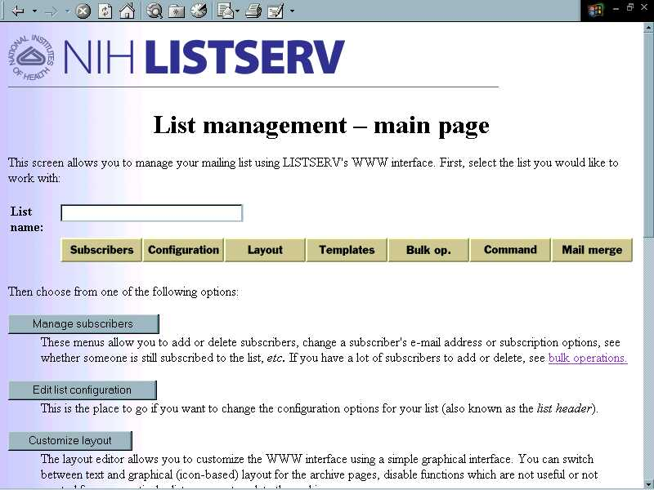

Managing Subscribers

Accessing the Account Management Screen
From the List Management Main Page, select the desired list, then click the Subscribers button. The Account Management screen appears (Figure 6).

Figure 6. The Account Management Screen
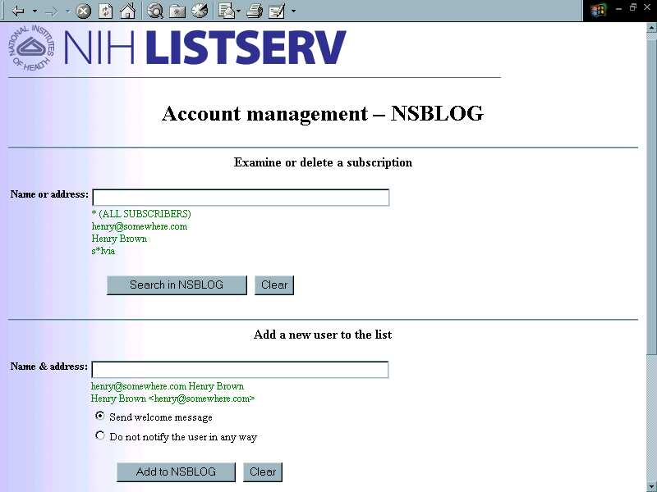

Adding Subscribers
To add a subscriber to the list, scroll down the Account Management page to the section entitled “Add a new user to the list.” In the “Name or address:” field, type the e-mail address and name of the user you wish to add, in one of the following formats:
henry@somewhere.com Henry Brown

Henry Brown <henry@somewhere.com>
henry@somewhere.com (Henry Brown)
If you wish for the user to receive notification that he/she has been added to the list, click the radio button labeled Send welcome message. If you do not wish for the user to be notified, click the radio button labeled Do not notify the user in any way.
Click the Add to listname button to add the user to the list. The Account Management page reappears, along with an acknowledgment message that the user has been added.

Note: LISTSERV has a shortcut for adding multiple users. See “Bulk Operations,” p. 27.

Subscribing a List to Another List
LISTSERV allows you to include a list address as a subscriber on another list, known as the host list. This is useful, for example, if you have a subcommittee that should always receive mail from its parent committee, but not vice-versa. You add a list as a subscriber exactly as you would an individual, using the address of the list, e.g., nsb-l@list.nih.gov, followed by a descriptive name such as “NSB E-mail List.” All postings sent to the host list are automatically forwarded to the subscribed list. NOTE: When adding a list as a subscriber, be sure to click the radio button labeled Do not notify the user in any way. Otherwise, LISTSERV will send notification to everyone on the subscribed list.
NOTE: for a more sophisticated method of using one list to disseminate mail to another, see LISTSERV’s “Super-list” feature. For details, see the List Owner’s Manual for LISTSERV from L-Soft:

http://www.lsoft.com/manuals/1.8d/owner/owner.html#2.13.11

Adding a Fax Address as a Subscriber
LISTSERV allows you to include a fax gateway address as a subscriber on a list. Mail from the list is sent to an e-mail-to-fax gateway, called the NIH Central Fax Service, , which converts the e-mail to a fax. This feature is especially useful for subscribers who do not use e-mail, are not network connected, or simply prefer to receive information by fax.
Adding a fax subscription is the same as adding a regular subscription, except that instead of the user’s e-mail address, you type the user’s fax gateway address. The format for a fax gateway address is:
name%faxnumber@FAX.NIH.GOV
Examples:
Jane_User%9-202-863-4001@fax.nih.gov
Robert_Porter%2-4359@fax.nih.gov
Format the fax number (the part between the % and the @ signs) as though you were dialing it from an NIH campus telephone or fax machine. NOTE: Spaces and parenthesesnot allowed. Hyphens are optional.
As the list owner, you will receive an acknowledgement message from the fax gateway each time a fax message is sent to a list subscriber. Due to a quirk of the system, this acknowledgement message may appear to be an error message; however, it generally is not. Read the bottom part of the message to make sure the fax went through. If it did, simply delete the acknowledgement. If it did not, you may wish to re-send the message or (if the problem persists) delete the subscriber from your list. If your list has many fax subscribers, you may wish to set up a rule in your e-mail software to delete these messages automatically, or to send them to a separate folder.

For more information on the NIH Central Fax Service, please point your web browser to http://www.mail.nih.gov/, and select "Central Fax Service" from the User Section in the left margin.

Examining or Modifying a Subscription
To examine or modify an existing subscription, go to the the “Examine or delete a subscription” section at the top of the the Account Management page. Type all or part of the subscriber’s name or e-mail address in the “Name or address:” field, then click the Search in listname button. If only one subscription matches your search criteria, LISTSERV displays all of the information for that subscriber. If more than one subscription matches the search criteria you typed, you will see a list of subscribers with the title “Select a subscriber.” Click on the desired subscriber name to select it, then click the Examine button. LISTSERV displays all of the information for that subscriber.
From this screen you can modify the subscriber’s name or e-mail address, or change any of the subscriber’s options. For example, you can temporarily turn off mail for the subscriber, set topics, or block the subscriber from posting to the list. For further information, click on any of the highlighted terms and read the online help.
When you have made the desired changes, click on the Update button.

Deleting a Subscription
To delete a subscriber from your list, go to the the “Examine or delete a subscription” section at the top of the the Account Management page. Type all or part of the subscriber’s name or e-mail address in the “Name or address:” field, then click the Search in listname button. One or more subscriptions matching your search criteria should appear. Select the one you wish to delete, then click the Delete button.
NOTE: LISTSERV has a shortcut for deleting multiple users. See “Bulk Operations,” p. 27.

Changing Your List Settings (Modifying the List Header)

List Settings

What Are List Settings?
Every list has settings that control the automatic “behavior” of the list. For example, your list settings determine whether list archives are kept, or who can subscribe to a list. You specify your initial list settings when you fill out the online LISTSERV list application form.

The List Header
List settings are recorded in a special file called the list header. The list header is a file kept by LISTSERV that contains all the information LISTSERV knows about your list -- i.e., your list settings, owner and editor information, and list description. (LISTSERV also stores your subscriber information in the same file, although it’s not considered part of the list header.) The list header is created by the LISTSERV Administrator when the list is set up. Once the list is created, the list owner can change the list settings at any time by modifying the list header.
Below is an example of a list header for a fictitious list called MIG-L.

Sample List Header
Microscopy Interest Group
Confidential= No
Review= Private
Subscription= By Owner
Notify= Yes
Send= Public
Reply-to= List,Respect
Default-Options= Repro
Ack= Yes
Errors-to= Owners
Validate= Yes,Confirm
Confirm-Delay= 96
Notebook= Yes,/anonymous_ftp/d2/listserv/mig-l,Monthly,Public
Notebook-Header= Full
Owner= smith@helix.nih.gov (Steven Smith, PhD)
The Microscopy Interest Group is concerned with all aspects
of use of the microscope for biomedical research.

List Control Keywords
List settings are specified in the list header using List Control Keywords. Each keyword has a set of possible values. When you apply for a new list, values for a basic group of List Control Keywords are set for you “behind the scenes” based on your responses to the questions on the application form. These basic keyword values are defined in the list header. In the example above, the List Control Keywords are the terms followed by an equals sign (=). The keyword value is the information to the right of the equals sign.
You will need to understand something about List Control Keywords in order to modify the list header or troubleshoot your list. The following section explains the most common keywords.
For details, see the List Owner’s Manual for LISTSERV from L-Soft:
http://www.lsoft.com/manuals/1.8d/owner/appendb.html

The Most Common List Control Keywords
SERVICE keyword: defines a "service area" outside of which subscription and other requests are not accepted. Possible values:
Local NIH only
domain1,domain2… specified domain(s) only
If you selected the NIH ONLY service area for your list on the application, this keyword was set to LOCAL. On the NIH LISTSERV facility, LOCAL is predefined as NIH only (e-mail addresses ending in NIH.GOV, NCIFCRF.GOV, or CBER.FDA.GOV).
The SERVICE keyword may also be set equal to a specific domain or set of domains. The asterisk (*) may be used as a wildcard character in specifying a domain. For example, the following SERVICE value would be used to create an NCI-only list:

SERVICE= *@nci.nih.gov, *@ncifcrf.gov
The NIH LISTSERV Facility now has a predefined HHS service area (all NIH addresses, plus e-mail addresses ending in: DHHS.GOV; AHCPR.GOV; CDC.GOV; FDA.GOV; HCFA.GOV; HRSA.GOV; IHS.GOV; and SAMHSA.GOV). The HHS service area is defined in a file that is maintained on the NIH LISTSERV machine. To define a list as HHS ONLY, it is only necessary to point to, or "include," the file name in the list header. This is done by adding the following line to the list header:
* .ik hhs
If the SERVICE keyword does not appear at all, and there is no "include" line, then subscription and other requests may be submitted from anywhere on the Internet. (Subscription requests may be further controlled by the SUBSCRIPTION keyword -- see below.)
REVIEW keyword: determines who may view subscriber information. Possible values:
Owner only list owner may view
Private only list subscribers may view
Service only users within the defined service area may view
(valid only if a service area is defined)
Public anyone may view (NOT recommended **)
This keyword determines who may view the list of subscribers (the output of the REVIEW command). If set to OWNER, only the list owner will be able to view the subscriber list. PRIVATE limits viewing to list subscribers only. SERVICE limits viewing to the defined service area (valid only if a service area is defined). PUBLIC means that anyone on the Internet may view (and copy) your list of subscribers.
**NOTE: We recommend against setting REVIEW= PUBLIC in order to protect your list from spammers who may wish to "mine" your subscriber list for addresses.
SUBSCRIPTION keyword: determines how subscription requests are handled by LISTSERV. Possible values:
Closed only the owner may add/delete subscribers; subscription requests are ignored
By Owner anyone may send a subscription request; subscription requests are forwarded to owner for approval
Open,Confirm anyone may subscribe; subscriber receives a confirmation message requiring a response before the subscription becomes effective
This keyword defines how user requests to subscribe to the list are handled by LISTSERV. If subscription is CLOSED, only the owner may add or delete subscribers; all user subscription requests are rejected by LISTSERV. If subscription is BY OWNER, subscription requests from within the list's service area are forwarded to the list owner for approval. If subscription is OPEN, anyone in the list's service area may subscribe.
SEND Keyword: determines who may send mail ("post") mail to the list. Possible values:
Owner only the list owner may post to the list
Editor puts list under control of an editor (see
EDITOR keyword)
Private only list subscribers may post to the list
Service only users within the defined service area may post to the list
(valid only if a service area is defined)
Public anyone may post to the list
This keyword defines who is allowed to post to your list. Selecting OWNER means that only the owner of the list may post. Selecting EDITOR puts your list under control of an editor. This means that all list mail will be forwarded to the editor for approval before it is posted to the list. Selecting PRIVATE allows any list subscriber to post. Selecting SERVICE allows anyone within your service area to post (valid only if a service area is defined). Selecting PUBLIC means anyone on the Internet may post to your list. (NOTE: this may include spammers.)
EDITOR keyword: defines a list editor to whom all mail will be sent for approval before being posted to the list.
If you selected EDITOR as the value of the SEND keyword, above, you must specify at least one editor here. Fill in the editor’s full e-mail address.
WARNING!!! In most cases, your NIH directory alias (i.e., an address ending in @nih.gov) WILL NOT WORK as an editor address. Your editor address for the list must exactly match the "From:" address that appears on your outgoing e-mail, or LISTSERV will not recognize you as the editor once the list is set up. In most cases, your "From:" address is the same as your ACTUAL e-mail address, e.g., jonesp@odrockm1.od.nih.gov (NOT Paul_Jones@nih.gov). POSSIBLE EXCEPTIONS: if you use e-mail software such as Eudora mail, which allows you to specify your "From:" address, AND you have specified your NIH directory alias as your "From:" address, you can use it as an editor address.
REPLY-TO keyword: sets a default value for the “Reply-To:” field in the header of list mail. Possible values:
Sender,Respect replies to postings are addressed to sender
List,Respect replies to postings are addressed to entire list
This keyword determines who gets the response when a subscriber hits the “reply” button while reading list mail. In most cases, setting this keyword to List,Respect causes replies to be propagated to the whole list (useful for discussion lists), while setting it to Sender,Respect directs replies to to the original sender of the message only (useful for announcement lists). Variations in the reader’s e-mail software may cause exceptions by ignoring the Reply-to: header generated by LISTSERV. In such cases, you, as list owner, have no control over where the reply is sent.
CONFIDENTIAL keyword: determines whether the list appears in the “List of Lists” (a list of all known lists, which LISTSERV supplies when a user sends the LISTs command). Possible values:
Yes list is hidden from List of Lists
Service appears on List of Lists visible within defined service area
(valid only if a service area is defined)
No appears on global List of Lists
The response to this question determines whether, and how widely, LISTSERV publishes your list name and description. Depending on this setting, LISTSERV may or may not include your list on a composite "list of lists" available to users by command. A value of YES completely hides your list from the world. A value of SERVICE (valid only if a service area is defined) causes your list to be visible within the specified service area. NOTE: a value of NO makes your list visible on LISTSERV's global "list of lists", which in turn may be further publicized to various search sites on the Internet.
NOTEBOOK keyword: determines whether list archives are kept, how often they are stored, and who may view them. One value must be selected from each section. Possible values:
Yes archives are kept
No archives are not kept
Weekly archive file stored weekly
Monthly archive file stored monthly
Yearly archive file stored yearly
Owner only the list owner may view archived files
Private only list subscribers may view archived files
Service only users within the defined service area
may view archived files (valid only if a service area is defined)
Public anyone may view archived files
A value of "yes" for this keyword will cause LISTSERV to keep a copy of every posting sent to your list. These copies can be retrieved and viewed upon request. (NOTE: If you choose "no"--i.e., you choose not to keep list archives--your list will not appear on the NIH website at all. This means that users will have to use emailed commands to join or leave the list.)
The second value lets you specify how often the archive files are saved. LISTSERV groups all postings during the interval you specify together into a single concatenated file and stores the file by date. Thus, indirectly, the size of the saved files is also determined by this value. Your choices are WEEKLY, MONTHLY, YEARLY, or SEPARATE. The busier your list, the shorter the interval you should choose (mostly to keep the archive file size manageable).
The third value lets you control who is allowed to read your list archives. A good rule of thumb is to limit this to the same group that was allowed to read the original messages when they were posted to the list. Your choices are OWNER (only the list owner may view), PRIVATE (only list subscribers may view), SERVICE (only individuals within the defined service area may view), or PUBLIC (anyone may view). NOTE that if your archives are PUBLIC, they will appear on the public LISTSERV Archive website and may be easily read by anyone Internet-wide.

Editing the List Header
From the List Management page, select the desired list, then click the Configuration button. The Edit List Header screen appears (Figure 7).

Figure 7. The Edit List Header Screen
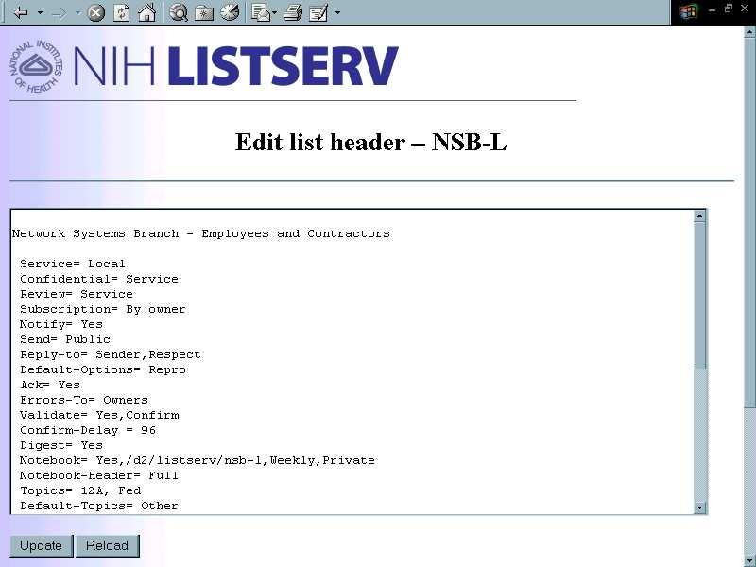
To edit the list header, simply modify the text in the window, either by typing over or deleting existing text, or by inserting additional text; then click the Update button. You should see a message acknowledging that the header has been updated. (If you’ve made a syntax error, you will see an error message. For assistance, copy the error message if possible, and e-mail it to listmaster@list.nih.gov.) For specific instructions concerning common changes you may wish to make, see the next section.

Making Your List an Edited List
When more careful control over list content is needed, the list can be edited. On an edited list, all mail posted to the list is sent for review to an individual designated as the list editor. Only postings approved by the editor are circulated to the list. This feature is particularly useful for announcement lists, electronic journals, newsletters, and moderated discussions.
An edited list can be set up by using two list keywords:
Send= Editor,Hold,Confirm
Editor= editor_address@host
More than one editor can be designated. However, mail sent to the list is automatically forwarded to the first person listed in the “Editor= ” keyword list. Only the editors (not the list owners) are allowed to mail directly to the list subscribers. Any editor can send to the list, but only the first listed editor will receive postings for review.
The Hold keyword is optional. With the Hold keyword, LISTSERV holds incoming postings and sends a copy to the editor asking for approval. The editor need only reply “OK” to LISTSERV for the message to be posted. If the message is not approved after a specified time, LISTSERV deletes it automatically. Subscribers see approved mail exactly as originally posted. Without the Hold keyword, LISTSERV delivers all list mail to the editor, who then has the option of forwarding it to the list. List subscribers see the mail as a forwarded message from the list owner.
When the optional Confirm keyword is used, messages posted directly by the editor(s) (i.e., not forwarded for approval by LISTSERV) are confirmed using the OK confirmation mechanism (see "Confirming a Request for Confirmation,” p. 13).

Changing Owner Addresses for Your List
To change an owner address, modify the appropriate “Owner=” line. It will look something like this:

Owner= smithj@mail.nih.gov (Jane Smith)
To add additional owners, or an additional listing for an existing owner (e.g., for an owner who uses more than one e-mail address on a regular basis), add an additional line or lines in the same format. (To avoid receiving duplicate owner mail, use the Quiet: definition. See “Turning Off Owner Mail,” below.)

Owner= jws@cu.nih.gov (Jane Smith)
To delete an owner address, simply remove the owner definition line from the list header. NOTE: You must have at least one non-quiet Owner defined in the header, or LISTSERV will reject the change.

Changing Editor Addresses for Your List
The process of modifying or adding an editor address is similar to that for modifying an owner address, except that you modify/add the appropriate “Editor= ” line(s).

Turning Off Owner Mail
In some cases it may be desirable to turn off owner e-mail to a particular owner address. Owner e-mail usually consists of bounced list messages, announcements of importance to list owners, and other warnings and reports. At least one owner must receive owner mail, in order to monitor list problems, etc. To turn off owner mail to one or more owner addresses, insert a header line containing the Quiet prefix:
Owner= smithj@mail.nih.gov (Jane Smith)
Owner= Quiet:
Owner= sxj@cu.nih.gov (Jane Smith)
Owner addresses following the Owner= Quiet: keyword will not receive owner mail, but will have owner privileges. There should only be one Owner= Quiet: line in the header.
Use this keyword to eliminate duplicate mailings to list owners who have more than one owner address for a single list.

Turning On "Hands-Off" Bounce Processing
“Hands-off bounce processing” is a setting that allows LISTSERV to monitor and eliminate bad subscriber addresses without owner intervention. It utilizes a feature called passive monitoring, a new setting available for the Autodelete keyword. To turn on “hands-off” bounce processing, change the "Auto-Delete" keyword in the list header to read:
Auto-Delete= Yes,Full-Auto,Probe(30)
This setting suppresses bounce messages the list owners. Instead, the list owners receive a single daily error monitoring report showing which addresses LISTSERV is monitoring for possible deletion.
This setting suppresses bounce messages to the list owners. Instead, the list owners receive a single daily error monitoring report showing which addresses LISTSERV is monitoring for possible deletion.
For further details on the probe feature, please consult the List Owner’s Manual for LISTSERV from L-Soft:
http://www.lsoft.com/manuals/1.8d/owner/owner.html#4.9.2

Changing Where Replies Are Sent
A popular change involves modifying the Reply-to= keyword so that replies to list postings are automatically addressed to the sender of the post rather than to the entire list. If the entire list is seeing replies to postings (sometimes inappropriately), here’s what the keyword line probably looks like:

Reply-to= List,Respect
Modify the line as follows:

Reply-to= Sender,Respect
Be aware that due to variations in e-mail software, the settings of the Reply-to keyword are not always honored.

NIH-Only Lists
If a list is only of interest to members of the NIH user community (e-mail addresses ending in NIH.GOV, NCIFCRF.GOV, or CBER.FDA.GOV), the following keywords should be set:
- Service= Local
- Review= Service
(or Review= anything other than Public)
- Send= Service
(or Send= anything other than Public)
- Confidential= Service
- Notebook= Yes,pathname,interval,Service
(or Notebook= Yes,pathname,interval,Private)

HHS-Only Lists
If a list is only of interest to members of the HHS user community (NIH e-mail addresses, plus e-mail addresses ending in: DHHS.GOV; AHCPR.GOV; CDC.GOV; FDA.GOV; HCFA.GOV; HRSA.GOV; IHS.GOV; and SAMHSA.GOV), the following keywords should be set:
- .ik hhs
- Review= Service
(or Review= anything other than Public)
- Send= Service
(or Send= anything other than Public)
- Confidential= Service
- Notebook= Yes,pathname,interval,Service
(or Notebook= Yes, pathname,interval,Private)
The “.ik hhs” designation points to a file on the LISTSERV machine which contains the HHS service definition. If you choose to make your list an HHS-only list, be sure to delete any line in your header that begins with “Service=”.

Layout
The Layout screen contains a questionnaire that allows you to customize the appearance of the WWW archive interface for your list(s). You will be asked simple questions, such as whether to use a text or graphical interface for your archives, which icons you want to include in the toolbar, etc. It is recommended that, before answering the questions, you start a new browser window and access the archives for your list (the layout page gives you a hyperlink to assist you in doing so). After changing the layout, you can simply reload the second browser window to see your new layout.
Click the Layout button on the List Management Web interface to access the Layout Screen (Figure 8). You will see a form with multiple questions. Answer one or more questions (you need only answer the ones that apply to the changes you wish to make), then click the Update now! button. If for some reason you are dissatisfied with the changes, click on the Reset to site defaults button at the bottom of the questionnaire to revert to the default settings.

Figure 8. The Layout Screen
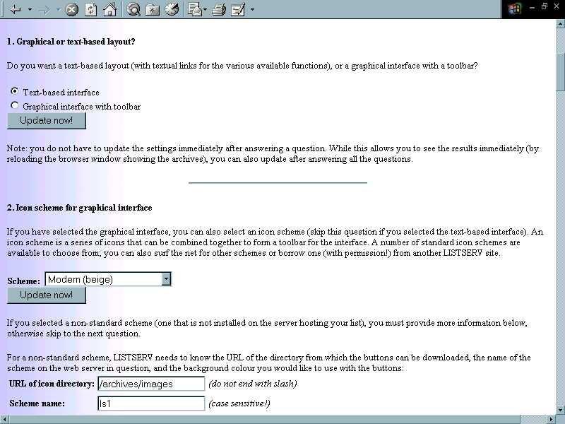
Note: if you are familiar with HTML, you can also use the WWW Template Editor to provide your own HTML code for the various pages of the interface. However, if you do so, you will no longer be able to customize the page in question using this questionnaire, i.e., using the Layout screen.

Template Management
The mail and web template editor lets you customize the default templates for your list. Editing any of your list templates is completely optional, as LISTSERV provides a full set of default messages.
LISTSERV groups the templates into two categories:
- mail templates – files containing the “boilerplate” text for the administrative messages sent by LISTSERV in response to most commands; and
- WWW templates – files containing the HTML for your list’s web pages.
Click Templates from the List Management Screen to access the Template Management Screen (Figure 9). LISTSERV brings up the Mail Template Screen first by default. To switch to the WWW templates screen, click the Switch to WWW templates button underneath the drop box. (Similarly, to switch back to the mail templates, click the Switch to Mail templates button from the WWW templates screen.)

Figure 9. The Template Management Screen
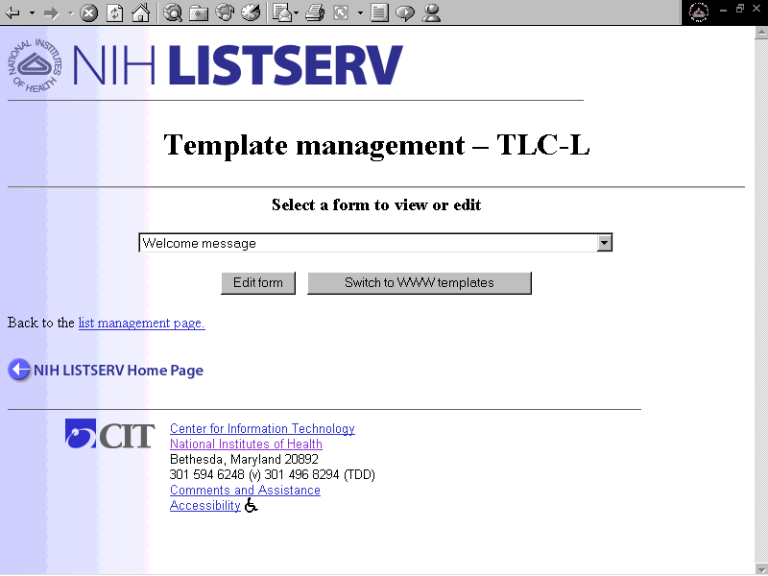

Mail Templates
Using this screen, you can easily create a welcome message or a bottom or top banner for your list. A welcome message is one that is sent automatically whenever someone joins your list (it is sent in addition to LISTSERV’s default message to new subscribers). A banner is a “boilerplate” message that is appended to the top or bottom of every message posted to your list. By default, these messages are blank, so to create one, simply select the desired form, click the Edit button, and type the desired text. When finished, click Update.
The other mail templates contain varying combinations of text and codes. If you feel a compelling need to modify one of these templates, please be careful not to alter the codes. We strongly recommend that you consult the L-Soft List Owner’s Manual and read the chapter on modifying the default mail templates before attempting any modifications.

WWW Templates
This screen allows you to customize the web pages for your list. However:
WE STRONGLY RECOMMEND THAT YOU USE THE LAYOUT SCREEN TO MAKE CHANGES IN YOUR LIST’S WEB PAGES. DO NOT EDIT THE WWW TEMPLATES UNLESS YOU HAVE A PROGRAMMING BACKGROUND AND ARE EXTREMELY FAMILIAR WITH HTML.

Bulk Operations
This screen allows you to add large numbers of subscribers to your list, or delete large numbers of subscribers from your list, based on a source file that you specify, called the Input file. LISTSERV refers to addresses in the Input file as “imported addresses.” From the List Management interface, click Bulk op. to access the Bulk Operations screen (Figure 10).

Figure 10. The Bulk Operations Screen
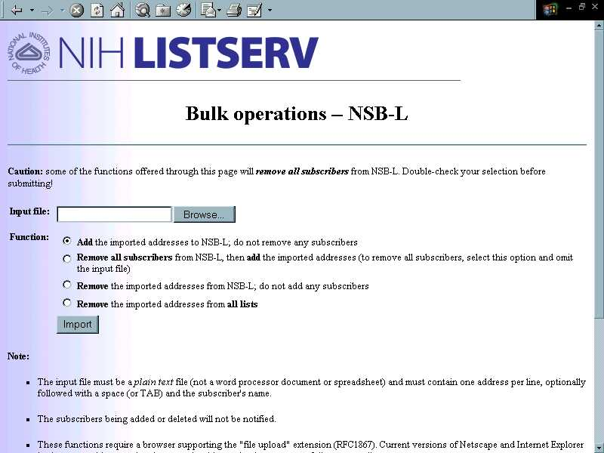

Available Functions
- Add the imported addresses to the list; do not remove any subscribers
- Remove all subscribers from the list, then add the imported addresses (to remove all subscribers, select this option and omit the input file)
- Remove the imported addresses from the list; do not add any subscribers
- Remove the imported addresses from all lists (that you own)

The Input File
The input file must be a plain text file (not a word processor document or spreadsheet) and must contain one address per line, optionally followed with a space (or TAB) and the subscriber's name.
The subscribers being added or deleted will not be notified.
These functions require a browser supporting the "file upload" extension (RFC1867). Current versions of Netscape and Internet Explorer both support this operation, but you should try other browsers carefully on a test list.
NOTE FOR MAC USERS: You may encounter difficulties with bulk operations if you create your input file on a Macintosh computer. Macintosh text editors do not provide line breaks at the end of each line, causing LISTSERV to process the file as one long entry. Mac SimpleText is known to cause this problem and should not be used to create an input file. The following have been tested and found to work:
- MS Word - save the file as MS-DOS text or MS-DOS text with line breaks;
- BBEdit Lite - save the file using the "Line Breaks = DOS" feature;
- Corel WordPerfect - save the file using the Text Export option, then select PC Text--Delete Soft Returns in the dialog box.

Sending Commands
Many list management operations may be performed simply by sending a command to LISTSERV. Despite the convenience of LISTSERV’s web interface, occasionally you may need or prefer to send a command to LISTSERV.
Included for the convenience of list owners, the General Command screen allows you to send a command to LISTSERV without having to exit the List Management Interface in your browser. Click the Commands button from the List Management Web page to access the General Command screen (Figure 11). To send a command, type it in the Command: field, then click the Submit button. LISTSERV responds to the command on the web page, usually within seconds.

Figure 11. The General Command Screen
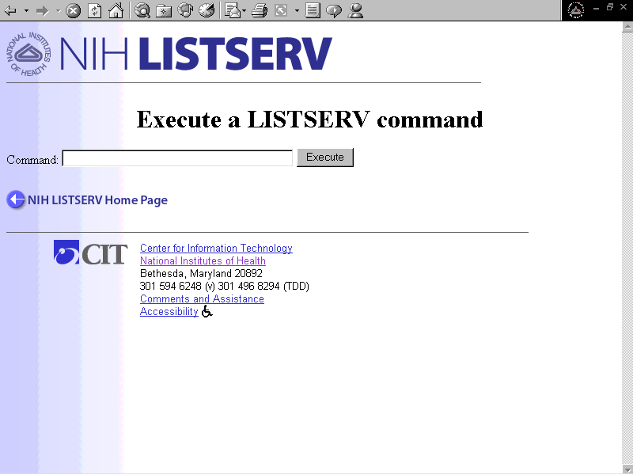
You can also e-mail commands directly to LISTSERV. For further information on e-mailing commands to LISTSERV, please see “Sending Commands,” p. 29.

Commands You May Wish to Use
Most list owner functions can be accomplished most easily using the List Management Web Interface. However, on occasion, you may wish to use the following commands, which allow you to accomplish a couple of functions that the Web Interface doesn’t readily accommodate.
HOLD command. This command causes all list mail to be held. Use it any time you suspect a mail loop, i.e., your list is suddenly being inundated with mail. Use the FREE command to free a held list.
QUERY command. The query command may be used to query subscription options for one or more subscribers on your list(s). The query command allows use of wildcard characters, allowing you to request information about groups of users, or find a user on more than one list, etc.
REVIEW command. While the web interface allows you to display your subscriber list, it does not provide a way to print it, save it, easily count how many subscribers you have, or view more than a handful of subscribers at a time. If you wish to do any of these things, you must use the REVIEW command. If you intend to print or save the subscriber list, you must use an e-mailed REVIEW command rather than the web command interface.
SET command. The SET command is used to modify the subscription options for one or more users. The Accounts Management interface does this very well on a user-by-user basis. However, to set options simultaneously for a single user across multiple lists, or for multiple users on a single list, the SET command, which allows for wildcard characters, may be more convenient.
ARCHIVE commands: INDEX, GET, SEARCH, and GETPOST. List archives for which access is restricted to the list owner cannot be viewed via the web interface. The only way for the list owner to access the archive files is via commands.
For more information on these selected commands, see “Administering Your List Using Commands,” p. 43. For comprehensive information on these and other LISTSERV commands, please consult the List Owner’s Manual for LISTSERV from L-Soft:
http://www.lsoft.com/manuals/1.8d/owner/appenda.html

Mail-Merge
The mail-merge feature is not implemented on the NIH LISTSERV Facility.

Other List Owner Functions
A number of other functions, especially designed for List Owners, are available via the LISTSERV Home Page. To access them, click For List Owners from the LISTSERV Home Page. The following modified Home Page appears (Figure 12). Note that a drop-down list is now visible under For List Owners. Each of the items on the drop-down list is a clickable link connecting you to a List Owner feature or utility. Each item is detailed in the following sections.
Figure 12. Functions for List Owners
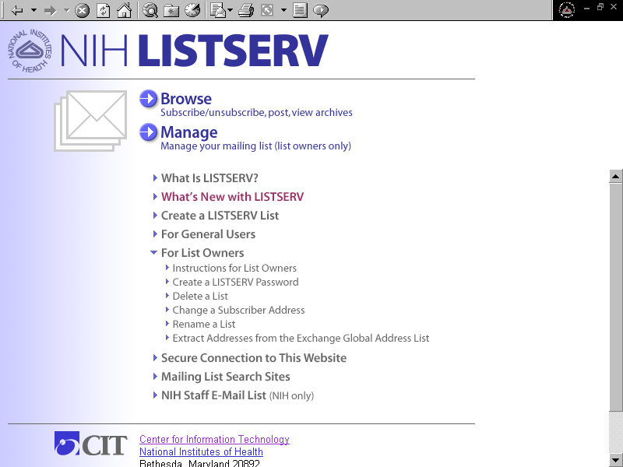

Instructions for List Owners
To access instructions for LISTSERV List Owners, click Instructions for List Owners on the drop-down list. The Instructions for List Owners page appears (Figure 13).
Figure 13. Instructions for List Owners
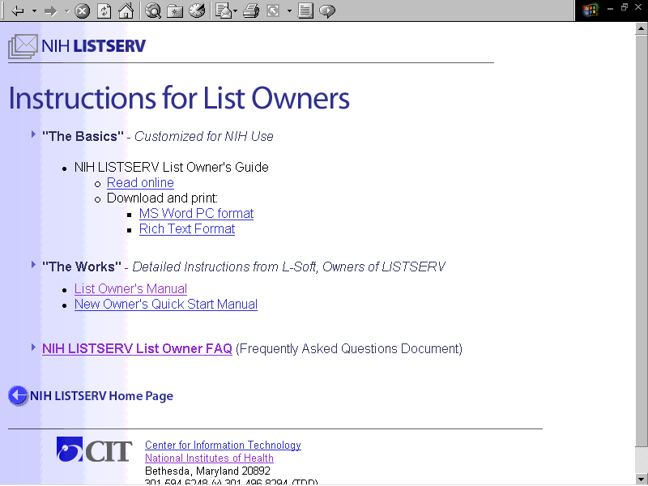
The first section, entitled “The Basics,” contains links to the NIH LISTSERV List Owner’s Guide, which is written specifically for NIH LISTSERV List Owners. You can browse the Guide online, or download a copy for printing. (NOTE: If you want a printed copy, please print out one of the downloaded versions, so that your copy is properly formatted with page numbers, cross-references, etc. The online version will not print as well.)
The second section, entitled “The Works,” provides links to the List Owner’s Manual written by L-Soft, the owners of the LISTSERV technology. It is very thorough and, of course, authoritative. In fact, it is a tome. Most List Owners will never need to access this information; however, it’s there if you wish to consult it.
The last item on the page is the NIH LISTSERV List Owner FAQ (Frequently Asked Questions Document). Hopefully, this is fairly self-explanatory.

Create a LISTSERV List
This option is detailed above. See Setting Up a New List, p. 3.

Create a LISTSERV Password
This option is detailed above. See Login and Passwords, p. 12.

Delete a List
Use this feature to request removal of a list from the NIH LISTSERV Facility. (NOTE: this form cannot be used to remove subscribers from a list.)
To access the feature, click Delete a List on the drop-down list. The Delete a List page appears (Figures 14a and 14b).
Figure 14a. Delete a List
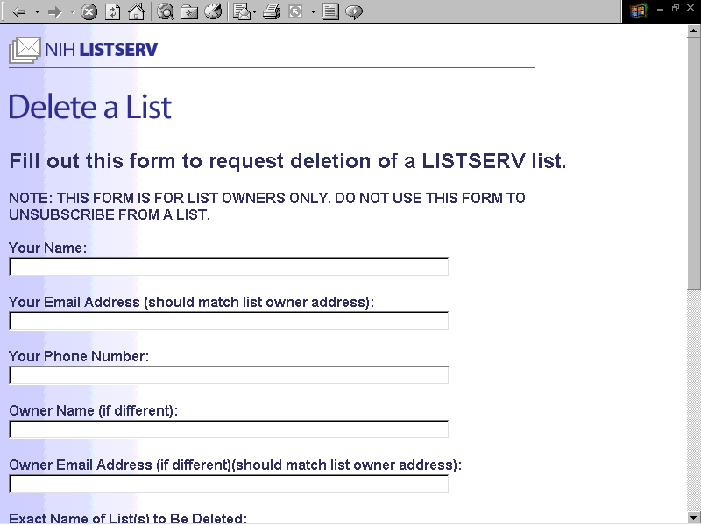
Fill out the online form as follows:
Your Name
Please fill in your full name.
Your Email Address (should match list owner address)
Fill in your email address here. If you own the list, and you know your owner address, use that. Otherwise, please provide your preferred email address so that we can reach you.
Your Phone Number
Please provide area code and full number if outside of NIH.
Owner Name (if different)
If you are not the list owner, please provide the list owner’s name, if you know it.
Owner Email Address (if different) (should match list owner address)
If you are not the list owner, and you know the list owner’s email address, please provide it.
Figure 14b. Delete a List (cont’d)
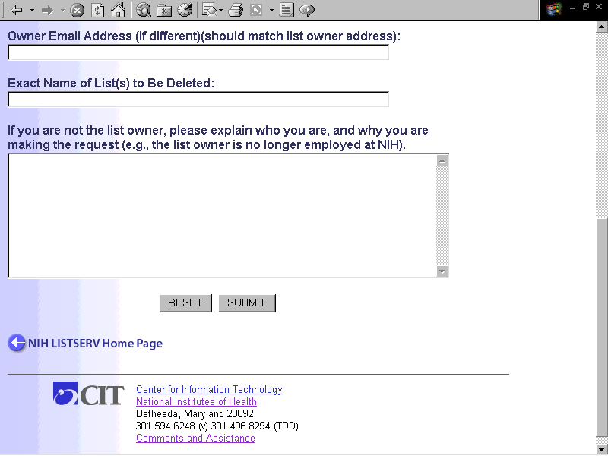
Exact Name of List(s) to Be Deleted
Please provide the name(s) of any LISTSERV lists you wish to delete.
If you are not the list owner, please explain who you are, and why you are
making the request (e.g., the list owner is no longer employed at NIH).
Normally, the List Owner should make this request. We will accept a request from someone else, provided a reasonable explanation is given here, e.g., if the List Owner is no longer at NIH.
Submit Button
When you have finished filling out the form, click the SUBMIT button to submit the request. You will see an onscreen message acknowledging that your request has been submitted.
NOTE: for your protection, we require emailed confirmation of your request. After you have submitted the request, please bring up your email software and look for a message from the NIH LISTSERV Administrators. To confirm the request, reply to the message, type OK in the message body, and send it. Once we receive the emailed confirmation, your request should be processed within one business day. We will notify you by email when we have deleted your list(s).

What Lists Do I Own?
This utility lets you find out what lists you own under a given address.
To access the feature, click What Lists Do I Own? on the drop-down list. The “What Lists Do I Own?” page appears (Figure 15).
Press the SUBMIT button, and then log in using the owner address you want to check for. The names of lists whose owner address matches your login address will be displayed. You can use this utility to check any address for which you have a LISTSERV password.
If you previously saved your LISTSERV login as a cookie in your browser, you will bypass the login step. In such a case, you will need to turn off the cookie feature in your web browser if you wish to check addresses other than the one saved in the cookie. Please contact TASC at 301-594-6248 (TDD 301-496-8294) for assistance with turning off browser cookies.
Figure 15. What Lists Do I Own?

Change a Subscriber Address
Use this feature to change a subscriber’s email address on a list that you own, or on all lists that you own. (NOTE: this form cannot be used to change an owner or editor address. To change an owner or editor address, you must modify the list header (see “Changing Owner Addresses for Your List,” p. 23).
To access the feature, click Change a Subscriber Address on the drop-down list. The Change a Subscriber Address page appears (Figure 16).
Fill out the form as follows:
List Name (to make a global change, type * in the listname field)
Type in the name of a list that you own, on which you’d like to change the subscriber’s address. If you want to change the subscriber’s address simultaneously on all lists that you own, type a star (*) instead of a list name.
Old Email Address
Type the subscriber’s old email address in this field.
New Email Address
Type the subscriber’s new email address in this field.
Submit Button
Click the SUBMIT button to submit the request. A second screen, with a link for you to click, will appear. Click the link to process the change. A login screen will appear. Log in using your owner address and LISTSERV password.
NOTE: Your owner address for the list(s) must exactly match the login address you use, or you will not be able to make the change.
Figure 16. Change a Subscriber Address
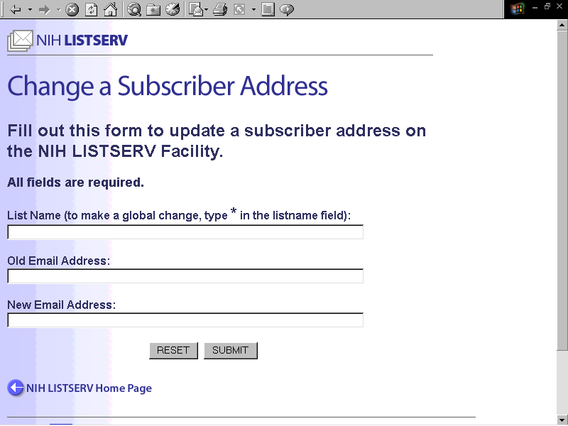

Rename a List
Use this feature to request that a list be renamed.
To access the feature, click Rename a List on the drop-down list. The Rename a List page appears (Figures 16a and 16b).
Figure 17a. Rename a List
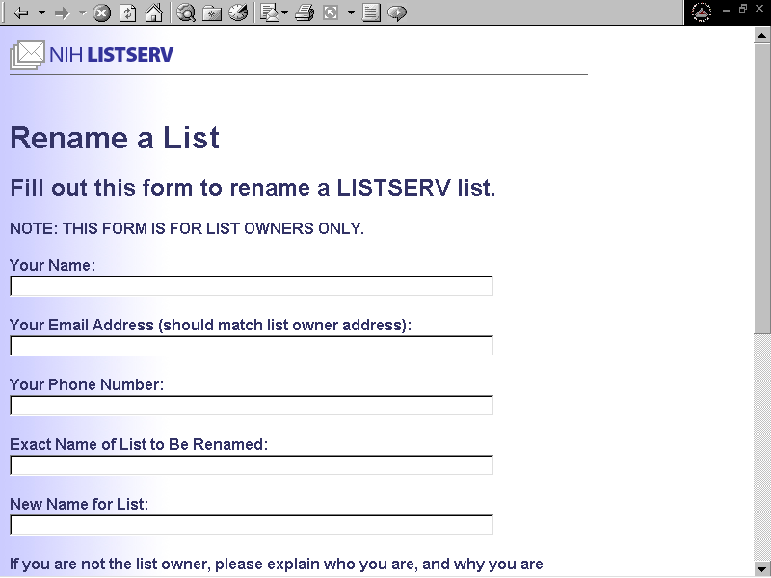
Fill out the form as follows:
Your Name
Type your full name in this field.
Your Email Address
Type your email address in this field. This address should match your owner address (the one you use to manage your list).
Your Phone Number
Please provide a phone number where you can be reached.
Exact Name of List to Be Renamed
Please provide the current list name.
Figure 17b. Rename a List (cont’d)
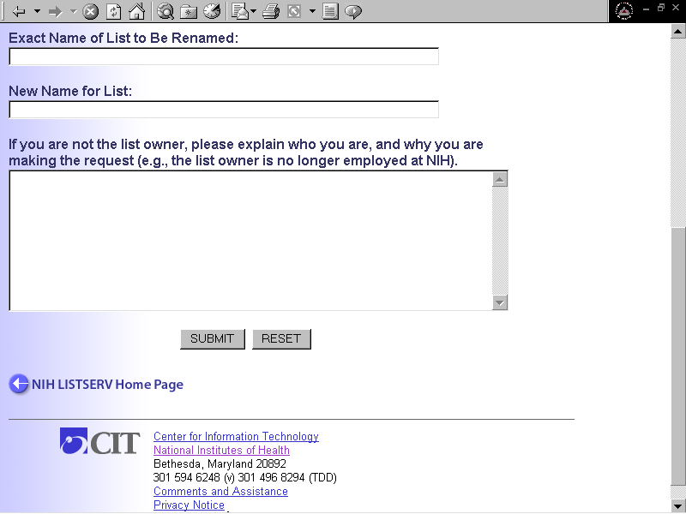

New Name for List
Please provide the new name you wish to give your list.
If you are not the list owner, please explain who you are, and why you are making the request
If you are the list owner, you need not fill out this field. If you are not the list owner, this information will help us ensure that the request is legitimate. For example, the employee may have left your organization, and you are the new list owner.
Submit Button
Click the SUBMIT button to submit the request. An acknowledgement screen will appear. You will also receive an emailed request for confirmation. You must reply to this request beforethe list can be renamed. To confirm, reply to the email message, type “OK” in the body of the email message, and send it back.

Extract Addresses from the Exchange Global Address List
The LISTSERV Global Address List (GAL) Utility allows users to extract names and email addresses from the NIH Exchange Global Address list. The extracted information is automatically formatted for addition to LISTSERV via the list management web interface.
The GAL Utility is ideal for transferring subscribers from an email distribution list on the NIH MS Exchange System to a LISTSERV list. All of the addresses can be extracted in a single operation, saved as a file, then added to a LISTSERV list using LISTSERV's bulk operations feature. The LISTSERV GAL Utility can also extract individual addresses. The information can be saved to the user's clipboard, then copied and pasted onto the LISTSERV Account Management page.
The GAL Utility must be downloaded and installed on the user’s PC.
Click Extract Addresses from the Exchange Global Address List to access the main page for the GAL Utility (Figures 18a and 18b).
Figure 18a. Extract Addresses from the Exchange Global Address List
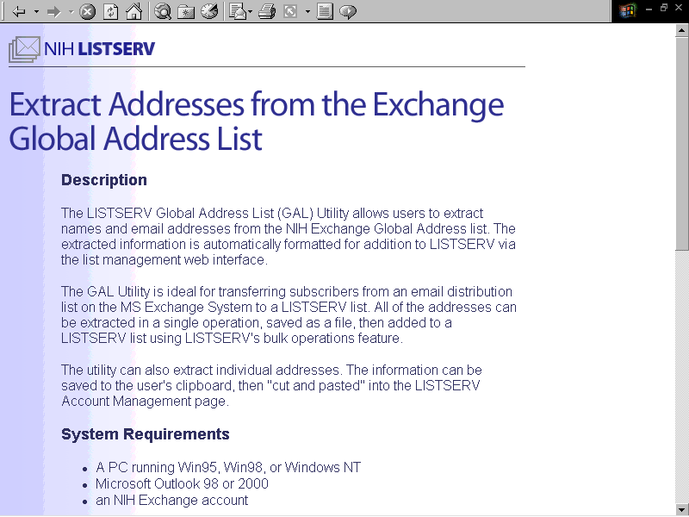
Figure 18b. Extract Addresses from the Exchange Global Address List (cont’d)
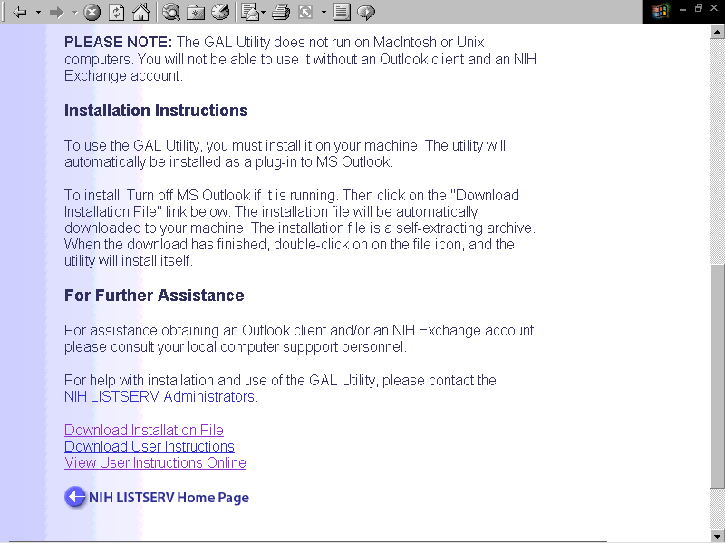

System Requirements
- A PC running Windows 9x, 2000, or NT operating system
- MS Outlook 98 or 2000
- An NIH Exchange System account
PLEASE NOTE: The GAL Utility does not run on MacIntosh or Unix computers. You will not be able to use it without an Outlook client and an NIH Exchange account.

Installation instructions
To use the GAL Utility, you must install it on your machine.
Turn off MS Outlook if it is running. Then click the Download Installation File link. The installation file will be automatically downloaded to your machine. The installation file is a self-extracting archive. When the download has finished, double-click on on the file icon, and the utility will install itself. The utility will automatically be installed as a plug-in to MS Outlook.

Instructions for Use
To begin, click the ListServ button on the Outlook toolbar, or select LISTSERV Utility from the Outlook Tools menu. The “LISTSERV Address Book Utility” window appears (Figure 19).
Figure 19. The “LISTSERV Address Book Utility” Window
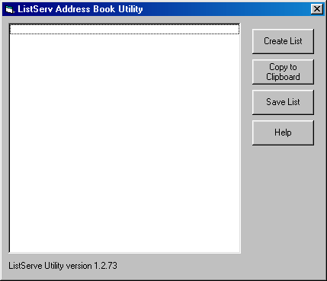
Click the Create List button, or tab until the button is highlighted, then press enter. The GAL "Select Names" window (also called the Address Book) opens (Figure 20).
Figure 20. The GAL “Select Names” Window
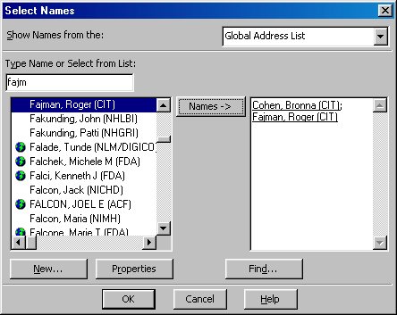
To select names or distribution lists from the GAL, type a name in the “Type Name or Select from List” field, or highlight the name in the left window pane. When you have highlighted the name(s) or distribution list(s) you want, click the Names button, or tab to it and press ENTER. When finished, click the OK button, or tab to it and press ENTER. After you press the OK button, the address book will close, and the names you selected will be transferred to the “LISTSERV Address Book Utility” window.
Figure 21. ”The LISTSERV Address Book Utility” Window
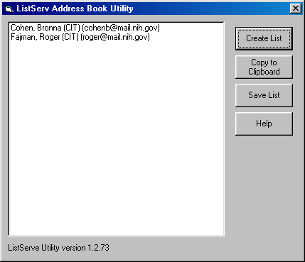

Figure 21 shows how the “LISTSERV Address Book Utility” window looks after you press the OK button. Note that both names and email addresses are visible. If you selected a distribution list, the names of all of the list recipients should be visible.
To copy and paste an individual name and address into the LISTSERV Account Management page, press the Copy to Clipboard button, or tab to it and press ENTER. Bring up your browser, log onto the Account Management page for your list, paste the name and address into the “Name & Address” field under “Add a New User to the List,” and click the button to add the user to the list.
To save multiple addresses in a file for use with LISTSERV’s BULK ADD feature, choose Save List. Figure 22 shows how the information looks when saved to a file. The file is ready to import to your LISTSERV list using LISTSERV’s BULK ADD feature (see Bulk Operations, p. 27.
Figure 22. Saving to a File
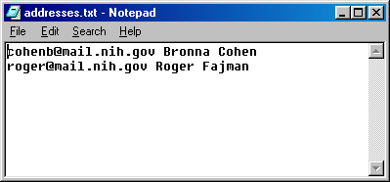

For Further Assistance
For assistance obtaining an Outlook client and/or an NIH Exchange account, please consult your local computer support personnel.
For help with installation and use of the GAL Utility, please contact the NIH LISTSERV Administrators at listmaster@list.nih.gov.

Administering Your List Using Commands

Sending Commands to LISTSERV
Most list management operations may be more easily, and safely, accomplished using the LISTSERV List Management Web interface. For this reason, list owners are encouraged to use the web interface to manage their lists.
However, it is useful to know that the list management functions you can do using the List Management Web interface can also be accomplished by sending commands to LISTSERV. In fact, before the Web interface was available, the only way to communicate with LISTSERV was via e-mailed commands. If you prefer, you may still use e-mailed commands to interact with the NIH LISTSERV facility.
You can also transmit commands to LISTSERV by typing them into the Command Screen on the List Management Web Interface. See “Sending Commands,” p. 29.
This section contains a very limited set of LISTSERV commands. It is not intended to be comprehensive. For comprehensive information on these and other LISTSERV commands, please consult the List Owner’s Manual for LISTSERV from L-Soft:
http://www.lsoft.com/manuals/1.8d/owner/appenda.html

The Importance of Your E-mail “From:” Address
When you communicate with LISTSERV via e-mail, e.g., to add a subscriber to a list, or to confirm a command, LISTSERV identifies you by the address that appears on the “From:” line in your e-mail message. This address, which we call your e-mail “From:” address, is generally set by your e-mail administrator (although some e-mail software, such as Eudora Mail, allows you to choose your “From:” address).
NOTE: Your “From:” address must exactly match the owner address defined in your list header, or LISTSERV will not recognize you as a list owner. If this problem occurs, use the Web interface to modify your list header and include your e-mail “From:” address as a second owner address. (You may wish to make the second address a “quiet” owner to avoid receiving two copies of administrative mail.)

How to E-mail a Command to LISTSERV
To e-mail a LISTSERV command, type it in the body of an e-mail message and send it to listserv@list.nih.gov. Leave the subject line blank. If your e-mail software appends a signature to your e-mail messages, turn this feature off before sending commands to LISTSERV.

The QUIET Prefix
QUIET command-text
This special prefix suppresses notification mail for the specified command. For example, a “QUIET ADD” command would prevent notification from being sent to the person being added to the list. Note that this does not disable future mail to the user, or any future ADD notifications. In addition, it will not suppress severe error messages, which are usually sent via mail.

Command Conventions
Commands are listed in alphabetical order. The minimum acceptable abbreviation appears in capital letters (e.g., DELete). Square brackets [ ] are used to indicate optional keywords. A vertical bar | indicates a choice. Italics show that a value is to be filled in, e.g., listname. Commands that support the QUIET prefix are marked (‡).

General Commands
CHANGE (‡) listname|* user@oldhost|pattern user@newhost|pattern
Allows the list owner to change user addresses with a single command (this previously required two commands, ADD and DELETE). If the wildcard character (*) is used in place of the list name, the change will be made in all lists owned by the sender. Use of the wildcard character in the address allows all addresses fitting a particular pattern to be changed to a new pattern. For example, if the oldhost.nih.gov server were being renamed to newhost.nih.gov, you might use the following CHANGE command:
Quiet change mylist *@oldhost.nih.gov *@newhost.nih.gov

FREE listname [PW=password]

Release a held list
FREE negates a previous HOLD command and releases mail files that may have been previously placed in HOLD status (see HOLD command, below).
LISTSERV will automatically HOLD a list that exceeds the list’s “daily threshold” -- i.e., the maximum number of postings allowed per day (an additional safeguard against mail loops -- see HOLD command, below). At NIH, the default maximum is 50. Use the FREE command to release the hold. (The value for the Daily-Threshold keyword may be modified.

HOLD listname [PW=password]
Hold a list, preventing new postings from being processed until a FREE command is sent
Causes LISTSERV to hold all mail sent to the list after sending an appropriate message to the sender. This effectively suspends all postings to the specified list without purging the files and without affecting any other lists (postmasters have access to a similar command that suspends mailing activity for ALL lists). Useful when a list is suddenly flooded with mail and a mail loop is suspected.
If you suspect a loop, issue the hold command, then send e-mail to listmaster@list.nih.gov. Once you and the LISTSERV Administrators have stopped the loop or determined that there is none, you can issue the FREE command to release the hold on the list. Mail that was held will be released to the list at that time. To review (and possibly delete) backlogged mail after a list has been held, modify the header and designate a temporary editor for the list, before you issue the FREE command. This will cause the backlogged mail to be sent to the editor for review before it is posted. For instructions on making your existing list an edited list, see "Making Your List an Edited List," p 23.
Query listname FOR user@host

Query subscription options for one or more users
List owners are authorized to query the distribution options of list subscribers by appending “FOR user@host” to the command text. Wildcards may be used to designate multiple users -- e.g., FOR *@*niaid.nih.gov will query distribution options for all list subscribers whose address ends in niaid.nih.gov. No password is required on this command, and no notification is sent to the target user.
REView listname [(options]
Get information about a list
Options restricted to list owners:
NOHEADER causes LISTSERV to omit the list header from the
output of the command
BY NAME sorts the subscriber list by name
BY HOST sorts the subscriber list by host name
When sent by the list owner, the command returns a copy of the list header and the subscriber list. NOTE: This command is the only way to get a full copy of your subscriber list to print or save in a file.

SET(‡) listname [options] FOR user@host [PW=password]
Alter subscription options for the list, or for one or more users
Options restricted to list owners:
POST/NOPOST enable/prevent user from posting to list (useful for screening out postings from troublesome subscribers)
REVIEW/NOREVIEW postings from the specified user go to list owner or editor for review/postings from user receive no special review. (The REVIEW option can be useful for screening out postings from troublesome subscribers.)
Other options (not restricted to list owners):
MAIL/NOMAIL user receives list mail/user’s list mail is suspended
DIGEST/NODIGEST user receives list mail in digest form (i.e., combined into one or two messages per day)/user receives list mail as separate postings
ACK/NOACK/MSGack user receives/doesn’t receive. ackn. of postings
CONCEAL/NOCONCEAL user’s subscription is hidden from/visible to REVIEW
REPro/NOREPro user receives/doesn’t receive a copy of his/her own postings
INDex/NOINDex user receives postings in index format (i.e., summarized into one message per day containing a list of subjects, with info on how to retrieve full text)/user receives list mail as separate postings
Options for mail headers of incoming postings (choose one):
FULLhdr “full” mail headers
IETFhdr Internet-style headers
SHORThdr short (default) headers
DUALhdr LISTSERV copies the mail headers into the body of the e-mail. Useful for e-mail software that doesn’t show complete header info
SUBJecthdr “full” headers, except LISTSERV adds the name of list to the subject line
The SET command is used to modify the subscription options for one or more users. The optional FOR clause allows list owners to modify options for list subscribers. Wildcards may be used to designate groups of users with like addresses -- e.g., FOR *@*niaid.nih.gov will set subscription options for all list subscribers whose address ends in niaid.nih.gov. Notification will be sent to the target users after their options have been modified, unless the QUIET prefix is used. The options of all current subscribers can be set by the following command (using the wildcard *@*):

QUIET SET listname option FOR *@*
To set the default subscription options for all new users, you must modify the Default-Options keyword in the list header. For details concerning this and other list control keywords, please see the List Owner’s Manual for LISTSERV from L-Soft:
http://www.lsoft.com/manuals/1.8d/owner/appendb.html

Archive Commands
LISTSERV allows list owners to specify that archives be kept for each list. List archives (also known as notebook files) are stored files containing copies of all list postings. If these files have been set up for public use by the list owner, users may access them.

Requesting a List of Available Archive Files
To find out what archive files are available for a specific list, use the INDEX command. The format is:

INDEX listname
The INDEX command causes a FILELIST to be sent back to the requestor, listing the available files and their access limitations. For example, the command “INDEX TLC-L” would get the following mail as a response:

TLC-L FILELIST for LISTSERV@LIST.NIH.GOV
****************************************************************

TLC-L files
****************************************************************
The GET/PUT authorization codes shown with each file entry describe who is authorized to GET or PUT the file:
N/A = Not Applicable
OWN = List owners
PRV = Private, i.e., list members only
::::::::::::::::::::::::::::::::::::::::::::::::::::::::::::::::
rec last - change
filename filetype GET PUT -fm lrecl nrecs date time
* -------- -------- --- --- --- ----- ----- ---- ----
TLC-L GETLOG OWN N/A . . 0 .... ....
TLC-L WELCOME PRV OWN . . 0 .... ....
*
NOTEBOOK archives for the list(monthly notebook)
rec last change
filename filetype GET PUT -fm lrecl nrecs date time Remarks
-------- -------- --- --- --- ----- ----- ---- ---- -------
TLC-L LOG9507 ALL OWN V 73 23 95/07/31 22:34:32 Started
TLC-L LOG9508 ALL OWN V 78 173 95/08/24 11:43:54 Started
TLC-L LOG9509 ALL OWN V 79 384 95/09/25 12:51:13 Started
END/
Each entry in the FILELIST specifies the name of the file, its format and size, a brief comment, and the identities of those users who can store and retrieve, or PUT and GET, the file.
The GET command is used to request a file from a particular FILELIST. In order to get the archive file for the month of July 1995 listed in the above example, the following command would be issued:
GET TLC-L LOG9507
This would result in the archive file for the month of July 1995 being sent to you by LISTSERV.

Searching List Archives for Specific Terms or Topics
To search the archives of a specific list for one or more key terms, you can use the SEARCH command:

SEARCH term1 [term2 term3 etc.] in listname
For example, to search the archives for the NSBLOG list for references to the term POWER OUTAGE, you would type:
search power outage in nsblog
LISTSERV will mail you back a response that will look something like this:
> SEARCH POWER OUTAGE IN NSBLOG
-> 4 matches.

Item # Date Time Recs Subject
------ ---- ---- ---- -------
007482 97/03/16 14:48 60 Another power outage Sat evening
007491 97/03/18 10:52 39 B15F
007492 97/03/18 12:11 15 Power outages around campus today 4-5pm
007497 97/03/19 09:58 16 Building 31 B wing power on 3/22

To actually obtain a copy of the message, send the GETPOST command to LISTSERV, substituting the item number(s) from LISTSERV’s response to your search (column 1):

GETPOST listname #
For example, to request the file with Subject “B15F” from the example above, you would send the following command to LISTSERV:
GETPOST NSBLOG 7491

FAQ (Frequently Asked Questions)
How can I become a list owner?
Any HHS employee can become a list owner by creating a list on our website. To create a list online, visit the NIH LISTSERV Home Page at https://list.nih.gov, click "For List Owners," then click "Create a LISTSERV List."
I'm a new list owner. How do I get started?
The first thing to do is create a LISTSERV password (see below). The password allows you to log onto LISTSERV's List Management Interface, from which you can administer your lists. Next, print out the NIH LISTSERV List Owner's Guide, glance through it, and keep it handy for reference. When you're ready to start administering your list--e.g., adding or deleting subscribers--visit the NIH LISTSERV Home Page at https://list.nih.gov and click "MANAGE" to access the List Management Interface.
How do I send mail to a list?
To send mail, or "post," to a list, address your e-mail message to:
listname@list.nih.gov
where listname is the name of the list to which you're posting.
How do I create a password?
To create a LISTSERV password, visit the NIH LISTSERV Home Page, click "For List Owners," then click "Create a LISTSERV Password." Fill out the online form and submit it. LISTSERV will e-mail you a request for confirmation. Pop into your e-mail software, find and open the mail message from LISTSERV. Follow the instructions in the e-mail to confirm your password.
When you create a LISTSERV password, LISTSERV asks you for an e-mail address. LISTSERV associates this address with the password. You can use any valid e-mail address when you create your LISTSERV password. However, make sure that the address you use exactly matches your owner address for your list, or LISTSERV will not let you log in to the list management page.
I've forgotten my password.
No problem. Just repeat the procedure for creating a LISTSERV password (see previous question). This will overwrite the password you forgot.
How do I add a user to my list?
There are two ways:
Via e-mail. Send e-mail to listserv@list.nih.gov with the following text in the message body:
add listname user@host Firstname Lastname
where where listname is the name of the list, user@host is the e-mail address of the user, and Firstname Lastname is the user's name. Be sure to spell the user's e-mail address correctly, or you'll be seeing error messages from LISTSERV.
Via the Web. Go to the NIH LISTSERV Home Page and click "MANAGE" to access the List Management Interface. Log in using your owner address and your LISTSERV password, select the desired list, then click the "Subscribers" button. Scroll down the page to the section marked, "Add a new user to the list." Fill in the user's name and address in the following format:
user@host Firstname Lastname
where user@host is the user's e-mail address, and Firstname Lastname is the user's name. If you want the user to be notified, click the radio button labeled, "Notify user"; if not, click "Do not notify the user in any way." Last, click the "Add to [listname]" button to add the user to the list.
How do I delete a user from my list?
There are two ways:
Via e-mail. Send e-mail to listserv@list.nih.gov with the following text in the message body:
delete listname userid@host
where listname is the name of the list and userid@host is the e-mail address of the user. NOTE: do not include the user's name in the delete command, only their e-mail address.
Via the Web. Go to the NIH LISTSERV Home Page and click "MANAGE" to access the List Management Interface. Log in using your owner address and your LISTSERV password, select the desired list, then click the "Subscribers" button. In the top section of the page, marked, "Examine or delete a subscription," fill in all or part of the name or address of the user you wish to delete, then click the "Search in [listname]" button. LISTSERV will search the subscriber list and, hopefully, find the subscription you're looking for. If you want the user to be notified, click the radio button labeled, "Notify user"; if not, click "Do not notify the user in any way." Click the "Delete" button to delete the user from the selected list; click the "Delete from all lists" button to delete the user from all lists that you own.
I'm getting bounce messages for an address that is not subscribed to my list.
How do I fix this?
Sometimes a subscriber will set his/her subscribed address to be forwarded to a new address. Later, that new address becomes unreachable and starts generating bounced messages. This can be a difficult problem to resolve, because the bounced address that you see doesn't match any address on your subscriber list.
Your best bet for solving the problem is to do some detective work. You can use the SCAN command to try to identify the subscribed address. If the bounced message contains the user's name, scan for part or all of it. Sometimes the userID (the part of the e-mail address to the left of the @ sign) remains the same from one address to another; you can try scanning for that. If you can identify a name in the userID, try scanning for that.
To use the SCAN command, send e-mail to listserv@list.nih.gov with the following text in the message body:
scan listname searchstring
If all else fails, turn on the "Hands-Free Bounce Processing" feature for your list and let LISTSERV find and eliminate the bad address for you. For details on turning on this feature, please see http://www.lsoft.com/manuals/1.8d/owner/owner.html#4.9.2.
How can I print out my list of subscribers?
While you can view your list of subscribers on the LISTSERV List Management Web Interface, there is no way you can print out the whole thing from the Web. To print or save a copy of your subscriber list, use the REVIEW command. Send e-mail to listserv@list.nih.gov with the following text in the message body:
review listname noheader
where listname is the name of the list. LISTSERV will send you a copy of the list of subscribers by return e-mail. You can then save it, print it, etc.
To have the subscriber list sorted by name, type the command as follows:
review listname noheader by name
How do I delete a list?
Point your web browser at the LISTSERV Home Page and click "For List Owners," then click "Delete a List." Fill in the online form and press the "Submit" button. Be sure and check your e-mail for a request for confirmation. You must reply to the request in order for your list to be deleted.
I don't see my list on the List of Lists.
Is your list brand new? If so, it won't appear on the website until the day after you create the list. However, if your list was created properly, you should be able to see it via the List Management Interface (see "I'm a new list owner," above).
If your list is not new, there are a couple of possibilities. Does your list have archiving turned off? Lists without archives do not appear on the website. If you have such a list, you will have to administer the list using e-mailed commands. Likewise, users will have to subscribe, unsubscribe, and post to the list via e-mail; they will not have the option of doing so on the website.
If list archiving is turned on, the most likely explanation is that the list is confidential. Confidential lists do not appear on the List of Lists. To access the web pages for a confidential list, click the "Access unlisted lists" link just under the alpha index on the List of Lists. Type the list name in the "List name:" field and click the Go button.
Still can't see your list? Check to make sure you spelled the list name correctly. If all else fails, contact the LISTSERV Administrators at listmaster@list.nih.gov.
I can't log in to the list management page.
When using the List Management Web Interface, LISTSERV checks your login address against the list owner e-mail addresses in its records. When entering the list management area, the names of lists you "own" under the login address are displayed. You may find that some of the lists you own are not displayed; or, if LISTSERV finds no matches, that you cannot access the list management area at all.
If you've run into this problem, your login address doesn't match your owner address for the list. This is a common problem, especially at NIH, where most users have more than one valid e-mail address. Try logging on using another valid e-mail address (you may have to create a LISTSERV password for the new address). If your list has just been set up, your e-mail address may have been mistyped on the online application form, or you may have registered a forwarding address (such as Jane_User@nih.gov) with LISTSERV, rather than your actual e-mail address. If you have a list co-owner, he or she may be able to log on and ascertain your owner address. You can then log into the website using that address (again, you may have to create a password for the address).
If all fails, contact the LISTSERV Administrators at listmaster@list.nih.gov.
I don't see my list on the list management page.
See the previous question.
How can I change where replies to list mail are sent?
To direct replies to the sender, change the REPLY-TO keyword in the list header to SENDER,RESPECT instead of LIST,RESPECT. To direct replies to the whole list, change the REPLY-TO keyword to LIST,RESPECT instead of SENDER,RESPECT. See Editing the List Header, p. 22, for details on how to modify the list header, and Changing Where Replies Are Sent, p. 24, for specifics on changing this keyword in the list header.
How do I change an owner address for my list?
To change, add, or delete an owner address, you must modify the list header. For detailed instructions, please see Editing the List Header, p. 22. For further information on changing an owner address, see Changing Owner Addresses for Your List, p. 23.
If your address is the one that's changing, and you know what your new address will be, it's a good idea to add it as a second owner address in the list header before your address changes. That prevents you from losing access to the list when the change occurs. Once your old address goes away, be sure to remove it from the list header to avoid generating bounce messages to the LISTSERV Administrators. You will need to create a password for the new address.
My e-mail address has changed, and now I can't access the list management page.
If you have a valid LISTSERV password for your old address, log in to the List Management page with your old address and add the new address to the list header (see previous question). Then create a password for your new address, and you should be good to go. Alternatively, if you have a co-owner whose address is still valid, have him or her add your new address to the owner definitions in the list header, then create a password for your new address.
LISTSERV sent me an error message I don't understand.
The quickest way to get help with an error message is to forward a copy to the LISTSERV Administrators at listmaster@list.nih.gov. Type a brief note of explanation at the beginning of the message.
I just set up a new list and sent a test message. Why didn't I receive a copy?
LISTSERV doesn't assume that the list owner wants to receive list mail. To receive list mail, you must subscribe to the list.
I'm a list editor, but LISTSERV won't let me approve any messages.
If your editor address in the list header doesn't exactly match the "From:" address in your outgoing e-mail, LISTSERV won't "recognize" you when you try to approve a posting. You'll need to have the list owner modify the editor address in the list header so that it exactly matches the "From:" address in your outgoing e-mail. If you are the list owner as well as the list editor, you can make the change yourself.
My list is suddenly being flooded with mail. How do I stop it?
If your list volume does a sudden and obvious jump--especially if you see multiple copies of the same message--you may have a mail loop. Putting the list on HOLD causes all list mail to be held by LISTSERV, giving you time to get help. To hold the list, log in to the List Management page using your owner address for the list, click the "Command" button, and type the following command:
hold listname pw=password
Fill in your list name and password, of course! Then contact the NIH LISTSERV Administrators at listmaster@list.nih.gov for assistance as soon as possible. When you're ready, restart mail to the list with the FREE command:
free listname pw=password
My list is receiving "out of office" messages. It's annoying.
"Out of office" messages (a.k.a. vacation messages) are automated replies sent in response to incoming mail, usually by a user's e-mail client software. Not only are they annoying when sent to a LISTSERV list, but they are also a potential cause of mail loops.
"Smart" e-mail clients send the automated reply exactly once to each sender. "Dumb" e-mail clients, however, send out an automated reply to every single incoming e-mail message. If the "dumb" client also directs the reply to a LISTSERV list, or the reply bounces to the LISTSERV machine, a mail loop can result. This scenario is more likely if your list has many non-NIH subscribers, since most NIH employees use "smart" e-mail clients such as MS Outlook.
To prevent this problem, educate your (non-Outlook) subscribers to create a rule that excludes LISTSERV lists from the automated reply. The subscriber may need to consult with his/her e-mail administrator, or with technical support for the e-mail software, to find out how.
The message got through to the list, but the attachments didn't.
This is a problem that we see occasionally with the Microsoft Outlook e-mail client. For some reason--and only for some users--Outlook sends the attachments in a proprietary Microsoft format called MS-TNEF. This causes LISTSERV to strip off the attachments.
Adding the following line to the list header prevents the attachments from being stripped:
Language = Exchange
However, this represents a trade-off. The attachments will be visible in the list mail but, unfortunately, they will not be readable in the list archives. To date, neither we nor the experts at L-Soft have found a perfect solution for the problem.
I sent an e-mail message to several LISTSERV lists at once, but I only got one copy. I'm subscribed to all of the lists. What happened?
Chances are that you're seeing the effect of a recent change in how the NIH Microsoft Exchange system processes e-mail. Microsoft recently added a filter designed to detect and eliminate "duplicate" messages. Here's how it makes your messages seem to disappear:
An e-mail message is posted to several lists simultaneously. Joe is subscribed to several of the lists, and has an NIH Exchange account. Since Joe is subscribed to several of the lists, LISTSERV addresses several copies of the message to Joe, which are received by the NIH Exchange server. Since all the copies originated from the same message, they have the same Message ID (a unique identifier that is assigned to the message by the originator's e-mail software or e-mail server). The Exchange server "sees" these as duplicate copies, and forwards only the first one to Joe, discarding the rest. From the point of the Exchange server, this eliminates unnecessary load. Unfortunately, if you're the person "expecting" several copies of the message in order to verify that it went out properly, it can be unnerving.
This effect may be visible to recipients of list mail who use MS Outlook or MS Exchange e-mail clients, or an e-mail client (such as IMAP) that uses the NIH Exchange Hub as its mail server. Other mail systems may perform the same sort of duplicate elimination, although we are not aware of any at NIH that do. To make sure that the message actually reached all the lists to which it was sent, check the list archives.
Finally, it's worth noting that not all mail systems assign message-IDs to messages they send. So some duplicate messages from multiple lists (i.e., those sent from mail systems that don't assign message-IDs) may still appear in Exchange.
We've been getting some inappropriate messages lately. How can I control what gets posted to the list?
The best way to monitor all postings to your list is to set up a list editor. The editor can be the list owner or any designated individual. To make your list an edited list, modify your list header to include the following keywords:
Send= Editor,Hold,Confirm
Editor= user@host
where user@host is a designated editor other than the owner. LISTSERV will send all postings to the editor for approval before posting them to the list. For detailed instructions on modifying the list header, please see Editing the List Header, p. 22.
If the inappropriate postings are all coming from one individual, you have a couple of choices. From the List Management screen, click the "Subscribers" button to access the Account Management screen. Examine the subscription for the problematic user and select one of the following options (under miscellaneous), then click "Update":
- User may not post to list
- All postings sent to list owner for review
Is there a way to send secure e-mail to my list? What if I post to the list from the LISTSERV website using a secure connection?
E-mail is inherently insecure because it is sent as clear text over the network, and thus is vulnerable to hackers, although the likelihood of someone hacking your particular message is small. It is true that you can link to our website using a secure browser connection, and even post a message to a list from there. Unfortunately, however, once LISTSERV releases the message to the network for distribution, it is no longer secure.
E-mail can be sent securely on a one-to-one basis using encryption, provided that both sender and recipient are set up to use encryption technology. Unfortunately, e-mail lists, due to their "one-to-many" nature, cannot accommodate public-key infrastructure (PKI) technology, which is the basis of current encryption schemes. In short, you can send an encrypted message to a LISTSERV list; but by the time it arrives, either it will be unreadable to the recipients, or it will no longer be secure.
In terms of privacy, e-mail in general is risky, and e-mail lists add an additional element of risk. You may not know who is subscribed to the list or who is browsing the list archives, or who may browse them later. Further, you cannot know what the recipients of your message will do with it. This is true of non-list mail as well, but's it's more of a risk when many recipients are involved, especially if you don't know them. In short, your message could end up in the hands of someone you didn't intend to see it. Your best bet is to keep all of this in mind and be careful what you send.
I have a question you didn't answer here. Where can I get more help?
You can e-mail the NIH LISTSERV Administrators at listmaster@list.nih.gov.

