Clean Toys
Help Prevent Disease

Guidelines for

Child Care Facilities

FOR MORE INFORMATION:

Child Care Health Program
Regional Health Outreach Services
1916 Boren, Suite 200
Seattle WA 98101

(206) 296-2770

Communicable Disease Prevention and Epidemiology
(206) 296-4774
(for Seattle and King County): Offers consultation on prevention and control of disease outbreaks, including reporting communicable diseases in child care facilities.

This Brochure is available in alternate formats upon request by people with disabilities. Please call (206) 296-2770

Information in this brochure is in accordance with the U. S. Centers for Disease Control recommendations.

Revised 2/13/02

Washing toys in a washing machine
- Use HOT water and soap or detergent.
- Dry toys completely in a hot dryer or air dry overnight. (Air drying stuffed toys may take longer.)
3. You do not need to dip or wipe toys with a chlorine solution if they are washed by machine.

Washing toys in a dishwasher

- Some hard toys such as wood, plastic or metal may be washed in a dishwasher. Check instructions on toy.
- Run toys through the complete wash and dry cycle. Use top rack only.
- Use the proper amount of dishwasher detergent recommended by manufacturer.

You do not need to use a chlorine rinse solution with toys washed in a dishwasher.

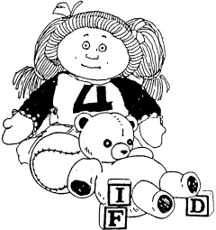

CHILD CARE HEALTH PROGRAM
Public Health – Seattle & King County
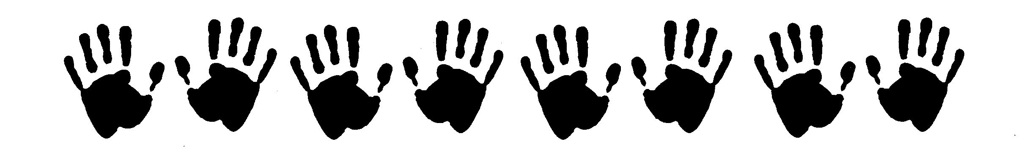


Cleaning Toys is Important!

Germs can be easily spread among children as they share toys. Choose washable toys whenever possible. Cleaning and disinfecting toys helps to prevent the spread of communicable disease in a child care setting. We recommend cleaning and disinfecting toys daily.

Washing toys is an IMPORTANT FIRST STEP

Washing toys thoroughly with soap or detergent removes most dirt, grime, and saliva. It is the most important step in cleaning toys.
Washing toys removes some, but not all of the germs. Disinfecting toys is a second important step in cleaning toys. It is important to wash toys before disinfecting them as the disinfectant kills germs more easily on surfaces that are not covered with dirt and grime.
Disinfecting is
the Second Cleaning Step

To disinfect means to remove or kill most of the germs on an object or toy. We recommend the use of household chlorine bleach for disinfecting toys after they have been washed.
When used and stored properly, chlorine bleach solution is safe and effective. Store chlorine bleach in its original container out of the reach of children.
Chlorine evaporates off the toys so no residue remains. Mix a fresh solution each day. This insures that it maintains the desired proportion: ¼ teaspoon of chlorine bleach to 1 quart cool water. Dispose of the solution at the end of each day. An example of the safety and effectiveness of chlorine as a sanitizer/disinfectant is its widespread use as a disinfectant in swimming pools.

NOTE: Do not mix chlorine bleach with other cleansers or chemicals. Mixing chlorine with ammonia will cause dangerous fumes. Only mix chlorine bleach with cool, fresh water.
Recommended procedures

As toys become dirty during the day, collect them in separate containers: one for cloth and stuffed toys, one for wood and plastic toys, etc. Sorting the toys ahead of time will make it easier to wash and disinfect them. At the end of the day, or at a specified time, such as naptime, wash and disinfect the toys. You can use a washing machine, dishwasher, or wash them by hand.

Washing toys by hand:
- Wash and scrub each toy with HOT water and soap or detergent.
- Rinse well.
- Disinfect each toy with a solution of ¼ teaspoon chlorine bleach to 1 quart of cool water. Dip the toys in solution. Allow toys to dry completely, such as overnight. You may want to wear household rubber gloves to prevent the soap, water, and bleach solution from drying out your skin.



