QPix Colony Picker Users Protocol
(New Software/XT)

Version Number: 2.3
Production Start Date: 02/06/03
Version 2.3 Date: 7/06/05
Authors: Danielle Mihalkanin, Steven Wilson,
Tijana Glavina
Reviewed/Revised by: Christine Naca, Cailyn Spurrell

Summary
This protocol describes the operation and maintenance of the Qpix2 and Qpix 2 XT instruments by a QPix operator using the JGI custom software. The QPix instrument picks bacterial colonies from large bioassay trays and inoculates them into 384-well NUNC plates containing LB broth with 7.5% glycerol in preparation for rolling circle amplification and fosmid processing.

Materials & Reagents

Materials/Reagents/Equipment  Disposables  384-well NUNC plate  15-ml Centrifuge Tube  1.5/2.0-ml Centrifuge Tubes  LTS Pipette Tips (1000μl)  Reagents  Chloramphenicol (98%)  Kanamycin Sulfate  Ampicillin  LB Broth with 7.5% Glycerol  95% Ethanol (190 Proof)  Milli-Q Water  Equipment  QPix  Single-channel Pipette (1000μl) | Vendor  Applied Scientific  Corning/VWR  Eppendorf  Rainin  Aldrich  Fisher Biotech  Roche  Teknova  AAPER Alcohol (LBNL)  Millipore Milli-Q System  Genetix  Rainin | Stock Number  QH-6431  -  -  -  857440-25G  BP906-5  835269  L8075  6810-46175  -  -  -

EH&S
JGI employee performing this procedure must wear a lab coat and gloves. In situation were there might be a chance of an accidental splash to the eyes, safety glasses must be worn.

Calibration Check
The QPix requires daily calibration and alignment. The QPix should be checked for calibration and alignment each time a new operator takes over, when QPix head is changed, when switching to a different library that has a different colony size, and from bioassay to bioassay as needed. Follow steps 2.1-2.4 as outlined within the main body of the procedure.

QPix Operator Training
QPix operator training should follow the Production Training Protocol. A production technician is not allowed to operate any QPix instrument without first being trained and certified by the trainer and supervisor.

Workflow
Getting started:
- Prepare LB glycerol plates by following the NUNC 384-well Plate with LB Glycerol Preparation SOP.
- Start up the QPix according to this procedure.
- Evaluate sterility test plates according to the QPix Sterility SOP and if the sterility shows positive growth, send an email the report to the Library Support and QC supervisor. The sterility plates are visually checked before the run starts and OD readings are taken and recorded into database at the end of the day.
- Depending on the schedule for performing the Qpix Sterility SOP, sterility plates will be created as the first plates of a shift following Qpix startup, or as the last plates of the shift before Qpix shutdown.
- Check the incubation incubators in Rm139 to remove plates whose incubation times are completed and put them in the 3-door deli of Rm147, where unpicked plates are kept. Examine the plates and look for anything irregular, such as large colonies, discolored colonies, and colony smearing due to liquid, or other irregular growths. Fail any irregular bioassays in the database following step 4 of the procedure. Select fail plate in the picking queue.

During QPix operation:
- Check picking accuracy on bioassay tray while picking sterility check plates to determine any adjustments that need to be made to the camera calibration.
- QPix operation according to the following protocol. The priority is to keep the QPix’s running throughout the entire shift. The following things can be done while they are running.
- Unpicked bioassays are removed from the 4°C deli and separated out by library on the middle table in preparation of being picked. They usually come already organized by library from the plating step.
Important! Only individual libraries with their destination 384-well plates go to each picker.
- Every destination plate coming off of the QPix should be covered with a lid. The top lid on each stack should be labeled with the library name and QPix number.
- As needed, more LB glycerol destination plates can be prepared in parallel with operating the Qpixs.
- On close to an hourly basis, approximately 10-15 plates at a time, the libraries that have been picked should be entered into the database and have barcodes printed up. As work continues, one barcode should be placed on the top right corner of the lid and the other barcode on the side of plate opposite of where letters are located.
- Picked bioassays go onto the cart. Towards the end of each shift, bioassays are placed into a, 2-door picked-deli in Rm139 for storage.
- Disposal of picked bioassays: Picked bioassays are saved for 2 days. The Autoclave person comes daily and packages the picked bioassays for autoclaving and disposal. Special libraries that need to be saved are taped with a note “SAVE” on them so they do not get disposed until supervisor approval.
Randomizing Bioassays:
  - Distribute libraries evenly among all QPix instruments.
  - When there is a minimum of 10 bioassays for one library, the library should be picked on multiple QPix instruments.
  - Example:
    - If there are 10 bioassays of ASYA pick 5 bioassays on QPix 2 and 5 bioassays on QPix 5.
    - If there are 40 bioassays of AZYH pick 10 bioassays on QPix 2,3,4, and 5.
  - Preventing multiple fix sources.
    - When imaging a bioassay, the QPix software will generate the number of 384 well NUNC plates it can inoculate into for the operator.
    - The number of FULL 384 well NUNC plates is known prior to picking the bioassay; in order to reduce the number of ‘Fix Sources’, when picking the same library on multiple QPix instruments, inoculate into only FULL 384 well plates on all but one QPix instrument. This will result in partial bioassays with Pickable colonies from those instruments.
    - Use one QPix instrument to partially pick the remaining bioassays to control the number of fix sources.

Finishing up:
- QPix shut down should follow the QPix operation procedure for how to shut the instrument down. Depending on the shift, the shutdown procedures are slightly different.
- Dispose of ethanol in large red hazardous waste containers only (SAA waste). This needs to be done during a shift change.
- Check and empty, if necessary, autoclave waste receptacles.

Procedure
NOTE: All reagents/stock solutions should be prepared prior to the start of the procedure.

- QPix Setup
  - Wipe down center table, Qpix stations, and white destination trays with 70% EtOH.
  - Power on the QPix by turning the red lever on the right side of the picker from a horizontal to a vertical position (QPix 1, 3, 4 & 5) and from a vertical to a horizontal position for QPix 2.
NOTE: If e-stops are still engaged, twist (for Qpix 3-5) or pull out (for Qpix 2) to disengage before turning the red lever.
  - Press the red button marked reset on the front of the QPix.
  - Turn on the computer if it does not boot up automatically.
  - Login using username/password on monitor.
  - Launch the software program from the QPix desktop icon.
  - Select the blue bulb icon on the main software page and run the UV light for 15 min on Qpix 2-5.
  - Using 70% EtOH wipe down all internal surfaces of the picking bed except the light tray and inside of door.
  - To install the picking head and perform pin firing test:
    - Click on the diagnostics icon (the hammer/screwdriver icon on the toolbar at the top of the QPix 2, 3, 4 and 5 software window or the diagnostics button on the toolbar at the bottom of the QPix 1 software window).
    - On the Diagnostics screen, move the cursor above the picking bed, right click, and select move actuator to from the dropdown menu that appears.
NOTE: This moves the actuator to an accessible position for installing the picking head. You can click to deselect slow motion at the top of the diagnostic screen prior to moving the actuator head.
    - Prior to installing the picking head, thoroughly inspect the head to make sure there are no bent pins in both x and y directions or that there is residue on the pins.
    - Make sure to load each designated head on the appropriate QPix machine. For example, QPix 1 head should only be installed on QPix 1 and so on for all 5 machines.
    - Open the Qpix door and insert the picking head into the actuator from the right side.
    - Secure the head in the actuator by inserting the thumbscrew into the hole on the left side of the actuator and tightening.
NOTE: Hand tight is sufficient. Do not over tighten the thumbscrew. Check that there is no movement of picking head after installation.
    - While still in the Diagnostics screen, move the picking ahead above the light tray and where it is clear of all obstacles following 1.8.b.
    - While still in the Diagnostics screen, click on the pin firing test bar. Watch the pins through two full cycles.
    - While they are firing, watch for broken springs (indicated when pin doesn’t fire to full depth and/or doesn’t completely retract into the head), or evidence that air pressure settings are off (indicated when more than one pin fires at a time and/or whole rows lightly fire during test).
    - For a bad spring, replace picking head, and repeat step 1.8 entirely. If the air pressure settings are off, submit a work request and do not proceed with picking. You can also call an instrumentation specialist to replace a broken pin if one is available.
    - Right click anywhere on the image and select Home Drives to bring the head back to the home position.
    - Exit the Diagnostics screen.
  - Prepare the ethanol bath for picking:
    - Insert the scrub brushes into the rectangular metal well and place the well into the middle well position on the right side of the picking bed.
    - Fill the well with 70% ethanol so the level of the liquid just covers the top of the brushes.
    - Check the ethanol level during after each bioassay is picked and add 95% ethanol if the liquid level drops below the brush tips.
    - At the end of one shift, the 70% ethanol is replaced with fresh 70% Ethanol on all 4 machines. Dispose of EtOH in red hazardous waste container located in picking room.

- Qpix Calibration and Sterility:
  - Plates being imaged and picked should be checked for accurate picking constantly. After the plate is initially imaged, start the picking process and observe the performance of the machine briefly. If you notice the QPix is not accurately picking colonies, stop the machine and align and calibrate, as needed. Refer to the Troubleshooting section of this procedure to assist with determining if picking is inaccurate and which calibration procedure to perform it if is needed.
  - Setting the threshold (background):
    - Place a bioassay tray onto the bioassay tray holder.
    - Perform a test image on image region 18 by selecting the Test Image button (the “T” inside a circle icon on the toolbar at the top of the QPix 2, 3, 4 and 5 software window or the Test Image button on the toolbar at the bottom of the QPix 1 software window).
    - Select the Tools button at the bottom of the image screen.
    - Click the Threshold tab.
    - Find the green histogram in the middle of the window (Refer to Figure 5 in the Appendix).
    - Zoom in on the histogram and find the part on the right side of the histogram between the two peaks (Refer to Figure 5c).
    - Press the right mouse button at the location described in step 2.2.f to set the upper-bound centre frame value.
    - Find the part on the left side of the histogram where the line begins to flatten out (Refer to Figure 5a).
    - Press the left mouse button at the location described in step 2.2.h to set the lower-bound centre frame value.
NOTE: The numbers selected in step 2.2.g and 2.2.i select a range of values that section of the large peak of the histogram. This large peak represents the agar that the colonies grow on. The colony picker software uses these values to ‘ignore’ the agar. Anything outside of the agar (lighter gray or darker gray) is determined to be a colony.
    - Click the down arrow next to the lower-bound centre frame number 4 to 5 times. (Refer to Figure 4, #3). (Manual Alt)
NOTE: This will allow the low range to be set properly for image regions near the outside of the plate.
    - Set the Blue Threshold by selecting a value between the apex of the histogram and the left edge of the histogram (Refer to Figure 5b).
NOTE: This value tells the software that any circular object (presumably a colony) with a gray value lower than this (the blue threshold) is a blue colony and should not be picked. It has the proximity rules applied to it so that good colonies near this one will not be picked either.
    - Press OK to ensure that your changes have been saved.
      - Check hist or text box.
    - Reprocess the image to see your changes take effect.
    - Press the Tools button again and make sure the values are set properly.
    - If the values are incorrect set them again and press OK. If they are okay, select OK.
    - Press DONE on the test image screen.
    - Do a test image in a corner region (1, 5, 31 or 35):
      - View the threshold settings (Tools → Threshold → View threshold).
      - If there is a significant portion of the image that cannot be viewed because the white pixels are creeping in from the left and/or right, lower the low value of the center frame. This should cause the white portions to disappear. (See Figure 9)
  - Lens calibration:
    - Examine the plate to be imaged for cracks and topographical differences.
    - Press the Calibrate Camera or Calibrate Camera (Tray 1) or Calibrate Camera (Tray 2) button on the main screen to begin the calibration procedure.
    - The Qpix will automatically scan through five test regions and display the Pixels per MM X, Pixels per MM Y, and the Aspect ratio for each region.
NOTE: If calibration fails to find a suitable colony in a region, user intervention is required for the calibration to proceed onto the next regions. Press OK for calibration to proceed.
    - Determine which values are acceptable and check or uncheck the boxes appropriately so that they best match the desired aspect ratio.
    - Select OK.
    - If calibrating tray 1, a window will appear, asking if the current calibration values should be used for tray 1 and tray 2.
      - Press Yes if the new values should be used for both trays
      - Press No if different values should be generated for tray 2.
Camera Calibration Value Ranges (350mL agar tray):

 | QPix1 | QPix2 | QPix3 | QPix4 | QPix5
Min Pixels/mm X |  | 11.6 | 11.45 | 11.51 | 12.25
Max Pixels/mm X |  | 11.95 | 11.83 | 11.93 | 12.60
Avg. Pixels/mm X |  | 11.79 | 11.63 | 11.71 | 12.43
Min Pixels/mm Y |  | 11.61 | 11.70 | 11.59 | 12.46
Max Pixels/mm Y |  | 11.95 | 12.06 | 11.97 | 12.81
Avg. Pixels/mm Y |  | 11.76 | 11.89 | 11.76 | 12.63
Avg. Aspect Ratio | 0.94 | 1.00 | 0.98 | 0.99 | 0.98

These calibration ranges are valid for a bioassay tray filled with 350mL of agar. These ranges, although only representing fractions of a pixel, can have a great effect on picking accuracy. A change in ¼ of a pixel per mm can change the picking accuracy of some colonies by 0.3mm (this is almost 1/3 of the diameter of many of the colonies that are picked by the instrument). If repeated calibration results in values that fall outside of the normal ranges, there may be something particular about the plate you can see (higher/lower fill volume, slanted agar, etc.), but reproducibility in calibration values indicates that the camera is seeing the plate properly.

  - Camera Alignment: Camera alignment should be performed using the makeshift tray with Styrofoam in the middle, and a black sticker attached to the top of the foam.
    - Place the tray on the picking bed.
    - Select the Align Camera button on the run screen.
    - Make sure that region 18 is highlighted, click on CONTINUE.
    - The red crosshairs should be centered within the visible picked hole for accurate camera alignment. Refer to Figure 1 in the Appendix. If they are off center, use the arrow key to align in the center of the hole.
NOTE: Refer to page 22 of the Genetix:QPix manual located on the shelves for further alignment and calibration instructions.
  - Perform the picking sterility test according to the Q-pix Sterility (New Software) SOP.

- Checking Main Screen Defaults:
  - Select the setup screen tab on the main screen of the custom software.
  - The defaults should be checked at the beginning of the shift and periodically throughout the shift. Refer to Figure 2 in the Appendix.

- Scanning bioassay plates into the database
NOTE: For QPix 1, you will have to use the switchbox located between the computer and the QPix to switch between the network and the QPix whenever doing database work.
  - Each operator must log onto the database with his or her own username whenever there is a shift change.
  - In the Venonat database (http://venonat.jgi-psf.org/psf/PSF.home), click on Libraries DB → select Picking Queue → on the Select Libraries for Plating page, choose the appropriate QPix and Library.
  - Click on SUBMIT.
  - Remove the bioassay plates from the deli, and place them next to the Qpix that will pick them.
NOTE: Do not put more than one library at a Qpix table at the same time.
  - For each QPix run on a particular bioassay plate, scan in the bioassay’s barcode into the Picking Queue.

- QPix Run
NOTE 1: Depending on the library, fix sources should be created. Fix sources are extra colonies that are needed to fixing no growth wells later on. For whole genome libraries, create fix sources on a as-needed basis in order to preserve colonies. For BAC libraries, pick 1 fix source per library.
NOTE 2: You can pick 1-2 quadrants instead of the entire plate.
  - Loading destination plates Qpix-2 only:
    - Set the Max. Plates variable to the desired number of output plates.
NOTE: The maximum that can be set up on the deck in one run is 15 destination plates. It is acceptable to set the Max. Plates number higher than the number necessary because the picker will indicate which plates it has inoculated.
    - Load the destination plates starting with the front right position and fill the column before moving onto next column.
    - Load plates with well A1 oriented towards the front right corner. The plates must be snug in the corner to avoid picking head crashes and damaged head and picking pins.
  - Loading destination plates Qpix-2 XT only:
NOTE: Throughout the shift load plates into the in-stacks as needed.
    - Set the Max. Plates variable to the desired number of output plates.
NOTE: The maximum number of plates that can be loaded into each stacker is 25 destination plates. It is acceptable to set the Max. Plates number higher than the number necessary because the completed plates will automatically be placed in the out-stack and the Qpix will indicate which plate it has completed.
    - Load a stack of destination plates into both source stackers by placing the stack of plates with lids on the bench and placing the stacker over it.
    - Lift plates past white plate locks to ensure that they are securely sitting within the stacker.
    - Load stacker with proper A1 well orientation as indicated on the stacker base.
  - Check to make sure that the plexi-glass is clean on the picking bed (If it is not, use an optically clear cleaning solution and a soft rag to clean it off).
  - Wipe the underside of the bioassay plate that is to be picked with a paper towel and remove the lid of the plate.
  - Place the both bioassay plates snuggly onto the picking bed with the barcode toward the back of the machine. If the plates are loose they will likely shift during the run and cause inaccurate picking. To make them tighter, adjust the plate positioners. For the Qpix 2 they are in the back-left corner. For the Qpix 2 XT they are in the front corners.
  - Once source and destination plates are properly placed in the Qpix, click on the Start Full Run button on the bottom toolbar to image the plates.
NOTE: The Start Partial Run button may be selected to image only one bioassay tray or certain regions of each plate. For example, in order to exclude abnormal regions of the bioassays (too many satellites or smearing instead of individual colonies), certain regions may need to be eliminated to maintain picking quality or for a bioassays that has previously been partially picked.
  - Watch the computer monitor while the QPix is imaging to ensure that each area of the bioassay trays are being processed correctly.
  - Image data will automatically be displayed.
  - Before any adjustments are made to the image, region 18 (the center of the bioassay) must be selected. Sometimes after changes have been made, it is necessary to reselect region 18 in order to view the changes and make further changes.
  - To view picking criteria and threshold settings, click on the TOOLS menu.
  - Tips for adjusting the criteria (Refer to Figures 3 in the Appendix):
NOTE 1: This is also done during the calibration of the Qpix to make sure values are within an acceptable range.
NOTE 2: In general, the size and shape parameters do not need to be changed very often.
    - Diameter, Roundness, Axis Ratio, Proximity: The operator can adjust these criteria according to the chart below to optimize the pickable colony counts for specific plates. Settings for plates within the same library usually remain the same.

Settings Chart (Updated 7/28/04)
 | Project Type |  | Unlimited DNA |  |  |  |  |  |  | Limited DNA
 | Colony Size |  | Normal/Small |  |  | Large Colonies |  |  |  | Any
 | Plating Spread |  | Sparse | Good | Dense | Sparse | Good | Dense |  | Any
Settings | minDiam (Include) |  | 4 | 6 | 6 | 7 | 7 | 7 |  | 4
Settings | maxDiam (Include) |  | 20 | 20 | 15 | 25 | 25 | 20 |  | 20
Settings | axisRatio (Include) |  | 0.6 | 0.65 | 0.75 | 0.75 | 0.75 | 0.75 |  | 0.6
Settings | Roundness |  | 0.6 | 0.65 | 0.75 | 0.75 | 0.75 | 0.75 |  | 0.6
Settings | Proximity |  | 4 | 7 | 7 | 4 | 7 | 7 |  | 4
Settings | maxDiam (Blobs) |  | 4 | 1 | 1 | 4 | 4 | 4 |  | 4
Settings | axisRatio (Blobs) |  | 0.25 | 0.1 | 0.1 | 0.1 | 0.1 | 0.01 |  | 0.15
Colony Property/Count | Colony radius of good colonies (mm) |  | >=1 | ~1 | <1 | >>>1 | >>1 | >1 |  | Any
Colony Property/Count | Colony Count w/ Normal Size-Good Spread Settings |  | <800 | 800-1500 | >1500 | <800 | 800-1200 | >1200 |  | Any

Definitions:
Diameter – The diameter of a colony (in pixels)
Roundness – A comparison of the ideal circumference of a colony (based on the calculated radius) and the actual circumference (in pixels)
Axis ratio – A comparison of the x-axis radius and the y-axis radius of a colony. A perfect circle has an axis ratio of 1.
Proximity – The closeness of one colony to another.

NOTE: Delete Blobs are checked before the Include Colonies criteria. Any colony that does not meet the minimum requirements of the Delete Blobs will not even be processed as a bad colony.
NOTE: Changing the settings outside of the ones specified above will alter the manner in which the image is processed. Please see the Troubleshooting section “Changing the Criteria” for more information.
a. Other areas highlighted in red are defaults and should not be changed by operator.
  - Tips for adjusting the threshold (Refer to Figures 4-9 in the Appendix and “How does the imaging software work” in Troubleshooting): Transfer section somewhere into here from the troubleshooting section; Depending on performance of XT, may need to use Automatic Thresholding.
    - Zoom in on the threshold histogram to assist in selecting the Upper Center Frame Threshold. Right click between the tall peak on the left and the small hump on the right.
NOTE: Threshold values can vary from plate to plate yet they tend to be consistent within libraries.
    - Upper center frame threshold: Place the cursor and right click on the upper center frame value on the right corner of the histogram.
NOTE: An alternative method to adjusting the upper center frame threshold: Start with Upper Center Frame = Blue Threshold value. Adjust the Center Frame to remove the exposure creep from sides of image (Refer to Figure 7 in the Appendix).
    - Lower center frame threshold: Left click on the left side of the green histogram to set the lower center frame threshold. Then, use the down button to manually adjust the value down 7-8 more units – i.e., if the left side of the histogram is 137, set the value to ~130)
    - Blue threshold: This should be used at all times to prevent the picking of blue colonies. In general, the value for the blue threshold is few units above the left corner value of the histogram (e.g. The left side of the histogram is 137, set value at ~140).
    - When comparing threshold values, make sure that the number of pickable colonies being compared is for an entire bioassay plate since the QPix images different regions of the plate differently. The pre-set “Threshold correction values” should compensate for imaging variance on the bioassays.
  - After settings have been changed, select Re-Process so that these new settings are applied to all 70 images. This can either be done by selecting Re-Process in the Image Tools window, or by selecting OK followed by Re-Process from the main imaging window.
  - Depending on the pickable colony counts, it may be necessary to enter the Tools menu multiple times.
NOTE: Ultimately, trying a few different values and then selecting the values that result with the highest number of pickable colonies without sacrificing picking quality are the best settings for any given bioassay.
  - When the settings have been adjusted and everything is ready for picking to begin, select DONE.
  - While the QPix is picking, record the number of pickable colonies for both bioassay plates in the Picking Queue field for colony count.
  - After both plates have been picked, a dialogue box will alert you to the completion. From here, another box appears and prompts the user whether to keep the plate and position settings.
    - If this was the last bioassay plate picked for a library, select NO.
    - If there are more bioassay plates to be picked for a library, select YES.
NOTE: This will allow the imaging of the next bioassay plate to begin where picking just left off or for you to know which one was the last plate inoculated and how many wells were inoculated. If you forget to click on YES, refer to the Troubleshooting section.
  - Remove the picked bioassay plates from the light tray and inspect them for the quality of picking. Refer to the troubleshooting section for guidance with how to deal with inaccurate picking. It may be necessary to perform one or more calibrations. If picking accuracy was acceptable, then proceed.
  - If there are more bioassay plates to be picked, scan in the next bioassay plates into the Picking Queue and repeat steps 5.1 – 5.19 until the completion of the shift.
  - Destination barcodes:
    - On close to an hourly basis, approximately 10-15 plates at a time or if all of the bioassays of a particular library have been picked and this is less than 15 plates, go to the Picking Queue and enter in the number of 384-well plates picked and the number of fix sources.
    - Select pick time, LB lot, dispense instrument, and antibiotic lot from a list of drop-down menus at the top of the page.
    - Click on SUBMIT.
    - Print out the barcodes.
  - Removing destination plates Q-Pix 2 XT only:
    - Lift each out-stack out of the stacker base and place it on the lab bench.
    - Remove the plates from the stackers by lifting the plates out of the top of the stacker.
    - Number each of the plates from out-stack 1 with odd numbers according to the range that was previously picked, and number each of the plates from out-stack 2 with even numbers beginning from the top plate of each stack.
    - Re-stack the plates alternating between out-stack 1 and out-stack 2 in the order that they were created.
  - Affix one barcode to the 384-well plate on the side opposite the letters and one to the lid in the top right corner.
  - Associate destination barcodes destination barcodes with dispense batch:
    - In the Venonat database (http://venonat.jgi-psf.org/psf/PSF.home), click on Libraries DB → select Dispense Batch Form.
    - Select the daily dispense batch # and the dispense operator from the drop-down menus and scan all plates from that batch into the fields below.
    - Select Submit.
    - Repeat as needed for scanning additional plates into other batches.
  - As trays are full with 9 stacks of 5 plates, place the 384-well plates in the 37ºC “Destination Plates” incubators in Rm139 and label the white tray and the outside of the incubator: in-time/date and when they will come out. The destination plates should be incubated for 18 hours at 37ºC.
  - Shift changes:
    - Between shifts, continue picking bioassays into 384-well destination plates until a half of an hour before the end of the shift.
    - Clear off all bioassays and destination plates from picker and computer table.
    - Log off of Venonat.
    - Empty ethanol sterilization bath at each shift change.
    - Turn the UV light on for 15 minutes.
    - For the last shift of the day, stop picking 1 hour prior to end of the shift in order to have enough time to perform the required shutdown procedure.

- Shutting down:

  - Perform the picking sterility test according to the Q-pix Sterility (New Software) SOP.
  - Remove the ethanol sterilization bath and pour the remaining ethanol into the large red hazardous waste container. Remove the brush and rinse it with ethanol and remove any debris. For both the Qpix 2 and Qpix 2 XT, place bath and brush in a location that they will not interfere with the actuator.
    - If there is a layer of debris on the interior of the wash station, rinse the wash station with hot water until debris is gone.
    - Rinse wash station with 95% ethanol when done. Place wash station and brush pad in a location on deck where they will not interfere with the actuator.
  - Enter the Diagnostic screen and position the actuator towards the center of the picking bed (Refer to steps 1.5.a –1.5.b).
  - Remove the picking head by loosening the screw to the left of the head and sliding the head out of the actuator while taking care to ensure that is does not drop. Place the head on the bed with the pins facing upward in a location that does not interfere with the actuator.
Important! Do not place your hand under the picking pins.
  - Close the front door and click on UV light icon (the blue light bulb icon on the toolbar at the top of the QPix 2-5 software window).
  - Allow the UV light to be on for 30 minutes if you are the last operator for the day.
  - If the QPix’s need to be turned off for the night:
    - When the UV light is done, select DONE in the bottom right side of the QPix software’s window to exit the program.
    - Once the program has been closed, shut down the computer.
    - After the computer has been given adequate time to shut down the QPix by gently pressing the red E-Stop button on the front of the machine.
    - Return the EStop button to its default position after instrument has powered down (this usually takes 2 or 3 seconds for amplifiers and drivers to discharge).
      - EStop buttons on Qpixes 2,3 and 4 should be rotated counterclockwise to release EStop.
      - EStop on QPix 5 should be pulled straight out to release EStop.

Reagent/Stock Preparation

70% Ethanol

    - Pour 1,474ml of 95% ethanol to a 2-L graduated cylinder.
    - Add 526ml Milli-Q water to bring the volume up to 2L.
    - Transfer the mixture to a 2-Lglass bottle and mix the solution by inverting the bottle several times.
    - Label: 70% Ethanol, date, and your initials.

Instrument Preventative Maintenance

QPix Preventative Maintenance:
Each QPix undergoes a preventative maintenance once per month. Refer to the QPix Preventative Maintenance SOP for more detail.

QPix Picking Head:
- Cleaning: The picking pins must be sonicated after 1 week of picking use. When a work request is submitted, an instrumentation technician will clean the picking heads according to the Head Cleaning SOP.
- Spring/Pin: For periodic spring/pin failure, the QPix operator needs to replace an entire head and submit a work request for the other head to be fixed and cleaned prior to use.

QPix Sterility Test:
Sterility tests should be run on any machine that undergoes preventative maintenance, change of mechanical parts, or any other mechanical problem. The machine should not be run until the test is completed and passes the criteria established for the pickers. When the sterility test fails, notify production supervisors.
QPix room cleaning – Ethanol Wipedown:
The QPix, computer, and center tables should be wiped down after picking has been completed and destination plates have been placed in the incubators. Wipe down with 10% bleach followed by 70% Ethanol.

Service Agreement:
According to the Genetix service agreement, each QPix receives preventative maintenance servicing from the field service engineer every six months. The service agreement includes parts and labor for machine related failures.

Troubleshooting & Information
If the plate and position settings are not carried over to the next bioassay plate and you need to determine which pin and quadrant to start picking with on the next bioassay plate, do the following steps.
In the QPix software window, go to the VIEW menu → select LOGS → open the date/time of the last run → scroll down to the last plate picked → scroll down to the last quadrant → scroll down to the last picking pin → calculate what the next pin will be and enter in the values for the plate, quadrant (well offset), and pin into the software’s Picking Setup window.

If many colonies are being ignored by software, check the thresholding:
Setting the threshold for a QPix allows the software to accurately decide where the edge of a colony is (Refer to Figure 6). If the colony is too big (upper threshold set too high) the colony picker may think the center of the colony is somewhere outside the actual perimeter of the colony (Refer to Figure 7). If the colony is too small (upper threshold set too low) the software may instruct the pin to pick at the edge of the colony because there were not enough data points to make an appropriate calculation of the centroid (Refer to Figure 8).

The lower center frame value should be set a few digits to the left of the peak (Refer to ‘a’ in Figure 5). If the lower center frame value is set too high (Refer to Figure 9) colonies can be excluded. The value in region 18 (the center frame) needs to be set to the left of the peak region to account for edge effects that occur at the edge of the plate. It is possible that the proper setting in 18 can create bad images in border regions.

This is one step in accounting for differences in agar depth, topographical differences and concentration.

If colonies are being picked erratically to all sides:
Calibrating the camera allows the mechanical aspects of the machine to come in line with the digital imaging. Calibration must be done after the threshold is set properly.

Calibration generates 3 numbers: pixels to mm ratio for the X-axis, a pixel to mm ratio for the Y-axis and an aspect ratio (pixels to mm X divided by pixels to mm Y). The pixels to mm ratios are extremely important, as they are the basis for movement in each of the 35 image regions. For each pixel the software sees in an image, it tells the motor to move the actuator a certain fraction of a millimeter in the X or Y-axis. These values will change according to how high the agar is because a taller agar will move the colonies closer and generate a larger pixels to mm ratio – that is, it will take more pixels to show a colony that is closer than one that is far away (think artistic perspective).

Since the software does not allow these numbers to be generated for each individual region (which would be the most accurate way to do it, although time consuming) finding the most representative set of numbers is the best way to calibrate the camera for an entire plate.

If the calibration is not correct for a given plate, the user will notice some areas of the plate looking like they are picking perfectly while in other areas picking is off to the left, right, top or bottom. If a plate is examined, the user should find picking off in all directions.

If colonies are being picked consistently to one side:
Ensure that the camera is aligned to pin A1 properly.
Aligning the camera to pin A1 creates an offset for the entire picking head. This offset will be used for all 96 picking pins.

If calibration and alignment do not help:
In the cases that aligning and calibrating the camera do not affect the picking accuracy, the instrument may need to be reset, the head or camera may not be level to the deck or the alignment rubber may be uneven – this can be shifted or replaced.
Operators can power cycle the instrument by shutting down the picking software, shut down the computer and then use the E-Stop button to turn off the instrument. Let the instrument rest for at least 30 seconds (this allows some of the components to release stored charge) and then power it back on. Allowing the instrument to sit for more time with the power off can let more components cool
Spare bits of rubber should be located near the alignment stickers. If there are none, inform instrumentation.
The instrumentation group should be contacted in order to evaluate the levelness of the head or camera.

How does the imaging software work?

The upper center frame threshold value (‘x’) is the first number that is used to process the image. This value is used to determine what the black and white image will look like. Any pixel that is determined to have a gray level value that is greater than ‘x’ is determined to be white (a possible colony). The lower center frame value (‘y’) is then used to determine what is a dark (blue) colony. Any colony that has a gray level value than ‘y’ is determined to be a blue colony. It will not be picked, but it should not be ignored. Anything between ‘x’ and ‘y’ is determined to be background (agar) and is made black.

The delete blobs section of the criteria is the second set of values that are used to process the image. First up for examination is the diameter of the colony. If there is a white blob in the black/white image then its diameter is compared to the value specified in the delete blobs section of the window. Refer to Figure 3.
- If a colony has a diameter less than 4, for example, it will be assumed to be background noise and treated as if it were agar – i.e., there is no reason to ever want to pick it.
- If a colony has a diameter greater than 4, it goes into the pool of possibly good colonies.
This same type of comparison is done with the area value and the axis ratio value.

The colonies that have made it to the set of possibly good colonies are then checked against the ‘Include Colonies’ criteria. These are the min/max diameter, axis ratio, roundness, proximity, overlaps, etc. These colonies in the ‘possibly good’ set are the ones that receive colored circles during image processing. Each criteria has its own specific color associated with its failure mode – e.g., failing due to overlaps shows up as blue, failing for area might show up as red, failing because of the exclusion zone (outside the pickable area) may be purple.

Changing the imaging criteria:

There are consequences for changing the delete blobs values. For example (Refer to Figures 10 and 11), if a plate has many satellite colonies and the delete blobs diameter value is set to be very strict (1), all of these colonies will be seen, but not included as good ones if the Include colonies min diameter value is set to 6. Furthermore, any ‘good’ colonies that are directly next to the satellites may be ignored because of proximity. This is a good thing to have happen because satellites have the potential of contaminating ‘good’ colonies. If this same plate has its delete blobs diameter value set to 4 and the Include colonies min diameter value set to 6, many of those satellite colonies will be ignored as agar and ‘good’ colonies that would otherwise be discarded because of proximity will now be picked. This increases the risk of contamination between colonies.

SOP Approval
DEPARTMENT | APPROVED BY | DATE
Lab Supervisor
Research & Development
Instrumentation
QC
Purchasing
EH & S
Informatics
Seq Assessment & Analysis
Dept Head of Prod Seq

Appendix A
AUDIT TRACKING
3/17/05 – Damon Tighe and Cailyn Spurrell performed an audit between 6:05AM – 2:10PM. The operator was Sandy Huynh.

Appendix B

Figure 1. Camera Alignment with red crosshairs centered on the picked hole.

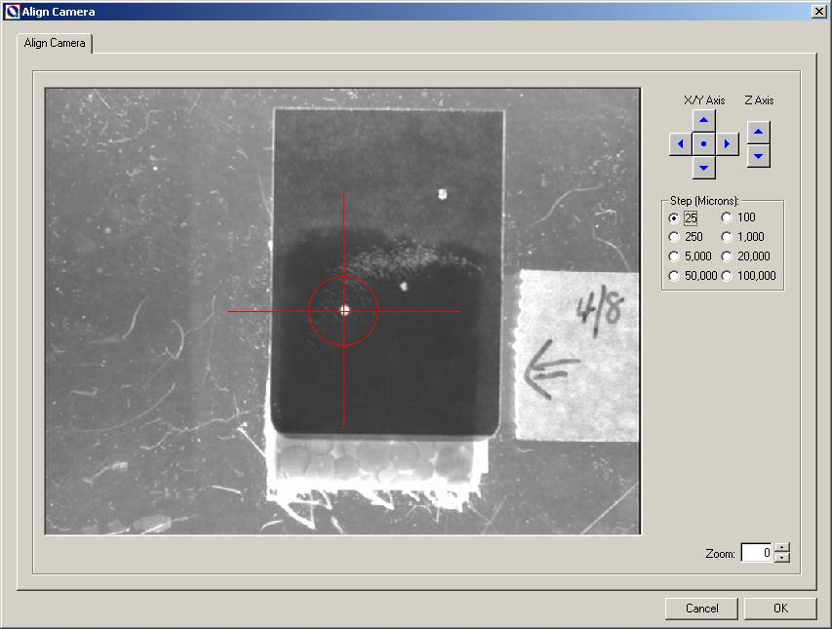

Figure 2. QPix Main Screen Tabs.

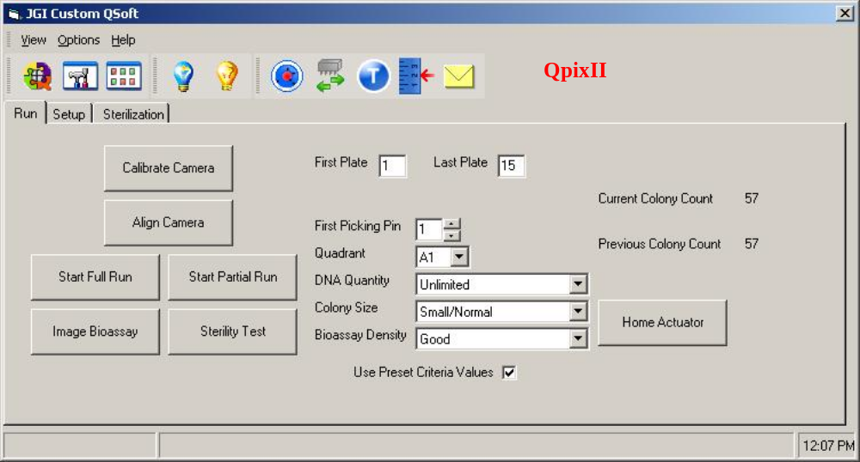

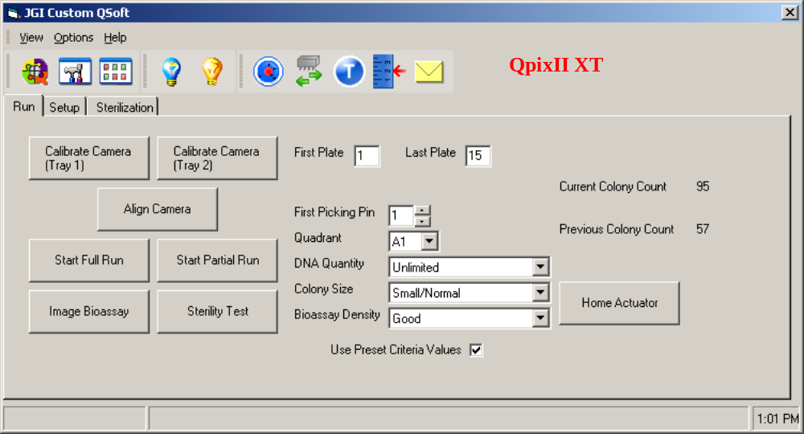

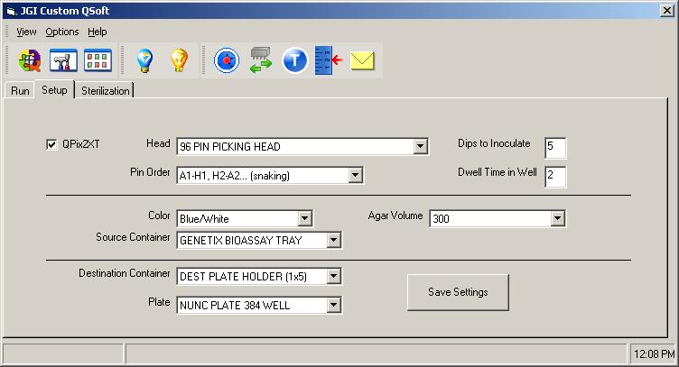

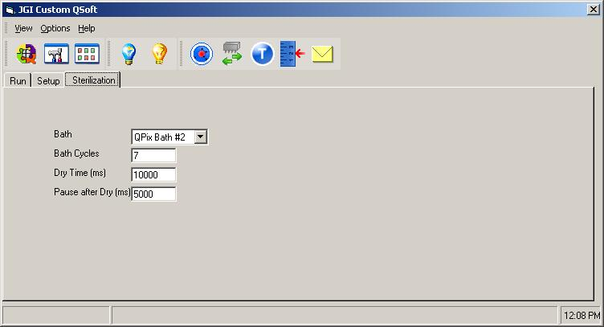

Figure 3. Criteria Diagram.

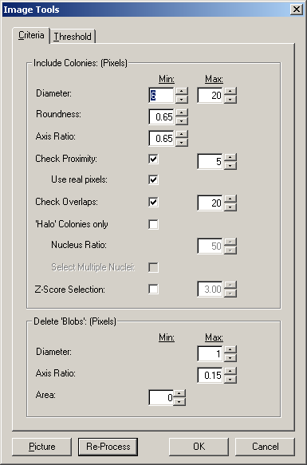
Nominal 6: 6,7
Nominal 0.67:
Can Lower to 0.6
Nominal 0.65:
Can Lower to 0.6
Nominal 6:
Range: 4 - 10
Nominal 4:
Range: 1 - 10
Nominal 0.25:
Range: 0.15-0.25

Figure 4. Threshold diagram.
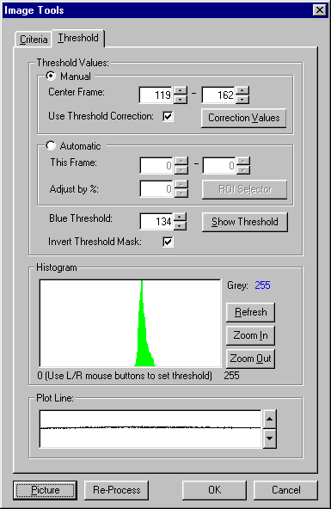
User Defined
150 - 165
User Defined
90 - 145
User Defined
100 - 130
Left Click
Right Click

1
3
2
4
5

Figure 5. Histogram - a) A good range for the lower center frame value, b) A good value for the Blue Threshold and c) A good value for the upper center frame value.
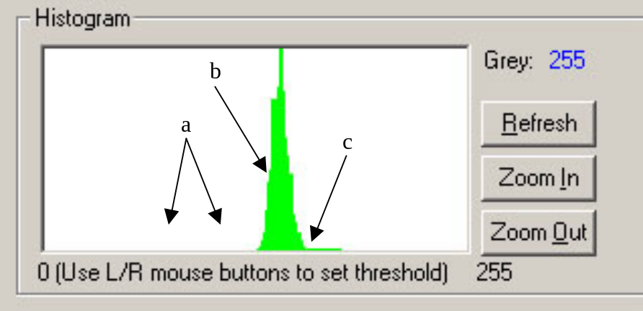

Figure 6. An example of a region with properly defined threshold values. Make sure to select region 18 to do this.
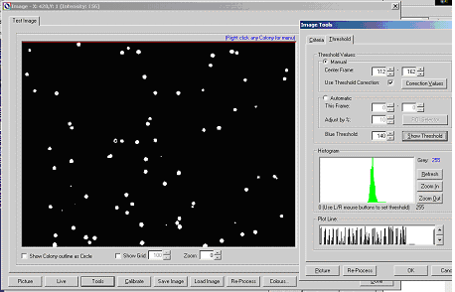

Figure 7. A region where the upper center frame value is too low (Colonies lost from top and bottom).
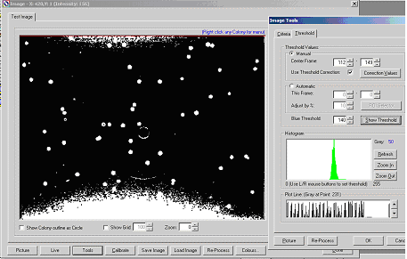

Figure 8. A region where the upper center frame value is too high (Colonies lost from the side).
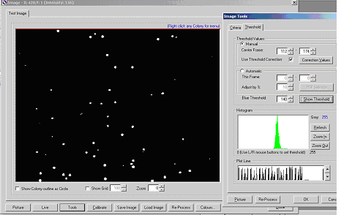

Figure 9. A region where the lower center frame value is too high (colonies lost from the sides).
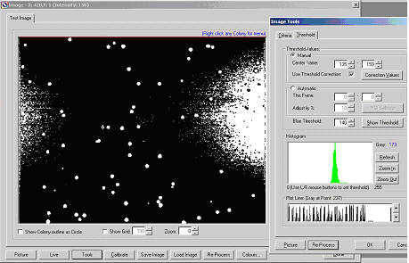

Figure 10. An image with loose criteria settings. Delete Blobs equals 4, 0.25. Compare to Figure 11.
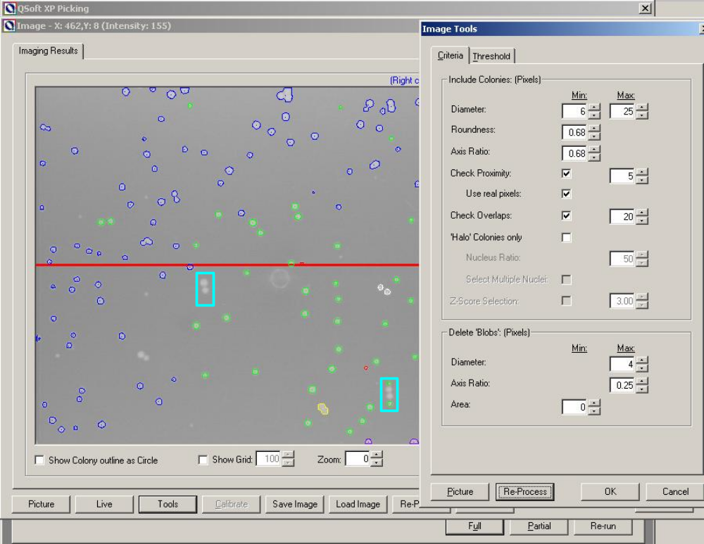
The imaging software does not process these colonies
The imaging software does not process the two colonies in the center, so the ones on the top and bottom are selected as good.
Figure 11. An image with strict criteria settings. Delete Blobs equals 1, 0.10. Compare to Figure 12.

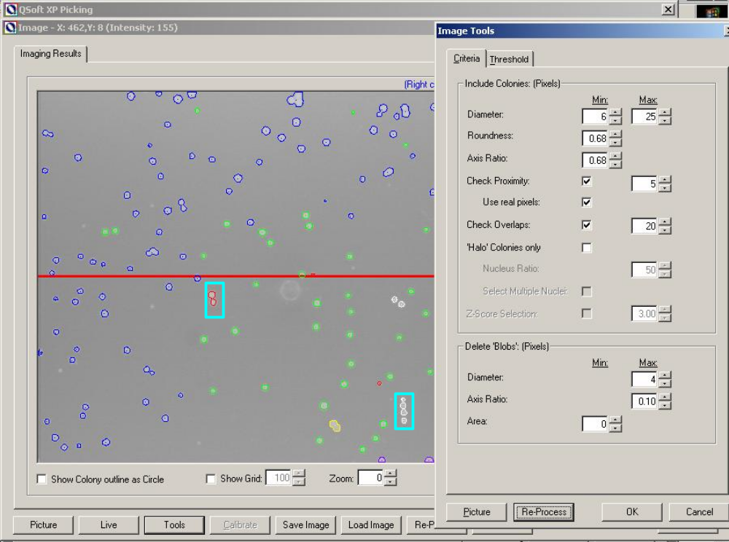
Now the imaging software processes these colonies.
Now the imaging software processes the two colonies in the center so the ones on the top and bottom are not selected due to proximity.

