DNA Quantification Protocol

Version Number: 1.1
Production Start Date: 11/06/01
Version 1.1 Date: 08/25/04
Authors: Anna Ustaszewska
Reviewed/Revised by: Tijana Glavina

Summary
Upon isolation of the large BAC, fosmid, or cosmid clones, the DNA is quantified and diluted or concentrated to a target concentration of 40ng/μl.

Materials & Reagents

Materials/Reagents/Equipment  Disposables  96-well skirted PCR Microplate  Centricon YM-100  Weigh boats  Reagents  Lamda DNA (500μg/ml)  DNA Molecular Weight Marker II  (Lamda DNA-Hind III digest)  50X TAE buffer  TE buffer  UltraPure Agarose  UltraPure Ethidium Bromide (10mg/ml)  Bromophenol Blue-Xylene Cyanole Dye Solution  Milli-Q Water  Equipment  Centrifuge 5417C  Vortexer  Fluor-S MultiImager  Gel Pouring Apparatus (inc. gel box, casting tray)  Gel Combs 50 teeth, 8mm  Microwave  Stir bars  Thermometer | Vendor  USA Scientific  Millipore  -  New England Biolabs  Roche  Gibco/Invitrogen  Ambion  Gibco/Invitrogen  Gibco/Invitrogen  Sigma -Aldrich  Millipore Milli-Q System  Eppendorf  Vortex-Genie  Bio-Rad  -  -  -  -  - | Stock Number  1402-9708  42412  -  N3011L  236250  24710-030  9858  15510-027  15585-011  B3269  -  -  -  -  -  -  -  -  -

Procedure
NOTE 1: All reagents/stock solutions should be prepared prior to the start of the procedure.
NOTE 2: When working with ethidium bromide, always wear nitrile gloves.
1. Gel Casting
  - Place the gel-casting tray in the gel-pouring stand and lock it into position. Make sure the tray is leveled.
  - Prepare 1.0% agarose gel solution containing ethidium bromide (Refer to the Reagent/Stock Preparation section).
  - Place a mercury thermometer in the agarose gel solution while it continues stirring over the magnetic stir plate in order to monitor the temperature.
  - When the temperature of the agarose gel solution falls to 65ºC, pour a thin 1.0% agarose gel solution containing ethidium bromide into the casting tray.
NOTE: The thinner the gel, the better the resolution, but make sure that it is even across the gel.
  - Insert 2 or 4 clean combs (50 teeth/8mm) in the designated slots of the casting tray and allow the gel to set for 30 minutes.
  - Remove the combs from gel, making sure not to tear the gel.
  - Remove the gel and place it in the electrophoresis box oriented so that the row of wells are closest to the negative (cathode, black) end of the gel box and fill the box with 1X TAE buffer so that it covers the gel but does not go over fill line. (Use fresh buffer if needed, change every 3 days).
NOTE 1: If there is too much buffer in the gel box, the mobility of the DNA on the gel will be impeded.
NOTE 2: Dump out leftover 80ml of agarose into gel disposal tray. Rinse off thermometer and bottle in the sink area.

2. Sample Preparation
NOTE: If quantification of samples is delayed for a couple of days, samples can be frozen at 80ºC.
  - Thaw samples to be quantified and concentration standards on ice. Samples should be kept on ice.
  - While the samples are thawing, go to the Bio-Rad 1 computer in Rm 145 (the small room inside the picking room) and enter the Venonat database → Libraries DB → select Print out Excel sheet for Concentration Gel → select up to 25 Library names for the samples that will be run on the concentration gel → select Run Report → Save this Excel file to \\C:drive\Library isolation\centricon\Keeper\name concentration\using the date and gel number (e.g.: 01-09-04gel22).
NOTE: The gel numbers should all be in chronological order.
  - In the Excel file, enter in the gel number (refer to Quantification notebook), sample numbers for each library, and leave the BAC conc. column blank. Refer to Table 1 in Appendix A.
  - Print a copy to guide you in organizing the order of your samples (step 2.5). Arrange sample tubes in same order as excel.
  - In a 96-well PCR plate (colored or clear), pipette 2μl of loading dye in the wells that will have DNA loaded in them. Pipette on one side of the well rather than on the bottom. Use a plate base.
  - Make a loading diagram.
  - Arrange samples according to the loading diagram.
  - Vortex sample briefly before pipetting. Pipette 2μl of sample per well. Pipette on the opposite side of the well from the loading dye.
  - Repeat step 2.8 with the concentration standards. Load 2 sets of concentration standards.
  - Perform a quick spin of the plate in the centrifuge by allowing the centrifuge to ramp up to 1,000 rpm and then pressing the stop button. Make sure the sample and dye are at the bottom of the well. Cover plate with clear seal. Store source samples in deli when finished loading.

3. Loading and Running the Gel
NOTE: Refer to Tables 1 and 2 in Appendix A to determine how to load the gel.
  - Load 4μl of each sample into the wells using a single-channel pipette.
    - Leave wells 1-3 empty.
    - Leave wells 4-11 empty (for standards, to be loaded last).
    - Leave one well empty (#12).
    - Load the sample DNA in wells 13 – 50 depending on the number of samples you have to run. Refer to the Concentration Gel Excel sheet to determine the sample order.
    - Load the concentration standards in wells 4 – 11.
    - Load another set of concentration standards in the same order on row 2 of the gel.
  - Run the gel 5 minutes at 100V.
  - After the gel has finished running, carefully remove it and place in a tray.
  - Wash the gel in Milli-Q water, drain, fill again with Milli-Q water and let it sit in Milli-Q water for 1 hour.
NOTE: This is done in order to wash ethidium bromide from background.

4. Imaging the Gel
  - Take the gel to the Fluor-S MultiImager in Rm145.
  - Wipe-down the Fluor-S MultiImager’s platform with 70% ethanol using Kimwipes, not paper towels.
  - On the computer desktop located next to the MultiImager, open the MultiAnalyst program on the computer desktop. Refer to Figure 1 in Appendix A.
  - Under the Image Preview Display, select POSITION and position the gel on the MultiImager.
  - If the gel image is out of focus, select FOCUS.
  - Select PREVIEW.
  - If the gel image is centered and focused, select OFF.
  - Make sure that the settings on the MultiAnalyst are as follows: Ethidium 520LP, Integration: Manual, Integration Time: 2.0 secs, Light Source: Scan: UV 302,#2 or Scan: UV 302, #1 (either one is ok) Scan Width: 250mm, High Resolution on.
  - Click on CAPTURE. Make sure picture seems correct.
  - Save the gel image as the date and gel number (e.g.: 01-09-04gel22.bif) in the following directory: \\C:\Library isolation\centricon\Keeper\. Also, print a copy for your notebook.

Rerun Gel
  - Carefully transfer the analyzed gel back onto the gel tray and place the tray back into the gel box.
  - Load 10μl of Marker II (different standard) into 3 empty wells of the gel (the well before the standards, the well in between the standards and the samples of unknown concentration and the well after the samples).
  - Run the gel for additional 45 minutes at 125V (or until there is clear separation between the individual bands of the marker). Use manual timer.
NOTE: While the gel is running, you may continue onto the next section – Quantifying DNA samples.
  - Image the gel again (Image 5 seconds, longer than before) and save the new gel image as the date and gel number (e.g.: 01-09-04gel22longrun.bif) in the following directory: \\C:\Library isolation\centricon\longer gel runs. Refer to Figure 5 in Appendix A.
  - Print copy of the picture for the Quantification Gels binder.
NOTE: All the samples we process carry inserts between 40-200kb in size. The heaviest fragment of the marker is 23kb in size. This means that all of the samples, being significantly larger in size than the top band of the marker, should appear above the 23kb band on the gel. If a sample band has traveled down beyond the 23kb band, it may have a deletion. Bring this to the attention of your supervisor.
  - Wipe down the Imager with 70% ethanol and a Kimwipe.

6. Quantifying the DNA samples
NOTE: Turn the lights off for ease of viewing.
  - Zoom into the concentration standards on the gel image. Refer to Figure 2 in Appendix A.
  - Using the red box icon to the left of the window, create a box around the first concentration standard band.
  - On the menu bar, select the arrow icon, then use the arrow cursor to select the box that was just drawn around the concentration standard band.
  - Holding down the Ctrl key, click and drag a box copy to the next concentration standard band and repeat until all 8 standard bands have blue boxes around them.
NOTE: It is imperative that the boxes around each band occupy the same area. Otherwise, the standard concentration plot will not be accurate.
  - Holding down the Ctrl key, click and drag a box copy to the black portion of the gel to create 2 background blanks.
  - Double-click on each standard and background box, and in the volume properties menu, pick the type (standard, background, unknown) and input the known concentrations.
  - On the menu bar, select the View Volume Report icon, then select the middle BK (background, “local”) icon. Refer to Figure 3 in Appendix A.
  - On the menu bar, select the Volume Standard Curve and Data icon, and do the following based on the standard curve. Refer to Figure 4 in Appendix A.
    - Delete bad standards (any that appear to be too high or too low compared to the others). Change remaining standards to be accurate.
    - If the concentration standard points do not lie on the best-fit line, move the blue boxes on the gel image up or down to adjust the curve points closer to the line. Make sure the DNA band is contained within the box. If you cannot adjust the point close to the curve and keep the band in the box, you should not use that standard.
NOTE: We will usually load two sets of standards on the gel, then once we take a picture, we see which set looks better and then use that set. We do this because standards are crucial and if they look bad you have to redo the entire gel.
    - If your standard curve is good, the correlation coefficient should be close to 1. Do not use the curve if your coefficient is less than 0.90. Coefficient =0.95, deleted 50μg/μl std.
  - Once the concentration standard points lie on the best-fit line, copy and paste the same size red box around each sample band.
  - Copy the concentration numbers into the Excel sheet from step 2.2. Print a copy of the updated Excel file. Put a “d” by dilute ones, put a “c” for centricon.
  - Remove the overlays (File → remove overlays) from the gel image and print a copy of the picture, standard curve, and volume report. Place these in the Quantification Gels binder.
  - Once all samples are in the 20-40ng/μl concentration range, update the database so that all can be passed on to the next step (shearing):
    - Go back to the BAC conc. column of the Excel file in step 2.2 and change all of the concentrations of samples, which were diluted, to 40ng/μl.
    - Resave the file as “text only” file to a temporary folder on Nassau on the Network.
      - Go to FILE → select Save As → select My Network Places → open tmp on Nassau.
ii. If prompted, type in your username and password.
iii. Save the file as MM-DD-YY in the Text (Tab delimited) format.

    - Upload the file to the Venonat database:
      - In Venonat, go to the Libraries DB → click on Concentration Upload File Form (enter username and password)→ enter the file name from 5.14.b
      - Click on UPDATE. Check shearing queue to make sure they made it.
  - Adjust the sample concentration (400μl) to 40ng/μl by dilution with TE buffer (if concentration is above 40ng/μl) or centricon (if concentration is below 20ng/μl). Do not adjust samples that fall between 20-40ng/μl.
NOTE: To determine how much TE buffer to add for dilutions, use the dilution equation in Appendix A.
  - If the sample concentration is below 20ng/μl, centricon the sample to remove excess buffer:
    - Centrifuge the entire sample through the centricon column for 20 minutes at 4,000rpm.
    - Discard the collected buffer.
    - Reverse the column and collect the concentrated DNA by centrifuging for 2 minutes at 4,000rpm.
    - Bring the total sample volume to 100μl by adding TE.
    - Rerun the sample on the next quantification gel. If the sample falls within the correct concentration range on the second gel, pass it on to shearing. If the sample fails the second gel, fail it in the database. This sample will go back into the Isolations queue.
  - Quick spin the adjusted samples in the small centrifuge 5417C for 5 min at 12,000 rpm.
  - Pipette 200μl of the DNA into a fresh tube using p200 and pass to the subcloning group by placing the tubes in a box labeled “Shearing All Others” in the bottom shelf of the -80ºC freezer 008 in Functional Genomics Lab (Rm 459).
NOTE: Make sure you are pipetting from the top of the tube to prevent aliqouting any contaminants that may clog the hydroshear machine in the later steps.
  - Any remaining DNA in the original tube can be reracked in the Rm139 DNA freezer.

6. Gel Disposal
  - Place the gel containing ethidium bromide in the labeled white bin in Rm139 for disposal. Once the gel is completely dry, it can be disposed of into the regular trash.
  - Dump the gel box’s TAE buffer into the sink and wash the gel box with Milli-Q water.
  - Wash the gel pouring apparatus and gel combs with Milli-Q water. Make sure that there is no residual gel left behind.

Reagent/Stock Preparation

1X TAE Solution
For 20L: Mix 400ml 50X TAE with 19.6L Milli-Q H₂O
For 10L: Mix 200ml 50X TAE with 9.8L Milli-Q H₂O
For 7.5L: Mix 150ml 50X TAE with 7.35L Milli-Q H₂O
For 5L: Mix 100ml 50X TAE with 4.9L Milli-Q H₂O

1.0% Agarose Solution
NOTE: Always wear nitrile gloves when working with solutions or gels containing ethidium bromide.

- Add 200ml 1X TAE buffer to a 500-ml bottle.
- Add 2g agarose. (1g/100ml, i.e. 1%) –Measure on scale with weigh boat.
- Swirl in bottle briefly. Heat in microwave for 2 minutes.
NOTE: If still in solid form, it will settle on bottom, reheat up to 2 min. watching to make sure it does not boil over.
- Add 2μl Ethidium Bromide (1μl/100ml) while stirring. Flush tip in solution.
- Carefully add an autoclaved magnetic stir bar to the solution and mix the solution over a stir plate until the liquid is clear. Stir until temperature comes down to ~65ºC, use thermometer.
NOTE: Make sure you add the stir bar after heating the solution in the microwave.

6X Loading Dye
To a 500-ml bottle, add and mix the following:
174ml Milli-Q water
0.5g Bromophenol Blue
0.5g Xylene Cyanole

1X Loading Dye
To a 1-L bottle, add and mix the following:
400ml Milli-Q water
100ml 100% Glycerol
100ml 6X Loading Dye

Lamda DNA Concentration Standards
10ng/μl, 20ng/μl, 30ng/μl, 40ng/μl, 50ng/μl, 60ng/μl, 70ng/μl, 80ng/μl

Lambda DNA (500μg/ml) Serial Dilutions

Desired concentration(μg/ml) | 200 | 150 | 120 | 100 | 80 | 70 | 60 | 50 | 40 | 30 | 20 | 10
Initial concentration to use(μg/ml) | 500 | 200 | 150 | 120 | 100 | 80 | 70 | 60 | 50 | 40 | 30 | 20
Quantity of initial standard* | 300 | 675 | 740 | 750 | 720 | 700 | 600 | 500 | 400 | 300 | 200 | 100
TE to add* | 450 | 225 | 185 | 150 | 180 | 100 | 100 | 100 | 100 | 100 | 100 | 100
Quantity of new standard made* | 750 | 900 | 925 | 900 | 900 | 800 | 700 | 600 | 500 | 400 | 300 | 200
Final Quantity* | 75 | 160 | 175 | 180 | 200 | 200 | 200 | 200 | 200 | 200 | 200 | 200

* All units are in μl

SOP Approval
DEPARTMENT | APPROVED BY | DATE
Lab Supervisor
Research & Development
Instrumentation
QC
Purchasing
EH & S
Informatics
Seq Assessment & Analysis
Dept Head of Prod Seq

Appendix A
Table 1. Concentration Gel Excel File.

Lib. Id | Project | Library | Gel | Well | BAC Conc.
25646 | 3578618 | AHCG | 248 | 1 | 50.35 | d
25647 | 3596143 | AHCH | 248 | 2 | 30.18
25648 | 3571467 | AHCI | 248 | 3 | 31.73
25649 | 3599772 | AHCK | 248 | 4 | 50.22 | d
25650 | 3609042 | AHCN | 248 | 5 | 30.82
25651 | 3599327 | AHCO | 248 | 6 | 42.69 | d
25652 | 3612140 | AHCP | 248 | 7 | 58.6 | d
25653 | 3601856 | AHCS | 248 | 8 | 52.52 | d
25654 | 3611680 | AHCT | 248 | 9 | 43.15 | d
25655 | 3627846 | AHCU | 248 | 10 | 46.61 | d
25656 | 3571926 | AHCW | 248 | 11 | 50.2 | d
25657 | 3602860 | AHCX | 248 | 12 | 42.06 | d
25658 | 3608629 | AHCY | 248 | 13 | 45.25 | d
25659 | 3581190 | AHCZ | 248 | 14 | 35.93
25660 | 3568588 | AHFB | 248 | 15 | 27.74
25661 | 3568543 | AHFC | 248 | 16 | 38.92
25662 | 3589661 | AHFF | 248 | 17 | 40.74 | d
25663 | 3571447 | AHFG | 248 | 18 | 46.29 | d
25664 | 3600663 | AHFH | 248 | 19 | 43.05 | d
25665 | 2988708 | AHFI | 248 | 20 | 49.48 | d
25666 | 2975047 | AHFK | 248 | 21 | 59.17 | d
25667 | 2954569 | AHFN | 248 | 22 | 50.94 | d
25668 | 2975730 | AHFO | 248 | 23 | 45.68 | d
25669 | 2984259 | AHFP | 248 | 24 | 54.3 | d
25670 | 2959921 | AHFS | 248 | 25 | 58.46 | d
25671 | 2973597 | AHFT | 248 | 26 | 50.64 | d
Table 2. Loading the gel:

1 | 2 | 3 | 4 | 5 | 6 | 7 | 8 | 9 | 10 | 11 | 12 | 13 | 14 | 15 | 16-50
empty | empty | empty | Std | Std | Std | Std | Std | Std | Std | Std | empty | Sample  1 | Sample  2 | Sample3 | Samples

Figure 1. MultiAnalyst software image.

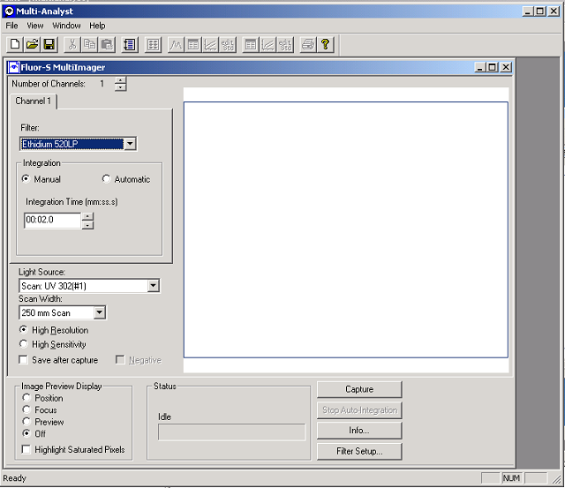

Figure 2. MultiAnalyst Software after the gel image has been captured.
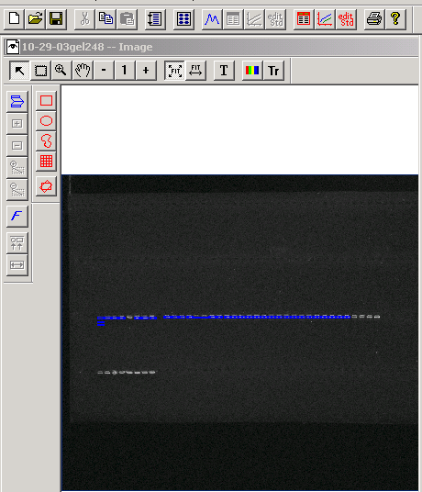

Figure 3. Volume Report chart.
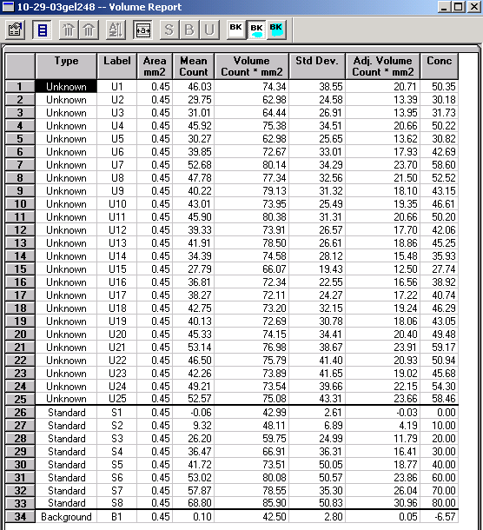

Figure 4. Concentration Standard Curve.
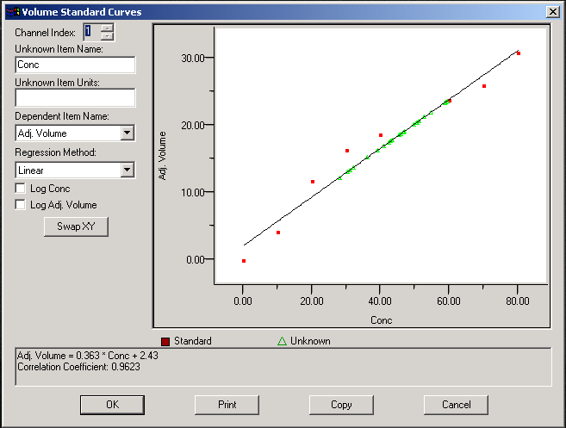

The coefficient should be as close to 1 as possible.

Figure 5. Longer gel run with Marker II.
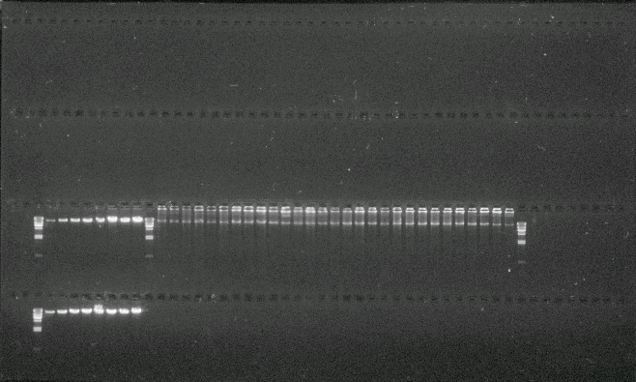

Sample DNA Dilution Equation:

M₁V₁ = M₂V₂ where:
M₁ = starting concentration of the sample
V₁ = 400μl
M₂ = target concentration 40ng/μl.
Solve for V_{2.}
Subtract 400μl from the value you obtain for V₂ and add this final volume of TE buffer to the DNA sample.

Appendix B
AUDIT TRACKING
6/03/04 – Danielle Mihalkanin and Duane Kubischta performed an audit between 2:00PM – 6:00PM (6/03). The user was Anna Ustaszewska. Changes incorporated on 8/25/04.

