
U.S. Department of Health and Human Services
Public Health Service

SF424 (R&R)
SBIR/STTR
Application Guide for NIH
and Other PHS Agencies
A guide developed and maintained by NIH for preparing and submitting SBIR/STTR applications via Grants.gov to NIH and other PHS agencies using the SF424 (R&R)

Version 2 (To be used with PureEdge application packages
indicating Version 2 and Version 2a)

Updated August 1, 2008
Table of Contents
Part I. Instructions for Preparing and Submitting an Application
1. Foreword I-1
1.1 Application Guide Format I-2
1.2 NIH Extramural Research and Research Training Programs I-3
1.3 Program Guidelines I-3
1.3.1 Three-Phase Program I-3
1.3.2 Fast-Track Applications I-4
1.3.3 Supplemental Applications I-5
1.3.4 SBIR/STTR Program Eligibility I-5
1.4 Interactions with PHS Staff I-6
1.5 Grants Policy Statements I-11
1.6 References I-11
1.6.1 Other Resources I-13
1.7 Authorization I-14
1.8 Paperwork Burden I-14
2. Process for Application Submission via Grants.gov I-15
2.1 Overview I-15
2.2 Registration Processes I-16
2.2.1 Grants.gov Registration I-16
2.2.2 eRA Commons Registration I-16
2.3 Software Requirements I-18
2.3.1 PureEdge I-18
2.3.2 Creating PDFs for Text Attachments I-18
2.3.3 Special Instructions for Macintosh Users I-19
2.4. Funding Opportunities I-19
2.4.1 NIH Guide for Grants and Contracts I-19
2.4.2 Grant and Cooperative Agreement Announcements I-20
2.4.3 Finding a Funding Opportunity Announcement (FOA) for Grants.gov
Submission I-21
2.5 Components of an Application to NIH or Other PHS Agencies I-24
2.6 Format Specifications for Text (PDF) Attachments I-24
2.7 “Resubmission” (Revised) Applications I-27
2.8 “Revision” (Competing Supplemental) Application I-28
2.9 Similar, Essentially Identical, or Identical Applications I-28
2.10 Submitting Your Application Via Grants.gov I-29
2.11 After You Submit Your Application Via Grants.gov I-30
2.12 Correcting Errors I-32
2.13 Submission of Supplementary or Corrective Information I-34
2.14 Application Submission Dates I-34
2.15 Submission, Review and Award Cycles I-34
2.16 Resources for Finding Help I-36
2.16.1 Finding Help for Grants.gov Registration or Submissions I-36
2.16.2 Finding Help for the eRA Commons Registration or eRA Commons Validation Processes I-36
2.16.3 Finding Help for Application Preparation I-37
2.16.4 Finding Help for SBIR/STTR Specific Inquiries I-37
3. Using the Grant Application Package I-37
3.1 Verify Grant Information I-38
3.2 Enter the Name for the Application I-38
3.3 Open and Complete Mandatory Documents I-39
3.4 Open and Complete Optional Documents I-39
3.5 Submitting the Application via Grants.gov I-39
4. Completing the SF424 Research and Related (R&R) Forms I-40
4.1 Overview I-40
4.2 Cover Component I-41
4.3 Project/Performance Site Locations Component I-56
4.4 Other Project Information Component I-59
4.5 Senior/Key Person Profile(s) Component(s) I-64
4.5.1 Senior/Key Person Profile Component I-65
4.5.2 Senior/Key Person Profile (Expanded) Component I-71
4.6 R&R Budget Component I-82
4.6.1 Section A and B I-83
4.6.2 Sections C through E I-89
4.6.3 Sections F through K I-92
4.6.4 Cumulative Budget I-98
4.7 Special Instructions for Preparing Applications with a Subaward/Consortium I-100
5. Completing PHS398 Components I-103
5.1 Overview I-103
5.2 Cover Letter Component I-104
5.3 Cover Page Supplement Component I-106
5.4 Research Plan Component I-112
5.5 Checklist Component I-128
5.6 Completing SBIR/STTR Information Component I-132
6. Peer Review Process I-137
Part II. Supplemental Instructions for Preparing the Human Subjects Section of the Research Plan
1. Introduction II-1
2. Scenarios II-1
3. Instructions for Preparing the Section on Protection of Human Subjects II-3
4. Instructions Pertaining to Non-Exempt Human Subjects Research II-7
4.1 Protection of Human Subjects II-7
4.1.1 Risks to Human Subjects II-7
4.1.2 Adequacy of Protection Against Risks II-8
4.1.3 Potential Benefits of the Proposed Research to Human Subjects and Others II-9
4.1.4 Importance of the Knowledge to be Gained II-9
4.1.5 Data and Safety Monitoring Plan II-9
4.1.6 ClinicalTrials.gov Requirements II-10
4.2 Inclusion of Women and Minorities II-11
4.2.1 Additional Instructions and Requirements When NIH-Defined Phase III Clinical Trials Are Proposed II-12
4.3 Instructions for Completing the Targeted/Planned Enrollment Tables for Reporting Race
and Ethnicity Data for Subjects in Clinical Research II-13
4.4 Inclusion of Children II-14
5. Human Subjects Research Policy II-16
5.1 Protection of Human Subjects II-16
5.2 Vulnerable Populations II-17
5.3 Data and Safety Monitoring Plans for Clinical Trials II-17
5.4 IRB Approval II-17
5.5 Required Education in the Protection of Human Research Participants II-18
5.6 NIH Policy on the Inclusion of Women and Minorities in Clinical Research II-18
5.7 NIH Policy on Inclusion of Children II-19
5.8 NIH Policy on Reporting Race and Ethnicity Data: Subjects in Clinical Research II-19
5.9 Research on Transplantation of Human Fetal Tissue II-21
5.10 Research Using Human Embryonic Stem Cells II-21
5.11 ClinicalTrials.gov Requirements II-21
Part III. Policies, Assurances, Definitions, and Other Information
1. Policy III-1
1.1 Applications That Include Consortium/Contractual Facilities and Administrative Costs III-1
1.2 Resubmission of Unpaid RFA Applications and Resubmission of Applications with a
Changed Grant Activity Mechanism III-1
1.3 NIH Policy on Resubmission Applications III-2
1.4 Policy on the Acceptance for Review of Unsolicited Applications That Request $500,000
or More in Direct Costs III-3
1.5 Sharing Research Resources III-4
1.5.1 Data Sharing Policy III-4
1.5.2 Sharing Model Organisms III-5
1.5.3 Policy for Genome-Wide Association Studies (GWAS) III-5
1.6 Inventions and Patents III-6
1.7 Just-In-Time Policy III-6
1.8 Other Support III-7
1.9 Graduate Student Compensation III-11
1.10 DUNS Number III-12
1.11 Public Access Policy III-13
1.12 PHS Metric Program III-13
1.13 NIH Plans to Transition to the SF424 (R&R) Application and Electronic Submission
through Grants.gov III-13
2. Assurances and Certifications III-15
2.1 Human Subjects Research III-15
2.1.1 Research on Transplantation of Human Fetal Tissue III-17
2.1.2 Research Using Human Embryonic Stem Cells III-17
2.1.3 NIH Policy on the Inclusion of Women and Minorities as Subjects in Clinical Research III-17
2.1.4 NIH Policy on Reporting Race and Ethnicity Data: Subjects in Clinical
Research III-18
2.1.5 NIH Policy on Inclusion of Children III-18
2.1.6 ClinicalTrials.gov III-18
2.2 Vertebrate Animals III-19
2.3 Debarment and Suspension III-20
2.4 Drug-Free Workplace III-20
2.5 Lobbying III-20
2.6 Non-Delinquency on Federal Debt III-21
2.7 Research Misconduct III-21
2.8 Assurance of Compliance (Civil Rights, Handicapped Individuals, Sex Discrimination,
Age Discrimination) III-22
2.9 Research Involving Recombinant DNA, including Human Gene Transfer Research III-22
2.10 Financial Conflict of Interest III-23
2.11 Smoke-Free Workplace III-24
2.12 Prohibited Research III-24
2.13 Select Agent Research III-25
2.14 Principal Investigator Assurance III-25
2.15 Impact of Grant Activities on the Environment and Historic Properties III-26
2.16 Small Business Concern SBIR Verification Statement III-26
2.17 Small Business Concern STTR Verification Statement III-27
3. Definitions III-29
4. General Information III-40
4.1 Research Grant Mechanisms III-40
4.2 Government Use of Information Under Privacy Act III-42
4.3 Information Available to the PD(s)/PI(s) III-43
4.4 Information Available to the General Public III-43
4.5 Access to Research Data III-44
5. Award Guidelines, Reporting Requirements, and Other Considerations III-44
5.1. Awards III-44
5.2. Terms and Conditions of Award III-45
5.3 Payment Schedule III-46
5.4 Reports III-47
Financial Status Report (FSR) (OMB 269) III-48
Final Report Requirements III-48
Progress Reports as Part of Noncompeting Continuation Requests (All Applications with Multiple Years) III-49
Final Invention Statement and Certification (HHS 568) III-49
Annual Utilization Report III-50
Phase II Data Collection Requirement for Government Tech-Net Database III-50
5.5 Innovations, Inventions and Patents III-51
Limited Rights Information and Data III-51
Research Tools/Unique Research Resources III-54
5.6 Joint Ventures and Limited Partnerships III-54
5.7 American-Made Equipment and Products III-54
5.8 Profit or Fee III-54
5.9 Additional Information III-55
5.10 Cost Sharing III-55
5.11 Audit Requirements of For-Profit Organizations III-55
5.12 Time and Effort Reporting for Commercial Organizations III-56

PART I
Instructions for Preparing and Submitting
an Application

1. Foreword

Version 2 — Released July 5, 2006
Version 2 of this application guide includes changes to instructions necessitated by the recent upgrade of the SF424-R&R form set, from version 1.0 to version 2.0. Grants.gov recently performed this upgrade in order to make the SF424-R&R data items consistent wherever possible, with identical items that are also collected on the base SF424 forms (discretionary, mandatory, individual, and short). These changes include the addition of a few new fields, updates to the help text, and several modifications to the lists of values that are presented in drop-down lists.
Many of the Grants.gov changes affect all components with detailed address fields. Address changes include the addition of a separate field for Province, and a modification to all State fields to now include US Possessions, territories and Military Codes.
Other changes of note to specific components include:

SF424 (R&R) Cover
5. Type of Applicant: An expanded list of values has been incorporated.
6. Employer Identification: The agency-specific instruction has been modified to instruct applicants to use the entire 12-digit EIN if one has been established.
14. Congressional District: Instructions have been modified to provide more specific details including a specific format; e.g., CA-012.
21. Additional Project Congressional Districts: This is a new data field and is an attachment option for those projects needing to provide more information than can be entered in Item 14.

PHS398 Research Plan Component
Four sections have been added to the Research Plan: Inclusion Enrollment Report and Progress Report Publication List are now separate attachments. These were previously part of section 4. Preliminary Studies/Progress Report. They have been separated out to avoid being counted in the page limit validations. In addition, new distinct sections have been added for Select Agent Research and Multiple PI Leadership Plan. Some of the previous sections have been renumbered.
Another change to the Research Plan Component eliminates the separate section for Data and Safety Monitoring. This is now incorporated as a subtopic within section 8. Protection of Human Subjects.

PHS398 Checklist Component
This component has been modified to remove the itemized list of policies, assurances, and certifications that appeared on the form. Instead, applicants are instructed to consult a specific website.

General Text Edits
Throughout Version 2 text has also been edited to provide additional clarity and guidance.
- All references to the eRA Commons verification steps for the PD/PI and AOR have been changed to now reflect the 2-day period to view an application.
- Additional agency-specific instructions have been included in 4.7 R&R Budget Component for Person Months, Requested Salary, Consultants, Subawards/Consortium, Patient Care Costs, Joint University/VA Appointments, Budget Justification and Supplemental/Revision Applications.
- Instruction text throughout Part II. Supplemental Instructions for Preparing the Human Subjects Section of the Research Plan has been revised to reflect the revised sections of the PHS398 Research Plan component.
- A number of text edits have been made to the instruction text of specific R&R data elements so that it reflects revised text used by Grants.gov in the actual forms.

This application guide contains instructions and other useful information for preparing SBIR/STTR grant applications to the National Institutes of Health (NIH) and other Public Health Service (PHS) agencies for:
Small Business Innovation Research (SBIR) Grants
Small Business Technology Transfer (STTR) Grants
This application guide is used as a companion document to a new set of application forms, the SF424 Research and Related (R&R). In addition to the SF424 (R&R) form components, applications to NIH and other PHS agencies will include agency-specific form components, titled “PHS398” and “SBIR/STTR Information.” These PHS398 and SBIR/STTR Information components were developed to continue the collection of agency-specific data required for a complete application. While these agency-specific components are not identical to the PHS398 application form pages, the PHS398 reference is used to distinguish these additional data requirements from the data collected in the SF424 (R&R) components. A complete SBIR/STTR application to NIH and other PHS agencies will include SF424 (R&R) components, PHS398 components, and the SBIR/STTR Information component. Instructions for all application components, SF424 (R&R), PHS398, and SBIR/STTR Information, are found in this document.
The use of these new forms also involves electronic submission of completed applications through Grants.gov. NIH and other PHS agencies will gradually transition all mechanisms to the new application forms and Grants.gov submission. Specific Funding Opportunity Announcements (FOAs) will clearly indicate which forms and submission process an applicant should use. NIH will continue to use Requests for Applications (RFAs) and Program Announcements (PAs) as categories of FOAs. See Section 2.4.2 for definitions.
Applicants must carefully review FOAs for guidance on when to use the 424 (R&R) forms, instructions, and electronic submission for a specific mechanism (i.e., R43, R44, etc.). This new process will apply to all types of submissions for the announced mechanism – new, resubmission (formerly “revised/amended”), renewal (formerly “competing continuation”), and revision (formerly “competing supplemental”) grant applications. Each FOA will include a link to the most current version of these instructions. Applicants are encouraged to check the web site frequently for the most current version.
For purposes of this document, any references to “NIH” may also mean “NIH and other PHS agencies” such as the Agency for Healthcare Research and Quality (AHRQ), the Centers for Disease Control and Prevention (CDC), and the Food and Drug Administration (FDA).

1.1 Application Guide Format
This application guide is organized into three distinct parts:
Part I: Instructions for Preparing and Submitting the Application. Part I includes specific instructions for completing the application form components as well as information on electronically submitting applications through Grants.gov.
Part II: Supplemental Instructions for Preparing the Human Subjects Section of the Research Plan. Part II is to be used if your proposed research will involve human subjects. These instructions assist in determining whether human subjects are involved and include scenarios and detailed instructions for completing Items 8 – 11 of the PHS 398 Research Plan component.
Part III: Policies, Assurance, Definitions, and Other Information. Part III includes information on policies, assurances, definitions, and other information relating to submission of applications to the PHS. Applicants should refer to this document as well as the instructional materials, Grants Information (GrantsInfo), and NIH Grants Policy Statement sections for additional sources of information.

1.2 NIH Extramural Research and Research Training Programs
The NIH Office of Extramural Research Grants homepage (http://grants.nih.gov/grants/oer.htm) provides an array of helpful information. Applicants are encouraged to bookmark this site and visit it often.
The Division of Extramural Outreach and Information Resources (DEOIR) is the central source for general information about NIH extramural research and research training programs, funding mechanisms, the peer review system, and application procedures. Grants Information (GrantsInfo) is a communication service within the DEOIR. Information about the NIH extramural research and research training programs, funding opportunities, and the grant application process, can be obtained by emailing your request to: GrantsInfo@nih.gov or by calling (301) 435-0714.

1.3 Program Guidelines

1.3.1 Three-Phase Program
Both the SBIR and STTR programs are structured in three phases, the first two of which are supported using SBIR/STTR funds. The stated Phase I and Phase II award levels and project periods are statutory guidelines, not ceilings. Therefore, applicants are encouraged to propose a budget and project duration period that is reasonable and appropriate for completion of the research project.
Deviations from the indicated statutory award amount and project period guidelines are acceptable, but must be well justified and should be discussed with NIH Program Staff prior to submission of the application. (CDC and FDA do not make awards greater than the stated guidelines.) The budgets of SBIR and STTR applications will be evaluated to assess the appropriateness of the budget to the timeliness of the research goals and may be reduced on a case by case basis as recommended by peer reviewers, Institute/Center Advisory Board/Council, or program staff. When making awards, NIH reserves the right to withhold or reduce grant funding on applications at any ranking based on program priority.
Funding levels for projects are determined through the combined interaction among peer review, grants management, program, budget, and other Institute and/or Centers (IC) staff. These levels are based on allowable costs that are consistent with the principles of sound cost management and in consideration of IC priorities, constraints on the growth of average grant costs, and the availability of funds.
Phase I. The objective of Phase I is to establish the technical/scientific merit and feasibility of the proposed R/R&D efforts. Preliminary data may be included but are not required. The application should concentrate on R/R&D efforts that will significantly contribute to proving the scientific or technical feasibility of the approach or concept that would be a prerequisite to further support in Phase II.
SBIR Phase I awards normally may not exceed $100,000 total (direct costs, facilities and administrative (F&A)/indirect costs, and fee) for a period normally not to exceed 6 months. STTR Phase I awards normally may not exceed $100,000 total for a period of 1 year.
Phase II. The objective of Phase II is to continue the research or R&D efforts initiated in Phase I. Funding shall be based on the results of Phase I and the scientific and technical merit and commercial potential of the Phase II application.
All Phase II applications must include a succinct Commercialization Plan. Specific details for preparing this section are described in Section 5.6 of this Application Guide.
SBIR and STTR Phase II awards normally may not exceed $750,000 total (direct costs, F&A/indirect costs, and fee) for a period normally not to exceed 2 years.
Only Phase I awardees are eligible to apply for and obtain Phase II funding. Awardees identified via a “successor-in-interest” or “novated” or similarly-revised funding agreement, or those that have reorganized with the same key staff, regardless of whether they have been assigned a different tax identification number, are eligible to apply for Phase II funding. Agencies may require the original awardee to relinquish its rights and interests in an SBIR/STTR project in favor of another applicant as a condition for that applicant’s eligibility to participate in the SBIR/STTR program for that project.
Only one new Phase II award may be made for a single SBIR/ STTR project.
You may submit a Phase II application either before or after expiration of the Phase I budget period, unless you elect to submit a Phase I and Phase II application concurrently under the Fast-Track procedure. To maintain eligibility to seek Phase II support, a Phase I grantee organization should submit a Phase II application within the first six receipt dates following the expiration of the Phase I budget period.
Phase III. An objective of the SBIR/STTR program is to increase private sector commercialization of innovations derived from Federal R/R&D. During Phase III, the small business concern (SBC) is to pursue commercialization with non-SBIR/STTR funds (either Federal or non-Federal). In some Federal agencies, Phase III may involve follow-on, non-SBIR/STTR funded R&D, or production contracts for products or processes intended for use by the U.S. Government.
The competition for SBIR/STTR Phase I and Phase II awards satisfies any competition requirement of the Armed Services Procurement Act, the Federal Property and Administrative Services Act, and the Competition in Contracting Act. Therefore, an agency that wishes to fund an SBIR/STTR Phase III project is not required to conduct another competition in order to satisfy those statutory provisions. As a result, in conducting actions relative to a Phase III SBIR/STTR award, it is sufficient to state for purposes of a Justification and Approval pursuant to FAR 6.302-5 that the project is a SBIR/STTR Phase III award that is derived from, extends, or logically concludes efforts performed under prior SBIR/STTR funding agreements and is authorized under 10 U.S.C. 2304(b)(2) or 41 U.S.C. 253(b)(2).

1.3.2 Fast-Track Applications
CDC and FDA do not accept Fast-Track applications.
The NIH Fast-Track mechanism expedites the decision and award of SBIR and STTR Phase II funding for scientifically meritorious applications that have a high potential for commercialization. Fast-Track incorporates a submission and review process in which both Phase I and Phase II grant applications are submitted and reviewed together. The Phase I portion of a Fast-Track must specify clear, measurable goals (milestones) that should be achieved prior to initiating Phase II work. In addition, as is required for all Phase II applications, the Phase II portion of a Fast-Track application must present a Commercialization Plan (maximum 15 pages) that addresses specific points (see Section 5.6).
In the past, applicant small business concerns (SBCs) submitting SBIR/STTR Fast-Track grant applications to NIH were required to complete two separate applications – one for Phase I and another for Phase II. Beginning with the December 1, 2005, submission date, all SBCs wishing to propose SBIR/STTR Fast-Track projects to NIH must prepare one grant application package consisting of both Phase I and Phase II activities. To be eligible for the Fast-Track option, the Phase I Research Plan must include well defined, quantifiable milestones that will be used to judge the success of the proposed research, as well as a credible development plan for the Phase II application. The Fast-Track must have a section labeled “Milestones” at the end of the PHS 398 Research Plan component for Phase I activities.
The Fast-Track application will receive a single rating for the entire proposed project (i.e., it will receive a numerical score or it will receive an “unscored” designation).
Below are general instructions for preparing NIH SBIR/STTR Fast-Track applications. More specific instructions are provided in Sections 4 and 5 of this application guide.
- Follow the instructions as provided through Section 3, using the Grant Application Package.
- Use the forms in Section 4.6, R&R Budget Component: Complete Budget Period 1 for Phase I; complete Budget Periods 2 and 3 (or more, if appropriate) for Phase II; complete the Cumulative Budget form page used to accumulate total amounts for the entire Fast-Track project period.
- Prepare the Research Plan in accordance with Section 5.4, Research Plan Component, using the PHS 398 Research Plan for items 2-5 in each Phase (Phase I and Phase II plans must be contained within 25 pages).
- Identify the application as “Fast-Track” at the beginning of the “Specific Aims” portion of the PHS 398 Research Plan.
- Under the heading “Phase I Segment,” follow the instructions for the remainder of the application as provided in the Research Plan Component.
Upon completion of all the requirements for Phase I, use the heading “Phase II Segment” and repeat the process for that portion of the proposed project.
Phase I and Phase II are considered separate funding agreements under the Fast-Track Initiative. Therefore, Phase I Fast-Track awardees must recertify that they meet all of the eligibility criteria for an SBIR or STTR award prior to issuance of the Phase II award.

1.3.3 Supplemental Applications
Under special circumstances, requests for supplemental funds to existing NIH SBIR/STTR grants or requests for an extension of the period of support with funds may be considered. (The awarding of supplemental funds applies to NIH ONLY, as CDC and FDA do not make awards greater than the stated guidelines.) See Section 2.8.

1.3.4 SBIR/STTR Program Eligibility
Each applicant submitting an SBIR/STTR grant application must qualify as a small business concern (SBC) at the time of award. The following sections provide more details about these eligibility criteria.

1.3.4.1 Organizational Criteria
A small business concern is one that, for both Phase I and Phase II awards, meets all of the following criteria:
1. Is independently owned and operated, is not dominant in the field of operation in which it is proposing, has a place of business in the United States and operates primarily within the United States or makes a significant contribution to the U.S. economy, and is organized for profit.
2. Is (a) at least 51% owned and controlled by one or more individuals who are citizens of, or permanent resident aliens in, the United States, or (b) for SBIR only, it must be a for-profit business concern that is at least 51% owned and controlled by another for-profit business concern that is at least 51% owned and controlled by one or more individuals who are citizens of, or permanent resident aliens in, the United States.
3. Has, including its affiliates, an average number of employees for the preceding 12 months not exceeding 500, and meets the other regulatory requirements found in 13 C.F.R. Part 121. Business concerns are generally considered to be affiliates of one another when either directly or indirectly, (a) one concern controls or has the power to control the other; or (b) a third-party/parties controls or has the power to control both.
Control can be exercised through common ownership, common management, and contractual relationships. The term "affiliates" is defined in greater detail in 13 C.F.R. 121.103. The term "number of employees" is defined in 13 C.F.R. 121.106.
A business concern may be in the form of an individual proprietorship, partnership, limited liability company, corporation, joint venture, association, trust, or cooperative. Further information may be obtained at http://sba.gov/size, or by contacting the Small Business Administration's Government Contracting Area Office or Office of Size Standards.
One of the circumstances that would lead to a finding that an organization is controlling or has the power to control another organization involves sharing common office space and/or employees and/or other facilities (e.g., laboratory space). Access to special facilities or equipment in another organization is permitted (as in cases where the awardee organization has entered into a subcontractual agreement with another organization for a specific, limited portion of the research project). However, research space occupied by an SBIR/STTR awardee organization must be space that is available to and under the control of the SBIR/STTR awardee for the conduct of its portion of the proposed project.
Title 13 C.F.R. 121.3 also states that control or the power to control exists when “key employees of one concern organize a new concern ... and serve as its officers, directors, principal stockholders, and/or key employees, and one concern is furnishing or will furnish the other concern with subcontracts, financial or technical assistance, and/or other facilities, whether for a fee or otherwise.” Where there is indication of sharing of common employees, a determination will be made on a case-by-case basis of whether such sharing constitutes control or the power to control.
For purposes of the SBIR/STTR program, personnel obtained through a Professional Employer Organization or other similar personnel leasing company may be considered employees of the awardee. This is consistent with SBA’s size regulations, 13 C.F.R. 121.106 – Small Business Size Regulations.
All SBIR/STTR grant applications will be examined with the above eligibility considerations in mind. If it appears that an applicant organization does not meet the eligibility requirements, NIH will request a size determination by the SBA. If eligibility is unclear, NIH will not make an SBIR or STTR award until the SBA provides a determination.

1.4 Interactions with PHS Staff
The PHS agencies encourage applicants to communicate with staff throughout the entire application, review and award process. Web site addresses and staff phone numbers of relevant NIH awarding components and other PHS agencies are listed in the table below.
Table 1.4-1. Awarding Component Contact Information Table
Awarding Component | Program Contact | Grants Mgmt. Contact
National Institute on Aging  http://www.nia.nih.gov | Dr. Michael-David A.R.R. Kerns  Phone: 301-496-9322  Fax: 301-402-2945  Email: mk417e@nih.gov | Ms. Linda Whipp  Phone: 301-496-1472  Fax: 301-402-3672  Email: lw17m@nih.gov
National Institute on Alcohol Abuse and Alcoholism  http://www.niaaa.nih.gov | Dr. Q. Max Guo  Phone: 301-443-0639  Fax: 301-594-0673  Email: qg7s@nih.gov | Ms. Judy Fox  Phone: 301-443-4704  Fax: 301-443-3891  Email: js182a@nih.gov
National Institute of Allergy and Infectious Diseases  http://www.niaid.nih.gov | Dr. Gregory Milman  Phone: 301-496-8666  Fax: 301-402-0369  Email: gm16s@nih.gov | Mr. Michael Wright  Phone: 301-451-2688  Fax: 301-493-0597  Email: mw406g@nih.gov
National Institute of Arthritis and Musculoskeletal and Skin Diseases  http://www.niams.nih.gov/ | Mr. Elijah Weisberg  Phone: 301-435-1002  Fax: 301-480-4543  Email: ew160p@nih.gov | Ms. Sheila Simmons  Phone: 301-594-9812  Fax: 301-480-5450  Email: ss433y@nih.gov  Mr. Erik (Timothy) Edgerton  Phone: 301-594-3968  Fax: 301-480-5450  Email: te62m@nih.gov
National Institute of Biomedical Imaging and Bioengineering  http://www.nibib.nih.gov/ | Mr. Todd Merchak  Phone: 301-496-8592  Fax: 301-480-1614  Email: tm311u@nih.gov | Ms. Florence Turska  Phone: 301-496-9314  Fax: 301-480-4974  Email: ft7p@nih.gov
National Cancer Institute  http://www.nci.nih.gov or  http://www.cancer.gov | Mr. Michael Weingarten  Phone: 301-496-1550  Fax: 301-480-7807  Email: mw498z@nih.gov | Mr. Ted Williams  Phone: 301-496-8785  Fax: 301-496-8601  Email: tw133b@nih.gov
National Institute of Child Health and Human Development  http://www.nichd.nih.gov | Dr. Louis A. Quatrano  Phone: 301-402-4221  Fax: 301-402-0832  Email: lq2n@nih.gov | Mr. Bryan Clark  Phone: 301-435-6975  Fax: 301-402-0915  Email: clarkb1@nih.gov
National Institute on Drug Abuse  http://www.nida.nih.gov | Dr. Cathrine Sasek  Phone: 301-443-6071  Fax: 301-443-6277  Email: cs106o@nih.gov | Ms. Diana Haikalis, M.B.A.  Phone: 301-443-6710  Fax: 301-594-6849  Email: dh84m@nih.gov
National Institute on Deafness and Other Communication Disorders  http://www.nidcd.nih.gov | Dr. Roger Miller  Phone: 301-402-3458  Fax: 301-402-6251  Email: rm378j@nih.gov | Mr. Christopher P. Myers  Phone: 301-402-0909  Fax: 301-402-1758  Email: cm143g@nih.gov
National Institute of Dental and Craniofacial Research  http://www.nidcr.nih.gov | Dr. R. Dwayne Lunsford  Phone: 301-594-2421  Fax: 301-480-8319  Email: rl332k@nih.gov | Ms. Mary Daley  Phone: 301-594-4808  Fax: 301-480-3562  Email: md74u@nih.gov
National Institute of Diabetes and Digestive and Kidney Diseases  http://www.niddk.nih.gov | Dr. Sanford A. Garfield  Phone: 301-594-8803  Fax: 301-402-6271  Email: sg50o@nih.gov | Ms. Helen Y. Ling  Phone: 301-594-8857  Fax: 301-480-3504  Email: hl12d@nih.gov
National Institute of Environmental Health Sciences  http://www.niehs.nih.gov | Dr. Jerrold Heindel  Phone: 919-541-0781  Fax: 919-541-5064  Email: jh190f@nih.gov | Mr. Dwight Dolby  Phone: 919-541-7824  Fax: 919-541-2860  Email: dd45g@nih.gov
National Eye Institute  http://www.nei.nih.gov | Dr. Jerome Wujek  Phone: 301-451-2020  Fax: 301-402-0528  Email: jw513y@nih.gov | Mr. William Darby  Phone: 301-451-2020  Fax: 301-496-9997  Email: wwd@nei.nih.gov
National Institute of General Medical Sciences  http://www.nigms.nih.gov/ | Dr. Matthew Portnoy  Phone: 301-594-0943  Fax: 301-480-2228  Email: mp371e@nih.gov | Ms. Patrice Molnar  Phone: 301-594-5136  Fax: 301-480-2554  Email: pm32e@nih.gov
National Heart, Lung, and Blood Institute  http://www.nhlbi.nih.gov | Ms. Susan Pucie  Phone: 301-435-0079  Fax: 301-480-0867  Email: sp34j@nih.gov | Mr. Robert Vinson  Phone: 301-435-0166  Fax: 301-451-5462  Email: rv7g@nih.gov
National Human Genome Research Institute  http://www.genome.gov | Dr. Bettie J. Graham  Phone: 301-496-7531  Fax: 301-480-2770  Email: bg30t@nih.gov | Ms. Cheryl Chick  Phone: 301-435-7858  Fax: 301-402-1951  Email: cc149o@nih.gov
National Institute of Mental Health  http://www.nimh.nih.gov | Dr. Michael F. Huerta  Phone: 301-443-3563  Fax: 301-443-1731  Email: mh38f@nih.gov | Ms. Rebecca Claycamp  Phone: 301-443-2811  Fax: 301-443-6885  Email: rc253d@nih.gov
National Institute of Neurological Disorders and Stroke  http://www.ninds.nih.gov | Dr. Randall Stewart  Phone: 301-496-1917  Fax: 301-402-1501  Email: rs416y@nih.gov | Ms. Kimberly Campbell  Phone: 301-496-7809  Fax: 301-402-0219  Email: kc274k@nih.gov
National Institute of Nursing Research  http://www.nih.gov/ninr | Dr. Paul A. Cotton  Phone: 301-402-6423  Fax: 301-480-8260  Email: pc272a@nih.gov | Mr. Brian Albertini  Phone: 301-594-6869  Fax: 301-402-4502  Email: ba18b@nih.gov
National Center for Research Resources  http://www.ncrr.nih.gov | Dr. Amy Swain  Phone: 301-435-0755  Fax: 301-480-3659  Email: as387d@nih.gov | Ms. Leslie Le  Phone: 301-435-0856  Fax: 301-480-3777  Email: ld40e@nih.gov
National Center for Complementary and Alternative Medicine  http://www.nccam.nih.gov/ | Dr. Carol Pontzer  Phone: 301-435-6286  Fax: 301-480-3621  Email: cp253q@nih.gov | Mr. George Tucker, MBA  Phone: 301-594-8853  Fax: 301-480-1552  Email: gt35v@nih.gov
National Center on Minority Health and Health Disparities  http://www.ncmhd.nih.gov | Mr. Vincent Thomas, MSW, MPA  Phone: 301-402-2516  Fax: 301-480-4049  Email: vt5e@nih.gov | Ms. Priscilla Grant, J.D., C.R.A.  Phone: 301-594-8412  Fax: 301-480-4049  Email: pg38h@nih.gov
National Library of Medicine  http://www.nlm.nih.gov | Dr. Jane Ye  Phone: 301-594-4882  Fax: 301-402-2952  Email: yej@mail.nih.gov | Mr. Dwight Mowery  Phone: 301-496-4221  Fax: 301-402-0421  Email: dm99n@nih.gov
Centers for Disease Control and Prevention (CDC)  http://www.cdc.gov | Dr. Brenda Colley Gilbert  (NCCDPHP, NCBDDD)  Phone: 770-488-6295  Fax: 770-488-8046  Email: bjc4@cdc.gov  Dr. Paul Smutz (NCIPC)  Phone: 770-488-1508  Fax: 770-488-4422  Email: pos1@cdc.gov  Dr. Virginia Cain (NCHS)  Phone: 301-458-4395  Fax: 301-458-4020  Email: vxc6@cdc.gov  Ms. Susan Board (NIOSH)  Phone: 404-498-2530  Fax: 404-498-2569  Email: SBoard@cdc.gov  Dr. Mildred Williams-Johnson (NCEH)  Phone: 404-498-0639  Fax: 404-498-0059  Email: MMW1@cdc.gov  Dr. Thomas G. Savel (NCPHI)  Phone: 404-498-3081  Fax: 404-498-6570  Email: azn6@cdc.gov | Ms. Nealean Austin (NCCDPHP, NCBDDD)  Phone: 770-488-2722  Fax: 770-488-2777  Email: neal@cdc.gov  Ms. Edna Green (NCIPC)  Phone: 770-488-2743  Fax: 770-488-2777  Email: egreen@cdc.gov  Ms. Sylvia Dawson (NCHS)  Phone: 770-488-2771  Fax: 770-488-2777  Email: snd8@cdc.gov  Mr. Larry Guess (NIOSH)  Phone: 412-386-6826  Fax: 412-386-6429  Email: lguess@cdc.gov  Ms. Tracey Coleman (NCEH)  Phone: 404-488-2074  Fax: 404-488-2688  Email: apf4@cdc.gov  Ms. Sharon H. Robertson  (NCPHI)  Phone: 770-488-2748  Fax: 770-488-2670  Email: sqr2@cdc.gov
Food and Drug Administration (FDA)  http://www.fda.gov | Mr. Lee Cohen  Phone: 301-827-7046  Fax: 301-827-7101  Email: Lee.Cohen@fda.hhs.gov | Ms. Gladys Melendez-Bohler  Phone: 301-827-7168  Fax: 301-827-7101  Email: Gladys.Melendez-Bohler@fda.hhs.gov

Before Submission
You may wish to contact NIH/CDC/FDA staff with a variety of questions before submitting an application.
Contact GrantsInfo and/or the Division of Receipt and Referral, Center for Scientific Review (CSR), NIH:
- To identify Institutes/Centers (ICs) at NIH or other non-NIH agencies and/or a Scientific Review Group (SRG) that might be appropriate for your application. Note requests for assignment to an Institute/Center and/or a SRG may be made in a cover letter at the time of application submission.
- To learn about grant mechanisms.
- To receive advice on preparing and submitting an application (e.g., format, structure).
Contact program staff in the relevant awarding component:
- To determine whether your proposed application topic would fit into the NIH IC’s or other non-NIH agency's programmatic area.
- To learn about programmatic areas of interest to the IC or other non-NIH agencies.
- To find out about requesting an assignment to an IC.
- To discuss whether you should respond to an RFA.
Contact Scientific Review Officers in the CSR to discuss requesting assignment to a SRG.

After Submission
If the initial assignment to an IC or SRG seems inappropriate, the Program Director/Principal Investigator (PD/PI) may request reassignment. Such requests should be made in writing to:
Division of Receipt and Referral
Center for Scientific Review
National Institutes of Health
6701 Rockledge Drive, Suite 2030, MSC 7720
Bethesda, MD 20892-7720
Fax requests (301-480-1987) are also acceptable.
Although these requests will be carefully considered, the final determination will be made by the PHS agency.
Applicants must never contact reviewers regarding their applications because discussion of the scientific content of an application or an attempt to influence review outcome will constitute a conflict of interest in the review process. Reviewers are required to notify the Scientific Review Officer if they are contacted by an applicant. Communication by the applicant to a reviewer may delay the review or result in the return of the application without review.

After Assignment
Contact your Scientific Review Officer to discuss the review assignment, to request permission to send additional/corrective materials, and/or to discuss any review concerns (e.g., expertise needed on your study section, conflicts, reviewers that may have bias).

After Peer Review
Feedback to applicants is very important. Once the PD/PI reviews the Summary Statement, in the eRA Commons, the appropriate awarding component program official noted in the Summary Statement may be contacted:
- To discuss the review outcome of the application and obtain guidance.
- To get feedback and answers to any questions about the Summary Statement.
- To find out the meaning of a numerical designation pertaining to human subjects or vertebrate animals on the Summary Statement.
- To find out the funding status of an application.
More detailed information on each of the NIH awarding components, as well as the CDC and the FDA, and their research interests are available electronically on the home pages cited in Table 1.4-1 and in the NIH, CDC, and FDA Program Descriptions and Research Topics of the SBIR and STTR funding opportunity announcements.
A paper copy of the Peer Review Outcome Letter and Summary Statement will not be mailed to the PI and may only be accessed through the eRA Commons.

1.5 Grants Policy Statements
- The NIH Grants Policy Statement serves as a term and condition of award and is a compilation of the salient features of policies and various policy issues regarding the administration of NIH awards.
- The HHS Grants Policy Statement serves as a term and condition of award and is a compilation of the salient features of policies and various policy issues regarding the administration of grant awards from other PHS agencies, excluding NIH awards.

1.6 References

Applicants New to NIH: Getting Started
http://grants.nih.gov/grants/useful_links.htm

Award Data
http://grants.nih.gov/grants/award/award.htm
(CRISP, extramural research grants, award trends, training and career awards)

Contact Information for an NIH Staff Person
http://directory.nih.gov
NIH locator: (301) 496-4000

Electronic Receipt
For additional information on preparing for electronic receipt, see: http://era.nih.gov/ElectronicReceipt/preparing.htm

eRA Commons
https://commons.era.nih.gov/commons/index.jsp
Institutions and PDs/PIs are required to register with the eRA Commons. Registered PDs/PIs can check assignment/contact information, review outcome, and other important information. For more details on Commons registration, see Section 2.2.2.
Email: commons@od.nih.gov.
Telephone: 1-866-504-9552 (toll-free) or 301-402-7469; 301-451-5939 (TTY). Business hours are M-F 7am-8pm Eastern Time.

Grant Writing Tips
http://grants.nih.gov/grants/grant_tips.htm

Grants Information
http://grants.nih.gov/grants/giwelcome.htm
Email: GrantsInfo@nih.gov
Telephone: (301) 435-0714

Grants.gov User Guide
The Grants.gov User Guide is a comprehensive reference to information about Grants.gov. Applicants can download the User Guide as a Microsoft Word document or as a PDF document. The User Guide can be accessed at the following address: http://www.grants.gov/CustomerSupport.

NIH Office of Extramural Research Human Subjects Website
http://grants.nih.gov/grants/policy/hs/index.htm
This site provides, in one place, DHHS and NIH requirements and resources for the extramural community involved in human subjects research.

Office for Human Research Protections
http://www.hhs.gov/ohrp
Information about human subject protections, Institutional Review Boards, and Federal Wide Assurances
Telephone: 1-866-447-4777 or (301) 496-7005

Office of Laboratory Animal Welfare (OLAW)
http://olaw.nih.gov
Information about animal welfare policy requirements, Institutional Animal Care and Use Committees (IACUC), and Animal Welfare Assurances
Telephone: (301) 496-7163

Receipt/Referral of an Application
http://www.csr.nih.gov/EVENTS/AssignmentProcess.htm
Division of Receipt and Referral
Center for Scientific Review
Telephone: (301) 435-0715
Fax: (301) 480-1987

Specific Application: Before Review
Telephone or email the Scientific Review Officer identified for the application in the eRA Commons.

Specific Application: Post Review
Telephone or email the NIH Program Official named in the Summary Statement for the application.

1.6.1 Other Resources

Collaboration Opportunities and Research Partnerships (CORP)
Are you in need of a collaborator or researcher with specific scientific expertise to work on an SBIR/STTR project? NIH wants to foster collaborative opportunities related to the SBIR/STTR programs. Therefore, if you are looking for a research partner or looking to partner with a small research firm, please visit http://grants.nih.gov/cfdocs/corp/add.htm to submit your needs or capabilities. Submissions considered appropriate for this site will be added to the CORP list (http://grants.nih.gov/grants/funding/corp.htm).

FDA Resources and Useful Websites
The Food and Drug Administration offers various types of information to small businesses engaged in research projects that will ultimately require FDA approval. This information could be valuable in formulating research aims designed for this purpose, especially those in later stages of development (e.g., Investigational New Drug [IND] filing).
Small Business Assistance: http://www.fda.gov/cder/about/smallbiz/default.htm
Drug Approval Application Process: http://www.fda.gov/cder/regulatory/applications/
Center for Drug Evaluation and Research (CDER): http://www.fda.gov/cder/
Center for Biologics Evaluation and Research (CBER): http://www.fda.gov/cber/
Center for Devices and Radiological Health (CDRH): http://www.fda.gov/cdrh/
International Conference on Harmonisation of Technical Requirements for Registration of Pharmaceuticals for Human Use (ICH): http://www.ich.org
Guidance Documents: http://www.fda.gov/cder/guidance
Applicants should be aware that not all information in these documents apply to drugs intended for use in patients with serious and life-threatening diseases (e.g., for refractory metastatic cancers).
Drug development, drug review, and postmarketing activities:
The FDA's Drug Review Process: Ensuring Drugs are Safe and Effective. (9/2002). FDA Consumer magazine article.
From Test Tube to Patient: Improving Health Through Human Drugs (9/1999). In-depth review of drug development and post-marketing activities.
New Drug Development in the United States. Online seminar provides healthcare professionals with an overview of FDA's role in the new drug development process.

SBIR/STTR LISTSERV
To get timely information about the SBIR/STTR programs, send an email to LISTSERV@LIST.NIH.GOV with the following text in the message body: subscribe SBIR-STTR <your name> (e.g., subscribe SBIR-STTR Jane Doe). (The LISTSERV will retrieve your email address from the “From:” section of your email message.)

1.7 Authorization
The PHS requests the information described in these instructions pursuant to its statutory authorities for awarding grants, contained in Sections 301(a) and 487 of the PHS Act, as amended (42 USC 241a and 42 USC 288). Therefore, such information must be submitted if an application is to receive due consideration for an award. Lack of sufficient information may hinder the ability of the PHS to review an application and to monitor the grantee’s performance.
SBIR: This request for SBIR information is issued pursuant to the authority contained in P.L. 106-554. The current law authorizes the program through September 30, 2008. Government-wide SBIR policy is provided by the Small Business Administration (SBA) through its SBIR Program Policy Directive. Federal agencies with extramural research and development budgets over $100 million are required to administer SBIR programs using an annual set-aside of 2.5% for small companies to conduct innovative research or research and development (R/R&D) that has potential for commercialization and public benefit. Currently, 11 Federal agencies participate in the SBIR program: the Departments of Health and Human Services (DHHS), Agriculture (USDA), Commerce (DOC), Defense (DOD), Education (ED), Energy (DOE), Homeland Security (DHS), and Transportation (DOT); the Environmental Protection Agency (EPA), the National Aeronautics and Space Administration (NASA), and the National Science Foundation (NSF).
STTR: This request for STTR information is issued pursuant to the authority contained in P.L. 107-50. The current law authorizes the program through September 30, 2009. Government-wide STTR policy is provided by the SBA through its STTR Program Policy Directive.
Federal agencies with extramural R&D budgets over $1 billion annually are required to administer STTR programs using a set-aside of 0.30%. Currently, six Federal agencies participate in the STTR program: DoD, DHHS (NIH), DOE, NASA, NSF, and DHS.

1.8 Paperwork Burden
The PHS estimates that it will take approximately 40 hours to complete this application for a regular research project grant. This estimate excludes time for development of the scientific plan. Other items such as human subjects are cleared and accounted for separately and therefore are not part of the time estimate. An agency may not conduct or sponsor the collection of information unless it displays a currently valid OMB control number. Nor is a person required to respond to requests for the collection of information without this control number. Send comments regarding this burden estimate or any other aspect of this collection of information, including suggestions for reducing this burden, to: NIH, Project Clearance Office, 6705 Rockledge Drive MSC 7974, Bethesda, MD 20892-7974, ATT: PRA (0925-0001). Do not send applications to this address.

2. Process for Application Submission via Grants.gov
Application submission through Grants.gov involves several steps. Access the “Get Started” tab on the Grants.gov Web site (http://grants.gov). Some of the steps need only be done one time. Others are ongoing steps that will be necessary for each application submission. Before beginning the application process, you are encouraged to review Grants.gov and all the resources available there.

2.1 Overview
The following steps must be taken in order to submit a grant application through Grants.gov. Please be sure to complete all steps to ensure that NIH receives the application in a timely manner.
- Register your organization at Grants.gov. (This is a one-time only registration process for all Federal agencies. If your organization has already completed this step for any Federal agency submission, skip to step #2. If your organization has not completed this step, see Section 2.2 for more details.)
- Register your organization and PD/PI in the eRA Commons. (This is a one-time only registration process. If your organization has already completed this step, skip to step #3. If your organization has not completed this step, see Section 2.2 for more details.)
- Find a Funding Opportunity Announcement (FOA) using the Grants.gov “Apply” feature that reflects use of the SF424 (R&R) forms and electronic submission through Grants.gov. (See Section 2.4 for more details.)
SBIR-PA-08-050: PHS 2008-2 Parent Solicitation of the NIH, CDC, and FDA for Small Business Innovation Research Grant Applications (SBIR [R43/R44]): Electronic Submission through Grants.gov
STTR-PA-08-051: PHS 2008-2 Parent Solicitation of the NIH for Small Business Technology Transfer Grant Applications (STTR [R41/R42]): Electronic Submission through Grants.gov.
A complete list of SBIR/STTR FOAs is available on the NIH Small Business Funding Opportunities Web site.
- Download the associated Application Package from Grants.gov. (PureEdge Viewer required before download. See Section 2.3 for more details.)
- Complete the appropriate application components, including all text (PDF) and PureEdge attachments. Upload all attachments into the appropriate application component. (See Section 2.6 for more details on the requirements for text (PDF) attachments.)
- The completed application should be reviewed through your own organizational review process.
- Coordinate with an Authorized Organization Representative (AOR) at the applicant organization to submit the application by the date specified in the FOA. (Keep a copy locally at the Applicant Organization/Institution.)
- Receive the Grants.gov tracking number.
- After agency validation, receive the agency tracking number (accession number).
- PD/PI and AOR/Signing Official (SO) complete a verification process in the eRA Commons. (See Section 2.11 for detailed information.)
The following sections explain each step in more detail.

2.2 Registration Processes

2.2.1 Grants.gov Registration
Grants.gov requires a one-time registration by the applicant organization. PDs/PIs do not have to register individually in Grants.gov unless they also serve as the Authorized Organizational Representative (AOR) for their institution/organization. If an applicant organization has already completed Grants.gov registration for another Federal agency, they can skip this section and focus on the NIH eRA Commons registration steps noted below. For those applicant organizations still needing to register with Grants.gov, registration information can be found at Grants.gov/GetStarted (http://www.grants.gov/GetStarted). While Grants.gov registration is a one-time only registration process, it does involve several steps and will take some time. Applicant organizations needing to complete this process are encouraged to start early allowing several weeks to complete all the steps before actually submitting an application through Grants.gov.
The AOR is an individual authorized to act for the applicant organization and to assume the obligations imposed by the Federal laws, requirements, and conditions for a grant or grant application, including the applicable Federal regulations. This individual has the authority to sign grant applications and required certifications and/or assurances that are necessary to fulfill the requirements of the application process. Once this individual is registered, the organization can then apply for any government funding opportunity listed in Grants.gov, including NIH and other PHS agencies grants.
Questions regarding Grants.gov registration should be directed to the Grants.gov Contact Center at telephone: 1-800-518-4726. Contact Center hours of operation are Monday–Friday from 7:00 a.m. to 9:00 p.m. Eastern Time.

2.2.2 eRA Commons Registration
The applicant organization and the PD/PI must also complete a one-time registration in the eRA Commons. Access to the Commons is vital for all steps in the process after application submission. An organization and PDs/PIs must be registered in the Commons before they can take advantage of electronic submission and retrieval of grant information, such as reviewing grant applications, institute/center assignments, review outcomes, and Summary Statements. Institutional/organizational officials are responsible for registering PDs/PIs in the eRA Commons. PDs/PIs should work with their AOR (also known as the Signing Official in the eRA Commons) to determine their institutional/organizational process for registration.
IMPORTANT: The eRA Commons registration process should be started at least two (2) weeks prior to the submittal date of a Grants.gov submission. Failure to register in the Commons and to include a valid PD/PI Commons ID in the credential field of the Senior/Key Profile Component will prevent the successful submission of an electronic application to NIH

2.2.2.1 Commons Registration for the Organization
Organizations may verify their current registration status by accessing the “List of Grantee Organizations Registered in NIH eRA Commons (http://era.nih.gov/userreports/ipf_com_org_list.cfm).
To register an organization in the eRA Commons:
1. Open the eRA Commons homepage (https://commons.era.nih.gov/commons/).
2. Click Grantee Organization Registration (found in “About the Commons” links on the right side of the screen).
3. Follow the step-by-step instructions. Remember to fax in the registration signature page to eRA.
4. Click Submit. The organization is registered when the NIH confirms the information and sends an email notification of registered Signing Official (SO) account (userid/password).
This registration is independent of Grants.gov and may be done at any time.
Organizational data elements, such as Institutional Profile Number (IPF), Entity Identification Number (e.g., 5555555555A5) and DUNS Number must be accurately identified. Note the DUNS number must be included in the Institutional Profile for applications to be accepted. In addition, the DUNS number in the Institutional Profile must match that entered in the SF424 (R&R) Cover Component in Section 5, Applicant Information. This information will be used to generate the electronic grant application image that the Signing Official and the PD/PI will be asked to verify within the eRA Commons. See Section 2.11 for details on the Commons application verification process.
Since eRA has not required a DUNS number during eRA Commons registration, there are many accounts that do not contain valid information in this field. Prior to submission, the AOR/SO should verify that their organization’s eRA Commons profile contains the valid DUNS number that will be used for the submission process. The SO has the ability to edit this field in the organization profile in Commons.
To confirm that your organization has a DUNS number or to find out if the DUNS number you have matches the one in Commons, access the List of Grantee Organizations Registered in NIH eRA Commons (http://era.nih.gov/userreports/ipf_com_org_list.cfm). This listing of grantee organizations registered in Commons and their DUNS numbers can be accessed without logging into Commons.

2.2.2.2 Commons Registration for the Program Director/Principal Investigator (PD/PI)
The individual designated as the PD/PI on the application must also be registered in the Commons. The PD/PI must hold a PI account and be affiliated with the applicant organization. This registration must be done by an organizational official (or delegate) who is already registered in the Commons. To register PDs/PIs in the Commons, refer to the NIH eRA Commons User Guide (http://era.nih.gov/Docs/COM_UGV2630.pdf). Assure that the Person Profile in the Commons for Employments has entered the applicant organization as the preferred address (it must be current for one of the employments). Check the box to the right of “Is this your preferred employment address?” The address on the SF424 (R&R) form and the employments section must match.
Once the PD/PI has received email confirming his/her registration within the Commons, the PD/PI must verify that all Personal Information located within the Personal Profile tab in the eRA Commons System is accurate. Please have the PD/PI review and update, as needed, data elements such as first name, middle initial, last name, prefix and/or suffix to PD/PI name (including all embedded punctuation), email, phone, fax, street address, city, state, country, zip code and degrees earned. These data must contain the most recent information in order for the application to be processed accurately.
Both PD/PI and SO need separate accounts in Commons since both need to verify the application. If you are the SO for your organization as well as a PI of the grant, you will need two separate accounts with different user names – one with SO authority and one with PI authority. When an organization is registered, an SO account is created. Log on to the account with the SO authority role and create another account with PI authority.
It is important to note that if a PD/PI is also an NIH peer-reviewer with an Individual DUNS and CCR registration, that particular DUNS number and CCR registration are for the individual reviewer only. These are different than any DUNS number and CCR registration used by an applicant organization. Individual DUNS and CCR registration should be used only for the purposes of personal reimbursement and should not be used on any grant applications submitted to the Federal Government.
For additional information on how to prepare for electronic submission, see: http://era.nih.gov/ElectronicReceipt/preparing.htm.
The STTR applicant organization must officially affiliate the PD/PI with the small business concern in the Commons if the PD/PI is not an employee of the small business concern.
Following are the steps to affiliate a PD/PI to the applicant organization/institution:
1. PD/PI gives commons user ID and email address to the administrator of the applicant organization/institution. (The email address must be the one that is contained in the Personal Profile for the PI.)
2. Administrator logs into the Commons. (The Administrator can be the Signing Official, Administrative Official, or the Accounts Administrator.)
3. Administrator selects “Administration” tab and then “Accounts” tab.
4. Administrator selects “Create Affiliation” tab.
5. Administrator enters the Commons User ID and email address into the appropriate fields and clicks “Submit.”
The account cannot have any other roles attached to it other than the PD/PI.

2.3 Software Requirements

2.3.1 PureEdge
In order to access, complete and submit applications, applicants need to download and install the PureEdge Viewer. For minimum system requirements and download instructions, please see the Grants.gov User Guide.

2.3.2 Creating PDFs for Text Attachments
NIH and other PHS agencies require all text attachments to the PureEdge forms to be submitted as Portable Document Format (PDF) files.
Attachments generated from PureEdge forms, such as the Research & Related Subaward Budget Attachment(s) Form, should not be converted to PDF.
Applicants should prepare text attachments using any word processing program (following the format requirements in Section 2.6) and then convert those files to PDF before attaching the files to the appropriate component in the application package. (The PDF format is used to preserve document formatting.) In addition, be sure to save files with descriptive file names.
Some type of PDF-creation software is necessary to create the PDF. (The free Adobe Reader will not create a PDF.) To assist applicants searching for PDF-creation software, Grants.gov has published the following list of available tools and software: http://www.grants.gov/assets/PDFConversion.pdf. Additionally, applicants may find Planet PDF’s “Find PDF Software” feature (http://www.planetpdf.com/find_software.asp) useful to browse or search a comprehensive database of free, shareware, or commercial PDF products. Applicants should choose the PDF-creation software that best suits their needs.
It is recommended that, as much as possible, applicants avoid scanning text documents to produce the required PDFs. Instead, NIH recommends producing the documents electronically using text or word-processing software and then converting documents to PDF. Scanning paper documents, without the proper Optical Character Recognition (OCR) process, will hamper automated processing of your application for NIH analysis and reporting.
DISCLAIMER: References to software packages or Internet services neither constitute nor should be inferred to be an endorsement or recommendation of any product, service, or enterprise by the NIH or other PHS agencies, any other agency of the United States Government, or any employee of the United States Government. No warranties are stated or implied.

2.3.3 Special Instructions for Macintosh Users
Mac users can use any of the following options to view, complete and submit Grants.gov PureEdge-based applications:
- IBM Workplace Forms (PureEdge) Viewer for Macintosh: IBM has provided Special Edition Mac Viewers for PPC and Intel that are now available for download. See http://www.grants.gov/resources/download_software.jsp for more information.
- NIH-hosted Citrix® servers: For non-Windows users, a free Citrix server is available to remotely launch a Windows session and submit completed grant applications. See http://www.grants.gov/resources/download_software.jsp for more information.
- Commercial Service Providers offer a wide range of platform independent services - from low-cost, single transaction options through full scale, end-to-end grants management solutions.
You should coordinate with your institutions’ grants office to explore these options further. See http://era.nih.gov/ElectronicReceipt/sp.htm for more information.
If you have problems setting-up the software, you may not have security permissions to install new programs on your organization’s computer system. If that is the case, contact your organization’s system administrator.

2.4. Funding Opportunities
Grants for health-related research and research training projects or activities make up the largest category of funding provided by the NIH Institutes/Centers (ICs) and other non-NIH agencies. Most applications for support are investigator-initiated and originate with individual investigators who develop proposed plans for research or research training within an area that is relevant to the NIH. Research project grants are awarded to organizations/institutions on behalf of PDs/PIs to facilitate the pursuit of a scientific objective when the idea for the research is initiated by the investigator. If the funding agency anticipates substantial program involvement during the conduct of the research, a cooperative agreement will be awarded, rather than a grant. The NIH awards grants and cooperative agreements for terms ranging from one to five years. Organizational/institutional sponsorship assures that the awardee organization will provide the facilities and the financial stability necessary to conduct the research, and be accountable for the funds. For a list and brief description of grant mechanisms, see Part III: Policies, Assurances, Definitions, and Other Information.

2.4.1 NIH Guide for Grants and Contracts
The NIH Guide for Grants and Contracts (http://grants.nih.gov/grants/guide), a weekly electronic publication, contains announcements about funding opportunities, such as Requests for Applications (RFAs) and Program Announcements (PAs), including Parent Announcements, from NIH and other PHS agencies. The NIH Guide also contains vital information about policies and procedures. To subscribe to the NIH Guide, visit http://grants.nih.gov/grants/guide/listserv.htm.

2.4.2 Grant and Cooperative Agreement Announcements
To hasten the development of a program or to stimulate submission of applications in an area of high priority or special concern, an awarding component will encourage applications through the issuance of a PA to describe new, continuing, or expanded program interests, or issuance of an RFA inviting applications in a well-defined scientific area to accomplish a scientific purpose.
Definitions are as follows:
Parent Announcements: Electronic grant applications must be submitted in response to a Funding Opportunity Announcement (FOA). For applicants who wish to submit what were formerly termed “investigator-initiated” or “unsolicited” applications, NIH and other PHS agencies have developed Parent Announcements. Responding to such an omnibus or umbrella Parent FOA ensures that the correct application package is used and enables NIH to receive the application from Grants.gov. Additional information about, as well as links to published Parent Announcements, can be found at: http://grants.nih.gov/grants/guide/parent_announcements.htm.
Program Announcement (PA): A formal statement about a new or ongoing extramural activity or mechanism. It may serve as a reminder of continuing interest in a research area, describe modification in an activity or mechanism, and/or invite applications for grant support. Most applications in response to PAs may be submitted to a standing submission date and are reviewed with all other applications received at that time.
Request for Applications (RFA): A formal statement that solicits grant or cooperative agreement applications in a well-defined scientific area to accomplish specific program objectives. An RFA indicates the estimated amount of funds set aside for the competition, the estimated number of awards to be made, and the application submission date(s). Applications submitted in response to an RFA are usually reviewed by a Scientific Review Group (SRG) specially convened by the awarding component that issued the RFA.
PAs (including Parent Announcements) and RFAs are published in the NIH Guide for Grants and Contracts (http://grants.nih.gov/grants/guide), the Federal Register (http://www.gpoaccess.gov/nara/index.html), and on Grants.gov under Find Grant Opportunities (http://www.grants.gov/applicants/find_grant_opportunities.jsp). Read the announcement carefully for special instructions. The instructions in the announcement may differ from these general instructions, and the instructions in the announcement always supersede these general instructions. Each announcement published in the NIH Guide for Grants and Contracts, the Federal Register, Grants.gov Find, or other public document contains contact information under Inquiries in addition to information specific to the announcement.
While individual announcements will continue to carry an announcement number reference to “PA” or “RFA,” all announcements are “Funding Opportunity Announcements (FOAs).” This general term will be used to reference any type of funding announcement. NIH will continue to use the PA and RFA references in the actual announcement number to distinguish between the various types of announcements.
In reading any FOA in the NIH Guide for Grants and Contracts:
- A “release/posted date” refers to the date the FOA is posted on Grants.gov/Apply. An applicant can download the application package on that date and begin filling it out. However, the applicant has to wait until the FOA’s “opening date” to submit the application.
- An application can be submitted anytime between the “opening date” and the “application submission date(s)” noted for AIDS and non-AIDS applications. (Standard dates may apply; check http://grants.nih.gov/grants/funding/submissionschedule.htm for details.)
- When you download an application package from Grants.gov, the “expiration date” is prepopulated. Do not go strictly by this date since it may not apply to your particular situation; for instance, it may reflect the submission date for AIDS applications and you may be submitting a non-AIDS application that is due earlier. In this case, the prepopulated date has no bearing on your application and you should not be concerned by it.

2.4.3 Finding a Funding Opportunity Announcement (FOA) for Grants.gov Submission
Implementation of the SF424 (R&R) application and electronic submission through Grants.gov will be announced through specific FOAs posted in the NIH Guide for Grants and Contracts and on Grants.gov under “Find Grant Opportunities” (a.k.a. “Find”) and “Apply for Grants” (a.k.a “Apply”). While all FOAs are posted in Grants.gov Find, not all reference electronic submission via Grants.gov at this time. FOAs posted in Grants.gov Apply reflect those the agency is prepared to receive through electronic Grants.gov submission. Applicants are encouraged to read each FOA carefully for specific guidance on the use of Grants.gov submission.
There are several ways a prospective applicant can find a FOA on Grants.gov.

Using the NIH Guide for Grants and Contracts
FOAs in the NIH Guide for Grants and Contracts that reference electronic submission via Grants.gov now include a link from the FOA directly to the Grants.gov site where you can download the specific application package. The “Apply for Grants Electronically” button is found in the NIH Guide FOA directly under the announcement number. This link is only provided in those announcements involving electronic submission through Grants.gov.

Using “Find Grant Opportunities” (Find) Feature
Grants.gov Find provides general search capabilities. From the “Find Grant Opportunities” page, you may search by clicking on the “Search Grant Opportunities” link. This takes you to a screen providing options for: 1) Basic Search; 2) Browse by Category; 3) Browse by Agency; and 4) Advanced Search. To perform a basic search for a grant, complete the “Keyword Search”; the “Search by Funding Opportunity Number”; OR the “Search by CFDA Number” field; and then click the “Search” button below. Search for application packages on Grants.gov by funding opportunity number rather than CFDA. Grants.gov can only associate one CFDA number with an application package, so currently only the first CFDA number appears in the Grants.gov Apply system.
Note that NIH has made it easier for applicants by adding a button (“Apply for Grant Electronically”) to the NIH Guide for Grants and Contracts announcements that allows applicants to access the Grants.gov application package directly from the NIH Guide. See the preceding paragraph “Using the NIH Guide for Grants and Contracts” for more details.
Access Search Tips for helpful search strategies, or click the Help button in the upper right corner of Grants.gov to get help with the Search screen.
Once you find an opportunity for which you wish to apply, you may initiate the application download process immediately by selecting the “How to Apply” link that appears on the FOA synopsis page. Or you may elect to initiate the application download at a later time. In this case, you should record the Funding Opportunity number or CFDA number and enter it manually later on the Download Application Packages screen in the Grants.gov/Apply section of this site.
You must download the SF424 (R&R) Application Package and Application Guide for a specific FOA (e.g., PA-08-050, PA-08-051) through Grants.gov/Apply. Only the forms package directly attached to a specific FOA may be used.
Remember, before you can apply electronically, the applicant small business organization must be registered at BOTH Grants.gov and the eRA Commons.

Using “Apply for Grants” (Apply) Feature
If you know the specific funding opportunity number, a more direct route is to use the “Apply for Grants” feature. From the Grants.gov home page, select “Apply for Grants” and follow the steps provided. “Step 1” allows you to download an application package by inserting a specific Funding Opportunity Number (FOA). If you do not know the specific Funding Opportunity Number there is a link that will take you back to the Find Grant Opportunities page.
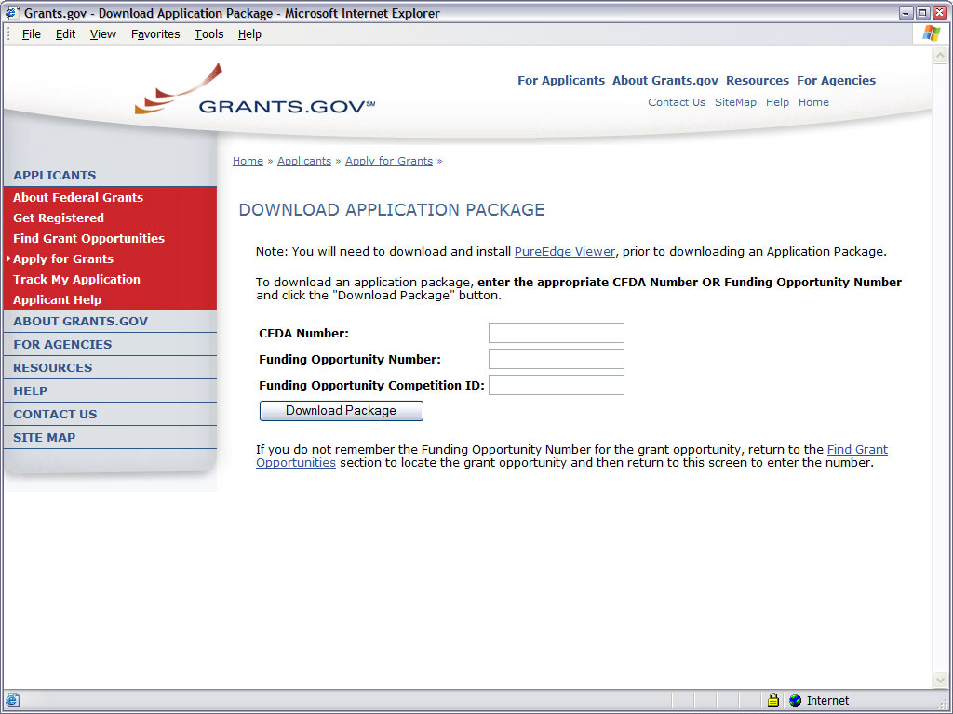
A Funding Opportunity Number is referenced in every announcement. It may be called a Program Announcement (PA) Number or a Request for Application (RFA) Number. Enter this number in the Funding Opportunity Number field and click “Download Package.” This takes you to a “Selected Grant Applications for Download” screen. If you searched only on a specific opportunity number, only one announcement is provided in the chart. Click the corresponding “download” link to access the actual application form pages and instruction material. The following screen appears:
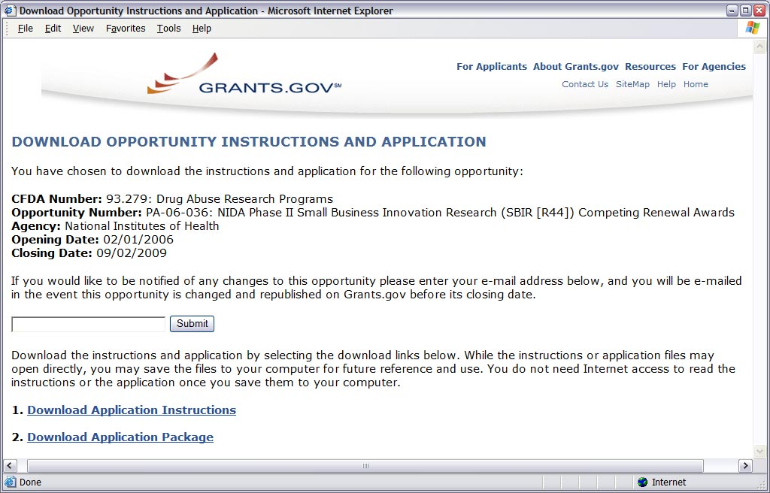
To access the instructions, click “Download Application Instructions.” For NIH opportunities and other PHS agencies using this Application Guide, this action will download a document containing a link to the NIH Web site where the most current set of application instructions is available (http://grants.nih.gov/grants/funding/424/index.htm). Applicants are encouraged to check this site regularly for the most current version.
To access the form pages, click “Download Application Package.” Section 2.5 provides specific information regarding the components of an Application Package. Section 3 provides additional instructions for properly using a package.
On the Download Opportunity Instructions and Applications screen you will be given an opportunity to provide an e-mail address if you would like to be notified of any changes to this particular opportunity. Applicants to NIH and other PHS agencies are strongly encouraged to complete this information. The agency can then use it to provide additional information to prospective applicants.
Note: If multiple CFDA numbers are cited in the FOA, the Download Opportunity Instructions and Applications screen may prefill a CFDA number and description that may not correspond to the Institute/Center of interest to you, or the CFDA information may not appear at all. In either case, do not be concerned since the Center for Scientific Review, NIH does not use the CFDA number for assignment of the application. Be assured the correct CFDA number will be assigned to the record once the appropriate IC assignment has been made.

2.5 Components of an Application to NIH or Other PHS Agencies
The SF424 (R&R) form set is comprised of a number of components, each listed in the table below as a separate “document.” In addition to these components, NIH and other PHS agencies applicants will also complete supplemental components listed as “PHS398” components in the table below.
SBIR/STTR applicants will also complete the “SBIR/STTR Information” component.
Table 2.5-1. Components of an NIH or Other PHS Agencies Application
Document | Required | Optional | Instructions
SF424 (R&R) Cover | x |  | Section 4.2
SF424 (R&R) Project/Performance Site Locations | x |  | Section 4.3
SF424 (R&R) Other Project Information | x |  | Section 4.4
SF424 (R&R) Senior / Key Person Profile(s) | x |  | Section 4.5
SF424 (R&R) Budget | x |  | Section 4.6
SF424 (R&R) Subaward Budget Attachment Form |  | x | Section 4.7
PHS398 Cover Letter |  | x | Section 5.2
PHS398 Cover Page Supplement | x |  | Section 5.3
PHS398 Research Plan | x |  | Section 5.4
PHS398 Checklist | x |  | Section 5.5
SBIR/STTR Information | x |  | Section 5.6
All required and optional forms for electronic submission listed above are available through Grants.gov and should be downloaded from the FOA being applied to. Do not use any forms or format pages from other sources; these may include extraneous headers/footers or other information that could interfere with the electronic application process.

2.6 Format Specifications for Text (PDF) Attachments
Designed to maximize system-conducted validations, multiple separate attachments are required for a complete application. When the application is received by the agency, all submitted forms and all separate attachments are concatenated into a single document that is used by peer reviewers and agency staff.
When using Adobe Acrobat (and possibly other tools), the signature has to be “off” when you create the originals. Please go to the security options menu selection in Adobe to ensure the signature is off. If you do not have the originals, copy the content of the signed documents and create a new document. Save this document without signing it.
Applicants should not submit protected PDF documents. Protected documents prevent NIH from opening and processing the document. Security settings vary by PDF tool, but please ensure security settings are not marked. The applicant needs to look at the Document Security tab under Document Properties (directly from the tab) and set the security parameters to ensure open access so NIH can process the content. For instance, do not password protect the document and do not mark Content Extraction or Copying, Document Assembly, etc. as “Not Allowed.”
If you are having trouble fixing the PDF settings, simply cut and paste from the PDF document into a Microsoft Word document and then reconvert (in some cases it may be better to use another PDF converter).
NIH and other PHS agencies require all text attachments be submitted as PDFs and conform to the agency-specific formatting requirements noted below. Failure to follow these requirements may lead to rejection of the application during agency validation or delay in the review process. (See Section 2.3.2 for more information on creating PDFs.)
Text attachments should be generated using word processing software and then converted to PDF using PDF generating software. Avoid scanning text attachments to convert to PDF since that causes problems for the agency handling the application. Additional tips for creating PDF files can be found at http://era.nih.gov/ElectronicReceipt/pdf_guidelines.htm.
When attaching a PDF document to the actual forms, please note you are attaching an actual document, not just pointing to the location of an externally stored document. Therefore, if you revise the document after it has been attached, you must delete the previous attachment and then reattach the revised document to the application form. Use the “View Attachment” button to determine if the correct version has been attached.
Font
Use an Arial, Helvetica, Palatino Linotype, or Georgia typeface, a black font color, and a font size of 11 points or larger. (A Symbol font may be used to insert Greek letters or special characters; the font size requirement still applies.)
Type density, including characters and spaces, must be no more than 15 characters per inch.
Type may be no more than six lines per inch.
Page Margins
Use standard paper size (8 ½” x 11).
Use at least one-half inch margins (top, bottom, left, and right) for all pages. No information should appear in the margins, including the PI’s name and page numbers.
Page Formatting
Since a number of reviewers will be reviewing applications as an electronic document and not a paper version, applicants are strongly encouraged to use only a standard, single-column format for the text. Avoid using a two-column format since it can cause difficulties when reviewing the document electronically.
Do not include any information in a header or footer of the attachments. A header will be system-generated that references the name of the PD/PI. Page numbers for the footer will be system-generated in the complete application, with all pages sequentially numbered.
Figures, Graphs, Diagrams, Charts, Tables, Figure Legends, and Footnotes
You may use a smaller type size but it must be in a black font color, readily legible, and follow the font typeface requirement. Color can be used in figures; however, all text must be in a black font color, clear and legible.
Grantsmanship
Use English and avoid jargon.
If terms are not universally known, spell out the term the first time it is used and note the appropriate abbreviation in parentheses. The abbreviation may be used thereafter.
Separate Attachments
Separate attachments have been designed for the Research Plan sections to maximize automatic validations conducted by the eRA system. When the application is received by the agency, all of the Research Plan sections will be concatenated in the appropriate order so that reviewers and agency staff will see a single cohesive Research Plan.
While each section of the Research Plan needs to eventually be uploaded separately, applicants are encouraged to construct the Research Plan as a single document, separating sections into distinct PDF attachments just before uploading the files. In this way the applicant can better monitor formatting requirements such as page limits. When validating for page limits, the eRA Commons will not count the white space created by breaking the text into separate files for uploading.
Page Limits
Although many of the sections of this application are separate text (PDF) or PureEdge attachments, page limitations referenced in these instructions and/or funding opportunity announcement must still be followed. Agency validations will include checks for page limits. Some accommodation will be made for sections that when combined must fit within a specified limitation. Note that while these computer validations will help minimize incomplete and/or non-compliant applications, they do not replace the validations conducted by NIH staff. Applications found not to comply with the requirements may lead to rejection of the application during agency validation or delay in the review process.
All applications and proposals for NIH and other PHS agency funding must be self-contained within specified page limitations. Unless otherwise specified in an NIH solicitation, Internet website addresses (URLs) may not be used to provide information necessary to the review because reviewers are under no obligation to view the Internet sites. Moreover, reviewers are cautioned that they should not directly access an Internet site as it could compromise their anonymity. Observe the page number limitations given in Table 2.6-1.
Table 2.6-1. Page Limitations and Content Requirements
Section | Page Limit | Content
Introduction  - New applications  - Resubmission applications  - Resubmission Phase I  SBIR/STTR applications  - Revision applications | Not required/Not to be submitted  3  1  1 | See Instructions
Research Plan  - Sections 2-5  - Sections 6-17 | Phase I SBIR/STTR: 15 pages  Phase II SBIR/STTR: 25 pages  Fast-Track SBIR/STTR: 25 pages  none | Text including all figures, charts, tables, and diagrams.  For Sections 2-5 of a Fast-Track application, Phase I and Phase II plans must be contained within the 25 page limitation.
Biographical Sketches | 4 | No more than four pages for each person listed as Senior/Key Persons.
Appendix | none  Phase I SBIR/STTR: Not permitted unless specifically requested by NIH. | New requirements effective 1/3/2007. See Instructions for specifics.  Generally limited publications are allowed now only in certain situations. Only questionnaires and other materials are allowed.
FOAs (PAs and RFAs) | Page limitations specified in the PA and RFA announcement in the NIH Guide take precedence. | See specific instructions in FOAs (PAs and RFAs) published in the NIH Guide and Grants.gov.

2.7 “Resubmission” (Revised) Applications
NIH allows the submission of up to two revised applications (now known as “Resubmission” applications) and no longer restricts those submissions to a two-year timeframe. See NIH Policy on Resubmission Applications in Part III.
NIH has established new policies for application resubmissions of certain categories. See Resubmission of Unpaid RFA Applications and Resubmission of Applications with a Changed Grant Activity Mechanism in Part III.
Before a resubmission application can be submitted, the Program Director/Principal Investigator (PD/PI) must have received the Summary Statement from the previous review.
Acceptance of a resubmission application will not automatically withdraw the prior version. As of February 2008, eRA keeps all versions (e.g., 01, A1, A2) of a grant application active and provides an internal MAA (“Multiple Active Applications” flag for each application in an active cluster. The cluster allows applicants to identify quickly all versions of one application. If any version in a cluster is awarded, application will notice that all other applications within the cluster will be automatically withdrawn without any additional action by applicants or staff.
Introduction to Resubmission Application. The resubmission must include a brief Introduction of not more than three pages (one page limitation for SBIR and STTR Phase I resubmission) that summarizes the substantial additions, deletions, and changes. The Introduction must also include responses to the criticisms and issues raised in the Summary Statement. Use Item 2.1, Introduction to Application, of the PHS 398 Research Plan component to provide this information.
Research Plan of Resubmission Application. A resubmission application must include substantial changes. Identify the changes in each section of the Research Plan clearly by bracketing, indenting, or changing typography, unless the changes are so extensive as to include most of the text. This exception should be explained in the Introduction. Do not underline or shade changes. The Preliminary Studies/Progress Report section should incorporate any work done since the prior version was submitted.
Application processing may be delayed or the application may be returned if it does not comply with all of these requirements.
Investigators who have submitted three versions of an application and have not been successful often ask NIH staff how different the next application submitted needs to be, as it will be considered a new application. It is recognized that investigators are trained in a particular field of science and are not likely to make drastic changes in their research interests. However, a new application following three reviews is expected to be substantially different in content and scope with more significant differences than are normally encountered in a resubmission application. Simply rewording the title and Specific Aims or incorporating minor changes in response to comments in the previous Summary Statement does not constitute a substantial change in scope or content. Changes to the Research Plan should produce a significant change in direction and approach for the research project. Thus, a new application would include substantial changes in all sections of the Research Plan, particularly the Specific Aims and the Research Design and Methods sections.
In the referral process, NIH staff look at all aspects of the application, not just the title and Project Summary/Abstract. Requesting review by a different review committee does not affect the implementation of this policy. When necessary, previous applications are analyzed for similarities to the present one. Thus, identical applications or those with only minor changes will not be accepted for review.

2.8 “Revision” (Competing Supplemental) Application
A competing supplemental application (now known as a “Revision” application) may be submitted to request support for a significant expansion of a project’s scope or research protocol. Applications for revisions are not appropriate when the sole purpose is to restore awards to the full SRG-recommended level if they were administratively reduced by the funding agency. A revision application should not be submitted until after the original application has been awarded and may not extend beyond the term of the current award period.
Provide a one-page “Introduction” that describes the nature of the supplement and how it will influence the specific aims, research design, and methods of the current grant. Use Item 2.1. Introduction to Application, of the PHS 398 Research Plan component to provide this information. Any budgetary changes for the remainder of the project period of the current grant should be discussed in Section K., Budget Justification, of the Research and Related Budget component. The body of the application should contain sufficient information from the original grant application to allow evaluation of the proposed supplement in relation to the goals of the original application.
If the revision application relates to a specific line of investigation presented in the original application that was not recommended for approval by the SRG, then the applicant must respond to the criticisms in the prior Summary Statement, and substantial revisions must be clearly evident and summarized in the “Introduction.”
Administrative “Revisions” (a.k.a. Supplements)
An administrative supplement provides additional funding to meet increased costs that are within the scope of your approved application, but were unforeseen when the new or competing renewal (formerly “competing continuation”) application was submitted. If you are contemplating supplemental funding, you must consult in advance with your designated Grants Management Officer and Program Official. It is important for you to submit a request before your grant expires. To be considered for an administrative supplement, you must submit a request in writing to the IC (not to CSR), signed by the authorized Business Official, describing the need for additional funding and the categorical costs. In your letter, also be sure to point out what you will NOT be able to accomplish if such a request is denied. At this time, administrative revisions/supplements will not be submitted through Grants.gov.

2.9 Similar, Essentially Identical, or Identical Applications
Submissions of identical applications to one or more components of the PHS are not allowed.
The NIH will not accept similar grant applications with essentially the same research focus from the same applicant organization. This includes derivative or multiple applications that propose to develop a single product, process or service that, with non-substantive modifications, can be applied to a variety of purposes. Likewise, identical or essentially identical grant applications submitted by different applicant organizations will not be accepted. Applicant organizations should ascertain and assure that the materials they are submitting on behalf of the principal investigator are the original work of the principal investigator and have not been used elsewhere in the preparation and submission of a similar grant application. Applications to the NIH are grouped by scientific discipline for review by individual Scientific Review Groups and not by disease or disease state. The reviewers can thus easily identify multiple grant applications for essentially the same project. In these cases, application processing may be delayed or the application(s) may be returned to the applicant without review.
Essentially identical applications will not be reviewed except for: 1) individuals submitting an application for an Independent Scientist Award (K02) proposing essentially identical research in an application for an individual research project; and 2) individuals submitting an individual research project identical to a subproject that is part of a program project or center grant application.

2.10 Submitting Your Application Via Grants.gov
The Applicant Organizational Representative (AOR) registered in Grants.gov is the only official with the authority to actually submit applications through Grants.gov. Therefore, PDs/PIs will need to work closely with their AORs to determine that all the necessary steps have been accomplished prior to submitting an application. This includes any internal review process required by the applicant organization.
Before starting the final submission step, applicants are encouraged to save a copy of the final application locally. Once all required documents are properly completed and the application has been saved, the “Submit” button will become active. Click the “Submit” button to submit the application to Grants.gov. A confirmation page will appear asking for verification that this is the funding opportunity and Agency to which you want to submit an application. Applicants should review the provided application summary to confirm that the application will be submitted to the intended program. Click the “Yes” button if this information is correct and you are ready to submit the application. If not already connected to the Internet, applicants will be directed to do so. Log in to Grants.gov using the username and password that was established in the Register with Grants.gov process.
Once logged in, the application package will be automatically uploaded to Grants.gov. A confirmation screen will appear once the upload is complete and a Grants.gov Tracking Number will be provided on this screen. Applicants should record this number so that they may refer to it should they need to contact Grants.gov Customer Support.
For additional information, access Grants.gov/Submit Application Package (http://grants.gov/SubmitApplication).
Note, on-time submission of an application is currently a 2-step process: 1) accepted by Grants.Gov on or before 5 p.m. local time (of the applicant institution/organization) on the submission date; and 2) reviewed within two business days of the image being available in Commons. Note, the image is available only once all errors are corrected. For a limited time during the transition period, NIH provides a window of two weekdays (Monday-Friday, excluding Federal holidays) for correction of any validation errors after initial submission. Note that this has recently been changed from the previous 5-day window available for making corrections, and please refer to the NIH Guide for Grants and Contracts for more information and updates on the eventual elimination of the current two-day window.

2.11 After You Submit Your Application Via Grants.gov
The Authorized Organizational Representative (AOR) can use Grants.gov to check the status of an application at any time. Note that Grants.gov requires a user login and password. To check the status of an application, go to https://apply.grants.gov/ApplicantLoginGetID.
Once an application has been submitted via Grants.gov, several emails are generated by Grants.gov and sent to the AOR (also known as the Signing Official [SO]) named in the grant application indicating a Grants.gov tracking number that is assigned to the submission:
1) Submission Receipt: An email is sent indicating your application has been received by Grants.gov and is currently being validated.
2) Submission Validation Receipt: An email is sent indicating your application has been received and validated by Grants.gov and is being prepared for Grantor agency retrieval.
3) Grantor Agency Retrieval Receipt: An email is sent indicating your application has been retrieved by the Grantor agency.
4) Agency Tracking Number Assignment for Application: An email is sent indicating your application has been assigned an Agency Tracking Number.
If the AOR/SO has not received a confirmation message from Grants.gov within 2 business days of submission, please contact:
Grants.gov Contact Center
Telephone: 1-800-518-4726
Email: support@grants.gov
At that point, the application will be scheduled for download into the eRA system for agency validation. It is imperative that the email address provided in blocks 15 for the PD/PI and 19 for the AOR/SO on the SF424 (R&R) Cover component be current and accurate. Once agency validation is completed, an agency notification (not Grants.gov) will be emailed to the PD/PI and AOR/SO named in the application.
This email notification will inform the PD/PI and AOR/SO that the application has been received and processed by the agency and will indicate whether any errors or warnings resulted during the validation process. The PD/PI and AOR/SO will be invited to log on the eRA Commons, to view the application or review the list of warnings/errors that were encountered during the validation process.
If you cannot see the status of your application in the eRA Commons, it may be that the application did not contain a valid Program Director/Principal Investigator (PD/PI) eRA Commons user ID. This field is not marked as required on the government-wide form, but it is required by NIH.
Action: Check the 'Credential, e.g., agency login:' field in the 'Profile - Program Director/Principal Investigator' section of the Senior/Key Person Profile(s) component of your application to ensure a valid PD/PI eRA Commons user ID was included and entered in all capital letters. It is important to include the PD/PI user ID and not the Signing Official (SO) user ID in this field. You will need to submit the corrected application through Grants.gov in order to view application status in the eRA Commons.
Be sure to check the Changed/Corrected application box in the Type of Submission field of the SF 424 (R&R) cover component. Once that box is checked you will notice that Grants.gov will require data in the Federal Identifier field. If you are submitting a new project application (including corrected submissions for new applications) simply enter “N/A” in this field. For a continuation, revision, or renewal application, enter the assigned Federal Identifier number or award number (e.g., 1 R01 CA 123456-01).
If there were no validation errors, this email notification will also inform the PD/PI and AOR/SO of an agency accession number, which represents the “agency tracking number.” This number replaces the Grants.gov tracking number that was assigned when the application was first submitted. The Grants.gov system will indicate that the agency tracking number has been assigned, and will reflect both numbers. In subsequent interaction with the eRA Commons, however, it is the agency accession number that will be used to refer to the application, not the Grants.gov tracking number.
The eRA system will make every effort to send an email to the PD/PI and AOR/SO summarizing download and validation results. However, since email can be unreliable, applicants are strongly encouraged to periodically check on their application status in the Commons.
Once an application package has been successfully submitted through Grants.gov, all errors are corrected and an application has been assembled by the eRA Commons, PDs/PIs and AORs/SOs will have two weekdays (Monday – Friday, excluding Federal holidays) to view the application. If everything is acceptable, no further action is necessary. The application will automatically move forward to the Division of Receipt and Referral in the Center for Scientific Review for processing after two weekdays, excluding Federal holidays. (Note, the previous PI & SO Verification steps have been eliminated effective with submissions made on/after May 10, 2006.)
If, however, it is determined that some part of the application was lost or did not transfer correctly during the submission process, the AOR/SO will have the option to “Reject” the application and submit a Changed/Corrected application. In these cases, please contact the eRA Help Desk to ensure that the issues are addressed and corrected. Once rejected, applicants should follow the instructions for correcting errors in Section 2.12, including the requirement for cover letters on late applications.
The “Reject” feature should also be used if you determine that warnings are applicable to your application and need to be addressed now. Remember, warnings do not stop further application processing. If an application submission results in warnings (but no errors), it will automatically move forward after two weekdays (Monday – Friday, excluding Federal holidays) if no action is taken. Some warnings may need to be addressed later in the process.
PIs should work with their AOR/SO to determine when the “Reject” feature is appropriate.
To view the assembled application the AOR/SO should:
1. Login to the eRA Commons (https://commons.era.nih.gov/commons/) with your Signing Official (SO) account.
2. Click the Status tab on the Commons menu bar.
3. Click Recent/Pending eSubmissions on the left-hand side of the screen.
4. Search for your application by date received, grants.gov tracking number, or accession number, to view a hitlist of available applications.
5. When you find the appropriate application, click the accession number in the Application ID column to view the status information screen.
6. Click e-Application from the Other Relevant Documents section to view the assembled application.
Note: The SO can Reject the application by clicking on the Reject eApplication hypertext link from the Action Column of the search hit list.
To view the assembled application the PD/PI should:
1. Login to the eRA Commons (https://commons.era.nih.gov/commons/) with your Principal Investigator (PI) account.
2. Click the Status tab on the Commons menu bar.
3. Click Recent/Pending eSubmissions near the top of the screen to view a hitlist of available applications.
4. When you find the appropriate application, click the accession number in the Application ID column to view the status information screen.
5. Click e-Application from the Other Relevant Documents section to view the assembled application.

2.12 Correcting Errors
Prior to a specified submission date, applicants may make corrections and resubmit a corrected application through Grants.gov. After a specified submission date, if applicants make corrections and resubmit, the application will be considered late. In this case, applicants must include a cover letter explaining the reasons for the delay. Also see Section 2.14 for additional information on submission dates.
If validation errors or warnings result from the validation process, the PD/PI and AOR/SO will be issued an email instructing them to log on to the eRA Commons to review the list of warnings/errors that were encountered during the validation process. The eRA system will make every effort to send an email to the PD/PI and AOR/SO indicating whether errors or warnings were detected. However, since email can be unreliable, applicants are strongly encouraged to periodically check on their application status in the eRA Commons, so that any errors or warnings can be resolved in the timeliest manner possible.
Please be aware of the distinction between errors and warnings. The word error is used to characterize any condition which causes the application to be deemed unacceptable for further consideration. Generally, errors will indicate significant inaccuracies, inconsistencies, omissions, or incorrect formatting that have been identified in the body of the application. Conversely, the word warning characterizes any condition that is acceptable, but worthy of bringing to the applicant’s attention. It is at the applicant’s discretion whether a warning condition requires any action.
Error conditions must be corrected, and then the application may be submitted as a changed/corrected application (as outlined below) in order for the application to be accepted. Please note that if validation has identified warnings only, then the PD/PI and SO will be allowed to view the application. Warnings do not require any action or submission of a changed/corrected application at this time. However, please be aware that some warnings may need to be addressed later in the process or review stages. Failure to comply with stated NIH policies can also result in a submitted application being returned to the applicant without review. For this reason, applicants are strongly encouraged to review all warnings, to ensure that they require no further attention and that they are satisfied with the validation results. If desired, warnings can be corrected in the same manner as errors.
A changed/corrected application may also be submitted if the PDF image, as viewed in the eRA Commons is incomplete or inaccurate from that submitted.
Errors and warnings may be reviewed in the Commons by performing the following steps:
1. After the application has been downloaded from Grants.gov and validated by the system, access the eRA Commons (https://commons.era.nih.gov/commons/).
2. Click the Status tab on the Commons menu bar.
3. Click Recent/Pending eSubmissions on the left-hand side of the screen.
4. Search for your application by date received, grants.gov tracking number, or accession number.
5. A hit list of application numbers is displayed. If the application was validated with warnings only, or without encountering any problems whatsoever, then it is identified in the hit list by its NIH accession number (e.g., “AN:2911064”). This is the same number that Grants.gov displays, and refers to as the “agency tracking number.”
If any errors were identified during validation, then the application still appears in the hit list, but in this case it is identified by its Grants.gov tracking number (e.g., “GRANT12345678”). This is the number that Grants.gov assigned to your application at the time of submission.
6. When you find the appropriate application in the hit list, click its application link.
7. The error/warning page appears, and you are then able to review all conditions that were identified during validation. If only warnings were identified, you may elect to take action and resubmit; however you may accept the warnings and proceed to view the application, as described earlier.
To correct errors and resubmit the application:
- Make whatever corrections are necessary, wherever appropriate. Most often this means that you have to edit the data within the application forms to correct whatever problem or inconsistency that was noted.
- Check the “Changed/Corrected Application” box in block 1 of the SF424 (R&R) Cover component.
- If submitting after the submission date, include an explanation in the Cover Letter Component.
- When you check the Changed/Corrected Application box, Item 4. Federal Identifier becomes a required field.
- When submitting a Changed/Corrected Application for a “New” Type of Application (Item 8 = New), in the Federal Identifier field (Item 4) enter the Grants.gov tracking number for the previous application that you are correcting. If you are unable to recall the Grants.gov tracking number, enter “N/A.”
- When submitting a Changed/Corrected Application for a “Resubmission,” “Renewal,” or “Revision” Type of Application (Item 8 = Resubmission, Renewal, or Revision), in the Federal Identifier field (Item 4) enter the previously assigned grant number (e.g., CA123456).
- Do not use the Changed/Corrected Application box to denote a submission of a revised or amended application. That will be indicated in item 8, Type of Application.
- Have the AOR/SO submit the revised application package to Grants.gov again.
The same email notifications will be issued once the agency has downloaded and validated the re-submitted application and the PD/PI and AOR/SO will once again be required to log on to the Commons either to view the application, or to review the errors that were encountered during validation.
The application will only be assigned for scientific review once errors are resolved.
In addition to the validations performed by the eRA system, further administrative review will be conducted by agency staff. The PD/PI and/or the applicant organization may be contacted for further corrections/clarifications.

2.13 Submission of Supplementary or Corrective Information
Unless specifically required by these instructions (e.g., vertebrate animals verification), do not send supplementary or corrective material after the submission date unless the Scientific Review Officer (SRO) of the Scientific Review Group solicits or agrees to accept this information. Such additional information will be sent directly to the SRO and will not be submitted through Grants.gov.

2.14 Application Submission Dates
For electronic submission through Grants.gov, each FOA posted in Grants.gov Apply includes an Opportunity Open Date and an Opportunity Close Date. Many announcements, including those using the “Standard Submission Dates” noted in Table 2.15-1 below, include multiple submission/receipt dates and are active for several years. These announcements are posted in Grants.gov showing an Open/Close period that spans the entire active period of the announcement. Applicants should read the Funding Opportunity Announcement carefully for specific submission/receipt dates. If specific dates are not referenced in the announcement, applicants should refer to the Standard Submission Dates for Competing Applications noted in Table 2.15-1.
Applications submitted for the Standard Submission Dates listed in Table 2.15-1 are considered on time if they are submitted to Grants.gov on or before the appropriate date listed. When multiple submission dates are included in a specific FOA, applications submitted for Special Receipt Dates listed in a FOA are considered on time if they are submitted to Grants.gov on or before the appropriate date listed. When only a single submission date is referenced in the FOA, the Closing Date noted in Grants.gov Apply will be that submission date. In this case, applications are considered on time if they are submitted to Grants.gov on or before the Grants.gov posted Closing Date.
Weekend/ Federal Holiday Submission Dates. If a submission date falls on a weekend, it will be extended to the following Monday; any time the date falls on a Federal holiday, the submission date will be extended to the following business day. The application will be on time if it is submitted on or before the following business day.
Late Applications. Permission is not granted in advance for submission of a late application. Late applications are accepted only in extenuating circumstances. If an application is submitted late, use the optional PHS 398 Cover Letter component to explain the reasons for the delay and include this component with the completed application. Late applications are evaluated on an individual basis considering the reasons provided. Contacting the Division of Receipt and Referral, Center for Scientific Review (CSR), NIH in advance will not influence the acceptance of a late application. For additional information on late applications, see http://grants.nih.gov/grants/guide/notice-files/NOT-OD-06-086.html.

2.15 Submission, Review and Award Cycles
The PHS submission, review, and award schedule is provided in Table 2.15-1. For specialized grant applications, consult with the appropriate PHS agency prior to the preparation of an application.
Table 2.15-1. Submission Dates, Review, and Award Cycles
New Schedule effective January 3, 2007 | Receipt Cycle I | Receipt Cycle II |  | Receipt Cycle III
Small Business Innovation Research (SBIR),  Small Business Technology Transfer (STTR) Grants – R41, R42, R43 and R44  new, renewal, resubmission, revision* | April 5  (old date  April 1) | August 5  (old date August 1) | December 5  (old date December 1)
AIDS and AIDS-Related Grants  All (including SBIR/STTR)  new, renewal, resubmission, revision* | May 7 | September 7 | January 7
NOTE: RFAs and some PARs have special receipt dates indicated in the specific NIH Guide Announcement.
* Change in Terminology: The move to electronic applications has brought a change in terminology. The new Grants.gov terminology (included in the table above) corresponds to the traditional NIH terms as follows:
New = New
Resubmission = A Revised or Amended application
Renewal = Competing Continuation
Continuation = Noncompeting Progress Report
Revision = Competing Supplement
Review and Award Cycles: | Cycle I | Cycle II | Cycle III
Scientific Merit Review | June - July | October - November | February - March
Advisory Council Review | September - October | January - February | May - June
Earliest Project Start Date | December | April | July
Note: Awarding components may not always be able to honor the requested start date of an application; therefore, applicants should make no commitments or obligations until confirmation of the start date by the awarding component.

Application Assignment Information
Competing grant applications that have been successfully submitted through Grants.gov (including correcting all errors and the grant application assembled by the eRA Commons system) will be processed through the Division of Receipt and Referral, CSR, NIH unless otherwise stated. The application will be assigned to an appropriate Scientific Review Group and awarding component(s). Assignment is based on the scientific content of the application using established referral guidelines. Business rule validations are conducted by the system as well as NIH staff.
Assignment to Review Group. The Center for Scientific Review (CSR) will assign appropriately completed applications to the Scientific Review Groups (commonly referred to as “SRGs” or “study sections”) that will perform the scientific/technical merit review. The CSR lists the recurring review panels (https://cms.csr.nih.gov/PeerReviewMeetings/CSRIRGDescription/), and you may suggest a specific group in the PHS 398 Cover Letter component.
Assignment to Relevant Potential Awarding Component(s) (Institutes/Centers (ICs)). In addition, CSR will assign each application to the agency awarding component that is the potential funding component. When the scientific areas and the research proposed in a grant application are sufficiently relevant to the program responsibilities of two or more awarding components, CSR may assign your application to all such components. The component that has the most relevant program responsibility is designated as the primary assignee. The other components that have an interest in your application are designated as secondary assignees. If your application is eligible for funding and the primary assignee does not intend to make an award, the secondary assignees will be given the opportunity to do so. Although these suggestions will be taken into consideration, the final determination will be made by the agencies participating in this solicitation.
After the submission date, usually within two (2) weeks, the PD/PI and the applicant organization will be able to access in the eRA Commons the application’s assignment number; the name, address, and telephone number of the Scientific Review Officer of the Scientific Review Group to which the application has been assigned; and the assigned Institute contact and phone number. Review outcome and other important information is also available in the Commons.
If assignment information is not available in the eRA Commons within two weeks of the submission date, contact the Division of Receipt and Referral, Center for Scientific Review (CSR), National Institutes of Health, Bethesda, MD 20892-7720, (301) 435-0715; TTY (301) 451-0088. If there is a change in assignment, you will receive a notification.
Applicant investigators must not communicate directly with any review group member about an application either before or after the review. Failure to strictly observe this policy will create serious breaches of confidentiality and conflicts of interest in the peer review process. From the time of assignment to the time the review of your application is complete, applicant investigators must direct all questions to the Scientific Review Officer. This individual is in charge of the review group and is identified in your assignment notice.

2.16 Resources for Finding Help

2.16.1 Finding Help for Grants.gov Registration or Submissions
If help is needed with the Grants.gov registration process or with the technical aspects of submitting an application through the Grants.gov system, check first the resources available at Grants.gov (http://grants.gov/).
Grants.gov customer support is also provided by the following office:
Grants.gov Program Management Office
200 Independence Avenue, SW
HHH Building, Room 739F
Washington, DC 20201
Grants.gov Helpdesk: support@grants.gov
Grants.gov Contact Center Phone Number: 1-800-518-4726
The Contact Center’s hours of operation are Monday-Friday from 7:00 a.m. to 9:00 p.m. Eastern Time.

2.16.2 Finding Help for the eRA Commons Registration or
eRA Commons Validation Processes
If help is needed with the eRA Commons registration process for the applicant organization and PDs/PIs or with the application validation process in the Commons after submission through Grants.gov, check first the resources available at Electronic Submission of Grant Applications (http://era.nih.gov/ElectronicReceipt/).
eRA Commons customer support is also provided by the eRA Commons Helpdesk:
eRA website: http://era.nih.gov
eRA Commons website: https://commons.era.nih.gov/commons/index.jsp
eRA Commons Helpdesk Email: commons@od.nih.gov
eRA Commons Phone: 301-402-7469
866-504-9552 (Toll Free)
301-451-5939 (TTY)
The eRA Commons Helpdesk hours of operation are Monday-Friday from 7:00 a.m. to 8:00 p.m. Eastern Time.

2.16.3 Finding Help for Application Preparation
If after reviewing this application instruction guide, help is still needed in preparing the application, contact GrantsInfo:
GrantsInfo Phone: 301-435-0714
301-451-0088 (TTY)
GrantsInfo Email: GrantsInfo@nih.gov

2.16.4 Finding Help for SBIR/STTR Specific Inquiries
Questions of a general nature about the NIH SBIR/STTR program should be directed to:
Ms. Jo Anne Goodnight Phone: 301-435-2688
NIH SBIR/STTR Program Email: sbir@od.nih.gov
Coordinator Fax: 301-480-0146
6705 Rockledge Drive
Rockledge I, Room 3534
Bethesda, MD 20892-7963
Ms. Kay Etzler Phone: 301-435-2713
Email: sbir@od.nih.gov
Fax: 301-480-0146
SBIR/STTR Help Desk Email: sbirsttr@peacetech.com

3. Using the Grant Application Package
This section describes the steps an applicant takes once the appropriate FOA (see Section 2.4) has been located and the corresponding grant application package has been successfully downloaded. Note when you “Save” the package locally for the first time, you will receive an error message indicating “One or more of the items in this form contains an invalid value. Do you want to proceed anyway?” Applicants should always answer “Yes.” This error message shows because no data has been entered yet. In fact, applicants will get this or a similar message every time the package is saved until all data entry is completed. Applicants can ignore this error message until the final save before the application is submitted. When an application is ready to be submitted, if this error message is still shown, applicants are encouraged to use the “Check Package for Errors” button to determine what needs to be corrected. When errors are found, a message box will appear indicating the total number of errors found and the details about the first one. Unfortunately there is no way to get a comprehensive list at this time. For instance, if five errors are found, the first one will need to corrected, and then repeat the “check package for errors” process until all are corrected.
Note the “Check Package for Errors” button only checks errors in the actual PureEdge forms. It does not check the forms for data errors against NIH business processes. Those validations will be performed by the eRA Commons system after the application has been submitted.

3.1 Verify Grant Information
When you select a funding opportunity in Grants.gov Apply, verify that the information shown in the Grant Application Package screen corresponds to the funding opportunity for which you wish to apply. Grants.gov auto-populates the following information:
- Opportunity Title
- Offering Agency
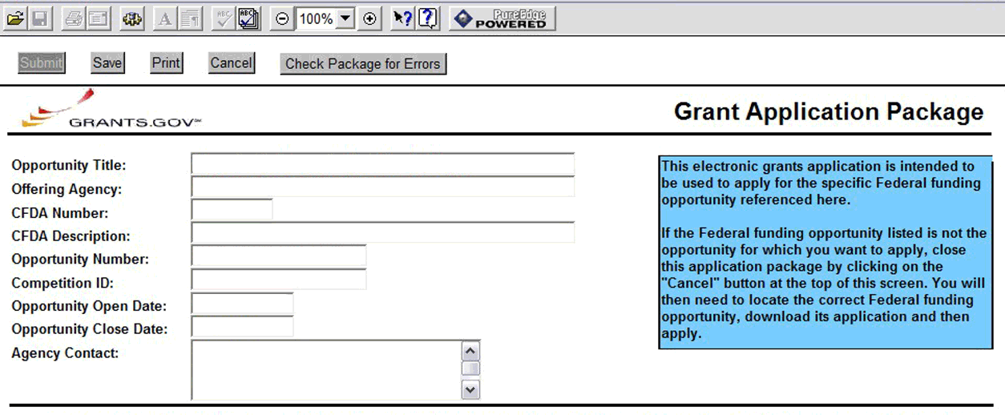
- CFDA Number
- CFDA Description
- Opportunity Number
- Competition ID
- Opportunity Open Date
- Opportunity Close Date
- Agency Contact
CFDA Number Field: Many FOAs include multiple CFDA (Catalog for Domestic Assistance) numbers. When this is the case, the CFDA Number and CFDA Description fields will appear blank in the Grants.gov Grant Application Package screen shown above. The appropriate CFDA number will be automatically assigned once the application is assigned to the appropriate agency awarding component.
Opportunity Open Date & Close Date Fields: Many FOAs posted by NIH and other PHS agencies include multiple submission/receipt dates and are active for several years. These announcements are posted in Grants.gov showing an Open/Close period that spans the entire active period of the announcement. Applicants should read the funding opportunity announcement carefully for specific submission/receipt dates. If specific dates are not referenced in the announcement, applicants should refer to the Standard Postmark/Submission Dates for Competing Applications found in Table 2.15-1. Submission Dates, Review, and Award Cycles. Applications submitted after a posted submission date will be held over into the next review cycle. See also Section 2.14 above for the late application policy.

3.2 Enter the Name for the Application
Enter a name for the application in the Application Filing Name field (this is a required field). This name is for use solely by the applicant for tracking the application through the Grants.gov submission process. It is not used by the receiving agency.

3.3 Open and Complete Mandatory Documents
Open and complete all of the documents listed in the Mandatory Documents box. Complete the component titled SF424 (R&R) first. Data entered in this component populates other mandatory and optional forms where applicable.
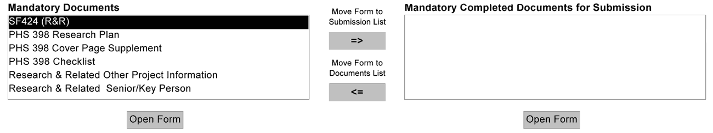
To open an item:
1. Click the document name in the Mandatory Documents box.
2. Click Open Form.
3. When a form or document has been completed, click the document name to select it, and then click the => button. This moves the form/document to the Completed Documents box. To remove a document from the Completed Documents box, click the document name to select it, and then click the <= button. This returns the document to the Mandatory Documents or Optional Documents box.

3.4 Open and Complete Optional Documents
These documents can be used to provide additional information for the application or may be required for specific types of grant activities. Information on each of these documents is found later in these instructions.
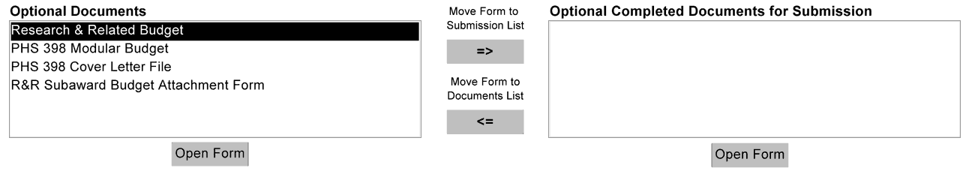

3.5 Submitting the Application via Grants.gov
Once all documents have been completed and saved locally, click Submit to submit the application to Grants.gov. Only an AOR will be able to perform the submit action, and will be prompted to enter username and password to verify his/her identity. The Submit button does not become active until all required documents have been properly completed and the application has been saved. If an edit has been made somewhere in the application package, the file must be resaved before attempting to submit. If the Submit button is grayed out, resave the file. Reminder, the system will not consider a component form document to be complete until it has been moved to the Completed Documents box. Once you click the Submit button, a confirmation page appears asking you to verify the desired funding opportunity and Agency to which the application is being submitted.

4. Completing the SF424 Research and Related (R&R) Forms

4.1 Overview
This section contains all of the instructions you will need to complete the SF424 (R&R) forms.

Any agency-specific instructions are denoted by the DHHS logo displayed to the left of the paragraph, as illustrated here.
Conformance to all instructions is required and strictly enforced. Agencies may withdraw any applications from the review process that are not consistent with these instructions.
As you navigate through the forms, required fields are highlighted in yellow and noted with an asterisk (*). Optional fields and completed fields are displayed in white. Data entered into a specific field is not accepted until you have navigated to the next field. If you enter invalid or incomplete information in a field, you will receive an error message.
For those form components that are more than one page, click the “Next” button at the top of the form to navigate to a subsequent page. Once all data have been entered, click the “Close Form” button at the top of the form. You will be returned to the Grant Application Package screen. From this main screen, click on the form/document that you have just completed, and then click the => button. This will move the form/document to the Completed Documents box. To remove a form/document from the Completed Documents box, click the form/document name to select it, and then click the <= button. This will return the form/document to the Mandatory Documents or Optional Documents box.

4.2 Cover Component
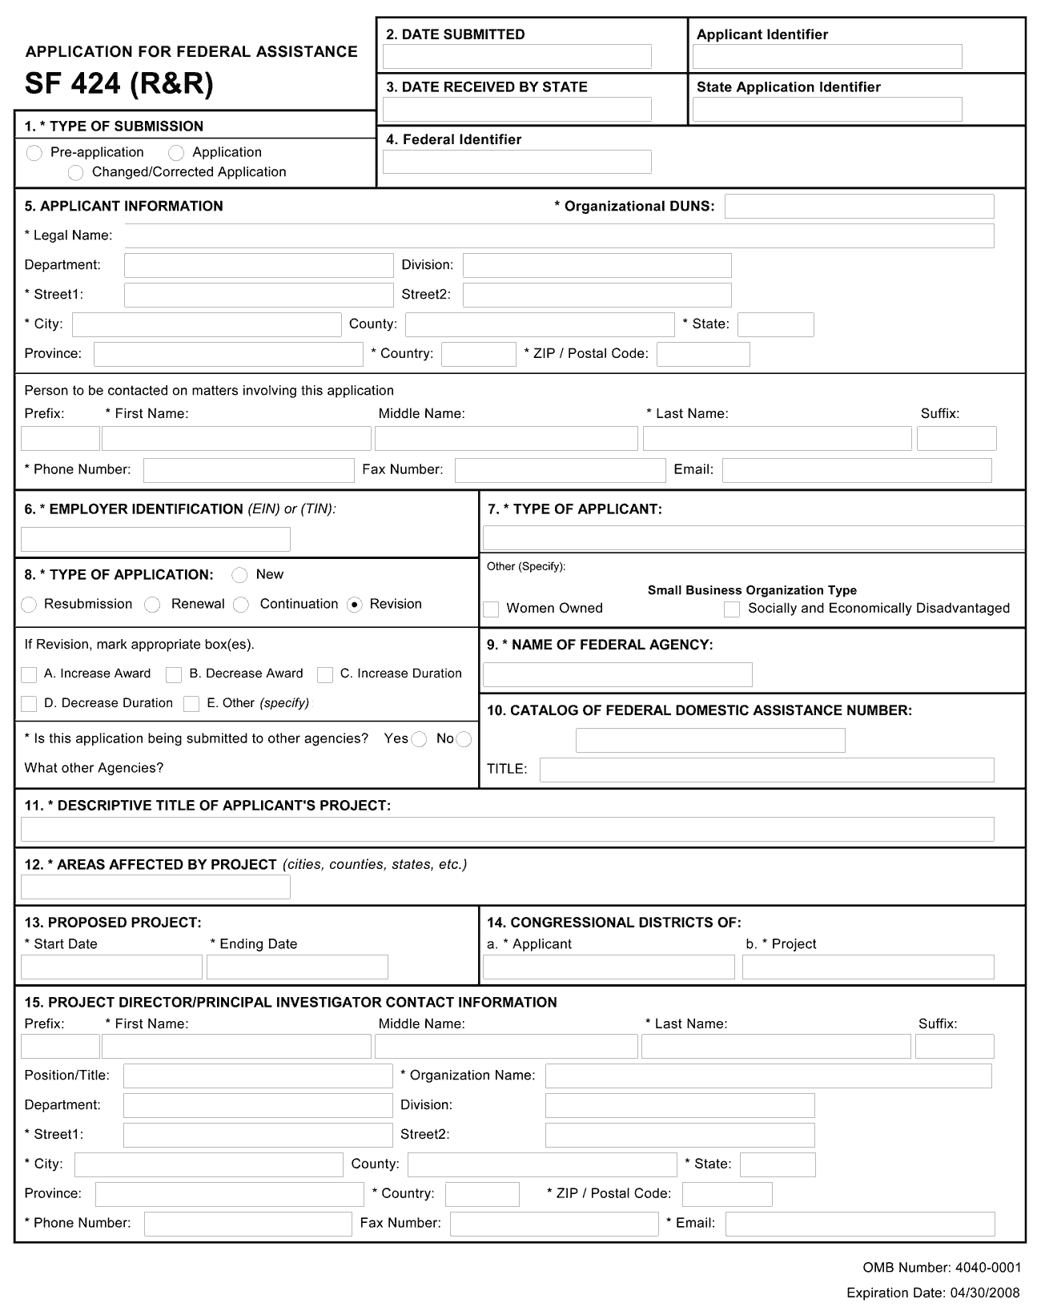
1. Type of Submission
Select Type of Submission. If this submission is to change or correct a previously submitted application, click the Changed/Corrected Application box and enter the Grants.gov tracking number in the Federal Identifier field. Unless requested by the agency, applicants may not use this to submit changes after the closing date. This field is required.
Pre-Application: Unless specifically noted in a program announcement, the Pre-application option is not used by NIH and other PHS agencies.
Changed/Corrected Application: This box must be used if you need to submit the same application again because of corrections for system validation errors or if a portion of the application was lost or distorted during the submission process. This option is for correcting system validation errors only and may not be used to include last minute changes to any of the PDF attachments. When submitting a Changed/Corrected Application:
  - If submitting after the submission date, include an explanation in the Cover Letter Component.
  - When you check the Changed/Correct Application box, Item 4. Federal Identifier becomes a required field.
  - When submitting a Changed/Corrected Application for a “New” Type of Application (Item 8 = New), in the Federal Identifier field (Item 4)) enter the Grants.gov tracking number for the previous application that you are correcting. If you are unable to recall the Grants.gov tracking number, enter “N/A.”
  - When submitting a Changed/Corrected Application for a “Resubmission,” “Renewal,” or “Revision” Type of Application (Item 8 = Resubmission, Renewal, or Revision), in the Federal Identifier field (Item 4) enter the previously assigned grant number (e.g., only CA123456).
  - Do not use the Changed/Corrected Application box to denote a submission of a revised or amended application. That will be indicated in item 8. Type of Application.
SBIR/STTR Phase II applications may be submitted either before or after expiration of the Phase I budget period. However, Phase II grant applications should be submitted no later than the first six submission dates following expiration of the Phase I budget period.
Applicant small business concerns are reminded that Phase II funding is based on the results of Phase I, demonstration of feasibility, scientific, and technical merit, and commercial potential of the Phase II application. Applicants are cautioned that applications demonstrating insufficient results in Phase I may not receive a score in the peer review process.
2. Date Submitted and Applicant Identifier
In the Date Submitted field, enter the date the application is submitted to the Federal agency (or state, if applicable). In the Applicant Identifier field, enter the applicant’s control number (if applicable).
Note the Applicant Identifier field is a control number created by the applicant organization, not the Federal agency.
3. Date Received by State and State Application Identifier
Enter the date received by state (if applicable). In the State Application Identifier field, enter the state application identifier, if applicable.
For submissions to NIH and other PHS agencies, leave these fields blank.
4. Federal Identifier
New project applications should leave this field blank, unless you are submitting a Changed/Corrected application. When submitting a changed/corrected “new” application, enter the Grants.gov tracking number. If this is a resubmission or renewal application, enter the assigned Federal Identifier number (for example, award number) even if submitting a changed/corrected application.
For submissions to NIH and other PHS agencies, an example of a grant number need only be CA123456.
Existing definitions for NIH and other PHS agencies applications are somewhat different:
- New is the same; i.e., an application that is submitted for the first time. See also the policy Resubmission of Unpaid RFA Applications and Resubmission of Applications with a Changed Grant Activity Mechanism.
- Resubmission is equivalent to NIH and other PHS agencies Revision; i.e., a revised or amended application. See also the NIH Policy on Resubmission Applications.
- Renewal is equivalent to NIH and other PHS agencies Competing Continuation.
- Continuation is equivalent to NIH and other PHS agencies Progress Report. For the purposes of NIH and other PHS agencies, the box for Continuation will not be used.
- Revision is somewhat equivalent to NIH and other PHS agencies Competing Supplement. Applicants should contact the awarding agency for advice on submitting any revision/supplement application.
Applicants to NIH and other PHS agencies should complete this field when submitting a resubmission, renewal or revision application. When submitting a “New” application, this field should remain blank unless you are submitting a Changed/Corrected Application. In this case, where Item 1 = Changed/Corrected Application and Item 8 = New, the Federal Identifier field becomes a required field. Therefore you must enter the Grants.gov tracking number assigned to the application that you are correcting. If you are unable to recall the tracking number, enter “N/A.”
5. Applicant Information
This information is for the Applicant Organization, not a specific individual.
The small business concern is ALWAYS the applicant organization for an SBIR or STTR award (e.g., ABC Incorporated).
Field Name | Instructions
Organizational DUNS | Enter your organization’s DUNS or DUNS+4 number.  For submission to NIH and other PHS agencies, this DUNS must match the number entered in the eRA Commons Institutional Profile for the applicant organization. The applicant AOR is encouraged to confirm that a DUNS has been entered in the eRA Commons Institutional Profile prior to submitting an application. If your organization does not already have a DUNS number, you will need to go to the Dun & Bradstreet website at http://fedgov.dnb.com/webform to obtain the number.
Legal Name | Enter the legal name of the applicant which will undertake the assistance activity, enter the complete address of the applicant (including county and country), and name, telephone number, e-mail, and fax of the person to contact on matters related to this application.
Department | Enter the name of the primary organizational department, service, laboratory, or equivalent level within the organization that will undertake the assistance activity.
Division | Enter the name of the primary organizational division, office, or major subdivision that will undertake the assistance activity.
Street1 | Enter the first line of the street address for the applicant in “Street1” field.
Street2 | Enter the second line of the street address for the applicant in “Street2” field. This field is optional.
City | Enter the city/place for address of applicant.
County | Enter the county for address of applicant.
State | Select the state where the applicant is located. This field is required if the applicant is located in the United States.
Province | Enter the province where the applicant is located.
Country | Select the country for the applicant address.  For SBIR/STTR applications, the small business concern must be located in the United States.
ZIP Code | Enter the postal code (e.g., ZIP code) of applicant. This field is required if the applicant is located in the United States. This field is required if a State is selected; optional for Province.

Person to be contacted on matters involving this application:
This information is for the Administrative or Business Official, not the PD/PI. This person is the individual to be notified if additional information is needed and/or if an award is made. To avoid potential errors and delays in processing, please ensure that the information provided in this section is identical to the AO profile information contained in the eRA Commons.
Field Name | Instructions
Prefix | Enter the prefix (e.g., Mr., Mrs., Rev.) for the person to contact on matters related to this application.  See also the PHS398 Cover Page Supplement for additional required contact information.
First Name | Enter the first (given) name of the person to contact on matters relating to this application.
Middle Name | Enter the middle name of the person to contact on matters relating to this application.
Last Name | Enter the last (family) name of the person to contact on matters relating to this application.
Suffix | Enter the suffix (e.g., Jr., Sr., Ph.D.) for the person to contact on matters relating to this application.
Phone Number | Enter the daytime phone number for the person to contact on matters relating to this application.
Fax Number | Enter the fax number for the person to contact on matters relating to this application.
Email | Enter the email address for the person to contact on matters relating to this application.  This is a required field for applications submitted to NIH and other PHS agencies.
6. Employer Identification
Enter the TIN or EIN as assigned by the Internal Revenue Service. If your organization is not in the US, type 44-4444444.
If you have a 12-digit EIN established for grant awards from NIH or other PHS agencies, enter all 12digits (e.g., 1123456789A1).
7. Type of Applicant
This information is for the Applicant Organization, not a specific individual.

Field Name | Instructions
Type of Applicant | Select from the menu or enter the appropriate letter in the space provided.  If Small Business is selected as Type of Applicant, then note if the organization is Woman-owned and/or Socially and Economically Disadvantaged.  For SBIR/STTR applicant organizations, select R. Small Business.  The applicant organization must certify that it will qualify as a small business concern at the time of award.
Other (Specify) | Complete only if X: Other was selected as the Type of Applicant.
Woman Owned | Check the box if you are a woman-owned small business: a small business that is at least 51% owned by a woman or women, who also control and operate it.
Socially and Economically Disadvantaged | Check the box if you are a socially and economically disadvantaged small business, as determined by the US Small Business Administration pursuant to Section 8(a) of the Small Business Act U.S.C. 637(a).
8. Type of Application
Field Name | Instructions
Type of Application | Select the type from the following list. Check only one:  - New: An application that is being submitted to an agency for the first time.  - Resubmission: An application that has been previously submitted, but was not funded, and is being resubmitted for new consideration.  - Renewal: An application requesting additional funding for a period subsequent to that provided by a current award. A renewal application competes with all other applications and must be developed as fully as though the applicant is applying for the first time.  - Continuation: A non-competing application for an additional funding/budget period within a previously approved project period.  - Revision: An application that proposes a change in  1) the Federal Government’s financial obligations or contingent liability from an existing obligation, or  2) any other change in the terms and conditions of the existing award.  Existing definitions for NIH and other PHS agencies Type of Application are somewhat different:  - New is the same. Check this option when submitting an application for the first time. See also the policy Resubmission of Unpaid RFA Applications and Resubmission of Applications with a Changed Grant Activity Mechanism.  - Resubmission is equivalent to NIH and other PHS agencies Revision. Check this option when submitting a revised or amended application. See also the NIH Policy on Resubmission Applications.  - Renewal is equivalent to NIH and other PHS agencies Competing Continuation.  - Continuation is equivalent to NIH and other PHS agencies Progress Report. For the purposes of NIH and other PHS agencies, the box for Continuation will not be used and should not be checked.  - Revision is somewhat equivalent to NIH and other PHS agencies Supplement, but would also include other changes as noted in the definition above. In general, changes to the “terms and conditions of the existing award” (as noted in example 2 above) would not require the submission of another application through Grants.gov. Applicants should contact the awarding agency for advice on submitting any revision/supplement application.  This field also affects how you complete Item 4. Federal Identifier. If “Type of Application” is “New”, you can leave the Federal Identifier field blank on the first submission attempt. However, the Federal Identifier field becomes a required field when submitting a Changed/Corrected application to address errors/warnings. When submitting a Changed/Corrected “New” application, enter the Grants.gov tracking number of the previous submission attempt (e.g. GRANT12345678). If you are unable to find the tracking number, enter “N/A”.  If “Type of Application” is “Renewal”, “Revision” or “Resubmission”, enter the IC and serial number of the prior application/award number (e.g. CA123456). For these types of applications, do not change the Federal Identifier field when submitting Changed/Corrected applications.
If Revision, Enter Appropriate Letter(s) in Box(es) | If application is a revision, check the appropriate box(es):  A. Increase Award  B. Decrease Award  C. Increase Duration  D. Decrease Duration  E. Other  May select more than one.
Other (Specify) | If E. Other was selected as the Revision, enter text to explain.
Is this application being submitted to other agencies? | Check the box, if applicable.
What Other Agencies? | Enter Agency name(s).
9. Name of Federal Agency
This is the name of the Federal agency from which assistance is being requested with this application. This information is pre-populated by Grants.gov.
10. Catalog of Federal Domestic Assistance (CFDA) Number and Title (CFDA)
Use the Catalog of Federal Domestic Assistance number and title of the program under which assistance is requested. This information is pre-populated by Grants.gov.
This field may be blank if you are applying to an opportunity that references multiple CFDA numbers. When this field is blank, leave it blank; the field will not allow any data entry. The appropriate CFDA number will be automatically assigned by the agency once the application is assigned to the appropriate awarding component.
11. Descriptive Title of Applicant’s Project
Enter a brief descriptive title of the project.
A “new” application must have a different title from any other PHS project with the same PD/PI. A “resubmission” or “renewal” application should normally have the same title as the previous grant or application. If the specific aims of the project have significantly changed, choose a new title.
A “revision” application must have the same title as the currently funded grant.
NIH and other PHS agencies limit title character length to 81 characters, including the spaces between words and punctuation. Titles in excess of 81 characters will be truncated.
An SBIR/STTR Phase II application should have the same title as the previously awarded Phase I grant.
12. Areas Affected by Project (Cities, Counties, States, Etc.)
List only the largest political entities affected by the project (for example, state, counties, cities).
Enter “N/A” for not applicable.
13. Start Date and Ending Date
Enter the proposed start date of the project in the Start Date field. Enter the proposed end date in the Ending Date field. Use the following format: MM/DD/YYYY.
Phase I: Routinely, SBIR Phase I awards do not exceed six (6) months and STTR Phase I awards do not exceed one year.
Phase II: Routinely, SBIR and STTR Phase II awards do not exceed two years.
Under special circumstances, applicants to NIH may propose longer periods of time for completion of the research project (e.g., feasibility demonstration). Such requests that deviate from the guidelines must be thoroughly justified. Project duration deviations apply to NIH ONLY, as CDC and FDA do not make awards for periods longer than the stated guidelines.
14. Congressional District Applicant and Congressional District Project
Congressional District – Applicant: Enter the Congressional District in the format: 2 character State Abbreviation – 3 character District Number. Examples: CA-005 for California’s 5th district, CA-012 for California’s 12th district.
If outside the U.S., enter 00-0000.
To locate your congressional district, visit the Grants.gov web site.
Congressional District – Project: Enter the Congressional District in the format: 2 character State Abbreviation – 3 character District Number. Examples: CA-005 for California’s 5th district, CA-012 for California’s 12th district.
If all districts in a state are affected, enter “all” for the district number. Example: MD-all for all congressional districts in Maryland.
If nationwide (all districts in all states), enter US-all.
If the program/project is outside the U.S., enter 00-0000.
To locate your congressional district, visit the Grants.gov web site.
Attach an additional list of Project Congressional Districts on page 2 (Item 21), if needed.
15. Program Director/Principal Investigator (PD/PI) Contact Information
If submitting an application reflecting Multiple PDs/PIs, the individual designated as the Contact PI should be entered here. See Section 4.5 Senior/Key Person Profile Components for additional instructions for Multiple PDs/PIs. To avoid potential errors and delays in processing, please ensure that the information provided in this section is identical to the PD/PI profile information contained in the eRA Commons.
Name the one person responsible to the applicant small business concern for the scientific and technical direction of the project. PHS staff conduct official business only with the named PDs/PIs and organizational/institutional officials. A revision/supplemental application must have the same PD/PI as the currently funded grant.

Field Name | Instructions
Prefix | Enter the prefix (Mr., Mrs., Rev.) for the name of the PD/PI.  See also the PHS398 Cover Page Supplement for additional PD/PI required data.
First Name | Enter the first (given) name of the PD/PI.
Middle Name | Enter the middle name of the PD/PI.
Last Name | Enter the last (family) name of the PD/PI.
Suffix | Enter the suffix (e.g., Jr., Sr., Ph.D.,) for the name of the PD/PI.  Do not use this field to record degrees. Degrees for the PD/PI are requested separately in the PHS398 Cover Page Supplement.
Position/Title | Enter the title of the PD/PI.
Organization Name | Enter the name of the organization for the PD/PI.
Department | Enter the name of the primary organizational department, service, laboratory, or equivalent level within the organization of the PD/PI.
Division | Enter the name of the primary organizational division, office, or major subdivision of the PD/PI.
Street1 | Enter the first line of the street address for the PD/PI. This field is required.
Street2 | Enter the second line of the street address for the PD/PI, if applicable.
City | Enter the city for the address of the PD/PI . This field is required.
County | Enter the county for the address of the PD/PI.
State | Select the state where the PD/PI is located in the United States.
Province | Enter the Province for PD/PI.
Country | Select the country for the PD/PI address.
ZIP Code | Enter the Postal Code (e.g., ZIP Code) of the PD/PI. This field is required if the PD/PI is located in the United States.
Phone Number | Enter the daytime telephone number for the PD/PI. This field is required.
Fax Number | Enter the fax number for the PD/PI.
Email | Enter the email address for the PD/PI. This field is required.

Program Director/Principal Investigator Criteria

SBIR
Under the SBIR program, for both Phase I and Phase II, the primary employment of the PD/PI must be with the small business concern at the time of award and during the conduct of the proposed project. Primary employment means that more than one half of the PD/PI’s time is spent in the employ of the small business concern. Primary employment with a small business concern precludes full-time employment at another organization. Occasionally, deviations from this requirement may occur. Such deviations must be approved in writing by the grants management officer after consultation with the NIH SBIR/STTR Program Coordinator.
For Multiple PD/PI applications: The first PI listed must be affiliated with the applicant small business concern organization submitting the application and will serve as the contact PD/PI. For both SBIR Phase I and SBIR Phase II, the primary employment of the “Contact PD/PI” must be with the small business concern at the time of award and during the conduct of the proposed project. As noted above, occasionally, deviations from this requirement may occur. Such deviations must be approved in writing by the grants management officer after consultation with the NIH SBIR/STTR Program Coordinator.
As defined in 42 C.F.R. 52, the PD/PI is the “single individual designated by the grantee in the grant application … who is responsible for the scientific and technical direction of the project.” When the proposed PD/PI clearly does not have sufficient qualifications to assume this role, the application is not likely to receive a favorable evaluation.
If the application has the likelihood for funding, the awarding component will require documentation to verify the eligibility of the PD/PI, if at the time of submission of the application, the PD/PI is a less-than-full-time employee of the small business concern, is concurrently employed by another organization, or gives the appearance of being concurrently employed by another organization, whether for a paid or unpaid position.
If the PD/PI is employed or appears to be employed by an organization other than the applicant organization in a capacity such as Research Fellow, Consultant, Adjunct Professor, Clinical Professor, Clinical Research Professor, or Associate, a letter must be provided by each employing organization confirming that, if an SBIR grant is awarded to the applicant small business concern, the PD/PI is or will become a less-than-half-time employee of such organization and will remain so for the duration of the SBIR project. If the PD/PI is employed by a university, such a letter must be provided by the Dean's office or equivalent; for other organizations, the letter must be signed by a corporate official.
This requirement applies also to those individuals engaged currently as the PD/PI on an active SBIR project. All current employment and all other appointments of the PD/PI must be identified in his or her “Biographical Sketch” required as part of the application. Be certain that correct beginning and ending dates are indicated for each employment record listed.

STTR
For Multiple PD/PI applications: The first PD/PI listed must be affiliated with the applicant small business concern and will serve as the Contact PD/PI. For STTR, the Contact PD/PI may be from either the SBC or the single partnering research institution. Note: the Contact PD/PI must have a formal appointment with or commitment to the SBC, which must be in the form of an official relationship between the parties, but need not include a salary or other form of remuneration.
The PD/PI must commit a minimum of 10% (1.2 calendar months) effort to the project and the PD/PI must have a formal appointment with or commitment to the applicant small business concern, which is characterized by an official relationship between the small business concern and that individual. Such a relationship does not necessarily involve a salary or other form of remuneration. In all cases, however, the PD/PI’s official relationship with the grantee must entail sufficient opportunity for the PD/PI to carry out his or her responsibilities for the overall scientific and technical direction of the project. Documentation (e.g., consultant, consortium and contractual arrangements) describing the official relationship of the PD/PI with the applicant small business concern should NOT be submitted with the grant application, but a copy must be furnished upon the request of the NIH awarding component.
Following is guidance for such documentation, which is required prior to award: The letter should be prepared on the letterhead of the independent PD/PI and addressed to the Small Business Concern (SBC). One page is recommended. At a minimum, each letter should (1) verify the PD/PI’s commitment to the project; (2) refer to the specific project by name; and (3) specify what assets or services the PI will contribute (e.g. expertise, number of hours/ percent of effort) as well as the PD/PI’s remuneration. The letter should also indicate that the PD/PI and the SBC have reached an agreement on proprietary interests for the project to continue to move forward (e.g., intellectual property).
Signatures of the Authorized Organizational Representative (a.k.a. Signing Official) for the applicant organization on the SF424 (R&R) Cover component (Item 18) and the signature of the duly authorized representative of the research institution certifies, among other things, that the PD/PI has a formal relationship with/commitment to the small business concern when the PD/PI is an employee of the Research Institute (RI).
The following are examples of situations describing the official relationship of the PD/PI with the applicant small business organization:
- PD/PI with a full-time, university appointment may also have appointments with other organizations (with or without salary) and still appropriately consider his or her commitment to the university to be “full-time,” consistent with the personnel policies and procedures of the university applied on a routine basis. The PD/PI’s commitment to the university and other organizations (including the applicant small business concern) cannot exceed 100% of his or her total professional effort.
- PD/PI with a full-time, 12-month appointment with a small business concern would be considered to have a commitment to the applicant organization of 100% of his or her total professional effort.
- PD/PI who has a part-time appointment with a small business concern and has concurrent commitments or appointments with organizations in addition to the small business concern would deem each commitment as a portion of 100% of his or her total professional effort.
As responsible stewards of funds, the NIH is concerned that the PD/PI has the time available to carry out the proposed STTR research activities. Therefore, it should be clear in the application that the time proposed for the PD/PI on a particular project is reasonable and it should be clear that the PD/PI has sufficient time (minimum 10% effort, which is 1.2 calendar months) from among his or her total professional commitments to devote to this project.
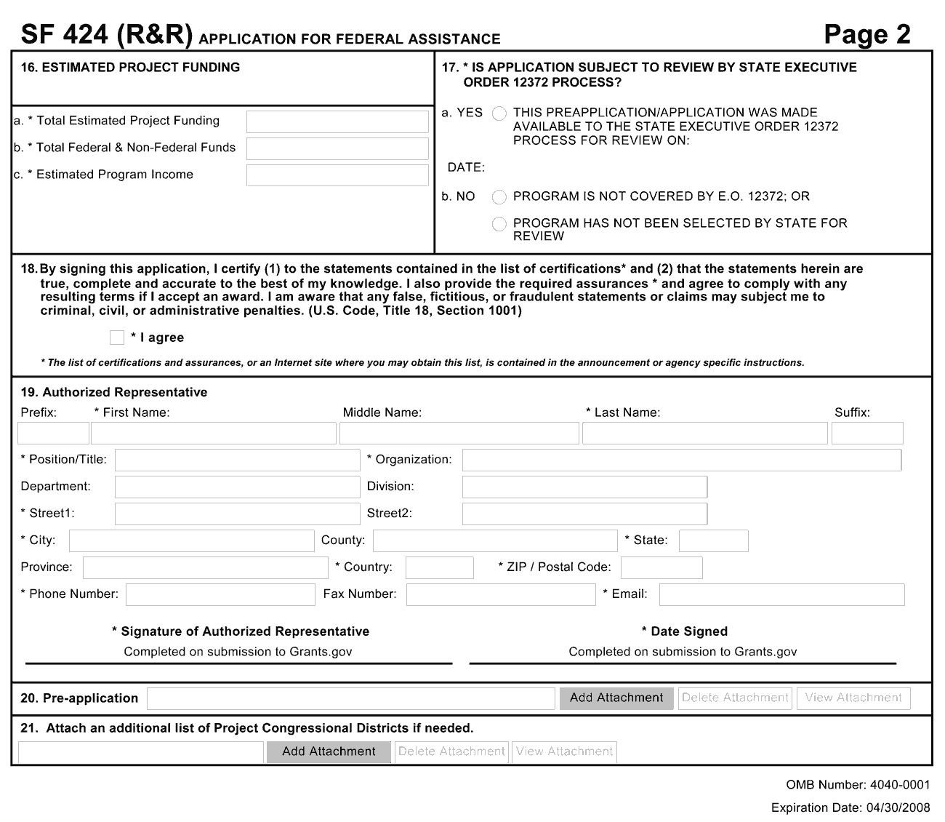
16. Estimated Project Funding
Field Name | Instructions
Total Estimated Project Funding | Enter the total Federal funds, including Direct Costs, F&A Costs (Indirect Costs), and Fee, requested for the entire project period.  Phase I total is normally $100,000; Phase II is normally $750,000. Deviations from these guidelines for NIH applications must be well justified and discussed with appropriate NIH staff prior to submission of the application. NOTE: CDC and FDA do not make awards above these guidelines.
Total Federal & Non-Federal Funds | Enter the total estimated funds for the entire project period, including both Federal and non-Federal funds.  For NIH and other PHS agencies applicants, this field will be the same as item 16a unless the specific announcement indicates that cost sharing is a requirement.
Estimated Program Income | Identify any Program Income estimated for this project period, if applicable.
17. Is Application Subject to Review by State Executive Order 12372 Process?
If yes, check the “Yes” box. If the announcement indicates that the program is covered under Executive Order 12372, you should contact the State Single Point of Contact (SPOC) for Federal Executive Order 12372. If no, check the appropriate box. This field is required.
For NIH and other PHS agency submissions using the SF424 (R&R), applicants should check “No, Program is not covered by E.O. 12372.”
18. Complete Certification
Check the “I agree” box to provide the required certifications and assurances. This field is required.
The list of NIH and other PHS agencies Assurances, Certifications, and other Policies is found in Part III, Policies, Assurances, Definitions, and Other Information.
19. Authorized Representative
This is equivalent to the individual with the organizational authority to sign for an application; otherwise known as the Authorized Organizational Representative or the Signing Official.
Field Name | Instructions
Prefix | Enter the prefix (Mr., Mrs., Rev.) for the name of the Authorized Representative.
First Name | Enter the first (given) name of the Authorized Representative.
Middle Name | Enter the middle name of the Authorized Representative.
Last Name | Enter the last (family) name of the Authorized Representative.
Suffix | Enter the suffix (e.g., Jr., Sr., Ph.D.) for the name of the Authorized Representative.
Position/Title | Enter the title of the Authorized Representative.
Organization | Enter the name of the organization for the Authorized Representative.
Department | Enter the name of the primary organizational department, service, laboratory, or equivalent level within the organization of the Authorized Representative.
Division | Enter the name of the primary organizational division, office, or major subdivision of the Authorized Representative.
Street1 | Enter the first line of the street address for the Authorized Representative. This field is required.
Street2 | Enter the second line of the street address for the Authorized Representative, if applicable.
City | Enter the city for the address of the Authorized Representative. This field is required.
County | Enter the county for the address of the Authorized Representative.
State | Select the State where the Authorized Representative is located. This field is required if the Authorized Representative is located in the United States.
Province | Enter the Province for the Authorized Representative.
Country | Select the country for the Authorized Representative address.
ZIP Code | Enter the Postal Code (e.g., ZIP Code) for the Authorized Representative address. This field is required if the Authorized Representative is located in the United States.
Phone Number | Enter the daytime telephone number for the Authorized Representative. This field is required.
Fax Number | Enter the fax number for the Authorized Representative.
Email | Enter the email address for the Authorized Representative. This field is required.
Signature of Authorized Representative | It is the organization’s responsibility to assure that only properly authorized individuals sign in this capacity and/or submit the application to Grants.gov. If this application is submitted through Grants.gov, leave this field blank. If a hard copy is submitted, the AOR must sign here.
Date Signed | If this application is submitted through Grants.gov, the system generates this date. If submitting a hard copy, enter the date the AOR signed the application.
20. Pre-Application
If you are submitting a pre-application, provide a summary description of the project in accordance with the announcement and/or agency specific instructions, and save the file in a location you remember. Click “Add Attachment,” browse to where you saved the file, select the file, and then click “Open.”
Unless specifically noted in a program announcement, NIH and other PHS agencies do not use Pre-applications.
21. Additional Project Congressional Districts
If additional Congressional Districts are affected, attach a file using the appropriate buttons.

Once all data have been entered, click the “Close Form” button at the top of the form. You will be returned to the Grant Application Package screen. From this main screen, click on the form/document that you have just completed, and then click the => button. This will move the form/document to the Completed Documents box. To remove a form/document from the Completed Documents box, click the form/document name to select it, and then click the <= button. This will return the form/document to the Mandatory Documents or Optional Documents box.

4.3 Project/Performance Site Locations Component
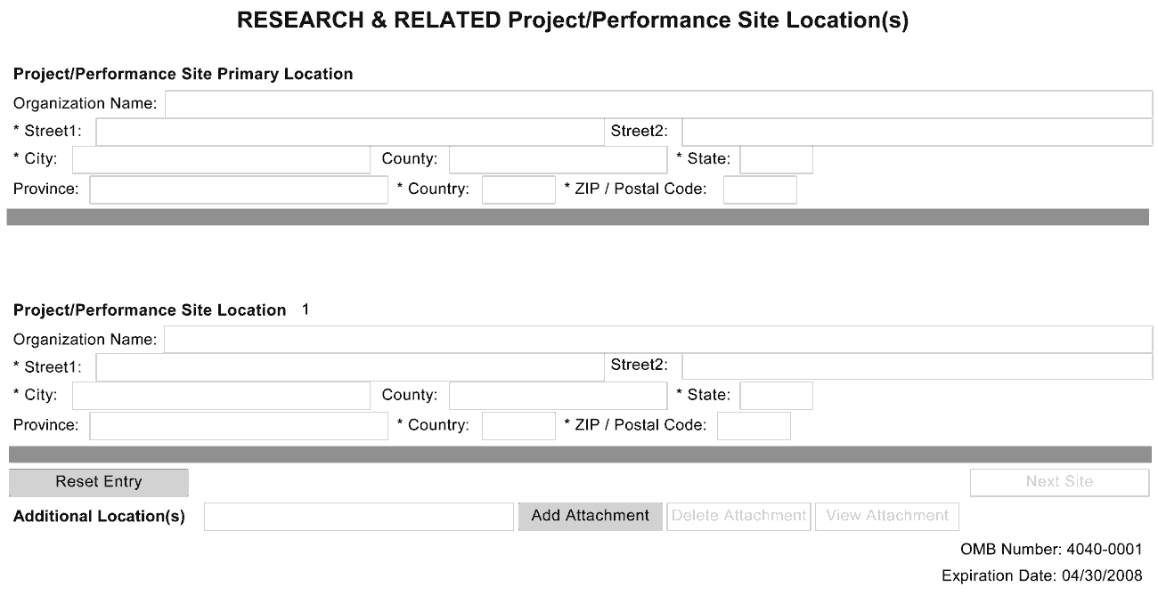
Indicate the primary site where the work will be performed. If a portion of the project will be performed at any other site(s), identify the site location(s) in the blocks provided. If more than eight project/performance site locations are proposed, provide the information in a separate file, and then attach.
Project/Performance Site Primary Location
Generally, the Primary Location should be that of the applicant organization or identified as off-site in accordance with the conditions of the applicant organization’s negotiated Facilities and Administrative (F&A) agreement. If there is more than one performance site, list all additional sites in the fields provided for Location 1 - # below.
For SBIR/STTR applications, one of the performance sites indicated must be that of the applicant small business concern.
For both Phase I and Phase II, the research or R&D project activity must be performed in the United States. However, based on a rare and unique circumstance, for example, if a supply or material or the study design (e.g., patient population) is not available in the United States, NIH may allow that particular portion of the research or R&D work to be performed or obtained in a foreign country. Investigators must thoroughly justify the use of these sites in the application. These rare and unique situations will be considered on a case-by-case basis, and they should be discussed with NIH staff prior to submission of the application. Approval by the funding officer for such specific condition(s) must be in writing prior to issuance of an award. Whenever possible, non-SBIR/STTR funds should be used for other work outside of the United States that is necessary to the overall completion of the project.
The research and analytical work performed by the grantee organization is to be conducted in research space occupied by, available to, and under the control of the SBIR/STTR grantee for the conduct of its portion of the proposed project. However, when required by the project activity, access to special facilities or equipment in another organization is permitted, as in cases where the SBIR/STTR awardee has entered into a subcontractual agreement with another institution for a specific, limited portion of the research project.
Whenever a proposed SBIR/STTR project is to be conducted in facilities other than those of the applicant organization, the awarding component will request that the small business concern provide a letter from the organization stating that leasing/rental arrangements have been negotiated for appropriate research space. This letter must be signed by an authorized official of the organization whose facilities are to be used for the SBIR/STTR project and must certify that the small business concern (grantee organization) will have access to and control over the research space. In addition, the letter must include a description of the facilities and, if appropriate, equipment that will be leased/rented to the grantee organization. (If the letter is included with the application, it is excluded from the page limitations.) Attach this letter to the PHS 398 Research Plan Component, Item 15, Consortium/Contractual Arrangements.
Field Name | Instructions
Organization Name | Indicate the primary site where the work will be performed.
Street1 | Enter first line of the street address of the primary performance site location. This field is required.
Street2 | Enter second line of the street address of the primary performance site location, if applicable.
City | Enter the city for address of the primary performance site location. This field is required.
County | Enter the county of the primary performance site location.
State | Select the state or province of the primary performance site location. This field is not active until USA has been selected for the country. This field is required if the performance site location is in the United States.
Province | Enter the province of the primary performance site location.
Country | Select the country of the primary performance site location. This field is required.
ZIP Code | Enter the postal code (e.g., ZIP code) of the primary performance site location. This field is required if the project performance site is located in the United States.
Project/Performance Site Location 1
Field Name | Instructions
Organization Name | Enter the name of organization of the performance site location.
Street1 | Enter first line of the street address of the performance site location. This field is required.
Street2 | Enter second line of the street address of the performance site location, if applicable.
City | Enter the city of the performance site location. This field is required.
County | Enter the county of the performance site location.
State | Select the state or province where the performance site is located. This field is not active until USA has been selected for the country. This field is required if the performance site location is in the United States.
Province | Enter the province of the performance site location.
Country | Select the country for the performance site location. This field is required.
ZIP Code | Enter the postal code (e.g., ZIP code) of the performance site location. This field is required if the performance site location is in the United States.
For additional performance site locations, click Next Site to display the fields for Project/Performance Site Locations 3 through 8.
If you need to add more than eight locations, enter the information in a separate file. On the form, click Add Attachment, select the file, and then click Open. A sample Additional Performance Sites format page for greater than 8 locations is found under “Additional Format Pages” at: http://grants.nih.gov/grants/funding/424/index.htm.

Once all data have been entered, click the “Close Form” button at the top of the form. You will be returned to the Grant Application Package screen. From this main screen, click on the form/document that you have just completed, and then click the => button. This will move the form/document to the Completed Documents box. To remove a form/document from the Completed Documents box, click the form/document name to select it, and then click the <= button. This will return the form/document to the Mandatory Documents or Optional Documents box.

4.4 Other Project Information Component
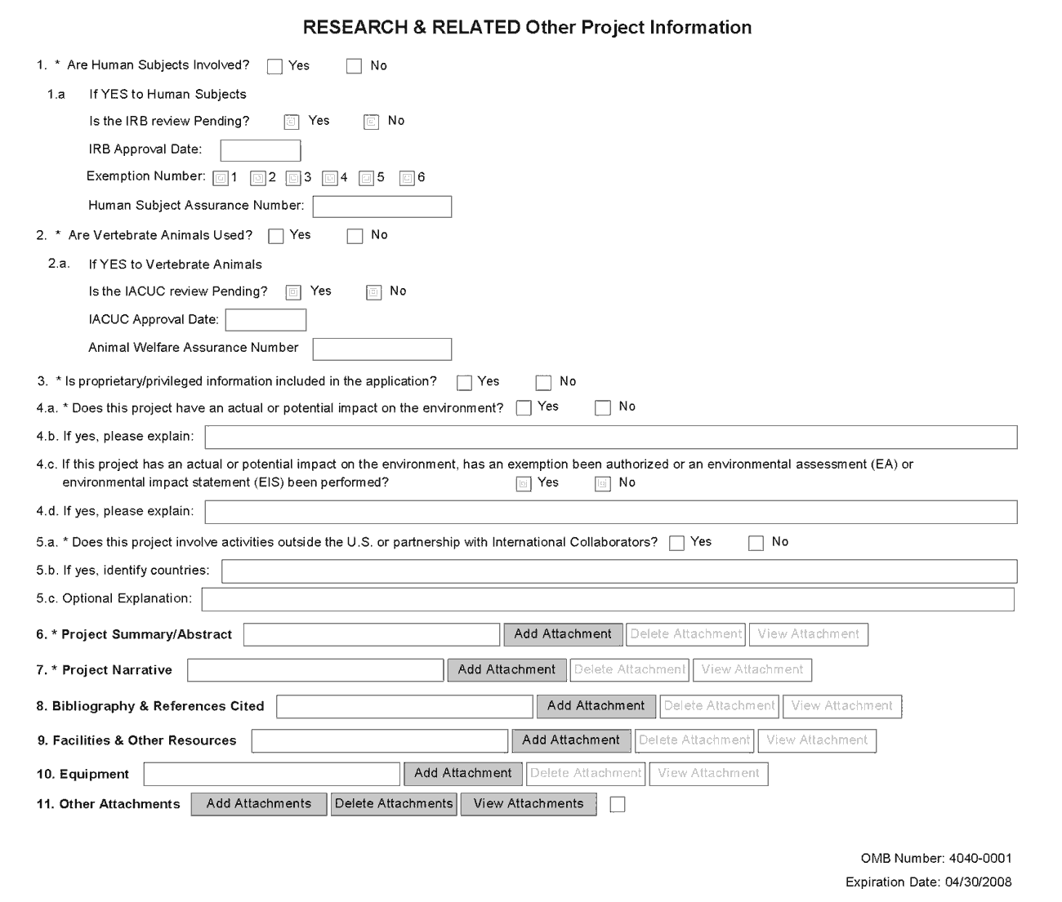
1. Are Human Subjects Involved?
If activities involving human subjects are planned at any time during the proposed project at any performance site, check the Yes box. Check Yes even if the proposed project is exempt from Regulations for the Protection of Human Subjects. If no activities involving human subjects are planned, check the No box, and skip the rest of block 1. This field is required.
Refer to Part II, Supplemental Instructions for Preparing the Human Subjects Section of the Research Plan.
1.a. Is the IRB review Pending?
If the Institutional Review Board (IRB) review is pending, check the Yes box. Otherwise, check the No box. In the IRB Approval Date field, enter the latest IRB approval date, if available. Leave blank if Pending.
Applicants should check “Yes” to the question “Is the IRB review Pending?” even if the IRB review/approval process has not yet begun at the time of submission. Also note that an IRB Approval Date is not required at the time of submission. This may be requested later in the pre-award cycle as a Just-In-Time requirement.
For Exemption Number, if human subject activities are exempt from Federal regulations, provide the exemption numbers corresponding to one or more of the exemption categories. The six categories of research that qualify for exemption from coverage by the regulations are defined in the Common Rule for the Protection of Human Subjects. These regulations can be found at http://www.hhs.gov/ohrp/humansubjects/guidance/45cfr46.htm.
For Human Subject Assurance Number, enter the approved Federal Wide Assurance (FWA) Number that the applicant has on file with the Office for Human Research Protections, if available. Enter only the 8-digit number, do not enter the “FWA” before the number.
Insert “None” if the applicant organization does not have an approved assurance on file with OHRP. In this case, the applicant organization, by the signature in item 19 on the SF424 (R&R) Cover component, is declaring that it will comply with 45CFR Part 46 and proceed to obtain a human subjects assurances (see http://www.hhs.gov/ohrp). Do not insert the human subjects assurance number of any collaborating institution in the space provided.
2. Are Vertebrate Animals Used?
If activities involving vertebrate animals are planned at any time during the proposed project at any performance site, check the Yes box. Otherwise, check the No box, and skip the rest of block 2. This field is required.
Note that the generation of custom antibodies constitutes an activity involving vertebrate animals.

2.a. If YES to Vertebrate Animals
For the “Is the IACUC review Pending” field, if an Institutional Animal Care and Use Committee (IACUC) review is pending, check the Yes box. Otherwise check the No box. For IACUC Approval Date, enter the IACUC approval date, if available. Leave blank if Pending.
For Animal Welfare Assurance Number, enter the Federally approved assurance number, if available. (To determine if your organization holds an Animal Welfare Assurance, see http://grants.nih.gov/grants/olaw/olaw.htm#assur.)
Applicants should check “Yes” to the question “Is the IACUC review Pending?” even if the IACUC review/approval process has not yet begun at the time of submission. Also note that an IACUC Approval Date is not required at the time of submission. However, the approval date and other data may be requested later in the pre-award cycle as a Just-In-Time requirement. If the applicant organization does not have an approved Animal Welfare Assurance on file with the Office of Laboratory Animal Welfare (OLAW), NIH, enter “None” in the Animal Welfare Assurance Number field. Do not enter the Animal Welfare Assurance number of any collaborating institution. By inserting “None” at the time of submission, the applicant organization is essentially declaring that it will comply with the PHS Policy on Humane Care and Use of Laboratory Animals by submitting an Animal Welfare Assurance and verification of IACUC approval when requested to do so by OLAW.
3. Is proprietary/privileged information included in the application?
Patentable ideas, trade secrets, privileged or confidential commercial or financial information, disclosure of which may harm the applicant, should be included in applications only when such information is necessary to convey an understanding of the proposed project. If the application includes such information, check the “Yes” box and clearly mark each line or paragraph on the pages containing the proprietary/privileged information with a legend similar to: “The following contains proprietary/privileged information that (name of applicant) requests not be released to persons outside the Government, except for purposes of review and evaluation.”
4. Environmental Questions
Unless a specific FOA indicates that the National Environmental Policy Act (NEPA) applies, applicants should check “No.”
4.a. Does this project have an actual or potential impact on the environment?
If your project will have an actual or potential impact on the environment, check the Yes box, and then explain in the box provided in 4.b. Otherwise, check the No box.
4.b. If yes, please explain
If you checked the Yes box indicating an actual or potential impact on the environment, enter the explanation of the actual or potential impact on the environment here.
4.c. If this project has an actual or potential impact on the environment, has an exemption been authorized or an Environmental Assessment (EA) or an Environmental Impact Statement (EIS) been performed?
If an exemption has been authorized or an Environmental Assessment (EA) or an Environmental Impact Statement (EIS) been performed, check the Yes box, and then explain in the box provided in 4.d. Otherwise, check the No box.
4.d. If yes, please explain
If you checked the Yes box indicating an exemption has been authorized or an EA or EIS has been performed, enter the explanation here. If desired, you can provide the information in a separate file, and attach by clicking Add Attachments located to the right of Step 11 - Other Attachments.
5. Activities Outside US or with International Collaborators Questions
5.a. Does this project involve activities outside of the United States or partnerships with International Collaborators?
If your project involves activities outside the United States or partnerships with international collaborators, check the Yes box, and then explain in the box provided in 5.b. Otherwise, check the No box.
Applicants to NIH and other PHS agencies must check “Yes” if the applicant organization is a foreign institution or if the project includes a foreign component. For a definition of a substantial foreign component, see “Definitions” section of Part III: Policies, Assurances, Definitions, and Other Information.
5.b. If yes, identify countries
If you checked the Yes box indicating your project involves activities outside the US, enter the countries with which international cooperative activities are involved.
5.c. Optional Explanation
Use this block to provide any supplemental information, if necessary. If desired, you can provide the information in a separate file, and attach by clicking “Add Attachments” located to the right of Item 11, Other Attachments.
If you have checked “Yes” to 5.a, applicants to the NIH and other PHS agencies must describe special resources or characteristics of the research project (e.g., human subjects, animals, disease, equipment, and techniques), whether similar research is being done in the United States and whether there is a need for additional research in this area. Provide this information in a separate file, attaching it as Item 11, Other Attachments. In the body of the text, begin the section with a heading indicating “Foreign Justification.” When saving this file, please name it “Foreign Justification” as well.
6. Project Summary/Abstract
The Project Summary must contain a summary of the proposed activity suitable for dissemination to the public. It should be a self-contained description of the project and should contain a statement of objectives and methods to be employed. It should be informative to other persons working in the same or related fields and insofar as possible understandable to a scientifically or technically literate lay reader. This Summary must not include any proprietary/confidential information.
To attach a project summary/abstract file, click Add Attachment, browse to where you saved the file, select the file, and then click Open.
The first and major component of the Project Summary/Abstract (i. e., “Description”) is a Project Summary. It is meant to serve as a succinct and accurate description of the proposed work when separated from the application. State the application's broad, long-term objectives and specific aims, making reference to the health relatedness of the project (i.e., relevance to the mission of the agency). Describe concisely the research design and methods for achieving the stated goals. This section should be informative to other persons working in the same or related fields and insofar as possible understandable to a scientifically or technically literate reader. Avoid describing past accomplishments and the use of the first person. Finally, please make every effort to be succinct. This section must be no longer than 30 lines of text, and follow the required font and margin specifications. An abstract which exceeds this allowable length may be flagged as an error by the agency upon submission. This would require a corrective action before the application will be accepted.
The attachment must be in PDF format. (See Section 2.6 for additional information on preparing attachments.)
7. Project Narrative
For NIH and other PHS agencies applications, this attachment will reflect the second component of the Project Summary. The second component of the Project Summary/Abstract (i.e., “Description”) is Relevance. Using no more than two or three sentences, describe the relevance of this research to public health. In this section, be succinct and use plain language that can be understood by a general, lay audience.
A separate Research Plan component is required for NIH and other PHS agencies applications. Refer to Section 5.4, Research Plan Component, for separate file uploads and instructions.
8. Bibliography & References Cited
Provide a bibliography of any references cited in the Project Narrative. Each reference must include the names of all authors (in the same sequence in which they appear in the publication), the article and journal title, book title, volume number, page numbers, and year of publication. Include only bibliographic citations. Be especially careful to follow scholarly practices in providing citations for source materials relied upon when preparing any section of the application.
To attach a bibliography, click “Add Attachment,” browse to where you saved the file, select the file, and then click “Open.”
Unless otherwise noted in an FOA, this section is required for submissions to NIH and other PHS agencies. This section (formerly “Literature Cited”) should include any references cited in the PHS 398 Research Plan component (see Section 5.4 for details on completing that component). When citing articles that fall under the Public Access Policy, were authored or co-authored by the applicant and arose from NIH support, provide the NIH Manuscript Submission reference number (e.g., NIHMS97531) or the Pubmed Central (PMC) reference number (e.g., PMCID234567) for each article. If the PMCID is not yet available because the Journal submits articles directly to PMC on behalf of their authors, indicate “PMC Journal – In Process.” A list of these journals is posted at: http://publicaccess.nih.gov/submit_process_journals.htm.
Citations that are not covered by the Public Access Policy, but are publicly available in a free, online format may include URLs or PMCID numbers along with the full reference (note that copies of publicly available publications are not accepted as appendix material). The references should be limited to relevant and current literature. While there is not a page limitation, it is important to be concise and to select only those literature references pertinent to the proposed research.
9. Facilities & Other Resources
This information is used to assess the capability of the organizational resources available to perform the effort proposed. Identify the facilities to be used (Laboratory, Animal, Computer, Office, Clinical and Other). If appropriate, indicate their capacities, pertinent capabilities, relative proximity and extent of availability to the project. Describe only those resources that are directly applicable to the proposed work. Provide any information describing the Other Resources available to the project (e.g., machine shop, electronic shop) and the extent to which they would be available to the project.
The research to be performed by the applicant small business concern and its collaborators must be in United States facilities (i.e., foreign sites must be approved by the funding officer) that are available to and under the control of each party for the conduct of each party’s portion of the proposed project.
No special form is required but this section must be completed and attached for submissions to NIH and other PHS agencies unless otherwise noted in an FOA. If there are multiple performance sites, then resources available at each site should be described. In describing the scientific environment in which the work will be done, discuss ways in which the proposed studies will benefit from unique features of the scientific environment, or subject populations or employ useful collaborative arrangements. If research involving Select Agent(s) will occur at any performance site(s), the biocontainment resources available at each site should be described.
To attach a facilities and other resources file, click Add Attachment, browse to where you saved the file, select the file, and then click Open.
10. Equipment
List major items of equipment already available for this project and, if appropriate identify location and pertinent capabilities. To attach an equipment file, click Add Attachment, browse to where you saved the file, select the file, and then click Open.
11. Other Attachments
Attach a file to provide any other project information not provided above or in accordance with the announcement and/or agency-specific instruction by clicking Add Attachment, browsing to where you saved the file, selecting the file, and then clicking Open.

Once all data have been entered, click the “Close Form” button at the top of the form. You will be returned to the Grant Application Package screen. From this main screen, click on the form/document that you have just completed, and then click the => button. This will move the form/document to the Completed Documents box. To remove a form/document from the Completed Documents box, click the form/document name to select it, and then click the <= button. This will return the form/document to the Mandatory Documents or Optional Documents box.

4.5 Senior/Key Person Profile(s) Component(s)
Two components are now available to collect information on Senior/Key persons. The original component continues to be called “Research & Related Senior/Key Person.” The new component is titled: “Research & Related Senior/Key Person Expanded.” Application packages will include one or the other, but never both. Eventually, only the expanded version will be used in application packages. Until that transition is complete, instructions are provided in this section for both components.
Multiple PDs/PIs
NIH is now accepting applications reflecting Multiple PDs/PIs for all grant mechanisms using the SF424 (R&R) application. When submitting an application involving Multiple PDs/PIs, the Contact PI should be listed as the PD/PI in the SF424 R&R Cover Component (see Section 4.2.15). That information automatically prepopulates the first Senior/Key Person Profile record in this component. For the additional PDs/PIs, complete all the requested information. Each PD/PI must be assigned the PD/PI role, even those at subaward/consortium sites when applicable. (Do not use the “Co-PI” role.)
Each PD/PI must also be registered in the eRA Commons and must be assigned the PI Role in that system (note other roles such as SO or IAR will not give PDs/PIs the appropriate access to the application records). Each PD/PI must include their respective eRA Commons ID in the Credential field. For more information on NIH Implementation of Multiple PDs/PIs, see: http://grants.nih.gov/grants/multi_pi/index.htm.
When completing the detailed budget component for either the prime organization or a subaward/consortium organization, the project roles listed in the budget component should be consistent with those used in the Senior/Key Person component.

4.5.1 Senior/Key Person Profile Component
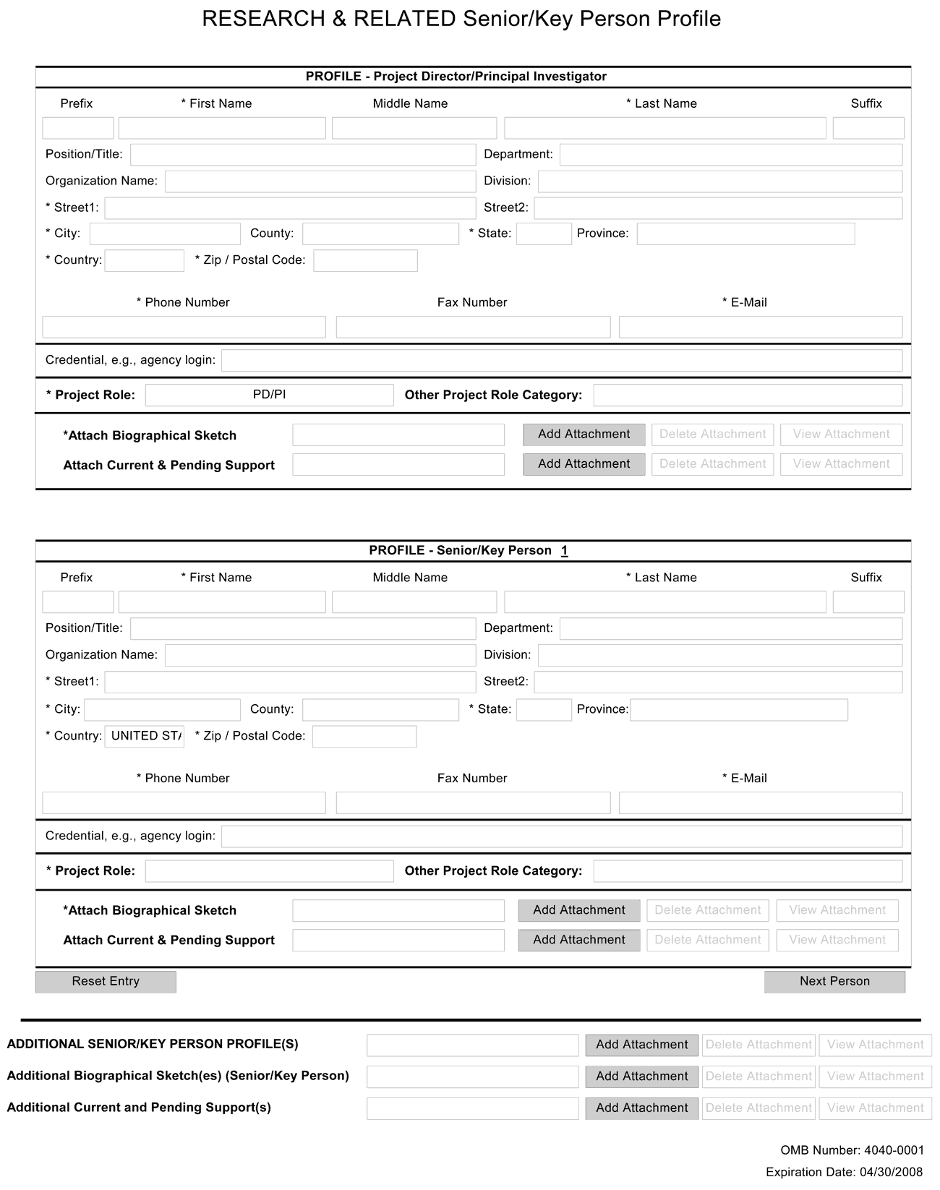
Starting with the PD/PI, provide a profile for each senior/key person proposed. Unless otherwise specified in an agency announcement, senior/key personnel are defined as all individuals who contribute in a substantive, measurable way to the scientific development or execution of the project, whether or not salaries are requested. Consultants should be included if they meet this definition. Key Personnel must devote measurable effort to the project whether or not salaries are requested – “zero percent” effort or “as needed” are not acceptable involvements for someone designated as Key Personnel.
Special Note for STTR applicants: The STTR applicant organization must officially affiliate the PD/PI with the small business concern in the Commons if the PD/PI is not an employee of the small business concern. See Section 2.2.2.2 for steps to affiliate a PD/PI to the applicant organization/institution.
Profile – Program Director/Principal Investigator (PD/PI)
Field Name | Instructions
Prefix | This field is automatically populated from the SF424 (R&R). It is the prefix (e.g., Mr., Mrs., Rev.) for the name of the PD/PI.
First Name | This field is automatically populated from the SF424 (R&R). It is the first (given) name of the PD/PI. This field is required.
Middle Name | This field is automatically populated from the SF424 (R&R). It is the middle name of the PD/PI.
Last Name | This field is automatically populated from the SF424 (R&R). It is the last (family) name of the PD/PI. This field is required.
Suffix | This field is automatically populated from the SF424 (R&R). It is the suffix (e.g., Jr., Sr., PhD) for the name of the PD/PI.
Position/Title | This field is automatically populated from the SF424 (R&R). It is the title of the PD/PI.
Department | This field is automatically populated from the SF424 (R&R). It is the name of primary organizational department, service, laboratory, or equivalent level within the organization of the PD/PI.
Organization Name | This field is automatically populated from the SF424 (R&R). It is the name of the organization of the PD/PI.
Division | This field is automatically populated from the SF424 (R&R). It is the name of primary organizational division, office, or major subdivision of the PD/PI.
Street1 | This field is automatically populated from the SF424 (R&R). It is the first line of the street address of the PD/PI.
Street2 | This field is automatically populated from the SF424 (R&R). It is the second line of the street address of the PD/PI, if applicable.
City | This field is automatically populated from the SF424 (R&R). It is the city for the address of the PD/PI.
County | This field is automatically populated from the SF424 (R&R). It is the county for the address of the PD/PI.
State | This field is automatically populated from the SF424 (R&R). It is the state where the PD/PI is located. This field is required if the PD/PI is located in the United States.
Province | This field is automatically populated from the SF424 (R&R). It is the province where the PD/PI is located.
Country | This field is automatically populated from the SF424 (R&R). It is the country for the PD/PI address.
ZIP Code | This field is automatically populated from the SF424 (R&R). It is the Postal Code (e.g., ZIP Code) of the PD/PI. This field is required if the PD/PI is located in the United States.
Phone Number | This field is automatically populated from the SF424 (R&R). It is the daytime phone number for the PD/PI.
Fax Number | This field is automatically populated from the SF424 (R&R). It is the fax number for the PD/PI.
Email | This field is automatically populated from the SF424 (R&R). It is the email address for the PD/PI.
Credential, e.g., agency login | If you are submitting to an agency (e.g., NIH and other PHS agencies) where you have an established personal profile, enter the agency ID. If not, leave blank.  For NIH and other PHS agencies, registration in the eRA Commons for all PDs/PIs is required. The assigned Commons UserName (the unique name used to log into the system) for anyone assigned the PD/PI role must be entered here. This is a required field for applications submitted to NIH and other PHS agencies. Applications will not pass agency validation requirements without this field.
Project Role | Select a project role from the list. Select “Other” if an appropriate project role is not listed.  Select Program Director/Principal Investigator for this person.
Other Project Role Category | Complete if you selected “Other Professional” or “Other” as a project role. For example, Engineer, Chemist.
Attach Biographical Sketch | Provide a biographical sketch for the PD/PI. Recommended information includes: Education and Training, Research and Professional Experience, Collaborators and Affiliations (for conflicts of interest), Publications and Synergistic Activities. Save the information in a single file and attach by clicking Add Attachment.  Biographical sketches should follow the format described below.
Attach Current & Pending Support | Unless otherwise required in a specific FOA, do not use this attachment upload for NIH and other PHS agency submissions. This information is no longer required at the time of application submission. This information may be requested later in the pre-award cycle. When this occurs, you will be instructed to refer to Other Support in Part III, Policies, Assurances, Definitions and Other Information.

Profile – Senior/Key Person [n]
The remaining Senior/Key Person Profiles should be listed in alphabetical order. While alphabetical order is preferred, it is not required. However, be aware that these profiles will appear in the application in the order provided by the applicant. Therefore, peer reviewers will see them in the order presented. Also use this section to list any Other Significant Contributors (OSCs). OSCs should be listed after all Key Persons. OSCs are individuals who have committed to contribute to the scientific development or execution of the project, but are not committing any specified measurable effort (in person months) to the project. These individuals are typically presented at “effort of zero person months” or “as needed” (individuals with measurable effort cannot be listed as Other Significant Contributors). Consultants should be included if they meet this definition. This would also be an appropriate designation for mentors on Career awards.
A biosketch, including Research Support information, will be required for these individuals as this highlights their accomplishments as scientists. Reviewers use these pages to address the “investigator” review criterion. However, if an award is to be made, Other Support information will not be required or accepted since considerations of overlap do not apply to these individuals.
Should the level of involvement change for an individual listed as an OSC, they should be redesignated as “key personnel.” This change should be made before any compensation is charged to the project.
Field Name | Instructions
Prefix | Enter the prefix (e.g., Mr., Mrs., Rev.) for the name of the Senior/Key Person.
First Name | Enter the first (given) name of the Senior/Key Person. This field is required.
Middle Name | Enter the middle name of the Senior/Key Person, if applicable.
Last Name | Enter the last (family) name of the Senior/Key Person. This field is required.
Suffix | Enter the suffix (e.g., Jr., Sr., Ph.D.) for the name of the Senior/Key Person.
Position/Title | Enter the title of the Senior/Key Person.
Department | Enter the name of primary organizational department, service, laboratory, or equivalent level within the organization of the Senior/Key Person.
Organization Name | Enter the name of organization of the Senior/Key Person.  This is a required field for applications submitted to NIH and other PHS agencies.
Division | Enter the name of primary organizational division, office, or major subdivision of the Senior/Key Person.
Street1 | Enter first line of the street address for the Senior/Key Person. This field is required.
Street2 | Enter second line of the street address for the Senior/Key Person, if applicable.
City | Enter the city for the address of the Senior/Key Person. This field is required.
County | Enter the county for the address of the Senior/Key Person.
State | Enter the State where the Senior/Key Person is located. This field is required if the Senior/Key Person is located in the United States.
Province | Enter the Province of Senior/Key Person.
Country | Select the country for the Senior/Key Person address. This field is required.
ZIP Code | Enter the Postal Code (e.g., ZIP Code) of the Senior/Key Person address. This field is required if the Senior/Key Person is located in the United States.
Phone Number | Enter the daytime telephone number for the Senior/Key Person. This field is required.
Fax Number | Enter the fax number for the Senior/Key Person.
Email | Enter the email address for the Senior/Key Person. This field is required for the Senior/Key Person.
Credential, e.g., agency login | If you are submitting to an agency (e.g., NIH and other PHS agencies) where you have an established personal profile, enter the agency ID. If not, leave blank.  For NIH and other PHS agencies, registration in the eRA Commons for all PDs/PIs is required. The assigned Commons UserName (the unique name used to log into the system) for anyone assigned the PD/PI role must be entered here. This is a required field for applications submitted to NIH and other PHS agencies. Applications will not pass agency validation requirements without this field.  Note for applications reflecting Multiple PDs/PIs, the Commons UserName must be provided for all individuals assigned the PD/PI Role.
Project Role | Select a project role from the list. Select “Other” if an appropriate project role is not listed.  If you are submitting an application reflecting Multiple PDs/PIs, all such individuals must be assigned the PD/PI role, even those at organizations other than the applicant organization. The role of “Co-PD/PI” is not currently used by NIH and other PHS agencies. Do not assign any individual this role. If applicants wish to use the role of “Co-Investigator” or some other similar role, select “Other” for the Project Role field and then insert the appropriate role descriptor in the Other Project Role Category field.  If including individuals classified as “Other Significant Contributors (OSCs),” use the “Other” category and indicate “Other Significant Contributor” as the role in the “Other Project Role Category.” OSCs should be listed last after all other Senior/Key Persons have been listed.
Other Project Role Category | Complete if you selected “Other Professional” or “Other” as a project role. For example, Engineer, Chemist.
Attach Biographical Sketch | Provide a biographical sketch for the Senior/Key Person. Recommended information includes: Education and Training, Research and Professional Experience, Collaborators and Affiliations (for conflicts of interest), Publications and Synergistic Activities. Save the information in a single file and attach by clicking Add Attachment.  Biographical sketches should follow the format described below.
Attach Current & Pending Support | Unless otherwise required in a specific FOA, do not use this attachment upload for NIH and other PHS agency submissions. This information is no longer required at the time of application submission. This information may be requested later in the pre-award cycle. When this occurs, refer to Other Support in Part III, Policies, Assurances, Definitions, and Other Information.
Note: After completing Profile – Senior/Key Person 1, click the Next Person button to display the fields for Profile – Senior/Key Person 2.
Additional Senior/Key Person Profile(s)
If more than eight Senior/Key Person profiles are proposed, enter the information in a separate file. On the form, click Add Attachment, select the file, and then click Open.
A sample Additional Senior/Key Person Profiles format page for greater than 8 profiles is found under “Additional Format Pages” at: http://grants.nih.gov/grants/funding/424/index.htm.

Additional Biographical Sketch(es) (Senior/Key Person)
Provide a biographical sketch for each Senior/Key Person. Recommended information includes: Education and Training, Research and Professional Experience, Collaborators and Affiliations (for conflicts of interest), Publications and Synergistic Activities. Save the information in a single file and attach by clicking Add Attachment.
Biographical sketches should follow the format described below.

Additional Current and Pending Support(s)
Provide a list of all current and pending support for the PD/PI and each Senior/Key Person (even if they receive no salary support from the project(s) for ongoing projects and pending proposals. Show the total award amount for the entire award period (including indirect costs) as well as the number of person-months per year to be devoted to the project by the senior/key person, regardless of source of support. Concurrent submission of a proposal to other organizations will not prejudice its review.
Unless otherwise required in a specific FOA, do not use this attachment upload for NIH and other PHS agency submissions. This information is no longer required at the time of application submission. This information may be requested later in the pre-award cycle. When this occurs, refer to Other Support in Part III, Policies, Assurances, Definitions, and Other Information.

4.5.2 Senior/Key Person Profile (Expanded) Component
This component provides the ability to collect structured data for up to 40 Senior/Key Persons. Data must be entered for the first 8 individuals (PD/PI + seven others) before the Additional Senior/Key Person Form Attachments section becomes available. The information for the PD/PI continues to be pre-populated from the SF424 (R&R) Cover component. See instructions in section 4.2 Cover Component if these fields are empty.
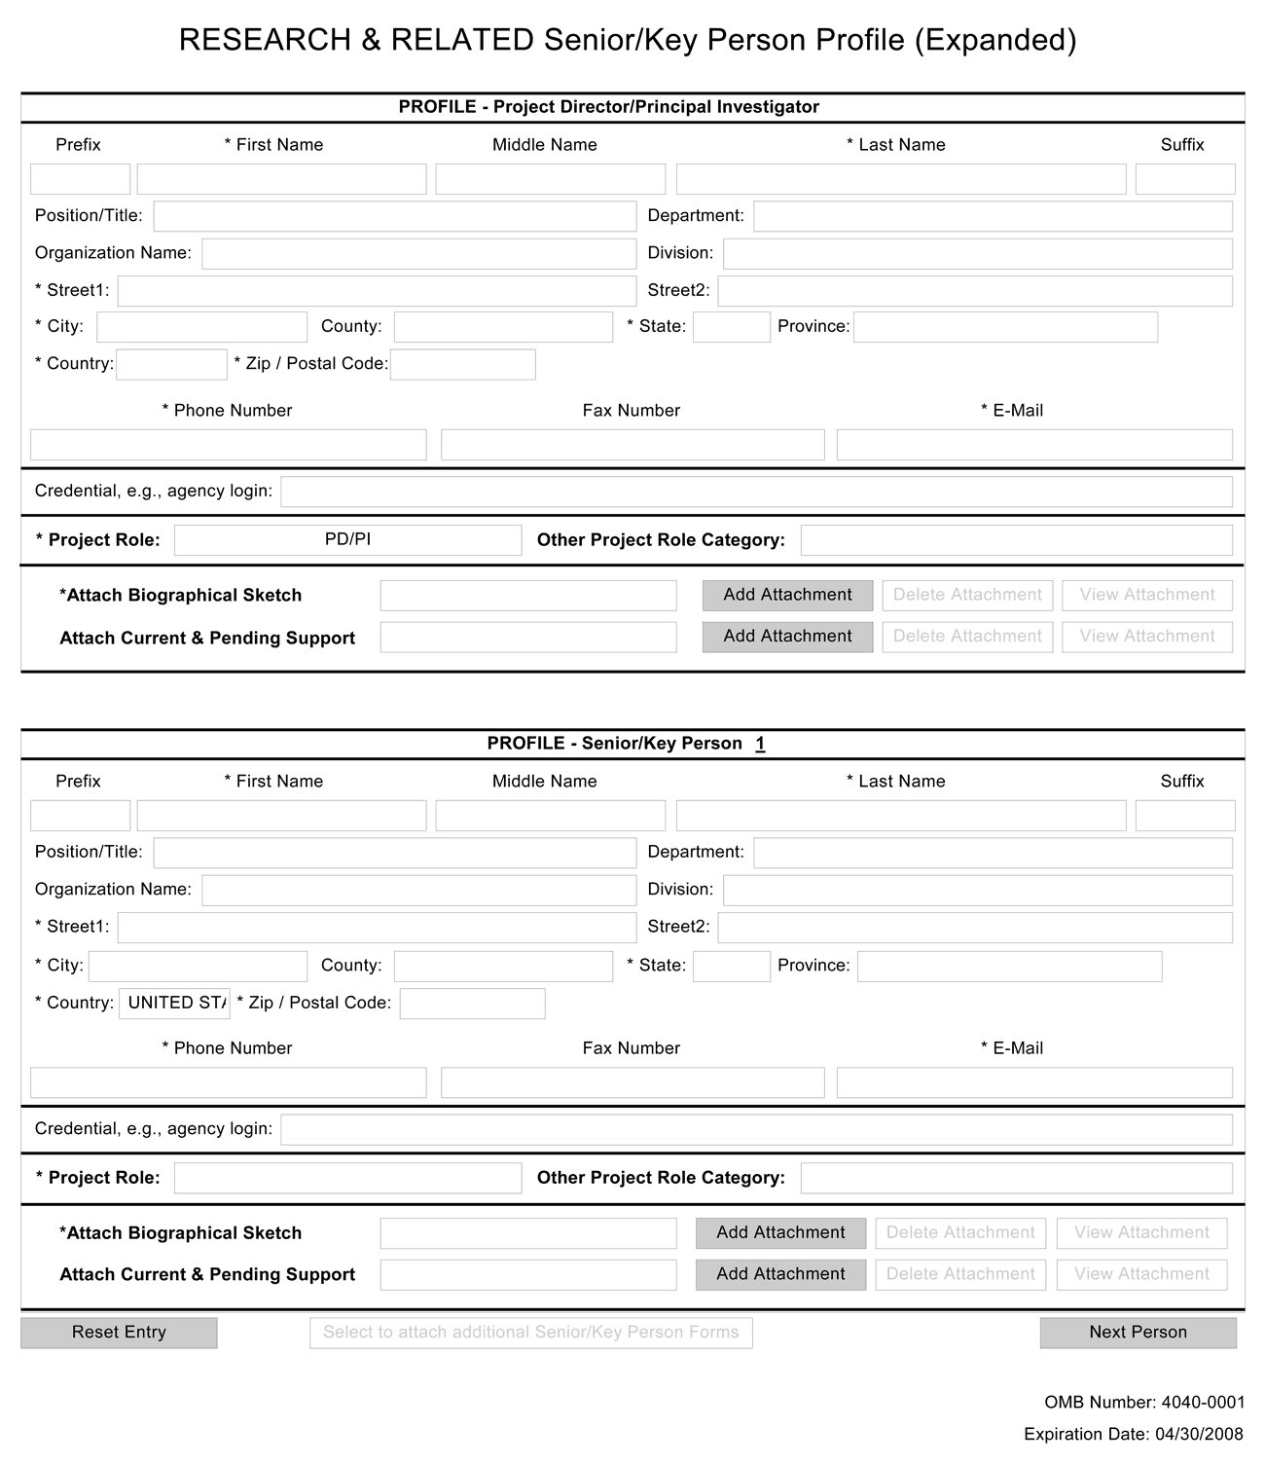
Starting with the PD/PI, provide a profile for each senior/key person proposed. Unless otherwise specified in an agency announcement, senior/key personnel are defined as all individuals who contribute in a substantive, measurable way to the scientific development or execution of the project, whether or not salaries are requested. Consultants should be included if they meet this definition.
Profile – Program Director/Principal Investigator (PD/PI)
Field Name | Instructions
Prefix | This field is automatically populated from the SF424 (R&R). It is the prefix (e.g., Mr., Mrs., Rev.) for the name of the PD/PI.
First Name | This field is automatically populated from the SF424 (R&R). It is the first (given) name of the PD/PI. This field is required.
Middle Name | This field is automatically populated from the SF424 (R&R). It is the middle name of the PD/PI.
Last Name | This field is automatically populated from the SF424 (R&R). It is the last (family) name of the PD/PI. This field is required.
Suffix | This field is automatically populated from the SF424 (R&R). It is the suffix (e.g., Jr., Sr., PhD) for the name of the PD/PI.
Position/Title | This field is automatically populated from the SF424 (R&R). It is the title of the PD/PI.
Department | This field is automatically populated from the SF424 (R&R). It is the name of primary organizational department, service, laboratory, or equivalent level within the organization of the PD/PI.
Organization Name | This field is automatically populated from the SF424 (R&R). It is the name of the organization of the PD/PI.
Division | This field is automatically populated from the SF424 (R&R). It is the name of primary organizational division, office, or major subdivision of the PD/PI.
Street1 | This field is automatically populated from the SF424 (R&R). It is the first line of the street address of the PD/PI.
Street2 | This field is automatically populated from the SF424 (R&R). It is the second line of the street address of the PD/PI, if applicable.
City | This field is automatically populated from the SF424 (R&R). It is the city for the address of the PD/PI.
County | This field is automatically populated from the SF424 (R&R). It is the county for the address of the PD/PI.
State | This field is automatically populated from the SF424 (R&R). It is the state where the PD/PI is located. This field is required if the PD/PI is located in the United States.
Province | This field is automatically populated from the SF424 (R&R). It is the province where the PD/PI is located.
Country | This field is automatically populated from the SF424 (R&R). It is the country for the PD/PI address.
ZIP Code | This field is automatically populated from the SF424 (R&R). It is the Postal Code (e.g., ZIP Code) of the PD/PI. This field is required if the PD/PI is located in the United States.
Phone Number | This field is automatically populated from the SF424 (R&R). It is the daytime phone number for the PD/PI.
Fax Number | This field is automatically populated from the SF424 (R&R). It is the fax number for the PD/PI.
Email | This field is automatically populated from the SF424 (R&R). It is the email address for the PD/PI.
Credential, e.g., agency login | If you are submitting to an agency (e.g., NIH and other PHS agencies) where you have an established personal profile, enter the agency ID. If not, leave blank.  For NIH and other PHS agencies, registration in the eRA Commons for all PDs/PIs is required. The assigned Commons UserName (the unique name used to log into the system) for anyone assigned the PD/PI role must be entered here. This is a required field for applications submitted to NIH and other PHS agencies. Applications will not pass agency validation requirements without this field.
Project Role | Select a project role from the list. Select “Other” if an appropriate project role is not listed.
Other Project Role Category | Complete if you selected “Other Professional” or “Other” as a project role. For example, Engineer, Chemist.
Attach Biographical Sketch | Provide a biographical sketch for the PD/PI. Recommended information includes: Education and Training, Research and Professional Experience, Collaborators and Affiliations (for conflicts of interest), Publications and Synergistic Activities. Save the information in a single file and attach by clicking Add Attachment.  Biographical sketches should follow the format described below.
Attach Current & Pending Support | Unless otherwise required in a specific FOA, do not use this attachment upload for NIH and other PHS agency submissions. This information is no longer required at the time of application submission. This information may be requested later in the pre-award cycle. When this occurs, you will be instructed to refer to Other Support in Part III, Policies, Assurances, Definitions and Other Information.
Profile – Senior/Key Person [n]
The remaining Senior/Key Person Profiles should be listed in alphabetical order. While alphabetical order is preferred, it is not required. However, be aware that these profiles will appear in the application in the order provided by the applicant. Therefore, peer reviewers will see them in the order presented. Also use this section to list any Other Significant Contributors (OSCs). OSCs should be listed after all Key Persons. OSCs are individuals who have committed to contribute to the scientific development or execution of the project, but are not committing any specified measurable effort (in person months) to the project. These individuals are typically presented at “effort of zero person months” or “as needed” (individuals with measurable effort cannot be listed as Other Significant Contributors). Consultants should be included if they meet this definition. This would also be an appropriate designation for mentors on Career awards.
A biosketch, including Research Support information, will be required for these individuals as this highlights their accomplishments as scientists. Reviewers use these pages to address the “investigator” review criterion. However, if an award is to be made, Other Support information will not be required or accepted since considerations of overlap do not apply to these individuals.
Should the level of involvement change for an individual listed as an OSC, they should be redesignated as “key personnel.” This change should be made before any compensation is charged to the project.
Field Name | Instructions
Prefix | Enter the prefix (e.g., Mr., Mrs., Rev.) for the name of the Senior/Key Person.
First Name | Enter the first (given) name of the Senior/Key Person. This field is required.
Middle Name | Enter the middle name of the Senior/Key Person, if applicable.
Last Name | Enter the last (family) name of the Senior/Key Person. This field is required.
Suffix | Enter the suffix (e.g., Jr., Sr., Ph.D.) for the name of the Senior/Key Person.
Position/Title | Enter the title of the Senior/Key Person.
Department | Enter the name of primary organizational department, service, laboratory, or equivalent level within the organization of the Senior/Key Person.
Organization Name | Enter the name of organization of the Senior/Key Person.  This is a required field for applications submitted to NIH and other PHS agencies.
Division | Enter the name of primary organizational division, office, or major subdivision of the Senior/Key Person.
Street1 | Enter first line of the street address for the Senior/Key Person. This field is required.
Street2 | Enter second line of the street address for the Senior/Key Person, if applicable.
City | Enter the city for the address of the Senior/Key Person. This field is required.
County | Enter the county for the address of the Senior/Key Person.
State | Enter the State where the Senior/Key Person is located. This field is required if the Senior/Key Person is located in the United States.
Province | Enter the Province of Senior/Key Person.
Country | Select the country for the Senior/Key Person address. This field is required.
ZIP Code | Enter the Postal Code (e.g., ZIP Code) of the Senior/Key Person address. This field is required if the Senior/Key Person is located in the United States.
Phone Number | Enter the daytime telephone number for the Senior/Key Person. This field is required.
Fax Number | Enter the fax number for the Senior/Key Person.
Email | Enter the email address for the Senior/Key Person. This field is required for the Senior/Key Person.
Credential, e.g., agency login | If you are submitting to an agency (e.g., NIH and other PHS agencies) where you have an established personal profile, enter the agency ID. If not, leave blank.  For NIH and other PHS agencies, registration in the eRA Commons for all PDs/PIs is required. The assigned Commons UserName (the unique name used to log into the system) for anyone assigned the PD/PI role must be entered here. This is a required field for applications submitted to NIH and other PHS agencies. Applications will not pass agency validation requirements without this field.  Note for applications reflecting Multiple PDs/PIs, the Commons UserName must be provided for all individuals assigned the PD/PI Role.
Project Role | Select a project role from the list. Select “Other” if an appropriate project role is not listed.  If you are submitting an application reflecting Multiple PDs/PIs, all such individuals must be assigned the PD/PI role, even those at organizations other than the applicant organization. The role of “Co-PD/PI” is not currently used by NIH and other PHS agencies. Do not assign any individual this role. If applicants wish to use the role of “Co-Investigator” or some other similar role, select “Other” for the Project Role field and then insert the appropriate role descriptor in the Other Project Role Category field.  If including individuals classified as “Other Significant Contributors (OSCs),” use the “Other” category and indicate “Other Significant Contributor” as the role in the “Other Project Role Category.” OSCs should be listed last after all other Senior/Key Persons have been listed.
Other Project Role Category | Complete if you selected “Other Professional” or “Other” as a project role. For example, Engineer, Chemist.
Attach Biographical Sketch | Provide a biographical sketch for the Senior/Key Person. Recommended information includes: Education and Training, Research and Professional Experience, Collaborators and Affiliations (for conflicts of interest), Publications and Synergistic Activities. Save the information in a single file and attach by clicking Add Attachment.  Biographical sketches should follow the format described below.
Attach Current & Pending Support | Unless otherwise required in a specific FOA, do not use this attachment upload for NIH and other PHS agency submissions. This information is no longer required at the time of application submission. This information may be requested later in the pre-award cycle. When this occurs, refer to Other Support in Part III, Policies, Assurances, Definitions, and Other Information.
Note: After completing Profile – Senior/Key Person 1, click the Next Person button to display the fields for Profile – Senior/Key Person 2.
Once you have completed the data entry in all required fields for the first 8 individuals (PD/PI + seven others), the “Select to attach additional Senior/Key Person Forms” button at the bottom of the form becomes active.
Clicking this button engages a new page that allows up to four additional Senior/Key Person (PureEdge) components to be attached (each containing another 8 individuals).
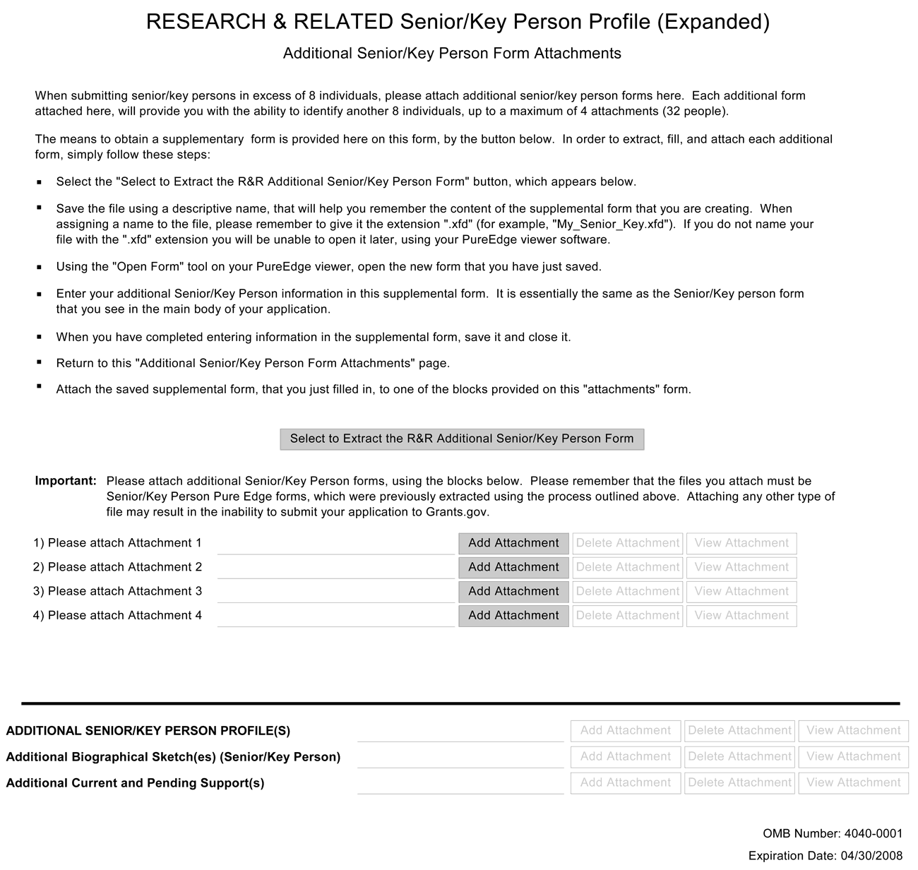
The following instructions are provided on this form:
Additional Senior/Key Person Form Attachments
When submitting senior/key persons in excess of 8 individuals, please attach additional senior/key person forms. Each additional form attached will provide you with the ability to identify another 8 individuals, up to a maximum of 4 attachments (32 people).
The means to obtain a supplementary form is provided on this form, by the button below. In order to extract, fill, and attach each additional form, simply follow these steps:
- Select the “Select to Extract the R&R Additional Senior/Key Person Form” button, which appears below.
- Save the file using a descriptive name that will help you remember the content of the supplemental form that you are creating. When assigning a name to the file, please remember to give it the extension “.xfd” (for example, “My_Senior_Key.xfd”). If you do not name your file with the “.xfd” extension you will be unable to open it later using your PureEdge viewer software.
- Using the “Open Form” tool on your PureEdge viewer, open the new form that you have just saved.
- Enter your additional Senior/Key Person information in this supplemental form. It is essentially the same as the Senior/Key person form that you have seen in the main body of your application.
- When you have completed entering information in the supplemental form, save it and close it.
- Return to this “Additional Senior/Key Person Form Attachments” page.
- Attach the saved supplemental form that you have just filled in to one of the blocks provided on this “attachments” form.
Important: Please attach additional Senior/Key Person forms using the blocks below. Please remember that the files you attach must be Senior/Key Person Pure Edge forms, which were previously extracted using the process outlined above. Attaching any other type of file may result in the inability to submit your application to Grants.gov.
Clicking on the “Select to Extract the R&R Additional Senior/Key Person Form” button produces the PureEdge form shown below.
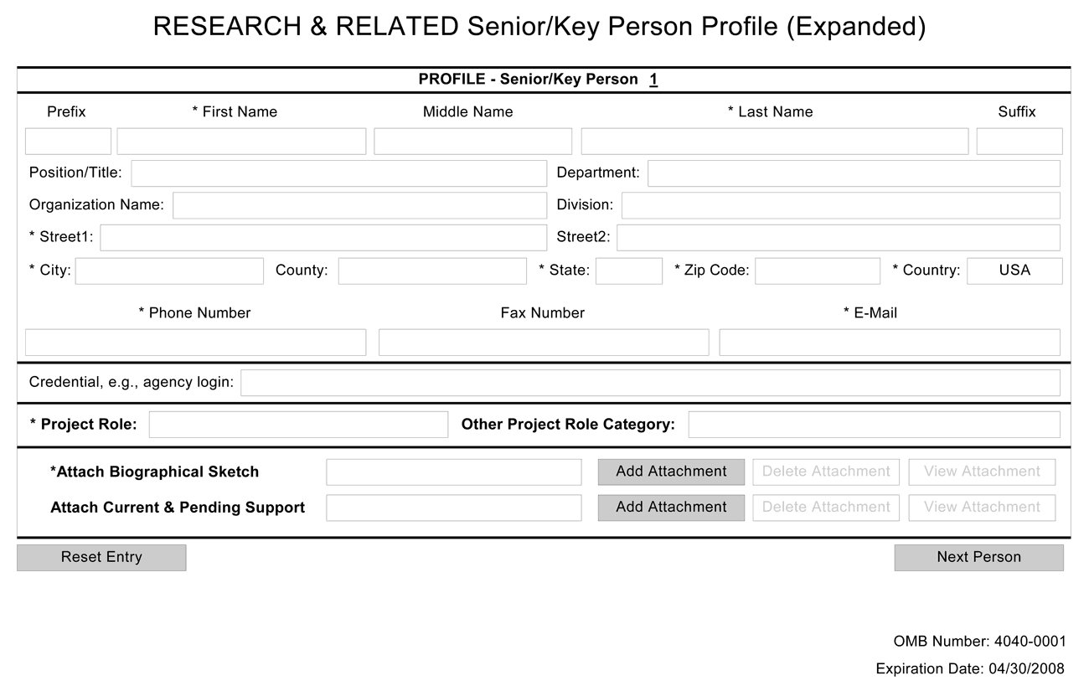
Additional Senior/Key Person Profile(s)
If more than forty Senior/Key Person profiles are proposed, enter the information in a separate file and attach it here.
A sample Additional Senior/Key Person Profiles format page for greater than 40 profiles is found under “Additional Format Pages” at: http://grants.nih.gov/grants/funding/424/index.htm.

Additional Biographical Sketch(es) (Senior/Key Person)
Provide a biographical sketch for each Senior/Key Person. Recommended information includes: Education and Training, Research and Professional Experience, Collaborators and Affiliations (for conflicts of interest), Publications and Synergistic Activities. Save the information in a single file and attach here.
Biographical Sketches should follow the format described below.

Additional Current and Pending Support(s)
Provide a list of all current and pending support for the PD/PI and each Senior/Key Person (even if they receive no salary support from the project(s) for ongoing projects and pending proposals. Show the total award amount for the entire award period (including indirect costs) as well as the number of person-months per year to be devoted to the project by the senior/key person, regardless of source of support. Concurrent submission of a proposal to other organizations will not prejudice its review.
Unless otherwise required in a specific FOA, do not use this attachment upload for NIH and other PHS agency submissions. This information is no longer required at the time of application submission. This information may be requested later in the pre-award cycle. When this occurs, refer to Other Support in Part III, Policies, Assurances, Definitions, and Other Information.

Additional NIH and Other PHS Agencies Instructions for a Biographical Sketch
Use the sample format on the Biographical Sketch Format Page to prepare this section for all (modular and other) grant applications. Include biographical sketches of all Senior/Key Personnel and Other Significant Contributors. The Biographical Sketch may not exceed four pages per person. This 4-page limit includes the table at the top of the first page. See the sample of a completed Biographical Sketch.
If the individual is registered in the eRA Commons, include the Commons User Name. This data item is required for the PD/PI but is currently optional for all other Senior/Key Persons. In other federal forms this information is referred to as “Credential, e.g., agency login.” For information on the eRA Commons, see https://commons.era.nih.gov/commons/index.jsp.
Complete the educational block at the top of the format page, and complete Sections A, B, and C.
A. Positions and Honors. List in chronological order previous positions, concluding with your present position. List any honors. Include present membership on any Federal Government public advisory committee.
B. Selected peer-reviewed publications or manuscripts in press (in chronological order): When citing articles that fall under the Public Access Policy, were authored or co-authored by the applicant and arose from NIH support, provide the NIH Manuscript Submission reference number (e.g., NIHMS97531) or the Pubmed Central (PMC) reference number (e.g., PMCID234567) for each article. If the PMCID is not yet available because the Journal submits articles directly to PMC on behalf of their authors, indicate “PMC Journal – In Process.” A list of these journals is posted at: http://publicaccess.nih.gov/submit_process_journals.htm. Citations that are not covered by the Public Access Policy, but are publicly available in a free, online format may include URLs or PMCID numbers along with the full reference (note that copies of publicly available publications are not accepted as appendix material, and do not include manuscripts submitted but not accepted for publication or in preparation).
C. Research Support. List both selected ongoing and completed (during the last three years) research projects (Federal or non-Federal support). Begin with the projects that are most relevant to the research proposed in this application. Briefly indicate the overall goals of the projects and responsibilities of the key person identified on the Biographical Sketch. Do not include number of person months or direct costs.
Don't confuse “Research Support” with “Other Support.” Though they sound similar, these parts of the application are very different. As part of the biosketch section of the application, “Research Support” highlights your accomplishments, and those of your colleagues, as scientists. This information will be used by the reviewers in the assessment of each individual's qualifications for a specific role in the proposed project, as well as to evaluate the overall qualifications of the research team. In contrast, “Other Support” information is required for all applications that are selected to receive grant awards. NIH staff will request complete and up-to-date “other support” information from you after peer review. This information will be used to check that the proposed research has not already been Federally-funded.

Once all data have been entered, click the “Close Form” button at the top of the form. You will be returned to the Grant Application Package screen. From this main screen, click on the form/document that you have just completed, and then click the => button. This will move the form/document to the Completed Documents box. To remove a form/document from the Completed Documents box, click the form/document name to select it, and then click the <= button. This will return the form/document to the Mandatory Documents or Optional Documents box.

4.6 R&R Budget Component
The R&R Budget component includes three separate data entry screens: (1) Sections A and B; (2) Sections C through E; and (3) Sections F through K. To navigate between the various screens, use the “Previous” and “Next” buttons at the top of the form. Complete the R&R Budget component following the instructions provided. You must complete a separate detailed budget for each year of support requested. The form will generate a cumulative budget for the total project period. You must complete all the required information (i.e., those fields that are highlighted and noted with an “*”) before the “Next Period” button is activated. If no funds are requested for a required field, enter “0.”
While the dollar fields allow cents to be entered, all dollar fields should be presented in whole numbers. Please round to the nearest whole number.
The concept of person months as a metric for determining percent of effort is a new business process for the applicant community of the NIH and other PHS agencies. To assist with this transition, resources are available on the web at: http://grants.nih.gov/grants/policy/person_months_faqs.htm. Frequently asked questions and a conversion calculator are available.
If funds are being requested for more than one budget period, click the “Next Period” button at the top of the third budget screen (Sections F through K) to navigate to screens for the next budget period.
Revision (Supplemental) Application. For a “Revision” (Supplemental) application, show only those items for which additional funds are requested. If the initial budget period of the supplementation application is less than 12 months, prorate the personnel costs and other appropriate items of the detailed budget.

4.6.1 Section A and B
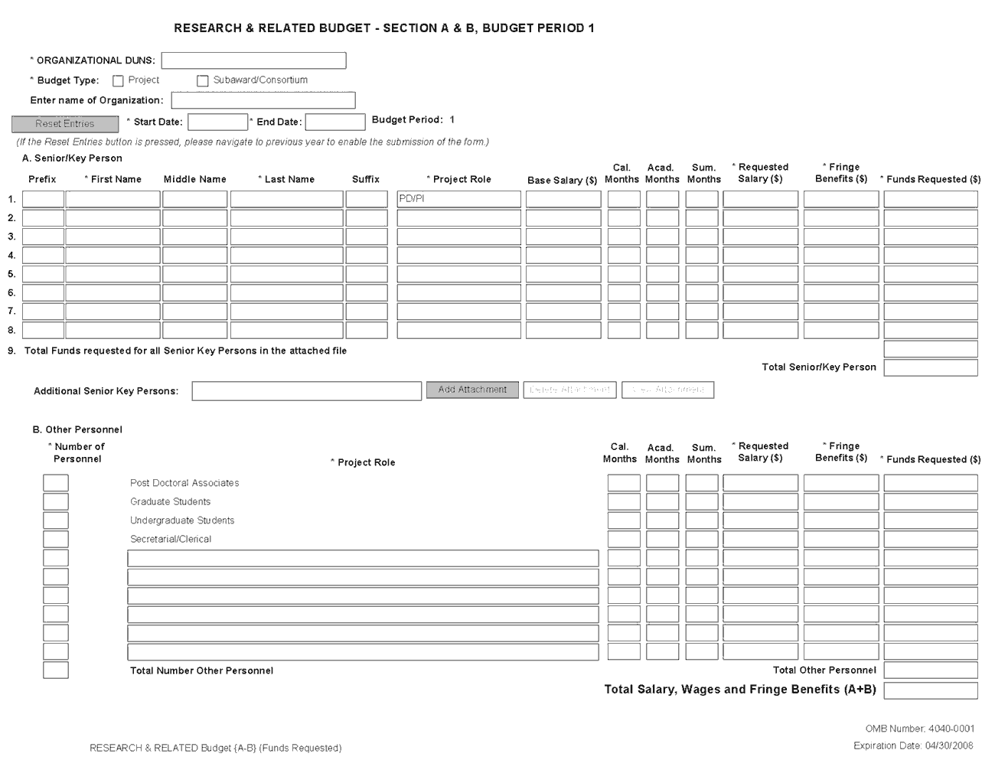
Organizational DUNS
Enter the DUNS or DUNS+4 number of your organization. For project applicants, this field is pre-populated from the R&R SF424 Cover Page. For subaward applicants, this field is required.
Budget Type
Check the appropriate block. Check Project if the budget requested is for the primary applicant organization. Check Subaward/Consortium if the budget requested is for subawardee/consortium organization(s). Note: Separate budgets are required only for subawardee/consortium organizations that perform a substantive portion of the project. If creating a Subaward Budget, use the R&R Subaward Budget Attachment and attach as a separate file on the R&R Budget Attachment(s) form.
If you are preparing an application that includes a subaward/consortium, see Section 4.7 Special Instructions for Preparing Applications with a Subaward/Consortium.
Enter name of Organization
Pre-populated from the R&R SF424. Enter the name of your organization.
Start Date
Pre-populated from the R&R SF424. Enter the requested/proposed start date of each budget period. Use the following format: MM/DD/YYYY. This field is required.
End Date
Enter the requested/proposed end date of each budget period. Use the following format: MM/DD/YYYY.
Budget Period
Identify the specific budget period (for example, 1, 2, 3, 4, 5). If submitting through Grants.gov, the system will automatically generate a cumulative budget for the total project period.
A. Senior/Key Person
This section should include the names of all senior/key persons at the applicant organization who are involved on the project in a particular budget year. Include all collaborating investigators, and other individuals meeting the senior/key person definition if they are from the applicant organization. Details of collaborators at other institutions will be provided in the Subaward budget for each subaward/consortium organization. Personnel listed as Other Significant Contributors who are not committing any specific measurable effort to the project should not be included in the Personnel section of the budget since no associated salary and/or fringe benefits should be requested for their contribution. Consultants designated as Senior/Key Persons in the Senior/Key Person Profile Component can be included in Budget Section A only if they are also employees of the applicant organization. Otherwise, consultant costs should be included in F.3 Consultant Services.
Field Name | Instructions
Prefix | Select from the list the prefix (for example, Mr., Mrs., Rev.) of the Senior/Key Person.
First Name | Enter the first (given) name of each Senior/Key Person. This field is required.
Middle Name | Enter the middle name of each Senior/Key Person, if applicable.
Last Name | Enter the last (family) name of each Senior/Key Person. This field is required.
Suffix | Select from the list the suffix (for example, Jr., Sr., PhD) of each Senior/Key Person.
Project Role | Enter the project role of the Senior/Key person. This field could also include such roles as Co-PD/PI, Postdoctoral Associates, and Other Professionals.  The role of the PD/PI is auto-populated in the 01 year budget only. Do not change or edit this field for the PD/PI. For future year budgets, use consistent terminology.
Base Salary ($) | Enter the annual compensation paid by the employer for each Senior/Key person. This includes all activities such as research, teaching, patient care, or other. You may choose to leave this column blank.  An applicant organization may choose to leave this blank; however, PHS staff will request this information prior to award.  STTR: If the PD/PI is an employee of the Research Institution (RI), the PD/PI salary should be entered on the RI subaward budget page.
Cal. Months | Enter the number of months devoted to the project for each Senior/Key person (for example, calendar, academic, summer).  If effort does not change throughout the year, it is OK to use only the calendar months column. However, you may use both academic and summer months columns if your institutional business process requires noting each separately even if effort remains constant. If effort varies between academic and summer months, leave the calendar months column blank and use only the academic and summer months columns.  STTR: If the PD/PI is an employee of the Research Institution (RI), the PD/PI months devoted should be entered on the RI subaward budget page.
Acad. Months | Enter the number of months devoted to the project for each Senior/Key person (for example, calendar, academic, summer).  If your institution does not use a 9-month academic year, indicate your institution’s definition of academic year in the budget justification.  STTR: If the PD/PI is an employee of the Research Institution (RI), the PD/PI months devoted should be entered on the RI subaward budget page.
Sum. Months | Enter the number of months devoted to the project for each Senior/Key person (for example, calendar, academic, summer).  If your institution does not use a 3-month summer period, indicate your institution’s definition of summer in the budget justification.  STTR: If the PD/PI is an employee of the Research Institution (RI), the PD/PI months devoted should be entered on the RI subaward budget page.
Requested Salary ($) | Regardless of the number of months being devoted to the project, indicate only the amount of salary being requested for this budget period for each Senior/Key person.  Some PHS grant programs are currently subject to a legislatively imposed salary limitation. Any adjustment for salary limits will be made at the time of award. For guidance on current salary limitations, see the Salary Cap Summary on the NIH grants Web site or contact your office of sponsored programs.  NIH grants also limit the compensation for graduate students. Compensation includes salary or wages, fringe benefits and tuition remission. While actual institutional-based compensation should be requested and justified, this may be adjusted at the time of the award. For more guidance on this policy, see: http://grants.nih.gov/grants/ guide/notice-files/NOT-OD-02-017.html.  STTR: The PD/PI may be paid by either the research institution (RI) or the small business, but not both. If the PD/PI is an employee of the small business, enter the PD/PI’s salary on the small business budget. If the PD/PI is an employee of the RI, enter the PD/PI’s salary on the RI’s subaward budget.
Fringe Benefits ($) | Enter applicable fringe benefits, if any, for each Senior/Key person.  SBIR and STTR: Leave this section blank as commercial (for-profit) organizations usually treat 'fringe benefits' as indirect costs. In certain cases, fringe benefits may be requested as a direct cost to the extent that they are treated consistently by the organization as a direct cost to all sponsors.
Funds Requested ($) | Enter the requested salary and fringe benefits for each Senior/Key person.
Total Funds requested for all Senior Key Persons in the attached file | Enter the total funds requested for all Senior/Key persons listed in the attached file.
Total Senior/Key Person | The total funds requested for all Senior/Key persons.
Additional Senior Key Persons | If funds are requested for more than eight Senior/Key persons, include all pertinent budget information and attach as a file here. Enter the total funds requested for all additional senior/key persons in line 9 of Section A.  Use the same format as the budget component and include all required information.

Special Instructions: Joint University and Department of Veterans Affairs (V.A.) Appointments
Individuals with joint university and V.A. appointments may request the university’s share of their salary in proportion to the effort devoted to the research project. The individual’s salary with the university determines the base for computing that request. Signature by the institutional official on the application certifies that: (1) the individual is applying as part of a joint appointment specified by a formal Memorandum of Understanding between the university and the V.A.; and (2) there is no possibility of dual compensation for the same work, or of an actual or apparent conflict of interest regarding such work. Additional information may be requested by the awarding components.

B. Other Personnel
Field Name | Instructions
Number of Personnel | For each project role category identify the number of applicant organization personnel proposed. Note, for Secretarial/Clerical Personnel, in most circumstances the salaries of administrative or clerical staff at educational institutions and nonprofit organizations are included as part of indirect costs. Examples, however, of where direct charging of administrative or clerical staff salaries may be appropriate may be found at: http://www.whitehouse.gov/omb/circulars/a021/a21_2004.html. The circumstances for requiring direct charging of these services must be clearly described in the budget justification.  For all Postdoctoral Associates and Graduate Students not already named in Section A. Senior/Key Person, individually list names, roles (e.g., PostDoc or Graduate Student), associated months, and salary & fringe benefits requested in the Budget Justification.
Project Role | If Project Role is other than Post Doctoral Associates, Graduate Students, Undergraduate Students, or Secretarial/Clerical, enter the appropriate project role (for example, Engineer, IT Professional, etc.) in the blanks.  Do not include consultants in this section. Consultants are included below in Section F. Other Direct Costs.
Cal. Months | Enter the number of months devoted to the project in the applicable box for each project role category (for example, calendar, academic, summer).
Acad. Months | Enter the number of months devoted to the project in the applicable box for each project role category (for example, calendar, academic, summer).  If your institution does not use a 9-month academic year, indicate your institution’s definition of academic year in the budget justification.
Sum. Months | Enter the number of months devoted to the project in the applicable box for each project role category (for example, calendar, academic, summer).  If your institution does not use a 3-month summer period, indicate your institution’s definition of summer in the budget justification.
Requested Salary ($) | Regardless of the number of months being devoted to the project, indicate only the amount of salary/wages being requested for each project role.  Some PHS grant programs are currently subject to a legislatively imposed salary limitation. Any adjustment for salary limits will be made at the time of award. For guidance on current salary limitations, see the Salary Cap Summary on the NIH grants Web site or contact your office of sponsored programs.  NIH grants also limit the compensation for graduate students. Compensation includes salary or wages, fringe benefits and tuition remission. While actual institutional-based compensation should be requested and justified, this may be adjusted at the time of the award. For more guidance on this policy, see: http://grants.nih.gov/grants/ guide/notice-files/NOT-OD-02-017.html.
Fringe Benefits ($) | Enter applicable fringe benefits, if any, for this project role category.  SBIR and STTR: Leave this section blank as commercial (for-profit) organizations usually treat 'fringe benefits' as indirect costs. In certain cases, fringe benefits may be requested as a direct cost to the extent that they are treated consistently by the organization as a direct cost to all sponsors.
Funds Requested | Enter requested salary/wages & fringe benefits for each project role.
Total Number of Other Personnel | The total number of other applicant organization personnel.
Total Other Personnel | The total funds requested for all other Personnel.
Total Salary, Wages and Fringe Benefits (A+B) | Total Funds requested for all Senior Key Persons and all Other Personnel.
To navigate to the next page (Sections C through E), click the “Next” button at the top of the form.

4.6.2 Sections C through E
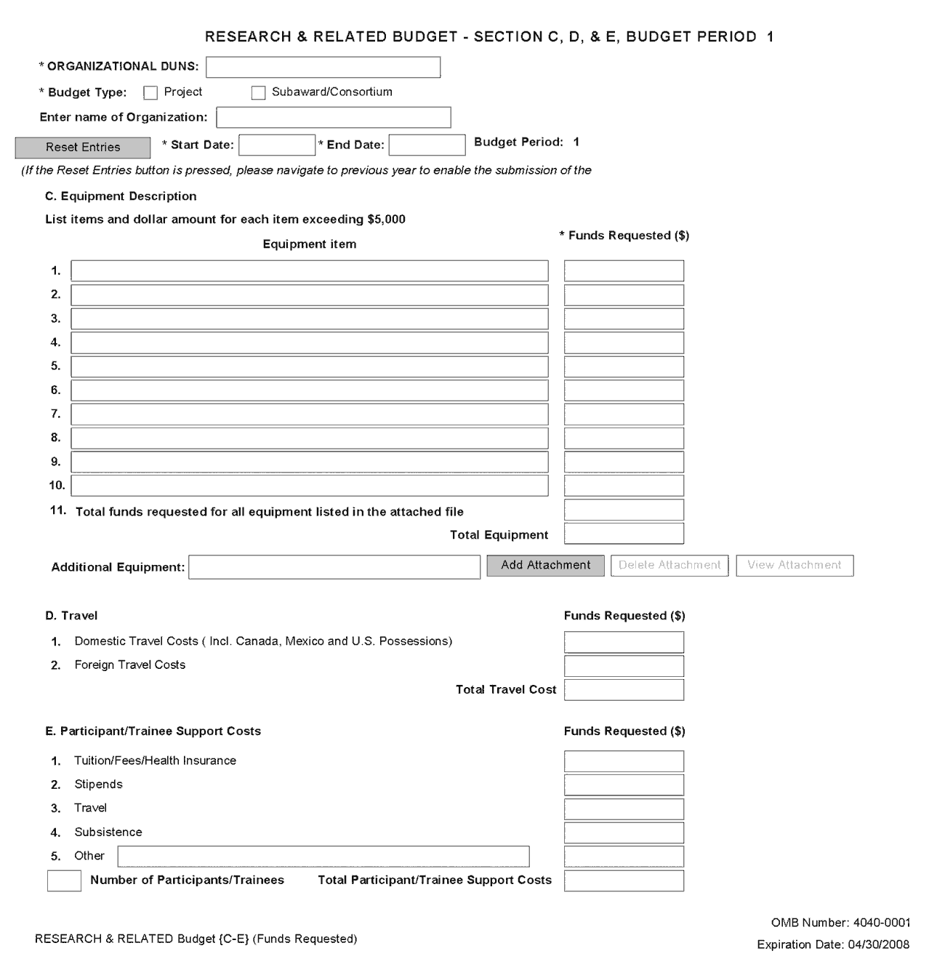
The information for Organizational DUNS, Budget Type, Name of Organization, and Start and End Dates is automatically filled in based on the information entered on the first budget screen. To edit this information, return to the initial budget screen (Sections A and B) by clicking the “Previous” button.
C. Equipment Description
Field Name | Instructions
Equipment item | Equipment is defined as an item of property that has an acquisition cost of $5,000 or more (unless the organization has established lower levels) and an expected service life of more than one year. List each item of equipment separately and justify each in the budget justification section. Ordinarily, allowable items will be limited to research equipment and apparatus not already available for the conduct of the work. General-purpose equipment, such as a personal computer, is not eligible for support unless primarily or exclusively used in the actual conduct of scientific research.
Funds Requested | List the estimated cost of each item of equipment including shipping and any maintenance costs and agreements. This is required information.
Total funds requested for all equipment listed in the attached file | Enter the total funds requested for all equipment listed in the attached file. Dollar amount for each item should exceed $5000.
Total Equipment | Total Funds requested for all equipment.
Additional Equipment | If the space provided cannot accommodate all the equipment proposed, attach a file by clicking Add Attachment. List each additional item and the funds requested. For all additional items in the attached file, list the total funds requested on line 11 of this section.
D. Travel
Field Name | Instructions
Domestic Travel Costs (Incl. Canada, Mexico, and US Possessions) | Enter the total funds requested for domestic travel. Domestic travel includes Canada, Mexico, and US possessions. In the budget justification section, include the purpose, destination, dates of travel (if known), and number of individuals for each trip. If the dates of travel are not known, specify estimated length of trip (for example, 3 days).
Foreign Travel Costs | Enter the total funds requested for foreign travel. Foreign travel includes any travel outside of North America and/or US possessions. In the budget justification section, include the purpose, destination, dates of travel (if known) and number of individuals for each trip. If the dates of travel are not known, specify estimated length of trip (for example, 3 days).
Total Travel Cost | The total funds requested for all travel.
E. Participant/Trainee Support Costs
Unless specifically stated otherwise in an announcement, NIH and other PHS agencies applicants should leave blank Section E. Note: Tuition remission for graduate students should continue to be included in Section F. Other Direct Costs when applicable.
Field Name | Instructions
Tuition/Fees/Health Insurance | Enter the total amount of funds requested for Participant/Trainee tuition, fees, and/or health insurance.
Stipends | Enter the total funds requested for Participant/Trainee stipends.
Travel | Enter the total funds requested for Participant/Trainee travel.
Subsistence | Enter the total funds requested for Participant/Trainee subsistence.
Other | Describe any other participant trainee funds requested. Enter the total funds requested for any other Participant/Trainee costs described.
Number of Participants/Trainees | Enter the total number of proposed Participants/Trainees.
Total Participant/Trainee Support Costs | The total funds requested for all trainee costs.

4.6.3 Sections F through K
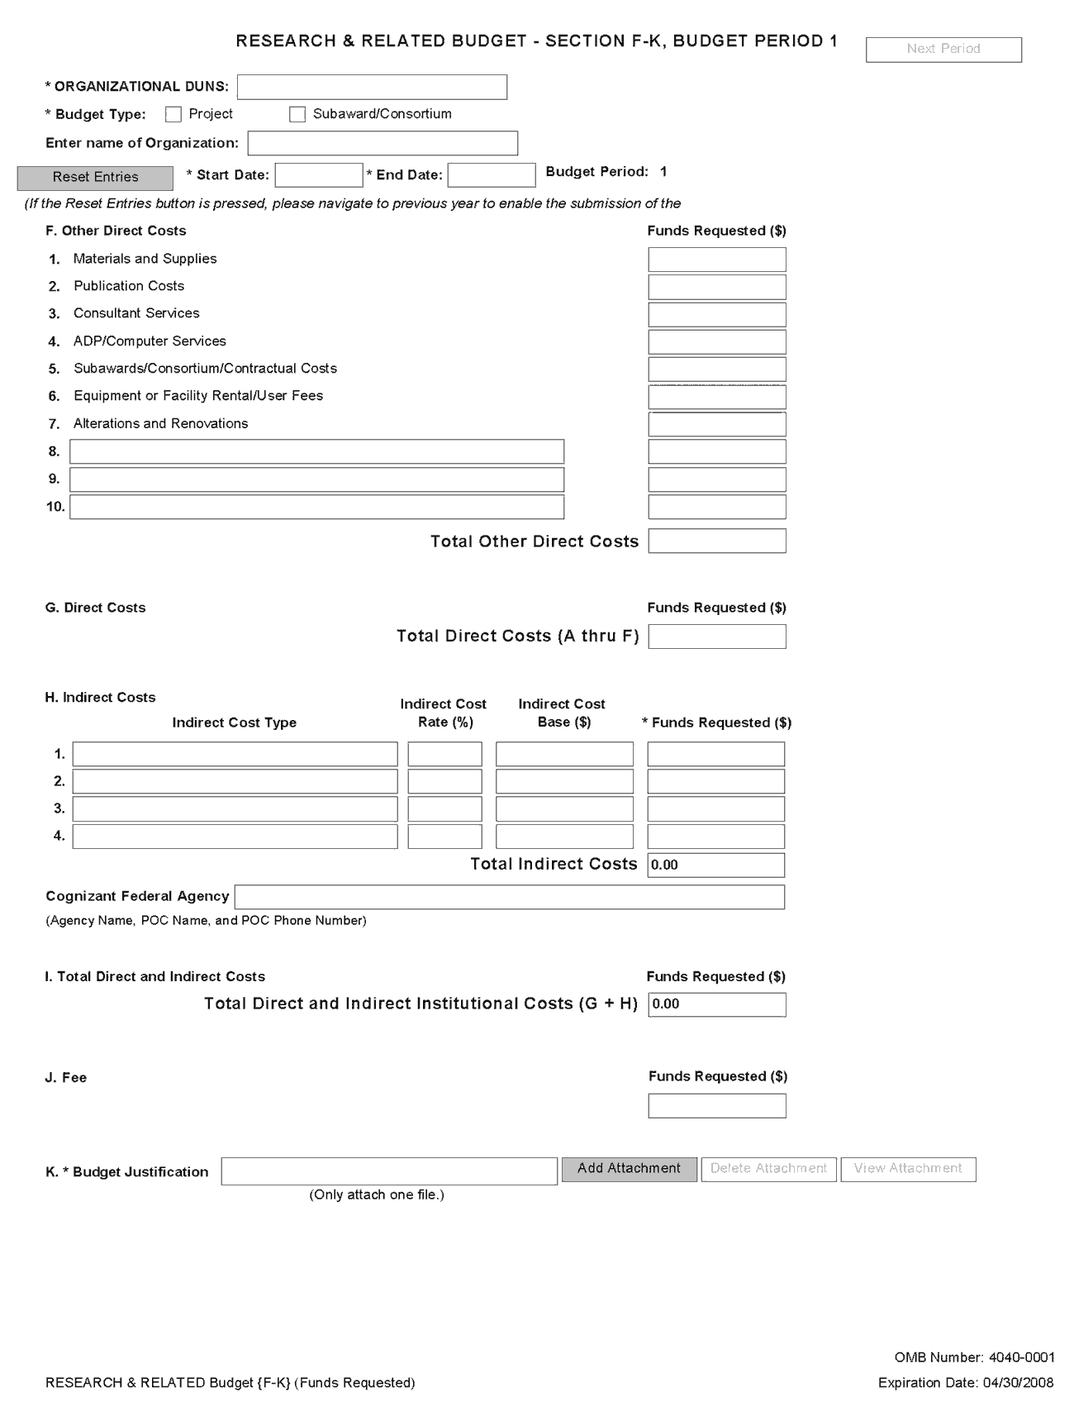
The information for Organizational DUNS, Budget Type, Name of Organization, and Start and End Dates is automatically filled in based on the information entered on the first budget screen. To edit this information, return to the initial budget screen (Sections A and B) by clicking the “Previous” button.
F. Other Direct Costs
Field Name | Instructions
1. Materials and Supplies | Enter the total funds requested for materials and supplies. In the budget justification, indicate general categories such as glassware, chemicals, animal costs, including an amount for each category. Categories less than $1,000 do not have to be itemized.
2. Publication Costs | Enter the total publication funds requested. The proposal budget may request funds for the costs of documenting, preparing, publishing, or otherwise making available to others the findings and products of the work conducted under the award. In the budget justification include supporting information.
3. Consultant Services | Enter the total costs for all consultant services. In the budget justification, identify each consultant, the services he or she will perform, total number of days, travel costs, and the total estimated costs.  In the budget justification also provide the names and organizational affiliations of all consultants, other than those involved in consortium/contractual arrangements. Include consultant physicians in connection with patient care and persons who are confirmed to serve on external monitoring boards or advisory committees to the project. Describe the services to be performed.
4. ADP/Computer Services | Enter total funds requested for ADP/computer services. The cost of computer services, including computer-based retrieval of scientific, technical and education information may be requested. In the budget justification, include the established computer service rates at the proposing organization if applicable.
5. Subawards/Consortium/ Contractual Costs | Enter the total funds requested for 1) all subaward/consortium organization(s) proposed for the project and 2) any other contractual costs proposed for the project.  This line item should include both direct and indirect costs for all subaward/consortium organizations. Contractual costs for support services, such as the laboratory testing of biological materials, clinical services, or data processing, are occasionally sufficiently high to warrant a categorical breakdown of costs. When this is the case, provide detailed information as part of the budget justification.
6. Equipment or Facility Rental/User Fees | Enter the total funds requested for equipment or facility rental/user fees. In the budget justification, identify each rental user fee and justify.
7. Alterations and Renovations | Enter the total funds requested for alterations and renovations. In the budget justification, itemize by category and justify the costs of alterations and renovations including repairs, painting, removal or installation of partitions, shielding, or air conditioning. Where applicable, provide the square footage and costs.  Under certain circumstances the public policy requirements that apply to construction activities may also apply to A&R activities. Please refer to the NIH Grants Policy Statement section on “Construction Grants – Public Policy Requirements and Objectives” for more information.  Note, costs for any Alterations and Renovations (A&R) were previously unallowable on applications from foreign institutions, international organizations and domestic applications with foreign subawards. However, an HHS policy change now allows for minor A&R (<$500,000) on these applications.  When requesting minor A&R costs under this policy, please provide detailed information on the planned A&R in the budget justification.
8-10 Other | Add text to describe any “other” direct costs not requested above. Use the budget justification to further itemize and justify.  Use lines 8-10 for such costs as patient care and tuition remission. If requesting patient care costs, request inpatient and outpatient costs separately using lines 8 and 9.  If line space is an issue, combine all remaining “other direct costs” together on the last line and include details in the budget justification (description and funds requested).
Total Other Direct Costs | The total funds requested for all other direct costs.

Special Instructions for Patient Care Costs
If inpatient and/or outpatient costs are requested, provide the names of any hospitals and/or clinics and the amounts requested for each in the budget justification
State whether each hospital or clinic has a currently effective DHHS-negotiated research patient care rate agreement and, if not, what basis is used for calculating costs. If an applicant does not have a DHHS-negotiated rate, the PHS awarding component can approve a provisional rate. Indicate, in detail, the basis for estimating costs in this category, including the number of patient days, estimated cost per day, and cost per test or treatment. If both inpatient and outpatient costs are requested, provide information for each separately. If multiple sites are to be used, provide detailed information by site.
Include information regarding projected patient accrual for the project/budget periods and relate this information to the budget request for patient care costs. If patient accrual is anticipated to be lower at the start or during the course of the project, plan budget(s) accordingly.
Provide specific information regarding anticipated sources of Other Support for patient care costs, e.g., third party recovery or pharmaceutical companies. Include any potential or expected utilization of General Clinical Research Centers.
G. Total Direct Costs (A through F)
The total funds requested for all direct costs.

H. Indirect Costs
Indirect costs are defined as costs that are incurred by a grantee for common or joint objectives and that, therefore, cannot be identified specifically with a particular project or program. If the applicant small business concern has a currently effective negotiated indirect cost rate with a Federal agency, that rate should be used when calculating proposed indirect costs. (However, these rates must be adjusted for independent [self-sponsored] research and development expenses, which are not allowable by the Department of Health and Human Services [DHHS].)
If applicable, indicate your organization’s most recent indirect cost rate established with the Division of financial Advisory Services (DFAS), NIH, or with another Federal agency. If your applicant organization is in the process of negotiating or renegotiating a rate, use that rate in the application.
If the applicant organization does not have a current negotiated rate, it should develop a provisional rate for application purposes. If the applicant organization has a current negotiated rate with another Federal agency, the negotiated rate must be adjusted to treat any independent research and development (IR&D) costs in accordance with DHHS policy.
If this field does not allow a figure greater than 100% to be entered, use two lines to show the entire calculation.
In accordance with the Small Business Innovation Development Act of 1982 and the Small Business Technology Transfer Act of 1992, irrespective of the time period in which the costs are incurred, no SBIR/STTR funds can be used to “support” any commercialization (Phase III activities). “Support” in this case includes both direct and indirect costs.
The Small Business Administration’s SBIR and STTR Program Policy Directives defined terms:
SBIR agencies must establish an SBIR Program by reserving, in each fiscal year, not less than 2.5 percent of its extramural budget for awards to SBCs for R/R&D. “R&D activities” include any activities directed toward reducing the technical risk of the technology.
- Commercialization. The process of developing marketable products or services and producing and delivering products or services for sale (whether by the originating party or by others) to government or commercial markets.
- Phase III is the period during which Phase II innovation moves from the laboratory into the marketplace. No SBIR funds support this phase. The small business must find funding in the private sector or other non-SBIR Federal agency funding.
Based on this position, when NIH is negotiating indirect costs with SBIR/STTR grantees/contractors, we are disallowing all indirect costs applicable to commercialization activities related to SBIR/STTR awards.
Note: Below is a list of cost categories NIH considers to be commercialization. In addition, these items include labor costs for the Marketing Director and Director of Business Development, as well as sales and marketing staff who are grantee/contractor employees or contractors hired for those purposes.
Commercialization cost categories: market and sales; market research; business development/product development/market plans; legal fees, travel and other costs relating to license agreements and partnerships.
You are encouraged to visit the following Division of Financial Advisory Services (DFAS) Web sites or call the DFAS staff at 301-496-2444 for guidance:
Main DFAS website, http://ocm.od.nih.gov/dfas/dfas.htm
FAQS, http://ocm.od.nih.gov/dfas/faqindirectcosts.htm
Listing of unallowable and unallocable costs and the related Federal Acquisition Regulation (FAR) citation for each, http://ocm.od.nih.gov/dfas/ unallowables.htm

Field Name | Instructions
Indirect Cost Type | Indicate the type of cost (for example, Salary & Wages, Modified Total Direct Costs, or Other [explain]). Also indicate if Off-site. If more than one rate/base is involved, use separate lines for each. If you do not have a current indirect rate(s) approved by a Federal agency, indicate, “None--will negotiate” and include information for a proposed rate. Use the budget justification if additional space is needed.
Indirect Cost Rate (%) | Indicate the most recent indirect cost rate(s) (also known as Facilities & Administrative Costs [F&A]) established with the cognizant Federal office, or in the case of for-profit organizations, the rate(s) established with the appropriate agency. If you have a cognizant/oversight agency and are selected for an award, you must submit your indirect rate proposal to that office for approval. If you do not have a cognizant/oversight agency, contact the awarding agency.  SBIR and STTR Phase I Applicants: If your organization does not have a currently effective negotiated F&A cost rate with a Federal agency, then propose estimated F&A costs at a rate not to exceed 40% of the total direct costs. If awarded at a rate of 40% or less of total direct costs the rate used to charge actual F&A costs to projects cannot exceed the awarded rate. NIH will not negotiate F&A rates for Phase I awards.  SBIR and STTR Phase II Applicants: If the requested F&A rate is 25 percent or less (of total direct costs), F&A costs will be awarded at the requested rate. If the requested F&A rate is greater than 25 percent of total direct costs, additional information will be required prior to award to justify the requested rate. If awarded at a rate of 25% or less of total direct costs, the rate used to charge actual F&A costs to projects cannot exceed the awarded rate.  Indirect cost rates cannot exceed 99 on any line. If the negotiated rate exceeds 99%, request the additional rate amount on the next line. This field should be entered using a rate such as “55.5.”
Indirect Cost Base ($) | Enter the amount of the base for each indirect cost type.
Funds Requested | Enter the funds requested for each indirect cost type.
Total Indirect Costs | The total funds requested for indirect costs.
Cognizant Federal Agency | Enter the name of the cognizant Federal Agency, name and telephone number of the individual responsible for negotiating your rate. If no cognizant agency is known, enter “None.”
I. Total Direct and Indirect Institutional Costs (G + H)
The total funds requested for direct and indirect costs.
Ensure that the direct costs and the indirect costs (G+H) on Section F-K EQUAL the Total Direct and Indirect Costs (G+H) on the Cumulative Budget page.
Routinely, SBIR and STTR Phase I awards do not exceed $100,000 total costs (direct costs, indirect costs, and fee). Routinely, total costs for the entire proposed Phase II period do not exceed $750,000 for SBIR and STTR projects. However, under special circumstances, applicants may propose greater amounts of funds necessary and appropriate for completion of the project.
The ability to deviate from the statutory guidelines applies to NIH ONLY – Phase I applications to CDC and FDA are limited to total costs of $100,000. Phase II applications to CDC and FDA are limited to total costs of $750,000.
J. Fee
A reasonable fee, not to exceed 7% of total costs (direct and indirect) for each Phase (I and II) of the project, is available to small business concerns receiving awards under the SBIR/STTR program. The fee is intended to be a reasonable profit factor available to for-profit organizations, consistent with normal profit margins provided to profit-making firms for research and development work.
Explain the basis and the amount requested for the fee in the budget justification. The amount requested for the fee should be based on the following guidelines: (1) it must be consistent with that paid under contracts by the PHS for similar research conducted under similar conditions of risk; (2) it must take into account the complexity and innovativeness of the research to be conducted under the SBIR/STTR project; and (3) it must recognize the extent of the expenditures for the grant project for equipment and for performance by other than the grantee organization through consultant and subaward agreements.
The fee is not a direct or indirect "cost" item and may be used by the small business concern for any purpose, including additional effort under the SBIR/STTR award. The fee applies solely to the small business concern receiving the award and not to any other participant in the project. However, the grantee may pay a profit/fee to a contractor providing routine goods or services in accordance with normal commercial practice.
Note: The electronic system automatically rounds up. If you get an error “The fee must be less than 7%,” try using 6.99% as the rate.
K. Budget Justification
Use the budget justification to provide the additional information requested in each budget category identified above and any other information you wish to submit to support your budget request. Note this is a single justification for all budget years so include all justification information for all years in the same file. Click Add Attachment to attach the file.
Use this section to also list the names, role (e.g., PostDoc or Graduate Student), associated months, salary and fringe benefits for all Postdoctoral Associates and Graduate Students included in Budget Section B. Other Personnel.
Include a justification for any significant increases or decreases from the initial year budget. Also, justify budgets with more than a standard escalation from the initial to the future year(s) of support.
If the application includes a subaward/consortium budget, a separate budget justification is submitted for that budget. See Section 4.7 Special Instructions for Preparing Applications with a Subaward/Consortium
Completing Budget Periods 2-5
If funds are being requested for more than one budget period, you must complete a separate detailed budget for each year of support requested. To navigate to screens for the next budget period, click the “Next Period” button at the top of the 3rd budget screen (Sections F through K). You must complete all the required information (i.e., those fields that are highlighted and noted with an “*”) before the “Next Period” button is activated. If no funds are requested for a required field, enter “0.” Note the Budget Justification is also a required item and must be attached before the “Next Period” button is activated.
Supplemental/Revision Application
For a supplemental/revision application, show only those items for which additional funds are requested. If the initial budget period of the supplemental/revision application is less than 12 months, prorate the personnel costs and other appropriate items of the detailed budget.
Submitting Budgets With More Than 5 Budget Periods
When authorized or requested by the appropriate NIH IC, applicants may submit applications with more than 5 budget periods. In these situations complete the detailed budget for periods 1-5 as usual. However, include the same level of detail for Period 6 in the Budget Justification along with an explanation of the situation. Also, be sure to include a cover letter that addresses these extra budget periods, and include the IC Program Official’s preapproval as part of the Cover Letter PDF.”

4.6.4 Cumulative Budget
All values on this form are calculated automatically. They present the summations of the amounts that you have entered previously, under Sections A through K, for each of the individual budget periods. Therefore, no data entry is allowed or required, in order to complete this “Cumulative Budget” section.
If any of the amounts displayed on this form appears to be incorrect, you may correct it by adjusting one or more of the values that contribute to that total. To make any such adjustments, you will need to revisit the appropriate budget period form(s), to enter corrected values.
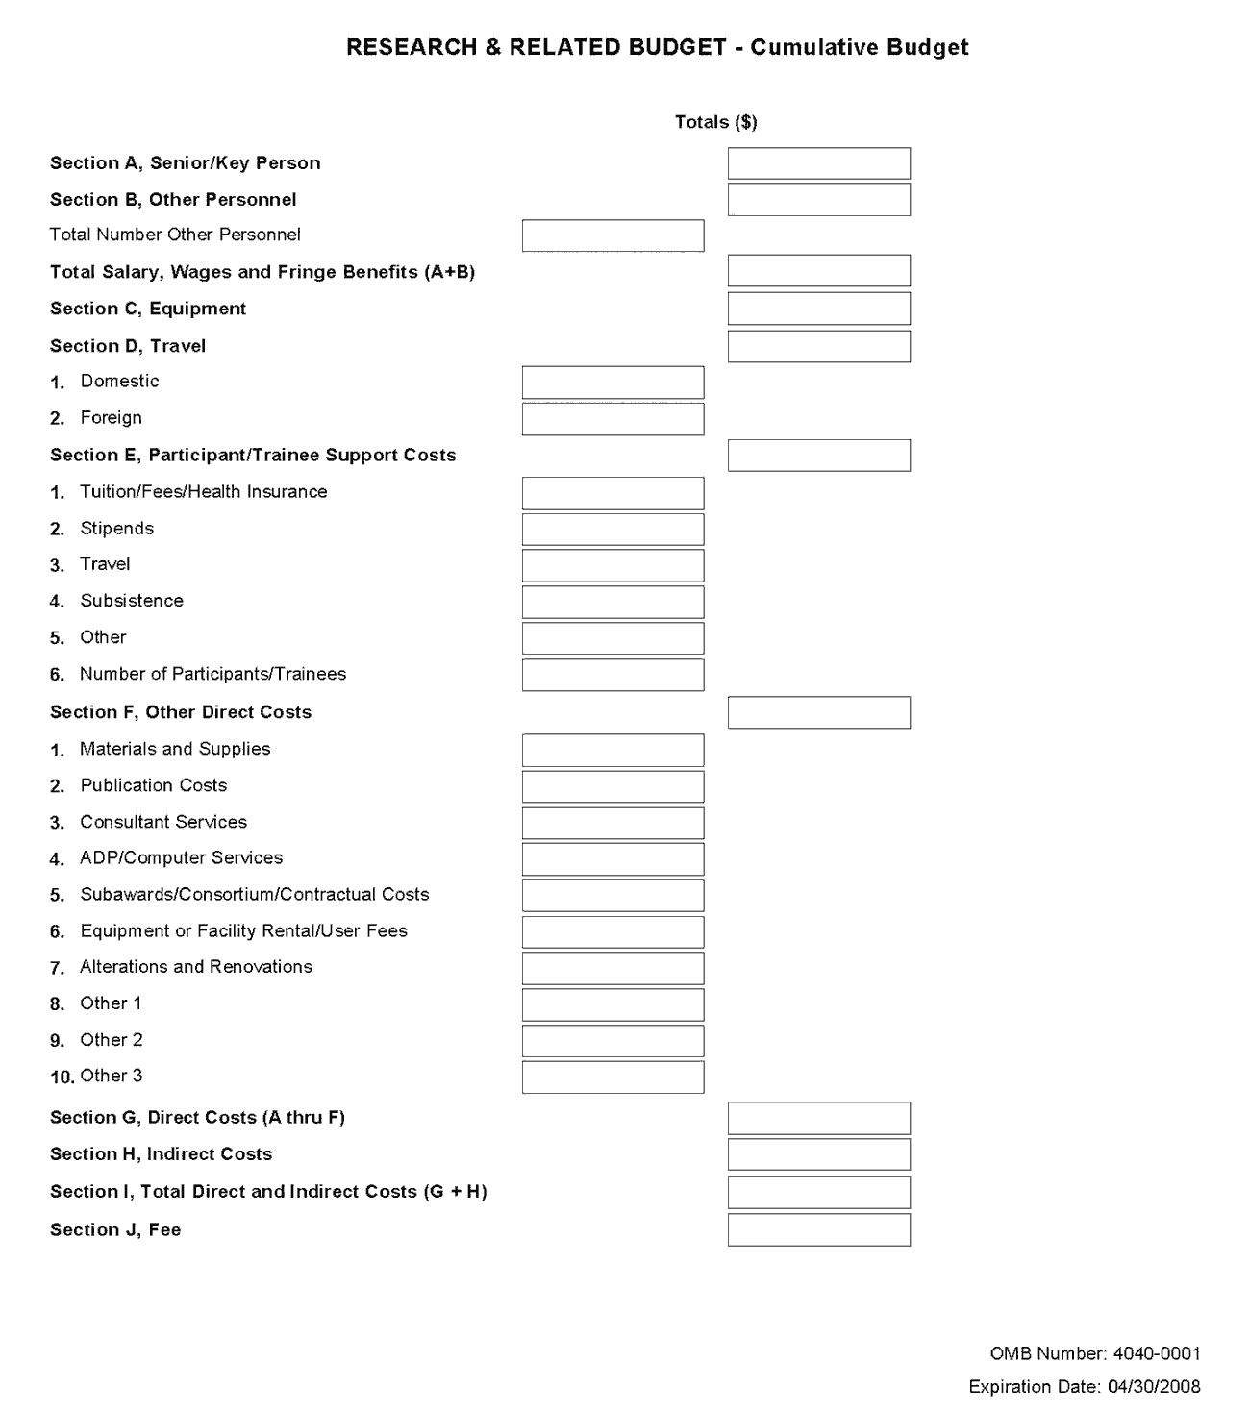

Once all data have been entered, click the “Close Form” button at the top of the form. You will be returned to the Grant Application Package screen. From this main screen, click on the form/document that you have just completed, and then click the => button. This will move the form/document to the Completed Documents box. To remove a form/document from the Completed Documents box, click the form/document name to select it, and then click the <= button. This will return the form/document to the Mandatory Documents or Optional Documents box.

4.7 Special Instructions for Preparing Applications with a Subaward/Consortium

SBIR
In Phase I, normally, a minimum of two-thirds or 67% of the research or analytical effort must be carried out by the small business concern. The total amount of all consultant and contractual arrangements to third parties for portions of the scientific and technical effort generally may not exceed 33% of the total amount requested (direct, F&A/indirect, and fee).
If the application is selected for an award, the Authorized Organizational Representative (AOR) will need to certify that the applicant and all proposed consortium participants understand and agree to the following statement: The appropriate programmatic and administrative personnel of each organization involved in this grant application are aware of the NIH consortium agreement policy and are prepared to establish the necessary inter-organizational agreement(s) consistent with that policy.
In Phase II, normally, a minimum of one-half or 50% of the research or analytical effort must be carried out by the small business concern. The total amount of consultant and contractual arrangements to third parties for portions of the scientific and technical effort generally may not exceed 50% of the total Phase II amount requested (direct, F&A/indirect, and fee).
The basis for determining the percentage of work to be performed by each of the cooperative parties in Phase I or Phase II will be the total of the requested costs attributable to each party, unless otherwise described and justified in Item 15, Consortium/Contractual Arrangements, of the PHS 398 Research Plan component.

STTR
In Phase I and Phase II, at least 40% of the work must be performed by the small business concern and at least 30% of the work must be performed by the single partnering research institution. The basis for determining the percentage of work to be performed by each of the cooperative parties will be the total of the requested costs (direct, F&A/indirect, and fee) attributable to each party, unless otherwise described and justified in Item 15, Consortium/Contractual Arrangements, of the PHS 398 Research Plan component.
The single “partnering” research institution must provide a letter to the applicant small business concern certifying that at least 30% of the work of the STTR project will be performed by the research institution. The small business concern will include this letter as an attachment upload in Item 15, Consortium/Contractual Arrangements, of the PHS 398 Research Plan component.
In addition, a small business concern must negotiate a written agreement between the small business and the research institution allocating intellectual property rights to carry out follow-on research, development or commercialization. See Model Agreement for the Allocation of Rights. This agreement is required to receive support under the STTR program but is NOT submitted with the application. A copy of the Agreement must be furnished upon request of the NIH awarding component.
A small business concern may subcontract a portion of its STTR award to a Federally Funded Research and Development Center (FFRDC), either in its capacity as the Research Institution or as a participant in the STTR project in another capacity. However, STTR funds may not be used to pay for laboratory resources of non-FFRDCs, and no STTR funds may be used to pay for subcontracting any portion of the STTR award back to the issuing agency or to any other Federal government unit unless a waiver is granted by the Small Business Administration.
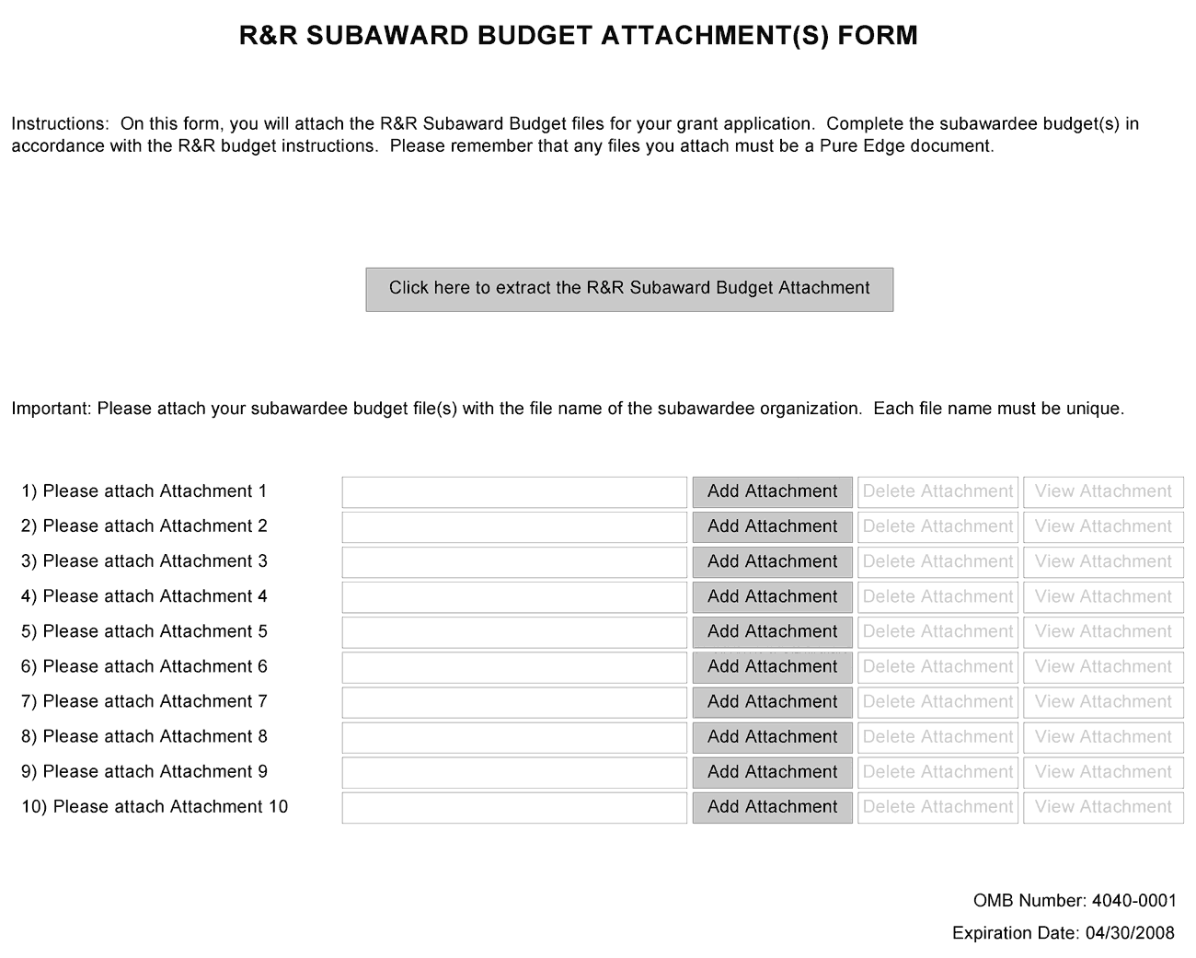
A complete subaward/consortium budget component (including the budget justification section) should be completed by each consortium grantee organization. Separate budgets are required only for subawardee/consortium organizations that perform a substantive portion of the project.
When completing the Project Role for the investigator leading the portion of the project at the consortium site, the project role of “PD/PI” should only be used if the entire application is being submitted under the Multiple PI policy. Also, the role of Co-PD/PI is not currently used by NIH and other PHS agencies. Do not assign any individual this role. If applicants wish to use roles of “Co-Investigator” or “Consortium PI”, select “Other” for the Project Role field and then insert the appropriate role descriptor in the Other Project Role Category field.
This component currently accommodates up to 10 separate subaward budgets. If you are submitting an application with >10 subaward budgets, budgets 11 and above should be converted to PDF and included as part of Section K. Budget Justification of the parent budget (R&R Budget Component). Reminder, the sum of all subaward budgets; e.g., those attached separately and those provided as part of the budget justification, must be included in Line F.5 Subawards/Consortium/Contractual Costs of the parent budget.
To start the process, the applicant organization should:
- Select the Subaward Budget Attachment Form from the Optional Documents in the Grant Application Package.
- Open the form, and click the “Click here to extract the R&R Subaward Budget Attachment” button in the middle of the form. A “SAVE” dialog box appears.
- Save the file locally using the first 10 letters of the consortium organization’s name as the file name and leave “.xfd” as the file extension. (The extracted file is a PureEdge document.) Once you have saved the file, there is no need to extract another budget attachment. Doing so may cause you to lose any data already stored in the saved file.
- Email the extracted, saved form to the consortium grantee. Note: consortium grantees must have installed the PureEdge Viewer before they can complete the form. The consortium grantee should complete all the budget information as instructed in the R&R Budget component instructions in Section 4.6. Note: Organizational DUNS and Name of Organization fields must reflect that of the subaward/consortium grantee.
- The consortium grantee must complete the budget component and email it back to the applicant organization.
- A fee cannot be entered for a subaward/consortium budget. Fee is allowable only for the small business applicant organization budget page.
- Return to the Subaward Budget Attachment Form and attach the consortium grantee’s budget to one of the blocks provided on the form. Do not convert this attachment to PDF.
STTR: If more than one Subaward is included in the STTR application, identify the single, partnering research institution on the RI Subaward budget justification page.
Only text attachments must be converted to PDFs. Attachments generated from PureEdge forms, such as the R&R SubAward Budget Attachment Form, should not be converted to PDFs.

Submitting Subaward Budgets that are not Active for all Periods of the Prime Grant
When submitting subaward budgets that are not active for all periods of the prime grant, fill out the subaward R&R Budget form and include only the number of periods for which the subaward is active. The budget period start/end dates reflected in each period should reflect the corresponding prime budget period start/end dates. This approach is the most workable solution to the limitations in existing forms that do not allow an “empty” budget period and do not allow submission of a subaward budget with zero effort to skip a budget period.
For example, suppose the prime has filled out a budget form with the following periods:
- period 1 Jan 1 2008 – Dec 31 2008
- period 2 Jan 1 2009 – Dec 31 2009
- period 3 Jan 1 2010 – Dec 31 2010
- period 4 Jan 1 2011 – Dec 31 2011
- period 5 Jan 1 2012 – Dec 31 2012
Now, suppose there is a subaward that performs in support year 1 and does not become active again until support year 4. The subaward can fill out the first two periods of their budget form as follows:
- period 1 Jan 1 2008 – Dec 31 2008 (dates correspond to prime period 1)
- period 2 Jan 1 2011 – Dec 31 2011 (dates correspond to prime period 4)
It is not necessary that the budget period numbers between the prime and subaward match; the correlation is reflected in the dates. Do be careful, however, that the dates exactly match what is listed for the period in the prime budget.
Note this approach may cause a validation warning regarding the NIH $500,000 per year limit on direct costs, therefore you should document in both the cover letter and the subaward budget justification that the subaward is only active for specific periods of the prime. Appropriate NIH staff has access to the cover letter and reviewers have access to the budget justification. This documentation will make the date correlation immediately apparent and will help avoid any confusion.

Once all data have been entered, click the “Close Form” button at the top of the form. You will be returned to the Grant Application Package screen. From this main screen, click on the form/document that you have just completed, and then click the => button. This will move the form/document to the Completed Documents box. To remove a form/document from the Completed Documents box, click the form/document name to select it, and then click the <= button. This will return the form/document to the Mandatory Documents or Optional Documents box.

5. Completing PHS398 Components

5.1 Overview
In conjunction with the SF424 (R&R) components, NIH and other PHS agencies grants applicants should also complete and submit additional components titled “PHS398.” Note the PHS398 components include additional data required by the agency for a complete application. While these are not identical to the PHS398 application form pages, the PHS398 reference is used to distinguish these additional data requirements from the data collected in the SF424 (R&R) components. A complete application to NIH and other PHS agencies will include SF424 (R&R) and PHS398 components. The PHS398 components include:
- PHS398 Cover Letter Component (optional, however applicants are strongly encouraged to include this component)
- PHS398 Cover Page Supplement (this supplements the data requirements in the R&R Cover component)
- PHS398 Research Plan Component
- PHS398 Checklist Component
Complete each component using the instructions provided below.

5.2 Cover Letter Component
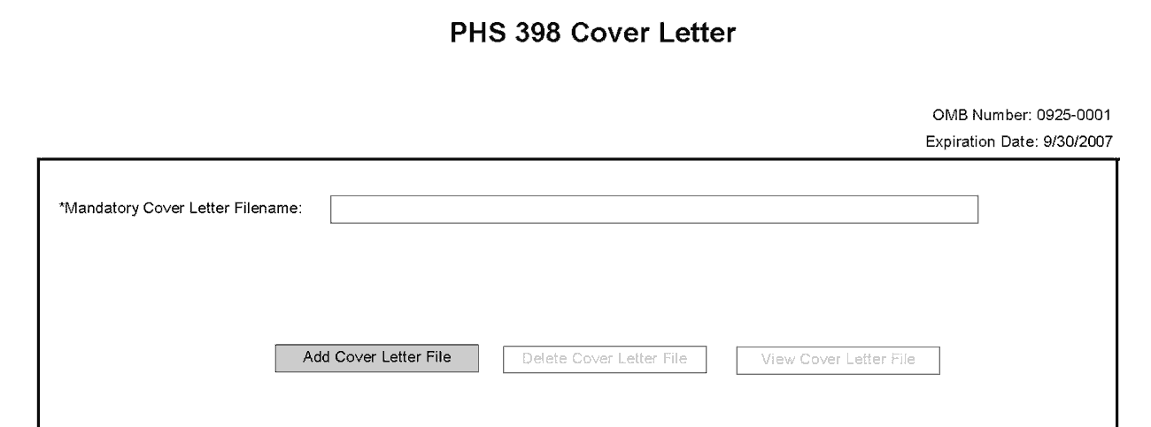
Applicants are encouraged to include a cover letter with the application. The cover letter is only for internal use and will not be shared with peer reviewers. The letter should contain any of the following information that applies to the application:
1. Application title.
2. Funding Opportunity (PA or RFA) title of the NIH initiative.
3. Request of an assignment (referral) to a particular awarding component(s) or Scientific Review Group (SRG). The PHS makes the final determination.
4. List of individuals (e.g., competitors) who should not review your application and why.
5. Disciplines involved, if multidisciplinary.
6. For late applications (see Late Application policy in Section 2.14) include an explanation of the delay as part of the cover letter attachment.
7. When submitting a Changed/Corrected Application after the submission date, a cover letter is required explaining the reason for the Changed/Corrected Application. If you already submitted a cover letter with a previous submission and are now submitting a Changed/Corrected Application, you must include all previous cover letter text in the revised cover letter attachment. The system does not retain any previously submitted cover letters until after an application is verified; therefore, you must repeat all information previously submitted in the cover letter as well as any additional information.
8. Explanation of any subaward budget components that are not active for all periods of the proposed grant.
9. Statement that you have attached any required agency approval documentation for the type of application submitted. This may include approval for applications $500,000 or more, approval for Conference Grant or Cooperative Agreement (R13 or U13), etc.
Two types of approval documentation are cited as examples in item 6 above: NIH IC approval for an application $500,000 or more and NIH institute approval for a Conference Grant or Cooperative Agreement application (R13 or U13). To attach the approval documents to this submission, please append those referenced documents to your Cover Letter File, and upload as one attachment.
Suggested Cover Letter Format
The Division of Receipt and Referral (DRR), Center for Scientific Review (CSR) is responsible for assigning applications to ICs and to scientific review groups (SRGs). DRR will be utilizing knowledge management approaches as an adjunct to the work of referral experts as part of an overall plan to shorten the time from submission to review. Analysis has shown that requests made by investigators are a valuable source of information in this process. In order to facilitate the use of these requests in conjunction with knowledge management analysis of the content of the application, applicants are requested to use the following format when assignment requests are contained in a cover letter.
- List one request per line.
- Place institute/center (IC) and SRG review requests (if both are made) on separate lines.
- Place positive and negative requests (if both are made) on separate lines.
- Include name of IC or SRG, followed by a dash and the acronym. Do not use parentheses.
- Provide explanations for each request in a separate paragraph.
Examples:
Please assign this application to the following:
Institutes/Centers
National Cancer Institute - NCI
National Institute for Dental and Craniofacial Research – NIDCR
Scientific Review Groups
Molecular Oncogenesis Study Section – MONC
Cancer Etiology Study Section – CE
Please do not assign this application to the following:
Scientific Review Groups
Cancer Genetics Study Section – CG
The reasons for this request are [provide a narrative explanation for the request(s)].
Save this information in a single file in a location you remember and convert the file to PDF. Click Add Cover Letter File, browse to where you saved the file, select the file, and then click Open. The name of the file attached will automatically appear in the “Mandatory Cover Letter Filename” field.

Once all data have been entered, click the “Close Form” button at the top of the form. You will be returned to the Grant Application Package screen. From this main screen, click on the form/document that you have just completed, and then click the => button. This will move the form/document to the Completed Documents box. To remove a form/document from the Completed Documents box, click the form/document name to select it, and then click the <= button. This will return the form/document to the Mandatory Documents or Optional Documents box.

5.3 Cover Page Supplement Component
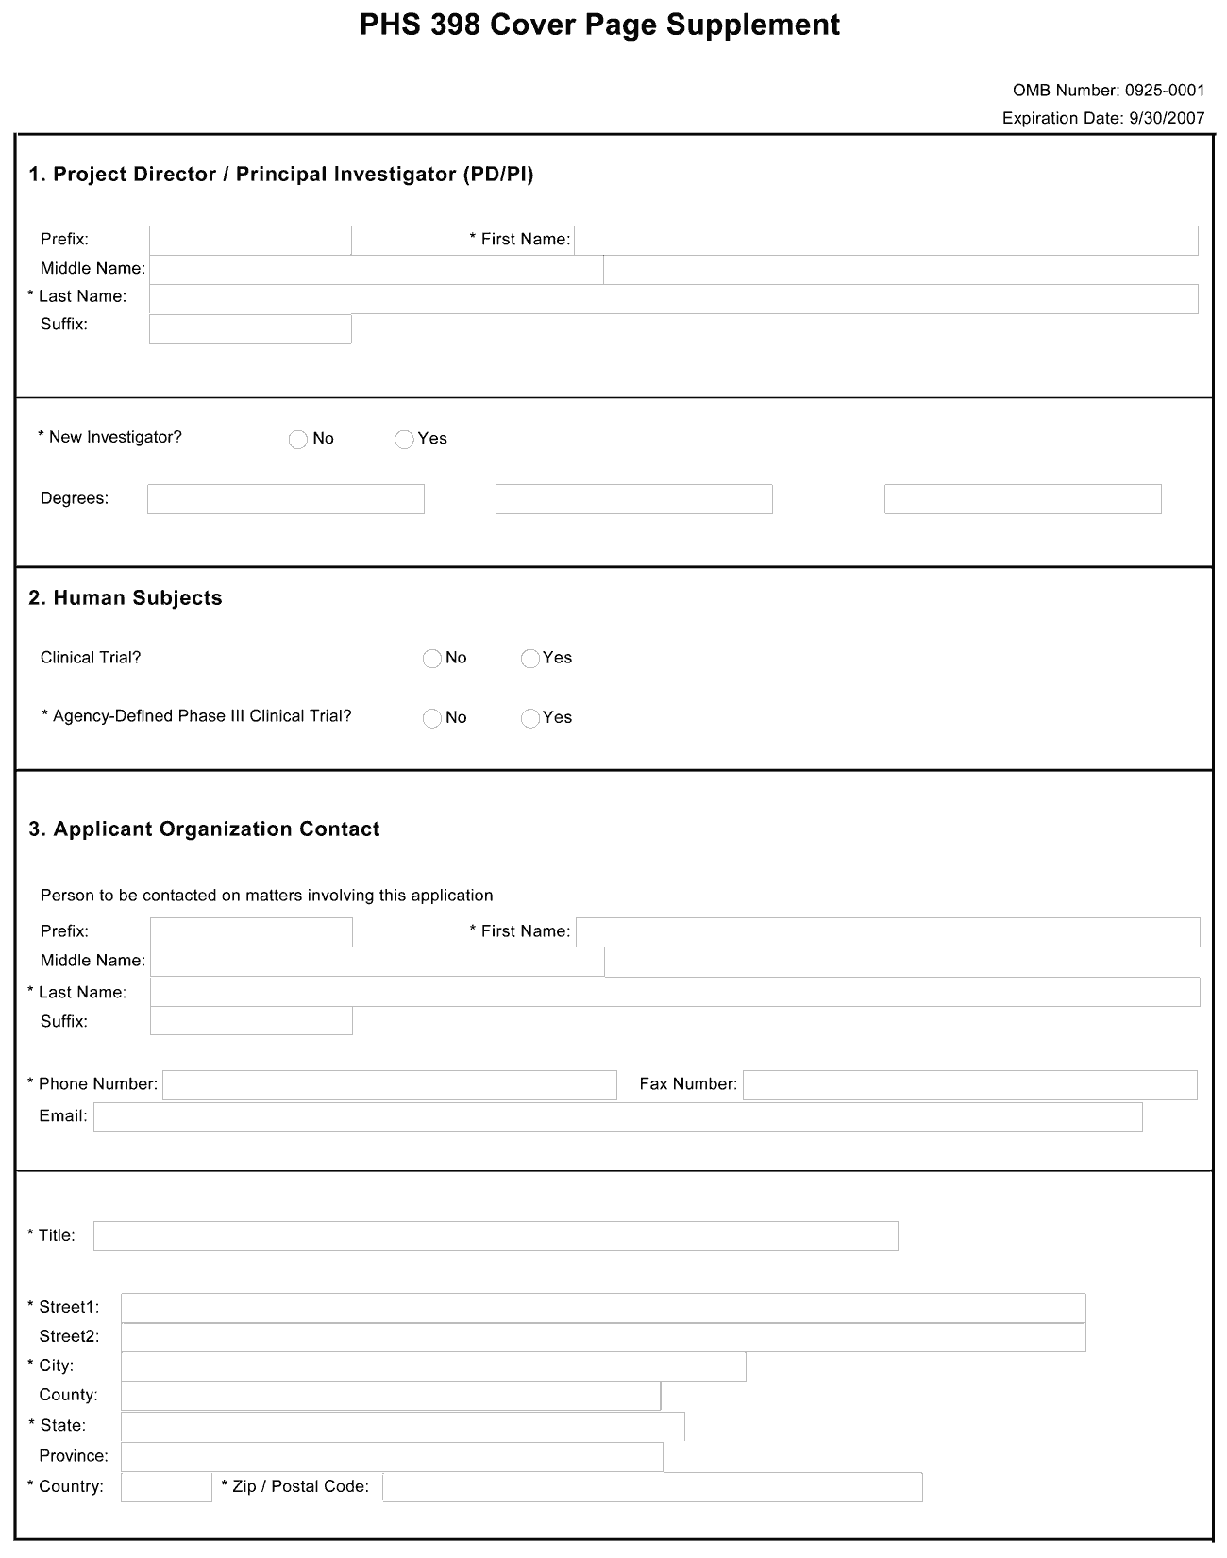
1. Program Director/Principal Investigator (PD/PI)
Field Name | Instructions
Prefix | Pre-populated from the SF424 (R&R). The prefix (for example, Mr., Mrs., Rev.) for the name of the PD/PI.
First Name | Pre-populated from the SF424 (R&R). The first (given) name of the PD/PI. This field is required.
Middle Name | Pre-populated from the SF424 (R&R). The middle name of the PD/PI.
Last Name | Pre-populated from the SF424 (R&R). The last (family) name of the PD/PI. This field is required.
Suffix | Pre-populated from the SF424 (R&R). The suffix (for example, Jr., Sr., PhD) for the name of the PD/PI.
New Investigator | Check “Yes” in the “New Investigator” box only if the PD/PI has not previously competed successfully for an NIH-supported research project other than the following small or early stage research awards:  - Pathway to Independence Award-Research Phase (R00)  - Small Grant (R03)  - Academic Research Enhancement Award (R15)  - Exploratory/Developmental Grant (R21)  - Clinical Trial Planning Grant (R34)  - Dissertation Award (R36)  - Small Business Technology Transfer Grant-Phase I (R41)  - Small Business Innovation Research Grant-Phase I (R43)  - Shannon Award (R55)  - NIH High Priority, Short-Term Project Award (R56)  Additionally, the PD/PI is not excluded from consideration as a “New Investigator” if he/she has received an award from any of the following classes of awards:  Training-Related and Mentored Career Awards  - Fellowships (F05, F30, F31, F32, F34, F37, F38)  - Mentored-career awards (K01, K08, K22, K23, K25, K99-R00)  - Other mentored career awards (developmental K02 as used by NINDS and the developmental K07)  - Loan repayment contracts (L30, L32, L40, L50, L60)  Please note that current or past recipients of non-mentored career awards that normally require independent research support (K02, K05, K24, and K26) are not considered new investigators.  Instrumentation, Construction, Education, or Meeting Awards  - G07, G08, G11, G13, G20  - S10, S15  - X01, X02  - R25  - C06, UC6  - R13, U13  In general, if the PD/PI has competed successfully as PD/PI for a significant NIH independent research award, he/she is not considered a new investigator and must check “No.”  When Multiple PD/PIs are proposed, all PD/PIs must meet the definition of New Investigator to check “Yes” in the “New Investigator” box.
Degrees | Indicate up to three academic and professional degrees or other credentials, such as licenses (for example, R.N.). These degrees should be a subset of the degrees that are listed on the PD/PI’s Commons account. If the PD/PI’s Commons account does not include the degrees listed here, please update the Commons account information accordingly.
2. Human Subjects
Field Name | Instructions
Clinical Trial | Check the Yes or No box to indicate whether the project is a clinical trial. The NIH defines a clinical trial as a prospective biomedical or behavioral research study of human subjects that is designed to answer specific questions about biomedical or behavioral interventions (drugs, treatments, devices, or new ways of using known drugs, treatments, or devices). Note that Public Law 110-85, enacted 09/27/2007, mandates registration and results reporting of applicable clinical trials in ClinicalTrials.gov (see Part II and Part III).
Agency-Defined Phase III Clinical Trial | Check the Yes or No box to indicate whether the project is an NIH-defined Phase III clinical trial. An NIH-defined Phase III clinical trial is a broadly based prospective Phase III clinical investigation, usually involving several hundred or more human subjects, for the purpose of either evaluating an experimental intervention in comparison with a standard or control intervention or of comparing two or more existing treatments. Often the aim of such investigation is to provide evidence leading to a scientific basis for consideration of a change in health policy or standard of care. The definition includes pharmacologic, non-pharmacologic, and behavioral interventions given for disease prevention, prophylaxis, diagnosis, or therapy. Community trials and other population-based intervention trials are also included.

3. Applicant Organization Contact
Person to be contacted on matters involving this application
Field Name | Instructions
Prefix | Pre-populated from the SF424 (R&R). The prefix (e.g., Mr., Mrs., Rev.) for the person to contact on matters related to this application.
First Name | Pre-populated from the SF424 (R&R). The first (given) name for the person to contact on matters related to this application. This field is required.
Middle Name | Pre-populated from the SF424 (R&R). The middle name for the person to contact on matters related to this application.
Last Name | Pre-populated from the SF424 (R&R). The last (family) name for the person to contact on matters related to this application. This field is required.
Suffix | Pre-populated from the SF424 (R&R). The suffix (e.g., Jr., Sr., PhD) for the person to contact on matters related to this application.
Phone Number | Pre-populated from the SF424 (R&R). The daytime phone number for the person to contact on matters related to this application. This field is required.
Fax Number | Pre-populated from the SF424 (R&R). The fax number for the person to contact on matters related to this application.
Email | Pre-populated from the SF424 (R&R). The email address for the person to contact on matters related to this application.
Title | Enter the title for the person to contact on matters related to this application. This field is required.
Street1 | Enter first line of the street address for the person to contact on matters related to this application. This field is required.
Street2 | Enter second line of the street address for the person to contact on matters related to this application. This field is optional.
City | Enter the city for address for the person to contact on matters related to this application. This field is required.
County | Enter the county for address for the person to contact on matters related to this application.
State | Enter the state for address for the person to contact on matters related to this application.
Province | Enter the province.
Country | Select the country for address for the person to contact on matters related to this application. This field is required.
Zip Code | Enter the Postal Code (e.g., ZIP code) for the person to contact on matters related to this application.
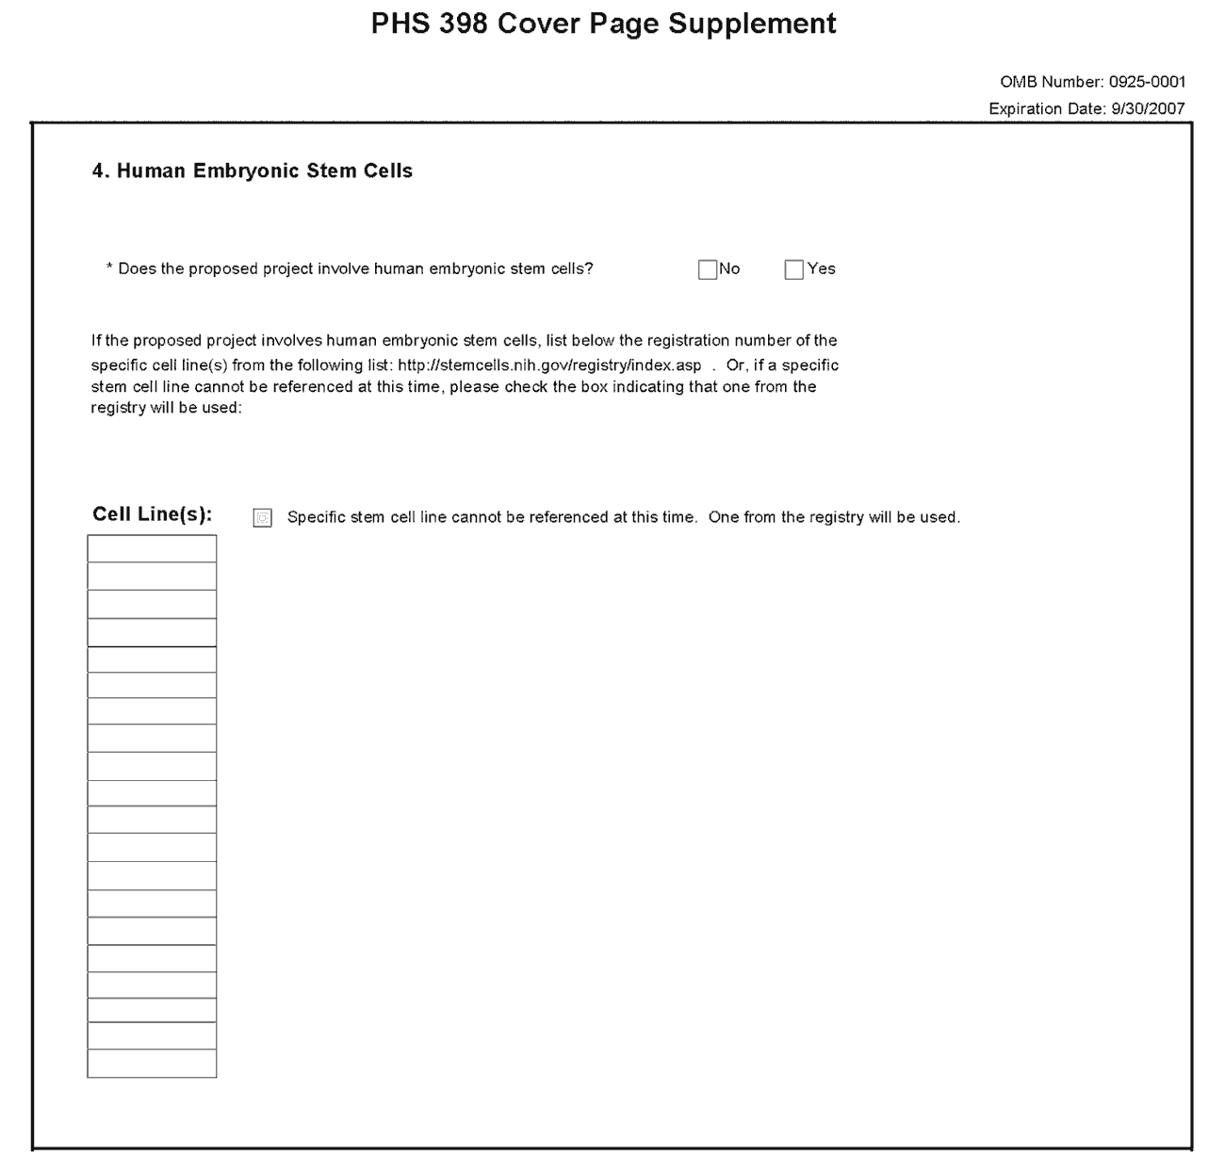
4. Human Embryonic Stem Cells
Field Name | Instructions
Does the proposed project involve human embryonic stem cells? | If the proposed project does not involve human embryonic stem cells, check the No box. If the proposed project involves human embryonic stem cells, check the Yes box, and then complete the section below.
Cell Line(s) | List in this section the registration number of the specific cell line(s) from the NIH Human Embryonic Stem Cell Registry.
Specific stem cell line cannot be referenced at this time. One from the registry will be used. | If a specific line cannot be referenced at the time of application submission, check this box.

Once all data have been entered, click the “Close Form” button at the top of the form. You will be returned to the Grant Application Package screen. From this main screen, click on the form/document that you have just completed, and then click the => button. This will move the form/document to the Completed Documents box. To remove a form/document from the Completed Documents box, click the form/document name to select it, and then click the <= button. This will return the form/document to the Mandatory Documents or Optional Documents box.

5.4 Research Plan Component
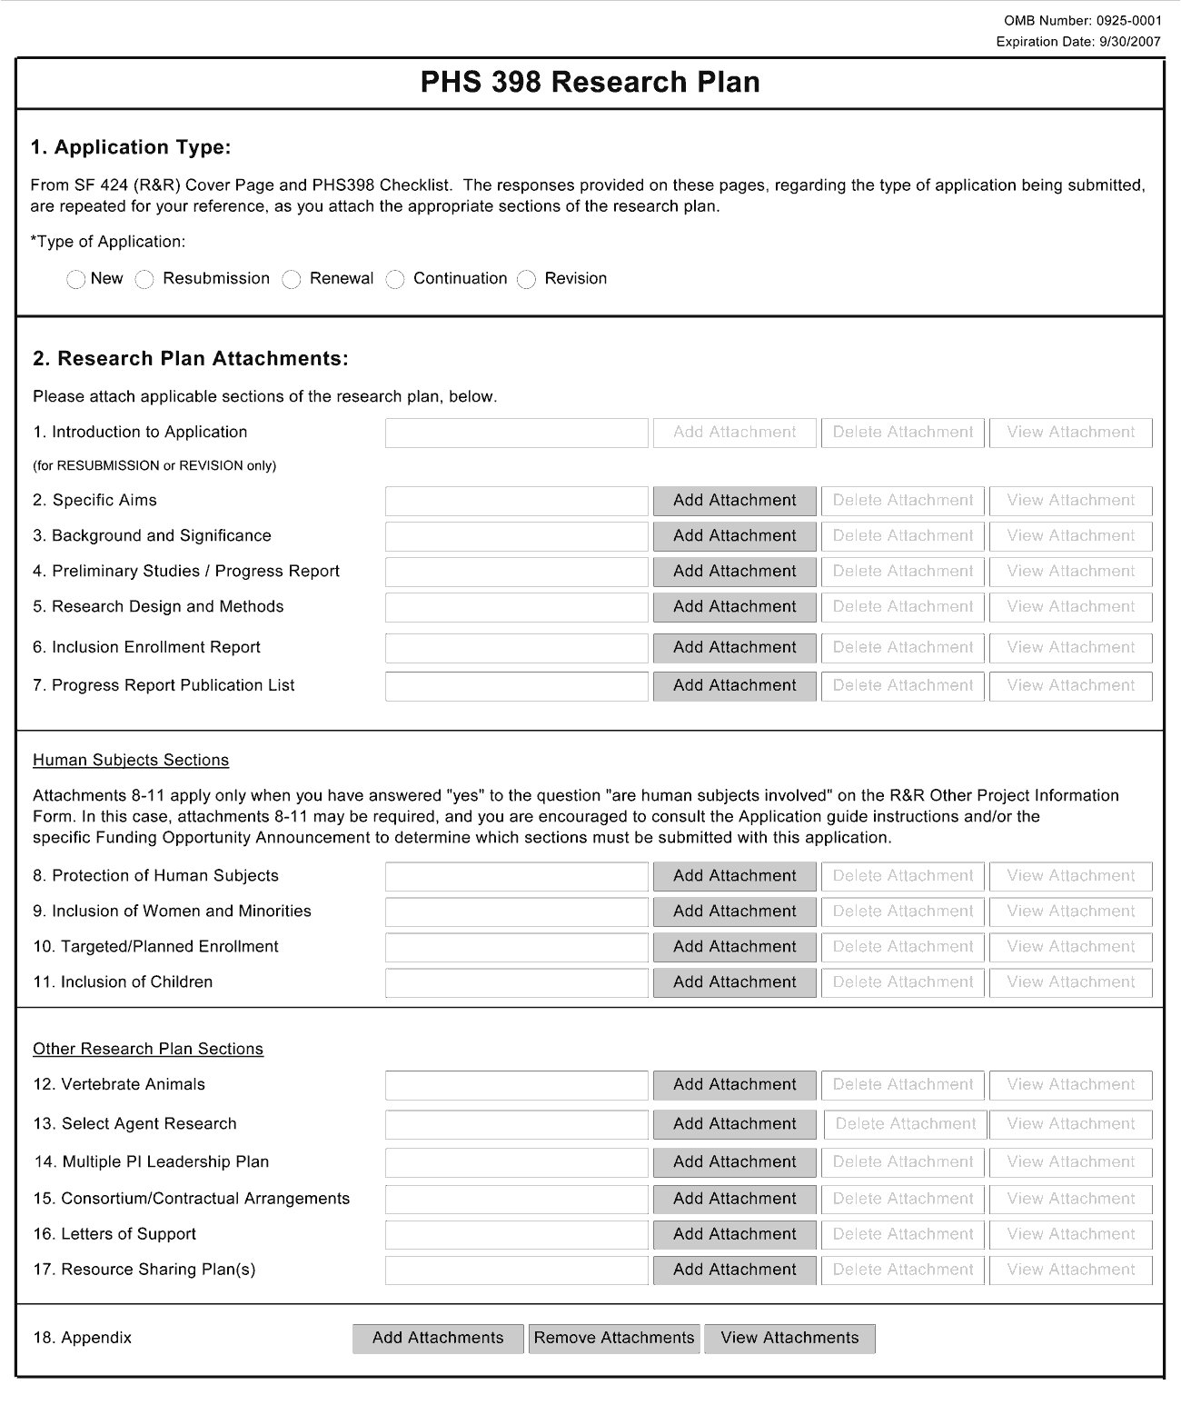
The Research Plan should include sufficient information needed for evaluation of the project, independent of any other document (e.g., previous application). Be specific and informative, and avoid redundancies.
Your SBIR/STTR application should represent a sound approach to the investigation of an important biomedical research, behavioral research, technological, engineering or scientific question, and be worthy of support under the stated criteria of this program solicitation. It should be self-contained and written with the care and thoroughness accorded to papers for publication. Review the application carefully to ensure that information essential for evaluation is included. The scientific and technical merit of the proposed research is the primary concern for all research supported by NIH, CDC, and FDA.
You are strongly encouraged to contact agency program staff for pre-application guidance and/or for more specific information on the research topics described in this solicitation.
A firm must not propose market research, patent applications, or litigation. The research may be carried out through construction and evaluation of a laboratory prototype, where necessary.
1. Application Type
This field is pre-populated from the SF424 (R&R) Cover Component. Corrections to this field must be made in that component.
2. Research Plan Attachments (see also Section 2.3.2 Creating PDFs for Text Attachments)
Although many of the sections of this application are separate PDF attachments, page limitations referenced in the instructions and/or funding opportunity announcement must still be followed. Agency validations will include checks for page limits (and use of appropriate font). Some accommodation will be made for sections that, when combined, must fit within a specified limitation.
Text attachments should be generated using word processing software and then converted to PDF using PDF generating software. Avoid scanning text attachments to convert to PDF since that causes problems for the agency handling the application. In addition, be sure to save files with descriptive file names.
Do not include any information in a header or footer of the attachments. A header will be system-generated that references the name of the PD/PI. Page numbers for the footer will be system-generated in the complete application, with all pages sequentially numbered.
Since a number of reviewers will be reviewing applications as an electronic document and not a paper version, applicants are strongly encouraged to use only a standard, single-column format for the text. Avoid using a two-column format since it can cause difficulties when reviewing the document electronically.
Full-sized glossy photographs of material such as electron micrographs or gels must only be included within the page limitations of the Research Plan. The maximum size of images to be included should be approximately 1200 x 1500 pixels using 256 colors. Figures must be readable as printed on an 8.5 x 11 page at normal (100%) scale.
Investigators must use image compression such as JPEG or PMG. Do not include figures or photographs as separate attachments either in the Appendix or elsewhere in the application.
Separate Attachments
Separate attachments have been designed for the Research Plan sections to maximize automatic validations conducted by the eRA system. When the application is received by the agency, all of the Research Plan sections will be concatenated in the appropriate order so that reviewers and agency staff will see a single cohesive Research Plan.
While each section of the Research Plan needs to eventually be uploaded separately, applicants are encouraged to construct the Research Plan as a single document, separating sections into distinct PDF attachments just before uploading the files. In this way the applicant can better monitor formatting requirements such as page limits. When validating for page limits, the eRA Commons will not count the white space created by breaking the text into separate files for uploading.
When attaching a PDF document to the actual forms, please note you are attaching an actual document, not just pointing to the location of an externally stored document. Therefore, if you revise the document after it has been attached, you must delete the previous attachment and then reattach the revised document to the application form. Use the “View Attachment” button to determine if the correct version has been attached.
Page Limitations
Do not exceed the following page limitations for Items 2 – 5. All tables, graphs, figures, diagrams, and charts must be included within the specified page limits. Be succinct and remember that there is no requirement to use all pages allotted to items 2-5 of the Research Plan. We suggest that you create the Research Plan in MS Word or some other word processing software; keep it to the specified page limits for Sections 2-5. Then “excise” the appropriate sections for each Item 2-5 and create a pdf from each excised part. There will be white space, which is fine and expected.
For SBIR and STTR Phase I, Items 2-5 of the Research Plan are limited to 15 pages. All tables, graphs, figures, diagrams and charts must be included within the page limit.
For SBIR and STTR Phase II, Items 2-5 of the Research Plan are limited to 25 pages total.
For SBIR and STTR Fast-Track, Items 2-5 of the Research Plan may not exceed a total of 25 pages.
Follow page limitations as specified in Funding Opportunity Announcements.
All applications and proposals for NIH funding must be self-contained within specified page limitations. Agency validations will include checks for page limits. Some accommodation will be made for sections that when combined must fit within a specified limitation. Note that while these computer validations will help minimize incomplete and/or non-compliant applications, they do not replace the validations conducted by NIH staff. Applications found not to comply with the requirements may be delayed in the review process. Unless otherwise specified in an NIH solicitation, Internet website addresses (URLs) may not be used to provide information necessary to the review because reviewers are under no obligation to view the Internet sites. Moreover, reviewers are cautioned that they should not directly access an internet site as it could compromise their anonymity.

Notice of Proprietary Information
Applicants are discouraged from submitting information considered proprietary unless it is deemed essential for proper evaluation of the application. However, when the application contains information that constitutes trade secrets, information that is commercial or financial, or information that is confidential or privileged, make sure you have checked the “Yes” box of question #3 in the “Other Project Information” component. Identify the pages in the application that contain this information by marking those paragraphs or lines with an asterisk (*) in the left-hand margin. Include a legend at the beginning of Section 2, similar to “The following sections marked with an asterisk contain proprietary/privileged information that (name of Applicant) requests not be released to persons outside the Government, except for purposes of review and evaluation.”
When information in the application constitutes trade secrets or information that is commercial or financial, or information that is confidential or privileged, it is furnished to the Government in confidence with the understanding that the information shall be used or disclosed only for evaluation of this application. If a grant is awarded because of or in connection with the submission of this application, the Government shall have the right to use or disclose the information to the extent authorized by law. This restriction does not limit the Government’s right to use the information if it is obtained without restriction from another source.
Begin each text section of the Research Plan with a section header (e.g., Introduction, Specific Aims, Background & Significance, etc).
Field Name | Instructions
1. Introduction to Application (Resubmission or Revision only) | Use only if you are submitting an R&R Resubmission or Revision (Cover Page Item 8).  All Resubmission (previously known as a revision or amendment) or Revision (previously known as competing supplements) applications must include an Introduction that summarizes the substantial additions, deletions, or changes. The Introduction must also include responses to the criticisms and issues raised in the Summary Statement.  A resubmission application must include substantial changes. Identify the changes in the Research Design and Methods section clearly by bracketing, indenting, or changing typography, unless the changes are so extensive as to include most of the text. This exception should be explained in the Introduction. Do not underline or shade changes.  Phase I and Supplemental Applications: Do not exceed one page for a revised Phase I or supplemental application.  Phase II and Fast-Track Applications: Do not exceed three pages for a revised Phase II or Fast-Track application. The Introduction is excluded from the page limitations of the Phase I, Phase II or Fast-Track application.  Save this information in a single file in a location you remember. Click Add Attachment, browse to where you saved the file, select the file, and then click Open.
2. Specific Aims | Phase I Applications: State the specific objectives of the Phase I research and development effort, including the technical questions you will try to answer to determine the Phase I feasibility of the proposed approach. State concisely and realistically what the proposed research is intended to accomplish in terms of its potential for technological innovation and commercial application. Define the proposed product, process or service to ultimately be developed. Include milestones for each of the aims as these will be used in the evaluation process. One page is recommended.  Phase II Applications: State the specific objectives of the Phase II research and development effort. State concisely and realistically what the proposed research is intended to accomplish in terms of its potential for technological innovation and commercial application. Define the proposed product, process or service to ultimately be developed. Include milestones for each of the aims as these will be used in the evaluation process. One page is recommended.  Fast-Track Applications: Create a heading titled “Phase I Specific Aims”, and follow the instructions above for “Phase I Applications.” Next, create a heading titled “Phase II Specific Aims” and follow the instructions above for “Phase II Applications.”  Save this information in a single file in a location you remember. Click Add Attachment, browse to where you saved the file, select the file, and then click Open.
3. Background and Significance | Provide a clear statement of the specific technical problem or opportunity. Describe significant R/R&D that is directly related to the proposal including any conducted by the proposing small business concern. Describe how it relates to the proposed effort, and any planned coordination with outside sources.  Briefly sketch the background to the present grant application, critically evaluate existing knowledge, and specifically identify the commercial opportunities and societal benefits that the project is intended to address. Two to three pages are recommended.  Phase I and Fast-Track Applications: State concisely the importance of your proposed Phase I research by relating its specific aims to the longer-term objectives of Phase II. This discussion is important in providing a foundation for the Phase II R/R&D effort. State the anticipated outcomes of the proposed approach if the project (Phase I and II) is successful.  Phase II Applications: State the anticipated outcomes of the proposed Phase II approach if the project (Phase I and II) is successful.  Save this information in a single file in a location you remember. Click Add Attachment, browse to where you saved the file, select the file, and then click Open.
4. Preliminary Studies/Progress Report | Phase I applications: Preliminary data are not required for Phase I applications; however, such results may assist reviewers in assessing the likelihood of success of the proposed project and should be included in this section. If you are not including preliminary data, proceed to Item 5.  For resubmissions or revisions, the Preliminary Studies/Progress Report section should incorporate any work done since the prior version was submitted.  Phase II applications: A Phase I Final Report is required for all Phase II applications. There is no form page for the Phase I Final Report. The report should be a presentation of the accomplishments of the Phase I effort. Abbreviations and language that may not be generally known to the broader scientific community should be avoided unless clearly defined.  The format for the Phase I Final Report is as follows:  1. State the beginning and ending dates for the period covered by the SBIR/STTR Phase I grant.  2. List all senior/key personnel who have worked on the project during that period, their titles, dates of service, and number of hours devoted to the project.  3. Summarize the specific aims of the Phase I grant.  4. Provide a succinct account of published and unpublished results, indicating progress toward their achievement. Summarize the importance of the findings. Discuss any changes in the specific aims of Phase I since the project was initiated. Include the Inclusion Enrollment Report with the final enrollment data for clinical research. A list of publications, manuscripts accepted for publication, patents, copyrights, trademarks, invention reports, and other printed materials will be included in Section 7, do not include that information here.  5. Describe the technology developed from this SBIR/STTR, its intended use and who will use it.  6. Describe the current status of the product (e.g., under development, commercialized, in use, discontinued).  7. If applicable, describe the status of FDA approval for your product, process, or service (e.g., continuing pre-IND studies, filed an IND, in Phase I (or II or III) clinical trials, applied for approval, review ongoing, approved, not approved).  8. Describe how your company has benefited from the program and/or the technology developed (e.g., firm's growth, follow-on funding, increased technical expertise, licensing agreements, spin-off companies, public offering [include stock exchange and symbol]).  9. List of the generic and/or commercial name of product, process, or service, if any, that resulted from SBIR/STTR funding. If applicable, indicate the number of products sold.  10. Provide the current number of employees (total full time equivalents [FTEs]).  Six to eight pages are recommended for the narrative portion of the Preliminary Studies/Progress Report section.  Phase II portion of a Fast-Track application: For Fast-Track applications, the Phase I Final Progress Report is submitted to the awarding component after Phase I is awarded and the Phase I research proposed is completed. The report should be a presentation of the accomplishments of the Phase I effort. See the Phase II instructions above for specific details. While the Phase II portion of a Fast-Track application will not include the Phase I Final Progress Report, you may use this space to further explain the Phase I feasibility measures and milestones to be met.  Save this information in a single file in a location you remember. Click Add Attachment, browse to where you saved the file, select the file, and then click Open.
5. Research Design and Methods | Phase I and Phase II Applications: Include a detailed description of the Phase I or Phase II R/R&D plan. The plan should indicate what will be done, where it will be done, and how the R/R&D will be carried out to address the objectives in the Specific Aims section. As part of this section, provide a tentative sequence or timetable for the project. For Phase I applications, discuss the criteria that will be used to determine that feasibility has been demonstrated.  Discuss in detail the experimental design, procedures and protocols to be used to achieve each objective or task, and the means by which the data will be analyzed and interpreted. Describe any new methodology and its advantage over existing methodologies. Describe any novel concepts, approaches, tools, or technologies for the proposed studies. Discuss the potential difficulties and limitations of the proposed procedures and alternative approaches to achieve the aims.  Point out any procedures, situations, or materials that may be hazardous to personnel and the precautions to be exercised.  Unless addressed separately in Item 17, include how the data will be collected, analyzed, and interpreted as well as the data-sharing plan as appropriate.  SBIR and STTR Fast-Track Applications: Create two separate sections, entitled “Phase I Research Design and Methods” and “Phase II Research Design and Methods.” Follow the instructions above for each phase.  Although no specific number of pages is recommended for the Research Design and Methods section, be as succinct as possible. There is no requirement that all pages allotted for items 2-5 be used.  Save this information in a single file in a location you remember. Click Add Attachment, browse to where you saved the file, select the file, and then click Open.
6. Inclusion Enrollment Report | Phase II Competing Renewal applications: If the renewal or resubmission/revision application involves clinical research, then you must report on the enrollment of research subjects and their distribution by ethnicity/race and sex/gender.  See Part II, Section 4.3 for more detailed instructions on which Target and Enrollment Report or Table to use.  In the Progress Report for the renewal and revision applications, the publications portion and/or any Target and Enrollment Reports/Tables are not included in the 25-page limit.
7. Progress Report Publication List (Renewal Applications Only) | Phase II Applications: List the titles and complete references to all appropriate publications, manuscripts accepted for publication, patents, copyrights, trademarks, invention reports and other printed materials, if any, that resulted from the Phase I or describe patent status, trade secrets or other demonstration of IP protection, and other printed materials that have resulted from the Phase I effort. When citing articles that fall under the Public Access Policy, were authored or co-authored by the applicant and arose from NIH support, provide the NIH Manuscript Submission reference number (e.g., NIHMS97531) or the Pubmed Central (PMC) reference number (e.g., PMCID234567) for each article. If the PMCID is not yet available because the Journal submits articles directly to PMC on behalf of their authors, indicate “PMC Journal – In Process.” A list of these journals is posted at: http://publicaccess.nih.gov/submit_process_journals.htm.  Citations that are not covered by the Public Access Policy, but are publicly available in a free, online format may include URLs or PMCID numbers along with the full reference (note that copies of these publications are not accepted as appendix material).

Human Subjects Sections
Field Name | Instructions
8. Protection of Human Subjects | This section covers only the initial information regarding the Protection of Human Subjects. Follow the instructions in Part II, Supplemental Instructions for Preparing the Human Subjects Section of the Research Plan. See separate sections below for other human subjects related sections that may apply.  Save this information in a single file in a location you remember. Click Add Attachment, browse to where you saved the file, select the file, and then click Open.  Unless an explanation is necessary, if Human Subjects research is not involved, and you have checked the box marked “No” on the Other Project Information Component, you need not include any additional information in this section.
9. Inclusion of Women and Minorities | To determine if Inclusion of Women and Minorities applies to this application, follow the instructions in Part II, Supplemental Instructions for Preparing the Human Subjects Section of the Research Plan.  Save this information in a single file in a location you remember. Click Add Attachment, browse to where you saved the file, select the file, and then click Open.
10. Targeted/Planned Enrollment | If this application involves the Inclusion of Women and Minorities, complete the Targeted/Planned Enrollment Table.  Save this information in a single file in a location you remember. Click Add Attachment, browse to where you saved the file, select the file, and then click Open.
11. Inclusion of Children | To determine if Inclusion of Children applies to this application, follow the instructions in the Supplemental Instructions for Preparing the Human Subjects Section of the Research Plan.  Save this information in a single file in a location you remember. Click Add Attachment, browse to where you saved the file, select the file, and then click Open.
Other Sections
Field Name | Instructions
12. Vertebrate Animals | If you indicated that Vertebrate Animals are involved in this project, address the following five key points. In addition, when research involving vertebrate animals will take place at collaborating site(s) or other performance site(s), provide this information before discussing the five points. Although no specific page limitation applies to this section of the application, be succinct.  1. Provide a detailed description of the proposed use of the animals in the work outlined in the Research Design and Methods section. Identify the species, strains, ages, sex, and numbers of animals to be used in the proposed work.  2. Justify the use of animals, the choice of species, and the numbers to be used. If animals are in short supply, costly, or to be used in large numbers, provide an additional rationale for their selection and numbers.  3. Provide information on the veterinary care of the animals involved.  4. Describe the procedures for ensuring that discomfort, distress, pain, and injury will be limited to that which is unavoidable in the conduct of scientifically sound research. Describe the use of analgesic, anesthetic, and tranquilizing drugs and/or comfortable restraining devices, where appropriate, to minimize discomfort, distress, pain, and injury.  5. Describe any method of euthanasia to be used and the reasons for its selection. State whether this method is consistent with the recommendations of the Panel on Euthanasia of the American Veterinary Medical Association. If not, present a justification for not following the recommendations.  Save this information in a single file in a location you remember. Click Add Attachment, browse to where you saved the file, select the file, and then click Open.
 | For those applicants familiar with the PHS398, please note that the Literature Cited section of the Research Plan is now called “Bibliography & References Cited.” Refer to Item 8 in the Other Project Information Component for instructions.
13. Select Agent Research | Select Agents are hazardous biological agents and toxins that have been identified by DHHS or USDA as having the potential to pose a severe threat to public health and safety, to animal and plant health, or to animal and plant products. CDC maintains a list of these agents. See http://www.cdc.gov/od/sap/docs/salist.pdf.  If the activities proposed in your application involve only the use of a strain(s) of Select Agents which has been excluded from the list of select agents and toxins as per 42 CFR 73.4(f)(5), the Select Agent requirements do not apply. Use this section to identify the strain(s) of the Select Agent that will be used and note that it has been excluded from this list. The CDC maintains a list of exclusions at http://www.cdc.gov/od/sap/sap/exclusion.htm.  If the strain(s) is not currently excluded from the list of select agents and toxins but you have applied or intend to apply to DHHS for an exclusion from the list, use this section to indicate the status of your request or your intent to apply for an exclusion and provide a brief justification for the exclusion.  If any of the activities proposed in your application involve the use of Select Agents at any time during the proposed project period, either at the applicant organization or at any other performance site, address the following three points for each site at which Select Agent research will take place. Although no specific page limitation applies to this section, be succinct.  1. Identify the Select Agent(s) to be used in the proposed research.  2. Provide the registration status of all entities* where Select Agent(s) will be used.  - If the performance site(s) is a foreign institution, provide the name(s) of the country or countries where Select Agent research will be performed.  *An “entity” is defined in 42 CFR 73.1 as “any government agency (Federal, State, or local), academic institution, corporation, company, partnership, society, association, firm, sole proprietorship, or other legal entity.”  3. Provide a description of all facilities where the Select Agent(s) will be used.  - Describe the procedures that will be used to monitor possession, use and transfer of Select Agent(s).  - Describe plans for appropriate biosafety, biocontainment, and security of the Select Agent(s).  If you are responding to a specific funding opportunity announcement (e.g., PA or RFA), address any requirements specified by the solicitation.  Reviewers will assess the information provided in this Section, and any questions associated with Select Agent research will need to be addressed prior to award.  Save this file in a location you remember. Click Add Attachment, browse to where you saved the file, select the file, and then click Open.
14. Multiple PD/PI Leadership Plan | For applications designating multiple PDs/PIs, a leadership plan must be included. A rationale for choosing a multiple PD/PI approach should be described. The governance and organizational structure of the leadership team and the research project should be described, including communication plans, process for making decisions on scientific direction, and procedures for resolving conflicts. The roles and administrative, technical, and scientific responsibilities for the project or program should be delineated for the PDs/PIs and other collaborators.  If budget allocation is planned, the distribution of resources to specific components of the project or the individual PDs/PIs should be delineated in the Leadership Plan. In the event of an award, the requested allocations may be reflected in a footnote on the Notice of Grant Award.  Save this file in a location you remember. Click Add Attachment, browse to where you saved the file, select the file, and then click Open.
15. Consortium/Contractual Arrangements | Explain the programmatic, fiscal, and administrative arrangements to be made between the applicant organization and the consortium organization(s). If consortium/contractual activities represent a significant portion of the overall project, explain why the applicant organization, rather than the ultimate performer of the activities, should be the grantee.  SBIR  Phase I SBIR Applications: Normally, a minimum of two-thirds or 67% of the research or analytical effort must be carried out by the small business concern. The total amount of all consultant and contractual arrangements to third parties for portions of the scientific and technical effort generally may not exceed 33% of the total amount requested (direct, F&A/indirect, and fee).  The signature of the official signing for the application organization on the SF424 (R&R) cover component (Item 18) of the application signifies that the applicant and all proposed consortium participants understand and agree to the following statement: The appropriate programmatic and administrative personnel of each organization involved in this grant application are aware of the agency’s consortium agreement policy and are prepared to establish the necessary inter-organizational agreement(s) consistent with that policy.  Phase II SBIR Applications: Normally, a minimum of one-half or 50% of the research or analytical effort must be carried out by the small business concern. The total amount of consultant and contractual arrangements to third parties for portions of the scientific and technical effort generally may not exceed 50% of the total Phase II amount requested (direct, F&A/indirect, and fee).  The basis for determining the percentage of work to be performed by each of the cooperative parties in Phase I or Phase II will be the total requested costs attributable to each party, unless otherwise described and justified in Item 15, Consortium/Contractual Arrangements, of the PHS 398 Research Plan component.  Fast-Track SBIR Applications: Create two separate sections entitled “Phase I Consortium/Contractual Arrangements” and “Phase II Consortium/Contractual Arrangements”, and complete the sections following the instructions provided above for each phase.  STTR  Phase I and Phase II STTR Applications: At least 40% of the work must be performed by the small business concern and at least 30% of the work must be performed by the single partnering research institution. The basis for determining the percentage of work to be performed by each of the cooperative parties will be the total of the requested costs (direct and F&A/indirect costs and fee) attributable to each party, unless otherwise described and justified in Item 15, Consortium/Contractual Arrangements, of the PHS 398 Research Plan component.  Certification showing the cooperative R&D arrangement between the small business concern and the research institution will be requested prior to an award.  The single partnering research institution must certify at the time of application that at least 30% of the work of the STTR project will be performed by the research institution. This 30% requirement applies to the single collaborating organization identified as the “research institution.” The requisite signature, printed name, title, and date of signature of the duly authorized representative of the research institution affirming certifications made by the research institution must be included in a letter stating: “The small business concern and the research institution certify jointly that: (1) the proposed STTR project will be conducted jointly by the small business concern and the research institution in which not less than 40 percent of the work will be performed by the small business concern and not less than 30 percent of the work will be performed by the research institution (“cooperative research and development”); (2) the proposed STTR project is a cooperative research or research and development effort to be conducted jointly by the small business concern and the research institution in which not less than 40 percent of the work will be performed by the small business concern and not less than 30 percent of the work will be performed by the research institution (“performance of research and analytical work”); and (3) regardless of the proportion of the proposed project to be performed by each party, the small business concern will be the primary party that will exercise management direction and control of the performance of the project.  If the research institution is a contractor-operated Federally Funded Research and Development Center (FFRDC), the duly authorized representative of the contractor-operated Federally funded research and development center certifies, additionally, that it: (4) is free from organizational conflicts of interests relative to the STTR program; (5) did not use privileged information gained through work performed for an STTR agency or private access to STTR agency personnel in the development of this STTR grant application; and (6) used outside peer review, as appropriate, to evaluate the proposed project and its performance therein.”  The applicant small business concern should convert the letter from the partnering research institution into a PDF attachment, and include it as part of Item 15, Consortium/Contractual Arrangements, of the PHS 398 Research Plan component.  Fast-Track STTR Applications: Create two separate sections entitled “Phase I Consortium/Contractual Arrangements” and “Phase II Consortium/Contractual Arrangements”, and complete the sections following the instructions provided above for each phase.  Save this information in a single file in a location you remember. Click Add Attachment, browse to where you saved the file, select the file, and then click Open.
16. Letters of Support | Attach all appropriate letters of support, including any letters necessary to demonstrate the support of consortium participants and collaborators such as Senior/Key Personnel and Other Significant Contributors included in the grant application. Letters are not required for personnel (such as research assistants) not contributing in a substantive, measurable way to the scientific development or execution of the project. For consultants, letters should include rate/charge for consulting services  Phase I, Phase II, and Fast-Track SBIR/STTR Applications: Involvement of consultants and collaborators in the planning and research stages of the project is permitted. Include with the application letters from each individual and/or collaborator confirming their role(s) in the project. Following is guidance for such documentation: The letter(s) should be prepared on the consultant or collaborator’s letterhead and addressed to the Small Business Concern (SBC). One page is recommended.  At a minimum, each consultant and collaborator letter should (1) verify their commitment to the project; (2) refer to the specific project by name, acknowledging the PD/PI as the lead on the project; and (3) specify what services /tasks the consultant or collaborator will contribute (e.g. expertise, number of hours/ percent of effort, summary of tasks to be completed). For consultants, the letter should also include rate/charge for consulting services. Also include biographical sketches for each consultant.  For STTR projects, the single “partnering” research institution must provide a letter to the applicant small business concern certifying that at least 30% of the work of the STTR project will be performed by the research institution.  Letters of interest from potential commercial partners or investors and letters of commitment of funds or other resources that will enhance the likelihood of commercialization should be placed following the letters of support for consultants and collaborators.  Save this information in a single file in a location you remember. Click Add Attachment, browse to where you saved the file, select the file, and then click Open.
17. Resource Sharing Plan(s) | NIH considers the sharing of unique research resources developed through NIH-sponsored research an important means to enhance the value and further the advancement of the research. When resources have been developed with NIH funds and the associated research findings published or provided to NIH, it is important that they be made readily available for research purposes to qualified individuals within the scientific community. See Part III, 1.5 Sharing Research Resources. If the final data/resources are not amenable to sharing, this must be explained in the application. See http://grants.nih.gov/grants/policy/data_sharing/data_sharing_faqs.htm.  1. Data Sharing Plan: Investigators seeking $500,000 or more in direct costs in any year are expected to include a brief 1-paragraph description of how final research data will be shared, or explain why data-sharing is not possible (for example human subject concerns, the Small Business Innovation Development Act provisions, etc.). Specific funding opportunity announcements may require that all applications include this information regardless of the dollar level. Applicants are encouraged to read the specific opportunity carefully and discuss their data-sharing plan with their program contact at the time they negotiate an agreement with the Institute/Center (IC) staff to accept assignment of their application. See Data-Sharing Policy or http://grants.nih.gov/grants/guide/notice-files/NOT-OD-03-032.html.  2. Sharing Model Organisms: Regardless of the amount requested, all applications where the development of model organisms is anticipated are expected to include a description of a specific plan for sharing and distributing unique model organisms or state appropriate reasons why such sharing is restricted or not possible. See Sharing Model Organisms Policy, and NIH Guide NOT-OD-04-042.  3. Genome Wide Association Studies (GWAS): Regardless of the amount requested, applicants seeking funding for a genome-wide association study are expected to provide a plan for submission of GWAS data to the NIH-designated GWAS data repository, or an appropriate explanation why submission to the repository is not possible. GWAS is defined as any study of genetic variation across the entire genome that is designed to identify genetic associations with observable traits (such as blood pressure or weight) or the presence or absence of a disease or condition. For further information see Policy for Sharing of Data Obtained in NIH Supported or Conducted Genome-Wide Association Studies, NIH Guide NOT-OD-07-088, and http://grants.nih.gov/grants/gwas/.  Save this information in a single file in a location you remember. Click Add Attachment, browse to where you saved the file, select the file, and then click Open.
18. Appendix | Only one copy of appendix material is necessary. Use the add attachments button to the right of this field to complete this entry.  A maximum of 10 PDF attachments is allowed in the Appendix. If more than 10 appendix attachments are needed, combine the remaining information into attachment #10. Note that this is the total number of appendix items, not the total number of publications. When allowed there is a limit of 3 publications that are not publicly available (see below for further details and check the FOA for any specific instructions), though not all grant mechanisms allow publications to be included in the appendix.  Do not use the appendix to circumvent the page limitations of the research plan.  Appendix material may not appear in the assembled application in the order attached, so it is important to use filenames for attachments that are descriptive of the content. A summary sheet listing all of the items included in the appendix is also encouraged but not required. When including a summary sheet, it should be included in the first appendix attachment. Applications that do not follow the appendix requirements may be delayed in the review process.  New, resubmission, renewal, and revision applications may include the following materials in the Appendix:  - Publications – No longer allowed as appendix materials except in the circumstances noted below. Applicants may submit up to 3 of the following types of publications:  - Manuscripts and/or abstracts accepted for publication but not yet published: The entire article should be submitted as a PDF attachment.  - Manuscripts and/or abstracts published, but a free, online, publicly available journal link is not available: The entire article should be submitted as a PDF attachment.  - Patents directly relevant to the project: The entire document should be submitted as a PDF attachment.  (Do not include unpublished theses, or abstracts/manuscripts submitted (but not yet accepted) for publication.)  - Surveys, questionnaires, and other data collection instruments; clinical protocols and informed consent documents may be submitted in the Appendix as necessary.  - For materials that cannot be submitted electronically or materials that cannot be converted to PDF format (e.g., medical devices, prototypes, DVDs, CDs), applicants should contact the Scientific Review Officer for instructions following notification of assignment of the application to a study section. Applicants are encouraged to be as concise as possible and submit only information essential for the review of the application.  Items that must not be included in the appendix:  - Photographs or color images of gels, micrographs, etc., are no longer accepted as Appendix material. These images must be included in the Research Plan PDF. However, images embedded in publications are allowed.  Publications that are publicly accessible. For such publications, the URL or PMC submission identification numbers along with the full reference should be included as appropriate in the Bibliography and References cited section, the Progress Report Publication List section, and/or the Biographical Sketch section.  Phase I SBIR/STTR Applications: Do not include appendices unless specifically solicited by NIH.

Once all data have been entered, click the “Close Form” button at the top of the form. You will be returned to the Grant Application Package screen. From this main screen, click on the form/document that you have just completed, and then click the => button. This will move the form/document to the Completed Documents box. To remove a form/document from the Completed Documents box, click the form/document name to select it, and then click the <= button. This will return the form/document to the Mandatory Documents or Optional Documents box.

5.5 Checklist Component
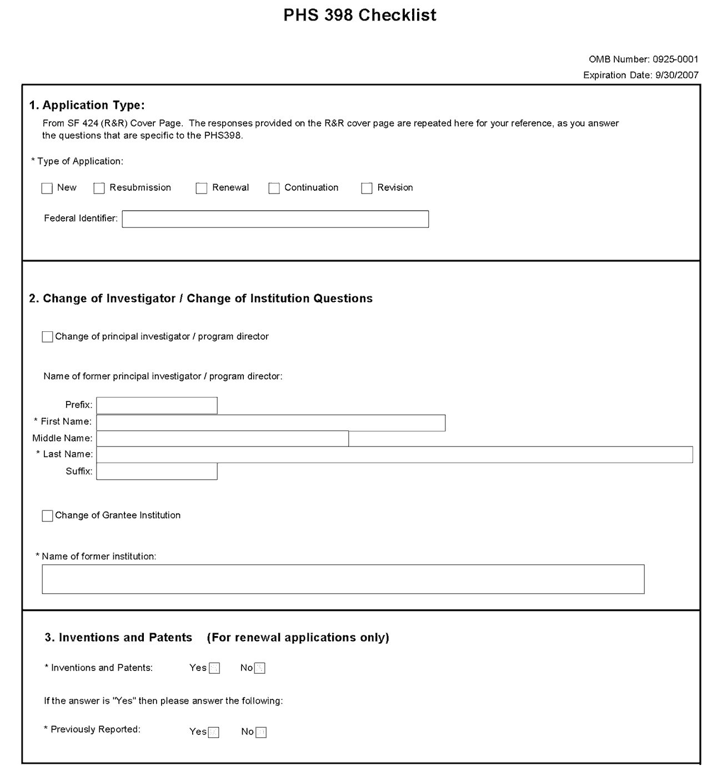
1. Application Type
Field Name | Instructions
Type of Application | This field is pre-populated from the SF424 (R&R) Cover Component. Corrections to this field must be made in that component.
Federal Identifier | This field is pre-populated from the SF424 (R&R). Corrections to this field must be made in that component. For New applications this field will be blank.
2. Change of Investigator/Change of Institution Questions
Field Name | Instructions
Change of Program Director/Principal Investigator | Check this box if this application reflects a change in PD/PI from the one who was indicated on a previous application. This is not generally applicable to a “New” application.
Prefix | If this application reflects a change in PD/PI, enter the name prefix (for example, Mr., Mrs., Rev.) of the former PD/PI.
First Name | If this application reflects a change in PD/PI, enter the first name of the former PD/PI.
Middle Name | If this application reflects a change in PD/PI, enter the middle name of the former PD/PI.
Last Name | If this application reflects a change in PD/PI, enter the last name of the former PD/PI.
Suffix | If this application reflects a change in PD/PI, provide the suffix (for example, Jr., Sr., PhD) of the former PD/PI.
Change of Grantee Institution | Check this box if this application reflects a change in grantee institution from the one that was indicated on a previous application. This is not generally applicable to a “New” application.
Name of Former Institution | If this application reflects a change in grantee institution, enter the name of the former institution.
3. Inventions and Patents (For renewal applications only)
Field Name | Instructions
Inventions and Patents | This block need only be completed if submitting an R&R “Renewal” application. If no inventions were conceived or reduced to practice during the course of work under this project, check the No box. The remaining parts of the item are then not applicable. If any inventions were conceived or reduced to practice during the previous period of support, check the Yes box.  SBIR and STTR Applications: This block needs to be completed for Phase II SBIR/STTR applications only (not Phase I or Fast-Track).
Previously Reported | If you checked the Yes box for Inventions and Patents, above, indicate whether this information has been reported previously to the PHS or to the applicant organization official responsible for patent matters.
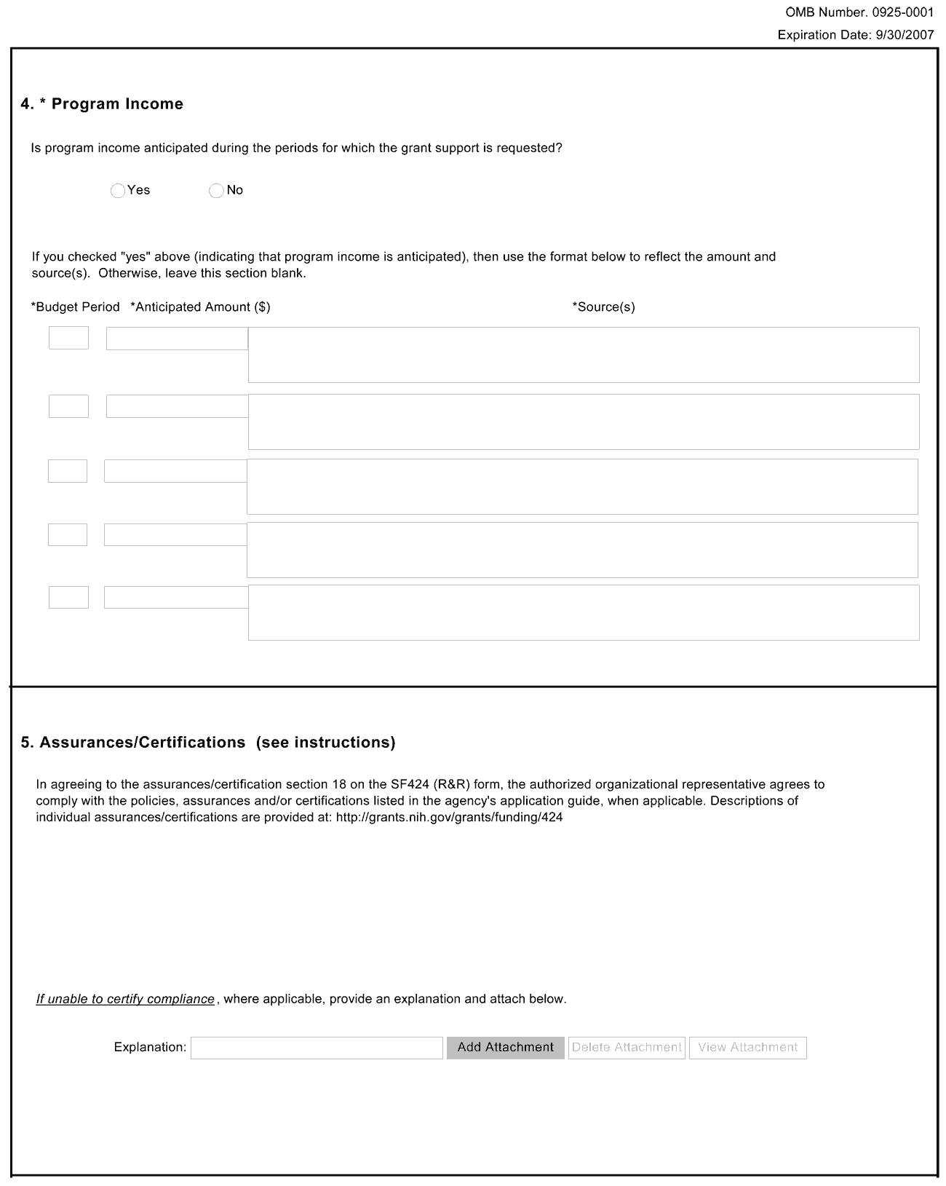
4. Program Income
NIH policy requires applicants for research grants to include in their grant applications an estimate of the amount and source of program income (defined below) expected to be generated as a result of the project for which funding is being sought. The specific policies that govern the treatment of program income under research grants are set forth in the NIH Grants Policy Statement (http://grants.nih.gov/grants/policy/nihgps_2003/index.htm).
Program Income is defined as gross income earned by the applicant organization that is directly generated by a supported activity or earned as a result of the award. The PHS Grants Policy Statement or NIH Grants Policy Statement contains a detailed explanation of program income, the ways in which it may be generated and accounted for, and the various options for its use and disposition.
Examples of program income include:
- Fees earned from services performed under the grant, such as those resulting from laboratory drug testing;
- Rental or usage fees, such as those earned from fees charged for use of computer equipment purchased with grant funds;
- Third party patient reimbursement for hospital or other medical services, such as insurance payments for patients when such reimbursement occurs because of the grant-supported activity;
- Funds generated by the sale of commodities, such as tissue cultures, cell lines, or research animals;
- Patent or copyright royalties (exempt from reporting requirements); and
- Registration fees generated from grant-supported conferences.
Generally, SBIR/STTR grantee organizations that earn program income are authorized to have such income added to the grant account and used to further the objectives of the research project under the expanded authorities stated in the Notice of Award.
Field Name | Instructions
Is program income anticipated during the periods for which the grant support is requested? | If program income is anticipated during the periods for which the grant support is requested, check the Yes box, and then complete the section below. If no program income is anticipated, check the No box and leave the following section blank.
Budget Period | If program income is anticipated, enter the budget periods. If the application is funded, the Notice of Award will provide specific instructions regarding the use of such income.
Anticipated Amount ($) | If program income is anticipated, enter the amount anticipated for each budget period listed.
Source(s) | If program income is anticipated, enter the source for each budget period listed.
5. Assurances/Certifications (see instructions)
In agreeing to the assurances/certification section 18 of the SF424 (R&R) form, the authorized organizational representative agrees to comply with the following policies, assurances and certifications when applicable. Descriptions of individual assurances/certifications are provided in Part III: Policies, Assurances, Definitions, and Other Information.
Human Subjects Research; Research on Transplantation of Human Fetal Tissue; Research Using Human Embryonic Stem Cells; Women and Minority Inclusion Policy; Inclusion of Children Policy; Vertebrate Animals; Debarments and Suspension; Drug Free Workplace; Lobbying; Non-Delinquency of Federal Debt; Research Misconduct; Civil Rights; Handicapped Individuals; Sex Discrimination; Age Discrimination; Recombinant DNA, including Human Gene Transfer Research; Financial Conflict of Interest; Smoke-Free Workplace; Prohibited Research; Select Agent Research; Principal Investigator Assurance
If you are unable to certify compliance with the applicable policies, assurances, and certifications listed, please provide an explanation in a separate file. Click Add Attachment, browse to where you saved the file, select the file, and then click Open.

Once all data have been entered, click the “Close Form” button at the top of the form. You will be returned to the Grant Application Package screen. From this main screen, click on the form/document that you have just completed, and then click the => button. This will move the form/document to the Completed Documents box. To remove a form/document from the Completed Documents box, click the form/document name to select it, and then click the <= button. This will return the form/document to the Mandatory Documents or Optional Documents box.

5.6 Completing SBIR/STTR Information Component
In conjunction with the SF424 (R&R) components and the PHS398 components, NIH, CDC, and FDA SBIR/STTR grant applicants must also complete and submit the “SBIR/STTR Information” component.
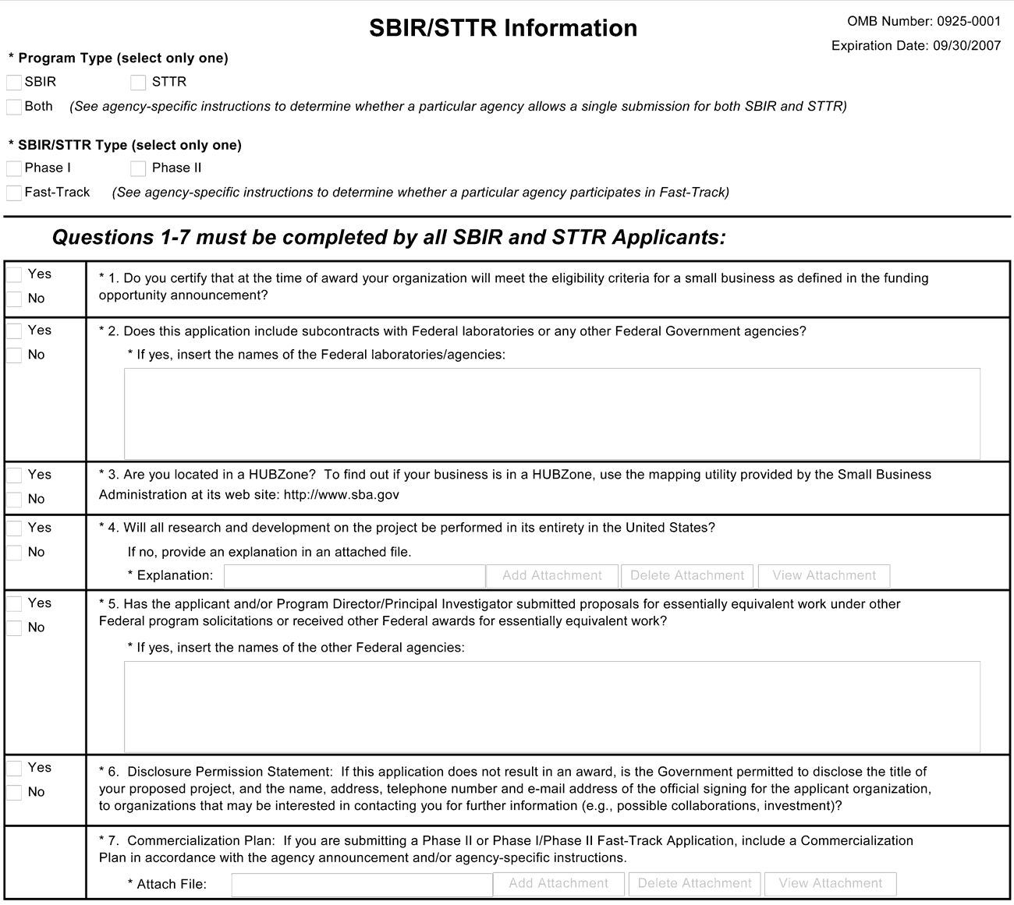
1. Certification of Small Business Eligibility
If you certify that at the time of award, your organization will meet the eligibility criteria for a small business as defined in the FOA, check the Yes box. Otherwise, check the No box. A selection is required.
2. Subcontracts
If this application includes subcontracts with Federal laboratories or any other Federal Government agencies, check the Yes box and insert the name of the Federal laboratories/agencies in the space provided. Otherwise, check the No box. A selection is required.
3. HUBZone
If you are located in a HUBZone, check the Yes box. To find out if your business is in a HUBZONE, use the mapping utility provided by the Small Business Administration at its web site: http://www.sba.gov. Otherwise, check the No box. A selection is required.
4. R&D Performance
If all research and development on the project will be performed in its entirety in the United States, check the Yes box. Otherwise, check the No box and provide an explanation in an attached file. A selection is required.
5. Essentially Equivalent Work
If the applicant and/or PD/PI has submitted proposals for essentially equivalent work under other Federal program solicitations or received other Federal awards for essentially equivalent work, check the Yes box and insert the names of the other Federal agencies in the space provided. Otherwise, check the No box. A selection is required.
6. Disclosure Permission Statement
Check “Yes” to provide permission for the government to disclose the title of the proposed project and the name, address, telephone number and email address of the official signing for the applicant organization to organizations that may be interested in contacting you for further information (e.g., possible collaborations, investment) in the case this application does not result in an award. Check “No” if you do not provide this permission. Your response will not affect any peer review or funding decisions.
7. Commercialization Plan
(Applicable to all Phase II applications and Phase I/ Phase II Fast-Track Applications.)
All Phase II applications and Fast-Track applications must include a succinct Commercialization Plan. The Commercialization Plan is limited to 15 pages. Be succinct. There is no requirement for applicants to use the maximum allowable pages allotted to the Commercialization Plan.
Create a section entitled, “Commercialization Plan,” and provide a description in each of the following areas:
a. Value of the SBIR/STTR Project, Expected Outcomes, and Impact. Describe, in layperson's terms, the proposed project and its key technology objectives. State the product, process, or service to be developed in Phase III. Clarify the need addressed, specifying weaknesses in the current approaches to meet this need. In addition, describe the commercial applications of the research and the innovation inherent in this application. Be sure to also specify the potential societal, educational, and scientific benefits of this work. Explain the non-commercial impacts to the overall significance of the project. Explain how the SBIR/STTR project integrates with the overall business plan of the company.
b. Company. Give a brief description of your company including corporate objectives, core competencies, present size (annual sales level and number and types of employees), history of previous Federal and non-Federal funding, regulatory experience, and subsequent commercialization, and any current products/services that have significant sales. Include a short description of the origins of the company. Indicate your vision for the future, how you will grow/maintain a sustainable business entity, and how you will meet critical management functions as your company evolves from a small technology R&D business to a successful commercial entity.
c. Market, Customer, and Competition. Describe the market and/or market segments you are targeting and provide a brief profile of the potential customer. Tell what significant advantages your innovation will bring to the market, e.g., better performance, lower cost, faster, more efficient or effective, new capability. Explain the hurdles you will have to overcome in order to gain market/customer acceptance of your innovation.
Describe any strategic alliances, partnerships, or licensing agreements you have in place to get FDA approval (if required) and to market and sell your product.
Briefly describe your marketing and sales strategy. Give an overview of the current competitive landscape and any potential competitors over the next several years. (It is very important that you understand and know the competition.)
d. Intellectual Property (IP) Protection. Describe how you are going to protect the IP that results from your innovation. Also note other actions you may consider taking that will constitute at least a temporal barrier to others aiming to provide a solution similar to yours.
e. Finance Plan. Describe the necessary financing you will require to commercialize the product, process, or service, and when it will be required. Describe your plans to raise the requisite financing to launch your innovation into Phase III and begin the revenue stream. Plans for this financing stage may be demonstrated in one or more of the following ways:
- Letter of commitment of funding.
- Letter of intent or evidence of negotiations to provide funding, should the Phase II project be successful and the market need still exist.
- Letter of support for the project and/or some in-kind commitment, e.g., to test or evaluate the innovation.
- Specific steps you are going to take to secure Phase III funding.
f. Production and Marketing Plan. Describe how the production of your product/process/service will occur (e.g., in-house manufacturing, contract manufacturing). Describe the steps you will take to market and sell your product/process/service. For example, explain plans for licensing, Internet sales, etc.
g. Revenue Stream. Explain how you plan to generate a revenue stream for your company should this project be a success. Examples of revenue stream generation include, but are not limited to, manufacture and direct sales, sales through value added resellers or other distributors, joint venture, licensing, service. Describe how your staffing will change to meet your revenue expectations.
Applicants are encouraged to seek commitment(s) of funds and/or resources from an investor or partner organization for commercialization of the product(s) or service(s) resulting from the SBIR/STTR grant. Place relevant letters following letters from consultants and collaborators in Item 16, Letters of Support in the PHS398 Research Plan Component.
Your Phase III funding may be from any of a number of different sources including, but not limited to: SBIR/STTR firm itself; private investors or “angels”; venture capital firms; investment companies; joint ventures; R&D limited partnerships; strategic alliances; research contracts; sales of prototypes (built as part of this project); public offering; state finance programs; non SBIR-funded R&D or production commitments from a Federal agency with the intention that the results will be used by the United States government; or other industrial firms.

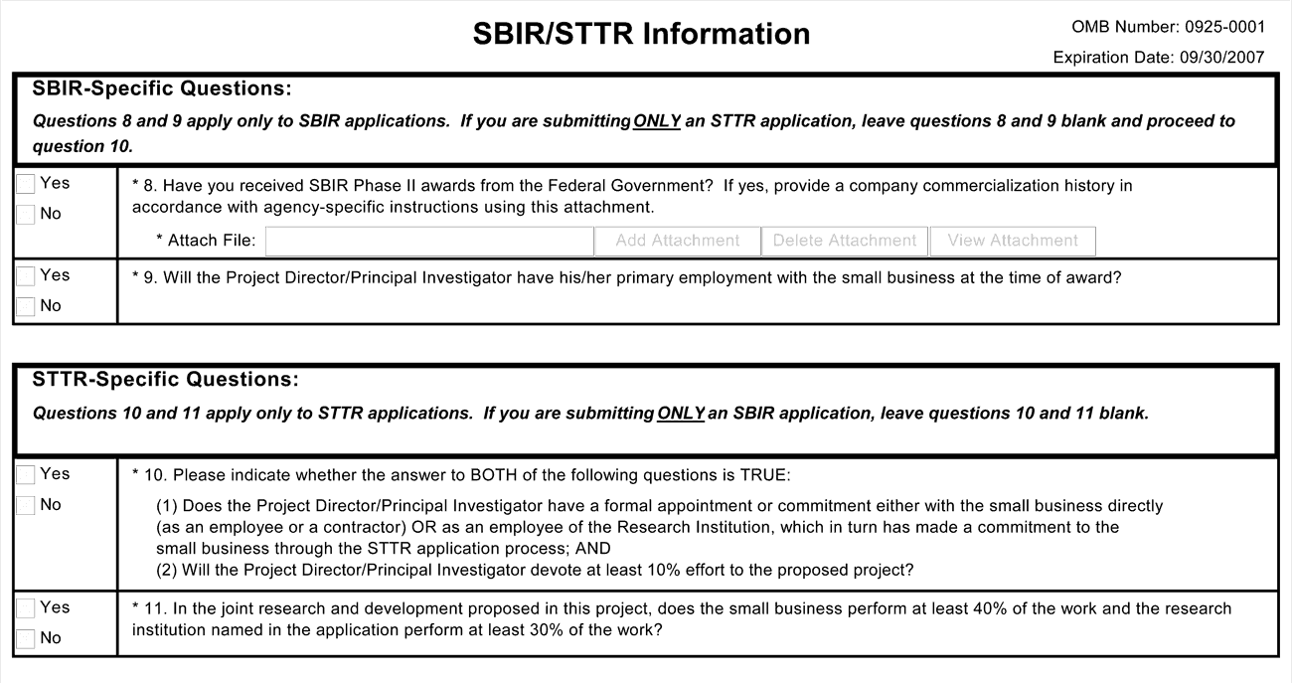
SBIR-Specific Questions:
8. Prior SBIR Phase II Awards
If you have received SBIR Phase II awards from the Federal Government (including NIH), check the Yes box. Attach a file that includes either: (1) a statement indicating that the applicant small business has not received more than 15 SBIR Phase II awards from the Federal Government during the preceding five fiscal years; or (2) a company commercialization history if you have received more than 15 Phase II SBIR awards from the Federal Government during the preceding five fiscal years. The history must document the extent to which the company was able to secure Phase III funding to develop concepts resulting from previous Phase II SBIR awards, and for each Phase II award the history must include: (1) name of awarding agency; (2) award number and date; (3) amount of award; (4) title of project; (5) source, date, and amount of Phase III funding agreement; and (6) commercialization status of each Phase II award.
If you have not received SBIR Phase II awards, then check the No box.
9. PD/PI Primary Employment
If the PD/PI will have his/her primary employment with the small business at the time of award, check the Yes box. Otherwise, check the No box. A selection is required.
STTR-Specific Questions:
10. PD/PI Commitment
Check the Yes box only if both of the following conditions is true:
(1) The PD/PI has a formal appointment or commitment either with the small business directly (as an employee or a contractor) OR as an employee of the Research Institution, which in turn has made a commitment to the small business through the STTR application process; and
(2) The PD/PI will devote at least 10% effort to the proposed project.
Check the No box if either of these two conditions (or both) is false.
11. Joint Research and Development Proposed
If in the joint research and development proposed in this project, the small business will perform at least 40% of the work and the research institution named in the application will perform at least 30% of the work, check the Yes box. Otherwise, check the No box.

Once all data have been entered, click the “Close Form” button at the top of the form. You will be returned to the Grant Application Package screen. From this main screen, click on the form/document that you have just completed, and then click the => button. This will move the form/document to the Completed Documents box. To remove a form/document from the Completed Documents box, click the form/document name to select it, and then click the <= button. This will return the form/document to the Mandatory Documents or Optional Documents box.

6. Peer Review Process
A description of what happens to your research project grant application after it is received for peer review can be found at the following location: http://cms.csr.nih.gov/ResourcesforApplicants/Submission+And+Assignment+Process.htm.

Overview
Applications submitted in response to an SBIR/STTR funding opportunity will be assigned to the ICs on the basis of established PHS referral guidelines. Most applications submitted to the PHS will be reviewed through a two-tier system. The first level of review will be performed by a Scientific Review Group (SRG), often called a “study section” or “review committee.” The purpose of the SRG is to evaluate the scientific and technical merit of applications. The SRG does not make funding decisions. Additional detailed information on review procedures for scientific review group meetings is located at: http://www.csr.nih.gov/guidelines/proc.pdf. The complete listing of Rosters for NIH Scientific Review Groups (SRGs) is available at http://era.nih.gov/roster/index.cfm.

Streamlining
The initial scientific peer review of most research applications also will include a process in which only those applications deemed by the reviewers to have the highest scientific merit, generally the top half of the applications under review, will be discussed at the SRG meeting, assigned a priority score, and receive a second level review. Applications in the lower half are not discussed or scored at the SRG meetings. This process allows the reviewers to focus their discussion on the most meritorious applications.
SRG members will be instructed to evaluate research applications by addressing five review criteria (see below) and assigning a single, global score for each scored application. The score will reflect the overall impact that the proposed research could have on the field. Requests for Applications (RFAs) and other types of funding opportunities may have different and/or additional review criteria.
As part of the initial merit review and regardless of whether an application is scored or unscored (streamlined), all applicants will receive a written critique, called a “Summary Statement.” The Summary Statement represents a combination of the reviewers' written comments and, for non-streamlined applications, includes the SRO's summary of the members' discussion during the study section meeting as well as the recommendations of the study section, a recommended budget, and administrative notes of special considerations.
Information about charters and membership of SRGs, Councils, and Boards may be obtained from the appropriate agency.

Research Project Evaluation Criteria
The scientific review group will address and consider each of the following criteria in assigning the application's overall score, weighting them as appropriate for each application:
- Significance
- Approach
- Innovation
- Investigator
- Environment
Note that an application does not need to be strong in all categories to be judged likely to have major scientific impact and thus deserve a high priority score.
Applicants should include information in relevant sections of the grant application that addresses the questions for each review criterion below.
All SBIR/STTR Applications
Significance: Does the proposed project have commercial potential to lead to a marketable product, process or service? Does this study address an important problem? What may be the anticipated commercial and societal benefits that may be derived from the proposed research? If the aims of the application are achieved, how will scientific knowledge or clinical practice be advanced? What will be the effect of these studies on the concepts, methods, technologies, treatments, services, or preventative interventions that drive this field? Does the application lead to enabling technologies (e.g., instrumentation, software) for further discoveries? Will the technology have a competitive advantage over existing/alternate technologies that can meet the market needs?
Approach: Are the conceptual or clinical framework, design, methods, and analyses adequately developed, well-integrated, well-reasoned, and appropriate to the aims of the project? Is the proposed plan a sound approach for establishing technical and commercial feasibility? Are the milestones and evaluation procedures appropriate? Does the applicant acknowledge potential problem areas and consider alternative tactics? For applications designating multiple PDs/PIs, is the leadership approach, including the designated roles and responsibilities, governance, and organizational structure, consistent with and justified by the aims of the project and the expertise of each of the PDs/PIs?
Innovation: Is the project original and innovative? For example: Does the project challenge existing paradigms or clinical practice; address an innovative hypothesis or critical barrier to progress in the field? Does the project develop or employ novel concepts, approaches, methodologies, tools, or technologies for this area?
Investigator(s): Are the PD/PI(s) and other key personnel appropriately trained and well suited to carry out this work? Is the work proposed appropriate to the experience level of the PD/PI(s) and other researchers, including consultants and subcontractors (if any)? Do the PD/PIs and investigative team bring complementary and integrated expertise to the project (if applicable)? Are the relationships of the key personnel to the small business and to other institutions appropriate for the work proposed?
Environment: Do(es) the scientific and technological environment in which the work will be done contribute to the probability of success? Do the proposed studies benefit from unique features of the scientific environment, or subject populations, or employ useful collaborative arrangements? Is there evidence of institutional support? Is there sufficient access to resources (e.g., equipment, facilities)?
Phase II Applications
In addition to the above review criteria:
1. How well did the applicant demonstrate progress toward meeting the Phase I objectives, demonstrating feasibility, and providing a solid foundation for the proposed Phase II activity?
2. Did the applicant submit a concise Commercialization Plan that adequately addresses the specific areas described in the SF424 (R&R) SBIR/STTR Application Guide and the SBIR/STTR Information component?
3. Does the project carry a high degree of commercial potential, as described in the Commercialization Plan?
Phase I/Phase II Fast-Track Application Review Criteria:
For Phase I/Phase II Fast Track applications, the following criteria also will be applied:
1. Does the Phase I application specify clear, appropriate, measurable goals (milestones) that should be achieved prior to initiating Phase II?
2. Did the applicant submit a concise Commercialization Plan that adequately addresses the specific areas described in the SF424 (R&R) SBIR/STTR Application Guide and the SBIR/STTR Information component?
3. To what extent was the applicant able to obtain letters of interest, additional funding commitments, and/or resources from the private sector or non-SBIR/STTR funding sources that would enhance the likelihood for commercialization?
4. Does the project carry a high degree of commercial potential, as described in the Commercialization Plan?
Phase I and Phase II Fast-Track applications that satisfy all of the review criteria will receive a single rating.
For Fast-Track applications, the Phase II portion may not be funded until a Phase I final report and other documents necessary for continuation have been received and assessed by IC program staff that the Phase I milestones have been successfully achieved. Items 2-5 of the Research Plan may not exceed 25 pages. That is, the combined Phase I and Phase II plans for a Fast-Track application (for Items 2-5) must be contained within the 25-page limitation.
Phase II Competing Renewal Applications
In addition to the above review criteria described under “All SBIR/STTR Applications,” the following items will be applied to ALL Phase II competing renewal applications in the determination of scientific merit and the priority score.
1. Did the applicant submit a concise Commercialization Plan that adequately addresses the specific areas described in the SF424 (R&R) SBIR/STTR Application Guide and the SBIR/STTR Information component?
2. Does the project carry a high degree of commercial potential as described in the Commercialization Plan?
Additional Review Criteria:
In addition to the above criteria, the following items will continue to be considered in the determination of scientific merit and the priority score:
Resubmission Applications: Are the responses to comments from the previous scientific review group adequate? Are the improvements in the resubmission application appropriate?
Protection of Human Subjects from Research Risk: The involvement of human subjects and protections from research risk relating to their participation in the proposed research will be assessed. See the “Human Subjects Sections” of the PHS398 Research Plan component of the SF424 (R&R).
Inclusion of Women, Minorities and Children in Research: The adequacy of plans to include subjects from both genders, all racial and ethnic groups (and subgroups), and children as appropriate for the scientific goals of the research will be assessed. Plans for the recruitment and retention of subjects will also be evaluated. See the “Human Subjects Sections” of the PHS398 Research Plan component of the SF424 (R&R).
Care and Use of Vertebrate Animals in Research: If vertebrate animals are to be used in the project, the adequacy of the plans for their care and use will be assessed. See the “Other Research Plan Sections” of the PHS398 Research Plan component of the SF424 (R&R).
Biohazards: If materials or procedures are proposed that are potentially hazardous to research personnel and/or the environment, determine if the proposed protection is adequate.
Additional Review Considerations:
Budget and Period of Support: The reasonableness of the proposed budget and the appropriateness of the requested period of support in relation to the proposed research may be assessed by the reviewers. The priority score should not be affected by the evaluation of the budget.
Resource Sharing Plan
When relevant, reviewers will be instructed to comment on the reasonableness of the following Resource Sharing Plans, or the rationale for not sharing the following types of resources. However, reviewers will not factor the proposed resource sharing plan(s) into the determination of scientific merit or priority score. Program staff within the funding organization will be responsible for monitoring the data sharing policy
- Data Sharing Plan [http://grants.nih.gov/grants/policy/data_sharing/data_sharing_guidance.htm]
- Sharing Model Organisms [http://grants.nih.gov/grants/guide/notice-files/NOT-OD-04-042.html]
- Genome Wide Association Studies (GWAS) [http://grants.nih.gov/grants/guide/notice-files/NOT-OD-07-088.html]
Dual-Level Peer Review: The second level of review will usually be performed by the Advisory Council or Board of the potential awarding component (Institute, Center, or other unit). Council or Board recommendations are based not only on considerations of scientific merit, as judged by the SRGs, but also on the relevance of the proposed study to an Institute/Center’s mission, programs, and priorities.
PART II
Supplemental Instructions for Preparing the Human Subjects Section of the Research Plan

1. Introduction
A Protection of Human Subjects section of the Research Plan is required for certain applications submitted using the SF424 R&R instructions and forms. The information provided in the section on Protection of Human Subjects should be consistent with the information provided on the face page of the application.
For all research involving human subjects, the Scientific Review Group (SRG) will assess the adequacy of protections for research participants against research risks, and the appropriate inclusion of women, minorities, and children, based on the information provided in the application.
To assist in preparing the section on Protection of Human Subjects, six possible scenarios are provided in Section 2 below. All research projects will fall into one of these six scenarios. Determine which scenario the proposed research falls into, then go to the specific instructions applicable to that scenario in Section 3. Where appropriate, Section 3 provides instructions on addressing the Inclusion of Women and Minorities, the Targeted/Planned Enrollment Table, and the Inclusion of Children (items 9, 10, and 11 of the Research Plan). All definitions related to human subjects research are linked to text found in Part III.3 under Human Subjects Research Definitions and Terms. Section 5 of this Part includes descriptions of and links to the DHHS Human Subjects Protections regulations and NIH policies that apply to clinical research.

2. Scenarios

Scenario A. No Human Subjects Research
If no human subjects research is proposed in the application, you will have designated “No” in Item 1 on the SF424 R&R Other Project Information page. If your proposed research involves human specimens and/or data from subjects, you must provide a justification for your claim that no human subjects are involved in the Protection of Human Subjects section of the Research Plan.
See the instructions for Scenario A.
Unless you are providing a special justification as described above, no additional information is necessary if no human subjects are involved.

Scenario B. Non-Exempt Human Subjects Research
If research involving human subjects is anticipated to take place under the award, you will have designated “Yes” in Item 1 on the SF424 R&R Other Project Information page and entered your OHRP assurance number in Item 1a. In the Protection of Human Subjects section of the Research Plan, you must provide sufficient information for reviewers to determine that the proposed research meets (1) the requirements of the DHHS regulations to protect human subjects from research risks (45 CFR Part 46), and (2) the requirements of NIH policies on inclusion of women, minorities, and children. Research involving a clinical trial will fall under either Scenario E or F below.
See the instructions for Scenario B.

Scenario C. Exempt Human Subjects Research
If all of the proposed research meets the criteria for one or more of the exemptions from the requirements in the DHHS regulations (46.101(b)), “yes” should be designated in Item 1 on the SF424 R&R Other Project Information page, the appropriate exemption number checked in Item 1a, and “NA” entered for the Human Subject Assurance Number since no OHRP assurance number is needed for exempt research. In the section on Protection of Human Subjects in the Research Plan, provide a justification for the exemption(s) containing sufficient information about the involvement of the human subjects to allow a determination by peer reviewers and NIH staff that claimed exemption(s) is/are appropriate.
The PHS will make a final determination as to whether the proposed activities are covered by the regulations or are in an exempt category, based on the information provided in the Research Plan. When in doubt, consult with the Office for Human Research Protections (OHRP), Department of Health and Human Services by accessing their website http://www.hhs.gov/ohrp/ for guidance and further information.
The exemptions appear in Part III under Human Subjects Research Definitions and Terms.
See the instructions for Scenario C.

Scenario D. Delayed-Onset Human Subjects Research
If human subjects research is anticipated within the period of the award but plans for involvement of human subjects cannot be described in the application as allowed by the DHHS regulations (45 CFR Part 46.118), you will have designated “Yes” in Item 1 on the SF424 R&R Other Project Information page and entered your OHRP assurance number in Item 1a. In the section on Protection of Human Subjects in the Research Plan, you should either include an explanation of anticipated protections for human subjects or an explanation of why protections cannot be described.
Examples of delayed-onset of human subjects research include:
- Human subjects research is dependent upon the completion of animal or other studies; or
- Human subjects research protocols to be included will undergo an independent decision-making process (often defined by a FOA).
See instructions for Scenario D.

Scenario E. Human Subjects Research Involving a Clinical Trial
If research involving human subjects is anticipated to take place under the award, and you intend to conduct a clinical trial during the project period, you will have designated “Yes” in Item 1 on the SF424 R&R Other Project Information page, entered your OHRP assurance number in Item 1a, and checked “Yes” to Clinical Trial in Item 2 on the PHS 398 Cover Page Component.
In the section on Protection of Human Subjects in the Research Plan, you must provide sufficient information for reviewers to determine that the proposed research meets:
1) the requirements of the DHHS regulations to protect human subjects from research risks (45 CFR Part 46);
2) NIH policy requirements for Data and Safety Monitoring for Clinical Trials;
3) the ClinicalTrials.gov requirements if applicable;
4) the requirements of NIH policies on inclusion of women, minorities, and children; and
5) the requirements of NIH policy on reporting race and ethnicity data for subjects in clinical research.
See instructions for Scenario E.

Scenario F. Human Subjects Research Involving an NIH-Defined Phase III Clinical Trial
If research involving human subjects is anticipated to take place under the award, and you intend to conduct an NIH-defined Phase III clinical trial during the project period, you will have designated “Yes” in Item 1 on the SF424 R&R Other Project Information page, entered your OHRP assurance number in Item 1a, and checked “Yes” to Agency-Defined Phase III Clinical Trial in Item 2 on the PHS 398 Cover Page Component. In the section on Protection of Human Subjects in the Research Plan, you must provide sufficient information for reviewers to determine that the proposed research meets:
1) the requirements of the DHHS regulations to protect human subjects from research risks (45 CFR Part 46);
2) NIH policy requirements for Data and Safety Monitoring for Clinical Trials;
3) the ClinicalTrilas.gov requirements if applicable;
4) the requirements of NIH policies on inclusion of women, minorities, and children;
5) additional Requirements for NIH-defined Phase III clinical trials; and
6) the requirements of NIH policy on reporting race and ethnicity data for subjects in clinical research.
See instructions for Scenario F.

3. Instructions for Preparing the Section on Protection of Human Subjects

Scenario A. No Human Subjects Research Proposed

Criteria
Human Subjects Research No
Exemption Claimed No
Clinical Trial N/A
NIH-Defined Phase III Clinical Trial N/A

Instructions and Required Information
If proposed studies using coded human data or biospecimens do not involve human subjects as described in the OHRP Guidance on Research Involving Coded Private Information or Biological Specimens (http://www.hhs.gov/ohrp/humansubjects/guidance/cdebiol.htm), provide an explanation of why the proposed studies do not constitute research involving human subjects. Save this explanation as a .pdf file entitled “Human Subjects Research.pdf” and attach in line 8 of the PHS 398 Research Plan.
The explanation could include: a description of the source of the data/biospecimens; the role(s) of providers of the data/biospecimens in the proposed research; and the manner by which the privacy of research participants and confidentiality of data will be ensured.
Research that does not involve intervention or interaction with living individuals, or identifiable private information, is not human subjects research (see Definitions in Part III.3).
Research that only proposes the use of cadaver specimens is not human subjects research because human subjects are defined as “living individuals.” The use of cadaver specimens is not regulated by 45 CFR Part 46, but may be governed by other Federal, State or local laws.

Scenario B. Non-Exempt Human Subjects Research

Criteria
Human Subjects Research Yes
Exemption Claimed No
Clinical Trial No
NIH-Defined Phase III Clinical Trial No

Instructions and Required Information
Although no specific page limitation applies to this section of the application, be succinct.
In the application narrative, provide the information that is requested for each of the following topics below as a separate appendix. Save each of the four appendices as a .pdf file and attach in lines 8-11 of the PHS 398 Research Plan.
Protections for Human Subjects - Section 4.1 - 4.1.4
Inclusion of Women and Minorities - Section 4.2
Targeted/Planned Enrollment Table - Section 4.3
Inclusion of Children - Section 4.4
If the research involves collaborating sites, provide the information identified above for each participating site.

Scenario C: Human Subjects Research Claiming Exemption 1, 2, 3, 4, 5, or 6

Criteria
Human Subjects Research Yes
Exemption Claimed 1, 2, 3, 4, 5, or 6
Clinical Trial Yes or No
NIH-Defined Phase III Clinical Trial No

Instructions and Required Information
Although no specific page limitation applies to this section of the application, be succinct. The exemptions appear in Part III under Human Subjects Research Definitions and Terms.
Although the research may be exempt from the DHHS regulatory requirements, it is still research involving human subjects and the application must follow the instructions that are identified for each of the following topics and provide the information that is requested.
In the application narrative, provide the information that is requested for each of the following topics below as a separate appendix. Save each of the four appendices as a .pdf file and attach in lines 8-11 of the PHS 398 Research Plan.
Protections for Human Subjects – Include the following statement: ‘This Human Subjects Research falls under Exemption(s) … .’ Clearly identify which exemption(s) (1, 2, 3, 4*, 5, 6) you are claiming, and justify why the research meets the criteria for exemption that you have claimed. If the research will include a clinical trial, even if exempt, include a Data and Safety Monitoring Plan – Section 4.1.5, and address the ClinicalTrials.gov requirements if applicable – Section 4.1.6.
Inclusion of Women and Minorities - Section 4.2
Targeted/Planned Enrollment Table - Section 4.3
Inclusion of Children - Section 4.4
*NOTE: If all the proposed research meets the criteria for Exemption 4, then the requirements for inclusion of women and minorities, targeted/planned enrollment table, and inclusion of children, do not need to be addressed.

Scenario D: Delayed-Onset Human Subjects Research

Criteria
Human Subjects Research Yes
Exemption Yes or No
Clinical Trial Yes or No
NIH-Defined Phase III Clinical Trial Yes or No

Instructions and Required Information
In rare situations, applications are submitted with the knowledge that human subjects will be involved during the period of support, but plans are so indefinite that it is not possible to describe the involvement of human subjects in the application. The kinds of activities that lack definite plans are often institutional awards where the selection of specific projects is the institution's responsibility, research training grants, and projects in which the involvement of human subjects depends upon completion of instruments, animal studies, or purification of compounds.
If the involvement of human subjects is indefinite, create a heading entitled “Protection of Human Subjects” and provide a detailed explanation why it is not possible to develop definite plans at this time. The explanation should be specific and directly related to the Specific Aims in the application. If the involvement of human subjects depends upon information that is not presently available (e.g., completion of instruments, animal studies, purification of compounds), be explicit about the information and the factors affecting the availability of the information. Describe the information that will be necessary in order to develop definite plans for the involvement of human subjects, why that information is not currently available, and when the information is expected to become available during the course of the project.
If an award is made, prior to the involvement of human subjects the grantee must submit to the NIH awarding office for prior approval either (1) detailed information as required in the Research Plan, Protection of Human Subjects (addressing risks to the subjects, adequacy of protection against risks, potential benefits of the proposed research, importance of the knowledge to be gained, and data and safety monitoring plan if applicable) and certification of IRB approval, OR (2) if all of the research meets the criteria for one or more exemptions, identification of which exemption(s) is/are applicable to the research, and a justification for the exemption with sufficient information about the involvement of human subjects to allow a determination that the claimed exemption is appropriate. If the research is not exempt, the request for prior approval must also address the inclusion of women and minorities, the inclusion of children, and provide completed targeted/planned enrollment tables as required in the Research Plan.
Under no circumstance may human subjects be involved in non-exempt research until approval is granted by the awarding entity, and certification of IRB approval has been accepted by the agency.
In the application narrative, provide the information that is requested for each of the following topics below as a separate appendix. Save each of the four appendices as a .pdf file and attach in lines 8-11 of the PHS 398 Research Plan. Follow the instructions that are identified for each of the following topics and EITHER provide as much of the information that is requested as possible; OR describe why it is not possible to provide the information due to delayed-onset of human subjects research:
Protection of Human Subjects - Section 4.1. If the research will include a clinical trial, even if exempt, include a Data and Safety Monitoring Plan as described in Section 4.1.5, and address the ClinicalTrials.gov requirements if applicable – Section 4.1.6.
Inclusion of Women and Minorities - Section 4.2
Targeted/Planned Enrollment Table - Section 4.3
Inclusion of Children - Section 4.4

Scenario E: Clinical Trial

Criteria
Human Subjects Research Yes
Exemption Yes or No
Clinical Trial Yes
NIH-Defined Phase III Clinical Trial No

Instructions and Required Information
In the application narrative, provide the information that is requested for each of the following topics below as a separate appendix. Save each of the four appendices as a .pdf file and attach in lines 8-11 of the PHS 398 Research Plan.
Protection of Human Subjects - Section 4.1 - 4.1.6
Inclusion of Women and Minorities - Section 4.2
Targeted/Planned Enrollment Table - Section 4.3
Inclusion of Children - Section 4.4
If the research involves collaborating sites, provide the information identified above for each participating site.

Scenario F: NIH Defined Phase III Clinical Trial

Criteria
Human Subjects Research: Yes
Exempt: No
Clinical Trial: Yes
NIH-Defined Phase III Clinical Trial: Yes

Instructions and Required Information
In the application narrative, provide the information that is requested for each of the following topics below as a separate appendix. Save each of the four appendices as a .pdf file and attach in lines 8-11 of the PHS 398 Research Plan.
Protection of Human Subjects - Section 4.1 - 4.1.6. Also include the statement that ‘This Human Subjects Research involves an NIH-Defined Phase III Clinical Trial.’
Inclusion of Women and Minorities - Section 4.2 - 4.2.1
Targeted/Planned Enrollment Table - Section 4.3
Inclusion of Children - Section 4.4
If the research involves collaborating sites, provide the information identified above for each participating site.

4. Instructions Pertaining to Non-Exempt Human Subjects Research
In your PHS398 Research Plan Component, include attachments for Items 8 through 11, if required. Although no specific page limitation applies to this section of the application, be succinct. Scientific Review Groups will assess each application as being acceptable or unacceptable with regard to the protection of human subjects. DHHS regulations and policies governing human subjects research are described and referenced in Section 5 below. Use subheadings to address the issues listed under items 4.1-4.4 below. If your research includes a clinical trial, include a subheading "Data and Safety Monitoring Plan" and follow the instructions in 4.2 below. If your research includes an NIH-Defined Phase III Clinical Trial, follow the additional instructions in 4.2.1 below.

4.1 Protection of Human Subjects

4.1.1 Risks to Human Subjects
a. Human Subjects Involvement and Characteristics
- Describe the proposed involvement of human subjects in the work outlined in the Research Design and Methods section.
- Describe the characteristics of the subject population, including their anticipated number, age range, and health status.
- Identify the criteria for inclusion or exclusion of any subpopulation.
- Explain the rationale for the involvement of special classes of subjects, such as fetuses, neonates, pregnant women, children, prisoners, institutionalized individuals, or others who may be considered vulnerable populations. Note that 'prisoners' includes all subjects involuntarily incarcerated (for example, in detention centers) as well as subjects who become incarcerated after the study begins.
- List any collaborating sites where human subjects research will be performed, and describe the role of those sites and collaborating investigators in performing the proposed research.
b. Sources of Materials
- Describe the research material obtained from living individuals in the form of specimens, records, or data.
- Describe any data that will be collected from human subjects for the project(s) described in the application.
- Indicate who will have access to individually identifiable private information about human subjects.
- Provide information about how the specimens, records, or data are collected and whether material or data will be collected specifically for the proposed research project.
c. Potential Risks
- Describe the potential risks to subjects (physical, psychological, financial, legal, or other), and assess their likelihood and seriousness to the subjects.
- Where appropriate, describe alternative treatments and procedures, including the risks and potential benefits of the alternative treatments and procedures, to participants in the proposed research.

4.1.2 Adequacy of Protection Against Risks
a. Recruitment and Informed Consent
- Describe plans for the recruitment of subjects (where appropriate) and the process for obtaining informed consent. If the proposed studies will include children, describe the process for meeting requirements for parental permission and child assent.
- Include a description of the circumstances under which consent will be sought and obtained, who will seek it, the nature of the information to be provided to prospective subjects, and the method of documenting consent. If a waiver of some or all of the elements of informed consent will be sought, provide justification for the waiver. Informed consent document(s) need not be submitted to the PHS agencies unless requested.
b. Protections Against Risk
- Describe planned procedures for protecting against or minimizing potential risks, including risks to privacy of individuals or confidentiality of data, and assess their likely effectiveness.
- Research involving vulnerable populations, as described in the DHHS regulations, Subparts B-D must include additional protections. Refer to DHHS regulations, and OHRP guidance:
- Additional Protections for Pregnant Women, Human Fetuses and Neonates: http://www.hhs.gov/ohrp/humansubjects/guidance/45cfr46.htm#subpartb
- Additional Protections for Prisoners: http://www.hhs.gov/ohrp/humansubjects/guidance/45cfr46.htm#subpartc
OHRP Subpart C Guidance: http://www.hhs.gov/ohrp/policy/index.html#prisoners
- Additional Protections for Children: http://www.hhs.gov/ohrp/humansubjects/guidance/45cfr46.htm#subpartd
OHRP Subpart D Guidance: http://www.hhs.gov/ohrp/children/
- Where appropriate, discuss plans for ensuring necessary medical or professional intervention in the event of adverse effects to the subjects. Studies that involve clinical trials (biomedical and behavioral intervention studies) must include a general description of the plan for data and safety monitoring of the research and adverse event reporting to the IRB, the NIH and others, as appropriate, to ensure the safety of subjects.

4.1.3 Potential Benefits of the Proposed Research to Human Subjects and Others
- Discuss the potential benefits of the research to research participants and others.
- Discuss why the risks to subjects are reasonable in relation to the anticipated benefits to research participants and others.

4.1.4 Importance of the Knowledge to be Gained
- Discuss the importance of the knowledge gained or to be gained as a result of the proposed research.
- Discuss why the risks to subjects are reasonable in relation to the importance of the knowledge that reasonably may be expected to result.
NOTE: Test articles (investigational new drugs, devices, or biologics) including test articles that will be used for purposes or administered by routes that have not been approved for general use by the Food and Drug Administration (FDA) must be named. State whether the 30-day interval between submission of applicant certification to the FDA and its response has elapsed or has been waived and/or whether use of the test article has been withheld or restricted by the FDA, and/or the status of requests for an Investigational New Drug (IND) or Investigational Device Exemption (IDE) covering the proposed use of the test article in the Research Plan.

4.1.5 Data and Safety Monitoring Plan
The NIH Data and Safety Monitoring Plan Policy is described and referenced in Section 5.3.
- If the research includes a clinical trial, create a heading entitled "Data and Safety Monitoring Plan."
- Provide a general description of a monitoring plan that you plan to establish as the overall framework for data and safety monitoring. Describe the entity that will be responsible for monitoring and the process by which Adverse Events (AEs) will be reported to the Institutional Review Board (IRB), the funding I/C, the NIH Office of Biotechnology Activities (OBA), and the Food and Drug Administration (FDA) in accordance with Investigational New Drug (IND) or Investigational Device Exemption (IDE) regulations. Be succinct. Contact the FDA (http://www.fda.gov/) and also see the following websites for more information related to IND and IDE requirements:
http://www.access.gpo.gov/nara/cfr/waisidx_01/21cfr312_01.html (IND)
http://www.access.gpo.gov/nara/cfr/waisidx_01/21cfr812_01.html (IDE)
- The frequency of monitoring will depend on potential risks, complexity, and the nature of the trial; therefore, a number of options for monitoring trials are available. These can include, but are not limited to, monitoring by a:
a. PD/PI (required)
b. Institutional Review Board (IRB) (required)
c. Independent individual/safety officer
d. Designated medical monitor
e. Internal Committee or Board with explicit guidelines
f. Data and Safety Monitoring Board (DSMB). NIH specifically requires the establishment of Data and Safety Monitoring Boards (DSMBs) for multi-site clinical trials involving interventions that entail potential risk to the participants, and generally for Phase III clinical trials. Although Phase I and Phase II clinical trials may also use DSMBs, smaller clinical trials may not require this oversight format, and alternative monitoring plans may be appropriate.
- A detailed Data and Safety Monitoring Plan must be submitted to the applicant's IRB and subsequently to the funding IC for approval prior to the accrual of human subjects (http://grants.nih.gov/grants/guide/notice-files/NOT-OD-00-038.html). For additional guidance on creating this Plan, see the above reference.

4.1.6 ClinicalTrials.gov Requirements
Public Law 110-85 mandates registration and results reporting of "applicable clinical trials" in ClinicalTrials.gov. Under the statute these trials generally include: (1) Trials of Drugs and Biologics: Controlled, clinical investigations, other than Phase 1 investigations, of a product subject to FDA regulation; and (2) Trials of Devices: Controlled trials with health outcomes, other than small feasibility studies, and pediatric postmarket surveillance. Review the statutory definition of applicable clinical trial to identify if registration is required to comply with the law (See PL 110-85, Section 801(a), adding new 42 U.S.C. 282(j)(1)(A)).
NIH encourages registration of ALL trials whether required under the law or not.
Registration is accomplished at the ClinicalTrials.gov Protocol Registration System Information Website (http://prsinfo.clinicaltrials.gov/). A unique identifier called an NCT number will be generated during the registration process.
For new and renewal (competing) applications that include ongoing clinical trials which require registration and results reporting, provide the NCT number/s, Brief Title/s (as defined by ClinicalTrials.gov, see http://prsinfo.clinicaltrials.gov), and the identity of the responsible party (or parties) in the human subjects section of the Research Plan under a section heading entitled ClinicalTrials.gov. The entity responsible for registering is the “responsible party.” The statute defines the responsible party as:
(1) the sponsor of the clinical trial (as defined in 21 C.F.R. 50.3) (http://a257.g.akamaitech.net/7/257/2422/14mar20010800/edocket.access.gpo.gov/cfr_2003/aprqtr/pdf/21cfr50.3.pdf), or
(2) the principal investigator of such clinical trial if so designated by a sponsor, grantee, contractor, or awardee (provided that “the principal investigator is responsible for conducting the trial, has access to and control over the data from the clinical trial, has the right to publish the results of the trial, and has the ability to meet all of the requirements” for submitting information under the law) (http://frwebgate.access.gpo.gov/cgi-bin/getdoc.cgi?dbname=110_cong_public_laws&docid=f:publ085.110.pdf). See PL 110-85, Section 801(a), (adding new 42 U.S.C. 282(j)(1)(A)(ix)).
If a new applicable trial is proposed, under the heading ClinicalTrials.gov include a statement that the application includes a trial which requires registration in ClinicalTrials.gov. The signature on the application of the Authorized Organizational Representative assures compliance for the registration of any such trial.

4.2 Inclusion of Women and Minorities
In the attachment for Item 9, include a heading entitled “Inclusion of Women and Minorities.” Although no specific page limitation applies to this section of the application, be succinct. The NIH Policy on the Inclusion of Women and Minorities in Clinical Research is described and referenced in Section 5.6.
Scientific Review Groups will assess each application as being acceptable or unacceptable with regard to the protection of human subjects.
In this section of the Research Plan, address, at a minimum, the following four points:
1. The targeted/planned distribution of subjects by sex/gender and racial/ethnic groups for each proposed study or protocol using the format in the Targeted/Planned Enrollment Table. (Instructions for completing this table are provided below in 4.3.) If using existing specimens and/or data without access to information on the distribution of women and minorities, so state and explain the impact on the goals of the research as part of the rationale that inclusion is inappropriate (item 3 below). Alternatively, describe the women and minority composition of the population base from whom the specimens and/or data will be obtained. Include the Targeted/Planned Enrollment Table in this section.
2. A description of the subject selection criteria and rationale for selection of sex/gender and racial/ethnic group members in terms of the scientific objectives and proposed study design. The description may include, but is not limited to, information on the population characteristics of the disease or condition under study.
3. A compelling rationale for proposed exclusion of any sex/gender or racial/ethnic group (see examples below).
4. A description of proposed outreach programs for recruiting sex/gender and racial/ethnic group members as subjects.
Examples of acceptable justifications for exclusion of:
A. One gender:
1. One gender is excluded from the study because:
- inclusion of these individuals would be inappropriate with respect to their health;
- the research question addressed is relevant to only one gender;
- evidence from prior research strongly demonstrates no difference between genders; or
- sufficient data already exist with regard to the outcome of comparable studies in the excluded gender, and duplication is not needed in this study.
2. One gender is excluded or severely limited because the purpose of the research constrains the applicant's selection of study subjects by gender (e.g., uniquely valuable stored specimens or existing datasets are single gender; very small numbers of subjects are involved; or overriding factors dictate selection of subjects, such as matching of transplant recipients, or availability of rare surgical specimens).
3. Gender representation of specimens or existing datasets cannot be accurately determined (e.g., pooled blood samples, stored specimens, or data-sets with incomplete gender documentation are used), and this does not compromise the scientific objectives of the research.
B. Minority groups or subgroups:
1. Some or all minority groups or subgroups are excluded from the study because:
- inclusion of these individuals would be inappropriate with respect to their health;
- the research question addressed is relevant to only one racial or ethnic group;
- evidence from prior research strongly demonstrates no differences between racial or ethnic groups on the outcome variables;
- a single minority group study is proposed to fill a research gap; or
- sufficient data already exists with regard to the outcome of comparable studies in the excluded racial or ethnic groups and duplication is not needed in this study.
2. Some minority groups or subgroups are excluded or poorly represented because the geographical location of the study has only limited numbers of these minority groups who would be eligible for the study, and the investigator has satisfactorily addressed this issue in terms of:
- the size of the study;
- the relevant characteristics of the disease, disorder or condition; or
- the feasibility of making a collaboration or consortium or other arrangements to include representation.
3. Some minority groups or subgroups are excluded or poorly represented because the purpose of the research constrains the applicant's selection of study subjects by race or ethnicity (e.g., uniquely valuable cohorts, stored specimens or existing datasets are of limited minority representation, very small numbers of subjects are involved, or overriding factors dictate selection of subjects, such as matching of transplant recipients or availability of rare surgical specimens).
4. Racial or ethnic origin of specimens or existing datasets cannot be accurately determined (e.g., pooled blood samples, stored specimens or data sets with incomplete racial or ethnic documentation are used) and this does not compromise the scientific objectives of the research.

4.2.1 Additional Instructions and Requirements When NIH-Defined Phase III Clinical Trials Are Proposed
If the proposed research includes an NIH-Defined Phase III Clinical Trial, the section on Inclusion of Women and Minorities also must address whether clinically important sex/gender and/or race/ethnicity differences are expected from the intervention effect. The discussion may include supporting evidence and/or data derived from animal studies, clinical observations, metabolic studies, genetic studies, pharmacology studies, and observational, natural history, epidemiology and other relevant studies. The discussion of expected sex/gender and/or race/ethnicity differences in intervention effect must include selection and discussion of one of the following analysis plans:
- Plans to conduct valid analyses to detect significant differences in intervention effect among sex/gender and/or racial/ethnic subgroups when prior studies strongly support these significant differences among subgroups, or
- Plans to include and analyze sex/gender and/or racial/ethnic subgroups when prior studies strongly support no significant differences in intervention effect between subgroups. (Representation of sex/gender and racial/ethnic groups is not required as subject selection criteria, but inclusion is encouraged.), or
- Plans to conduct valid analyses of the intervention effect in sex/gender and/or racial/ethnic subgroups (without requiring high statistical power for each subgroup) when the prior studies neither support nor negate significant differences in intervention effect between subgroups.

4.3 Instructions for Completing the Targeted/Planned Enrollment Tables for Reporting Race and Ethnicity Data for Subjects in Clinical Research
If your application includes Targeted/Planned Enrollment tables, save all as a single PDF file and attach them using section 10. Targeted/Planned Enrollment of the PHS 398 Research Plan Component.
The NIH Policy on Reporting Race and Ethnicity Data for Subjects in Clinical Research is described and referenced in Section 5.8.
A. New Applications
All new clinical research studies should collect and report information on participants with respect to two categories of ethnicity and five categories of race. The Inclusion Enrollment Report (http://grants.nih.gov/grants/funding/424/SF424R-R_enrollmentreport.doc) for reporting summary data on participants to NIH includes two categories of ethnicity and five categories of race and is based on the Office of Management and Budget (OMB) reporting standards for data on race and ethnicity. Investigators should review the instructions and Frequently Asked Questions about using the Enrollment Table format at http://grants.nih.gov/grants/guide/notice-files/NOT-OD-01-053.html.
When reporting these data in the aggregate, investigators should report: (a) the number of research participants in each ethnic category; (b) the number of research participants who selected only one category for each of the five racial categories; (c) the total number of research participants who selected multiple racial categories reported as the “number selecting more than one race,” and (d) the number of research participants in each racial category who are Hispanic or Latino. Investigators may provide the detailed distributions, including all possible combinations, of multiple responses to the racial designations as additional information. However, more detailed data should be compiled in a way that they can be reported using the required categories.
Instructions for Completing Targeted/Planned Enrollment Table (http://grants.nih.gov/grants/funding/424/SF424R-R_enrollment.doc)
Attach the Targeted/Planned Enrollment Table as Item 10. Provide the study title.
The “Total Planned Enrollment” means the number of subjects that are expected to be enrolled in the study, consistent with the definition in ClinicalTrials.gov.
The “Total Planned Enrollment” will be reported in two ways in the table: by “Ethnic Category” and by “Racial Categories.”
“Ethnic Category”: Provide the numeric distribution of the Total Planned Enrollment according to ethnicity and sex/gender in the top part of the table.
“Racial Categories”: Provide the numeric distribution of the Total Planned Enrollment, this time by racial categories and sex/gender, in the bottom part of the table. Note that Hispanic is an ethnic, not a racial, category.
If there is more than one study/protocol, provide a separate table for each.
List any proposed racial/ethnic subpopulations below the table.
Submitting Applications or Proposals Using Existing Data in Clinical Research with No Plans for Collecting New/Additional Data:
Investigators are instructed to provide plans for the total number of subjects proposed for the study and to provide the distribution by ethnic/racial categories and sex/gender using the Targeted/Planned Enrollment Table. Under these circumstances, investigators are not required to re-contact subjects solely to comply with the newly revised categories.
If Data Collection is Ongoing, Such that New Human Subjects Will be Enrolled and/or Additional Data Will be Collected from Human Subjects:
Investigators should report ethnicity/race and sex/gender sample composition using the Inclusion Enrollment Report.
If Data Collection is Complete, Such that No New/Additional Subject Contact is Planned:
Investigators should use the Inclusion Enrollment Report.
Research Conducted at Foreign Sites:
If proposed studies involve a foreign site, investigators are encouraged to design culturally sensitive and appropriate data collection instruments that allow research participants to self-identify their racial and ethnic affiliation. However, these items should be designed in a way that they can be aggregated into the OMB-required categories. Also, the investigator can report on any racial/ethnic subpopulations by listing this information in an attachment to the required table. This may be particularly useful when distinctive subpopulations are relevant to the scientific hypotheses being studied.
When completing the tables that describe research in foreign sites, investigators should asterisk and footnote the table indicating that data includes research participants in foreign sites. If the aggregated data only includes participants in foreign research sites, the investigator should provide information in one table with an asterisk and footnote. However, if the study includes both domestic and foreign sites, the investigator should complete two separate tables – one for domestic and another for foreign participants.
B. Renewal Application and Progress Reports
The Inclusion Enrollment Report (http://grants.nih.gov/grants/funding/424/SF424R-R_enrollmentreport.doc) must be used for reporting accrual data to the NIH. For Revision applications, any proposed additions to the Targeted/Planned Enrollment Table should be provided, in addition to the Inclusion Enrollment Report. In annual progress reports, investigators conducting clinical research are required to provide the cumulative total enrollment of subjects to-date, showing the distribution by ethnic/racial categories and sex/gender on the Inclusion Enrollment Report, and update the Targeted/Planned Enrollment Table as needed.

4.4 Inclusion of Children
The NIH Policy on Inclusion of Children is referenced and described in Section 5.7. Instructions for Item 11 of the Research Plan are as follows:
- Create a section entitled “Inclusion of Children” and place it immediately following the Targeted/Planned Enrollment Table.
- For the purpose of implementing these guidelines, a child is defined as an individual under the age of 21 years (for additional information see http://grants.nih.gov/grants/funding/children/children.htm and http://grants.nih.gov/grants/guide/notice-files/not98-024.html).
- Provide either a description of the plans to include children, or, if children will be excluded from the proposed research, application, or proposal, present an acceptable justification for the exclusion (see below).
- If children are included, the description of the plan should include a rationale for selecting a specific age range of children. The plan also must include a description of the expertise of the investigative team for dealing with children at the ages included, of the appropriateness of the available facilities to accommodate the children, and the inclusion of a sufficient number of children to contribute to a meaningful analysis relative to the purpose of the study.
- Scientific Review Groups will assess each application as being acceptable or unacceptable with regard to the age-appropriate inclusion or exclusion of children in the research project.
- When children are involved in research, the Additional Protections for Children Involved as Subjects in Research (45 CFR Part 46 Subpart D) apply and must be addressed under the Protections Against Risk subheading (4.1.2.b).
Justifications for Exclusion of Children
For the purposes of this policy, all individuals under 21 are considered children; however, exclusion of any specific age group, such as individuals under 18, should be justified in this section. It is expected that children will be included in all clinical research unless one or more of the following exclusionary circumstances can be fully justified:
1. The research topic to be studied is not relevant to children.
2. There are laws or regulations barring the inclusion of children in the research.
3. The knowledge being sought in the research is already available for children or will be obtained from another ongoing study, and an additional study will be needlessly redundant. Documentation of other studies justifying the exclusions should be provided. NIH program staff can be contacted for guidance on this issue if the information is not readily available.
4. A separate, age-specific study in children is warranted and preferable. Examples include:
a. The condition is relatively rare in children, as compared to adults (in that extraordinary effort would be needed to include children, although in rare diseases or disorders where the applicant has made a particular effort to assemble an adult population, the same effort would be expected to assemble a similar child population with the rare condition); or
b. The number of children is limited because the majority are already accessed by a nationwide pediatric disease research network; or
c. Issues of study design preclude direct applicability of hypotheses and/or interventions to both adults and children (including different cognitive, developmental, or disease stages or different age-related metabolic processes). While this situation may represent a justification for excluding children in some instances, consideration should be given to taking these differences into account in the study design and expanding the hypotheses tested, or the interventions planned, to allow inclusion of children rather than excluding them.
5. Insufficient data are available in adults to judge potential risk in children (in which case one of the research objectives could be to obtain sufficient adult data to make this judgment). Although children usually should not be the initial group to be involved in research studies, in some instances, the nature and seriousness of the illness may warrant their participation earlier based on careful risk and benefit analysis.
6. Study designs are aimed at collecting additional data on pre-enrolled adult study subjects (e.g., longitudinal follow-up studies that did not include data on children).
7. Other special cases can be justified by the investigator and found acceptable to the review group and the Institute Director.

5. Human Subjects Research Policy
Human Subjects Research Policy includes DHHS regulations for the protection of human subjects and the following NIH policies related to human subjects research.

5.1 Protection of Human Subjects
The Department of Health and Human Services (DHHS) regulations for the protection of human subjects provide a systematic means, based on established, internationally recognized ethical principles, to safeguard the rights and welfare of individuals who participate as subjects in research activities supported or conducted by the DHHS. The regulations stipulate that the awardee organization, whether domestic or foreign, bears responsibility for safeguarding the rights and welfare of human subjects in DHHS-supported research activities. The regulations require that applicant organizations proposing to involve human subjects in nonexempt research hold a Federal-wide Assurance (FWA) with the Office for Human Research Protections (OHRP), and establish appropriate policies and procedures for the protection of human subjects. These regulations, 45 CFR Part 46, Protection of Human Subjects, are available from OHRP, Department of Health and Human Services, The Tower Building, 1101 Wootton Parkway, Suite 200, Rockville, MD; telephone: 1-866-447-4777 (toll-free) or (240) 453-6900; email: ohrp@osophs.dhhs.gov.
Nonexempt research involving human subjects may only be conducted under a DHHS award if the organization is operating in accord with an approved FWA and provides verification that an Institutional Review Board (IRB) that is registered under the specific FWA has reviewed and approved the proposed activity in accordance with the DHHS regulations. No award to an individual will be made unless that individual is affiliated with an assured organization that accepts responsibility for compliance with the DHHS regulations. Foreign applicant organizations must also comply with the provisions of the regulations unless a determination of equivalent protections is made in accord with 45 CFR 46.101(h).
Under DHHS regulations to protect human subjects, certain research areas are exempt. However, if an applicant makes inappropriate designations of the noninvolvement of human subjects or of exempt categories of research, this may result in delays in the review of an application or the return of the application without review. The PHS will make a final determination as to whether the proposed activities are covered by the regulations or are in an exempt category, based on the information provided in the Research Plan. With the exception of research projects that meet the criteria for Exemption 4, studies that are exempt from the human subjects regulatory requirements must still address the inclusion of women, minorities and children in the study design.
Regulations of the Food and Drug Administration (21 CFR 50, 21 CFR 56) generally apply to biomedical research involving an unapproved drug, device or biologic and may apply to certain studies of approved products. Additional information on FDA regulations is available at http://www.accessdata.fda.gov/scripts/cdrh/cfdocs/cfcfr/cfrsearch.cfm. If work falls under FDA's regulatory requirements, the grantee must follow both DHHS and FDA human subject protection regulations.
The National Institutes of Health Guidelines for Research Involving Recombinant DNA Molecules (NIH Guidelines) apply to all projects (NIH-funded and non NIH-funded) involving recombinant DNA molecules that are conducted at or sponsored by an institution that receives NIH support for recombinant DNA research. See Part III, 2.9. Research Involving Recombinant DNA, including Human Gene Transfer Research.
Federal requirements to protect human subjects apply to most research on human specimens (such as cells, blood, and urine), residual diagnostic specimens, and medical information. Research involving the collection or study of existing data, documents, records, pathological specimens, diagnostic specimens, or tissues that are individually identifiable is considered “research involving human subjects.” The NIH Office of Extramural Research Human Subjects website contains additional information and Frequently Asked Questions to help investigators understand how these federal requirements apply to their research. See http://grants.nih.gov/grants/policy/hs/index.htm.
The DHHS regulations require the NIH to evaluate all applications and proposals involving human subjects (http://www.hhs.gov/ohrp/humansubjects/guidance/45cfr46.htm#46.120). This independent evaluation is conducted at the NIH through the peer review system and NIH staff review, and, as required, will take into consideration the risks to the subjects, the adequacy of protection against these risks, the potential benefits of the research to the subjects and others, and the importance of the knowledge gained or to be gained. On the basis of this evaluation, the NIH may approve or disapprove the application or proposal, or enter into negotiations to develop an approvable one.

5.2 Vulnerable Populations
Investigators who conduct research involving pregnant women, human fetuses and neonates, prisoners, or children, must follow the provisions of the regulations in Subparts B, C, and D of 45 CFR Part 46, respectively. The subparts describe the additional protections required for conducting research involving these populations. Relevant information may be obtained at the OHRP website (http://www.hhs.gov/ohrp/policy/index.html).
REMINDER: DHHS regulations at 45 CFR Part 46, Subpart C describe requirements for additional protections for research involving prisoners as subjects or individuals who become prisoners after the research has started. Refer to: http://www.hhs.gov/ohrp/humansubjects/guidance/prisoner.htm for complete instructions.
Exemptions 1-6 do not apply to research involving prisoners or subjects who become prisoners (see Subpart C). Although Exemptions 1 and 3-6 apply to research involving children (see Subpart D), Exemption 2 can only be used for research involving educational testing or observations of public behavior when the investigator(s) do not participate in the activities being observed.

5.3 Data and Safety Monitoring Plans for Clinical Trials
For each proposed clinical trial, NIH requires a data and safety monitoring plan that describes oversight and monitoring to ensure the safety of participants and the validity and integrity of the data. The level of monitoring should be commensurate with the risks and the size and complexity of the clinical trial. Prior to the accrual of human subjects, a detailed data and safety monitoring plan must be submitted to the applicant’s IRB and to the funding entity for approval. Adverse Events must be reported to the IRB, the NIH funding Institute or Center, and other appropriate offices or agencies. This policy requirement is in addition to any monitoring requirements imposed by 45 CFR Part 46. NIH policy specifically requires the establishment of a Data and Safety Monitoring Board (DSMB) for multi-site clinical trials involving interventions that entail potential risk to the participants, and generally for Phase III clinical trials. See also Part III, 2.1 Human Subjects Research.

5.4 IRB Approval
NIH does not require certification of IRB approval of the proposed research prior to NIH peer review of an application. See http://grants.nih.gov/grants/guide/notice-files/NOT-OD-00-031.html.
Following NIH peer review, applicants and their institutions will be notified of the need for review and approval of the proposed research by an IRB that is registered with OHRP. See http://www.hhs.gov/ohrp/ to register an IRB. Certification of IRB approval must be sent to the Grants Management Office identified in the notice requesting documentation. Certification of IRB review and approval must include: the PHS application number, title of the project, name of the program director /principal investigator, date of IRB approval, and appropriate signatures. Grantees may also use the optional form “Protection of Human Subjects - Assurance Identification/IRB Certification/Declaration of Exemption (Common Rule)” (OMB Form No. 0990-0263 http://www.hhs.gov/ohrp/humansubjects/assurance/OF310.rtf) to meet this requirement.
The OHRP has determined that an institution is automatically considered to be engaged in human subjects research when it receives an NIH award to support nonexempt human subjects research. See http://www.hhs.gov/ohrp/humansubjects/assurance/engage.htm. All institutions engaged in human subjects research must obtain a Federal Wide Assurance (FWA) from OHRP. Instructions for applying for a Federal Wide Assurance (FWA) are available from the OHRP website at http://www.hhs.gov/ohrp/assurances/assurances_index.html.
HHS human subject regulations at 45CFR46.101(f) require that each application for non-exempt HHS-supported human subject research be reviewed and approved by an IRB (see also http://www.hhh.gov/ohrp/humansubjects/guidance/aplrev.htm). Only the date of approval of the application should be submitted to NIH. However, the IRB must ensure that any corresponding protocol(s) are consistent with the application, and must maintain documentation of IRB approval of all corresponding protocols, including those reviewed by consortium participants.
Any modifications to the Research Plan in the application, required by either NIH or by the IRB, must be submitted with follow-up certification of IRB approval to the NIH before the competing award is made. It is the responsibility of the PD/PI and the applicant organization to submit the follow-up documentation.
If more than a year will have elapsed between the initial IRB review date and the anticipated award date, the awarding unit staff shall require re-review by the IRB prior to award.

5.5 Required Education in the Protection of Human Research Participants
NIH requires education on the protection of human research participants for all individuals identified in PHS applications as Senior/key Personnel who will be involved in the design or conduct of human subjects research, before funds are awarded for applications or contract proposals involving human subjects. For information relating to this requirement, see the following notices http://grants.nih.gov/grants/guide/notice-files/NOT-OD-00-039.html and http://grants.nih.gov/grants/guide/notice-files/NOT-OD-01-061.html, and Frequently Asked Questions at: http://grants.nih.gov/grants/policy/hs_educ_faq.htm. Prior to award, applicants will be required to provide a description of education completed in the protection of human subjects for all Senior/key Personnel involved in the design or conduct of human subjects research. Although NIH does not endorse specific programs, there are curricula available that can provide guidance or that can be modified to provide training in this area. See http://phrp.nihtraining.com for computer-based training developed for NIH that can be downloaded at no charge. For information on facilitating education and developing curricula, see http://www.nih.gov/sigs/bioethics.

5.6 NIH Policy on the Inclusion of Women and Minorities in Clinical Research
NIH policy requires that women and members of minority groups and their subpopulations must be included in all NIH-supported biomedical and behavioral research projects involving clinical research unless a clear and compelling rationale and justification establishes to the satisfaction of the relevant IC Director that inclusion is inappropriate with respect to the health of the subjects or the purpose of the research. Exclusion under other circumstances may be made by the Director, NIH, upon the recommendation of an IC Director based on a compelling rationale and justification. Cost is not an acceptable reason for exclusion except when the study would duplicate data from other sources. Women of childbearing potential should not be routinely excluded from participation in clinical research. All NIH-supported biomedical and behavioral research involving human subjects is defined as clinical research. This policy applies to research subjects of all ages.
The inclusion of women and members of minority groups and their subpopulations must be addressed in developing a research design appropriate to the scientific objectives of the study. The Research Plan should describe the composition of the proposed study population in terms of sex/gender and racial/ethnic group, and provide a rationale for selection of such subjects. Such a plan should contain a description of the proposed outreach programs for recruiting women and minorities as participants. See http://grants.nih.gov/grants/funding/women_min/women_min.htm.

5.7 NIH Policy on Inclusion of Children
Research involving children (see definition of “child”) must comply with the NIH Policy and Guidelines on the Inclusion of Children in Clinical Research. Investigators should obtain full copies of the Policy and Guidelines from NIH staff, or from http://grants.nih.gov/grants/funding/children/children.htm.
NIH policy requires that children (i.e., individuals under the age of 21) must be included in all clinical research, conducted or supported by the NIH unless there are clear and compelling reasons not to include them. Therefore, proposals for clinical research must include a description of plans for including children. If children will be excluded from the research, the application or proposal must present an acceptable justification for the exclusion.
The involvement of children as subjects in research must be in compliance with all applicable subparts of 45 CFR Part 46 as well as with other pertinent Federal laws and regulations.
IRBs have special review requirements to protect the well-being of children who participate in research. These requirements relate to risk, benefit, parental/guardian consent, and assent by children, and to research involving children who are wards of the state or of another institution. The local IRB approves research that satisfies the conditions set forth in the regulations.

5.8 NIH Policy on Reporting Race and Ethnicity Data: Subjects in Clinical Research
The Office of Management and Budget (OMB) (http://www.whitehouse.gov/omb/fedreg/ombdir15.html) defines minimum standards for maintaining, collecting and presenting data on race and ethnicity for all Federal reporting agencies (including NIH). The standards were revised in 1997 and include two ethnic categories (Hispanic or Latino and Not Hispanic or Latino) and five racial categories (American Indian or Alaska Native, Asian, Black or African American, Native Hawaiian or Other Pacific Islander, and White). Reports of data on race and ethnicity shall use these categories. The categories in this classification are social-political constructs and should not be interpreted as being anthropological in nature. NIH is required to use these definitions to allow comparisons to other federal databases, especially the census and national health databases. The following definitions apply to the minimum standards for the ethnic and racial categories.

Ethnic Categories:
Hispanic or Latino: A person of Cuban, Mexican, Puerto Rican, South or Central American, or other Spanish culture or origin, regardless of race. The term, “Spanish origin,” can be used in addition to “Hispanic or Latino.”
Not Hispanic or Latino

Racial Categories:
American Indian or Alaska Native: A person having origins in any of the original peoples of North, Central, or South America, and who maintains tribal affiliation or community attachment.
Asian: A person having origins in any of the original peoples of the Far East, Southeast Asia, or the Indian subcontinent including, for example, Cambodia, China, India, Japan, Korea, Malaysia, Pakistan, the Philippine Islands, Thailand, and Vietnam. (Note: Individuals from the Philippine Islands have been recorded as Pacific Islanders in previous data collection strategies.)
Black or African American: A person having origins in any of the black racial groups of Africa. Terms such as “Haitian” or “Negro” can be used in addition to “Black or African American.”
Native Hawaiian or Other Pacific Islander: A person having origins in any of the original peoples of Hawaii, Guam, Samoa, or other Pacific Islands.
White: A person having origins in any of the original peoples of Europe, the Middle East, or North Africa.
Ethnic/Racial Subpopulations: In addition to OMB ethnic and racial categories, NIH uses the following definition for ethnic/racial subpopulations:
Subpopulations: Each ethnic/racial group contains subpopulations that are delimited by geographic origins, national origins, and/or cultural differences. It is recognized that there are different ways of defining and reporting racial and ethnic subpopulation data. The subpopulation to which an individual is assigned depends on self-reporting of specific origins and/or cultural heritage. Attention to subpopulations also applies to individuals who self identify with more than one race. These ethnic/racial combinations may have biomedical, behavioral, and/or social-cultural implications related to the scientific question under study.

Guidance on Collecting Race and Ethnicity Data from Human Subjects
When an investigator is planning to collect data on ethnicity and race, the categories identified above should be used. The collection of greater detail is encouraged, for example on ethnic/racial subpopulations. However, any collection that uses more detail must be designed in a way that data can be aggregated into these minimally required categories. Use self-report or self-identification to collect this information by asking two separate questions – one on ethnicity and one on race. Collect ethnicity information first followed by the question on race and provide subjects with the option to select more than one racial category. An example of a format for collecting information from study subjects in the US that meets the OMB requirements can be found in the Ethnic Origin and Race section of the Personal Data Form Page http://grants.nih.gov/grants/funding/phs398/phs398.html in the PHS 398.
See NIH Policy on Inclusion of Women and Minorities and http://grants.nih.gov/grants/funding/women_min/women_min.htm.

5.9 Research on Transplantation of Human Fetal Tissue
In checking the “I agree” box on line 18 of the SF424 (R&R) Cover component, the Authorized Organizational Representative of the applicant organization certifies that if research on the transplantation of human fetal tissue is conducted, the applicant organization will make available, for audit by the Secretary, DHHS, the physician statements and informed consents required by section 498A (b)(2) and (c) of the Public Health Service Act, 42 U.S.C. 289g (b)(2) and (c), or ensure DHHS access to those records, if maintained by an entity other than the applicant organization.

5.10 Research Using Human Embryonic Stem Cells
In checking the “I agree” box on line 18 of the SF424 (R&R) Cover component, the Authorized Organizational Representative of the applicant organization certifies that if research using human embryonic stem cells is proposed, the applicant organization will be in compliance with the “Notice of Extended Receipt Date and Supplemental Information Guidance for Applications Requesting Funding that Proposes Research with Human Embryonic Stem Cells” (http://grants.nih.gov/grants/guide/notice-files/NOT-OD-02-006.html). See http://stemcells.nih.gov/index.asp for additional information on stem cells, and http://stemcells.nih.gov/policy/guidelines.asp for Federal policy statements and guidelines on federally funded stem cell research.

5.11 ClinicalTrials.gov Requirements
In checking the “I agree” box on line 18 of the SF424 (R&R) Cover component, the Authorized Organizational Representative of the applicant organization certifies that if the research is an applicable clinical trial under Public Law 110-85, the applicant organization will be in compliance with the registration and reporting requirements of Public Law 110-85 (see Part III, Section 2.1.6).
PART III
Policies, Assurances, Definitions,
and Other Information

1. Policy

1.1 Applications That Include Consortium/Contractual Facilities and Administrative Costs
See: http://grants.nih.gov/grants/guide/notice-files/NOT-OD-05-004.html.
NIH broadens the scope of Notice OD-04-040 to apply to all applications involving consortium/contractual facilities and administrative (F&A) costs, regardless of budget amount or budget format (e.g., modular and non-modular).
This policy applies to all solicited and investigator-initiated applications. For solicited applications, this policy change now applies to all currently active announcements (Request for Applications and Program Announcements), regardless of the announcement issue date.
This policy is particularly relevant to all applications that include a limitation on direct costs. While consortium F&A costs will continue to be requested and awarded, applicants will now separate these costs when determining if a budget exceeds a direct cost limit.
This policy impacts eligibility to submit a modular budget. The modular budget format continues to be used for applications requesting $250,000 or less in direct costs per year. However consortium/contractual F&A costs are no longer factored into this direct cost limit. They may be requested in addition to the $250,000.
The policy also impacts applications requesting a budget of $500,000 or more direct costs for any year. These applications continue to require prior approval from Institute/Center staff; however this limit is now exclusive of any consortium F&A costs.
Note: The implications of this policy do not affect the Small Business Innovation Research (SBIR) and Small Business Technology Transfer (STTR) programs since the statutory budget guidelines are based on total costs, not direct costs.

1.2 Resubmission of Unpaid RFA Applications and Resubmission of Applications with a Changed Grant Activity Mechanism
See http://grants.nih.gov/grants/guide/notice-files/NOT-OD-03-019.html.
The majority of grant applications submitted to NIH each year are investigator-initiated. However, the Institutes and Centers of NIH also solicit grant applications on specific topics through the use of Requests for Applications (RFAs). Resubmissions of grant applications fall into the following categories:
1. Applications that were originally submitted in response to an RFA and then resubmitted as an investigator-initiated application.
2. Applications that were originally submitted as investigator-initiated applications and subsequently resubmitted in response to an RFA.
3. Applications that were originally submitted using one grant mechanism and subsequently resubmitted using a different grant mechanism (for example, an application that was originally an R01 and then is resubmitted as an R21).
Since an RFA often has special considerations of eligibility, scientific scope, and review criteria, it is felt that most unfunded applications should be resubmitted as new applications. Similarly, a change of grant mechanism (from an R01 to an R21 or from an R03 to an R01, for example) usually involves a change of eligibility criteria, application characteristics, dollar limits, time limits, or review criteria. This also suggests that consideration as a new application is the most appropriate course. Because the application will be new, it will be easier to conform to the new application requirements, which should be an advantage to the applicant in the review process. Additionally, submission of a new application will allow the applicant to benefit fully from the NIH policy that allows an applicant to submit two resubmissions (see http://grants.nih.gov/grants/policy/amendedapps.htm).
NEW APPLICATIONS: The new application must be submitted on the scheduled due dates for new applications (see http://grants.nih.gov/grants/funding/submissionschedule.htm). It must not include an Introduction describing the changes and improvements made and the text must not be marked to indicate the changes. Although the investigator may still benefit from the previous review, the applicant should not explicitly address reviewers’ comments. The reviewers will not be provided with the previous Summary Statement. The investigator will be allowed to submit the new application and up to two resubmissions of this application, should that be necessary.
POLICY: This general policy on application resubmission, stated below, applies to all grant mechanisms that might be solicited via an RFA and to instances where there is a change in mechanism. There may, however, be exceptions to this policy, which will be clearly identified in the original RFA or in a follow-up RFA.
1. When an application that was submitted in response to an RFA is not funded and the investigator wishes to resubmit an application on this topic as an investigator-initiated application, it is to be submitted as a new application, unless provisions for a resubmission are clearly delineated in the RFA. In addition, if a subsequent RFA specifically solicits resubmissions of unfunded applications from a previous RFA, the instructions in the second RFA should be followed. In all other cases, applications submitted in response to an RFA and then resubmitted as an investigator-initiated application must be submitted as a new application.
2. When a previously unfunded application, originally submitted as an investigator-initiated application is to be submitted in response to an RFA, it is to be prepared as a new application.
3. When an unfunded application that was reviewed for a particular research grant mechanism (for example, R01) is to be submitted for a different grant mechanism (for example, R03), it is to be prepared as a new application.

1.3 NIH Policy on Resubmission Applications
See: http://grants.nih.gov/grants/guide/notice-files/NOT-OD-03-041.html.
The NIH will not consider a third resubmission (A3) or higher resubmission to an application for extramural support. There is no longer a time limit for the submission of the first and second resubmissions (A1 and A2). This policy applies to all NIH extramural funding mechanisms.
In submitting a resubmission application, it is worth noting that a lengthy hiatus after the initial submission may be marked by significant advances in the scientific field and the comments of the reviewers may no longer be relevant. PDs/PIs and their institutions need to exercise their best judgment in determining the advisability of submitting a resubmission application after several years have elapsed.
The policy limiting the number of resubmissions was established following analysis of data indicating that investigators who receive initial funding for a resubmission application have a lower success rate in obtaining support for a follow-on renewal application. The likelihood of subsequent success decreased with an increasing number of resubmissions. After three reviews, it was felt that it was time for investigators to take a fresh approach to their research proposals.
Investigators who have submitted three versions of an application and have not been successful often ask NIH staff how different the next application submitted has to be to be considered a new application. It is recognized that investigators are trained in a particular field of science and are not likely to make drastic changes in their research interests; however, a new application following three reviews is expected to be substantially different in content and scope with more significant differences than are normally encountered in a resubmission application. Simply re-wording the title and/or Specific Aims or incorporating minor changes in response to comments in the previous Summary Statement does not constitute a substantial change in scope or content. Changes to the Research Plan should produce a significant change in direction and approach for the research project. Thus, a new application would include substantial changes in all sections of the Research Plan, particularly the Specific Aims and the Research Design and Methods sections.
In the referral process, NIH staff look at all aspects of the application, not just the title and Description (abstract). Requesting review by a different review committee does not affect the implementation of this policy. When necessary, previous applications are analyzed for similarities to the present one. Thus, identical applications or those with only minor changes will not be accepted for review.

1.4 Policy on the Acceptance for Review of Unsolicited Applications That Request $500,000 or More in Direct Costs
Applicants must seek agreement to accept assignment from Institute/Center staff at least six weeks prior to the anticipated submission of any application requesting $500,000 or more in direct costs for any year. Note for the purposes of determining whether or not this policy applies, this $500,000 limit now excludes any consortium F&A costs.
The NIH supports research projects with large budgets but needs to consider such awards as early as possible in the budget and program planning process. Regardless of the merit of the application or the budget justification, unanticipated requests for unusually high amounts of direct costs are difficult for NIH to manage. It is in the best interest of all parties if applicants anticipating large direct costs contact the appropriate NIH program staff as early as possible to ensure that an Institute/Center (IC) would be willing to accept the application.
Applicants must seek agreement from IC staff at least six weeks prior to the anticipated submission of any application requesting $500,000 or more in direct costs for any year. Note for the purposes of determining whether or not this policy applies, this limit now excludes any consortium F&A costs. If the proposed budget excluding consortium F&A costs equals or exceeds the $500,000 level, then prior approval is required. If staff is contacted less than six weeks before submission, there may be insufficient time to make a determination about assignment prior to the intended submission date. If the requested dollars are significantly greater than $500,000, then approval should be sought even earlier.
This prior acceptance policy does not apply to applications submitted in response to RFAs or in response to other Announcements that include specific budgetary limits. Such applications must be responsive to any budgetary limits specified; however, any specified budgetary limit now excludes consortium F&A costs.
PROCEDURES
- An applicant planning to submit a grant application with $500,000 or more in direct costs for any year (excluding consortium F&A costs) is required to contact in writing or by telephone NIH IC program staff. This contact should be made during the development process of the application but no later than six weeks before the anticipated submission date. If the IC is willing to accept assignment of the application for consideration of funding, the staff will notify the Center for Scientific Review before the application is submitted.
- The PD/PI must include a cover letter with the application. That cover letter must identify the program staff member contacted and the Institute/Center that has agreed to accept assignment of the application.
- An application received without indication of prior staff concurrence and identification of program staff contacted will be returned to the applicant without review. Therefore, NIH strongly encourages applicants to contact appropriate IC staff at the earliest possible time.
For additional information about this policy, contact the program staff at any Institute/Center. Applicants who are uncertain about which IC may have the greatest interest in the research for which support is sought should contact the NIH CSR Receipt and Referral Office at (301) 435-0715.
SBIR/STTR applicants are NOT required to obtain pre-approval to submit an application if the budget exceeds $500K in direct costs per year. The $500K Policy does not apply to applications submitted in response to RFAs or other solicited applications, and SBIR/STTRs are solicited applications. In addition, the budget levels set for SBIR/STTRs are statutory guidelines, not caps.
However, applicants are very strongly encouraged to contact Institute/Center Program Staff before submitting an application in which the budget and/or project period deviates from the SBIR or STTR statutory guidelines. While the Phase I and Phase II award levels are guidelines that allow for applicants to propose a budget and project period appropriate for completion of the research project, deviations from the guidelines should be discussed with appropriate NIH staff listed in the Awarding Component/Agency Contact Information Table (http://grants.nih.gov/grants/funding/sbirsttr1/SBIR_STTR_ContactInfo.pdf) prior to submission of the application.

1.5 Sharing Research Resources
Investigators conducting biomedical research frequently develop unique research resources. NIH considers the sharing of such unique research resources (also called research tools) an important means to enhance the value of NIH-sponsored research. Restricting the availability of unique resources can impede the advancement of further research. Therefore, when these resources are developed with NIH funds and the associated research findings have been published or after they have been provided to NIH, it is important that they be made readily available for research purposes to qualified individuals within the scientific community. At the same time NIH recognizes the rights of grantees and contractors to elect and retain title to subject inventions developed with federal funding pursuant to the Bayh Dole Act. See the NIH Grants Policy Statement, and the Office of Extramural Research, Division of Extramural Inventions & Technology Resources (DEITR), Intellectual Property Policy page: http://inventions.nih.gov.
The adequacy of resource sharing plans are considered by reviewers when a competing application is evaluated. Reviewers are asked to describe their assessment of the sharing plan in an administrative note, and will not normally include their assessment in the overall priority score. Program staff are responsible for overseeing resource sharing policies and for assessing the appropriateness and adequacy of any proposed resource sharing plans.

1.5.1 Data Sharing Policy
All investigator-initiated applications with direct costs of $500,000 or greater in any single year are expected to address data-sharing in their application. Applicants are encouraged to discuss data-sharing plans with their program contact at the time they negotiate an agreement with the Institute/Center (IC) staff to accept assignment of their application as described at http://grants.nih.gov/grants/guide/ notice-files/NOT-OD-02-004.html.
Applicants are reminded that agreement to accept assignment of applications $500,000 or greater must be obtained at least six weeks in advance of the anticipated submission date. Instructions related to the data-sharing policy as it is applied to applications and proposals responding to a specific Request for Application (RFA) or Request for Proposals (RFP) will be described in the specific solicitation. In some cases, other Funding Opportunity Announcements (FOAs) may request data-sharing plans for applications that are less than $500,000 direct costs in any single year.
NIH recognizes that in some cases data-sharing may be complicated or limited by institutional policies, local IRB rules, as well as local, state and Federal laws and regulations, including the HIPAA Privacy Rule. The rights and privacy of individuals who participate in NIH-sponsored research must be protected at all times. Thus, data intended for broader use should be free of identifiers that would permit linkages to individual research participants and variables that could lead to deductive disclosure of the identity of individual subjects. When data-sharing is limited, applicants should explain such limitations in their data-sharing plans.
Under the Small Business Act, SBIR grantees may withhold their data for 4 years after the end of the award. The Small Business Act provides authority for NIH to protect from disclosure and nongovernmental use all SBIR data developed from work performed under an SBIR funding agreement for a period of 4 years after the closeout of either a Phase I or Phase II grant unless NIH obtains permission from the awardee to disclose these data. The data rights protection period lapses only upon expiration of the protection period applicable to the SBIR award, or by agreement between the small business concern and NIH.
For more information on data-sharing, please see http://grants.nih.gov/grants/policy/data_sharing and the NIH Final Policy on Sharing Research Data, http://grants.nih.gov/grants/guide/notice-files/NOT-OD-03-032.html.

1.5.2 Sharing Model Organisms
All applications where the development of model organisms is anticipated are expected to include a description of a specific plan for sharing and distributing unique model organism research resources generated using NIH funding so that other researchers can benefit from these resources, or state appropriate reasons why such sharing is restricted or not possible. Model organisms include but are not restricted to mammalian models, such as the mouse and rat; and non-mammalian models, such as budding yeast, social amoebae, round worm, fruit fly, zebra fish, and frog. Research resources to be shared include genetically modified or mutant organisms, sperm, embryos, protocols for genetic and phenotypic screens, mutagenesis protocols, and genetic and phenotypic data for all mutant strains.
This expectation is for all applications where the development of model organisms is anticipated, regardless of funding amount.
For additional information on this policy, see the NIH Model Organism for Biomedical Research Website at: http://www.nih.gov/science/models/ and NIH Guide Notices OD-04-042: http://grants.nih.gov/grants/guide/notice-files/NOT-OD-04-042.html, and OD-04-066: http://grants.nih.gov/grants/guide/notice-files/NOT-OD-04-066.html.

1.5.3 Policy for Genome-Wide Association Studies (GWAS)
NIH is interested in advancing genome-wide association studies (GWAS) to identify common genetic factors that influence health and disease through a centralized GWAS data repository. For the purposes of this policy, a genome-wide association study is defined as any study of genetic variation across the entire human genome that is designed to identify genetic associations with observable traits (such as blood pressure or weight), or the presence or absence of a disease or condition.
All applications, regardless of the amount requested, proposing a genome-wide association study are expected to provide a plan for submission of GWAS data to the NIH-designated GWAS data repository, or provide an appropriate explanation why submission to the repository is not possible. Data repository management (submission and access) is governed by the Policy for Sharing of Data Obtained in NIH Supported or Conducted Genome-Wide Association Studies, NIH Guide NOT-OD-07-088. For additional information see: http://grants.nih.gov/grants/gwas/.

1.6 Inventions and Patents
According to NIH Grants Policy and Federal law, NIH recipient organizations must promptly report all inventions that are either conceived or first actually reduced to practice using NIH funding. Invention reporting compliance is described at http://www.iedison.gov. Grantees are encouraged to submit reports electronically using Interagency Edison (http://www.iedison.gov). Information from these reports is retained by the NIH as confidential and submission does not constitute any public disclosure. Failure to report as described at 37 CFR Section 401.14 is a violation of 35 U.S.C. 202 and may result in loss of the rights of the recipient organization. Inquiries or correspondence should be directed to: Division of Extramural Inventions and Technology Resources, Office of Policy for Extramural Research Administration, OER, NIH, 6705 Rockledge Drive, Suite 310, MSC 7980, Bethesda, MD 20892-7980, Telephone: (301) 435-1986.

1.7 Just-In-Time Policy
Several elements of an application are no longer required at the time the application is submitted. Instead, this information will be requested later in the review cycle (i.e., “just-in-time”) to ensure that it is current. The information eligible for just-in-time submission includes:
- Current Other Support: See Other Support section for policy information. See Part II. Section 5.4 IRB Approval. For all Key Personnel, provide details on how you would adjust any budgetary, scientific, or effort overlap if this application is funded.
- For Career Development Award applicants, information on all active support for the candidate, sponsor(s), co-sponsor(s), and Key Personnel may be requested by the awarding component prior to award.
- Certifications:
- If human subjects are involved, provide the assurance type and number (if not previously provided) and the Certification of IRB Review and Approval. Pending or out-of-date approvals are not acceptable.
- If vertebrate animals are involved and this information was not previously provided on the Research & Related Other Project Information Component of the application, provide assurance number, verification of IACUC approval with date, and any IACUC-imposed changes. Pending or out-of-date approvals are not acceptable.
- Human Subjects Education: For grants involving Human Subjects, provide certification that each person identified under Key Personnel involved in the design or conduct of research involving human subjects has completed an educational program in the protection of human subjects. For further information refer to the separate section on Required Education in the Protection of Human Research Participants.
In addition, applicants for Research Career Development Awards will be asked to provide detailed, categorical budget and narrative justification pages prior to award.
Applicants are advised to submit this information (countersigned by an authorized business official) only when requested by the awarding component. Guidance for submitting this information will be provided at the time of the request. Alternatively, this information may now be submitted using the Just-In-Time feature of the eRA Commons found in the Status section. For information on the Commons see: https://commons.era.nih.gov/ commons/index.jsp.

1.8 Other Support
Do not submit information on Other Support with the application beyond that required in the biographical sketch. If this information is included at the time of application, processing may be delayed or the application may be returned to the applicant without review.
Information on Other Support is required for all applications that are to receive grant awards; NIH will request complete and up to date information from applicants at an appropriate time after peer review. The Institute/Center scientific program and grants management staff will review this information prior to award.
Do not confuse Research Support with Other Support. Though they sound similar, these parts of the application are distinctly different. As part of the biosketch section of the application, Research Support highlights your accomplishments, and those of your colleagues, as scientists. This information will be used by the reviewers in the assessment of each individual’s qualifications for a specific role in the proposed project, as well as to evaluate the overall qualification of the research team. In contrast, Other Support information is required for all applications that are selected to receive grant awards and includes detailed financial information. NIH staff will request complete and up-to-date “other support” information after peer review. This information will be used to check that the proposed research is not already funded through other sources.

Other Support Policy
Other Support includes all financial resources, whether Federal, non-Federal, commercial or institutional, available in direct support of an individual’s research endeavors, including but not limited to research grants, cooperative agreements, contracts, and/or institutional awards. Training awards, prizes, or gifts are not included.
Information on Other Support assists awarding agency staff in the identification and resolution of potential overlap of support. Overlap, whether scientific, budgetary, or commitment of an individual’s effort greater than 100 percent or 12 person months, is not permitted. The goals in identifying and eliminating overlap are to ensure that sufficient and appropriate levels of effort are committed to the project; that there is no duplication of funding for scientific aims, specific budgetary items, or an individual’s level of effort; and that only funds necessary to the conduct of the approved project are included in the award.
Budgetary overlap occurs when duplicate or equivalent budgetary items (e.g., equipment, salary) are requested in an application but are already provided for by another source.
Commitment overlap occurs when a person’s time commitment exceeds 100 percent or 12 person months, whether or not salary support is requested in the application. While information on other support is only requested for Key Personnel (excluding consultants), no individuals on the project may have commitments in excess of 100 percent.
Scientific overlap occurs when: (1) substantially the same research is proposed in more than one application or is submitted to two or more different funding sources for review and funding consideration, or (2) a specific research objective and the research design for accomplishing that objective are the same or closely related in two or more applications or awards, regardless of the funding source. Potential scientific overlap is to be addressed by the SRG only by its identification in an Administrative Note in the Summary Statement.
Resolution of Overlap. Resolution of overlap occurs at the time of award in conjunction with applicant institution officials, the PD/PI, and awarding agency staff.

Other Support Information
Information on Other Support should be submitted ONLY when requested by the NIH Institute/Center (IC).
There is no form page for Other Support. Follow the sample format provided below. The sample is intended to provide guidance regarding the type and extent of information requested.
The following instructions should be followed in completing the information:
- Information on active and pending Other Support is required for Key Personnel, excluding consultants. For individuals with no active or pending support, indicate “None.” Neither the application under consideration nor the current PHS award for this project should be listed as Other Support. Do not include Other Support for individuals listed as “Other Significant Contributors” unless their involvement has changed so that they now meet the definition of “key personnel.”
- If the support is provided under a consortium/contractual arrangement or is part of a multiproject award, indicate the project number, PD/PI, and source for the overall project, and provide all other information for the subproject only.

Instructions for Selected Items
Project Number: If applicable, include a code or identifier for the project.
Source: Identify the agency, institute, foundation, or other organization that is providing the support. Include institutional, federal, public, and private sources of support.
Major Goals: Provide a brief statement of the overall objectives of the project, subproject, or consortium/contractual arrangement.
Dates of Approved/Proposed Project: Indicate the inclusive dates of the project as approved/proposed. For example, in the case of NIH support, provide the dates of the approved/proposed competitive segment.
Annual Direct Costs: In the case of an active project, provide the current year’s direct cost budget. For a pending project, provide the proposed direct cost budget for the initial budget period.
Percent Effort/Person Months: For an active project, provide the level of actual effort in person months (even if unsalaried) for the current budget period. Person months should be classified as academic, calendar and/or summer. For a pending project, indicate the level of effort in person months as proposed for the initial budget period. In cases where an individual’s appointment is divided into academic and summer segments, indicate the proportion of each devoted to the project.
Overlap: After listing all support, summarize for each individual any potential overlap with the active or pending projects and this application in terms of the science, budget, or an individual’s committed effort.
Sample Format for Other Support
OTHER SUPPORT
Format
NAME OF INDIVIDUAL
ACTIVE/PENDING
Project Number (PD/PI)  Source  Title of Project (or Subproject)  The major goals of this project are… | Dates of Approved/Proposed Project  Annual Direct Costs | Person Months  (Cal/Acad/  Summer)
OVERLAP (summarized for each individual)
Samples
ANDERSON, R.R.
ACTIVE
2 R01 HL 00000-13 (Anderson) 3/1/1997 – 2/28/2002 3.60 calendar
NIH/NHLBI $186,529
Chloride and Sodium Transport in Airway Epithelial Cells
The major goals of this project are to define the biochemistry of chloride and sodium transport in airway epithelial cells and clone the gene(s) involved in transport.

5 R01 HL 00000-07 (Baker) 4/1/1994 – 3/31/2002 1.20 calendar
NIH/NHLBI $122,717
Ion Transport in Lungs
The major goal of this project is to study chloride and sodium transport in normal and diseased lungs.

R000 (Anderson) 9/1/1996 – 8/31/2002 1.20 calendar
Cystic Fibrosis Foundation $43,123
Gene Transfer of CFTR to the Airway Epithelium
The major goals of this project are to identify and isolate airway epithelium progenitor cells and express human CFTR in airway epithelial cells.

PENDING
DCB 950000 (Anderson) 12/01/2002 – 11/30/2004 2.40 calendar
National Science Foundation $82,163
Liposome Membrane Composition and Function
The major goals of this project are to define biochemical properties of liposome membrane components and maximize liposome uptake into cells.

OVERLAP
There is scientific overlap between aim 2 of NSF DCB 950000 and aim 4 of the application under consideration. If both are funded, the budgets will be adjusted appropriately in conjunction with agency staff.

RICHARDS, L.
NONE

HERNANDEZ, M.
ACTIVE
5 R01 CA 00000-07 (Hernandez) 4/1/1995 – 3/31/2002 3.60 academic
NIH/NCI $110,532
Gene Therapy for Small Cell Lung Carcinoma
The major goals of this project are to use viral strategies to express the normal p53 gene in human SCLC cell lines and to study the effect on growth and invasiveness of the lines.

5 P01 CA 00000-03 (Chen) 7/1/2000 – 6/30/2002 1.80 academic
NIH/NCI $104,428 (sub only) 3.00 summer
Mutations in p53 in Progression of Small Cell Lung Carcinoma
The major goals of this subproject are to define the p53 mutations in SCLC and their contribution to tumor progression and metastasis.

BE 00000 (Hernandez) 9/1/1996 – 8/31/2002 1.80 academic
American Cancer Society $86,732
P53 Mutations in Breast Cancer
The major goals of this project are to define the spectrum of p53 mutations in human breast cancer samples and correlate the results with clinical outcome.

OVERLAP
Potential commitment overlap for Dr. Hernandez between 5 R01 CA 00000-07 and the application under consideration. If the application under consideration is funded with Dr. Hernandez committed at 3.60 person months, Dr. Hernandez will request approval to reduce her months on the NCI grant.

BENNETT, P.
ACTIVE
Investigator Award (Bennett) 9/1/1999 – 8/31/2002 9.00 calendar
Howard Hughes Medical Institute $581,317
Gene Cloning and Targeting for Neurological Disease Genes
This award supports the PD/PI’s program to map and clone the gene(s) implicated in the development of Alzheimer’s disease and to target expression of the cloned gene(s) to relevant cells.

OVERLAP: None

Special Instructions for Individuals with Multiple Research Appointments (e.g., dual university/Department of Veterans Affairs appointments)
When an individual holds multiple appointments involving support for research activities, information from each appointment must be included separately in the Other Support documentation. The support from each funding source should be clearly and separately delineated so that the separate appointments can be considered independently when determining any potential overlap.
List each appointment separately and include enough information on the type of appointment; (e.g., full time academic or 6/8 VA) so that an assessment of an individual’s commitment can be made. Within each appointment, include appropriate sources of research support providing the standard detailed information cited above.
Note that when an individual has multiple appointments it is possible that the combined effort can result in excess of 12 calendar months (not from any one institution, but a combination of multiple appointments). In all cases, an individual’s combined total professional effort must meet a test of reasonableness.

1.9 Graduate Student Compensation
The maximum amount awarded by the NIH for the support of a graduate student on a research grant or a cooperative agreement is tied to the National Research Service Award (NRSA) zero-level stipend in effect at the time the grant award is issued. The schedule for NRSA stipends can be found at http://grants.nih.gov/training/nrsa.htm. Consistent with cost principles for educational institutions described in Office of Management and Budget (OMB) Circular A-21 at section J.41.b (http://www.whitehouse.gov/omb/ circulars/a021/a021.html), the compensation of graduate students supported by research grants must be reasonable. These operating principles associated with the compensation of students performing necessary work on NIH funded research projects are described in detail in the NIH Grants Policy Statement at http://grants.nih.gov/grants/policy/nihgps_2003/NIHGPS_Part6.htm. As before, the amount provided for compensation includes salary or wages, fringe benefits, and tuition remission.
These guidelines apply to graduate students at the grantee institution who are supported by NIH research grants and cooperative agreements and not to individuals supported by NRSA training grants and fellowships. NIH has separate appropriations to support research training under the NRSA authorization at Section 487 of the Public Health Service Act.
The stipends provided to recipients of NRSA support offset the cost-of-living during the period of training and are not considered equivalent to salaries or other forms of compensation provided to individuals supported on research grants. Nevertheless, the entry-level postdoctoral NRSA stipend provides a useful benchmark for an award amount that approximates a reasonable rate of compensation for graduate students. Anticipated escalations in NRSA stipends (see http://grants.nih.gov/training/nas_report/NIHResponse.htm) in future years should permit annual increases in the maximum award amount for such individuals.
For all new and competing grant and cooperative agreement awards, the NIH will provide reasonable amounts for graduate compensation, consistent with the requested budget for the position(s) and up to the currently effective NRSA zero postdoctoral stipend level. NIH staff will review the compensation requested for graduate students on competing and cooperative agreement applications for which a detailed budget is submitted. NIH will neither request nor accept budgets for those applications using a modular budget format solely for the purpose of reviewing graduate student compensation. However, applicants should use this policy when estimating the number of modules.
When submitting detailed budgets that request support for a graduate student, grantees are reminded to request actual institutional-based compensation and to provide information justifying the requested compensation level. If this information is not provided, NIH staff will obtain this information from the institution's business office for any request that appears excessive.
NIH institutes and centers will review the requested compensation level and, if considered reasonable, will award the actual amount requested, up to a maximum equal to the NRSA zero level postdoctoral stipend. Revised budgets submitted solely to adjust requested levels for graduate students will not be accepted.
Institutions may continue to rebudget funds to charge more than the awarded amount provided that OMB cost principles requiring reasonable compensation are observed. In general, graduate student compensation will not be considered reasonable if in excess of the amount paid to a first-year postdoctoral scientist at the same institution performing comparable work.

1.10 DUNS Number
Applicant organizations must have a DUN and Bradstreet (D&B) Data Universal Numbering System (DUNS) number as the Universal Identifier when applying for Federal grants or cooperative agreements. Form Page 1 includes a field for the organization's DUNS number. The DUNS number is a nine-digit number assigned by Dun and Bradstreet Information Services. An authorized organizational official should be consulted to determine the appropriate number. If the organization does not have a DUNS number, an authorized organizational official should complete the US D&B D-U-N-S Number Request Form or contact Dun and Bradstreet by telephone directly at 1-866-705-5711 (toll-free) to obtain one. A DUNS number will be provided immediately by telephone at no charge. Note this is an organizational number. Individual PDs/PIs do not need to register for a DUNS.

1.11 Public Access Policy
The Public Access Policy ensures that the public has access to the published results of NIH funded research at the NIH Library of Medicine’s (NLM) PubMed Central (PMC), a free digital archive of full-text biomedical and life sciences journal literature (http://www.pubmedcentral.nih.gov/). Under the policy NIH-funded investigators are required by Federal law to submit (or have submitted for them) to PMC an electronic version of the final, peer-reviewed manuscript upon acceptance for publication, to be made publicly available no later than 12 months after the official date of publication. The author’s final peer-reviewed manuscript is defined as the final version accepted for journal publication on or after 4/7/2008, and includes all modifications from the publishing peer review process, and all graphics and supplemental material associated with the article. Institutions and investigators are responsible for ensuring that any publishing or copyright agreements concerning submitted articles fully comply with this Policy. Applicants citing articles in NIH application, proposals, and progress reports that fall under the Policy, were authored or co-authored by the applicant and arose from the NIH support must include the PubMed Central reference number (PMCID) or NIH Manuscript Submission Number (NIHMS ID).
This policy applies to all peer-reviewed articles resulting from research supported in whole or in part with direct costs from NIH, including research grant and career development award mechanisms, cooperative agreements, contracts, Institutional and Individual Ruth L. Kirschstein National Research Service Awards, SBIR/STTR awards, and NIH intramural research studies.
Additional information can be found at http://publicaccess.nih.gov/.

1.12 PHS Metric Program
Consistent with Government-wide implementing regulations, 15 CFR Part 19, Subpart B and/or any other Government-wide requirements, PHS policy is to support Federal transition to the metric system and to use the metric system of measurement in all grants, cooperative agreements, and all other financial assistance awards. Likewise, measurement values in reports, publications, and other communications regarding grants will be in metric.

1.13 NIH Plans to Transition to the SF424 (R&R) Application and Electronic Submission through Grants.gov
As first announced in August 2005 (See NOT-OD-05-067), NIH is transitioning from the PHS398 application to the SF424 (R&R) application and electronic submission through Grants.gov. This transition is being done by grant mechanism. Applicants should refer to the Timeline to determine when a particular mechanism has transitioned to the new form and electronic submission. Information on Transition Strategy and Timeline can be found at: http://era.nih.gov/ElectronicReceipt/strategy_timeline.htm.
As part of the ongoing effort to keep the PHS398 and the SF424 (R&R) synchronized, changes in terminology are being implemented throughout the PHS398 instructions. Specifically, you will see dual references to types of applications:
- “Competing Continuation” is now termed “Renewal”
- “Revision” or “Amendment” is now termed “Resubmission”
- “Competing Supplement” is now termed “Revision”
During this transition period, both terms are being used together; i.e., “Competing Continuation/Renewal.”
For more information on NIH’s transition plans, see the website for Electronic Submission of Grant Applications: http://era.nih.gov/ElectronicReceipt/.

2. Assurances and Certifications
Each application to the PHS requires that the following assurances and certifications be verified by checking the “I agree” box on line 18 of the SF424 (R&R) Cover Component.

PI and SO Verification
After the PI and SO successfully submit an application, they will receive an automatically generated email requesting them to view and verify (or reject) the application on-line in the Commons. To do this, the PI and SO need to:
1. Make sure they can log onto the NIH eRA Commons. Before they receive the email, they should be sure to know their Commons account names and passwords.
2. Verify the electronic grant application via the NIH eRA Commons. Complete instructions on the verification process are in the Applicant Package.
The assurances listed and explained below may or may not be applicable to your project, program, or type of applicant organization. There are a number of additional public policy requirements with which applicants and grantees must comply. Contact your institution's research grant administrative office or consult the NIH Grants Policy Statement for additional information. A copy of the NIH Grants Policy Statement may be obtained from the NIH website (http://grants.nih.gov/grants/policy/ policy.htm). When verifying the submitted application in the eRA Commons, the duly authorized representative of the applicant organization certifies that the applicant organization will comply with the following policies, assurances and/or certifications:

2.1 Human Subjects Research
(See also Part II: Supplemental Instructions for Preparing the Protection of Human Subjects Section of the Research Plan.)
The DHHS regulations for the protection of human subjects provide a systematic means, based on established, internationally recognized ethical principles, to safeguard the rights and welfare of individuals who participate as subjects in research activities supported or conducted by the DHHS. The regulations stipulate that the awardee organization, whether domestic or foreign, bears responsibility for safeguarding the rights and welfare of human subjects in DHHS-supported research activities. The regulations require that applicant organizations proposing to involve human subjects in non-exempt research hold a Federal-wide Assurance (FWA) with the Office for Human Research Protections (OHRP), and establish appropriate policies and procedures for the protection of human subjects. These regulations, 45 CFR Part 46, Protection of Human Subjects, are available from the OHRP, Department of Health and Human Services, The Tower Building, 1101 Wootton Parkway, Suite 200, Rockville, MD 20852; telephone: 1-866-447-4777 (toll-free) or (240) 453-6900; email: ohrp@osophs.dhhs.gov.
Non-exempt research involving human subjects may only be conducted under a DHHS award if the organization is operating in accord with an approved FWA and provides verification that an Institutional Review Board (IRB) that is registered under the specific FWA has reviewed and approved the proposed activity in accordance with the DHHS regulations. No award to an individual will be made unless that individual is affiliated with an assured organization that accepts responsibility for compliance with the DHHS regulations. Foreign applicant organizations must also comply with the provisions of the regulations unless a determination of equivalent protections is made in accord with 45 CFR 46.101(h).
Under DHHS regulations to protect human subjects, certain research areas are exempt. (See Exemption Categories). With the exception of research projects that meet the criteria for Exemption 4, studies that are exempt from the human subjects regulatory requirements must still address the inclusion of women, minorities and children in the study design.
Regulations of the Food and Drug Administration (21 CFR 50; 21 CFR 56) generally apply to biomedical research involving an unapproved drug, device or biologic, and may apply to certain studies of approved products. Additional information on FDA regulations is available at http://www.accessdata.fda.gov/scripts/cdrh/cfdocs/cfcfr/cfrsearch.cfm. If work falls under FDA’s regulatory requirements, the grantee must follow both DHHS and FDA human subject protection regulations.

Vulnerable Populations
Investigators who conduct research involving pregnant women, human fetuses and neonates, prisoners, or children, must follow the provisions of the regulations in Subparts B, C, and D of 45 CFR Part 46, respectively. The subparts describe the additional protections required for conducting research involving these populations. Relevant information may be obtained at the OHRP website (http://www.hhs.gov/ohrp/policy/index.html).
REMINDER: DHHS regulations at 45 CFR Part 46, subpart C describe requirements for additional protections for research involving prisoners as subjects or individuals who become prisoners after the research has started. Refer to: http://www.hhs.gov/ohrp/humansubjects/guidance/prisoner.htm for complete instructions.
Exemptions 1-6 (see Exemptions under Human Subjects Research Definitions and Terms, Part III.3) do not apply to research involving prisoners or subjects who become prisoners (see Subpart C). Although Exemptions 1 and 3-6 apply to research involving children (see Subpart D), Exemption 2 can only be used for research involving educational testing or observations of public behavior when the investigator(s) do not participate in the activities being observed.

Data and Safety Monitoring
For each proposed clinical trial, NIH requires a data and safety monitoring plan that describes oversight and monitoring to ensure the safety of participants and the validity and integrity of the data. The level of monitoring should be commensurate with the risks and the size and complexity of the clinical trial. Prior to the accrual of human subjects, a detailed data and safety monitoring plan must be submitted to the applicant’s IRB and to the funding entity for approval. Adverse Events must be reported to the IRB, the NIH funding Institute or Center, and other appropriate offices or agencies. This policy requirement is in addition to any monitoring requirements imposed by 45 CFR Part 46.
NIH Policy specifically requires the establishment of Data and Safety Monitoring Boards (DSMBs) for multi-site clinical trials involving interventions that entail potential risk to the participants, and generally for Phase III clinical trials. A DSMB also may be appropriate for clinical trials if the studies are blinded (masked), employ high-risk interventions, or involve vulnerable populations.
Summary reports of adverse events must be provided to the NIH funding IC and to individual IRBs in order for them to address reports related to the site for which they have responsibility. Grantees should address questions on this subject to the NIH Program Official.
Further information concerning these requirements is contained in several NIH Guide for Grants and Contracts notices (http://grants.nih.gov/grants/guide/notice-files/not98-084.html and http://grants.nih.gov/grants/guide/notice-files/NOT-OD-00-038.html).

Required Education in the Protection of Human Research Participants
NIH requires education on the protection of human research participants for all individuals identified in PHS applications as Senior/key Personnel who will be involved in the design or conduct of human subjects research, before funds are awarded for applications or contract proposals involving human subjects. For information relating to this requirement, see the following notices: http://grants.nih.gov/grants/guide/notice-files/NOT-OD-00-039.html and http://grants.nih.gov/grants/guide/notice-files/NOT-OD-01-061.html, and Frequently Asked Questions at http://grants.nih.gov/grants/policy/hs_educ_faq.htm. Prior to award, applicants will be required to provide a description of education completed in the protection of human subjects for all Senior/key Personnel involved in the design or conduct of human subjects research. Although NIH does not endorse specific programs, there are curricula available that can provide guidance or that can be modified to provide training in this area. See http://cme.cancer.gov/clinicaltrials/learning/humanparticipant-protections.asp for computer-based training developed for NIH that can be downloaded at no charge. For information on facilitating education and developing curricula, see http://www.nih.gov/sigs/bioethics.

2.1.1 Research on Transplantation of Human Fetal Tissue
In checking the “I agree” box on line 18 of the SF424 (R&R) Cover Component, the Authorized Organizational Representative of the applicant organization certifies that if research on the transplantation of human fetal tissue is conducted, the applicant organization will make available, for audit by the Secretary, DHHS, the physician statements and informed consents required by section 498A (b)(2) and (c) of the Public Health Service Act, 42 U.S.C. 289g (b)(2) and (c), or ensure DHHS access to those records, if maintained by an entity other than the applicant organization.

2.1.2 Research Using Human Embryonic Stem Cells
In checking the “I agree” box on line 18 of the SF424 (R&R) Cover Component, the Authorized Organizational Representative of the applicant organization certifies that if research using human embryonic stem cells is proposed, the applicant organization will be in compliance with the “Notice of Extended Receipt Date and Supplemental Information Guidance for Applications Requesting Funding that Proposes Research with Human Embryonic Stem Cells” (http://grants.nih.gov/grants/guide/notice-files/NOT-OD-02-006.html). See also http://stemcells.nih.gov/index.asp for additional guidance on stem cells and http://stemcells.nih.gov/policy/guidelines.asp for Federal policy statements and guidelines on federally funded stem cell research.

2.1.3 NIH Policy on the Inclusion of Women and Minorities as Subjects in Clinical Research
NIH policy requires that women and members of minority groups and their subpopulations must be included in all NIH-supported biomedical and behavioral research projects involving clinical research unless a clear and compelling rationale and justification establishes to the satisfaction of the relevant IC Director that inclusion is inappropriate with respect to the health of the subjects or the purpose of the research. Exclusion under other circumstances may be made by the Director, NIH, upon the recommendation of an IC Director based on a compelling rationale and justification. Cost is not an acceptable reason for exclusion except when the study would duplicate data from other sources. Women of childbearing potential should not be routinely excluded from participation in clinical research. All NIH-supported biomedical and behavioral research involving human subjects is defined as clinical research. This policy applies to research subjects of all ages.
The inclusion of women and members of minority groups and their subpopulations must be addressed in developing a research design appropriate to the scientific objectives of the study. The Research Plan should describe the composition of the proposed study population in terms of sex/gender and racial/ethnic group, and provide a rationale for selection of such subjects. Such a plan should contain a description of the proposed outreach programs for recruiting women and minorities as participants. See http://grants.nih.gov/grants/funding/women_min/women_min.htm.

2.1.4 NIH Policy on Reporting Race and Ethnicity Data: Subjects in Clinical Research
See NIH Policy on Reporting Ethnicity/Race and Sex/Gender in Clinical Research in Part II, 5.8.
The Office of Management and Budget (OMB) defines minimum standards for maintaining, collecting, and presenting data on race and ethnicity for all grant, contract, and intramural proposals and for all active research grants, cooperative agreements, contracts, and intramural projects. The minimum standards are described in the 1997 OMB Directive 15, http://www.whitehouse.gov/omb/fedreg/ombdir15.html.
The standards were revised in 1997 and include two ethnic categories (Hispanic or Latino, and Not Hispanic or Latino) and five racial categories (American Indian or Alaska Native, Asian, Black or African American, Native Hawaiian or Other Pacific Islander, and White). The categories in this classification are social-political constructs and should not be interpreted as being anthropological in nature. NIH is required to use these definitions to allow comparisons to other Federal databases, especially the census and national health databases. Federal agencies will not present data on detailed categories if doing so would compromise data quality or confidentiality standards.
Collection of this information and use of these categories is required for research that meets the NIH definition of clinical research. See Part II, 5.8 for additional information.

2.1.5 NIH Policy on Inclusion of Children
Research involving children (see definition of “child”) must comply with the NIH Policy and Guidelines on the Inclusion of Children in Clinical Research. Investigators should obtain full copies of the Policy and Guidelines from NIH staff, or from http://grants.nih.gov/grants/funding/children/children.htm.
NIH policy requires that children (i.e., individuals under the age of 21) must be included in all clinical research, conducted or supported by the NIH unless there are clear and compelling reasons not to include them. Therefore, proposals for clinical research must include a description of plans for including children. If children will be excluded from the research, the application or proposal must present an acceptable justification for the exclusion.
The involvement of children as subjects in research must be in compliance with all applicable subparts of 45 CFR Part 46 as well as with other pertinent Federal laws and regulations.
IRBs have special review requirements to protect the well-being of children who participate in research. These requirements relate to risk, benefit, parental/guardian consent, and assent by children, and to research involving children who are wards of the state or of another institution. The local IRB approves research that satisfies the conditions set forth in the regulations.

2.1.6 ClinicalTrials.gov
In checking the “I agree” box on line 18 of the SF424 (R&R) Cover Component, the Authorized Organizational Representative of the applicant organization assures compliance with Public Law 110-85, enacted 09/27/2007, if applicable (http://frwebgate.access.gpo.gov/cgi-bin/getdoc.cgi?dbname=110_cong_public_laws&docid=f:publ085.110.pdf). The law amends the Public Health Service Act to expand the scope of clinical trials that must be registered in ClinicalTrials.gov. It also increases the number of registration fields that must be submitted, requires certain results information to be included, and sets penalties for noncompliance.
The trials that must be registered are called “applicable clinical trials.” Under the statute these trials generally include: (1) Trials of Drugs and Biologics: Controlled, clinical investigations, other than Phase 1 investigations, of a product subject to FDA regulation; and (2) Trials of Devices: Controlled trials with health outcomes, other than small feasibility studies, and pediatric postmarket surveillance. NIH encourages registration of ALL trials whether required under the law or not.
For additional information see NIH Guide Notices at http://grants.nih.gov/grants/guide/notice-files/NOT-OD-08-014.html and http://grants.nih.gov/grants/guide/notice-files/NOT-OD-08-023.html.

2.2 Vertebrate Animals
NIH no longer requires Institutional Animal Care and Use Committee (IACUC) approval of the proposed research before NIH peer review of an application (http://grants.nih.gov/ grants/guide/notice-files/NOT-OD-02-064.html).
In August, 2002 NIH announced an IACUC “just-in-time” process for applications submitted for the October 1, 2002 deadline or other deadlines where the applications had a May/June 2003 Council review. The PHS policy requirement that no award may be made without an approved Assurance and without verification of IACUC approval remains in effect. The new policy gave institutions flexibility in the timing of IACUC review relative to the submission of an application and the verification of IACUC review. The policy does not require that IACUC approval be deferred. Institutional officials retain the discretion to require IACUC approval prior to NIH peer review in circumstances of their choosing if deemed necessary. As part of the NIH peer review process, the scientific review group will continue to address the adequacy of animal usage and protections in the review of an application and will continue to raise any concerns about animal welfare issues. Verification of IACUC approval will be required in a “just-in-time” fashion prior to award.
The PHS Policy on Humane Care and Use of Laboratory Animals requires that applicant organizations proposing to use vertebrate animals file a written Animal Welfare Assurance with the Office of Laboratory Animal Welfare (OLAW), establishing appropriate policies and procedures to ensure the humane care and use of live vertebrate animals involved in research activities supported by the PHS. The PHS policy stipulates that an applicant organization, whether domestic or foreign, bears responsibility for the humane care and use of animals in PHS-supported research activities. This policy implements and supplements the U.S. Government Principles for the Utilization and Care of Vertebrate Animals Used in Testing, Research, and Training and requires that institutions use the Guide for the Care and Use of Laboratory Animals as a basis for developing and implementing an institutional animal care and use program. This policy does not affect applicable state or local laws or regulations that impose more stringent standards for the care and use of laboratory animals. All institutions are required to comply, as applicable, with the Animal Welfare Act as amended (7 USC 2131 et sec.) and other Federal statutes and regulations relating to animals. These documents are available from the Office of Laboratory Animal Welfare, National Institutes of Health, Bethesda, MD 20892, (301) 496-7163.
The PHS policy defines “animal” as “any live, vertebrate animal used or intended for use in research, research training, experimentation or biological testing or for related purposes.”
No PHS award for research involving vertebrate animals will be made to an applicant organization unless that organization is operating in accordance with an approved Animal Welfare Assurance and provides verification that the IACUC has reviewed and approved the proposed activity in accordance with the PHS policy. Applications may be referred by the PHS back to the IACUC for further review in the case of apparent or potential violations of the PHS policy. No award to an individual will be made unless that individual is affiliated with an assured organization that accepts responsibility for compliance with the PHS policy. Foreign applicant organizations applying for PHS awards for activities involving vertebrate animals are required to comply with PHS policy or provide evidence that acceptable standards for the humane care and use of animals will be met.

2.3 Debarment and Suspension
Executive Order 12549, “Debarment and Suspension,” mandated development of a Government-wide debarment and suspension system for nonprocurement transactions with Federal agencies. Executive Order 12689 and Section 2455 of the Federal Acquisition Streamlining Act of 1994 further required Federal agencies to establish regulations for reciprocal Government-wide effect across procurement and nonprocurement debarment and suspension actions. This reciprocity rule is effective for any debarment, suspension or other Government-wide exclusion initiated on or after August 25, 1995.
DHHS regulations implementing Executive Orders 12549 and 12689 and Section 2455 of the Federal Acquisition Regulation are provided in 45 CFR 76, “Government-wide Debarment and Suspension (Nonprocurement).” Changes in this Government-wide requirement (adopted in the November 26, 2003 Federal Register Notice) now implement this as a term and condition of an award.

2.4 Drug-Free Workplace
DHHS regulations implementing the Drug-Free Workplace Act of 1988 (Public Law 100-690, Title V, Subtitle D) are now provided in 45 CFR 82, “Government-wide Requirements for Drug-Free Workplace (Financial Assistance).” Changes in this Government-wide requirement (adopted in the November 26, 2003 Federal Register Notice) now implement this as a term and condition of an award.

2.5 Lobbying
Title 31, United States Code, Section 1352, entitled “Limitation on Use of Appropriated Funds to Influence Certain Federal Contracting and Financial Transactions,” generally prohibits recipients of Federal grants and cooperative agreements from using Federal (appropriated) funds for lobbying the Executive or Legislative Branches of the Federal Government in connection with a specific grant or cooperative agreement. Section 1352 also requires that each person who requests or receives a Federal grant or cooperative agreement must disclose lobbying undertaken with non-Federal (nonappropriated) funds. These requirements apply to grants and cooperative agreements exceeding $100,000 in total costs. DHHS regulations implementing Section 1352 are provided in 45 CFR Part 93, “New Restrictions on Lobbying.”
The complete Certification Regarding Lobbying is provided below.
“The undersigned (authorized official signing for the applicant organization) certifies, to the best of his or her knowledge and belief that:
“(1) No Federal appropriated funds have been paid or will be paid, by or on behalf of the undersigned, to any person for influencing or attempting to influence an officer or employee of any agency, a Member of Congress, an officer or employee of Congress, or an employee of a Member of Congress in connection with the awarding of any Federal contract, the making of any Federal grant, the making of any Federal loan, the entering into of any cooperative agreement, and the extension, continuation, renewal, amendment, or modification of any Federal contract, grant, loan, or cooperative agreement.
“(2) If any funds other than Federally appropriated funds have been paid or will be paid to any person for influencing or attempting to influence an officer or employee of any agency, a Member of Congress, an officer or employee of Congress, or an employee of a Member of Congress in connection with this Federal contract, grant, loan, or cooperative agreement, the undersigned shall complete and submit Standard Form LLL, “Disclosure of Lobbying Activities,” in accordance with its instructions.
“(3) The undersigned shall require that the language of this certification be included in the award documents for all subawards at all tiers (including subcontracts, subgrants, and contracts under grants, loans and cooperative agreements) and that all subrecipients shall certify and disclose accordingly.
“This certification is a material representation of fact upon which reliance was placed when this transaction was made or entered into. Submission of this certification is a prerequisite for making or entering into this transaction imposed by section 1352, U.S. Code. Any person who fails to file the required certification shall be subject to a civil penalty of not less than $10,000 and not more than $100,000 for each such failure.”
Standard Form LLL, “Disclosure of Lobbying Activities,” its instructions, and continuation sheet are available from GrantsInfo, National Institutes of Health, email: GrantsInfo@nih.gov, (301) 435-0714.

Prohibition on Awards to 501(c)4 Organizations That Lobby
Organizations described in section 501(c)4 of the Internal Revenue Code of 1968 that engage in lobbying are not eligible to receive grant/cooperative agreement awards. This is not to be confused with 45 CFR Part 93, Section 1352, “New Restrictions on Lobbying.”

2.6 Non-Delinquency on Federal Debt
The Federal Debt Collection Procedure Act, 28 U.S.C. 3201 (e), provides that an organization or individual that is indebted to the United States, and has a judgment lien filed against it, is ineligible to receive a Federal grant. NIH cannot award a grant unless the authorized organizational official of the applicant organization (or individual as in the case of an individual Ruth L. Kirschstein National Research Service Award) certifies, by means of his/her signature on the application, that the organization is not delinquent in repaying any Federal debt. If the applicant discloses delinquency on a debt owed to the Federal Government, NIH may not award the grant until the debt is satisfied or satisfactory arrangements are made with the agency to which the debt is owed.

2.7 Research Misconduct
Each institution that receives or applies for a research, research training, or research-related grant or cooperative agreement under the Public Health Service Act must certify that the institution has established administrative policies as required by 42 CFR Part 93, “Public Health Service Policies on Research Misconduct.”
In checking the “I agree” box on line 18 of the SF424 (R&R) Cover Component, the Authorized Organizational Representative of the applicant organization certifies that:
1. The institution will comply with the requirements of the PHS regulations for dealing with reporting possible scientific misconduct under 42 CFR Part 50, Subpart A, and for protecting research misconduct whistleblowers under 42 CFR Part 94;
2. The institution has established policies and procedures incorporating the provisions set forth in 42 CFR Part 50, Subpart A, and 42 CFR Part 94;
3. The institution will provide its policies and procedures to the Office of Research Integrity upon request; and
4. The institution will submit an Annual Report on Possible Research Misconduct (Form 6349). A copy of Form 6349, covering the previous year, will be automatically sent to all PHS awardees by the Office of Research Integrity each January.
Research Misconduct is defined by the Public Health Service as “fabrication, falsification or plagiarism in proposing, performing, or reviewing research, or in reporting research results.”
(a) Fabrication is making up data or results and recording or reporting them.
(b) Falsification is manipulating research materials, equipment, or processes, or changing or omitting data or results such that the research is not accurately represented in the research record.
(c) Plagiarism is the appropriation of another person’s ideas, processes, results, or words without giving appropriate credit.
(d) Research misconduct does not include honest error or differences of opinion.
For further information, please contact:
U.S. Department of Health and Human Services
Office of Research Integrity
1101 Wootton Parkway, Suite 750
Rockville, MD 20852
AskORI@osophs.dhhs.gov
Phone: (240) 453-8200
Fax: (301) 443-5351.

2.8 Assurance of Compliance (Civil Rights, Handicapped Individuals, Sex Discrimination, Age Discrimination)
Before a grant award can be made, a domestic applicant organization must certify that it has filed with the DHHS Office for Civil Rights: an Assurance of Compliance (Form HHS 690) with Title VI of the Civil Rights Act of 1964 (P.L. 88352, as amended), which prohibits discrimination on the basis of race, color, or national origin; Section 504 of the Rehabilitation Act of 1973 (P.L. 93-112, as amended), which prohibits discrimination on the basis of handicaps; Title IX of the Education Amendments of 1972 (P.L. 92-318, as amended), which prohibits discrimination on the basis of sex; and the Age Discrimination Act of 1975 (P.L. 94-135), which prohibits discrimination on the basis of age.
The Assurance of Compliance Form HHS 690 is available from http://www.hhs.gov/ocr/ps690.pdf.
Assurance of Compliance Form HHS 690 is now used in lieu of individual assurances: Form HHS 441, Civil Rights; Form HHS 641, Handicapped Individuals; Form HHS 639-A, Sex Discrimination; and Form HHS 680, Age Discrimination.

2.9 Research Involving Recombinant DNA, including Human Gene Transfer Research
The National Institutes of Health Guidelines for Research Involving Recombinant DNA Molecules (NIH Guidelines) apply to all projects (NIH-funded and non-NIH-funded) involving recombinant DNA molecules that are conducted at or sponsored by an institution that receives NIH support for recombinant DNA research. As defined by the NIH Guidelines, recombinant DNA molecules are either: (1) molecules that are constructed outside living cells by joining natural or synthetic DNA segments to DNA molecules that can replicate in a living cell; or (2) DNA molecules that result from the replication of those described in (1). The NIH Guidelines set forth principles and standards for safe and ethical conduct of recombinant DNA research and apply to both basic and clinical research studies. The NIH Guidelines should be carefully reviewed and implemented to ensure that proper biosafety and containment practices are employed for all projects involving recombinant DNA research, including review by an Institutional Biosafety Committee that meets the requirements of the NIH Guidelines. Further, the NIH Guidelines include special review and reporting requirements for the conduct of human gene transfer studies (under Appendix M). Failure to comply with the NIH Guidelines may result in suspension, limitation, or termination of NIH funds for recombinant DNA research at the organization or a requirement for NIH prior approval of any or all recombinant DNA projects at the organization. A copy of the NIH Guidelines is posted at the following URL: http://www4.od.nih.gov/oba/rac/guidelines/guidelines.html and may be obtained from the NIH Office of Biotechnology Activities, 6705 Rockledge Drive, Suite 750, Bethesda, MD 20892, 301-496-9838.

2.10 Financial Conflict of Interest
NIH requires grantees and investigators (except Phase I SBIR/STTR applicants) to comply with the requirements of 42 CFR Part 50, Subpart F, “Responsibility of Applicants for Promoting Objectivity in Research for which PHS Funding is Sought.” These requirements promote objectivity in research by establishing standards to ensure there is no reasonable expectation that the design, conduct, or reporting of research funded under PHS grants or cooperative agreements will be biased by any conflicting financial interest of an investigator.
In checking the “I agree” box on line 18 of the SF424 (R&R) Cover Component, the Authorized Organizational Representative of the applicant organization certifies compliance with the requirements of 42 CFR Part 50, Subpart F, including that:
1. There is in effect at the organization a written and enforced administrative process to identify and manage, reduce, or eliminate conflicting financial interests with respect to research projects for which NIH funding is sought.
2. Prior to the expenditure of any NIH funds awarded under a new award, the organization will inform NIH of the existence of any conflicting financial interests of the type covered by 42 CFR 50.605 and assure that the interest has been managed, reduced, or eliminated in accordance with the regulations;
3. The Institution will continue to make similar reports on subsequently identified conflicts within 60 days of identification.
4. When the Institution determines that a financial conflict of interest exists (see #2 and #3 above), the Institution must notify the NIH awarding component Chief Grants Management Officer of its existence and provide the following information:
- Grant number and Principal Investigator;
- Name of Investigator with FCOI; and
- Distinguish which method was used to protect the involved PHS funded research from bias (i.e., managed, reduced, or eliminated).
5. When requested, the Institution will make information available to NIH regarding all identified conflicting interests and how those interests have been managed, reduced, or eliminated to protect the research from bias.
The NIH Grants Policy Statement requires all grantees to establish safeguards to prevent any individuals who are involved in grant-supported activities from using their position for private financial gain for themselves, family members, or organizations with which they have financial ties, such as an employer.
The following example may raise concerns about the impartiality of individuals who are involved in grant-supported activities: The principal investigator (or key personnel) is an employee at the research institution and the President/CEO of the small business. All research activities are proposed to be conducted in the principal investigator's lab at the university with “300 sq ft in one of the principal investigator’s labs dedicated” for research conducted by the small business (e.g., one employee, post-doc). The possible conflict raised by the example is that the principal investigator or other employee of the collaborating research institution who also serves as the business official for the small business could appear to lack impartiality. The business official might appear to be acting without sufficient independence from his or her employer, the collaborating institution, which could possibly result in improper financial gain for the collaborating institution. To address this concern, the small business could appoint someone who is not an employee of the collaborating institution to serve as the business official.

2.11 Smoke-Free Workplace
The PHS strongly encourages all grant recipients to provide a smoke-free workplace and to promote the non-use of all tobacco products. In addition, Public Law 103-227, the Pro-Children Act of 1994, prohibits smoking in certain facilities (or in some cases, any portion of a facility) in which regular or routine education, library, day care, health care, or early childhood development services are provided to children. This is consistent with the PHS mission to protect and advance the physical and mental health of the American people.

2.12 Prohibited Research

BAN ON FUNDING OF HUMAN EMBRYO RESEARCH (Section 510)
This section continues the current ban that prohibits NIH from using appropriated funds to support human embryo research. Grant, cooperative agreement, and contract funds may not be used for: “(a)…(1) the creation of a human embryo or embryos for research purposes; or (2)research in which a human embryo or embryos are destroyed, discarded, or knowingly subjected to risk of injury or death greater than that allowed for research on fetuses in utero under 45 CFR Part 46.208(a)(2) and section 498(b) of the Public Health Service Act (42 U.S.C. 289g(b)). (b) For purposes of this section, the term `human embryo or embryos' includes any organism not protected as a human subject under 45 CFR Part 46 as of the date of the enactment of this Act, that is derived by fertilization, parthenogenesis, cloning, or any other means from one or more human gametes or human diploid cells.”
The NIH has published final guidelines on the allowability of Federal funds to be used for research on existing human embryonic stem cell lines. The URL is http://stemcells.nih.gov/index.asp.

LIMITATION ON USE OF FUNDS FOR PROMOTION OF LEGALIZATION OF CONTROLLED SUBSTANCES (Section 511)
“(a) None of the funds made available in this Act may be used for any activity that promotes the legalization of any drug or other substance included in schedule I of the schedules of controlled substances established by section 202 of the Controlled Substances Act (21 U.S.C.812). (b)The limitation in subsection (a) shall not apply when there is significant medical evidence of a therapeutic advantage to the use of such drug or other substance or that Federally sponsored clinical trials are being conducted to determine therapeutic advantage.”

RESTRICTION ON DISTRIBUTION OF STERILE NEEDLES (Section 505)
“Notwithstanding any other provision of this Act, no funds appropriated under this Act shall be used to carry out any program of distributing sterile needles or syringes for the hypodermic injection of any illegal drug.”

RESTRICTION ON ABORTIONS (Section 508)
“(a) None of the funds appropriated under this Act, and none of the funds in any trust fund to which funds are appropriated under this Act, shall be expended for any abortion.”

2.13 Select Agent Research
The Public Health Security and Bioterrorism Preparedness and Response Act of 2002 (P.L. 107-188) is designed to provide protection against misuse of select agents and toxins whether inadvertent or the result of terrorist acts against the United States homeland or other criminal acts. The Act was implemented, in part, through regulations published by CDC at 42 CFR 73 <http://www.cdc.gov/od/sap/docs/ 42cfr73.pdf>, Select Agents and Toxins.
As a term of award, grantees who conduct research involving Select Agents (see 42 CFR 73 for the list; and 7 CRF 331 and 9 CFR 121 for the relevant animal and plant pathogens) are reminded that they must complete registration with CDC (or USDA, depending on the agent) before using NIH funds. No funds can be used for research involving Select Agents if the final registration certificate is denied.
In addition to the above requirements, research involving both select agents and recombinant DNA molecules is also subject to the NIH Guidelines for Research Involving DNA Molecules (NIH Guidelines) (see Section 2.9 Research Involving Recombinant DNA, including Human Gene Transfer Research in this subsection for applicability of these guidelines).
For additional information regarding Select Agent research, see the following websites maintained by NIH, CDC, and USDA:
NIH Office of Extramural Research Select Agent Information: http://grants.nih.gov/grants/policy/select_agent/
Center for Disease Control Select Agent Program: http://www.cdc.gov/od/sap/index.htm
Center for Disease Control Select Agent Program Guidelines: http://www.cdc.gov/od/sap/guidelines.htm
Center for Disease Control Select Agent Program Public Laws and Regulations: http://www.cdc.gov/od/sap/regulations.htm
Center for Disease Control Select Agent Program Related Links: http://www.cdc.gov/od/sap/regulations.htm
Animal and Plant Health Inspection Service (APHIS) Select Agent Program: http://www.aphis.usda.gov/programs/ag_selectagent/

2.14 Principal Investigator Assurance
The applicant organization agrees to secure and retain a written assurance from the Principal Investigator (PI) prior to submitting an application to the PHS. While this assurance is no longer required as part of the submitted application, it remains a compliance requirement. Therefore, organizations must retain a unique signature and date for each submitted application. This assurance must be available to the sponsoring agency or other authorized DHHS or Federal officials upon request. Such an assurance must include at least the following certifications: 1) that the information submitted within the application is true, complete and accurate to the best of the PI’s knowledge; 2) that any false, fictitious, or fraudulent statements or claims may subject the PI to criminal, civil, or administrative penalties; and 3) that the PI agrees to accept responsibility for the scientific conduct of the project and to provide the required progress reports if a grant is awarded as a result of the application. If multiple PIs are proposed in an application, this assurance must be retained for all named PIs.

2.15 Impact of Grant Activities on the Environment and Historic Properties
All NIH grants, whether or not they include construction or major alteration and renovation activities, are subject to the requirements of the National Environmental Policy Act of 1969 (ACT), as amended. This Act requires Federal agencies to consider the probable environmental consequences of all grant-supported activities. As part of NIH’s implementation of this Act, grantees are required to promptly notify NIH of any probable impacts on the environment from grant-supported activities, or certify that no such activities exist upon receipt of a grant award. This requirement is in addition to the other public policy requirements for grants for construction and alteration and renovation activities discussed more fully in the NIH Grants Policy Statement Construction Grants – Public Policy Requirements and Objectives.
Additionally, all NIH grant awards should not involve activities that violate provisions of the National Historic Preservation Act of 1966 or other statutory requirements. All grantees are subject to the requirements of Executive Order 13287 – Preserve America, requiring notification to NIH of all activities that would affect any historic property, or certification that no impact will occur upon receipt of the grant award or in a post-award action without NIH prior approval. For the purposes of the Order, historic property is defined to include any prehistoric or historic district, site, or object included in, or eligible for inclusion in, the National Register of Historic Places maintained by the Secretary of the Interior. This term includes artifacts, records, and remains that are related to and located within such properties. The term includes properties of traditional religious and cultural importance to an Indian tribe or Native Hawaiian organization and that meet the National Register criteria.

2.16 Small Business Concern SBIR Verification Statement
Grant Application Number: ___________________________________________________________
Organization: ______________________________________________________________________
Program Director(s)/Principal Investigator(s) (PD(s)/PI(s)): ___________________________________
The Small Business Innovation Research (SBIR) program legislation requires that the applicant small business concern (SBC) be eligible at the time of the award. As the responsible Federal staff for administering NIH grant funds, Grants Management Officials of the NIH Institutes and Centers (ICs) must verify eligibility prior to issuing a Notice of Grant Award. If the SBC is affiliated with any other organization (domestic or foreign), see www.sba.gov/size.
If an application is selected for funding under the SBIR program, no award will be issued until the NIH IC receives and accepts the following information, which may be provided in a format of your choosing or by completing a checklist as in the example below:
1 The above-named organization is a for-profit United States SBC that is at least 51% owned and controlled by one or more individuals who are citizens of, or permanent resident aliens in, the United States, or in the case of a publicly-owned business, at least 51% of its voting stock is owned by United States citizens or lawfully admitted permanent resident aliens.
or
The above-named organization is a for-profit business concern that is at least 51% owned and controlled by another (one) for-profit business concern that is at least 51% owned and controlled by one or more individuals who are citizens of, or permanent resident aliens in, the United States.

Complete the following part of (1) if relevant: If the above-named applicant organization has been determined by the Small Business Administration (SBA) to be “other than small” for a size standard of not more than 500 employees or for purposes of the SBIR program:

Have you been recertified by SBA? Yes No
If not recertified, have you requested a recertification by SBA for eligibility under the SBIR program? Yes No
2 The above-named organization is independently owned and operated, is not dominant in the field of operation in which it is proposing, has its principal place of business located in the United States, has, including its affiliates, 500 or fewer employees, is not involved in a merger/acquisition that is near complete, and meets the other regulatory requirements found in Title 13, Code of Federal Regulations (CFR), Part 121. (Note that the SBA considers “agreements to merge (including agreements in principle) to have present effect on the power to control a concern” [Section 121.103(d)(1) of 13 CFR 121]).
3 The research space occupied by the above-named organization is available to and under the control of the above-named organization for the conduct of its portion of the proposed project.
4 All research on the above-referenced grant will be performed in its entirety in the United States, unless otherwise approved by the Grants Management Officer prior to issuance of an award.
5 The above-named PD’s/PI's primary employment is with the above-named organization and more than one-half of the above-named PD’s/PI’s time will be in the employ of the above-named organization at the time of award and for the duration of the project, unless otherwise approved by the Grants Management Officer prior to issuance of an award. For Multiple PD/PI projects, the Contact PD/PI meets the primary employment requirement.
6 It is understood that the Public Health Service will not support any market research under its SBIR program (see “Definitions,” SBIR/STTR SF424 (R&R) Application Guide) or literature searches that will lead to a new or expanded statement of work, and that if an award is made, any such costs, if requested in the application, will be removed prior to award.
7 It is understood that if this project is funded, drawing NIH award funds from the DHHS Payment Management System serves as certification that the above-named organization has in place written policies and procedures for financial and business management systems that comply with 45 CFR 74 and the NIH Grants Policy Statement (12/03) and will follow those policies and procedures.
My signature is verification that the statements checked () above are true and complete. I am aware that any false, fictitious, or fraudulent statements or claims may subject me to criminal, civil, or administrative penalties.

__________________________________________________ _____________________
(Official Authorized to Sign for the Organization) (Date)

2.17 Small Business Concern STTR Verification Statement
Grant Application Number: ___________________________________________________________
Organization: ______________________________________________________________________
Program Director(s)/Principal Investigator(s) (PD(s)/PI(s)): ___________________________________
The Small Business Technology Transfer (STTR) program legislation requires that the applicant small business concern (SBC) be eligible at the time of the award. As the responsible Federal staff for administering NIH grant funds, Grants Management Officials of the NIH Institutes and Centers (ICs) must verify eligibility prior to issuing a Notice of Grant Award. If the SBC is affiliated with any other organization (domestic or foreign), see www.sba.gov/size.
If an application is selected for funding under the STTR program, no award will be issued until the NIH IC receives and accepts the following information, which may be provided in a format of your choosing or by completing a checklist as in the example below:
1 The above-named organization is a for-profit United States SBC that is at least 51% owned and controlled by one or more individuals who are citizens of, or permanent resident aliens in, the United States, or in the case of a publicly-owned business, at least 51% of its voting stock is owned by United States citizens or lawfully admitted permanent resident aliens.

Complete the following part of (1) if relevant: If the above-named applicant organization has been determined by the Small Business Administration (SBA) to be “other than small” for a size standard of not more than 500 employees or for purposes of the STTR program:

Have you been recertified by SBA? Yes No
If not recertified, have you requested a recertification by SBA for eligibility under the STTR program? Yes No
2 The above-named organization is independently owned and operated, is not dominant in the field of operation in which it is proposing, has its principal place of business located in the United States, has, including its affiliates, 500 or fewer employees, is not involved in a merger/acquisition that is near complete, and meets the other regulatory requirements found in Title 13, Code of Federal Regulations (CFR), Part 121. (Note that the SBA considers “agreements to merge (including agreements in principle) to have present effect on the power to control a concern” [Section 121.103(d)(1) of 13 CFR 121]).
3 The research space occupied by the above-named organization is available to and under the control of the above-named organization for the conduct of its portion of the proposed project.
4 All research on the above-referenced grant will be performed in its entirety in the United States, unless otherwise approved by the Grants Management Officer prior to issuance of an award.
5 The above-named PD(s)/PI(s) has (have) a formal appointment with or commitment to the above-named organization, which is characterized by an official relationship between the organization and the PD(s)/PI(s), whose effort on this project will be not less than 10% of his or her total professional effort. For Multiple PD/PI projects, each PD/PI must commit a minimum of 1.2 calendar months (10% effort) to the project.
6 It is understood that the Public Health Service will not support any market research under its STTR program (see “Definitions,” SBIR/STTR SF424 (R&R) Application Guide) or literature searches that will lead to a new or expanded statement of work, and that if an award is made, any such costs, if requested in the application, will be removed prior to award.
7 In conducting the joint research and development proposed in this project, the above-named applicant SBC will conduct not less than 40% of the work and the single “partnering” research institution named in the application will perform not less than 30% of the work.
8 It is understood that if this project is funded, drawing NIH award funds from the DHHS Payment Management System serves as certification that the above-named organization has in place written policies and procedures for financial and business management systems that comply with 45 CFR 74 and the NIH Grants Policy Statement (12/03) and will follow those policies and procedures.
My signature is verification that the statements checked () above are true and complete. I am aware that any false, fictitious, or fraudulent statements or claims may subject me to criminal, civil, or administrative penalties.

__________________________________________________ _____________________
(Official Authorized to Sign for the Organization) (Date)

3. Definitions
AIDS Related. Includes: (1) projects relating to the etiology, epidemiology, natural history, diagnosis, treatment, or prevention of AIDS; (2) various sequelae specifically associated with the syndrome; and (3) preparation and screening of anti-AIDS agents as well as vaccine development, including both preclinical and clinical studies. Not all applications examining various influences on T-lymphocytes or retroviruses will be appropriate for the expedited AIDS review process. Applications only indirectly related to AIDS will be evaluated by established Scientific Review Groups (SRGs) appropriate to the scientific discipline during regular NIH review cycles and should not be submitted in response to the expedited AIDS receipt dates. Applicants are urged to take note of the yearly NIH Plan for HIV-Related Research and indicate how their application addresses the NIH priorities set forth in that Plan. The Plan can be found on the NIH Office of AIDS Research homepage.
Affiliate. This term has the same meaning as set forth in 13 C.F.R. Part 121 – Small Business Size Regulations, §121.103, “What is affiliation?”
Animal. Any live, vertebrate animal used or intended for use in research, research training, experimentation, or biological testing or for related purposes at the applicant organization or any collaborating site or other performance site.
Applicant. The organizational entity that, at the time of award, will qualify as a Small Business Concern (SBC) and that submits a grant application for a funding agreement under the SBIR or STTR program.

Applicant Organization Types.
Federal: A cabinet-level department or independent agency of the Executive Branch of the Federal Government or any component part of such a department or agency that may be assigned the responsibility for carrying out a grant-supported program.
State: Any agency or instrumentality of a state government of any of the United States or its territories.
Local: Any agency or instrumentality of a political subdivision of government below the State level.
Nonprofit: An institution, corporation, or other legal entity no part of whose net earnings may lawfully inure to the benefit of any private shareholder or individual.
For profit: An institution, corporation, or other legal entity, which is organized for the profit or benefit of its shareholders or other owners. A “for profit” organization is considered to be a small business if it is independently owned and operated, if it is not dominant in the field in which research is proposed, and if it employs no more than 500 persons. Also see definition for Small Business Concern.
Small Business Concern: A small business concern is one that, at the time of award of Phase I and Phase II, meets all of the following criteria:
1. Is independently owned and operated, is not dominant in the field of operation in which it is proposing, has its principal place of business located in the United States, and is organized for profit.
2. Is at least 51% owned and controlled by either: (a) one or more natural persons (individuals who are citizens of, or permanent resident aliens in, the United States); or (b) another for-profit business concern that is itself at least 51% owned and controlled by one or more natural persons (individuals who are citizens of, or permanent resident aliens in, the United States) (See 13 CFR 121.105 (defining “business concern”)).
3. Has, including its affiliates, a number of employees not exceeding 500, and meets the other regulatory requirements found in 13 CFR Part 121. Business concerns, other than investment companies licensed, or state development companies qualifying under the Small Business Investment Act of 1958, 15 U.S.C. 661, et seq., are affiliates of one another when either directly or indirectly, (a) one concern controls or has the power to control the other; or (b) a third-party/parties controls or has the power to control both.
Control can be exercised through common ownership, common management, and contractual relationships. The term “affiliates” is defined in greater detail in 13 CFR Part 121, as is the process for calculating “number of employees.”
Business concerns include, but are not limited to, any individual (sole proprietorship), partnership, corporation, joint venture, association, or cooperative. Further information may be obtained by contacting the Small Business Administration Size District Office at http://www.sba.gov/size/.
Socially and Economically Disadvantaged Small Business Concern: A socially and economically disadvantaged small business concern is one that is at least 51% owned by (a) an Indian tribe or a native Hawaiian organization, or (b) one or more socially and economically disadvantaged individuals; and whose management and daily business operations are controlled by one or more socially and economically disadvantaged individuals.
Women-Owned Small Business Concern: A small business concern that is at least 51% owned by a woman or women who also control and operate it. “Control” in this context means exercising the power to make policy decisions. “Operate” in this context means being actively involved in the day-to-day management.
Clinical Research. See Human Subjects Research Definitions and Terms.
Coded. See Human Subjects Research Definitions and Terms.
Co-investigator. An individual involved with the PD/PI in the scientific development or execution of the project. The co-investigator (collaborator) may be employed by, or be affiliated with, the applicant/grantee organization or another organization participating in the project under a consortium agreement. This individual would typically devote a specific percent of effort to the project and would be identified as Senior/Key Personnel. The designation of a co-investigator, if applicable, does not affect the PD/PI's roles and responsibilities as specified in the Grants Policy Statement.
Collaborator. An individual involved with the PD/PI in the scientific development or execution of the project. These individuals would typically devote a specific percent of effort to the project and would be identified as Key Personnel. The collaborator may be employed by, or affiliated with, either the grantee organization or an organization participating in the project under a consortium or contractual agreement.
Commercialization. The process of developing markets and producing and delivering products for sale (whether by the originating party or by others). As used here, commercialization includes both government and private sector markets.
Consortium Agreement. A formalized agreement whereby a research project is carried out by the grantee and one or more other organizations that are separate legal entities. Under the agreement, the grantee must perform a substantive role in the conduct of the planned research and not merely serve as a conduit of funds to another party or parties. These agreements typically involve a specific percent of effort from the consortium organization’s PD/PI and a categorical breakdown of costs, such as personnel, supplies, and other allowable expenses, including Facilities and Administrative costs.
Consultant. An individual who provides professional advice or services for a fee, but normally not as an employee of the engaging party. In unusual situations, an individual may be both a consultant and an employee of the same party, receiving compensation for some services as a consultant and for other work as a salaried employee. To prevent apparent or actual conflicts of interest, grantees and consultants must establish written guidelines indicating the conditions of payment of consulting fees. Consultants may also include firms that provide paid professional advice or services.
Consulting fees. The fee paid by an institution to a salaried member of its faculty is allowable only in unusual cases and only if both of the following conditions exist: (1) the consultation crosses departmental lines or involves a separate operation; and (2) the work performed by the consultant is in addition to his or her regular workload.
In all other cases, consulting fees paid to employees of recipient or cost-type contractor organizations in addition to salary may be charged to PHS grant-supported projects only in unusual situations and when all of the following conditions exist: (1) the policies of the recipient or contractor permit such consulting fee payments to its own employees regardless of whether Federal grant funds are received; (2) the consulting services are clearly outside the scope of the individual’s salaried employment; and (3) it would be inappropriate or not feasible to compensate the individual for these services through payment of additional salary.
For additional clarification on the allowance and appropriateness of consulting fees, refer to the NIH Grants Policy Statement.
Contract. An award instrument establishing a binding legal procurement relationship between a funding agency and the recipient, obligating the latter to furnish an end product or service and binding the agency to provide payment therefore.
Cooperative Agreement. A financial assistance mechanism that will have substantial Federal scientific and/or programmatic involvement. Substantial programmatic involvement means that after award, scientific or program staff will assist, guide, coordinate, or participate in programmatic activities beyond the normal stewardship responsibility in the administration of grants. Proposed cooperative agreements will be published as policy announcements, Program Announcements, or Requests for Applications.
Employees. The number of employees of a firm is its average number of persons employed for each pay period over the firm's latest 12 months. Any person on the payroll must be included as one employee regardless of hours worked or temporary status. The number of employees of a firm in business under 12 months is based on the average for each pay period it has been in business.
Equipment. An article of tangible nonexpendable personal property that has a useful life of more than one year and an acquisition cost per unit that equals or exceeds the lesser of the capitalization threshold established by the organization or $5,000.
Essentially Equivalent Work. This term is meant to identify “scientific overlap,” which occurs when (1) substantially the same research is proposed for funding in more than one contract proposal or grant application submitted to the same Federal agency; or (2) substantially the same research is submitted to two or more different Federal agencies for review and funding consideration; or (3) a specific research objective and the research design for accomplishing that objective are the same or closely related in two or more proposals or awards, regardless of the funding source.
Expanded Authorities. The operating authorities provided to grantees under certain research grant mechanisms that waive the requirement for NIH prior approval for specified actions. See the NIH Grants Policy Statement (http://grants.nih.gov/grants/policy/ nihgps_2003/NIHGPS_Part7.htm#_Toc54600128) and the NIH Guide Notice (http://grants.nih.gov/grants/ guide/notice-files/NOT-OD-01-070.html) which expanded the authorities (other than Phase I carry-over) to include Phase I SBIR/STTR.
Facilities and Administrative (Indirect) Costs. Facilities and Administrative (F&A) Costs are defined as costs that are incurred by a grantee for common or joint objectives and that, therefore, cannot be identified specifically with a particular project or program.
Feasibility. The extent to which a study or project may be done practically and successfully.
Foreign Component. The performance of any significant scientific element or segment of a project outside of the United States, either by the grantee or by a researcher employed by a foreign organization, whether or not grant funds are expended. Activities that would meet this definition include, but are not limited to: (1) the involvement of human subjects or animals; (2) extensive foreign travel by grantee project staff for the purpose of data collection, surveying, sampling, and similar activities; or (3) any activity of the grantee that may have an impact on U.S. foreign policy through involvement in the affairs or environment of a foreign country. Foreign travel for consultation is not considered a foreign component.
Full-Time Appointment. The number of days per week and/or months per year representing full-time effort at the applicant/grantee organization, as specified in organizational policy. The organization's policy must be applied consistently regardless of the source of support.
Funding Agreement. Any grant, contract, or cooperative agreement entered into between any Federal agency and any small business concern for the performance of experimental, developmental, or research work, including products or services, funded in whole or in part by the Federal Government.
Grant. A financial assistance mechanism providing money, property, or both to an eligible entity to carry out an approved project or activity. A grant is used whenever the NIH Institute or Center anticipates no substantial programmatic involvement with the recipient during performance of the financially assisted activities.
Grantee. For purposes of the SBIR and STTR programs, “grantee” means the organization awarded a grant by NIH that is responsible and accountable for the use of the funds provided and for the performance of the grant-supported project or activity. The grantee is the entity legally responsible and accountable to NIH for the performance and financial aspects of the grant-supported project or activity.
Historically Underutilized Business Zone (HUBZone). A small business concern meeting the following criteria:
1. Located in a “historically underutilized business zone” or HUBZone area located in one or more of the following:
a. A qualified census tract (as defined in section 42(d)(5)(C)(i)(l) of the Internal Revenue Code of 1986; or
b. A qualified “non-metropolitan county” (as defined in section 143(k)(2)(B) of the Internal Revenue Code of 1986) with a median household income of less than 80 percent of the state median household income or with an unemployment rate of not less than 140 percent of the statewide average, based on U.S. Department of Labor recent data; or
c. Lands within the boundaries of Federally recognized Indian reservations.
2. Owned and controlled by one or more U.S. Citizens.
3. At least 35% of its employees must reside in a HUBZone.
Human Subjects Research Definitions and Terms.
Autopsy Materials. The use of autopsy materials is governed by applicable Federal, state and local law and is not directly regulated by 45 CFR Part 46.
Child. The NIH Policy on Inclusion of Children defines a child as an individual under the age of 21 years. The intent of the NIH policy is to provide the opportunity for children to participate in research studies when there is a sound scientific rationale for including them, and their participation benefits children and is appropriate under existing Federal guidelines. Thus, children must be included in NIH conducted or supported clinical research unless there are scientific or ethical reasons not to include them.
DHHS Regulations (45 CFR Part 46, Subpart D, Sec.401-409) provide additional protections for children involved as subjects in research, based on this definition: “Children are persons who have not attained the legal age for consent to treatments or procedures involved in research, under the applicable law of the jurisdiction in which the research will be conducted.” Generally, state laws define what constitutes a “child.” Consequently, the age at which a child's own consent is required and sufficient to participate in research will vary according to state law. For example, some states consider a person age 18 to be an adult and therefore one who can provide consent without parental permission.
Clinical Research. NIH defines human clinical research as research with human subjects that is:
(1) Patient-Oriented Research.
Research conducted with human subjects (or on material of human origin such as tissues, specimens and cognitive phenomena) for which an investigator (or colleague) directly interacts with human subjects. Excluded from this definition are in vitro studies that utilize human tissues that cannot be linked to a living individual. Patient-oriented research includes: (a) mechanisms of human disease, (b) therapeutic interventions, (c) clinical trials, or (d) development of new technologies.
(2) Epidemiologic and Behavioral Studies.
(3) Outcomes Research and Health Services Research.
Note: Studies falling under Exemption 4 for human subjects research are not considered clinical research by this definition.
Clinical Trial. The NIH defines a clinical trial as a prospective biomedical or behavioral research study of human subjects that is designed to answer specific questions about biomedical or behavioral interventions (drugs, treatments, devices, or new ways of using known drugs, treatments, or devices).
Clinical trials are used to determine whether new biomedical or behavioral interventions are safe, efficacious, and effective.
Behavioral human subjects research involving an intervention to modify behavior (diet, physical activity, cognitive therapy, etc.) fits this definition of a clinical trial.
Human subjects research to develop or evaluate clinical laboratory tests (e.g. imaging or molecular diagnostic tests) might be considered to be a clinical trial if the test will be used for medical decision making for the subject or the test itself imposes more than minimal risk for subjects.
Biomedical clinical trials of experimental drug, treatment, device or behavioral intervention may proceed through four phases:
Phase I clinical trials test a new biomedical intervention in a small group of people (e.g., 20-80) for the first time to evaluate safety (e.g., to determine a safe dosage range and to identify side effects).
Phase II clinical trials study the biomedical or behavioral intervention in a larger group of people (several hundred) to determine efficacy and to further evaluate its safety.
Phase III studies investigate the efficacy of the biomedical or behavioral intervention in large groups of human subjects (from several hundred to several thousand) by comparing the intervention to other standard or experimental interventions as well as to monitor adverse effects, and to collect information that will allow the intervention to be used safely.
Phase IV studies are conducted after the intervention has been marketed. These studies are designed to monitor effectiveness of the approved intervention in the general population and to collect information about any adverse effects associated with widespread use.
NIH-Defined Phase III Clinical Trial. For the purpose of the Guidelines an NIH-defined Phase III clinical trial is a broadly based prospective Phase III clinical investigation, usually involving several hundred or more human subjects, for the purpose of evaluating an experimental intervention in comparison with a standard or controlled intervention or comparing two or more existing treatments. Often the aim of such investigation is to provide evidence leading to a scientific basis for consideration of a change in health policy or standard of care. The definition includes pharmacologic, non-pharmacologic, and behavioral interventions given for disease prevention, prophylaxis, diagnosis, or therapy. Community trials and other population-based intervention trials are also included.
Coded. With respect to private information or human biological specimens, coded means that:
(1) identifying information (such as name or social security number) that would enable the investigator to readily ascertain the identity of the individual to whom the private information or specimens pertain has been replaced with a number, letter, symbol or combination thereof (i.e., the code); and
(2) a key to decipher the code exists, enabling linkage of the identifying information with the private information or specimens.
Research that involves only coded private information/data or coded human biological specimens may not constitute human subjects research under the DHHS human subjects regulations (45 CFR 46) if:
- the specimens and/or information/data are not obtained from an interaction/intervention with the subject specifically for the research; and
- the investigator(s) cannot readily ascertain the identity of the individual(s) to whom the coded private information or specimens pertain (e.g., the researcher's access to subject identities is prohibited).
Individuals who provide coded information or specimens for proposed research and who also collaborate on the research involving such information or specimens are considered to be involved in the conduct of human subjects research.
(See the following guidance from the Office for Human Research Protections (OHRP) for additional information and examples: http://www.hhs.gov/ohrp/humansubjects/guidance/cdebiol.pdf.)
Data and Safety Monitoring Plan. For each clinical trial, NIH requires a data and safety monitoring plan that will provide oversight and monitoring to ensure the safety of participants and the validity and integrity of the data. The level of monitoring should be commensurate with the risks and the size and complexity of the clinical trial. A detailed data and safety monitoring plan must be submitted to the applicant’s IRB and subsequently to the funding IC for approval prior to the accrual of human subjects. The reporting of Adverse Events must be reported to the IRB, the NIH funding Institute or Center, and other required entities. This policy requirement is in addition to any monitoring requirements imposed by 45 CFR Part 46.
Data and Safety Monitoring Board (DSMB). NIH requires the establishment of a Data and Safety Monitoring Board (DSMB) for multi-site clinical trials involving interventions that entail potential risk to the participants, and generally for Phase III clinical trials.
Exemptions. The six categories of research exempt from the DHHS human subject regulations are:
Exemption 1: Research conducted in established or commonly accepted educational settings, involving normal educational practices, such as (i) research on regular and special education instructional strategies, or (ii) research on the effectiveness of or the comparison among instructional techniques, curricula, or classroom management methods.
Exemption 2: Research involving the use of educational tests (cognitive, diagnostic, aptitude, achievement), survey procedures, interview procedures, or observation of public behavior, unless:
(i) information obtained is recorded in such a manner that human subjects can be identified directly or through identifiers linked to the subjects and (ii) any disclosure of the human subjects' responses outside the research could reasonably place the subjects at risk of criminal or civil liability or be damaging to the subjects' financial standing, employability, or reputation.
Exemption 2 for research involving survey or interview procedures or observation of public behavior, does not apply to research with children (see 45 CFR Part 46, Subpart D), except for research involving observations of public behavior when the investigator(s) do not participate in the activities being observed.
Exemption 3: Research involving the use of educational tests (cognitive, diagnostic, aptitude, achievement), survey procedures, interview procedures, or observation of public behavior that is not exempt under paragraph (b)(2) of this section if: (i) the human subjects are elected or appointed public officials or candidates for public office; or (ii) Federal statute(s) require(s) without exception that the confidentiality of the personally identifiable information will be maintained throughout the research and thereafter.
Exemption 4: Research involving the collection or study of existing data, documents, records, pathological specimens, or diagnostic specimens, if these sources are publicly available or if the information is recorded by the investigator in such a manner that subjects cannot be identified, directly or through identifiers linked to the subjects.
The humans subjects regulations decision charts (http://www.hhs.gov/ohrp/humansubjects/guidance/decisioncharts.htm) of the Office of Human Research Protection (OHRP) will determine whether the research falls under the human subjects regulations and if so, whether it meets the criteria for Exemption 4. The NIH Office of Extramural Research website also contains information that is helpful for determining whether human subjects research meets the criteria for Exemption 4. See http://grants.nih.gov/grants/policy/hs/index.htm.
Research that meets the criteria for Exemption 4 is not considered “clinical research” as defined by NIH. Therefore the NIH policies for inclusion of women, minorities and children in clinical research, and targeted/planned enrollment tables, do not apply to research projects covered by Exemption 4.
Exemption 5: Research and demonstration projects that are conducted by or subject to the approval of Department or Agency heads and that are designed to study, evaluate, or otherwise examine: (i) public benefit or service programs (ii) procedures for obtaining benefits or services under those programs (iii) possible changes in or alternatives to those programs or procedures or (iv) possible changes in methods or levels of payment for benefits or services under those programs.
Exemption 6: Taste and food quality evaluation and consumer acceptance studies (i) if wholesome foods without additives are consumed or (ii) if a food is consumed that contains a food ingredient at or below the level and for a use found to be safe, or agricultural, chemical, or environmental contaminant at or below the level found to be safe, by the Food and Drug Administration or approved by the Environmental Protection Agency or the Food Safety and Inspection Service of the U.S. Department of Agriculture.
Gender. Refers to the classification of research subjects into either or both of two categories: women and men. In some cases, representation is unknown, because gender composition cannot be accurately determined (e.g., pooled blood samples or stored specimens without gender designation).
Human Subjects. The DHHS regulations “Protection of Human Subjects” (45 CFR 46, administered by OHRP) define a human subject as a living individual about whom an investigator conducting research obtains:
- data through intervention or interaction with the individual or
- identifiable private information
Investigator. The OHRP considers the term investigator to include anyone involved in conducting the research. OHRP does not consider the act of solely providing coded private information or specimens (for example, by a tissue repository) to constitute involvement in the conduct of the research. However, if the individuals who provide coded information or specimens also collaborate on other activities related to the conduct of the research with the investigators who receive such information or specimens, they will be considered to be involved in the conduct of the research. (See OHRP’s 2004 Coded Specimen Guidance.)
Research. DHHS regulations define research at 45 CFR 46.102(d) as follows:
Research means a systematic investigation, including research development, testing and evaluation, designed to develop or contribute to generalizable knowledge. Activities which meet this definition constitute research for purposes of this policy, whether or not they are conducted or supported under a program which is considered research for other purposes. For example, some demonstration and service programs may include research activities.
Obtains. In its guidance for use of coded specimens, OHRP has determined that under the definition of human subject at 45 CFR 46.102(f), obtaining identifiable private information or identifiable specimens for research purposes constitutes human subjects research. Obtaining means receiving or accessing identifiable private information or identifiable specimens for research purposes. OHRP interprets obtaining to include an investigator’s use, study, or analysis for research purposes of identifiable private information or identifiable specimens already in the possession of the investigator.
Intervention includes both physical procedures by which data are gathered (for example, venipuncture) and manipulations of the subject or the subject's environment that are performed for research purposes. (45 CFR 46.102(f))
Interaction includes communication or interpersonal contact between investigator and subject. (45 CFR 46.102(f))
Private information includes information about behavior that occurs in a context in which an individual can reasonably expect that no observation or recording is taking place, and information that has been provided for specific purposes by an individual and that the individual can reasonably expect will not be made public (for example, a medical record). Private information must be individually identifiable (i.e., the identity of the subject is or may readily be ascertained by the investigator or associated with the information) in order for obtaining the information to constitute research involving human subjects. (45 CFR 46.102(f))
Individually Identifiable Private Information. According to its guidance for use of coded specimens, OHRP generally considers private information or specimens to be individually identifiable as defined at 45 CFR 46.102(f) when they can be linked to specific individuals by the investigator(s) either directly or indirectly through coding systems. Conversely, OHRP considers private information or specimens not to be individually identifiable when they cannot be linked to specific individuals by the investigator(s) either directly or indirectly through coding systems.
Significant Difference. For purposes of NIH policy, a “significant difference” is a difference that is of clinical or public health importance, based on substantial scientific data. This definition differs from the commonly used “statistically significant difference,” which refers to the event that, for a given set of data, the statistical test for a difference between the effects in two groups achieves statistical significance. Statistical significance depends upon the amount of information in the data set. With a very large amount of information, one could find a statistically significant, but clinically small difference that is of very little clinical importance. Conversely, with less information one could find a large difference of potential importance that is not statistically significant.
Valid Analysis. This term means an unbiased assessment. Such an assessment will, on average, yield the correct estimate of the difference in outcomes between two groups of subjects. Valid analysis can and should be conducted for both small and large studies. A valid analysis does not need to have a high statistical power for detecting a stated effect. The principal requirements for ensuring a valid analysis of the question of interest are: allocation of study participants of both sexes/genders (males and females) and from different racial/ethnic groups to the intervention and control groups by an unbiased process such as randomization; unbiased evaluation of the outcome(s) of study participants; and use of unbiased statistical analyses and proper methods of inference to estimate and compare the intervention effects among the gender and racial/ethnic groups.
Innovation. Something new or improved, including research for (1) development of new technologies, (2) refinement of existing technologies, or (3) development of new applications for existing technologies. For the purposes of PHS programs, an example of “innovation” would be new medical or biological products for improved value, efficiency, or costs.
Institutional Base Salary. The annual compensation paid by an organization for an employee’s appointment, whether that individual’s time is spent on research, teaching, patient care, or other activities. Base salary excludes any income that an individual may be permitted to earn outside of duties to the applicant/grantee organization. Base salary may not be increased as a result of replacing institutional salary funds with NIH grant funds.
Some PHS grant programs are currently subject to a legislatively imposed salary limitation. Any adjustment for salary limits will be made at time of award. Applicants are encouraged to contact their offices of sponsored programs or see the NIH Guide for Grants and Contracts for current guidance on salary requirements.
Intellectual Property. The separate and distinct types of intangible property that are referred to collectively as “intellectual property,” including but not limited to: patents, trademarks, copyrights, trade secrets, SBIR/STTR technical data (as defined in this section), ideas, designs, know-how, business, technical and research methods, and other types of intangible business assets, and including all types of intangible assets either proposed or generated by an SBC as a result of its participation in the SBIR program.
Joint Venture. An association of concerns with interests in any degree or proportion by way of contract, express or implied, consorting to engage in and carry out a single specific business venture for joint profit, for which purpose they combine their efforts, property, money, skill, or knowledge, but not on a continuing or permanent basis for conducting business generally. A joint venture is viewed as a business entity in determining power to control its management.
Market Research. For purposes of the SBIR/STTR programs, “market research” is defined as the systematic gathering, editing, recording, computing, ad analyzing of data about problems related to the sale and distribution of the subject of the research project. It includes various types of research, such as the size of potential market and potential sales volume, the identification of consumers most apt to purchase the product(s), and the advertising media most likely to stimulate their purchases. However, “market research” does NOT include activities under a research plan or protocol that require a survey of the public as part of the objective of the project to determine the impact of the subject of the research on the behavior of individuals.
Other Significant Contributors. This category identifies individuals who have committed to contribute to the scientific development or execution of the project, but are not committing any specified measurable effort to the projects. These individuals are typically presented at “zero percent” effort or “as needed” (individuals with measurable effort cannot be listed as Other Significant Contributors). Consultants should be included if they meet this definition. This would also be an appropriate designation for mentors on Career awards.
Person Months. A metric for expressing the effort (amount of time) that PD/PIs, faculty and other senior/key personnel devote to a specific project. Effort is expressed as a percentage of the total institutional appointment and is based on the organization’s regular academic-year, summer or calendar-year.
Principal Investigator, Program Director, or Project Director (PD/PI). The individual(s) designated by the applicant organization to have the appropriate level of authority and responsibility to direct the project or program to be supported by the award. The applicant organization may designate multiple individuals as principal investigators (PDs/PIs) who share the authority and responsibility for leading and directing the project, intellectually and logistically. When multiple principal investigators are named, each is responsible and accountable to the applicant organization, or as appropriate, to a collaborating organization for the proper conduct of the project or program including the submission of all required reports. The presence of more than one PD/PI on an application or award diminishes neither the responsibility nor the accountability of any individual PD/PI.
Program Income. Gross income earned by the applicant organization that is directly generated by a supported activity or earned as a result of the award. The PHS Grants Policy Statement or NIH Grants Policy Statement contains a detailed explanation of program income, the ways in which it may be generated and accounted for, and the various options for its use and disposition.
Examples of program income include:
- Fees earned from services performed under the grant, such as those resulting from laboratory drug testing;
- Rental or usage fees, such as those earned from fees charged for use of computer equipment purchased with grant funds;
- Third party patient reimbursement for hospital or other medical services, such as insurance payments for patients when such reimbursement occurs because of the grant-supported activity;
- Funds generated by the sale of commodities, such as tissue cultures, cell lines, or research animals;
- Patent or copyright royalties (exempt from reporting requirements); and
- Registration fees generated from grant-supported conferences.
Prototype. A model of something to be further developed and includes designs, protocols, questionnaires, software, and devices.
Research or Research and Development (R/R&D). Any activity that is:
- A systematic, intensive study directed toward greater knowledge or understanding of the subject studied; or
- A systematic study directed specifically toward applying new knowledge to meet a recognized need; or
- A systematic application of knowledge toward the production of useful materials, devices, and systems or methods, including design, development, and improvement of prototypes and new processes to meet specific requirements.
Research Institution. A United States research organization that is:
- A nonprofit college or university or
- A nonprofit research institution, including nonprofit medical and surgical hospitals. (A “nonprofit institution” is defined as an organization that is owned and operated exclusively for scientific or educational purposes, no part of the net earnings of which inures to the benefit of any private shareholder or individual.) or
- A contractor-operated, Federally funded research and development center, as identified by the National Science Foundation in accordance with the Government-wide Federal Acquisition Regulation issued in accordance with section 35(c)(1) of the Office of Federal Procurement Policy Act (or any successor legislation thereto).
(Laboratories staffed by Federal employees do not meet the definition of “research institution” for purposes of the STTR program.)
SBIR/STTR Technical Data. All data generated during the performance of an SBIR/STTR award.
SBIR/STTR Technical Data Rights. The rights a small business concern obtains in data generated during the performance of any SBIR/STTR Phase I, Phase II, or Phase III award that an awardee delivers to the Government during or upon completion of a Federally-funded project, and to which the Government receives a license.
Senior/Key Personnel. The PD/PI and other individuals who contribute to the scientific development or execution of the project in a substantive, measurable way, whether or not salaries or compensation are requested under the grant.
Typically these individuals have doctoral or other professional degrees, although individuals at the masters or baccalaureate level should be included if their involvement meets the definition of Senior/Key Personnel. Consultants should also be included if the meet the definition of Senior/Key Personnel. Senior/Key Personnel must devote measurable effort to the project whether or not salaries or compensation are requested – “zero percent” effort or “as needed” are not acceptable levels for those designated as Senior/Key Personnel.
Socially and Economically Disadvantaged Individual. A member of any of the following groups: Black Americans; Hispanic Americans; Native Americans; Asian-Pacific Americans; Subcontinent Asian Americans; other groups designated from time to time by the Small Business Administration (SBA) to be socially disadvantaged; or any other individual found to be socially and economically disadvantaged by SBA pursuant to Section 8(a) of the Small Business Act, 15 U.S.C. 637(a).
Summary Statement. The official agency record of the evaluation and recommendations made by peer review groups. It contains the essentially unedited, verbatim critiques of two or more individuals assigned to review the grant application.
United States. The 50 states, territories and possessions of the U.S., Commonwealth of Puerto Rico, Trust Territory of the Pacific Islands, and District of Columbia.

4. General Information

4.1 Research Grant Mechanisms
The following table summarizes the major mechanisms NIH uses to fund research grants. For more detailed information, visit the OER Grants website http://grants.nih.gov/grants/oer.htm.
Over the next several years, NIH will transition all the mechanisms listed below to electronic submission through Grants.gov. Initial plans are announced in the NIH Guide Notice, OD-05-067: http://grants.nih.gov/grants/guide/notice-files/NOT-OD-05-067.html. Additional notices will be posted in the Guide giving the community several months notice of the transition of a specific mechanism. Specific funding opportunity announcements will also be posted in the NIH Guide and on Grants.gov, Apply for Grants, when a particular mechanism is transitioned.

Type (Mechanism) | Description
Research Grants
Basic Research Grant (R01) | Basic Research Grants are awarded to eligible institutions on behalf of a PD/PI to support a discrete project related to the investigator's area of interest and competence. These grants make up the largest category of NIH funding.
Small Research Grant (R03)  http://grants.nih.gov/grants/funding/r03.htm | Small Research Grants support small research projects that can be carried out in a short period of time with limited resources for projects such as pilot or feasibility studies; secondary analysis of existing data; small, self-contained research projects; development of research methodology and/or development of new research technology. Not all awarding components accept investigator-initiated R03 applications.  Applicants interested in the small research grant program of PHS-awarding components other than NIH should contact an official of the appropriate PHS-awarding component.
Academic Research Enhancement Award (AREA) (R15)  http://grants.nih.gov/grants/funding/area.htm | Academic Research Enhancement Awards provide support to scientists at eligible domestic institutions for small-scale health-related research projects, such as pilot research projects and feasibility studies; development, testing, and refinement of research techniques; and similar discrete research projects that demonstrate research capability. This award is directed toward those smaller public and private colleges and universities that provide undergraduate training for a significant number of the U.S. research scientists.
Exploratory/Developmental Research Grant (R21/R33)  http://grants.nih.gov/grants/funding/r21.htm | Exploratory/Developmental Research Grants seek to broaden the base of inquiry in fundamental biomedical research by encouraging applications for research projects that involve an especially high degree of innovation and novelty. NIH provides pilot-scale support for potentially ground-breaking ideas, methods, and systems that meet the following criteria: they lack sufficient preliminary data for feasibility to be established, their successful demonstration would have a major impact on biomedical research, and they fall within the areas supported by the awarding I/C. Not all awarding components accept R21/R33 applications.
Small Business Innovation Research Grant (SBIR: R43/R44)  Small Business Technology Transfer Grant (STTR: R41/R42)  http://grants.nih.gov/grants/funding/sbir.htm | SBIR and STTR grants are made to eligible domestic for-profit small business concerns conducting innovative research that has the potential for commercialization.  SBIR/STTR awards are intended to stimulate technological innovation, use small business to meet Federal research and development needs, increase private sector commercialization of innovations derived from Federal research and development, and foster and encourage participation by minority and disadvantaged persons in technological innovation.
Program Project Grant (P01) | Program Project Grants are more complex in scope and budget than the individual basic research (R01) grant. While R01s are awarded to support the work of one PD/PI who, with supporting staff, is addressing a scientific problem, program project grants are available to a group of several investigators with differing areas of expertise who wish to collaborate in research by pooling their talents and resources. Program project grants represent synergistic research programs that are designed to achieve results not attainable by investigators working independently. Not all awarding components accept P01 applications.
Research Center Grant (P50/P60) | Research Center Grants serve varying scientific and IC-specific purposes, but they have elements in common. The grants are multidisciplinary in scope and may focus more on an area or discipline of science than on a specific theme or goal. Independent investigators direct the projects and cores. Center grants offer a greater opportunity for scientific interactions and overall progress than with individually-funded projects. Not all awarding components accept P50/P60 applications.
Scientific Meeting Support (R13)  http://grants.nih.gov/grants/funding/r13/index.htm | Most NIH ICs provide support for scientific meetings, conferences, and workshops that are relevant to its scientific mission. Any U.S. institution or organization, including an established scientific or professional society, is eligible to apply. For more information and guidelines, see http://grants.nih.gov/grants/guide/pa-files/PAR-03-176.html. Applicants must obtain IC approval prior to submission.
Research Grants to Foreign Institutions and International Organizations | http://grants.nih.gov/grants/policy/nihgps_2003/ NIHGPS_Part12.htm#_Toc54600260.
Training, Fellowships and Career Development Programs
NIH Institutional Ruth L. Kirschstein National Research Service Award (T32/ T34/T35)  http://grants.nih.gov/training/nrsa.htm | These awards are made to domestic institutions that have the facilities and faculty to provide for research training programs in scientific specialties. Grant funds may be used for personnel, equipment, supplies, trainee stipends (both pre- and postdoctoral), and related costs.
Individual Ruth L. Kirschstein National Research Service Award Fellowships) (NRSA: F30/F31/F32/F33)  http://grants.nih.gov/training/nrsa.htm | These fellowships are awarded to qualified individuals at the predoctoral, postdoctoral, or senior investigator level to pursue full-time research training in designated biomedical or behavioral science areas. NRSA APPLICANTS MUST USE PHS 416-1 FORMS/INSTRUCTIONS (http://grants.nih.gov/grants/funding/416/phs416.htm)
Career Development Award (K Award)  http://grants.nih.gov/training/careerdevelopmentawards.htm | Among NIH components, several types of career development awards are available to research and academic institutions on behalf of scientists who require additional independent or mentored experience in a productive scientific environment in order to further develop their careers in independent biomedical or behavioral research.
APPLICATIONS AVAILABLE FROM OTHER OFFICES
International Research Fellowship Award Application (NIH 1541-1) | Fogarty International Center (FIC)  (301) 496-1653
Nonresearch Training Grant Application (PHS 6025) | Health Resources and Services Administration (HRSA)  (301) 443-6960
Health Services Project Application (5161-1) | Substance Abuse and Mental Health Services Administration (SAMHSA)  (301) 436-8451

4.2 Government Use of Information Under Privacy Act
The Privacy Act of 1974 (5 U.S.C. 552a) is a records management statute and regulates the collection, maintenance, use, and dissemination of personal information by Federal agencies. In accordance with the Act, the PHS is required to provide the following notification to each individual whom it asks to supply information.
The PHS maintains applications and grant records pursuant to its statutory authority for awarding grants. The purpose of the information collection is to aid in the review, award, and administration of PHS programs. Provision of information is voluntary; however, a lack of sufficient information may hinder the ability of the PHS to review applications, monitor grantee performance, or perform overall management of grant programs.
The Privacy Act authorizes discretionary disclosure of this information within the Department of Health and Human Services and outside the agency to the public, as required by the Freedom of Information Act and the associated DHHS regulations (45 CFR 5), including the Congress acting within its legislative authority, the National Archives, the General Accounting Office, the Bureau of Census, law enforcement agencies, and pursuant to a court order. Information also may be disclosed outside the Department, if necessary, for the following purposes:
- To a Congressional office at the request of the record subject;
- To the Department of Justice as required for litigation;
- To the cognizant audit agency for auditing;
- To qualified experts not within the definition of Department employees as prescribed in Department Regulations (45 CFR 5b.2) for opinions as part of the application review/award process;
- For an authorized research purpose under specified conditions;
- To contractors for the purpose of processing, maintaining, and refining records in the system. Contractors will be required to maintain Privacy Act safeguards with respect to such records;
- To a Federal agency, in response to its request, in connection with the letting of a contract, or the issuance of a license, grant, or other benefit by the requesting agency, to the extent that the records are relevant and necessary to the requesting agency’s decision on the matter; and
- To the applicant organization in connection with the review of an application or performance or administration under the terms and conditions of the award, or in connection with problems that might arise in performance or administration if an award is made.

4.3 Information Available to the PD(s)/PI(s)
Under the provisions of the Privacy Act, PDs/PIs may request copies of records pertaining to their grant applications from the PHS component responsible for funding decisions. PDs/PIs are given the opportunity under established procedures to request that the records be amended if they believe they are inaccurate, untimely, incomplete, or irrelevant. If the PHS concurs, the records will be amended.

4.4 Information Available to the General Public
The PHS makes information about awarded grants available to the public, including the title of the project, the grantee institution, the PD/PI, and the amount of the award. The Project Summary/Abstract, from Item 6 on the Other Project Information Component, of a funded research grant application is sent to the National Technical Information Service (NTIS), U.S. Department of Commerce, where the information is used for the dissemination of scientific information and for scientific classification and program analysis purposes. These descriptions are available to the public from the NTIS.
NIH also routinely places information about awarded grants, including project title, name of the PD/PI, and project description (abstract) in the CRISP system.

Freedom of Information Act Requirements
The Freedom of Information Act and implementing DHHS regulations (45 CFR Part 5) require the release of certain information about grants upon request, regardless of the intended use of the information. Generally available for release, upon request are: all funded grant applications and progress reports including their derivative funded noncompeting supplemental grant progress reports; pending and funded noncompeting continuation progress reports; progress reports of grantees; and final reports of any review or evaluation of grantee performance conducted or caused to be conducted by the DHHS. Generally not available for release to the public are: competing grant progress reports (new, resubmission, renewal, and revisions) for which awards have not been made; evaluative portions of site visit reports; and summary statements of findings and recommendations of review groups. Trade secrets and commercial, financial, or otherwise proprietary information may be withheld from disclosure. Information, which, if disclosed, would be a clearly unwarranted invasion of personal privacy, may also be withheld from disclosure. Although the grantee institution and the PD/PI will be consulted about any such release, the PHS will make the final determination. If a requested document contains both disclosable and nondisclosable information, the nondisclosable information will be deleted and the balance of the document will be released.

4.5 Access to Research Data
As required by regulation 45 CFR 74.36, grantees that are institutions of higher education, hospitals, or non-profit organizations must release “research data” first produced in a project supported in whole or in part with Federal funds if they are cited publicly and officially by a Federal agency in support of an action that has the force and effect of law (i.e., regulations and administrative orders). The term “research data” is defined as the recorded factual material commonly accepted in the scientific community as necessary to validate research findings. It does not include preliminary analyses; drafts of scientific papers; plans for future research; peer reviews; communications with colleagues; physical objects (e.g., laboratory samples, audio or video tapes); trade secrets; commercial information; materials necessary to be held confidential by a researcher until publication in a peer-reviewed journal; information that is protected under the law (e.g., intellectual property); personnel and medical files and similar files, the disclosure of which would constitute an unwarranted invasion of personal privacy; or information that could be used to identify a particular person in a research study.
This requirement to release research data does not apply to commercial organizations or to research data produced by state or local governments. However, if a state or local governmental grantee contracts with an educational institution, hospital or non-profit organization, and the contract results in covered research data, those data are subject to these disclosure requirements. See http://grants.nih.gov/grants/policy/data_sharing/index.htm.

5. Award Guidelines, Reporting Requirements, and Other Considerations

5.1. Awards
The approximate number of Phase I grant awards to be issued under the current Solicitation are:
NIH – 950 SBIR awards
100 STTR awards
CDC – 15 awards
FDA – 2 awards
The primary award mechanism will be the grant instrument. The mean dollar amount of Phase I awards (composed of direct costs, indirect costs, and profit/fee) to be issued under this solicitation is estimated to be approximately $120,000. The mean dollar amount of Phase II awards (composed of direct costs, indirect costs, and profit/fee) to be issued to continue the research or R&D efforts initiated in Phase I, is estimated to be approximately $800,000 for SBIR awards and STTR awards.
Deviations from the statutory award amount and project period guidelines are acceptable when well justified. (CDC and FDA do not make awards greater than the stated guidelines.) The budgets of SBIR and STTR applications are evaluated to assess the appropriateness of the budget to the timeliness of the research goals and may be reduced as recommended by peer reviewers, Institute/Center Advisory Board/Council, or program staff. When making awards, NIH reserves the right to withhold or reduce grant funding on applications at any ranking based on program priority.
PHS awarding components may not always be able to honor the requested start date. No commitments or obligations should be made until confirmation of the actual start date by the awarding component.
Most NIH grant awards provide for cost reimbursement (as contrasted with fixed-price arrangements) and are subject to government-wide or DHHS-wide cost principles. The cost principles establish standards for the allowability of costs, provide detailed guidance on the cost accounting treatment of costs as direct or F&A costs, and set forth allowability principles for selected items of cost. Applicability of a particular set of cost principles depends on the type of organization making the expenditure. For example, a for-profit organization collaborating with a university grantee would be subject to the cost principles for commercial organizations, while the university would be subject to the cost principles for educational institutions.
The cost principles are set forth in the following documents and are incorporated by reference in 45 CFR 74.27 and 92.22. The cost principles apply to all NIH grants, award mechanisms, and special programs and authorities, including modular awards and awards under SNAP with one exception: they are not applicable to NIH fellowship awards. The allowable use of funds under NIH fellowships is included in “National Research Service Awards.”
- OMB Circular A-21 – Cost Principles for Educational Institutions
- OMB Circular A-87 – Cost Principles for State and Local Governments and Indian Tribal Governments
- OMB Circular A-122 – Cost Principles for Non-Profit Institutions
- 45 CFR Part 74, Appendix E – Cost Principles for Hospitals
- 48 CFR Subpart 31.2 (Federal Acquisition Regulation) – Cost Principles for Commercial Organizations
Grantees are able to use their own previously developed accounting systems, policies, and procedures to implement the cost principle requirements as long as the standards prescribed in 45 CFR 74.21 or 92.20 for financial management systems are met.

5.2. Terms and Conditions of Award
Preaward Costs. A potential grantee may, at its own risk and without NIH prior approval, incur obligations and expenditures to cover costs up to 90 days prior to the effective date of a new or competing continuation award if such costs:
- Are necessary to conduct the project, and
- Would be allowable under the grant, if awarded, without NIH prior approval.
Upon acceptance of a grant award, the grantee must comply with the terms and conditions contained or referenced in the Notice of Grant Award document. These terms and conditions, constituting legal requirements imposed on an awardee by statute, regulations, administrative policy, or the award document itself, are either “standard” or “special” as follows:
Standard Terms and Conditions. Those that are required by policy to be incorporated by reference in Notices of Grant Award through citations of specific documents that contain requirements applicable to the grant.
Special Terms and Conditions. Those that are judged necessary to attain the objectives for which the grant is being awarded, facilitate post-award administration, conserve grant funds, or otherwise protect the interests of the Federal Government. They are stated in full on the Notice of Grant Award.
Expanded Authorities. Under expanded authorities of NIH Grants Policy, the grantee organization may elect to extend the project period for up to 12 months without additional funds. At least 10 days prior to the original project end date, the grantee must notify the awarding agency Grants Management Official (GMO) in writing (email or letter) of the extension. The notification must be signed by the authorizing business official and must include the new project end date. Extensions beyond the initial notification must be requested by the grantee organization and approved by the awarding GMO.
Grant awards must be administered in accordance with the NIH Grants Policy Statement (http://grants.nih.gov/grants/policy/nihgps_2003/index.htm) and with the following regulations and policy:
9 C.F.R. 1,2,3 Animal Welfare
37 C.F.R. 401 Rights to Inventions Made by Non-profit Organizations and Small Business Firms under Government Grants, Contracts, and Cooperative Agreements
42 C.F.R. 52 Grants for Research Projects
45 C.F.R. 46 Protection of Human Subjects
45 C.F.R. 74 Administration of Grants
45 C.F.R. 80 Nondiscrimination Under Programs Receiving Federal Assistance Through DHHS Effectuation of Title VI of the Civil Rights Act of 1964.
45 C.F.R. 84 Nondiscrimination on the Basis of Handicap in Programs and Activities Receiving or Benefiting from Federal Financial Assistance
45 C.F.R. 91 Nondiscrimination on the Basis of Age in Programs and Activities Receiving or Benefiting from Federal Financial Assistance
P.L. 99-158 Public Health Service Policy on Humane Care and Use of Laboratory Animals Section 495 “Animals in Research”
P.L. 100-690 Drug-Free Workplace Act of 1988 Title V, Subtitle D

5.3 Payment Schedule
Payments for SBIR/STTR grants awarded by NIH are made through the Division of Payment Management http://www.dpm.psc.gov/. Once an SBIR/STTR grant is awarded, the grantee will receive information and forms from the Payment Management System of the DHHS regarding requests for cash, manners of payment, and associated reporting requirements. Payment may be made on a cost-reimbursement or advance basis.
Applicant organizations are assigned a 12-digit Entity Identification Number for payment and accounting purposes. That number is an expansion of the 9-digit Employer Identification Number assigned to an organization by the Internal Revenue Service.
The Payment Management System http://www.dpm.psc.gov/Login.aspx is administered by the Program Support Center (PSC), DHHS. Requests for downloadable forms and inquiries regarding payments should be directed to:
Division of Payment Management
http://www.dpm.psc.gov/
P.O. Box 6021
Rockville, MD 20852
1-877-614-5533
Grantees may find additional information about the Payment Management System at the following websites:
http://grants.nih.gov/grants/documentindex.htm (Frequently Used Links)
http://grants.nih.gov/grants/funding/welcomewagon.htm#pmt (Payment Procedures)
NIH grantees are required to submit a quarterly Federal Cash Transaction Report (SF 272) to PMS.
DPM uses the automated PSC 272 as approved by OMB for Electronic Reporting.

5.4 Reports
Grantees are allowed a specified period of time in which to submit required financial and final progress reports (see 45 C.F.R. 74.51 and 74.52, 92.40 and 92.41).
SBIR/STTR grantees must submit the following reports within 90 days of the end of the grant budget period unless the award is under an extension.
- Financial Status Report (OMB 269, http://grants.nih.gov/grants/forms.htm)
- Final Progress Report (see format below)
- Final Invention Statement and Certification (HHS 568)
- Annual Invention Utilization Reports
- Final Cash Transaction Report (PSC 272, http://www.dpm.psc.gov/Reports.aspx)
- Phase II Data Collection Requirement for Government Tech-Net Database (http://technet.sba.gov)
Failure to submit complete, accurate, and timely reports may indicate the need for closer monitoring by NIH or may result in possible award delays or enforcement actions, and may affect future funding to the organization or awards with the same principal investigator.

Financial Status Report (FSR) (OMB 269)
As stated in the NIH Grants Policy Statement, a Financial Status Report (OMB 269) must be submitted within 90 days of the expiration date. Reports of expenditures are required as documentation of the financial status of grants according to the official accounting records of the grantee organization. Electronic submission of the required closeout documents is now required. Grantee institutions must register in the eRA Commons and submit the FSR electronically through the eRA Commons available at https://commons.era.nih.gov/commons/. To access the FSR module, be sure that at least one person (often the AOR) is assigned the FSR role in the Commons. Additional information on electronic submission of FSRs is available at the Commons Homepage or by contacting the eRA Helpdesk at: commons@od.nih.gov or (866) 504-9552.
Prior to submitting FSRs to NIH, grantees must ensure that the information submitted is accurate, complete, and consistent with the grantee's accounting system. By clicking Submit on the Submit FSR Screen, the authorized institutional official on the FSR certifies that the information in the FSR is correct and complete and that all outlays and obligations are for the purposes set forth in grant documents, and represents a claim to the Federal Government. Filing a false claim may result in the imposition of civil or criminal penalties.
For awards under SNAP, an FSR is required only at the end of a competitive segment rather than annually. The FSR must be submitted within 90 days after the end of the competitive segment and must report on the cumulative support awarded for the entire segment. An FSR must be submitted at this time whether or not a competing renewal award is made. If no further award is made, this report will serve as the final FSR. The final FSR must indicate the exact balance of unobligated funds and may not reflect any unliquidated obligations. There must be no discrepancies between the final FSR and the Payment Management System’s Federal Cash Transaction Report (SF-272).

Final Report Requirements
A Phase I Final Progress Report is required for all Phase II applications.
Final reports serve as an important source of material for staff of the awarding component in preparing annual reports, for planning purposes, and in communicating scientific accomplishments achieved through the SBIR/STTR program.
If a Phase I awardee does not intend to submit a Phase II application within four months of the Phase I project period end date, then an original and one copy of the Phase I Final Progress Report must be submitted to the Grants Management Office of the Awarding Component within 90 days of the expiration of the Phase I grant period. Otherwise, the Phase I Final Report is a required part of the Phase II application.
There is no “form page” for a Final Report. The recommended length for the narrative portion is 6 to 8 pages. See the instructions for completion of the “Research Plan” regarding the presentation of the accomplishments of the Phase I effort. For the required elements and the format of the final report, see Section 4 of the Research Plan Component (5.4) of the SF424 (R&R) SBIR/STTR Application Guide.

Progress Reports as Part of Noncompeting Continuation Requests (All Applications with Multiple Years)
Progress reports usually are required annually as part of the noncompeting continuation request or competing renewal application. However, NIH may require these reports more frequently. The information to be included in the progress report as part of a noncompeting continuation request is specified in the PHS-2590 application instructions, which also include the alternate instructions for awards under Streamlined noncompeting process (SNAP) (see "Administrative Requirements—Noncompeting Continuation Awards" of the NIH Grants Policy Statement).
Non-competing grant progress reports must be submitted directly to the awarding office. Grantees should routinely query and review the list of pending grant progress reports and due dates available at the NIH website (http://era.nih.gov/userreports/pr_due.cfm). Late submission or receipt of an incomplete grant progress report will result in delaying the issuance and funding of the non-competing continuation award and may result in a reduced award amount.

Final Invention Statement and Certification (HHS 568)
The Bayh-Dole Act of 1980 (Public Law 96-517; 35 U.S.C. 200-212) and the related EO 12591 (April 10, 1987) provide incentives for the practical application of research supported through Federal funding agreements. To be able to retain rights and title to inventions made with Federal funds, so-called “subject” inventions, the grantee must comply with a series of regulations that ensure the timely transfer of the technology to the private sector, while protecting limited rights of the Federal government.
The regulations apply to any subject invention—defined as any invention either conceived or first actually reduced to practice in the performance of work under the Federal award—and to all types of recipients of Federal funding. This includes non-profit entities and small businesses or large businesses receiving funding through grants, cooperative agreements, or contracts as direct recipients of funds, or as consortium participants or subcontractors under those awards.
NIH grantees may retain intellectual property rights to subject inventions provided they do the following:
- Report all subject inventions to NIH.
- Make efforts to commercialize the subject invention through patent or licensing.
- Formally acknowledge the Federal government’s support in all patents that arise from the subject invention.
- Formally grant the Federal government a limited use license to the subject invention.
Grantees should refer to 37 CFR Part 401 (available on the Interagency Edison site: https://s-edison.info.nih.gov/iEdison/) for a complete discussion of the regulations.
The grantee must submit a Final Invention Statement and Certification (HHS-568), whether or not an invention(s) results from work under the grant. Electronic submission is strongly encouraged. Grantee institutions registered in the NIH Commons should submit the Final Invention Statement electronically through the NIH Commons available at https://commons.era.nih.gov/commons/. Additional information on electronic submission is available at the Commons Homepage or by contacting the eRA Helpdesk at: commons@od.nih.gov or (866) 504-9552.
The final invention statement/certification must be signed by the principal investigator and an authorized institutional official and must list all inventions that were conceived or first actually reduced to practice during the course of work under the project, from the original effective date of support through the date of expiration or termination, whether or not previously reported. If there were no inventions, the statement should indicate “None.”
IMPORTANT: All inventions made in the course of, or under, any NIH research grant, including SBIR/STTR awards, must be promptly and fully disclosed to NIH within 2 months after the inventor provides written disclosure to the grantee's authorized official. See http://www.iedison.gov.
The disclosure must be in writing. Identify the applicable grant and the name of the inventor(s), and provide a complete technical description and other information as required by 37 C.F.R. 401.14(c)(1) (see “Administrative Requirements Availability of Research Results: Publications and Intellectual Property Rights, Including Unique Research Resources” for the full text of the clause).
In addition to immediate invention disclosure, each application for competing or non-competing continuation support of an NIH grant-supported research project must include either a listing of all inventions conceived or reduced to practice during the preceding budget period or a certification that no inventions were made during the applicable period.
However, if closeout documents are not submitted electronically, the Final Invention Statement (HHS 568) is available at: http://grants.nih.gov/grants/forms.htm. Paper submission of the Final Invention Statement should be sent to the awarding component.
In addition to complying with Bayh-Dole-related regulations, each NIH competing grant application and non-competing progress report must indicate whether or not any subject inventions were made during the preceding budget period. If inventions were made, the grantee must also indicate whether they were reported.

Annual Utilization Report
The grantee must also submit an annual utilization report when the grantee has elected title to an invention or when royalties or licensing fees are generated for inventions that are not patented (research tools). The utilization report provides a way to evaluate the extent of commercialization of subject inventions, consistent with the objectives of the Bayh-Dole Act. Information from these reports is not made publicly available.
A summary of grantee/contractor invention responsibilities, which provides information on time limits placed by law and identifies specific invention reporting actions that must be taken, is provided at https://s-edison.info.nih.gov/iEdison/timeline.jsp.
A grantee’s failure to comply with invention reporting requirements may result in the loss of patent rights or a withholding of grant funds.

Phase II Data Collection Requirement for Government Tech-Net Database
The SBA maintains a ‘‘Technology Resources Access Network’’ (Tech-Net) Database System to track and report on statistics regarding the SBIR and the STTR programs.
Each small business concern applying for a Phase II award is required to update the appropriate information in the Tech-Net Database for any of its prior Phase II awards.
In meeting this requirement, the small business concern may apportion sales or additional investment information relating to more than one Phase II award among those awards, if it notes the apportionment for each award. Each Phase II awardee is required to update the appropriate information in the Tech-Net database on that award upon completion of the last deliverable (e.g., Final Report, Financial Status Report, Invention Report) under the funding agreement. In addition, the awardee is requested to voluntarily update the appropriate information on that award in the Tech-Net database annually thereafter for a minimum period of 5 years.
Questions about this requirement may be submitted to SBA directly through the Tech-Net URL. To register on and use the Tech-Net database system, visit the Web site http://technet.sba.gov. Online help is available. SBA will minimize the data reporting requirements of small business concerns, make updating available electronically, and provide standardized procedures.
Project commercialization and sales data can only be viewed by Congress, General Accounting Office (GAO), agencies participating in the SBIR/STTR programs, Office of Management and Budget (OMB), Office of Science and Technology Policy (OSTP), Office of Federal Procurement Policy (OFPP), and other authorized persons (for example, authorized contractors) who are subject to a use and nondisclosure agreement with the Federal Government covering the use of the database. Pursuant to 15 U.S.C. 638(k)(4), information provided to the Government Tech-Net Database is privileged and confidential and not subject to disclosure pursuant to 5 U.S.C. 552 (Government Organization and Employees); nor must it be considered to be publication for purposes of 35 U.S.C. 102 (a) or (b).
Examples of the data to be entered by applicants into Tech-Net include revenue from the sale of new products or services resulting from the research conducted under each Phase II award or additional investment from any source, other than Phase I or Phase II awards, to further the research and development conducted under each Phase II award.

5.5 Innovations, Inventions and Patents
According to NIH Grants Policy and Federal law, NIH recipient organizations must promptly report all inventions that are either conceived or first actually reduced to practice using NIH grant funds.
NIH strongly supports electronic reporting through an Internet-based system, Interagency Edison (https://s-edison.info.nih.gov/iEdison/). To meet the objectives of the Federal Financial Assistance Management Improvement Act of 1999 (P.L. 106-107), grantees should make all reasonable efforts to submit invention reports using iEdison. The system supports confidential transmission of required information and provides a utility for generating reports and reminders of pending reporting deadlines. Further information about the system, including instructions for creating an account needed to submit reports electronically, are on the iEdison site (http://www.iedison.gov).
Inquiries or correspondence should be directed to Extramural Inventions and Technology Resources Branch of the Office of Policy for Extramural Research Administration, OER, NIH, 6705 Rockledge Dr., MSC 7980, Bethesda, MD 20892-7980, (301) 435-1986. Information from these reports is retained by the NIH as confidential and submission does not constitute any public disclosure. Failure to report as described at 37 C.F.R. Section 401.14 is a violation of 35 U.S.C. 202 and may result in loss of the rights of the recipient organization.

Limited Rights Information and Data

Proprietary Information
Applicants are discouraged from submitting information considered proprietary unless it is deemed essential for proper evaluation of the application. However, when the application contains information that constitutes trade secrets, information that is commercial or financial, or information that is confidential or privileged, make sure you have checked the “Yes” box of question #3 in the “Other Project Information” component. Identify the pages in the SF424 R&R application that contain this information by marking those paragraphs or lines with an asterisk (*) in the left-hand margin. Include a legend at the beginning of Section 2, similar to “The following sections marked with an asterisk contain proprietary/privileged information that (name of Applicant) requests not be released to persons outside the Government, except for purposes of review and evaluation.”
When information in the application constitutes trade secrets or information that is commercial or financial, or information that is confidential or privileged, it is furnished to the Government in confidence with the understanding that the information shall be used or disclosed only for evaluation of this application. If a grant is awarded because of or in connection with the submission of this application, the Government shall have the right to use or disclose the information to the extent authorized by law. This restriction does not limit the Government’s right to use the information if it is obtained without restriction from another source.
Information contained in unfunded grant applications will remain the property of the applicant. The Government may, however, retain copies of all applications submitted. Public release of information in any application submitted will be subject to existing statutory and regulatory requirements.

Title to Equipment and Supplies
Title to equipment and supplies acquired by a for-profit organization as a grantee or subcontractor under a grant awarded by the agencies participating in this solicitation, shall vest, upon acquisition, in the grantee or subcontractor, respectively. Final disposition of equipment acquired with Federal funds by for-profit grantees is covered under 45 C.F.R. 74.34.

Rights in Data Developed Under SBIR/STTR Funding Agreement
To preserve the SBIR data rights of the awardee, the legend (or statements) used in the SBIR Data Rights clause included in the SBIR award must be affixed to any submissions of technical data developed under that SBIR award. If no Data Rights clause is included in the SBIR award, the following legend, at a minimum, should be affixed to any data submissions under that award:
“These SBIR data are furnished with SBIR rights under Funding Agreement No. ___________ (and subcontract No. ___________ if appropriate), Awardee Name _________, Address, Expiration Period of SBIR Data Rights __________. The Government may not use, modify, reproduce, release, perform, display, or disclose technical data or computer software marked with this legend for (choose four (4) or five (5) years). After expiration of the (4- or 5-year period), the Government has a royalty-free license to use, and to authorize others to use on its behalf, these data for Government purposes, and is relieved of all disclosure prohibitions and assumes no liability for unauthorized use of these data by third parties, except that any such data that is also protected and referenced under a subsequent SBIR award shall remain protected through the protection period of that subsequent SBIR award. Reproductions of these data or software must include this legend.”
Rights to data, including software developed under the terms of any funding agreement resulting from a grant application submitted in response to this solicitation, shall remain with the grantee, except that the Government shall have the limited right to use such data for internal Government purposes and shall not release such data outside the Government without permission of the grantee for a period of four years from completion of the project from which the data were generated.
Investigators submitting an NIH application seeking $500,000 or more in direct costs in any single budget period are expected to include a plan for data sharing or state why data sharing is not possible.

Copyrights
The grantee may normally copyright and publish (consistent with appropriate national security considerations, if any) material developed with PHS support. The awarding component receives a royalty-free license for the Federal Government and requires that each publication contain an acknowledgment of agency support and disclaimer statement, as appropriate. An acknowledgment shall be to the effect that “This publication was made possible by grant number ________ from (NIH/CDC/FDA awarding component)” OR “The project described was supported by grant number ________ from (NIH/CDC/FDA awarding component). Its contents are solely the responsibility of the authors and do not necessarily represent the official views of the (NIH/CDC/FDA awarding component).

Inventions
Refer to http://www.iedison.gov for more detailed information.
Any invention first conceived or reduced to practice with award funds must be reported to the NIH. The inventor must report the discovery to the grantee organization promptly. Within two months of the inventor’s initial report to the grantee organization, the organization must report the invention to the NIH’s Extramural Invention Reporting and Technology Resources Branch of the Office of Policy for Extramural Research (see address in “Patents” section below). This should be done prior to any publication or presentation of the invention at an open meeting, since failure to report at the appropriate time is a violation of 35 USC 202, and may result in loss of the rights of the small business concern, inventor, and Federal Government in the invention. All foreign patent rights are immediately lost upon publication or other public disclosure unless a United States patent application is already on file. In addition, statutes preclude obtaining valid United States patent protection after one year from the date of a publication that discloses the invention.
NIH strongly supports electronic reporting through an Internet-based system, Interagency Edison (https://s-edison.info.nih.gov/iEdison/). Use of the IEdison system satisfies all mandated invention reporting requirements and access to the system is through a secure interactive Website (http://www.iedison.gov) designed to ensure that all information submitted is confidential.
In addition to fulfilling reporting requirements, IEdison notifies the user of future time-sensitive deadlines with enough lead-time to avoid the possibility of loss of patent rights due to administrative oversight. IEdison can accommodate the invention reporting needs of all organizations. For additional information about this invention reporting and tracking system, visit the IEdison home page cited above or contact Edison via email at edison@od.nih.gov.

Patents
Small business concerns normally retain the principal worldwide patent rights to any invention developed with Government support. Under existing regulations, 37 C.F.R. 401, the Government receives a royalty-free license for Federal Government use, reserves the right to require the patent-holder to license others in certain circumstances, and requires that anyone exclusively licensed to sell the invention in the United States must normally manufacture it substantially in the United States. The applicant small business concern is strongly encouraged to obtain information about additional requirements imposed by 37 C.F.R. 401 from local counsel or from:
Extramural Inventions and Technology Resources Branch
Office of Policy for Extramural Research
National Institutes of Health
6705 Rockledge Drive, MSC 7980
Bethesda, MD 20892-7750
Phone: (301) 435-1986; Fax: (301) 480-0272
Email: edison@od.nih.gov.
To the extent authorized by 35 U.S.C. 205, the Government will not make public any information disclosing a Government-supported invention for a four-year period from the date of disclosure (that may be extended by subsequent SBIR/STTR funding agreements) to allow the grantee a reasonable time to file a patent application, nor will the Government release any information that is part of that patent application.

Research Tools/Unique Research Resources
It is the policy of the NIH to make available to the public the results and accomplishments of the activities it funds. Restricted availability of unique research resources, upon which further studies are dependent, can impede the advancement of research and delivery of medical care. Notices in the NIH Guide for Grants and Contracts (Contracts (Volume 25, Number 23, July 12, 1996), http://grants.nih.gov/grants/guide/notice-files/not96-184.htm) and the NIH Grants Policy Statement (http://grants.nih.gov/grants/policy/nihgps_2003/NIHGPS_Part7.htm) fully explain the policy regarding the distribution of research resources developed with NIH funds.
The NIH encourages the commercialization of research products and allows grantee organizations to make materials available to others for commercial purposes with appropriate restrictions and licensing terms. Where the product of research developed with Federal funding is a patentable but unpatented research product, the terms of a license must be no more restrictive than they would have been if the product had been patented.

5.6 Joint Ventures and Limited Partnerships
Joint ventures and limited partnerships are eligible provided the entity created qualifies as a small business concern in accordance with the definition in Section III. Size determination of a joint venture entity requires that the combined total number of employees from all affiliates not exceed 500. Other criteria under the definition of a small business concern must also be met.

5.7 American-Made Equipment and Products
When purchasing equipment or a product under the SBIR/STTR award, the small business concern should purchase only American-made items whenever possible.

5.8 Profit or Fee
A reasonable profit/fee is available to small business concerns receiving awards under the SBIR/STTR program; however, this profit/fee must be included in your budget request at the time of application. The fee is not a “cost” item and may be used by the small business concern for any purpose, including additional effort under the SBIR/STTR award. The fee is intended to be a reasonable profit factor available to for-profit organizations, consistent with normal profit margins provided to profit-making firms for research and development work. However, the amount of the fee approved by the agencies participating in this solicitation normally will not exceed 7% of total costs (direct and indirect) for each phase (I and II) of the project.
Example:
$70,000 direct costs (includes all third party costs) + $28,000 F&A costs (40% * 70,000) = $98,000.
Maximum allowable fee = 7% * $98,000 = $6,860 fee. Total Award = $104,860.
The profit/fee applies solely to the small business concern (grantee organization) receiving the SBIR/STTR award and not to any other participant in the project. However, the grantee may pay a profit/fee to a contractor providing routine goods or services in accordance with normal commercial practice.

5.9 Additional Information
The omnibus solicitation is intended for informational purposes and reflects current planning. If there is any inconsistency between the information contained herein and the terms of any resulting SBIR/STTR funding agreement, the terms of the funding agreement are controlling.
Prior to award of an SBIR/STTR funding agreement, the Government may request the applicant small business concern to submit certain organizational, management, personnel, and financial information to ensure organizational eligibility and responsibility of the applicant organization.
The omnibus solicitation is not an offer by the Government and does not obligate the Government to make any specific number of awards. Awards under the SBIR/STTR program are contingent upon the scientific and technical merit and potential for commercialization of an application and the availability of funds for research and development. The Government is not responsible for any monies expended by the applicant organization before award of any funding agreement.

5.10 Cost Sharing
Cost sharing is permitted for SBIR/STTR applicants, however it is not required, and it will not be a review criterion. If you are cost sharing the project, be sure that the costs reflected on the budget page(s) are only those Federal funds that you are requesting from the SBIR/STTR program. You may state in the budget justification or elsewhere in the application your plans to cost share.

5.11 Audit Requirements of For-Profit Organizations
The Department of Health and Human Services (DHHS) has specified requirements for non-Federal audits of for-profit (commercial) organizations in DHHS' Title 45, Code of Federal Regulations (C.F.R.), Part 74.26, “Non-Federal Audits.” Per the regulations, a for-profit (commercial) organization is subject to audit requirements for a non-Federal audit if, during its fiscal year, it expended $500,000 or more under DHHS awards and at least one award is a DHHS grant.
Title 45 C.F.R. Part 74.26 essentially incorporates the thresholds and deadlines of Office of Management and Budget (OMB) Circular No. A-133, “Audits of States, Local Governments and Non-Profit Organizations,” but provides for-profit organizations with two options regarding the type of audit that will satisfy the audit requirements, either: (1) a financial related audit (as defined in the Government Auditing Standards, GPO Stock #020-000-00-265-4, http://www.gao.gov/govaud/ybk01.htm) of all the DHHS awards in accordance with Government Auditing Standards, or (2) an audit that meets the requirements contained in OMB Circular No. A-133, http://www.whitehouse.gov/omb/circulars/a133/a133.html.
Audits shall be completed and submitted to the office shown below within a period that is either (1) the earlier of 30 days after receipt of the auditor's report(s), or (2) nine months after the end of the audit period (i.e., the organization's fiscal year).
National External Audit Resources
DHHS Office of Audit Services
Lucas Place
323 West 8th Street, Room 514
Kansas City, MO 64105
The DHHS will identify organizations not meeting audit requirements. Failure to comply may jeopardize eligibility for receiving future DHHS awards.

5.12 Time and Effort Reporting for Commercial Organizations

Policy
Commercial (for-profit) organizations must document salaries and wages charged to contracts and grants by maintaining a labor distribution system for all employees regardless of function. The labor distribution system must account for total hours and charge direct and indirect labor to the appropriate cost objectives to accurately identify labor costs:
- Charged to direct projects.
- Charged to indirect activities.
- Included in the base to which indirect costs are allocated.

Internal Controls
Timekeeping procedures and controls on labor charges are of utmost concern. Unlike other costs, labor is not supported by external documentation or physical evidence, which provides independent checks and balances. It is critical that managers indoctrinate individual employees on their independent responsibility for accurately recording their time. Internal controls over labor charging should meet the following criteria:
- Responsibility for timekeeping and payroll accounting should be separated.
- Procedures must be clear and reasonable so there is no confusion regarding the rationale for the controls or misunderstanding as to what is and is not permissible.
- Maintenance of controls must be verified continually, and violations must be acted upon promptly and effectively to serve as a deterrent to prospective violations.
- Individual employees must be constantly made aware of controls that act as an effective deterrent against violations. This awareness can be accomplished by emphasizing the importance of accurate time and effort reporting in orientation sessions, periodic meetings, and the posting of messages as reminders.
- Changes on timesheets to the number of hours recorded or the cost center identified should be made by the employee and must be initialed by the employee.
- Company policy must state that the nature of the work performed determines the proper distribution of time, not the availability of funding, type of contract/grant, or other factors.
- Company policy should emphasize that complete and accurate time and effort reporting is an important part of an employee's job. Careless or improper reporting may lead to disciplinary actions under company policies as well as applicable Federal statutes.

Time and Effort Documentation Requirements and Responsibilities
Detailed instructions for time documentation should be established in written company procedures. A manual system would require handwritten pen and ink entries on a paper timesheet reflecting all the days in the pay period. An automated timekeeping system typically would use remote data entry for recording labor charging data and sending it directly to a central computer for processing. Supporting documentation for an automated system would normally consist of computer printouts showing data that appear on source documents, i.e., timesheets in a manual system.
Employee Responsibilities
Whether a manual or automated time and effort reporting system is in place, the employee is personally responsible for:
- After the fact recording of hours (or fractions thereof) on a daily basis.
- Recording all hours worked and all hours absent. All hours should be recorded whether or not they are paid.
- Recording of hours on the timesheet in ink (manual system only).
- Recording the correct distribution of hours by project or indirect category. The nature of the work performed determines the proper distribution of time, not the availability of funding, type of contract/grant, or other factors.
- To ensure accuracy, a listing of project numbers/indirect categories and their descriptions should be provided in writing to each employee.
- Any changes/corrections to timesheets should be made by the employee and must show what was initially recorded, i.e., no erasures or “white out” of entries.
- The employee also must initial any change(s).
- At the end of each pay period, the employee must sign the timesheet or electronically certify the labor distribution in an automated system.
Supervisor Responsibilities
- An authorized company official (e.g., supervisor) must cosign timesheets or electronically certify individual time and effort reporting at the end of each pay period.
The supervisor is prohibited from completing an employee's timesheet or entering hours in an automated system unless the employee is absent for an extended period of time on some form of authorized leave.

The SBIR Program is not a substitute for existing unsolicited proposal mechanisms. Unsolicited proposals must not be accepted under the SBIR Program in either Phase I or Phase II. All DHHS SBIR and STTR grant applications to the National Institutes of Health (NIH), Centers for Disease Control and Prevention (CDC), and the Food and Drug Administration (FDA) must be submitted electronically through the Federal-wide portal Grants.gov (http://www.grants.gov) using the SF424 Research and Related (R&R) forms and the SF424 (R&R) SBIR/STTR Application Guide. All SBIR and STTR applications must be in response to a funding opportunity announcement (FOA) for the electronic submission of applications as announced in http://grants.nih.gov/grants/guide/notice-files/NOT-OD-05-067.html.
If an award is made pursuant to a proposal submitted under this SBIR/STTR Program solicitation, a representative of the contractor or grantee or party to a cooperative agreement will be required to certify that the concern has or is currently being, paid for essentially equivalent work by any Federal agency.

