2/25/06njm
Q. What are some of the issues about viability in the range of 23-25 EGA weeks?

A. Try a collaborative approach that involves providers and the parents in decisions. See details

Because of the uncertainty about survival and the high risk for development of neurodevelopmental abnormalities, decision-making about providing treatment for infants at the threshold of viability is complex. We recommend a collaborative approach that involves physicians and other care providers and the parents in treatment decisions.

Background
In one review of ELBW outcomes in the 1990s, survival at 23, 24, and 25 weeks ranged from 2 to 35, 17 to 58, and 35 to 85 percent, respectively.

A second study examined outcomes of 1193 infants born at GA 20 weeks and BW 500 g in Alberta, Canada between 1983 and 1994. Of these, 68 percent were stillborn and the remainder were liveborn. Intensive care was initiated in 30 percent of the liveborn infants. Of those, only 11 percent survived to 36 months of age, and 69 percent of the survivors had 1 major disability.

In a subsequent population based Norwegian report (1999-2000), there were no survivors of infants born with GA < 23 weeks. In the majority of these cases, resuscitation was not attempted. Survival rates of 16 and 44 percent were reported for infants with GA 23 and 24 weeks, respectively.

Here are some thoughts from the 2005 policy statement from the American Academy of pediatrics on "Perinatal Care at the Threshold of Viabilty" by the AAP Committee on the fetus and newborn. You can access the full article at the link below.

To summarize: resuscitation is not usually instituted for infants < 23 weeks gestation or < 400 grams at birth. Prenatal estimations of weight and gestational age have a range of accuracy and the infant's viability needs to be reevaluated at birth and with an extrauterine judgment of weight and gestational age.

Infants less than 23 weeks have survived but it is uncommon and they often have severe disabilities. Conversely, even with optimal medical care only 50-60% of 25 week infants survive and many have significant disabilities. In general, resuscitation would be done on any infant thought to be > 25 weeks gestation though support might be withdrawn at a later time. On the other hand, it would be rare to aggressively treat an infant < 23 weeks gestation unless they appeared to be older, heavier or more vigorous at birth. The 23-24 week gestational age infants are the most difficult and the degree of treatment may vary depending on the parents wishes and the pediatrician's practice style.

Obstetric Management
When the fetus’ prognosis is uncertain, decisions regarding obstetric management must be made by the parents and their physicians and documented in the obstetric records. Parents should be encouraged to participate actively in discussions regarding delivery, maternal transport, and other management decisions. Counseling about management options and potential infant survival and long-term outcome allows the family to have the information they need to choose a course of action that is medically appropriate and consistent with their own personal values and goals. Whenever possible, a nondirective approach needs to be used; in some circumstances, however, directive counseling may be appropriate. Counseling may result in the family choosing not to have active intervention for the delivery and care of the infant. Because the relative benefits of different types of obstetric management are not always known, families should be supported in these often difficult and sometimes controversial decisions.

Some decisions, such as the choice of cesarean birth, can result in an increased risk of morbidity to the woman. Few studies have been performed to evaluate the influence of obstetric management on the outcome of infants at the threshold of viability. Furthermore, literature on this subject is largely retrospective and often lacks sufficient data regarding potential confounding variables. Despite these limitations, study results have consistently failed to document benefits of cesarean delivery for extremely preterm infants. It has even been difficult to document improved outcome with cesarean birth for infants in the breech position who are extremely preterm. However, in one study, the opinion of the obstetrician regarding the potential viability of an extremely preterm fetus, as measured by the willingness to perform cesarean delivery, was found to have a major impact on the likelihood of survival of the fetus to birth.

Physicians should avoid characterizing managements of uncertain benefit as "doing everything possible" or "doing nothing" so as not to place a value on the judgment. Rather, they should hold discussions with the family regarding available data and provide an explanation of the risks incurred by management options, including route of delivery. In the case of cesarean delivery, risks to the woman include not only those incurred during the perioperative period but also long-term implications for childbearing, because a vertical uterine incision is often made. A vertical uterine incision at these gestational ages may extend into the fundus, thus precluding the option of vaginal birth in a future pregnancy. Counseling regarding management decisions, such as whether to use maternal transport, should include a discussion of the potential disadvantages of separating the mother from supportive family members and familiar caregivers when benefit for the mother or infant is uncertain versus potential advantages of ensuring that the infant is delivered in a setting with maximum expertise in caring for an extremely preterm infant should the infant be more mature and/or larger than anticipated.

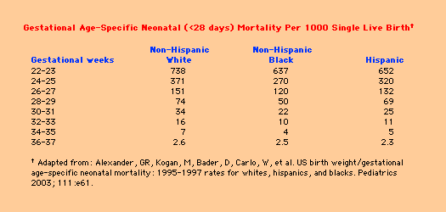

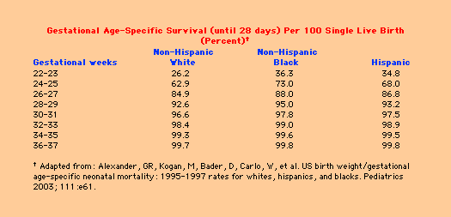

http://www.uptodateonline.com/utd/content/image.do?imageKey=pedi_pix\infant_m.gif~pedi_pix\infant_s.gif

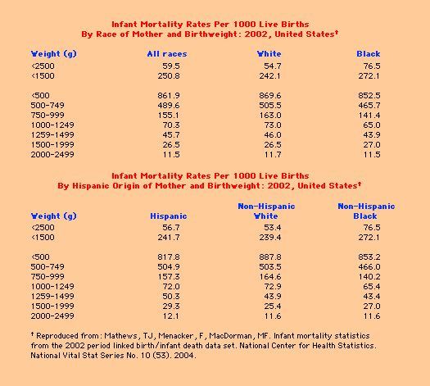

http://www.uptodateonline.com/utd/content/image.do?imageKey=pedi_pix\infant_m.gif~pedi_pix\infant_s.gif

Resources:
Perinatal Care at the Threshold of Viability, AAP
http://aappolicy.aappublications.org/cgi/content/full/pediatrics;110/5/1024

Perinatal mortality, UpToDate
http://www.uptodateonline.com/utd/content/topic.do?topicKey=neonatol/14943&type=P&selectedTitle=8~17

Premature infant, UpToDate
http://www.uptodateonline.com/utd/content/topic.do?topicKey=neonatol/13045

