5/9/05njm
Q. What is the significance of a ultrasound (US) ‘soft marker’ for Down Syndrome?

A. 2nd trimester US markers for Down syndrome are varied in their significance. See details

The minor markers: echogenic intraventricular focus (EIF), choroids plexus cyst (CPC), ‘sandal-gap’ toes, pyelectasis, clinodactyly, etc. are poor predictors of DS (but excellent predictors of overwhelming maternal anxiety!). They are found in about 1% of normal fetuses between 15-20 wks. Younger women (<35 y/o) with a negative quad screen are at very low risk if they have one of these minor markers; amniocentesis is not recommended for this group.

An enlarged nuchal thickness (NT), echogenic bowel, more than one marker, or any anomaly, are stronger predictors. Older women (>35 y/o), with or without a positive quad screen, are at higher risk with even a minor marker however, and counseling about amniocentesis may be appropriate for this group.

The EIF is often the most worrisome to women; they should be reassured that it is NOT a marker that something is wrong with the baby’s heart; and they do NOT need fetal echocardiography for follow up. They should also be reassured that a CPC does not mean there is something wrong with their baby’s brain!

Attached is a chart of the relative risks of each of the markers. Notice that a negative ultrasound (no markers found) will actually lower the pt’s risk (RR = 0.6) and should be reassuring (although it can’t be 100% so…..).

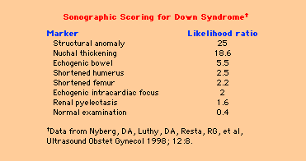

Also, as more patients get 1st trimester testing (to include BOTH nuchal translucency and PAPP-A and free bHCG at 11-13 wks, not just NT), it is important to know that that’s all they need; 2nd trimester testing is NOT indicated. If the results of 1st trimester screening are negative, no further (noninvasive) testing is indicated, and 2nd trimester testing will then only increase the number of false positives.

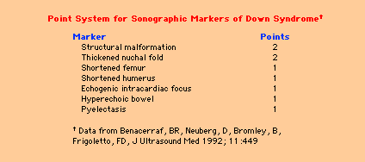

For more information on the whole perspective on Prenatal Genetic Screening – Serum and Ultrasound go here:
http://www.ihs.gov/MedicalPrograms/MCH/M/TM01.cfm

Other Resources
Ultrasound Markers Down Syndrome: Perinatology Corner Module
http://www.ihs.gov/MedicalPrograms/MCH/M/TM01_8.cfm

Down Syndrome: Perinatology Corner Module
http://www.ihs.gov/MedicalPrograms/MCH/M/TM01_6.cfm

Prenatal Genetic Screening – Serum and Ultrasound: Module Home Page
http://www.ihs.gov/MedicalPrograms/MCH/M/TM01.cfm

UpToDate: The sonographic diagnosis of fetal aneuploidy
http://www.uptodateonline.com/application/topic.asp?r=/application/topic.asp&file=antenatl/4468&type=A&selectedTitle=6%7E53&app=utdol

