Telework Centers Can Be a
Convenient Option for You
A telework center is a multi-agency office facility which is more geographically convenient to where employees live rather than where they may typically work.
To learn more about telework centers in the Washington Metro area, visit www.gsa.gov/teleworkcenters.

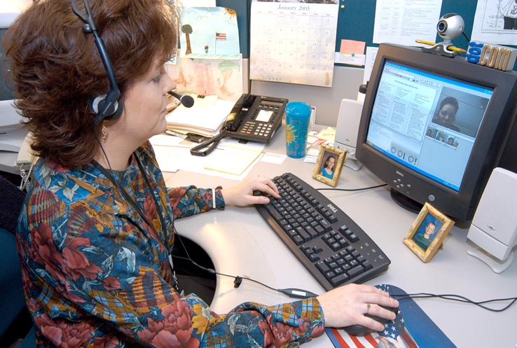
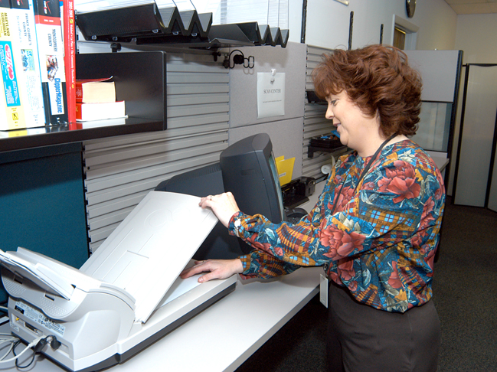
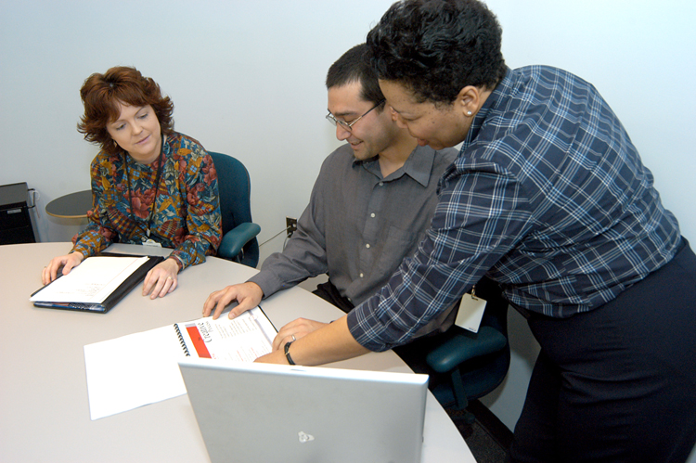

“with telework
everyone wins”

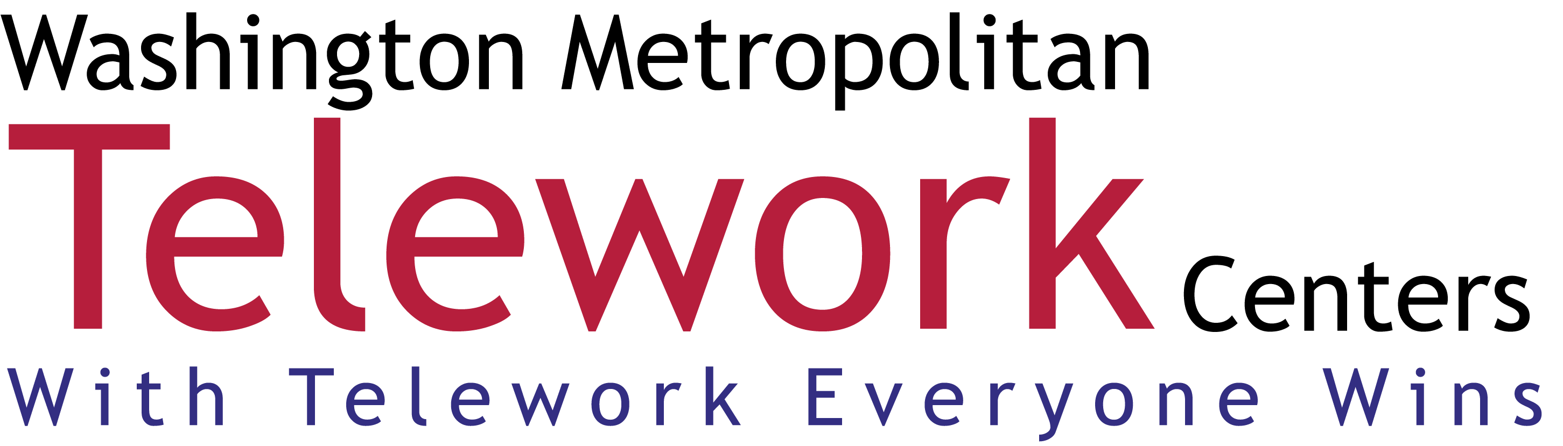

www.wmtc.org

