WRITTEN TESTIMONY OF
DR. ALEXANDER MACDONALD
DEPUTY ASSISTANT ADMINISTRATOR FOR LABORATORIES AND COOPERATIVE INSTITUTES
OFFICE OF OCEANIC AND ATMOSPHERIC RESEARCH
NATIONAL OCEANIC AND ATMOSPHERIC ADMINISTRATION
U.S DEPARTMENT OF COMMERCE

HEARING ON
“CLIMATE MODELING”

BEFORE THE
COMMITTEE ON COMMERCE, SCIENCE, AND TRANSPORTATION
UNITED STATES SENATE

May 8, 2008

Introduction
Good afternoon, Mr. Chairman and members of the Committee. I am Alexander MacDonald, Deputy Assistant Administrator for Laboratories and Cooperative Institutes in the Office of Oceanic and Atmospheric Research at the National Oceanic and Atmospheric Administration (NOAA) in the Department of Commerce. Thank you for inviting me to discuss climate modeling and NOAA’s key role in improving the understanding and prediction of global climate and how it is changing.

NOAA’s mission is to understand and predict changes in the Earth’s environment and conserve and manage coastal and marine resources to meet our nation’s economic, social, and environmental needs. In support of the mission, NOAA researchers develop and use mathematical models and computer simulations to both improve our understanding and prediction of natural climate variability, as well as to identify and predict climate change. Climate models help create an informed society that uses a comprehensive understanding of the role of the oceans, coasts, and atmosphere in the global ecosystem to make the best social and economic decisions. The ongoing pursuit of these objectives – of increasing our knowledge of the complex global climate system and communicating the relevant information to stakeholders – is summarized in NOAA’s climate goal “to understand and describe climate variability and change so as to enhance society’s ability to plan and respond.”
Today, I will be discussing the societal demands for climate change information, how climate models are used to meet these demands, and how the nation benefits by improving climate models.

Societal Demands for Climate Change Information
Climate variability and change can have a profound influence on society. Recent evidence of global climate change includes multi-year droughts, warmer global surface temperatures, accelerating sea level rise, decreasing Arctic sea ice, retreating glaciers, the acidification of our oceans, and shifts in ecosystems.

Federal, regional, state, and local decision makers need credible climate information at increasingly finer geographic scales to adapt to and mitigate climate variability and change on time scales from seasons to centuries. Land managers in Western states dealing with drought have requested long-term regional temperature and precipitation data, along with easily accessible and understandable tools for decision support. Resource managers from numerous federal agencies have requested site-specific information to help plan for and manage the effects of climate change. Regions and municipalities have requested local information about climate change to improve long-term decision-making on transportation, energy availability, and for emergency preparedness.

A broad scope of industries face operational challenges due to climate variability and change, including: utilities; integrated oil and gas; mining and metals; insurance; pharmaceuticals; building and construction; and real estate. Our understanding of how climate change impacts U.S. fisheries and the health of the world’s ocean ecosystems will aid in effective long-term fleet planning and enhance the security of the nation’s food supply.

More accurate predictions of future climate will contribute to improved preparation for and response to phenomena such as drought, hurricane activity, coastal inundation associated with storms and sea level rise, heat waves, poor air quality, and forest fires. The nation’s scientific community can provide this key information with comprehensive, state-of-the-art climate models (with related computational and data storage capabilities), that continue to advance the understanding of climate change and its potential consequences at local to global scales.

Using Climate Models to Meet Societal Demands

Climate Modeling to Inform Society

Many advancements in the scientific community’s knowledge and understanding of the way our planet’s climate system works come about via a synthesis of improved observations, advancements in theory, and computer modeling. Like a sturdy three-legged stool, observations, theory, and modeling together provide the foundation for our understanding of the way the climate system has changed in the past, and how it may change in the future.

Why are climate models so important for providing reliable information on climate change? Science generally proceeds from observations to theory, then to experiments to verify the theory's predictions against the observations, and finally further refinement or even refutation of the theory. In order to perform experiments, we need to replicate the system being studied. This poses a problem for the study of the Earth's climate, for there is only one Earth! The use of a computer model of the Earth – a "virtual Earth" – allows us to perform "climate experiments." Other fields in which it is expensive or dangerous to perform real experiments make similar use of computer simulation. Car design is a good example – most designs are tested for aerodynamic efficiency and crash testing on a computer, before a design ever makes it to the shop floor. The design of nuclear weapons is another excellent example; given the ban on tests of these weapons, the United States is devoting significant resources to develop the ability to model nuclear detonations.

Climate science and computer modeling of the Earth’s climate have advanced greatly since the world’s first coupled atmosphere-ocean global climate model was created in the late 1960s. At NOAA we proudly note that the world’s first such climate model was created by scientists at NOAA’s Geophysical Fluid Dynamics Laboratory (GFDL). The esteemed journal Nature identified this first climate model as one of the “Milestones of Scientific Computing” – along with advances like the invention of the handheld calculator, the internet, and CT scanners.

Over the last four decades, climate models have improved as both scientific brainpower and high performance computing have been devoted to this work. During that time, climate modeling has gone from being of interest primarily to a fairly small segment of the scientific and academic community to being of great interest to a broad section of society – here in the United States and around the world. More than fifteen climate modeling centers now exist, including those run by NOAA partners at the National Science Foundation’s National Center for Atmospheric Research (with additional support from the Department of Energy), and the National Aeronautics and Space Administration. NOAA has remained at the forefront of climate modeling through this transition. This is evident in NOAA/GFDL having produced not one, but two of the premier global climate models that played an integral role in last year’s influential report issued by the Intergovernmental Panel on Climate Change (IPCC), for which the IPCC shared the 2007 Nobel Peace Prize.

The best of today’s climate models are most reliable on relatively large geographic scales (i.e., for regions comparable in size to a third of the contiguous 48 states, or larger), with increasing uncertainty associated with climate projections on smaller scales. Those climate model results are being used now for an increasing range of applications. Projected changes in surface temperature and precipitation patterns, storm tracks, ocean currents, and Arctic sea ice are only a few of the aspects of climate being examined intensively by experts in the academic, government, and private sector communities. The customer base for high-quality climate model results is rapidly increasing. At NOAA we actively support these efforts by making large amounts of our climate model output freely available. Consistent with the U.S. Climate Change Science Program’s (CCSP) strategic plan, anyone can go to NOAA websites and download data files that document many of our climate model results. In this way, the output of NOAA’s climate models becomes input into climate impact studies and assessments.

However, the demand for scientifically credible projections (based on variable greenhouse gas scenarios) of future climate change goes beyond what currently can be offered. Today’s models are limited in two primary aspects: (a) there remain significant gaps in our understanding of how the climate system works, and (b) models are constrained by available computing. This latter limitation means that while these models are at their best in simulating climate features at scales of several hundred miles and larger, there is increasing uncertainty in their simulation of smaller scale climatic features. In addition, some of the processes operating in the climate system on small geographic scales are missing, and yet these processes may be important for large-scale climate. Both of these limitations can be addressed to a significant extent through the use of very large supercomputers. As an additional benefit, access to advanced supercomputers makes it easier for NOAA to attract and retain the world’s best climate scientists, to run models that resolve phenomena at the scale of a single state or even city.

What is a Climate Model?

Climate models divide the three-dimensional global ocean and atmosphere into millions of boxes referred to as grid cells. At each of those grid cells many calculations are performed over and over again in order to simulate the time evolution of processes important to the climate. The number and size of a climate model's grid cells are largely determined by the amount of computer resources available; more, smaller boxes results in more calculations which require more computing power. Higher geographic resolution (more, smaller boxes) are desirable for climate models for much the same reason people prefer the picture quality of a high definition TV as compared to a grainy You-Tube video: higher resolution provides a more detailed representation of the features in which we are interested, which benefits both scientific researchers and stakeholders. As a point of reference, in NOAA’s recent climate models atmospheric grid points were of a size such that one box's surface area covers about twice the land surface area of the Commonwealth of Massachusetts. That means Maine is covered by two boxes, North Dakota and Washington State by about 4 each, and Texas by 13. Since it takes several grid boxes to properly define or resolve a pattern, we can say that today's global climate models are limited in their ability to fully resolve features on spatial scales much less than the size of the 48 contiguous states.

We test our understanding of climate, as expressed in a computer model, by comparing how well that model does against observations of past climate. For instance, we might initialize our model of the Earth's climate with its known state in, say, 1750 – the "pre-industrial" climate, then apply the history of all the known external forces on the climate – solar variability, volcanoes, industrial emissions, land use changes – and see how well we do in predicting the known history of the 20th century climate. Our successes and failures help us refine our theories and our understanding. It is possible to "tune" a model to perform well against a given metric of skill – say the global mean surface temperature – but we use a wide range of metrics (e.g., temperature, rainfall patterns, number of storms, wintertime snow cover, etc.) – and the only way to do well against a diverse and comprehensive set of metrics is to represent the physical climate system with fidelity.

Models of the Earth system have many components and feedback loops. Today’s models include interactions among many components, including the ocean, atmosphere, sea ice, vegetation, ecosystems, and reactions between natural and industrial chemicals in the atmosphere. With increasing complexity, new challenges appear. For example, a key research area in the current generation of climate models is to capture the effect of aerosols, which include industrial pollutants, soot, dust, and sea spray on climate. Aerosols block sunlight directly, but they also impact the formation of clouds, a key player in the climate system. Progress in this key topic is delayed because our ability to represent such computationally expensive climate processes in our models has outpaced the available computing resources on which to run them.

Current Modeling Capabilities and Achievements

Computer models of the Earth’s climate have been central to NOAA's pursuit of its goal to “understand climate variability and change and enhance society's ability to plan and respond.” These models have done so well over time that they have now become central to the integrated assessments that are used to inform industrial and governmental climate and energy policy. The leading international assessments such the IPCC, and focused products from the CCSP, both synthesize results from computer models to answer key questions asked by policy makers.

At the time of the first IPCC report in 1991, NOAA/GFDL's model was one of the few models capable of producing reasonably realistic simulations of the Earth's climate. Since then, several centers around the world have developed climate models, and the assessment reports are now based on "model intercomparison projects," where coordinated computations are independently run by different centers around the world. It is a testimony to NOAA/GFDL models' pre-eminence in the field that in 2007, at the time of the IPCC Fourth Assessment Report, they are still seen as being at the very apex of climate modeling, on the basis of independent evaluations of their performance against a wide range of metrics of skill.

Specific achievements of NOAA’s current climate models are manifold. NOAA climate modeling has helped demonstrate that the U.S. Dust Bowl in the 1930’s and the drought in the African Sahel of the 1980’s were both caused in part by changes in the temperatures of the oceans. Our current understanding of El Niño and of how El Niño affects the U.S. climate is based in large part on NOAA research with climate models. NOAA climate modeling first pointed to the importance of the circulation of the Atlantic Ocean as a potential source for abrupt climate change. Further, NOAA models have clarified the competition between warming due to increasing concentrations of long-lived greenhouse gases and cooling due to short-lived atmospheric particles generated by human activity.

NOAA models have also been major contributors to the most recent Ozone Assessments conducted by the World Meteorological Organization (WMO), evaluating the response of the Antarctic ozone hole to the reductions in the emissions of chlorofluorocarbons that followed the Montreal Protocol and projecting the future evolution of the ozone shield. NOAA has also developed climate models with higher geographic resolution that are currently being used to develop climate change projections over North America, as part of the North American Regional Climate Change and Assessment Program.

The computer models themselves represent an important NOAA product. NOAA/GFDL’s Modular Ocean Model (MOM) is the world's most widely used numerical model for simulating ocean circulation at the global scale and for understanding and predicting ocean climate phenomena. Significant recent advances include the ability to directly predict sea-level changes as well as improved representations of the complex features of the ocean's heat and chemical distributions. Over 400 scientists around the world are now using MOM to perform oceanographic, weather, and climate studies. It is used for operational weather forecasting at NOAA’s National Weather Service.

Benefits from Improving Climate Models

NOAA’s state of the art climate models were used extensively in the latest IPCC assessment, the most recent WMO ozone assessment, and the ongoing North American Regional Climate Change Assessment Program. But despite recognition from independent experts as being among the highest quality climate models in the world, the models are not able to meet the growing suite of societal demands for climate change predictions. Current models are limited by some remaining gaps in our understanding of how the climate system works, and in computer resources. The lack of adequate computer power prevents us from making optimal use of existing knowledge by extending our simulations to smaller geographic scales and including a more complete set of climate processes.

An example of a gap in understanding that is holding back progress in climate modeling is our lack of understanding of the Greenland and Antarctic ice sheets, a major source of uncertainty in predicting the future sea level. Recent observations have highlighted the potential for rapid changes in the ice sheets and the inadequacies of current theories of ice sheet dynamics. Coordinated progress will be needed in ice sheet observations, a build-up of the human capacity in this research field, and experimentation incorporating new models of the ice sheets into our climate models. Another key gap is our inadequate understanding of the factors that control the Earth’s cloud cover and how it might change as the Earth warms. This gap is a key source of uncertainty in predicting the magnitude of the warming resulting from a given change in atmospheric carbon dioxide.

Improving understanding on such central questions is fundamental to progress, and we are confident that our climate models will improve as they begin to explicitly resolve smaller geographic scales. The scales that our models resolve are determined by the available computer resources. With currently available computer resources, our models are most reliable at simulating climatic features with geographic scales of several hundred miles and larger, with increasing uncertainty in the simulation of smaller scale phenomena. The following are some of the benefits related to the inclusion of smaller scale processes in models:

- Projections of temperature and precipitation on smaller scales than those currently resolved adequately by climate models to aid decision makers and planners at the regional and local levels. For example, trends in many local water resources are affected by small-scale topographic features and land-use patterns that are not represented in current climate models.
- Many of the greatest effects of climate change may come about through changes in extreme events, such as hurricanes, heat waves, droughts, and floods. The climate models used in the recent IPCC assessment do not provide adequate simulations of hurricanes, for example. Other extreme events, such as droughts and floods, are strongly influenced by small-scale processes that are not well resolved in these models.
- It is likely that small-scale ocean currents and other ocean processes may play a crucial role in the future behavior and stability of the Antarctic and Greenland ice sheet, with large potential influences on sea level rise.
- The response of ecosystems to climate change, including the cycling of carbon through the system, is highly uncertain in current models. This is strongly influenced by limited computational resources, preventing the inclusion of important small-scale processes, such as intense ocean upwelling near the coasts, which are crucial to the global cycling of carbon.
- Improved predictive capability to support integrated national air quality policy and regional emission management strategies for air quality and climate. The prediction of climate change impacts on air quality could be better assessed by including smaller scale processes in to models.

Pathways to Climate Model Improvements

The next generation of climate models that explicitly include smaller-scale processes has been developed in NOAA. Prototypes of these models have been tested, but computer resources in NOAA are inadequate to use these models for the comprehensive simulations of climate change that are necessary to provide stakeholders with robust predictions of climate change. We cite here two examples of next generation models that have been developed but are too computationally expensive to run extensively given current resources:

- A new climate model has been developed that resolves important ocean features on scales as small as 20 miles (Figure 1). For comparison, models used in the most recent IPCC assessment resolve ocean features on scales of 200-300 miles. The inclusion of the small-scale ocean features may produce large improvements in understanding how ocean circulation responds to global warming, with major climatic impacts. This includes how much carbon dioxide the ocean will absorb (or outgas) in the future, the response of marine ecosystems to global warming, how El Niño will respond to global warming, and the potential for abrupt climate change due to changes in the circulation of the Atlantic Ocean.

Application of this model for comprehensive climate change predictions would deliver much more credible predictions of the ocean’s response to global warming, including the effect on marine ecosystems, carbon uptake, and ocean acidification. This would also greatly improve the prediction of decadal scale changes in the ocean that may strongly influence hurricanes and droughts, as well as predictions of Arctic climate change and sea ice. However, NOAA does not currently possess the computational capability to use this model. Applying this model for the next IPCC assessment report would require approximately 10 times NOAA’s current computing resource, which is comparable to the largest machines in the United States. NOAA does not now have access to these systems.

- A global atmospheric model is being developed that resolves processes on a geographic scale of about 10 miles. A regional version of this model faithfully simulates Atlantic hurricane activity (Figure 2). The global version will simulate important high impact climate phenomena and small-scale variations of rainfall around the world. Use of such a model for comprehensive predictions of climate change would increase our confidence in the prediction of how hurricanes will change in the future. This model would also be a great improvement in our ability to predict regional climate change over the United States, including such features as future changes in western U.S. snowpack with associated water resource implications (Figure 3). The output from this model would be of substantial value across a wide suite of applications, from water resource and infrastructure development to agricultural planning.

The use of this model in comprehensive climate change predictions would provide climate change predictions on geographic scales of ten to twenty miles. However, it would require approximately 50 times NOAA’s current computing capability to apply this model to the next IPCC assessment report. Although this level of computing corresponds to roughly half of the Nation’s entire research high performance computing capacity, a limited set of climate integrations with this model could be used to advance our understanding of how climate change affects high-impact phenomena.

These fine resolution oceanic and atmospheric climate model components will advance our understanding of and ability to predict climate. But our ambition is to combine them into a fine resolution coupled climate prediction system that is commensurate with the requests of policymakers and stakeholders at the regional and local levels. In the next 5-10 years, NOAA will work towards advancing the fidelity and utility of our climate models and combining the advantages of finer resolution in both the oceans and the atmosphere while fully capturing their complex interactions. Fulfilling such a vision would require approximately 100 times as much computing power as is currently available.

Conclusion

We now have a deeper understanding of the climate system and the delivery of climate information to the nation as a direct result of NOAA scientists and their collaborators using high performance computing for numerical simulation. Climate models have demonstrably improved our ability to simulate the Earth’s climate. However, the demand for scientifically credible projections of future climate change goes beyond what currently can be offered. Scientific advancements and the generation of new climate information products that arise from better climate models are intimately tied to the state-of-the-art computers that are devoted to running them. NOAA is poised to run advanced climate models that resolve regional scale features in the atmosphere and ocean, incorporate the effects of chemistry and aerosols on climate, and provide long lead-time predictions of high-impact climate phenomena such as drought and hurricane activity.

Thank you again for inviting me to discuss climate modeling and NOAA’s key role in improving the understanding and prediction of global climate. Robust climate models help NOAA to provide reliable information on climate change. Many advancements in the scientific community’s knowledge and understanding of the way our planet’s climate system works have come about via a synthesis of improved observations, advancements in theory, and computer modeling. I look forward to working with the Committee on any further information you may require for your deliberations on this topic.

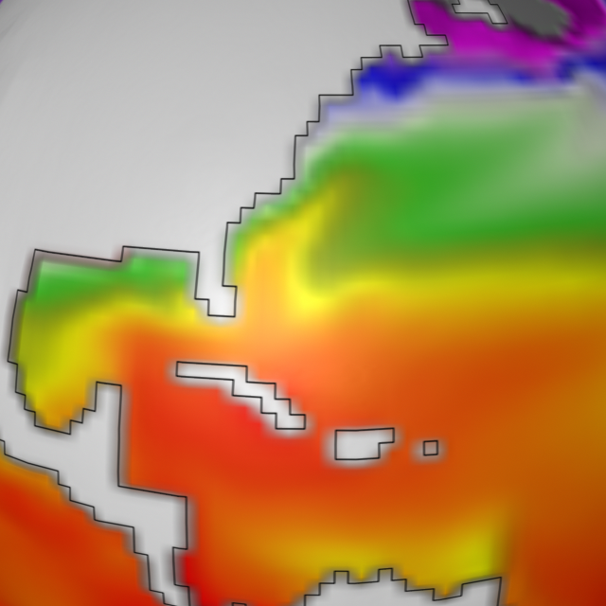
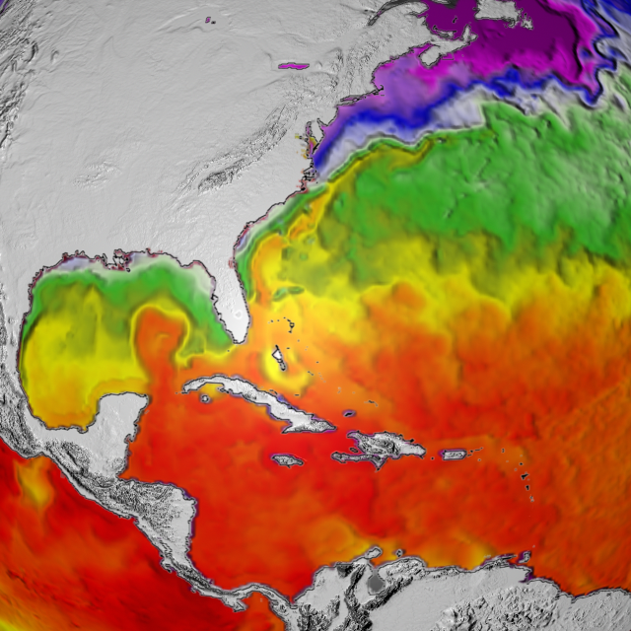
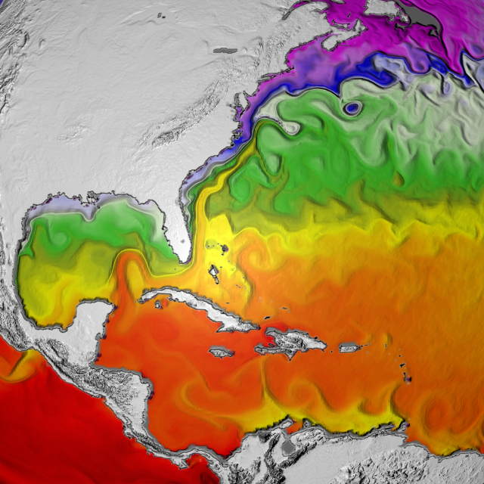
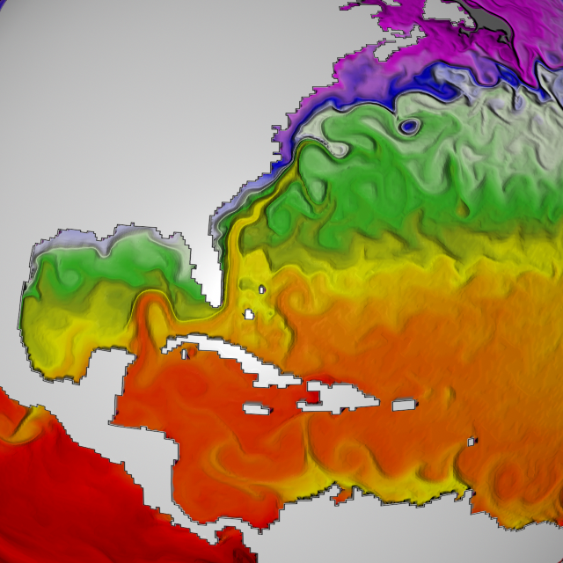

Current Generation Model Next Generation Model Observations
60 mile resolution 14 mile resolution

Figure 1. A new climate model has been developed that resolves crucially important ocean features on scales as small as 20 miles. Application of this model for comprehensive climate change predictions would deliver much more credible predictions of the ocean’s response to global warming, including the effect on marine ecosystems, carbon uptake, and ocean acidification.

Figure 2. A regional version of a global model with 10 mile resolution can faithfully simulate Atlantic hurricane activity. The global version will simulate important high impact climate phenomena and small-scale variations of rainfall around the world.
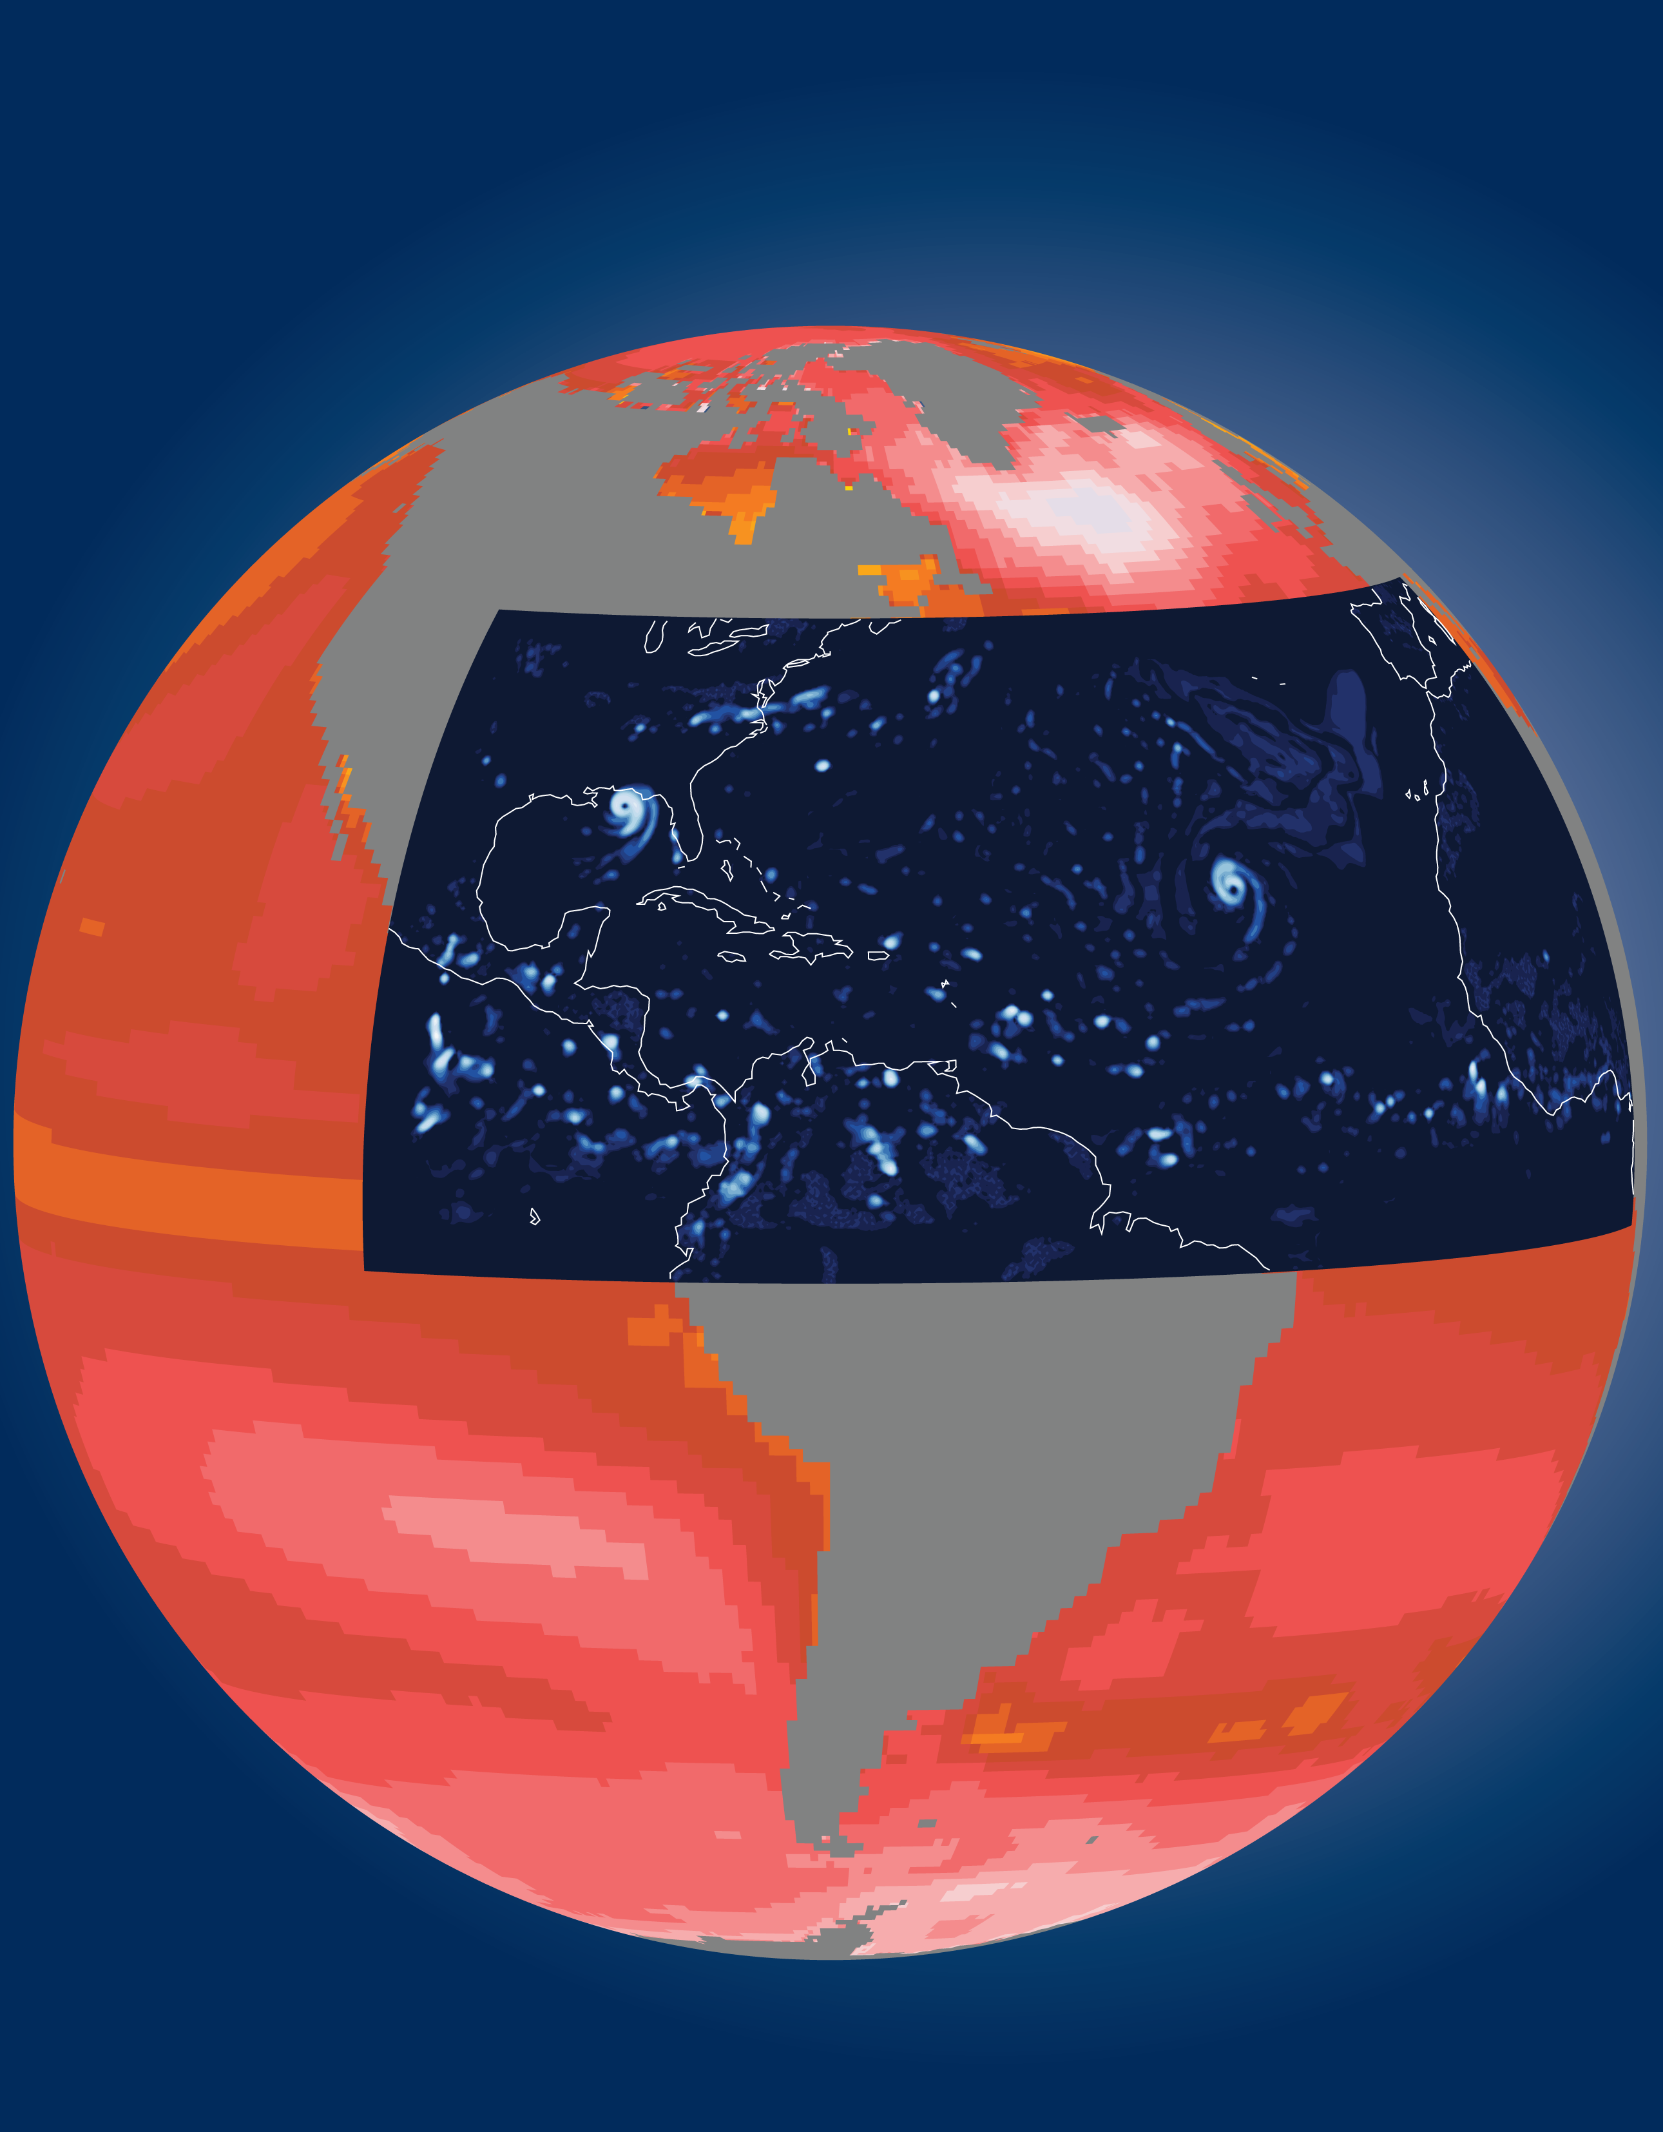

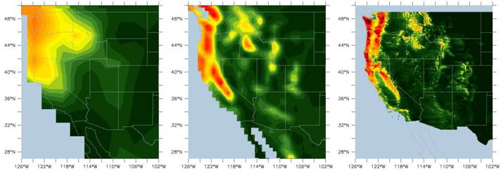
Current Generation Model NARCCAP Model Observations
120 mile resolution 30 mile resolution

Figure 3. A prototype model with a resolution of 30 miles was used to support the North American Regional Climate Change Assessment Program (NARCCAP) and simulates substantially more of the features in the precipitation field in the Western U.S. than do current models. A global model with 10 mile resolution is expected to improve the capture of the amount, timing, location, and type of precipitation in order to better predict water resource issues arising in the Western U.S., a key concern that has been identified by NOAA customers.

