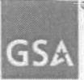
GSA Office of the Chief Acquisition Officer
JUN 2 2006 GSA Acquisition Letter V-05-12 Supplement Number 1
MEMORANDUM FOR ALL GSA CONTRACTING ACTIVITIES
FROM: ROGER D. WALDRON 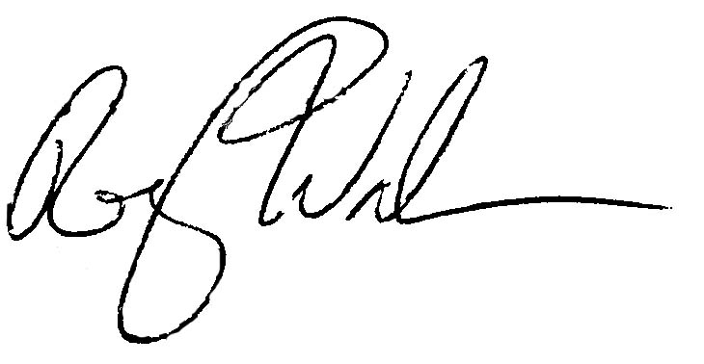
ACTING, DEPUTY CHIEF ACQUISITON OFFICER OFFICE OF THE CHIEF ACQUISITION OFFICER

SUBJECT: Socio-Economic Programs Under Schedules

1. Purpose. This supplement extends the expiration date in the General Services Acquisition Letter V-05-12.

2. Effective Date. June 6, 2006

3. Termination Date. Acquisition Letter V-05-12 and Supplement I will expire June 6, 2007, or upon incorporation into the General Services Administration Acquisition manual, whichever is earlier.

U.S. General Services Administration 1800 F Street, NW
Washington, DC 20405-0002 www.gsa.gov

