
TRADOC Pamphlet 525-5-600

The United States Army’s
Concept of Operations

LandWarNet

2015

11 February 2008

2007

This page intentionally left blank.

Foreword

From the Director
U.S. Army Capabilities Integration Center

The idea for the LandWarNet concept of operations (CONOPS) began in July, 2006 at the U.S. Army Signal Center as a means to focus the U.S. Army’s attention on the capabilities and potential behind the network and its growing impact on the commander and Soldier. Recently approved joint and Army concepts highlight the need for network capabilities that enable information superiority and effective battle command.

From a joint perspective, the LandWarNet CONOPS addresses Tier 1 and 2 joint capability areas by identifying and listing the Army’s network required capabilities in the categories described in the Net-Centric Environment Joint Functional Concept.

This LandWarNet CONOPS is unique in that it captures the network capabilities identified in the currently approved key Army concepts and provides a singular network reference across the warfighting functions. It outlines Army network expectations in the future Modular Force of 2015. Most importantly, the LandWarNet CONOPS provides a comprehensive view of the capabilities that the Army network must provide to enable the warfighter.

Transformation is enabled by technological advances, but our most critical asset is not technology, but the critical thinking of our Soldiers and leaders. As we continue to provide capability enhancements to the Army’s LandWarNet, we must remain focused on enabling our Soldiers from the “first tactical mile” all the way back to the operational base. LandWarNet is about connecting all of our forces, systems, platforms, and installations into a collaborative environment that enables the seamless flow of information to enable decision making.

This LandWarNet CONOPS will be refined and updated on a regular basis as we continually develop new capabilities and concepts that enable our Soldiers and leaders to tackle the myriad challenges in an ever changing global environment. We seek institutional innovation and the application of critical thinking that provides insight into these challenges. We welcome your comments and collaboration in this endeavor that we call LandWarNet.


MICHAEL A. VANE
Lieutenant General, U.S. Army
Director, U.S. Army Capabilities
Integration Center

Executive Summary

Warfighters require a robust global network that supports joint operations in a wide variety of operational environments. The Army must be able to operate within this joint, network-enabled, global collaborative environment.

LandWarNet is defined as the Army’s portion of the global information grid and consists of all globally interconnected, end-to-end Army information capabilities supporting warfighters, policy makers, and support personnel. As the Army’s enterprise system of systems, LandWarNet moves information through a seamless network that facilitates information-enabled joint warfighting and supporting operations from the operational base to the edge of tactical formations, down to the individual Soldier.

LandWarNet is not a program of record or a new network for the future, it exists today. It is the name for the Army’s enterprise networking capabilities that enable Soldiers, Leaders, and units – today and in the future to operate anytime, anywhere, at every echelon as part of the joint force.
LandWarNet provides the construct for the Army’s transition to the future and is a key contributor for information and decision superiority. LandWarNet will enable voice, data, and video to the edge of tactical formations—ultimately pushing these capabilities lower and lower to our modular U.S. Army’s brigades, battalions, and Soldiers. The Future Combat Systems will have a wide array of new information capabilities to achieve conceptual objectives; however, it must be able to pass that information to a variety of organizations with dissimilar levels of capability. LandWarNet is the means to provide linkages between sensors, shooters, and leaders; seamless and secure interoperability; network services; and, end-to-end connectivity throughout the enterprise.
Focused on leaders and Soldiers—LandWarNet integrates C2 capabilities to enable leader-centric operations. The Army must view the future joint operational environment from a global perspective and realistically consider where operations can occur. The strategic environment will be volatile, uncertain, complex, and ambiguous with multiple and combinations of operational contingencies that require joint, interagency, and multinational capabilities.

The Army recognizes that we have multiple stove-piped networks, insufficient access to actionable intelligence, limited battle command on-the-move, and other shortfalls today. These shortfalls are being addressed through multiple means from organizational changes to development of new capabilities and systems that will provide a common user networking capability throughout the force. This CONOPS addresses the full spectrum future Modular Force and how LandWarNet enables network operations in a global collaborative context. This CONOPS is fully nested in the Army concept strategy documents from the capstone concept, the operating concepts, and through the six Army functional concepts. It is designed to address LandWarNet capabilities during each of the joint operational phases in the 2015 timeframe.
Although LandWarNet exists to enable the war fight through battle command, the network enables all warfighting functions and must be developed as an integrated capability that supports the commander’s ability to make informed decisions, delegate authority, and synchronize the warfighting functions. The LandWarNet CONOPS will serve to further develop and integrate the operational concepts that support the Army’s network development efforts that allow for seamless dissemination of the commander’s intent and understanding of the joint, common operational picture. It will provide the opportunity to exchange ideas on how to organize, train, plan, and rehearse to operate in the global collaborative environment.

The LandWarNet CONOPS offers insights into how LandWarNet must be developed, fielded, and managed to address diverse threats and the volatile conditions throughout the joint phased framework. Coupled with higher level guidance, the CONOPS will leverage existing and ongoing development efforts, and inform subsequent functional analyses, experimentation, architectural development, force development recommendations, and implementation decisions.

We must reinforce the common understanding of LandWarNet that describes its purpose, developmental approach, and relevance to joint and Army transformation objectives with our Service counterpart’s similar overarching efforts: U.S. Navy FORCEnet and the U.S. Air Force C² Constellation.

This page intentionally left blank.

Department of the Army TRADOC Pamphlet 525-5-600
Headquarters, United States Army
Training and Doctrine Command
Fort Monroe, Virginia 23651-1046

11 February 2008

Military Operations

THE U.S. ARMY CONCEPT OF OPERATIONS FOR LANDWARNET 2015

FOR THE COMMANDER:

OFFICIAL: DAVID P. VALCOURT
Lieutenant General, U.S. Army
Deputy Commanding General/
Chief of Staff

History. This publication is a new United States Army Training and Doctrine Command (TRADOC) Pamphlet.

Summary. TRADOC Pamphlet (Pam) 525-5-600, The U.S. Army Concept of Operations for LandWarNet 2015 serves as the basis for developing doctrine, organization, training, materiel, leadership and education, personnel and facilities focused requirements and solutions for LandWarNet. Under this concept, LandWarNet capabilities are projected across the future battlespace to conduct military operations to fight and win across the full spectrum of military operations. This publication captures the network-enabling capabilities from the Army capstone concept, the operating concepts, and through the six Army functional concepts in order to provide a singular network reference across the warfighting functions.

Applicability. This pamphlet applies to all Department of Army and TRADOC activities that identify and develop doctrine, organization, training, materiel, leadership and education, personnel and facilities solutions to field required capabilities. Active Army, U.S. Army National Guard and U.S. Army Reserve may use this pamphlet to identify future trends in the Army. This pamphlet may also serve as a reference document to agencies within the joint community that are planning or are concerned with LandWarNet operations.

Proponent and exception authority. The proponent of this pamphlet is the TRADOC Headquarters, Director, Army Capabilities Integration Center (ARCIC). The proponent has the authority to approve exceptions or waivers to this pamphlet that are consistent with controlling law and regulations. Do not supplement this pamphlet without prior approval from Director, ARCIC (ATFC-RW), 10 Whistler Lane, Fort Monroe, VA 23651-1046.

Suggested improvements. Users are invited to send comments and suggested improvements on DA Form 2028 (Recommended Changes to Publications and Blank Forms) directly to Director, ARCIC (ATFC-RW), 10 Whistler Lane, Fort Monroe, VA 23651-1046. Suggested improvements may also be submitted using DA Form 1045 (Army Ideas for Excellence Program (AIEP) Proposal).

Distribution. This publication is only available on the TRADOC Homepage at http://www.tradoc.army.mil/tpubs/pamndx.htm.

Contents
Page

Foreword i
Executive Summary ii

Chapter 1 5
Introduction 5
1-1. Purpose 5
1-2. Functional Area 5
1-3. Scope 5
1-4. Relation to the Key Army Concepts 6
1-5. References 10
1-6. Explanation of abbreviations and terms 10
Chapter 2 10
Concept of Operations 10
2-1. Introduction 10
2-2. Operational Environment 11
2-3. Joint Interdependence 13
2-4. The Plan (Joint Phasing – Six Phase Model) 14
2-5. Summary of LandWarNet in the Joint Phase Model 43
Chapter 3 44
LandWarNet Required Capabilities 44
3-1. Achieving the Objective State of LandWarNet 44
3-2. Overarching LandWarNet Required Capabilities 45
3-3. LandWarNet Enabled Battle Command Required Capabilities 48
3-4. LandWarNet Enabled See Required Capabilities 50
3-5. LandWarNet Enabled Move Required Capabilities 55
3-6. LandWarNet Enabled Strike Required Capabilities 55
3-7. LandWarNet Enabled Protect Required Capabilities 56
3-8. LandWarNet Enabled Sustain Required Capabilities 57
3-9. LandWarNet Capabilities Summary 61
Appendix A. References 62

This page intentionally left blank.

Chapter 1

Introduction

1-1. Purpose
This concept of operations (CONOPS) addresses the full spectrum future Modular Force and how LandWarNet enables leader-centric operations in a fully networked, global collaborative context. Operational capabilities and integrated architectures are required so that systems can be developed, fielded, and managed to ensure compliance with joint and Army concepts in order to address these diverse threats and the volatile conditions throughout the joint operations phases (see fig 1-1). The planning, preparation, and execution of the supporting network enablers for example voice, video, text, etc. is critical to the final outcome. Additionally, to support extended ranges and global operations, the generating force must play a greater role than ever before in support of decisive, shaping, and sustaining operations. LandWarNet provides the integrated applications, services, and network transport capabilities to enable leader-centric operations anytime, anywhere at every echelon as a part of the joint force.

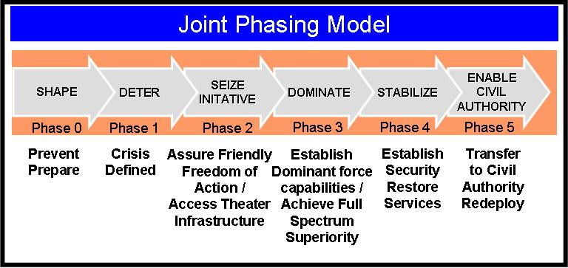
Figure 1-1. The Joint Operations Six Phase Model

1-2. Functional Area
The LandWarNet CONOPS identifies capabilities required to execute Army operations during the 2015 timeframe. This CONOPS reaches across the joint functional areas of battlespace awareness, command and control (C2), force application, protection, focused logistics, network-centric, sustainment, and training. Additionally, this CONOPS is fully nested in the Army concept strategy documents to include TRADOC Pamphlet 525-3-0, The U.S. Army in Joint Operations: The U.S. Army’s Future Force Capstone Concept and the six U.S. Army functional concepts.

1-3. Scope
The scope of LandWarNet CONOPS is consistent with current joint and Army concepts and focuses on the 2015 timeframe. The primary basis for analysis are the Capstone Concept for Joint Operations, the joint operating concepts (Major Combat Operations Joint Operating Concept (JOC), Homeland Defense and Civil Support Operations JOC, Military Support to Stabilization, Security, Transition, and Reconstruction Operations JOC, Irregular Warfare JOC and Deterrence Operations JOC), TRADOC Pamphlet 525-3-0, The U.S. Army in Joint Operations: The U.S. Army’s Future Force Capstone Concept, TRADOC Pamphlet 525-3-1, The U.S. Army Operating Concept for Operational Maneuver, and TRADOC Pamphlet 525-3-2, The U.S. Army Concept for Tactical Maneuver. Other considerations in the analysis include interagency, multinational, and coalition interactions.

1-4. Relation to the Key Army Concepts

a. TRADOC Pamphlet 525-3-0, The U.S. Army in Joint Operations: The U.S. Army’s Future Force Capstone Concept, states that Army forces will conduct operations as an integrated component of a joint force and will depend on the capabilities from other Services to maximize effectiveness. It is within this context that the campaign is linked firmly to theater strategy and the operations must establish early, sustained control of the air, land, sea, space, and information domains. The capstone concept lays out seven key operational ideas (see fig 1-2) across the spectrum of conflict to achieve full spectrum dominance. Supporting these ideas is LandWarNet and the network effort, the exponential increase in the value of a network as the number of those using it increases. It extends the interconnectivity of headquarters to the extremities of the force: individual Soldiers, weapons, sensors, platforms, etc. The network effect enables information superiority and effective battle command. LandWarNet as the Army network will serve to form the backbone of the future Modular Force.

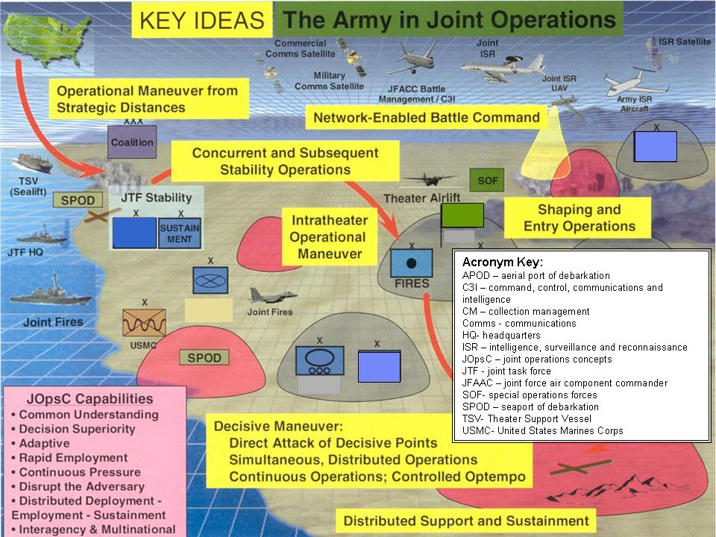
Figure 1-2. Operational Overview

b. TRADOC Pamphlet 525-3-1, The U.S. Army Operating Concept for Operational Maneuver, addresses the operational level of war and focuses on the ways and means by which future Modular Force commanders link a broad array of tactical actions to achieve a joint force commander’s (JFC) campaign objectives. The concept presents a detailed discussion of the seven key operational ideas identified in the Army capstone concept and how they are applied at the operational level of war. The concept reinforces the importance of LandWarNet, and the capabilities required to establish a knowledge-based network which underpins all other capabilities.

c. TRADOC Pamphlet 525-3-2, The U.S. Army Concept for Tactical Maneuver, describes the future Modular Force within the framework of tactical operations—battles and engagements. The concept addresses five key ideas concerning tactical operations: (1) conduct simultaneous and continuous operations; (2) conduct decisive maneuver; (3) exploit the routine employment of joint capabilities at tactical level; (4) perform self-synchronizing and cooperative engagement and (5) seek to exploit the quality of firsts (see first, understand first, act first, finish decisively, and re-engage at will). LandWarNet enables the maneuver element of the joint land component, tactical formations to exploit higher levels of situational understanding (SU) and networked C2. This in turn improves their mobility to defeat the enemy in close combat; maneuver throughout the depth and breadth of the area of operations (AO); transition rapidly from one engagement to the next. LandWarNet will further allow future Modular Forces to integrate joint, multinational, interagency, and nongovernmental organizations (NGO) and capabilities at the tactical level.

d. TRADOC Pamphlet 525-3-3, The U.S. Army Functional Concept for Battle Command, provides a visualization of how Army future Modular Force commanders will exercise C2 of Army operations in a joint, interagency, and multinational (JIM) environment. The battle command function is a blend of the cognitive and the technical. Commanders achieve battle command by combining the art of well prepared leaders with the enabling science and technical systems of the future Modular Force. LandWarNet enables capabilities associated with the Battle Command functional concept for example:

(1) Establish and maintain information connectivity and common services infrastructure between battle command applications (sensors, handhelds, computers, vehicles, tactical operations centers, area processing centers, and sanctuary locations).

(2) Manage efficient movement and storage of battle command information in accordance with commander’s priorities and operational imperatives.

(3) Protect battle command applications, information devices, and information in motion and at rest.

e. TRADOC Pamphlet 525-3-4, The U.S. Army Functional Concept for See, describes how the future Modular Force will acquire and generate knowledge of itself, its opponent and the operational environment. The function of seeing and creating knowledge of the operational environment is the essential element of transforming to a knowledge-based, net-enabled force capable of seeing first, understanding first, acting first, and finishing decisively. LandWarNet enables the capabilities associated with the See functional concept for example:

(1) Acquire data from organic and nonorganic sources including JIM; this includes the subordinate functions of gathering, collecting, and fusing.

(2) Transform data through the rapid and continuous fusion of data and analysis of information to produce knowledge, across all domains and disciplines to develop relevant knowledge.

(3) Provide timely, precise, and tailored knowledge input to the command for decisionmaking, force application, movement, protection, and sustainment.

f. TRADOC Pamphlet 525-3-6, The U.S. Army Functional Concept for Move, focuses on strategic force projection and operational agility in support of joint campaign objectives. The Army’s approach to this requirement for strategic responsiveness is through a “prompt and sustained framework.” LandWarNet enables the capabilities associated with the Move functional concept for example:

(1) Enroute mission planning and rehearsal system.

(2) Maintain a common operating picture with forces already in theater.

(3) Automated decision aids.

g. TRADOC Pamphlet 525-3-4, The U.S. Army Functional Concept for Strike addresses joint and future Modular Force fires at the strategic, operational, and tactical levels. Strike includes fires routinely integrated with information operations (IO) and three IO-related military activities; public affairs (PA), civil military operations (CMO), and defense support to public diplomacy (DSPD). LandWarNet enables capabilities associated with the Strike functional concept for example:

(1) Providing continuous access to the common operational picture (COP).

(2) Ensuring seamless and transparent communications and computer interface.

(3) Executing routine employment of available joint and multinational fires.

h. TRADOC Pamphlet 525-3-5, The U.S. Army Functional Concept for Protect lays out a set of enabling tasks and capabilities by which the future Modular Force protects people, physical assets, and information against the full spectrum of threats. The function of protect will take place on land, in the air, on the sea, in space, and the electronic domains. LandWarNet enables the capabilities associated with the Protect functional concept for example:

(1) Share protection information horizontally and vertically in a JIM environment.

(2) Employ sensors, automated protection systems, and robotics in a combat environment, in order to achieve SU and assist the ability to decide and act against hostile forces.

(3) Capability to receive updated or new training support packages for improved sensor, automated, and robotic capabilities in a formal and unit training setting.

i. TRADOC Pamphlet 525-4-1, The U.S. Army Functional Concept for Sustain establishes the overarching framework for logistics support to the future Modular Force. At the strategic and operational level, future Modular Force support is envisioned as a single joint system that senses and interprets the operational environment and responds through networked capabilities and advanced distribution platforms with precision, from the source of support to the point of effect. Future Modular Force support operations include supply and field services, medical support, maintenance, transportation, force health protection, Soldier services, and aviation logistics support. LandWarNet enables the capabilities associated with the Sustain functional concept for example:

(1) A single joint capable network-enabled logistics system.

(2) High-speed, precision, accuracy, visibility, and centralized supply chain management with minimum essential forward stockage and reachback capabilities.

(3) Interdependent, capabilities-based, modular, network-enabled organizations with increased commonality of equipment and organizational designs.

1-5. References
Required and related publications and prescribed and referenced forms are listed in appendix A.

1-6. Explanation of abbreviations and terms
Abbreviations and special terms used in this regulation are explained in the glossary.

Chapter 2

Concept of Operations

2-1. Introduction

a. The strategic environment has changed significantly since the end of the Cold War, and events since September 11, 2001 have dramatically demonstrated that we have entered a new era of conflict with different challenges to overcome. The Department of Defense (DOD) is aggressively transforming to meet these challenges.

b. The Army is pursuing the most comprehensive transformation of its forces since World War II. These transformation efforts are both evolutionary and revolutionary in nature, intended to improve joint and Army force capabilities to meet the demanding requirements of a Nation at war, as well as future full spectrum requirements. The focus for such transformation is to attain a force capable of full spectrum operations (FSO) that is achieved through the interdependent application of decisive maneuver, precision engagement, distribution-based logistics, and force protection enabled by information superiority.

c. Currently, separate, multiple, stove-piped systems and processes prevent network-enabled, commander-centric operations. The presentation of a disjointed picture by disparate functional areas also limits the potential impact found in a net-centric environment.

d. LandWarNet, underpinned by integrated architectures enables, “one Army battle command system” as part of “one network” and facilitates a consistent alignment of joint capabilities across all layers of the network (platforms and sensors, applications, services, transport, and standards) to design and field an integrated system of systems (see fig 2-1). This network provides the link from Soldier to sustaining base, with tailored software applications that are optimized for conducting joint operations.
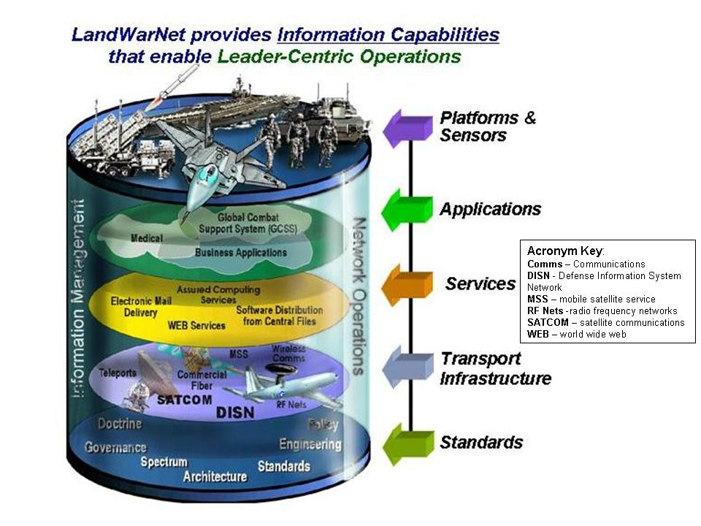
Figure 2-1. LandWarNet (The U.S. Army Network)

2-2. Operational Environment

a. The Army must view the future joint operational environment (JOE) from a global perspective and realistically consider where operations can occur. There will be a volatile, uncertain, complex, ambiguous strategic environment that will have multiples and combinations of operational contingencies that require JIM capabilities (see fig 2-2).

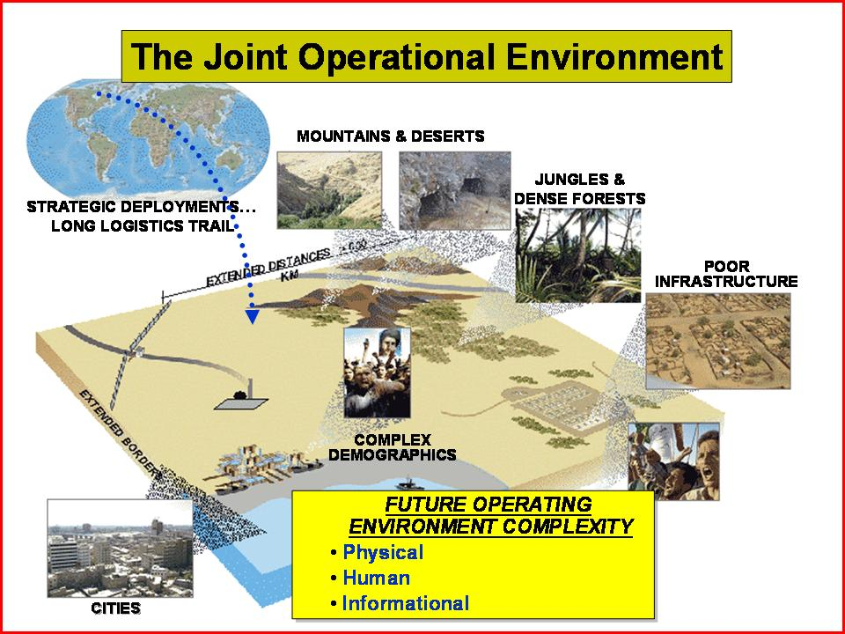
Figure 2-2. Joint Operating Environment

b. Reliance on a global information environment that provides a virtual representation of the actual environment requires supporting organizations and functions that are immediately responsive and seamlessly connected in a manner that provides a virtual picture of the operational environment for deployed commanders and Soldiers (see fig 2-3).

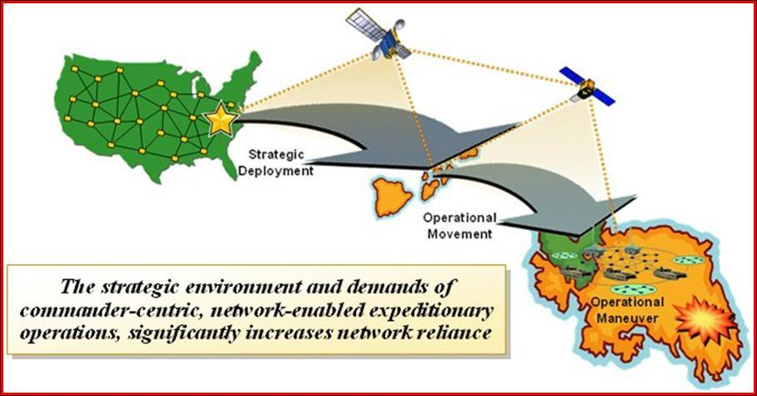
Figure 2-3. Strategic Environment

c. The future Modular Force will fight as a part of a networked joint force, integrated at every level, and interdependent in the joint areas of battle command, force projection, air and missile defense, sustainment, and fires.

2-3. Joint Interdependence

a. Joint interdependence is the purposeful reliance on other Service and joint capabilities to maximize their complementary and reinforcing effects while minimizing service vulnerabilities. Key joint interdependencies per TRADOC Pam 525-3-0 and derived from the joint functional concepts include: Joint Command and Control Functional Concept; Joint Force Projection Functional Concept; Joint Air and Missile Defense Functional Concept; Joint Sustainment Functional Concept; Joint Fires and Effects Functional Concept. Key enablers for joint interdependencies are joint integrated architectures and the global information grid (GIG) via LandWarNet for the Army.

b. From an Army perspective, LandWarNet provides the technical medium to synchronize the employment of land, air, sea, space, and special operations forces (SOF) in order to provide the commander with the widest range of strategic, operational, and tactical options. As mentioned earlier in paragraphs 1-2 and 1-3, LandWarNet draws from the Army’s Capstone Concept which is nested in joint operations concepts when addressing Army network capabilities.

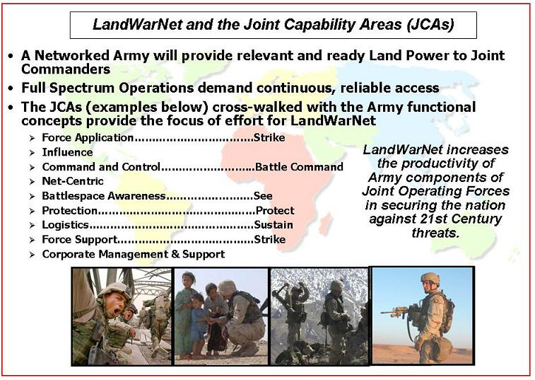
Figure 2-4. LandWarNet and the JCAs

c. While the joint operations concepts address the operational context, the joint functional concepts amplify a particular military function and apply broadly across the range of military operations. The LandWarNet CONOPS focuses on the following eight joint functional concepts:

- Battlespace Awareness
- Force Application
- Protection
- Focused Logistics
- Joint Command and Control
- Net-Centric Environment
- Training
- Force Management

2-4. The Plan (Joint Phasing – Six Phase Model)

a. Army operations within a joint campaign framework. The joint force will conduct a phased campaign to achieve assigned objectives. These phases often overlap and are described as part of a six phase model: shape, deter, seize the initiative, dominate, stabilize, and enable civil authority. Joint Publication (JP) 3-0 prescribes this six phase model replaces the previous four phase model. See figure 2-5 for the new six phase model.

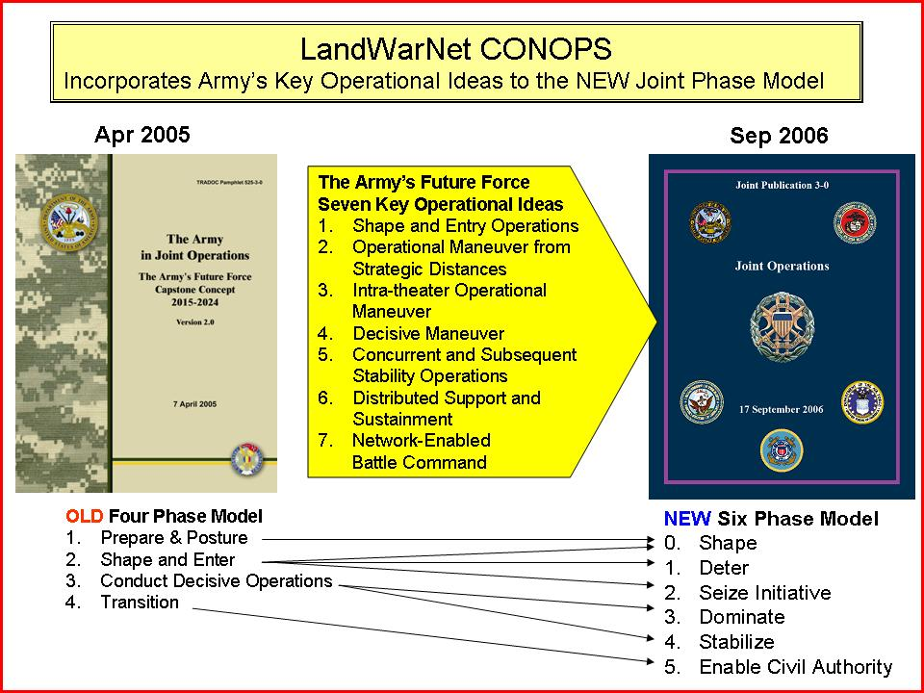
Figure 2-5. LandWarNet CONOPS and the New Six Phase Model

b. Phasing assists commanders and staffs to visualize the entire operation or campaign and to define requirements in terms of forces, resources, time, space, and purpose. Within the context of the joint campaign framework, the Army future Modular Force will apply adaptive combinations of seven key operational ideas: (1) shaping and entry operations, (2) operational maneuver from strategic distances, (3) intratheater operational maneuver, (4) decisive maneuver, (5) concurrent and subsequent stability operations, (6) distributed support and sustainment, and (7) network-enabled battle command. To facilitate a scenario based description of LandWarNet enabling the future Modular Force in 2015, this CONOPS will address the Army’s “seven key operational ideas” using the current six phase model outlined in JP 3-0.

c. The CONOPS scenario addresses each phase of the operation from a LandWarNet perspective with specific focus on the 101st Air Assault Division. The scenario covers their deployment through a normal phase model into an immature theater in 2015. The scenario assumes Future Combat System, Joint Tactical Radio System, and Warfighter Information Network–Tactical have been successful in spiraling out incremental capability to the force. This 2015 scenario also takes modular brigade combat teams and brings them up to a level of interoperability with the Future Combat System in the task organization.

d. The vignettes in this scenario are intended to show required capabilities when supporting the joint fight in 2015. The information is broken down by capability group across each phase of operation and it incorporates deployment anecdotes from lessons learned, all woven into this depiction. While not covering every requirement in each phase, the intent in this chapter is to identify some of the major operational requirements, by functional area, that LandWarNet must support to enable the land component forces as part of the joint operation. For material systems, this CONOPS assumes the scheduled fielding of future systems and modular spinouts.

e. Vignette operational setting. The following vignette (fig 2-6) used in this CONOPS is built upon a notional scenario.

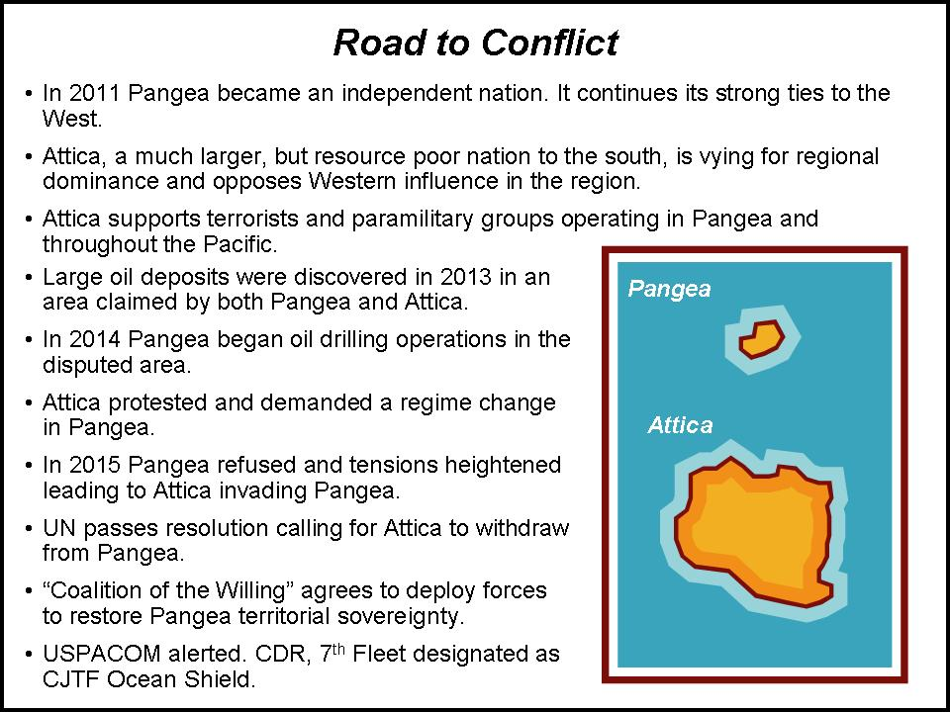
Figure 2-6. Operational Setting

f. Scenario task organization. The task organization for the Joint Force Land Component Commander involves two modular brigades from the 101st Air Assault Division, one modular brigade from the 4th Infantry Division, one Future Combat System brigade and one Marine expeditionary unit in 2015. Enhanced division capabilities include upgrades such as network-centric waveforms, a standard suite of network operations tools, and the system of systems common operating environment. Also, Warfighter Information Network–Tactical provides the new network-centric waveforms such as high band networking waveform and net-centric waveform for the modular and future force. Network operations improvements will be fielded from Warfighter Information Network–Tactical.

g. Phase 0 – Shape.

(1) Shape phase description:

(a) Joint and multinational operations inclusive of normal and routine military activities and various interagency activities are performed to dissuade or deter potential adversaries and to assure or solidify relationships with friends and allies. They are executed continuously with the intent to enhance international legitimacy and gain multinational cooperation in support of defined military and national strategic objectives

(b) Joint and multinational operations are designed to assure success by shaping perceptions to influencing the behavior of both adversaries and allies, developing allied and friendly military capabilities for self-defense and coalition operations, improving information exchange and intelligence sharing, and providing U.S. forces with peacetime and contingency access. Shape phase activities must adapt to a particular theater environment and may be executed in one theater in order to create effects and/or achieve objectives in another.

(c) Combatant commanders during this phase are focused on normal peacetime shaping operations. The expeditionary units (such as the 101st Air Assault Division for this scenario) have been placed in the U.S. Army Force Generation Model in the ready force pool. Critical tasks such as applied research, education, planning and training, rehearsal, configuration, modeling and simulation, etc. include the expeditionary units, forward support from the operational base and the generating forces.

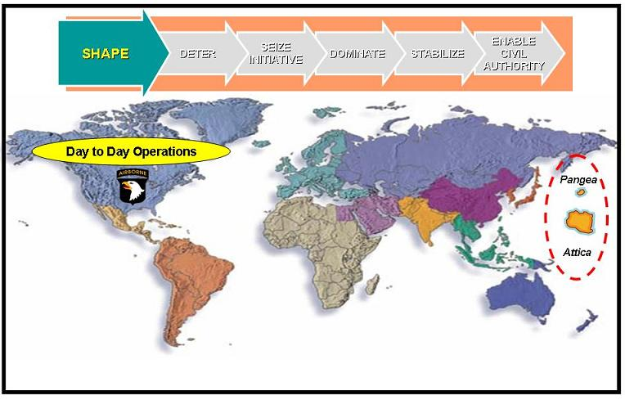
Figure 2-7. LandWarNet Capabilities in Phase 0

(d) Organizations supporting and enabling LandWarNet also manage and integrate the installation infrastructure to support tactical requirements. They establish the “LandWarNet processes” for day-to-day operations based on the work/train as you fight concept that includes tactical units, directors of information management, U.S. Army Service Component Commands (ASCC) and signal command theater, Theater Network Operations and Security Center, etc., and across functional areas such as the Joint Information Operations Warfare Command enabled by the global information grid.

(2) LandWarNet contribution to Phase 0:

(a) LandWarNet enables the Army to organize and train forces to conduct operations throughout the operational area as a means of deterrence. The network allows rehearsal of key combat and logistic actions to make the participants more familiar with the operations by visualizing the plan. LandWarNet, in conjunction with the other Service networks, allows the JFCs to establish and maintain access to operational areas where they are likely to operate. It allows the Army to execute a forward presence, basing, freedom of navigation, and cooperation with allied and/or coalition nations to enhance operational reach.

(b) LandWarNet maximizes space capabilities to help shape the operational environment by enabling strategic intelligence and communications. It also enables the Army to execute stability operations when required. For example, the JFC will quickly restore security and infrastructure or provide humanitarian relief in select portions of the operational area to dissuade further adversary actions or to help ensure access and future success.

(3) Major missions/required capabilities during Phase 0:

(a) Joint task forces (JTF) and components that are likely to be employed in theater operations should be exercised regularly during peacetime. Staffs should be identified and trained for planning and controlling joint and multinational operations. While rehearsals usually occur at the tactical level, headquarters at the operational level can rehearse key aspects of a plan using command post exercises, typically supported by computer-aided simulations.

(b) Space capabilities shape the operational environment in a variety of ways including providing intelligence, surveillance, and reconnaissance (ISR), and communications necessary for keeping commanders and leaders informed worldwide.

(4) Battle command functional requirements during Phase 0: LandWarNet enables the capability to C2 operations from a sanctuary location or a location within the joint operations area (JOA) and its area of active combat operations. LandWarNet gives the commander more C2 options, as well as provides a capability to command operations from the unit's home station or unit operations center while the unit's tactical command post is deploying forward to the area of responsibility to establish C2.

(5) Battlespace awareness (see) functional requirements during Phase 0:

(a) LandWarNet enables the capability for situational awareness (SA) and SU which allows operational units with near real time intelligence assessments of the situation as it develops. The commander's mission analysis leads to priority intelligence requirements (PIR) that include SA data based on persistent intelligence and change analysis.
(b) LandWarNet also enables the Theater Military Advisory and Assistance Group to coordinate, conduct, support, and sustain initial and steady-state security assistance, and building partnership capacity operations. The Theater Military Advisory and Assistance Group ensures the availability and readiness of all military service assets required to support these missions; like foreign area officers or specialists; individual ready reserve Soldier specialists; or military doctors, nurses, dentists, or veterinarians; or interagency or contract specialists like foreign service officers, economists, agricultural specialists, law enforcement specialists, telecommunications or information technology specialists, firefighters, major construction specialists, or business developers.
(6) Move functional requirements during Phase 0:

(a) Rapid deployment of ground formations strengthens the JFC’s ability to deter conflict, limit its escalation, or preclude early enemy success. Units capable of immediate employment upon arrival diminish an enemy’s maneuver options. As the theater matures, forces flow from locations outside the theater with some deploying directly into objective areas while others flow through more traditional staging bases or lodgments.

(b) Expect virtual/modeling/simulating capability at the home station for training and rehearsal using table of organization and equipment systems. Platforms will have connectivity through the installation infrastructure in order to plan and rehearse. Core curriculums will be available via deployable digital training campuses.

(7) Strike functional requirements during Phase 0:

(a) Conduct collaborative planning and employment across all levels of command. LandWarNet allows JFCs to conduct collaborative and dynamic strike planning and employment across all layers of command throughout the duration of the campaign. All commanders will understand the JFC’s intent, participate in planning, and routinely employ strike in support of the commander’s end state objectives.

(b) Commanders will have continuous and secure access to the COP, which will provide the means to obtain the data and information required to identify, target, and employ strike and to rapidly and accurately assess effects during each phase of the evolving campaign.

(8) Protect functional requirements during Phase 0: Space-based detectors and processors provide the ability to focus missile warning and battlespace characterization assets on the JOA with priority of effort to counter threat anti-access operations. This includes sister Service capabilities in order to leverage all aspects of intelligence. Other actions include establishing and sustaining control of the space domain to support shaping and early entry operations, and deny or disrupt the threat's ability to leverage its access to space-based systems, services, and products.

(9) Sustain functional requirements during Phase 0:

(a) Focus is pre-deployment support (facilitating the deployment process) which focuses on integrating logistics with joint and strategic partners in the national sustainment base. Part of the coordination includes establishing an end-to-end distribution pipeline to support deploying units.

(b) The U.S. Army Sustainment Command enabled by LandWarNet integrates logistics with joint and strategic partners in the national sustainment base. They coordinate and establish end-to-end distribution pipeline to the deployed theater sustainment command with U.S. Transportation Command (USTRANSCOM) and other organizations. They also assist U.S. Forces Command and U.S. Joint Forces Command rapid projection of forces to the ASCC and their return. They provide C2 and training readiness oversight of assigned forces, and they provide oversight of regeneration of redeploying equipment and reset. The ASCC also provides backup support for homeland defense and military support to civilian authorities.

(c) The deployed theater sustainment command is under the operational control of the JFC or ASCC and executes combatant commander priorities and policy; and develops theater support and distribution plans in accordance with the joint logistics command located with the geographic combatant command; establishes single Army logistics C2 and distribution in theater for JFC; coordinates and synchronizes theater opening with USTRANSCOM and leverages joint and strategic partners in the JOA. Medical considerations include the ability to upload automatically real time data on the health and status (such as readiness) of JTF assigned resources (units, systems availability, personnel, level of training etc). This data would then be used for planning modeling and simulations to assist collaborative planning from home stations before the assigned forces come together in the theater. Also, on board sensors with Joint Tactical Radio System fitted platforms will provide unit commanders and their staffs with immediate operational status of equipment. This data needs to constantly update data warehouses that Joint Operation Planning and Execution System and other planning applications can pull from for immediate status on unit readiness. This requirement exists in all phases so the unit commander at all levels can know accurately the status of friendly forces.

(10) Training/leader development requirements during Phase 0:

(a) While normal day-to-day training occurs in Phase 0, training requirements will quickly shift to pre-deployment and deployment operations as units await deployment notification. In the Pangea scenario, the 101st Air Assault Division prepares for plus ups of “warfighters” not associated with the tasked units. These may be sailors, marines, or airmen that are performing Army missions. Normally these augmentees will deploy and join the unit in theater. The Joint Knowledge Development and Distribution Capability would become available both at home station and in theater to provide common joint training capabilities for dispersed individuals and units. Enabling joint distributed training is a key requirement while units are still in their garrison locations.
(b) Tasks (for example education, planning, etc.) associated with LandWarNet during Phase 0 require identification and synchronization. For example, during Phase 0 there may be an immediate need for U.S. Department of State, Bureau of Public Affairs involvement. The Bureau of Public Affairs addresses nation building which means a communications/network interface requirement with them during operations. This collaboration also implies continuous strategic and tactical planning to advance the U.S. Department of State, Bureau of Public Affairs’ priority foreign policy goals.

(c) Home station operations during Phase 0 links LandWarNet capabilities to virtual teaming collaborative planning requirements to support Army force generation contingency expeditionary forces. This includes the threat situation as it develops, and the collaborative planning, mission rehearsals with those unit headquarters (division or corps) who will execute the contingency operation.

(11) Network infrastructure requirements during Phase 0:

(a) Managing the infrastructure and processes for LandWarNet is critical for executing battle command. LandWarNet requires an organization focused on supporting units at all echelons throughout the phases of an operation. This includes the pre-deployment activity phase in garrison to the seamless transition to warfighting operations phase, anywhere in the world. This organizational concept, currently called the Global Network Signal Command–Army (GNSC-A), provides the top level network management oversight in each of the operational phases.

(b) A product from this planning process is the signal annex derived from the U.S. Strategic Command overarching directive to the combatant commanders involved in the operation. The signal annex addresses the LandWarNet link to the U.S. Navy's FORCEnet and U.S. Air Forces’s C2 Constellation network and the C2 functions enabled by LandWarNet. The GNSC-A would also have the responsibility of syncing this annex with the overarching order produced by the Joint Operation Planning and Execution System process. This also includes synchronizing and optimizing the linkages to external networks for example: DOD, National Intelligence, U.S. Navy, U.S. Marine Corps, U.S. Air Force, etc.

(c) Supporting the GNSC-A type organizations are major operating organizations that are regionally based with a global network infrastructure called the network service centers (NSC). The NSC provides a regional capability for global connectivity and services. These regional NSCs provide the key interface between the expeditionary forces and the operational base, providing seamless common services as a unit transitions between different phases of the operation. The NSC is the “gateway” between the tactical and strategic portions of LandWarNet.

(d) In an operational environment, the GNSC-A type organizations manage all the NSCs by providing support to all current Army missions, not just the units in Phase 0. During Phase 0, the home station NSC continental U.S. must coordinate with the receiving NSC (U.S. Pacific Command) for transfer of data and services. They also advise the Army Deputy Chief of Staff for Operations and Army Chief Information Officer regarding the appropriation of NSC resources to support all U.S. Army missions/functions and execute the Army Deputy Chief of Staff for Operations' direction. The scope and role of the GNSC-A extends beyond pure communications services. It enhances and enables intelligence, space, information operations capabilities to name a few. The GNSC-A is empowered and resourced to execute their ASCC role to U.S. Strategic Command for command, control, communications and computers, ISR, information operations, space, etc.

(e) The NSC is not a single physical entity but a virtual grouping of the capabilities provided by the area processing center, regional hub, and the theater network operations and security center. The capabilities provided by the NSC should be transparent to the user base. From a user perspective, their primary concern is what they are receiving in Defense Information Systems Network services for example: secure internet protocol router, non-secure internet protocol router, video teleconferencing center, red switch, and special circuits.

(f) Gaining theater and/or NSC must adjust from its "steady state" to "receive" incoming forces. The NSC must be able to manage access to network services and capabilities based on established theater and global priorities with adequate C2 constructs and data transport in place.

(g) The GNSC-A type organizations rely heavily on space layer connectivity while also having on hand a continuity of operations plan to support deployed operations. The continuity of operations plan addresses more than one "connect" capability should the space segment be eliminated as a transport capability. Alternate means of communications include commercial undersea, cable, high frequency, Ku band tropospheric propogation or "over the horizon" communications link etc. The NSCs also require continuity of operations plan capabilities should their network services degrade or fail. This may include transferring operations from one NSC to another in order to provide required support to the task force.

(h) Network planning, modeling and simulation: the 101st Air Assault Division must be able to determine, based on a force package overlay on digital terrain data, where they are going to loose line of sight and therefore require beyond line of sight capabilities such as aerial and space layers. Infrastructure may also need to be considered if the virtual line of site indicates new networking waveforms fail to deliver in complex terrain (for example, mountains, jungles, urban canyons, etc.).

(i) LandWarNet provides network access to coalition partners based on policy and the combatant commander’s direction. In this phase, the preparation starts for possible new operations or relief. When planning support from coalition forces, it is important they are able to address the same available data. Data interoperability is a problem that will have to be addressed. Coalition collaboration during Phase 0 must account for sovereign nation network boundaries such as how we connect and pass information across boundaries.

(12) Summary of Phase 0:

(a) Joint and multinational operations during Phase 0, which includes normal and routine military activities and various interagency activities, are performed to dissuade or deter potential adversaries and to assure or solidify relationships with friends (Pangea in this scenario) and allies. Operations are executed continuously with the intent to enhance international legitimacy and gain multinational cooperation in support of defined military and national strategic objectives, and they are designed to assure success by shaping perceptions and influencing the behavior of both adversaries and allies, developing allied and friendly military capabilities for self-defense and coalition operations, improving information exchange and intelligence sharing, and providing U.S. forces with peacetime and contingency access.

(b) LandWarNet, as part of the GIG, enables the 101st Air Assault Division SA and SU as events unfold and the ability to rapidly coordinate and prepare for any contingency. As addressed in JP 3-0, the shape phase activities automatically adapt to a particular theater environment and poise to be executed in one theater in order to create effects and/or achieve objectives in another. LandWarNet enables the means for the future Modular Force to model and simulate courses of action (COA) and assess their potential effects during Phase 0. The planning that occurs in the shape phase surrounds the normal apportionment of forces to standing contingency plans and operations plans in the Joint Operation Planning and Execution System process. Units that enter the ready force pool are tentatively apportioned to numbered plans. Once this apportionment happens, organizations responsible for ensuring LandWarNet capabilities to the projected AO update, plan, prepare and execute for the next phase.

h. Phase 1 – Deter.

(1) Deter phase description:

(a) The intent of this phase is to deter undesirable adversary action by demonstrating the capabilities and resolve of the joint force. It differs from deterrence that occurs in the shape phase in that it is largely characterized by preparatory actions that specifically support or facilitate the execution of subsequent phases of the operation/campaign. Once the crisis is defined, these actions may include mobilization, tailoring of forces and other predeployment activities; initial overflight permission(s) and/or deployment into a theater; employment of ISR assets; and development of mission-tailored C2, intelligence, force protection, and logistic requirements to support the JFC’s CONOPS.

(b) Combatant commanders continue to engage multinational partners, thereby providing the basis for further crisis response. Liaison teams and coordination with other governmental agencies (OGA), intergovernmental organizations (IGO), and NGO assist in setting conditions for execution of subsequent phases of the campaign. Many actions in the deter phase build on activities from the previous phase and are conducted as part of security cooperation plans (SCPs) and activities. They can also be part of stand-alone operations.

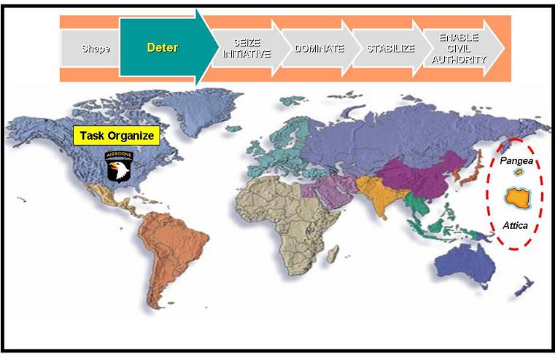
Figure 2-8. LandWarNet Capabilities in Phase 1

(2) LandWarNet contribution to Phase 1:

(a) At the advent of a crisis or other indication of potential military action, LandWarNet in conjunction with the other service networks allow the JFCs to package and examine available intelligence estimates. LandWarNet enables the tools, means, and process to focus the intelligence efforts, to refine the estimates of enemy capabilities, their dispositions, their intentions, and develop probable COA within the context of the current situation and identify additional intelligence requirements. It is the medium used to plan and coordinate both military and nonmilitary flexible deterrent options. LandWarNet enables SU and battle command capability to bring an issue to early resolution without armed conflict or to deter further aggression during a crisis.

(b) Joint force planning and operations conducted prior to commencement of hostilities also should establish a sound foundation for operations in the stabilize and enable civil authority phases. SA of the enemy allows the JFCs to isolate the enemy by denying them support and sanctuary and to separate the main enemy force from both its strategic leadership and its supporting infrastructure. LandWarNet also enables immediate access to essential information such as weather, terrain, sea conditions, and other factors of the physical environment, such as urban and littoral areas that can significantly affect operations and logistic support of the joint force and should be carefully assessed before sustained combat operations.

(c) LandWarNet enables reachback capability to home station and to the TRADOC branch schools and their associated centers of excellence, U.S. Forces Command and other ASCCs to the generating force. The Army’s Generating Force consists of Army organizations whose primary mission is to generate and sustain the operational force capabilities for employment by JFCs.

(3) Major missions/required capabilities during Phase 1:

(a) Shifting posture from day-to-day operations, disparate and geographically dispersed organizations supporting the scenario now have a requirement to virtually join. Sponsorship begins at the installation level and extends globally in all functional areas. Tasks during this phase include alerting operational base for support and validating network requirements.

(b) Organizations enabling LandWarNet establish collaborative capabilities (to support planning, training, modeling and simulation of COA, etc.) between the 101st Air Assault Division, its task force subordinate units, its higher headquarters, and U.S. Army Pacific Command. They also ensure required information services are pre-positioned in the global NSC to support the anticipated operation. Then they leverage the Theater Network Operations and Security Center to coordinate, synchronize and execute these requirements.

(4) Battle command functional requirements during Phase 1: During deployment, en route network capabilities include the ability to communicate with joint, coalition, and SOF elements. This capability allows the operational and tactical commanders the opportunity to reinforce and rehearse mission execution and disseminate commander’s intent.

(5) Battlespace awareness (See) functional requirements during Phase 1: The required capability during this Phase is the rapid assimilation of coalition intelligence/geospatial data in order to maintain SA. LandWarNet capabilities enable the rapid dissemination of this information throughout the JTF as forces will be in different stages of deployment.

(6) Move functional requirements during Phase 1: Organizations enabling LandWarNet determine the network capability for en route, such as voice, video, and data. The "en route intelligence and planning capability" requirement applies to those forces involved in forced entry operations. Other headquarters can deploy personnel in phases maintaining SU from a unit’s home station or the unit operations center while deploying early entry command posts and then deploy the main command post personnel into the AO.

(7) Strike functional requirements during Phase 1: Collaborative target development/fire support planning includes joint and coalition partners. LandWarNet enables data collection and assessment of targeting information, terrain, enemy order of battle, etc. LandWarNet also enables fire support, close air support, naval gunfire asset allocation via global force management, and data initialization required for network establishment and operation. It is critical that a robust line of sight/beyond line of sight network be planned and engineered including redundant capabilities to ensure seamless connectivity to the warfighter.

(8) Protect functional requirements during Phase 1: LandWarNet enables the flow of information to provide a common understanding of friendly and enemy force defensive and offensive capabilities, probabilities of enemy offensive measures; as well as the capability to link results of modeling and simulation of COA. LandWarNet also enables connectivity of space-based ISR assets focused on entry and initial operational areas to determine enemy positions, obstacles, and maneuverability across terrain.

(9) Sustain functional requirements during Phase 1:

(a) Sustainment assets and sustainment command structures will arrive in the JOA in advance of the JTF main force in order to prepare reception and staging areas for the force. These logistics units will require responsive and reliable network connectivity to support this early mission.

(b) Critical sustainment planning tasks rely on a single Army Log C2 and end-to-end distribution management control in theater for the JFC to execute support for deployment, employment, and sustainment operations; the means to conduct joint reception, staging, and onward movement to build and sustain combat power to set conditions for decisive operations; the means to expand inter and intratheater distribution operations, establish asset visibility; leverage joint and strategic partners in the JOA; and maximize the use of host nation support. Also, the TSC in the JOA along with their sustainment brigades require up to date ISR data in order to plan and forecast distribution requirements in support of the JTF Plan.

(c) Full visibility of all sustainment processes (maintenance, supply, transportation assets, in-transit visibility, etc. require network connectivity in order to maintain the sustainment portion of the COP. This data must be assessable by the JTF and TSC staffs.

(10) Training/leader development requirements during Phase 1: Future leaders must possess a "joint and expeditionary mindset," accept change as a routine condition, and acquire proficiency in the use of a wide range of new technologies, particularly within the information arena. Access to knowledge centers through LandWarNet support the professional education of leaders while deployed.

(11) Network infrastructure requirements during Phase 1:

(a) Coordination/synchronization occurs at theater level between ASCC G6s and the theater signal command. Gaining NSC should be operating at a steady state in Phase 0 to support units assigned/stationed/hosted in that theater. They also must establish procedures to support gaining units. Tactics, techniques, and procedures, policies and standards must already be established for receiving incoming units and procedures rehearsed for this mission. Gaining NSC, based on projected incoming network requirements should have pre-positioned contracts, satellite communication leases or other services ready to put in place. Network/unit/individual information/identity is pre-positioned as part of the content staging. Additionally, the GNSC-A and theater signal command must coordinate with the deploying forces to support required communications to support staging and deployment operations. Most deploying forces will have their organic communications capabilities packed and loaded for deployment and will require external support. The installation director of information management is another key player during this phase providing needed support to the deploying forces.

(b) The GNSC–A (conceptual organization) reports to the JTF-Global Network Operations for the cross service coordination and synchronization of services. This coordination drives what services will be provided by which NSC. The GNSC-A leverages/uses Joint standard collaboration tools for cross service coordination and follows the joint standards for collaborative tools (portals, IM Chat, voice, orders development). Coordination to provide connectivity to the Marine force in the scenario is required to enable the “virtual task organization” to plan, coordinate and rehearse for the operation.

(12) Summary of Phase 1:

(a) Many actions in the deter phase build on activities from the previous phase and are conducted as part of strategic capabilities plans and activities. For the 101st Air Assault Division, Phase 1 begins with the shift in focus to posture for military operations. At this time, a warning order and a request for forces is sent out to the Services to prepare for military operations. SOF, Air Force, Navy, and Marines begin to make adjustments to their global deployments to include repositioning their strategic assets. Simultaneously, the Army begins planning for a forced entry. Once the units are designated to support an operation, the organizations enabling LandWarNet turn the existing network plans and warning order to OPORDs detailing how to provide connectivity to the JTF.

(b) The organizations enabling LandWarNet provide the expertise in extending the operational base network to the expeditionary force. Expertise includes continuous training and education of leaders and Soldiers from the classroom to the battlefield by integrating training between multiple enabling organizations in order to provide network enabled battle command in support of leader centric operations. The organizations enabling LandWarNet develop virtual teams that focus on any networking issues required to deploy the unit and keep them networked through all phases of the operation. This phase ends with the units loading strategic lift assets, postured for global deployment and follow on operations.

i. Phase 2 – Seize Initiative.

(1) Seize initiative phase description (per JP 3-0): JFCs seek to seize the initiative in combat and noncombat situations through the application of appropriate joint force capabilities. In combat operations this involves executing offensive operations at the earliest possible time, forcing the enemy to offensive culmination and setting the conditions for decisive operations. Rapid application of joint combat power may be required to delay, impede, or halt the enemy’s initial aggression and to deny their initial objectives. If an enemy has achieved its initial objectives, the early and rapid application of offensive combat power can dislodge enemy forces from their position, creating conditions for the exploitation, pursuit, and ultimate destruction of both those forces and their will to fight during phase 3. During this phase, operations to gain access to theater infrastructure and to expand friendly freedom of action continue while the JFC seeks to degrade enemy capabilities with the intent of resolving the crisis at the earliest opportunity. In all operations, the JFC establishes conditions for stability by providing immediate assistance to relieve conditions that precipitated the crisis.

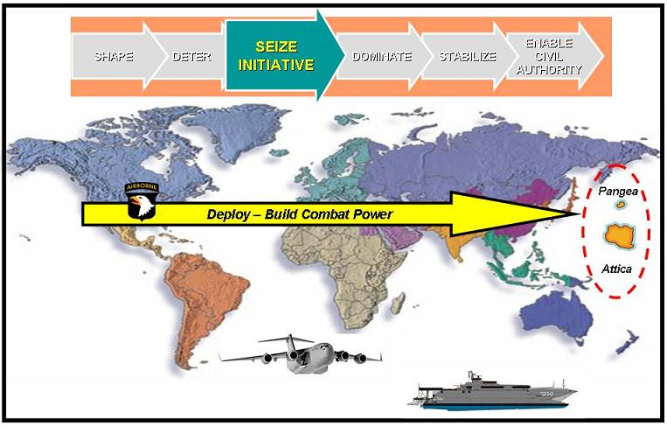
Figure 2-9. LandWarNet Capabilities in Phase 2

(2) LandWarNet contribution to Phase 2:

(a) As operations commence, LandWarNet, in conjunction with the other service networks, enables the JFC needs to coordinate and exploit friendly advantages and capabilities to shock, demoralize, and disrupt the enemy immediately. LandWarNet allows the JFC to sequence, enable, and protect the opposed or unopposed deployment of forces to achieve early decisive advantage. LandWarNet shortens the decision cycle for the JFC to observe, orient, decide, and act. During forcible entry operations (amphibious, airborne, and air assault operation), the JFC may be required to seize and hold a military lodgment in the face of armed opposition for the continuous landing of forces.

(b) LandWarNet enables SU, collaborative tools, and battle command capability to coordinate this event. As part of achieving decisive advantages early, joint force operations may be directed immediately against enemy centers of gravity using conventional and SOF and capabilities. JFCs also seek superiority early in air, land, maritime, and space domains and the information environment (enabled by LandWarNet and the other service networks) to prepare the operational area to accomplish the mission as rapidly as possible.

(c) Ground commanders also use LandWarNet to prepare for land operations to neutralize or eliminate potential phase 4 adversaries. If required, certain capabilities within LandWarNet may also be extended to support the national and local host nation authorities. Key infrastructure including communication buildings, broadcasting stations, and power stations may be seized or otherwise protected. Meanwhile, LandWarNet continues to store the intelligence collection on the status of enemy infrastructure, government organizations, and humanitarian needs. The JFCs uses the analysis tools in LandWarNet to constantly assess unit status in order to conserve the fighting potential of the joint/multinational force at the onset of combat operations.

(3) Major missions/required capabilities during Phase 2:

(a) During Phase 2, the JFC seeks to seize the initiative in combat and noncombat situations through the application of appropriate joint force capabilities. In combat operations this involves executing offensive operations at the earliest possible time, forcing the enemy to offensive culmination and setting the conditions for decisive operations. LandWarNet enables the 101st Air Assault Division access to joint force capabilities enabling a greater degree of battle command capability at all echelons. The scenario requires rapid application of joint combat power is required to delay, impede, or halt Attica’s initial aggression and to deny their achievement of follow-on objectives. Since Attica achieved its initial objective, the Pangean oil fields, the JFC directs the early and rapid application of offensive combat power to dislodge them from this location, creating conditions for the exploitation, pursuit, and the ultimate destruction of these enemy forces.

(b) The organizations enabling LandWarNet continue to assess and reassess the demands and conditions placed on the network and initiate appropriate action to support the mission requirements. Major emphasis during this phase is supporting deployment operations, en route mission planning, and initial entry operations.

(4) Battle command functional requirements during Phase 2:

(a) This is the phase where en route planning and mission rehearsal capability for units executing forced entry operations become critical. Executing units must have access to real time intelligence tailored to the objective area. Airborne C2 aircraft may also be available for brigade or higher level headquarters directly involved in commanding and controlling the forced entry operation.

(b) LandWarNet enables the ability to tailor information to provide relevant and responsive data that fits into the available bandwidth. It builds and maintains a running estimate focused on commander’s critical information requirements, PIR/information requirements, and other relevant data that feeds the COP.

(5) Battlespace awareness (See) functional requirements during Phase 2:

(a) LandWarNet enables comprehensive SA of terrestrial, space, and aerial network systems for the purpose of defensive and offensive operations. It enables dynamic updates from higher to an established knowledge grid; effects of joint fires on AOR; persistent intelligence on an established sensor grid; continuing intelligence preparation of the battlefield to allow for predictive intelligence; and retasking/redirection of the collection effort to fill identified gaps. It also enables target identification to inform decisions and minimize the potential for fratricide, as well as critical situation updates after arrival.

(b) Coalition interoperability and dissemination of SA data on both sides such as coalition and joint for C2/battlespace deconfliction and to avoid fratricide is a critical planning factor. Establishing the means to communicate and seamlessly share information without violating security restrictions is a high priority early in this phase.

(6) Move functional requirements during Phase 2:

(a) Units arriving in theater must establish connectivity. LandWarNet enables the means by plugging into an existing network when arriving into the theater of operation. This becomes particularly important in a forced entry operation with a self-developing, self-expanding and self-healing network capability with identities intact. Units must be able to “self-synchronize” as they reestablish network connectivity and receive updated information on the friendly and enemy situations.

(b) LandWarNet enables the user’s attributes and condition (fuel, ammunition, personnel, weapons, or critical systems, etc.). All of these attributes are transferred with the sub-unit when it moves from one headquarters to another.

(7) Strike functional requirements during Phase 2:

(a) The JFC may request that appropriate commands or agencies reposition selected space-based information systems and knowledge constellations to better support future operations, or launch additional microsatellites or other space capabilities to provide additional support.

(b) Future JFCs may have access to global strike capabilities to include hypersonic platforms capable of delivering a “strike virtually anywhere on the face of the Earth within 60 minutes.” Global network enabled capabilities will permit global strike aircraft while en route to access near real time information from numerous data sensors, including geospatial assets at the tactical level that can detect any target relocation, as well as identify and locate surface-to-air missiles, that may have been repositioned near the target.

(8) Protect functional requirements during Phase 2: Entry operations must include modular protection capabilities that will rapidly establish a joint fires umbrella and joint interdependent protection networks. The goal is to provide local, wide area, or theater-wide air and maritime superiority.

(9) Sustain functional requirements during Phase 2:

(a) Sustainment operations begin in the AO, establishing a single Army C2 and distribution management process and the operation of ports/distribution hubs in support of JFC theater support plans. It enables the means to support joint, multinational and coalition forces in deployment, employment and sustainment. It also enables a sustainment brigade (tasked organized) to provide reinforcing combat service support to all forces in the AOR.

(b) LandWarNet enables the ability to identify friendly assets, their readiness status for equipment and personnel, and identify their location. Further, it identifies logistics assets that are available or en route to support the JTF. LandWarNet enables accurate tracking and inventory management. Through NETOPS, it enables a logistic COP to assist in the prioritization of assets.

(10) Training/Leader development requirements during Phase 2: Networking institutional sites with each other and with Army Combat Training Centers will more robustly link academic, institutional, and operational environments. This enables additional an enhanced mission rehearsal capability for units to “train as they fight” as they prepare for deployment.

(11) Network infrastructure requirements during Phase 2:

(a) Modular Division/Corps, brigade combat teams, Stryker, and future Modular Force brigades bring their own signal companies; functional brigades rely on expeditionary signal battalions and NSC/fixed regional hub node support. Next, those deploying when required for enduring campaigns are adjusting/planning LandWarNet requirements. Relief in place and transfer of authorities are already being planned; LandWarNet and NETOPS mission essential task list also account for the transition.

(b) Synchronized/integrated/echeloned/joint NETOPS and network services are critical to rapid migration. The network must accommodate dynamic task organization of headquarters and subordinate units such that when a subordinate is chopped from one headquarters to another, the subordinate unit's status and attributes are automatically transferred from the losing headquarters to the gaining headquarters.

(c) Concerning joint interoperability, LandWarNet must be able to automatically route and retransmit across multiple waveforms and transmission paths to ensure connectivity through the space, aerial, and terrestrial layers of the network. Backwards compatibility with legacy and coalition systems is also a consideration that must be planned for throughout the operation.

(12) Summary of Phase 2: There are three stages in this phase:

(a) Stage 1 – this stage starts as units begin their move to power projection platforms. C2 and coordination of the deploying units must be supported by outside organizations as much as possible as organic signal assets are being prepared for deployment. Providing connectivity at staging locations, air and sea ports of embarkation must be well thought out in advance and should be part of standard operating procedures to minimize disruption during the pre-deployment part of this phase.

(b) Stage 2 – Strategic movement and en route mission rehearsal and planning, the 101st Air Assault Division migrate their common services: critical user email accounts, network entry authentication and role-based identity to the forward fight. The secure en route communications capability enables common SA, messaging, voice, and collaborative planning/rehearsal capability to enable updated understanding and mission adjustment for key leaders en route. Key leaders (commanders and staff) in the 101st Air Assault Division do not notice the change as their services are migrated from their home station networks to their en route networks, because they have common functional interfaces and equipment. This en route capability is critical to enabling conventional forces to fight upon arrival.

(c) Stage 3 – Initial entry, seizing the lodgment: upon initial entry, units begin moving into forward tactical assembly areas. In these tactical assembly areas, command posts connect to the global network. They also use secure wireless networks to rapidly auto-discover and authenticate to create dynamic, mobile ad hoc networks, which enable staffs to continue collaboration while deploying. The staff receives continuously updated SA via the distributed information environment. This allows accelerated staff coordination and decisionmaking. The 101st Air Assault Division leaders and Soldiers enter the common network via communications devices that are capable of forward staging information and creating ad hoc mobile networks. The minimum essential information these forward Soldiers require is position locations, preformatted situation reports, and ISR information. This forward extension of the network also extends basic connectivity to other battlefield sensors. Whether provided by a Soldier or an unmanned sensor, the intelligence must be gathered and shared to enrich the COP. Each Soldier serves as a sensor contributing to the overall SA feed that, in turn, enriches the COP. This shared information and understanding help reduce potential fratricide events as all joint elements are able to quickly identify friendly positions down to the individual Soldier. Units extend their lodgment and the network configures dynamically to extend services and access to the institutional base. The network shares SA of strategic guidance and effects-based targeting plan considering follow-on reconstruction and host nation rebuilding efforts as forces move forward to execute operations. As combat units move forward they leverage supporting or reinforcing relationships quickly through the network by assigning potential branches and sequels in their operational environment to other headquarters as they focus on the primary task at hand.

j. Phase 3 – Dominate.

(1) Dominate phase description:

(a) The dominate phase focuses on breaking the enemy’s will for organized resistance or, in noncombat situations, control of the operational environment. Success in this phase depends upon overmatching joint force capability at the critical time and place.

(b) The dominate phase includes full employment of joint force capabilities and continues the appropriate sequencing of forces into the operational area as quickly as possible. When a campaign is focused on conventional enemy forces, the dominate phase normally concludes with decisive operations that drive an enemy to culmination and achieve the JFC’s operational objectives.

(c) Against unconventional enemies, decisive operations are characterized by dominating and controlling the operational environment through a combination of conventional and unconventional information and stability operations. Stability operations are conducted as needed to ensure a smooth transition to the next phase and relieve suffering.

(d) In noncombat situations, the joint force’s activities seek to control the situation or operational environment. Dominate phase activities may establish the conditions for an early favorable conclusion of operations or set the conditions for transition to the next phase of the campaign.

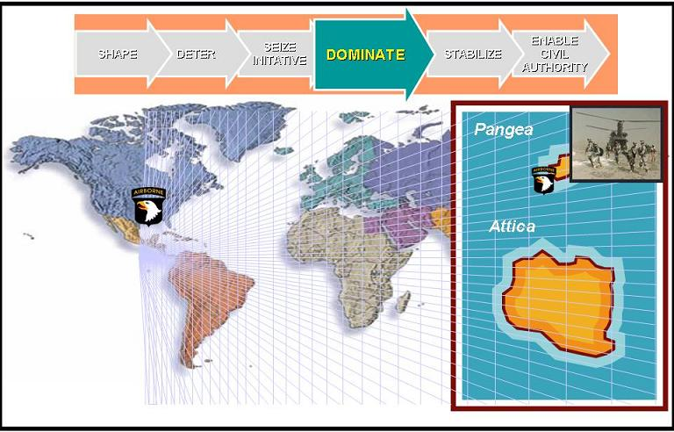
Figure 2-10. LandWarNet Capabilities in Phase 3

(2) LandWarNet contribution to Phase 3:

(a) During sustained combat operations, JFCs simultaneously employ conventional and SOF capabilities throughout the breadth and depth of the operational area in linear and nonlinear orientations. From a ground operations perspective, LandWarNet enables networked air and ground-based maneuver, maneuver support, and sustainment systems that include manned and unmanned platforms. LandWarNet also enables improved ISR, battle command, real time sensor shooter linkages and increased synergy between echelons and within small units.

(b) LandWarNet, in conjunction with the other service networks, enables the execution of direct and indirect attacks of enemy centers of gravity in a manner designed to achieve the required military strategic and operational objectives, while limiting the potential undesired effects on operations in follow-on phases. LandWarNet enables the means to enable the dynamic application of myriad effects to achieve the commander’s tactical and operational objectives.

(3) Major missions/required capabilities during Phase 3:

(a) During this high tempo phase of the operation, the allocation of LandWarNet assets is continually monitored and adjusted to ensure adequate network transport and other critical network services are provided in accordance with the commanders’ priorities.

(b) On-the-move C2 capabilities are most critical during this phase, allowing commanders and leaders to position themselves at decisive points on the battlefield while maintaining SA and contact with both subordinate and senior commanders. On-the-move elements are able to maintain LandWarNet access to meet mission requirements.

(c) LandWarNet capabilities enable the continuous connection of sensors, shooters, and ground force commanders to maximize the effect of joint and Army fires and maneuver.

(4) Battle command functional requirements during Phase 3:
LandWarNet supports requests for information which require simultaneous data feeds from multiple databases owned by various agencies or staff elements (sustainment, intelligence, etc.). This may require feeding or refreshing persistent displays of relevant information, and these displays may be dynamic, changing as the commander's information requirements change.

(5) Battlespace awareness (See) functional requirements during Phase 3:

(a) LandWarNet enables net-centric target identification and Blue Force Tracking (BFT) services. It pulls target identification sensor information to support engagement decisions. It publishes BFT information to data servers for pushing to requesting users based upon assigned roles (identity). It enables real time targeting and strike information and shares it across mobile, ad hoc networks. It provides predictive battlespace awareness that is enabled through persistent sensor coverage, collection, fusion, and Joint intelligence preparation of the battlefield net-centric services that constantly update weather, terrain, and targeting on information.

(b) Sharing position, location, identification information at the same classification level when displaying a COP with the other services and coalition partners.

(6) Move functional requirements during Phase 3: The force projection system (network-enabled) must simultaneously meet requirements for strategic deployment, operational employment of forces, and continuous sustainment throughout the JOA in support of decisive operations.

(7) Strike functional requirements during Phase 3:

(a) Lethality for mounted/dismounted operations – LandWarNet employs joint networked fires. It enables real time access down to Soldier level for available weapons/munitions, target information, engagement status, and assessment data. It enables digital sensor links to enable time critical target engagements. It also enables digital air-ground links from the forward tactical elements/dismounted soldiers to joint fires assets.

(b) The self-synchronizing nature of the network enables the forming of opportunistic alliances to engage the target. In the event network ability is degraded, the priority users retain support based on permissions and policies established by the JFC. The network flexes by realigning and/or reprioritizing existing capabilities or dispatching additional assets to re-extend network connectivity/services to priority units.

(8) Protect functional requirements during Phase 3: Protecting the network from hackers - in this scenario, the Atticans have a long history of hacking into commercial, government, and military networks and creating havoc. In addition to using viruses and worms, some of their common network attacks include:

- Eavesdropping
- Data modification
- Password-based attacks
- Identity spoofing
- Denial of service attacks
- Man in the middle attacks (such as an attack in which an attacker is able to read, insert and modify at will, messages between two parties without either party knowing that the link between them has been compromised)
- Compromise key attack (such as an attacker guesses, cracks or obtains the key used for encryption/decryption and then captures that data)
- Sniffer attack (such as an application or device that can read, monitor, and capture network data exchanges and read network packets) and
- Application layer attack (which occurs when the attacker takes advantage of a fault in a server’s operating system or one or more of the server’s applications).

(9) Sustain functional requirements during Phase 3:

(a) LandWarNet enables C2 and two-way end-to-end distribution in support of current operations to maintain combat power. It establishes priorities to support plans for current and future operations including unit rotations and equipment retrogrades. It maintains established logistic networks and in-transit visibility – total asset visibility to enable flexible and effective sustainment and synchronizes support for follow-on missions (branches and sequels) to sustain combat operations.

(b) Sustainment units at all levels track supply requests and status, maintenance readiness, personnel health status, financial transactions, etc and provide this data as part of the logistics portion of the COP. This enables SA and drives logistic C2 decisions and management processes. Sensor data will constantly provide information from personnel and equipment platforms throughout all phases, and will quickly feed a master data warehouse so other systems pulling from these data warehouses will have accurate information. All this will drive sustainment planning and execution during operations.

(c) Elements require collaboration with JIM organizations as the Army will rely on outside partners to perform different aspects of the support mission for the warfighter. For example, the Air Force may be needed to transport supplies to a specific AOR with intratheater transport. The Navy may be providing area medical support, host nation support may be providing water, and multinational partners may be providing fuel. All these elements must be tied into the transactional and C2 of logistics networks in order to provide timely support in connection with the JFC’s intent. Sustainment planners plan COA in support of the maneuver plan. The logisticians decision cycle, enabled by data mining tools and decision support tools must operate in concert with the maneuver commanders requirements.

(10) Training/leader development requirements during Phase 3: Expansion of capabilities for mission planning/rehearsal and automated after action reviews that reduce the burden of planning, execution, and assessment in training events.

(11) Network infrastructure requirements during Phase 3:

(a) During this phase, the organizations enabling LandWarNet monitor the status (health and load) of network links and nodes. They then provide the means to prioritize traffic flow based upon maneuver commander's priorities. Based on prior planning, LandWarNet organizations store forward high priority information – cache as a form of information assurance. The organizations enabling LandWarNet also provide the means for each echelon (from national to lower tactical) to be informed of the next echelon's priorities to maximize the use of the network. Network management ensures quality of service and response to changes in service priority based on the JFC’s needs.

(b) Throughout this phase, there are four key LandWarNet capabilities. Monitor the status (health and load) of network links and nodes; provide the organization enabling LandWarNet the means to prioritize traffic flow based upon maneuver commander's priorities; store forward high priority information – cache; and provide the means for each echelon (from national to lower tactical) to be informed of the next echelon's priorities in order to allow that level to maximize the use of the network.

(c) Virtual collaboration developed to meet joint warfighting needs must be expeditionary in character. The collaboration information environment that supports any JTF must be capable of rapid deployment and installation, operation and maintenance in a non-garrison, bandwidth limited, deployed environment. The capacity to support virtual collaboration must be scalable taking into consideration delivery to the lowest bandwidth-disadvantaged user.

(d) Providing outside access, for example, the Pangean Army, to LandWarNet for operational reasons remains a policy and technical issue. In order to enable interoperability and maintain information assurance within LandWarNet will require a unique interface specific to this operation in order to make this collaboration effective.

(12) Summary of Phase 3:

(a) The synergy achieved by integrating and synchronizing interdiction and maneuver through LandWarNet assists commanders in optimizing leverage at the operational level. Accordingly, commanders designate the target priority, effects, and timing of interdiction operations within their AO through LandWarNet and to other service networks respectively. Further, in coordination with the land or maritime commander, a component commander designated as the supported commander for theater/JOA-wide interdiction has the latitude, as well as the network tools to plan and execute JFC prioritized missions within a land or maritime AO.

(b) Courses of action and prediction models are simulated and analyzed through LandWarNet. If the operations have an adverse impact within a land or maritime AO, the commander can either adjust the plan or resolve the issue with the appropriate component commander or consult with the JFC for resolution. LandWarNet enables the tools and means to accelerate the decision process.

k. Phase 4 – Stabilize.

(1) Stabilize phase description:

(a) The stabilize phase is required when there is limited or no functioning, legitimate civil governing entity present. The joint force may be required to perform limited local governance, integrating the efforts of other supporting/contributing multinational, NGO, OGA, or IGO participants until legitimate local entities are functioning. This includes providing or assisting in the provision of basic services to the population. The stabilize phase is typically characterized by a change from sustained combat operations to stability operations.

(b) Stability operations are necessary to ensure that the threat (military and/or political) is reduced to a manageable level that can be controlled by the potential civil authority or, in noncombat situations, to ensure that the situation leading to the original crisis does not reoccur or its effects are mitigated. Redeployment operations may begin during this phase and should be identified as early as possible. Throughout this segment, the JFC continuously assesses the impact of current operations on the ability to transfer overall regional authority to a legitimate civil entity, which marks the end of the phase.

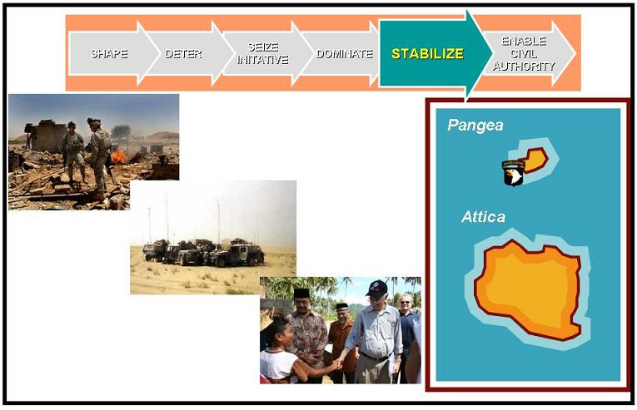
Figure 2-11. LandWarNet Capabilities in Phase 4

(2) LandWarNet contribution to Phase 4:

(a) Operations in the stabilize phase ensure the national strategic end state continues to be pursued at the conclusion of sustained combat operations. At this point, the priority of effort for LandWarNet begins to shift from supporting numerous mobile tactical networks to expanding fixed station network operations in preparation of new mission requirements. Several lines of operations may be initiated immediately for example providing humanitarian relief, establishing security, etc. LandWarNet enables the flexibility and means to address the new lines of operations.

(b) Consequently, the JFC may need to realign forces and capabilities or adjust force structure to begin stability operations in some portions of the operational area, even while sustained combat operations still are ongoing in other areas. LandWarNet enables the JFC the capability to execute battle command, monitor and direct intelligence operations, monitor/direct maneuver operations, monitor/direct effects, and monitor/direct current operations. Of particular importance will be LandWarNet-enabled civil-military operations initially conducted to secure and safeguard the populace, reestablish civil law and order, protect or rebuild key infrastructure, and restore public services.

(3) Major missions/required capabilities during Phase 4:

(a) Stability operations are necessary to ensure that the threat (military and/or political) is reduced to a manageable level that can be controlled by the potential civil authority or, in noncombat situations, to ensure that the situation leading to the original crisis does not reoccur or its effects are mitigated.

(b) During Phase 4, the 101st Air Assault Division establishes semi-fixed command posts and sustainment facilities while continuing to conduct limited mobile combat operations. Commanders and staff have dual focus during this phase, expanding their mission sets to include NGO and OGA as they conduct transition operations.

(c) Operational focus during this phase is shifting from the high intensity, mobile, and extended battlefield of major combat to more static and fixed operations. Network planning must account for this transition. Additionally, NGO and coalition military and governmental information needs will be more apparent. Conditioning the network to handle this transition is critical.

(d) As the 101st Air Assault Division assumes its new role, the staff changes the information requirements. It designates new information sources and collaborative partners within communities representing the diplomatic, information, military, economic elements of national power. Organizations that enable LandWarNet translate the new requirements and ensure network services mirror the 101st Air Assault Division’s new role. Many of these services have been pre-provisioned based on mission planning. As a result, the network opens up to a new set of players who must collaborate, incorporating diplomatic efforts, host nation services and relief operations.

(e) During this phase it may be necessary to create a network within a network in order to extend the network to civilian organizations, NGO, OGA, and the universe of developing local/regional authorities, while protecting the JTF's network and essential elements of friendly information from compromise. Bandwidth requirements may increase considerably, and the network may require extensive management. We cannot rely on the Pangean communications infrastructure to support our effort.

(4) Battle command functional requirements during Phase 4: Units receive access to intelligence tailored to the needs of the new mission from both local and national sources. With this intelligence, the unit prepares for multi-echelon, multi-mission requirements and conducts opportunistic task organization and collaboration with host nation and coalition forces.

(5) Battlespace awareness (See) functional requirements during Phase 4: The information requirements will continue to grow but in different areas as civil-military operations increase. This will require the ability to rapidly disseminate this information throughout the network to enable SA for a growing community of interest in this area.

(6) Move functional requirements during Phase 4: Better integration of force projection planning and execution to support campaign timelines and improved capability to synchronize strategic and intra-theater lift to deploy forces to forward objective areas. As tactical network assets begin to transition to more fixed base communications, joint connectivity must be assured to enable planning for redeployment operations and movement of commodities throughout the AO.
(7) Strike functional requirements during Phase 4: General operations may continue after campaign objectives have been met, even though the enemy may have greatly diminished capabilities to execute combat operations. JFCs must expect to be routinely conducting simultaneous stability and combat operations as the complexion of the operational environment changes.

(8) Protect functional requirements during Phase 4: Based on the threat, the force must protect the civilian populations and resources while maintaining adequate levels of force protection and conducting offensive actions to destroy the enemy. The network must be flexible to support both.

(9) Sustain functional requirements during Phase 4: Units establish logistics-focused network points of presence that enable new direction for Army contracting, as well as host nation support.

(10) Network infrastructure requirements during Phase 4:

(a) Army network capabilities continue to support integrated operational forces operating against insurgent cells. LandWarNet enables the sharing of intelligence, including live, full-motion video, to counter insurgent activities.

(b) Static command posts and support organizations begin the transition to commercial terrestrial communications capabilities to reduce load on tactical and space platforms.

(c) LandWarNet capabilities extend network support to interagency elements and NGO.

(11) Summary of Phase 4:

(a) LandWarNet enables U.S. military forces to conduct the activities necessary to accomplish civil-military operations tasks when indigenous civil, U.S. Government, multinational, or international capacity does not exist or is incapable of assuming responsibility. Once legitimate civil authority is prepared to conduct such tasks, U.S. military forces may support such activities as required/necessary.

(b) Phase 4 concludes with a stable environment, and units begin the process of transitioning civil functions to the host nation. Tactical communications assets start to transition services to more fixed facilities as forces begin to prepare for redeployment. Contractor support for functions such as system administration, information assurance and network management may be required as tactical signal forces transition from major combat operations to redeployment.

l. Phase 5 - Enable Civil Authority.

(1) Enable civil authority phase description:

(a) The enable civil authority phase is predominantly characterized by joint force support to legitimate civil governance. This support will be provided to the civil authority with its agreement at some level, and in some cases especially for operations within the U.S., under its direction. The goal is for the joint force to enable the viability of the civil authority and its provision of essential services to the largest number of people in the region. This includes coordination of joint force actions with supporting multinational, NGO, OGA, and IGO participants and influencing the attitude of the population favorably regarding the U.S. and local civil authority’s objectives.

(b) The joint force will be in a supporting role to the legitimate civil authority in the region throughout the enable civil authority phase. Redeployment operations, particularly for combat units, will often begin during this phase and should be identified as early as possible. The military end state is achieved during this phase, signaling the end of the joint operation. The joint operation is concluded when redeployment operations are complete. Combatant command involvement with other nations and OGAs, beyond the termination of the joint operation, may be required to achieve the national strategic end state.

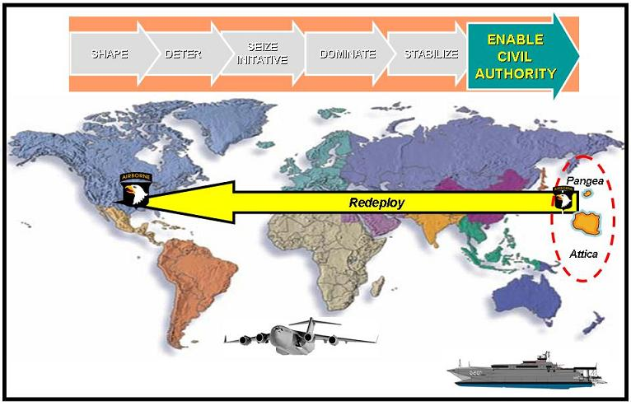
Figure 2-12. LandWarNet Capabilities in Phase 5

(2) LandWarNet contribution to Phase 5:

(a) The joint operation normally is terminated when the stated military strategic and/or operational objectives have been met and redeployment of the joint force is accomplished. LandWarNet continues to play an active role in routine day-to-day business for example email, video teleconference, data storage and sharing, etc. while ground forces continue to scale down in the transition process.
(b) Portions of the information technology infrastructure enabling LandWarNet at the host nation level may be left behind so as not to disrupt the legitimate civil authority in their C2 capability while reducing outside military assistance. JFCs may be required to transfer responsibility of operations to another authority (for example United Nations observers, multinational peacekeeping force, or North Atlantic Treaty Organization) as part of the termination criteria.

(3) Major missions/required capabilities during Phase 5: Phase 5 focuses on the joint force providing support to legitimate civil governance. In this scenario, the 101st Air Assault Division continues work reestablishing critical infrastructure, transitions to commercial communication and information technology systems, and prepares to redeploy. Leaders and Soldiers continue to conduct operations that support transition to civil authority, employing tactical military communications capabilities.

(4) Battle command functional requirements during Phase 5: Battle command: organizations enabling LandWarNet consider transnational threats to civil authority, the populace, and force protection. The network now has to accommodate additional requirements for organizations external to traditional military C2 models (U.S. Department of State; host nation) while maintaining capability sustained from Phases 0-4. LandWarNet now needs to facilitate collaboration between the organization leaving and any follow-on forces.

(5) Battlespace awareness (See) functional requirements during Phase 5:

(a) The future Modular Force must be capable of acquiring and transforming information that goes well beyond standard military expertise, and this agility must reside in all operating units in order to succeed.

(b) Environmentally, commanders must be capable of acquiring and transforming information relating to civil governance, economic activities and structures, physical infrastructure, and sociological aspects. While some of these can be met through reach to experts, some level of organic capability must also be present, and at lower tactical levels than in the past.

(6) Move functional requirements during Phase 5: Maneuver Soldier integration/communication the LandWarNet capability requirements will not change. They will always require the need to move and communicate, in all types of terrain and environments. The need for secure and non-secure communication with U.S. and coalition forces will also still be required.

(7) Strike functional requirements during Phase 5: The network continues to support sensor to shooter capability; however, this phase is predominantly characterized by joint force support to legitimate civil governance. Information initiatives continue to be of vital importance during this phase with the intent of building confidence and credibility of local government entities.

(8) Protect functional requirements during Phase 5: The future Modular Force may have to provide protection to legitimate governments to allow for their continued existence or to establish new regimes. This will include critical communication and information technology infrastructure. This will continue until the friendly government can conduct its own security.

(9) Sustain functional requirements during Phase 5: LandWarNet enables SA of the regeneration and resetting of redeploying equipment as well as coordination with USTRANSCOM to ensure necessary sealift and airlift is available.

(10) Network infrastructure requirements during Phase 5:

(a) This phase anticipates transition from DOD-lead to U.S. Department of State lead, and establishment of commercial and other agency networks. Installation and operation of tactical commercial networks for the transition may very well be a task given to the Army. The exit strategy may include transitioning the stay behind forces to a fixed communications infrastructure to enable the redeployment of tactical communications units. LandWarNet is tailorable/scalable to support the residual force and it must begin transition to commercial communications in order to release tactical signal resources.

(b) The joint force works with appropriate agencies to enable the civil authority and its provision of essential services to the people of Pangea. This includes coordination of joint force actions with supporting multinational, NGO, OGA, and IGO participants and influencing the attitude of the population favorably regarding the U.S. and local civil authority’s objectives. LandWarNet continues to serve as the network medium for the Army but is significantly down-sized in Pangea as the 101st Air Assault Division prepares to redeploy and the commercial information technology infrastructure under the civil authority continues to expand. The military end state is achieved during this phase, signaling the end of the joint operation.

(11) Summary of Phase 5: The impact to LandWarNet during the transfer in responsibility to civil authorities varies proportionally with Army’s new role, mission and presence during this transition. Reducing the size of the Army’s presence as well as the size of the Army network within the host nation will probably occur after an extended period of conducting joint or multinational stability operations as mentioned above. During this transition, the planning and collaborative tools found in LandWarNet facilitates the redeployment process concerning the use of these available forces and supplies to meet new missions. Upon redeployment, units or individuals may require refresher training prior to reassuming more traditional roles and missions. LandWarNet enables the initial means (virtual tools and services) for this training.

2-5. Summary of LandWarNet in the Joint Phase Model

a. Throughout each phase of the operation, LandWarNet serves to form the backbone of the future Modular Force. In 2015, the future Modular Force is integrated into the GIG by a highly mobile, self-organizing, self-healing, multilevel secure, resilient network that transports multiple forms of information among future force command echelons. It supports all applications that enable the warfighting functions to improve SA, and sensor to shooter linkages and sustainment applications.

b. LandWarNet can rapidly deploy, to support a highly mobile force, and facilitates the conduct of en route mission planning and rehearsal. Access through global systems provides use of key information systems to the warfighter, immediately upon arrival in theater.

c. LandWarNet can operate in all potential environments, while maneuver platforms are on the move. It will be dynamically reconfigurable, allowing tailoring of networks for time critical missions, specifically ensuring uninterrupted communications during decisive and long-range operations. Through the use of embedded training modules, the network will support individual and collective training, in any environment.

Chapter 3

LandWarNet Required Capabilities

3-1. Achieving the Objective State of LandWarNet
This chapter specifically addresses the required capabilities for LandWarNet. The Army’s functional concepts provide both explicit and implicit descriptions of network capabilities to achieve the objective state of LandWarNet for the future Modular Force. These capabilities are not an ends unto themselves but integral components of a larger capability goal (see fig 3-1). The influence of a single network-enabler is not confined to a single functional concept, but enables or affects all of the functional concepts and multiple proponent areas of responsibility. Because of this, when network capabilities are applied simultaneously, they have the potential of creating a greater synergy than ever experienced by a commander or military force.

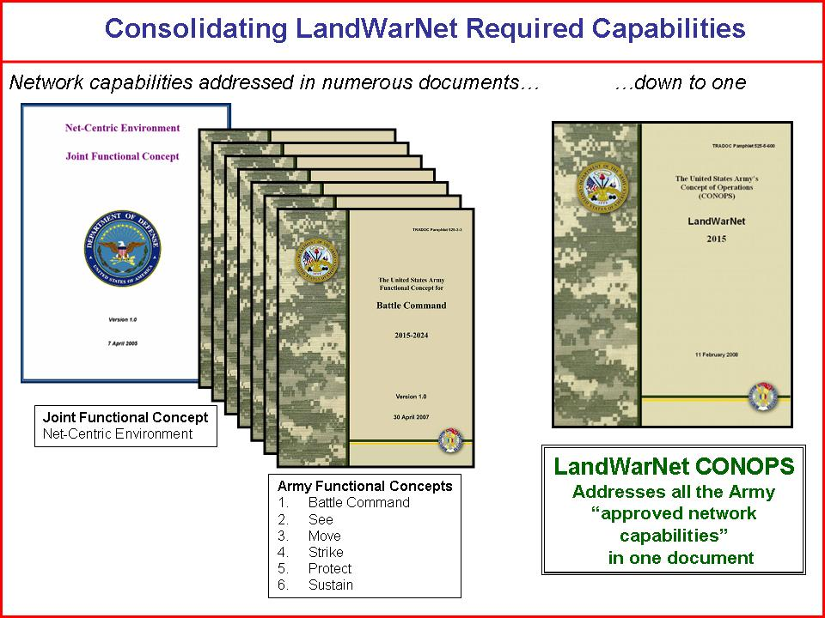
Figure 3-1. LandWarNet Required Capabilities

3-2. Overarching LandWarNet Required Capabilities

a. The Net-Centric Environment Joint Functional Concept addressed numerous network capabilities which in turn described the Army’s expectation for LandWarNet. The Net-Centric Environment Joint Functional Concept categorizes these capabilities into two distinct categories: knowledge capabilities and technical capabilities (see fig 3-2). The LandWarNet CONOPs uses the same construct to address the overarching network required capabilities for the Army network.

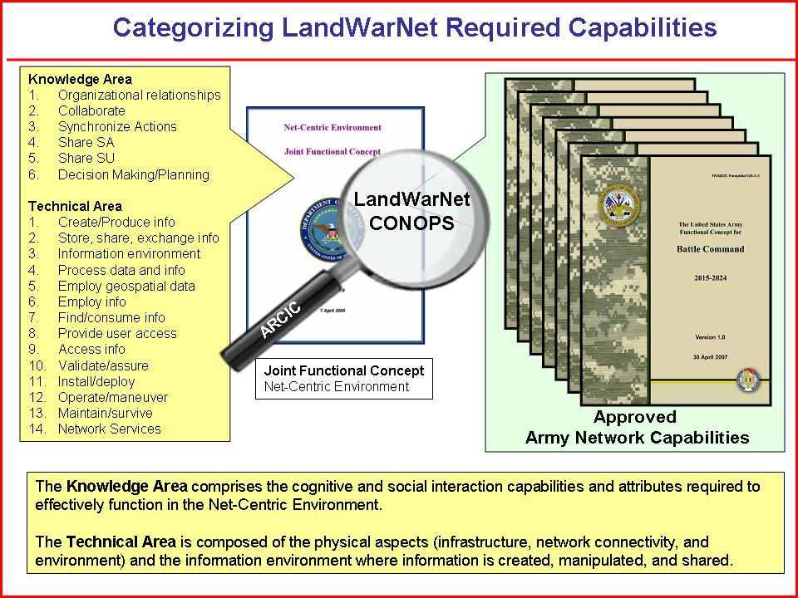
Figure 3-2. Categorizing LandWarNet Capabilities

b. The six U.S. Army functional concepts address the following 20 network required capabilities:

(1) Ability to establish appropriate organizational relationships. LandWarNet must have the ability to set up and change formal organizational and command relationships in accordance with mission and task needs, as well as to use flexible organizational constructs that extend across multiple commands and organizations for task accomplishment is critical.

(2) Ability to collaborate. Collaboration via LandWarNet must be continuous, include geographically separated participants, and involve all relevant parties. To develop trust in collaborative decisionmaking processes and organizational structures, doctrinal, cultural, and organizational limits will need to be removed to achieve full collaboration. Leaders will need to be trained, and procedures will need to be implemented.

(3) Ability to synchronize actions. The fast pace of operations in the net-centric environment through LandWarNet requires that entities be able to rapidly synchronize among themselves, independent of direction from superiors: self-synchronization. This will enable them to flexibly adapt actions to take advantage of opportunities and minimize impacts of changing or emerging threats.

(4) Ability to share SA. LandWarNet allows individuals to develop their own SA as well share this awareness with a wide range of participants. They will need to see how others perceive the situation, and be capable of processing information from many sources while remaining focused on current tasking(s).

(5) Ability to share SU. Where SA is the “who’s where and what are they doing?” aspect of battlespace knowledge, SU is the “what does it mean and what can I do about it?” aspect. Individuals will use reasoning methods and tools in LandWarNet to achieve the required level of understanding. Sharing their understandings with a wide array of participants will provide a synergy that leads to a higher quality collective understanding and contributes to high quality decisionmaking.

(6) Ability to conduct collaborative decisionmaking and planning. The ever-changing nature of the battlespace environment will require commanders to embrace the collaborative capabilities resident in LandWarNet and involve many elements, including other commanders and non-traditional communities of interest, in the decisionmaking process. Decisionmakers will need collaboration tools and sophisticated decision support tools in order to succeed in this environment. They will also need to deal with analyzing potential COA quickly and with sufficient resolution to address potential second and third order effects. The collaborative decisionmaking process will enable commanders to be aware of other entities’ changing tasks and missions and their ability to perform those tasks and missions.

(7) Ability to create/produce information. LandWarNet enables the capability to collect (in the case of sensors) data and transform that data into information.

(8) Ability to store, share, and exchange information and data. LandWarNet enables the capability to include all actions necessary to store, publish, and exchange information and data. Data must be appropriately identified and labeled (metadata), placed in a database or other data/information repository, and its presence announced to those who need it (post/publish/advertise).

(9) Ability to establish an information environment. LandWarNet enables the establishment of criteria, processes and procedures for the storing and sharing of data/information, including the sharing across different environments.

(10) Ability to process data and information. Users on LandWarNet must be able to filter, correlate, and fuse data and information into useful forms.

(11) Ability to employ geospatial information. All geospatial information in LandWarNet are properly formatted, tagged, and correlated to other geospatial information in an underlying database (for example population, utilities, transportation, services, and climate).

(12) Ability to employ information. Formatting in LandWarNet must be translatable to the extent that machine-to-machine information sharing is enabled.

(13) Ability to find and consume information. Users on LandWarNet must be able to locate the required information and extract it.

(14) Ability to provide user access. Different roles in LandWarNet will have different information and security access requirements. This will apply to both individuals and groups. Strong authentication procedures apply.

(15) Ability to access information. This capability in LandWarNet refers to the need for multiple levels of security to allow information sharing between users across different security domains.

(16) Ability to validate/assure. This capability in LandWarNet addresses the need for confidence and trust in networks, systems, and information.

(17) Ability to install/deploy. The net-centric model depends on the capability to have connectivity where and when required in LandWarNet. The network must be capable of forward deployment and must be tailored to mission requirements.

(18) Ability to operate/maneuver. Once in place, LandWarNet must be capable of dynamic allocation of resources, operate regardless of geography, and support all operations and transitional states along the range of military operations.

(19) Ability to maintain/survive. Once deployed, the network must be able to maintain service while under both physical attack and information attack.

(20) Ability to provide network services. LandWarNet must be capable of providing all services generally associated with network operations such as connecting all assets, sharing information among interagency/coalition/IO commercial/NGO participants, archiving large volumes of data, maintaining network status, keeping all nodes informed, and supporting geographically transitioning nodes.

3-3. LandWarNet Enabled Battle Command Required Capabilities

a. TRADOC Pam 525-3-3 provides a visualization of how Army future Modular Force commanders will exercise C2 of Army operations in a JIM environment. Central to the concept is a single, integrated Army Battle Command System enabled by an agile, ubiquitous communications network.

b. Key capabilities (beyond the 20 overarching capabilities) include:

(1) Ability to provide information and decision superiority.

(2) Ability for a single, integrated Army Battle Command System.

(3) Ability for interagency and multinational interoperability and integration.

(4) Ability for horizontal and vertical fusion.

(5) Ability for an agile, ubiquitous communications network from space to mud (ground).

c. Battle command, more than any other functional concept, is focused on the human dimension of warfare while LandWarNet aims at improving the function of C2 (see fig 3-3).

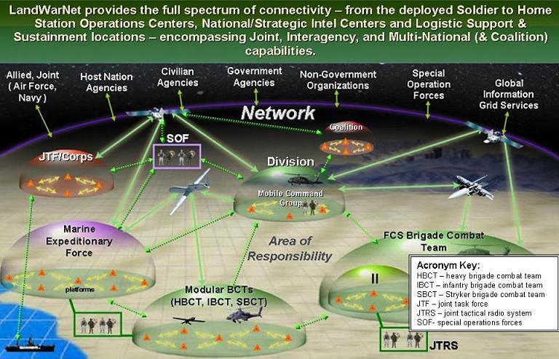
Figure 3-3. Battle Command enabled by LandWarNet

d. The future Modular Force C2 system enabled by LandWarNet will require the capability to:

(1) Establish a networked computing environment that provides the physical and logical connectivity among all the participants in the network. It must include data management strategies to ensure that data collected in one part of the network is compatible with the systems in use by the others in the network.

(2) Develop solutions that will minimize or negate the consequences of an attack on the network.

(3) Echelon command posts over greater distances while maintaining uninterrupted connectivity.

(4) Develop C2 suites similar to today’s command post of the future expanded and updated and tied into the future BFT System.

(5) Exercise battle command on-the-move.

(6) Conduct en route planning and rehearsals with a system embedded on Future Combat Systems including vehicles, aircraft, watercraft, and others, which allow direct, secure, real time collaboration any place on the globe. This system must facilitate dynamic retasking of subordinate units as the situation changes.

(7) The ability to provide high altitude and space platforms, links, and processors to enable the sharing of information from a wide variety of sensors and sources. Commanders and their staffs will be able to access information simultaneously from multiple noncontiguous locations, in order to provide timely, actionable, and relevant information in support of the planning, execution, and assessment operations of the joint force and component commanders.

(8) Provide a continuously updated COP from Soldier to the highest level of command with information gates that provide the necessary data pertinent to each level.

(9) Provide commander with real time visibility of their units’ combat readiness and locations to facilitate timely decisions.

(10) Provide logistics C2 with asset visibility that enables commanders to allocate resources at the point of main effort, maintain momentum, and retain the initiative.

(11) Automated systems that self-diagnose commodity consumption and system status, which in turn automatically initiates replenishment requests and related distribution actions.

(12) Future logistics information systems that are part of a joint federated information network, which is interoperable with major interagency, NGO, and multinational organizations.

3-4. LandWarNet Enabled See Required Capabilities

a. TRADOC Pam 525-2-1 describes how the future Modular Force will acquire and generate knowledge of itself, its opponent, and the operational environment. Without the ability to see, the Army is incapable of creating a force capable of seeing first, understanding first, acting first, and finishing decisively.

b. Key capabilities (beyond the 20 overarching capabilities) include:

(1) Ability for near real time visualization in the COP and an embedded ability to conduct mission rehearsal en route.

(2) Ability for accurate and timely adversary and geospatial information including geo-location, rapid understanding of environmental constraints, and cultural knowledge; all of which will be integrated through analysis conducted with reliable network access, data sharing, and collaboration.

(3) Ability for synchronized ISR to reduce unnecessary redundancy, expedite operational decisions, maximize coverage, and facilitate SA and SU.

(4) Ability for exploitation at all levels of the constellation of military and civilian space capabilities that support surveillance, reconnaissance, communications, positioning, navigation, weather, and missile defense.

(5) Ability to employ or coordinate strategic, JIM capabilities using organic command and knowledge architectures, particularly in the areas of intelligence and strike.

(6) Ability to rapidly downlink, process, and analyze national and commercial imagery from archives and databases in theater.

(7) Ability for organic collection and transformation capabilities at lower tactical levels.

(8) Ability for real time knowledge of friendly forces, particularly those not organic to maneuvering units.

(9) Ability for real time tailored knowledge of the environment, such as human, weather, terrain, and infrastructure, specific to each organization’s operating environment.

(10) Ability for exchanging sustainment information with joint and multinational elements, in and out of theater.

(11) Ability for seamless sharing of intelligence collection and analysis capabilities.

(12) Ability for continuous visibility of sustainment capabilities and materiel.

(13) Ability for continuously transform friendly data and information.

(14) Ability to predict likely enemy actions and patterns that assist commanders in denying the enemy the ability to reinforce, resynchronize, or exercise initiative information.

(15) Ability for detailed knowledge of opponent organizations and relationships information.

(16) Ability to discern adversaries from the civilian population, and between various enemy factions, while operating in complex physical environments information.

(17) Ability to track friendly forces, including multinational and interagency presence, particularly while highly distributed information.

(18) Ability for collection against ambiguous and low signature systems to counter adaptive threat capabilities information.

(19) Ability for air, ground, and space-based collection capabilities for high-clutter environments, such as jungles or built-up areas.

(20) Ability to apply extensive use of the knowledge built by other elements inside and outside the operational environment through access to JIM organizations.

(21) Ability for the capacity to develop knowledge with sufficient accuracy and timeliness to permit simultaneous engagement by air and ground maneuver elements, joint fires, and suppression of enemy air defenses, allowing forces to transit the operational environment on its terms in any terrain.

(22) Ability for highly detailed knowledge of enemy forces to allow the force to anticipate, detect, and defeat enemy attacks in all forms and domains.

(23) Ability for detailed knowledge of the population, including relationships, culture and social structure, that support both defensive operations and IO.

(24) Ability for use of data exploitation to help analysts develop information about low signature activities, and enemy patterns, linkages and organizations, enhancing awareness and force protection.

(25) Assessment of effects on the enemy, including red teaming to estimate possible behaviors and outcomes.

(26) Ability to gather cultural data and information in the JOA to plan and execute operations.

(27) Ability to develop measures of effectiveness to assess the impact of friendly and enemy operations on the population.

(28) Ability to identify enemy means to communicate internally or with the population, and what alternate means are likely if primary means are interrupted.

(29) Ability to understand enemy intelligence capabilities, leadership, and organizations.

(30) Ability to use a high degree of automated tracking of friendly forces to free commanders and staffs to focus on understanding the enemy and environment, and planning for future commitments, engagements, and actions.

(31) Ability to track detailed sustainment demands in order to support the continuity of operations.

(32) Ability to rapidly team without extensive pre-coordination.

(33) Ability to discriminate between enemy elements and noncombatants using advanced collection and analysis capabilities.

(34) Ability to detect low signature enemy systems, such as improvised explosive devices and commercially available encrypted communications.

(35) Ability to gather evidentiary data for dealing with enemy fighters acting from within the population, as well as, criminals taking advantage of the absence of local law enforcement.

(36) Ability to conduct pattern analysis for both the enemy and elements of the environment, such as economics and the population.

(37) Ability to model potential impacts of friendly and enemy operations on the population to enhance planning and preparation.

(38) Ability to tap into military and civilian experts from across a variety of disciplines, from linguistics and culture, to civil engineering and economics.

(39) Ability to red team potential COA for consequences, including enemy and noncombatant outcomes and risks.

(40) Ability to coordinate friendly activities with non-military and NGO.

(41) Ability to assess the impact of programs and initiatives.

(42) Ability to predict analysis that allows planning kinetic and IO against enemy elements.

(43) Ability to assess red team outcomes and risks accurately.

(44) Ability to collect and analyze data to develop enemy patterns of operation and
organizational linkages.

(45) Ability to acquire environmental knowledge to protect infrastructure vital to stability and popular support.

(46) Ability to improve ability to discriminate between combatants and noncombatants.

(47) Ability for effective integration of multinational forces’ capabilities and SA.

(48) Ability for self-knowledge to conduct rapid mission-tailoring.

(49) Ability to track and maintain status not only on all friendly forces, but key civilian elements, such as police or local leadership.

(50) Ability for near-instantaneous access to knowledge from diverse world-wide experts in order to deal with subjects outside normal analyst or staff expertise.

(51) Ability to “see” through hardened structures to find weapons and enemy personnel.

(52) Ability to allow Soldiers to pinpoint snipers and explosive events.

(53) Ability for sensors to identify mines and improvised explosive devices, for example, X-band radar and hyperspectral sensors capable of detecting minute changes to soil or ground cover.

(54) Ability for biometrics to identify potential enemies from the general population.

(55) Ability for every Soldier a sensor technology. Soldiers will continue to play the most critical role, reporting data and information, and will be aided by improved optics and reliable communications links.

(56) Ability to connect dedicated analysts through the network to tactical leaders.

(57) Ability for shared information about the enemy, environment, and friendly mission between all forces and supporting elements to permit anticipation of demands and greater certainty in planning.

(58) Ability for a high degree of automated tracking of friendly forces to more rapidly and accurately provide a picture of the status of forces throughout the operational environment.

(59) Ability for highly detailed force protection knowledge to enhance survivability of noncombat forces and elements.

(60) Ability to dynamically prioritize data acquisition in response to unexpected or emerging requirements from a cross the force.

(61) Ability for a highly reliable and accurate knowledge of friendly forces and noncombatants throughout the operational environment.

(62) Ability to access databases, and skilled analysts and experts to assist commanders and staffs in interpreting data and information.

(63) Ability to have systems and processes for matching stated requirements to transformed information, enabling rapid gap analysis and re-tasking of acquisition.

(64) Ability to have systems that effectively present/convey the situation, tailored to the commander’s decisionmaking style.

(65) Ability to intuitively present highly detailed knowledge of friendly forces locations, activities, missions, and planned maneuver of all elements in the AO to all levels of command in real time.

(66) Ability to expand operational reach to the tactical level to increase the number of available capabilities.

3-5. LandWarNet Enabled Move Required Capabilities

a. TRADOC Pam 525-3-6 describes how the future Modular Force will acquire strategic force projection and operational agility in support of joint campaign objectives. Operational maneuver from strategic distances, and achievement of the deploy equals employ paradigm are heavily reliant on accurate SU, reach, and the ability to execute en route mission planning and rehearsal.

b. Key capabilities (beyond the 20 overarching capabilities) include:

(1) Ability to employ advanced modeling and simulation.

(2) Ability to employ in-transit visibility in the context of a JOE.

(3) Ability to redesign unit identification codes and the tables of organization and equipment to support capability packaged deployments and associated supply coding in the context of a JOE.

(4) Ability to redesign DOD activity address codes to support multiple modular elements from the same unit at different locations in the context of a JOA.

(5) Ability to link force projection research and development efforts and requirements more effectively with maneuver research and development in the context of a JOE, to provide force projection, force protection, and strategic responsiveness in FSO.

3-6. LandWarNet Enabled Strike Required Capabilities

a. TRADOC Pam 525-3-4 describes how the future Modular Force fires and effects at the strategic, operational, and tactical levels. From a LandWarNet perspective, the future Modular Force will deploy with a tailored mix of organic and available joint, allied, and coalition strike capabilities enabled by a GIG that will provide fully integrated, transparent communication and computer interfaces between joint fires, C2, and knowledge networks. Commanders will be able to exploit the GIG to provide a continuous integration and employment of networked fires that will extend seamlessly from strategic to tactical levels and timeframes with no gaps in coverage or loss of timeliness.

b. Key capabilities (beyond the 20 overarching capabilities) include:

(1) Ability to provide continuous integration and employment of networked strike from strategic to tactical levels.

(2) Ability to provide seamless integration of lethal and nonlethal fires.

(3) Ability to attack all target types in all environments and terrains with unprecedented effectiveness.

3-7. LandWarNet Enabled Protect Required Capabilities

a. TRADOC Pam 525-3-5 describes how the future Modular Force will protect people, physical assets and information against the full spectrum of threats. On the ever increasingly lethal battlefield the need for combat identification will grow. Using SA combined with target identification will increase combat effectiveness and reduce fratricide. This requires training, simulations, doctrine, marking systems, and tracking systems.

b. Key capabilities (beyond the 20 overarching capabilities) include:

(1) Ability to understand how to employ sensors, automated protection systems, and robotics in a combat environment, in order to achieve SU and assist the ability to decide and act against hostile forces.

(2) Ability to receive updated or new training support packages for improved sensor, automated, and robotic capabilities in a formal and unit training setting, in order to respond to a changing threat.

(3) Ability to observe, monitor, and track actual and potential hostile activities aimed at people, assets, and information in a JIM environment, in order to detect and prevent enemy actions.

(4) Ability for sensors, explosive device neutralization, and offensive weapon platform systems mounted on robotics that can operate in all terrain, weather, and spectrum environments, in order to augment and assist Soldiers in protection operations.

(5) Ability to integrate air and ground sensors, C2, and ISR systems in all weather, terrain, and spectrum environments, in order to provide accurate and timely information.

(6) Ability to sense and detect lethal and nonlethal, energy based, and passive and active enemy systems in all environments, in order to allow for decisions on countermeasures and offensive actions.

(7) Ability to identify threats at adequate stand-off distance in all environments to allow for appropriate reaction time by friendly forces, in order to prevent or defeat a threat.

(8) Ability for networked system of sensors to identify enemy activity and weapons firing in all environments to automatically cue on board active protection systems, in order to prevent or neutralize a threat.

(9) Ability to detect and identify chemical, biological, radiological, and nuclear hazards in the air, water, food, or soil, on personnel, equipment, or facilities in all environments, in order to determine the state of those hazards and take preventive measures.

(10) Ability to provide warning and employ protective systems to counter enemy rockets, artillery, and mortars in all environments, in order to destroy the enemy rounds before they strike the intended target.

(11) Ability to provide chemical, biological, radiological, and nuclear and toxic industrial material detection in all environments, in order to implement consequence management operations.

(12) Ability to develop and maintain technical and tactical proficiency with automated, robotic, and sensor capabilities, in order to protect the force.

(13) Ability for leaders and Soldiers to conduct rapid decisionmaking at lower levels to conduct protection measures in high tempo operations, in order to preserve the fighting capability of the force.

(14) Ability for leaders and Soldiers to make decisions between the use of nonlethal and lethal capabilities in a JIM environment, in order to reduce unintended casualties and destruction.

(15) Ability for biometric entry identification systems in field and garrison environments, in order to provide greater reliability in ascertaining friendly and potential enemy personnel.

(16) Ability for advanced perimeter sensors in fixed, semi-fixed, and mobile environments, in order to provide early and accurate warning to the forces.

3-8. LandWarNet Enabled Sustain Required Capabilities

a. TRADOC Pam 525-4-1 describes the future Modular Force logistics as a single, coherent system that senses and interprets the operational environment and responds through network capabilities. LandWarNet capabilities enable the Sustain concept by providing:

b. Key capabilities (beyond the 20 overarching capabilities) include:

(1) Ability for a single joint capable network-enabled logistics system. Improves and enhances lines of communications across highly distributed noncontiguous operations occurring in multiple environments simultaneously.

(2) Ability to have a high-speed, precision, accuracy, visibility, and centralized supply chain management with minimum essential forward stockage and reachback capabilities. Multidirectional flow of stock tracked from origination source to point of employment or consumption, optimizes resource redirection, when required.

(3) Ability for an interdependent, capabilities based, modular, network-enabled organizations with increased commonality of equipment and organizational designs. Reduces sustainment requirements, mitigating the effects of distance, time, simultaneity, and the complexity of operations.

(4) Ability for highly mobile systems, advanced distribution platforms, precision delivery systems and state-of-the-art C2. Reduces personnel risk through robotics and reduces redundancy through joint enabled, combat integrated command systems. Increases utilization and enhances predictability.

(5) Ability for continuous support through global integrated management and sourcing of Army, joint, and combined partnerships. Reduces competition for like resources and maximizes host nation and Logistics Civilian Augmentation Program support to the joint force. Integrates decision cycles and supporting data.

c. The sustain concept combines intellectual approaches, capabilities as it focuses on how the Army will provide equipment, supplies, maintenance, health services, transportation, field service and Soldier support to the deployed force in the AO. The concept also focuses on C2, as it applies to the linkage between the strategic sustainment of corps, division, and field Army within the joint theater logistics structure.

d. LandWarNet capabilities associated with distribution include:

(1) Ability for a single joint capable logistics C2 headquarters to coordinate distribution operations in the context of the JOA, to provide distributed sustainment in FSO.

(2) Ability to integrate joint, Service, and commercial distribution capabilities in order to operate as an output focused enterprise across the JOE, to provide distributed sustainment in FSO.

(3) Ability to develop improved autonomous material handling equipment for new platforms in the context of a JOE, to provide distributed sustainment in FSO.

(4) Ability to develop embedded prognostics and diagnostics systems that enable proactive materiel management in the context of a JOE, to provide distributed sustainment in FSO.

(5) Ability to develop common intelligent protective packaging that complements emerging inter-modal distribution capability in the context of a JOE, in order to provide distributed sustainment in FSO.

(6) Ability to employ robotic technology in packaging, loading and off-loading operations in the context of a JOE, to provide distributed sustainment in FSO.

e. LandWarNet capabilities associated with supply and field support include:

(1) Ability to capture new material designs and acquisition strategies in the context of a JOE, to provide distributed sustainment in FSO.

(2) Ability to capture force design updates in the context of a JOE, to provide distributed sustainment in FSO.

(3) Ability to coordinate and control all supply and field service support distribution and management operations, including water, petroleum, mortuary affairs, feeding, shower, clothing, laundry, in the context of a JOE, in order to provide distributed support and sustainment in FSO.

(4) Ability to develop automated support tools to determine water requirements, and to provide quality assurance for all water products in the context of a JOE, to provide distributed sustainment in FSO.

(5) Ability to develop automated support tools to determine fuel needs based in the context of a JOE, to provide distributed sustainment in FSO.

(6) Ability to receive, store, issue, and use passive radio frequency identification tags in the context of a JOE, to provide distributed sustainment in FSO.

f. LandWarNet capabilities associated with maintenance support include:

(1) Ability to incorporate embedded diagnostic and prognostic technologies within an anticipatory sense and respond equipment monitoring system into all major weapons and systems in the context of a JOE, to provide distributed support in FSO.

(2) Ability to collect, monitor, and store maintenance data in the context of a JOE, to provide distributed sustainment in FSO.

(3) Ability to create automation tools that monitor equipment status, the disposition of resources in the distribution system, and the capability and capacity of maintenance activities, and collect demand history and usage rates in the context of the JOE, to provide distributed sustainment in FSO.

(4) Ability to fit equipment with identification chips in the context of a JOE, to provide distributed sustainment in FSO.

(5) Ability to create digital warehouses to store system software, sensor information, technical data, historical, and system engineering data in the context of a JOE, to provide distributed sustainment in FSO.

(6) Ability to add automation support to existing maintenance facilities in the context of a JOE, to provide distributed sustainment in FSO.

g. LandWarNet capabilities associated with health service support:

(1) Ability to provide continuous awareness of the force heath status through real time health surveillance and immediate recognition in the context of a JOE, to provide distributed support and sustainment in FSO.

(2) Ability to improve cognitive and other psychological functions in the context of a JOE, to provide distributed support and sustainment in FSO.

(3) Ability to have reliable, accurate intertheater and reachback communications to support seamless health services supply, soldier health care, and patient records support.

(4) Ability to electronically transmit patient treatment, diagnostic quality imagery, health record data from deployed medical treatment facilities to reachback locations within critical care timeline, conduct video teleconference between field and reachback locations, and cache all digital medical records and imagery of patient treatment.

h. LandWarNet capabilities associated with transportation:

(1) Ability to improve planning, coordinating, and executing tasks to employ transportation resources.

(2) Ability for Future Modular Force transportation units to be a part of a “smart distribution” a system of systems. This will enable future logisticians to provide timely sustainment and operate more efficiently. It consists of three subsystems: the modular platform system, the intelligent load handling system, and the future tactical truck system.

i. LandWarNet capabilities associated with Soldier support:

(1) Ability for LandWarNet to allow religious support operations to reach from the family to the foxhole.

(2) Ability for LandWarNet to enable human resources support to the future Modular Force by providing manning, human resources services, personnel support, and human resources planning and staff operations. A capability is required for a network-centric information system for all future Modular Force human resource providers.

(3) Ability for a single joint enabled human resource system database allowing access to a joint human resource database in order to increase efficiencies of the personnel readiness management, personnel accounting and strength reporting, pre-trained individual manpower, and enlisted promotion system core functions, allowing all components of the Army to operate on the same human resource system.
(4) Ability for financial management operations to sustain joint, Army, allied, and coalition forces. The future joint financial system enables and integrates the financial capabilities of both the DOD and commercial sector.

j. LandWarNet capabilities associated with aviation sustainment support:

(1) Ability to capture changes in aviation support in relevant doctrine that articulates how aviation resources may be employed to improve distribution operations within the context of the JOE, to provide distributed sustainment for FSO.

(2) Ability for ultra-reliable, intelligent, embedded electronics, diagnostics, and prognostics to detect system and platform problems prior to failure in the context of the JOE, to provide distributed sustainment for FSO.

3-9. LandWarNet Capabilities Summary

a. The emergence of the networked information age in the contemporary warfighting environment has created new problems that the legacy systems engineering processes are finding difficult to satisfy. Traditional systems engineering has been focused on monolithic large-scale system designs in a waterfall method that produced stovepipe systems and applications. This process worked sufficiently in the past, but as we continue to evolve our network-enabled warfighting capabilities processes must also change to rapidly take advantage of new technologies that can enable warfighter requirements.

b. LandWarNet is not a single monolithic network represented by a single system or program of record. Rather, LandWarNet is a system of systems that consists of current systems and processes that will be integrated with new systems driven by this conceptual framework underpinned by integrated architecture oriented on mission task and purpose. LandWarNet enables “one Army Battle Command System” as part of “one network” and facilitates a consistent alignment of joint capabilities.

c. Achieving LandWarNet requires an integrated approach informed by integrated architecture key decision points; gaps; findings; issues; relationships; and dependencies between key capabilities. To achieve the goals and objectives of LandWarNet, the Army must drive the planning and execution of all phases of the fight through vigilant transformation of National and joint strategy and policies and the U.S. Army Campaign Plan.

d. LandWarNet is a major enabler for the warfighter. LandWarNet delivers the full spectrum of connectivity at all phases to ensure the tools and capabilities are available at any time in the fight. LandWarNet provides an end-to-end set of information services, associated processes, and people to manage and provide the right information to the right user at the right time with appropriate protection across the DOD warfighting, intelligence, and business mission areas.

Appendix A

References

Section I
Required References

ARs, DA pams, FMs, and DA forms are available at http://www.usapa.army.mil/. TRADOC publications and forms are available at http://www.tradoc.army.mil/publications.htm.

The Army Plan (Available at http://www.army.mil/aps/07/armyPlan.html.)

The Army Game Plan (Available at http://www.army.mil/institution/leaders/gameplan/.)

The Army Strategic Planning Guidance (Available at http://www.army.mil/references/.)

FM 1-0
The U.S. Army

FM 3-0
Operations

FM 6-0
Mission Command

CIO/G6 500 Day Plan (Available at http://www.army.mil/ciog6/.)

TRADOC Pam 525-2-1
The U.S. Army Functional Concept for See 2015-2024

TRADOC Pam 525-3-0
The U.S. Army in Joint Operations: The Army Future Force Capstone Concept

TRADOC Pam 525-3-1
The U.S. Army Operating Concept for Operational Maneuver 2015-2024

TRADOC Pam 525-3-2
The U.S. Army Concept for Tactical Maneuver 2015-2024

TRADOC Pam 525-3-3
The U.S. Army Functional Concept for Battle Command 2015-2024

TRADOC Pam 525-3-4
The U.S. Army Functional Concept for Strike 2015-2024

TRADOC Pam 525-3-5
The U.S. Army Functional Concept for Protect 2015-2024
TRADOC Pam 525-3-6
The U.S. Army Functional Concept for Move 2015-2024

TRADOC Pam 525-4-1
The U.S. Army Functional Concept for Sustain 2015-2024

TRADOC Pam 525-7-4
Concept Capability Plan for Space Operations 2015-2024

Section II
Related References
A related publication is a source of additional information. The user does not have to read a related reference to understand this publication.

Battlespace Awareness Joint Functional Concept (Available at http://www.dtic.mil/futurejointwarfare/jfc.htm.)

Deterrence Operations Joint Operating Concept (Available at http://www.dtic.mil/futurejointwarfare/joc.htm.)

Focused Logistics Joint Functional Concept (Available at http://www.dtic.mil/futurejointwarfare/jfc.htm.)

Force Management Joint Functional Concept (Available at http://www.dtic.mil/futurejointwarfare/jfc.htm.)

Force Application Joint Functional Concept (Available at http://www.dtic.mil/futurejointwarfare/jfc.htm.)

Homeland Defense and Civil Support Operations Joint Operating Concept (Available at http://www.dtic.mil/futurejointwarfare/joc.htm.)

Irregular Warfare Joint Operating Concept (Available at http://www.dtic.mil/futurejointwarfare/joc.htm.)

Joint Command and Control Joint Functional Concept (Available at http://www.dtic.mil/futurejointwarfare/jfc.htm.)

JP 3-0
Joint Operations (Available at http://www.dtic.mil/doctrine/jpcsystemsseriespubs.htm.)

JP 5-0
Joint Operation Planning (Available at http://www.dtic.mil/doctrine/jpcsystemsseriespubs.htm.)

JP 6-0
Doctrine for Communications System Support to Joint Operations (Available at http://www.dtic.mil/doctrine/jpcsystemsseriespubs.htm.)

Joint Training Joint Functional Concept (Available at http://www.dtic.mil/futurejointwarfare/jfc.htm.)

Major Combat Operations Joint Operating Concept (Available at http://www.dtic.mil/futurejointwarfare/joc.htm.)

Military Support to Stabilization, Security, Transition, and Reconstruction Operations Joint Operating Concept (Available at http://www.dtic.mil/futurejointwarfare/joc.htm.)

National Military Strategy 2004 (Available at http://www.defenselink.mil/news/Mar2005/d20050318nms.pdf.)

National Security Strategy 2002 (Available at http://www.whitehouse.gov/nsc/nss/2002/index.html.)

Net-Centric Environment Joint Functional Concept (Available at http://www.dtic.mil/futurejointwarfare/jfc.htm.)

Net-Centric Operational Environment Joint Integrating Concept (Available at http://www.dtic.mil/futurejointwarfare/jic.htm.)

Protection Joint Functional Concept (Available at http://www.dtic.mil/futurejointwarfare/jfc.htm.)

Glossary

Section I
Acronyms

AO area of operations
APC area processing center
ASCC Army service component commands
C2 command and control
COA courses of action
CONOPS concept of operations
COP common operational picture
DA Department of the Army
DOD Department of Defense
FSO full spectrum operations
DOTM GIG global information grid
GNSC-A Global Network Command-Army
IGO intergovernmental organization
IO information operations
ISR intelligence, surveillance, and reconnaissance
JOC joint operating concept
JFC joint force commander
JIM joint, interagency, and multinational
JOA joint operations area
JOE joint operational environment
JP joint publication
JTF joint task force
NGO nongovernmental organizations
NSC network service center
OGA other governmental agency
Pam pamphlet
PIR priority intelligence requirements
SA situational awareness
SOF special operations forces
SU situational understanding
USTRANSCOM U.S. Transportation Command

Section II
Terms

Agility
The ability to move quickly and easily. Agility, as it applies to Joint C2, has six key elements: robustness, resilience, adaptability, responsiveness, flexibility, and innovation.

Architecture
A framework or structure that portrays relationships among all the elements of the subject force, system, or activity.
Area processing center (APC)
Under the APC construct, tactical, area, regional, and enterprise services are delivered from a centralized location in a standardized manner above the post/camp/station level. An APC will be a concentration point for installation interconnectivity, a location for common services, and an entry point into the U.S. Army enterprise through an enhanced security gateway. This concept will provide a standardized approach to facilitate LandWarNet intra-network communications and provide a service delivery paradigm by mission or functional community instead of geographic boundaries. For example, it will be feasible for Warfighters to position battle command applications at the APC for primary or backup services in support of their deployed forces.

Collaborative information environment (CIE)
The collaborative information environment is a specified information environment that enables collaborative processes between a group of individuals or organizations. The CIE is a subset of the emerging global information environment. The CIE consists of five elements: Infrastructure (the hardware, software, communication links, and appropriate supporting equipment); People (members conducting activities to gain understanding in the environment); Architecture (the virtual connectivity structure designed to deliver, process, and function); Rules (the customs, laws, procedures and policies that govern behavior in the collaborative environment); and Information (the data representing potential knowledge in the environment).

Command and control (C2)
The exercise of authority and direction by a properly designated commander over assigned and attached forces in the accomplishment of the mission.

Data
The lowest class of information on the cognitive hierarchy.

Expeditionary signal battalion
A modular, expeditionary-capable signal formation that supports warfighters across all echelons of the force with a full range of services through common, integrated network architecture.

Full spectrum dominance
The ability of U.S. forces, operating unilaterally or in combination with multinational and interagency partners, to defeat any adversary and control any situation across the full range of military operations.

Functional concept
The amplification of a particular function (such as counter-air) or description of how to employ a system or conduct a task (such as time-sensitive targeting).

Global Network Signal Command–Army (GNSC-A)
Notional. The GNSC-A is focused on supporting units at all echelons throughout the phases of an operation, including pre-deployment activities in garrison and the seamless transition to warfighting operations anywhere in the world.

Information
Facts, data, or instructions in any medium.

Information superiority
The operational advantage derived from the ability to collect, process, and disseminate an uninterrupted flow of information while exploiting or denying an adversary’s ability to do the same (JP 3-13).

Knowledge
In the context of the cognitive hierarchy, information analyzed to provide meaning and value or evaluated as to implications for the operation (FM 6-0)

Knowledge centers
Notional. Knowledge Centers enable knowledge and knowledge-based training and leader development products to be piped directly into institutional classrooms where near-real time experiences are shared directly with leaders preparing to join their units; many of which are already forward deployed and engaged with hostile opponents.

LandWarNet
LandWarNet is the Army’s contribution to the Global Information Grid (GIG) that consists of all globally interconnected, end-to-end set of U.S. Army information capabilities, associated processes, and personnel for collecting, processing, storing, disseminating, and managing information on demand supporting warfighters, policy makers, and support personnel. It includes all U.S. Army (owned and leased) and leveraged DOD/Joint communications and computing systems and services, software (including applications), data security services, and other associated services. LandWarNet exists to enable the war fight through Battle Command.

LandWarNet Institute
Notional. Chief Mission: the study of the technical, psychological, and operational integration of network enabled operations.

Lethality
Describes increased and refined joint force capabilities to destroy an adversary and/or his systems in all conditions and environments. It includes the use of kinetic and/or non-kinetic means, while leveraging technological advances in greater precision and more devastating target effects at both longer-ranges and in close combat.

Multinational organizations
A collective heading for intergovernmental and international organizations.

Nested
To fit compactly together or within one another.
Network operations
Network operations translate the language of operational mission into the language of network control. The objective of network operations is the sustainment of operational initiative. Network operations consist of network management, information assurance and information dissemination management. It provides the means to manage required network connectivity in support of operations.

Network-centric operations (NCO)
An information superiority-enabled concept of operations that generates increased combat power by networking sensors, decision makers and shooters to achieve shared awareness, increased speed of command, higher tempo of operations, greater lethality, increased survivability, and a degree of collaborative-synchronization. In essence, NCO translates information superiority into combat power by effectively linking knowledgeable entities in the operating environment.

Networked computing environment
Provides the physical and logical connectivity among all the participants in the network. It includes data management strategies to ensure that data collected in one part of the network is compatible with the systems in use by the others in the network.

Nongovernmental organizations (NGO)
A private, self-governing, not for profit organization dedicated to alleviating human suffering; and/or promoting education, health care, economic development, environmental protection, human rights, and conflict resolution; and/or encouraging the establishment of democratic institutions and civil society (JP 3-08).

Network service center (NSC)
The NSC is a regional/theater asset that consists of a fixed regional hub node, one or more area processing centers, and a theater network operations and security center. The NSC provides access to network services throughout all phases of military operations and enhances the warfighting commander's operational flexibility. NSC components may be collocated or in separate facilities that are electronically connected. The GNSC-A, in coordination with the theater G-6, the regional J-6, and associated network operations and security center, manages the allocation and configuration of NSC resources within and across regions to synchronize support of full spectrum operations.

Operational architecture view
The operational architecture view is a description of the tasks and activities, operational elements, and information flows required to accomplish or support a military operation.

Operational environment
A composite of the conditions, circumstances, and influences that affect the employment of capabilities and bear on the decisions of the commander (JP 3-0).

Precision engagement
The ability of joint forces to locate, discern, and track objectives or targets; select, organize, and use the correct systems; generate desired effects; assess results; and reengage with decisive speed and overwhelming operational tempo as required, throughout the full range of military operations.

Seamless
Having no awkward transitions, interruptions, or indications of disparity.

Self-synchronized operations
The collaborative and decentralized initiation and execution of actions by elements of a joint force in support of the desired end state. Also defined as the interaction between two or more entities to operate in the absence of hierarchical mechanisms for Joint C2. A mechanism for communicating the ongoing dynamics of the operational situation and triggering the desired value-added interaction.

Situational awareness
Knowledge of the immediate present environment, to include knowledge the factors of mission, enemy, terrain and weather, troops and support available-time available and civil considerations
(FMI 5-0.1).

Situational understanding
The product of applying analysis and judgment to the common operational picture to determine the relationship among the factors of mission, enemy, terrain and weather, troops and support available-time available and civil considerations (FMI 5-0.1).

Synchronization
(1) The arrangement of military actions in time, space, and purpose to produce maximum relative combat power at a decisive place and time and (2) in the intelligence context, application of intelligence sources and methods in concert with the operation plan. (JP 2-0), (JP 1-02).

Tropospheric
Tropospheric is the ability to transmit radio waves over the curvature of the Earth, without using satellites, by bouncing signals off irregularities (small changes in humidity, temperature and pressure) in the troposphere, approximately 6.2 miles (10 kilometers) above the Earth's surface.

Section III
Special Abbreviations and Terms

This section contains no entries.



