INTERIM REPORT

November 15, 2000

SPECTRUM STUDY OF THE
2500-2690 MHz BAND

The Potential for Accommodating
Third Generation Mobile Systems

Federal Communications Commission
Staff Report Issued by:

Office of Engineering and Technology
Mass Media Bureau
Wireless Telecommunications Bureau
International Bureau

ACKNOWLEDGEMENTS

This Initial Report was prepared under the leadership of the Office of Engineering and Technology, in cooperation with the Mass Media Bureau, Wireless Telecommunications Bureau, and International Bureau

Office of Engineering and Technology

Anthony Asongwed, Donald Campbell, Rebecca Dorch, Robert Eckert, Bruce Franca, Kathryn Hosford, Ira Keltz, Julius Knapp, Geraldine Matise, Fred Thomas

Mass Media Bureau

Melvin Collins, Charles Dziedzic, Joe Johnson, Keith Larson, Brad Lerner, David Roberts, Thomas Wilchek

Wireless Telecommunications Bureau

Diane Cornell, Charles Rush

International Bureau

Charles Breig, Richard Engelman, Ari Fitzgerald, Trey Hanbury, Henry Straube

-----------------------------------------------------------------

Text extracted from International Telecommunication Union (ITU) material has been reproduced with the prior authorization of the ITU as copyright holder. The sole responsibility for selecting extracts for reproduction lies with the Federal Communications Commission and can in no way be attributed to the ITU. The complete volume(s) of the ITU material, from which the texts reproduced are extracted, can be obtained from:

International Telecommunication Union
Sales and Marketing Service
Place des Nations – CH-1211 GENEVA 20 (Switzerland)
Telephone: +41 22 730 61 41 (English)/+41 22 730 51 94 (French)/+41 22 730 61 43 (Spanish)
Telex: 421 000 uit ch / Fax: +41 22 730 51 94
X.400 : S=sales; P=itu; A=400net; C=ch
E-mail: sales @itu.int / http://www.itu.int/publications
Table of Contents

Section Page
EXECUTIVE SUMMARY 1

1. INTRODUCTION 1

2. 3G SYSTEM DESCRIPTION 5

3. INCUMBENT SYSTEMS IN THE 2500-2690 MHz BAND 17

4. STUDY ASSUMPTIONS AND METHODOLOGY 36

5. EVALUATION OF SPECTRUM SHARING 39

6. BAND SEGMENTATION ANALYSIS 54

Appendices Page
APPENDICES FOR SECTION 1 A-1

APPENDICES FOR SECTION 2 A-21

APPENDICES FOR SECTION 3 A-33

APPENDICES FOR SECTION 5 A-56

EXECUTIVE SUMMARY

This Interim Report describes the current uses of the 2500 – 2690 MHz band and analyzes the potential for sharing that band with third generation (3G) wireless systems. This band is one of several frequency bands identified at the World Radiocommunication Conference (WRC-2000) for possible 3G use. Third generation wireless systems will provide mobile, high-speed access to the Internet and other broadband services. In the United States, the 2500-2690 MHz band is currently used by the Instructional Television Fixed Service (ITFS), Multipoint Distribution Service (MDS), and Multichannel Multipoint Distribution Service (MMDS). The Interim Report examines the nature and technical characteristics of planned 3G services, the current and planned use of this band by incumbent services, potential opportunities for sharing spectrum between 3G and incumbent services, and the potential impact on incumbent services of segmenting this band to provide separate spectrum for 3G and incumbent services.

The Interim Report is consistent with a memorandum executed by the President on October 13, 2000 (Presidential Memorandum) and a subsequent Study Plan released on October 20, 2000 by the Department of Commerce. The Presidential Memorandum articulates the need to select radio frequency spectrum to satisfy the United States’ future needs for mobile voice, high speed data, and wireless Internet capability. The Presidential Memorandum establishes for the Executive Agencies guiding principles to be used in selecting spectrum that could be made available for 3G wireless systems, and strongly encourages independent federal agencies to follow the same principles in any actions they take related to the development of 3G systems. Noting the joint spectrum management responsibilities of the Executive Branch and the Federal Communications Commission (FCC), the Presidential Memorandum directs the Secretary of Commerce to work cooperatively with the FCC: (1) to develop a plan to select spectrum for third generation wireless systems by October 20, 2000; and (2) to issue by November 15, 2000 an interim report on the current spectrum uses and potential for reallocation or sharing of the bands identified at WRC-2000 that could be used for third generation wireless systems. These actions are to enable the FCC to identify spectrum for third generation wireless systems by July 2001 and auction licenses by September 30, 2002.*

In accordance with the Presidential Memorandum, the Department of Commerce released a “Plan to Select Spectrum for Third Generation (3G) Wireless Systems in the United States” (Study Plan) on October 20, 2000. The Study Plan noted that although various frequency bands have been identified for possible 3G use, the FCC and the National Telecommunications and Information Administration (NTIA) needed to undertake studies of the 2500-2690 MHz and the 1755-2850 MHz frequency bands in order to provide a full understanding of all the spectrum options available. The Study Plan calls for the FCC to complete an Interim Report on the 2500–2690 MHz band and for NTIA to complete an Interim Report on the 1755–1850 MHz band by November 15, 2000. A final report will be issued by March 1, 2001 that will examine whether it may be necessary to reallocate spectrum for incumbent services, and if so, what spectrum may be made available and the costs.

The Interim Report represents the results of analyses by the FCC staff in the Office of Engineering and Technology, Mass Media Bureau, Wireless Telecommunications Bureau, and International Bureau. It does not necessarily represent the views of the FCC or its Commissioners.

SUMMARY OF FINDINGS

The key findings of the Interim Report are as follows:

- The ITU has done considerable work to develop the key technical characteristics of 3G systems and to identify several frequency bands that could be used for 3G systems. The ITU is conducting further studies of how IMT 2000 may be implemented in the frequency bands that were identified at WARC-92 and WRC-2000, taking into account the impact on incumbent systems, opportunities for worldwide roaming, equipment design considerations, and backward compatibility with first and second generation (1G and 2G) systems. There currently is no global consensus as to how the frequency bands identified at WARC-92 and WRC-2000 will be used to implement 3G, or whether common global bands for use by 3G systems are achievable.

- The 2500–2690 MHz band is in a state of rapid evolution by incumbent ITFS and MDS licensees. The MDS industry has invested several billion dollars to develop broadband fixed wireless data systems in this band, including high-speed access to the Internet. These systems offer a significant opportunity for further competition with cable and digital subscriber line (DSL) services in the provision of broadband services in urban and rural areas. The band is used currently to provide video services for education and training in schools, health care centers and a wide variety of other institutions, as well as for the provision of a commercial video distribution service known as wireless cable. This spectrum is heavily licensed throughout the country and is ramping up for full operational use in the very near term.

- Incumbent ITFS and MDS use of the 2500–2690 MHz band varies from one geographic area to another. This lack of uniformity presents serious challenges to developing band sharing or segmentation options that could be used across the country without severely disrupting ITFS and MDS use. For example, ITFS and MDS licensees provide a variety of analog and digital one-way and two-way services; ITFS and MDS are licensed with different authorized service or interference protection areas; extensive leasing arrangements exist between the two services; and flexible channel band plans for combined ITFS/MDS two-way systems will coexist with some incumbent one-way systems operating under the traditional channel band plan.

- This initial technical analysis shows that if currently contemplated 3G systems were to share the same spectrum or channels in any given geographic area large co-channel separation distances would be needed between 3G systems and incumbent ITFS and MDS systems. Without adequate separation distances, 3G systems would cause extensive interference to incumbent ITFS and MDS systems. This is because the 2500-2690 MHz band is either used or soon to be used by ITFS and MDS systems in most populated areas of the country. There are, however, a few geographic areas where some spectrum is not used by incumbent systems. In areas where spectrum is not yet at full operational capacity, voluntary partitioning between incumbent users and 3G operators may offer some promise of sharing as an interim measure.

- Segmenting the 2500 – 2690 MHz band to enable third generation mobile wireless systems access to this spectrum would raise technical and economic difficulties for incumbents. While there may be long term options to segment the 2500-2690 MHz, segmentation could affect the economics of current and planned ITFS and MDS systems and their ability to provide service to rural areas. In addition, any segmentation option would have to account for the flexible service configurations and offerings that incumbent licensees are currently implementing.

The details of the analyses that lead to these findings are provided in the following Sections and Appendices.

SECTION 1

INTRODUCTION

This Interim Report addresses the current spectrum uses and the potential for sharing or segmenting the 2500-2690 MHz band for possible third generation (3G) wireless systems. This band study, which is in response to the October 13, 2000 Presidential Memorandum, follows the processes described in the Study Plan released by the Department of Commerce on October 20, 2000. This study relies on certain technical assumptions that are based largely on work conducted by the International Telecommunication Union (ITU) and on information provided by industry.

This Interim Report represents the results of analyses by the Federal Communications Commission (FCC) staff in the Office of Engineering and Technology, Mass Media Bureau, Wireless Telecommunications Bureau, and International Bureau. It does not necessarily represent the views of the FCC or the Commissioners.

THE PRESIDENTIAL MEMORANDUM AND THE STUDY PLAN

The October 13, 2000 Presidential Memorandum establishes guiding principles for the Executive Agencies to use in selecting spectrum for 3G wireless systems, and strongly encourages independent federal agencies, such as the FCC, to follow the same principles in any actions taken related to the development of 3G systems. These principles are: (1) the federal government must cooperate with industry to identify spectrum that can be used for 3G systems, whether by reallocation, sharing or evolution of existing systems; (2) incumbent users of spectrum identified for reallocation or sharing must be treated equitably, taking national security and public safety into account; (3) the federal government must be technology-neutral in spectrum allocation and licensing decisions; (4) the federal government must support policies that encourage competition in services and provide flexibility in spectrum allocations to encourage competition; and (5) the federal government must support industry efforts as far as practicable and based on market demand and national considerations to harmonize spectrum allocations regionally and internationally.

The Study Plan released by NTIA on October 20, 2000 adheres to the principles in the Presidential Memorandum. The Study Plan notes that a variety of frequency bands have been identified for possible 3G system use by two International Telecommunication Union (ITU) radio conferences, WARC-92 and WRC-2000. Further, the United States will give full consideration to all identified frequency bands in identifying spectrum for possible 3G system use. In order to have a full understanding of all options available, NTIA and FCC will undertake studies of two frequency bands identified by WRC-2000 for possible 3G use. NTIA will undertake the study of the 1755-1850 MHz band, and the FCC will study the 2500-2690 MHz band. The Study Plan states that the purpose of the studies is to determine whether, and under what conditions, these bands could be made available for 3G systems and the cost and operating impacts to incumbent users.

The Study Plan notes that the same analysis will be applied to both bands under study. The basic requirements for the overall studies cover three areas: a description of 3G system requirements; a description of incumbent systems in the study bands; and identification of potential alternate bands for incumbent users of the study bands. Using this information, the studies are to include a technical evaluation of the following sharing/relocation options: (1) system sharing between current and planned systems in the bands and 3G systems; and (2) band/channel segmentation, including alternate band combinations to relocate incumbent users of the study bands. Finally, the studies are to consider costs for the spectrum sharing/relocation options identified for the study bands and benefits of using the spectrum in the study bands for 3G systems.

The Study Plan notes that the studies will be conducted in two phases. An Interim Report on each band is to be released by November 15, 2000; a Final Report on each band is to be released by March 1, 2001. The Interim Report is to include a description of 3G systems, a description of incumbent systems, and an evaluation of system sharing and band segmentation options. The Final Report will include the remainder of the study requirements, including information on other bands, a description of alternate bands and relocation studies, and cost/benefit analyses of system sharing, segmentation and relocation options identified.

Outreach to industry is an important component of the overall process to identify spectrum for 3G systems. As instructed by the Presidential Memorandum, NTIA, on behalf of the Secretary of Commerce, will initiate the Department’s outreach program to industry. The FCC also intends to solicit industry input through its rulemaking and other procedures. The purpose of these activities is to develop recommendations and plans for identifying spectrum for 3G wireless systems. In addition to regular government-industry public meetings, industry will be able to comment on the Initial Reports when they are released.

FCC’S ROLE IN IDENTIFYING SPECTRUM FOR 3G SYSTEMS

The FCC has several key roles in the overall process to identify spectrum for 3G systems. As already noted, the FCC has undertaken this study of the 2500-2690 MHz band, which is one of the bands identified by WRC-2000 for possible use by 3G systems. In addition, the FCC plans to issue a Notice of Proposed Rulemaking (NPRM) before the end of the year to examine and propose spectrum for allocation to the fixed and mobile service that would be capable of being used to provide 3G wireless service. As noted in the Study Plan, a number of frequency bands, including those identified by WARC-92 and WRC-2000, are capable of supporting third generation mobile wireless systems. The FCC will fully explore the extent to which various frequency bands may be used to provide spectrum for 3G services. This Interim Report on the 2500-2690 MHz band will become part of the official record for the rulemaking proceeding, and comments on this Initial Report will be considered in the context of that proceeding. The rulemaking proceeding also will invite comment on the Interim Report for the 1755-1850 MHz band that NTIA is preparing.

The FCC has generally expressed strong support for providing spectrum opportunities for 3G services. For example, many of the decisions reached in the FCC’s reallocation of spectrum in the 700 MHz region for fixed and mobile services are designed to enable that spectrum to be used for 3G or other advanced communications services determined by the market. In addition, the FCC’s November 1999 Spectrum Policy Statement announced that spectrum in the 1710-155 MHz, 2110-2150 MHz and 2160-2165 MHz bands may be proposed for allocation for advanced mobile and fixed communications services, such as 3G. The FCC’s recent report to Congress on competition in the commercial mobile radio services also discusses generally the FCC’s policies allowing 3G services to be introduced in existing frequency bands.

SCOPE OF INTERIM REPORT ON 2500-2690 MHz BAND

For purposes of studying the 2500–2690 MHz bands, certain fundamental assumptions were made concerning the overall spectrum requirements and technical characteristics of future 3G systems. We recognize that there are many ways in which various frequency bands may be partitioned or paired to implement 3G services. We expect further information in this regard to become available through dialogue with industry, additional international studies on 3G, and the planned FCC rulemaking. The assumptions made at this time are intended to facilitate initial analyses and are not intended to prejudge or foreclose other future options.

The Interim Report is organized in the following manner.

Section 2 describes 3G system requirements. In particular, this section describes the proposed uses of 3G systems; the technical characteristics for 3G systems developed by the ITU; and international spectrum considerations for 3G systems.

Section 3 describes incumbent ITFS and MDS systems in the 2500-2690 MHz band. This section focuses on: (1) the nature of use, including the band allocation and ITFS/MDS service descriptions; (2) spectrum usage, including the ITFS/MDS band channel plan, leasing arrangements, and flexible channel use; (3) ITFS/MDS geographic deployment; (4) ITFS/MDS system characteristics, including both one-way and two-way systems; and (5) ITFS/MDS interference protection standards.

Section 4 describes the assumptions that form the basis for this band study, including spectrum requirements for 3G systems.

Section 5 evaluates the spectrum sharing options between ITFS/MDS and potential 3G systems. In particular, it examines the co-channel and adjacent channel protection requirements of ITFS/MDS systems and the technical feasibility of co-channel sharing between ITFS/MDS and 3G systems.

Section 6 describes possible options for segmenting the 2500-2690 MHz band to provide spectrum for 3G systems. This section does not address whether it may be necessary or appropriate to reallocate additional spectrum to compensate for the reduction in spectrum available for incumbent systems, nor does it address the costs that would be incurred if ITFS/MDS systems were relocated to other parts of the spectrum. These matters will be addressed in the final report.

SECTION 2

3G SYSTEM DESCRIPTION

The Study Plan calls for the FCC to provide a description of 3G system requirements. This description is to include: (1) nature of proposed use; (2) system technical characteristic description (as a minimum, the necessary information to perform sharing studies with candidate band systems); (3) spectrum required including channeling bandwidths and overall spectrum plans (includes segmentation of candidate bands) to cover regions or nationwide; (4) timing requirements for identification of spectrum; (5) planned geographical deployments; (6) interference thresholds (ITU based if available); (7) potential relationship with other countries’ deployment of 3G and global roaming; (8) potential alternate spectrum band plans including any band segmentation; and, (9) any operational considerations that will have a bearing on the evaluation of the sharing/relocation options.

In order to simplify the presentation of the material called for in the Study Plan, we have combined the discussion of related items. For example, the discussion on 3G technical characteristics also addresses interference thresholds. The discussion on 3G spectrum requirements addresses other administrations’ current spectrum usage for wireless mobile services as well as their planned spectrum usage for 3G systems. In addition, some of the information listed above is discussed in our analyses of spectrum sharing and band segmentation in Section 5 and 6 of this Initial Report.

The ITU has been fostering the development of 3G systems for a number of years, under the name IMT-2000 and, earlier, FPLMTS (future public land mobile telecommunication systems). Therefore, for the purposes of this Interim Report, we rely largely on the international definitions and technical characteristics of IMT-2000 and 3G systems developed by the ITU. We also have incorporated other sources of information to the extent practicable. The information presented is intended to facilitate initial analyses of the 2500-2690 MHz band and is not intended to prejudge or foreclose any future decisions that may be made regarding the implementation of 3G systems.

PROPOSED USES OF 3G SYSTEMS

According to the ITU, IMT-2000 systems are third generation mobile systems that are scheduled to start service around the year 2000 subject to market considerations. They will provide access, by means of one or more radio links, to a wide range of telecommunication services supported by fixed telecommunication networks (e.g., PSTN/ISDN), and to other services that are specific to mobile users. A range of mobile terminal types is encompassed, linking to terrestrial or satellite-based networks, and the terminals may be designed for mobile or fixed use.

Key features of 3G or IMT-2000 systems are:

- high degree of commonality of design worldwide;
- compatibility of services within IMT-2000 and with fixed networks;
- high quality;
- use of small pocket-terminal with worldwide roaming capability;
- capability for multimedia applications, and a wide range of services and terminals.

Table 2.1, shown below, describes some of the key service attributes and capabilities expected of IMT-2000 or 3G systems.

Table 2.1: IMT-2000 Systems/Capabilities
Capabilities to support circuit and packet data at high bit rates:
- 144 kb/s or higher in high mobility (vehicular) traffic
- 384 kb/s or higher for pedestrian traffic
- 2 Mb/s or higher for indoor traffic
Interoperability and roaming among IMT-2000 family of systems
Common billing/user profiles:
- Sharing of usage/rate information between service providers
- Standardized call detail recording
- Standardized user profiles
Capability to determine geographic position of mobiles and report it to both the network and the mobile terminal
Support of multimedia services/capabilities:
- Fixed and variable rate bit traffic
- Bandwidth on demand
- Asymmetric data rates in the forward and reverse links
- Multimedia mail store and forward
- Broadband access up to 2 Mb/s

IMT-2000 systems will support a wide range of services based on fixed telecommunication networks and mobile networks. IMT-2000 users will not, in most circumstances, notice that a radio link is used to connect their terminal to the world's telecommunication networks. Services will be available in a variety of situations, both indoor and outdoor, and in a range of environments including dense urban (including high intensity office use), suburban, rural and remote areas. Land, maritime, and aeronautical environments are to be included within IMT-2000 systems so that the user in a vehicle, on a ship, or in an aircraft will have continuous availability of services.
Services will cover a wide range of offerings, including basic wide area paging, voice telephony (probably the prime requirement of the personal terminal), digital data services, and audio and visual communications. The actual services obtained by a user will depend on their terminal capabilities, a subscribed set of services, and the service offerings provided by the relevant network operator. Services requiring high transmission rates are most likely to be found in high density areas, such as business centers. Many new applications will be developed for IMT-2000 systems, of a nature that cannot readily be forecast today.
A key objective of IMT-2000 is to enable users of personal terminals to go anywhere in the world and to have access to a minimum set of services, such as voice telephony and a selection of data services. IMT-2000 also could provide services to fixed users and for any circumstance where a rapid and economical implementation of fixed communications is required. This capability is of particular interest to developing countries.

We note that IMT-2000 is intended to encompass both terrestrial and satellite services. For purposes of this study we are only considering terrestrial services. Also, we have taken the liberty to use the terms IMT-2000 and 3G synonymously, although we recognize that 3G terrestrial wireless systems include those terrestrial wireless systems identified by the ITU as IMT-2000 systems.

TECHNICAL CHARACTERISTICS OF 3G SYSTEMS

The ITU has developed a series of technical recommendations, or standards, that define the key characteristics of IMT-2000 radio systems. The standards are intended to minimize the number of different radio interfaces, maximize their commonality, and provide a transition path to 3G from first generation (1G) and second generation (2G) technologies.

There are five recommended radio interfaces for the terrestrial component of IMT-2000. These are as follows:

- CDMA Direct Spread - This interface is called the Universal Terrestrial Radio Access (UTRA) Frequency Division Duplex (FDD) or Wideband CDMA. FDD operations require paired uplink and downlink spectrum segments. The radio access scheme is direct-sequence CDMA with information spread over a bandwidth of about 5 MHz with a chip rate of 3.84 Mcps. Modulation is dual-channel QPSK.

- CDMA Multi-Carrier - This radio interface also is called cdma2000 and operates in FDD. The radio interface is a wideband spread spectrum system that uses code division multiple access (CDMA) technology and provides a 3G evolution for systems using the current TIA/EIA-95-B family of standards. RF channel bandwidths of 1.25 MHz and 3.75 MHz are supported at this time but the specification can be extended to bandwidths up to 15 MHz.

- CDMA TDD - This radio interface employs a direct-sequence CDMA radio access scheme. There are two versions: UTRA Time Division Duplex (TDD) that uses a 5 MHz bandwidth and a chip rate of 3.84 Mcps, and TD-SCDMA that uses 1.6 MHz bandwidth with a chip rate of 1.28 Mcps. TDD systems can operate within unpaired spectrum segments. The UTRA TDD specifications were developed to provide commonality with UTRA FDD. In addition, the specifications were developed based on an evolved GSM-MAP but include capabilities for operation with an evolved ANSI-41 based network.

- TDMA Single-Carrier - This radio interface also is called Universal Wireless Communication-136 (UWC-136) and is an FDD system. It was developed with the objective of maximum commonality between TIA/EIA-136 and GSM General Packet Radio Service. The radio interface is intended for evolving TIA/EIA-136 technology to 3G. This is done by enhancing the voice and data capabilities of the 30 kHz channels, adding a 200 kHz carrier for high speed data (384 kbits/s) for high mobility applications and adding a 1.6 MHz carrier for very high speed data (2 Mbits/s) for low mobility applications.

- FDMA/TDMA – This radio interface also is called Digital Enhanced Cordless Telecommunications (DECT) and is defined by a set of European Technical Standards Institute (ETSI) standards.

A more comprehensive list of the technical characteristics for each of these interfaces is included in Appendix 2.1. As can be seen from above and in the detailed specifications of these interfaces, these five radio interfaces support various channel bandwidths and have significantly different technical characteristics.

The FCC has generally declined to mandate specific air interface standards for commercial mobile radio services. We anticipate that this policy will likely apply in any spectrum that may be made available for IMT-2000 systems. Therefore, United States providers of these services may choose to employ the IMT-2000 standards for 3G systems, or they could deviate from these standards provided they do not cause interference to other users of the spectrum.

SPECTRUM CONSIDERATIONS FOR 3G SYSTEMS

As indicated in the Study Plan, a number of frequency bands have been identified for possible use by terrestrial 3G operations. For example, the 806-960, 1710-1885 and 2500-2690 MHz bands were identified for possible use by terrestrial IMT-2000 systems by WRC-2000. In the United States, the 698-746, 746-794, 806-960 (includes present cellular band), 1710-1850, 1850-1990 (present PCS bands), 2110-2150, 2160-2165 and 2500-2690 MHz bands could be considered for use by future 3G systems. The discussion below provides information on various international and domestic developments concerning the identification of frequency bands for possible use by future 3G systems.

International Spectrum Developments

At the 1992 World Administrative Radiocommunication Conference (WARC-92), the 1885-2025 MHz and 2110-2200 MHz bands were identified for use by countries wishing to implement future public land mobile telecommunication systems (FPLMTS). WARC-92 noted however that such use does not preclude the use of these bands for other allocated uses. At the 1997 World Radio Conference, FPLMTS became IMT-2000.

Like many nations in North and South America, and in Asia, the United States allocated to other uses portions of the bands that WARC-92 identified for IMT-2000 systems, recognizing that new commercial mobile services were needed long before the 2000 timeframe envisioned by the ITU for IMT-2000. Shortly after WARC-92, the FCC conducted auctions to license Personal Communication Services (PCS) in the 1850-1910 MHz and 1930-1990 MHz band pair. These extremely successfully PCS auctions not only prompted aggressive competition in the United States mobile telecommunications market, but also stimulated the demand for even more advanced wireless services.

Over the past decade, the United States participated in the ITU’s efforts to determine how much additional spectrum next-generation wireless systems would require and sought to identify additional frequency bands outside of the 1885-2025 MHz and 2110-2200 MHz bands that could be used for IMT-2000 systems. ITU Task Group 8/1 eventually determined that by 2010 up to 160 megahertz of additional spectrum might be needed for terrestrial IMT-2000 systems– i.e., spectrum beyond that already allocated for first- and second-generation wireless systems and previously identified at WARC-92.

WRC-2000 Preparations. During its preparations for WRC-2000, the United States, responding to the large anticipated demand for IMT-2000 systems and realizing that various countries around the world use the same frequencies to support different spectrum-consuming services, identified three major goals for identifying future spectrum for IMT-2000 use. First, the United States wanted the ITU to identify more than one band pair for IMT-2000 use. The rationale for a multi-band approach was that not all countries in the world require equal amounts of spectrum to support future wireless services. Identifying more than one band pair for IMT-2000 would allow countries to tailor their domestic band plans to their economic development and domestic priorities. Moreover, identifying a single band pair for IMT-2000 use would fail to consider the possibility that some nations already might have encumbered the identified bands with equally vital services that could not be displaced or relocated without significant strategic or economic hardship.

Second, the United States sought to convince ITU members to allow nations to choose freely among several, equally valid bands for IMT-2000 use. While global roaming might be improved by elevating a single band pair as the preferred band for IMT-2000 use, such a mandatory harmonization effort would just as likely stifle competition and technological development. A policy of equality among bands identified for IMT-2000 use would allow nations to tailor their domestic band plans to their specific needs and regulatory developments within a coherent global framework.

Third, the United States wanted the ITU to adopt a technology-neutral approach in identifying frequency bands for possible 3G system use. Industry decisions about which technology to deploy for third generation wireless systems should rest on sound engineering, not on international spectrum policies. A technologically neutral approach would allow companies to compete based on price and quality, rather than for spectrum allocations that favored particular interests.

Going into WRC-2000, different regions of the world supported the identification of different additional bands for IMT-2000. The member countries of the European Conference of Postal and Telecommunications Administrations (CEPT), for example, proposed the 2500-2690 MHz band as the additional band for IMT-2000 because in parts of Europe the 1710-1885 MHz band is occupied by second generation mobile (GSM-1800). Most of the countries in the Western Hemisphere, by contrast, favored the 1710-1850 MHz band as the additional band for IMT-2000 because the 2500-2690 MHz is occupied in many countries by Multipoint Distribution Systems (MDS). Meanwhile, the Asian-Pacific countries split between support for the 1710-1850 MHz band and the 2500-2700 MHz band.

During preparations for WRC-2000, the United States committed to studying the feasibility of using all or parts of the 1710-1850 MHz and 2500-2690 MHz bands for IMT-2000 operations. The United States said it would consider the impact of the operation of IMT-2000 systems on the systems already licensed to operate in these bands. The current study represents a step toward determining which of the bands or portion of the bands the ITU identified for IMT-2000 will be made available for such operations in the United States.

WRC-2000 Results. Despite competing national and regional priorities, the United States achieved its three major goals at WRC-2000. Most ITU member nations agreed that the ITU should identify multiple bands for IMT-2000 use. Member nations also agreed that the ITU should reject attempts to assign certain bands priority and to prescribe certain technologies for exclusive use in those bands. Based in large part on United States proposals, WRC-2000 identified the bands listed in the following Table as suitable for IMT-2000 use.

Table 2.2: WRC-2000 Additional IMT-2000 Bands
Frequency Band | Proposed by:
806-960 MHz | United States
1710-1885 MHz | United States; CITEL
2500-2690 MHz | United States; CEPT

The WRC adopted two key resolutions concerning the terrestrial component of IMT-2000: Resolution 223 (WRC-2000), “Additional frequency bands Identified for IMT-2000,” which addresses frequency bands above 1 GHz; and Resolution 224 (WRC-2000), “Frequency bands for the terrestrial component of IMT-200 below 1 GHz,” which addresses frequency bands below 1 GHz. The principles that are recognized in these resolutions allowed international consensus on the three frequency bands listed in the above table.

The key principles reflected in the WRC-2000 resolutions are as follows:

- the sharing implications between services sharing the bands identified for IMT-2000 will need further study in ITU-R;
- studies regarding the availability of the bands 1710-1885 MHz and 2500-2690 MHz for IMT-2000 are being conducted in many countries, the results of which could have implications for the use of those bands in those countries;
- due to differing requirements, not all administrations may need all of the IMT-2000 bands identified at the conference, or, due to the usage by and investment in existing services, may not be able to implement IMT-2000 in all of those bands;
- currently operating second-generation mobile communication systems may evolve to IMT-2000 in their existing bands;
- services such as fixed, mobile (second-generation systems), space operations, space research and aeronautical mobile are in operation or planned in the band 1710-1885 MHz, or in portions of that band;
- services such as broadcasting-satellite, broadcasting-satellite (sound), mobile-satellite and fixed (including multipoint distribution/communication systems) are in operation or planned in the band 2500-2690 MHz, or in portions of that band;
- the identification of several bands for IMT-2000 allows administrations to choose the best band or parts of bands for their circumstances;
- flexibility must be afforded to administrations to:
- determine, at a national level, how much spectrum to make available for IMT-2000 from within the identified bands;
- develop their own transition plans, if necessary, tailored to meet their specific deployment of existing systems;
- have the ability for the identified bands to be used by all services having allocations in those bands; and
- determine the timing of availability and use of the bands identified for IMT-2000, in order to meet particular market demand and other national considerations.

In summary, the WRC-2000 results allow countries flexibility in deciding how to implement IMT-2000 systems. The conference recognized that in many countries the frequency bands identified for 3G use are likely to be heavily encumbered by equally vital services that for either strategic or economic reasons cannot be readily displaced or relocated. Furthermore, not all countries in the world require equal amounts of spectrum to support future wireless services. The availability of spectrum to be used for future wireless services depends upon current spectrum usage, ease of deployment of future radio-based systems, and possible transition of incumbents to different frequency bands.

WRC-2000 took no further action with regard to the frequency bands identified for IMT-2000 at WARC-92. Thus, the frequency bands 1885-2025 MHz and 2110-2200 MHz bands may also be used to implement IMT-2000 systems.

Further 3G Spectrum Studies
In addition to identifying additional spectrum that should be considered for implementing IMT-2000 systems, WRC-2000 also adopted a plan for the ITU-R to study the additional frequency bands identified for IMT-2000 systems in order to determine their applicability for providing IMT-2000 systems. Included in this plan (Resolution 223 and Annex 1 thereto) are studies that address the sharing implications of IMT-2000 with other services in the newly identified bands above 1 GHz, harmonized frequency arrangements for the implementation of IMT-2000 systems taking into account the frequency arrangements of second generation systems in the bands, and means to facilitate global roaming in light of different regional band usage. The ITU-R studies recognize the fact reflected in the US proposal to WRC-2000 that not all the spectrum required for IMT-2000 systems can, and must be, obtained from the same frequency bands. In response to this Resolution 223, ITU-R generally will study the following areas:

- sharing implications and possibilities for all services having allocations in the identified frequency bands;
- harmonized frequency arrangements for the implementation of IMT-2000 that take into account the services currently using the bands or planning to use the bands, the required compatible frequency arrangements of second-generation systems, and the need to facilitate the evolution of current mobile systems to IMT-2000;
- means to facilitate global roaming across different regional band usage within the bands identified for IMT-2000;
- spectrum demand predictions related to traffic density and timing; and
- study of the provision of a fixed wireless access using IMT-2000 technologies.

ITU Working Party 8F has been tasked to perform these studies over the next three years. In performing this work, Working Party 8F is expected to examine various ways in which the spectrum identified both at the WARC-92 and WRC-2000 might be divided into blocks and potentially paired to facilitate backward compatibility with 2G systems. At this time Study Group 8F is in the early stages of identifying a variety of options for further consideration and study. There currently is no global consensus as to how the frequency bands identified at the WARC-92 and WRC-2000 will be used to implement 3G.

Current Use of Frequency Bands Identified for 3G

The 1710–1850 MHz and 2500–2690 MHz bands are currently used in a variety of ways around the world. The chart in Appendix 2.2 describes some of the current uses that various nations have allocated to the 1710-1885 MHz and 2500-2690 MHz bands. The chart also include excerpts from ITU-R Report M.2024, which documents the comments of countries that responded to an ITU survey on current usage within the 1710-1885 MHz and 2500-2690 MHz bands.

For example, many European nations use the 1710-1885 MHz band for second generation GSM mobile phone service and Digital Enhanced Cordless Telecommunications (DECT). Similarly, several Asia nations (Malaysia, Korea, China) and South Africa have allocated this band to terrestrial mobile uses and/or DECT. Canada, Brazil and New Zealand have deployed low capacity fixed services in these bands.

The 2500-2690 MHz band is used principally for electronic newsgathering in Europe, Australia and New Zealand. Many of the other countries, including the United States, Canada, Brazil, Malaysia, China and South Africa, use the 2500-2690 MHz band principally for MDS services. Japan and Korea indicated that they intend to rely heavily on this band for Mobile Satellite Service while China and Malaysia indicated an intention to use this band for satellite services.

Many countries, especially in Europe, have already identified spectrum bands for IMT-2000 systems and some have begun the licensing process. In fact, all member countries of the European Union are obligated to issue licenses for 3G systems by January 2001. To aid in the planning for IMT-2000 in the United States and to help facilitate global roaming, it is beneficial to note the spectrum allocation decisions that have been made by other administrations. A summary of spectrum identified by ITU for IMT-2000 near 2 GHz, and spectrum usage in Europe and the United States near 2 GHz is provided in the figure below. Additionally, the table in Appendix 2.3, which was compiled by FCC staff using publicly available information, indicates specific frequency plans of various countries.

Figure 2.1: IMT-2000 Spectrum Near 2 GHz

Domestic Spectrum Considerations for 3G Implementation

The FCC plans to initiate a rulemaking in the near future to address spectrum issues for 3G systems. It should be noted that the Commission has generally sought to allow the marketplace to determine the particular uses for spectrum. We anticipate that the Commission rulemaking will identify a number of frequency bands that will provide opportunities for implementation of 3G systems. For example, the Commission has allocated spectrum in the 700 MHz region for both fixed and mobile services. This spectrum is planned to be auctioned beginning on March 6, 2001. Parties have expressed interest in using this spectrum for either fixed or mobile systems, including 3G systems. The ultimate use of this spectrum will be determined by the winners of the auction.

TIMING OF 3G IMPLEMENTATION

For any frequency band identified for possible use by 3G systems, the time period in which spectrum may need to be made available for 3G systems will greatly affect the impact on incumbent services in those bands. We expect to address timing issues in the final report of this study.

OPERATIONAL CONSIDERATIONS

Various operational considerations often will enable different systems to share spectrum. For example, fixed satellite and terrestrial fixed operations often are able to share spectrum due to the ability to coordinate operations to avoid mutual interference. 3G systems are expected to be ubiquitous and may operate at any time. Further, the incumbent and planned services in the 2500–2690 MHz band also are ubiquitous. These operational considerations are considered in Section 5 on spectrum sharing.

SECTION 3

INCUMBENT SYSTEMS IN THE 2500-2690 MHz BAND

The Study Plan states that one of the study information basic requirements is to describe candidate band incumbent systems. Specifically, the studies are to describe incumbent systems in the candidate bands, including: (1) nature of use, (2) system technical characteristics (at a minimum, the necessary information to perform sharing studies with 3G systems), (3) spectrum currently used, including channeling bandwidths and overall spectrum to cover regions or nationwide, (4) current geographical deployments, (5) planned geographical deployments, (6) system life expectancy, (7) planned replacement systems, (8) interference thresholds (ITU based, if available), (9) unique operational features (e.g., specific location, area or elevation required, or relationship with other frequency bands such as separation between uplinks and downlinks), and (10) any operational considerations including national security and public safety that will have a bearing on the evaluation of the sharing or relocation options. This section of the Report addresses this basic requirement.

This section organizes the information, called for in the Study Plan, into the following categories: nature of use, spectrum usage, geographic deployment, system characteristics, and interference protection standards. Information on system life expectancy, planned replacement systems, and a cost/benefit analysis will be provided in the Final Report of the band study.

The predominant use of the 2500-2690 MHz band is by the Fixed Service for Multipoint Distribution Service (MDS), Multichannel Multipoint Distribution Service (MMDS), and Instructional Television Fixed Service (ITFS). ITFS licensees make extensive use of the spectrum to provide formal classroom instruction, distance learning, and videoconference capability to a wide variety of educational users throughout the nation. Often supported by leasing arrangements to access excess capacity from ITFS licensed spectrum, MDS licensees provide a commercial video programming service in this frequency band. The frequency band is in a state of rapid evolution and development by both ITFS and MDS licensees so that they can provide high-speed, two-way access to the Internet. The MDS industry has invested several billion dollars to develop the band for broadband fixed wireless data systems. These systems will provide a significant opportunity for further competition with cable and digital subscriber line (DSL) services in the provision of broadband services in urban areas and deliver broadband services to rural areas. These systems also will enable ITFS operators to bring a wide variety of broadband services to educational users, often in cooperation with MDS operators in the band.

NATURE OF USE

Domestic Allocations

The Table of Frequency Allocations (47 C.F.R. § 2.106) shows the 2500-2690 MHz band to be allocated domestically for non-Federal Government use on a primary basis to the Fixed Service, the Fixed Satellite Service (FSS) (2500-2655 MHz – space-to-earth and 2655-2690 – earth-to-space), and the Broadcasting Satellite Service (BSS). In addition, there is an allocation for space research (passive) and earth exploration-satellite (passive) in the 2640-2690 MHz portion of the band for use on a secondary basis on a shared basis for Federal Government and non-Federal Government use. See Appendix 3.1, an excerpt from Table of Frequency Allocations for the 2500-2690 MHz band.

The predominant use of the 2500-2690 MHz band is by ITFS, which is licensed under Part 74 of the Commission’s Rules and MDS, which is licensed under Part 21 of the Commission’s Rules. In addition to ITFS and MDS use, thirty-eight fixed stations are licensed to two entities in this band under the Fixed Microwave Service rules in Part 101. One licensee is a common carrier, and the other is a public safety entity. Regarding the FSS and BSS, there are no users of this band in those services. Finally, the Radio Astronomy service is allocated on a secondary basis and there are a few stations in use around the country.

ITFS/MDS Service Description

ITFS and MDS share 190 megahertz of spectrum in the 2500-2690 MHz band. ITFS licensees are allotted 120 megahertz of spectrum, MDS licensees are allotted 66 megahertz of spectrum, and 4 megahertz of spectrum is allotted for response channels for each service. As discussed below, these services share the spectrum through complex licensing and leasing arrangements that have evolved over time and that are not uniform in all geographic areas.

ITFS has approximately 1,275 entities holding over 2,175 ITFS licenses in urban and rural locations throughout the United States. Over 70,000 locations serve as registered receive sites, the number of actual locations at which ITFS programming is viewed is likely much higher since receive sites are typically located within a 56.3-kilometer (35-mile) protected service area around an ITFS base station. An ITFS licensee is required to be an educational institution or governmental body engaged in the formal education of enrolled students. ITFS stations traditionally have been utilized for a wide variety of services, including the provision of formal telecourses (on the K-12, secondary, and post-secondary levels) to schools, hospitals, workplaces and other places of learning; transmission of other educationally valuable programming (including news, public affairs and similar material) into schools; provision of professional and worker training (such as for teachers, health professionals and public safety officers); and transmission of teleconferences for educational, training and administrative purposes. Distance learning via ITFS takes students beyond the school walls by giving them access to experiences and instructions in locations anywhere in the world. Videoconferencing allows students and teachers to interact with presenters and ask questions by telephone and e-mail. ITFS has become a crucial part of the curriculum of many educators. ITFS licensees are permitted to lease excess channel capacity to MDS licensees, with the income from those leases typically helping to underwrite the cost of providing the ITFS service. See Appendix 3.2 for a detailed description of traditional ITFS service throughout the nation.

MDS currently has 2,570 station licensees and conditional licensees (i.e., authorizations to construct or modify facilities). Although the original MDS channels were intended for business data, the MDS spectrum traditionally has been used to deliver multichannel video programming service (known as wireless cable service since it is similar to cable television) to residential customers. Through leasing arrangements with ITFS licensees, MDS licensees have used excess capacity on ITFS channels to provide a viable video programming service in many communities. Approximately one million homes continue to receive multichannel video programming service from approximately 250 ITFS/MDS-based wireless cable systems. These systems compete with cable and satellite providers of broadcast and video programming services.

Although the ITFS/MDS spectrum traditionally was used for one-way analog video transmission, the communications industry is rapidly taking advantage of Commission service rule changes to permit the use of the 2500-2690 MHz band for very high speed, fixed wireless broadband services. The Commission’s July 1996, Digital Declaratory Ruling permitted licensees to digitize their MDS and ITFS spectrum. With this Commission ruling and the advances in digital technology, ITFS/MDS video providers can now deliver as many as 200 channels of programming. In October 1996, the Commission allowed wireless cable and ITFS operators to use their spectrum for high-speed digital data applications, including Internet access.

In 1998 the FCC approved the use of two-way transmissions on MDS and ITFS frequencies, effectively enabling the provision of voice, video, and data services. In the Two-Way Order, the Commission decided to: (1) permit both MDS and ITFS licensees to provide two-way services on a regular basis; (2) permit increased flexibility on permissible modulation types; (3) permit increased flexibility in spectrum use and channelization, including combining multiple 6 megahertz channels to accommodate wider bandwidths, dividing 6 megahertz channels into smaller bandwidths, and swapping licensed MDS and ITFS channels; (4) adopt a number of technical parameters to mitigate the potential for interference among service providers and to ensure interference protection to existing MDS and ITFS services; (5) simplify and streamline the licensing process for stations used in cellularized systems; and (6) modify the ITFS programming requirements in a digital environment. The introduction of two-way service will allow many educational users to develop broadband access to support education throughout the nation and MDS entities to develop a commercial wireless broadband alternative.

The Two-Way Order provided increased flexibility to ITFS licenses that will facilitate their ability to use licensed spectrum to take advantage of broadband access. In the Two-Way Order, the Commission expanded its definition of educational usage requirements on the ITFS band, allowing both voice and data services to fulfill ITFS programming requirements. An analog, non-two-way ITFS licensee who leases excess channel capacity to an MDS operator must provide a total of at least 20 hours per channel per week of ITFS programming on its authorized channels. Such a licensee retains the right to recapture an additional 20 hours per channel per week for simultaneous programming on the number of channels for which it is authorized. An ITFS licensee may also shift required educational programming onto fewer than its authorized number of channels. For example, a licensee with two authorized channels could carry 40 hours of programming on one of those channels and satisfy the requirement. A licensee may further agree to reservation of time on channels not authorized to it but which are included in the MDS system with which it has a leasing arrangement. In a digital environment, ITFS licensees must maintain a minimum capacity of 5% of its channel capacity. Depending on their curriculum needs, some ITFS licensees retain most or all of their capacity for their own use. Under the flexibility allowed by the Two-Way Order, ITFS licensees can devise systems that provide educational users with broadband access for a variety of video and data applications, thereby establishing ITFS as an integral educational tool for school districts across the country. Two-way systems will provide schools with Internet access at speeds far in excess of that available with dial-up service, as well as allow other users in the community to access a wide variety of educational materials that ITFS licensees and other educators can make available over the World Wide Web.

With the advent of two-way technology, MDS has become a vehicle for offering high-speed Internet access and broadband services to residential and small office/home office (“SOHO”) customers. For example, since 1998 WorldCom and Sprint have invested over $2 billion dollars in the acquisition (by purchase or lease) of MDS and ITFS channel rights covering 60 million households. Using primarily the MDS allocation at 2150-2160/2 MHz, MDS entities have already begun to provide high-speed Internet access in 12 cities. In addition, MDS providers such as WorldCom, Sprint, and Nucentrix, have worked with manufacturers such as Cisco, ADC, and Adaptive Broadband to develop technologies capable of delivering high speed, high capacity broadband voice, video and data services to residential customers, small and medium businesses and educational institutions. One industry analyst estimated there were 12,000 MDS Internet access subscribers at the end of 1999, and other analysts expect the market for this service to grow substantially over the next 3 to 5 years. Approximately 25 companies are currently using MDS spectrum to offer high-speed Internet access in at least 43 markets and have announced plans to offer the service in numerous additional markets. See Appendix 3.3 for a description of current and planned deployment of MDS Internet access by specific carriers.

Available evidence indicates that over the next several years the demand for affordable broadband services in the United States will far outpace the ability of incumbent local exchange carriers and cable operators to provide those services. The U.S. market for fixed wireless broadband services is expected to increase from $767 million in 1999 to $7.4 billion by 2003, with the total number of fixed wireless broadband subscribers predicted to increase from 200,000 this year to 9.4 million in 2005.

One key objective of the Telecommunications Act of 1996 was to increase choice and competition in all aspects of telecommunications. Nationwide deployment of MDS systems will provide Americans with another option for high-speed access, which may include digital subscriber line (DSL), cable modem, or satellite-based service provided by the incumbent telephone company, cable operators, or satellite operators. Indeed, in rural or otherwise underserved markets in the country, ITFS/MDS may be the sole provider of broadband service.

In its Second Report on the Availability of High-Speed and Advanced Telecommunications Services, the Commission identified rural Americans, particularly those remote from major population centers, as being particularly vulnerable to not receiving access to advanced telecommunications services in a reasonable and timely basis. Thus, the Commission has adopted a proactive role in the promotion of advanced services for these particularly vulnerable groups “by encouraging competition, promoting infrastructure investment and addressing the affordability of advanced services.” The growth of ITFS/MDS two-way service is intended to provide affordable service to those market sectors that are more likely to be underserved and provide a competitive choice to consumers in more urban and more affluent markets.

SPECTRUM USAGE

ITFS/MDS Band Channel Plan

Except for two channels at 2150 MHz, the majority of ITFS and MDS operations are located in the 190 megahertz in the 2500-2690 MHz band. In this band, ITFS licensees are allotted five groups of 6 megahertz channels (120 megahertz of spectrum), and MDS licensees are allotted three groups of 6 megahertz channels (66 megahertz of spectrum). Each 6 megahertz channel has associated with it a 125 kHz response channel (4 megahertz of spectrum). The additional spectrum used by MDS is located in a lower band. In the largest fifty metropolitan areas in the country, MDS utilizes two 6 megahertz channels in the 2150-2162 MHz band. In the rest of the country, the 6 megahertz MDS 2 channel is replaced by a 4 megahertz MDS 2-A channel (2150 to 2160 MHz). To the extent that this Initial Report considers only spectrum sharing and band segmentation of the 2500-2690 MHz band, it will not address relocation of the MDS service located in the 2150-2162 MHz band; the issue of MDS usage of the 2150-2162 MHz band will be addressed in the Final Report when relocation issues are considered. The channel plan is shown in Figure 3.1.
Figure 3.1: ITFS/MDS Channel Plan

Leasing Arrangements

In 1983, the Commission reallocated eight of the then twenty-eight ITFS channels for MDS use, and also authorized ITFS licensees to lease excess capacity on their systems to MDS operators. These actions allowed for the development of a multichannel video distribution service that could be competitive with cable television service. In 1991, the Commission made additional channels available for MDS operators’ use. Over the years, the MDS and ITFS operators typically operated in a symbiotic relationship with MDS operators providing funding used by ITFS licensees for their educational mission in exchange for the extra channel capacity needed to make MDS systems viable. Today, most ITFS licensees lease excess capacity to MDS operators. The leasing of excess ITFS channel capacity has been subject to certain technical limitations and programming requirements. Although the Commission’s licensing processes can identify in a given geographic area how many channels MDS licensees own through either area-wide and site specific licensing, this information does not reveal how much additional spectrum is being leased from ITFS licensees or the extent to which MDS spectrum is being leased to other companies.

Flexible Channel Use

In its 1998 Two-Way Order, the Commission established a regulatory framework under which MDS has become a fully flexible service in which licensees can provide either one-way or two-way service to fixed or portable locations in response to local marketplace demands. MDS and ITFS licensees were given the flexibility to reconfigure their licensed spectrum not only to change the direction of transmissions but also to change the bandwidth used in any direction. In these two-way systems, operators are able to deploy a cellular configuration to take advantage of frequency reuse techniques and to employ modulation schemes that would permit the use of variable bandwidth while assuring appropriate levels of interference protection to other licensed users of the spectrum.

The most common spectrum plans for two-way data services call for either the highest or lowest frequencies in the 2500-2690 MHz band to be used for “upstream” service from the user to the system’s receiver. Downstream voice data channels would occupy the remaining spectrum. This type of band arrangement would allow operators to provide approximately 30 megahertz separation between upstream and downstream transmissions to provide sufficient isolation of upstream and downstream signals in the duplex switch.

Licensees are given flexibility to assign bandwidth as needed to meet the asynchronous bandwidth needs of their customers, including offering adjustable bandwidth “on demand” to meet specific customer needs. Licensees can subchannelize and superchannelize the 6 megahertz main channels and the I-channels (125 kHz response channels) to permit the maximum possible operating flexibility. (Subchannelization is the division of a standard channel of fixed bandwidth into multiple, although not necessarily equal, channels of lesser bandwidth. Superchannelization is the aggregation of multiple contiguous channels of standard bandwidth into channels of larger bandwidth.) For example, the downstream Internet speeds reported by MDS operators range from 750 kbps to 11 Mbps, and MDS Internet systems can be designed in point-to-point or point-to-multipoint configurations to meet these requirements. Upstream data channels typically are either 200 or 400 kHz, and they are most often delivered by subchanneling 6 megahertz main channels. Licensees can choose the bandwidth plan for each licensed station, taking into account channel availability (both licensed and leased channel availability) and interference protection to other authorized users of the band. Thus, the bandwidth plans for two-way systems will likely vary from one geographic area to another. See Appendix 3.4 for a pictorial representation of ITFS/MDS band plans.

Further, the Commission’s rules allow MDS and ITFS licensees to swap channels, subject to Commission approval. Channel swapping could be a useful means to devise flexible band plans for two-way systems. Finally, it should be noted that under certain circumstances, MDS entities could apply for licenses for up to eight ITFS channels per community, and ITFS entities have a subsequent right of access to those channels.

ITFS/MDS Geographic Deployment

ITFS and MDS are licensed with different service areas and thus have different geographic areas entitled to interference protection. ITFS is authorized on a site-specific and channel-specific basis. Although an ITFS licensee may be authorized to use multiple channels, not all available ITFS channels may be licensed at any given site or in any given geographic area. Originally, ITFS transmit and receive sites were licensed on a point-to-point basis. Eventually the Commission adopted a protected service area (PSA) concept which provided that receive sites within a 24.1 kilometer (15 mile) radius of a licensed ITFS transmitter was entitled to interference protection. Nonetheless, the Commission allowed receive sites beyond the identified boundary to be registered and protected from interference. With the adoption of the Two-Way Order, the Commission increased the PSA to 56.3 kilometers (35 miles) and eliminated registration of receive sites. The Commission continued to provide interference protection to numerous previously registered receive sites that were beyond the new 56.3 kilometer (35 mile) PSA boundary. Today, interference protection for ITFS transmit and receive sites is an amalgam of different channels and geographic boundaries that vary from location to location. Figure 3.2 below depicts current ITFS channel usage.

Figure 3.2: Current ITFS Channel Usage
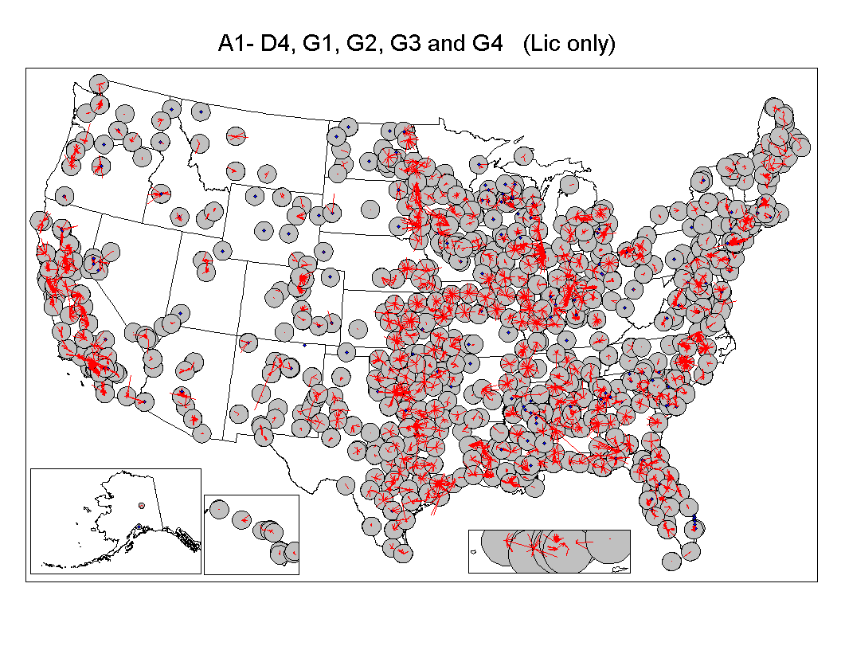

MDS originally was licensed on a site-specific and channel-specific basis as well. Because MDS was a point-to-multipoint service, the Commission provided interference protection to receivers located within a PSA of 24.1 kilometers (15 miles), later expanded to 56.3 kilometers (35 miles), surrounding licensed transmit sites. In 1995, the Commission decided to license all available MDS channels on a wide-area basis. In 1996, the Commission allotted, through a simultaneous multiple round bidding process, one MDS authorization for each of the 487 Basic Trading Areas (BTAs) and six additional BTA-like geographic areas. The BTA licensees are authorized to construct facilities to provide service over any usable MDS channels within the BTA and have preferred rights to the available ITFS channels. Today, some incumbent site-specific MDS licensees continue to provide service within PSAs that either overlap with or lie within licensed BTAs. Figure 3.3 below depicts current MDS channel usage.

Figure 3.3: Current MDS Channel Usage
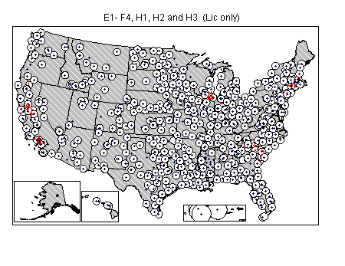

As discussed above, the Two-Way Order allows both ITFS and MDS licensees to modify the historic band plan and to operate with subchannels or superchannels. In effect, the traditional channel boundaries across the band are erased, but the geographic protection areas licensed to a particular band segment remain for interference protection purposes. This has practical consequences for combined systems that utilize interleaved channels from both MDS and ITFS channel groups. For example, channel B1 is immediately adjacent to channel A1. Protection of the BTA boundary would only apply to the band segment licensed under the MDS channel group, whereas a 56 kilometer (35 mile) PSA boundary would apply to the band segment licensed under the ITFS channel group or MDS stations authorized prior to the BTA auction. Consequently, the actual overlay of BTA and PSA boundaries would be a relevant consideration in determining the actual service area boundary of a superchannel that crosses historic band channel boundaries.

As a result of the 1998 Two-Way Order, MDS and ITFS licensees are modifying their facilities to add transmit paths and to modify channel usage to accommodate the introduction of new two-way services. MDS entities have been able to provide two-way service on MDS channels located at 2150-2160 MHz since 1998, but given the complex interference environment in the 2500-2690 MHz band, the Commission adopted a specific authorization process in the shared band. To ease the transition to two-way service and allow time to resolve potential interference conflicts, the Commission decided to announce an initial filing window for two-way modification applications for the 2500-2690 MHz band. Subsequent to this initial licensing process, two-way applications will be processed under a rolling one-day filing window. The Commission requires specific types of MDS and ITFS facilities be licensed, including main stations, hub stations, and high and low power booster stations. In addition, licensees will have to provide notice to other users of the band of some high power receive sites because of potential interference conflicts.

The initial filing window for two-way service in the 2500-2690 MHz band occurred from August 14, 2000 until August 18, 2000. Applicants had to certify that they met all requirements regarding interference protection to existing and proposed facilities or had received the necessary consent letters. In addition, applicants were required to serve all potentially affected parties with copies of their application and engineering materials. Any applications that do not certify that the requirements have been met will be dismissed. The Commission will conduct random audits prior to or after a license has been issued in reliance on a certification. If an audit reveals that an application is improperly certified, incomplete or contains a material error, the Commission will dismiss the application or revoke the license. Even after an application is approved, the licensee cannot cause unauthorized interference to any protected facility. If such interference is documented, the licensee must immediately cease operations. Figure 3.4 depicts current ITFS/MDS applications on file with the Commission.

Figure 3.4: Current ITFS/MDS Applications
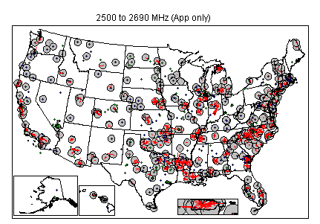

ITFS/MDS SYSTEM CHARACTERISTICS

The architectures and technical characteristics of ITFS/MDS systems in the 2500-2690 MHz band vary and depend on the type of service being offered, the population of the market being served, and terrain characteristics of the area being served. Today there are four basic service offerings by ITFS/MDS operators: analog video, digital video, unidirectional digital data, and bi-directional digital data. An ITFS or MDS system may be providing any one of these services or a combination of services.

The typical system characteristics of traditional one-way ITFS and MDS systems as well as proposed two-way ITFS and MDS systems is considered below. In Appendix 3.5, the specific technical characteristics for stations in traditional one-way ITFS and MDS systems are provided in Tables 3-A (base stations) and 3-B (response stations). These are primarily specifications for analog systems, and they also apply to any digital system authorized prior to the adoption of the Two-Way Order in 1998. In Appendix 3.5, the specific technical characteristics for stations in two-way ITFS and MDS systems are provided in Tables 3-C (base stations) and 3-D (response stations). These are primarily specifications for two-way digital systems that have been authorized since 1998.

Traditional One-Way ITFS Systems

Traditional one-way ITFS systems provide one-way video transmission service to their users. In such a system, a main station transmitter broadcasts (usually omindirectionally) to multiple receive sites located within the system service area, typically a radius of 56.3 kilometers (35 miles). Such receive sites are typically at schools or similar facilities where a reception antenna can be located on a tower or roof in order to provide a line-of-sight path back to the main station location. A 125 kHz response station transmitter may be located at any or all of the receive sites to enable students (and/or faculty) at the receive site to communicate with faculty (and/or students) at the main station site. One or more booster stations may be used to retransmit the main station signal to locations where the signal cannot be received directly, e.g., where there is terrain blockage. Most systems make use of standard 6 megahertz composite NTSC video/audio modulation for the downstream signal and wideband FM for response transmissions.

Traditional One-Way MDS Systems

Traditional one-way MDS systems provide one-way multichannel video programming to subscribers, a service known as “wireless cable.” Wireless cable systems operate similar to ITFS systems, with a main station transmitter broadcasting (usually omnidirectionally) multiple channels of fee-for-service entertainment television programming to customer premises located within the MDS service area. Each customer typically has a tower-mounted or rooftop-mounted reception antenna and is connected, via a block downconverter, to one or more television sets. As in ITFS systems, an MDS system makes use of booster stations to achieve coverage in portions of the service area where direct coverage from the main station is impossible. Also in common with ITFS systems, most MDS systems make use of standard 6 megahertz composite video/audio modulation, although a few systems have implemented digital modulation in recent years.

Two-Way ITFS/MDS Systems

The Two-Way Order introduced a wholly new method of configuring MDS and ITFS systems. In discussing the technical aspects of ITFS/MDS systems, it is important to be familiar with the following terms:

Main Station: The primary station authorized by the Commission to the MDS or ITFS licensee for providing coverage within a given service area. A maximum station power of 33 dBW (per 6 megahertz bandwidth) EIRP is permitted.

Booster Station (high power): A station used by an ITFS or MDS licensee to provide service within a given service area to locations not served by the main station. Any number of such stations may be located within a given service area and they may both repeat main station transmissions and originate transmissions. These stations operate at a power level greater than -9 dBW up to a maximum of 33 dBW (per 6 megahertz bandwidth) EIRP.

Booster Station (low power): Same as above except limited to a maximum power of –9 dBW (per 6 megahertz bandwidth) EIRP. These stations may be activated without prior Commission approval and operate so long as they do not cause harmful interference.

Receive Site: A location at which a receiver is located and used in conjunction with an ITFS system. A site may be 'registered’ (with the Commission) and thus protected from harmful interference or ‘unregistered’ and not protected from interference in certain circumstances.

Response Station (traditional): A transmitting station used within a traditional, one-way ITFS system for transmitting an audio signal from a receive site back to the main station using 125 kHz ‘response channels’ located in the 2186-2190 MHz range.

Response Station (two-way system): A customer-premises transceiver used for the reception of downstream and transmission of upstream signals as part of a large system of such stations licensed under the authority of a single license. A maximum EIRP of 33 dBW (per 6 megahertz) is permitted.

Hub Station: A receive-only station licensed as part of a system of response stations in a two-way system and used for the purpose of receiving the upstream transmissions of those response stations.

Sectorization (at main or booster stations): The use of multiple directional transmitting antennas for the purpose of achieving simultaneous frequency re-use at a single site.

Sectorization (at hub stations): The use of multiple directional receiving antennas for the purpose of receiving transmissions on the same frequencies from multiple directions simultaneously.

In a two-way MDS or ITFS system, a main station transmitter is used to send data using digital modulation to numerous users. Each user has at least one response station transceiver with its receive antenna oriented towards the main station and its transmit antenna oriented towards its associated hub station. Typically, a large number of response stations will be served by a single main station and by a single hub station linked to that main station, and in most cases these stations will be co-located. Additionally, typical systems will utilize numerous booster stations, each of which serves its own system of response stations and is associated with its own hub station. In this way, the system service area can be ‘cellularized,’ similar to cellular telephone systems, in order to facilitate frequency reuse. Two-way systems using digital modulation may also ‘subchannelize’ and ‘superchannelize’ their authorized spectrum on a real-time dynamic basis to meet needs within the system. There is no limit on the number or locations of response stations so long as the aggregate interference generated by the stations within the system falls at or below the level required for protection of neighboring systems. Bandwidths and associated data rates may be symmetrical or asymmetrical for upstream and downstream paths, dependant on system architecture and the nature of the service(s) provided. ‘Hybrid’ systems are also permissible, consisting of both ‘traditional one-way’ and ‘two-way’ operations within the same service area.

While different providers use different types of equipment, two-way systems operate in generally the same way. Through a computer, a user sends a request for data or a Web page to the MDS modem. The MDS modem sends the data request to the receiver/transmitter on the user’s roof. The receiver/transmitter sends the data within the 2500-2690 MHz band at speeds up to 10 megabits per second to the MDS provider’s receive/transmit tower. The tower relays the data request through the MDS provider’s network to the Internet Service Provider (ISP) facility. The ISP receives the request and retrieves data either from its servers or from the Internet over its high-speed backbone connection. The ISP then returns the data via the MDS provider’s network to the receive/transmit tower. The transmit site sends the data within the 2500-2690 MHz band at speeds up to 10 megabits per second to the receiver on the user’s roof. The roof-mounted receiver relays information to the MDS modem. The modem passes the information to a stand-alone PC or Macintosh computer, or to multiple users in seconds. Figure 3.5 shows a pictorial representation of how an MDS system works.

Figure 3.5: How An MDS System Works
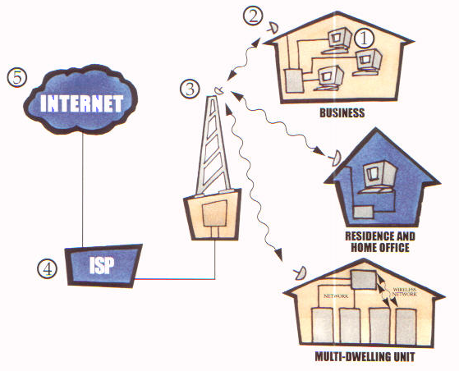

- Data query sent from computer to MDS modem.

- MDS modem sends data to small transceiver on customer premise.

- Transceiver sends request to MDS base station.

- MDS base station connects to telephone network and then to the internet.

- The data then returns back the same path to the customer – at 128 kbps up to 10 Mbps.

In the wake of the Two-Way Order, MDS equipment manufacturers have begun developing new ways to use the available MDS spectrum more efficiently, such as sectored antennas and advanced modulation techniques. For example, Wireless Online utilizes an antenna technology that enhances the coverage, quality, and capacity of MDS networks. NextNet, Inc. has developed a sectorized base station that uses 6 megahertz channels, with each of the six 60-degree sectors of the base station occupying one channel. The system minimizes multi-path signal propagation and reportedly delivers maximum user capacity per spectrum allocated. Hybrid Network, Inc.’s equipment allows carriers to split one 6-megahertz channel into three 2-megahertz channels and thereby offer different levels of service using the different 2 megahertz channels. Also, in December 1999, Cisco Systems released a cellularization technology for MDS and unlicensed spectrum called VOFDM (“Vector Orthogonal Frequency Division Multiplexing”). VOFDM captures signals as they bounce off buildings and other objects and redirects them to end-user transceivers, therefore eliminating the need for a fixed line-of-sight between a transmitter and a receiver. Nucentrix recently completed a field trial of Cisco’s VOFDM equipment in Austin, TX and plans to deploy the technology in at least 20 markets by the end of 2001. WorldCom is also testing VOFDM in its Dallas trial. All of these innovations permit MDS licensees to make ever more effective use of their spectrum.

ITFS/MDS Interference Protection Standards

The calculation of permissible interference levels on an inter-system basis is extremely complex. The requirements for MDS system protection are set out in sections 21.902, 21.909, 21.913, 21.933, 21.937 and 21.938 of the Commission’s rules. The requirements for ITFS system protection are set out in sections 74.903, 74.939, 74.949 and 74.985 of the Commission’s rules. Additional requirements and procedures for interference protection for stations in both services are found in Appendix D (titled “Methodology”) to Report and Order on Further Reconsideration and Further Notice of Proposed Rulemaking in MM Docket 97-217. Interference is calculated using undesired/desired (D/U) signal ratios and field values that are always referenced to the bandwidths of the two signals involved in the calculation. The D/U values specified in the MDS and ITFS rules are normalized to 6 megahertz and all calculations are based on these normalized values. Interference is also calculated using a reference field strength value specified in dBW per square meter, and this value is also always referenced and normalized to 6 megahertz bandwidth.

The geographical areas for MDS systems that must be protected fall into 3 basic categories. First, there are protected service areas (PSA), typically with a 56.3 kilometer (35-mile) radius, for “incumbent” MDS licensees who received their authorizations prior to March 1996 when the MDS channels were auctioned nationwide. The second geographic classification is a Basic Trading Area (BTA), including portions of BTAs that are created when a BTA is partitioned. Finally, ITFS registered receive sites within an area swept by a 35-mile radius surrounding the main station transmitter are entitled to protection.

Interference is calculated using ‘aggregated’ values for the power flux density on any given channel, subchannel or superchannel, i.e., interference potential is based on the summation of all of the individual potential interference contributions of all of the transmitters within a system which might be received in a neighboring system. Aggregation must be used for calculation of both desired to undesired (D/U) signal ratios and field values.

Interference protection is calculated with reference to specific, known locations in an ITFS system, and to general geographic areas. The calculation is done using a grid of points laid out checkerboard fashion using a reference antenna pattern and a reference standard antenna height above ground level (AGL).

The most interference-sensitive portion of a two-way system is the hub station receiver. This receiver must be protected down to its ‘noise floor’ by all neighboring systems, using a calculation that takes into account its noise figure, feedline loss, antenna gain and other pertinent factors. All ITFS/MDS interference calculations must utilize the Epstein-Peterson propagation formulations found in the Methodology. Because the locations of response stations in two-way systems are not known prior to licensing of the system, a totally theoretical construct was devised for estimating interference from response stations into neighboring systems.

SECTION 4

STUDY ASSUMPTIONS AND METHODOLOGY

The Study Plan calls for an analysis of the ability of 3G systems to share spectrum with incumbent services in the 2500 – 2690 MHz band. The Study Plan also calls for an analysis of the possible segmentation of this spectrum to accommodate 3G systems. In order to perform these analyses, certain assumptions about the technical characteristics of 3G systems and incumbent systems must be made. The assumptions made for purposes of these analyses are discussed in this section.

These analyses may need to be revised to take into account additional information that may be gained through discussions with industry, further international studies on 3G, and the planned FCC rule making. The assumptions made at this time do not prejudge or foreclose consideration of other options at a future date.

SYSTEM TECHNICAL CHARACTERISTICS

Future 3G Systems

As an initial matter, it is not expected that the Commission will mandate use of any particular standards for 3G systems and is likely only to establish minimal requirements to control radio frequency interference and to protect against human exposure to radio frequency energy. However, in order to perform technical analyses of the ability of 3G systems to share spectrum with incumbent systems certain assumptions were made about the likely technical characteristics of 3G systems, such as the power levels likely to be used by base stations and mobile units and the bandwidths of 3G signals. Where appropriate the ITU technical standards for IMT-2000 systems, which are described in Section 2, were used. Table 2-A in Appendix 2.2 describes the characteristics of IMT-2000 mobile stations, and Table 2-B describes the characteristics of IMT-2000 base stations.

Incumbent ITFS and MDS Systems

Additionally, certain assumptions about the technical characteristics of ITFS and MDS systems were made. For purposes of this Initial Report, the technical characteristics currently employed by ITFS and MDS systems in the 2500-2690 MHz band were used. These system characteristics are described in Section 3. Appendix 3.5 describes the technical characteristics of one-way base and receive stations and two-way base and response stations. It is recognized that some of the assumptions about the technical characteristics of ITFS and MDS systems may have limitations. For example, while the interference protection ratios that currently apply between MDS and ITFS systems were used, the appropriate interference protection ratio could vary where the source of interference is a 3G signal. Additionally, current regulations provide flexibility to MDS operators to design their systems as they see fit, so the ability of these systems to reject interference from 3G systems may vary. Thus, the assumptions regarding the appropriate interference protection ratios must be examined further and may be modified for the final report.

SPECTRUM REQUIREMENTS FOR 3G SYSTEMS

In order to perform an analysis of band segmentation options, certain assumptions about the overall amount of spectrum that may be made available for 3G systems in the 2500–2690 MHz band have been made. Several factors are important in making this determination.

As an initial matter, the impact on incumbent services of any spectrum that is made available for 3G systems must be made. While it may be feasible to offset reductions in the spectrum available for incumbent systems by improving spectrum efficiency, this has its limitations. Further, it is anticipated that the options for replacement spectrum may also be limited. Therefore, it has been assumed that a substantial part of the 2500–2690 MHz band will continue to be required to support MDS and ITFS operations.

A number of options are under consideration in the ITU for either developing IMT-2000 for independent operation in the 2500-2690 MHz band or to pair some portion of this spectrum with other bands. It is not clear at this time that pairing this spectrum with other bands is feasible. Therefore, for purposes of this Interim Report, it is assumed that 3G systems would operate independently in this band.

If 3G systems were implemented independently in the 2500–2690 MHz band, sufficient spectrum would need to be made available to support multiple licensees to promote competition. Also, the spectrum would need to be of sufficient size to enable development of systems that are economically viable and support the economies of scale necessary to warrant development of transmitters, antennas, consumer handsets, and other related equipment. For example, the Commission has allocated a total of 120 megahertz of spectrum for Personal Communications Service (PCS) in the 1.9 GHz band, which provided for three licenses of 30 megahertz and three licenses of 10 megahertz in each geographic area. Also, a number of European countries have recently made spectrum available for 3G services in excess of 100 megahertz.

Spectrum also must be made available in contiguous blocks of some minimal size, both to facilitate reasonable system design and to allow choice in available technologies. For example, wideband CDMA technology requires a minimal spectrum block size of about 5 megahertz paired, duplex operation would require two blocks of 5 megahertz.

In light of these factors, it is assumed that 90 megahertz of spectrum would be made available for 3G systems for purposes of this Interim Report. This would continue to leave more than half of the current spectrum available for ITFS and MDS. It would also provide sufficient spectrum for multiple licenses. For example, an allocation of 90 megahertz could provide for three licenses of 30 megahertz each, or three licenses of 20 megahertz each and three licenses of 10 megahertz each.

A variety of other technical factors may also be relevant to determining spectrum requirements for future 3G systems. These include constraints on the separation between paired frequency blocks for frequency duplex technologies, compatibility with existing channeling plans for incumbent systems, adjacent channel interference, and backward compatibility with existing 1G and 2G systems. It is also recognized that the traffic loading requirements for 3G data services, where downstream traffic is much greater than upstream traffic, may lead to asymmetric pairing of spectrum bands. These factors have not been recognized in this Interim Report, although they will be examined at a later time as specific options become clearer and more information becomes available.

STUDY METHODOLOGY

As suggested in the Study Plan, this Interim Report examines spectrum sharing and frequency band segmentation.

In the case of spectrum sharing, this Interim Report first evaluates whether 3G systems could operate on a co-channel basis with incumbent ITFS and MDS systems. Next, the Interim Report examines whether there is spectrum that is not currently used by ITFS and MDS systems that could be used by 3G systems.

With regard to band segmentation, several options are considered for making available 90 megahertz of spectrum for 3G systems in the 2500–2690 MHz band. The potential impact of these options on ITFS and MDS is evaluated. The costs and operating impacts to incumbent users are not examined at this time but will be considered in the Final Report.

SECTION 5

EVALUATION OF SPECTRUM SHARING

In this section a technical evaluation of options for sharing between 3G and incumbent operations in the 2500-2690 MHz band is presented. Specifically, this section evaluates the ability of 3G systems to share spectrum with current ITFS and MDS licensees. The technical feasibility of co-channel and adjacent channel sharing between licensed ITFS/MDS stations and 3G base and mobile stations is examined by calculating minimum distance separation requirements using the interference protection criteria established in the Commission’s rules for ITFS and MDS. ITFS/MDS licenses within the spectrum band are examined to assess where, in light of the minimum separation distances, 3G systems could operate without causing harmful interference to ITFS/MDS systems.

INTERFERENCE PROTECTION REQUIREMENTS

The technical characteristics used in this analysis include the five ITU IMT-2000 radio interface standards and the FCC’s rules for ITFS/MDS interference protection. Specifically, the analysis calculates the predicted levels of co-channel and first adjacent channel interference from 3G base and mobile stations into an ITFS/MDS licensees’ receivers at hub and response sites and determines the minimum distance separation required to avoid harmful interference .

Interference from a 3G system into the ITFS/MDS stations receivers’ could come from either the 3G base station or the 3G mobile unit. Because base stations are fixed, it is fairly straightforward to predict the interference from a 3G base station into ITFS/MDS receivers. We also analyze the effect that a single typical 3G mobile unit would have on ITFS/MDS receivers. We note that because mobile units could potentially operate at any location at any time, a complete analysis of the effect of multiple 3G mobile stations would require assumptions regarding their level of deployment within an area. Such assumptions are beyond the scope of this Interim Report.

ITFS/MDS services in the 2500-2690 MHz band tend to fall within one of four distinct architectures: 1) analog multichannel video distribution; 2) digital multichannel video distribution; 3) one-way digital data transmissions; and 4) two-way data transmissions. Although variations exist, a substantial number of technical characteristics are consistent across the four different architectures.

Each system architecture can be implemented utilizing a single main transmitter configuration. These systems typically have a single high power transmitter located at high elevation with an omnidirectional or wide cardioid antenna pattern. FCC rules set the maximum permitted EIRP for ITFS/MDS base stations at 2000 watts (33 dBW). Typical EIRP for analog systems are in the 100-1000 watt range and are slightly higher for digital or cardioid antennas. Both horizontal and vertical polarization are used and are often precisely calibrated to avoid co-channel interference to neighboring systems. Booster stations are also used in some systems designs to overcome signal loss within a protected service area.

In addition to single main transmitter designs, cellular architectures are being developed and deployed for two-way data transmission systems in densely populated areas. Because transceivers are located close together, power levels are scaled back for both downstream and upstream transmissions to between 1 and 100 watts EIRP, using the minimum necessary to achieve path reliability. Interference is controlled within the protected service area by careful frequency planning utilizing polarization, sector geometry and receive antenna isolation. Transceivers located at customer premises have downstream gains of 12 to 27 dBi, similar to that for single cell one-way system, and also have upstream gains of 10 to 24 dBi.

To determine co-channel and first adjacent channel protection requirements, technical characteristics specified in the FCC rules for a typical ITFS/MDS station are used. Current FCC rules require co-channel ITFS/MDS licensees to maintain a desired signal to undesired signal level (D/U) of 45 dB at all unobstructed areas within the 56.3 kilometer (35 mile) radius protected service area of an incumbent station. This is particularly important in analog single station architectures, where a high D/U ratio is required to maintain a high quality video signal. For digital single station architectures, the D/U ratio can be less than 45 dB as a practical matter because digital systems can tolerate more interference. However, FCC rules do not specify different D/U ratio values based upon whether the incumbent licensee is operating an analog or digital system. Therefore, for purposes of this study the required 45 dB D/U ratio for co-channel analysis is used. For the adjacent channel analysis, FCC rules specify that a D/U ratio of 0 dB be maintained. Tables 5-A and 5-B in Appendix 5.1 summarize the pertinent provisions of the FCC rules for ITFS/MDS response stations and ITFS/MDS main stations.

The analysis assumes two operating scenarios for 3G base stations based on the five IMT-2000 radio interface standards, one operating with high power – 500 watts EIRP (27 dBW), and one operating with low power – 10 watts EIRP (10 dBW). The analysis of the interference potential from an IMT-2000 mobile station into an ITFS/MDS receiver assumes the 3G mobile station is operating with 100 milliwatts EIRP (-10 dBW). The technical characteristics of the five IMT-2000 systems used in this analysis are summarized in Tables 2-A and 2-B in Appendix 2.1.

Table 5.1 shows the minimum spacing required to prevent interference between 3G base and mobile stations and ITFS/MDS hub and response station receivers based on the planning factors set forth in Tables 5-A and 5-B in Appendix 5.1. The required separation is first tabulated assuming free space conditions, as prescribed in the FCC’s rules for radio propagation predictions for ITFS/MDS service. However, as a practical matter interference does not extend beyond the radio horizon. FCC rules recognize this concept by setting 161 kilometers (100 miles) as a limiting distance for purposes of establishing minimum distance separations. Accordingly, if the calculated free space distance separation exceeds this limit, the practical limit of 161 kilometers (100 miles) is shown in the table.

Table 5.1: Calculation of Co-channel Separation Distances
of 3G Stations to ITFS/MDS Stations
ITFS/MDS  System Parameters |  | 3G System Parameters |  | 3G Base Station  (500 Watts) |  | 3G Base Station  (10 Watts) |  | 3G Mobile Station  (100 milliwatts)
Protected  Receiver  Type | Bandwidth  (kHz) | Modulation  Type | Bandwidth  (kHz) | EIRP  (dBW) | Minimum  Separation  (km) | EIRP  (dBW) | Minimum  Separation  (km) | EIRP  (dBW) | Minimum  Separation  (km)
Hub | 125 | CDMA | 1250 | 27 | 161 | 10 | 161 | -10 | 161
 | 125 | CDMA | 3750 | 27 | 161 | 10 | 161 | -10 | 148
 | 125 | W-CDMA | 5000 | 27 | 161 | 10 | 161 | -10 | 127
 | 125 | TDMA | 30 | 27 | 161 | 10 | 161 | -10 | 161
 | 125 | TDMA | 200 | 27 | 161 | 10 | 161 | -10 | 161
Response  Station | 6000 | CDMA | 1250 | 27 | 161 | 10 | 161 | -10 | 161
 | 6000 | CDMA | 3750 | 27 | 161 | 10 | 161 | -10 | 114
 | 6000 | W-CDMA | 5000 | 27 | 161 | 10 | 161 | -10 | 100
 | 6000 | TDMA | 30 | 27 | 161 | 10 | 161 | -10 | 161
 | 6000 | TDMA | 200 | 27 | 161 | 10 | 161 | -10 | 161

Similar to the analysis above, Table 5.2 tabulates the minimum spacing required to prevent interference between 3G base and mobile stations and first adjacent ITFS/MDS main and response station receivers.

Table 5.2: Calculation of Adjacent Channel Separation Distances
of 3G Stations to ITFS/MDS Stations
ITFS/MDS  System Parameters |  | 3G System Parameters |  | 3G Base Station  (500 Watts) |  | 3G Base Station  (10 Watts) |  | 3G Mobile Station  (100 milliwatts)
Protected  Receiver  Type | Bandwidth  (kHz) | Modulation  Type | Bandwidth  (kHz) | EIRP  (dBW) | Minimum  Separation  (km) | EIRP  (dBW) | Minimum  Separation  (km) | EIRP  (dBW) | Minimum  Separation  (km)
Hub | 125 | CDMA | 1250 | 27 | 101 | 10 | 14 | -10 | 1
 | 125 | CDMA | 3750 | 27 | 58 | 10 | 8 | -10 | 1
 | 125 | W-CDMA | 5000 | 27 | 51 | 10 | 7 | -10 | 1
 | 125 | TDMA | 30 | 27 | 161 | 10 | 93 | -10 | 9
 | 125 | TDMA | 200 | 27 | 161 | 10 | 36 | -10 | 4
Response  Station | 6000 | CDMA | 1250 | 27 | 161 | 10 | 99 | -10 | 10
 | 6000 | CDMA | 3750 | 27 | 161 | 10 | 57 | -10 | 6
 | 6000 | W-CDMA | 5000 | 27 | 161 | 10 | 50 | -10 | 5
 | 6000 | TDMA | 30 | 27 | 161 | 10 | 161 | -10 | 64
 | 6000 | TDMA | 200 | 27 | 161 | 10 | 161 | -10 | 25

These tables show, generally, that large co-channel separation distances are needed between 3G systems and ITFS/MDS systems to avoid causing harmful interference to ITFS/MDS systems. For example, a 3G base station, whether a high-powered 500 watt base station or a low-powered 10 watt base station, would need to be beyond the radio horizon of the ITFS/MDS station or 161 kilometers (100 miles) to avoid causing interference to co-channel ITFS/MDS receivers at either hub or response stations. Very low-powered 3G mobile stations must maintain distances between 100 kilometers (62 miles) and 161 kilometers (100 miles) to avoid causing harmful interference to co-channel ITFS/MDS hub and response stations. The results of this analysis of predicted level of interference and associated minimum separation distances are consistent with a similar study conducted by MSI. Adjacent channel separation requirements do not appear to be as limiting.

ITFS/MDS CHANNEL LICENSING

In this section, the 2500-2690 MHz band is examined to determine if there are any vacant channels (i.e., channels not currently licensed) that could be made available for 3G use. This study looks at channel availability in the 50 largest metropolitan areas in terms of population. To determine whether there are any vacant channels, the information in the FCC’s database as of November 6, 2000 was used. The database contains information on licensees, their channel number and geographic coordinates of the main transmitter. Using the licensing data, the number of ITFS/MDS channels licensed within 161 kilometers (100 miles) of the city center coordinates was determined for each of the 50 cities. Appendix 5.4 indicates the number of channels licensed per city. This analysis shows that in 49 of the 50 cities all 31 ITFS/MDS channels are licensed within 161 kilometers (100 miles). The exception is Salt Lake City where 5 channels currently are not licensed.

Maps have been drawn depicting the locations of hub and response stations and the protected service areas for each of the of 31 ITFS and MDS channels. Channel availability may be examined from both these composite maps and the maps of the individual channels. Appendix 5.3 contains a map for each of the 20 ITFS and 11 MDS channels. By way of example, close-up maps of one ITFS and one MDS channel in each of six cities are shown in Figures 5.1 through 5.12. As is explained in the sections below, the two channels shown (ITFS Channel A1 and MDS Channel E1) are representative of each of the ITFS/MDS channels.

In the figures in this section, the diamonds surrounded by shaded or white circles represent main transmit sites for MDS licenses and their 56.3 kilometer (35 mile) radius protected service areas. The diamonds without circles represent MDS hub receivers and/or transmit sites licensed prior to November 6, 2000 within auctioned Basic Trading Areas (BTAs). Grandfathered point-to-point ITFS registered receive sites are represented by the lines emanating from the centers of some circles. Auctioned MDS channels by BTA are also shaded.

Figure 5.1: Channel A1 in New York Figure 5.2: Channel E1 in New York
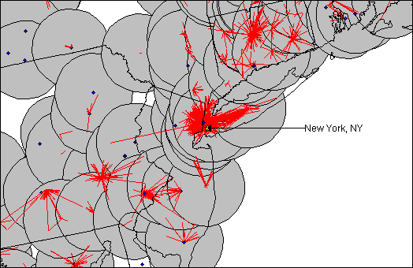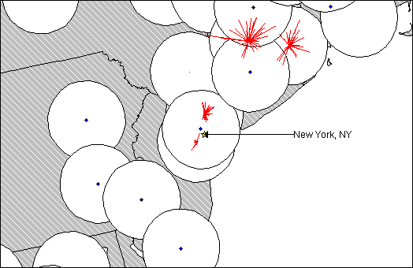

Figure 5.3: Channel A1 in Los Angeles Figure 5.4: Channel E1 in Los Angeles
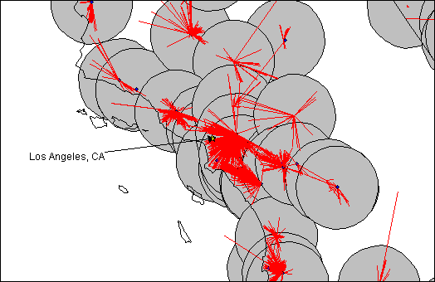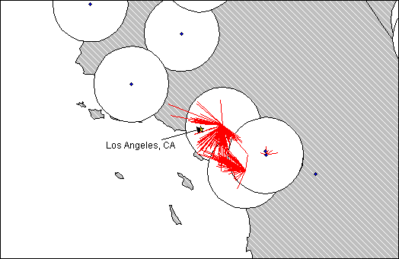

Figure 5.5: Channel A1 in Chicago Figure 5.6: Channel E1 in Chicago
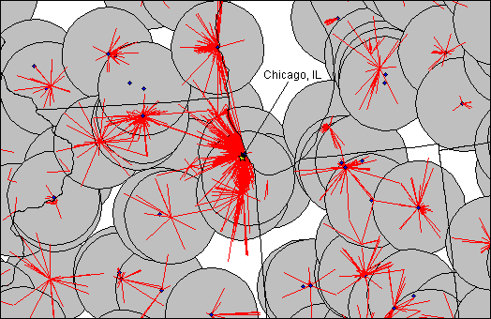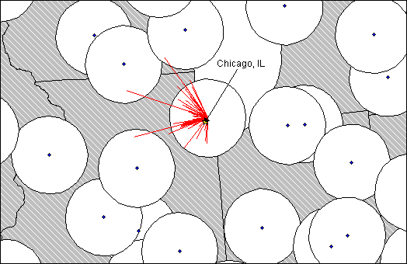

Figure 5.7: Channel A1 in San Francisco Figure 5.8: Channel E1 in San Francisco
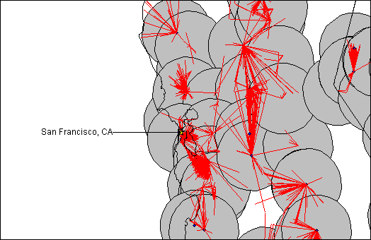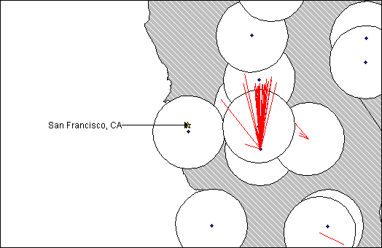

Figure 5.9: Channel A1 in Washington Figure 5.10: Channel E1 in Washington
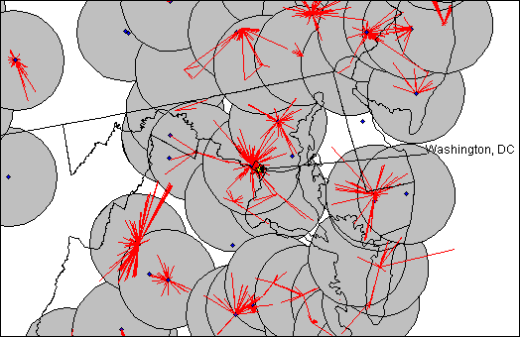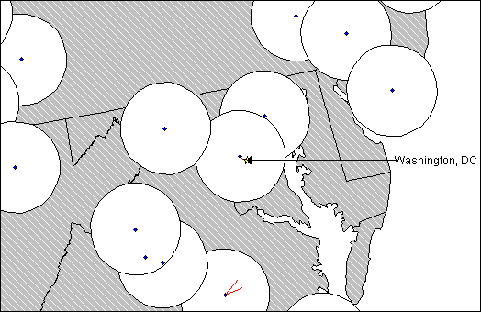

Figure 5.11: Channel A1 in Miami Figure 5.12: Channel E1 in Miami
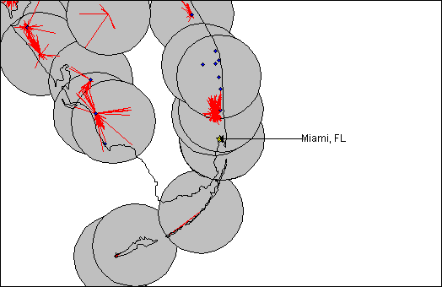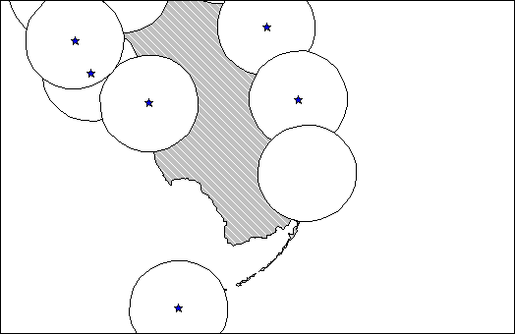

Geographic Distribution of MDS Systems

As noted in Section 3, the entire 66 megahertz allocated to the MDS service is encumbered throughout the entire United States. This is because the rights to provide MDS service in all areas of the country were acquired by winning auction bidders and are not subject to a site specific license and protected service area. Figure 5.13 is a nationwide composite of all 11 MDS channel site specific licenses, protected service areas and auctioned BTAs.

Figure 5.13: MDS Composite

In sum, Figure 5.13 illustrates that all MDS spectrum has been licensed throughout the entire United States. The majority of sites shown on the map denote incumbent MDS systems, however some sites (those shown without protected service areas) depict locations of MDS systems that have been built by geographic MDS licensees.

Recognizing that not all of the BTAs have been completely built-out, we next examine the actual occupancy of a sample MDS channel only where licensed facilities exist. This analysis is conducted solely for the limited purpose of this study and licensees and auction winners should not assume any change in current policy or Commission rules by this analysis. On the contrary, this analysis is being done in order to be as complete as possible in describing the occupancy of this spectrum band for purposes of assessing the feasibility of sharing with 3G systems. This analysis will also reveal whether MDS licensees might be positioned to partition an area within their BTA to prospective 3G system operators. By this we are simply recognizing the theoretical possibility that a geographic MDS licensee that does not build its system out in a portion of its BTA, could partition it to a 3G licensee who could then offer 3G services in that limited area.

Using the information available in the Commission’s database regarding MDS Channel E1 (2596-2602 MHz), for example, Commission staff have assembled an occupancy profile that contains a static snapshot of currently licensed MDS facilities. This profile is shown on the map in Figure 5.14. The gray crosshatched area shows that the entire country has been licensed on a geographic basis by BTAs. The white circles reveal where incumbent MDS facilities have been licensed. Looking at this from the perspective of Figures 5.1 through 5.12 above, this map shows that even if the geographic licensees were not considered, Channel E1 is currently licensed in each of the six cities shown on those maps. Accordingly, the 6 megahertz associated with Channel E1 is not available for 3G services in those cities. Additionally, analysis of the Commission’s licensing data and this map show that Channel E1 is already licensed in most of the densely populated areas of the country. Indeed, comparing Figure 5.14 with a population density map reveals that protected service areas currently exist in virtually all densely populated areas of the country. The relative population density map is seen in Figure 5.15.

Figure 5.14: Single MDS Channel E1
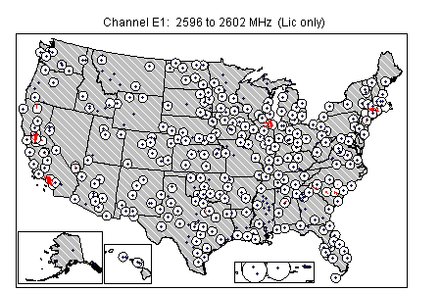

Figure 5.15: Relative Population Density
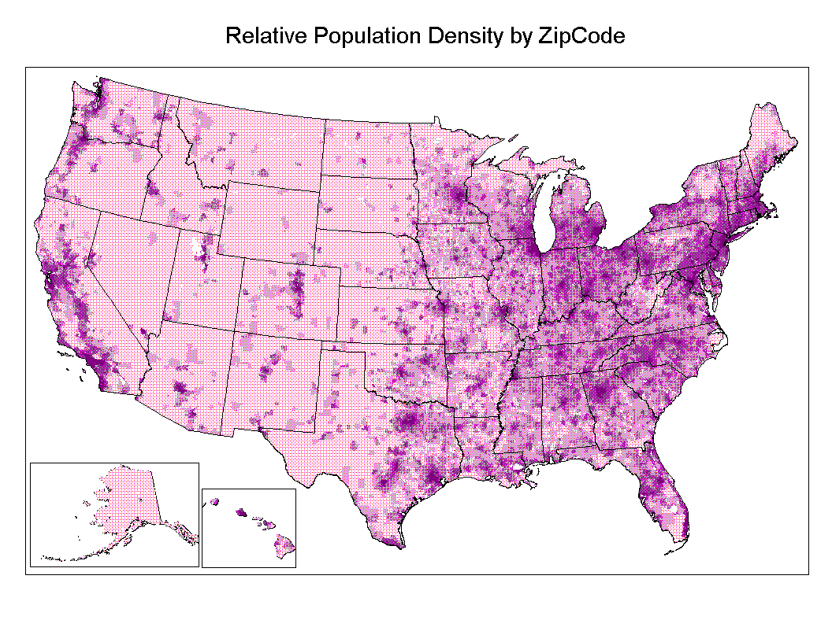

The gray crosshatched area in Figure 5.14 represents the area within which a 3G system may be able to operate, assuming the partitioning of the BTA and no further licensing of MDS Channel E1. However, as noted above, the gray area shown on this map does not reflect the finding that a co-channel 3G system would need a minimum separation of 161 kilometers (100 miles) – rather, this map reflects the much smaller 56.3 kilometer (35-mile) protected service areas of licensed MDS stations. Accordingly, the area available for co-channel 3G systems is significantly less than the area depicted. This can be seen in Figure 5.16 which reproduces the map of Channel E1 but substitutes 217 kilometer (135 mile) circles for the 56.3 kilometer (35 mile) protected service areas shown in Figure 5.14. Only in the very limited white space of Figure 5.16 would it be possible to locate a 3G station and maintain the 161 kilometer (100 mile) base station separation requirement.

Figure 5.16: Single MDS Channel E1 With 217 kilometer (135 mile) Protected Service Areas
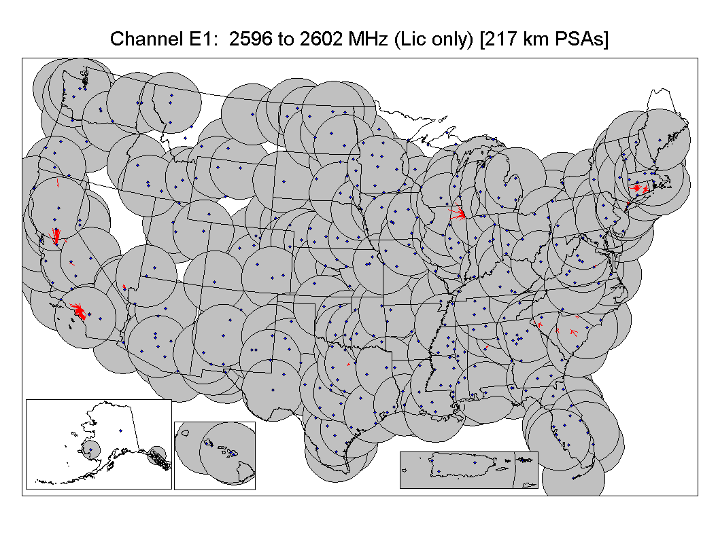

The maps in Appendix 5.3 demonstrate that use and occupancy of the 11 MDS channels is not significantly different for any MDS channel. It is apparent that each of the major metropolitan areas of the United States is encumbered with incumbent MDS systems. Accordingly, Figure 5.14 represents a fair illustration of the geographic availability of currently unoccupied MDS frequencies throughout the country.

Geographic Distribution of ITFS Channels

The same analysis as was done for the MDS channels is now done for the ITFS channels. Figure 5.17 is a composite of ITFS licenses on all 20 ITFS channels. As can be seen in the map, some of the registered receive sites extend beyond the protected service area; these sites are entitled to the same protection as those receive sites that are located within the protected service area. This composite of ITFS Channels A, B, C, D, and G, a total of 120 megahertz, illustrates the areas of the country currently encumbered by ITFS licenses. Similar to the results of the MDS analysis, Figure 5.17 shows that most of the United States is covered by at least one ITFS station.

Figure 5.17: ITFS Composite

Because the ITFS composite map only shows whether there is at least one station on any one of the 20 ITFS channels, the occupancy of a single ITFS channel is also examined. Figure 5.18 shows the occupancy for ITFS Channel A1 (2500-2506 MHz). Similar to MDS, it is clearly seen that the United States is heavily encumbered by ITFS operators on this channel. From the maps in Appendix 5.3, it is clear that each ITFS channel is similarly encumbered. Therefore, the map shown in Figure 5.14 is representative of each ITFS channel.

Figure 5.18: Single ITFS Channel A1
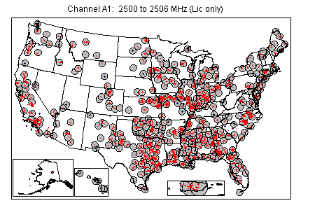

The white areas of this map reflect those areas of the country beyond the 56.3 kilometer (35-mile) protected service area of current ITFS stations. This reveals that only in the least populated areas of the country is ITFS spectrum not currently occupied. However, as noted above, co-channel sharing of 3G with ITFS/MDS may not occur within 161 kilometers (100 miles) of an ITFS/MDS receive site. Thus, the available area for locating a 3G system within the ITFS spectrum is significantly less than the white area depicted in Figure 5.18. To illustrate, this map is reproduced, but instead of depicting the 56.3 kilometer (35 mile) protected service areas, the circles are enlarged to 217 kilometers (135 miles) and show the areas of the country where a 3G system can be deployed without causing harmful interference. Only in the very limited white space of Figure 5.19 would it be possible to locate a 3G station and maintain the 161 kilometer (100 mile) base station separation requirement.

Figure 5.19: Single ITFS Channel A1 With 217 kilometer (135 mile) Protected Service Areas
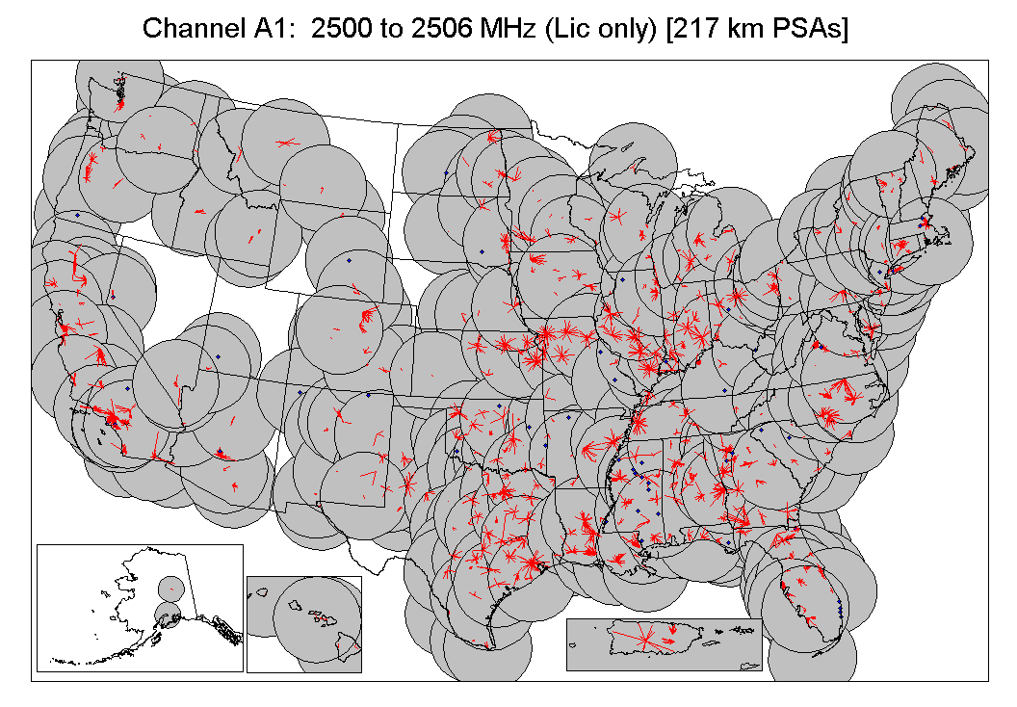

Composite Nationwide ITFS/MDS Geographic Channel Occupancy

Figure 5.20 is a composite of all encumbered area for the entire 2500-2690 MHz band: including licensed stations, but excluding the auctioned BTAs. The dark areas of the map are the ITFS/MDS protected service areas. Again, as noted before, these circles do not reflect the 161 kilometer (100 mile) distance separation required for co-channel operations. Also, as addressed above the Commission has auctioned all of the MDS channels nationwide on a BTA basis. Therefore these channels are already licensed nationwide and are not available currently for sharing with 3G operations.

Figure 5.20: Composite ITFS/MDS
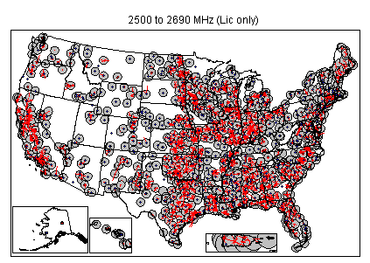

As this map reveals, ITFS and MDS channels are used in the major metropolitan areas. And, similar to the previous maps, the area available for possible 3G services within the 2500-2690 MHz band is significantly less than the white space shown when the 161 kilometer (100 mile) minimum distance separation requirement is considered. Accordingly, based on the assumptions used for this initial analysis, sharing between 3G systems and ITFS/MDS operations is extremely problematic. At this point, there does not appear to be enough spectrum in the 2500-2690 MHz band in the populated areas to support a viable 3G service. Voluntary partitioning between incumbent users and 3G operators, however, could offer some promise of sharing as an interim measure.

SECTION 6

BAND SEGMENTATION ANALYSIS

This section describes possible band segmentation options for the 2500-2690 MHz band. In this section, the analysis assesses the feasibility of dividing the 2500-2690 MHz band into segments or channels to meet the radiocommunications requirements for 3G systems and ITFS/MDS systems. Band segmentation would require a portion of the ITFS/MDS spectrum to be cleared and made available for 3G systems.

As noted in Section 2, for the purposes of this study, our analysis will assume that 90 megahertz of spectrum in the 2500-2690 MHz band is to be used for 3G service, and the remaining 100 megahertz of spectrum is to be used for ITFS/MDS. The amount of spectrum assumed for 3G use in this study has been chosen solely to illustrate possible band segmentation scenarios. It should not in any way be considered indicative of any position that the Commission may ultimately take on how much spectrum or which frequency band(s) should be used for the provision of 3G services.

Other factors are also relevant in analyzing various segmentation options. For example, as described in Section 2, five radio interface standards have been incorporated into the international standards for the terrestrial component of IMT-2000 by the ITU. As shown, these standards incorporate both Frequency Division Duplex (FDD) and Time Division Duplex (TDD) operation. Similarly, the architecture of planned new two-way MDS stations must also factor into our analysis. As described in Section 2, most planned implementations use FDD technology and require a separation of at least 30 megahertz between upstream (customer to base) and downstream (base to customer) transmissions. For FDD operation, this separation is necessary to provide sufficient isolation of upstream and downstream signals in the duplexer. Accommodations must also be made for TDD systems. These systems, which tend to be less robust than FDD systems, generally require a guard band between their band of operation and adjacent bands to minimize the potential of harmful interference.

Finally, when assessing the impact that any band segmentation option has on 3G or ITFS/MDS systems, the operational environment of these systems must be considered. Because 3G systems have not yet been implemented and because under a band segmentation approach they would operate on cleared spectrum, they have many options for their system design. ITFS/MDS systems by contrast have developed over the last 30 years and the effect of any band segmentation must consider the impact to how these systems are implemented today and are planned to be implemented in the future.

Three band segmentation options, as well as their implications, are discussed below.

TWO-WAY ITFS/MDS SYSTEMS: BAND PLANS

As discussed in Section 3, ITFS and MDS services will be deploying two-way systems in the 2500-2690 MHz band, subject to certain limitations arising from how the spectrum is currently licensed in any given geographic area. As noted, all MDS channels have been licensed on a BTA basis through the competitive bidding process. Geographic MDS licensees, in implementing their systems, must protect incumbent MDS systems licensed on a site-specific basis for thirty-five miles around each transmitter. With respect to ITFS channels, not all are licensed in all areas. However, where they are licensed, the MDS licensee may lease excess capacity on the ITFS channels, and MDS and ITFS licensees can broker channel swaps with each other. Additionally, geographic MDS licensees have limited ability to gain access to ITFS channels that are not licensed at this time. Because of the regulatory flexibility that the Commission has allowed in this band and the licensing differences between each geographic area, conclusions cannot be made regarding the implementation of a typical ITFS/MDS system.

To accommodate this flexibility, the MDS industry has initiated a number of band plans to accommodate new service offerings, such as two-way service, as well as to accommodate existing ITFS and MDS users. The figure in Appendix 3.4 shows a pictorial representation of the various band plans that MDS licensees are contemplating to accommodate the individual needs of different geographic areas. The sample plans presented in this figure are for study purposes only and do not reflect the varied options that could be deployed by ITFS/MDS licensees in the future. As seen in this figure, WorldCom has indicated three variations based on actual situations. WorldCom-1 depicts a scheme where two-way ITFS/MDS is overlaid in a market that has heavy ITFS video use. WorldCom-2 depicts a band plan that provides a single main transmitter and cellular configurations where video would be accommodated either on the two-way system or a limited number of ITFS channels. WorldCom-3 depicts a deployment that has to accommodate various individual licenses. Sprint and Nucentrix both indicate two generic plans each that depict asymmetric systems by grouping the upstream transmissions on either the upper or the lower channels. And as noted above, all plans depict a 30 megahertz separation between the upstream and downstream data transmissions.

BAND SEGMENTATION OPTIONS

Although the number of band segmentation options are extensive, three band segmentation options, presented in Figure 6.1 below, were examined as representative samples. In analyzing the impact that each of these options will have on 3G and ITFS/MDS systems, the functional and operational factors described in the previous section are included in the assessment.

Figure 6.1: Band Segmentation Options

Option 1 provides two 45 megahertz frequency blocks for 3G services and leaves the remaining 100 megahertz for ITFS/MDS in two 50 megahertz segments. A benefit of this option is that it provides frequency separation between paired channel blocks for both 3G and ITFS/MDS operations. As detailed above, this separation is necessary to implement systems using FDD technology, which the IMT-2000 radio standards as well as the two-way MDS implementations anticipate. Just as important, the ability to implement TDD systems is not precluded by this segmentation plan. An operator may implement FDD technology on any spectrum block for which it is licensed. To accommodate this possibility, guard bands between the 3G and ITFS/MDS segments have been included.

Further analysis of this option includes an examination of which current ITFS/MDS channels would be impacted. As can be seen from Figure 6.2, the placement of the 3G channels in this option coincide with the lower portion of the ITFS band (channels A1 through B4) and the MDS band (channels E1 through F4). This is problematic because, as described earlier, all of the MDS channels have been licensed on a geographic basis through the competitive bidding process and these geographic licensees have legal rights to build systems anywhere within their BTA that is not encumbered.

Alternatively, a similar segmentation plan with the 3G segments in the center and upper portion of the band (channels C1 through D4, channels G1 through G4, and channel I) may be considered. Under this scenario, 3G channels coincide with fewer MDS channels that have been sold at auction (the interleaved channels H1, H2, and H3) than the option depicted in Figure 6.1. This option, however, would cede the response channel (channel I) to 3G systems. This channel, is used for interactive systems, such as distance learning, to provide an audio channel so that persons at remote locations can converse with persons located in the studio. The response channel is currently able to be accessed by any licensee in the ITFS/MDS band.

Finally, the examination must assess the number of licensees that may be affected under segmentation Option 1. As can be seen in the following map, there are numerous systems deployed all over the United States that would have to be accommodated. Aside from the issues of finding suitable spectrum on which to move these systems and the economic costs involved in such an endeavor, the flexible nature of this band makes it extremely difficult to assess the actual impact that this segmentation option would have on currently deployed systems. Such an analysis would entail an examination of the complex interaction of stations in any given geographic area, including the way station operation is influenced by various lease arrangements and channel swaps.

Figure 6.2: ITFS/MDS Stations Affected by Segmentation Option 1.
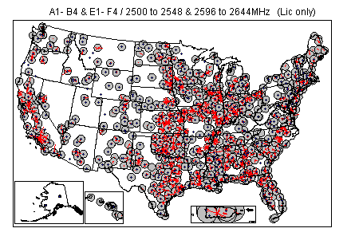

Option 2 provides a segmentation option in which both the 3G and ITFS/MDS spectrum is combined in a contiguous block. As seen in Figure 6.1, 90 megahertz of 3G spectrum is provided at the lower end of the band. The ITFS/MDS spectrum, including a single guard band, is located at the upper end of the band. The biggest drawback to this option is that 3G and ITFS/MDS operators would not be able to implement FDD technology unless suitable spectrum could be found with which to pair their respective segments. On the other hand, this option lends itself nicely to TDD technology for both 3G and ITFS/MDS systems. However, in the absence of paired spectrum, flexibility for any individual operator to implement the technology of its choice may be lost.

Under this option, the spectrum denoted for 3G systems would impact only ITFS channels (channels A1 through C4) and the channels that were auctioned to MDS would remain with that service. Because of this, the option as depicted provides a better choice than reversing the segments (i.e., placing the 3G segment at the upper portion of the band and the ITFS/MDS segment in the lower portion of the band) where the 3G segments would encompass all the MDS channels and the response channel (channel I).

Finally, as with the option presented above, the map shown below depicts the numerous stations that are currently licensed on the channels segmented to 3G systems. And as described above, the actual impact to any individual ITFS/MDS system due to clearing this portion of the spectrum for 3G systems cannot be determined unless a detailed analysis is undertaken for each geographic area.

Figure 6.3: ITFS/MDS Stations Affected by Segmentation Option 2.
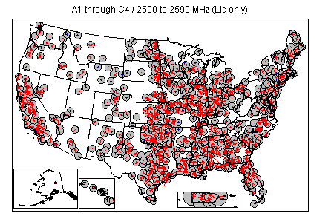

Option 3 provides a combination of options 1 and 2. Under this option, two 45 megahertz frequency blocks would be provided for 3G systems at the extreme upper and lower ends of the band. The ITFS/MDS spectrum is provided between these two 3G spectrum blocks. The frequency separation provided for 3G systems preserves the ability of system operators to implement FDD technology. And the inclusion of guard bands preserves the ability of both 3G and ITFS/MDS operators to implement TDD technology. The biggest drawback to this option is that it precludes the ability of ITFS/MDS operators to implement FDD systems without finding suitable paired spectrum. It is expected that most MDS operators contemplate implementing FDD for their new two-way systems.

Under this option, the channels segmented for 3G systems would encompass ITFS channels A1 through B4, and all the ITFS/MDS interleaved channels G1 through G4 plus the response channel (channel I). As described above for Option 1, this is problematic in that auctioned MDS spectrum would need to be retrieved to provide spectrum for 3G operators.

Finally, as with Options 1 and 2, there are numerous ITFS and MDS assignments that would need to be accommodated to implement this segmentation option. This is shown on the map below. And again, the actual impact to any given ITFS or MDS system cannot be determined without a detailed area by area analysis.

Figure 6.4: ITFS/MDS Stations Affected by Segmentation Option 3.
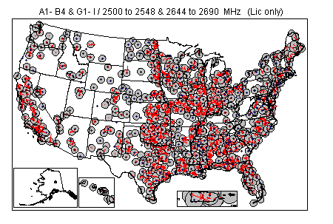

IMPACT OF BAND SEGMENTATION ON DEPLOYMENT OF ITFS/MDS SYSTEMS

The impact of each segmentation option has been described above. In addition, the impact of segmentation can be examined in more general terms. Specifically, regardless of segmentation option, it is worthwhile to examine the number of licensees that may be affected on any given channel. A review of the Commission’s licensing data as of November 6, 2000, indicates that each channel is similarly encumbered with a high degree of use in and around the major United States markets. (The figures in Appendix 5.3 depict the location of ITFS and MDS licenses for each channel.) As can be seen from these thirty-one figures, any band segmentation option would entail the widespread relocation of a large number of stations regardless of the segmentation option chosen.

Analyzing the licensing data currently shows that the number of licensed transmitters per one 6 megahertz channel averages over 4000 nationwide. Thus, within the framework of our assumption of 90 megahertz for 3G services, over 60,000 transmitters would have to be accommodated. It is important to note that these numbers are based on current ITFS/MDS deployment and the majority of these stations are incumbent operators. As geographic MDS licensees begin deploying two-way service, the number of stations will increase. This increase will be substantial because with two-way service, each subscriber’s location becomes an additional transmit site for upstream traffic. Therefore, for every transmitter that a geographic MDS licensee currently has licensed, there is the potential for many times that number to ultimately exist. Additionally, educational institutions could continue to be licensed ITFS stations where spectrum is available.

In light of the number of ITFS/MDS stations that need to be accommodated regardless of segmentation option and the current lack of suitable spectrum to which stations can move, options for increasing the spectrum efficiency of ITFS/MDS operations must be explored. Such use would entail the use of more spectrum efficient digital technologies through digital compression techniques. It must be noted, however, that these options, while possibly satisfying short term needs would hamper the long-term growth of this service. For example, if licensees were to implement digital compression due to band segmentation, they would be doing so on less total spectrum than they currently have available. Thus, the upper limit on the number of channels they can provide is reduced from what it would be if segmentation were not implemented. It also must be noted that, while many operators have been or are planning to implement digital technologies, there are still many operators who provide analog TV service and have made no plans to change. Therefore, digital techniques are not a panacea for the entire universe of incumbent operators and any band segmentation option that may be contemplated must account for all of the varied uses and implementations of incumbent licensees.

Another issue that must be addressed under any segmentation option is that of ITFS station downconverter overload. That is, ITFS receive stations are vulnerable to interference from digital MDS response stations. Such interference, intermittent and noise-like in nature, could occur if a transmit site is located nearby an ITFS receive site regardless of the frequency separation between the stations. This situation was addressed in the Two-Way Order and certain coordination requirements were placed on MDS licensees to minimize this possibility. The effect of this situation on 3G systems is that under the contemplated segmentation options, even if there is frequency separation between 3G and ITFS stations, this type of interference could occur from the 3G system to the ITFS system and render it unusable.

IMPACT OF BAND SEGMENTATION ON CELL SIZE

Another factor that must be examined under any band segmentation option is the effect the reduction of available spectrum for ITFS/MDS has on cell size (i.e., the effect that squeezing ITFS and MDS stations into less spectrum will have on the size of service areas). Figure 6.5 below indicates the amount of spectrum needed per cell site to serve customers within a specified distance from that site. As illustrated by the figure, it is evident that if the total amount of spectrum available to an MDS licensee is reduced, that licensee, to continue providing an acceptable grade of service to its customers, must reduce the cell size. As cell size is reduced, the licensee must then make a business decision to continue operating the site with reduced coverage thereby reaching fewer customers or to add new sites to maintain the same coverage as it had prior to the reduction in available spectrum. The consequences of either of these options are clear. Either the licensee ceases to provide service to its customers in the outlying areas of its coverage area (most likely rural and underserved areas) or it must build and maintain additional transmit sites to cover these areas. For example, the figure shows that a single main transmitter operating with its full complement of spectrum can serve a cell with a 32 mile radius. If the total amount of spectrum for the ITFS/MDS service is reduced from 190 megahertz to 100 megahertz or by 47.4%, it is reasonable to assume that all operators are affected similarly (i.e., each operator must reduce its spectrum by 47%). Given this reduction, the chart shows that for a 45% reduction in available spectrum (55% of the total spectrum is available for the MDS licensee) an MDS licensee must reduce its cell radius to 23 miles to maintain the same bandwidth density or grade of service to its customers. Reducing cell size in this manner reduces the cell area by half from 3217 square miles to 1662 square miles. In this situation, it is expected that a licensee would require 3-5 transmitter sites to cover the same geographic area as the single main transmitter. Either option has adverse effects. Namely, the MDS operator either incurs a significant economic cost to build additional sites to continue serving its current customer base or the customers in outlying areas will cease to be able to receive service.

Figure 6.5: Cell Size As A Function of Available Spectrum

Based on our analysis of various segmentation options for the 2500–2690 MHz band, a few key findings can be made at this time. Any segmentation option that may be pursued should account for the flexible service configurations and offerings that incumbent and geographic licensees are currently implementing. Further, no segmentation option appears to be significantly better than another in terms of number of licensees affected. That is, regardless of any option that is considered a substantial number of licensees would need to be accommodated. Also, if segmentation is pursued, ITFS/MDS service providers may need to reduce their service areas and their ability to provide service to customers in outlying areas or add more transmitter sites may be affected. Finally, because of the complex licensing scheme present in this band due to the mix of auction winners, incumbent ITFS and MDS licensees and the channel swaps and lease agreements that have been implemented, blanket statements as to the effect of segmentation on any specific market area cannot be made. To fully understand the implications of any segmentation plan on the ITFS/MDS service, each geographic area would need to be analyzed individually.

If spectrum were to be reallocated from ITFS/MDS, careful consideration would need to be given to the options available to ensure the continued viability of these services. For example, it would be necessary to examine the extent to which service can be maintained in a reduced amount of spectrum by improving spectrum efficiency. Alternatively, it may be appropriate to identify additional spectrum in other bands. It may also be possible to satisfy some communications requirements by using alternative technologies, such as fiber optic communications. These issues will be examined more fully in the Commission’s planned rule making proceeding on spectrum allocations that may be made available for 3G services.

* NTIA, “Plan to Select Spectrum for Third Generation (3G) Wireless Systems in the United States,” released October 20, 2000, http://www.ntia.doc.gov/ntiahome/threeg/3g_plan14.htm. See Appendix 1.1 attached.
Principles for Reallocation of Spectrum to Encourage the Development of Telecommunications Technologies for the New Millennium: Policy Statement, FCC 99-354, released November 22, 1999.
Implementation of Section 6002(b) of the Omnibus budget Reconcilliation Act of 1993, Annual Report and Analysis of Competitive Market Conditions with Respect to Commercial Mobile Services: Fifth Report, FCC 00-289, released August 18, 2000.
Other international organizations that have worked with and through the ITU have proved instrumental in beginning to establish characteristics of 3G systems. These organizations include the Telecommunications Industry Association (TIA), the Third Generation Partnership Project (3GPP), the Third Generation Project 2 Partnership (3GPP2), the Internet Engineering Task Force (IETF), the Universal Wireless Consortium (UWC), the CDMA Development Group (CDG), the European Telecommunications Standards Institute (ETSI) and others.
See, e.g., “Vocabulary of Terms for International Mobile Telecommunications-2000 (IMT-2000),” Recommendation ITU-R M.1224 (1977), International Telecommunications Union, and “Key Characteristics for the IMT-2000 Radio Interfaces,” Recommendation ITU-R M.1455(2000), International Telecommunications Union.
See “Detailed Specifications of the Radio Interfaces of IMT-2000,” Recommendation ITU-R M.1457 (2000), International Telecommunication Union.
See Footnote 764A to the international Table of Frequency Allocations, Final Acts of the World Administrative Radio Conference for Dealing with Frequency Allocations in Certain Parts of the Spectrum (WARC-92), Malaga-Torremolinos, 1992.
Footnote 764A was renumbered to S5.388 and the reference to FPLMTS was changed to IMT-2000. See Final Acts WRC-97, World Radiocommunication Conference, Geneva, 1997.
Although the United States proposed the 1710-1885 MHz band for IMT-2000 use, the United States noted that existing United States personal communication service (PCS) licensees operate in the 1850-1910 MHz band. In the United States, nothing prohibits PCS licensees from providing terrestrial IMT-2000 services in spectrum in any bands allocated for the Commercial Mobile Radio Service (CMRS). Because the United States already permits IMT-2000 services at 1850-1885 MHz, no further study was deemed necessary for this portion of the internationally identified band.
Provisional Final Acts of WRC-2000, 2nd ed., Istanbul, Turkey, June 2000.
WRC-2000 acknowledged that, in some countries, the 698-806 MHz band is allocated to mobile service and that some administrations plan on using part of that band for IMT-20000. See Resolution 224, Provisional Final Acts of WRC-2000, 2nd ed., Istanbul, Turkey, June 2000. The Study Plan noted that the 698-746 MHz band could be considered in the United States for possible 3G use.
CITEL is an organization of North and South American administrations in Region 2.
CEPT is an organization of European administrations in Region 1.
See Resolutions 223 and 224, Provisional Final Acts of WRC-2000, 2nd ed., Istanbul, Turkey, June 2000.
See Resolution 223, Provisional Final Acts of WRC-2000, Istanbul, Turkey, June 2000.
In June, 1997, the European Radiocommunications Commission (ERC) designated 155 megahertz for IMT-2000 in Europe. The frequency bands identified for terrestrial use are 1900-1980 MHz, 2010-2025 MHz, and 2110-2170 MHz. More specifically, the ERC plan pairs 1920-1980 MHz (mobile) with 2110-2170 MHz (base) and leave 1900-1920 MHz and 2010-2025 MHz unpaired.
Due to the fact that the terms “MDS” and “MMDS” are often used interchangeably, some clarification is necessary with respect to use of those terms in this Report. In fifty markets in the country, Multipoint Distribution Service or “MDS” utilizes two 6 megahertz channels (Channel Nos. 1 and 2) in the 2150-2162 MHz band (in the rest of the country, the 6 megahertz No.2 channel is replaced by a 4 megahertz No. 2-A channel (2156-2160 MHz)). The shared spectrum between 2500 and 2690 MHz is referred to as the Multichannel Multipoint Distribution Service or “MMDS.” For purposes of this Interim Report, the term “MDS” will not only refer to the Nos. 1, 2, and 2-A channels located in the 2150-2162 MHz spectrum, but also the channels located in 2500-2690 MHz spectrum. When the terms "MDS systems" or "ITFS/MDS systems" are referenced throughout this paper, licensees may be using the MDS channels in the 2150-2160 MHz spectrum and various channels in the WCS (2305 to 2360 MHz) spectrum as part of those systems.
Nevada Bell is the licensee (WLL589-WLL619 and WLU983-WLU988) of a Time Division Multiple Access (TDMA) system providing telephone service to remote rural farms around Austin, NV. More than 50% of the subscribers on this system are Native Americans. The system operates on channels G3 and G4.
The City and County of Denver is licensed (WHW35) to use channel D1 to transmit video training programs to fire stations metro-wide.
In addition, nonprofit organizations formed to provide instructional material to enrolled students may also be licensees. Furthermore, nonprofit organizations that would be eligible to be licensees of noncommercial educational broadcast television stations are eligible to become ITFS licensees.
Because of the nonprofit nature of ITFS licensees and the licensees’ limited resources, it is difficult to compile information about the exact nature and type of educational programs being offered by the licensees to the public.
See In the Matter of the Request for Declaratory Ruling on the Use of Digital Modulation by Multipoint Distribution Service and Instructional Television Fixed Service Stations, 11 FCC Rcd 18839 (1996).
See The Mass Media Bureau Implements Policy for Provision of Internet Service on MDS and Leased ITFS Frequencies, 11 FCC Rcd 22419 (1996).
See Two-Way Order,13 FCC Rcd 19112 (1998), recon., 14 FCC Rcd 12764 (1999), further recon., FCC 00-244 (released July 21, 2000).
See MCI WorldCom Announces ‘Fixed Wireless’ Service Trials, PR Newswire, Mar. 7, 2000; Sprint Launches Wireless High Speed Internet Access Service in Houston, News Release, Sprint Corp., Oct. 4, 2000; Sprint to Launch First Broadband Wireless Service for Residential and Small Business Customers in Bay Area, News Release, Sprint Corp., Oct. 24, 2000.
Andrew Backover, Cable, DSL and Wireless Vie for Market Leadership, Denver Post, Jan. 24, 2000, available in 2000 WL 4450560 (citing the Strategis Group).
The Strategis Group predicts there will be 1.2 million residential and 300,000 business MDS broadband subscribers by 2003. U.S. Wireless Broadband: LMDS, MMDS and Unlicensed Spectrum, Peter Jarich and James Mendelson, The Strategis Group Inc., Feb. 17, 2000.
Analysts estimate that for a variety of technical, financial and operations reasons, cable modem and xDSL services cannot or will not meet the increasing demand for broadband by themselves. See, e.g., The Wall Street Journal, “[t]he cable industry’s rush to wire up America with high-speed Internet access is running into a serious problem: Too many heavy Internet users are crowding online at once, in some cases creating major bottlenecks and slowdowns.” Cauley, “Heavy Traffic is Overloading Cable Companies’ New Internet Lines,” The Wall Street Journal, at B1, B16 (Mar. 16, 2000). In addition, the need for cable operators to upgrade their plant for two-way capability (particularly in less densely populated areas) and the business strategies of the large cable MSOs suggest that cable modem service will not be ubiquitously available. See “Broadband! - A Joint Industry Study by Sanford C. Bernstein & Co., Inc. and McKinsey & Company, Inc.,” at 25-26 (January 1999). (“The nature of smaller and more rural systems -- often with less access to capital; less threat of competition; and less dense and, therefore, more expensive plant to upgrade -- keeps our forecast for [non-MSO] systems at about 15% upgraded. . . It’s worth pointing out that many of the cable upgrades to date appear to be targeted at the most attractive neighborhoods (i.e., high densities and high household incomes). On a homes-passed basis, we estimate that about 60% (12 million) of all high-income households in the U.S. are passed by upgraded cable plant.”) (the “Bernstein/McKinsey Study”). Ubiquitous xDSL services are unavailable due to factors that include “loop length (if loops are too long), presence of non-DSL compatible remote terminal technology (such as nearly all the legacy variety of digital loop carrier systems) as well as other aspects of deployed line electronics, such as load coils and bridge taps.” Bernstein/McKinsey Study at 25. Indeed, it has been estimated that existing telephone plant is “DSL capable” in only 44% of the residential market. See Id. at 26. See also “Next-Generation Networks Exploit Last-Mile Bandwidth,” TR’s Last-Mile Telecom Report (Feb. 24, 2000) <http://www.tr.com/newsletters/lmtr/sample.html> (quoting officer of Bell Atlantic Network Services as referring to DSL as an “interim strategy”); Cauley, “For Phone Companies Wiring the Web, a Surprising Speed Bump,” The Wall Street Journal, at B1 (Feb. 17, 2000).
“The Broadband Fixed Wireless Services Market Gains Momentum, According to IDC,” PR Newswire (Dec. 13, 1999). All totaled, it has been estimated that by the year 2005, seventy percent of the nearly 10 million estimated fixed wireless broadband subscribers will be served via ITFS/MDS.
Smith, “Wireless Rides To The Rescue,” Wireless Week, at 16 (Feb. 7, 2000).
See § 706 Pub. L. 104-104, Title VII, Feb. 8, 1996, 110 Stat. 153, reproduced in the notes under 47 U.S.C. § 157.
See In the Matter of Inquiry Concerning the Deployment of Advanced Telecommunications Capability to All Americans in a Reasonable and Timely Fashion, and Possible Steps To Accelerate Such Deployment Pursuant to Section 706 of the Telecommunications Act of 1996, CC Docket No. 98-146, FCC No. 00-290 (released August 21, 2000).
See Id.
See 47 C.F.R. § 21.901.
Report and Order in Gen. Docket No. 80-112 and CC Docket No. 80-116, 94 FCC2d 1203 (1983). The Commission reassigned eight channels in the E and F groups (2596-2644 MHz) from the ITFS entities to the MDS service. The Commission also grandfathered interference protection to existing ITFS applicants, permittees or licensees on these eight E and F channels, resulting in twenty-eight ITFS channels in some locales.
The Commission reallocated the H group channels from the Operational Fixed Service to MDS and made MDS operators eligible for authorization on vacant ITFS channels with specified restrictions. Second Report and Order in Gen. Docket No. 90-54, 6 FCC Rcd 6792, 6793-94, 6801-06 (1991), recon. denied, 7 FCC Rcd 5648 (1992).
See 47 C.F.R. § 74.939 (providing that the 2686-2690 MHz is divided into 31 narrowband (125 kHz) response station channels).
See 47 C.F.R. §§ 74.990, 74.991, 79.992; Amendment of Parts 21, 43, 74, 78, and 94 of the Commission’s Rules Governing Use of the Frequencies in the 2.1 and 2.5 GHz Bands, 6 FCC Rcd 6792, 6801-06 (1991). The rules provide that an MDS operator may be licensed on ITFS frequencies in areas where at least eight other ITFS channels remain available in the community for future ITFS use. In addition, no more than eight ITFS channels per community may be licensed to MDS operators. To be licensed on ITFS channels, an MDS applicant must hold a conditional license, license or a lease; must have filed an unopposed application for at least four MDS channels to be used in conjunction with the facilities proposed on the ITFS frequencies; and must show that there are no MDS channels available for application, purchase or lease. Finally, ITFS entities have the right to demand access to ITFS channels licensed to MDS operators. Today, some MDS entities have licenses for ITFS channels.
See Page 42 for an explanation of the symbols shown on the map.
Basic Trading Areas (BTAs) are based on the Rand McNally 1992 Commercial Atlas & Marketing Guide, 123rd Edition, at pages 38-39, with the following additions: American Samoa (492), Guam (490), Northern Mariana Islands (493), San Juan, Puerto Rico (488), Mayagüez/ Aguadilla-Ponce, Puerto Rico (489), and the United States Virgin Islands (491). For extensions and revisions by the Federal Communications Commission, see 59 FR 46195 (September 7, 1994); see also, <http://www.fcc.gov/oet/info/maps/areas/>.
Since the auctions concluded in 1996, there have been bankruptcy defaults for 4 of the auctioned BTAs. In 1997, the Commission adopted default orders for two of the BTAs, Hickory, NC and Hagerstown, MD. Commission action for two additional BTAs, York, PA and Reading, PA, is pending.
Keith Ross, Gearing Up for Two-Way Wireless, Private Cable & Wireless Cable, Oct. 1998.
This figure was provided by and used with the permission of WorldCom, Inc.
Sue O Keefe, MMDS: From Back Burner to Center Stage, Telecommunications, Sept. 1, 1999.
Wireless OnLine Adds Vice President of Product Management, PR Newswire, Jan. 5, 2000.
NextNet, Inc., Products (visited Jan. 20, 2000) <http://www.netwnetworks.com/products_prod_botton.html>.
Regional Wireless Operators Select Hybrid Networks’ 2-Way Today Solution to Launch Multiple Markets, PR Newswire, Jan. 10, 2000.
Cliff Edwards, Cisco Hopes Advances New Wireless Technology for Internet, AP Newswires, Dec. 2, 1999.
See Id.
Nucentrix Files for FCC Approval to Launch Broadband Fixed-Wireless Services, News Release, Nucentrix Broadband Networks, Inc., Aug. 21, 2000; Nucentrix Successfully Completes Initial Field Trial of Cisco Broadband Fixed-Wireless Solution, News Release, Nucentrix Broadband Networks, Inc., Aug. 15, 2000.
MCI WorldCom Adds Dallas to ‘Fixed Wireless’ Service Trials, News Release, WorldCom, Inc., Apr. 5, 2000.
See 47 C.F.R. §§ 21.902, 21.909, 21.913, 21.933, 21.937 and 21.938.
See 47 C.F.R. §§ 74.903, 74.939, 74.949 and 74.985.
See Appendix D, Report and Order on Reconsideration In the Matter of Amendment of Parts1, 21 and 74 to Enable Multipoint Distribution Service and Instructional Television Fixed Service Licensees to Engage in Fixed Two-Way Transmissions, MM Docket 97-217, 14 FCC Rcd 12764 (2000) (Methodology) for details. The Methodology is periodically refined to accommodate real-world technical concerns. See, e.g., Public Notice, Commission Amends Methodology Used for Calculation of Interference Protection and Data Submission for MDS and ITFS Station Applications for Two-Way Systems, DA 00-938, released April 27, 2000. A copy of the most recent version of the Methodology can be found at <http://www.fcc.gov/mmb/vsd/files/methodology.doc>.
See Id.
See 47 C.F.R. §§ 21.902, 21.909, 21.913, 74.903, 74.939, and 74.985. See also, Section 3 supra regarding ITFS/MDS Interference Protection Standards.
See Appendix 2.1 for a summary of IMT-2000 technical characteristics.
See 47 C.F.R. §§ 21.902, 21.909, 21.913, 74.903, 74.939, and 74.985.
ITFS/MDS receivers, for purposes of this interference analysis include not only response station receivers located at commercial customer premises and registered ITFS receive sites, but also the main station receivers associated with the main station transmitters. Main station receivers receive signals on 125 kilohertz response channels associated with each 6 megahertz channel.
For example, such assumptions may include statistics regarding how many mobile units may be operating in any given area at any one time and the calling patterns of users.
47 C.F.R. §§ 21.904 and 74.935.
See 47 C.F.R. §§ 21.902, 21.909, 21.913, 74.903, 74.939, and 74.985.
The minimum distance separation is rounded to the nearest kilometer. Additional data is available in Tables 5-C, 5-C, and 5-D of Appendix 5.1.
See 47 C.F.R. §§ 21.902 and 74.903.
See Id.
The minimum distance separation is rounded to the nearest kilometer. Additional data is available in Tables 5-F, 5-G, and 5-H of Appendix 5.1.
George W. Harter, MSI, “Feasibility Study on Spectrum Sharing between Fixed Terrestrial Wireless Services and proposed Third Generation Mobile Services in the 2500-2690 MHz Bands” October 2000. See Appendix 5.2.
The study used the center city coordinates and list of cities currently in the FCC rules for Part 90 licensees. See 47 C.F.R. § 90.741. We also confirmed that the list of 50 most populated cities had not changed significantly by comparing this list with 1999 data from the United States Bureau of the Census.
In Salt Lake City applications have been tendered for 4 of the 5 channels.
The circles depicted on the maps reflect the 56.3 kilometer (35 mile) radius protected service area provided for in the FCC’s rules, rather than a minimum distance separation zone as shown in the tables. Maintaining the standard protected service areas in the illustrations provides the reader a very conservative estimate of the potential unencumbered geographic areas for the 2500-2690 MHz band and recognizes the potential for engineering solutions that might permit sitings closer than the separation distances calculated above.
The differences in representation of the protected service area circles (gray on ITFS channels and white on MDS channels) is a function of the different licensing schemes used for these channels. Because MDS channels have been auctioned, the geographic licensee, subject to the interference rules, may place a station on any unencumbered area. Thus, all unencumbered area is shaded and white circles are overlaid on this area to show the location and protected service areas of incumbent MDS stations. In contrast, ITFS stations are only licensed on a site specific basis. Therefore, the location and protected service areas of these stations are shown as shaded circles on a white (no geographic licensees) background.
We note stations operated by geographic MDS licensees are not subject to the same interference protection as incumbent stations and that maps shown below depict a 56.3 kilometer (35 mile) circle around station locations currently in our database for incumbent MDS licensees. Stations operated by geographic MDS licensees are shown as diamonds without circles around them.
Partitioning is the assignment of a portion of a geographic licensees service area to another entity. This entity becomes the licensee for the indicated spectrum in the partitioned area of the service area.
The lightest areas on the population density map represent population densities up to 28,000 people per square mile and the darkest areas represent population densities over 114,000 people per square mile.
The circles are drawn with radius 217 kilometers (135 miles) rather than 161 kilometers (100 miles) to ensure that receivers located at the edge of the 56.3 kilometer (35 mile) protected service area are protected.
A duplexer is a device that permits alternative transmission and reception with a common antenna.
Although guard bands appear to be necessary to accommodate TDD operation, there is no data regarding how large they may need to be.
An architecture which uses a single main transmitter, sometimes referred to as a super-cell, uses a single base station to provide service over the entire service area. It is usually characterized by a tall tower and relatively high power. A cellular configuration, sometimes referred to as a mini-cell system, uses many cells to serve a geographic area. They will often use low towers and low power. A system comprised of a single main transmitter cannot add more capacity, whereas a cellular configuration can grow by subdividing and adding cells.
The limit on the number of customers that a two-way MDS system can accommodate cannot readily be estimated. It depends on the amount of spectrum available, the level of service each individual customer contracts for as well as the usage patterns in any specific area.
See Two-way Order at 45-47 and 56.
This figure was provided by Worldcom in a presentation to the FCC on October 11, 2000. It has been used with the permission of Worldcom.
In this case, the MDS operator needs appoximately 56 MHz total (32 miles x 32 miles =1024 square miles x 0.055 MHz/square mile) to serve customers in this cell.

