

BSO Tutorial for Tax Year 2007

Acknowledge Resubmission Notice

Contains the following lesson:

- Acknowledge Receipt of a Resubmission Notice Received from SSA

Lesson 1: Acknowledge Your Resubmission Notice

Follow the instructions below to acknowledge that you received a notice from SSA requiring you to resubmit your W-2 data.

Step 1: Point your browser to the Business Services Online Welcome page: www.socialsecurity.gov/bso/bsowelcome.htm.

Step 2: Select the Log In button on the Business Services Online Welcome page. The system displays the General Login Attestation page.

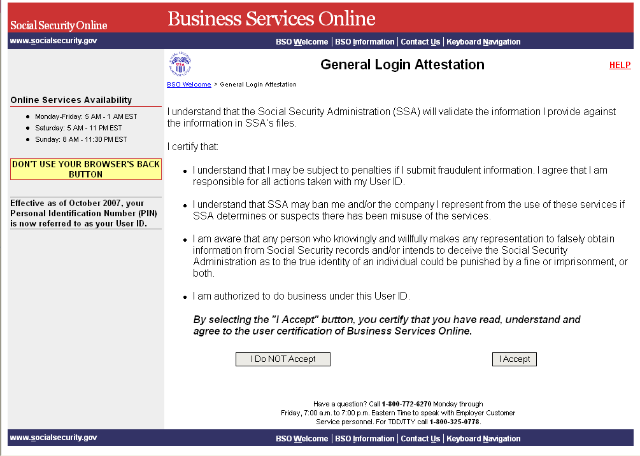

Step 3: Select the I Accept button after reading the conditions defined on the General Login Attestation page. The system displays the Log In to BSO page.

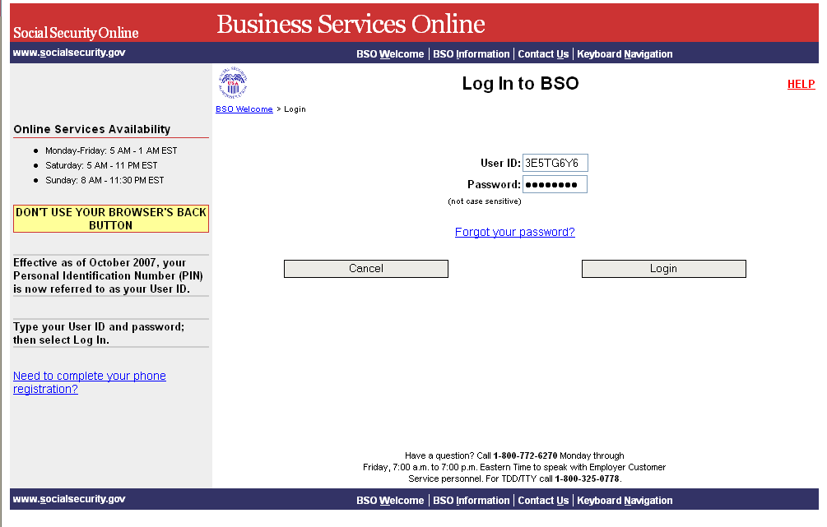

Step 4: Enter your User ID and password.

Step 5: Select the Login button. The system displays the BSO Main Menu page. (To return to the BSO Welcome page, select the Cancel button.)
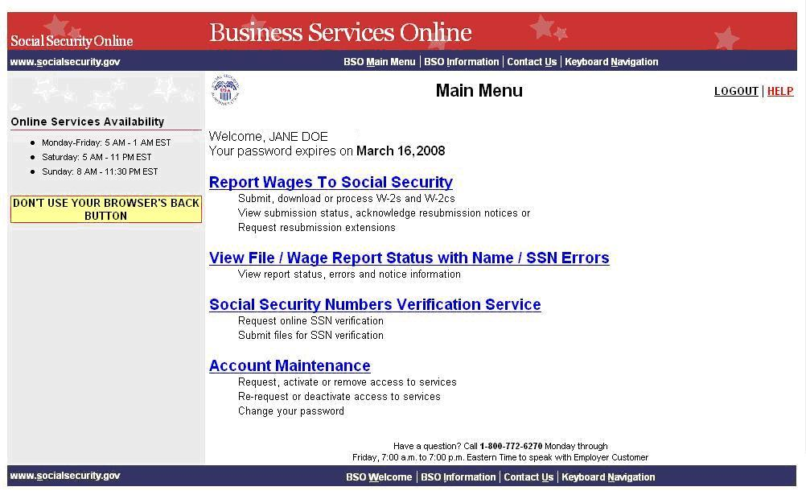
Step 6: Select the Report Wages to Social Security link.

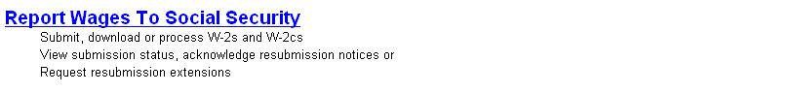

The system displays the Report Wages to Social Security menu page.

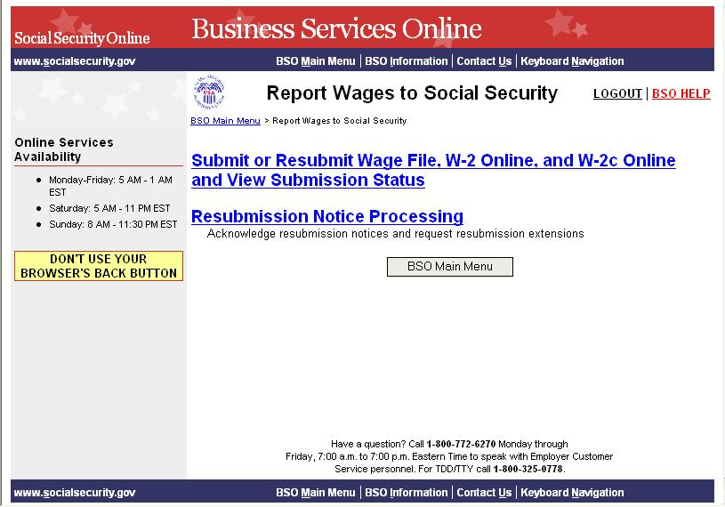

Step 7: Select the Resubmission Notice Processing link. The system displays the Resubmission Notice Processing menu page.

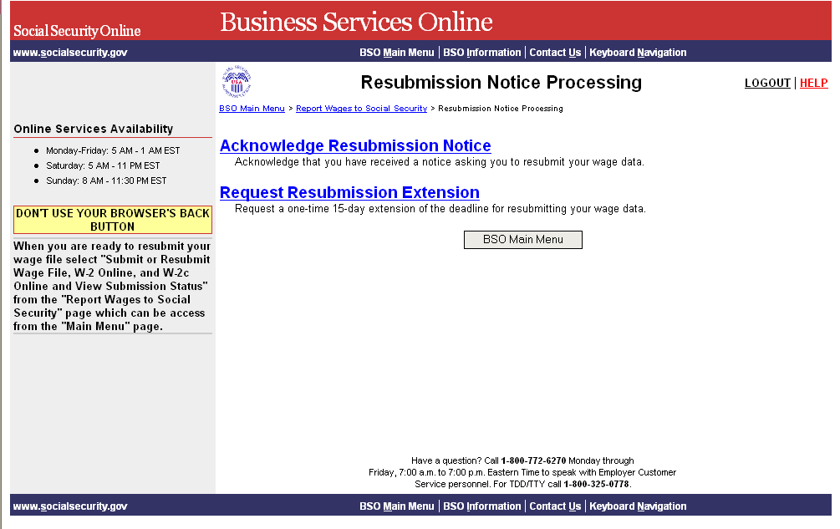

Step 8: Select the Acknowledge Resubmission Notice link.

The system displays the Query Attestation page.

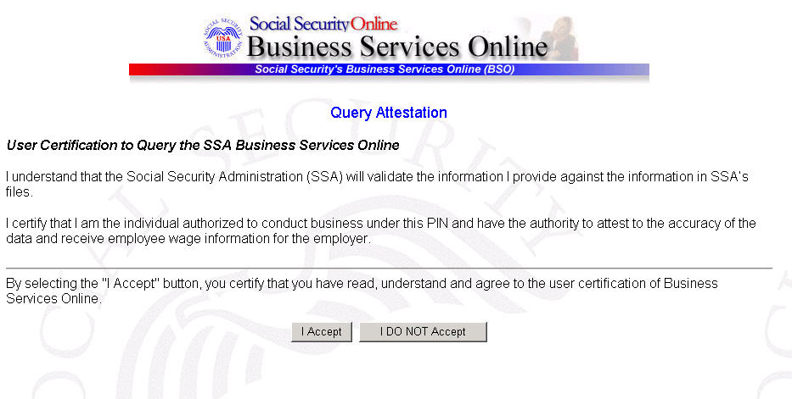

Step 9: Select the I Accept button after reading the conditions defined on the Query Attestation page. The system displays the Acknowledge Resubmission Notice page.

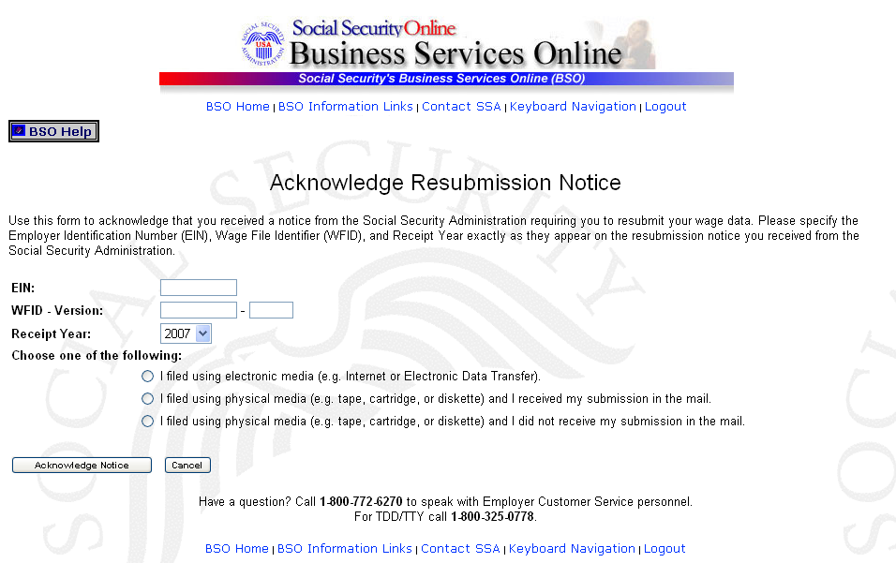

Step 10: Enter your EIN, WFID, Version, and Receipt Year (exactly as they appear on the resubmission notice you received from SSA) and indicate the appropriate filing method.

Step 11: Select the Acknowledge Notice button to process the acknowledgement. (Otherwise, select the Cancel button to cancel the acknowledgement and return to the BSO Main Menu page.) The system displays the Notice Acknowledgement Receipt page.

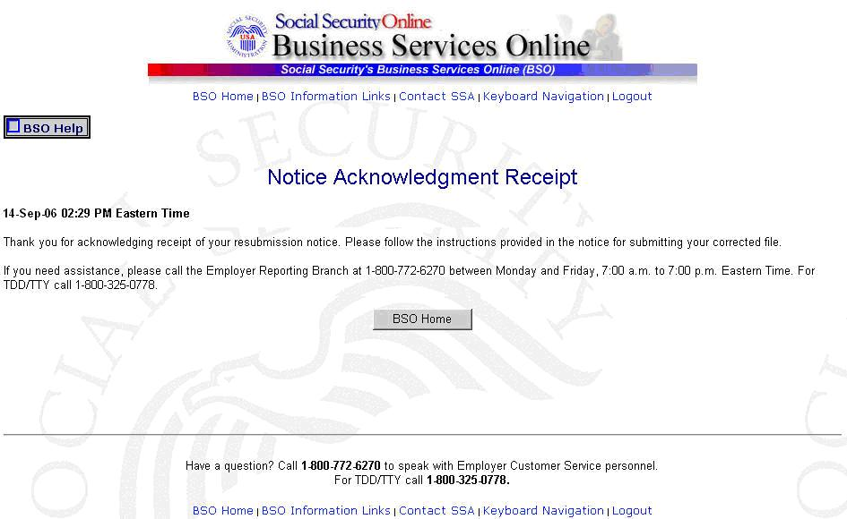

Step 12: Select the BSO Home button to return to the BSO Main Menu page.

