

Contents
1. What is the Development Submodule? 1-1
Tenant Data in the Development Submodule 1-3
Selecting Criteria in the Development Submodule 1-4
2. Logging On to PIC 2-1
3. Navigating to the Development Submodule 3-1
4. The Development Tab 4-1
The Profile Page 4-2
The List Page 4-10
The Address Page 4-11
The Contact page 4-14
5. The Building Tab 5-1
The Building List Page 5-2
The Building Detail Page 5-8
6. The Unit Tab 6-1
The Unit List Page 6-2
The Building/Unit Data Transfer Page 6-18
The Upload Error Report Page 6-25
7. The Submission Tab 7-1
8. Major Data Changes (Key Field Corrections) 8-1
9. The FCR Unit Information Tab 9-1
10. The Reports Tab 10-1
The Building Reports Page 10-2
The Unit Reports Page 10-11
The MTCS Occupancy Reconciliation Report Page 10-24
The Resident Assessment Subsystem (RASS) Report Page 10-25
The Vacancy/Occupancy Report Page 10-32

Appendix A: Quick Reference Guide…………………………………...A-1

Appendix B: Defining Structure Types…………………………………B-1

Appendix C: Building and Unit Data Entry Guidance………………..C-1

Appendix D: Building and Unit Data Uploading Instructions……..…D-1

The Development Submodule
The Development Submodule is the Department of Housing and Urban Development’s main building and unit data resource. Located in the Housing Inventory Module of the Public and Indian Housing (PIH) Information Center (PIC), this submodule collects and displays the most current:

What is the Development Submodule?

- Development Data
- Development Profile and Inventory Summaries
- Lists of all Developments in a Housing Authority (HA)
- Physical and Mailing Addresses for Development Management Offices
- Contact Names, Telephone Numbers, and Email Addresses
- Building Data
- Physical Addresses
- Building Structure Types
- Number of Units
- Entrance Numbers
- Lists of all Buildings in a Development
- Unit Data
- Unit Type (Family, Elderly, Non Dwelling, or Merged)
- Door Numbers (if applicable)
- Head of Household (HOH) Details

The submodule also provides a venue to electronically submit building and unit data. The performance of this submission process affects HA funding and performance scores.

In addition, the submodule enables you to generate various building and unit data reports.

User Manual Objectives
In this manual, you will learn to:

- Access the submodule.
- Perform all site functions.
- Interpret the building and unit data on the submodule pages.

Note: Appendix A contains a quick reference guide for use as a submodule refresher.

Acknowledgements
The following HUD employees assisted in the creation of the Development Submodule documentation:

- Julia Ann Borders
- Emily Bridge
- Jose Morales
- Larry Wheeler

Their professional attention to detail, teamwork, and specialized knowledge enhanced the value and clarity of this document.

Tenant Data in the Development Submodule
Some pages in this submodule contain details about the tenants who occupy units in a building. PIC draws this tenant data from the most recent Form-50058 as presented in PIC’s Form-50058 Module.

HUD’s old tenant information database, the Multifamily Tenant Characteristics System (MTCS), is no longer in use. All data from MTCS has been or is being transferred into PIC’s Form-50058 Module (see Figure 1-1).

Figure 1-1: An MTCS reference in the Development Submodule.

Selecting Criteria in the Development Submodule
PIC usefulness relies heavily on your ability to select the proper criteria for your purpose. PIC provides two main features for the selection and entering of data: dialog boxes and text boxes.

Selecting Information Using Dialog Boxes
For all tabs in the submodule, PIC enables you to select information on the screen using dialog boxes (see Figure 1-2 for an example).

Follow these steps to use a dialog box:

Step | Action/Result
- Click the dialog box. | PIC displays a list of options.
- Click the desired option. | PIC inserts the choice into the box.

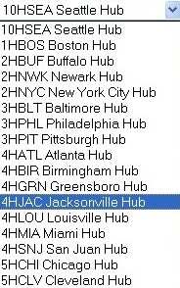
Figure 1-2: An example of a
dialog box option menu list.

Entering Data Using Text Boxes
The other main method for criteria selection is the use of text boxes (see Figure 1-3 for examples).

Follow these steps to use a text box:

Step | Action/Result
- Click the text box. | PIC inserts a cursor into the box.
- Type the appropriate data in the box.

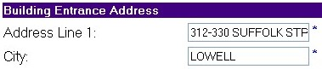
Figure 1-3: Examples of text boxes.
Logging on to PIC is the first step toward accessing the Development Submodule.

Logging On
to PIC

You need a user ID and password to enter PIC. HA employees should contact their executive director or system administrator to obtain this information.

Follow these steps to log on to PIC:

Step | Action/Result
- Go to the Public and Indian Housing (PIH) Home page at http://www.hud.gov/offices/pih/. | A Quick Find List is displayed at the bottom right side of the PIH Home page (see Figure 2-4).
- Scroll to PIC – PIH Information Center in the Quick Find List and highlight the entry with a mouse click.

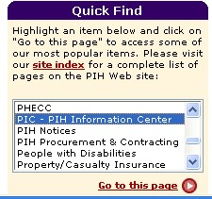
Figure 2-4: The PIC – PIH Information Center entry
highlighted in Quick Find List on the PIH Home page.

Step | Action/Result
- Click the hyperlink titled Go to this page. | The PIC Home page is displayed.
- Click the Logon to PIC hyperlink, which is located in the center of the screen. You can also click the Logon to the PIC System hyperlink in the Quick Access box (see Figure 2-5). | The PIH Information Center (PIC) Logon page is displayed.
- Type your user ID and password in the appropriate text boxes on the screen.
- Click the button titled Logon to PIC, or press the ENTER key. | The PIC Main Navigation page is displayed.

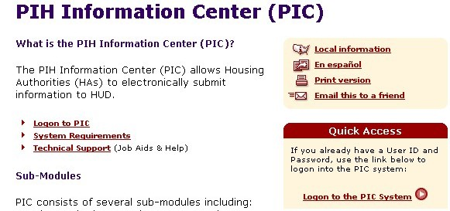
Figure 2-5: The PIC Home page.
Follow these steps to access the Development Submodule from the PIC Main Navigation page:

Navigating to the Development Submodule

Step | Action/Result
- Move your mouse cursor over the Housing Inventory Module button. | Three submodules are displayed (see Figure 3-6):  - Housing Authority  - Development  - Demolition & Disposition  Note: Access to the other submodules depends on the role(s) assigned to you.
- Click the Development hyperlink. | PIC displays the Profile page.

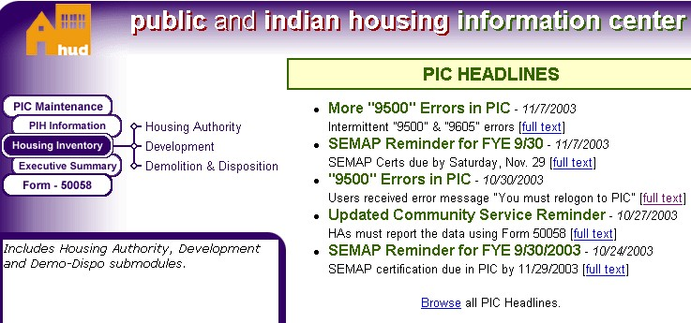
Figure 3-6: The PIC Main Navigation page with the
Housing Inventory submodules displayed.
After you click the Development hyperlink on the PIC Main Navigation page, PIC displays the Profile page. It provides a summary for a development’s program, structure, and inventory.

The Development Tab
The Profile page is one of four pages available on the Development Tab (see Figure 4-7). The other pages are as follows:

- List page: This page presents a list of all developments in the selected HA.
- Address page: This page presents the mailing and physical addresses (if available) for a development’s management office.
- Contact page: This page presents contact names, telephone numbers, email addresses, and other details for a selected development.

Figure 4-7: The Development Tab subtabs. The FCR Unit Information Tab is
not shown. Refer to page 1 for more information.

Note: Access to the pages depends on your security access role. If you want to gain access to a particular page, contact your security administrator.

The Profile Page
The Profile page presents a specific development’s vital housing information (program type, construction date, inventory, and so forth). This page also enables you to view the information for other developments in the HAs permitted by your security access role.

Identifying a Development to View
If you have security access to one HA, follow these steps to identify a specific HA development to view:

Step | Action/Result
- Click the Physical Development dialog box. | A list of developments you have access to displays (see Figure 4-8).
- Click the desired development. | The page refreshes to display the data for that development.

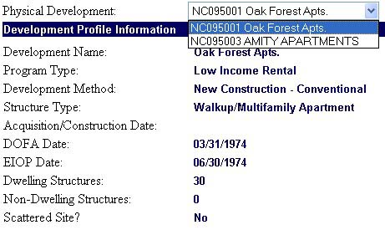
Figure 4-8: The Development Profile Information section of the Profile page.

After identifying the development, you can view its information on all other submodule pages without having to identify it again.

Note: The Physical Development dialog box contains both the development’s name and its number. This number is provided by the field office.
If you have security access to multiple HAs, follow these steps to find the desired HA development:

Step | Action/Result
- Click the hub that contains the desired field office in the Hub dialog box (if applicable).
- Click the appropriate field office in the Field Office dialog box (if applicable).
- Click the HA containing the development you are looking for in the Field Office HA dialog box.
- Click the development you are looking for in the Physical Development dialog box (see Figure 4-9). | The page refreshes to display the data for that development.

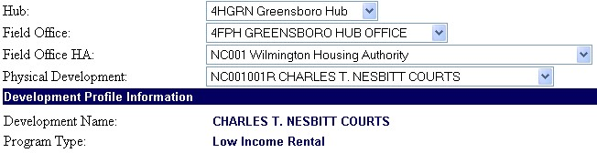
Figure 4-9: The dialog boxes used to locate a development
if you have access to multiple hubs.

After identifying the development, you can view its information on all other submodule pages without having to identify it again.

Note: The Physical Development dialog box contains both the development’s name and its number. This number is provided by the field office.

Information Presented on the Profile Page
This page contains a Development Profile Information section and a Development Summary section.

The following table includes all data presented in the Development Profile Information section and short description of each data category:

Profile Page  Data Category | Description
Development Name | The name an HA assigns a development.
Program Type | One of the following program types is displayed:  - HOPE VI: Any program involving HOPE VI funds  - Low Rent Rental: Regular public housing program  - Low Income/Fair Market Rent: Mixed Income programs unrelated to HOPE VI  - Mixed Finance: Mixed Finance programs unrelated to HOPE VI  - Section 23 Bond Financed: An obsolete program  - Section 23 Leased: An obsolete program  - Turnkey III: An obsolete Public Housing Homeownership program  Note: The obsolete program types will be removed in a future PIC release.
Development Method | One of the following development methods is displayed:  - Acquisition w/out Rehab: The development is purchased and no rehabilitation is necessary.  - Major Reconstruction of Obsolete Public Housing Projects (MROP): An obsolete development method.  - New Construction: A new development is built. Most developments fall into this category.  - New Construction – Conventional: Same as the New Construction method.  - New Construction – Turnkey: A method where the developer builds the development but “turns the keys over” when it’s ready for the HA.  - Rehabilitation – Conventional: An old development is rehabilitated for HA use.  - Rehabilitation – Turnkey: A method where the developer rehabilitates the development and “turns the keys over” when it’s ready for the HA.  Note: The obsolete development methods will be removed in a future PIC release.
Structure Type | One of the following structure types is displayed:  - Elevator Structure  - Mixed Type  - Row or Townhouse Style (Sep. Entrances)  - Semi-Detached  - Single-Family/Detached  - Walkup/Multifamily Apt (Shared Entrances)  See page 7 for more information on structure types.
Acquisition/Construction Date (if known) | Either the date the HA acquired the development, or the date construction began on the development.
Date of Full Availability (DOFA) | The DOFA occurs when at least 95% of the units in a development are ready to be occupied (i.e., have certificates of occupancy). The DOFA is especially important for management of a mixed-finance development because it starts the development’s initial operating period.
End of Initial Operating Period (EIOP) Date | EIOP is the last day of the first calendar quarter after DOFA provided that 95% of the units are actually occupied (vs. ready to be occupied). If 95% of the units are not occupied, EIOP is automatically established as the last day of the second calendar quarter after DOFA. EIOP marks the point at which the construction period for a development ends and management begins.
Dwelling Structures | Number of structures in the development containing inhabitable units.
Non Dwelling Structures | Number of structures in the development with Non Dwelling units only.
“Scattered Site?” | Yes: Units are located in different parts of the city. (They are separated by more than one street.)  No: Units exist in the same city location.

Structure Type Descriptions
Many of the following structure types are displayed in other parts of this submodule. Here are the definitions for each structure type listed.

Structure Type | Description
Elevator Structure | Any high-rise structure requiring an elevator under the Minimum Property Standards or local building codes.
Mixed Type | A development that consists of more than one structure type.
Row or Townhouse (Sep. Entrances) | A structure containing three or more living units. Each unit is separated by vertical walls. These building types have their own entrances and interior stairs.  Note: Units in this structure type should not have door numbers.
Semi-Detached | A structure containing two living units separated by a common vertical wall.
Single-Family/Detached | A structure consisting of a single-living unit surrounded by permanent, open spaces.
Walkup/Multifamily Apartment (Shared Entrances) | Any multilevel, low-rise structure containing two or more living units. Each unit is separated horizontally (ceiling/floor) and by vertical walls. This category includes row houses where the units share the same physical address and are identified by a door number only.

Note: Refer to Appendix B for detailed characteristics of each structure type.
The second section of data on the Profile page is called the Development Summary section. It is composed of two tables.

The first table displays the following data:

- Number of Dwelling Units
- Family
- Elderly
- Total
- Number of Non Dwelling Units
- Merged
- Non Dwelling
- Total
- Occupancy Status
- Occupied
- Vacant
- Total Unit Count

The second table displays the number of units in the development by type and by bedroom size:

- Unit Type
- Elderly
- Family
- Total
- 0 Bedrooms
- 1 Bedroom
- 2 Bedrooms
- 3 Bedrooms
- 4 Bedrooms
- 5+ Bedrooms
- Total

This section also includes an “Approved as of” date. This date refers to the date of the last approved building/unit data submission.
Editing a Development Profile
Users with the proper security access role can edit profile data. Contact your security administrator if you are missing this function and need to edit a development’s profile data.

Follow these steps to edit a profile:

Step | Action/Result
- Identify the development you want to edit using the dialog box(es) at the top of the page. | PIC displays the appropriate Development Profile.
- Click the Edit Development hyperlink. | PIC displays the Edit Profile page.
- Edit the information for the following fields (see Figure 4-10):  - Development Name*  - Program Type*  - Development Method*  - Structure Type*  - Acquisition/Construction Date  - DOFA Date*  - EIOP Date*  - “Scattered Site?” | The asterisk (*) designates a required field. If there is no data entered for any of these fields, you cannot save the information.
- Click the Save button to enter the changes.  You can also click the Cancel button to undo any changes. | If saved, PIC returns to the newly-corrected Profile page.  If you click Cancel, PIC returns to the previous Profile page.

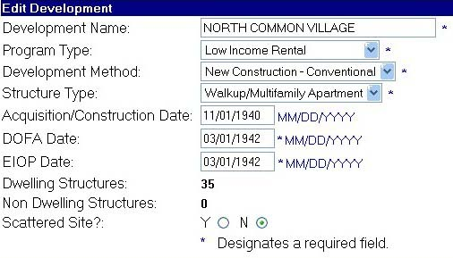
Figure 4-10: The Edit Development Profile fields.

The List Page
Click the List subtab in the Development tab to access the List page. It presents all developments associated with the HA selected on the Profile page.

Information Presented on the List Page
The List page contains a header and a Development List.

The header contains the following HA identifier information:

- Hub
- Field Office
- Field Office HA

The Development List displays the following information for each development (see Figure 4-11). PIC draws the information from the Development, Building, and Unit Tabs in this submodule.

- Development Number
- Development Name
- Status: The status of a development’s building and unit data submission.
- Total Units
- Total Employee Units
- Total Vacant Units

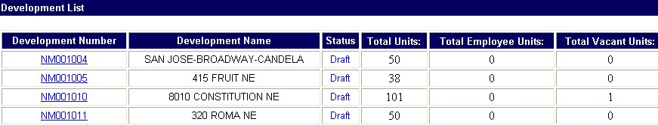
Figure 4-11: A Development List.

Click the Development Number hyperlink to view the building details for each building in the selected development. See page 8 for more information on the Building Detail page.

The Address Page
Click the Address subtab in the Development Tab to access the Address page. This page contains a development management office’s physical and mailing addresses. If the management office address information is unavailable, PIC displays the parent housing authority’s address information.

The default display for the page is the development management office’s physical address.

- A physical address is the office’s location. Example: The address an emergency services unit (police, rescue squad, and so forth) would respond to.
- A mailing address, such as a post office box (PO box), is needed if mail cannot be delivered to the physical address. It is not a required entry.

Follow these steps to display the mailing address:

Step | Action/Result
- Click the Select Address Type dialog box. | The dialog box displays a menu with two options: Mailing and Physical.
- Click Mailing. | The page refreshes to present the mailing address.

Information Presented on the Address Page
The Address page contains a header, an Address Information section, and an Additional Address Information section.

The header includes the following development identifier information:

- Hub
- Field Office
- HA
- Physical Development

The Address Information section contains the development management office’s physical and mailing address:

- Address Line 1
- Address Line 2
- County Name
- City/Locality
- State
- Zip Code

In the Additional Address Information section, PIC automatically provides the following data (if available):

- Rural Route Code
- County Code
- Congressional District Code
- MSA Code
- Census Tract Code
- Centroid Match Code
- Entity Code
- Latitude
- Longitude
- Place Code
- Highway Contract Route Code
- State Numeric Code
- Locality Code
- MCD Code
- Block Code
- Geo Match Code
- Class Code

Modifying a Development Address
Users with the proper security access role can modify the addresses presented on the page. Contact your security administrator if you are missing this function and need to modify address information.

Follow these steps to modify a development address:

Step | Action/Result
- Choose either the physical or mailing address on the Address page.
- Click the Modify Address hyperlink after selecting the type of address to edit. | PIC displays the Modify Address page. It is populated with the existing address data.
- Edit the following information as appropriate:  - Address Line 1*  - Address Line 2  - County Name  - City/Locality*  - State*  - Zip Code* | The asterisk (*) designates a required field. If there is no data entered for any of these fields, you cannot save the information.
- Click the Save button. | PIC refreshes to the newly corrected Address page.

The Contact Page
Click the Contact subtab in the Development Tab to access the Contact page. It lists the primary contacts for the selected development, their roles, telephone numbers, email addresses, and activity statuses.

Information Presented on the Contact Page
The Contact page consists of a header, an Activity Status filter, and a Contact List.

The header includes the following development identifier information:

- Hub
- Field Office
- Field Office HA
- Physical Development

The Contact Status Filter
The Contact List can be searched by activity status. This is helpful if there are several contacts listed.

Follow these steps to perform an activity status search:

Step | Action/Result
- Click the Contact Status dialog box. | A menu is displayed with the following options:  - Active (default)  - Inactive  - All
- Click the activity status you want presented in the list. | The page refreshes to present only the contacts with the selected activity status.

The Contact List
The Contact List provides a summary of the contact information for the person(s) involved with the selected development (see Figure 4-12).

Figure 4-12: A Development Contact List.

A Development Contact List contains the following information:

- Contact Name: The entries in this category are hyperlinked. Click a name to access additional details for the selected contact.
- Role
- Telephone Number
- Email: The entries in this category are hyperlinked. Click an email address to send a message to the selected contact.
- Status

Adding a Development Contact
Users with the proper security access role can add a contact to the Contact List. Contact your security administrator if you are missing this function and need to add a contact.

Follow these steps to add a development contact:

Step | Action
- Click the Add Contact hyperlink on the Contact page. | PIC displays the Add Contact page.
- Enter the data for the following fields:  - Last Name*  - First Name*  - Salutation  - Phone Number*  - Fax Number  - TTY Number  - Email Address  - Role*  - Effective Date*: The start of the role assigned.  - Effective End Date: The end of the assigned role (if applicable). | The asterisk (*) designates a required field. If there is no data entered for any of these fields, you cannot save the information.  For the Role dialog box, choose from the following options:  - A and E Representative  - Contract/Developer  - Design Architect  - Executive Director  - Inspection Architect  - On-Site Manager  - Other  - PHA Construct Representative  - Resident Manager  - Tribal Representative
- Click the Save button to enter the data into the Development Contact List.  You can also click the Cancel button to undo any changes you have made. | If saved, PIC displays the newly updated Contact page.  If you click Cancel, PIC returns to the previous Contact page.

Development Contact Details
If you click a Contact Name hyperlink, you can view additional details about that person (see Figure 4-13). The Development Contact Details section includes:

- First Name
- Last Name
- Salutation
- Phone Number
- Fax Number (if available)
- TTY Number (if available)
- Email Address: The entries in this category are hyperlinked. Click an email address to send a message to that person.
- Role
- Effective Date (for the Contact’s Role)
- Effective End Date (for the Selected Role) if available

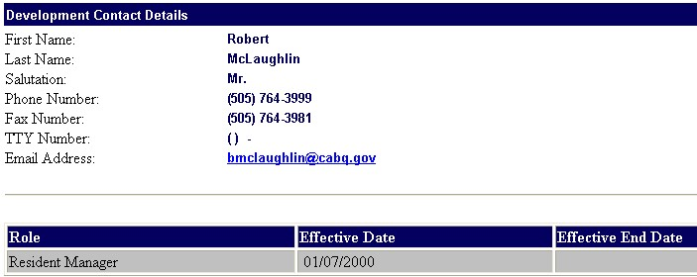
Figure 4-13: The information displayed on a Development Contact Detail page.

Modifying Contact Details
Users with the proper security access role can modify the contact details presented. Contact your security administrator if you are missing this function and need to modify contact details.

Follow these steps to modify a development contact’s details:

Step | Action/Result
- Click the Modify Contact Details hyperlink on the Contact Details page. | PIC displays the Modify Contact Details page (see Figure 4-14). The fields are populated with the existing data.
- Correct the following data as appropriate using the text boxes and dialog boxes presented:  - Last Name*  - First Name*  - Salutation  - Phone Number*  - Fax Number  - TTY Number  - Email Address | The page refreshes to present only the contacts with the selected activity status.  The asterisk (*) designates a required field. If there is no data entered for any of these fields, you cannot save the information.
- Click the Save Edits button to enter the changes.  You can also click the Cancel button to undo any changes you have made. | If saved, PIC displays the newly-corrected Development Contact Details page.  If you click the Cancel button, PIC returns to the previous Development Contact Details page.

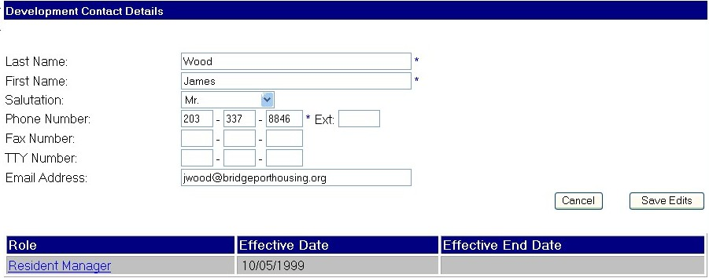
Figure 4-14: The Modify Contact Detail fields.

Modifying Contact Roles
From the Modify Contact Details page, users with the proper security access role can edit a role’s effective end date.

Follow these steps:

Step | Action/Result
- Click the contact’s Role hyperlink. | PIC refreshes the Role Table to display an Effective End Date text box.
- Type a date in the Effective End Date text box. The date must be in MM/DD/YYYY format (for example, 02/20/2002).
- Click the Save button to enter the changes.  You can also click the Cancel button to undo any changes you have made. | If saved, PIC displays the new role information on the Development Contact Details page.  If you click Cancel, PIC returns to the Development Contact Details page.

The Building Tab contains the official inventory of buildings for the development selected on the Profile page.

The Building
Tab

Two different pages are accessible via the Building Tab.
- The Building List page presents summary information for every building in the selected development. It also enables users with the proper security access role to delete building records from the development.
- The Building Detail page provides information about a specific building. It also enables users with the proper security access role to edit building details or add a new building record.

The default page for this tab is dictated by your security access role.

The Building List Page
If the Building List page is your default, click the Building Tab to access the page. If the Building Detail page is your default, click the Building List subtab to access the page.

The Building List page presents a list of all buildings in the development selected on the Profile page. It also provides summary data for each of those buildings.

Searching the Building Information Table
Developments can have hundreds of buildings. PIC provides two different methods for searching a Building List: a search by building number and a search by entrance number (see Figure 5-15).

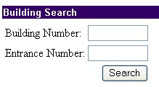
Figure 5-15: The Building Search filters available
on the Building List page.

These two search methods can be used independently or together.

Follow these steps if you are looking for a specific building and you know the exact building number:

Step | Action/Result
- Type the building number in the Building Number text box.
- Click the Search button. | PIC refreshes the list to display records pertaining to the specified building only.  PIC displays the following message if the building number entered is not on the list: No buildings were found for this development, please add a building.

Follow these steps if you are looking for a list of specific building entrances:

Step | Action/Result
- Type the desired entrance number in the Entrance Number text box.

You can type one entrance number only. The number can have a maximum of three digits.
- Click the Search button. | PIC refreshes the list to display records pertaining only to the specified entrance number.  PIC displays the following message if the building number entered is not on the list: No buildings were found for this development, please add a building.

Information Presented on the Building List Page
The Building List page consists of a header and a Building Information table.

The header includes all building identifier information.

- Hub
- Field Office
- Field Office HA
- Physical Development

The Building Information Table (see Figure 5-16 for an example) displays several categories of information.

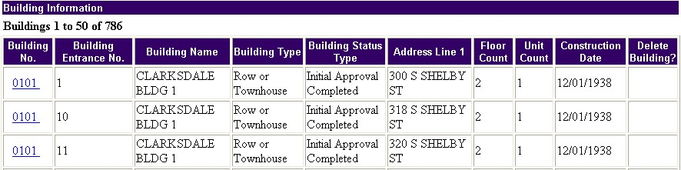
Figure 5-16: An example of a Building List.

The following table lists and provides descriptions for the Building Information Table data categories.

Data Category | Description
Building Number | The unique identification number for the selected building.
Building Entrance Number | The specific entrance number for the selected building record. One building structure can have several entrances. Each entrance number has its own physical address and its own building record.
Building Name | If entries in this category are blank, the HA has not entered a name for the building.
Building Type | One of the following structure types is displayed:  - Elevator Structure  - Walkup/Multifamily Apartment (Shared Entrances)  - Non Dwelling Structure  - Row or Townhouse (Sep. Entrances)  - Semi-Detached (Sep. Entrances)  - Single-Family/Detached  Refer to page 7 for more information on structure types.
Building Status Type | The status of the building entrance record in PIC. One of the following statuses is displayed:  - Initial Upload: The building record has been entered but not approved by a field office.  - Initial Approval Completed: The building record has been approved by the field office.  - Demo/Dispo – Approved: The building in question has been approved for either demolition or disposition. Source: Demo/Dispo Submodule.  - Demo/Dispo – Proposed: The building in question has been proposed for either demolition or disposition. Source: Demo/Dispo Submodule.  - Demo/Dispo Draft: A draft has been created to propose either demolition or disposition for this building. Source: Demo/Dispo Submodule.  - Removed from Inventory: HUD HQ has completed the HA request to remove this building from the HA’s inventory. Source: Demo/Dispo Submodule.  - Proposed Removed from Inventory: The HA has submitted a request to HUD HQ to remove this building from its inventory. Source: Demo/Dispo Submodule.  - Removed without HUD Approval: Buildings removed from the HA’s official inventory without formal approval from a HUD field office. This entry may switch to “Removed without Formal Approval” in the future.
Address Line 1 | The physical address for the selected building entrance. Example: The address an emergency services unit (e.g., police or rescue squad) would respond to.
Floor Count | The number of floors accessible via the specified building entrance where units that can be occupied exist.
Unit Count | Number of units accessible via the building entrance. This number includes units of all types.
Construction Date | The date the building entrance finished construction.
“Delete Building?” | In most instances, the fields in this category are blank. See page 7 for more information.
Click a Building Number hyperlink to view additional building details for that building.

Note: If you click a hyperlink for a building record with a Removed From Inventory status, PIC displays the following message: No buildings were found in this development, please add a building.

The Building Information table displays 50 building entrance records at a time. The total number of records is displayed at the top of the table.

If there are more than 50 buildings in a development, click the Next hyperlink at the bottom of the table to view the remainder. After clicking the Next hyperlink, you can click the Previous 50 Buildings hyperlink to return to the previous page (see Figure 5-17).

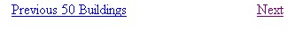
Figure 5-17: The Next and Previous 50 Buildings hyperlinks
at the bottom of a Building Information table.

Deleting Buildings
When you delete a building record, it cannot be retrieved. Only delete building records that are erroneous entries. Make sure the building has never been part of the development’s inventory before deciding to erase it permanently.

When Can You Delete Buildings?
PIC enables you to perform this deletion only in certain circumstances.

The HA can only delete a building record before it has been submitted to the field office or after that initial upload data has been rejected by the field office.

If you are uploading a second set of new building data after a first set of building data has been approved by the field office, buildings can only be deleted in the second set of data.

If none of the above situations apply, you must submit a formal request to HUD HQ to delete a building record.

Note: In the current PIC release, there is no way to delete building records after the field office approves them. Contact the PIC Help Desk if you have errors in your approved inventory.

Process for Deleting a Building
Follow these steps to delete a building:

Step | Action/Result
- Navigate to the Building List page. | When the functionality to delete buildings is available, check boxes are displayed in the “Delete Buildings?” column.
- Click the check box(es) next to the building(s) you want to delete. | PIC displays check marks in the selected check box(es).
- Click the Delete button at the bottom of the table. | PIC erases the building records(s).  Note: This is a nonreversible action. All building data, including the unit data associated with it, is deleted.

The Building Detail Page
There are three ways to access this page:

- Click the Building Tab if the Building Detail page is your default.
- Click the Building Details subtab from the Building List page.
- Click a Building Number hyperlink from the Building Information table.

This page presents extensive address, building entrance, and structure information for a selected building. It also displays any relevant building comments.

In addition, users with the proper security access role (normally HAs only) can add building records to a development or edit the presented building data on this page.

Information Presented on the Building Detail Page
The Building Detail page consists of the following sections:

- Header
- Building Entrance Identification
- Building Entrance Address
- Building Entrance Details
- Building Entrance Summary

The header includes the following development identifier information:

- Hub
- Field Office
- Field Office HA
- Physical Development

The Building Entrance Identification section includes the following building identifiers (see Figure 5-18):

- A Select Building dialog box containing a building’s number and Street Address
- Building Name (if applicable)

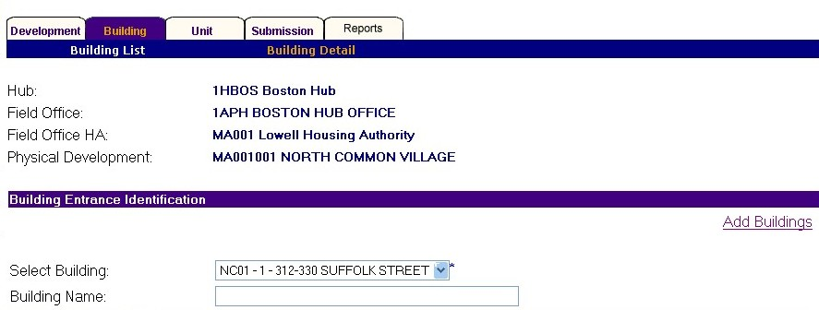
Figure 5-18: The Select Building dialog box.

If you have the proper security access role, you can access the building details for any building entrance in the selected development using the Select Building dialog box. Follow these steps:

Step | Action/Result
- Click the Select Building dialog box. | PIC displays a list of buildings in the selected development.
- Click the desired building. | PIC displays the Building Detail page for the selected building.

The Building Entrance Address section displays the following physical entrance address details:

- Address Line 1
- Address Line 2
- City
- County
- State
- Zip Code

The Building Entrance Details section provides the following structural and status details. Many of these data categories are also presented in the Building Information table (see page 4).

- Building Type
- Building Status Type
- Bar Code Number
- Floor Count
- Total Unit Count: This data category is the same as the Unit Count category on the Building List.
- Construction Date
- Comments: General comments about the building or development.

The Building Entrance Summary section (see Figure 5-19) provides the following information about the units accessible via the selected entrance:

- Number of Units by Type
- Family Units
- Elderly Units
- Total
- Number of Units by Bedroom Size
- 0 Bedroom
- 1 Bedroom
- 2 Bedrooms
- 3 Bedrooms
- 4 Bedrooms
- 5+ Bedrooms
- Total

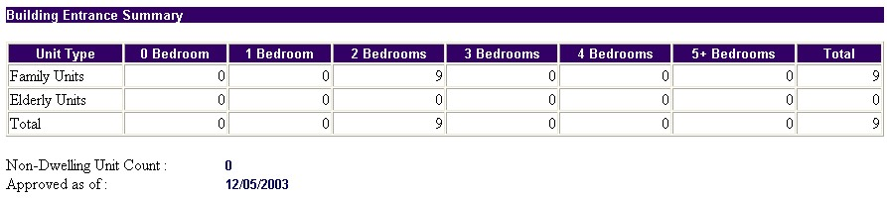
Figure 5-19: The Building Entrance Summary section of the Building Detail page.

This section also displays the following building entrance information:

- Non-Dwelling Unit Count: The number of Non Dwelling units accessible via the building entrance.
- Approved as of: The date of the last building data approval for the selected building.

Editing Building Details
If you have the proper security access role, you can edit all of the building detail fields on the page except for the Building Status, the Total Unit Count, and the unit data in the Building Entrance Summary section.

Common reasons to edit building data include the following:

- Changing a building’s name
- Changing a physical address
- Changing or adding the building’s construction date.
- Adding comments

Any change to the building details data must be submitted for field office approval. See page 5 for more information on submitting data for field office approval.

Contact your security administrator if you need to edit building details but do not have the security access role to do so.

Follow these steps to edit the building details for the selected building:

Step | Action/Result
- Access the Building Detail page for the building entrance you want to edit.
- Edit the data for any of the following fields:  - Building Name  - Address Line 1*  - Address Line 2  - City*  - State*  - County*  - Zip Code*  - Building Type*  - Floor Count*  - Construction Date  - Comment  Note: The City, State, Zip Code, Floor Count, and Building Type fields should not be edited unless you are correcting a data entry error. | The asterisk (*) designates a required field. If there is no data entered for any of these fields, you cannot save the information.
- Click the Save button. | PIC refreshes to the Building List page. The data is prepared for submission to the field office.

See Appendix C for more detailed descriptions on how to enter the data, such as guidelines on how many characters to use for a specific field.

Adding Buildings
If you have the proper security access role (normally HA users), PIC enables you to add building records to a development. Contact your security administrator if you need to add a building record but do not have the security access role to do so.

Examples of when to add new building records include the:

- Construction of a new Public Housing building.
- Purchase of a Public Housing building.

Note: You cannot add more buildings/units than the Annual Contributions Contact allows. Refer to the Code of Federal Regulations, Title 24, Chapter IX, Part 941, Section 102 for a complete look at the conditions and methods involved in creating new Public Housing buildings.
Follow these steps to add buildings to a selected development:

Step | Action/Result
- Click the Add Buildings hyperlink on the Building Detail page (see Figure 5-20). | The Add Building page is displayed. It is similar to the Building Detail page, except all fields are blank.
- Enter the data for the following fields:  - Building Number*  - Entrance Number*  - Building Name  - Address Line 1*  - Address Line 2 (if needed)  - City*  - State*  - County*  - Zip Code*  - Building Type*  - Floor Count*  - Total Units Count*  - Construction Date (MM/DD/YYYY format)  - Comments | The asterisk (*) designates a required field. If there is no data entered for these fields, you cannot save the information.  Note: The Bar Code Number field is reserved for future use. Do not enter any data into this field.
- Click the Save button to prepare the record for submission to the field office. | The information is added as an official building record in PIC.

Figure 5-20: The Add Buildings hyperlink.

All new building records are required to be submitted for field office approval. After you add a new building and click the Save button, the data is prepared for field office submission. See page 5 for more information on completing a submission.

See Appendix C for more detailed descriptions on how to enter the data, such as guidelines on how many characters to use for a specific field.
The Unit Tab contains the official inventory of units for the development selected on the Profile page. It also provides the functionality to upload large amounts of building and unit data for submission in PIC and to view histories of Upload Error Reports.

The Unit
Tab

Note: Uploading data is not the same as submitting data. After you perform an upload, you still need to submit building/unit data via the Submission Tab (see page 5 for more information).

The Unit Tab is composed of three pages:

- The Unit List page displays a list of all units in a development and enables you to view specific unit details. It also enables users with the proper security access to add unit records to a development, delete unit records from a development (during the initial upload stage only), or edit specific unit information.
- The Building/Unit Data Transfer page enables you to download a file template for a mass submission of building and unit data. It also enables HA users to upload a Comma Separated Values (CSV) or Microsoft® Excel file into PIC.
- The Upload Error Report page enables HA users to view any errors that occurred during the report upload process.

The Unit List page is the default page for the Unit Tab.

The Unit List Page
Click the Unit Tab to access the Unit List page. If you are on another Unit Tab page, you can also click the Unit List subtab to access this page.

The Unit List page presents a searchable list of every unit in the development selected on the Profile page. The list contains summary details for every unit displayed. It also enables users with the proper security access role to edit existing unit data, add new unit records, or delete invalid unit records (during the initial upload stage only).

Searching the Unit List
Developments can be responsible for hundreds, sometimes thousands, of units. While all units in a development can be presented on the Unit List page, PIC also supplies the following tools for filtering the list:

- Building Number
- Entrance Number
- Unit Number
- Floor Number
- Door Number
- HOH First Name
- HOH Last Name

Note: The availability of filters is based on your security access role. If you want to gain access to a filter you are missing, contact your security administrator.

Follow these steps to filter a Unit List using a building number:

Step | Action/Result
- Type the desired number in the Building Number text box.
- Click the Search button. | The list refreshes to display all the units in the specified building.

Follow these steps to filter a Unit List using an entrance number:

Step | Action/Result
- Type the desired number in the Entrance Number text box.
- Click the Search button. | The list refreshes to display all units associated with the specified entrance number.

Follow these steps to filter a Unit List using a unit number:

Step | Action/Result
- Type the desired number in the Unit Number text box.
- Click the Search button. | The list refreshes to display the unit specified.

Follow these steps to filter a Unit List using a certain floor number:

Step | Action/Result
- Type the desired floor number in the Floor Number text box.
- Click the Search button. | The list refreshes to display all units with entrances on the specified floor number.

Follow these steps to filter a Unit List using a particular door number:

Step | Action/Result
- Type the desired door number in the Door Number text box.
- Click the Search button. | The list refreshes to display all units with the specified door number.

Follow these steps to filter a Unit List using a certain HOH first name:

Step | Action/Result
- Type the desired name in the First Name text box.
- Click the Search button. | The list refreshes to display all units occupied by the HOH with the specified first name.

Follow these steps to filter a Unit List using a certain HOH last name:

Step | Action/Result
- Type the desired name in the Last Name text box.
- Click the Search button. | The list refreshes to display all units occupied by the HOH with the specified last name.

You can use any combination of these tools for one search. Simply type the data into the appropriate text boxes before clicking the Search button.

Information Presented on the Unit List Page
The Unit List page consists of a header and a Unit List.

The header contains the following development identifier information:

- Hub
- Field Office
- Field Office HA
- Physical Development

The Unit List (see Figure 6-21) is composed of a table displaying data for each unit that meets the applied search criteria. If you do not search for a particular unit or unit type, PIC displays a record for every unit in the development.

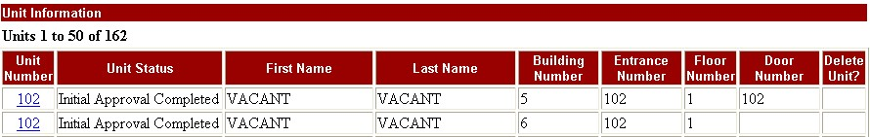
Figure 6-21: An example of a Unit List.

PIC presents the number of Unit List records just above the table. The table displays 50 records at a time.

PIC displays the units in ascending alphanumeric unit number order. If there are more than 50 units in a development, click the Next hyperlink at the bottom of the table to view the remainder. After clicking the Next hyperlink, you can click the Previous 50 Units hyperlink to return to the previous page.
The following table presents and describes the Unit List data categories:

Data Category | Description
Unit Number | The unique identifier for a unit. This number is the same as the HA’s inventory number for the unit.
Unit Status | The status of the unit in PIC. One of the following statuses is displayed:  - Initial Upload: The unit record has been entered into PIC but not approved by a field office.  - Initial Approval Completed: The unit record has been approved by the field office.  - Demo/Dispo – Approved: The building the unit is in has been approved for either demolition or disposition. Source: Demo/Dispo Submodule.  - Demo/Dispo – Proposed: The building the unit is in has been proposed for either demolition or disposition. Source: Demo/Dispo Submodule.  - Demo/Dispo Draft: A draft has been created to propose either demolition or disposition for the building this unit is in. Source: Demo/Dispo Submodule.  - Removed from Inventory: HUD HQ has completed the HA request to remove this unit from the HA’s inventory. Source: Demo/Dispo Submodule.  - Proposed Removed from Inventory: The HA has submitted a request to HUD HQ to remove this unit from its inventory. Source: Demo/Dispo Submodule.  - Removed without HUD Approval: Units removed from the HA’s official inventory without formal approval from a HUD field office. This entry may switch to “Removed without Formal Approval” in the future.
First Name | If the unit is unoccupied, the field will say “vacant.” PIC draws this HOH information from the Form-50058 Submodule.
Last Name | If the unit is unoccupied, the field will say “vacant.” PIC draws this HOH information from the Form-50058 Submodule.
Building Number | The unique identifier for the building containing the selected unit.

Data Category | Description
Entrance Number | The unique identifier for the building entrance used to access the unit. One building structure can have several entrances. Each entrance number has its own physical address and its own building record.
Floor Number | The floor in the building where the selected unit is located.
Door Number | The unique number for each unit within an elevator structure or walkup/multifamily apartment. Typically, door numbers are optional for row houses, town homes, semidetached, and single-family units.
“Delete Unit?” | In most instances, the fields in this category are blank. See page 8 for more information.

Deleting Units
When you delete a unit record, it cannot be retrieved. Only delete a unit record that is an erroneous entry. Make sure the unit has never been part of the official inventory before deciding to erase it permanently.

When Can You Delete Units?
PIC enables you to perform this deletion only in certain circumstances.

You can only delete a unit record before it is submitted to the field office or after that initial upload data is rejected by the field office.

If you are uploading a second set of new unit data after the first set of unit data has received field office approval, units can only be deleted from the second set of data.

If none of the above situations apply, you must submit a formal request to HUD HQ to delete a unit record.

Note: In the current PIC release, there is no way to delete unit records after the field office approves them. Contact the PIC Help Desk if you have errors in your approved inventory.

Process for Deleting a Unit
Follow these steps to delete a unit:

Step | Action/Result
- Navigate to the Unit List page. | When the functionality to delete units is available, check boxes are displayed in the “Delete Unit?” column of the Unit List.
- Click the check boxes next to the unit(s) you want to delete. | PIC displays check marks in the selected check box(es).
- Click the Delete button at the bottom of the table. | PIC erases the unit records(s).  This is a non-reversible action. After you delete a unit, all of its data is deleted.

Note: In the current PIC release, there is no way to delete units after the field office approves the unit records. Contact your PIC coach if there are errors in your approved inventory.

Unit Detail
Click a Unit Number hyperlink to access additional details about the selected unit.

PIC displays unit details in two sections:

- The Unit Information section
- The Head of Family Details section

The Unit Information Section
In addition to the data in the Unit List, the Unit Information section includes the following details:

Data Category | Description
Building Entrance Address | The physical address for the building entrance used to access the selected unit.
Annual Contributions Contract (ACC) Unit Indicator | Units labeled with a Yes are included in the ACC established by HUD and the HA. Most regular, inhabitable units are ACC Yes units.  Units marked with a No are not included in the contract.  See page 11 for more information on the ACC Unit Indicator.
Bedroom Count | The number of bedrooms in a unit.
Unit Type | One of the following unit types is displayed:  - Elderly: Designated Housing. Units subject to regulation concerning eligible tenancy. For PIC, this type includes units for handicapped tenants.  - Family: A regular tenant unit.  - Merged: A unit combined with another.  - Non Dwelling: A unit not used for Public Housing occupancy either on a temporary or permanent basis.
Floor Number | The floor number on which the selected unit is located.

The Head of Family Details Section
Along with the HOH’s first and last name (which is also found on the Unit List), this section displays the following data categories:

Data Category | Description
Social Security Number | The Social Security number of the HOH for the selected unit. If this field is blank, the unit is vacant. PIC draws this data from the Form-50058 Submodule.
Tenant Type | If the unit is occupied, PIC displays one of the following tenant types:  - Employee  - Law Enforcement  - Regular Tenant
Occupancy Date | The date the tenant occupied the unit. This date is the later of the lease date or the move-in date. PIC draws this data from the Form-50058 Submodule.
“Unit Info Complete?” | One of the following option buttons is selected:  - Yes: The record is ready for field office submission.  - No: There is information missing or incorrect.  Note: In order to submit the record to HUD for approval, Yes must be selected.

Note: In this section, PIC displays the following message: As the MTCS data transfer routine has been/is being executed, all further updates to the Head of Family details must be done using the MTCS Submodule. This statement is no longer true. You can only perform updates to Head of Family details in the Submission Submodule of the Form-50058 Module.

The ACC Unit Indicator
At the start of the Public Housing process, HUD and an HA enter into an ACC to establish what units get subsidized and what amount of HUD subsidies will be provided. The ACC Unit Indicator in PIC is used to identify units included in this contract.

All Public Housing Dwelling units are ACC Yes units. However, there are four situations where the ACC status of a unit can be brought into question:

- Permanent Conversions to Non Dwelling Units
- Temporary Conversions to Non Dwelling Units
- Merged Units
- Floating Units in Mixed Finance Developments

The following sections provide guidance on how to record the ACC status for units in each of these situations.

Permanent Conversions to Non Dwelling Units
A permanent conversion from a Dwelling unit to a Non Dwelling unit should be recorded as ACC No and removed from the contract.

Note: Permanent conversions require HUD field office approval.

Temporary Conversions to Non Dwelling Units
A unit is temporarily converted when it is approved for non–Public Housing dwelling purposes. This means no Public Housing tenant resides in the unit.

Examples of temporary conversions include:

- A unit being temporarily leased to another housing service agency.
- A unit converted into a community center or office space.

Temporary conversions require HUD field office approval and are effective for (up to) three years at a time. They are included in the official ACC unit count and receive some form of PIH HUD funding. A temporary conversion unit should be recorded as ACC Yes.

Note: Only two types of temporarily converted units receive operating subsidies: Drug Elimination and Economic Self-Sufficiency units. One unit or set of contiguous units per development is eligible for these designations.

Merged Units
When two units are combined to form one larger unit, one of those units is required to be listed as “merged.” When a unit is considered “merged,” it is no longer counted as an individual unit in an ACC. This type of unit should be recorded as ACC No. Merged units do, however, receive an adjusted operating subsidy from HUD.

After editing the unit detail of the merged unit to say ACC No, the HA should submit its changed data to the field office for approval. After approval has been granted, the development’s unit totals and merged unit totals should reflect the changes.

Floating Units in Mixed Finance Developments
Mixed Finance Developments are developments with both Public Housing and Market Rate units. Public Housing units in these types of developments can either be “fixed” or “floating.”

Fixed Units: Permanently designated Public Housing Units. The fixed units in a Mixed Finance Development are ACC Yes units. They cannot change unless there is an ACC amendment created.

Floating Units: A certain percentage or number of unspecified Public Housing units in a building.

For a Mixed Finance Development with floating units, the ACC indicator can switch from unit to unit depending on tenant turnover.
Floating Unit Example

A five-unit building enters into an ACC that specifies 20% of the units are Public Housing (which equals one unit) at all times. For the first year of the ACC, one unit is marked ACC Yes while the rest are marked ACC No.

Unit 1 = ACC Yes
Unit 2 = ACC No
Unit 3 = ACC No
Unit 4 = ACC No
Unit 5 = ACC No

After a few years, market rates and household turnover causes the Public Housing assignment to change from Unit 1 to Unit 2.

Unit 1 = ACC No
Unit 2 = ACC Yes
Unit 3 = ACC No
Unit 4 = ACC No
Unit 5 = ACC No

Refer to the PIH Information Center Building & Unit (“Fixed” vs.“Floating” Units) Job Aid for a more detailed description on how to handle floating units in PIC. It is accessible via the PIC Home Page (http://www.hud.gov/offices/pih/systems/pic/ts/floatingunit_jobaid.pdf).

Editing Unit Details
If you have the proper security access role, you can edit some of the unit details.

Common reasons to edit unit data include:

- Changing unit types.
- Changing door numbers.
- Changing bedroom counts.

Follow these steps to edit the details for a selected unit:

Step | Action/Result
- Click the Unit Number hyperlink of the unit you want to edit on the Unit List. | The details of the unit are displayed.
- Edit any of the following fields (see Figure 6-22):  - ACC Unit Indicator: Only edit this field after the field office grants approval for the change.  - Door Number  - Bedroom Count*  - Floor Number*: This field should not be edited unless you are correcting a data entry error.  - Unit Type | The asterisk (*) designates a required field. If there is no data entered for these fields, you cannot save the information.
- Click the Yes option button on the “Unit Details Complete?” field after all details are entered as completely as possible. | If the No option button is selected, PIC does not display the Save button.
- Click the Save button. | The newly corrected information becomes the official unit record.

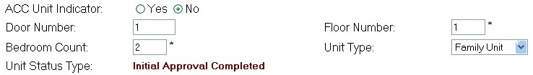
Figure 6-22: The editable unit detail fields.

Unit Editing Example
A building has four, one-bedroom Family units (Unit 1, Unit 2, Unit 3, and Unit 4). Only Units 1 and 3 are occupied.

The building undergoes a renovation where a wall is knocked down between Units 1 and 2, and another wall is knocked down between Units 3 and 4. This creates two, two-bedroom units.

Follow these steps to adjust your unit data:

- Change Units 2 and 4 from the Family unit type to Merged. Do not try to delete them. A good rule to follow is to always change the vacant units into the Merged type.
- Change Units 2 and 4 from ACC Yes to ACC No.
- Change the bedroom count to 2 for Units 1 and 3.
- Make sure the Yes option button is selected for the “Unit Information Complete?” field for each altered unit.
- Click the Save button for each unit altered.

All changes to unit data are required to be submitted for field office approval. After you edit the unit details and click the Save button, the data is prepared for field office submission. See page 5 for more information on completing a submission.

See Appendix C for more detailed descriptions on how to enter the data, such as guidelines on how many characters to use for a specific field.

Adding Units
If you have the proper security access role, you can add unit records to a development. Contact your security administrator if you need to add a unit but do not have the security access role to do so.

In order to add a new unit to a new building, you must first add the building to the PIC database. See page 13 for more information on adding a building.

Note: You cannot add more buildings/units than the ACC allows. Refer to the Code of Federal Regulations, Title 24, Chapter IX, Part 941, Section 102 for a complete look at the conditions and methods involved in creating new Public Housing units.

Follow these steps to add a unit:

Step | Action/Result
- Click the Add Units hyperlink on the Unit List page. | PIC displays the Add Unit page.
- Enter the appropriate data using the text boxes and dialog boxes presented:  - Unit Number*  - Building*  - ACC Unit Indicator  - Door Number  - Floor Number*  - Bedroom Count*  - Unit Type | The asterisk (*) designates a required field. If there is no data entered for any of these fields, you cannot save the information.
- Click the Yes option button on the “Unit Info Complete?” field after all information is entered as completely as possible. | If the No option button is selected, PIC does not display the Save button.
- Click the Save button. | The information is added as an official unit record in PIC.

See Appendix C for more detailed descriptions on how to enter the data, such as guidelines on how many characters to use for a specific field.

All new unit records are required to be submitted for field office approval. After you add a new unit and click the Save button, the data is prepared for field office submission. See page 5 for more information on completing a submission.

The Building/Unit Data Transfer Page
Click the Building/Unit Data Transfer subtab in the Unit Tab to access the Building/Unit Data Transfer page.

Situations may arise when you need to submit large amounts of data. Examples include:

- Adding a new 50-unit building.
- Editing 20 units or more.

The Building/Unit Data Transfer page (see Figure 6-23) provides a venue to upload this information into the PIC database and prepare it for submission to the field office in one bulk transaction.

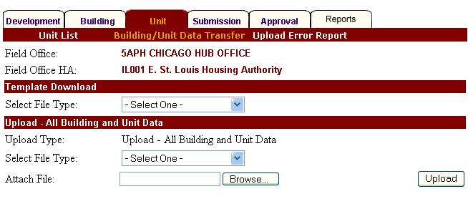
Figure 6-23: The Building/Unit Data Transfer page.

The upload can be performed using an Excel file or a CSV file. These are the only acceptable formats for the data transfer in PIC.

This page enables you to:

- Download a preformatted Excel spreadsheet, which you can use to enter the data.
- Download directions for preparing a text file submission.
- Upload the spreadsheet or a text file into PIC for field office approval.

Note: Use of this page depends on your security access role. If you would like access to the features on this page, contact your security administrator.

The Microsoft Excel Spreadsheet Method
Follow these steps to download a Microsoft Excel template:

Step | Action/Result
- Navigate to the Building/Unit Data Transfer page.
- Click Excel using the Select File Type dialog box in the Template Download section of the page. | A dialog box is displayed. It contains a question asking if you want to open the file or save it to your computer.
- Click the Save button. | The Save As dialog box is displayed (see Figure 6-24). PIC automatically assigns your user ID to the name of the file.
- Specify your desired name in the File name text box.
- Specify your desired location in the Save as type dialog box. Examples of popular locations include the computer’s Desktop or the My Documents folder. | Note: It is important to remember where you saved the file.
- Click the Save button. | The file downloads to the specified location.

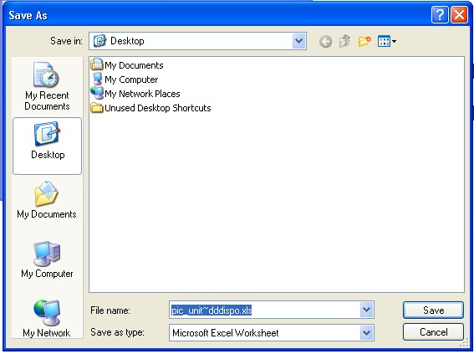
Figure 6-24: The Save As dialog box.
Follow these steps to input the data into the spreadsheet:

Step | Action/Result
- Open the spreadsheet from its saved location.  Note: Be sure to enable Macros when opening the spreadsheet. | Excel’s default display is the Unit Submission spreadsheet.
- Input the data following the column headings. (See Appendix C for descriptions and instructions on how to input this data.)
- Run the macro.  To do so, go to the Excel toolbar while the spreadsheet is open, and click Tools. Then, click the Format Columns for Upload menu option. | The file is saved automatically and prepared for uploading into the PIC database.
- Close the file after the data is entered completely.

As stated in the above table, Excel’s default display is the Unit Submission spreadsheet. If you want to input building data, click the tab titled P113PT_DEVELOPMENT_BUILDING_ENT at the bottom left corner of the spreadsheet to open the Building Submission form (see Figure 6-25).

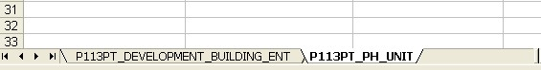
Figure 6-25: The Building and Unit tabs on the Excel spreadsheet.

Follow these steps to upload a completed spreadsheet into PIC for field office review:

Step | Action/Result
- Click Excel using the Select File Type dialog box in the Upload – All Building and Unit Data section of the page.
- Enter the complete file name into the Attach File text box.

You can also click the Browse button and navigate to the file’s location.
- Click the Upload button to send your information to HUD. | The file is saved to the system’s server where it undergoes a validation process to ensure the form was properly completed.  Note: PIC sends an email to the address listed in your User Profile confirming the information was received and summarizing the validation process results.

The Text File Method
You can generate a CSV file using vendor software. However, it is your responsibility to make sure this software-generated text file is in the correct format when you submit it for field office approval.

The Building/Unit Data Transfer page enables you to download instructions for verifying the text file format.

Follow these steps to download the CSV File instructions:

Step | Action/Result
- Navigate to the Building/Unit Data Transfer page.
- Click Pipe Delimited CSV File using the Select File Type dialog box in the Template Download section of the page. | A dialog box is displayed. It contains a question asking if you want to open the file or save it to your computer.
- Click the Save button. | The Save As dialog box is displayed.
- Specify your desired name in the File Name text box.
- Specify your desired location in the Save In dialog box. Examples of popular locations include the computer’s Desktop or the My Documents folder. | Note: It is important to remember where you saved the file.
- Click the Save button. | The file downloads to the specified location.

Follow these steps to verify the vendor-generated software file format:

Step | Action/Result
- Open the file from its saved location. | Your computer opens a file titled Uploading Building and Unit Data Using a Comma Separated Values (CSV) File. The directions for the text file format are on the first page. (See Appendix D for a copy of the file.)
- Verify that the lines on the software-generated text file match the examples on the directions for both the unit and building files. Make any necessary changes.
- Save the two text files.  Note: Make sure to save them as CSV files. | The files are now prepared for an upload.

Follow these steps to upload the text file into PIC for field office review:

Step | Action/Result
- Click Pipe Delimited CSV File in the Select File Type dialog box in the Upload – All Building and Unit Data section of the page.
- Enter the complete file name into the Attach File text box. You can also click the Browse button and navigate to the file’s location.

Note: When uploading both a building and a unit CSV file, submit the building CSV file first.
- Click the Upload button to send your information to HUD. | The file is saved to the system’s server where it undergoes a validation process to ensure the form was properly completed.

PIC sends an email to the address listed in your User Profile confirming the information was received and summarizing the validation process results.

The Upload Error Report Page
Click the Upload Error Report subtab on the Unit Tab to access the Upload Error Report page.

Many errors can occur during the submission process because it relies heavily on data entry. An Upload Error Report records the results of a submission and displays any errors found during the upload verification.

This information allows you to go back and fix the errors so the next submission can be approved with more speed. It also enables you to view the error records by error type, submitter, or historical file.

Information Presented on the Upload Error Report Page
This page contains a header, a Search section, and an Upload Error Table.

The header contains all identifier information for the HA that has received the submissions:

- Hub
- Field Office
- Field Office HA

The Search section contains tools to filter the results included in the Upload Error Table.

When you first view the table, it contains all errors occurring in the submission in question. Follow these steps to search for a particular error:

Step | Action/Result
- Click the sheet Error Type dialog box. | PIC displays a list of possible errors.
- Click the error you want to include in the table.
- Click the Retrieve button. | The table refreshes to display records containing only the error specified.

The table originally includes errors performed by all submitters. Follow these steps to search for an error performed by a particular person:

Step | Action/Result
- Type the User ID of the submitter in the User ID text box.
- Click the Retrieve button. | The table refreshes to display all erroneous records submitted by the specified user.

As its default display, the table includes errors for both buildings and units. Follow these steps to search for building or unit errors only:

Step | Action/Result
- Click the Sheet Type dialog box. | PIC displays a menu with the following options: All Sheet Types, Building, or Unit.
- Click the type you want included in the table.
- Click the Retrieve button. | The table refreshes to display erroneous records of the specified sheet type.

The table also defaults to display results from the most recent submission. Follow these steps to search for a specific report submission:

Step | Action/Result
- Click the File Name dialog box. | PIC displays the complete list of building/unit data files submitted to the selected HA.
- Click the desired file name.
- Click the Retrieve button. | The table refreshes to display all upload errors for the specified file.

You can use any combination of these tools for one search. Simply enter the data into the appropriate fields before clicking the Retrieve button.

If the search returns no matches, PIC displays the following message: No upload errors were found.

The Upload Error section (see Figure 6-26) contains a table displaying details about the errors found in the specified file upload. The default display for the table is the most recent submission.

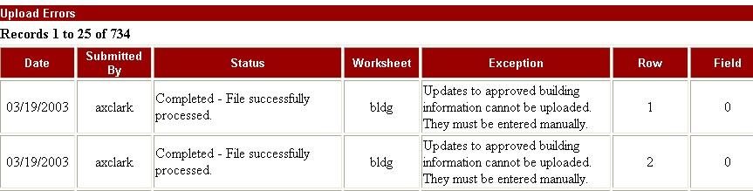
Figure 6-26: An Upload Errors table on the Upload Error Report page.

The table presents the following data categories for each report selected:

Data Category | Description
Date | The date the HA submitted the file.
Submitted By | Name of person who submitted the file.
Status | The status of the file submission.
Worksheet | The worksheet where the error occurred:  - Building  - Unit
Exception | The actual error that occurred (if available).
Row | The row on the spreadsheet where the error occurred.
Field | The field on the Job Aid explaining how to enter the errant data correctly.

If no errors occurred, PIC displays the following message in the Upload Errors section: No upload errors were found. This means that the building and unit data is ready for submission.

Click the Submission Tab to access the Submission page.

The Submission
Tab

If you have the proper security access role, you can submit building/unit data to the field office for approval on this page.
Note: While other users can update building and unit data, only an executive director (or a person designated by the executive director) can perform the actual submission.

Submission Preparation
Data is prepared for submission when:

- Information is updated and saved on the Building and Unit Tabs.
- A file is uploaded on the Building/Unit Data Transfer page.

If the Unit Details Complete option button is marked No on the Unit Details page, PIC displays the following message on the Submission page: The unit details are not complete. In this situation, you are unable to submit the data.

What Should Be Submitted
All changes to building and unit data are subject to field office review. However, you do not need to submit the data after every minor change.

The changes can accumulate. Submissions should be made when you determine significant changes have occurred and the process will be worthwhile.

There is no required time to submit the data. It can be submitted at any time.

Note: After any submission, you are required to notify the field office so the submission can be reviewed. A system is currently in development that will provide notification to the field office when you make a submission.
In addition to submitting data, you can also add specific comments about the transaction. Comments can help expedite approval by:

- Pointing out the reason for the submission.
- Highlighting changes from the previous submission.
- Providing contact information so problems can be fixed.

Comment Examples
- Here is the Hope VI building and unit submission.
- If you have any questions, please contact me at (999) 555-3276 or by emailing jane_doe@hud.gov.
- Submitted April 10, 2002. I changed 0 bedroom units in AG 002002 to 1 bedroom.
- The following units are being changed to Non Dwelling to reflect demolition/disposition:
- AX001019 (Scattered Site) - Bldg/Unit 013Y
- AX001037 (Scattered Site) - Bldg/Unit 0085
- AX001037 (Scattered Site) - Bldg/Unit 0067

Information Presented on the Submission Page
The Submission page displays the following sections of information:

- Enter Comments and Submit Information
- MTCS Data Transfer
- Status History Table

The Enter Comments and Submit Information section includes a Comments text box, a Submit Data for Approval button, and a Save button.

Note: If you have already submitted data but have not yet received a field office approval, PIC displays the following message: Unit data for this HA has been submitted for approval.

The MTCS Data Transfer section reports the status of the MTCS tenant data transfer to the Form-50058 Module.

PIC displays the same message for every housing authority: All applicable tenant certification records have been extracted from the old MTCS system and transferred to the new Form 50058 Module in PIC.

Contact your PIC coach if this section contains a different message.

The Status History Table displays the submission/approval history for the selected housing authority (see Figure 7-27). The table includes the following data categories:

- Date: The date the action was performed.
- Status
- Submitted
- Approved
- Rejected
- Author: The name of the person who performed the submission, approval, or rejection.

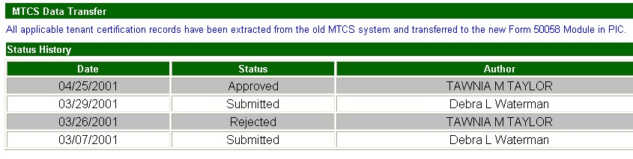
Figure 7-27: The MTCS Data Transfer section and the Status History table
on the Submission page.

Submitting Data to a Field Office
Follow these steps to submit data to a field office:

Step | Action/Result
- Click the Submission Tab after preparing the data for submission. | PIC displays the Submission page.
- Type any comments you think are necessary in the Submission Comments text box.
- Click the Submit Data For Approval button (see Figure 7-28). | The data is submitted to the field office. The submission is entered into the Status History table.  You can also click the Save button to save the entered comments and submit the data at a later time.

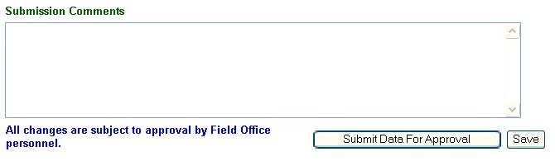
Figure 7-28: The Submission Comments text box, Save button, and Submit Data For Approval button on the Submission page
In the original design of the Development Submodule, developers did not envision the need for editing the following building and unit key identifying data:

Major Data Changes
(Key Field Corrections)

- Participant Code (“HA Code”)
- Development Number
- Building Number
- Building Entrance Number
- Unit Number

However, HA software vendor changes, human errors, and building modifications have made the ability to edit these key fields necessary.

Until recently, the only way PIC could permit changes to the key identifying fields mentioned above was to put all HA building and unit data back to “draft” and to delete all public housing Form-50058 and Demo/Dispo data linked to the units.

Then, after correcting the input error, resubmitting the building and unit data, and getting approval from the field office, the HA would also have to resubmit a current baseline tenant dataset for each public housing tenant and re-create all Demo/Dispo applications.

HUD has stopped this practice, and HAs can no longer be set back to draft.

PIC Management has decided to develop a better method. Developers are creating a building and unit data maintenance function, which will permit changes to the key identifying data without deleting the tenant history. This functionality will be available in early 2004.

Buildings may be renumbered, building entrances added or removed, units deleted, developments de-activated, and building entrance addresses reconfigured as required.

The actual changes will be made by PIC Headquarters staff or contractors based on documented change requests approved by the field office.

Understanding Key Field Edits
To understand why PIC Management set HAs back to draft, it is important to understand the distinctions between data corrections and data updates.

Data corrections are used to remove or correct data that was never true. Corrections apply to the key data fields that specifically identify each building and unit.

The following categories make up the key data fields:

- Participant Code
- Development Number
- Building Number
- Building Entrance Number
- Unit Number

Data updates involve changes to the database as the development’s inventory changes. PIC currently provides the data update functionality to:

- Add new buildings and units (HAs).
- Add new development numbers (HUD HQ).
- Remove buildings and units from their inventory using the Demo-Dispo Submodule of the PIC HA Inventory Module (HAs).
Click the FCR Unit Information Tab to access the FCR Unit Information page (see Figure 9-29).

The FCR Unit Information Tab

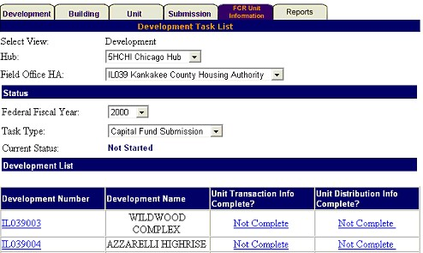
Figure 9-29: The FCR Unit Information page. This page is currently nonfunctional.

This page is inoperable. It does not contain current data or serviceable functions.
The pages discussed below are accessible via the Reports Tab (see Figure 10-30):

The Reports Tab
- The Building Reports page enables you to generate a report containing a range of information about the buildings in a selected development or group of developments.
- The Unit Reports page enables you to generate a report containing a range of information about the units in a selected development or group of developments.
- The Upload Task List Report page can be accessed by HUD employees only.
- The MTCS Occupancy Reconciliation Report page is a vestige from a previous PIC function. It does not use current data and has no current applicability.
- The Resident Assessment Subsystem (RASS) Report page enables you to generate a report presenting both a mailing and physical address for each unit in a development. It can be used to verify addresses so the Resident Survey is sent to the correct place and is not sent back to the Real Estate Assessment Center (REAC).
- The Vacancy/Occupancy (Vac/Occ) Report page enables you to generate a report containing either occupancy or vacancy data for a selected development or group of developments.

Figure 10-30: The subtabs on the Reports Tab.

PIC updates the data in these reports on a continuous basis. They normally reflect information entered as of the previous night.

Note: Availability of these pages depends on your security access role. Contact your security administrator if you want to gain access to a report you are missing.

After you click the Reports Tab, PIC automatically displays the Building Reports page.

The Building Reports Page
Click the Reports Tab to access the Building Reports page. If you are on another subtab in the Reports Tab, you can click the Building Reports subtab to access this page.

A Building Report presents a range of up-to-date building data for any development (or group of developments) in an HA. It can provide an HA’s entire inventory in one view. It also provides a comprehensive view of the HA’s building statuses (for example, the report lists which buildings are in a Demo/Dispo status).

PIC draws the data for these reports from the Building Detail and Unit Detail pages in the Development Submodule and the Demo/Dispo Submodule.

After creating a Building Report, you can download the results onto your computer in different formats for further analysis, distribution, or presentation.

The Building Reports page enables you to select the criteria for these reports (see Figure 10-31).

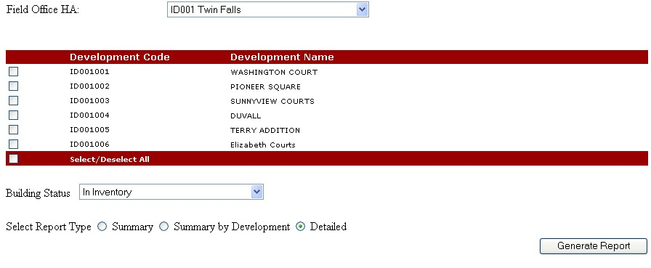
Figure 10-31: The Building Reports page.

Generating a Building Report
Follow these steps to generate a report if you have security access to one HA:

Step | Action/Result
- Click the check box next to the desired development or developments. | Clicking the Select/Deselect All check box one time selects all the developments. Clicking it twice clears all check marks.
- Click one of the following statuses using the Building Status dialog box:  - In Inventory (default)  - All  - Demo/Dispo – Approved  - Demo/Dispo Draft  - Demo/Dispo – Proposed  - Initial Approval Completed  - Initial Upload  - Proposed Removed from Inventory Building  - Removed from Inventory Building  - Removed without HUD Approval | The report includes only buildings in the selected status.  Note: In Inventory includes all buildings with an Initial Upload or Initial Approval Completed status. See page 5 for status definitions.
- Click one of the following report types using the Select Report Type option buttons:  - Summary  - Summary by Development  - Detailed Report (default) | Summary: This report provides building data totals for the development(s) selected.  Summary by Development: This report provides building data for each development selected.  Detailed Report: This report provides specific data for every building in the selected development(s).
- Click the Generate Report button. | PIC displays the selected report.
Follow these steps to generate a report if you have security access to multiple HAs:

Step | Action/Result
- Click the hub containing the desired field office in the Hub dialog box (if applicable).
- Click the appropriate field office in the Field Office dialog box (if applicable).
- Click the HA containing the development you are looking for in the Field Office HA dialog box. | PIC displays a list of developments for the selected HA.
- Click the check box next to the desired development(s). | Clicking the Select/Deselect All check box one time selects all developments. Clicking it twice clears all check marks.
- Click one of the following statuses using the Building Status dialog box:  - In Inventory (default)  - All  - Demo/Dispo – Approved  - Demo/Dispo Draft  - Demo/Dispo – Proposed  - Initial Approval Completed  - Initial Upload  - Proposed Removed from Inventory  - Removed from Inventory Building  - Removed without HUD Approval | The report includes only buildings in the selected status.  Note: In Inventory includes all buildings with an Initial Upload or Initial Approval Completed status. See page 5 for status definitions.

Step | Action/Result
- Click one of the following report types using the Select Report Type option buttons:  - Summary  - Summary by Development  - Detailed Report (default) | Summary: This report provides building data totals for the development(s) selected.  Summary by Development: This report provides building data for each development selected.  Detailed Report: This report provides specific data for every building in the selected development(s).
- Click the Generate Report button. | PIC displays the selected report.

Information Presented in a Summary Building Report
A Summary Building Report contains a header, a Search Criteria section, and a Building Summary table.

The header contains all development identifier information selected on the Building Reports page:

- Date When the Report Is Generated
- Hub
- Field Office
- Field Office HA
- Development(s) Selected

The Search Criteria section displays the building status selected on the Building Reports page. One of the following options is displayed:

- In Inventory
- All
- Demo/Dispo – Approved
- Demo/Dispo – Draft
- Demo/Dispo – Proposed
- Initial Approval Completed
- Initial Upload
- Proposed Removed from Inventory
- Removed from Inventory Building
- Removed without HUD Approval
The Building Summary table displays the following data categories (see Figure 10-32 for an example):

- Building Type
- Elevator Structure
- Mixed Type
- Non Dwelling Structure
- Row or Townhouse (Sep. Entrances)
- Semi-Detached (Sep. Entrances)
- Single Family/Detached
- Walkup/Multi-Family Apts (Shared Entrances)
- Number of Buildings (for Each Building Type)
- Number of Units Reported (for Each Building Type)
- Number of Units Uploaded (into PIC for Each Building Type)
- Total (Number of Buildings) for All Selected Developments
- Total Number of Units Reported in the Buildings for All Selected Developments
- Total Number of Units Uploaded for All Selected Developments

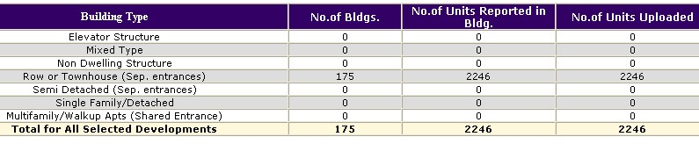
Figure 10-32: An example of a Summary Building table.

There are three options for further use of this data (see Figure 10-33). These options are displayed as icons on the upper-right side of the report page.

- Print Page: The report prints as a Web page.
- Download in Excel: The report downloads into a Microsoft Excel spreadsheet for further data manipulation.
- Download in Microsoft Word: The report downloads into a Microsoft Word file for further data manipulation.

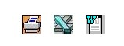
Figure 10-33: The options available for
further use of a report.

Information Presented in a Summary by Development
Building Report
A Summary-by-Development Building Report contains a header, a Search Criteria section, and a series of Building Data Tables.

The header contains all development identifier information selected on the Building Reports page:

- Date (when the report is generated)
- Hub
- Field Office
- Field Office HA
- Development(s) Selected

The Search Criteria section displays the building status selected on the Building Reports page. One of the following options is displayed:

- In Inventory
- All
- Demo/Dispo – Approved
- Demo/Dispo – Draft
- Demo/Dispo – Proposed
- Initial Approval Completed
- Initial Upload
- Proposed Removed from Inventory
- Removed from Inventory Building
- Removed without HUD Approval

The Building Data tables present the following information for each development selected:

- Building Type
- Elevator Structure
- Mixed Type
- Non Dwelling Structure
- Row or Townhouse
- Semi-Detached
- Single Family/Detached
- Walkup/Multi-Family Apartment
- Entrance Number: The total number of entrances for each building type.
- Number of Units Reported for Each Building Type
- Number of Units Uploaded into PIC for Each Building Type
- Total Entrance Number
- Total Number of Units Reported
- Total Number of Units Uploaded into PIC

The report screen contains up to three data tables. If you included more developments in the report, click a page number hyperlink to view the next page of records (see Figure 10-34).

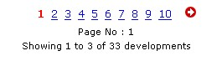
Figure 10-34: An example of the page number hyperlinks
at the bottom of a report page.

The report pages are grouped by sets of 10 pages each. If there are more than 10 pages in the report, you can jump to another page set using the Select Page Set dialog box.

To use the Select Page Set dialog box:

Step | Action/Result
- Click the dialog box. | A list of page sets is displayed. Example: 1 – 10, 11 – 20, and so forth.
- Click the page set you wish to view. | PIC displays the selected page set starting with the lowest page number in the set.

The report screen also presents three options for further use of this data. The options are displayed as icons on the upper-right side of the report page.

- Print Page: The report prints as a Web page.
- Download in Excel: The report downloads into a Microsoft Excel spreadsheet for further data manipulation.
- Download in Microsoft Word: The report downloads into a Microsoft Word file for further data manipulation.

Information Presented in a Detailed Building Report
A Detailed Building report contains a header, a Search Criteria section, and a Detailed Building Data table.

The header contains all development identifier information selected on the Building Reports page:

- Date When the Report Is Generated
- Hub
- Field Office
- Field Office HA
- Development(s) Selected

The Search Criteria section displays the building status selected on the Building Reports page. One of the following options is displayed:

- In Inventory
- All
- Demo/Dispo Approved
- Demo/Dispo Draft
- Demo/Dispo Proposed
- Initial Approval Completed
- Initial Upload
- Proposed for Removed from Inventory
- Removed from Inventory Building
- Removed without HUD Approval

The Detailed Building Data table presents the following information for every building in the selected development or developments:

- Development Number
- Building Number
- Entrance Number
- Location (Physical Entrance Address)
- Status
- Building Type
- Construction Date
- Floor Count
- Number of Units Reported in Building
- Number of Units Uploaded into PIC for the Status Selected

The default display for the table is ascending Development Number. The data can be sorted in ascending or descending order for any of these categories except for Location (see Figure 10-35).

- Click the Up Arrow button in the desired column heading to sort in ascending order (lowest to highest for numbers, A to Z for alphabetical categories, and earliest to most recent for dates).
- Click the Down Arrow button in the desired column heading to sort in descending order (highest to lowest for numbers, Z to A for alphabetical categories, and most recent to earliest for dates).

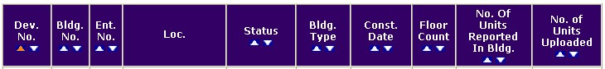
Figure 10-35: The data categories for a detailed Building Report. The Up and Down Arrow buttons represent sortable categories.

The report pages are grouped by sets of 10 pages each. If there are more than 10 pages in the report, you can jump to another page set using the Select Page Set dialog box.

To use the Select Page Set dialog box:

Step | Action/Result
- Click the dialog box. | A list of page sets is displayed. Example: 1 – 10, 11 – 20, and so forth.
- Click the page set you wish to view. | PIC displays the selected page set starting with the lowest page number in the set.

There are three options for further use of this data. These options are displayed as icons on the top right side of the report page.

- Print Page: The report prints as a Web page.
- Download in Excel: The report downloads into a Microsoft Excel spreadsheet for further data manipulation.
- Download in Microsoft Word: The report downloads into a Microsoft Word file for further data manipulation.

The Unit Reports Page
Click the Unit Reports subtab on the Reports Tab to access the Unit Reports page.

This page enables you to generate an up-to-date report on all units in a specific development or group of developments. Along with displaying informative unit details, a Unit Report can also add tenant data in the same view.

PIC draws the data for these reports from the Form-50058 Module and the Unit Detail page in the Development Submodule.

After creating a Unit Report, you can download the results onto your computer in different formats for further analysis, distribution, or presentation.

Generating a Unit Report
The Unit Reports page enables you to select the criteria for a Unit Report.

Follow these steps to generate a Unit Report if you have security access to one HA:

Step | Action/Result
- Click the check box next to the desired development(s). | Clicking the Select/Deselect All check box at the bottom of the development list one time selects all the developments. Clicking it twice clears all check marks.
- Click the Occupancy check box to include tenant names in the report. (Access to this check box depends on your security access role. Contact your security administrator if you would like to gain access to this feature.)
- Click one of the following statuses using the Unit Status dialog box:  - In Inventory (default)  - All  - Demo/Dispo – Approved  - Demo/Dispo Draft  - Demo/Dispo – Proposed  - Initial Approval Completed  - Initial Upload  - Proposed for Removed from Inventory  - Removed from Inventory  - Removed without HUD Approval | The report includes units in the selected status.  Note: In Inventory includes all units with an Initial Upload or Initial Approval Completed status. See page 6 of this manual for more status definitions.
- Click one of the following tenant types using the Tenant Type dialog box:  - All (default)  - Employee  - Law Enforcement  - Regular Tenant | The report displays the results for the selected tenant type.

Step | Action/Result
- Click one of the following options using the Unit Details Complete dialog box:  - All (default)  - Yes  - No | All: The report includes both complete and incomplete records.  Yes: The report includes only completed records.  No: The report includes incomplete records only.  Note: Any incomplete Unit record must be corrected before it can be submitted for approval.
- Click one of the following options using the ACC Unit Indicator dialog box (for detailed reports only):  - All (default)  - Yes  - No | All: The report includes ACC Yes and ACC No units.  Yes: The report includes only ACC Yes units.  No: The report includes only ACC No units.
- Click one of the following report types using the Select Report Type option buttons:  - Summary  - Summary by Development  - Detailed (default) | Summary: This report provides unit data totals for all development(s) selected.  Summary by Development: This report provides unit data for each development selected.  Detailed Report: This report provides specific data for every unit in the selected development(s).
- Click the Generate Report button. | PIC displays the selected report.
Follow these steps to generate a report if you have security access to multiple HAs.

Step | Action/Result
- Click the hub containing the desired field office in the Hub dialog box (if applicable).
- Click the appropriate field office in the Field Office dialog box (if applicable).
- Click the HA containing the development you are looking for in the Field Office HA dialog box. | PIC displays a list of developments for the selected HA.
- Click the check box(es) next to the development(s) you want to display in the report. | Clicking the Select/Deselect All check box at the bottom of the development list one time selects all developments. Clicking it twice clears all check marks.
- Click the Occupancy check box to include tenant names in the report. (Access to this check box depends on your security access role. Contact your security administrator if you would like to gain access to this feature.)
- Click one of the following statuses using the Unit Status dialog box:  - In Inventory (default  - All  - Demo/Dispo – Approved  - Demo/Dispo – Draft  - Demo/Dispo – Proposed  - Initial Approval Completed  - Initial Upload  - Proposed for Removed from Inventory  - Removed from Inventory  - Removed without HUD Approval | The report includes units in the selected status.  Note: In Inventory includes all units with an Initial Upload or Initial Approval Completed status. See page 6 of this manual for more status definitions.

Step | Action/Result
- Click one of the following tenant types using the Tenant Type dialog box:  - All (default)  - Employee  - Law Enforcement  - Regular | The report displays the results for the selected tenant type.
- Click one of the following options using the Unit Details Complete dialog box:  - All (default)  - Yes  - No | All: The report includes both complete and incomplete records.  Yes: the report includes only completed records.  No: The report includes incomplete records only.  Note: Any incomplete unit record must be corrected before it can be submitted for approval.
- Click one of the following options using the ACC Unit Indicator dialog box (for detailed reports only).  - All (default)  - Yes  - No | All: The report includes ACC Yes and ACC No units.  Yes: The report includes only ACC Yes units.  No: The report includes only ACC No units.
- Click one of the following report types using the Select Report Type option buttons:  - Summary  - Summary by Development  - Detailed (default) | Summary: This report provides unit data totals for all development(s) selected.  Summary by Development: This report provides unit data for each development selected.  Detailed Report: This report provides specific data for every unit in the selected development(s).
- Click the Generate Report button. | PIC displays the selected report.

Information Presented in a Summary Unit Report
A Summary Unit Report contains a header, a Search Criteria section, and a series of data tables.

The header contains the following development identifier information selected on the Unit Reports page:

- Date (when the report is generated)
- Hub
- Field Office
- Field Office HA
- Development(s) Selected

The Search Criteria section displays the search information selected on the Unit Reports page:

- The Unit Status
- The Tenant Type
- Details Complete

The tables listed below are included in every Unit Summary Report.

- The Elderly Unit table includes the following aggregate information for all developments selected on the Unit Reports page:
- Bedroom Size: 0, 1, 2, 3, 4, 5+, Total
- Unit Count for Each Bedroom Size
- ACC Unit Count for Each Bedroom Size
- Occupied Unit Count for Each Bedroom Size
- Vacant Unit Count for Each Bedroom Size

- The Family Unit table includes the following aggregate information for all developments selected on the Unit Reports page (see Figure 10-36 for an example):
- Bedroom Size: 0, 1, 2, 3, 4, 5+, Total
- Unit Count for Each Bedroom Size
- ACC Unit Count for Each Bedroom Size
- Occupied Unit Count for Each Bedroom Size
- Vacant Unit Count for Each Bedroom Size

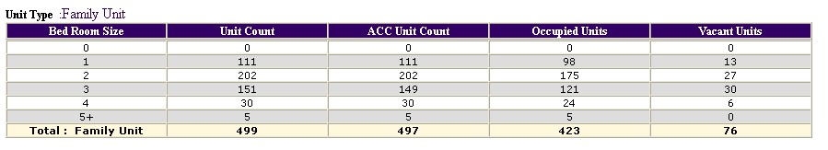
Figure 10-36: An example of a Family Unit table in a Summary Unit Report.

- The Merged Unit table includes the following aggregate information for all developments selected on the Unit Reports page:
- Bedroom Size: 1, 2, 3, 4, 5+, Total
- Unit Count for Each Bedroom Size
- ACC Unit Count for Each Bedroom Size

- The Non Dwelling Unit table includes the following aggregate information for all developments selected on the Unit Reports page:
- Bedroom Size: 1, 2, 3, 4, 5+, Total
- Unit Count for Each Bedroom Size
- ACC Unit Count for Each Bedroom Size

- The Summary table includes the following aggregate data for the development(s) selected:
- Total Unit Count
- Total ACC Unit Count
- Total Occupied Units
- Total Vacant Units
- ACC Unit Count Percentage
- Occupied Unit Percentage
- Vacant Unit Percentage

There are three options for further use of this data. These options are displayed as icons on the upper-right side of the report page.

- Print Page: The report prints as a Web page.
- Download in Excel: The report downloads into a Microsoft Excel spreadsheet for further data manipulation.
- Download in Microsoft Word: The report downloads into a Microsoft Word file for further data manipulation.

Information Presented in a Summary-by-Development Unit Report
A Summary-by-Development Unit Report includes a header, a Search Criteria section, and a series of data tables for each development included in the report.

The header contains all development identifier information selected on the Unit Reports page:

- Date (When the report is generated)
- Hub
- Field Office
- Field Office HA
- Development(s) Selected

The Search Criteria section displays the search information selected on the Unit Reports page:

- Unit Status
- Tenant Type
- Unit Details Complete
- ACC Indicator

A Summary-by-Development Unit Report includes the tables listed below for each development selected on the Unit Reports page:

- The Elderly Unit table includes the following information:
- Bedroom Size: 0, 1, 2, 3, 4, 5+, Total
- Unit Count for Each Bedroom Size
- ACC Unit Count for Each Bedroom Size
- Occupied Unit Count for Each Bedroom Size
- Vacant Unit Count for Each Bedroom Size

- The Family Unit table includes the following aggregate information for all developments selected on the Unit Reports page:
- Bedroom Size: 0, 1, 2, 3, 4, 5+, Total
- Unit Count for Each Bedroom Size
- ACC Unit Count for Each Bedroom Size
- Occupied Unit Count for Each Bedroom Size
- Vacant Unit Count for Each Bedroom Size

- The Merged Unit table includes the following aggregate information for all developments selected on the Unit Reports page:
- Bedroom Size: 1, 2, 3, 4, 5+, Total
- Unit Count for Each Bedroom Size
- ACC Unit Count for Each Bedroom Size

- The Non Dwelling Unit table includes the following aggregate information for all developments selected on the Unit Reports page:
- Bedroom Size: 1, 2, 3, 4, 5+, Total
- Unit Count for Each Bedroom Size
- ACC Unit Count for Each Bedroom Size

- The report also includes a Summary table for each development listed (see Figure 10-37). These tables include the following data categories:
- Development Number
- Total Unit Count
- Total ACC Unit Count
- Total Occupied Units
- Total Vacant Units
- ACC Unit Count Percentage
- Occupied Unit Percentage
- Vacant Unit Percentage

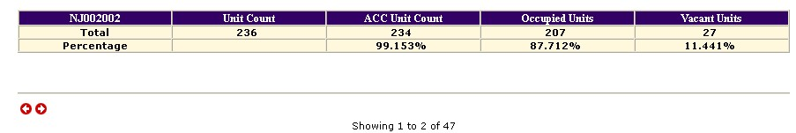
Figure 10-37: The Summary table in a Summary-by-Development Unit Report.

Each report page contains tables for two developments. If you have selected more than two, click the Arrow button at the bottom of the page to view the remainder.

There are three options for further use of this data. These options are displayed as icons on the upper right side of the report page:

- Print Page: The report prints as a Web page.
- Download in Excel: The report downloads into a Microsoft Excel spreadsheet for further data manipulation.
- Download in Microsoft Word: The report downloads into a Microsoft Word file for further data manipulation.

Information Presented in a Detailed Unit Report
A Detailed Unit Report consists of a header, a Search Criteria section, and a Detailed Unit Data table.

The header contains all development identifier information selected on the Unit Reports page.

- Date (When the report is generated)
- Hub
- Field Office
- Field Office HA
- Development(s) Selected

The Search Criteria section displays the search information selected on the Unit Reports page:

- Occupancy
- Selected
- Not Selected
- Unit Status
- Unit Tenant Type
- Unit Details Complete
- ACC Indicator

The Detailed Unit Data Table (see Figure 10-38) presents the following information for every unit in the selected development(s):

- Development Number
- Building Number
- Entrance Number
- Unit Number
- Unit Type
- Unit Status Type
- Bedroom Count
- Tenant SSN (if the Occupancy box is checked)
- Tenant First Name (if the Occupancy box is checked)
- Tenant Last Name (if the Occupancy box is checked)
- Occupancy Date (if the Occupancy box is checked)
- Tenant Type
- Unit Details Complete
- ACC Unit

Note: The tenant data is included if you check the Occupancy check box.
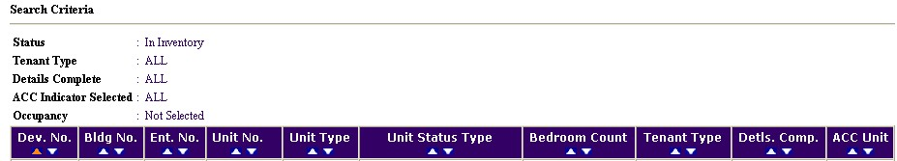
Figure 10-38: The data categories of a Detailed Unit Report. This report
was generated without marking the Occupancy check box.

The table data can be sorted in ascending or descending order for any of these categories:

- Click the Up Arrow button in the desired column heading to sort in ascending order (lowest to highest for numbers, A to Z for alphabetical categories, and earliest to most recent for dates).
- Click the Down Arrow button in the desired column heading to sort in descending order (highest to lowest for numbers, Z to A for alphabetical categories, and most recent to earliest for dates).

There are three options for further use of this data. These options are displayed as icons on the upper right side of the report page:

- Print Page: The report prints as a Web page.
- Download in Excel: The report downloads into a Microsoft Excel spreadsheet for further data manipulation.
- Download in Microsoft Word: The report downloads into a Microsoft Word file for further data manipulation.

The MTCS Occupancy Reconciliation Report Page
This report is no longer relevant. It contains confusing and old data.

The Resident Assessment Subsystem (RASS) Report Page
Click the RASS Report subtab on the Reports Tab to access the RASS Report page.

Access to this page depends on your security access role. Contact your security administrator if you would like to gain access to this page.

REAC uses the unit addresses in PIC for distribution of its Customer Satisfaction Survey and as an official listing for its physical inspections.

Only occupied Low Rent units receive surveys. The physical addresses are taken from the Development Submodule. The mailing addresses are taken from the Form-50058 Module.

A RASS Report contains the official addresses for all units in a selected development (or group of developments). This report enables HAs to check the information supplied to REAC for survey distribution and physical inspection purposes.

Note: You cannot certify the addresses in PIC. REAC still requires address certification in the PIH-REAC RASS System.

Generating a RASS Report
The RASS Report page enables you to select the criteria for this report.

Follow these steps to generate a report if you have security administrative access to one HA:

Step | Action/Result
- Click the check box(es) next to the development(s) you want to include in the report. | Clicking the Select/Deselect All check box at the bottom of the development list one time selects all developments. Clicking it twice clears all check marks.
- Click one of the following indicators using the Occupied Indicator dialog box:  - All (default)  - Yes  - No | All: The report includes all units.  Yes: The report includes only occupied units.  No: The report includes only vacant units.
- Type the date range you want the report to display in the Last Update Date From and Last Update Date To text boxes. Dates are required to be in MM/DD/YYYY format (example: 02/20/2003).

An Update Date is the most recent date when a building or unit data submission was approved.
- Click the Generate Report button. | PIC displays the RASS Report with the selected criteria.

Follow these steps to generate a report if you have security access to multiple HAs:

Step | Action/Result
- Click the hub that contains the desired field office in the Hub dialog box (if applicable).
- Click the appropriate field office in the Field Office dialog box (if applicable).
- Click the HA containing the development you are looking for in the Field Office HA dialog box. | PIC displays a list of developments for the selected HA.
- Click the check box(es) next to the development(s) you want to include in the report. | Clicking the Select/Deselect All check box at the bottom of the development list one time selects all developments. Clicking it twice clears all check marks.
- Click one of the following indicators using the Occupied Indicator dialog box:  - All (default)  - Yes  - No | All: The report includes all units.  Yes: The report includes only occupied units.  No: The report includes only vacant units.
- Type the date range you want the report to display in the Last Update Date From and Last Update Date To text boxes. Dates are required to be in MM/DD/YYYY format (example: 02/20/2003).

An Update Date is the most recent date when a building or unit data submission was approved.
- Click the Generate Report button. | PIC displays the RASS Report with the selected criteria.

Information Presented in a RASS Report
A RASS Report contains a header and a RASS Report table.

The header displays the following information selected on the RASS Report page:

- Hub
- Field Office
- Field office HA
- Occupied Indicator
- Total Number of Records
- Update Date From
- Update Date To
- Developments

The report defaults to display results for all developments. If you requested more than one development on the RASS Report page, follow these steps to view a specific development’s data:

Step | Action/Result
- Click the Developments dialog box. | PIC displays the development numbers of the developments selected on the RASS Report page.
- Click the desired development number. | PIC displays the RASS Report data for the selected development.

The RASS Report table displays the following information (see Figure 10-39 for an example):

- Development Number
- Building/Entrance/Unit Numbers
- Physical Address: Taken from the Development Submodule. This is the most recent data and is not necessarily approved by the field office:
- Address
- City
- State
- Zip Code
- Mailing Address: The tenant’s mailing address is taken from the most recent form submitted in the Form-50058 Module:
- Address
- City
- State
- Zip Code
- Occupied Indicator
- Last Update Date

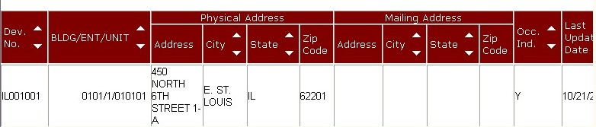
Figure 10-39: The RASS Report table.

Each table fits 50 entries onto a report page. If there are more than 50 vacant units in the selected development, click a page number at the bottom of the table to view the remaining records.

The report pages are grouped by sets of 10 pages each. If there are more than 10 pages in the report, you can jump to another page set using the Select Page Set dialog box.

To use the Select Page Set dialog box:

Step | Action/Result
- Click the dialog box. | A list of page sets is displayed (example: 1 – 10, 11 – 20, and so forth).
- Click the page set you wish to view. | PIC displays the selected page set starting with the lowest page number in the set.

The table data can be sorted in ascending or descending order for the Development Number, Building/Entrance/Unit Number, City (both physical and mailing), State (both physical and mailing), and Occupied Indicator categories:

- Click the Up Arrow button in the desired column heading to sort in ascending order (lowest to highest for numbers, A to Z for alphabetical categories, and earliest to most recent for dates).
- Click the Down Arrow button in the desired column heading to sort in descending order (highest to lowest for numbers, Z to A for alphabetical categories, and most recent to earliest for dates).

There are three options for further use of this data. These options are displayed as icons on the upper right side of the report page:

- Print Page: The report prints as a Web page.
- Download in Excel: The report downloads into a Microsoft Excel spreadsheet for further data manipulation.
- Download in Microsoft Word: The report downloads into a Microsoft Word file for further data manipulation.

Editing Address Information in PIC
The RASS Report displays a unit’s physical address and the tenant’s mailing address (if provided) side by side.

If the tenant uses the physical unit address to receive mail, the building entrance address in the Development Submodule is the source. If needed, edit the address information as described on page 11 and the door number data as described on page 14.

If the tenant uses a mailing address (e.g. a PO Box), corrections should be made by submitting a corrected form in the Form-50058 Module’s Submission Submodule:

- Edit the address in line 5c.
- Select the No check box in Line 5b (Is the mailing address the same as the unit address?).

The RASS Report reflects the changes after the daily database update.

RASS Certification Points of Emphasis
If you are involved with the RASS certification process, remember the following tips:

- Before certifying the information in RASS, make sure you have updated the unit address information in PIC and submitted the changes to the field office for approval.
- Any vacant units are ignored in the RASS system. This means vacant units scheduled for demolition do not receive surveys and are not included in the certification.
- If a mailing address is uploaded via the Submission Submodule, the survey is sent to that address instead of the physical address entered into the Development Submodule. If there is no mailing address listed, the survey is sent to the physical address contained in the Development Submodule.
- If you need assistance with the RASS system, please contact the PIH-REAC Technical Assistance Center at (888) 245-4860.

The Vacancy/Occupancy Report Page
Click the Vac/Occ subtab in the Reports Tab to access the Vacancy/Occupancy Report page. The page enables you to generate a detailed report about either the occupied or the vacant units in a development.

This report provides information for HAs, field offices, or HUD HQ on the management performance of an HA. It enables you to see the turn-around times in terms of occupancy and vacancy, which provides insight into an HA’s asset management effectiveness.

PIC draws the data from the Unit Details pages in the Development Submodule and the Form-50058 Module.

Generating a Vacancy/Occupancy Report
The Vacancy/Occupancy Reports page enables you to select the criteria for this report.

Follow these steps to generate a report if you have security administrative access to one HA:

Step | Action/Result
- Click the check box(es) next to the development(s) you want to include in the report (see Figure 10-40). | Clicking the Select/Deselect All check box at the bottom of the development list one time selects all developments. Clicking it twice clears all check marks.
- Click one of the following report types using the Select Report Type option buttons:  - Vacancy  - Occupancy (default) | Vacancy: This option filters out all occupied unit data for the selected development(s). This is called a Vacancy Report.  Occupancy: This option filters out all vacant unit data for the selected development(s). This is called an Occupancy Report.
- Click the Generate Report button. | PIC displays the selected report.

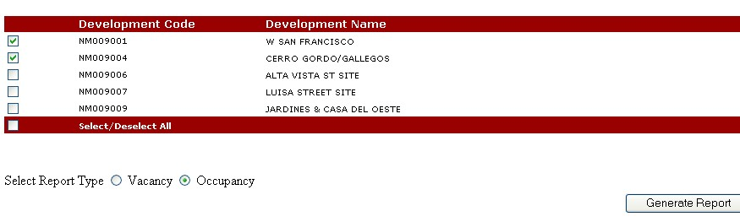
Figure 10-40: An example of the criteria available for
generating a Vacancy/Occupancy Report.

Follow these steps to generate a report if you have security access to multiple HAs:

Step | Action/Result
- Click the hub that contains the desired field office in the Hub dialog box (if applicable).
- Click the appropriate field office in the Field Office dialog box (if applicable).
- Click the HA containing the development you are looking for in the Field Office HA dialog box. | PIC displays a list of developments for the selected HA.
- Click the check box(es) next to the development(s) you want to include in the report. | Clicking the Select/Deselect All check box at the bottom of the development list one time selects all developments. Clicking it twice clears all check marks.
- Click one of the following report types using the Select Report Type option buttons:  - Vacancy  - Occupancy | Vacancy: This option filters out all occupied unit data for the selected development(s). This is called a Vacancy Report.  Occupancy: This option filters out all vacant unit data for the selected development(s). This is called an Occupancy Report.
- Click the Generate Report button. | PIC displays the selected report.

Information Presented in a Vacancy Report
A Vacancy Report contains a header and a Vacancy Data table.

The header includes the following information selected on the Vacancy/Occupancy Report page:

- Hub
- Field Office
- Field Office HA
- Report Type: Vacancy
- Development Code Selected
- Total Records

The Development Code is listed in a dialog box. The default selection is for the dialog box is All. If you requested more than one development on the Vacancy/Occupancy Report page, follow these steps to view a specific development:

Step | Action/Result
- Click the Development Code dialog box. | PIC displays the development codes of the developments selected on the Vacancy/Occupancy Report page.
- Click the desired development code. | PIC displays the Vacancy Report data for the selected development.

The Vacancy Data table displays the following information:

- Building Number
- Building Entrance Number
- Unit Number
- Vacant Days: The number of days the unit has been vacant. If there is a dash (-) in the Vacant Days column, the information is unavailable.

The table data can be sorted in ascending or descending order for any of its data categories:

- Click the Up Arrow button in the desired column heading to sort in ascending order (lowest to highest for numbers, A to Z for alphabetical categories, and earliest to most recent for dates).
- Click the Down Arrow button in the desired column heading to sort in descending order (highest to lowest for numbers, Z to A for alphabetical categories, and most recent to earliest for dates).

Each report page contains 50 table entries. If there are more than 50 vacant units in the selected development, click a page number at the bottom of the table to view the remaining records.

If there are more than 10 pages in the report, you can jump to another page set using the Select Page Set dialog box.

To use the Select Page Set dialog box:

Step | Action/Result
- Click the dialog box. | A list of page sets is displayed (example: 1 – 10, 11 – 20, and so forth).
- Click the page set you wish to view. | PIC displays the selected page set starting with the lowest page number in the set.

There are three options for further use of this data. These options are displayed as icons on the upper right side of the report page.

- Print Page: The report prints as a Web page.
- Download in Excel: The report downloads into a Microsoft Excel spreadsheet for further data manipulation.
- Download in Microsoft Word: The report downloads into a Microsoft Word file for further data manipulation.

Information Presented in an Occupancy Report
An Occupancy Report contains a header and an Occupancy Data table.

The header includes the following information selected on the Vacancy/Occupancy Report page:

- Hub
- Field Office
- Field Office HA
- Report Type: Occupancy
- Development Code Selected
- Total Records

The Development Code is listed in a dialog box. The default selection for the dialog box is All. If you requested more than one development on the Vacancy/Occupancy Report page, follow these steps to view a specific development:

Step | Action/Result
- Click the Development Code dialog box. | PIC displays the development code of the developments selected on the Vacancy/Occupancy Report page.
- Click the desired development code. | PIC displays the Occupancy Report data for the selected development.

The Occupancy Data Table displays the following information (information source):

- Building Number: The building number for the building holding the occupied unit. (Unit Details page)
- Building Entrance Number (Unit Details page)
- Unit Number (Unit Details page)
- SSN Head (Form-50058)
- First Name (Form-50058)
- Last Name (Form 50058)
- Occupancy Date (Form 50058)
- Bedroom Count (Unit Details page)
- Monthly Rent (Form 50058)
- Household Size (Form 50058)

Refer to pages 6 and 9 for these data category definitions.
The table data can be sorted in ascending or descending order for any of its data categories.

- Click the Up Arrow button in the desired column heading to sort in ascending order (lowest to highest for numbers, A to Z for alphabetical categories, and earliest to most recent for dates).
- Click the Down Arrow button in the desired column heading to sort in descending order (highest to lowest for numbers, Z to A for alphabetical categories, and most recent to earliest for dates).

Each report page contains 50 table entries. If there are more than 50 occupied units in the selected development, click a page number at the bottom of the table to view the remaining records.

If there are more than 10 pages in the report, you can jump to another page set using the Select Page Set dialog box.

To use the Select Page Set dialog box:

Step | Action/Result
- Click the dialog box. | A list of page sets is displayed (example: 1 – 10, 11 – 20, and so forth).
- Click the page set you wish to view. | PIC displays the selected page set starting with the lowest page number in the set.

There are three options for further use of this data. These options are displayed as icons on the upper right side of the report page:

- Print Page: The report prints as a Web page.
- Download in Excel: The report downloads into a Microsoft Excel spreadsheet for further data manipulation.
- Download in Microsoft Word: The report downloads into a Microsoft Word file for further data manipulation.

