Press Office
U.S. Department of Homeland Security
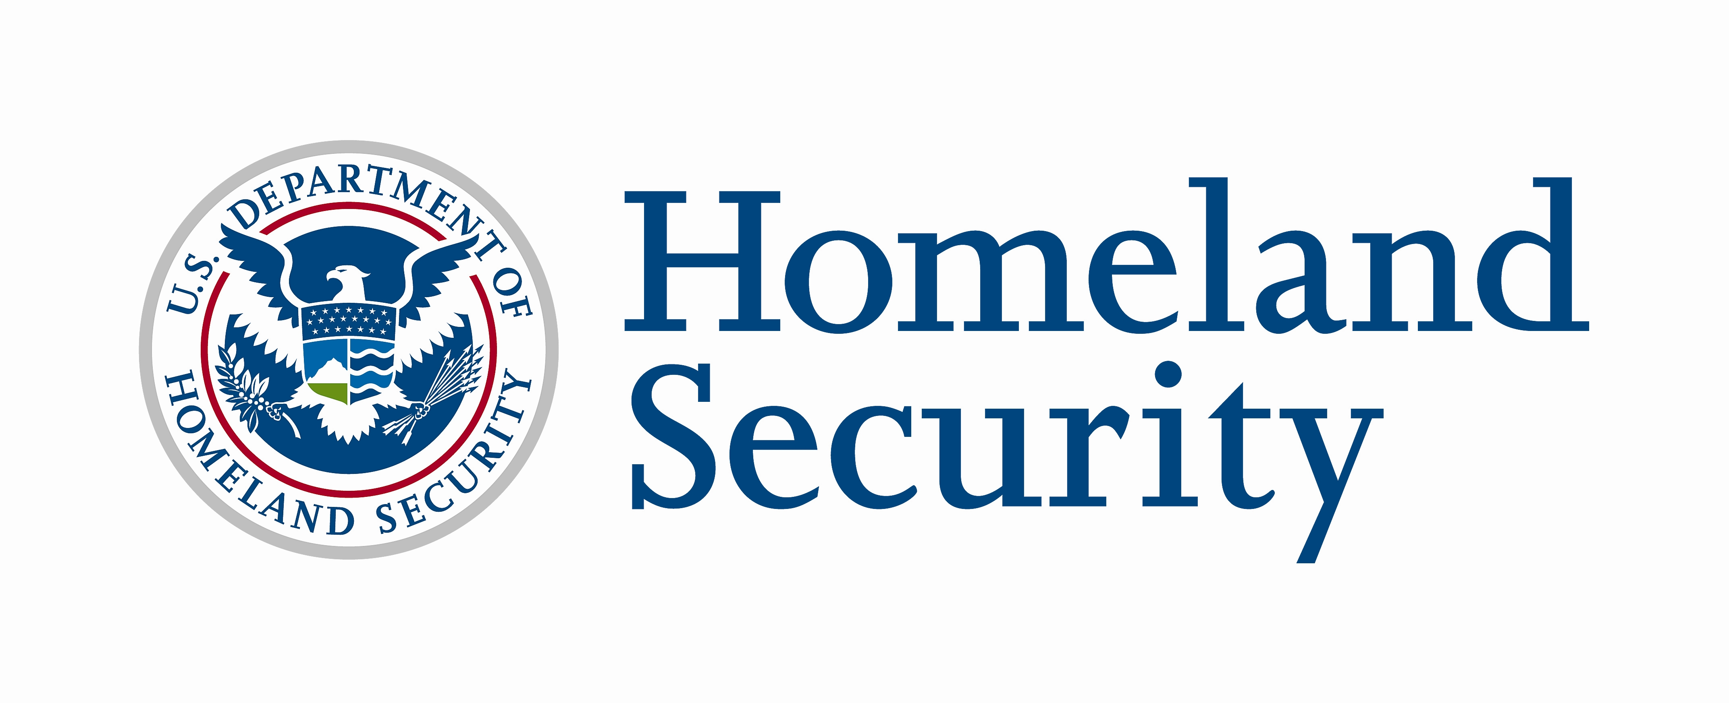
Press Release
October 5, 2007
Contact: DHS Press Office, (202) 282-8010

DHS DECLARES FOURTH ANNUAL NATIONAL PREPAREDNESS MONTH
MOST SUCCESSFUL READY EFFORT TO DATE
1,800 National and Regional Organizations Joined DHS During September

WASHINGTON – The U.S. Department of Homeland Security (DHS) announced today that a record number of national, regional, state, and local organizations participated in its fourth annual National Preparedness Month (NPM). More than 1,800 NPM coalition members coordinated at least 1,000 events and activities across America, reaching individuals, families, and diverse communities with the message of emergency preparedness.

“This coordinated effort helps to serve as an important reminder to millions of individuals to take steps to prepare,” said Homeland Security Secretary Michael Chertoff. “The large involvement from the public in National Preparedness Month 2007 reinforces the fact that a greater proportion of Americans are recognizing the need for personal responsibility in preparing for emergencies before they happen. However, this preparedness message must continue year-round to everyone in America.”

DHS’s Citizen Corps and its program partners offered preparedness trainings and education, as well as opportunities for citizens to engage in efforts in their local communities. For the first time, National Preparedness Month was broken into four theme areas. Sample events are listed below by theme area:
Preparedness for Kids
- The state of Alabama held three Be Ready Camps, an educational experience for sixth-grade students focused on building preparedness skills for all types of disasters.
- The Farmington Hills, Michigan Emergency Preparedness Commission (EPC) held its inaugural Emergency Preparedness Essay Contest for fifth and eighth grade students.

Business Preparedness

- San Diego, Santa Barbara, and Los Angeles, Calif., each hosted events to encourage and educate business representatives from public and private organizations on ways to partner to respond to natural and man-made disasters.
- The Fresno Fire Department in California conducted a fire and life safety inspection for local business owners and distributed information on how to prepare their businesses and employees for emergencies.
Multicultural Preparedness
- Neighbors in the West Adams Neighborhood Council area in Los Angeles, Calif., including Vineyard Recreation Center, CLASS Parks, and JBAC-LA Block Club hosted a Celebrate Diversity National Neighborhood Day, where participants learned more about preparedness and built emergency supply kits.
- The City of Orlando, Florida Office of Emergency Management and Citizen Corps program hosted and presented an Emergency Preparedness Workshop to the Hispanic-American Professional and Business Women’s Association (HAPBWA).

Home and Family Preparedness

- The Utah Foster Care Foundation hosted its first annual emergency preparedness fair. Attendees put together an emergency kit for their families.
- The Ohio Department of Mental Retardation and Developmental Disabilities (ODMRDD) developed and launched a two-hour Emergency Preparedness training class, as part of ODMRDD’s overall training program.

For a recap of additional events and activities that took place during September, visit the National Preparedness Month Journal at www.ready.gov.

Ready is a national public service advertising campaign produced by The Advertising Council in partnership with the Department of Homeland Security. The Ready Campaign is designed to educate and empower Americans to prepare for and respond to emergencies, including natural disasters and potential terrorist attacks. Individuals interested in more information about family, business and community preparedness can visit www.ready.gov or call 1-800-BE-READY to receive free materials.

Citizen Corps brings together community, emergency and government leaders to involve community members in emergency preparedness, planning, mitigation, response and recovery. Through Citizen Corps and its program partners and affiliates, individuals can find training and volunteer opportunities to support first responders in an emergency. To learn more and to get involved, contact your nearest Citizen Corps Council by visiting www.citizencorps.gov.

National Preparedness Month events and activities are voluntary. DHS is not financially obligated to any National Preparedness Month Coalition Member. For more information about National Preparedness Month, visit www.ready.gov.

###

