Press Office
U.S. Department of Homeland Security
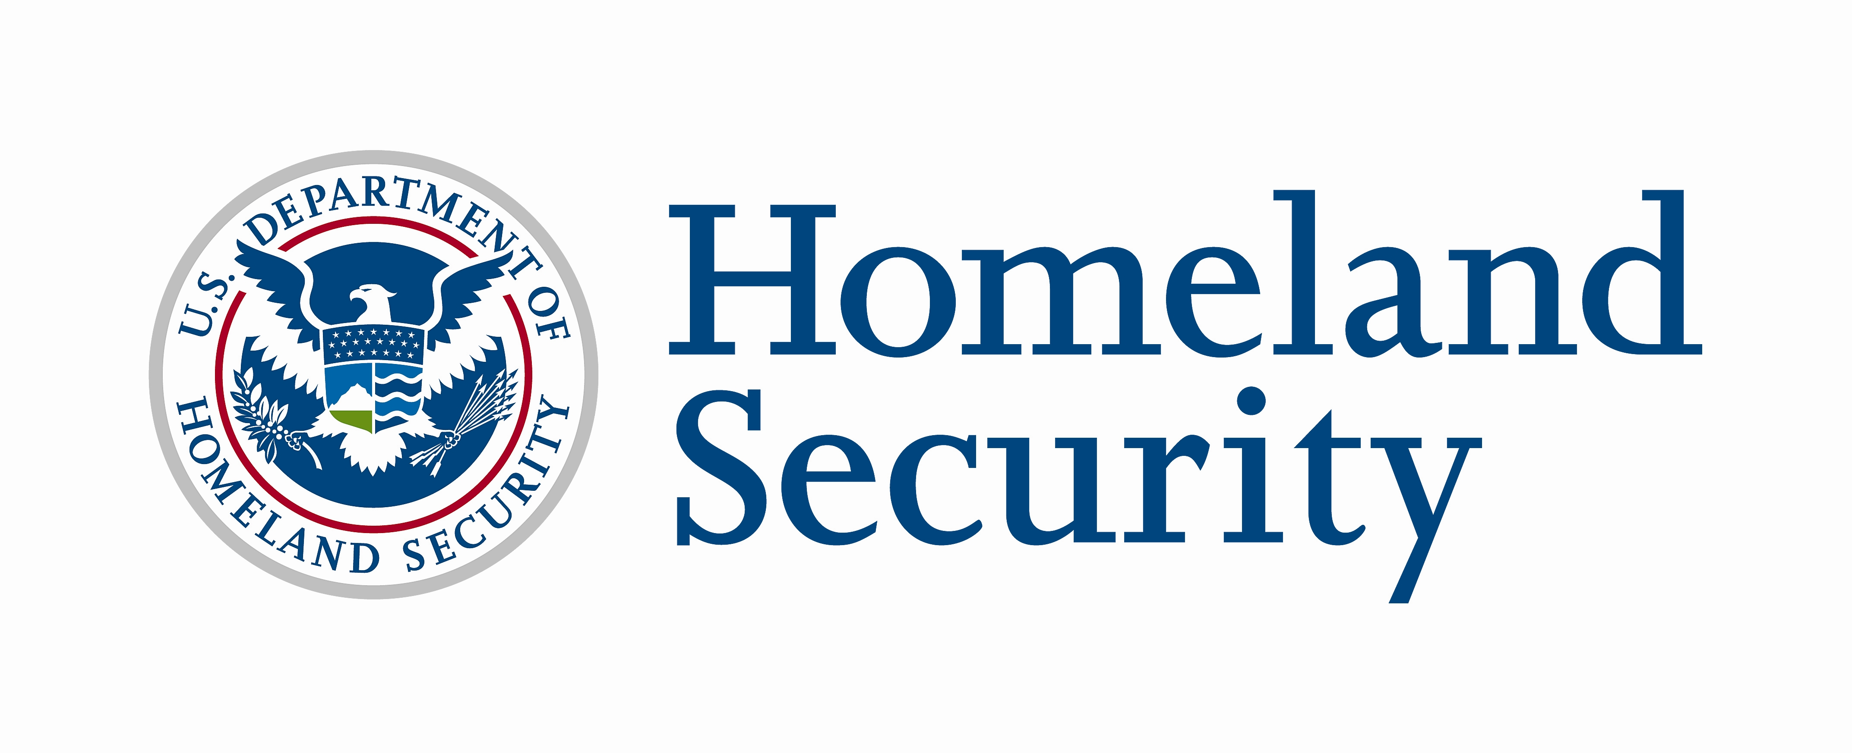
Fact Sheet

August 31, 2007
Contact: DHS Press Office, 202-282-8010

NATIONAL PREPAREDNESS MONTH 2007

National Preparedness Month is a nationwide coordinated effort sponsored by the U.S. Department of Homeland Security each September to encourage Americans to take simple steps to prepare for emergencies in their homes, businesses and schools.

- The goal of National Preparedness Month is to increase public awareness about the importance of preparing for emergencies, including natural disasters and potential terrorist attacks, and to encourage individuals to take action to prepare themselves and their families.

- This September will be the fourth annual National Preparedness Month. For the first time, the month will focus on different areas of emergency preparedness:

  - September 1-8; Back-to-School (Ready Kids)
  - September 9-15; Business preparedness (Ready Business)
  - September 16-22; Multicultural preparedness (Listo Campaign)
  - September 23-30; Home and family preparedness, including pets, older Americans and those individuals with disabilities and special needs (Ready America)

- The month provides Americans with a variety of opportunities to learn more about emergency preparedness. The Ready Campaign and the Department’s Citizen Corps Program will be working closely together to promote events and activities across the nation that will encourage individuals to get an emergency supply kit, make a family emergency plan and be informed about the different types of emergencies that could occur and their appropriate responses. Efforts will also encourage individuals to get trained and involved in community preparedness.

- Homeland Security is working with more than 1,760 organizations, including national, regional, state and local government organizations to highlight the importance of public emergency preparedness throughout September.
- During September, Coalition Members will share preparedness information with their members, customers, employees, and communities. National Preparedness Month activities taking place throughout September (for a complete list of events, visit www.ready.gov) include:

- In New York City, the Office of Emergency Management (OEM) will kick off National Preparedness Month with the New York City Citizen Corps Council at seven locations throughout the five boroughs. Various city and community partners will be stationed near major transit hubs to distribute copies of the Ready New York pocket-size preparedness guide, part of OEM's Ready New York Campaign, and educate New Yorkers about ways to prepare for emergencies. Ready New York ads will appear during the month on subways, local newspapers, bus shelters, supermarket circulars, and sanitation trucks. Later in September, OEM will debut its much-anticipated Ready New York for kids guide, which will be distributed to all New York City public school students.

- In an effort to prepare citizens for emergencies, Be Ready Alabama is coordinating youth “Be Ready Camps” focused on building preparedness skills and a “Be Ready Sunday” for faith-based organizations across the state to deliver preparedness messages. In addition, there will be a statewide event called “Be Ready Day” which will educate and train individuals on preparing for emergencies, volunteer opportunities in the communities, and first responders’ preparedness and response capabilities.

- Several California cities including San Diego, Los Angeles and Santa Barbara will host regional business preparedness events during National Preparedness Month’s Business Preparedness Week. These events will offer California business owners and managers guidance on how to develop a business emergency plan that can help secure their employees, operations and assets.

- To promote emergency preparedness in the workplace, Wal-Mart will broadcast Ready Campaign public service announcements on its internal television and radio network in all its United States stores throughout the month of September.

- National Preparedness Month Coalition membership is open to all public and private sector organizations. Groups can register to become a National Preparedness Month Coalition member by visiting www.ready.gov and clicking on the National Preparedness Month banner.

- Throughout the year, Homeland Security promotes individual emergency preparedness through the Ready Campaign. Ready is a national public service advertising campaign produced by The Advertising Council that is designed to educate and empower Americans to prepare for and respond to emergencies, including natural disasters and potential terrorist attacks. The campaign’s Web sites (www.ready.gov and www.listo.gov) and toll-free numbers (1-800-BE-READY and 1-888-SE-LISTO) provide Americans with free emergency preparedness information.

- Citizen Corps brings together community, emergency and government leaders to involve community members in emergency preparedness, planning, mitigation, response, and recovery. Through Citizen Corps and its Program Partners and Affiliates, individuals can find training and volunteer opportunities to support first responders in an emergency.

###

