Return to Duty
Created on April 4, 2005
Copyright & Trademarks
Copyright © 2003 by Global Knowledge. All rights reserved. Information in this document is subject to change without notice and does not represent a commitment on the part of Global Knowledge.

Global Knowledge
Knowledge Products Division
http://globalknowledge.com
475 Allendale Road, Suite 102
King of Prussia, PA 19406
+1 (610) 337-8878

Table of Contents
Introduction iv
Return to Duty 1
Return to Duty 1

Introduction
In EHRP, when an employee returns to duty from a period of a nonpay status the following procedure will be completed. Then the employee's record must be updated to reflect that the employee has returned to duty. A personnel action must be processed to return the employee to duty.

Return to Duty
In EHRP, when an employee returns to duty from a period of a nonpay status the following procedure will be completed. Then the employee's record must be updated to reflect that the employee has returned to duty. A personnel action must be processed to return the employee to duty.

Return to Duty
Introduction
In EHRP, when an employee returns to duty from a period of a nonpay status the following procedure will be completed. Then the employee's record must be updated to reflect that the employee has returned to duty. A personnel action must be processed to return the employee to duty.

Procedure

The following steps detail the procedure for processing a retirement in EHRP.

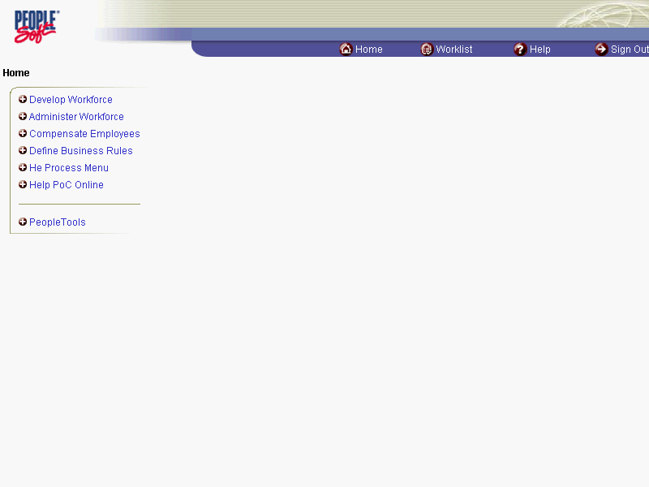

Step | Action
 | Click the Administer Workforce link.
 | Click the Administer Workforce (USF) link.
 | Click the Use link.
 | Click the HR Processing link.

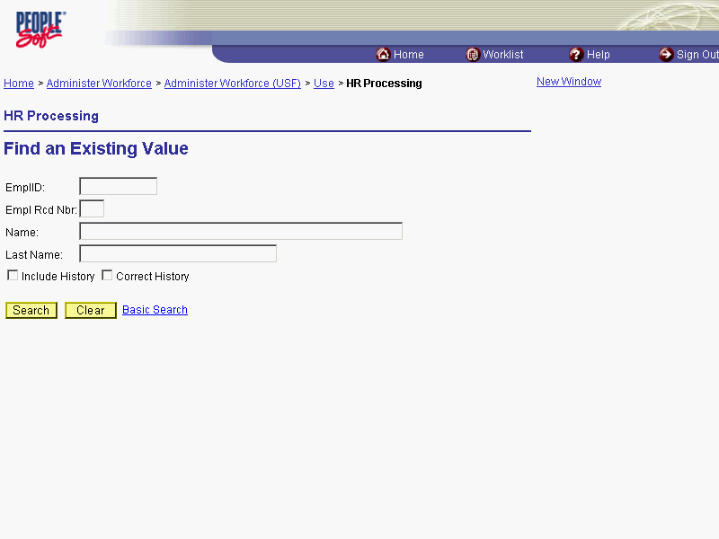

Step | Action
Enter the appropriate variable in the field. (for example, Last Name)
Click in the Last Name field.
Select the appropriate employee.
Enter the desired information into the Last Name field. Enter "ROMANO".
 | Click the Search button.

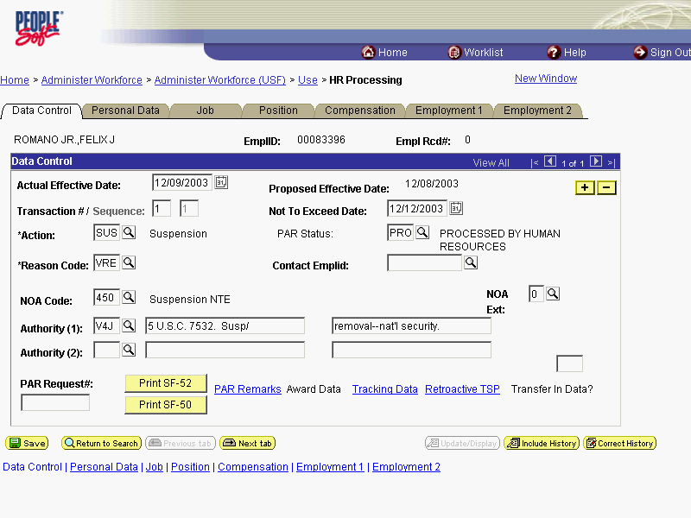

Step | Action
NOTE: The Data Control page will be populated with the most recent personnel action performed for the selected employee.
Click the Add a new row at row 1 button.
Enter the Actual Effective Date of the employee's return to duty.
Triple-click the Actual Effective Date object.

The Calendar icon represents a date prompt. Clicking this button will produce a pop-up calendar for reference. To select a specific date from the pop-up calendar as the field entry, simply click on the date. Use the arrows to move through the months and years.

Step | Action
 | Enter the desired information into the Actual Effective Date field. Enter "12/12/2003".

NOTE: The Proposed Effective Date field is populated by default with the date entered in the Actual Effective Date field. Since human resources personnel processing a request have final authority on when the action becomes effective, and they will enter the official actual effective date, but the proposed effective date will remain unchanged.

Step | Action
 | Click in the *Action field.

The Look Up icon represents a look-up prompt. Clicking this button will allow you to look up all possible entry options for this field.

Step | Action
 | Enter the desired information into the *Action field. Enter "REC".
 | Click in the *Reason Code field.
 | Enter the desired information into the *Reason Code field. Enter "REC".
 | Click in the NOA Code field.
Enter the NOA Code of "292."
Enter the desired information into the NOA Code field. Enter "292".
 | Click in the NOA Ext field.
 | Enter the desired information into the NOA Ext field. Enter "0".
If there is an NTE date for the previous LOA action, delete the NTE date in the Not to Exceed Date field.
NOTE: You will also need to delete the NTE date from the Employment Data 1 page, by accessing the Exp Date hyperlink on that page.
In the Authority (1) field, enter the legal authority.
Click in the Authority (1) field.
 | Enter the desired information into the Authority (1) field. Enter "DAM".
If applicable, enter Authority (2).
Click in the PAR Request# field.
NOTE: This field is not required but can be used for PAR request tracking purposes.
Enter the desired information into the PAR Request# field. Enter "0000082095".
 | Click the PAR Remarks link.

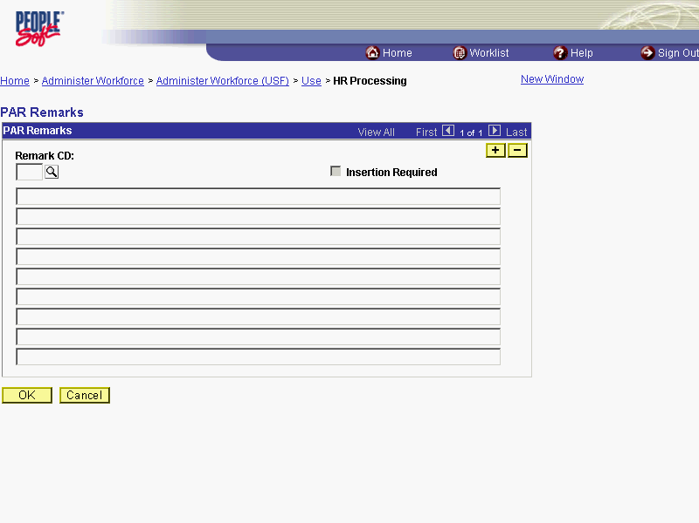

Step | Action
Enter the applicable Remark CD (Code) and tab out of the field to see the text of the remark.
Enter the desired information into the Remark CD field. Enter "A15".
 | Press [Tab].
 | Click the Ok button.

NOTE: To add additional remarks, use the Add a new row button to insert a row.

NOTE: If the Remark CD contains a "****", you must replace the asterisks with specific information. (i.e. this field may prompt you to enter date)

NOTE: Within the EHRP system, there is no limitation to the amount of remarks that can be captured.

NOTE: To enter a freeform remark, enter "ZZZ" in the Remark CD field. Enter applicable remark text in sentence format. Text should fill the line. Once the line is filled, move to the next line. There is no autowrap feature. Do not hyphenate across lines. If a word requires hyphenation, move it to the next line. Do not use bullets or dashes. The "ZZZ" remark can only be used once for each personnel action.

The system does not generate or suggest mandatory remarks that need to be entered in accordance with the NOA Code you are processing. Use the appropriate remarks based on OPM processing guidelines. There will no longer be HHS specific remarks for entry, except for the freeform ZZZ.

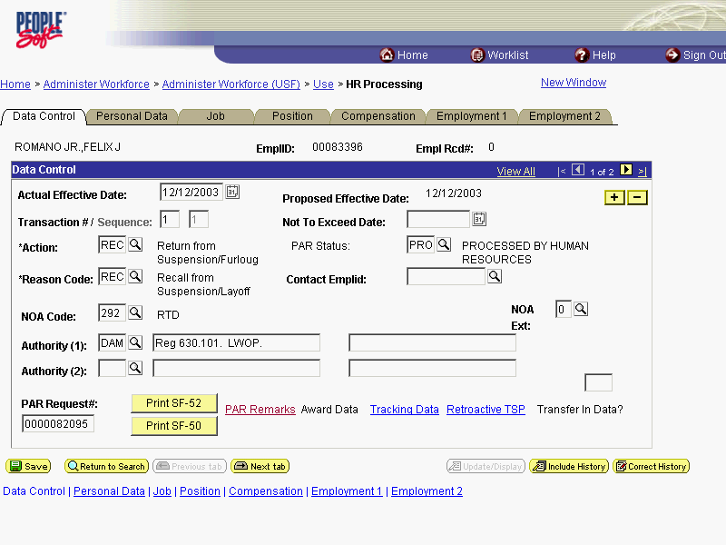

Step | Action
 | Click the Tracking Data link.

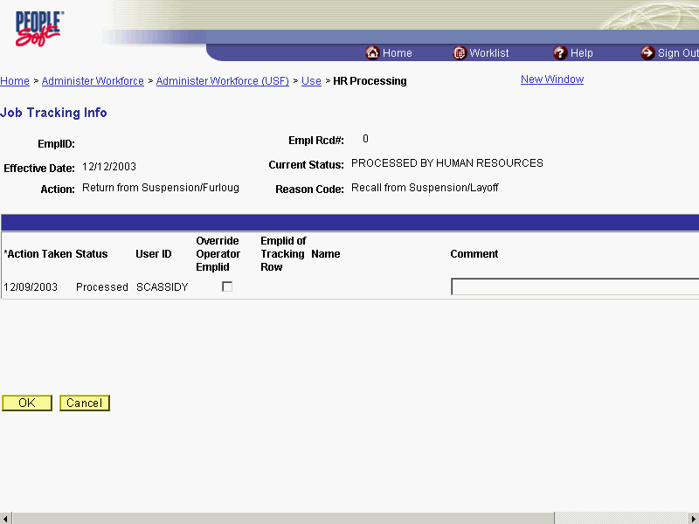

Step | Action
Enter any necessary Comment.
NOTE: There is a 30 character limit in the Comment field. Insert additional rows to add comments beyond 30 characters.
Click the Ok button.

The Job Tracking Info page is to be used only for entering and reviewing comments. Only the Comment field should be used. Notes made by your colleagues in relation to this particular action may be read and entered on this page.

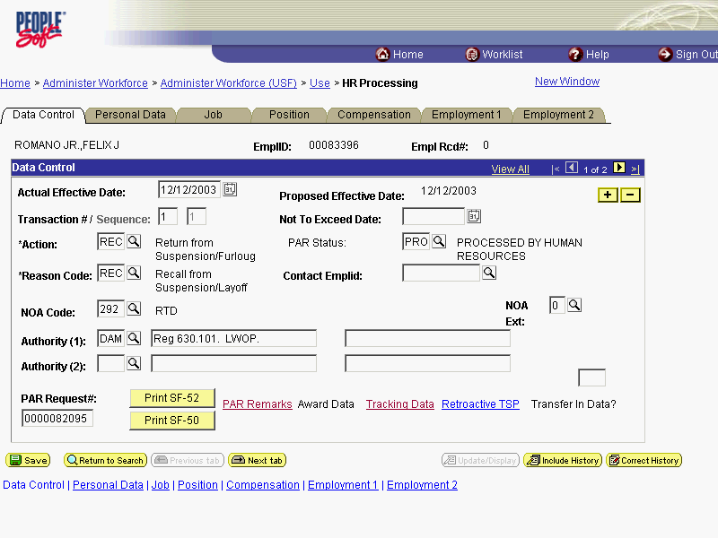

Step | Action
 | Click the Employment 1 tab.

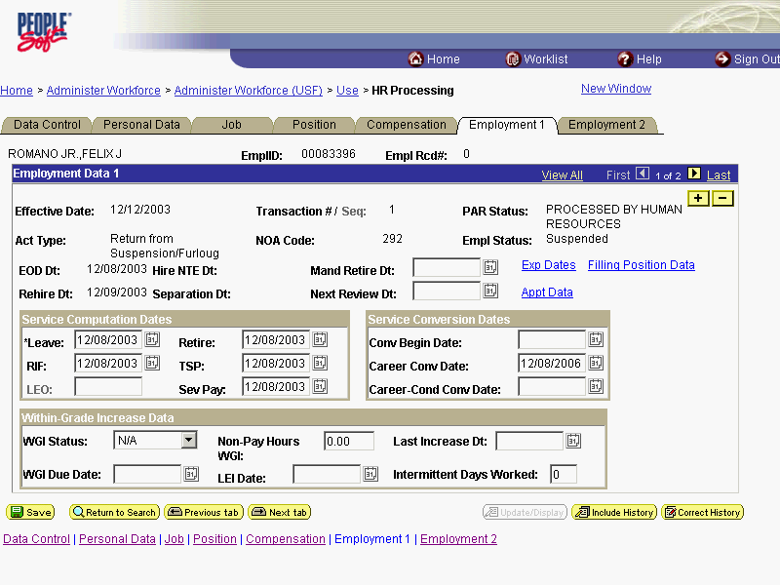

Step | Action
If there is an NTE date from the prior LOA action, click on the Exp Dates hyperlink.
Click the Exp Dates link.

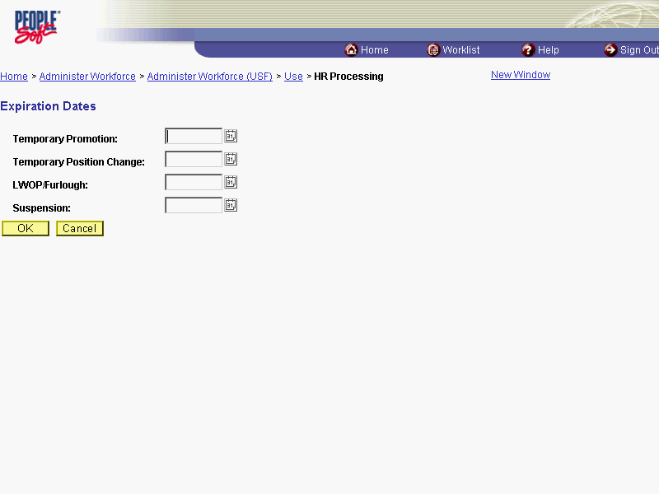

Step | Action
Delete the date from the LWOP/Furlough field.
Click the Ok button.
- Due to the lapse in service, modify the employee's Service Computation Dates, if necessary.
- If the LWOP affected the Service Conversion Dates, modify them as applicable.
- If necessary, modify the Within-Grade Increase Data.

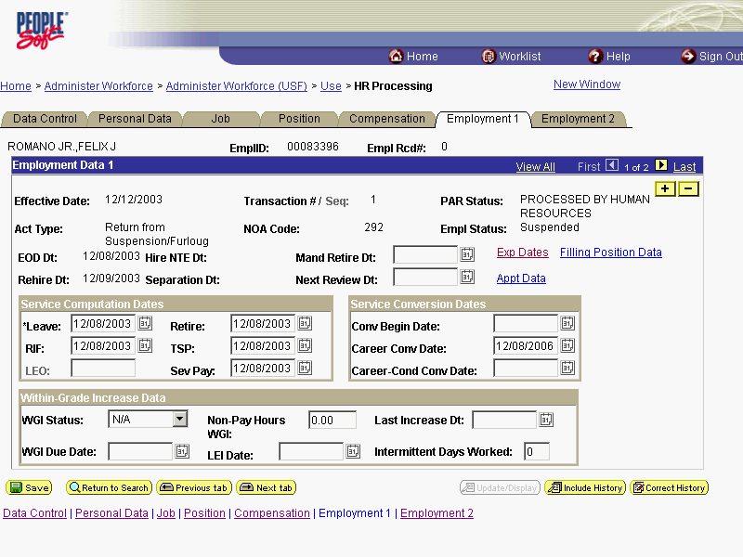

Step | Action
 | Click the Employment 2 tab.
 | Confirm or enter the appropriate Reports To Position for the employee.

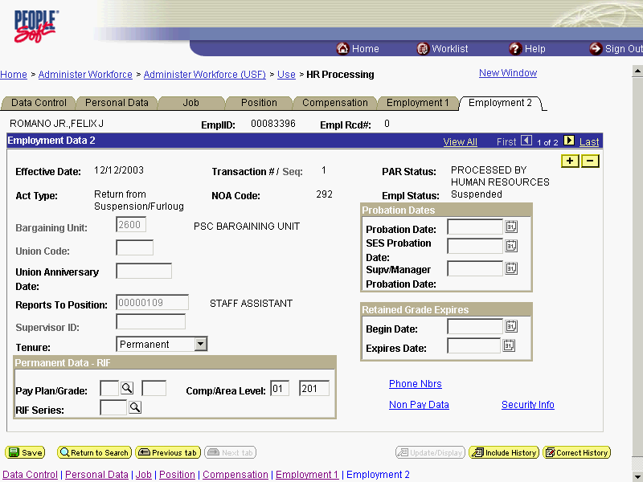

Step | Action
 | Click the Tenure list.
In the Tenure field, modify the appropriate type of tenure, if applicable.
Click Permanent
As applicable, enter or modify the employee's compensation area and level in the Comp/Area Level field.
NOTE: In IMPACT this variable is a 4 digit code. In EHRP, the first 2 digits would be entered in Area and the second 2 digits are entered in Level.
 | Due to the lapse in service, update the employee's Probation Date, if necessary.

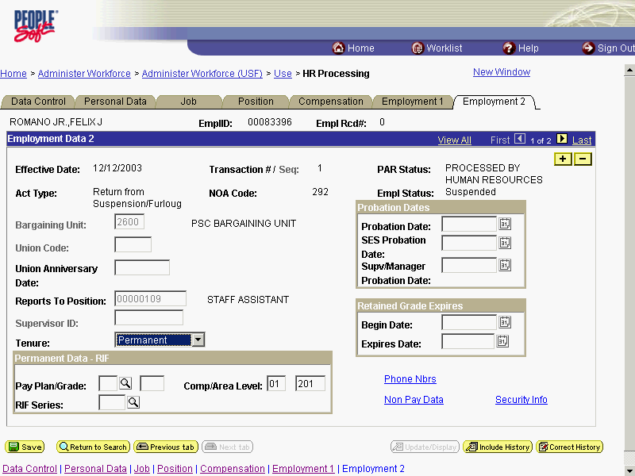

Step | Action
Return to the Data Control tab and change the PAR Status according to your role.
Click the Data Control tab.
 | Click the Save button.
The information is saved.
End of Procedure.

