Processing Premium Pay
Created on April 4, 2005
Copyright & Trademarks
Copyright © 2003 by Global Knowledge. All rights reserved. Information in this document is subject to change without notice and does not represent a commitment on the part of Global Knowledge.

Global Knowledge
Knowledge Products Division
http://globalknowledge.com
475 Allendale Road, Suite 102
King of Prussia, PA 19406
+1 (610) 337-8878

Table of Contents
Introduction iv
Imminent Danger Pay 1
Imminent Danger Pay Start/Change 1
Imminent Danger Pay Stop 11
Danger Pay 26
Danger Pay Start 26
Danger Pay Change 37
Danger Pay Stop 46
Home Leave 61
Starting Home Leave 61
Home Leave Stop 88
Premium Pay 108
Processing Premium Pay 108
Physician Special Pay (PSP) Processing 119
Manual Procedure for Stopping PSP 133
Physician's Comparability Allowance (PCA) Processing 142
PCA Processing 142
Manual Procedure for Stopping PCA 152
Commissioned Corps 159
Allowing a Comm Corps Officer to Participate in Workflow 159

Introduction
In EHRP, an employee's premium pay must be entered in the HR Processing page group. Premium pay includes retention allowances, COLAs, physician special pay (PSP), physician comparability allowances (PCA) and post differentials.
Special pay will be entered on the Other Pay Information sub-page, accessed from the hyperlink on the Compensation page of the HR Processing page group.

Imminent Danger Pay

Imminent Danger Pay Start/Change

Procedure

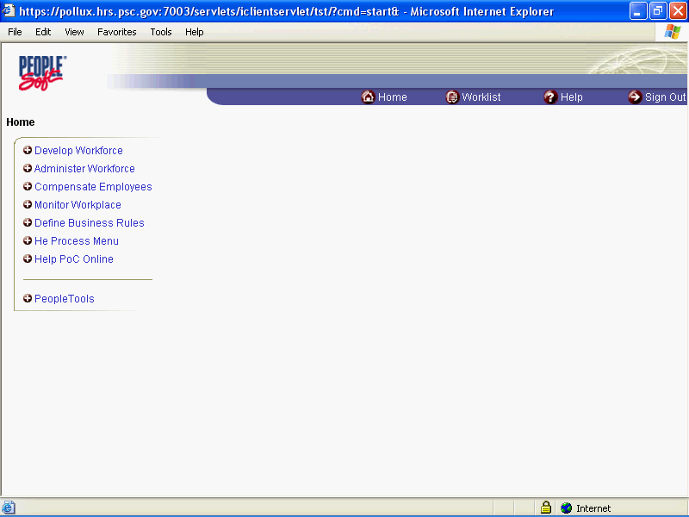

Step | Action
 | Click the Administer Workforce link.
 | Click the Administer Workforce (USF) link.
 | Click the Use link.
 | Click the HR Processing link.

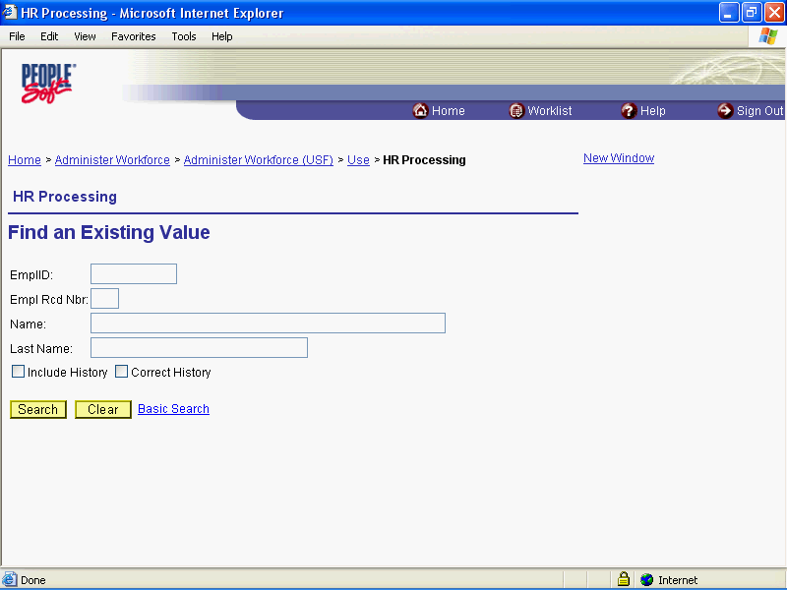

Step | Action
 | Enter the desired information into the EmplID field. Enter "00008575".
 | Click the Search button.

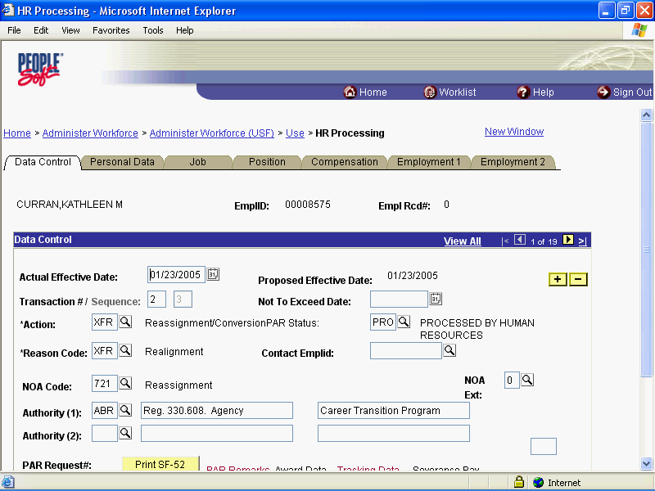

Step | Action
 | Click the Add a new row at row 1 button.
 | Click the Calendar icon button.

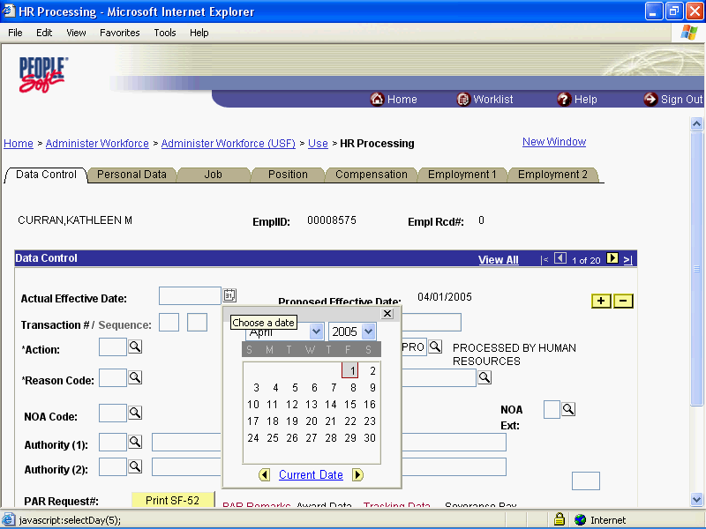

Step | Action
 | Click the desired date.

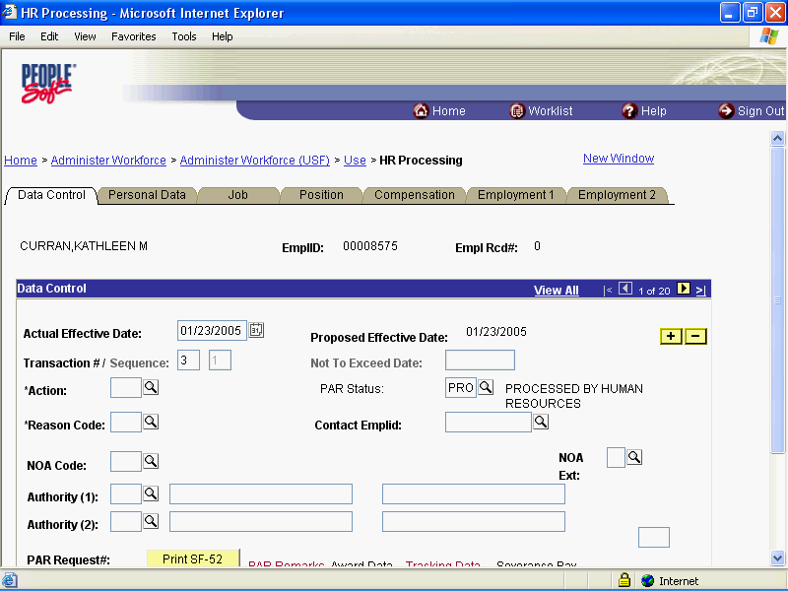

Step | Action
 | Press [Tab].
 | Enter the desired information into the *Reason Code field. Enter "DTA".
 | Press [Tab].
 | Enter the desired information into the NOA Code field. Enter "997".
 | Press [Tab].
 | Enter the desired information into the NOA Ext field. Enter "A".

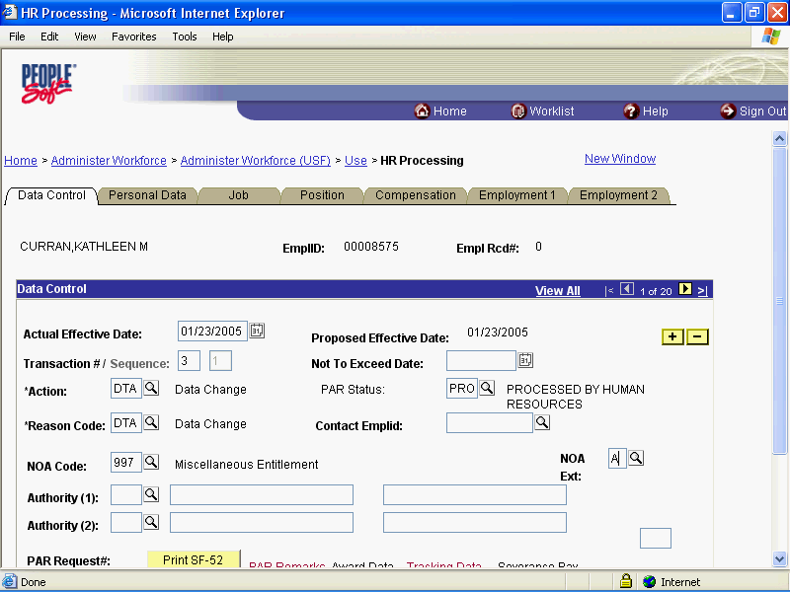

Step | Action
 | Click the Compensation tab.

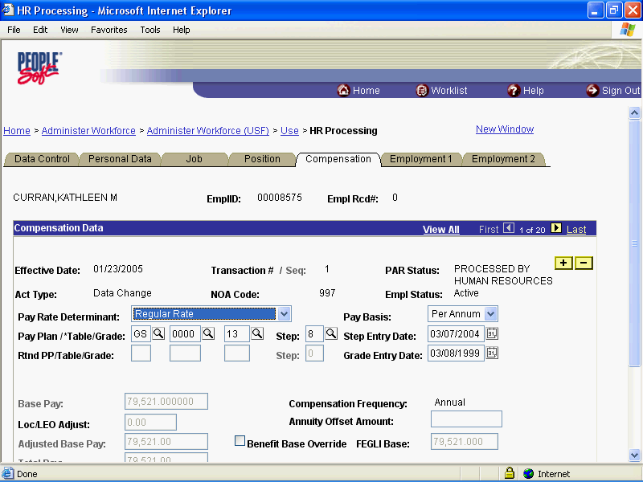

Step | Action
 | Click the Other Pay Information link.

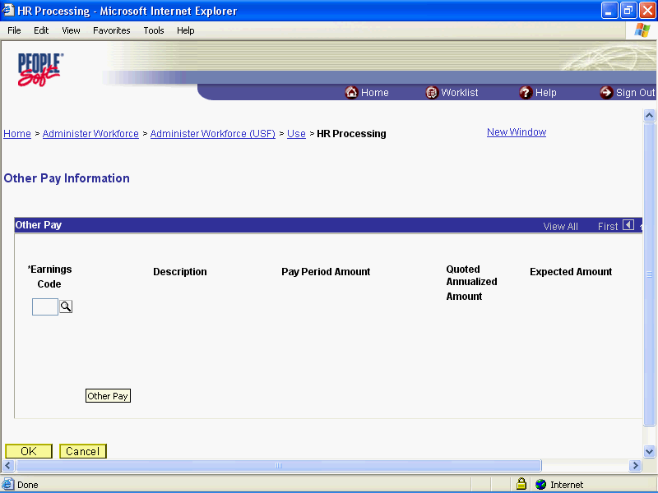

Step | Action
 | Click the Lookup Earnings Code button.

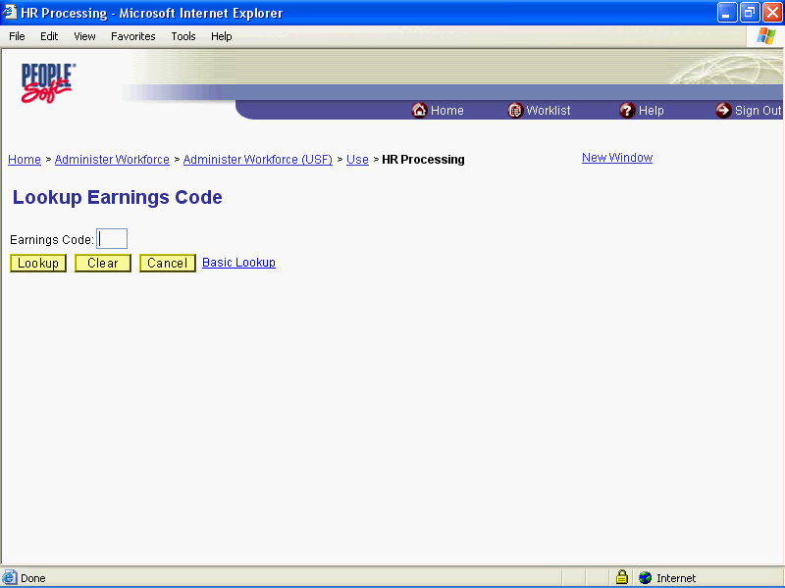

Step | Action
 | Click the Lookup button.
 | Click the Search Results table.

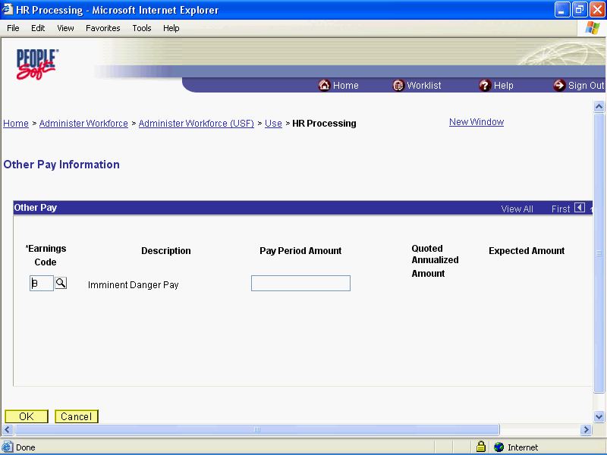

Step | Action
 | Press [Tab].
 | Enter the desired information into the Pay Period Amount field. Enter "50.00".
 | Press [Tab].
 | Click the OK button.

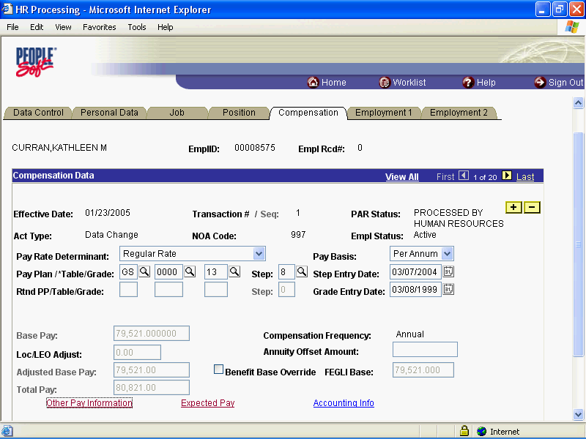

Step | Action
 | Click the Save button.
 | End of Procedure.

Imminent Danger Pay Stop

Procedure

Step | Action
 | Click the Administer Workforce link.
 | Click the Administer Workforce (USF) link.
 | Click the Use link.
 | Click the HR Processing link.

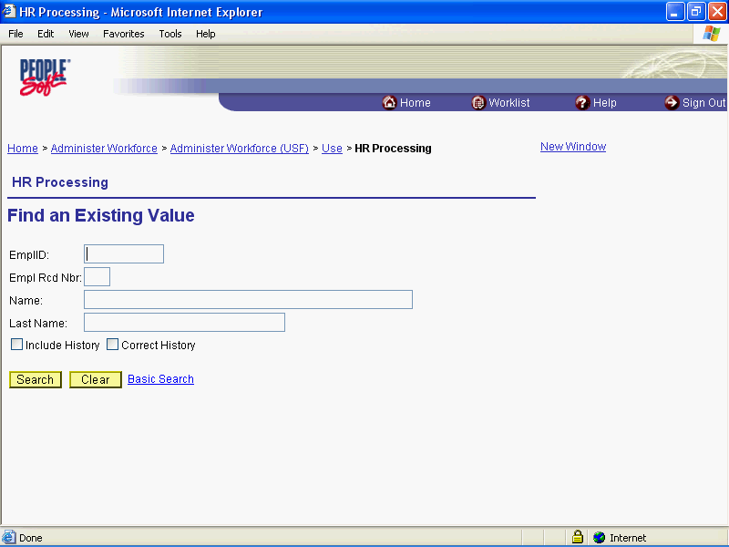

Step | Action
 | Enter the desired information into the EmplID field. Enter "00008575".
 | Click the Search button.

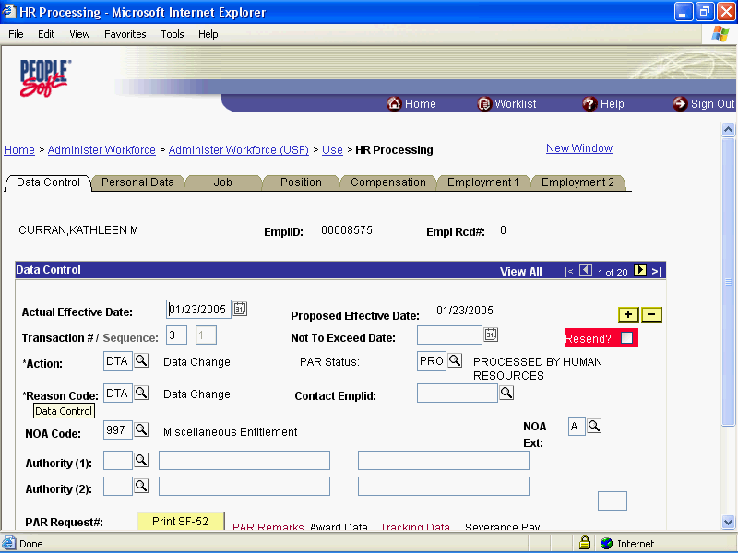

Step | Action
 | Point to the object.

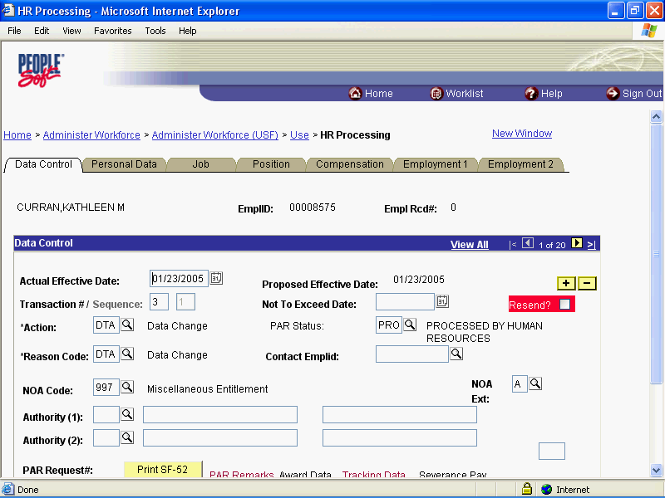

Step | Action
 | Click the Add a new row at row 1 button.
 | Click the Calendar icon button.

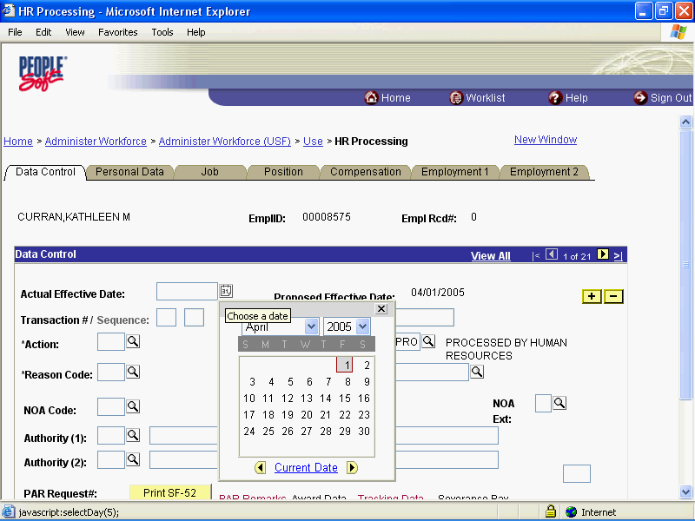

Step | Action
 | Click the desired date.

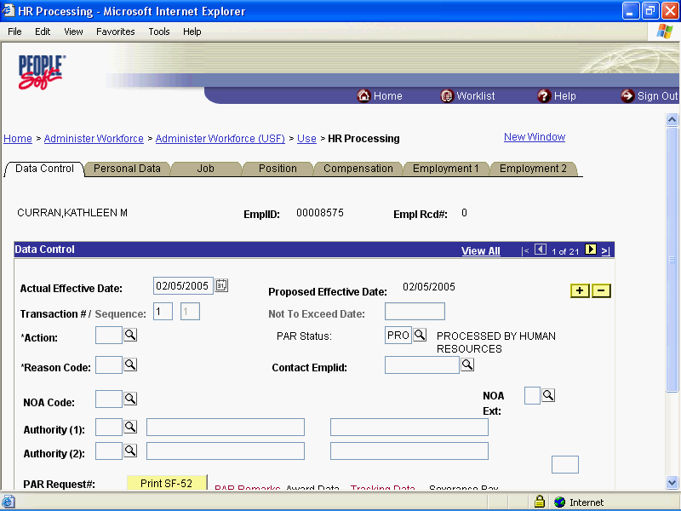

Step | Action
 | Enter the desired information into the *Action field. Enter "DTA".
 | Enter the desired information into the *Reason Code field. Enter "PRA".
 | Press [Tab].
 | Enter the desired information into the NOA Code field. Enter "997".
 | Press [Tab].
 | Enter the desired information into the NOA Ext field. Enter "B".
 | Press [Tab].

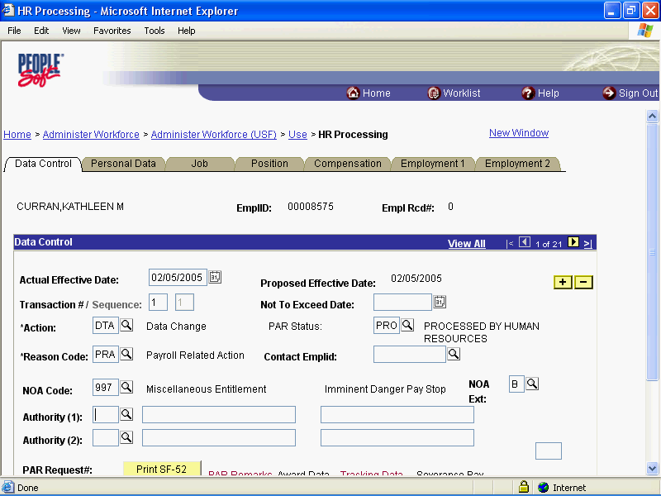

Step | Action
 | Click the Compensation tab.

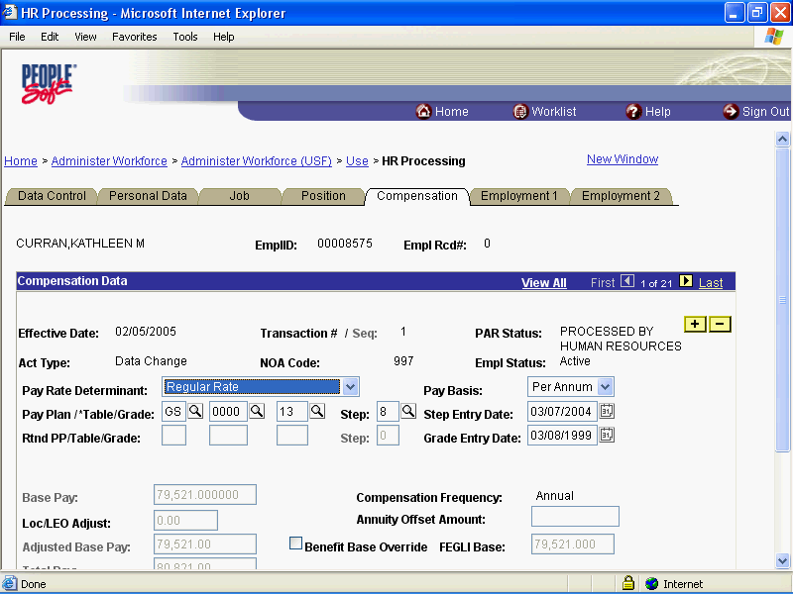

Step | Action
 | Click the Other Pay Information link.

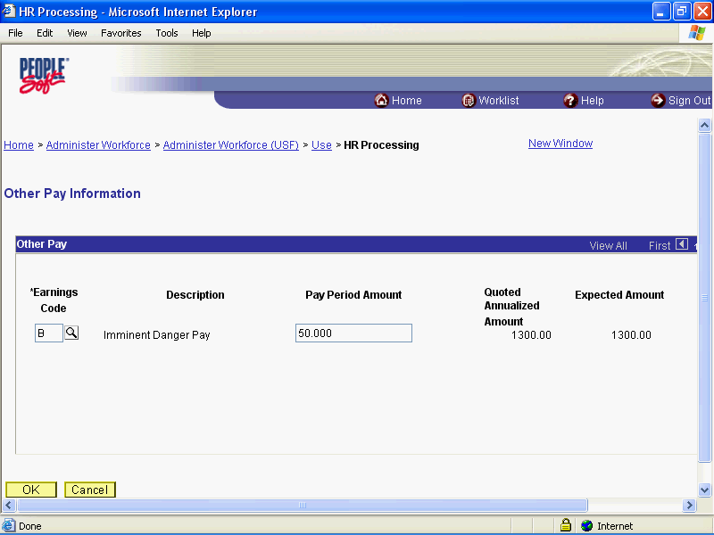

Step | Action
 | Click the Delete row 1 button.

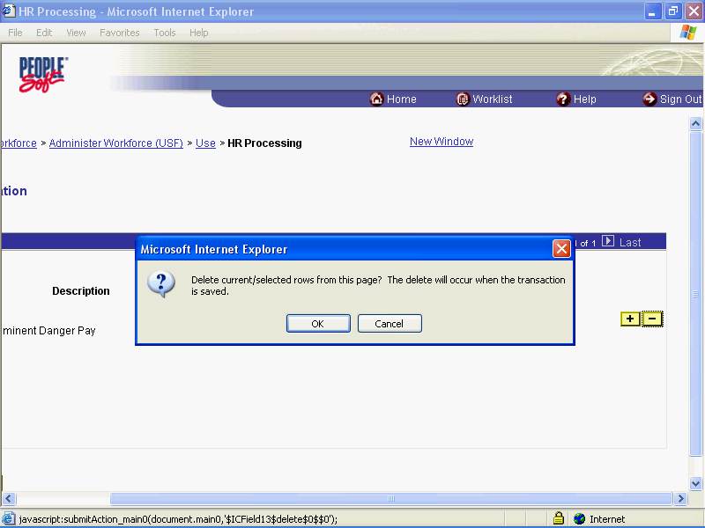

Step | Action
 | Click the OK button.

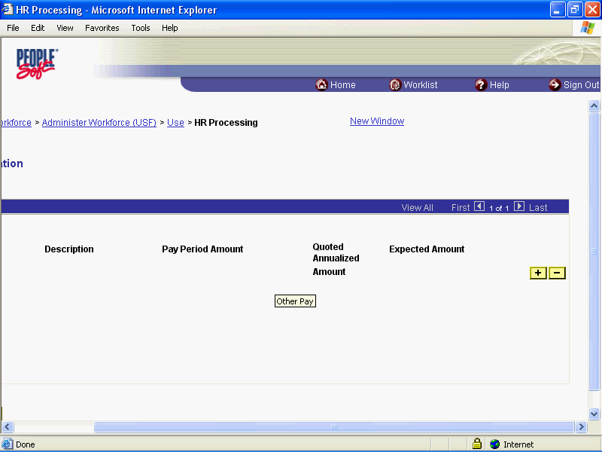

Step | Action
 | Release the mouse button.

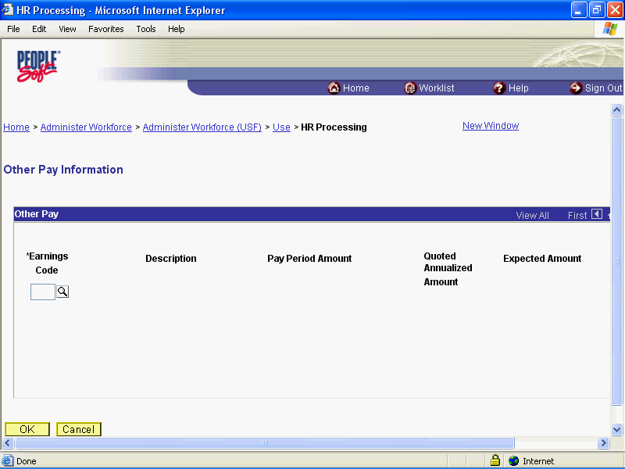

Step | Action
 | Click the OK button.

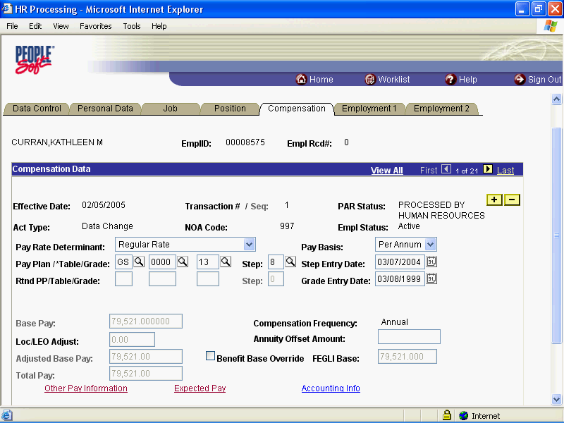

Step | Action
 | Click the Save button.

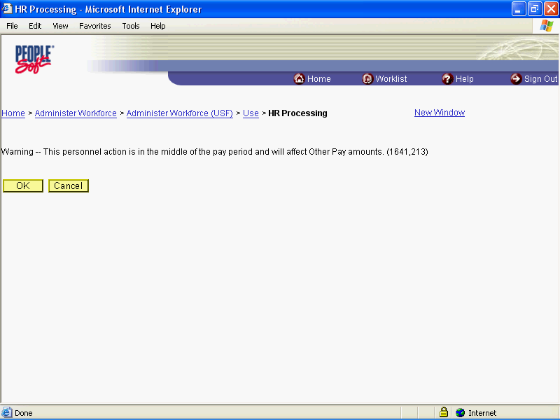

Step | Action
 | Click the Ok button.
 | End of Procedure.

Danger Pay

Danger Pay Start

Procedure

Step | Action
 | Click the Administer Workforce link.
 | Click the Administer Workforce (USF) link.
 | Click the Use link.
 | Click the HR Processing link.

Step | Action
 | Enter the desired information into the EmplID field. Enter "00008969".
 | Click the Search button.

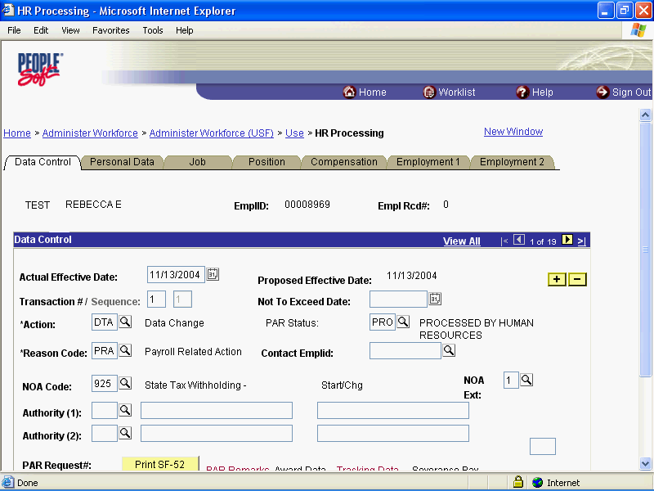

Step | Action
 | Click the Add a new row at row 1 button.
 | Click the Calendar icon button.

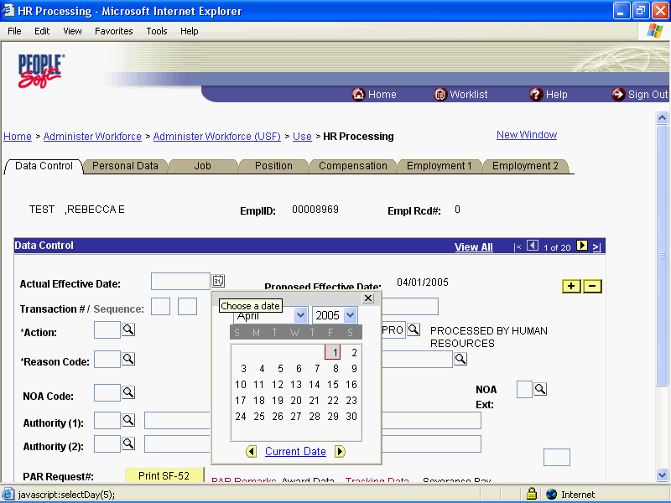

Step | Action
 | Click the desired date.

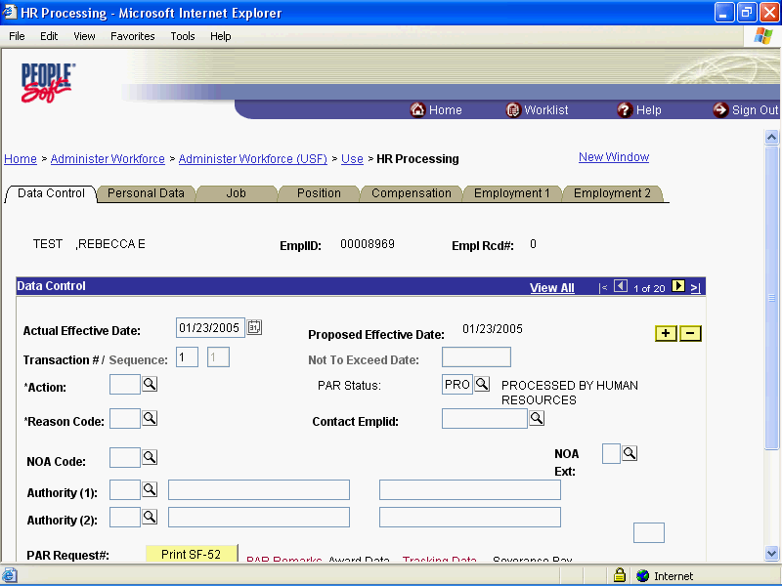

Step | Action
 | Press [Tab].
 | Click in the *Reason Code field.
 | Press [Tab].
 | Press [Tab].
 | Press [Tab].

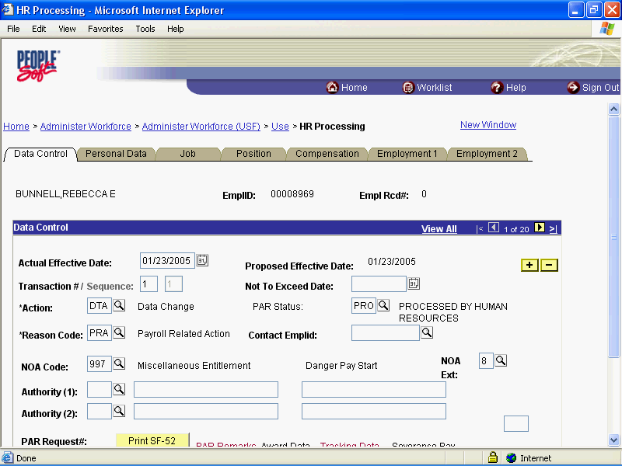

Step | Action
 | Click the Compensation tab.

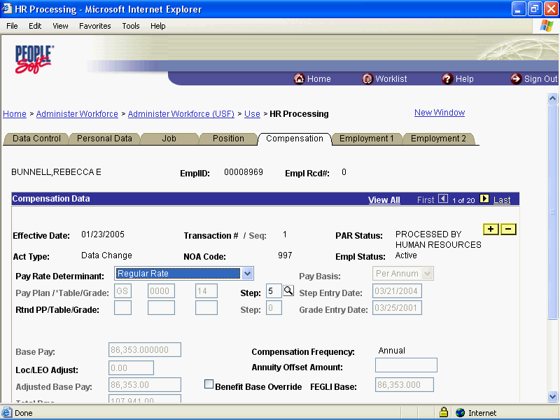

Step | Action
 | Click the Other Pay Information link.

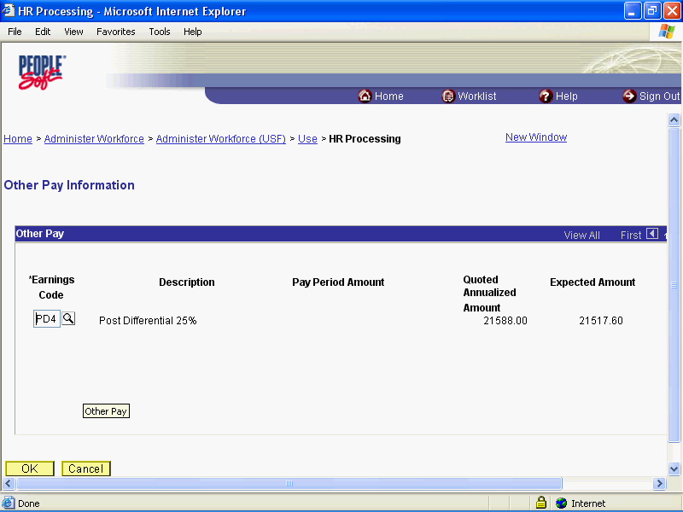

Step | Action
 | Click the Add a new row at row 1 button.
 | Click the Lookup Earnings Code button.

Step | Action
 | Click the Lookup button.
 | Click the Search Results table.
 | Click the Search Results table.

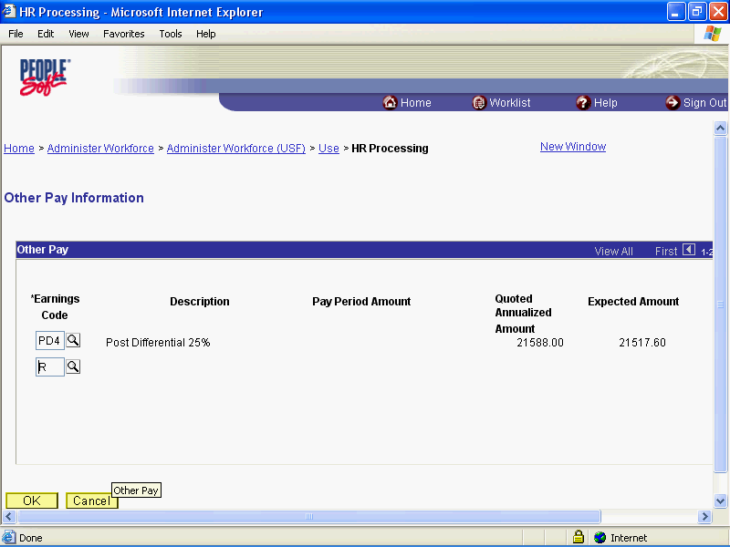

Step | Action
 | Click the OK button.

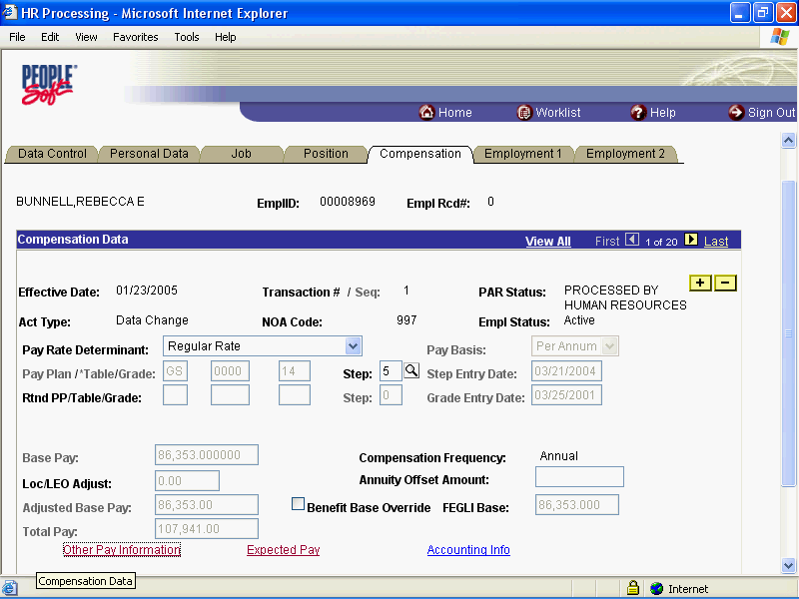

Step | Action
 | Point to the object.

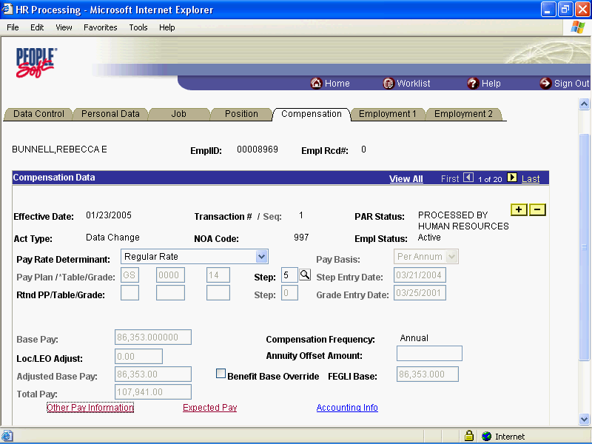

Step | Action
 | Click the Save button.
 | End of Procedure.

Danger Pay Change

Procedure

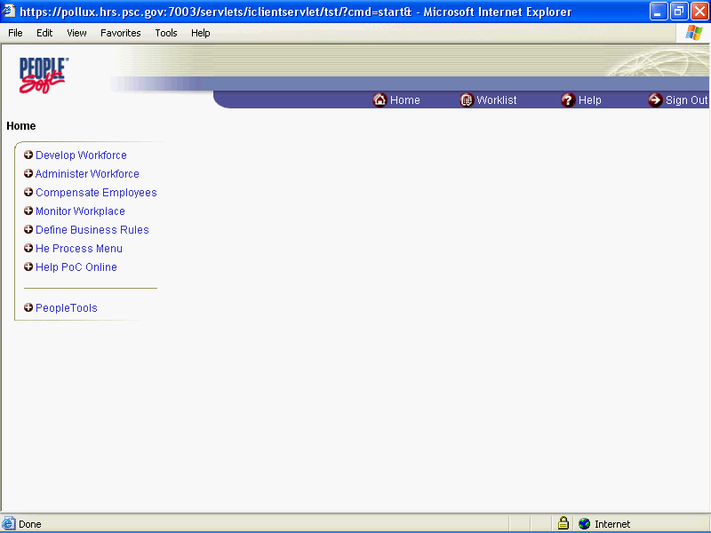

Step | Action
 | Click the Administer Workforce link.
 | Click the Administer Workforce (USF) link.
 | Click the Use link.
 | Click the HR Processing link.

Step | Action
 | Enter the desired information into the EmplID field. Enter "00008969".
 | Click the Search button.

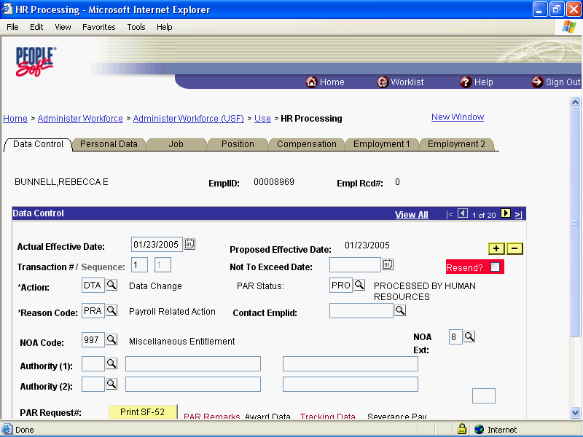

Step | Action
 | Click the Add a new row at row 1 button.
 | Click the Calendar icon button.

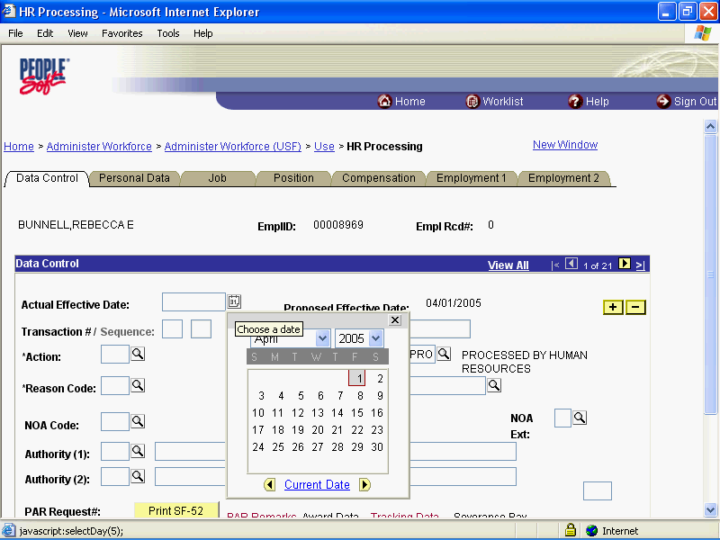

Step | Action
 | Click the desired date.

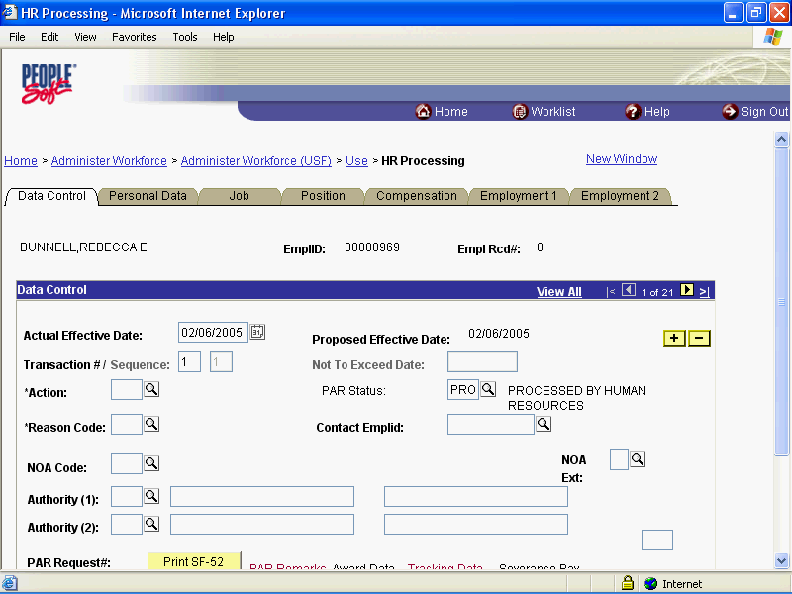

Step | Action
 | Enter the desired information into the *Action field. Enter "DTA".
 | Click in the *Reason Code field.
 | Press [Tab].
 | Enter the desired information into the NOA Code field. Enter "997".
 | Press [Tab].
 | Enter the desired information into the NOA Ext field. Enter "C".
 | Press [Tab].

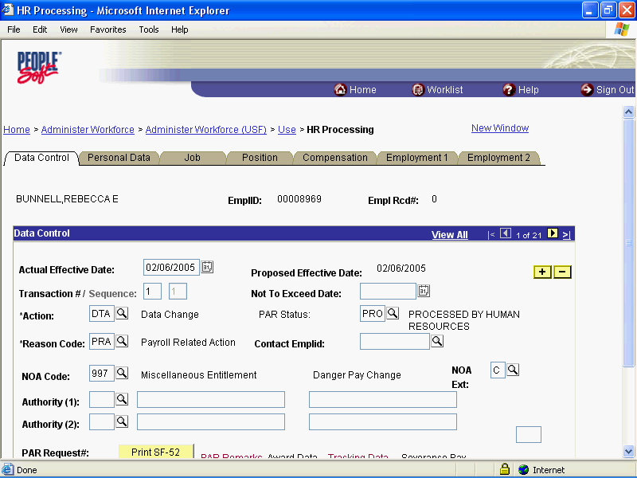

Step | Action
 | Click the Compensation tab.

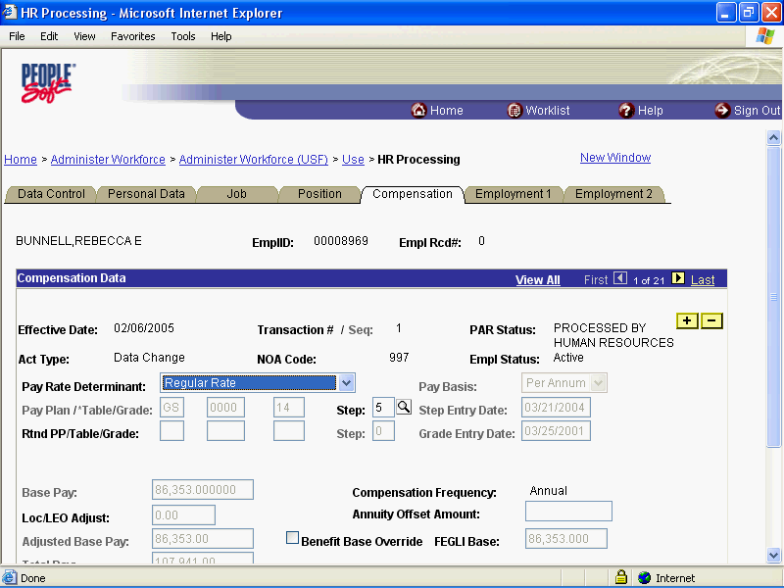

Step | Action
 | Click the Other Pay Information link.

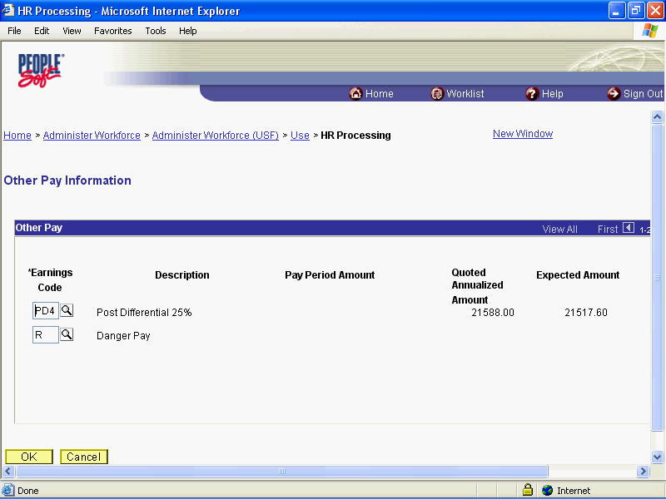

Step | Action
 | Click the OK button.

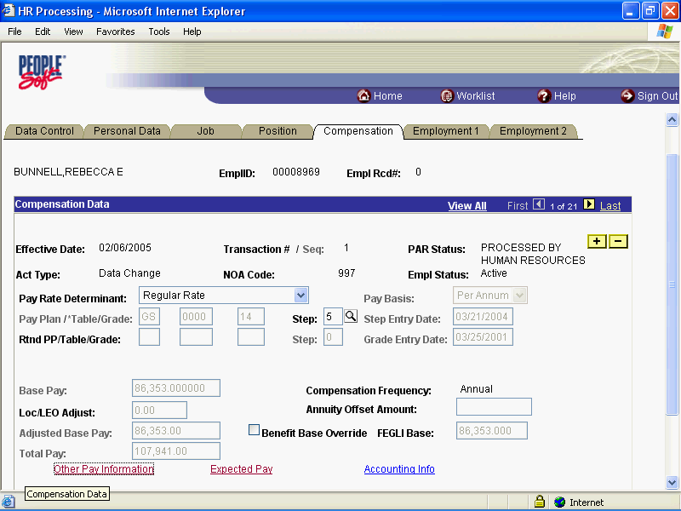

Step | Action
 | Click the Save button.
 | End of Procedure.

Danger Pay Stop

Procedure

Step | Action
 | Click the Administer Workforce link.
 | Click the Administer Workforce (USF) link.
 | Click the Use link.
 | Click the HR Processing link.

Step | Action
 | Enter the desired information into the EmplID field. Enter "00008969".
 | Click the Search button.

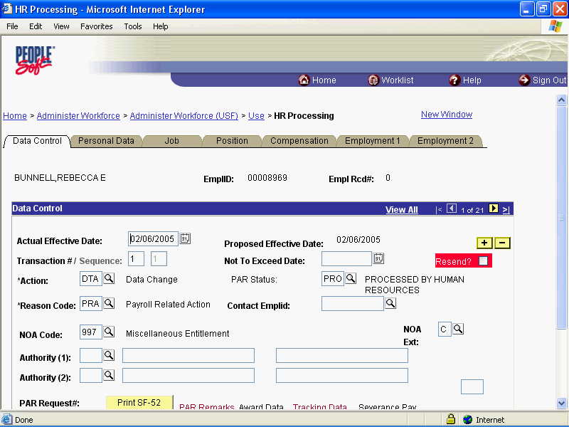

Step | Action
 | Click the Add a new row at row 1 button.
 | Click the Calendar icon button.

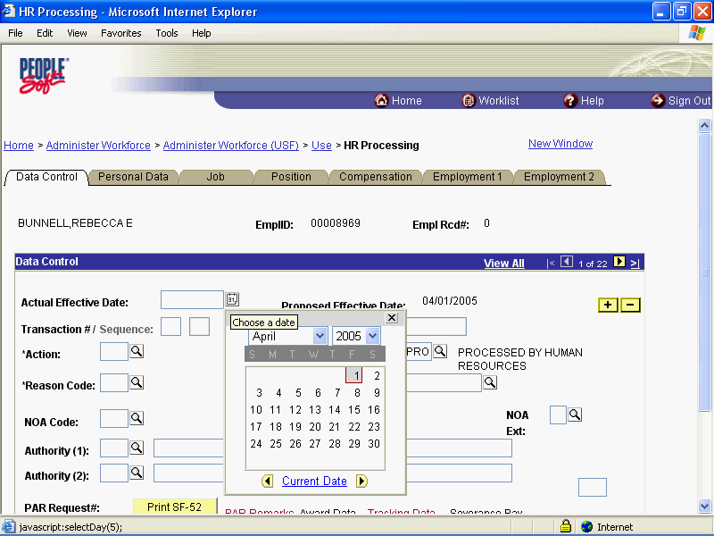

Step | Action
 | Click the desired date.

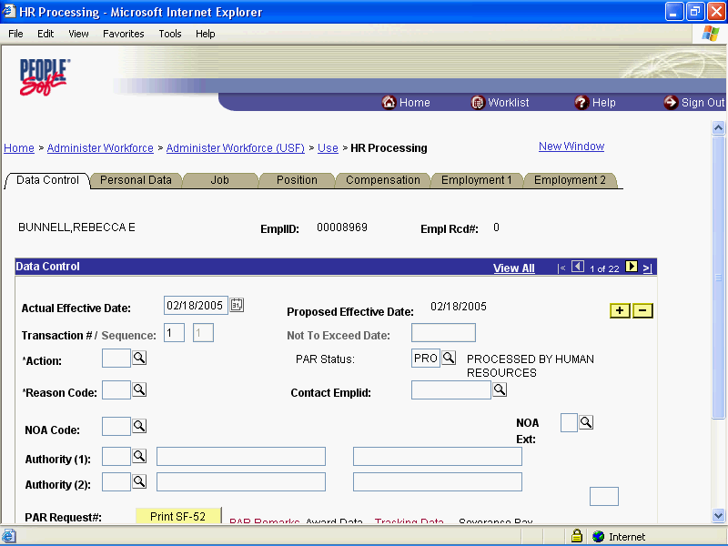

Step | Action
 | Press [Tab].

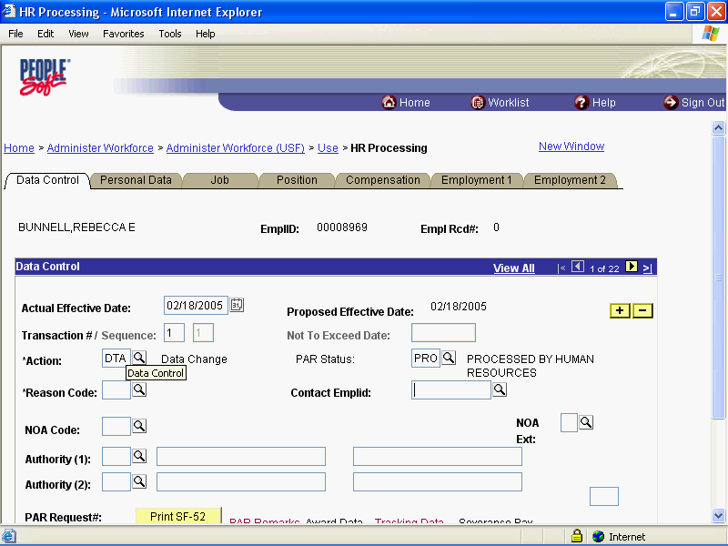

Step | Action
 | Point to the object.

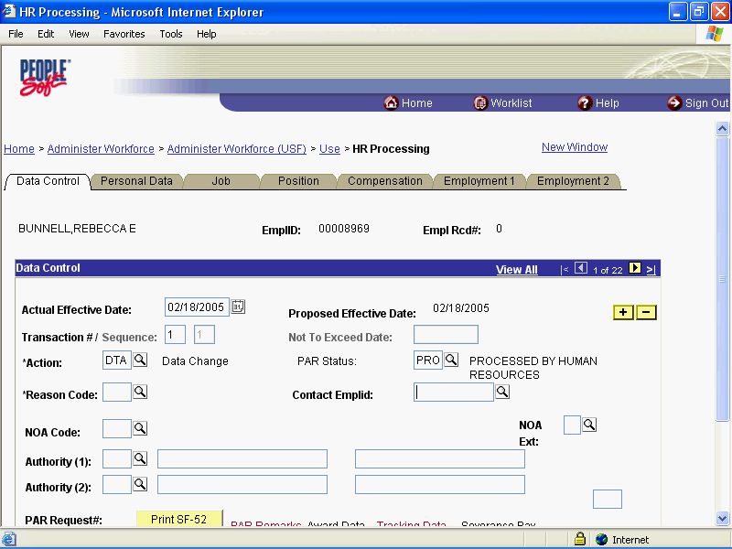

Step | Action
 | Enter the desired information into the *Reason Code field. Enter "PRA".
 | Press [Tab].
 | Enter the desired information into the NOA Code field. Enter "997".
 | Press [Tab].
 | Enter the desired information into the NOA Ext field. Enter "9".
 | Press [Tab].

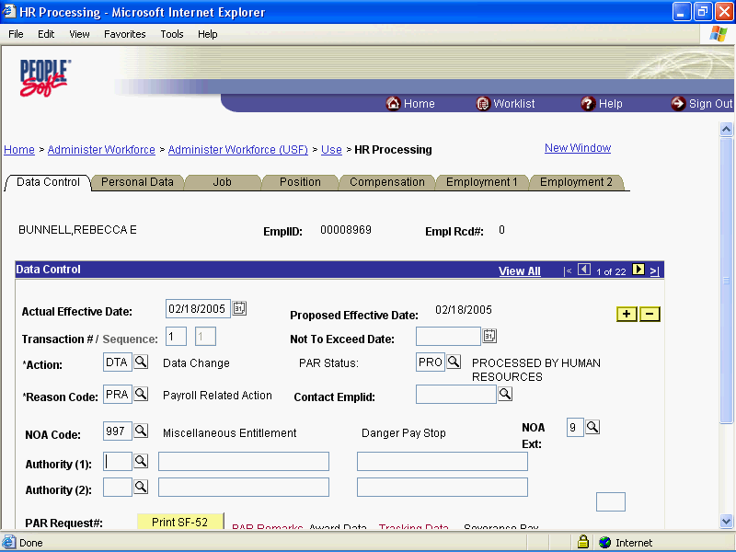

Step | Action
 | Release the mouse button.

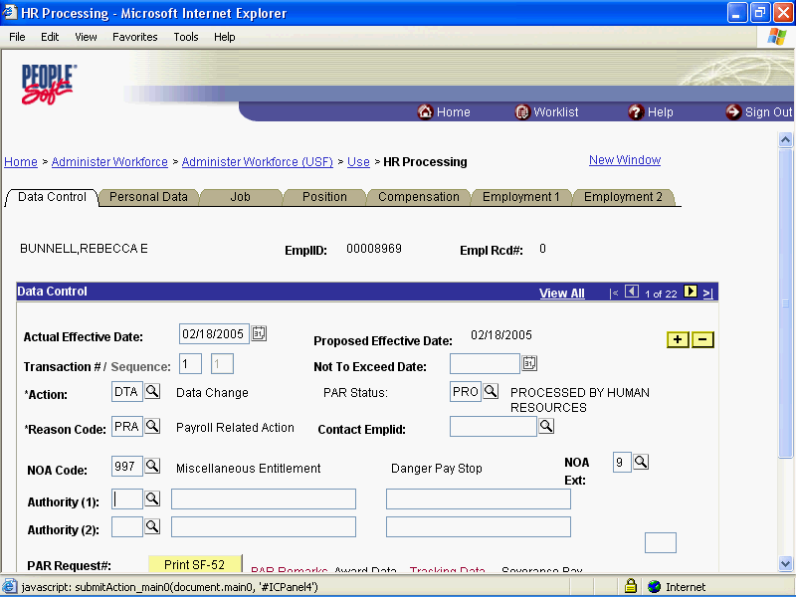

Step | Action
 | Click the Compensation tab.

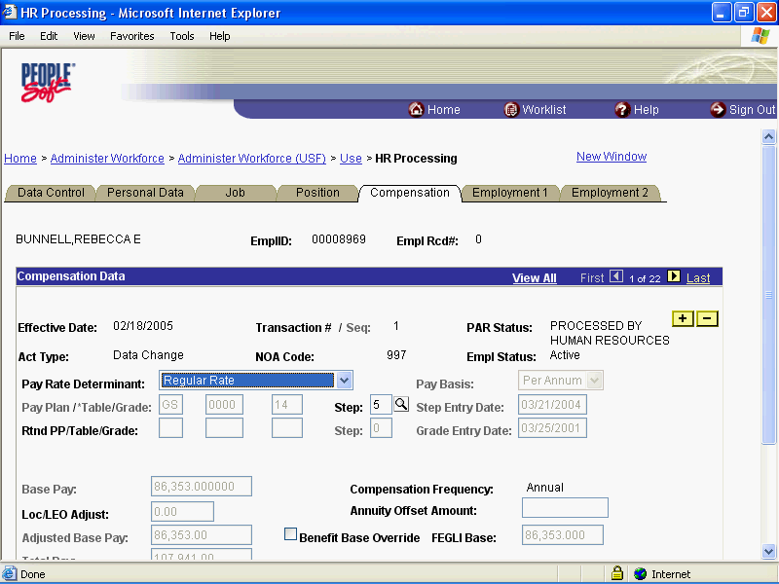

Step | Action
 | Click the Other Pay Information link.

Step | Action
 | Click the Delete row 1 button.

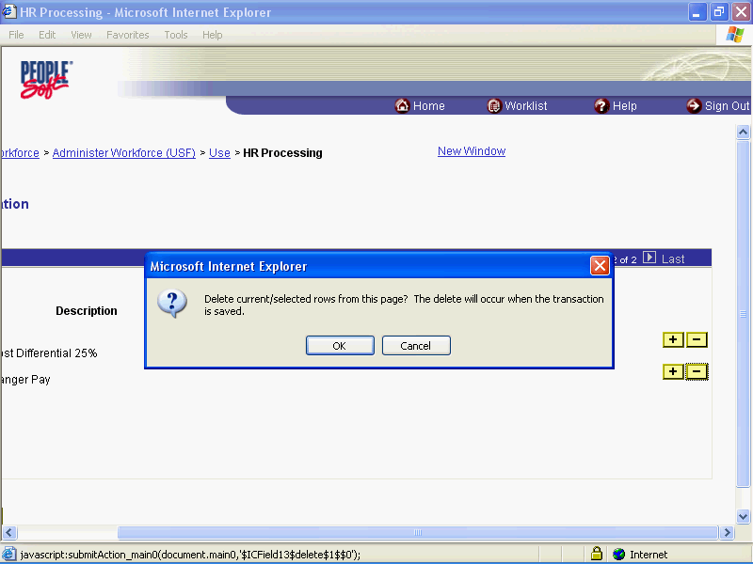

Step | Action
 | Release the mouse button.

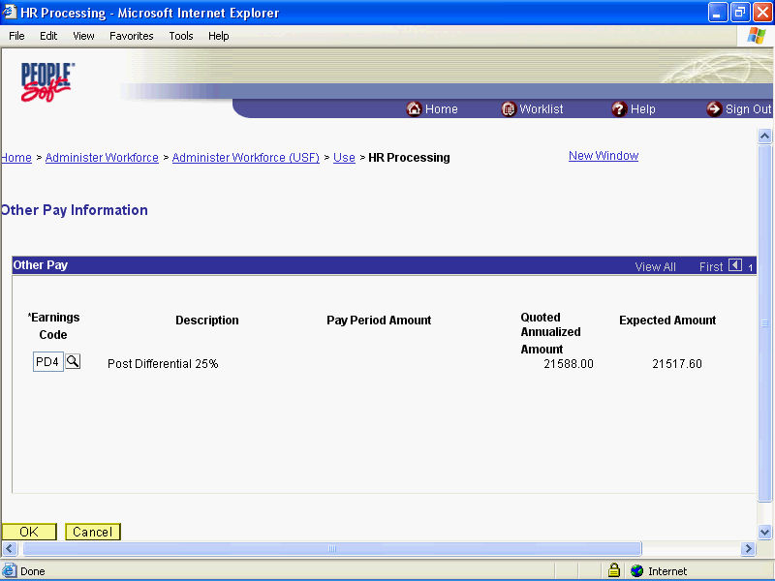

Step | Action
 | Click the OK button.

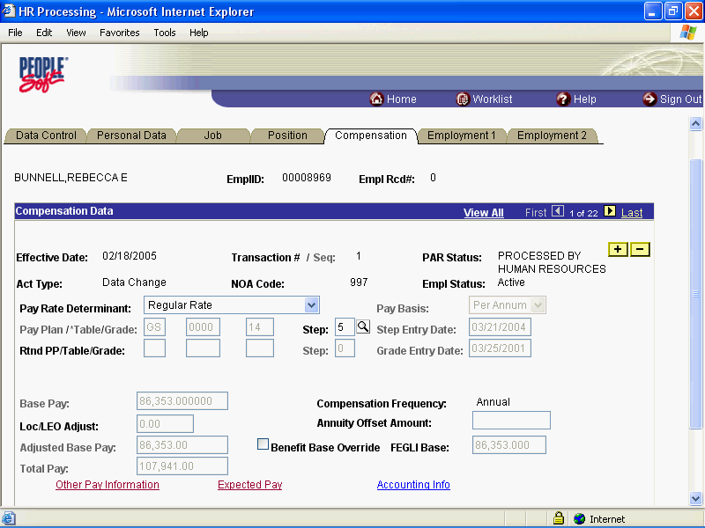

Step | Action
 | Click the Ok button.
 | End of Procedure.

Home Leave
Home Leave is leave granted to Federal employees who are stationed overseas after they have been abroad for a period of two years. This is in addition to regular sick and annual leave that Federal employees earn.
This topic will provide instructions for establishing the service agreement and the PAR action for processing a start, change or stop of Home Leave in EHRP.

Starting Home Leave

Procedure

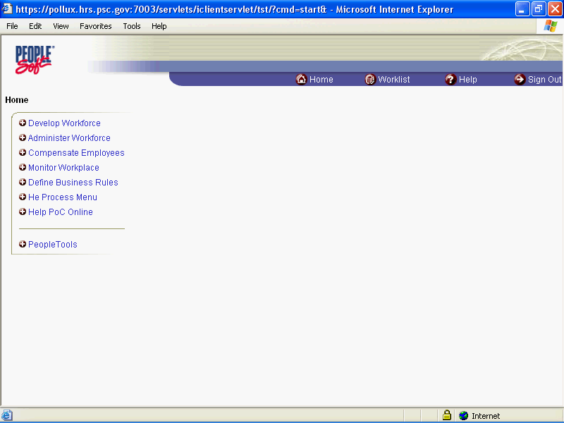

Step | Action
 | Click the Administer Workforce link.
 | Click the Administer Workforce (USF) link.
 | Click the Use2 link.
 | Click the Service Agreements link.

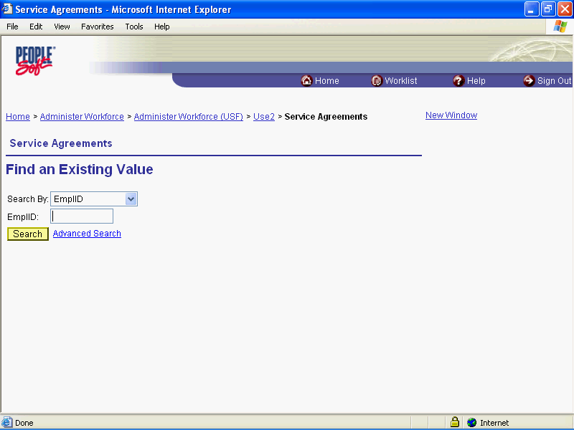

Step | Action
 | Click the Search By list.
Click an entry in the list.
Select Name, unless you know the EmplID.

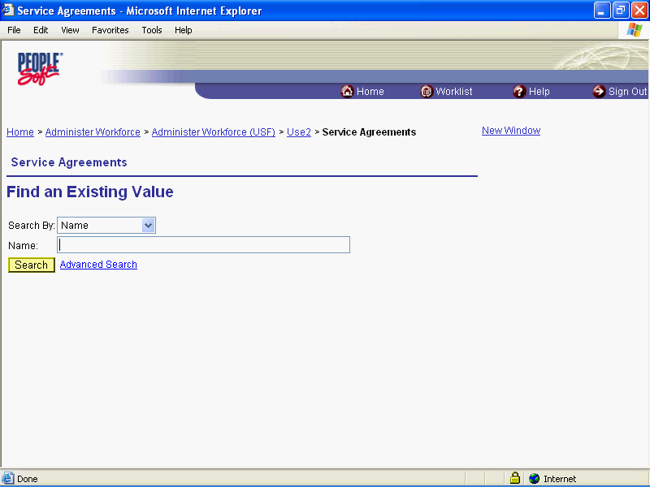

Step | Action
 | Enter the desired information into the Name field. Enter "TEST".
 | Click the Search button.
 | Click the Search Results table.

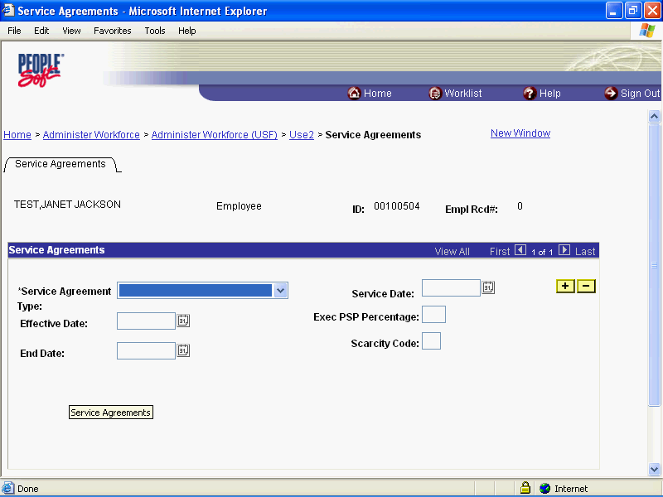

Step | Action
 | Click an entry in the list.
 | Click an entry in the list.
 | Click the Choose a date button.

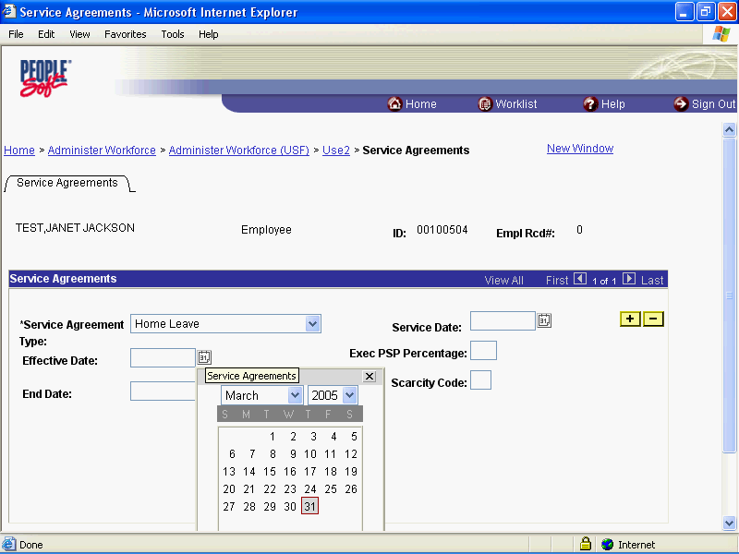

Step | Action
 | Click the desired date.
 | Click the desired date.
 | Click the desired date.

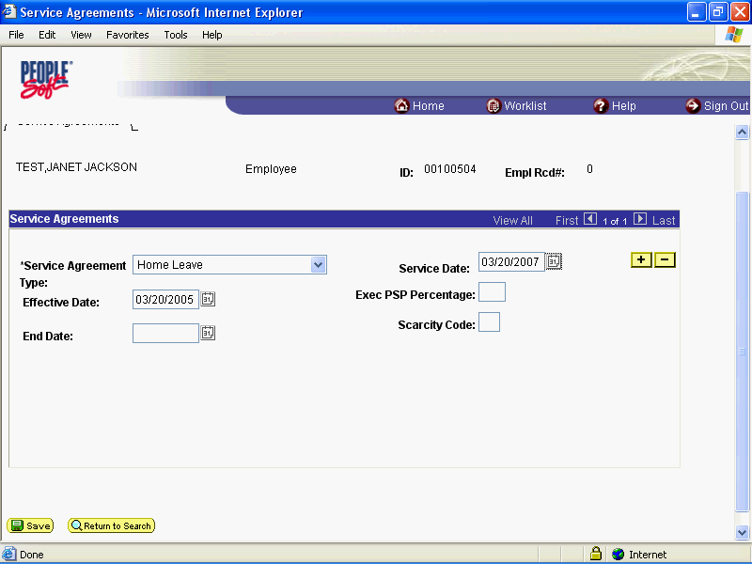

Step | Action
 | Click the Save button.

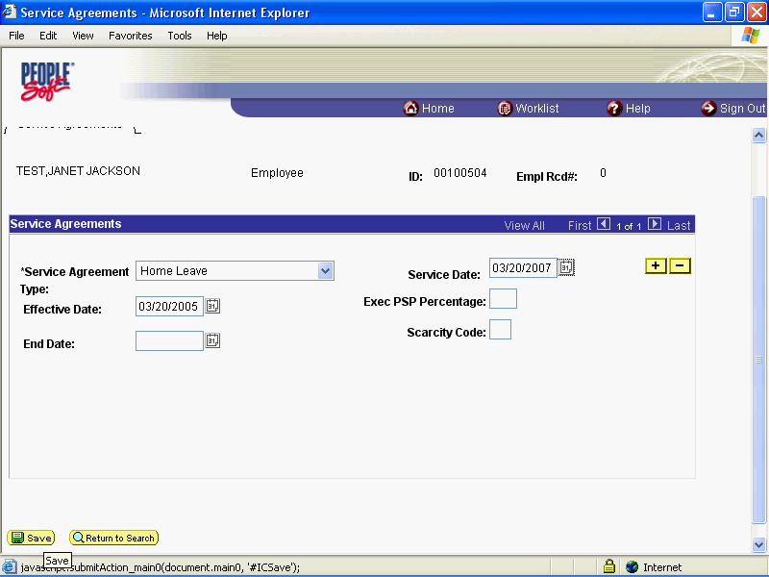

Step | Action
 | Click the Administer Workforce (USF) link.

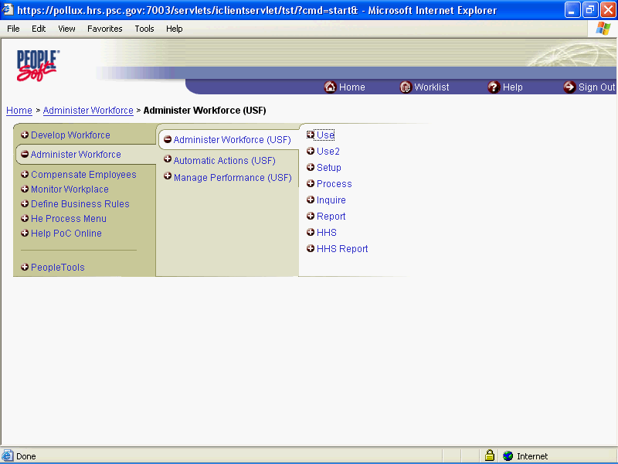

Step | Action
 | Click the Use link.
 | Click the HR Processing link.

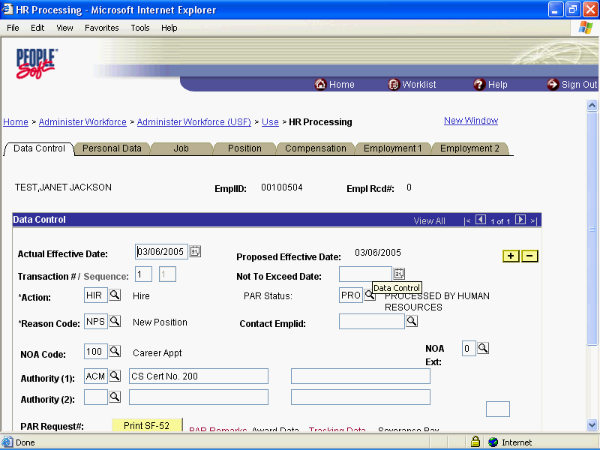

Step | Action
 | Release the mouse button.

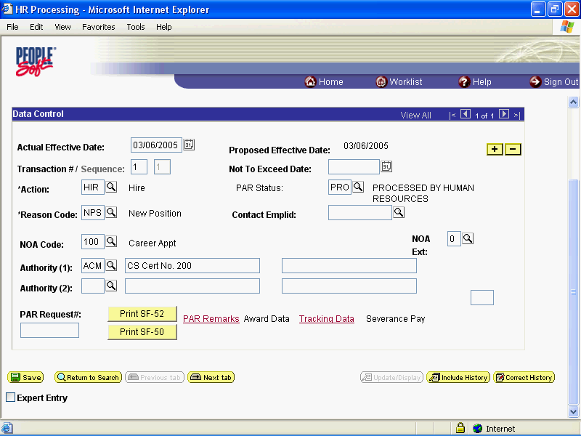

Step | Action
 | Click the Add a new row at row 1 button.

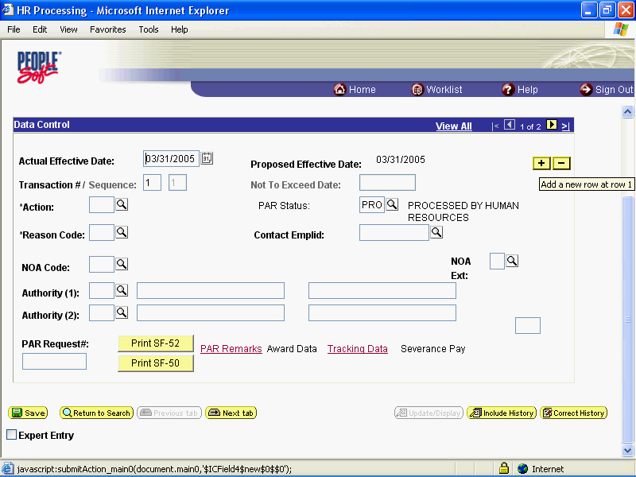

Step | Action
 | Click the desired date.

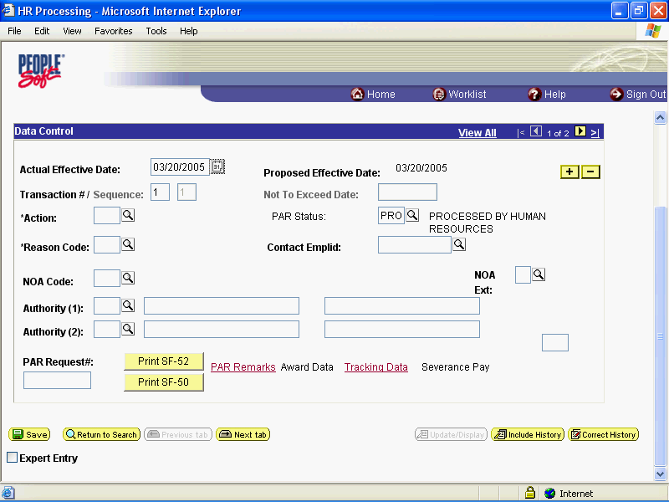

Step | Action
 | Press [Tab].
 | Press [Tab].
 | Enter the desired information into the NOA Code field. Enter "910".
 | Press [Tab].
 | Press [Tab].
 | Press [Tab].

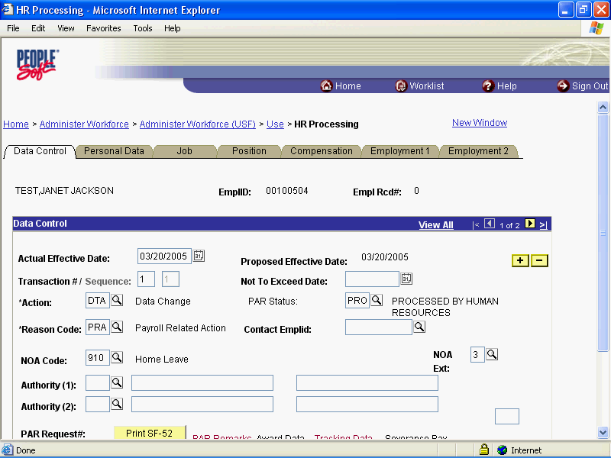

Step | Action
 | Click the Compensation tab.

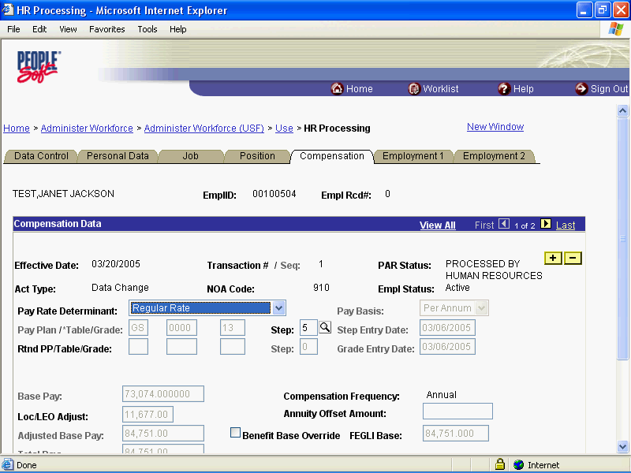

Step | Action
 | Click the Other Pay Information link.

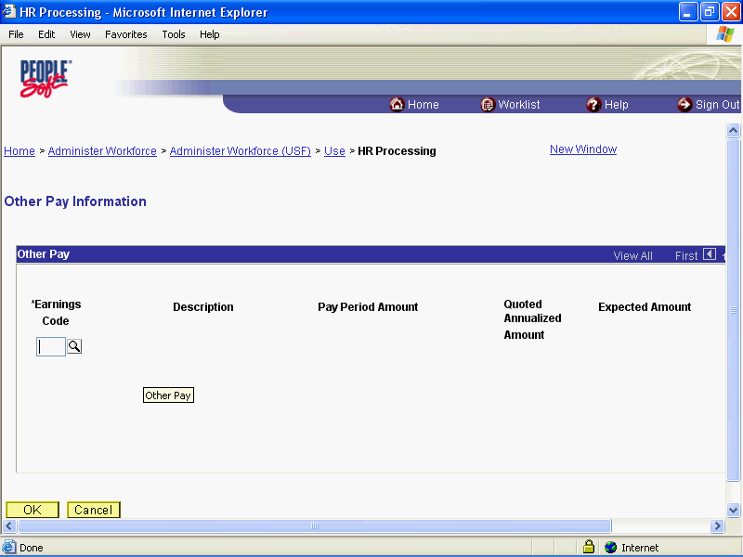

Step | Action
 | Click the Lookup Earnings Code button.

Step | Action
 | Click the Lookup button.

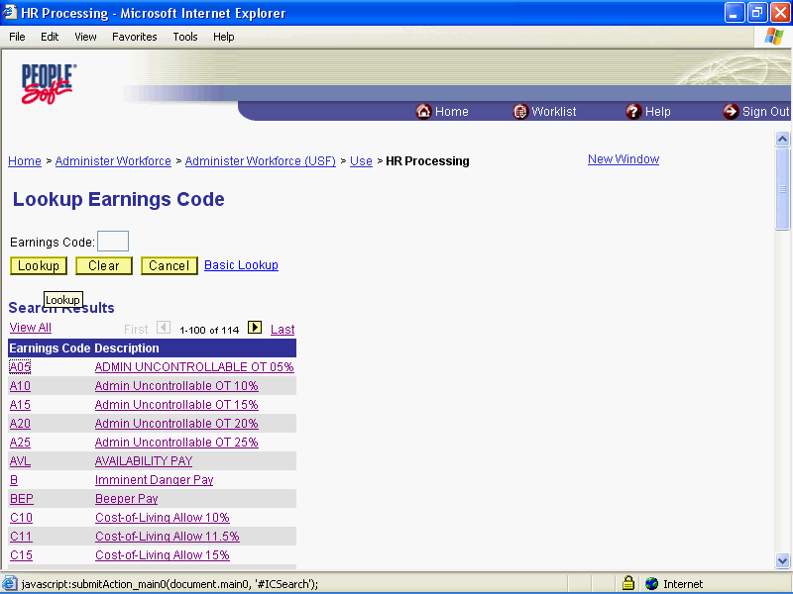

Step | Action
 | Release the mouse button.

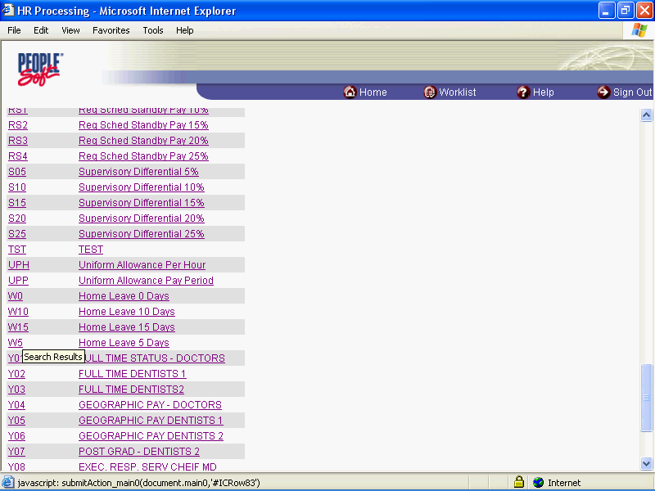

Step | Action
 | Click the Search Results table.

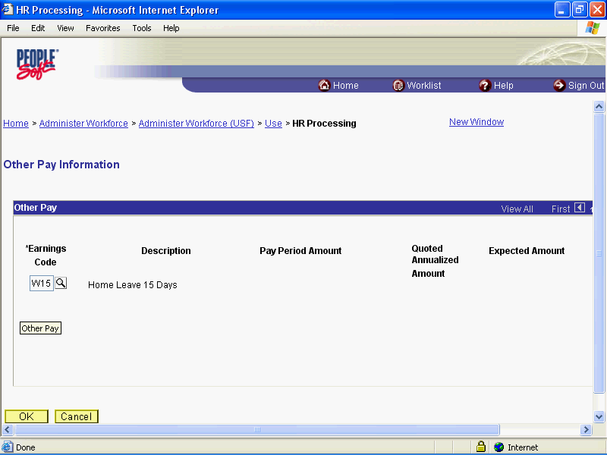

Step | Action
 | Click the OK button.

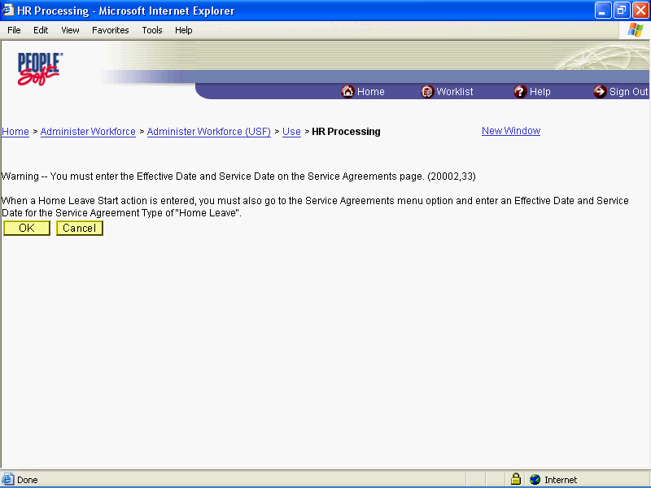

Step | Action
 | Click the Ok button.

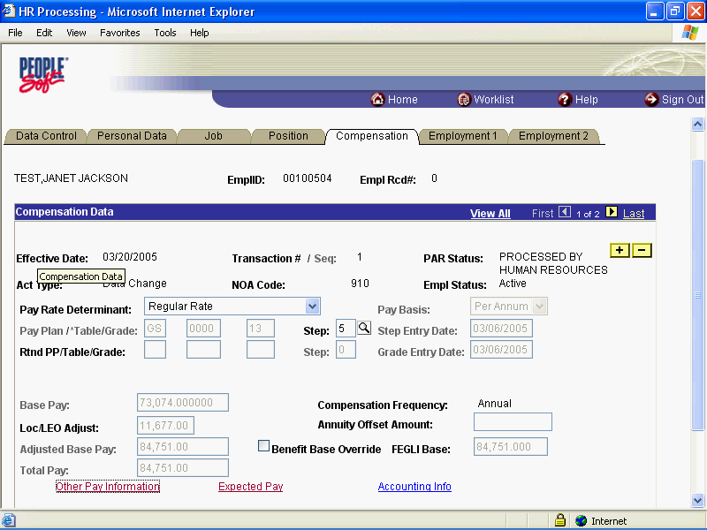

Step | Action
 | Release the mouse button.

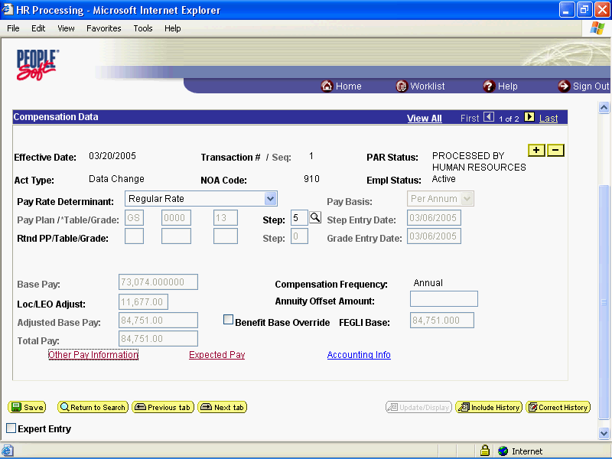

Step | Action
 | Click the Save button.

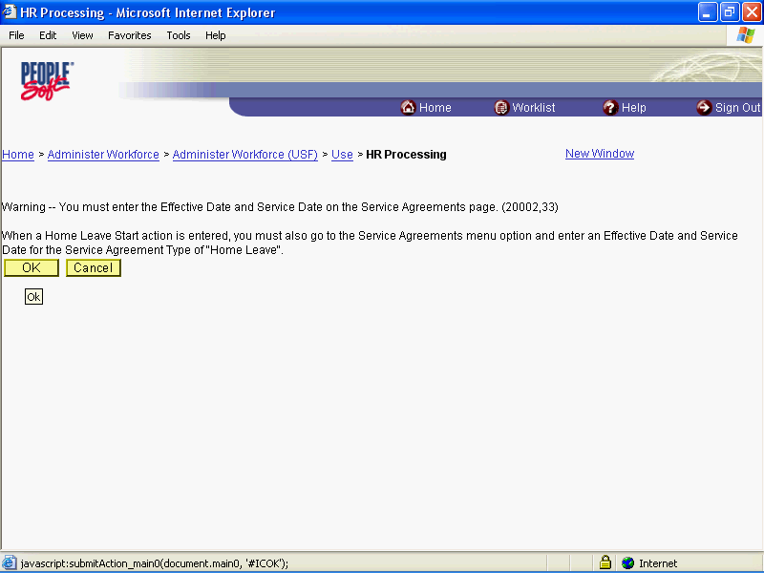

Step | Action
 | Click the Ok button.

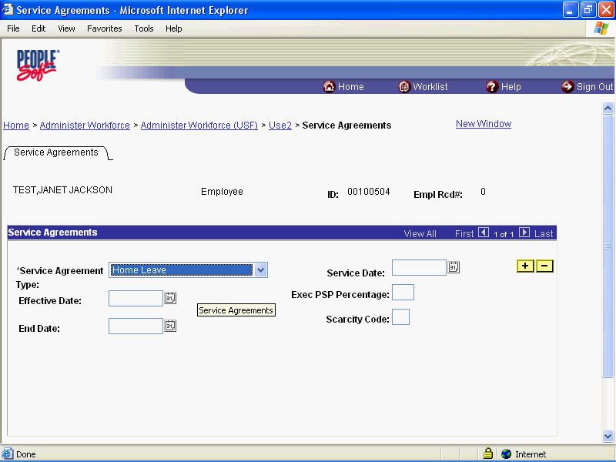

Step | Action
 | Click the Choose a date button.

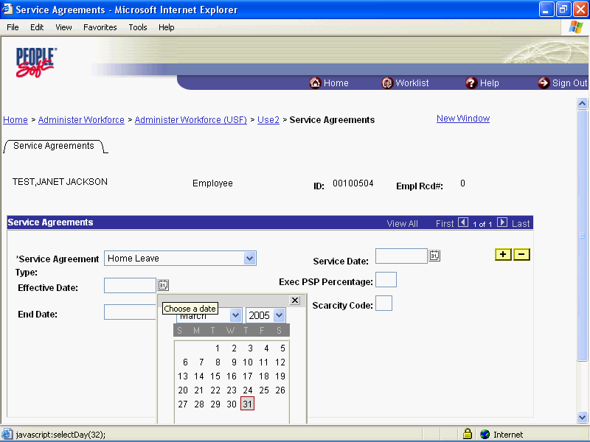

Step | Action
 | Click the desired date.

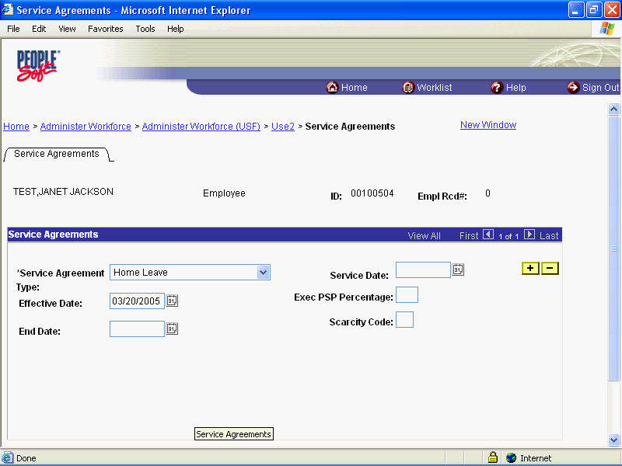

Step | Action
 | Click the Choose a date button.

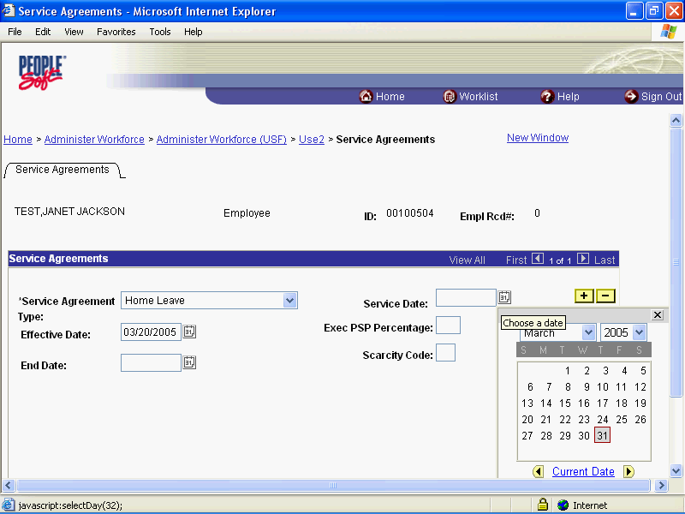

Step | Action
 | Click the desired date.

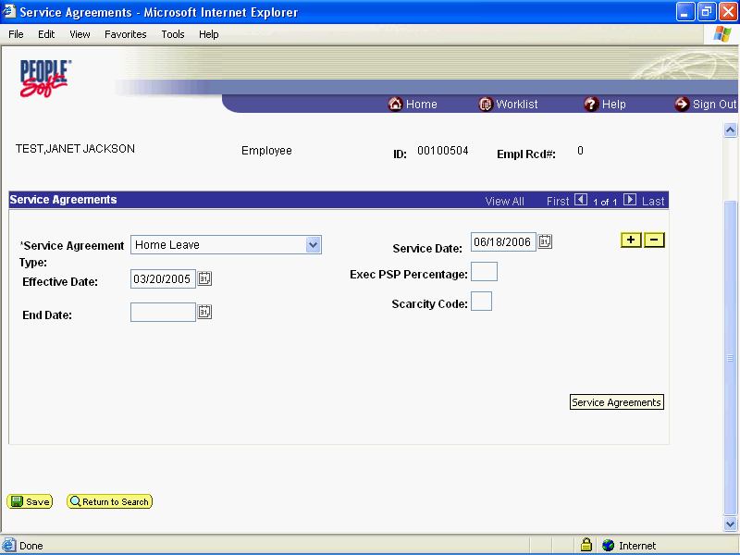

Step | Action
 | Click the Save button.
 | End of Procedure.

Home Leave Stop

Procedure

Step | Action
 | Click the Administer Workforce link.
 | Click the Administer Workforce (USF) link.
 | Click the Use link.
 | Click the HR Processing link.

Step | Action
 | Enter the desired information into the EmplID field. Enter "00100504".
 | Click the Search button.

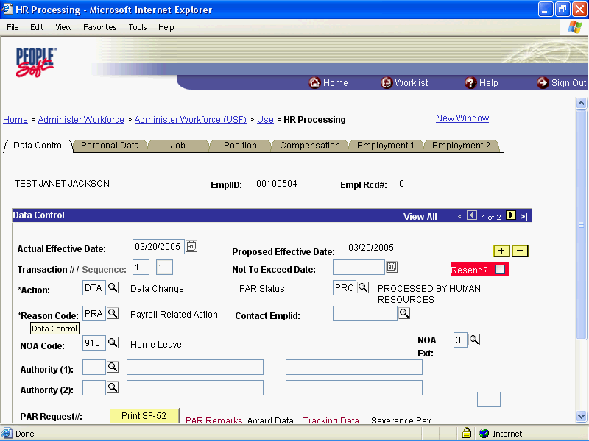

Step | Action
 | Click the Add a new row at row 1 button.
 | Click the Calendar icon button.

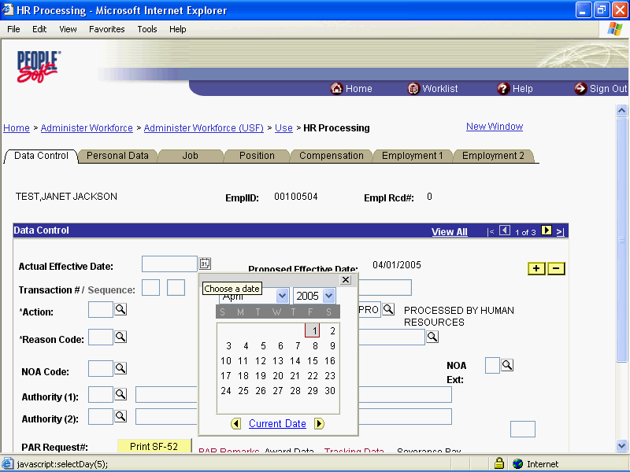

Step | Action
 | Click the desired date.

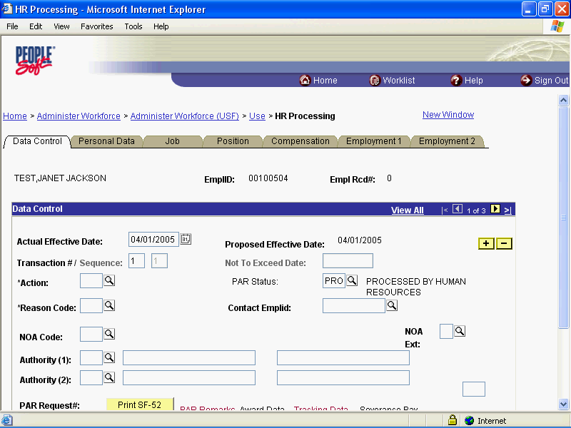

Step | Action
 | Enter the desired information into the *Action field. Enter "DTA".
 | Click in the *Reason Code field.
 | Press [Tab].
 | Enter the desired information into the NOA Code field. Enter "910".
 | Press [Tab].
 | Press [Tab].

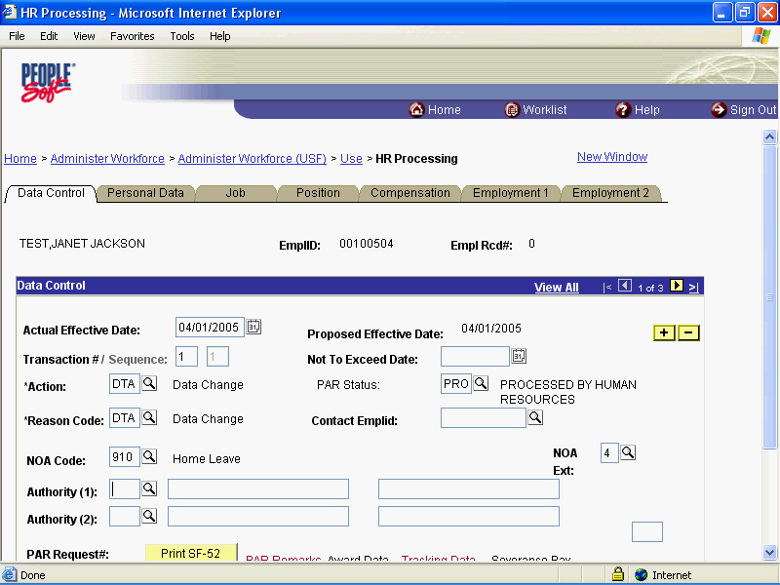

Step | Action
 | Click the Compensation tab.

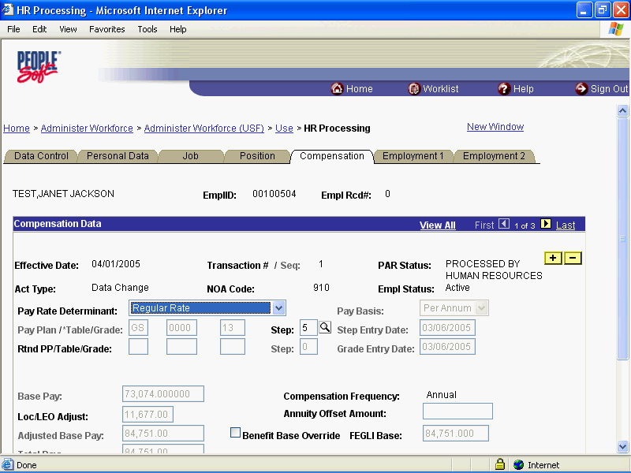

Step | Action
 | Click the Other Pay Information link.

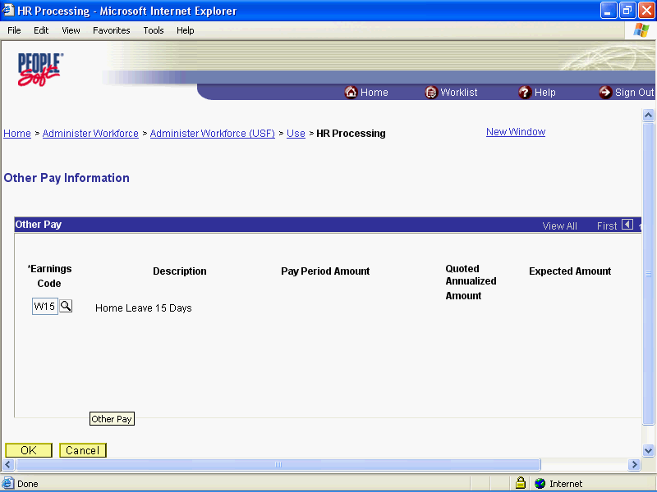

Step | Action
 | Release the mouse button.

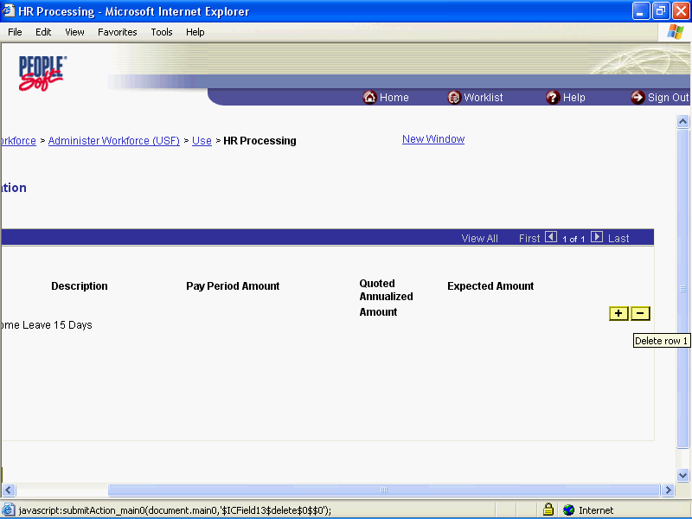

Step | Action
 | Click the Delete row 1 button.

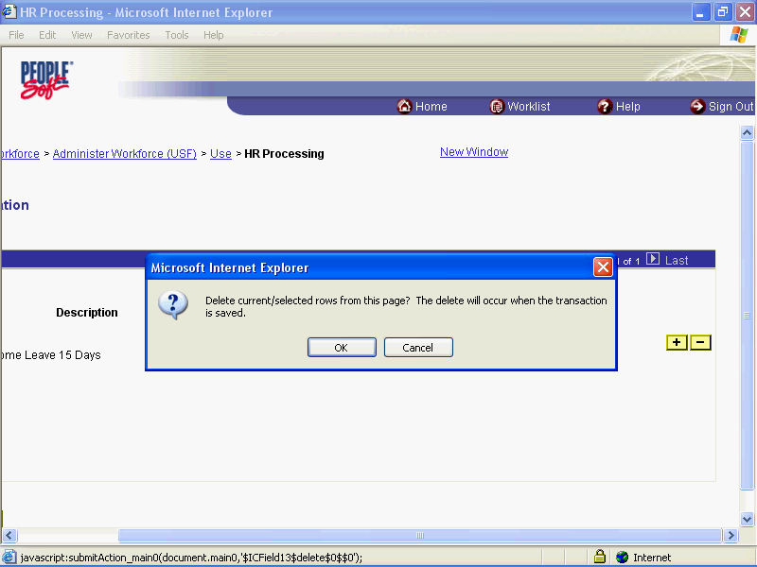

Step | Action
 | Click the OK button.

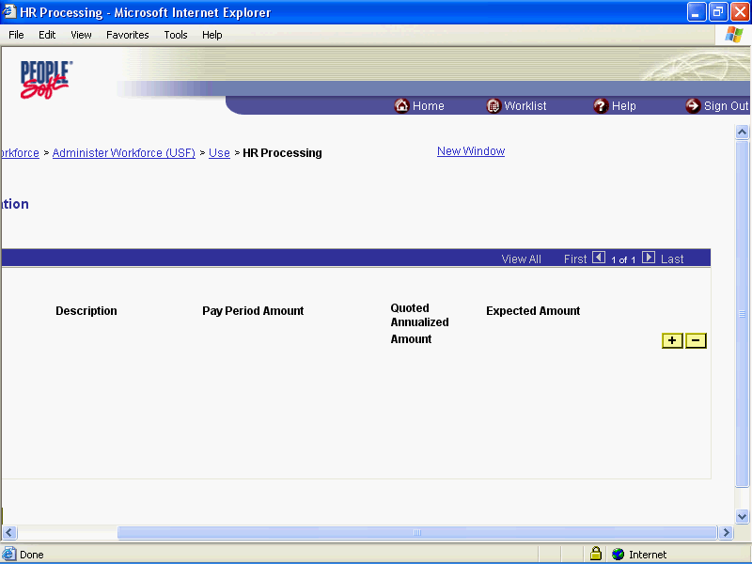

Step | Action
 | Click the OK button.

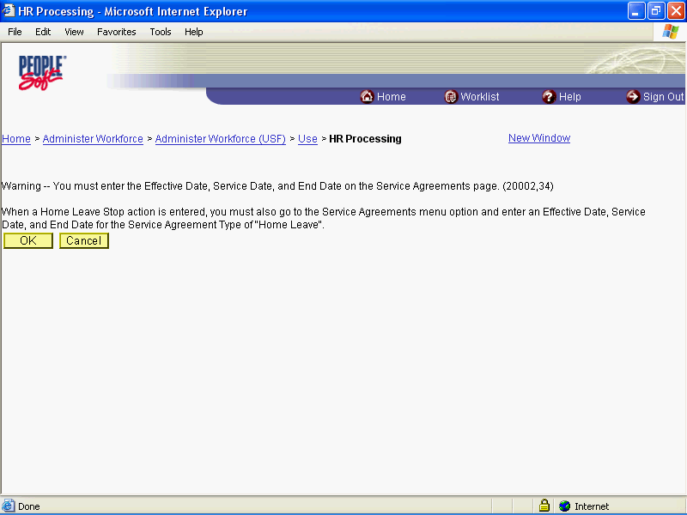

Step | Action
 | Click the Ok button.

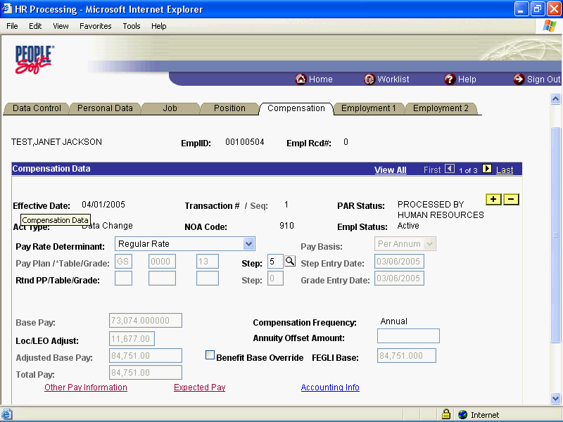

Step | Action
 | Point to the statusbar.

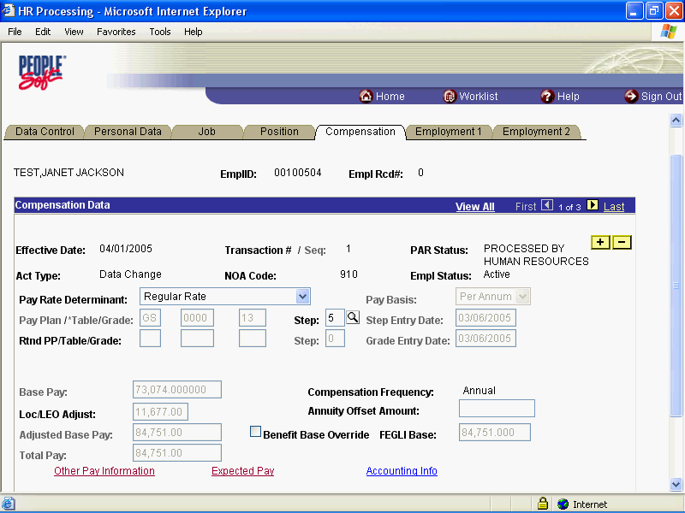

Step | Action
 | Click the Save button.

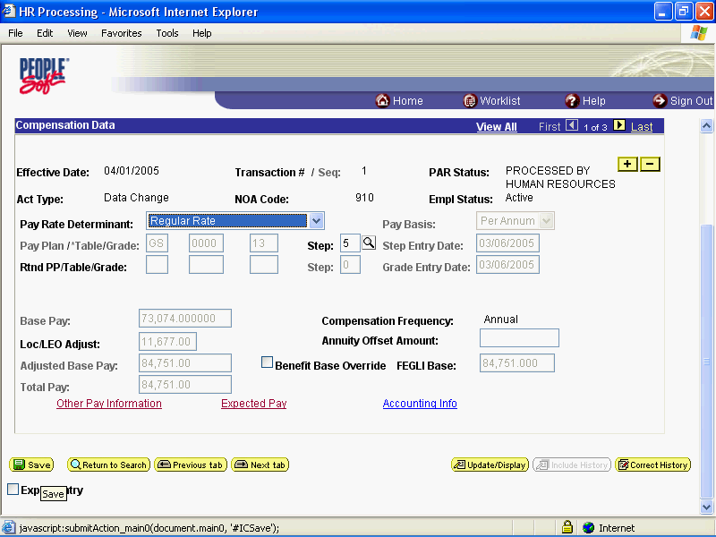

Step | Action
 | Click the Administer Workforce (USF) link.

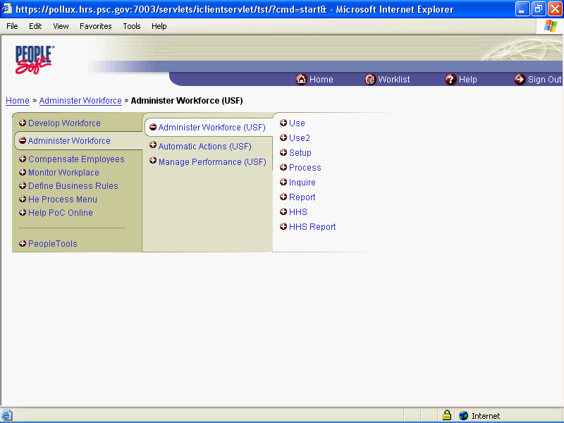

Step | Action
 | Click the Use2 link.
 | Click the Service Agreements link.

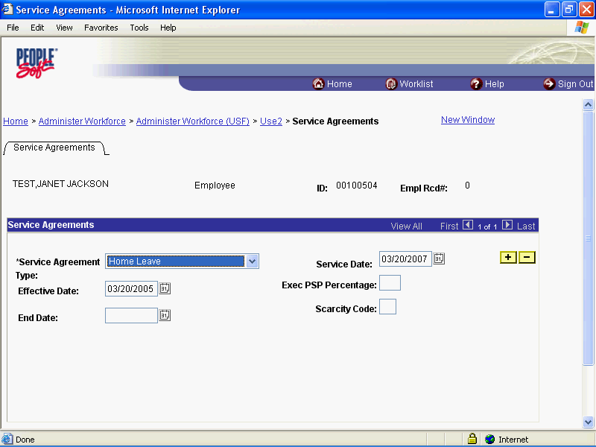

Step | Action
 | Click the Choose a date button.

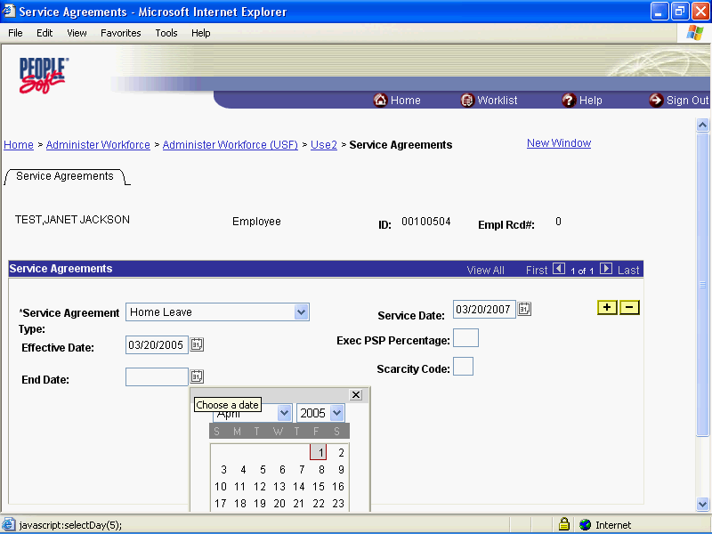

Step | Action
 | Click the desired date.

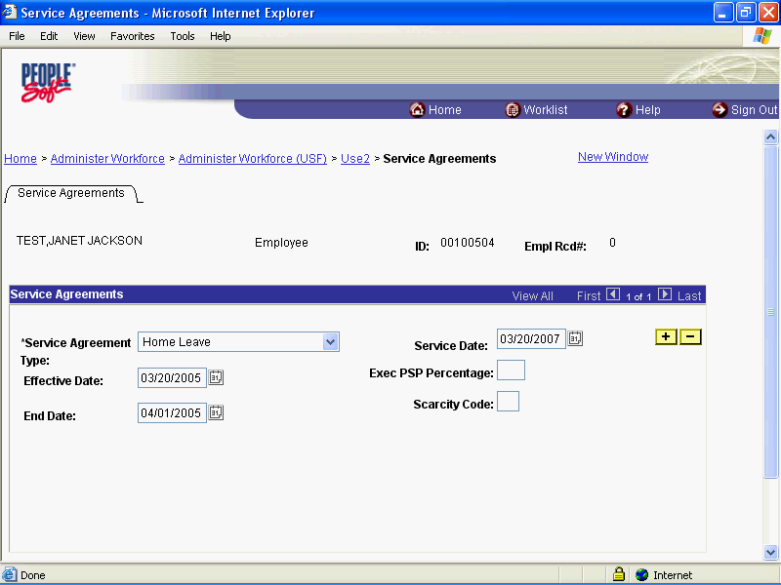

Step | Action
 | Click the Save button.
 | End of Procedure.

Premium Pay
In EHRP, an employee's premium pay must be entered in the HR Processing page group. Premium pay includes retention allowances, COLAs, physician special pay (PSP), physician comparability allowances (PCA) and post differentials.
Special pay will be entered on the Other Pay Information sub-page, accessed from the hyperlink on the Compensation page of the HR Processing page group.

Processing Premium Pay
Introduction
In EHRP, an employee's premium pay must be entered in the HR Processing page group. The special pays that this procedure references are ongoing special pays, rather than one-time payments, such as awards.Special pay will be entered on the Other Pay Information sub-page, accessed from the hyperlink on the Compensation page of the HR Processing page group. The user will need to know the appropriate NOAC and extension to use for the premium pay personnel action.
NOTE: Fields that are not required are not listed within the procedure. Optional fields that an end-user may choose to complete are not detailed.
NOTE: This procedure provides guidance on processing ongoing special pay for employees.

Procedure

Premium pay are special ongoing entitlements that an employee may receive, such as Retention Allowance, Post Differentials, COLA's. For the purpose of this exercise we will process a Retention Allowance.

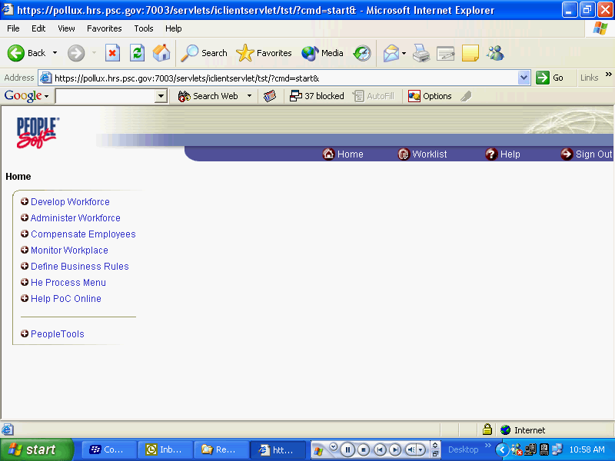

Step | Action
 | Click the Administer Workforce link.
 | Click the Administer Workforce (USF) link.
 | Click the Use link.
 | Click the HR Processing link.

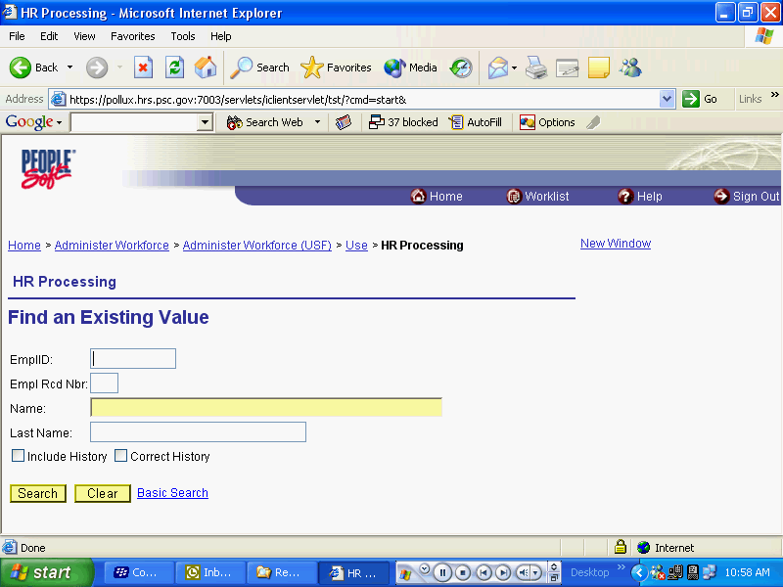

Step | Action
 | Enter the desired information into the Name field. Enter "test".
 | Click the Include History option.
 | Click the Search button.
 | Click the Search Results table.

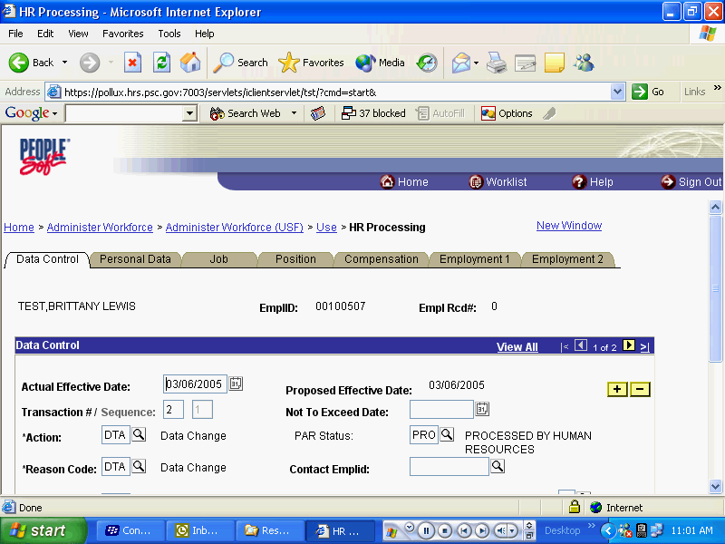

Step | Action
 | Click the Add a new row at row 1 button.
 | Enter the desired information into the Actual Effective Date field. Enter "03/20/2005".
 | Press [Tab].
 | Enter the desired information into the *Action field. Enter "pay".
 | Enter the desired information into the *Reason Code field. Enter "pay".
 | Press [Tab].
 | Enter the desired information into the NOA Code field. Enter "810".
 | Press [Tab].
 | Enter the desired information into the NOA Ext field. Enter "0".
 | Press [Tab].
 | Enter the desired information into the Authority (1) field. Enter "vpg".
 | Press [Tab].

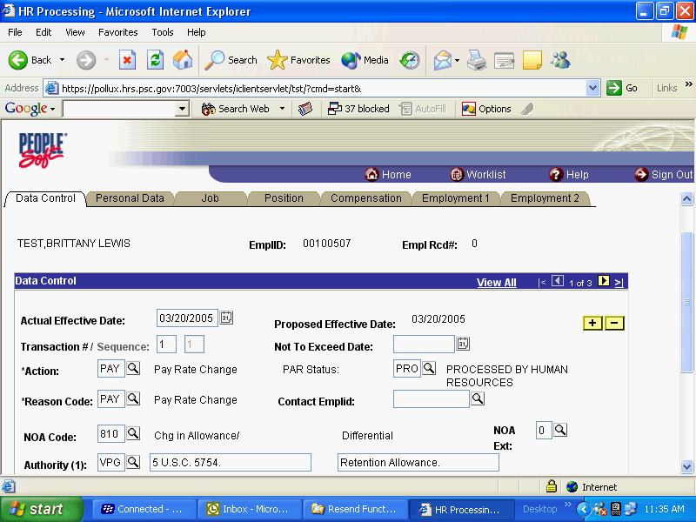

Step | Action
 | Click the Compensation tab.

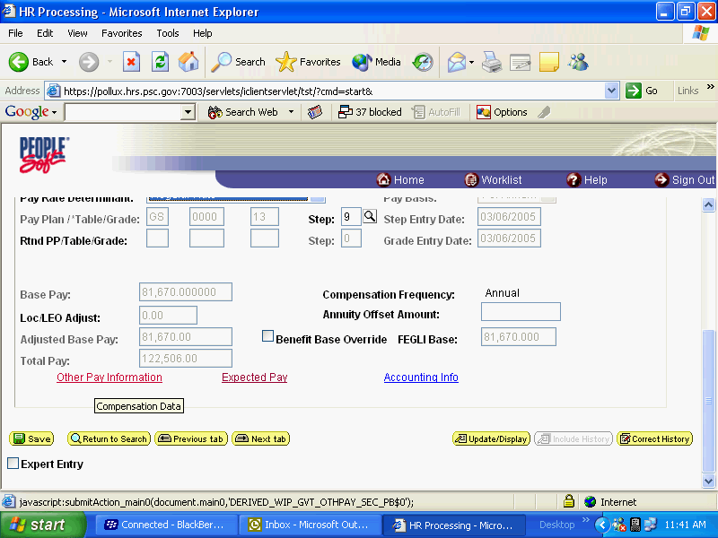

Step | Action
 | Click the Other Pay Information link.

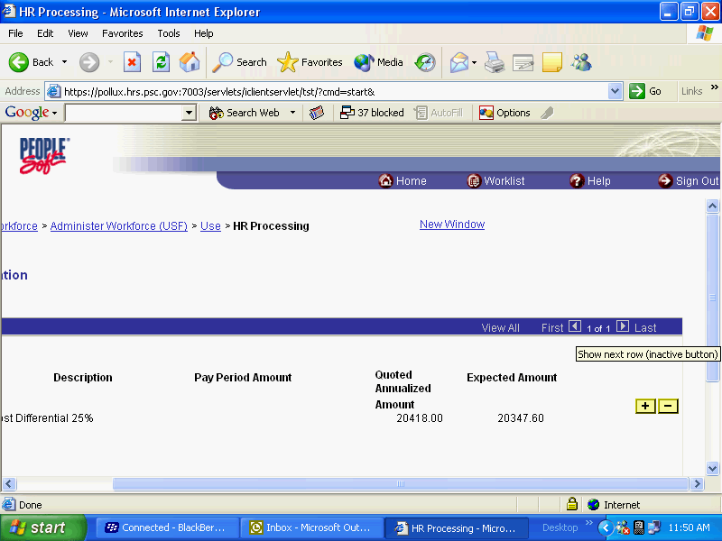

Step | Action
 | Point to the Add a new row at row 1 object.

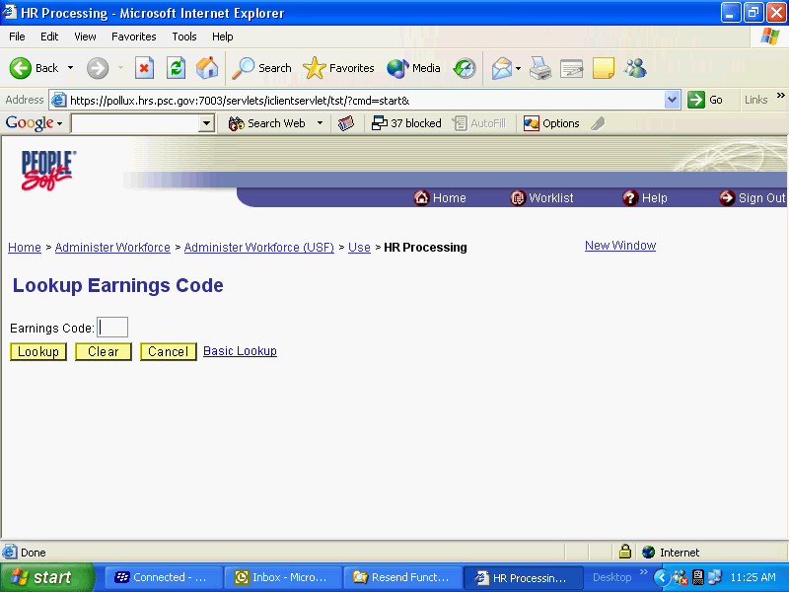

Step | Action
 | Click the Lookup button.
 | Click the Search Results table.

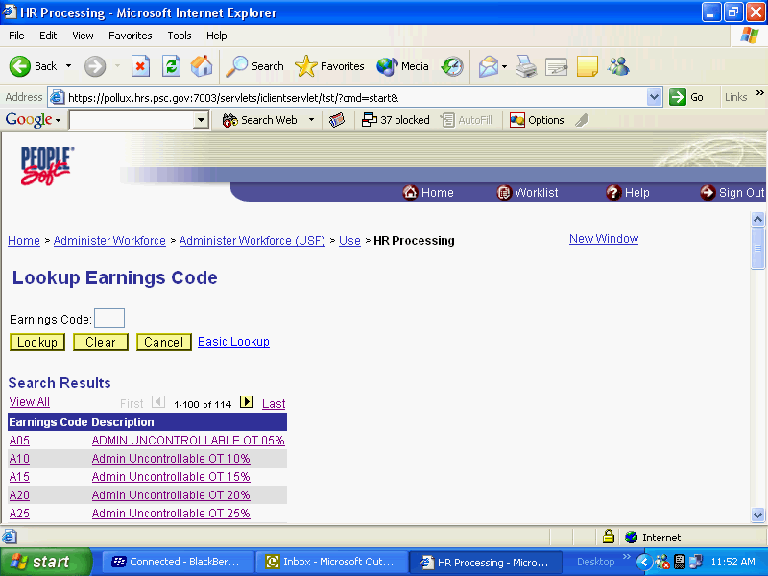

Step | Action
Point to the object.
Use the scroll bar to scroll down the search results to select the appropriate earnings code.

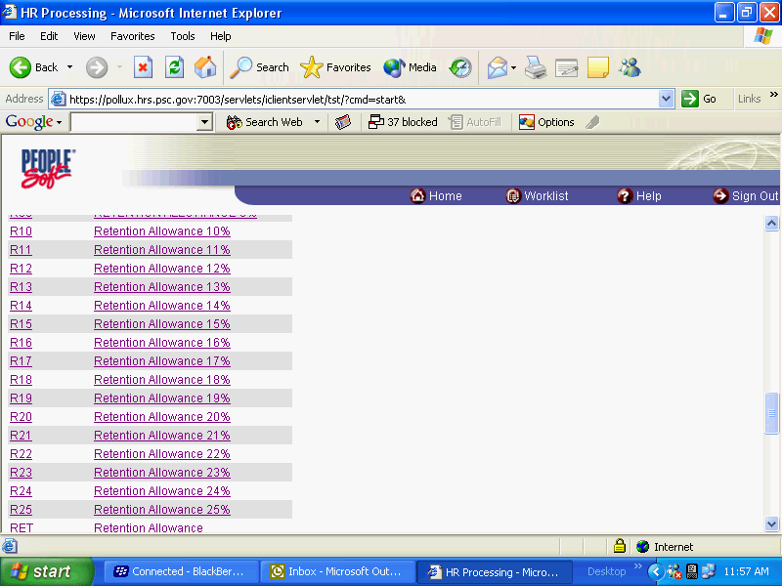

Step | Action
Click the Search Results table.
For this exercise, we will use R25.

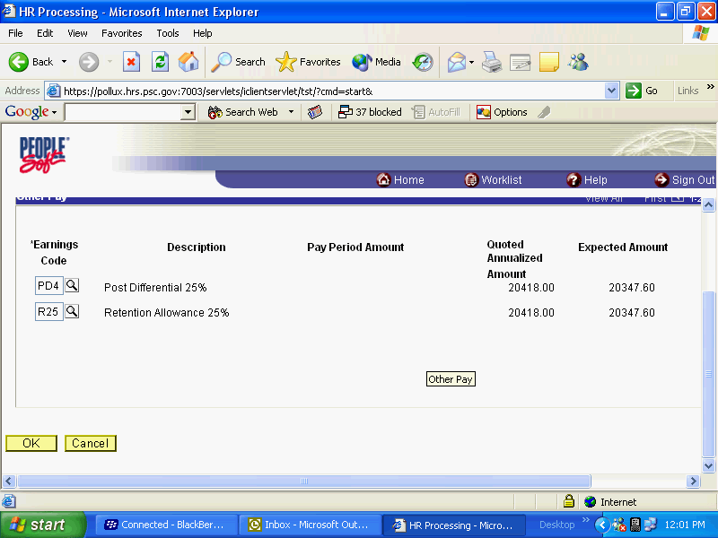

Step | Action
 | Click the OK button.

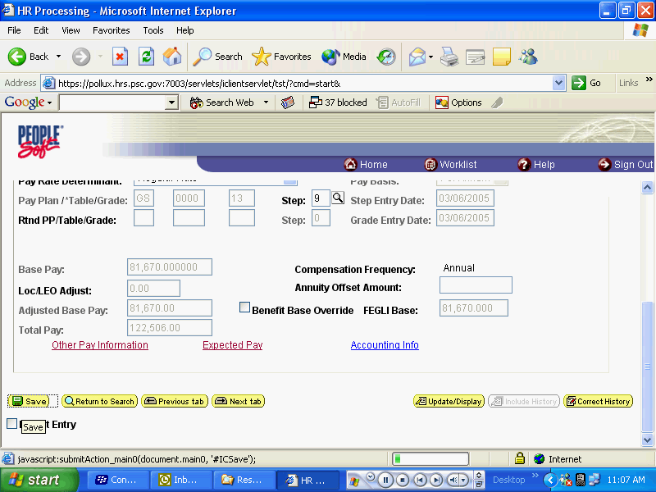

Step | Action
 | Click the Save button.
 | End of Procedure.

Physician Special Pay (PSP) Processing
Introduction
This topic outlines the procedure that needs to be followed when processing the Physician Special Pay (PSP) for eligible employees. Once the service agreement has been received, the data entry into EHRP can be completed.
Processing a PSP in EHRP is a 2-step process. The user must first go to the Service Agreements page to enter the type of agreement and effective dates of the agreement. Then, the PAR action will be completed, along with the entry of the specific pay items. Use the Data Control page to add a row for the action, and the Other Pay Information hyperlink on the Compensation page to enter the PSP codes that apply.

Procedure

The following procedures must be completed when processing a PSP.

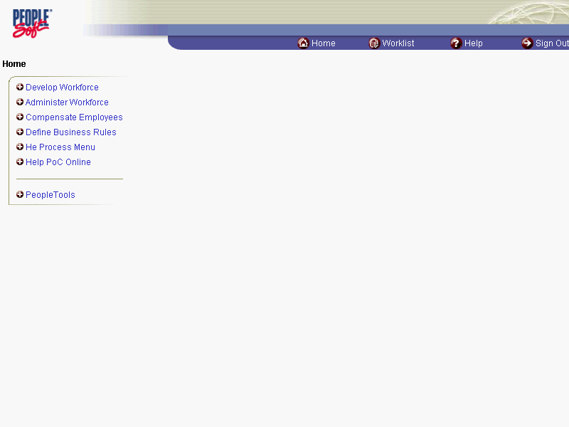

Step | Action
 | Click the Administer Workforce link.
 | Click the Administer Workforce (USF) link.
 | Click the Use2 link.
 | Click the Service Agreements link.

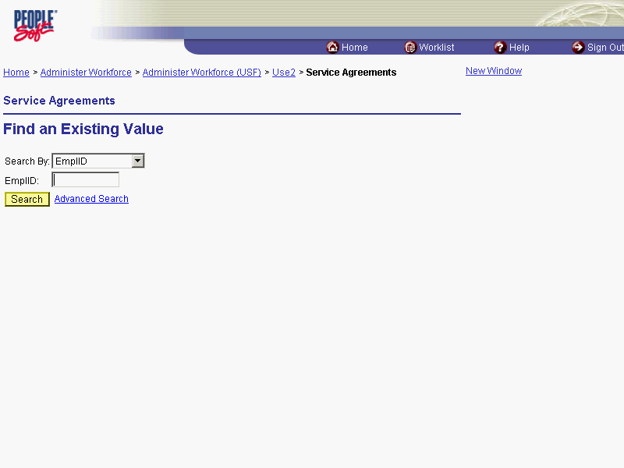

Step | Action
 | Click the Search By list.
Select the desired entry.
Click Last Name.

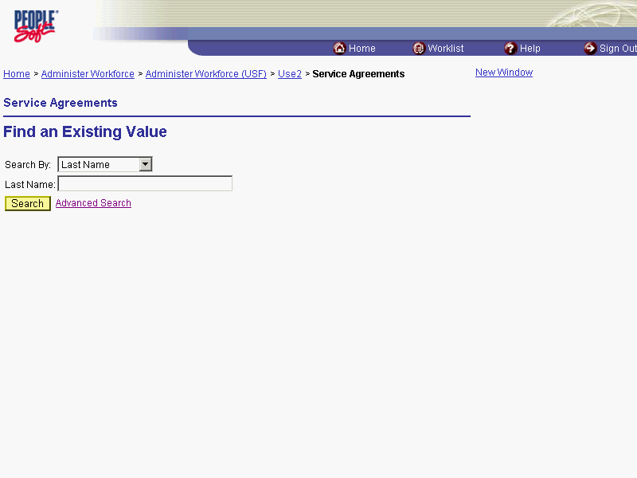

Step | Action
 | Enter the desired information into the Last Name field. Enter "Winter".
 | Click the Search button.
Scroll as necessary and click the desired entry in the Search Results table.
Click the link for Winter, Fred.

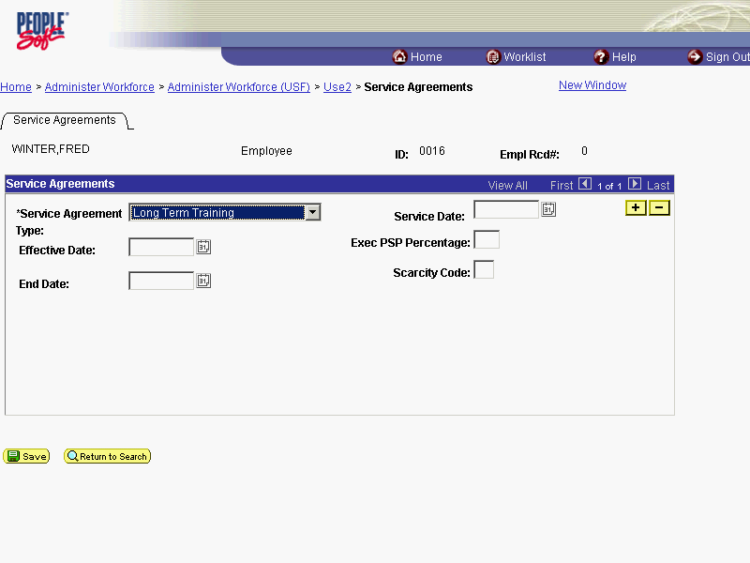

Step | Action
 | Click the *Service Agreement Type list.
Select the desired entry in the list.
Click Physician's Special Pay.
 | Enter the desired information into the Effective Date field. Enter "12/01/2003".
 | Press [Tab].
 | Click in the End Date field.
 | Enter the desired information into the End Date field. Enter "12/31/2005".
 | Enter the Executive Pay percentage amount in the Exec PSP Percentage field and the appropriate code into the Scarcity Code field, if applicable.

The Exec PSP Percentage field relates to the percentage of time a Chief of Staff or a Service Chief is contracted to spend in that role. The system will derive the scarcity percentage by subtracting the Executive percentage from 100.

When an employee eligible for PSP is part time, their PSP is prorated based on the number of hours they work. When an employee eligible for PSP has dual roles in scarcity and executive pay, their PSP is prorated based on the percent of time they work in each category. The prorating calculation occurs when the user enters the PSP amounts.

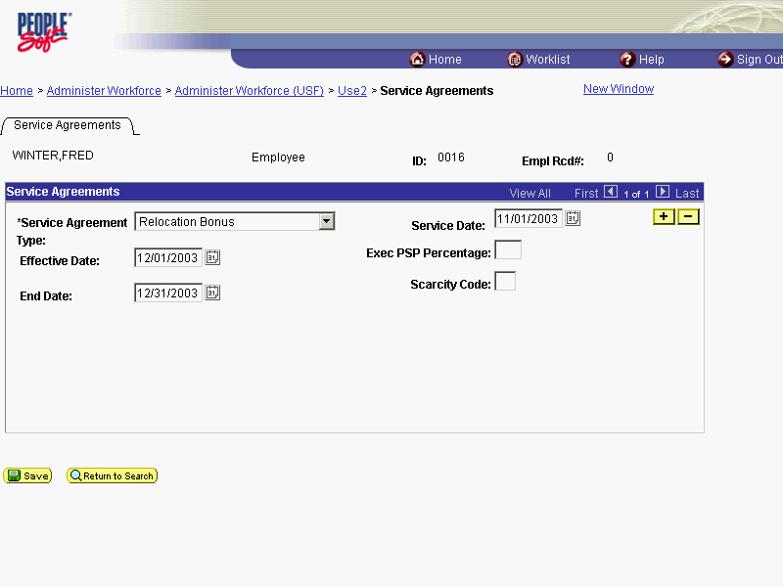

Step | Action
Once the data associated with the service agreements has been captured, the PSP personnel action must be completed and the pay specifics must be entered.
Click the Administer Workforce (USF) link.

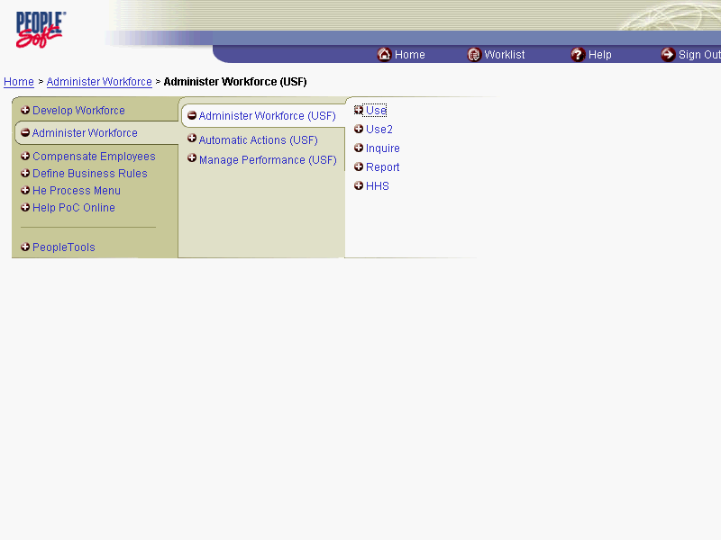

Step | Action
 | Click the Use link.
 | Click the HR Processing link.

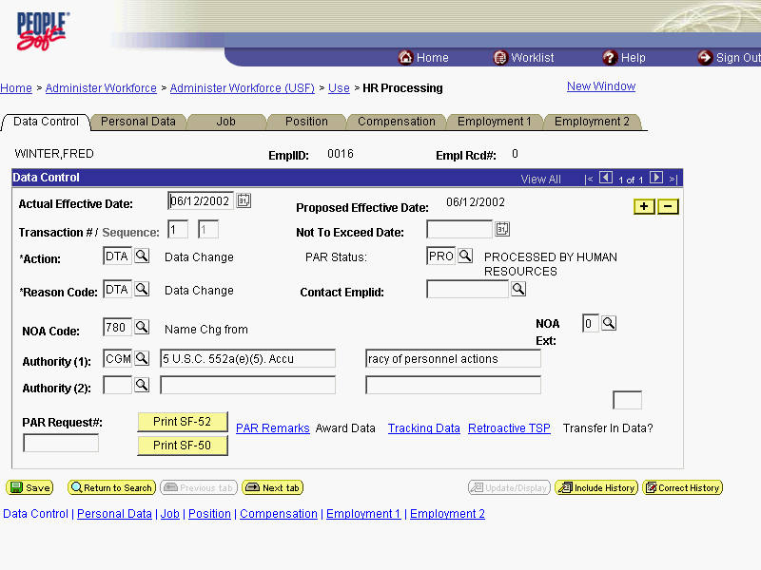

Step | Action
NOTE: The Data Control page will be populated with the most recent personnel action performed for the selected employee. You can use the Search feature to enter search criteria to locate another employee, if desired.
Click the Add a new row at row 1 button.

The Look Up icon represents a look-up prompt. Clicking this button will allow you to look up all possible entry options for this field.

Step | Action
 | Click the Calendar icon button.

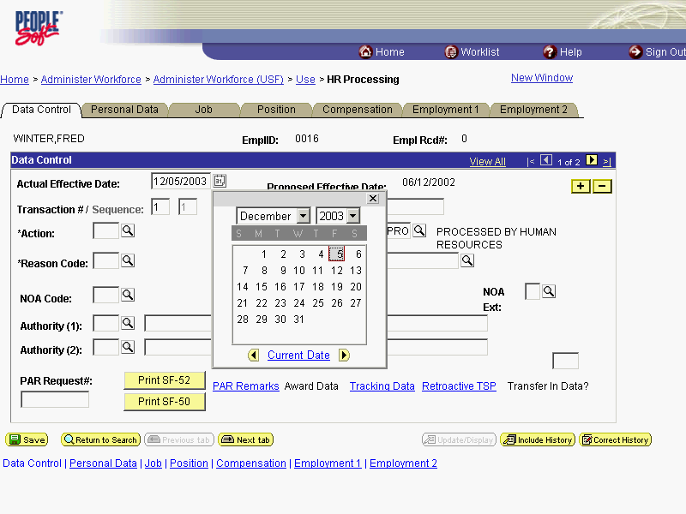

Step | Action
Select the desired date.
Click 8.

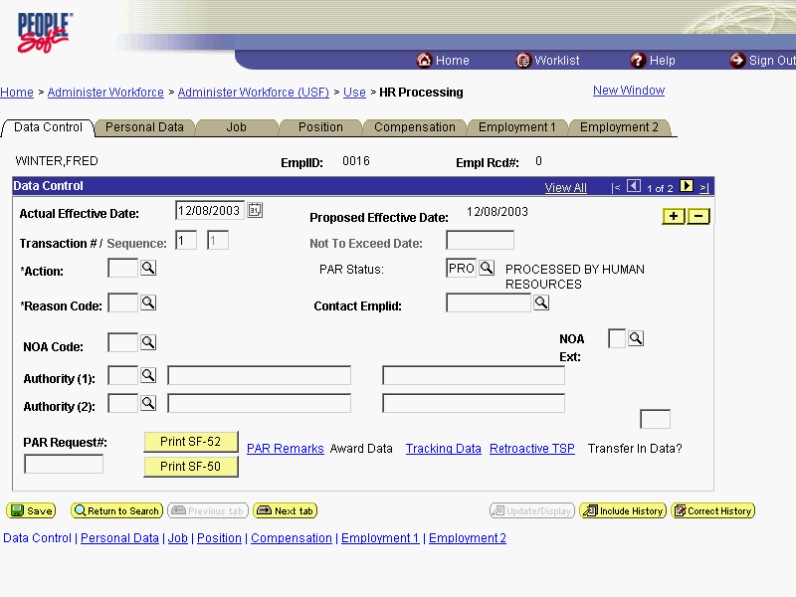

Step | Action
 | Click in the *Action field.
 | Enter the desired information into the *Action field. Enter "PAY".
 | Click in the *Reason Code field.
 | Enter the desired information into the *Reason Code field. Enter "MER".
 | Click in the NOA Code field.
 | Enter the desired information into the NOA Code field. Enter "850".
 | Press [Tab].
 | Enter the desired information into the NOA Ext field. Enter "B".

NOA Extension Description
A = PSP Start
B = Length of Service Increase
C = PSP Stop (Cancel) *
D = PSP Correction Amount
E = PSP Contract Amendment
F = Terminate PSP **

* NOA 850C is used to cancel all PSP as of the effective date of the PSP.

** NOA 850F is used to terminate or stop all pay factors associated with PSP as of the effective date of the termination action.

Step | Action
 | Press [Tab].
 | Enter the desired information into the Authority (1) field. Enter "V1P".

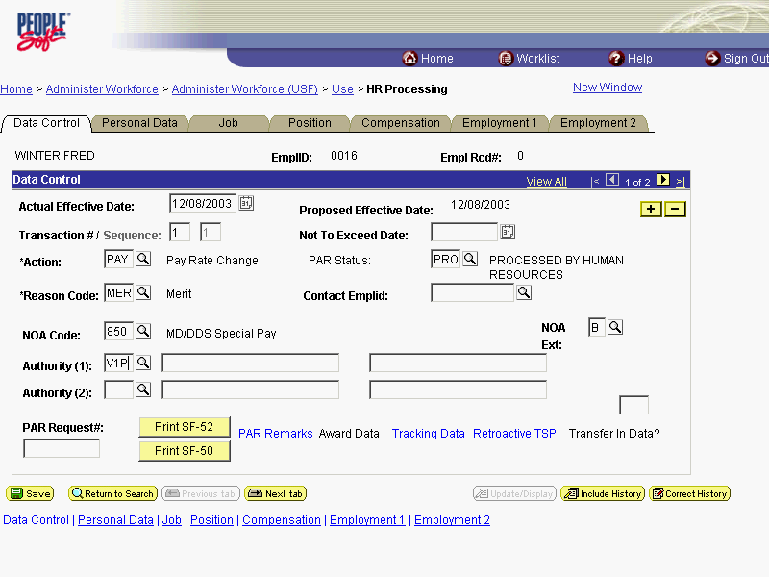

Step | Action
 | Click the Compensation tab.

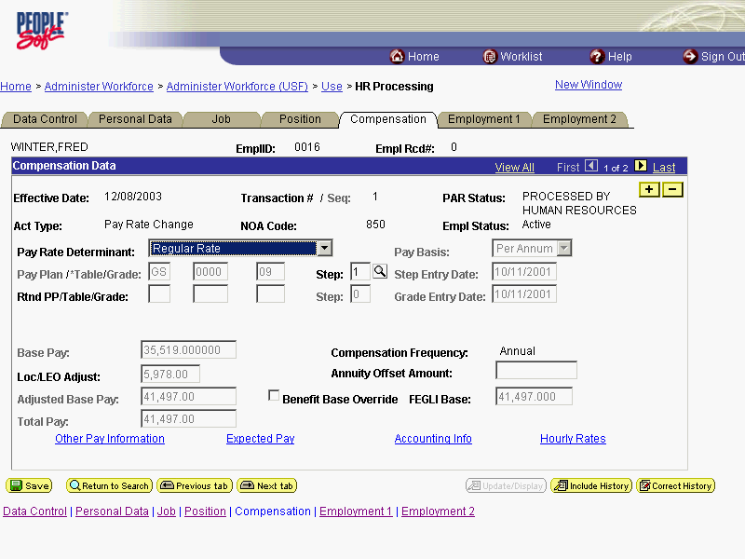

Step | Action
 | Click the Other Pay Information link.

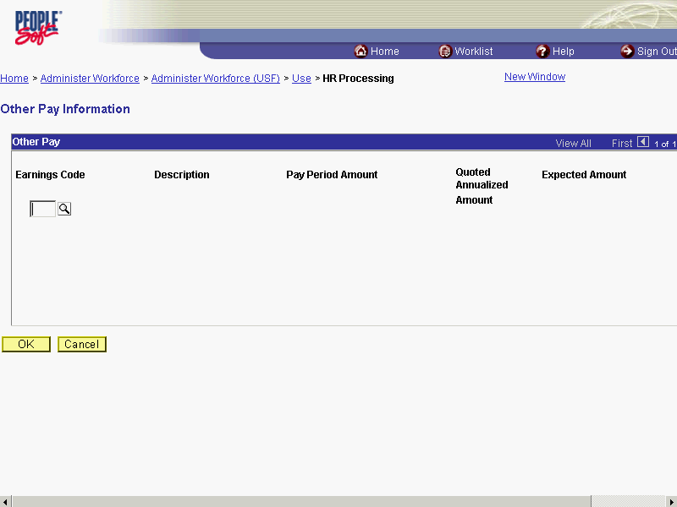

Step | Action
 | Enter the desired information into the Earnings Code field. Enter "Y04".
 | Press [Tab].
NOTE: When processing a PSP, users must only select one PSP category (PSP earnings code) and enter the PA amount on that one earnings code.
Enter the desired information into the Pay Period Amount field. Enter "100".
 | Press [Tab] to automatically populate the fields.
 | Click the OK button.

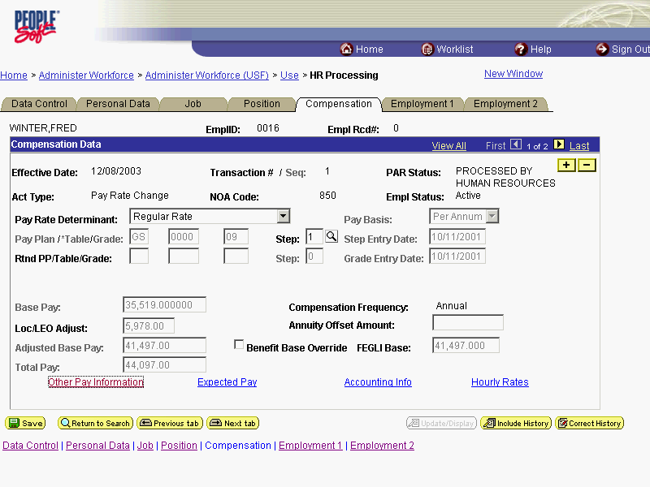

Step | Action
Change the PAR Status according to your role, if necessary.
Click the Save button.
The Physician Special Pay processing is completed.
End of Procedure.

Length of Service increases are part of an automatic process. The user will not have to check for anniversary dates.

The PSP NOA's cannot be corrected or cancelled using NOA 0010 or 0020. In order to correct or cancel the PSP, the applicable PSP NOA must be processed. See the NOA table on page 12-14 of this procedure for applicable NOA codes.

The following edits have been built into the processing of PSP in EHRP:

1. The employee's receiving PSP must be in a PSP eligible Occupational Series. Doctors must have the 602 Occ. Series. Dentists must have 680.

2. The physicians must be in PSP eligible pay plans. They must NOT belong to the following Pay Plans: ES, SL, ST, EL, EX, or AD.

3. If the employee has PSP they are not eligible for PSP.

4. The employee must be within Grades 13 and 15 including those grades.

5. If the employee's scarcity dollars have reached the maximum, they cannot receive Post Grad PSP dollars. (Only applies to Dentist 2)

6. The employee cannot be a reemployed annuitant under FERS or CSRS.

7. The Doctors pay rate determinant must be one of the following: Special & Superior Qualifications, Special Rate or Retained Pay - SES Removal.

8. Dentists must either be in the Regular Rate or Superior Qualifications Rate pay rate determinant.

Manual Procedure for Stopping PSP
Introduction
PSP is generally terminated through an automated process based on the Service Agreement end date. However, in the event that the PSP needs to be terminated prior to that date, the following process must be completed.
You must process a PAR using NOA code " 850 ", NOA ext " C".

Procedure

The following procedures must be completed when manually stopping PSP.

Step | Action
 | Click the Administer Workforce link.
 | Click the Administer Workforce (USF) link.
 | Click the Use link.
 | Click the HR Processing link.

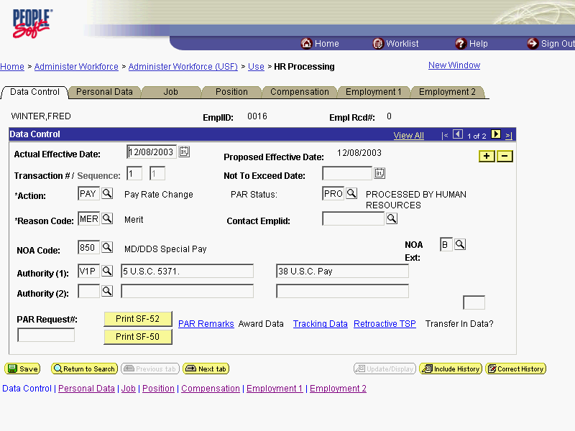

Step | Action
NOTE: The Data Control page will be populated with the most recent personnel action performed for the selected employee.
You can use the Search feature to enter search criteria to locate another employee, if desired.
Click the Add a new row at row 1 button.
 | Click the Calendar icon button.

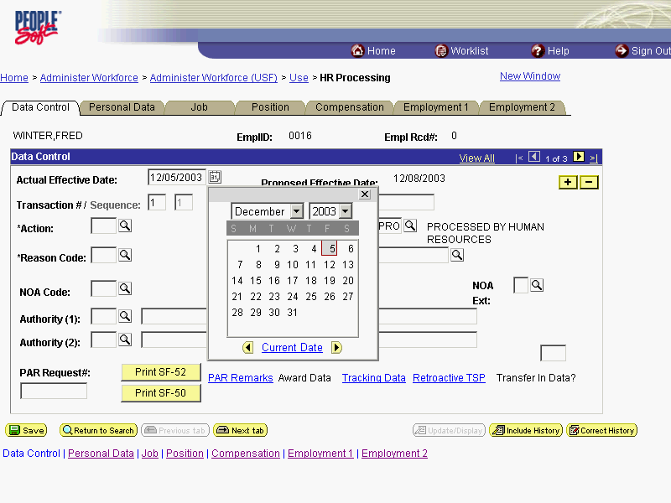

Step | Action
Enter the effective date of the PSP action in the Actual Effective Date field.
Select the desired date
Click 4.

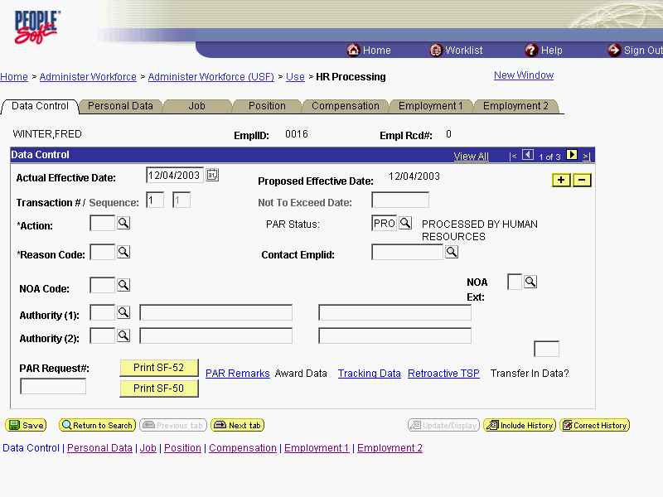

Step | Action
 | Click in the *Action field.

The Look Up icon represents a look-up prompt. Clicking this button will allow you to look up all possible entry options for this field.

Step | Action
 | Enter the desired information into the *Action field. Enter "PAY".
 | Click in the *Reason Code field.
 | Enter the desired information into the *Reason Code field. Enter "MER".
 | Click in the NOA Code field.
 | Enter the desired information into the NOA Code field. Enter "850".
 | Press [Tab].
 | Enter the desired information into the NOA Ext field. Enter "C".

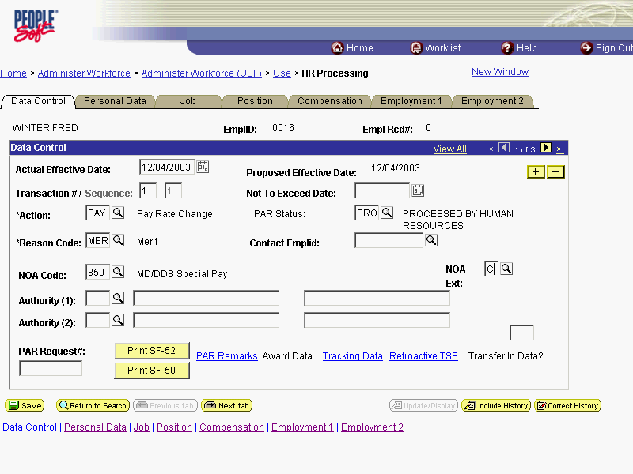

Step | Action
 | Click the Compensation tab.

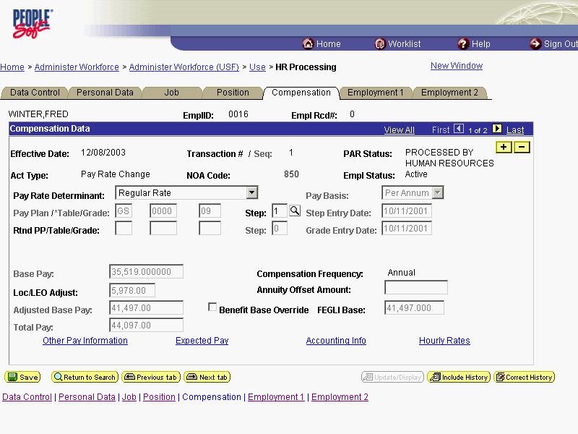

Step | Action
 | Click the Other Pay Information link.

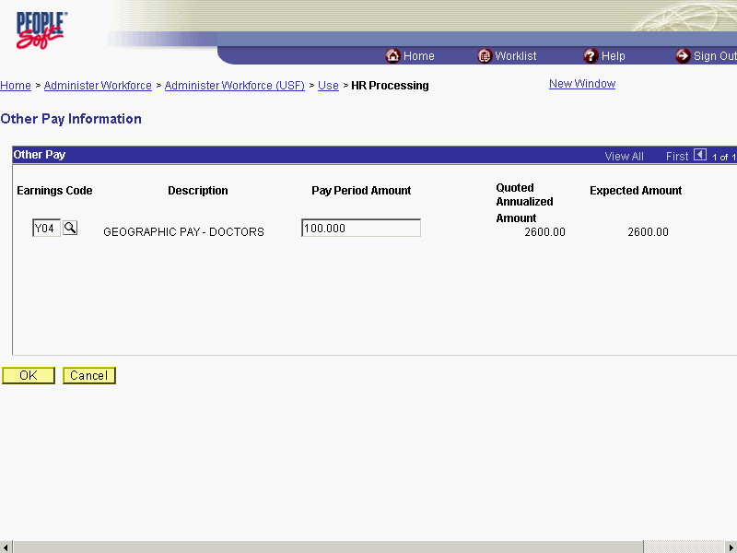

Step | Action
 | Double-click in the Earnings Code field.
 | Press [Delete].
 | Click the OK button.

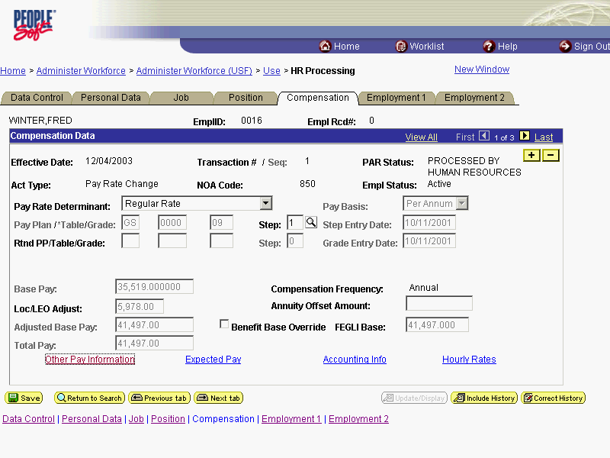

Step | Action
Change the PAR Status according to your role, if necessary.
Click the Save button.
The PSP procedure is stopped manually in EHRP.
End of Procedure.

Physician's Comparability Allowance (PCA) Processing
The following topics explain the procedures for processing the Physician's Comparability Allowance (PCA) for eligible employees. Once the service agreement has been received, the data entry into EHRP can be completed.

PCA Processing
Introduction
Processing a PCA in EHRP is a 2-step process. The user must first go to the Service Agreements page to enter the type of agreement and effective dates of the agreement. Then, the PAR action will be completed along with the entry of the specific pay items. Use the Data Control page to add a row for the action, and use the Other Pay Information hyperlink on the Compensation page to enter the PCA code that applies.

Procedure

The following procedures must be completed when processing a Physician's Comparability Allowance (PCA) for eligible employees.

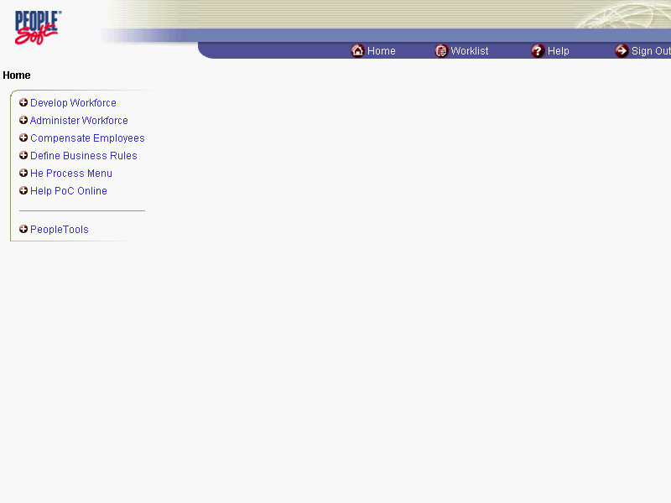

Step | Action
 | Click the Administer Workforce link.
 | Click the Administer Workforce (USF) link.
 | Click the Use2 link.
 | Click the Service Agreements link.

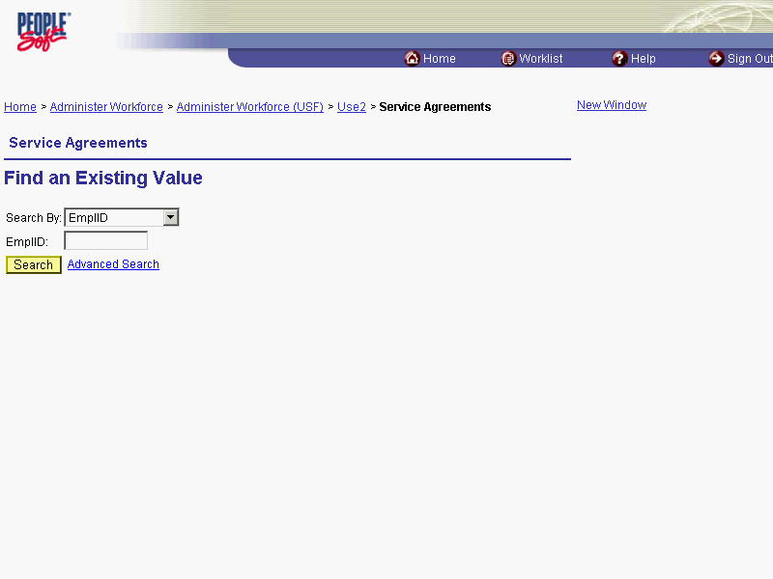

Step | Action
 | Click the Search By list.
Select the desired entry.
Click Last Name.

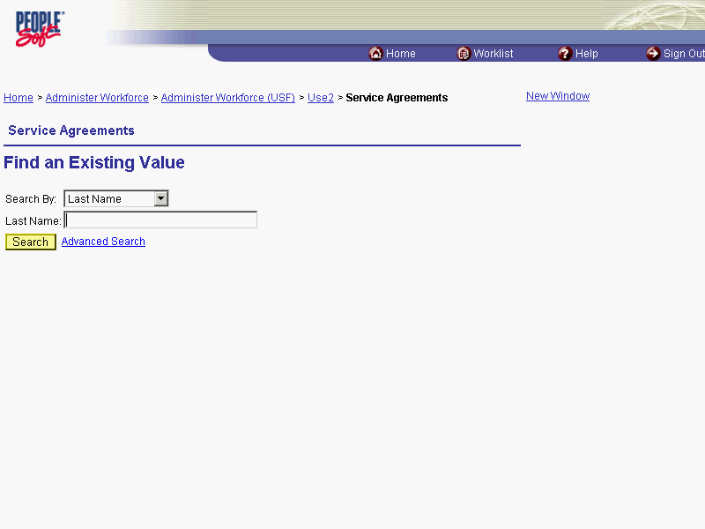

Step | Action
 | Enter the desired information into the Last Name field. Enter "WINTER".
 | Click the Search button.
Scroll as necessary and click the desired entry in the Search Results table.
Click the link for Winter, Dennis R.

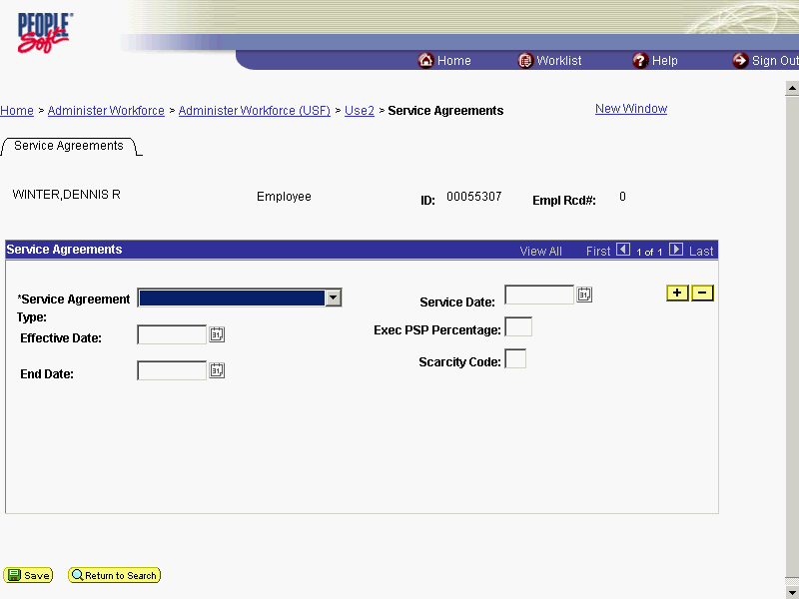

Step | Action
 | Click the *Service Agreement Type list.
Select the desired entry.
Click Physician's Comp. Allowance.
 | Click in the Service Date field.
 | Enter the desired information into the Service Date field. Enter "03/15/2004".

The Calendar icon represents a date prompt. Clicking this button will produce a pop-up calendar for reference. To select a specific date from the pop-up calendar as the field entry, simply click on the date. Use the arrows to move through the months and years.

Step | Action
 | Click in the Effective Date field.
 | Enter the desired information into the Effective Date field. Enter "03/15/2004".
 | Click in the End Date field.
 | Enter the desired information into the End Date field. Enter "03/16/2004".
 | Click the Save button.

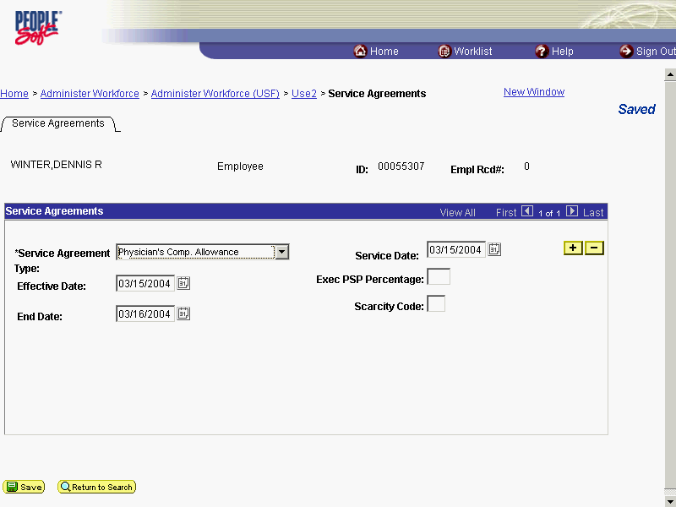

Step | Action
 | Click the Administer Workforce (USF) link.

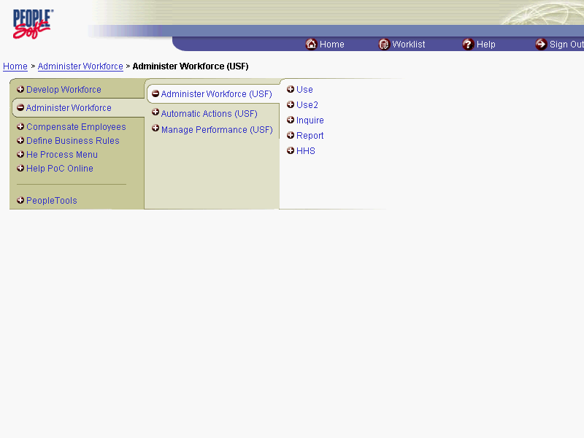

Step | Action
 | Click the Use link.
 | Click the HR Processing link.

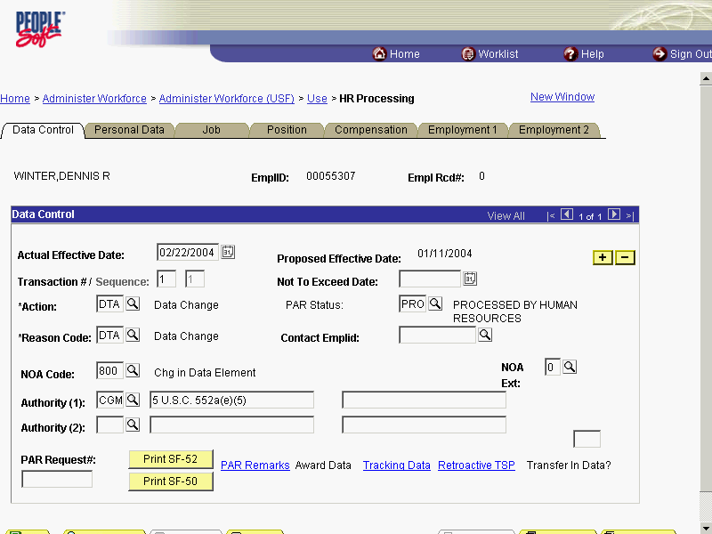

Step | Action
NOTE: The Data Control page will be populated with the most recent personnel action performed for the selected employee.
You can use the Search feature to enter search criteria to locate another employee, if desired.
Click the Add a new row at row 1 button.
Enter the effictive date of the PCA action in the Actual Effective Date field.
Double-click in the Actual Effective Date field.
 | Enter the desired information into the Actual Effective Date field. Enter "15".
 | Click in the *Action field.

The Look Up icon represents a look-up prompt. Clicking this button will allow you to look up all possible entry options for this field.

Step | Action
 | Enter the desired information into the *Action field. Enter "PAY".
 | Click in the *Reason Code field.
 | Enter the desired information into the *Reason Code field. Enter "MER".
 | Click in the NOA Code field.
Enter the NOA Code 958.
Enter the desired information into the NOA Code field. Enter "958".
 | Click in the NOA Ext field.
 | Enter the desired information into the NOA Ext field. Enter "0".

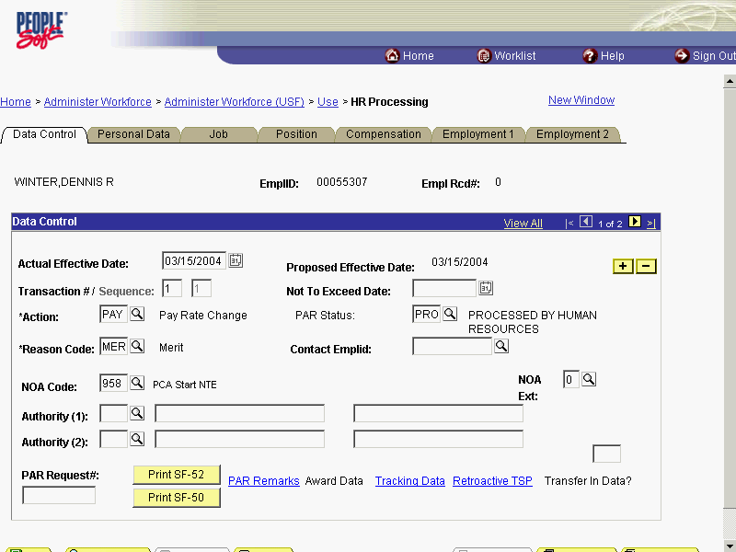

Step | Action
 | Click the Compensation tab.

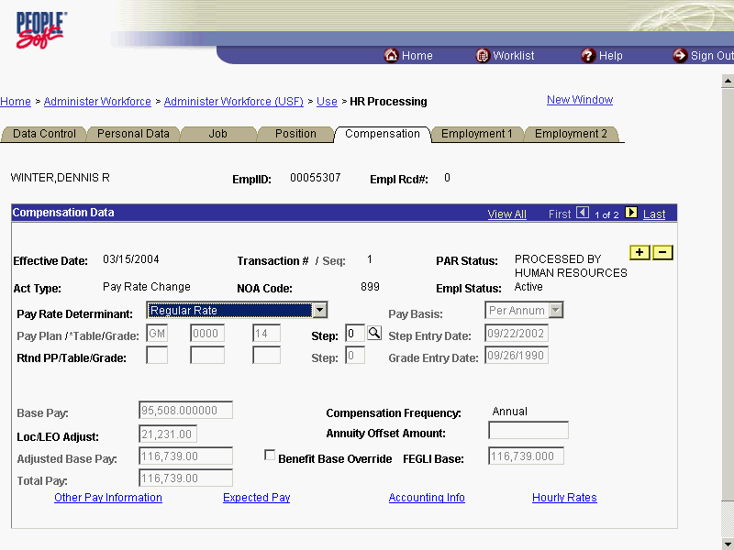

Step | Action
 | Click the Other Pay Information link.

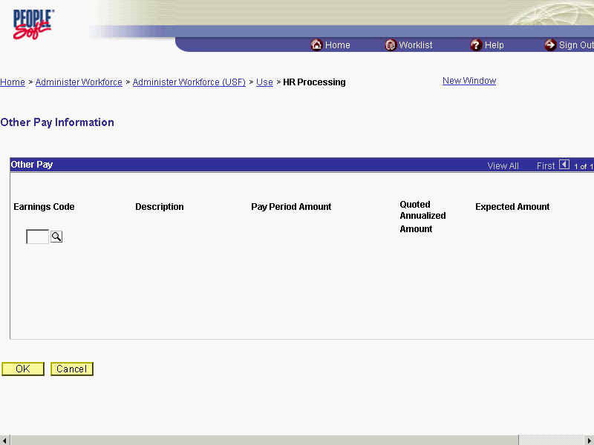

Step | Action
Enter the applicable PCA Earnings Code.
NOTE: All PCA codes begin with the letter Z.
Enter the desired information into the Earnings Code field. Enter "Z4B".
 | Press [Tab].
 | Click in the Pay Period Amount field.
Enter the pay period amount of the PCA pay.
NOTE: When processing a PCA, select one PCA earnings code and enter the PA amount on that one earnings code.
Enter the desired information into the Pay Period Amount field. Enter "820.00".
 | Click the OK button.
If necessary, change the PAR Status according to your role.
Scroll as necessary to view the rest of the page.
Click the horizontal scrollbar.

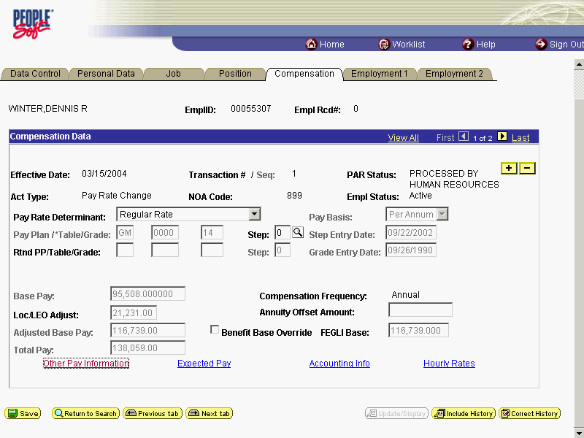

Step | Action
 | Click the Save button.
The PCA is processed.
End of Procedure.

Manual Procedure for Stopping PCA
Introduction
EHRP has an automated termination process for PCA based on Service Agreement End date. However, if the user needs to process a PCA stop prior to the Service Agreement End date, they should follow this process. Then you must process a PAR using NOA code " 959 ", NOA ext " 0 ".

Procedure

The following procedures must be completed when manually stopping PCA.

Step | Action
 | Click the Administer Workforce link.
 | Click the Administer Workforce (USF) link.
 | Click the Use link.
 | Click the HR Processing link.

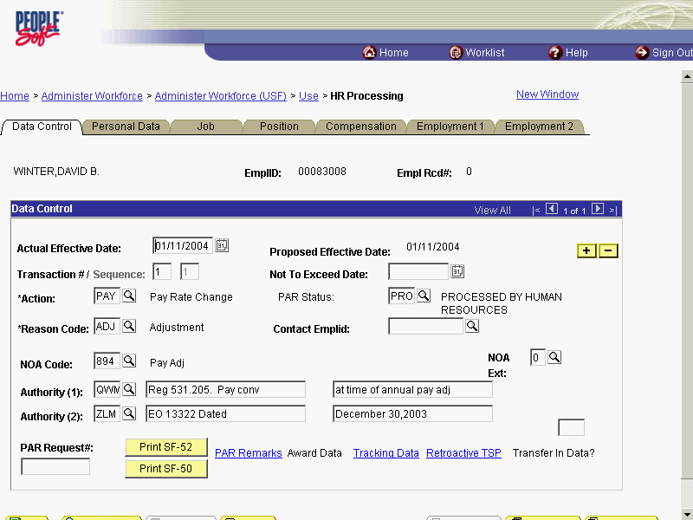

Step | Action
The employee's Data Control page appears.
NOTE: The Data Control page will be populated with the most recent personnel action performed for the selected employee.
Click the Add a new row at row 1 button.
If necessary, enter the effective date of the PCA action in the Actual Effective Date field and then select the *Action field..
Click in the *Action field.

The Look Up icon represents a look-up prompt. Clicking this button will allow you to look up all possible entry options for this field.

Step | Action
Enter DTA in the *Action field.
Enter the desired information into the *Action field. Enter "DTA".
 | Click in the *Reason Code field.
Enter DTA in the *Reason Code field.
Enter the desired information into the *Reason Code field. Enter "DTA".
 | Click in the NOA Code field.
 | Enter the desired information into the NOA Code field. Enter "959".
 | Click in the NOA Ext field.
 | Enter the desired information into the NOA Ext field. Enter "0".
 | No legal authority is required in the Authority (1) field.

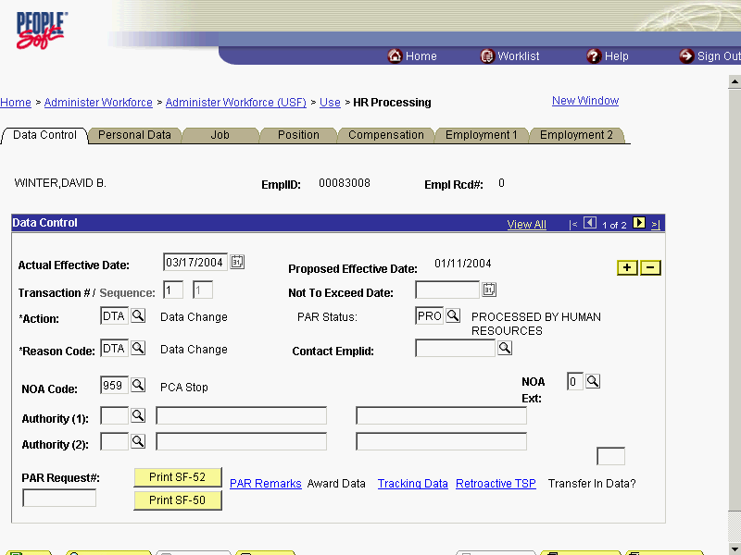

Step | Action
 | Click the Compensation tab.

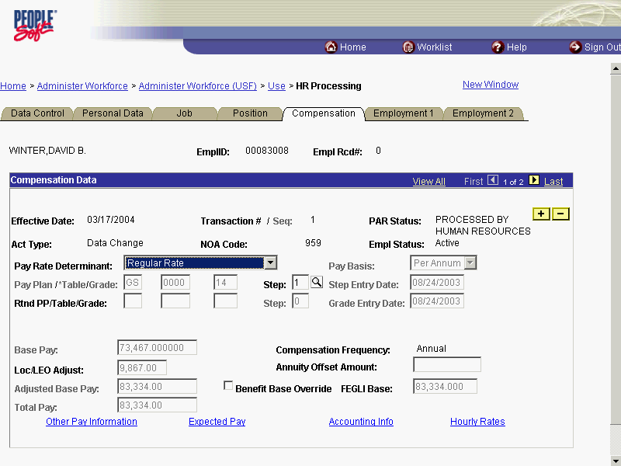

Step | Action
 | Click the Other Pay Information link.
 | Delete the applicable PCA Earnings Code, if necessary.

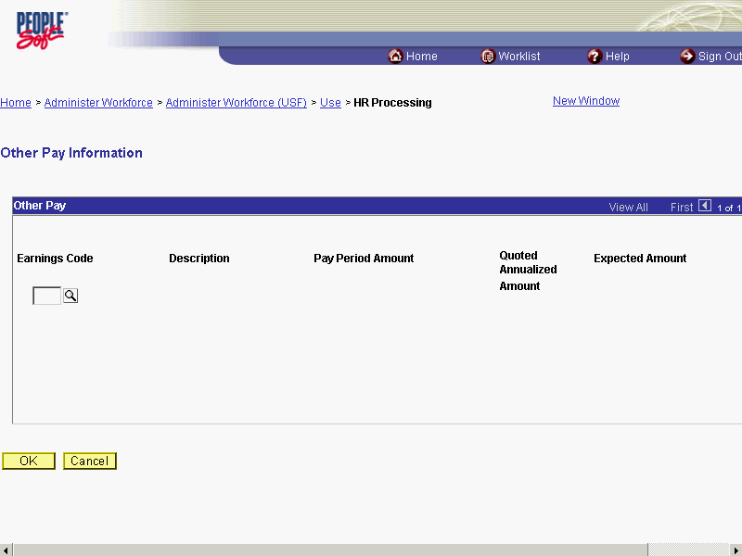

Step | Action
Upon completion of deleting the PCA Earnings Code, click the OK button.
Click the OK button.
If necessary, change the PAR Status according to your role.
Scroll as necessary to view the rest of the page.
Click the horizontal scrollbar.

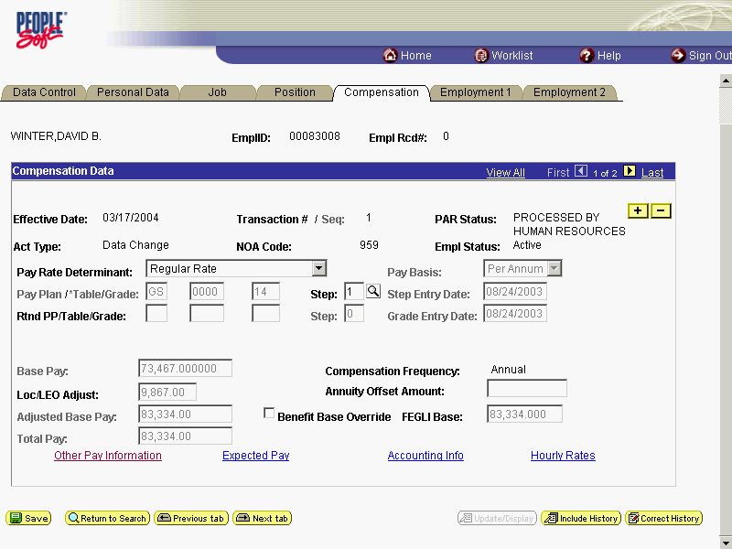

Step | Action
 | Click the Save button.
The procedure is complete.
End of Procedure.

Commissioned Corps

Allowing a Comm Corps Officer to Participate in Workflow
If a Commissioned Corps Officer needs to participate in Workflow to request or review actions for their civilian staff, you must first create a "dummy" job code, a "dummy" position, and hire the Commissioned Corps Officer as a non-compensated employee. Then the Security Administrator needs to create a user profile in the EHRP system.

Procedure

The following steps detail the procedure for creating a "dummy" job code, creating a "dummy" position, and hiring the Commissioned Corps Officer as a Non-Compensated Employee.

Step | Action
 | Click the Develop Workforce link.
 | Click the Manage Positions (USF) link.
 | Click the Setup link.
 | Click the Job Code Table link.

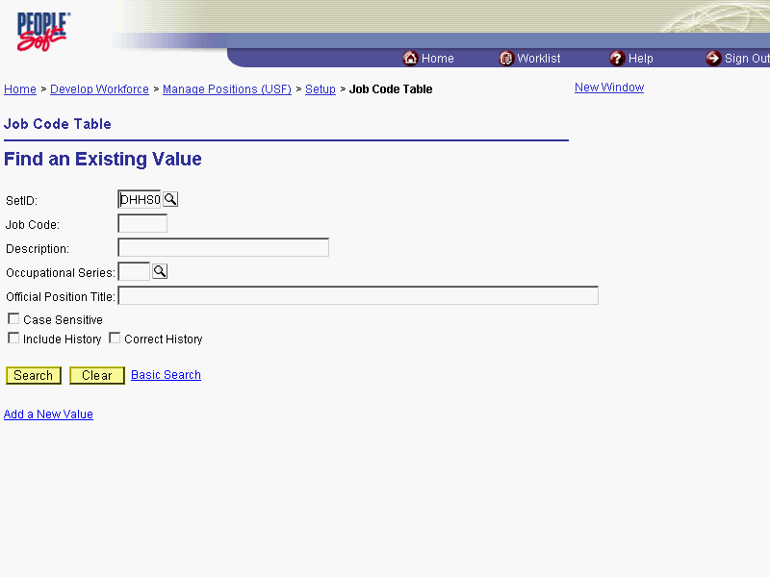

Step | Action
 | Click the Add a New Value link.

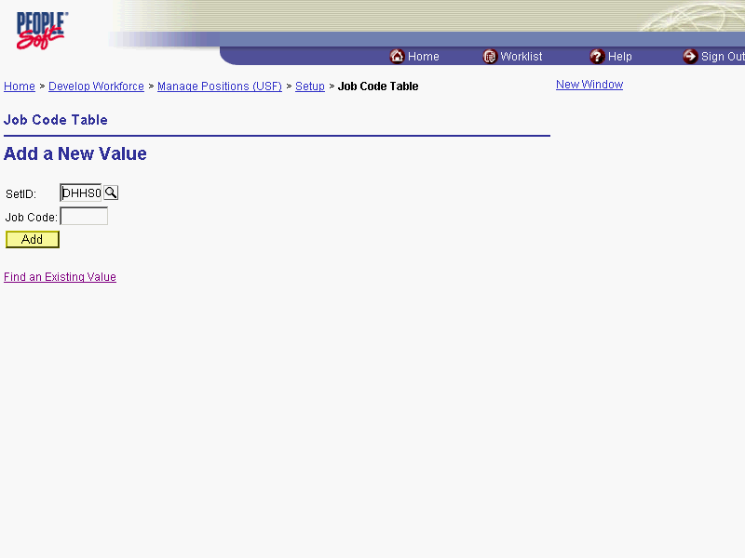

Step | Action
Change or confirm the SETID.
NOTE: The Job Code should be created within the SetID that corresponds with the Agency for which the Job Code is being created. This should default to your agency's SetID.
Click in the Job Code field.
NOTE: The job code number is the smart-coded Position Description number.
NOTE: The job code number should be entered in all caps.
Enter the desired information into the Job Code field. Enter "002880".
 | Click the Add button.

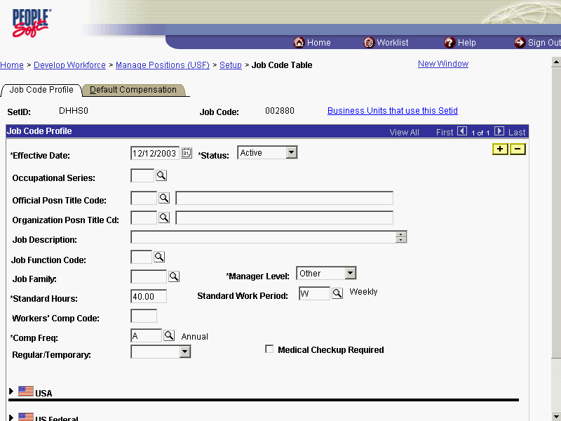

Step | Action
In the Effective Date field, enter the date this action was authorized if it differs from the default date, which is today's date.
Click the Choose a date button.

The Calendar icon represents a date prompt. Clicking this button will produce a pop-up calendar for reference. To select a specific date from the pop-up calendar as the field entry, simply click on the date. Use the arrows to move through the months and years.

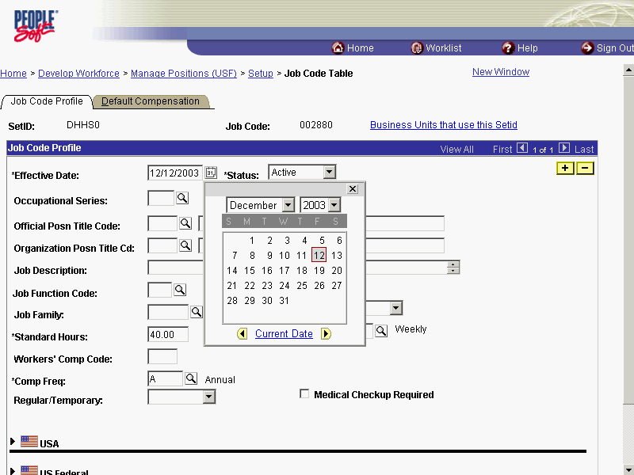

Step | Action
Select the desired entry.
Click 8.

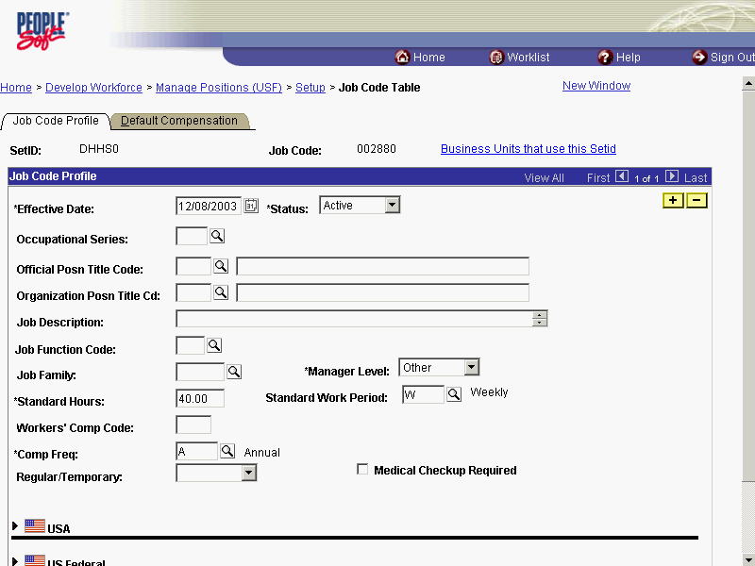

Step | Action
 | Click in the Occupational Series field.

The Look Up icon represents a look-up prompt. Clicking this button will allow you to look up all possible entry options for this field.

Step | Action
 | Enter the desired information into the Occupational Series field. Enter "0342".

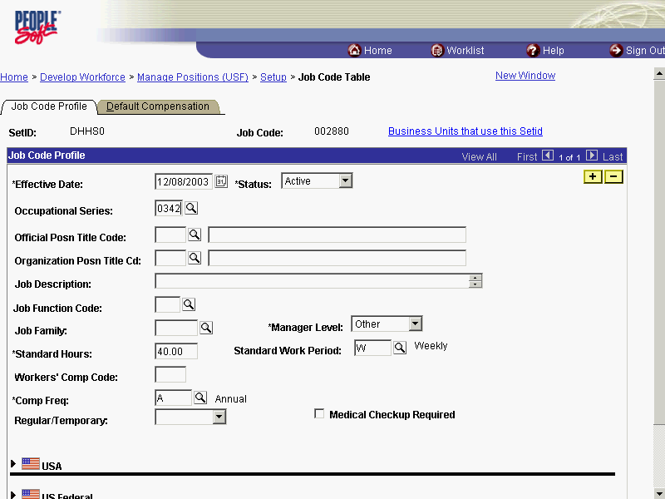

Step | Action
 | Click the Default Compensation tab.

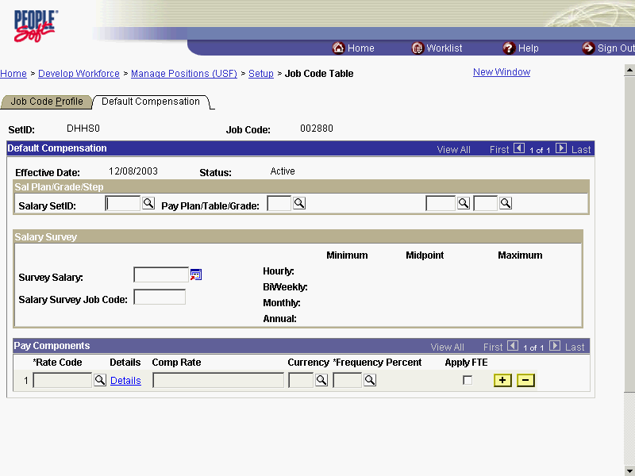

Step | Action
 | Click in the Pay Plan field.
 | Enter the desired information into the Pay Plan field. Enter "ZZ".
 | Scroll as necessary to view the Save button.

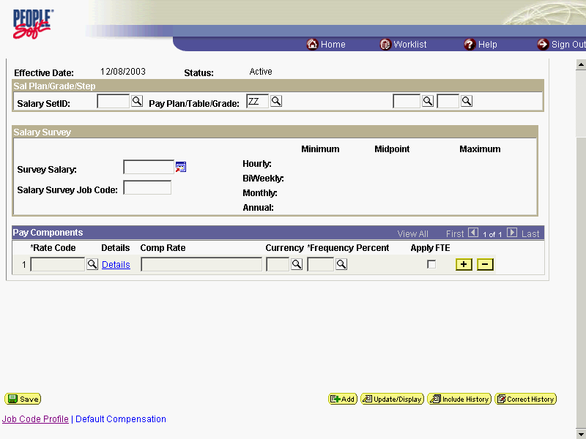

Step | Action
 | Click the Save button.
 | End of Procedure.

