Conversions
Created on April 4, 2005
Copyright & Trademarks
Copyright © 2003 by Global Knowledge. All rights reserved. Information in this document is subject to change without notice and does not represent a commitment on the part of Global Knowledge.

Global Knowledge
Knowledge Products Division
http://globalknowledge.com
475 Allendale Road, Suite 102
King of Prussia, PA 19406
+1 (610) 337-8878

Table of Contents
Introduction iv
Conversion to SES Career Appointment 1
Conversion to SES Career Appointment 1

Introduction
A conversion changes an employee to another appointment under either the same or a different authority, in the same agency without a break in service. For example, in EHRP, when an employee is to be converted from a GS (General Excepted Appointed Service) to an SES (Senior Executive Service) position, the user must enter the applicable personnel action (NOA 542-0). The data in the HR Processing page group must also be updated to reflect the change in the employee's position.

Conversion to SES Career Appointment
A conversion changes an employee to another appointment under either the same or a different authority, in the same agency without a break in service. For example, in EHRP, when an employee is to be converted from a GS (General Excepted Appointed Service) to an SES (Senior Executive Service) position, the user must enter the applicable personnel action (NOA 542-0). The data in the HR Processing page group must also be updated to reflect the change in the employee's position.

Conversion to SES Career Appointment
Introduction
In EHRP, when an employee is to be converted from a GS (General Excepted Appointed Service) to an SES (Senior Executive Service) position, the user must enter the applicable personnel action (NOA 542-0). The data in the HR Processing page group must also be updated to reflect the change in the employee's position.

Procedure

The following steps detail the procedure for converting an employee to a SES appointment.

Step | Action
Before beginning to process a Conversion, be sure to make note of the position number to which the employee will be assigned.
NOTE: Be sure all special pays are stopped on the prior appointment before proceeding.

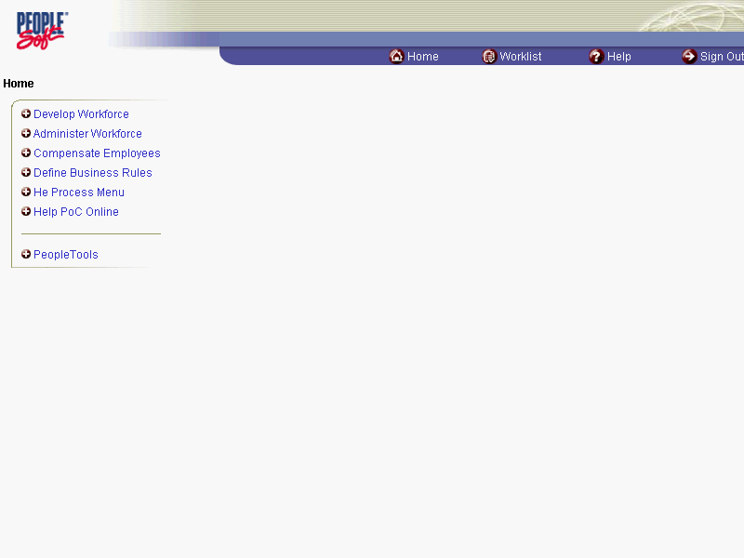

Step | Action
 | Click the Administer Workforce link.
 | Click the Administer Workforce (USF) link.
 | Click the Use link.
 | Click the HR Processing link.

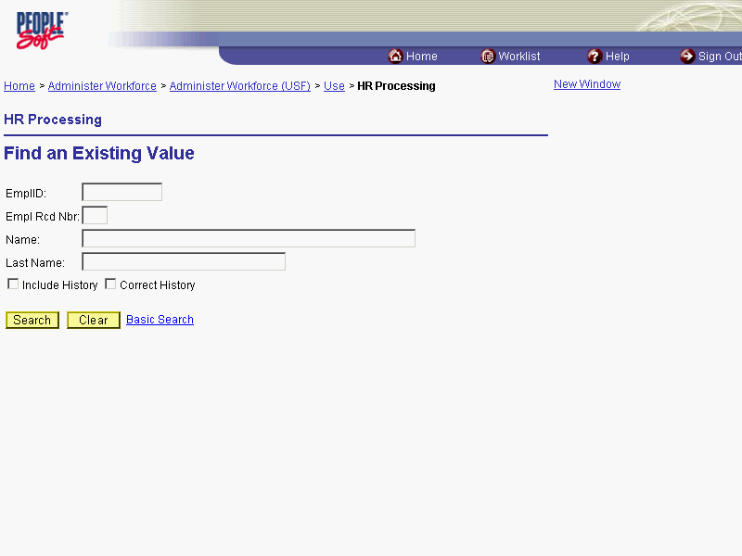

Step | Action
Enter the appropriate variable in the field. (i.e. Last Name)
Click in the Last Name field.
 | Enter the desired information into the Last Name field. Enter "WINTER".
 | Click the Search button.
Select the appropriate employee.
Click WINTER, BETTY

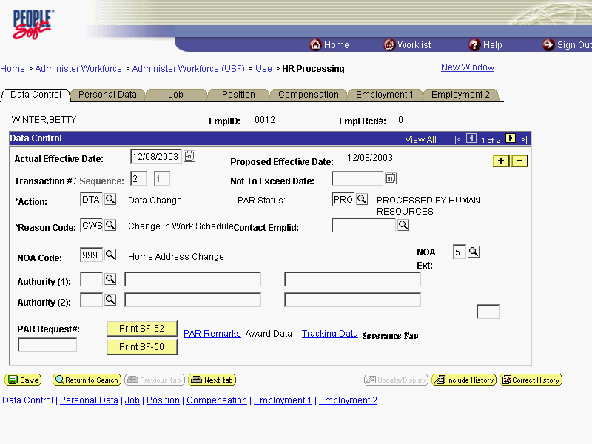

Step | Action
NOTE: The Data Control page will be populated with the most recent personnel action performed for the selected employee.
Click the Add a new row at row 1 button.
 | Triple-click the Actual Effective Date object.
Enter the effective date of the conversion in the Actual Effective Date field.
Enter the desired information into the Actual Effective Date field. Enter "12/15/2003".
 | Click in the *Action field.
In the Action field, enter "PRO" (Promotion).
Enter the desired information into the *Action field. Enter "PRO".
 | Click in the *Reason Code field.
 | Enter the desired information into the *Reason Code field. Enter "PRO".
 | Click in the NOA Code field.
Enter the NOA Code of "542" (Conversion to Senior Exec Service Career).
Enter the desired information into the NOA Code field. Enter "542".
 | Click in the NOA Ext field.
 | Enter the desired information into the NOA Ext field. Enter "0".
 | Click in the Authority (1) field.
 | Enter the desired information into the Authority (1) field. Enter "NRM".
If applicable, enter the Authority (2).
Click in the PAR Request# field.
 | Enter the desired information into the PAR Request# field. Enter "0000052608".
 | Click the PAR Remarks link.

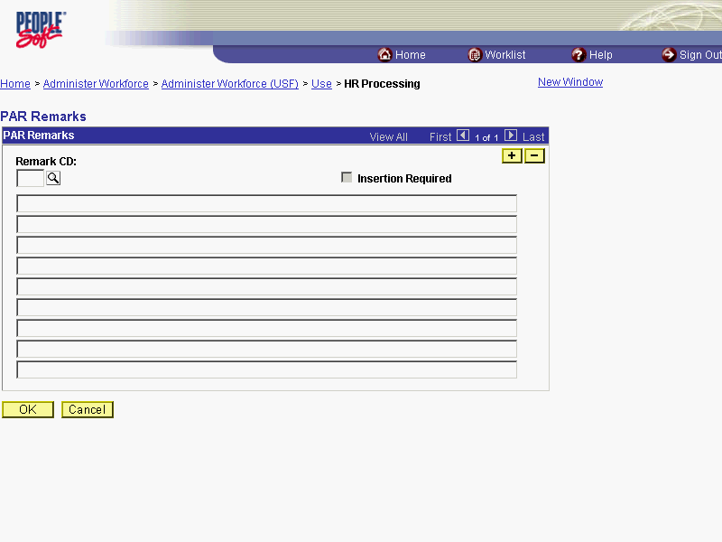

Step | Action
Enter the applicable Remark CD (Code) and tab out of the field to see the text of the remark.
Enter the desired information into the Remark CD field. Enter "A15".

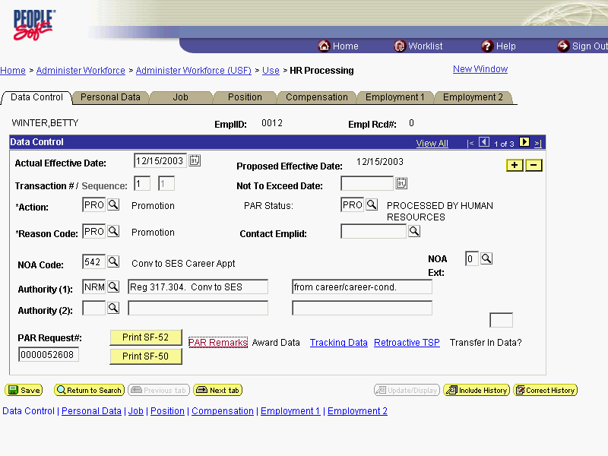

Step | Action
 | Click the Job tab.

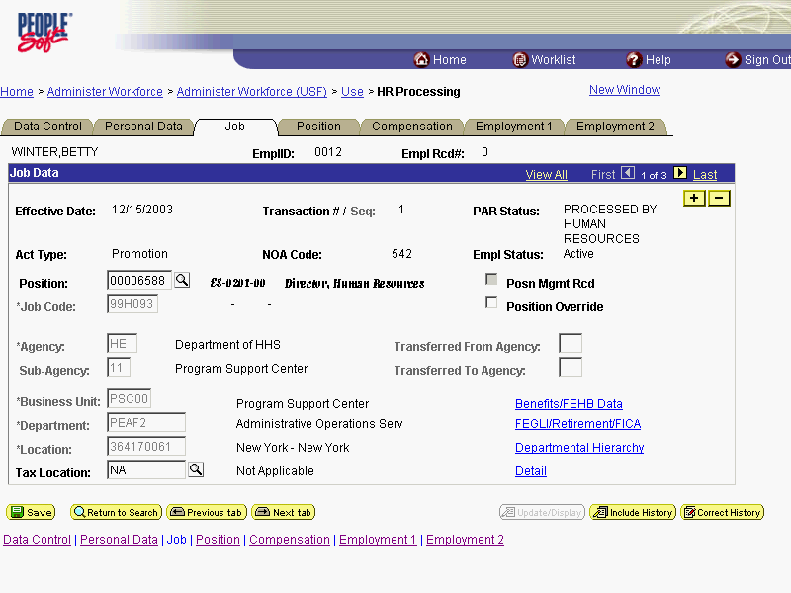

Step | Action
 | Double-click in the Position field.

NOTE: The following fields on this page will populate based upon the Position that has been entered:

- Job Code (formerly the "PD#")
- Agency
- Sub-Agency
- Business Unit
- Department (formerly the "Admin Code")
- Location (formerly the "GeoLoc Code")
- Tax Location

Step | Action
In the Position field, enter the SES position number to which the employee is being converted.
Enter the desired information into the Position field. Enter "00000086".

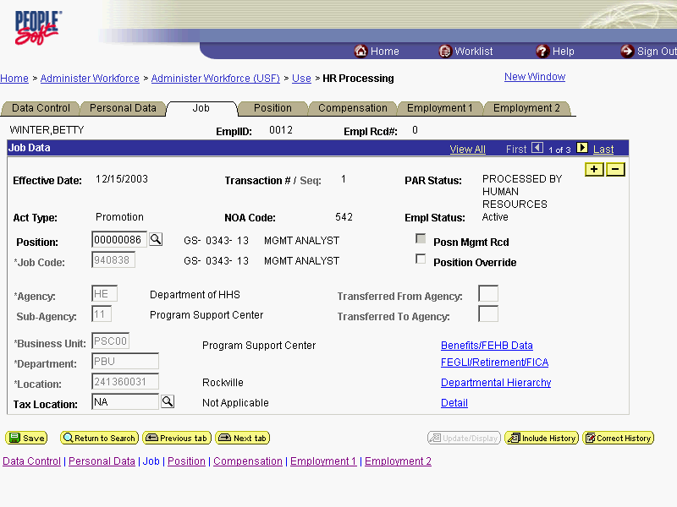

Step | Action
 | Click the Position tab.
 | If applicable, click the SF-113G Ceiling checkbox.

NOTE: The following fields will populate based on the position selected:
- LEO Position
- Regular Shift
- POI
- Pay Group
- Work Period
- Holiday Schedule
- Reg/Temp
- Posn Occupied
- Work Schedule
- FLSA Status
- Supervisor Level
- Medical Officer
- Standard Hours (Also known as Base Hours. Be sure this value is per week)

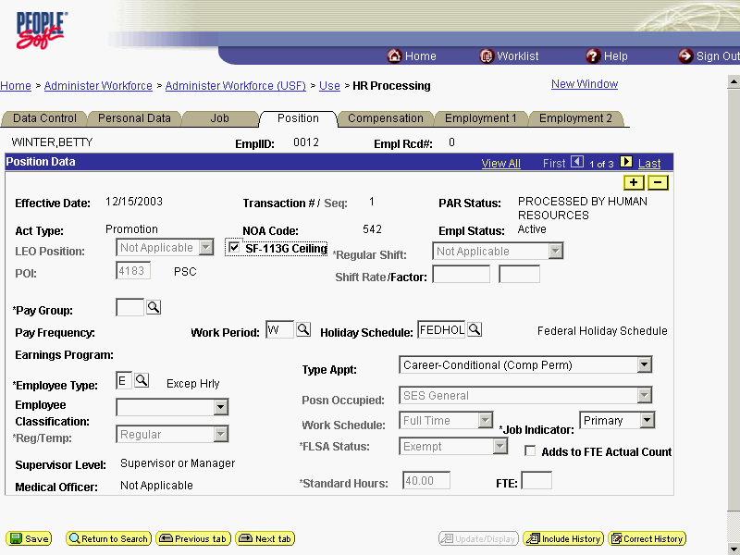

Step | Action
 | Click the Employee Classification list.
Select the Employee Classification from the dropdown menu.
NOTE: This field is only used for Indian Preferance.
Click the blank field
 | Click the Type Appt list.
Select the Type Appt from the dropdown menu.
Click Executive (Except NonPerm)
 | Click the *Job Indicator list.
Select the Job Indicator from the dropdown menu.
NOTE: The default is Primary.
Click Primary

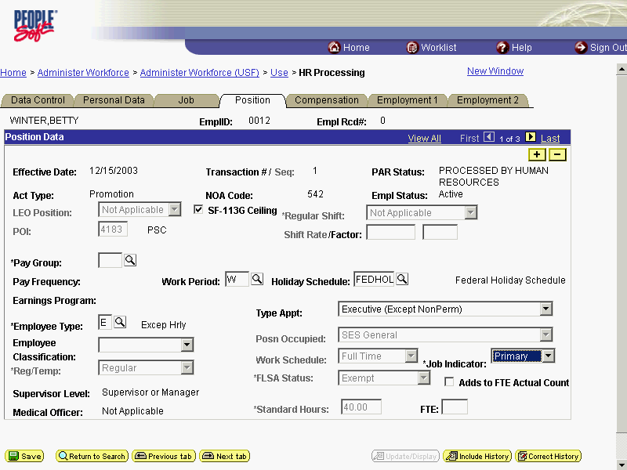

Step | Action
 | Click the Compensation tab.

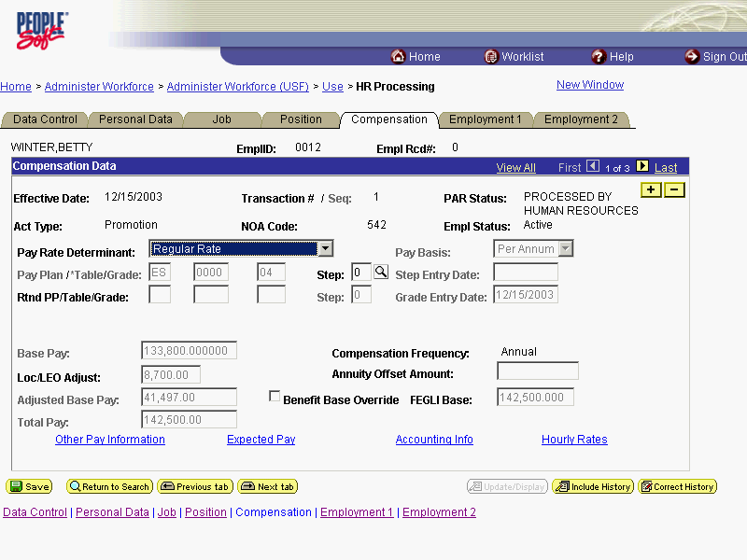

Step | Action
 | Click the Pay Rate Determinant list.

NOTE: The following fields default based upon the position selected:

- Pay Basis
- Pay Plan
- Table
- Grade

Step | Action
Select the Pay Rate Determinant from the dropdown menu.
Click Regular Rate
 | Double-click in the Step field.
NOTE: For those employees that do not have a step,"0" should be entered in the Step field.
Enter the desired information into the Step field. Enter "0".

NOTE: The page can not be saved until the Step is entered. After the Step is entered, the following fields will populate:

- Step Entry Date
- Base Pay
- Loc/LEO Adjust
- Total Pay
- FEGLI Base

Step | Action
 | If the employee is an annuitant, enter the Annuity Offset Amount as a per hour value.

The annuity offset amount must be entered as a PER HOUR value not an annual amount. This value must entered correctly in order to avoid significant payroll issues.

Step | Action
 | Use the Add a new row button to enter additional earnings codes.
 | Click the Expected Pay link.
View the read-only information.
NOTE: DO NOT use the data on this page for pay verifications.
Scroll as necessary to view the rest of the page.
Click the horizontal scrollbar.

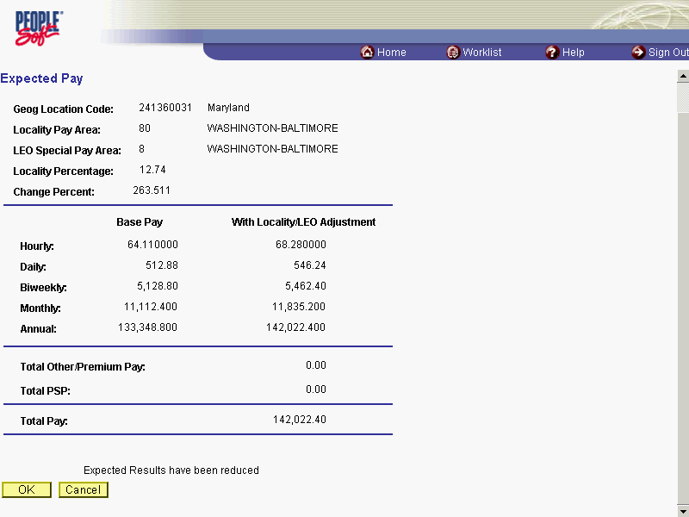

Step | Action
 | Click the Ok button.

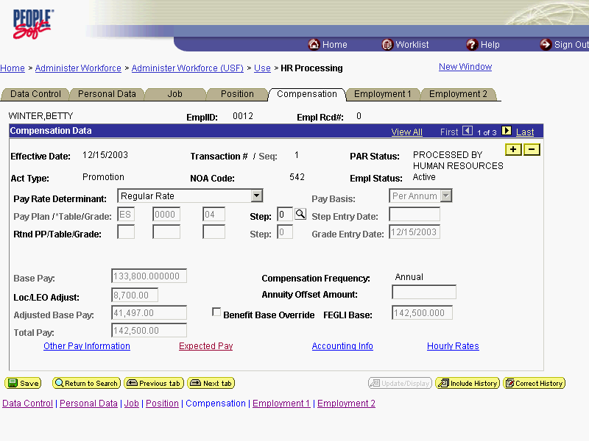

Step | Action
 | Click the Accounting Info link.

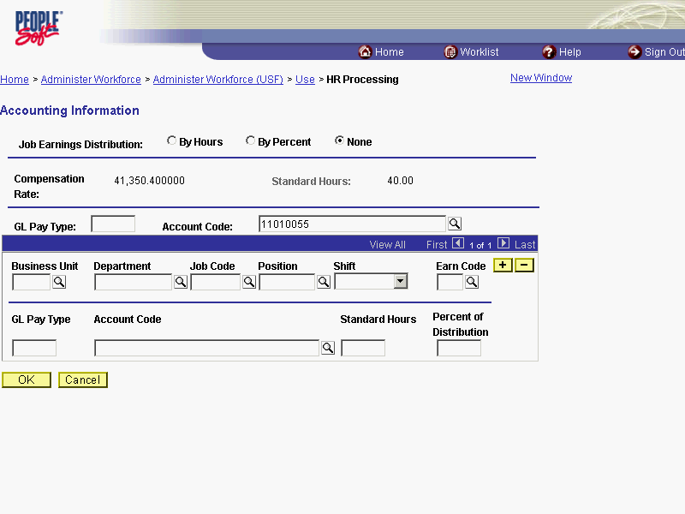

Step | Action
 | Double-click in the Account Code field.
Enter the CAN in the Account Code field.
The Common Account Number (CAN) is a required field and must be entered to process the appointment.
Enter the desired information into the Account Code field. Enter "1921T101".
 | Click the Ok button.

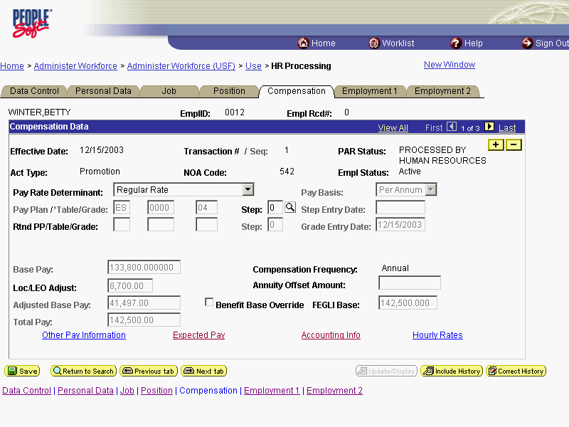

Step | Action
 | Click the Employment 1 tab.

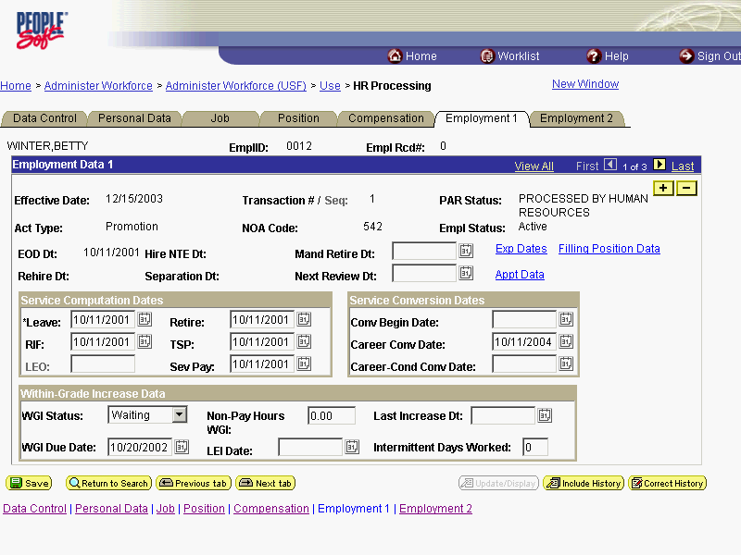

Step | Action
 | Click the Filling Position Data link.

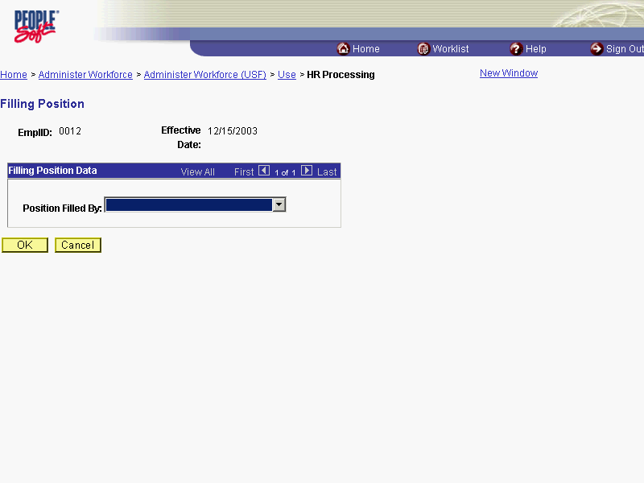

Step | Action
 | Click the Position Filled By list.
From the dropdown menu, select the correct method by which the position has been filled.
Click Career Ladder Promotion
 | Click the Ok button.

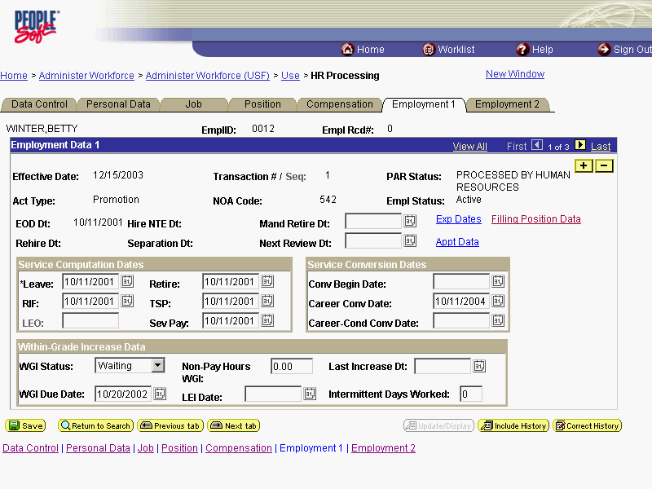

Step | Action
 | Click the Appt Data link.
If applicable, from the dropdown menu, select the Special Employment Program.
NOTE: This is where the Special Program ID would be entered.
NOTE: Welfare to Work should not be captured here.

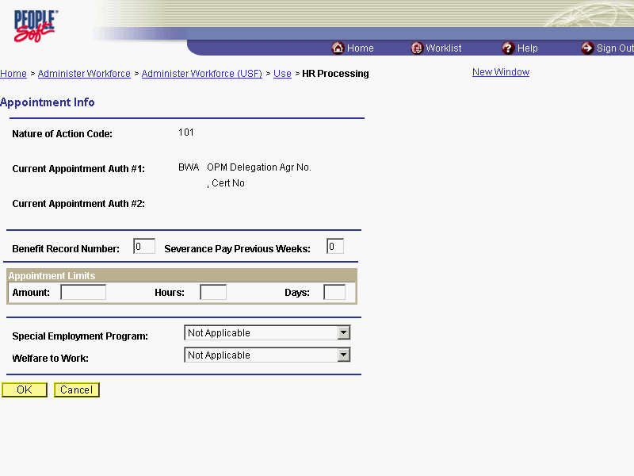

Step | Action
 | Click the Ok button.
 | If applicable modify the Service Computation Dates.

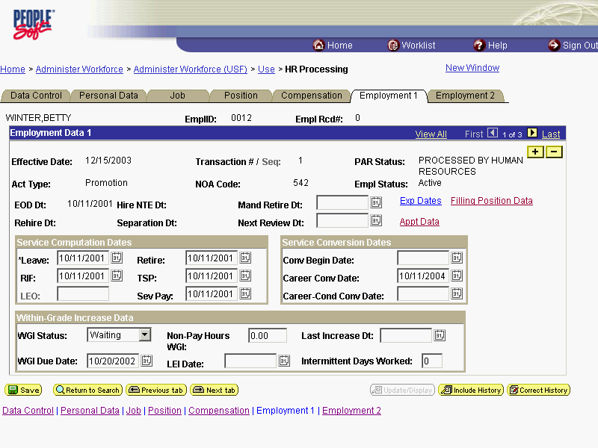

Step | Action
Modify the Within Grade Increase Data, if applicable, to N/A.
NOTE: SES employees do not receive WGIs. They receive salary adjustments.
Click the WGI Status list.
 | Click N/A
Modify the LEI date, if applicable.
NOTE: The LEI Date is the date of the last equivalent increase for this employee

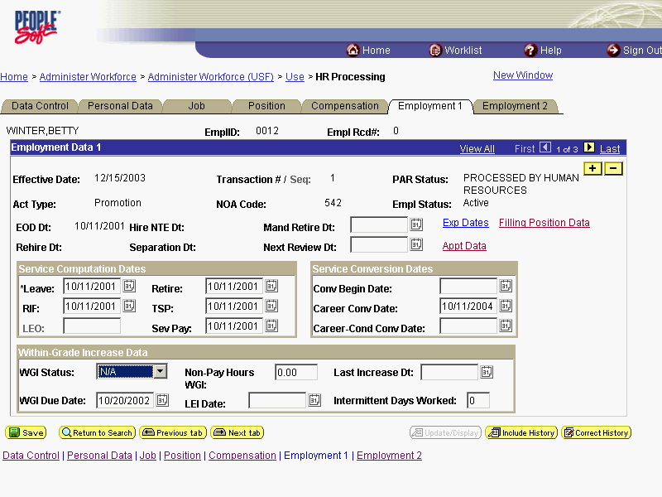

Step | Action
 | Click the Employment 2 tab.
 | Enter the employee's Union Code, if applicable.

NOTE: The following fields default based on the position selected:

- Bargaining Unit
- Reports To Position

Step | Action
Confirm or enter the appropriate Reports To Position for the employee.
NOTE: The Reports To Position field is required for automatic actions.

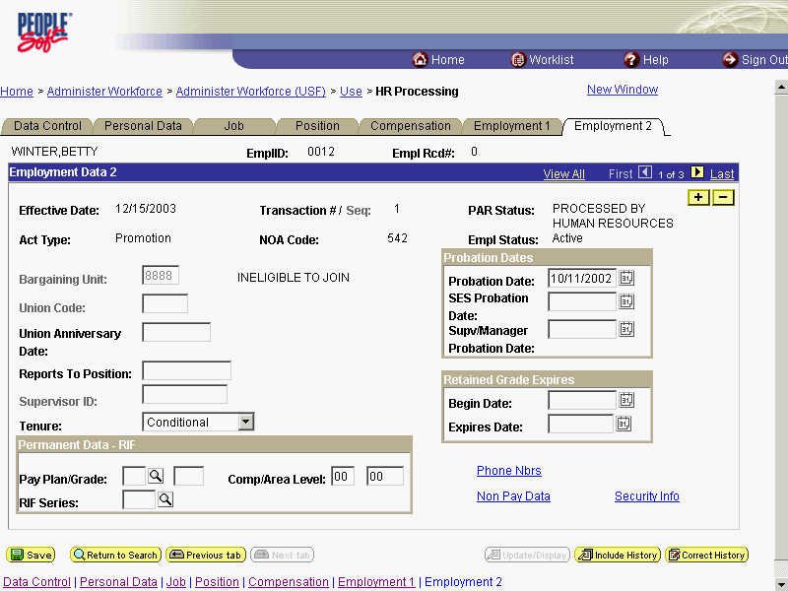

Step | Action
 | Click the Tenure list.
In the Tenure field, select None.
Click None
As applicable, enter the employee's compensation level in the CompLevel field.
Double-click in the Comp/Area Level field.
 | Enter the desired information into the Comp/Area Level field. Enter "408".

NOTE: In EHRP, the Comp Level is a 3 digit code. Therefore, when a user enters a 3 character Comp Level Code, the Payroll Interface will automatically add a "0" to the beginning of the Comp Level Code when transmitting that data to Payroll

NOTE: Users should no longer enter any data related to the Comp Area field. The entire Comp Level code should be entered into the Comp Level field only.

Step | Action
 | Enter the completion date for the employee's probation in the SES Probation field.
 | As applicable, enter the employee security information in the Security Info hyperlink.

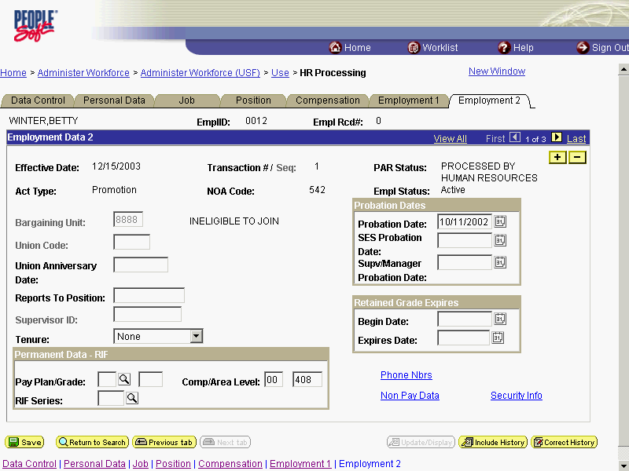

Step | Action
Change the PAR Status according to your role and then click Save.
Click the Save button.
The conversion is complete.
End of Procedure.

