Partnership Plus
New Service Delivery Model under Ticket to Work Program
Background
Under Social Security’s Ticket to Work program, a person with a Ticket may choose between being served by a provider approved by SSA to function as an Employment Network (EN) or being served by the State Vocational Rehabilitation (VR) agency. In addition, an EN can choose whether or not to serve a particular Social Security beneficiary with a disability. Since Social Security beneficiaries with disabilities are presumptively eligible for services, VR agencies cannot chose whether or not to serve a particular beneficiary. However, the Ticket to Work and Work Incentives Improvement Act of 1999 permits VR, on a case-by-case basis, to choose between seeking compensation under the traditional Cost Reimbursement system or one of the two EN payment options under the Ticket to Work program (i.e., Outcome or Outcome-Milestones).
In most states, VR has chosen the Cost Reimbursement system for almost all beneficiaries served. The Cost Reimbursement system reimburses State VR agencies for money that is spent rehabilitating beneficiaries. There are 3 types of expenses for which SSA reimburses VR agencies: direct costs, administrative costs, and tracking costs. A VR agency may submit for Cost Reimbursement when a beneficiary has completed a continuous period of Substantial Gainful Activity (SGA) for 9 out of 12 months. These claims must be filed in a timely manner.
Ticket Assignment No Longer a Prerequisite for Cost Reimbursement
Under the prior regulations, VR had to have Ticket assignment in order to submit for Cost Reimbursement for any beneficiary. Under the new Ticket regulations, VR is no longer required to have Ticket assignment to submit a case for Cost Reimbursement. The new regulations create a new status, “in-use SVRA,” for those situations where VR is serving a beneficiary under the traditional Cost Reimbursement program. This new status affords these beneficiaries the same protections against Medical Continuing Disability Reviews (CDRs) as associated with Ticket assignment. When a Ticket is in this status, it is not otherwise available for assignment to another EN. In a policy memo issued May 1, 2008, SSA implemented this change effective April 21st, 2008.
Partnership Plus: A New Approach to Service Delivery
The new Ticket regulations create an exciting opportunity for new EN-VR partnerships under which SSA will pay a State VR agency and an EN for assisting the same beneficiary, although the services must be provided sequentially not concurrently. Under this new “Partnership Plus” option, a Ticket Holder may receive VR services to meet his/her intensive up front service needs and, after the VR case is closed, assign his/her Ticket to an EN to receive ongoing support services. As in the past, the VR agency may submit for Cost Reimbursement when the beneficiary reaches 9 months of net SGA (i.e., SGA gross earnings, minus any Impairment Related Work Expenses or subsidy) within a 12 month period. The EN would provide job retention and/or ongoing support services and subsequently be eligible for any earned Phase II Milestones and Outcome payments. Phase II Milestones are triggered when a beneficiary’s gross earnings are above the SGA level and Outcome payments are triggered when the beneficiary’s net earnings are above SGA and the beneficiary is in zero cash payment status. Access to this new funding to support job retention or ongoing support services will likely result in increasing numbers of beneficiaries achieving 9 months of net SGA earnings, allowing VR agencies to submit more cases for Cost Reimbursement. This change can be an excellent source of assistance for Ticket Holders as VR is not designed to provide long-term support or follow-along services as envisioned for ENs under the new Ticket regulations. SSA’s willingness to commit more money to compensate providers (both VR and ENs) for assisting beneficiaries to achieve their employment goals is very exciting.
In some states, ENs and VR agencies are designing interagency agreements to facilitate equitable revenue sharing and a coordinated system of services for beneficiaries. Such agreements are an important component of a service delivery system that expands the scope of services available to beneficiaries and facilitates the coordination of services across agencies. To promote the development of viable interagency agreements, CESSI, SSA’s Program Manager for Recruitment and Outreach, is working with a few states to develop models of collaborative relationships to demonstrate how the Partnership Plus option can assist beneficiaries in securing and maintaining employment.
Partnership Plus is specific to EN-VR partnerships. If two ENs serve the same beneficiary due to change in Ticket assignment, an agreement may be developed to determine how EN payments will be shared or MAXIMUS, SSA’s Operations Support Manager for the Ticket to Work program, can assist the ENs in determining how to split the EN payments based on the work done by each EN.

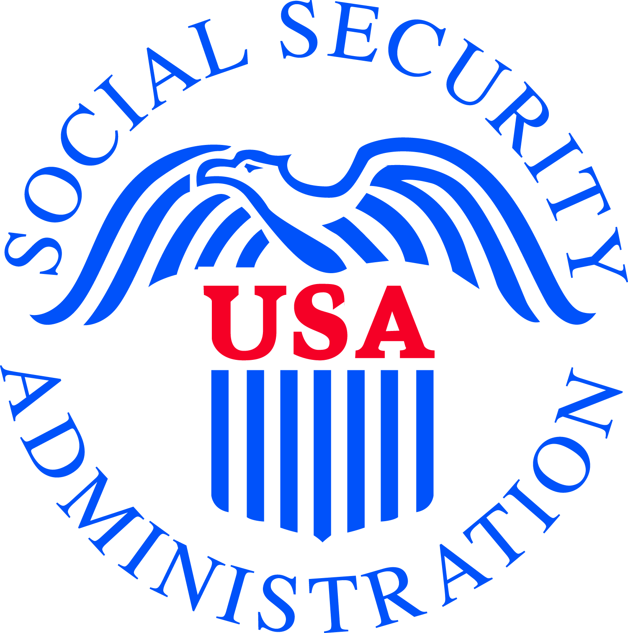

Social Security Administration

Office of Employment Support Programs
SSA Pub. No. 63-034
May 2008

