Donation Success Story - Wyoming
Visit About Surplus Donations for more information regarding personal property donations.
A Horse Tale
Have you ever wondered if donees receive "living" donations? What does that mean? While perusing available surplus property on the web, the Wyoming State Agency for Surplus Property (SASP) found a number of "horses" listed as available through the donations program and contacted GSA. The Wyoming SASP had several donees who use horses in their programs. The donees were contacted and offered a "savings" of $1,300 cost avoidance per horse, which is the average price for a horse in Wyoming.
The Wyoming State Training School (WSTS) was excited to hear that the horses were available. WSTS has a horse therapy program for their clients who are profoundly challenged both mentally and physically. Through the use of these horses, WSTS is able to provide greatly needed services. WSTS' staff traveled to Colorado Springs (1,000 miles round trip) to pick up the horses and were greeted by a very happy staff who gladly released "Charlie, Stormy, and Sky" to the school. GSA is pleased that the horses are providing many hours of happiness and pleasure to the residents and staff of WSTS.
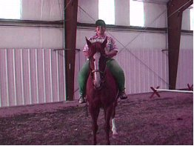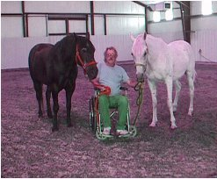
Charlie, Stormy, and Sky are horses the Wyoming State Training School received from the GSA donations program.

