Donation Success Stories - Kentucky

The Users and Screeners Association (USA) is an independent consortium of federal agencies, cost reimbursement contractors, project grantees, and federal cooperators from land grant universities and others who acknowledge the prime directive to use federal Excess Personal Property as the first source of supply.
The purpose of this organization is to share expertise, to alert members to program changes, to promote the benefits of using federal excess personal property, to develop professionalism among federal screeners, and to provide a unified voice to federal concerns. The following personal property success stories represent the Federal Excess Personal Property Program.
Federal Excess Personal Property for the Agriculture Experiment Stations
Research facilities at the West Kentucky Substation, Princeton, Kentucky, have been reconditioned using vinyl siding received from the Defense Reutilization Marketing Office, Fort Campbell, Kentucky.
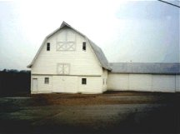

This Chevrolet Blazer is in use by the Fleet Management Division at the Agriculture Experiment Station (AES) in Lexington, Kentucky. The prospective users screened the property and discovered it was only five miles away at the Department of the Interior. What a real disappointment it would have been had AES missed out on this nice vehicle if it weren't for locating it via electronic screening.
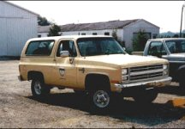

This 1985 Thomas 44-passenger bus was acquired for bussing research and extension personnel throughout the state of Kentucky. This bus and its identical mate both reside at the Lexington Agriculture Experiment Station and required only minimal maintenance prior to putting into use.
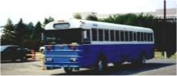

This bulldozer was used heavily in construction of a new Agriculture Experiment Station on 1500 acres of farmland under development in Woodford County. This is one piece of heavy equipment, from several obtained from the Federal Excess Personal Property (FEPP) Program, used to build many miles of road and used in preparation of all the building sites for construction. This piece -- and the remainder of the FEPP equipment "team" - have thus far saved $1.2 million in the development of this new research facility.
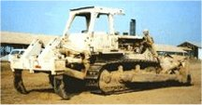

This Caterpillar, Model D7, dozer was modified for research on land reclamation. Biosystems and Agricultural Engineering teams designed and constructed modifications on the dozer to perform needed research. The addition of an auger, larger blade, hydraulic system and paint job all added to facilitate reclaiming operations. A CAT engine, also federal excess property, is mounted on the rear of the unit acting as a power source for the hydraulic system.
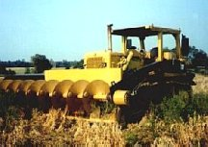

This is one of a pair of nice Dodge utility trucks obtained from the Department of Energy in Arkansas. They both serve the farm mechanics and fleet management services. This one has been outfitted with a two-way radio and a built-in "jump start" cable system. Trucks equipped with the utility/tool boxes on the back of the truck are invaluable to these crews.
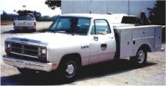

This red Ford dump truck was acquired from the Internal Revenue Service on Long Island. After repair of rust damage and a new paint job, this vehicle, with only 8,000 miles, is an asset to the University of Kentucky's College of Agriculture in Lexington, Kentucky. It is used for snow removal and general maintenance needs at the school's facility.
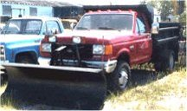

This is a 1977 Ford cabover road tractor converted into a "hi-tech" fertilizer truck. This vehicle was modified from the ground up by Biosystems and Agricultural Engineering for use in fertilizer distribution and research. All design, fabrication, and modification were performed "in-house." This redesign included construction and mounting of fertilizer bed, purchase and mounting of new tires, painting the truck, and installation of GPS system in the cab. All distribution operations are electronically controlled from the driver's seat.
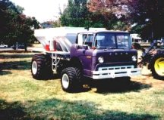

The Ford loader pictured was obtained from the Department of the Interior's, Fish and Wildlife Service, in Florida, and utilized for various jobs at the Agriculture Experiment Station in Lexington, KY. Loaders such as this are very useful for moving silage, brush, manure, feed, gravel, dirt, etc., on the many acres located at this site.
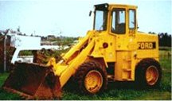

When this truck was obtained, it was just a cab and chassis. Engineers worked with the Agriculture Experiment Station's (AES) research and support staff to design and build the entire vehicle from the ground up. The truck now includes a tank, spray system, boom, GPS system, and serves as a spray rig for corn and cropland. Approximately, $18,000 was invested for an item that would cost $100,000 new. What a great investment and cost savings for this customer.
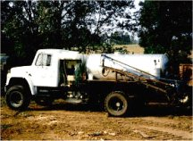

Systems furniture was acquired from the GSA Office of Personnel Management in Atlanta, Georgia, and re-configured for offices at the College of Agriculture, University of Kentucky. Approximately 30 workstations were transferred, picked up, transported, designed, and rebuilt into the research and extension areas at the college.
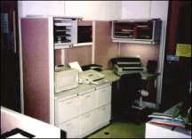
Federal Excess Personal Property (FEPP) for the National Science Foundation
The Research Aircraft, Flight Simulator, and the C-130 Hercules Aircraft were obtained by the National Science Foundation from the Federal Excess Personal Property Program. The last aircraft image is the Lockheed Electra acquired by the National Center for Atmospheric Research, in Boulder, Colorado.
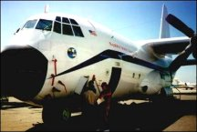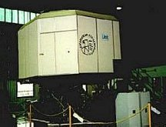

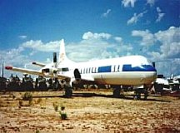

Federal Excess Personal Property (FEPP) for New Mexico State University

The surplus passenger bus is located at the New Mexico State University's Cooperative Extension Service and is used to meet the University's bussing needs.
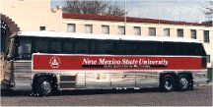
Federal Excess Personal Property (FEPP) for the U.S. Forest Service
The first truck is on loan to a local fire department through the Forest Service. This truck retains its Forest Service green interior. The second truck was available through the Federal Excess Property Program and is used for rural firefighting.
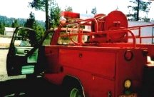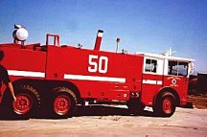

This "Gamma-Goat" pulls a trailer tank into otherwise inaccessible places in Hawaii. This equipment was modified by the Hawaii Division of Forestry. Note rollover protection installed.
