Sexual Assault Protocols

Warm Springs Health and Wellness Center

The purpose of these protocols is to provide for medical professionals in the care of the Sexual Assault Survivor. The goal is to ensure that compassionate and sensitive delivery of services and care, are provided in a non- judgmental manner. The following protocols are based on current Oregon and Local Tribal Law, American College of Emergency Physicians recommendations for the prophylactic treatment of sexually transmitted diseases, pregnancy prevention and the “Best Practice “in the Care of the Sexual assault survivor. These Protocols are divided into three sections: Standards, Recommendations and Resources. The physical, emotional and psychological well being of the sexual assault survivor is given precedence over all other matters.

STANDARDS

These are the protocols that represent the basic standards in the care of the sexual assault survivor.

- ADVOCACY
  - The survivor is informed that they have the right to speak to a sexual assault advocate. If the survivor decides to speak with an advocate , notification may be made by law enforcement or a medical professional

- LAW ENFORCEMNT NOTIFICATION

  - If the survivor is 17 years of younger, law enforcement must be notified
  - If the survivor is 18 years or older and is a dependent person or diminished mental capacity or 65 years of age or older, law enforcement must be notified

- CONSENT
  - Informed consent for all procedures, evidence collection and treatments is obtained in all cases
  - Survivor 14 years and older may sign their consents
  - Survivors 13 years and younger, a parent or guardian must sign consent

- EVIDENCE
  - Standard Forensic Evidence Collection Kit, provided by Oregon State Police Crime lab, is used for evidence collection.
  - Standard Documentation Forms, Provided with the kit , are used in the evidence collection process
  - The evidence collection exam is done by a nurse examiner or physician currently licensed in their state of practice. The preferred examiner would be a sexual assault forensic examiner

- RELEASE OF INFORMATION
  - Release of information /documentation is not done without first informing the survivor of the reasons for release and obtaining a signed consent

- COST OF EVIDENCE COLLECTION
  - Survivors will not be charged for the cost of the forensic evidence exam as long as they are reporting the assault to law enforcement or an exam has been requested by law enforcement.

- TREATMENT
  - Every survivor will be offered prophylactic treatment for gonorrhea, chlamydia, trichomonas and hepatitis B if available. Survivors should be informed in addition, they may be at risk for having contracted HPV and herpes and be offered information about these STDs. Survivors may be offered tetanus vaccine if indicated.
  - Every survivor will be offered prophylactic treatment for pregnancy prevention. If the survivor declines pregnancy prophylaxis, obtain refusal consent.

RECOMMENDATIONS

- EMERGENCY CONTRACEPTION IN THE NON-PREGNANT SURVIVOR
  - Pregnancy prophylaxis: all female survivors will be assessed for pregnancy. For survivors who have a negative pregnancy test and are at risk for conception from this assault, do the following:
    - Offer Emergency Contraception. Provide education to the survivor about Emergency Contraception so that she can make an informed choice
    - Obtain the survivors signed consent for emergency contraception
    - Dispense the pills to the survivor and encourage the first dose be taken as soon as possible
    - Listed below are the medications used for Emergency Contraception
      - Plan B
      - Preven
      - Orval (available in clinic pharmacy, 2 now 2 in 12 hours)
      - Ogestrel
      - Alesse
      - Aviane
      - Levlite
      - Nordette
      - Levlen
      - Levora
      - Lo/Ovral
      - Low-Ogestrol
      - Triphasil
      - Tri-levlen
      - Trivora
      - Orvette

Plan B is the preferred drug as it contains no estrogen and side effects are greatly reduced
The treatment of choice is one dose within 72 hours after unprotected intercourse and another dose 12 hours later. However, current research indicates that EC remains highly effective for 120 hours (5 days) after intercourse and survivors should be offered the choice of taking EC up to 120 hours.

  - Anti-emetic medications may be used when giving Emergency Contraception. Listed below are medications recommended for this use:

    - Metoclopramide 10 mg PO q 6 hours prn
    - Meclizine 25-50 mg PO q 6 hours
    - Diphenhydramine 25-50 mg PO q 6 hours
    - Promethizine 25 mg PO or PR q 6 hours prn
    - Dramamine 25-50 mg PO q 6 hours prn
Doses of anti emetics should be altered according to the patient’s weight, age and other current medications.

- INFECTIOUS DISEASE PROPHYLAXIS IN THE NON-PREGNANT SURVIVOR

Review allergies with the survivor and dispense accordingly. Do not use Ciprofloxacin in pregnancy.

  - Gonorrhea Prophylaxis:
    - Cefixime (Suprax) 400 mg PO x 1 dose
    - Cefpodoxime (Vantin) 200mg PO x 1 dose
    - Ciprofloxacin (Cipro) 500mg PO x 1 dose
    - Ceftriaxone 125mg IM x 1 dose
    - Spectinomycin 40 mg/kg IM x 1 dose (max 2 g)

  - Chlamydia Prophylaxis:
    - Azithromycin (Zithromax) 1 gram PO x 1 dose.
    - Doxycycline 100 mg PO BID x 7 days

Do not use doxcycline in pregnancy

  - Trichomonas Prophylaxis:
    - Metronidazole (Flagyl) 2 grams PO x 1 dose

  - Hepatitis B Prophylaxis:
    - If the survivor has never been immunized to Hepatitis B, you may initiate the first dose of the Hepatitis B vaccine in the Emergency Department.
    - If the survivor is unsure of their immunization status or has been partially immunized, draw Hepatitis B antibody titer. At the time of discharge provide the patient with instructions for appropriate follow up of titer results and completion of the vaccine series

  - Tetanus Prophylaxis:
    - If the patient has skin abrasions of other wound and the immunization status is unknown or grater than 10 years, for low risk wound and greater or 5 years for high risk wound, give the dT immunization
    - If the survivor has never been immunized, give Tetanus Immune Globulin (Hypertet) 250 units IM and dT immunization. Give each IM injection in a different extremity. Refer the patient for follow up to complete the immunization series

- INFECTIOUS DISEASE PROPHYLAXIS IN THE PREGNANT SURVIVOR

Review allergies with the survivor and dispense accordingly.

  - Gonorrhea Prophylaxis:
    - Cefixime (Suprax) 400 mg PO x 1 dose
    - Cefpodoxime (Vantin) 200mg PO x 1 dose
    - Ceftriaxone 125mg IM x 1 dose
    - Spectinomycin 40 mg/kg IM x 1 dose (max 2 g)

  - Chlamydia Prophylaxis:
    - Azithromycin (Zithromax) 1 gram PO x 1 dose.

  - Trichomonas Prophylaxis:
    - Metronidazole (Flagyl) 2 grams PO x 1 dose

  - Hepatitis B Prophylaxis:
    - If the survivor has never been immunized to Hepatitis B, you may initiate the first dose of the Hepatitis B vaccine in the Emergency Department.
    - If the survivor is unsure of their immunization status or has been partially immunized, draw Hepatitis B antibody titer. At the time of discharge provide the patient with instructions for appropriate follow up of titer results and completion of the vaccine series

  - Tetanus Prophylaxis:
    - If the patient has skin abrasions of other wound and the immunization status is unknown or grater than 10 years , for low risk wound and greater or 5 years for high risk wound, give the dT immunization
    - If the survivor has never been immunized, give Tetanus Immune Globulin (Hypertet) 250 units IM and dT immunization. Give each IM injection in a different extremity. Refer the patient for follow up to complete the immunization series

RESOURCES

- FOLLOW UP

  - Appropriate medical follow up will be given for evaluation of possible sexually transmitted diseases, pregnancy and any physical injuries the survivor may have sustained during the assault.

  - Follow up counseling information will be provided to the survivor by the sexual assault advocate or the forensic medical examiner.

  - Information on area resources concerning: medical follow up, crisis intervention phone numbers, rape crisis centers, shelters, Crime Victims Compensation Program, law enforcement and the district attorney’s office will be given to the survivor at the time of discharge.

FORM 1- PAGE 1 OF 2

INFORMATION PERTAINING

TO ASSAULT

Patient ID
Date of assault ______________ Approximate time of assault _______AM PM
Date of exam________________ Time of Exam______________AM PM Approximate hours since assault_____
City/Town/Jurisdiction of assault _________________________________________________________________________
ٱHouse / Apartment ٱAutomobile ٱOutdoors ٱOther____________ ٱUnsure
Agency providing service____________________________________________________________________________________________________
Advocate present ٱyes ٱno Name___________________________________________________________________________________________
Translator used ٱyes ٱno language__________________________________________________________________________________________

Assailant information ( use separate sheet for each assailant)
Approximate age_____ Gender ٱmale ٱfemale Assailants Name______________________________________________________
Race ٱ White (non-Hispanic) ٱHispanic ٱBlack (non-Hispanic) ٱNative American ٱAsian/Pac Is
Distinguishing features (piercing, tattoos, etc. )_________________________________________
Circumcised ٱyes ٱ no
Total number of Assailants__________
Assailant (s) relationship to patient – Identify with numbers
Parent/Step parent  Spouse/ Live-in partner  Ex-spouse /live in partner  Parents live in  Stranger  Care giver  Sibling |  |  |  |  | #male  ____  ____  ____  ____  ____  ____  ____ |  |  |  |  | #female  ____  ____  ____  ____  ____  ____  ____ |  |  |  | Boyfriend/girlfriend  Ex- boyfriend/girlfriend  Date  Friend  Other(specify)  __________________ |  |  |  |  | #male  ____  ____  ____  ____  ____ | #Female  ____  ____  ____  ____  ____
Acts |  |  |  |  |  |  |  |  |  |  |  |  |  | Described By the Patient
Was there penetration , however slight of :
Vagina?  Anus?  Mouth? |  | ٱNo  ٱNo  ٱNo |  | ٱUnsure  ٱUnsure  ٱUnsure |  |  |  | ٱattempt  ٱattempt  ٱattempt |  |  |  | ٱyes  ٱyes  ٱ yes |  | BY…  BY…  BY… |  | ٱpenis  ٱpenis  ٱpenis |  | ٱfinger ٱtongue ٱobject/other _____________  ٱfinger ٱtongue ٱobject/other _____________  ٱfinger ٱtongue ٱobject/other _____________
During the assault , were acts performed by the patient upon the assailant ٱyes ٱno ٱunsure
If yes, specify__________________________________________________________________________________

Did ejaculation occur? |  |  |  |  |  |  |  |  |  |  |  |  | If externally, where?  ٱOn the patient’s body… Where? ____________________________________  ٱOn an object.  What object? ______________________ Where? _______________________  ٱOther________________________________  Where? ____________________________________________
Vaginal?  Anally?  Orally?  Externally? |  |  | ٱyes  ٱyes  ٱyes  ٱyes |  | ٱno  ٱno  ٱno  ٱno |  |  |  | ٱunsure  ٱunsure  ٱunsure  ٱunsure
Did assailant(s) use a condom) ٱyes ٱno ٱunsure
Did assailant(s) use any substance as lubrication (saliva is considered lubrication): ٱyes ٱno ٱunsure
If yes. specify:_________________________________________________________________________________________________________
Did the assailant(s) kiss, lick, spit, or make other oral contact with patient? ٱyes ٱno ٱunsure
If yes, specify:_________________________________________________________________________________________________________
Did the assailant(s) touch the patient in other way? ٱyes ٱno ٱunsure
If yes , specify location:__________________________________________________________________________________________________
Any injuries to patient resulting in bleeding? ٱyes ٱno ٱunsure
If yes describe:__________________________________________________________________________________________________________
Any vomiting, urination, defecation, at the time of assault? ٱyes ٱno ٱunsure
If yes specify____________________________________________________________________________________________________________
Any lapse of consciousness? ٱyes ٱno ٱunsure
Any injuries to the assailant(s) resulting in bleeding? ٱyes ٱno ٱunsure
If yes please describe:____________________________________________________________________________________________________

_____________________________________________________ X________________________________________________ _____
PRINTED NAME OF MEDICAL PROVIDER OR NURSE EXAMINER SIGNATURE OF MEDICAL PROVIDER OR NURSE EXAMINER DATE
FORM 1- PAGE 2 OF 2
INFORMATION PERTAINING
TO ASSAULT

PATIENT ID
WEAPON /FORCE USED
Check all that apply as per patient report and/or physical findings
√ |  |  |  |  |  | Describe the incident and/ or body part involved
 | Verbal Threats
 | Strangling
 | Bites
 | Hitting
 | Burns
 | Gun
 | Knife
 | Blunt Object
 | Restraints
 | Other Weapons
 | Other Physical
SINCE THE TIME OF THE ASSAULT HAS THE PATIENT…
Changed clothes  Brushed teeth  Bathed/showered  Washed off |  |  |  | ٱyes  ٱyes  ٱ yes  ٱyes |  |  | ٱ no  ٱno  ٱno  ٱno |  |  |  | Vomited  Defecated  Urinated  Used an Enema |  |  |  | ٱyes  ٱyes  ٱyes  ٱyes |  | ٱno  ٱno  ٱno  ٱno | Smoked cigarettes  Eaten  Taken in Fluid  Douched |  |  | ٱyes  ٱyes  ٱyes  ٱyes | ٱno  ٱno  ٱno  ٱno
PERTINENT RECENT HEALTH HISTORY
Has the patient undergone recent medical, surgical or gynecological procedures or treatments which may affect physical findings or evidence collection? ٱyes ٱno

If yes describe______________________________________________________________________________________________

Is the patient pregnant? ٱyes ٱno EDC _________ EGA________ LMP_________ FHT_______

Patient menstruating at the time of assault? ٱyes ٱno Currently ٱyes ٱno

Patients tampon or sanitary napkin to be included in kit ٱyes ٱno

When was the last time the patient had consensual sexual intercourse?_________________________________________________

Is the patient using any type of contraception? ٱyes ٱno If yes specify _____________________________________________

________________________________________________ ____________________________________________ _________
PRINTED NAME OF MEDICAL PROVIDER OR NURSE EXAMINER SIGNATURE OF MEDICAL PROVIDER OR NURSE EXAMINER DATE

FORM 2
PATIENTS REPORT
OF INCIDENT

PATIENT ID
Note this form is to be completed by one examiner.
- This report is not an exhaustive account of every detail of the sexual assault but a brief description
- Use the patients own words, in quotes whenever possible. If you are not using the patients own words, be careful not to use quotes.
- When speaking with the patient, ensure that he/she understands your questions and your vocabulary. Record in the patients own terminology
- Do not include personal opinion or conjecture
Include only information that directly relates to this assault. (description of surroundings, threats, force , weapons, trauma and sexual acts
_____________________________________________________________________________________________________________
_____________________________________________________________________________________________________________
_____________________________________________________________________________________________________________
_____________________________________________________________________________________________________________
_____________________________________________________________________________________________________________
_____________________________________________________________________________________________________________
_____________________________________________________________________________________________________________
_____________________________________________________________________________________________________________
_____________________________________________________________________________________________________________
_____________________________________________________________________________________________________________
_____________________________________________________________________________________________________________
_____________________________________________________________________________________________________________
_____________________________________________________________________________________________________________
_____________________________________________________________________________________________________________
_____________________________________________________________________________________________________________
_____________________________________________________________________________________________________________
_____________________________________________________________________________________________________________
____________________________________________________________________________________________________________
____________________________________________________________________________________________________________
____________________________________________________________________________________________________________
_____________________________________________________________________________________________________________
_____________________________________________________________________________________________________________
_____________________________________________________________________________________________________________
_____________________________________________________________________________________________________________
_____________________________________________________________________________________________________________

PRINTED NAME OF MEDICAL PROVIDER OR NURSE EXAMINER SIGNATURE OF MEDICAL PROVIDER OR NURSE DATE

FORM 3

PHYSICAL APPEARANCE

WOUND DOCUMENTATION

PATIENT ID
Record the patient’s general physical appearance and demeanor
_______________________________________________________________________________________________________________________________________________________________________________________________________________________________________________________________________________________________________________________________________________________________________________________________________________________________________________________________________________________________________________________________________________________________________________________________________________________________________________________________________________

Patient’s Race ٱWhite(non-Hispanic) ٱHispanic ٱBlack(non-Hispanic) ٱNative American ٱAsian/Pac Is ٱother ٱunsure
Record injuries and findings on the diagram. Further documentation may be noted in other areas of the medical report. Document size of wounds

Key: A- Abrasion B- Bite C-Contusion D- Deformity E- Erythema L- Laceration P-Pain S- Swelling T- Tenderness
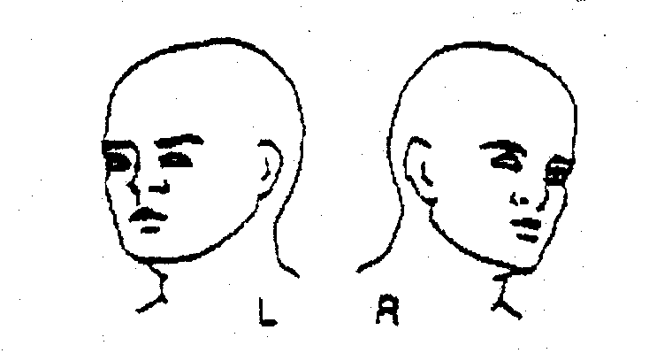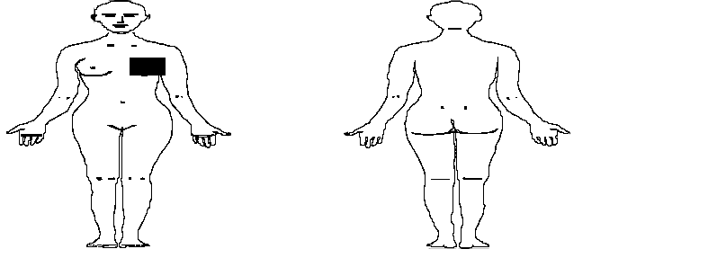__________________________________________________________ ________________________________________________________ ________________
PRINTED NAME OF MEDICAL PROVIDER OR NURSE EXAMINER SIGNATURE OF MEDICAL PROVIDER OR NURSE EXAMINER DATE

FORM 4-MALE

PHYSICAL EXAMINATION

PATIENT ID
MALE GENITAL ASSESSMENT
MALE | Injury |  | No injury |  | Swab | Describe
Penis  Meatus  Scrotum  Anus  Buttocks  Perianal Area  Perineal Area | ٱ  ٱ  ٱ  ٱ  ٱ  ٱ  ٱ  ٱ |  | ٱ  ٱ  ٱ  ٱ  ٱ  ٱ  ٱ  ٱ |  | ٱ  ٱ  ٱ  ٱ  ٱ  ٱ  ٱ  ٱ | ______________________________________________________________________________________  ______________________________________________________________________________________  ______________________________________________________________________________________  ______________________________________________________________________________________  ______________________________________________________________________________________  ______________________________________________________________________________________  ______________________________________________________________________________________  ______________________________________________________________________________________  ______________________________________________________________________________________
Direct Visualization  Discharge:  Circumcised:  Anoscope  Guiac |  | ٱYes  ٱYes  ٱYes  ٱYes  ٱpositive |  | ٱNo  ٱNo  ٱNo  ٱNo  ٱnegative |  | Describe_______________________________________________________________  Describe ______________________________________________________________________  Describe ______________________________________________________________  ٱnot done
Diagram Key:
Key: A- Abrasion B- Bite C-Contusion D- Deformity E- Erythema L- Laceration P-Pain S- Swelling T- Tenderness
___________________________________________________________ ______________________________________________________ ______________
PRINTED NAME OF MEDICAL PROVIDER OR NURSE EXAMINER SIGNATURE OF MEDICAL PROVIDER OR NURSE EXAMINER DATE

___________________________________________________________ ______________________________________________________ ______________
PRINTED NAME OF MEDICAL PROVIDER OR NURSE EXAMINER SIGNATURE OF MEDICAL PROVIDER OR NURSE EXAMINER DATE

FORM 4 FEMALE

PHYSICAL EXAMINATION

PATIENT ID
FEMALE GENITAL ASSESSMENT
FEMALE  Labia majora  Clitoris  Periurethral tissue  Vestibule  Vagina  Hymen  Posterior Forchette  Fossa Navicularis  Cervix  Buttocks  Perianal Area  Anus  Perineal Area  Other  Guiac | Injury  ٱ  ٱ  ٱ  ٱ  ٱ  ٱ  ٱ  ٱ  ٱ  ٱ  ٱ  ٱ  ٱ  ٱ  ٱ  ٱpositive |  |  | Non injury  ٱ  ٱ  ٱ  ٱ  ٱ  ٱ  ٱ  ٱ  ٱ  ٱ  ٱ  ٱ  ٱ  ٱ  ٱ  ٱnegative |  | Swab  ٱ  ٱ  ٱ  ٱ  ٱ  ٱ  ٱ  ٱ  ٱ  ٱ  ٱ  ٱ  ٱ  ٱ  ٱ  ٱnot done | Describe  __________________________________________________________________  __________________________________________________________________  __________________________________________________________________  __________________________________________________________________  __________________________________________________________________  __________________________________________________________________  __________________________________________________________________  __________________________________________________________________  __________________________________________________________________  __________________________________________________________________  __________________________________________________________________  __________________________________________________________________  __________________________________________________________________  __________________________________________________________________  __________________________________________________________________
EXAM INFORMATION
Direct Visualization  Speculum Exam  Colposcope Exam  Anoscope |  | ٱYes  ٱYes  ٱYes  ٱYes | ٱNo  ٱNo  ٱNo  ٱNo
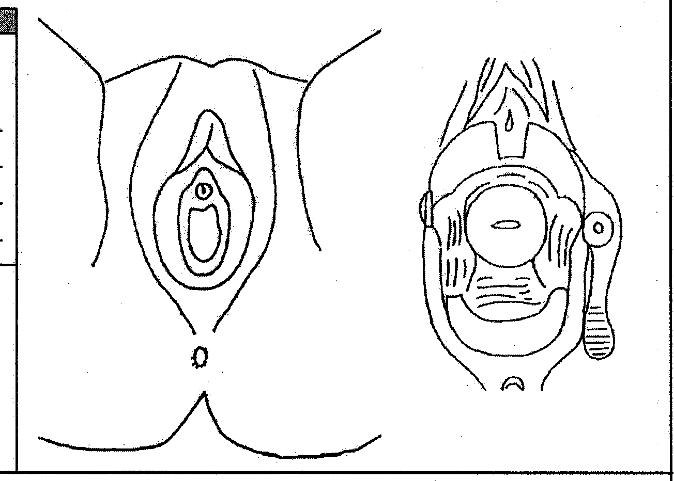

___________________________________________________________ ______________________________________________________ ______________
PRINTED NAME OF MEDICAL PROVIDER OR NURSE EXAMINER SIGNATURE OF MEDICAL PROVIDER OR NURSE EXAMINER DATE

___________________________________________________________ ______________________________________________________ ______________
PRINTED NAME OF MEDICAL PROVIDER OR NURSE EXAMINER SIGNATURE OF MEDICAL PROVIDER OR NURSE EXAMINER DATE

FORM 5

TREATMENT

AND DISCHARGE

PATIENT ID
LAB SPECIMENS OBTAIND FOR EVALUATION BY MEDICAL FACILITY
cHE  Check all that apply: | ٱ HCG ٱurine ٱserum results: ٱpositive ٱnegative  ٱHepatitis B titer ٱ Hepatitis B immunity  ٱOther labs : Results:
TREATMENTS AND PROPHYLAXIS GIVEN
Allergies ٱ yes ٱ no specify_______________________________________________________________________________________

Current medications ٱyes ٱno List_________________________________________________________________________________________________

Treatments Given  Emergency Contraception  Gonorrhea prophylaxis  Chlamydia prophylaxis  Trichomonas prophylaxis  Hepatitis B vaccine  dT immunization  other medications |  | ٱYes  ٱYes  ٱYes  ٱYes  ٱYes  ٱYes  ٱYes | ٱNo  ٱNo  ٱNo  ٱNo  ٱNo  ٱNo  ٱNo | ٱdeclined  ٱdeclined  ٱdeclined  ٱdeclined  ٱdeclined  ٱdeclined  ٱdeclined | medication/dosage_______________________________________________  medication/dosage_______________________________________________  medication/dosage_______________________________________________  medication/dosage_______________________________________________  medication/dosage_______________________________________________  medication/dosage_______________________________________________  medication/dosage_______________________________________________
COUNSELING
Community Resources are available to assist you with recovery. Your crisis advocate can be reached at ( )- _____________
Some one is available to talk to you 24 hours a day.
MEDICAL FOLLOW UP
You have identified ______________________________________ as your primary healthcare provider.
You should schedule a follow up appointment with _______________________________to be seen in __________ days

AFTERCARE INSTRUCTIONS
Within 2 days of this visit (_____________) Talk with your advocate

2 weeks after this visit (_____________) Obtain a repeat pregnancy test if you did not take
emergency contraception.
If you chose not to take medications for prevention of STD’s you should go for
testing.
4 -8 weeks after this visit (_____________) If you plan to complete the Hepatitis B vaccination series follow up with your primary provider or local health department. Vaccinations should occur in 4- 8 weeks and 6 months If no period has occurred in this time you should have a repeat pregnancy test.
6-8 weeks after this visit (_____________) If you plan to have an HIV antibody test, contact your care provider or local health
department to arrange testing. Testing should occur as soon as possible, with repeat
testing at 6 weeks, 3 months and 6 months
Safety planning offered __yes __no

You are entitled to copies of your records at your request

_______________________________________ _____________________________________ _________
PRINTED NAME OF MEDICAL PROVIDER OR NURSE EXAMINER SIGNATURE OF MEDICAL PROVIDER OR NURSE EXAMINER DATE

CONSENT TO ADMINISTER

EMERGENCY CONTRACEPTION

Patient ID
CRITERIA : Less than 120 hours (5 days) since first assault,
Of reproductive age
Negative pregnancy test
INFORMATION FOR YOU: The hormone medication that is administered by this facility or practitioner is considered an emergency treatment to prevent pregnancy. This treatment is 98% effective to prevent pregnancy. Emergency Contraception is not the same as “The Morning After Pill”( RU486) and will not induce abortion. Emergency Contraception will not harm a pregnancy that may already be present but undetectable.

There are no serious side effects from Emergency Contraception and almost all women can use it safely. Women with a history of clotting diseases, severe hypertension, smokers over age 40, prior stoke or heart attack should not use the estrogen containing forms. The most common side effects are nausea and vomiting. Other side effects include headaches, breast tenderness, fatigue, and dizziness.

YOUR INFORMED CONSENT OR REFUSAL TO RECEIVE THIS MEDICATION:
I have been screened for my personal risk and informed of the benefits and risks, side effects and limits of this drug. I understand that it has been shown effective in pregnancy prevention but is not 100% guaranteed. I have the opportunity to read this paper and have had my questions answered concerning the administration of this drug.

I will not hold this facility, practitioner or nurse examiner responsible for any pregnancy that might be preexisting but undetectable, or for any pregnancy that might result from incorrect use of this medication or despite use of this medication.

I hereby consent to treatment and I want to take the medication for the intention of preventing pregnancy that may result from the sexual assault. I authorize _______________________________ to give me hormone for the purpose of emergency contraception. I understand that I can withdraw my consent at any time by choosing not to take the medication.

X_______________________________________ __________________ X______________________________
Signature of patient or guardian date witness
I understand that medical personnel have chosen not to recommend emergency contraception for me because…

ٱpositive pregnancy test ٱprior hysterectomy ٱ other _______________________

X_______________________________________ __________________ X______________________________
Signature of patient or guardian date witness
Consent of Decline for Emergency Contraception
The purpose and intent of emergency contraception has been explained to me Emergency Contraception has been offered to me, I choose not to receive this medication and understand that my refusal could result in pregnancy related to sexual assault.

X_______________________________________ __________________ X______________________________
Signature of patient or guardian date witness

Evidence

Chain of Custody

Patient ID

# | OSP Rape Kit | # | OSP Suspect Kit
 | Oral swab standard |  | Oral swab standard
 | Oral swab (sodomy) |  | Head hair combing
 | Head hair combing |  | Head hair standard
 | Head hair standard |  | Pubic hair combing
 | Pubic hair combing |  | Pubic hair standard
 | Pubic hair standard |  | Penis shaft swab
 | Vaginal swabs |  | Scrotum swabbing
 | Vaginal slide
 | Cervical swab
 | Cervical slide
 | Anal swabs
 | Anal slide
 | Control swab
 | OTHER ITEMS

The above items were collected by:_________________________________________
Name and title

on ______________________________________at ___________________________
Month/Day/ Year military time

Chain of custody after the collection of evidence is as follows:

I____________________ released the above evidence to ________________________
Signature of examiner Signature of L.E. officer

of __________________________ at __________________ on ___________________
agency military time month/day/year

CONSENT FOR MEDICAL-LEGAL EXAM
In addition to consent for the medical evaluation and treatment given to this facility, I give consent for the collection of evidence for sexual assault, which may or may not include photographs. The evidence collected and documentation forms will be released to law enforcement for the sole purpose of investigation and prosecution. I understand I may withdraw consent at any time for any portion of the exam.
The original document will be kept with my medical record.

I consent and authorize____________________ of Warm Springs Health andWellnessCenter, to perform
Medical Provider
A medical-legal exam for the purpose of investigation and treatment.

X___________________________________ ____________________________________
Signature of patient/guardian Name and relationship of guardian

X___________________________________ ____________________________________
Signature of medical provider Printed name of provider

RRR
RELEASE OF INFORMATION
I consent to release information and evidence collected from this exam on _________________________
Month/day/year
to law enforcement and prosecution

From Warm Springs Health and Wellness Center 1270 Kot-Num Rd. Warm Springs OR, 97761

To:
_____________________________ _____________________________ ____________________________
agency agency agency

_____________________________ _____________________________ ____________________________
street address street address street address

_____________________________ _____________________________ ____________________________
city/state/ zip code city/state/ zip code city/state/ zip code

X___________________________________ ____________________________________
Signature of patient/guardian Name and relationship of guardian

X___________________________________ ____________________________________
Signature of medical provider Printed name of provider

