UNITED STATES DEPARTMENT OF AGRICULTURE
__________________________________________
Office of the Chief Information Officer



Project Management Handbook
Version 1.0
Record of Amendments

Version | Author | Date | Comments
0.1 | Mark Wasiak | Aug. 15, 2005 | First Draft
0.2 | Mark Wasiak | Sept. 27, 2005 | Second Draft – Several changes made based on team feedback, documented in file titled PM Guide changes 092705
0.3 | Mark Wasiak | Oct. 5, 2005 | Final Draft– Added appendix, section on EVM and several minor grammatical changes, documented in the file titled PM Guide Change Log.doc
1.0 | Mark Wasiak | Oct. 26, 2005 | Several changes from final draft review, documented in PM Guide Change Log.doc

United States Department of Agriculture
Office of the Chief Information Officer
Project Management Handbook

October 26, 2005

TABLE OF CONTENTS
Executive Summary 1
Chapter 1 – USDA IT Project Management framework 3
1.1 Introduction 3
1.2 Using this Guide 4
1.3 Project Versus Program 4
1.4 Project Management Life Cycle 5
1.5 Federal Government Mandates 8
1.6 CPIC Integration 11
1.7 System Development Life Cycle 13
1.8 Earned Value Management 13
1.9 Project Management is an Iterative Process 13
1.10 Project and Portfolio Management Tools 14
1.11 In-Process Reviews 14
1.12 Performance Review 14
Chapter 2 – Initiating Process Group 15
2.1 Project Manager Selection 18
2.2 Enterprise Architecture 18
Chapter 3 – Planning Process Group 20
3.1 IT Security 22
3.1.1 System Security Plan (SSP) 23
3.1.2 Configuration Management Approach 23
3.1.3 Contingency and Disaster Recovery Approach 24
3.1.4 Federal Information Security Management Act (FISMA) Self-Assessment and Plan of Action and Milestones (POA&M) 24
3.1.5 Preliminary Security Risk Assessment 24
3.2 Privacy Impact Assessment 24
Chapter 4 – Executing Process Group 25
4.1 IT Security 27
4.2 IT Operations Considerations 27
Chapter 5 – Monitoring and Controlling Process Group 28
5.1 Complete System and Technical Design 29
5.2 IT Security 30
5.3 Post Implementation Review 30
5.4 IT Operations Considerations 30
Chapter 6 – Closing Process Group 31
6.1 IT Security 32
6.2 IT Operations Considerations 32
Chapter 7 – Roles and Responsibilities 33
7.1 The Project Team and Stakeholders 33
7.2 Organizational Management 35
7.3 Project Sponsor / Business Sponsor 36
7.4 Program Manager 37
7.5 Project Manager 39
7.6 Project Team 41
7.7 Customer 42
Chapter 8 – Appendix 43
8.1 Project Checklists 43
8.2 Project Initiation Documents 43
8.3 Project Plan Templates 43
8.4 Project Closeout Templates 44

LIST OF FIGURES
Figure 1: Project Management Lifecycle Examples 6
Figure 2: Project Management Process Group Flow 7
Figure 3: Project Management Knowledge Areas 8
Figure 4: CPIC Lifecycle 12
Figure 5: CPIC Lifecycle Relationship with Project Process Groups 13
Figure 6: Initiating Process Group Processes 16
Figure 7: Initiating Process Group Stakeholders 16
Figure 8: Planning Process Group Processes 21
Figure 9: Executing Process Group Processes 26
Figure 10: Monitoring and Controlling Process Group Processes 29
Figure 11: Closing Process Group Processes 31

Executive Summary
The United States Department of Agriculture (USDA) considers effective project management a fundamental management responsibility and vital to achieving the Department’s overall mission and objectives. Agency officials and organizational managers must understand the current status of their programs and associated risks in order to make informed decisions. Risks must be appropriately mitigated with sufficient controls in place to insure that projects are completed on time, within budget, and aligned with the business case in order to achieve the USDA’s mission:
We provide leadership on food, agriculture, natural resources, and related issues based on sound public policy, the best available science, and efficient management.
As distinguished from ongoing operations and maintenance, a project is defined as a related set of activities having a definite beginning and end, developed incrementally and resulting in the delivery of unique products, services or results. Therefore this guide applies to projects defined, approved and funded by the USDA in order to:
- Establish and communicate a consistent project management framework for USDA projects as developed by the USDA Office of the Chief Information Officer (OCIO),
- Implement project management best practices incorporating common terminology and leverage the practices presented in the USDA IT Investment Project Management Training Program, and
- Provide project management forms and reference information as a tool to aid Project Managers and the organization in the consistent management and delivery of USDA projects.
The project management and system development processes, plans, and other outputs identified and described in this guide are based on the existing USDA project management practices, incorporate other best practices from throughout the Federal IT sector as well as those of the Project Management Institute’s Guide to the Project Management Body of Knowledge (PMBOK © Guide Third Edition).
The guide is divided into chapters that describe the project management activities and deliverables for each step of the USDA IT Project Management Framework. Project management forms for outputs identified in each step are provided in addition to this document.
The intended audience for this guide is primarily the Project and Program Managers responsible for managing OMB Exhibit 300 level projects. However, the practices documented in the guide are scaleable and are thus applicable to projects that may not be identified as an OMB Exhibit 300-level investment projects.
Specifically, the following individuals and groups will benefit from the utilization of this guide:
- Senior Executives, Project Sponsors
- Program Managers, Managers of Project Managers, and Supervisors
- Project Managers and other Project Team members
- Members of Project Management Offices (PMOs)
- IT Customers and other project stakeholders
- Functional Managers with employees assigned to Project Teams
- Consultants working with the USDA organization to provide products and services
It is the vision of the USDA’s Office of the Chief Information Officer that USDA Project Managers incorporate this guide as a tool to aid in their responsibilities to deliver projects on time, on budget, and within the scope and alignment with USDA’s mission.
This guide is to be used in conjunction with the USDA Capital Planning and Investment Control (CPIC) process to deliver IT projects. Be aware that project management is a methodology used within the CPIC process to assist project managers in delivering projects that meet cost, quality and schedule requirements. Refer to the USDA Information Technology Capital Planning and Investment Control Guide for more information on CPIC. Links to the guide and its appendices can be found on-line at http://www.ocio.usda.gov/cpic/usda_cpic_material.html.

USDA IT Project Management framework

Introduction
Prior to discussing the various Project Management Process Groups, constituent project management processes and standards involved in applying this guide to project management, the guide defines project management and the roles involved. Upon acceptance of the definition of project management internally, organizations can develop an infrastructure to provide the knowledge, skills, tools and techniques necessary to support projects, Project Managers and Project Teams.
The guide provides the foundation that enables the organization to conduct projects in a disciplined, well-managed, and consistent manner so that quality products are completed on time and within budget. Throughout the guide reference will be made to the Project Management Institute (PMI) and the Project Management Body of Knowledge Guide (PMBOK). PMI has established the industry standards for project management and the PMBOK embodies those standards. Further information can be found at the organization’s website, which is located at http://www.pmi.org/.
Chapter 1 is an introduction to Project Management Best Practices as embodied in the PMBOK as well as other best practices used in both industry and government and describes how those are integrated into the framework to create a holistic approach to managing projects within USDA. The guide does not simply restate the standards and processes defined by PMI’s PMBOK, but establishes an application of those standards to the Project Management Framework. The guide provides the methods addressing “what needs to be done” and “how it is to be done” in the execution and management of projects.
Large, complex projects require a more rigorous application of project management processes than small, non-complex projects with readily achievable goals. The Project Manager assesses the project characteristics to determine how to tailor the information in the guide to that specific project and determine which project management processes will be required. This “tailoring” effort is reflected in the Project Management Plan and its associated documentation.
Additionally, the guide should be evaluated and refined over time (continuous improvement) in order to maintain the applicability, usability and acceptability of the processes and techniques defined. As the guide is implemented, lessons learned from its use will become invaluable to the continuous improvement effort.
This guide focuses on project management and the steps necessary to deliver a project within the constraints identified by the organization. It provides standard methods and guidelines to ensure the USDA conducts projects in a disciplined, well-managed, and consistent manner promoting the delivery of quality products on time and within budget. As stated before, the application of project management is an iterative process.

Using this Guide
Chapter 1 provides background information and sets the context for understanding project management within USDA. The chapter also defines project management, discusses the difference between project and program management, and describes USDA’s IT Project Management process. The remaining chapters lead the reader through the process by devoting a chapter to each major phase in the USDA project management process. Lastly, a description of project stakeholder roles and responsibilities is discussed in Chapter 7.
The USDA Guide Appendices include project management forms and checklists that a Project Manager, Project Sponsor and Project Team members can use to initiate, plan, execute, monitor and control, and close out their projects. A basis and collection of best practices for project management as defined in the PMBOK is located in the Appendix as a reference. These tools can be accessed via the OCIO Project Management website at http://www.ocio.usda.gov/p_mgnt/index.html.
There is also USDA-specific reference information, such as a glossary of project management terms within the context of the USDA and the USDA project management organizational governance structure, located in the Appendix.

Project versus Program
According to the PMBOK:
A project is a temporary endeavor undertaken to create a unique product, service, or result.
A project exists only after a decision has been made to address a specific business need, either internal or external (customer need) to the organization, funding is available to support its execution, and measurable goals and objectives are well defined. Without knowing the expected results, quality level or capability of the end product, a project is difficult to plan, execute or conclude.
A project is unique and temporary in that there is a defined start (the decision to proceed) and a defined end (the achievement of the goals and objectives). Ongoing and repetitive business or maintenance operations are not projects. Process improvement efforts that result in better business processes or more efficient operations can be defined as projects.
Management of IT projects, in particular, is the area of focus for this handbook. Within USDA, IT project management encompasses the application of knowledge, skills, tools, and techniques necessary to ensure that an IT project progresses toward the achievement of its objectives in accordance with planned or revised cost, schedule, and technical baselines, as well as performance outcomes.
IT projects at USDA consist of the defined set of activities and resources that:
- Surround or support the use of information technology
- Address USDA’s strategic and programmatic objectives
- Support programmatic managerial and administrative functions
In most organizations, there is a descending hierarchy of endeavors ranging from the strategic plan to programs, projects, and subprojects. According to the PMBOK:
A program is a group of related projects managed in a coordinated way to obtain benefits and control not available from managing them individually.
A program should consist of several associated projects contributing to the achievement of the strategic plan. Programs may also contain elements of ongoing operations. Many organizations manage their programs/projects through a Project Management Office (PMO). PMOs can be successful within any organizational structure and may possess varying levels of authority within an organization. There are many benefits to implementing PMO, key of which are the ability to oversee and coordinate multiple related and/or unrelated projects (see the “big picture”), the ability to share and coordinate resources across all PMO projects, and the ability to develop and share common tools stored in a central repository to ensure consistency between PMO projects, and saving on development time.
Another means of grouping programs/projects for better management visibility and more effective decision-making is through Portfolio Management. This refers to the selection and support of projects from an enterprise perspective based on how they relate to the Strategic Plan. Those programs/projects within a Portfolio usually receive increased visibility due to the fact that the Portfolio’s success is usually the responsibility of Senior Managers or Senior Management Teams. Portfolio programs/projects are ranked based on their return on investment (ROI) and their contribution to the achievement of the Strategic Plan. The Capital Planning and Investment Control (CPIC) process contributes to USDA’s utilization of Portfolio Management.

Project Management Life Cycle
Phases are defined by the project life cycle and connect the beginning of a project to its end. Phases are characterized by the completion and approval of one or more major deliverables and are distinct from Project Management Process Groups. The names and number of project life cycle phases for a project are dependent upon the type of project and/or product being developed and are determined by the organization or Project Team. Remember, the product life cycle is not the same as project life cycle – a product life cycle can consist of multiple projects. Figure 1 represents the project lifecycle of different disciplines.
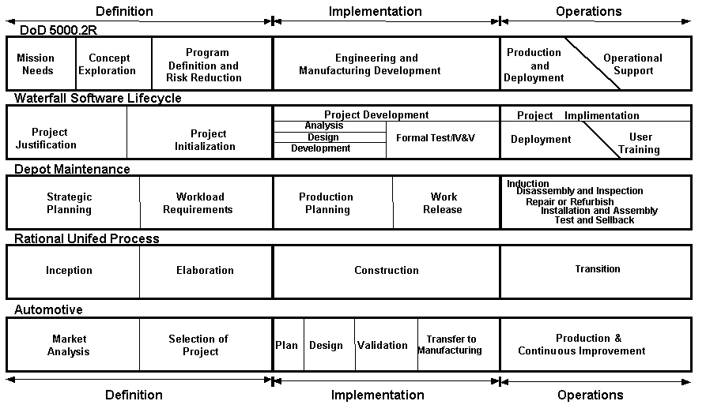
Figure 1: Project Management Lifecycle Examples
The project management processes that support the project phases are organized into five Project Management Process Groups. Each Process Group either interacts with the other Process Groups within a system development phase or across phases. These Process Groups are known as initiating, planning, executing, monitoring and controlling, and closing. As depicted in Figure 2, these Process Groups may be repeated during any of the phases of the life cycle. For example, repeating the Planning Process Group during each phase helps to keep the project focused on the business need and cost, schedule, and performance objectives. The Project Management Process Groups are not discrete, one-time events; they are overlapping activities that occur at varying levels of intensity throughout each phase of the project.
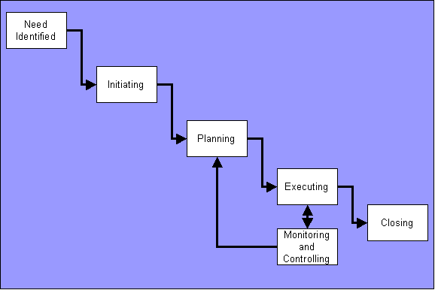
Figure 2: Project Management Process Group Flow
For the purpose of this guide, a project takes place within the context of the organization and the business unit driving the work effort. Therefore, the project life cycle methodology reflects the structure of the organization and the type of project being undertaken. Because the capital needs and high-level feasibility studies are performed at the USDA during the budget formulation and allocation processes, project life cycle will begin with project initiation and end with project closeout. The life cycle phases between initiation and closure encompass activities dictated by the type of project and the work complexity.
These Process Groups and their relationship are depicted in Figure 3. Also identified are nine Project Management Knowledge Areas that can be applied to a given project.
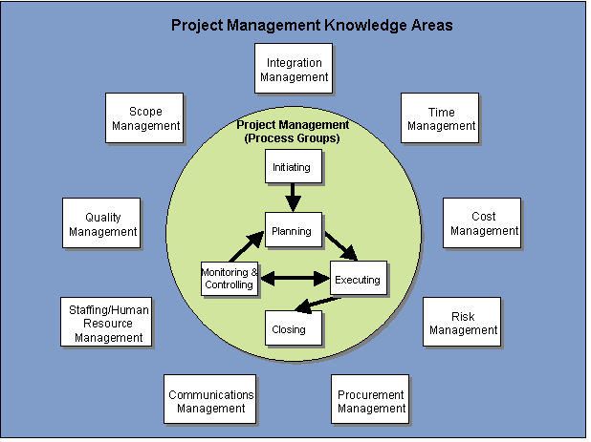
Figure 3: Project Management Knowledge Areas

Federal Government Mandates
There are many Federal Government mandates, which define the manner in which information technology project management will be conducted. They include the following statutes and guidance:
Clinger-Cohen Act (CCA) - This act calls for increased efficiency and reduced operating costs for federal agencies through proper planning and control and:
- Encourages use of performance-based and results-based management
- Simplifies procedures for purchasing commercial off-the-shelf (COTS) items
- Provides for major OMB role in tracking and analyzing risks and results of major capital investment
- Establishes duties of the agency CIO including advising and providing policy recommendations to the agency head; developing, maintaining, and facilitating information systems; and evaluating, assessing, and reporting to agency heads on the progress of IT development

Government Performance and Results Act (GPRA) - The GPRA is focused on increasing accountability and improving federal management by:
- Requiring agency strategic plans and ties them to resource requests; and
- Requiring answers to the questions:
  - What are we getting for our tax dollars?
  - How do we connect resources with results?
In addition, under GPRA, each department is required to submit to OMB a department-wide Performance Plan with the President’s annual budget request.
Federal Records Act – All records made or received by a Federal agency that document its organization, functions, policies, decisions, procedures, operations and other activities -- regardless of who created it or how the information was recorded -- must be identified, classified, retained and disposed of in accordance with procedures authorized by the National Archives and Records Administration. Procedures are detailed in Title 44 USC Chapters 21, 29, 31, and 33, and the relevant requirements of Title 36 CFR, Parts 1220 through 1238, Records Management. The term “record” encompasses documents in all media, including records created, used, maintained, transmitted, or disposed of in electronic form; machine-readable records that require machine processing for conversion to human-readable form; magnetic tapes, disks and drums, video files, optical disks, and floppy disks.
Federal Acquisition Streamlining Act (FASA) – The FASA aims at reducing barriers and increasing flexibility of procurement procedures by:
- Authorizing simplified procedures for limited procurements
- Encouraging reliance on commercial products
- Allowing agencies to select best value rather than lowest cost offeror
- Encouraging use of fixed price, performance-based contracts to reduce cost overruns
Chief Financial Officers (CFO) Act - The purpose of the CFO Act is to improve the efficiency and effectiveness of the federal government by:
- Enhancing certain OMB functions
- Reducing the amount of money lost to fraud, waste, and mismanagement
- Improving the federal government’s financial reporting processes
- Creating an Office of Federal Financial Management within OMB
- Establishing CFOs in the major executive departments and agencies
Government Paperwork Elimination Act (GPEA) - Under the GPEA, Federal Agencies are required to provide when practicable for the electronic maintenance, submission, or disclosure of information, and acceptance of electronic signatures. It also:
- Specifies that electronic records and their related electronic signatures are not to be denied legal effect, validity, or enforceability merely because they are in electronic form
- Encourages Federal Government use of a range of electronic signature alternatives
- Requires Federal agencies to develop and maintain an implementation plan for meeting the requirements of the Act
Government Information Security Reform Act (GISRA) - The GISRA provides a framework for program management and evaluation of an agency’s information assurance program. The Act
- Requires agencies to:
  - Develop and implement an agency-wide information security program that is reviewed annually, and ensure the plan is practiced throughout the life cycle of each system
  - Develop and implement policies and procedures for an incident response and reporting capability
  - Report significant agency deficiencies in policies or practices, as material weaknesses under applicable criteria of other laws
- Requires agency Chief Information Officers to:
  - Designate a senior agency information security official who reports directly to the CIO
  - Integrate security programs into the agency’s enterprise architecture and capital planning and investment control processes
  - Develop and maintain an agency-wide information security program and ensure that the agency effectively implements and maintains information security policies, procedures, and control measures
  - Train and oversee personnel with significant responsibilities for information security with respect to such responsibilities
- Requires the head of each agency to ensure that senior agency officials:
  - Assess the risks to the operations and assets over which they have control and ensure annual program reviews
  - Report to the agency head the results of evaluations, tests, and progress of corrective actions
  - Codify in Departmental directives the security requirements detailed in Appendix III of OMB Circular A-130, Management of Federal Information Resources
Rehabilitation Act (Section 508) - Section 508 requires that electronic and information technology developed, procured, maintained, or used by the Federal government be accessible to people with disabilities. After June 25, 2001, Federal employees and members of the public who have disabilities must have access to and use of information and services that is comparable to the access and use available to non-disabled Federal employees and members of the public. Section 508 has had a particularly profound impact on Federal websites.
Federal Acquisition Regulations Part 7 (Acquisition Planning) – Part 7 describes, acquisition plans; preference for buying in economic quantities; choosing between government and commercial sources; equipment lease and purchase methods; and inherently governmental functions.
Part 12 of the FAR, Acquisition of Commercial Items – Part 12 focuses on special requirements for acquiring commercial items; and streamlined procedures for evaluation and solicitation of commercial items.
OMB Direction - OMB requires agency investment submissions to be justified by rigid cost/benefit analyses. It further requires that full life cycle costing be used; full funding for costs must be appropriated in advance; cost, schedule, and performance goals be clearly identified, achievable, and measured using Earned Value Management (EVM); and, that risks be identified.

OMB Circulars describing these requirements include:
- Circular A-11 Part 2, Strategic Plans and Annual Performance Plan
- Circular A-11 Part 3, Capital Assets
- Circular A-11 Part 3, Supplement, Capital Programming Guide
- Circular A-94, Benefit-Cost Analysis
- Circular A-109, Major Systems Acquisitions
- Circular A-123, Management Accountability and Control
- Circular A-127, Financial Management Systems
- Circular A-130, Management of Federal Information Resources
Government Accounting Office Direction includes two directives in particular:
- GAO/AIMD 10.1.13, Assessing Risks and Returns
- GAO/AIMD 10.1.23, Information Technology Investment Management: A Framework for Assessing and Improving Process Management

CPIC Integration
Capital Planning and Investment Control (CPIC) is USDA’s primary process for
- Making decisions about which IT initiatives and systems USDA should invest in
- Creating and analyzing the associated rationale for these investments
The CPIC process occurs in five phases. Each phase consists of
- Entry criteria needed to begin work
- Processes performed during the phase
- Exit criteria needed before the project can move to the next phase.
Exit criteria for each phase most notably consist of E-Board approval to proceed to the next phase. Figure 4 shows the CPIC lifecycle.

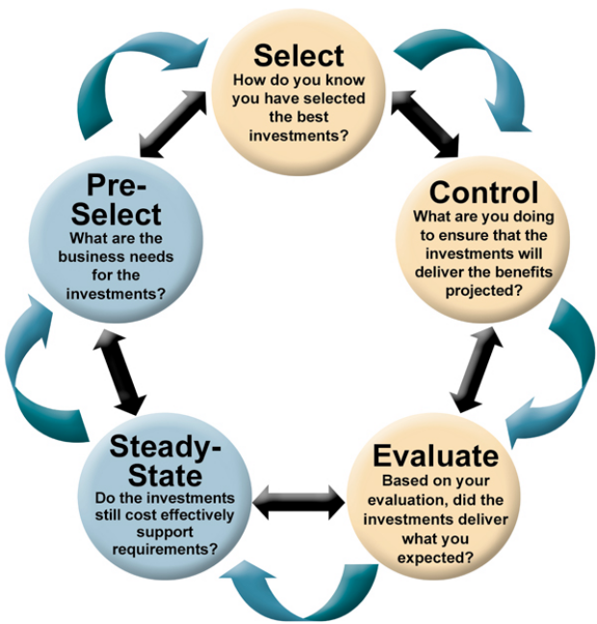
Figure 4: CPIC Lifecycle
While these phases may appear to be similar to the project management process groups, the two are unique. Project management is performed throughout the CPIC life cycle, and several project management processes are performed within each CPIC phase.
Figure 5 illustrates how the project management lifecycle aligns with the CPIC lifecycle. This alignment is an approximation for reference only. Do not infer that there are parallels to be drawn between the lifecycles. Each process has different requirements. One difference between the CPIC process and project management process groups is that CPIC defines exit criteria for each phase. The project management process groups interact with each other and are not easily defined by boundaries between each group. Also remember that CPIC is a cyclical process focused on annual investment decisions, while project management is focused on the one-time delivery of a unique project.
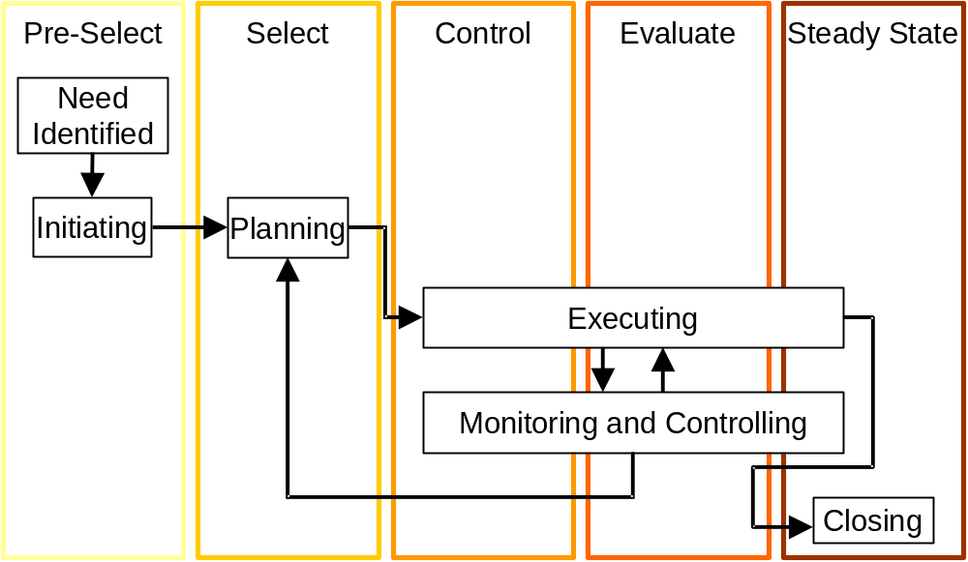
Figure 5: CPIC Lifecycle Relationship with Project Process Groups

System Development Life Cycle
The System Development Life Cycle (SDLC) identifies the processes and tasks and the order in which they must be completed to produce and maintain a system throughout its life cycle. USDA currently recognizes the Capital Planning and Investment Control (CPIC) life cycle as the equivalent of the SDLC for the purposes of managing projects.

Earned Value Management
Earned Value Management (EVM) is a process by which both schedule and cost data are analyzed to determine project status. USDA is in process of implementing an EVM guide. The guide will provide uniform procedures that have been approved by the Chief Information Officer under the authority as the United States Department of Agriculture Executive Agent for Earned Value Management Systems. The document will provide guidance to be used during the implementation and continuing oversight of EVM established in compliance with ANSI/EIA 748 Criteria.
For more information go to the OCIO website at http://www.ocio.usda.gov/cpic/index.html

Project Management is an Iterative Process
The application of project management is an iterative process. For example, within the Planning Process Group, several iterations of planning may occur as the team develops the optimal product solution for a customer. Identified solutions may require refinements to the schedule, the cost estimates, the quality requirements and/or the risk planning. As changes occur, the impact to other areas must be determined. Over time, the iterations should become smaller in magnitude and more defined as more detailed information is developed
After the Planning Process Group has been completed for the initial project phase, feedback from the Executing Process Group (identified through the Monitoring and Controlling Process Group) may result in adjustments to the Project Management Plan. Adjustments due to feedback typify the project management process. Project Management is a dynamic effort and requires a continual process of evaluation. Evaluation activities, such as oversight, quality control, and executive review are ongoing activities and affect every phase of the project.

Project and Portfolio Management Tools
A Project Management Information System (PMIS) facilitates project information to flow within an organization. The software application is a core component of the overall PMIS and is considered to represent the tools and techniques used to gather, integrate, and distribute output of the other project management processes (e.g. project management outputs such as the overall Project Management Plan and subsidiary plans).
Métier’s Worklenz has been selected as the project management software for managing USDA projects as well as USDA IT OMB 300-level projects. WorkLenz is a unified portfolio management software that offers the combined benefits of managing projects, building and using standard methodologies and efficiently leveraging resources to deliver projects on time, on budget, and within scope. WorkLenz training is provided and supported by Métier. Project Managers and Project Team members receive ongoing support for WorkLenz project implementations from Métier.
Creating and maintaining a project schedule is a key aspect of project management. A wide range of software tools is available for managing schedules, each with varying capabilities. OCIO does not mandate the use of any particular tool, but project managers are advised to consider software that meets reporting needs for the project, OCIO, and the Office of Management and Budget for OMB 300 projects.

In-Process Reviews
In-Process Reviews are briefings that are provided to the E-Board because a project is either experiencing problems or variances that are outside tolerance levels or because the time span between milestone reviews is too long to allow the E-Board to conduct adequate, timely oversight and control on the project. In-Process Reviews are scheduled by OCIO.

Performance Review
Performance reviews are conducted on all projects listed in the USDA IT portfolio of projects (also identified in the OMB Exhibit 53). The Project Manager provides to OCIO an assessment of project performance in each of the following areas: acquisition requirements, funding, staffing, schedule, budget and quality.

Initiating Process Group
The Initiating Process Group is the conceptual element of project management—the basic processes that should be performed to get the project started. This process group is applied during the CPIC Pre-Select Phase. This starting point is critical because those who will deliver the project, those who will use the project, and those who have a stake in the project need to reach an agreement on its initiation. During this phase in the USDA IT Project Management approach, it is important to have a clear understanding of the problem that needs to be solved and how solving that problem supports a strategic objective of the Department.
Stakeholders may be able to exert influence that can positively or negatively affect the Project Team’s ability to successfully complete the project, so it is very important to involve and manage, to the extent possible, all stakeholders in the Process Group activities. By garnering the buy-in and shared ownership of the project by the stakeholders, it generally improves the probability of satisfying customer requirements. The basic processes for the Initiating Process Group are:
- Selecting the project
- Determining business needs
- Considering Enterprise Environmental Factors (e.g., historical data, marketplace conditions, organization structure, industry standards)
- Considering Organizational Process Assets (e.g., policies, procedures, plans, guidelines)
- Determining objectives
- Developing the Project Charter
- Developing the Preliminary Project Scope Statement
- Determining high level deliverables and estimates
- Developing a product description
- Identifying the qualifications of the Project Manager that would be best suited for the particular project
- Determining high level resource requirements
•
- Obtaining project initiation approval.
Note the similarity between these tasks and the CPIC Pre-Select Phase process steps:
- Identify Project Sponsor
- Conduct mission analysis
- Develop concept
- Prepare preliminary business case
- Prepare investment review submission package
- Review initiative and recommend appropriate action
- Make final investment decisions
Figure 6 depicts the Initiating Process Group process flow.
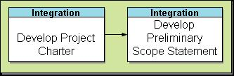
Figure 6: Initiating Process Group Processes
The key output of this process group is the project charter. The charter authorizes the project to begin and identifies the project manager responsible for leading the project.
For the project to get started “right,” it is essential that all stakeholders participate in this critical Process Group. The success of the organization and the Project Team depends upon starting with complete and accurate information, management support, and the authorization necessary to manage the project. According to the PMBOK, in order to have an effective project management team, the team needs to understand and use knowledge and skills from at least five areas of expertise. These areas are (1) The PMBOK, (2) Application area knowledge, standards and regulations, (3) Understanding the project environment, (4) General management knowledge and skills and (5) Interpersonal skills.
Figure 7 illustrates the project Initiating Process Group stakeholder participation.

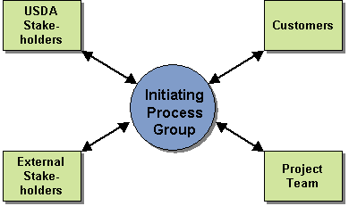
Figure 7: Initiating Process Group Stakeholders
The Project Mission Needs Statement defines the project’s reason for being and ensures the project is consistent with the USDA’s Strategic plan. It defines a high-level approach and other top-level planning information. Ideally, the information contained in the Mission Needs Statement provides management with the information necessary to decide if the project can be supported. The Mission Needs Statement should not be a collection of product or process deliverables, but it should define what is to be done, why it is to be done, and what business value it will provide to USDA when the project is completed. Further information on the Mission Needs Statement, including a template document, can be found in the CPIC Guide.
New IT projects/initiatives require submission of a Mission Needs Statement. Each paper is meant to be a high-level, conceptual description of a new proposed project that broadly identifies project goals and benefits. After the appropriate Administration or Staff Office approval, the Mission Needs Statement will be submitted to the OCIO for review. The reviewing official will determine whether the project should go forward to E-Board or be tabled, reworked, scrapped or refined. When all question and issues have been resolved to OCIO’s satisfaction, a review will be scheduled with the E-Board. A decision to proceed by the E-Board authorizes the submitting office to prepare a “planning” or “full acquisition” Capital Asset Plan and Business Case (OMB Exhibit 300).
The Project Manager should have a clear understanding of the problem that needs to be solved and how solving that problem supports a strategic objective of the Department. Based on a successful review, the Project Manager will be authorized to expend the resources necessary to establish the project’s business case.
If a new IT project/initiative is not approved by the E-Board, the agency may resubmit a revised business case for the next E-Board meeting. The USDA CPIC Guide contains further information on obtaining project approvals.
Specific attention must be paid to the projected cost of IT projects. An acquisition approval request (also known as a waiver) is required if an agency within the Department wishes to expend $25,000 or more for an IT acquisition. Waivers are processed through OCIO. Further guidance on waiver requirements and submittal process, including a template waiver document, can be found at www.ocionet.usda.gov/ocio/waivers/index.html
The primary task of the concept definition step is the “initiating” or “chartering” of the project. The Project Management document produced during concept definition is a project charter. This document:
- Identifies the business need for the project
- Gives the Project Sponsor, Business Sponsor, and/or Project Manager (if one has been assigned to the project yet) the authority to expend resources necessary to lead the project into the next phase or step in the life cycle
- Describes the project
- Provides a mapping of the project goals to the enterprise goals
- Provides a high-level discussion of the project’s work breakdown structure, schedule, major risks, benefits, critical success factors, acquisition strategy, IT security, and order of magnitude life cycle cost estimates
A USDA project is “chartered” once this artifact exists and the project has received approval from the E-Board or appropriate senior management.

Project Manager Selection
The Project Manager is responsible for project cost, schedule and performance. Selection of the Project Manager should be based upon qualifications and experience commensurate with the size, complexity and profile of the project. All OMB Exhibit 300 level projects must have a USDA qualified Project Manager. A USDA Level III qualified Project Manager should also be assigned to projects of high risk and complexity and inter-departmental impact. A USDA Level II qualified Project Manager should be assigned to projects of medium risk, moderate to high complexity and have intra-departmental impact. A USDA Level I qualified Project Manager are qualified to manage small projects which are low risk, low complexity with intra-agency activity.
The following table illustrates the types of projects that the various levels of qualified project managers are expected to work on:
PM Level | Complexity | Risk | Interaction
Level III | High and/or OMB300 level | High | Inter-departmental
Level II | Moderate to High | Medium | Intra-departmental
Level I | Low | Low | Intra-agency
The Project Manager should have broad authority over the entire project. Senior management should empower the Project Manager to take actions necessary to complete the project successfully. This includes the authority to make design decisions during development, as well as the ability to control requirements, budget, schedule, resources, and product quality.
It is important that management formally select a project manager as this sets the stage for the project manager to successfully interface with the entire organization. Successful project managers must be empowered to manage the project and be enabled to make decisions and take action necessary to complete the project.
Assignment of the Project Manager should take place as early as possible in the project life cycle. It is especially important that the Project Manager conduct the planning phase of the project. The Project Manager’s understanding of the project’s Planning Process Group processes and trade-offs can be invaluable to team members and matrixed support personnel as they come on-board. That understanding of ‘how we got here’ will also have a beneficial impact on the decisions made during the Executing Process Group processes.

Enterprise Architecture
Enterprise Architecture is a method of organizing an enterprise’s business processes, information needs and supporting technologies to support quality decision making on investment choices and present a future vision of the business.
The Enterprise Configuration Control Board (ECCB) exists to ensure consistency in agency architecture and set guidelines for system level configuration controls. As such, project managers need to be aware of the standards maintained by the ECCB to ensure that their projects meet Enterprise Architecture requirements.
Enterprise Architecture needs to be considered throughout the project management process, but perhaps most importantly during the initiation phase as the conceptual project is evaluated against the target architecture criteria. Some examples of questions that be answered by EA include:
- Initiation
  - Does this investment fit within the USDA target architecture?
  - Does the investment duplicate other USDA or agency functions or processes?
- Planning
  - Are data, design hardware and software selections, security planning and telecommunications design in alignment with existing standards and the target architecture? If not, has the ECCB approved an alternative?
- Monitor and Control
  - Is the development in alignment with existing standards and target vision?
- Closing
  - Did the project meet all the standards and fit within the target architecture?
More information related to Enterprise Architecture can be found at the USDA EA site, located at http://www.ocio.usda.gov/e_arch/index.html
More specific EA information can be found at the USDA EA intranet site, located at http://www.ocionet.usda.gov/ocio/e_arch/index.html
The Federal Enterprise Architecture site at http://www.whitehouse.gov/omb/egov/a-1-fea.html includes various current documents and FEA Reference Models
In addition, the CPIC guide contains reference material related to Enterprise Architecture.

Planning Process Group
The Planning Process Group is considered the most important Process Group in project management. It occurs primarily during the CPIC Select phase. Time spent up-front identifying the proper needs and structure for organizing and managing a project saves countless hours of confusion and rework during the Executing and Monitoring and Controlling Process Groups.
Project planning defines project activities that will be performed, the products that will be produced, and how these activities will be accomplished and managed. Project planning defines each major task, estimates the time, resources and cost required, and provides a framework for management review and control.
Planning involves identifying and documenting scope, tasks, schedules, cost, risk, quality, and staffing needs. This planning process:
- Identifies specific work to be performed and the goals that define the project
- Provides documented estimates regarding schedule, resources and cost for planning, tracking, and controlling the project
- Obtains organizational commitments that are planned, documented, and agreed upon
- Continues the development and documentation of project alternatives, assumptions, and constraints
- Establishes a baseline of the plan from which the project will be managed.
Compare these tasks with the process steps contained in the CPIC Select phase
- Review Mission Needs Statement and update if needed
- Approve Integrated Project Team membership
- Identify funding source and obtain agency approvals
- Prepare IT investment review submission
- Review initiative and recommend appropriate action
- Make final investment decisions
Although similarities exist between each discipline, note that CPIC is concerned with investment in the project, while project management is more concerned with overall project execution.
The result of the Planning Process Group, the Project Management Plan, is an approved, comprehensive document that allows a Project Team to begin and complete the work necessary to achieve the project goals and objectives (product/process). The Project Management Plan addresses how the Project Team will manage the project elements, including the Project Management System (i.e., set of tools, techniques, methodologies used to manage a project). The Plan provides a high level of confidence in the organization’s ability to meet the scope, timing, cost, and quality requirements by addressing all aspects of the project.
The Planning Process Group is comprised of a number of constituent project management processes that estimate the project’s size, technical scope, and the required resources. It produces a Work Breakdown Schedule (WBS), WBS Dictionary, schedule, risk identification and assessment, and negotiated commitments. Completing these processes is necessary to establish the entire, comprehensive Project Management Plan. Typically, several iterations of the planning processes are performed before the plan is completed and approved.
Figure 8 depicts the Planning Process Groups as a series of activities and steps to be completed that result in a complete Project Management Plan. These process activities:
- Produce a plan that defines how the project objectives will be achieved: scope, schedule, resources and cost
- Establish subsidiary management plans that will define how specific aspects of the project will be managed to make certain the objectives are met
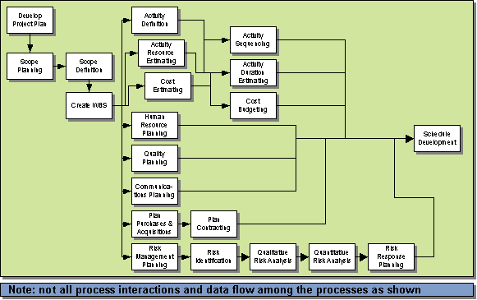
Figure 8: Planning Process Group Processes
The Planning Process Group consists of the development of the subsidiary management plans including:
- Cost management plan
- Human Resource (Staffing) management plan
- Scope management plan
- Schedule management plan
- Quality management plan
- Procurement management plan
- Communications management plan
- Risk management plan
- Integration management plan.
It is here that the Project Manager and project team develop the project Work Breakdown Structure (WBS), which communicates the specifics of the project scope and the requirements of the product or service that the project will produce. With an understanding of the project scope, the team prepares the project master schedule and time-phased budget that become the basis for project performance measurement (such as earned value management). Processes are put in place that will ensure close control over the project scope, schedule and budget. Other processes are initiated to identify and assess project risks and ensure product quality. Specific strategies are developed for the acquisition of project labor and materials.
It is during this period that the Project Manager or project sponsor obtains senior officer and business owner approval of the project scope, schedule, budget, risks, acquisition strategy, and product requirements. A best practice is to have the appropriate senior officer(s) and business owner actually sign the Project Management Plan and subordinate plans that contain the above information.
Important distinctions exist between Planning tasks and the tasks required to prepare and communicate information for the Exhibit 300 process. The major distinction is that the Planning process is goal driven, with milestones being reached after intermediate project goals are achieved; while the Exhibit 300 process is an annual process, requiring actions throughout the year to meet OMB submission dates. In the Planning Process Group, the Project Management Plans are created to control the project. This is also the period of time when the groundwork is laid for Exhibit 300 reporting by entering the Project Management Planning data into project management software.
Prototype efforts are encouraged within USDA, as a general principle, in order to speed time to market and to increase the likelihood that the delivered product will fit the end users’ true needs. For certain projects, the project requirements and maturity of the technology will have already been established.

IT Security
Security is absolutely essential to protect the availability, confidentiality and integrity of system assets by maximizing security safeguards and performance while controlling costs. The Security Plan is based on a preliminary security analysis conducted by the agency Information Systems Security Program Manager (ISSPM) and other security specialists. The review focuses on the following components:
- User Requirements Definition
- Responsibility for Security
- Sensitivity of Information
- Risk Assessment/Mitigation Strategies
- System Security Plan
- System rules
- Specialized Training
- Personnel Security
- Contingency Planning
- Technical Controls
- Information Sharing
- Public Assess Controls
- Security Architecture
- Security Cost/Benefit Analysis

System Security Plan (SSP)
The SSP documents the security risks (not project risks) and overall system security categorization in terms of potential level of impact (Low, Moderate, High) for each of the security objectives of confidentiality, integrity, and availability of Federal information and information systems. The plan documents the security processes that will be implemented and tested in the Security Controls Assessment (SCA) plan. The SCA plan is the basis for System Certification and Accreditation and acceptance of residual security risk. The System Security Plan includes the following components:
- System Boundary Summary – Describes what constitutes the system for the purposes of the SSP.
- IT System Security Categorization and Sensitivity – The System Security Categorization classifies the system as a Major Application or a General Support system. The Security Sensitivity identifies the potential level of impact as Low (limited impact), Moderate (serious impact), or High (severe or catastrophic impact) for confidentiality, integrity, and availability of federal information and information systems. The categorization and sensitivity determines the minimum management, operational, and technical security controls required for information and information systems. See Federal Information Processing Standards (FIPS) 199 – Standards for Security Categorization of Federal Information and Information Systems. Guidance on the use of FIPS 199 can be found in National Institute of Standards and Technology (NIST) Special Publication 800-60 (http://csrc.nist.gov/publications/nistpubs/index.html).

Configuration Management Approach
Develop the approach for managing change over the development and production life cycle of the system – application and operating system software, configuration settings, interfaces, and hardware. Note: A security risk assessment differs greatly from a project risk assessment. A security risk assessment assesses the security risks to the information system itself whereas a project risk assessment assesses the project risks.

Contingency and Disaster Recovery Approach
Prepare an approach for responding to man-made or natural incidents or disasters.

Federal Information Security Management Act (FISMA) Self-Assessment and Plan of Action and Milestones (POA&M)
FISMA requires the completion of an annual self-assessment to identify security deficiencies. The USDA has an automated tool to facilitate the tracking of deficiencies in the form of P0A&M that are submitted to OMB quarterly. OMB guidance also requires to be addressed by system owners/Program Managers in order to obtain a security score of 4 in the Exhibit 300 process.

Preliminary Security Risk Assessment
The basic assessment of the confidentiality, integrity, and availability risks that help determine what security controls are necessary to protect the information contained in this information system. Completing the FISMA self-assessment constitutes a preliminary risk assessment.

Privacy Impact Assessment
The E-Government Act of 2001 (E-Gov) requires a Privacy Impact Assessment (PIA) to be conducted for any new information collections. Primarily, the PIA formalizes and documents how private data is to be protected. It must describe:
- What information is to be collected
- Why the information is being collected
- The intended use of the information
- With whom the information will be shared
- What notice or opportunities for consent would be provided to individuals regarding what information is collected and how that information is shared
- How the information will be secured
- Whether a system of records is being created under the Privacy Act (5 U.S.C. 552a)
The PIA is to be initiated in the early stages of system development and completed as part of the required System Development Life Cycle reviews. Privacy must be considered when requirements are analyzed and decisions are made about data usage and system design.
Details on the PIA, its privacy principles, and steps for completing one can be found at: http://www.ocio.usda.gov/directives/files/dm/DM3515-002.htm A PowerPoint presentation explaining the Privacy Act is available at: http://www.ocio.usda.gov/p_mgnt/doc/ppt_the_Privacy_Act1974_062805.ppt

Executing Process Group
Once a project moves into the Executing Process Group, the Project Team and all necessary resources to carry out the project should be in place and ready to perform project activities. The Project Management Plan is completed and baselined by this time as well. The Project Team’s, and specifically the Project Manager’s focus now shifts from planning the project efforts to participating in, observing, and analyzing the work being done.
The Executing Process Group is where the work activities of the Project Management Plan are executed, resulting in the completion of the project deliverables and achievement of the project objective(s). This Process Group brings together all of the project management disciplines, resulting in a product or service that will meet the project deliverable requirements and the customers need. In this Process Group, elements completed in the Planning Process Group are implemented, time is expended, and money is spent.
This Process Group requires the Project Manager and Project Team to:
- Conduct, coordinate and manage the ongoing work activities
- Perform quality assurance activities continuously to ensure project objectives are being met or achieved
- Monitor identified risks for triggering events and implement containment or contingency strategies as necessary
- Request seller responses and select sellers (seller defined as the performing organization – buyer defined as outside organization acquiring product from seller)
- Distribute information to project stakeholders
- Manage change
In short, it means coordinating and managing the project resources while executing the Project Management Plan, performing the planned project activities, and ensuring they are completed efficiently.
The Executing Process Group spans the CPIC Control and Evaluate phases, with some overlap into the Steady State phase. The CPIC Control phase includes the following process steps:
- Establish and maintain initiative and security costs, schedule and technical baselines
- Maintain current initiative and security costs, schedule, technical and general status information
- Assess initiative progress against performance measures
- Prepare annual investment review submission package
- Review/approve investment submission
- Review initiative and recommend appropriate action
- Make final investment decision
- Work with project sponsor to develop solutions
The CPIC Evaluate Phase includes:
- Conduct PIR and present results
- Prepare annual investment review submission package
- Review/approve investment submission
- Review initiative’s PIR results and recommend appropriate action
- Make final investment decisions
- Evaluate IT capital investment management process
Note that in some cases the CPIC and project management process overlap, as in the management of work activities, but that each is focused on a different result.
The Executing Process Group allows the project’s deliverables to be produced and the objectives to be met. This Process Group facilitates the completion of the work activities, the expenditure of resources, and the application of the quality assurance processes to ensure that the end product(s) is viable and meets customer requirements. Figure 9 shows how these processes fit into the Executing Process Group.
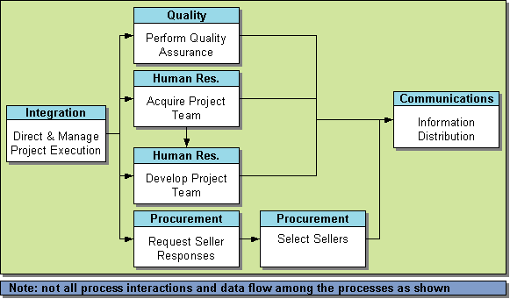
Figure 9: Executing Process Group Processes
The Executing Process Group involves coordinating and managing project activities and their subsequent output. The focus of the Project Manager and the Project Team is on the day-to-day management of the overall effort. In addition to the processes and activities defined above, the subsidiary management plans are implemented and project performance is monitored and managed accordingly.
During this phase the Project Manager begins executing the approved Project Management Plan and manages work efforts to design the system. These design activities will result in a validation of the approved and published baseline, as each component is detailed and vetted with the appropriate stakeholders. Typically, there are numerous requests for change during this phase, and the Project Team utilizes the change control procedures in the integrated change management plan to assess, decide upon and implement change proposals. Note that change can occur within project management areas including schedule, cost, quality and scope, and methods for addressing change within each area should be included in each of their subsidiary management plans. The Project Manager is required to report the impact of scope changes through the remainder of the project.
The system design may take the form of a prototype system, proof of concept, a demonstration or, depending on complexity, the first production article. Tasks in this phase lead to a briefing where the results of the initial design effort are reported and the decision is made to continue the project into system development.
The Project Manager addresses a basic set of questions necessary to warrant approval to deploy the system. Key issues to be addressed are whether the project has adequately demonstrated through test that the system meets its functional and performance requirements and whether the system is adequately supported by documentation, training, IT security, etc.

IT Security
It is critical that security be included in the design stage of a new application or information system. Security can be designed into a new system at a lower cost in the design phase than attempting to “paint it on” later in the life cycle. The security Certification and Accreditation (C&A) process is a formal methodology that examines security risks, threats, and vulnerabilities, as well as sensitivity and criticality of information, to determine what security controls are necessary to mitigate risk to an acceptable level. During this phase of the project, security documentation should continue to be updated as necessary.

IT Operations Considerations
Projects that will involve USDA’s telecommunications and operations infrastructure should consider network capacity planning, project performance requirements, availability and scalability requirements and a host of other topics during project execution. Detailed explanation of these topics can be accessed from the Telecommunications Guide, which is available at www.ocio.usda.gov/tso/index.html.

Monitoring and Controlling Process Group
Control is a formal process in project management. The PMBOK defines Project Control as a project management function that involves comparing actual performance with planned performance and taking corrective action to yield the desired outcome where significant differences exist. By monitoring and measuring progress regularly, identifying variances from plan, and taking corrective action when necessary, project control ensures that project objectives are met. The activities from this process group are performed primarily during the CPIC Evaluate and Control phases.
Project control involves the regular review of metrics and report status to identify variances from the planned baseline. The variances are determined by comparing the actual performance metrics from the execution process group against the baseline metrics assigned during the planning process group. If significant variances are observed, adjustments to the plan are made by repeating and modifying the appropriate Project Management Planning processes.
A significant variance from the plan does not explicitly require a change, but should be reviewed to determine whether preventive action is warranted. For example, a missed activity finish date may require adjustments to the current staffing plan, reliance on overtime, or trade-off between budget and schedule objectives. Controlling also includes taking preventive action in anticipation of possible problems.
While the Monitoring and Controlling Process Group relationship to other Process Groups is relatively concise and clear, control is often difficult to implement as a formalized system. Project control is still important however, because a project is unlikely to be considered successful by stakeholders if it is not monitored and controlled effectively. Success in this context translates to metrics (project, cost, completion dates, etc.) and customer’s expectations (features, functionality, performance, etc.).
The control processes implemented during this Process Group are Performance Reporting and Integrated Change Control, with several constituent processes interacting with these processes as depicted in Figure 10.
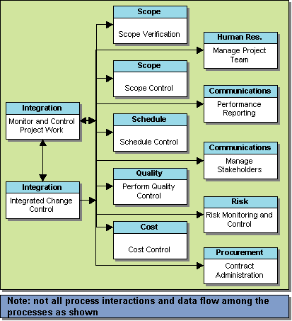
Figure 10: Monitoring and Controlling Process Group Processes
Only by monitoring and controlling a project can project progress and stakeholders expectations be achieved in unison. Projects rarely fail because of one issue. Rather, failure is usually a collection of minor items that individually have negative impact in a specific project area. However, when looked at over the life of a project, these minor items can cause significant impact to cost, schedule, risk, and functionality and can manifest themselves as deviations from the original Project Management Plan.
As discussed in the Planning Process Group section, the Project Management Plan will include the initially agreed upon baseline project schedule and budget. These become the primary tools for evaluating project performance.

Complete System and Technical Design
Accomplishing the project goals in accordance with user requirements, security requirements, statutory requirements, telecommunication requirements, and the USDA enterprise architecture is manifested in the system and technical design. Along with schedule and cost performance, the results of project design and test efforts must be reported to the Project Sponsor. Specific areas of interest include reliability, performance, stress and user acceptance testing and security certification. The briefing may include the project risk profile, cost assessments and an assessment of change management processes.

IT Security
The Project Manager should submit a security Certification and Accreditation (C&A) package, based on National Institute of Standards and Technology (NIST) SP 800-37 (http://csrc.nist.gov/publications/nistpubs/index.html), for new USDA information systems. The C&A process ensures that system security controls meet all applicable requirements and are in place and working properly. Change management practices must track all modifications to the application, including the security concerns. Significant changes require re-evaluation of the operating risks, security deliverables (such as the system security plan), FISMA survey, risk assessment, and security controls assessment. These in turn may trigger a revision to the system’s C&A package. For additional information on security requirements go to www.ocio.usda.gov/security/index.html.

Post Implementation Review
The Post Implementation Review evaluates the project history and “lessons learned” to identify training requirements and knowledge to be used by future Project Teams to identify and mitigate risks, refine estimating parameters, and improve project management. This includes assessment of the success in meeting the plans, performance metrics, cost, schedule, security and projected return on investment. It also includes an assessment of the adequacy of training, documentation and maintenance support for the IT system, as well as whether any changes are required to the IT system. The briefing needs to be scheduled after the system has been in operation long enough to provide a good basis for analysis, usually 6 to 18 months after becoming operational. After the initial review, subsequent reviews are conducted every three years. Refer to the CPIC Guide for more information on the Post Implementation Review.

IT Operations Considerations
Projects that will involve USDA’s telecommunications and operations infrastructure should consider final performance requirements for network capacity planning, performance metrics and a host of other topics during project monitoring and control. Detailed explanation of these topics can be accessed from the Telecommunications Guide, which is available at www.ocio.usda.gov/tso/index.html.

Closing Process Group
The last Process Group of a project’s life cycle is the project Closing Process Group. Project closeout is performed after all defined project objectives have been met and the customer has formally accepted the project’s deliverables and end product or, in some instances, when a project has been cancelled or terminated early. The activities from this process group are performed primarily during the CPIC Steady State phase. Project closeout is fairly routine, but it is an important process. By properly completing the project closeout, organizations can benefit from lessons learned and information compiled at closure.
The Closing Process Group is comprised of two processes: close project and contract closure. These are depicted in Figure 11.
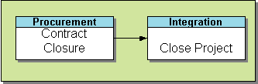
Figure 11: Closing Process Group Processes
Some of the key elements to project closeout are:
- Completion and closeout of any contractual agreements with suppliers or providers
- Formalizing customer acceptance
- Closeout of any financial matters
- Preparation of the project’s final performance report
- Conducting a project review
- Documenting lessons learned
- Completing, collecting and archiving project records
- Celebrating project success
For comparison and reference, the CPIC Steady State process steps, during which the Closing process group occurs, consists of:
- Analyze mission
- Assess user/customer satisfaction
- Assess technology
- Conduct O&M, eGov strategy and operational performance reviews (as necessary)
- Prepare investment review submission package
- Review/approve investment decision
- Review initiative and recommend appropriate action
- Make final investment decisions
A project does not generally include the repetitive and ongoing nature of system operations. But it is also clear that many project management processes should carry on through the life cycle of the system. For this reason, especially on large, multi-year, high dollar projects, project offices will continue to operate during the operational phase. Also, these offices manage small projects that are used to implement improvements to the major systems. This process is described as ‘management by projects’, which is a method to apply project management techniques to an on-going process.
It is good to understand that various life cycles and processes refer to this period of time by different names. The CPIC process calls this phase ‘Steady State.’ Processes that remain active during the operational phase are primarily related to the fiscal year funding cycle. They may include performance measurement, life cycle cost formulation, monthly status reviews, staffing planning, communication planning, and scheduling and scope management. There is also the project closeout report that should be accomplished after the initial deployment regardless of ongoing operations. USDA depends on the ‘lessons learned’ to recognize training requirements, identify and mitigate risks and improve overall project management on future projects.

IT Security
An Authority to Operate (ATO) granted under USDA’s C&A program is valid for no more than three years, or when significant changes cause an unacceptable increase in operating risk to the system, whichever comes first, thus triggering the C&A cycle. Moreover, the FISMA process requires that a self-assessment be conducted annually, that any identified security weaknesses are tracked and remedied, and that risk is continually monitored and managed in order to identify and mitigate security risks to an acceptable level. Disposal measures are required if an application is shut down.

IT Operations Considerations
Projects that will involve USDA’s telecommunications and operations infrastructure should consider the following questions:
Network Capacity Planning:
- Are the entire project’s final network performance requirements fully met?
- Are the project’s network scalability requirements scheduled?

Roles and Responsibilities
It is important to have a defined formal structure for the project and for the project staff. This provides each individual with a clear understanding of the authority given and responsibility necessary for the successful accomplishment of project activities. Project team members need to be accountable for the effective performance of their assignments and achievement of the project goals and objectives.
A successful project requires that the Project Team have the authority to complete a project, be participants (at some level) in the planning process, have ownership and buy-in to the Project Management Plan, and be responsible and accountable for completion of the project.
The roles and responsibilities of project participants will vary. The requirements placed on participants will be determined and defined during the Project Management Planning process; however the following is a good “rule of thumb” perspective:
- On a large project, individual role assignments may require full-time attention to the function.
- On smaller projects, role assignments may be performed part-time, with staff sharing in the execution of multiple functions.
- Tasking and individual responsibilities are often covered in the Organizational Breakdown Structure (OBS) as activity assignments are defined in the Planning Process Group processes. Typically these assignments are shorter term and exist only to the completion of the activity deliverable.

The Project Team and Stakeholders
A Project Team includes a diverse combination of people and skills that share the responsibility for accomplishing project goals. A Project Team may work in the same location or may be separated by distance and function as a “virtual” team (i.e., fulfill their project obligations with little or no time spent face to face). To ensure that all team members have clear expectations of proper behavior, it is important that “ground rules” be established at the beginning of a project. The project manager must employ the ground rules evenly and consistently so that employee performance expectations can be met.
Stakeholders are individuals and organizations who have a vested interest in the success of the project. The identification and input of stakeholders help to define, clarify, drive, change, and contribute to the scope, cost, timing, quality and, ultimately, the success of the project.
To ensure project success, the project management team needs to identify stakeholders early in the project, determine their needs and expectations, and manage and influence those expectations over the course of the project.
Stakeholders on every project include:
- Organizational Management, who define business needs, goals and objectives of the project as well as defining the policies and procedures governing the project
- The Project Manager, who has ultimate responsibility for project success
- The Project Team members, who are responsible for managing the performance of the project work activities. These could include:
- Project Management Team
- Business development staff
- Subject Matter Experts (SME)
- Documentation (user and technical) staff
- Training staff
- Technical staff
- Information Security Officer (ISO).
- Leaders/decision makers
- Influencers, who can influence the course of the project, whether positively or negatively, due to his/her position within the customer or performing organization.
- Project Management Office (PMO), if one exists
- The Project Sponsor, who leads in getting the need for the project recognized, as well as providing funding, enabling the resource staffing, and certifying the security of IT applications.
- The Customer, who is the person(s) or organization(s) using the product of the project and who determines the acceptance criteria for the product

Organizational Management
Organizational Management is responsible for the identification of the need and opportunity for a project, assessment of project risk, and the approval of the project’s feasibility and resources. They are also responsible for establishing the strategic plans and for validating that projects are consistent with customer and organizational requirements. Management provides close oversight for high risk or high cost projects.

MANAGEMENT ROLES AND RESPONSIBILITIES
General | Initiating | Planning | Executing | Monitoring/Controlling | Closing
Provide leadership and resources to establish and improve project management  Ensure that sufficient resources are available to conduct projects  Review and approve commitments to external entities (e.g., customers, vendors)  Ensure staff is properly trained in project management techniques and principles | Select Project Manager and assist in Project Team staffing  Review, validate and approve project charter  Authorize and provide funding | Verify that project goals and objectives are defined  Review and approve Project Management Plan, cost, risk and establish management reserves  Provide management oversight as predicated by review of the project risk analysis, risk response planning and Project Management Plan  Enable project staff availability | Regularly conduct executive management reviews and provide oversight | Review project status and corrective action plans (if required)  Review and approve changes affecting scope, timing, cost, and/or quality, as required | Validate project completion (goals & objectives)  Verify customer and sponsor acceptance  Review and close project accounting/financial files  Review project lessons learned and post project reports for continuous improvement action

Project Sponsor / Business Sponsor
The Project Sponsor is usually a member of the management team who will be the recipient of the project’s end result (the product). The Project Sponsor is typically the head of a program area. This individual makes the business argument for the project to exist, controls the overall funding of the project and defines the acceptance criteria of the product.

SPONSOR ROLES AND RESPONSIBILITIES
General | Initiating | Planning | Executing | Monitoring/Controlling | Closing
Articulate project and/or customer requirements  Validate that project requirements are met  Provide the necessary funding and resources as appropriate  Champion the project to provide exposure and buy-in  Communicate the sponsor’s views on project progress and success factors to the Project Team and other stakeholders  Define project goals, objectives and success criteria | Provide the strategic goals and objectives of the recipient organization and guidance to the Project Team to identify the relevance and value of the project  Obtain or provide funding for the project | Review and approve the Project Management Plan and management approach  Participate in planning sessions | Attend executive requirement reviews  Resolve escalated project requirements issues, remove barriers and obstacles to the project  Provide written agreement to project requirements and qualifying criteria | Attend and participate as needed at Project Status Reviews and steering meetings  Attend change control meetings and review and approve changes in scope, timing, quality and/or cost as impacted | Provide representation or input to lessons learned reviews  Sign off on project completion

Program Manager
The terms “program” and “project” management are often used interchangeably. However, within this document the two terms and concepts are separate and distinct. Program management is defined as a group or series of related projects and ongoing systems/applications managed in a coordinated way to achieve resource, cost and quality efficiencies not available to individual projects. Programs generally support strategic goals and objectives, while projects may be more targeted in focus. The Program Manager has responsibility for the management of a series of related projects and the management of the corresponding Project Managers.

PROGRAM MANAGER ROLES AND RESPONSIBILITIES
General | Initiating | Planning | Executing | Monitoring/Controlling | Closing
Plan, organize, staff, direct, control and coordinate  Recommend composition of own program team  Own and guide the program  Reward and recognize performance  Be accountable for cost, schedule, quality and scope  Resolve any outstanding issues among the Project Teams that cannot be resolved within the team  Responsibility for overall resource allocation for Project Managers assigned to the program  Maintain ongoing communication with the Project Managers from the program management level perspective  Communicate project status to fellow program managers  Ensure IT applications are developed consistently with the project management cycle  Ensure projects are managed in accordance with the recommendations for project management as outlined in the USDA Project Management Handbook  Ensure that IT security certification and accreditation (C&A) requirements are met. | Assign Project Manager and assist in Project Team staffing  Review/validate/concur on project charter  Validate and communicate individual project objectives | Verify that project goals and objectives are defined  Verify that project is aligned with the strategic goals of the program  Review/concur with Project Management Plan, cost, risk and establish management reserves  Provide guidance on cost and schedule development  Ensure project staff availability  Conduct routine program planning sessions as defined by individual’s organization | Conduct regularly scheduled project reviews | Review project status and corrective action plans (if required)  Review, concur and participate in milestone review briefings  Review/concur on changes affecting scope, timing, cost, and/or quality, as required  Prioritize any changes to project scope | Review whether stated improvements or benefits were realized from the project  Assure customer and sponsor acceptance is obtained  Review and concur on project accounting/ financial file closeout documents  Review project lessons learned and post project reports for continuous improvement action

Project Manager
The Project Manager has overall project responsibility. In order to achieve success, the Project Manager should work closely with the Sponsor with respect to staffing requirements and funding availability. The Project Manager is responsible for completing the project on time, within budget, and meeting the quality criteria and requirements.
The Project Manager should be assigned as early as possible in the life cycle of the project in order to establish project ownership and management responsibility as well as to begin the development of the project requirements from the “ground up.”

PROJECT MANAGER ROLES AND RESPONSIBILITIES
General | Initiating | Planning | Executing | Monitoring/Controlling | Closing
Comprehend and implement organizational project policies and procedures  Maintain project staff technical proficiency and productivity, and provide training where required  Establish and maintain project quality  Identify, purchase and acquire project infrastructure needs  Identify and secure Project Team resources  Serve as focal point for project communications  Ensure that IT security C&A requirements are met | Develop project concept document  Define sponsor and organizations needs  Develop Project Charter and obtain approval  Identify and document project constraints  Identify and document project assumptions  Document requirements  Review customer requirements for feasibility and available resources | Develop Project Plan, including Project Charter, Scope Statement, constraints, assumptions, WBS defining project deliverables, cost estimates and project budget, major milestones, schedule, resource requirements, acquisition/procurement plans, risk analysis and response plans, Project Team structure and communications plan. Also included will be the deliverables acceptance criteria (quality metrics) and the acceptance process.  Develop the supporting plans such as scope, cost, risk, schedule, quality, resource, security deliverables, procurement and change management plans  Obtain stakeholder approval and acceptance of the Project Management Plan  Obtain organizational commitment and support for completion of project task assignments, timing and quality  Establish baselines | Manage and monitor day-to-day activity and provide direction to team members and supporting organizations  Manage to and monitor quality targets and goals (both project and product)  Manage and monitor risk response strategies  Disseminate project information and maintain communication  Develop and update system security plan and other security deliverables  Manage, or support, purchases and acquisitions process and contract administration requirements | Develop and distribute project performance reports. Regularly review project status, evaluating performance criteria (scope, cost, schedule & quality)  Develop and manage corrective action plans  Evaluate project performance and initiate change requests as required (scope, cost, schedule or quality)  Participate in change control board to review and approve product/project changes  Review project risks and establish risk response plans  Adjust Project Management Planning, as required, to include approved changes in scope, timing, cost or quality after obtaining customer approval | Obtain customer and management approval and acceptance of completed product  Complete contract closure process  Close out open action items  Develop post-implementation report  Conduct lessons learned session and develop recommendations for continuous improvement  Close out any financial accounts or charge codes  Archive all project data  Recognize Project Team and celebrate success

Project Team
The Project Team is responsible for performing the project activities. Project Team members, as required, may assist the Project Manager with planning the project (e.g., scope and WBS) and they may also assist with obtaining commitments to complete the project within established schedule and budget constraints. Customers and/or stakeholders should interact with the Project Team to ensure that requirements are properly understood and implemented.

PROJECT TEAM ROLES AND RESPONSIBILITIES
General | Initiating | Planning | Executing | Monitoring/Controlling | Closing
Identify product alternatives  Complete the project within budgeted cost, schedule and quality requirements  Support Project Management Planning and control  Participate in identifying, mitigating, and monitoring project risks | Provide estimates for product deliverables  Analyze requirements for clarity, completeness and consistency | Develop technical approach  Participate in the development of the Project Management Plan  Participate in Scope Planning  Identify tools needed for project  Identify staff training needs | Create product and process solutions  Conduct or participate in internal and external reviews  Provide quality assurance support  Manage work effort to maintain on time, on cost and on quality results  Identify any project roadblocks, barriers or unanticipated risk events | Track the project execution effort and submit status reports (scope, cost, and schedule)  Maintain project and product quality requirements  Identify and react to risk events as they are identified or occur  Participate in change control reviews | Participate in lessons learned sessions  Identify ways to improve project processes or products (continuous improvement)  Turn over all project related documentation to the Project Manager for archiving

Customer
A Customer is responsible for communicating project needs and verifying that requirements have been met at project completion. A Customer may be internal, external or both.

CUSTOMER ROLES AND RESPONSIBILITIES
General | Initiating | Planning | Executing | Monitoring/Controlling | Closing
Articulate customer requirements  Validate that project requirements are met  Support and conduct staff training programs as required to make certain that the staff is “ready to accept” the new product  Be proponent of the new product to the customer organization | Clearly define customer needs and requirements to the Project Manager and Project Team | Review and approve Project Management Plan  Attend and participate in project requirement reviews  Assign customer personnel as project points of contact  Provide written agreement on requirements and qualifying criteria  Provide input into deployment planning | Review project status reports  Provide project support infrastructure as required | Participate with Project Team developing corrective action plans addressing variances in time, cost or quality  Communicate identified issues associated with project or product performance  Validate quality assurance of deliverables  Participate in change control process  Review and approve or escalate project changes affecting scope, time, cost or quality | Accept the completed product  Provide representation or input to lessons learned reviews

Appendix
This section contains links to several documents referenced throughout the Project Management Guide. Users can also find this information at the OCIO Project Management website.

Project Checklists
The project checklists identify the specific tasks that should occur throughout the project lifecycle, and contain links to important tools and information to be used in completing the tasks. The checklists should be used by sponsors, senior managers and project managers throughout the project lifecycle as an aid understanding the tasks required, and the timing of those tasks, to conduct projects with greater confidence in success.

Project Initiation Documents
The following documents can be used by senior managers, sponsors, program and project managers in justifying and defining the preliminary scope for a project.
Project Charter Template
Scope Statement Template

Project Plan Templates
Following are links to template documents that can be used by project managers and their teams in planning specific projects.
Project Management Plan Template
Schedule Management Plan Template
Cost Management Plan Template
Earned Value Management Cost Equations
Scope Management Plan Template
Work Breakdown Structure example
Quality Management Plan Template
Communications Plan Template
Meeting Architecture Template
Change Management Plan Template
Change Request Form Template
Risk Management Plan Template
Risk Control Form Template
Risk Management Log Template
Staffing Management Plan Template
Procurement Management Plan Template

Project Closeout Templates
The following templates should be used by the project manager when closing out a project.
Project Closeout Report Template

