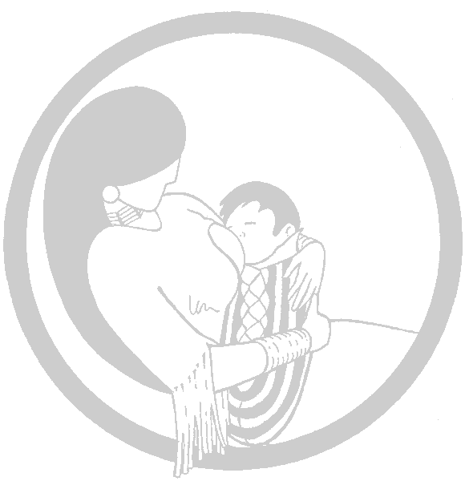

Breastfeeding as a

Diabetes Prevention Initiative

at Phoenix Indian

Medical Center
by William Daychild

Type 2 Diabetes has reached epidemic proportions in American Indians and Alaskan Natives

The growing burden of diabetes is felt throughout the world. However, minorities have higher rates than the general population. American Indians and Alaskan Natives (AIAN) in particular experience type 2 diabetes and its complications 4-6 times more often than the general population.

In response to the epidemic of diabetes, the Phoenix Indian Medical Center (PIMC), established its Diabetes Center of Excellence (DCOE) in 1998 with the goal of reducing the impact of diabetes among its clients. PIMC is an Indian Health Service (I.H.S.) medical facility, serving Native Americans in Arizona and parts of Nevada, New Mexico, Utah, and California. PIMC consists of 134 bed hospital and extensive outpatient clinics.

Breastfeeding as a type 2 diabetes prevention intervention
Breastfeeding was chosen by DCOE as one of the interventions to help reduce the impact of diabetes after a study by the National Institutes of Health (Pettitt, et al) suggested that people who were breastfed as infants for at least 2 months were less likely to have diabetes as adults than people who were fed formula.

The mechanism of the protective benefit of breastfeeding on type 2 diabetes is not known. One reason for the higher risk of diabetes may be that formula feeding is associated with childhood obesity. In a study of almost 10,000 Bavarian school aged children, breastfeeding was associated with lower rates of obesity.

Because breastfeeding is an intervention that can be done for a fairly short period of time, and yet have life-long benefits, it appears to be an ideal primary prevention intervention. If real life experience continues to confirm the benefit seen in these studies, then breastfeeding may become an intervention against diabetes, similar to early childhood immunizations for prevention of infectious disease.

Designing a Breastfeeding Intervention for AIAN
The DCOE began by evaluating breastfeeding practices and issues for PIMC families. The following was learned:
- Families tend to be slightly younger and have more children than the general population.
- Misinformation and lack of effective problem solving were common barriers to successful breastfeeding.
- A major enhancer to breastfeeding was that PIMC staff and patients both identified breastfeeding as a traditional and culturally appropriate food for their children.

With this knowledge, in October 1999 the Breastfeeding Intervention was designed to provide:
- Readily available breastfeeding support
- Standardization of breastfeeding information and messages
- Collaborative support with community and tribal services used by families

To achieve these objectives, the following were established:
- “24-7” breastfeeding hotline
- Daily breastfeeding consultant coverage for the maternity and pediatric floors, pediatric and Women’s clinics, postpartum follow-up
- Provide information about the obesity and diabetes risk reduction of breastfeeding during initial prenatal care visit
- Weekly breastfeeding drop-in classes, coordinated with WIC so that their prenatal participants can attend
- Breastfeeding classes – offered as an evening monthly class
- Standardization of breastfeeding support information used at PIMC
- Staff in-services offered in multiple formats
- Establishment of a breastfeeding registry to track patients and provide monthly incidence/duration rates
- Monthly progress reports for staff regarding PIMC breastfeeding incidence and duration rates
- Collaboration with Inter-Tribal Council of Arizona (ITCA), WIC and tribal clinics to encourage seamless coverage and uniform information
- Establishment of policy for employees to breastfeed and designated private pumping area for use

During the Breastfeeding Intervention’s first year, the following has been noted:

- Trendlines for breastfeeding initiation and 8 week duration rates indicate an increase of 5 and 10% respectively for all PIMC deliveries
- The rate of mother/infants who start out breastfeeding and stop before 8 weeks has dropped from 30% to 25%
- An observation first noted during planning assessments - as parity increases, incidence and duration of breastfeeding decreases - continued.

Plans for the future include:
- Expand networking within communities to improve patient follow-up and provide technical support/information sharing
- Initiate peer counseling, formalized support groups and increased networking
- Assessment of why and when our mothers begin using formula while breastfeeding, and why higher parity is associated with less successful breastfeeding
- In collaboration with NIH, completion of video, "Close to the Heart" and supporting education materials that shares information about the diabetes risk reduction for benefits of breastfeeding for Native Americans. These materials will be available upon request by 1/01/02, free of charge. Please call 1-877-868-9473,

The PIMC DCOE Breastfeeding Initiative is seeking to increase breastfeeding and the awareness of breastfeeding’s potential for reducing obesity and the risk of type 2 diabetes. For more information or to share ideas, please contact us at:

Phoenix Indian Medical Center 602-263-1200 X1896
Diabetes Center of Excellence or Breastfeeding Toll-Free Hotline
4212 N. 16th Street 1-877-868-9473
Phoenix, AZ 85016 Email: Suzan.Murphy@pimc.ihs.gov
Attn: Sue Murphy

