USDA OCIO Integrated IT Governance Process

Investment Planning and Review Guide
v. 2.0

DRAFT as of 6/11/2007

Table of Contents
PREFACE 3
1.0 BACKGROUND 3
1.1 Introduction 3
1.2 Integrated IT Governance Process and Investment Planning and Review 3
1.3 Investments and Systems 3
Special Investments 3
1.4 Updated Investment Planning Process 3
Framing Investments in your Portfolio 3
Capital Planning 3
Cost/Schedule Reporting and Earned Value Management (EVM) 3
IT Acquisition Approval Process 3
Other IGP for IT Components 3
1.5 How to Use this Guide 3
2.0 PORTFOLIO PREPARATION 3
2.1 Introduction 3
2.2 Documenting the Budget Year Investments 3
New Portfolio Requirements for FY2009 Investments 3
OMB Exhibits 3
2.3 Acquisition Approval and IT Investment Planning 3
2.4 Cost/Schedule Reporting, Earned Value Management (EVM) and IT Investment Planning 3
2.5 System Development Life-Cycle (SDLC) and IT Investment Planning 3
2.6 Enterprise Architecture (EA) and IT Investment Planning 3
2.7 OCIO Contacts 3
3.0 PORTFOLIO REVIEW 3
3.1 Introduction 3
3.2 Reviewer Responsibilities 3
4.0 PORTFOLIO APPROVAL AND SUBMISSION TO OMB 3
4.1 Introduction 3
4.2 E-Board 3
4.3 E-Board and OMB Scoring 3
4.4 OMB “Passback” 3
4.5 Additional Required Documentation 3
4.6 IT Acquisition Approval and the Review Process 3
REFERENCES 3
Appendix A: Agency Points of Contacts 3

PREFACE
The purpose of the Investment Planning and Review Guide is to provide guidance for implementing the Integrated IT Governance Process (IGP for IT) for Information Technology (IT) in the United States Department of Agriculture (USDA). The IGP for IT is currently being promoted and established by the USDA Office of the Chief Information Officer (OCIO) to provide a dynamic means of capturing, retaining, and presenting IT investment information so that the OCIO has the necessary tools to carry out legislated mandates.
This Guide provides instructions for the investment planning and review process, defining specific requirements for all investments during the submission and reviews of investment documentation. It supports the OCIO’s IGP for IT by providing the guidance necessary to successfully execute the investment planning and review phase of the process. By following the instructions in this Guide, USDA will have better investment planning, better reporting, and more visibility into where and how their IT budget is being spent.
This investment planning and review guide is designed for use for all major and non- major investments. The users of this guide include agency Chief Information Officers (CIOs), project managers, and portfolio managers.
January 2007 marks the beginning of planning the budget for the FY2009 investments. In 2007, OCIO is beginning the investment planning and review process earlier in the year (beginning in January instead of April) than it has been in the past to accommodate the new direction of the IGP for IT.
This Guide is one document in a suite of documents (Figure 1) that will provide the necessary structures, policies, processes, roles, and responsibilities for implementing the IGP for IT.

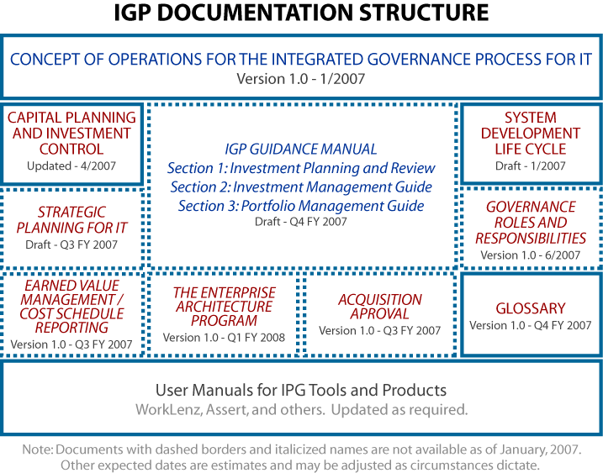

Figure 1
Agency IT investment portfolios must meet the following criteria:
- USDA IT investments must be framed so that each investment has an exclusive relationship to one system or a set of related systems. Agencies cannot have a portfolio that contains multiple investments tied to one system, in other words, a system cannot span two or more investments.
- Investments should consist of one or more systems that have the same primary Business Reference Model (BRM) classification.
- Full life-cycle system costs must be considered.
- Life-cycle cost information will be captured at the system level and automatically rolled up to the parent investment level to generate Office of Management and Budget (OMB) exhibits and other OCIO reports.
- Information must be consistent with:
  - the USDA Enterprise Architecture (EA) criteria
  - Cyber Security criteria
  - The IT Acquisition Approval (AA) Process and
  - The Capital Planning Investment Control (CPIC) processes.
- Investment documentation must be consistent with the expectations and standards set forth herein so that submitted investments can be reviewed against a clear set of criteria.

1.0 BACKGROUND

1.1 Introduction
The Information Technology Management Reform Act (ITMRA) of 1996 (also known as the Clinger-Cohen Act of 1996 and 40 U.S.C. 1401(3)), established that Federal Government CIOs have primary responsibility for supervision and coordination of the design, acquisition, maintenance, use, and disposal of information technology by their agencies, and for monitoring the performance of IT programs and activities.
The Clinger-Cohen Act requires executive agencies to develop a CPIC process for making technology, budget, financial and program management decisions. While each phase of a sound investment process has its own requirements for successful implementation, there are some overall organizational attributes that are critical to successful investment evaluation:
- Senior management attention
- Overall mission focus
- A comprehensive, enterprise-wide approach to IT investment.
The success of USDA IT investments is critical even beyond the requirements of law, because the IT systems and infrastructure that USDA uses directly influences its ability to deliver citizens’ needs for services and performance.
The OCIO is responsible for overseeing all IT investments and the IT spending for USDA. The OCIO is currently engaged in an ongoing effort to establish, maintain, and support an integrated IT investment analysis and decision-making environment.
OCIO is establishing an IGP for IT to ensure “line-of-sight” from investment planning through closeout, eliminate redundancies, and ensure that budget dollars are being spent on projects that are beneficial to the Agency. USDA IT investments must both support the USDA mission and advance the USDA EA.
Investments must be carefully managed. The IGP for IT will provide OCIO the ability to review projects throughout their development and implementation. If a specific project begins to falter or is being poorly managed, agency leadership will be able to intervene earlier and more effectively in the project’s life cycle than has been done in the past. If mismanagement persists, the investment’s budget for the following year will be jeopardized.

1.2 Integrated IT Governance Process and Investment Planning and Review
The IGP for IT is a cyclical process for all IT investments and includes three major elements: investment planning and review, investment management, and portfolio evaluation. Agencies stand to benefit from the establishment and enforcement of the IGP for IT. By adopting the process, agencies will have more help available to them as they prepare and submit investment documentation and will eventually prepare and submit better business cases—business cases that avoid ending up on the OMB “watch list.” The IGP for IT provides discipline and rigor to the investment planning process and allows for the tracking of every investment throughout its full life cycle. Detailed information about the overall IGP for IT is provided in the IGP for IT ConOps. The ConOps can be found on the OCIO website at www.(conops link)ocio.usda.gov. (when available, include link here and whenever site is mentioned throughout document)
The first element in the IGP for IT is Investment Planning and Review (Figure 2). Every year the USDA OCIO prepares an IT budget for future IT spending based on data provided by agencies. A memo that listed the required actions and documentation for the agency’s investments as well as schedules, was sent from OCIO to all the USDA agencies. This memo signaled the start of the investment planning process in April. Beginning in 2007, OCIO is initiating the investment planning process in January with the publication of this guide and the ConOps. The earlier start date provides more time for organizing, collecting and integrating IT data across disciplines such as CPIC, EA, Cyber Security, and Acquisition Approval (AA). The integrated process involves a deeper degree of review and analysis, thus more time is needed for these activities before the budget is finalized and submitted for approval to OMB in September.
Investment planning and review involves three major steps:
- Document preparation and submission by the agencies
- An iterative cycle of Investment review to ensure the quality and appropriateness of the investment
- Investment approval for submission to OMB.
The documentation preparation and submission step includes the tasks agencies undertake in preparing documentation (in the form of OMB Exhibit 300 and OMB Exhibit 53, prepared in WorkLenz) to support their investments in information technology (hardware, software, services). New investment documentation is prepared and existing investment documentation is updated to comply with CPIC, Federal Enterprise Architecture (FEA), Presidential Initiatives (PI), and Line of Business (LoB), EA and Earned Value Management (EVM) requirements in preparation for review by OCIO, OCFO and submission to Enterprise Change Control Board (ECCB) and the Executive Board (E-Board).
Agencies may be asked, upon submission of their business cases to OCIO, to continue to provide additional documentation for investments if OCIO requires them to make a stronger case for the investment. This may occur at any point in the review cycle. It is important to note that at any point in the review cycle, if a reviewing body finds that documentation is incomplete, agencies will need to provide the additional investment documentation as requested.
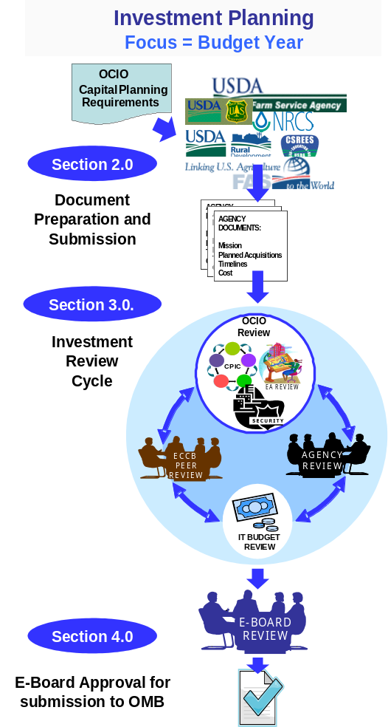
When an agency submits its investment documentation to the OCIO, the investment review cycle described in Figure 2 begins. The review within OCIO and OCFO involves review of investment documentation for CPIC, Security, EVM, AA, and EA requirements. The documentation that agencies prepared is subsequently reviewed from multiple perspectives and in several iterative review cycles. These reviews occur on an ongoing basis typically from March through July. During this time period, qualitative analyses of the documentation occur to determine alignment of the investment with USDA’s strategic plans, agency mission, and the USDA target EA. During this time, OCIO meets with agency leadership and OBPA to discuss the review results and present requirements for improvement and completion of the documentation.
Once the cycle of reviews is complete, documentation on projects along with OCIO’s recommendations is submitted to the E-Board for consideration before inclusion in the USDA portfolio. The E-Board review is crucial in determining funding for an investment. The E-Board review is the final step prior to submission of the USDA portfolio investment to OMB. Upon completion of the IT review, the E-Board, either approves, disapproves, or returns the investment to the agency for additional work.
Every IT investment that will require funding in the designated budget year must go through the planning and review step. That is, planning and review is independent of where the investment is in its life cycle. New investments, investments under development, and investments in the steady state of maintenance and operations must all pass through this process on an annual basis.
Figure 2

1.3 Investments and Systems
An investment is the funding mechanism for an IT project. It is through the accumulation of approved IT investments that the USDA budget for IT is identified in USDA’s budget submission to OMB. The “IT budget” is not typically a separate line item in USDA’s budget submission; it is essentially a categorization of how a portion of each agency’s programmatic or discretionary funds will be allocated.
Every USDA IT investment must meet two criteria: the investment must support the accomplishment of the Departmental and agency missions and it must support the advancement of USDA’s enterprise-wide IT infrastructure.
A system is a discrete set of information resources organized for the collection, processing, maintenance, use, sharing, dissemination, or disposition of information. It is comprised of data, assets (such as personnel, equipment, funds), and processes, it is a collection of components organized to accomplish a specific function or set of functions. Ideally, an investment is made up of one system. Exceptions to this general rule can be made for investments that address more than one system; however, in such cases, the systems involved must be structurally related as elements of the same effort.
The agency’s IT Investment Portfolio is made of all the agency’s major and non-major investments. The factors that differentiate a major investment from a non-major investment are listed in the text box to the right. The USDA IT Investment Portfolio (also known as the Department’s Portfolio) contains all agency portfolios. An OMB Exhibit 53, which contains the USDA IT Investment Portfolio information, is compiled at the OCIO level and submitted to OMB.
MAJOR INFORMATION TECHNOLOGY INVESTMENTS
Major investments meet at least one of the following criteria:
- Total life-cycle costs greater than $50 million or life-cycle Development/Modernization/Enhancement (D/M/E) funding of $20 million or more,
- Financial systems with costs greater than $500,000 per year in FY 2006 or later.
- Identified by the USDA OCIO as critical. This may include systems that:
  - Are mandated by legislation or executive order.
  - Require a common infrastructure investment.
  - Are considered strategic or mandatory-use systems
  - Significantly differ from or impacts on the Department infrastructure, architecture, or standards guidelines
  - Require significant multiple-agency funding.

Special Investments
Some investments are shared by multiple USDA agencies and/or departments and agencies outside of USDA. These special investments, such as e-Gov investments, have unique requirements that must be addressed within the documentation.
For some of these special investments, collaboration by agencies to prepare an interdepartmental business case might be required. For example, The USDA Forest Service and the Department of Interior share an investment. When an investment is shared one organization must accept ownership. That organization is then responsible for preparing the business case, but each contributing organization must reflect their dollar amount towards the contribution within its own portfolio.
Special investments can lead to special circumstances, for instance, when three agencies share one investment and collectively provide funding for this investment, only one agency, the owner of the investment, will be required to submit appropriate investment documentation. In such cases, OCIO works with the agency to ensure that investment documentation is handled properly. OCIO must pay close attention to special investments and ensure that “double counting”, inclusion of funding amounts twice for the same investment, does not occur. For questions regarding a particular special investment, contact OCIO directly as each case will involve unique information.

1.4 Updated Investment Planning Process
The investment review planning process in FY 2007 is modified as follows:

Framing Investments in your Portfolio
Beginning January 2007, agencies will begin meeting with OCIO representatives to discuss how to analyze and frame their portfolio of investments. Prior to meeting, OCIO will have reviewed an agency’s portfolio and will identify those investments that would benefit from reframing and make recommendations on how to reframe them.
In this context, reframing an investment means restructuring its composition to ensure and support the “Line-of-Sight” capability underpinning the new IGP for IT principles. Two guidelines will be followed in this process of investment review and reframing.
- Every USDA information system must now be clearly tied to a single investment.
- Therefore, a valid system-to-investment relationship is defined as:
- One investment may include one or more systems.
- Conversely, an invalid system-to-investment relationship is defined as:
- One system cannot span two or more investments.

- In those cases where an investment includes more than one system, the “family of systems” should align with the same investment Line-of-Business (LoB) and map to the same Primary Business Reference Model (BRM) classification.

This focus on information systems as units of investment management means that additional information will now be collected at the systems level and additional analyses will be undertaken.

Capital Planning
New data elements are required for every investment. The Investment Planning and Review guide covers both major and non-major investments. New investments will be evaluated against existing investments to phase out unnecessary redundant efforts.
More time will be allowed for planning and review, with the process beginning in January instead of in April or May.
All IT systems that will require resources in the designated budget year—including those systems in steady state maintenance and operations—must participate in the IGP for IT, beginning with planning and review.

Cost/Schedule Reporting and Earned Value Management (EVM)
Beginning in January 2007, there will be new cost and schedule tracking requirements for all investments. All investments—including non-majors—will now report regular cost and schedule performance data through WorkLenz. Currently, selected major investments report monthly EVM data through WorkLenz. The OCIO is preparing guidance to help project managers of non-major investments utilize WorkLenz for project performance monitoring. WorkLenz has the capability to capture cost and schedule data at the system and investment level.
For investments that fall under the EVM threshold (as described in the CPIC guide), cost and schedule data will be tracked to determine performance and progress of the investment. Performance of an investment is measured by determining the budgeted cost of work performance and comparing it to the actual cost of work performed (i.e. actual cost). Progress is measured by comparing the planned schedule to the actual schedule of the project.
EVM is a project management methodology for integrating scope, schedule, and resources, and for objectively measuring project performance and progress. All newly designated major investments that meet USDA’s criteria for EVM are required to be EVM compliant. The EVM requirements include:
- Reporting EVM Cost and Schedule Variances monthly
- Providing evidence of EVM clauses in applicable contracts, and
- Compliance with EVMS ANSI-748-A Standards.
- All applicable major IT investments must provide data using WorkLenz that will produce EVM reports by the 5th working day of each month. WorkLenz has been upgraded and EVM reporting enhanced to include:
  - Work Breakdown Structure (WBS) functionality and
  - Linking of Project Cost and Schedule data to WBS
- Corrective actions for cost or schedule variances that are either 7% over budget or behind schedule, for three consecutive months..

IT Acquisition Approval Process
The IT Acquisition Approval (AA) process was established by OCIO as a tracking mechanism for IT acquisitions to improve accountability and provide a reference for individual procurements. The process provides insight into Department wide IT spending, helps define baseline and helps identify trends. This process allows agencies and USDA staff offices to identify and address cross organizational redundancies to improve program efficiencies and allows agencies to leverage existing resources to reduce costs and strengthen their knowledge base.
The AA process is being revamped as part of the IGP for IT. New templates are currently under development and will be used to capture and record the required information.
All investments will now complete an Acquisition Plan template in WorkLenz. A new template is being developed to help project managers pre-populate the plan during the annual investment planning and review cycle and connect in one place the investment planning and acquisition management information upon which acquisition approvals are requested and considered. This approach eliminates the need for agencies to resubmit investment justifications for investments that were approved for inclusion in their IT investment portfolio at the conclusion of the investment planning and review stage unless the investment is materially changed by the agency between the investment approval and acquisition request stages.
Analysis will be completed on integrating the AA process within Integrated Acquisition System (IAS) to streamline the process and maximize data reuse.

Other IGP for IT Components
Other IGP for IT Components that will undergo changes as the integrated IT governance process is rolled out include:
- Enterprise Architecture Repository (EAR) - More detailed information—for instance, on technology standards and products and data architecture—will be entered into the EAR. This information will allow a better review of proposed investments against USDA’s existing infrastructure assets and target architecture. This process will, of course, require close coordination with agencies, through the agency architects.
- System Development Life Cycle (SDLC) - A USDA SDLC is under development.
- Life Cycle Cost Categories - Updated Life-cycle Cost Categories/ Budget Object Classification (BOC) mapping will be provided later for the FY 2009 cycle to ensure more complete life cycle cost projections and ensure consistency with the CFO’s requirements for this data.
- Business Transformation - A USDA Business Transformation Blueprint and a Configuration Management plan will be developed at a future date.
- ECCB - The ECCB plays a significant role in the review of USDA IT investments and in the review of the overall USDA IT portfolio.
How these new changes affect the planning and review of investments are detailed in the following chapters.

1.5 How to Use this Guide
This document provides the guidance for the first portion of the IGP for IT’s annual cycle, the planning and review (Figure 2) and gives guidance to agencies on how they must frame their IT investments around systems. Guides for the subsequent phases— investment management and portfolio evaluation—are currently under development. The guidance provided in this document supplements the ConOps and should be used in conjunction with the SDLC Guide, the EA guide, CPIC guide, and the rest of the investment guidance documents (Figure 1).
In addition, the guidance details the investment information required to track each investment though the other IGP for IT phases. This IGP for IT aims to provide “line-of-sight” for investments from planning through closeout. The chapters in this Guide provide instructions for agencies to successfully get through the investment planning and review process.

2.0 PORTFOLIO PREPARATION

2.1 Introduction
Beginning in FY 2007, with planning for budget year 2009, USDA is requiring a greater amount of investment information for all investments, both majors and non-majors. Non-majors will now be required to provide additional information and in a greater level of detail than was previously required. In FY 2006, the required information on non-major investments was collected in the form of Budget Supplementary Data (BSD) sheets on Excel spreadsheets. Eventually, this information will be populated directly in WorkLenz but in the interim, it is provided in the form of spreadsheets.
In the past, capital planning for IT focused only on major investments. Guidance in the CPIC guide for major investments articulated OMB’s requirements. OMB pays close attention to major investments, and requires that extensive business case support for them be provided by investment owners.
Details on how to prepare the documents for major investments can be found in the CPIC guide. Traditionally, however, less scrutiny was placed on non-major investments and thus less information was required for these non-major investments. Investment owners are already aware that all major IT investments must be entered into WorkLenz. Text Box 1 on page 9 lists the OMB criteria for major IT investments.
The purpose of this WorkLenz requirement is to ensure that a single, automated repository exists in which data on all USDA IT investments appearing in the Department’s IT Investment Portfolio (OMB Exhibit 53) can be found. This repository will allow “single entry—multiple use” functionality of the Department’s IT investment business data, eliminating or substantially reducing the Department’s need to issue several, disparate data calls and their related reporting burden to agencies.
The documentation that agencies produce includes OMB Exhibits 300, OMB Exhibits 53, and supporting documentation. Supporting documentation can include acquisition plans, risk management plans, and security plans.

2.2 Documenting the Budget Year Investments
Documenting the Budget Year investments in January 2007 occurs after OCIO has conducted an assessment of agency investments to determine the need to engage in modifications as described in Chapter 1. In planning the FY2009 portfolio, each agency should:
- Review their existing IT portfolio for its value and for the prioritization of its initiatives.
- Have an assigned portfolio manager who collects all the IT related information and who updates an existing agency portfolio (or creates a new one if one does not exist).
- Have one-and only one-portfolio.
- Have access to WorkLenz where this information should be documented.
The portfolio manager should make recommendations about which investments should be continued, enhanced, or discontinued. These decisions should be made in light of the EA view of USDA’s “to-be” architecture, especially with an eye for eliminating redundant investments.
As early as January 2007, agency IT portfolio managers will review all their agency’s major and non-major investments proposed for FY2008. Prior to this time, agencies have prepared documentation for the review. These investments should have been documented in WorkLenz and should have been submitted to OMB for a proposed budget review in September, 2006.
In November 2006, OMB returned the USDA’s proposed portfolio with passback information that included revised budgets for major and non-major investments as well as evaluation scores for the major investments’ business cases. All agencies should have documented new budgets as well as other additional information as specified by OMB in WorkLenz by December 29, 2006 for the President’s Budget for FY2008. The January agency portfolio should have been updated to reflect this information and this FY2008 portfolio is the now the basis for the FY2009 portfolio.
The FY2009 portfolio will include additional information on all investments, as well as information on a new category, that is, the systems that are documented in these investments.
For help in formulating the FY2009 portfolio, USDA is conducting monthly Project and Portfolio Managers Meetings. These are held on the last Wednesday of each month. The meetings are held from 1:00 to 2:30 Eastern Standard Time in the Washington, DC in the South Building, room S-107. There are conference call numbers available for off-site attendance. For more information, please email eva.desiderio@usda.gov. For help with WorkLenz, please call Métier at 202-965-9500 or email pmousda@metier.com. For agency contacts on CPIC, please see appendix.

New Portfolio Requirements for FY2009 Investments
The FY2007 planning and review process has several new requirements for the preparation of the 2009 investment portfolio.

Changes Affecting New Investments
New investments established for FY 2009 must be evaluated against all existing USDA investments, including cross-agency and cross-department investments. The goal of the evaluation is to identify whether functions are the same as or similar to the newly proposed functions already exist within the USDA portfolio. If similar or identical functions exist, then the existing function is evaluated to determine whether its potential can help USDA avoid redundancy and duplication. New investments must make a compelling case that no existing investment can be re-used in part, or in full, as part of the pre-select approval process.

Changes Affecting All FY2009 Investments
There will be changes to the WorkLenz Investment Identification (ID) Numbers. WorkLenz currently has a unique four-digit identification number for investments. WorkLenz will be modified to add two more numeric characters to the investment ID code to create a six-digit unique identification number for each of the investment's systems/applications. For instance, an investment with last year’s WorkLenz code of 1234 will now have a code of 123400 and its first system described in that investment will have a code of 123401.
This six-digit number will also be added to the EAR records to better align EAR investment technical and business applications to WorkLenz systems/applications. This unique code will also be tied to Assert records (Cyber Security System) for alignment. The investment and system information will be integrated using this code with the AA process through the Integrated Acquisition System (IAS) and EAR. In addition to collecting information on systems, USDA is integrating the IGP for IT components of EA and Acquisition Approval through the documentation entered in WorkLenz.

Expansion of Life-cycle Cost Categories
OCIO is currently working with the OCFO to align life-cycle cost categories with budget activity codes. In order to accomplish this alignment it will be necessary to expand the life cycle cost categories from the current 19 D/M/E and SS categories. The expanded categories will result in primary and secondary categories. OCIO is working with Metier to enhance Worklenz to incorporate the secondary categories into the life cycle cost tables.
The primary categories will be the same as they have been in the past unless modified by OMB. Several of the primary categories with have secondary categories. For example the D/M/E Support Service category will have the following secondary categories:
- D/M/E - Support Services Commercial Hosting and Network Services
- D/M/E - Support Services Training Services
- D/M/E - Support Services Security Services
- D/M/E - Support Services General
- D/M/E - Support Services C&A Services

There will also be other secondary categories that will stand alone that are not associated with a primary category. The standalone secondary categories capture agency costs associated with NITC, ITS, NFC, and UTN services. These standalone secondary categories include:
- SS - UTN Services
- D/M/E - UTN Services
- SS - NITC Hosting and Network Services
- D/M/E - NITC Hosting and Network Services
- SS - NFC Hosting and Network Services
- D/M/E - NFC Hosting and Network Services
- SS - ITS Hosting and Network Services
- D/M/E - ITS Hosting and Network Services

The cost information associated will secondary categories will remain in Worklenz for USDA’s internal use only and will not be reported to OMB. For those primary categories with secondary categories, the secondary cost category data will roll up to the primary cost category data. For standalone secondary categories the cost data will not roll up.
System cost category data will roll up to create the investment cost category data for the OMB Exhibit 300 and 53 life cycle cost data.
Expanding the categories will provide a better alignment to the USDA budget object classifications to improve data reuse between capital planning, budgeting and finance. Recording this information at the system level will provide better insight into the cost of system ownership.

OMB Exhibits
The agency and USDA portfolios and their contents are reviewed on the agency, USDA, and federal level (OMB) through the use of WorkLenz reports and exhibits. There are two IT exhibits that are used for review, the OMB Exhibit 300 and OMB Exhibit 53. They were designed by OMB and their format, content requirements, validation checks, and submission process are described in OMB’s Circular A-11 which can be found at http://www.whitehouse.gov/omb/circulars/a11/02toc.html.

Major Investments and the OMB Exhibit 300
OMB requires that all investments designated as major investments (CPIC Guide) submit a business case, or Exhibit 300. This exhibit presents a case as to why an investment should be funded. The Exhibit 300 includes documentation requirements for a risk management plan, security plan, privacy impact assessment, and acquisition plan.
OMB requirements for the Exhibits 300 are announced via email to CIO Council members each year. Changes come in the form of updates to the Circular A-11 that can be downloaded from OMB’s website at http://www.whitehouse.gov/omb. Generally, OMB requirements change from year to year. These updates are entered into the revised CPIC documentation when they are received by USDA (generally around April). The guidance for preparing OMB Exhibits 300, and OMB requirement for major investments, is provided in great detail in the annually updated USDA CPIC guide.

OMB Exhibit 53
The OMB Exhibit 53 is prepared for the entire portfolio and consists of information about all investments. Information from WorkLenz’s Life Cycle Costs worksheet for non-majors and the Exhibit 300s within WorkLenz are captured in the Exhibit 53 (produced in WorkLenz). The Exhibit 53 shows, line by line, all the investments, major and non-major, included in the USDA portfolio. In USDA, there are two levels of Exhibit 53s that reflect the two levels of portfolios, agency and Department. This exhibit shows not only investment names but also their descriptions, their UPIs, their financial and security percentages, their relationship to EA and Homeland Security, their funding sources, Certification and Accreditation (C&A) of their systems, and qualification levels of their project managers. This exhibit is used to show the total amount of IT spending per year and whether this total is for development or for operations and maintenance.

WorkLenz and OMB Exhibits
Information for USDA portfolio and agency investments are captured and managed within WorkLenz. This system continues to be the primary tool for investment documentation within USDA.
When portfolio and project managers document investment information in WorkLenz, they are required to use a form called the Life Cycle Cost (LCC) spreadsheet. Some information for the OMB exhibits is collected through the use of the LCC data entry form in WorkLenz. When the user first documents or updates the investment information, he/she uses this form to answer questions about the investment. These answers are used to complete information for both OMB Exhibits 300 and OMB Exhibit 53. Since the information is coming from one source, the LCC, the information that is used is the same for both exhibits and is therefore consistent. For example, one of the questions asks the user for which Federal Agency is this investment and when the user answers “USDA,” then WorkLenz inserts “005” for the first three digits of the investment’s Unique Project Identifier (UPI) code.
Once the LCC is completed, the investment, whether it is a major or non-major, becomes a line item on the OMB Exhibit 53. When the user indicates that the system is a major system, WorkLenz inserts “01” into the UPI and at the same time begins an OMB Exhibit 300 for the investment. The user then must also finish completing the OMB Exhibit 300 that was generated by WorkLenz through the LCC.
The following data elements are currently being generated and collected in the LCC and are used to pre-populate both OMB exhibits:
- Budget Year UPI
- Previous Year UPI, if different from the Budget Year’s UPI
- Investment Title
- Investment Description
- Primary FEA Mapping – Line of Business or Service Type
- Primary FEA Mapping – Sub-function or Service Component
- Percentage Budget Formulation (BF)
- Percentage Budget Execution (BE)
- Percentage Financial
- Percentage IT Security
- Supports Homeland Security
- Development/Modernization/Enhancement (DME)
- Steady State (SS)
- Investment C&A status
- Project Management Qualification Status
- Funding Source
- Funding Source Subtotal

Please note: OMB has increased their validation checks. For instance, the three percentages that make up the BF, BE, and Financial total together cannot exceed 100%. There are other similar checks like these that will be incorporated into WorkLenz Version 5.0.
This year the LCC will have extra items to be completed by the user. For instance some of the data that was collected on for the BSDs will be included in the LCC instead of on the Excel spreadsheets.
Concurrent with the establishment of new IT budget reporting requirements, Métier is migrating USDA data to the new Version 5.0 of WorkLenz. To make this transition easier, AgLearn will be offering Computer Based Training courses for all WorkLenz users.
To register, new WorkLenz users should contact Hien-Hoa Nguyen, 202-720-5786. In addition, the new WorkLenz users guide has been posted on the USDA OCIO website.
WorkLenz was recently modified to match the USDA’s new requirement of framing investments around systems. Figure 2 illustrates the new WorkLenz Version 5.0 taxonomy in comparison to the previous version. The WorkLenz taxonomy is the hierarchical data structure that allows for different types of data to be comparable in the system. Previously, the taxonomy did not have the appropriate USDA terms and did not have “system” as a subset of investment. The “Portfolio” now refers to the specific USDA portfolio and “Programs” are now agencies listed by their name. “Projects” are now “investments and “systems” have been added to support the reframing of investments by allowing them to be divided into systems. As you will note, data can now be collected by using the task breakout for investments as well as for systems.

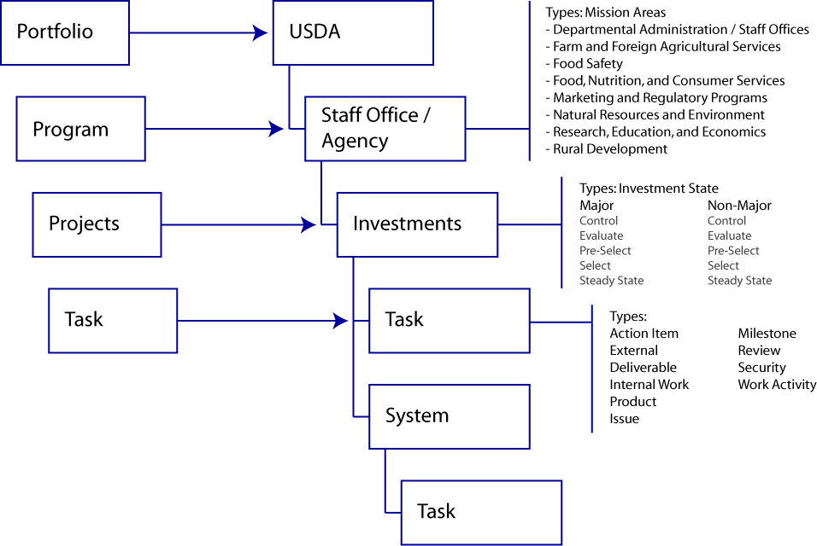

Figure 3: WorkLenz Taxonomy

Please note that WorkLenz now includes terms such as USDA portfolio, agencies, and systems instead of programs and projects.

Non-Major Investments and the Life-Cycle Cost Worksheet
OMB requires agencies to provide them with dollar amounts for all IT spending. To have “line-of-sight”, OCIO now requires additional information for non-major investments.
A new template is being developed to help project managers identify which information fields within WorkLenz now will apply. This new information maintained in WorkLenz will allow OCIO to phase-out and then eliminate several data calls that occur regularly, beginning with the Business Supplemental Data (BSD).
Non-major investments will require more information to be captured on the life-cycle cost worksheets in WorkLenz including:
- Additional narrative sections
- Expanded Life Cycle categories
- Template within WorkLenz for non-majors (beyond the existing Life Cycle Costs worksheet)
- Cost and Schedule tracking and reporting

In 2006, for BY 2008, OCIO requested additional info that was not asked for in WorkLenz’s life-cycle cost worksheet for non-majors. The supplemental information was provided in BSDs. The information that was requested on BSDs, not previously available in Worklenz will now be available in the tool for BY 2009. FY 2008 info submitted on BSDs will be backfilled into WorkLenz. The information that will be requested is as follows:

Existing Fields in WorkLenz for LCC | New Fields in WorkLenz for LCC (previously found on BSDs)
Investment Name | Dept. Agency or Staff office
Investment Description | Investment Phase
Federal Agency Code | What Type(s) of Data does this investment support?
Bureau Code | Describe the software used (e.g., operating system, software tools including version)
Part # of Exhibit 53 | What is the expected investment outcome?
Mission Area | Agency or contractor operated?
Type of Investment | Contact information for program/project manager or point of contact
Investment Identifier | Does this investment support a PART-assessed program?
Is this one of the President’s Management Council’s E-Gov initiatives? | Is this investment identified in the EAR?
Line of Business or Service Type | Total investment cost
Sub-Function or Service Component | Type of acquisition contract (e.g. BPA)
Budget Year Unique Project Identifier (UPI)(Automatically generated by WorkLenz) | Which component of the PMA does this investment support?
Prior year UPI | Does this investment utilize USDA’s ESS?
Homeland Security Project Identifier | Are the support contractors compliant with USDA information security requirements?
Budget Formulation Percentage | Is the investment compliant with USDA information security requirements?
Percentage Financial | Is the investment compliant with National Archives & Records Administration (NARA) requirements?
Percentage IT Security | List each system that is associated with this investment
Investment C&A Status | Is EVM being used on this investment?
Project Management Qualification Status
Life Cycle Costs Data Source
Project Data Funding Sources
Project Data OMB MAX Account
Life-cycle Costs Table
Project Plan Data

WorkLenz and Enterprise Architecture Repository (EAR) Functionality
WorkLenz provides day-to-day tools for assisting USDA senior managers make better investment decisions based on the current and target architectures, and the planned investments to support them.
While WorkLenz is the repository of the USDA IT Investment Portfolio, the EAR is used to identify redundancies and also opportunities for project or component collaboration and reuse.
The EAR is connected to the investments that are documented in WorkLenz through the WorkLenz assigned investment number. This number is generated by WorkLenz and it is assigned to each major and non-major investment in both WorkLenz and the EAR.
Reframing of Investments will require that the changes made to Worklenz will also need to be made to EAR to ensure the two repositories are aligned.
In order to support the higher level of analysis and planning required for investment planning, the information in the USDA EAR must be expanded beyond the current FEA classifications associated with the Business Reference Model, the Service Reference Model, the Performance Reference model, and the Technical Reference Models. These classification models are a sophisticated indexing methodology that requires a level of specific information on technology products and standards, data, and business processes that are associated with IT investment applications. Additionally, the investments and applications need to be identified as current and/or target architectures to reflect ongoing efforts to improve and transform the business environment and show the transition sequencing path between the two as the architecture evolves in a planned and controlled manner.
Expanding the EAR will be an ongoing effort and will not be completed before the investment planning process is started. However, at any point in time in the investment planning process the best information available in EAR and other repositories and automated tools used by agencies must be used to help guide the development of business cases.

2.3 Acquisition Approval and IT Investment Planning
The information technology (IT) Acquisition Approval (AA) process is the principal investment management practice in the Department’s overall integrated IT governance function. It is the central mechanism by which the Department monitors and reports agency-level IT spending.
Specifically, the purpose of the AA process is to implement a structured method that relates all USDA IT assets—both existing inventory and proposed new purchases--through an accurate and actionable “line-of-sight” extending from the investment plan through the IT acquisition review to the requisition record. The AA process supplies the Department’s integrated IT governance bodies with the financial and business inputs needed to support informed, pro-active, and strategic IT investment management decisions. The process enables these IT governance bodies to steer overall IT acquisition strategies toward the increased efficiencies and economies inherent in promoting: volume purchases, shared infrastructure assets, and reducing system redundancies and duplication.
The new “multiple use” functionality of the IT investment business data mentioned in the introduction of this chapter is vital to the AA process, because the OCIO is significantly enhancing the entire AA practice. A fully automated acquisition approval request mechanism that “links” pre-existing IT business case and acquisition strategy information with real-time purchasing and accounting data will be implemented by 2009. As an integral part of this effort, the OCIO has already undertaken initial discussions with the OCFO and OPPM to ensure collaboration, coordination and co-utility of outcomes with its principle interested and affected partners. Ultimately, the desired result is an accurate and actionable “line-of-sight” from the investment plan through the acquisition review to the requisition record of all the Department’s IT assets. All the while, supplying the Department’s integrated IT governance structure with the investment inputs needed to support informed, pro-active, and strategic IT investment management decisions.
The AA process is undergoing a comprehensive, systemic re-engineering, including eventual integration with other departmental automated systems. The entire effort is estimated to take 18 to 20 months for completion. With changes to the process occurring, the AA tasks will vary from year to year and person to person depending on which fiscal year’s data is being worked on and in which fiscal year this is occurring. The OCIO will communicate all process changes well in advance of their implementation, and will apprise integrated IT governance leaders of overall process transition progress through its normal channels.
AA templates for use in collecting acquisition information that is unavailable for re-use from existing data sources are currently under development by OCIO. This will affect investment owners/project managers differently depending on which fiscal year the AA is being planned.
General acquisition approval content guidelines are outlined below. Although the final format has not yet been designed, for investment planning purposes, investment owners/project managers should begin immediately thinking about, researching and assembling information that would be included in an initial acquisition plan. It is this data in the acquisition plan that will serve as the business and technical basis on which the follow-on acquisition approval request will be reviewed. At a minimum, an acquisition plan must address the following information items:
- Background--to include acquisition purpose, investment purpose and objectives, activity to date and any prior related acquisitions;
- Justification—to include business alignment with departmental, agency and IT strategic goals, and business activities;
- Acquisition Description—to include a short narrative, along with specifications (known at time of preparation) for hardware, software and services, plus contracting method/vehicle;
- Budget Information—to include high-level, full life-cycle budget estimates;
- E-Government—to include alignment with USDA shared services, and relationships with Presidential Management Agenda (PMA) Initiatives;
- EA—see EA section of this guide for parameters;
- Information Security—to include all relevant cyber security requirements (application, data, backup and recovery, user access and authentication, intrusion detection and investigation, and information sensitivity), plus related cost considerations—regular operating, C&A and remediation;
- Telecommunications—to include services, network components, justification for independent network access (if needed), projected impacts on workload and rate of growth; and
- Project Management—to include implementation, configuration management, and contact information.
General AA process task guidelines are described below. They represent the AA tasks to be completed by investment owners/project managers and performed in FY 2007. They are grouped by the fiscal year origin of the budget data. While the process task guidelines described below emphasize the use and/or re-use of existing investment data, each source named below does not represent 100 percent of the AA information required to evaluate an approval request. Therefore, a degree of additional investment data entry will be required. The extent of which, however, will depend on OCIO’s ability to leverage source systems.
- For FY 2009. Investment owners/project managers should stay alert for OCIO guidance related to the AA process in general, and related guidance for WorkLenz. New for FY 2009 will be an IT Acquisition Plan template in WorkLenz. All investments—those new in FY 2009 and those that already exist in WorkLenz (including non-majors) must complete this acquisition plan. All succeeding IT acquisition approval requests, no matter the fiscal year, will be reviewed against this data. It is, therefore, in the best interests of investment owners/project managers to update regularly the acquisition plan in WorkLenz. Ultimately, this will reduce the burden on requestors at the time of acquisition approval, because the investment information related to the individual acquisition will already exist in WorkLenz. This results in a reduction in the amount information needed at acquisition approval time to the purchase detail alone. If WokLenz cannot be modified in time for the FY 2009 budget formulation cycle, then investment owners/project managers must complete AA data templates, currently in development for use with FY 2008 and 2007 investments.
- For FY 2008. Investment owners/project managers should stay alert for OCIO guidance related to the AA process in general, and in particular, pay attention to the related guidance for FY 2008 amendments. FY 2008 acquisition approval request information must be entered into WorkLenz templates. Currently, much of the FY 2008 AA information for major investments already exists in WorkLenz. Much FY 2008 AA information for non-major investments exists in the form of MS Excel spreadsheets prepared in FY 2006 and called Business Supplemental Data (BSD). OCIO and investment owners/project managers will coordinate procedures on how to transfer this information from Excel to WorkLenz. For those necessary data elements that could not be captured through re-use of WorkLenz and/or BSD sources, investment owners/project managers must complete AA data templates currently in development for use with FY 2008 and 2007 investments.
- For FY 2007. Investment owners/project managers should stay alert for OCIO guidance related to the AA process in general, and related guidance for FY 2007 amendments particular. Until advised otherwise, investment owners/project managers should prepare and submit AAs using existing OCIO guidance (see reference section or OCIO website). Under the new “line-of-sight” principles, FY 2007 AAs are at a data disadvantage. Initially prepared in FY 2005, they do not benefit from the rigor added in the FY 2006 capital planning cycle (BSD first introduced). Most of the necessary data elements that could have been captured through re-use of WorkLenz and/or BSD sources are unavailable. Therefore, investment owners/project managers must complete—in their entirety--AA data templates currently in development for use with FY 2008 and 2007 investments.

2.4 Cost/Schedule Reporting, Earned Value Management (EVM) and IT Investment Planning
Beginning in FY 2007, OCIO will monitor regular investment progress on a project performance management basis for ALL investments in the USDA IT Investment Portfolio. Agencies and project managers will be responsible for reporting regular project cost and schedule performance metrics on a schedule based on investment type and asset size.
Monthly cost and schedule performance metrics through the EVM capability currently in WorkLenz will continue to be required for major investments that exceed $20 million in development, modernization, or enhancement (D/M/E) expenditures during the investment life-cycle. These investments must apply EVM in full compliance with American National Standards Institute-Electronic Industries Alliance (ANSI/EIA) Standard 748-A In addition, these investments are required to include EVM reporting clauses in acquisition contracts. (see Federal Acquisition Regulation (FAR)). EVM is tracked on a monthly basis using WorkLenz. Monthly EVM reports on the agency portfolio are then presented at IT leadership meetings. If cost and schedule variances are greater than 10%, the investment is considered to be in jeopardy. When a project reaches variance of 7%, for three consecutive months, OCIO requires that explanations and planned corrective actions be provided by portfolio managers.
For additional references about EVM please see the CPIC Guide, and Departmental Directive (DR 3130-006, Information Technology Earned Value Management). These references are available on the OCIO website at: www.ocio.usda.gov. In addition, WorkLenz added four new Computer Based Training courses to AgLearn. Each user should take these courses before using WorkLenz 5.0.
All other investments that have D/M/E funding must apply cost and schedule principles for tracking investment cost, schedule and performance, but are not required to meet ANSI-EIA Standard 748-A criteria.
USDA IT portfolio investments defined as “Non-Major” will begin in FY 2007 reporting regular cost/schedule performance metrics. Those non-major investments in the Development/ Modernization/Enhancement (D/M/E) phase will use an abbreviated application of the EVM capability currently in WorkLenz. This abbreviated EVM function will not require the same compliance with ANSI-748a standards as is the case with major investments.
Non-major investments in the Steady State (SS) phase will report cost/schedule performance as part of their existing requirement to conduct Operational Analysis, which is described in detail in the USDA CPIC Guide, Appendix __. This Cost/Schedule Status Report (C/SSR) component, along with the other Operational Analysis data, will be captured in a new template in WorkLenz. OCIO is preparing guidance on the procedures and timing for this process.
For USDA IT portfolio investments defined as “Mixed-Phase” in status, the agency portfolio manager and OCIO portfolio liaison will agree on the dollar values apportioned to respective project phase and the appropriate cost/schedule reporting system that applies to each.

Investment Type | Cost/Schedule Status Reporting (C/SSR)
Investment Type | Threshold | Reporting Method | Reporting System
Major | $20 Million or more in total life cycle costs; or as otherwise designated | EVM | WorkLenz – Project Management Section
Non-Major / DME | $1 to $19 Million in total life cycle costs | C/SSR | WorkLenz – Project Management Section
Non-Major / SS | $5 to $19 Million in total life cycle costs | C/SSR | WorkLenz – Operational Analysis Template

Table x: Cost/Schedule Status Reporting (C/SSR) by USDA IT Investment Type
For major investments required to be ANSI-EIA Standard 748-A compliant the following list of documents are to be maintained in WorkLenz for review by OCIO;
- OMB Exhibit 300 for majors and LCC forms for non-majors
- Contract (i.e. Delivery Order) with modifications
- Statement of Work (SOW)/Statement of Objectives (SOO)
- Work Breakdown Structure (WBS) with a WBS Dictionary
- Project Schedule
- Project Organization Chart
- Project Budget (showing WBS ID and budget for each control account)
- Project Plan
- Responsibility Assignment Matrix (i.e. Control Account Manager (CAM) list with WBS assignment identifications)
- Risk Matrix/List with mitigation plan
- Work Authorization Document (WAD)
- Performance Measurement Plan (PMP)
- EVM System Description

In addition to the required documents, each new investment must have clauses included within its acquisition contracts directing the use of EVM and ensuring compliance with the guidelines in ANSI/EAID Standard -748.

2.5 System Development Life-Cycle (SDLC) and IT Investment Planning
A successful IT solution requires an integrated SDLC process that outlines the deliverable requirements for IT investment projects in a well-defined, coordinated manner. The SDLC is a structured, integrated approach to developing and fielding IT systems, and is a key aspect of IT governance and portfolio management. It will help to ensure that the IT applications and systems developed will align with the Department’s mission, and support its business needs while minimizing risks and maximizing returns throughout the system life cycle. All systems developed under the USDA SDLC must conform to the principles, practices, and policies established by the EA and must contribute to the attainment of the Department’s strategic goals at every stage of the development process. It is our goal to establish, maintain and support one USDA-wide SDLC methodology.
Agencies and Staff Offices are reviewing the SDLC Guide to see how their Agency/Staff Office SDLCs align to it. Once finalized, it will become the baseline for the IT development life cycle within USDA. Agencies and staff offices with existing SDLCs can continue to use them as long as it meets the departmental framework in terms of phases, deliverables, etc. Each agency with an SDLC will need to demonstrate how it conforms to the Departmental SDLC. This can be demonstrated through a traceability matrix that does a crosswalk between the department’s SDLC requirements and the agency’s SDLC phases and deliverables. Those agencies and staff offices without an SDLC will need to use the Departmental SDLC. If addition details are required to address operational needs, the Departmental SDLC can be used to develop an agency specific SDLC. The Departmental SDLC will serve as the model that agencies can adopt or demonstrate that they have a SDLC that meets the provisions of the USDA SDLC.
The SDLC guides the realization of investments selected during the CPIC process. In order to ensure that the system developed under the SDLC corresponds in form, function, budget, and schedule to both the investment visualized during CPIC as well as the EA, it is necessary to tightly couple the CPIC to the SDLC. The figure below illustrates how the CPIC process (top) aligns to the evolution of a system across the SDLC (bottom).

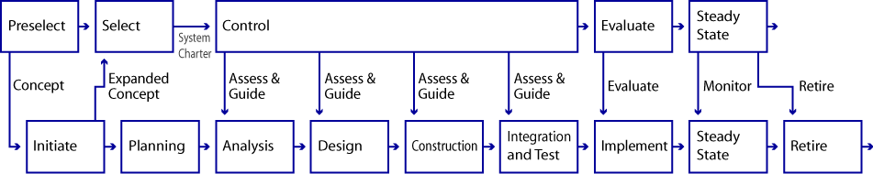

2.6 Enterprise Architecture (EA) and IT Investment Planning
EA is crucial to the investment planning process. The USDA EA Program is driven by the need to make good business decisions in a timely fashion. This includes support for IT investment analysis, managerial planning, and support for IT project managers and developers.
USDA’s EA is a business-based framework for defining, analyzing, managing and transforming processes, data and technology required to maximize technology investments and to better achieve mission outcomes. The EA framework will establish an enterprise-wide roadmap to support the Capital Planning and Investment Control process.
The USDA EA will be used by investment decision-makers to:
- Prioritize investments to determine how USDA can maximize value,
- Evaluate investments against each other – as well as against USDA strategic goals and objectives – to ensure that critical gaps in business process, data, and technology are being closed, and
- Compare all of the business, data, and technology pieces of an investment to existing investments to identify duplications and opportunities for integration and consolidation.
The following sections provide an overview of the EA focus areas for FY2009.

Technology Products and Standards
Basic information on technology products and standards in use at USDA must be identified, recorded into EAR and linked to the appropriate classifications within the TRM Model and to the investment applications. The basic information would include:
- Manufacturer hardware make and model information
- Manufacturer software make and model information along with the number of software licenses
- Technology standards
This information will support analysis of actual products and services that are in use at USDA. The analysis in many cases will identify opportunities for enterprise purchasing and product standardizing and reuse. These analyses will be used to establish short and long term strategies for retiring, containing, and selecting technologies to support the EA.
Data

Basic Information on data being used by USDA systems must be identified, recorded in EAR and linked to the appropriate investment applications. The first phase to identifying the basic information is to establish a USDA Data Reference Model (DRM) that identifies subject areas and information classes to be used to used to categorize USDA data. A USDA DRM Data Context Model has been developed that will be used to identify the categories of data associated with investment business applications. The DRM classification list was developed by leveraging efforts completed across the Department and other federal agencies. Specific sources include: the National Agricultural Library Taxonomy, the 1997 Information Systems Technology Architecture Business/Data Subject List, and Department of Interior's data classification schema.

The following table identifies several subject areas and associated information classes:

Subject Area | Definition | Information Class | Information Class Definition
ACQUISITION AND PROCUREMENT | Information about the procurement of personal and real property and services used by the Federal Government. | Acquisition and Procurement | procurement of personal and real property and services used by the Federal Government.
AUTHORIZATION | The legal consent acquired or granted by state, federal, and international organizations granting permission to conduct business activities or move commodities. | Permit and License | Information about formal permissions and revocable authorizations issued for a specified purpose and for a specified time period.

The mapping of this information to USDA business applications supports preliminary analysis to identify potential areas for further optimization analysis. Deeper analysis on data elements will need to be performed in order to make decisions on establishing USDA data element standards and normalizing data across applications.

2.7 OCIO Contacts
For additional information, or assistance on each of the integrated disciplines, please contact:
Discipline | Manager | Phone Number | E-mail Address
Integrated IT Governance | John Bebris | 202-720-8640 | John.bebris@usda.gov
AA Process | John Bebris | 202-720-8640 | John.bebris@usda.gov
 | Leslie Nanney | 202-690-5992 | Leslie.nanney@usda.gov
EA | Christopher Wren | 202-720-6746 | Christopher.wren@usda.gov
EVM | Eva Desiderio | 202-720-8918 | Eva.desiderio@usda.gov
Capital Planning | Eva Desiderio | 202-720-8918 | Eva.desiderio@usda.gov
CyberSecurity |  | 877-299-8329

3.0 PORTFOLIO REVIEW

3.1 Introduction
The review cycle of the Investment Planning and Review process begins upon submission of the investment documentation to OCIO. The submitted documentation is reviewed from multiple perspectives and in several review cycles. This process occurs on an ongoing basis from March trough July (internal OCIO review may begin as early as January). The review completed by OCIO at this phase is referred to as the “IT Review.” In addition to the IT review, the OBPA conducts the budget review for the investment. Reviewing responsibilities of OCIO, OCFO), OBPA, and the ECCB are described in detail in subsequent sections.
Any of the reviewing bodies could find the supporting documentation incomplete or insufficient in some way and send the investment information back to agencies at any point in the review process. The agency must address any deficiencies to support favorable consideration by the E-Board.

3.2 Reviewer Responsibilities

OCIO (EA, CPIC, and Security), OCFO and the Review Process
Within OCIO, the investment documentation undergoes reviews by the CPIC, EA, and Security teams. These reviewer groups must collectively approve the investment documentation for the review cycle to continue. If the documentation is not approved, the submitting agency will be required to provide additional supporting documentation. Upon this additional submission, the investment re-enters the review cycle. Upon approval by OCIO, the investment is reviewed by ECCB, undergoes budget review, and eventually moves into the E-Board review phase.
OCIO is responsible for reviewing and comparing agency budgets to the IT budget. OCIO serves as the liaison between agencies and OBPA in the budget review process.
The CPIC process as implemented at USDA is a structured, integrated approach to managing IT investments. Reviewing IT investments for compliance with the CPIC guide ensures that all IT investments align with the USDA mission strategic goals and business needs while minimizing risks and maximizing returns throughout the investment’s life-cycle. The CPIC relies on a systematic Pre-Select, Select, Control, Evaluate and Steady-State investment life-cycle process to ensure each investment’s objectives support the mission, business and architecture needs of the Department. This process requires that IT investments be aligned with the EA, and provides tools to ensure that IT investments are chosen that best support the agency’s mission and that comply with USDA’s IT architecture.
EA supports IT capital investment planning by defining target architecture for future IT acquisitions (e.g., application systems and infrastructure) as well as facilitating agency IT capital investment decision-making.
OCIO’s IT Security team reviews investment narratives pertaining to security requirements to ensure that the full range of security functions have been addressed in the investment documentation. The IT security review is conducted to ensure investments consistently address the security requirements: meeting privacy and information security requirements according to FISMA; mitigating weaknesses by identifying them in the Plan of Action Milestones (POAMs); and providing documentation about how security for the investment will be funded.
The supporting documentation for the security review should include privacy impact assessments and security plans covering testing, training, incident handling and control testing. The IT security review process is currently undergoing further development. The IT security team will provide process updates for this guide as they become available.

IT Budget Review Process
In addition to reviewing the IT investment documentation and preparing recommendations for investment decisions, OCIO also participates in the annual review of the IT portion of agency budget proposals. Around July, when each agency submits a funding request to the Office of Budget and Program Analysis, a copy of this request is also provided to the OCIO. As with the IT investment documentation, this information is reviewed by all the major functional areas of OCIO and OCFO. As part of this review, OCIO is analyzing these proposals for consistency with IT investment documentation. In particular, OCIO is interested to note if additional program requests have been made that are not supported by the required IT documentation (for major investments that would include all business case documents as well as an OMB Exhibit 300). This is also another opportunity to review for duplication of effort by multiple agencies.
After evaluating the Budget request justifications in concert with the IT support documentation, OCIO provides recommendations for approval or disapproval of an agency budget request.
Funding decisions are provided to the agencies in the form of a passback from OBPA. IT investments may or may not be specifically addressed in the passback but they could certainly be influenced by a funding decision to the program that the IT supports.
OBPA and OCIO interact informally through ad hoc communication and meetings throughout the budget process to align the IT review with the CFO’s budget.

Enterprise Change Control Board (ECCB) and the Review Process
OCIO established the Information Technology ECCB to assist USDA in making investment decisions. The ECCB facilitates collaborative decision making among Agencies to resolve common IT challenges and issues. In addition, the ECCB advises the USDA Chief Information Officer (CIO) of the value and opportunity to share or consolidate IT services, applications, and infrastructure.
The ECCB provides an assessment of business value and recommend preferred technical approaches for implementing the initiative to the USDA CIO. It will provide a mechanism for formalizing and facilitating partnerships between the USDA agencies and offices so that common solutions may be developed.
The ECCB is comprised of the USDA agency and office CIOs and Staff Office CIOs of and Associate CIOs of the OCIO. Doug Bailey, AMS CIO is Chairperson, Wendy Snow and Chris Wren, OCIO Enterprise Architects are the Vice Chairpersons. This position is held by USDA’s Enterprise Architect, Christopher Wren. Additional detail about the ECCB can be found in the ECCB Charter. A copy of the Charter is in the Appendix.

4.0 PORTFOLIO APPROVAL AND SUBMISSION TO OMB

4.1 Introduction
Once submitted documentation is approved by OCIO, it undergoes one additional level of review before it is submitted to OMB. This next level of review is done by the E-Board. Ultimately, for funding to be approved, the E-Board, headed by the Deputy Secretary, must approve the portfolio for inclusion with USDA’s budget submission. The Office of the Secretary/Deputy Secretary makes all budget decisions for the Department including the IT budget. The E-Board serves as the Deputy Secretary’s recommending body by providing IT investment information to inform the budget decisions.

4.2 E-Board
The reviews by senior-level policy executive are integral to the success of USDA’s CPIC process. The E-Board ensures compliance with guidance from Congress, OMB, and GAO, as well as applies sound business practices to the planning, acquisition, and operation of large IT investments. The following sections contain the E- Board Charter.
Pursuant to the requirements of the Clinger-Cohen Act, the Department of Agriculture established the E-Board, made up of senior-level policy executives, to ensure that USDA IT investments are managed as strategic business resources. The deputy secretary oversees this process as part of his responsibility for day-to-day operations of the Department. The E-Board is comprised of the Department’s senior level policy executives. In addition to these positions, the Board, at its discretion, may name ex-officio members to provide specialized expertise and advice. These principal positions (and the individuals currently holding the positions) are as follows:
Position | Board Member
Deputy Secretary, Chair | Deputy Secretary Conner
Chief Information Officer, Vice-Chair | Dave Combs, Chief Information Officer
Assistant Secretary for Administration | Boyd Rutherford, Assistant Secretary
Assistant Secretary for Civil Rights | Margo M. McKay, Assistant Secretary
Under Secretary, Farm and Foreign Agricultural Service | Floyd Gaibler, Acting Under Secretary
Under Secretary, Food, Nutrition and Consumer Services | Kate Coler, Deputy Under Secretary
Under Secretary, Food Safety | Curt Mann, Deputy Under Secretary
Under Secretary, Marketing and Regulatory Programs | Bruce Knight, Deputy Under Secretary
Under Secretary, Natural Resources and Environment | Mark Rey, Under Secretary
Under Secretary, Research, Education and Economics | Gale Buchanan, Under Secretary
Under Secretary, Rural Development | Douglas Faulkner, Deputy Under Secretary
General Counsel | Mark Kesselman, General Counsel
Inspector General | Kathy Tighe, Deputy Inspector General
Director, Office of Budget and Program Analysis | Scott Steele, Director
E-Board Point of Contact | Chris Niedermayer Associate Chief Information Officer

The E-Board Charter, which can be found in the CPIC Guide, describes the E-Board in additional detail.

4.3 E-Board and OMB Scoring
USDA’s E-Board meets quarterly to discuss issues concerning USDA IT strategy and direction. Before the USDA IT portfolio is submitted to OMB, the individual agency IT investment portfolios are presented to the E-Board. These portfolios are evaluated for redundancy of effort as well as cost, in addition to the ten criteria listed below. The USDA portfolio as well as the investments within each portfolio is reviewed. The E-board chooses the IT projects that best support the mission of the organization and that support USDA’s approach to EA. The E-board determines the IT direction for USDA provides guidance on choosing the investments for the USDA portfolio and its mission to insure success. The E-Board reviews the portfolios using USDA criteria which follow the OMB requirements. For the FY2008 submission, OMB scored the investments according to the following ten criteria:
- Support for the President’s Management Agenda (PMA)
- Program Management (PM)
- Acquisition Strategy (AS)
- Performance Information (PI)
- Security (SE)
- Privacy (PR)
- EA
- Alternatives Analysis (AA)
- Risk Management (RM)
- Performance-Based Management (PB)
Each criterion is worth up to 5 points. A total of 50 points is possible if the business case showed that it met all requirements, that all the research and work was completed and that the report is consistent. Investments that score below 31 are placed on the OMB “watch list.” If the score for the security criterion is 3 or below, the investment would still be placed on the “watch list” regardless of a total score of 31 or above. An additional category, “Outside Factors”, was added in 2006 which means that if there were issues outside the scoring categories that needed to be resolved, the investment would be placed on the “watch list.”
For all new and existing business cases, these criteria should be addressed within the business cases and within the supporting documents. All supporting material should be attached in WorkLenz and should be available for review when requested by the E-Board or by OMB. For additional information on how OMB scores investments, visit the OMB website at http://www.ocio.usda.gov/cpic/index.html

4.4 OMB “Passback”
The OMB Passback is the document that OMB sends to USDA after its review of the USDA’s IT OMB Exhibits 300 and 53. These exhibits are sent to OMB in September and then OMB reviews them in October and part of November. Around Thanksgiving, OMB sends the passback document which contains OMB decisions on what requests should be granted, reduced, or refused. In addition, the passback contains scores for the OMB Exhibit 300s submitted for USDA majors.
The scores indicate whether the major investments should be approved, disapproved or placed on an OMB “watch list.” At this point USDA can appeal the passback. This is done by a letter that is sent to OMB giving justifications on why the request should be changed or not denied. Also, at this time USDA representatives meet with OMB to find out why certain investments were placed on the “watch list” and how they can be removed. OMB may suggest that USDA provide additional documents or studies or present other alternatives. All these negotiation activities must be completed by the end of December so that the final Presidential Budget may be completed and posted.

4.5 Additional Required Documentation
Circumstances arise that require additional investment documentation be provided by agencies to OCIO or by OCIO to OMB as a result of the initial reviews. OMB maintains a “watch list” for investments. There are several reasons that can cause an investment to be listed in the “watch list” such as not meeting the documentation requirements, posing a risk or management issue, etc. Agencies, with the assistance of OCIO are responsible for remediating business cases so that they can be removed from OMB’s “watch list.” OMB Circular A-11 provides more detailed information about the OMB “watch list.”
In addition, OMB pays special attention to “high-risk” projects, which are described in Circular A-11 as investments requiring special attention from oversight authorities and the highest levels of agency management for any of the following reasons:
- The agency has not consistently demonstrated the ability to manage complex projects;
- The investment has exceptionally high development, operating, or maintenance costs, either in absolute terms or as a percentage of the agency’s total IT Portfolio;
- The investment is being undertaken to correct recognized deficiencies in the adequate performance of an essential mission program or function of the agency, a component of the agency, or another organization; or
- Delay or failure of investment would introduce for the first time unacceptable or inadequate performance or failure of an essential mission function of the agency, a component of the agency, or another organization.
Since September 2005, agency CIOs have been responsible for assessing, confirming, and documenting the performance of high risk projects. OCIO will work with owners of the high risk projects to compile and submit the required documentation to OMB. The documentation required is a quarterly report submitted by OCIO to OMB. The submitted report consists of the following information:

Agency Name:
As of Date:
Fiscal Year Quarter:
Prepared By:
Telephone Number:
Email Address:

Investment Name | Are the Principal Criteria Being Met?  (Indicate Y/N for each criterion) |  |  |  | For each of the Criteria not being met, Identify and Describe the Following:
Investment Name | Baseline with Clear Goals | Cost and Schedule Variance within 10% | Qualified Project Manager | Avoiding Duplication | Specific Performance Shortfall | Cause of the Shortfall | Necessary Corrective Actions, with dates | Amount and Source of Funding, if required

4.6 IT Acquisition Approval and the Review Process
The AA process is the pivotal review and approval phase that connects the IT investment planning phase (capital plans and business cases) with the IT asset purchasing phase (requisitions and expenses). This process occurs after approval from the E-Board and after the OMB submission is completed. It is the element within IGP for IT that spurs the investment management phase to begin. This step can be viewed as a verification or validation of the acquisition strategy (or plan)--originally prepared as part of a larger capital plan or business case--prior to the acquisition’s actual execution two years later at budget execution time.
It is important, as part of the investment planning phase (beginning January 2007 for the FY 2009 budget formulation activity), that all capital plans and business cases include as much detail as possible in their acquisition strategies (plans), because it is these data that will be used to substantiate their related acquisition approval requests during the appropriate budget execution year. Likewise, it is important to update the information in existing acquisition strategies for the same reasons. For example, while preparing FY 2009 investment plans (budget requests) in FY 2007, investment owners should update—where appropriate--related FY 2008 acquisition strategies. This will lessen the burden of revising substantially or preparing a new AA at the time of budget execution.

REFERENCES
Applicable references
OMB guidance
CPIC guide

Appendix A: Agency Points of Contacts

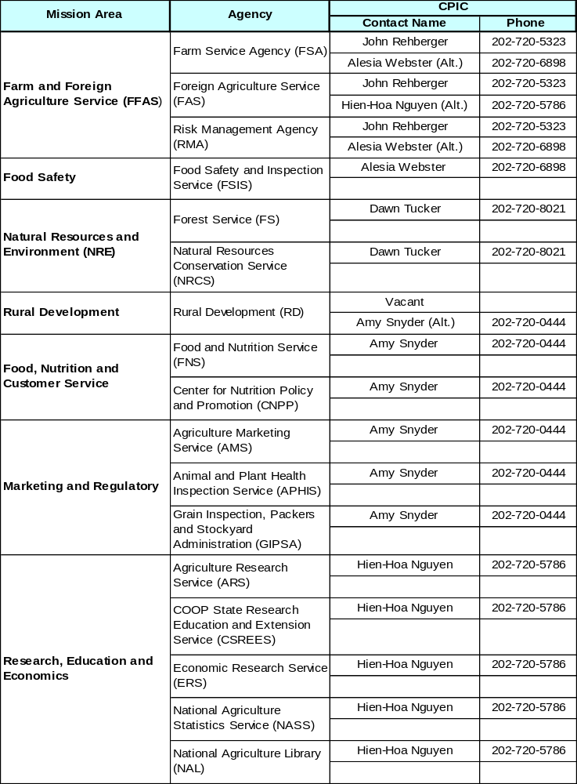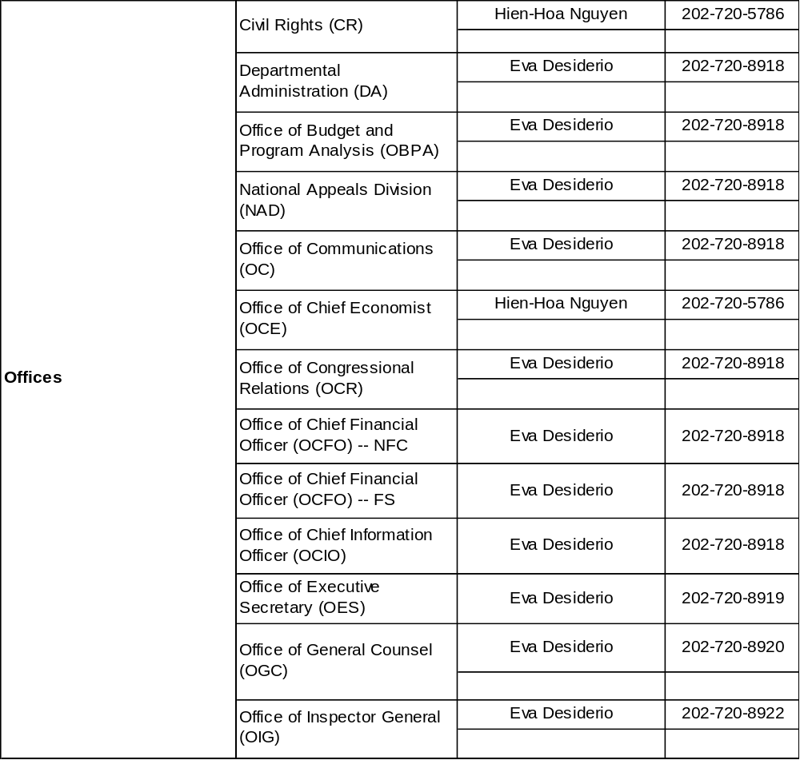

Information Technology (IT) is any equipment or interconnected system or subsystems used in the automatic acquisition, storage, manipulation, management, movement, control, display, switching, interchange, transmission, or reception of data or information. The IT budget also includes IT personnel costs and costs that are related to IT purchases, research, contract work, etc.
As noted in the ConOps, The activities that the investments undergo include planning, acquisition approval, purchasing, and implementation for a positive Return on Investment (ROI).
Agencies will have to organize systems within the same BRM into the same investment.
See the Concept of Operations for the IGP for IT for Information Technology
NIST 800-53 Guide for Developing Security Plans for Federal Information Systems (http://csrc.nist.gov/publications/nistpubs/800-53/SP800-53.pdf).
The CPIC guide is updated annually according to changes in requirements from OMB. The USDA CPIC Guide that was updated for the FY2008 submission will be updated again for the FY2009 submission. The FY2008 CPIC guide should be used for preparing the OMB Exhibit 300s. However, these exhibits may need to be updated later since OMB guidance changes annually during the June/July timeframe. The FY2009 CPIC guide will also be updated to reflect any changes that OMB proposes (include URL)
By extending the investment ID code to 6 digits, these multiple systems will be able to be tracked back to the specific investment through which they are approved.
http://www.ocio.usda.gov/cpic/usda_cpic_material.html
Métier is the software publisher of WorkLenz. Métier is a small business contractor that provides WorkLenz support to users at USDA.
AgLearn is the USDA’s Web based learning management system.
Details on how to access these courses will be provided at the January 24 IT Project and Portfolio Managers meeting.
Within WorkLenz, additional fields are required to be completed for each system associated with the non-major investment. The fields are currently available on the Budget Year 2008 BSDs.
http://www.whitehouse.gov/omb/circulars/a11/02toc.html

