Improving Urban Landscapes

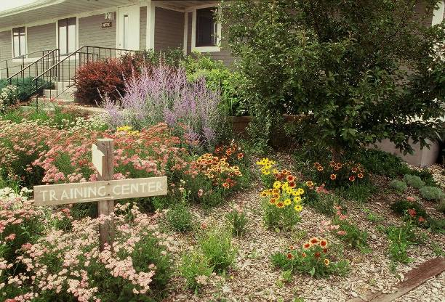
Urban communities are expanding due to growing populations nationwide. More homes, schools, shopping centers and roads are connecting people to desired services. Urban landscapes have different resource concerns than rural landscapes. Urban communities experience significantly more impervious surfaces. Rooftops, roads, parking lots, and compacted areas increase surface runoff and deliver more sediment, nutrients, hydrocarbons and other pollutants to receiving bodies of water. Urban landscapes often experience greater populations of invasive species and weeds that increase the potential of damaging wildfire.
Urban landscaping at the Bismarck, North Dakota Plant Materials Center
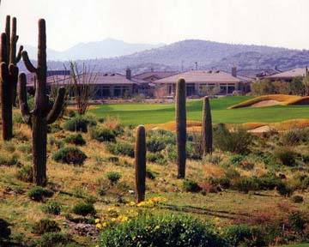
Arizona golf course with native plant landscaping.
One goal of the Natural Resources Conservation Service (NRCS) is to maintain and enhance the health of plant communities. Using plants in urban landscapes can be a valuable component of managing storm-water runoff. Plants can be used in biofiltration systems including bioswales, bioretention cells and rain gardens to capture runoff from impervious surfaces such as rooftops, driveways, and patios. Bioswales are vegetated conveyance systems that provide an alternative to storm sewers. Bioswales help store polluted runoff and allow it to slowly infiltrate into the vegetative filter. Nutrients in the runoff are also taken up by the plants. Bioretention cells are shallow landscape depressions that often handle large volumes of water from nearby impervious surfaces. Rain gardens are perennial vegetation strategically located to capture runoff from impervious surfaces such as rooftops, driveways, and patios. Plant materials used in these situations can also provide valuable habitat for wildlife and pollinators.

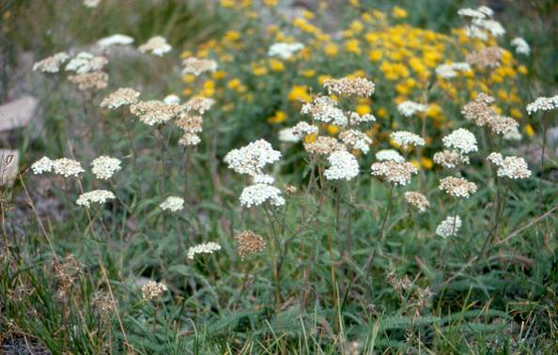
The Plant Materials Program is helping meet the NRCS goal by selecting adapted plants and developing plant technology that can be used to improve the quality of urban landscapes.
Great Northern Germplasm western yarrow, released by the Bridger, Montana Plant Materials Center, is a drought tolerant forb.
The Plant Materials Program is involved in native landscaping and xeriscaping. Native plants have a tremendous root architecture that builds soil quality and increases organic matter. Increasing organic matter content improves the water holding and infiltration capacity of the soil.
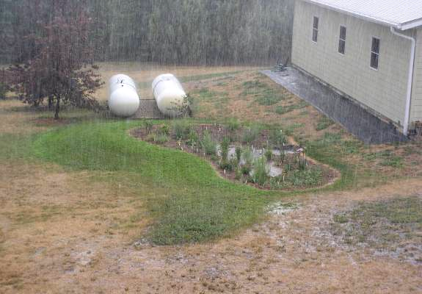
A rain garden captures roof runoff from a ½ inch, 15-minute prairie thunderstorm. Note the drought stressed area outside the rain garden.
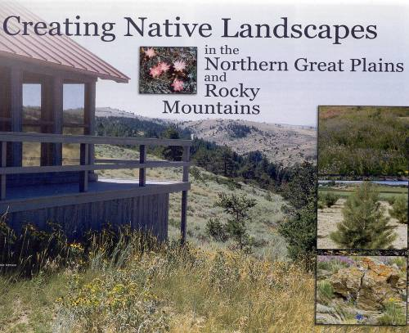
Xeriscaping is designing landscaped areas with low water use plants. Plants are grouped according to their water needs and irrigation is applied in the most effective manner possible. Xeriscaping also uses mulches to reduce moisture evaporation and limited turf areas.
This booklet is a product of the Plant Materials Center in Bridger, Montana.

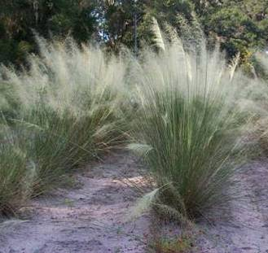
Many of the Plant Materials Programs 600+ conservation plant releases can and are used to create colorful low water-use, drought tolerant, sustainable landscapes. Native plants released by the Program are often more fire resistant and remain green longer than invasive species.
The white flower heads of Morning Mist Germplasm hairawn muhly make it valuable as a drought tolerant landscape plant.
In addition to plant releases, the Plant Materials Program has released several documents which are very useful to homeowners in all regions of the country. These publications provide solutions or guides for improving plant communities for homeowners and municipalities. These guides provide many ideas on conserving soil and improving water quality.

