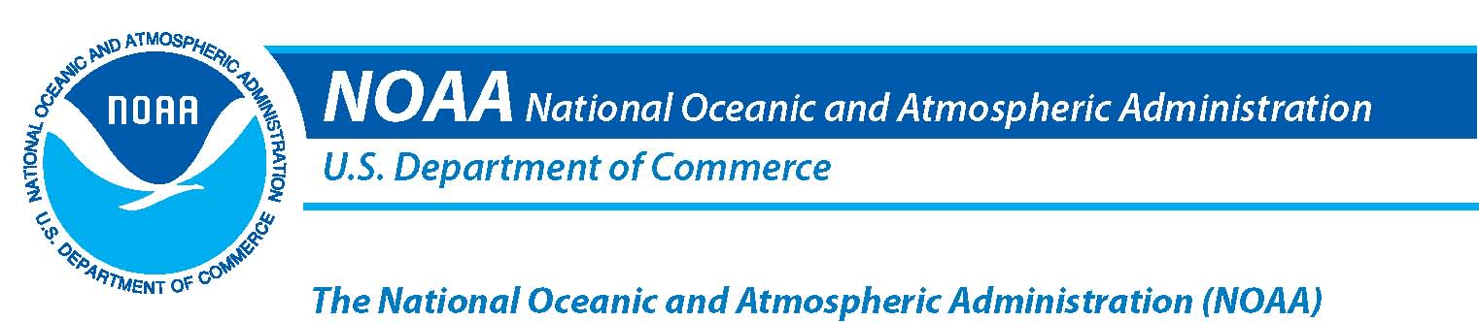
NOAA In Your State and Territory
Solomon Islands
“NOAA's work touches the daily lives of every person in the United States and in much of the world. Our products and services are the result of the hard work of NOAA’s dedicated staff and partner organizations located in program and research offices throughout the country. The following is a summary of NOAA programs based in, and focused on, your territory (as of January 2008).”
- Vice Admiral Conrad Lautenbacher
Under Secretary of Commerce for Oceans and Atmosphere and NOAA Administrator
Solomon Islands-Entire territory

NOAA Research
Pacific Marine Environmental Laboratory
NOAA Center for Tsunami Research (NCTR) (http://nctr.pmel.noaa.gov)
The Tsunami Research Program at the Pacific Marine Environmental Laboratory (PMEL), headquartered in Seattle, Washington, seeks to mitigate tsunami hazards to all U.S. coastal states and territories. A tsunami is a series of very large ocean waves caused by underwater earthquakes, landslides, volcanic eruptions, explosions, and even meteor impacts. Capable of flooding hundreds of meters inland past the typical high-water level, the fast-moving water associated with an inundating tsunami can crush homes and other coastal structures. More common occurrences, and devastating in an economic sense, are false alarms that lead to expensive evacuations of coastal areas.

The PMEL NCTR staff conducts research and development activities in close collaboration with the National Weather Service (NWS) Tsunami Warning Centers, National Data Buoy Center (NDBC), and the coastal states. Activities focus on the development of site-specific forecast models for coastal population centers. These models are integrated into a PMEL-developed operational tsunami forecasting system at the Tsunami Warning Centers. PMEL developed the original real-time DART tsunami-measuring buoy which has been transitioned to NDBC. Engineering development is underway at PMEL to improve the cost-effectiveness of these platforms. Tsunami research at PMEL focuses on model improvements and tsunami hazard mitigation.

Solomon Islands (Honiara)

National Marine Fisheries Service
Office of Law Enforcement
Honiara Field Office
NMFS Office for Law Enforcement is dedicated primarily to the enforcement of laws that protect and regulate our nation’s living marine resources and their natural habitat. NMFS’ special agents and enforcement officers have specified authority to enforce over 37 statutes, as well as numerous treaties related to the conservation and protection of marine resources and other matters of concern to NOAA. For additional information on the NMFS Office of Law Enforcement, please visit our web site: http://www.nmfs.noaa.gov/ole
NOAA’s Office of Legislative Affairs
Tel: 202-482-4981 http://www.legislative.noaa.gov

