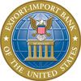


Getting Started with Ex-Im Online

A Guide for Current Policyholders

Table of Contents

This guide is intended to be used as a general reference tool to help policyholders utilize the Ex-Im Online system, and does not purport to identify every change to Ex-Im Bank products or procedures. The insured remains responsible for knowing and understanding its rights and responsibilities as set forth in the full set of policy documents.

Welcome to Ex-Im Online! 3
Broker and Lender Access Rights 4
Registering New Users in Ex-Im Online 4
Navigating in Ex-Im Online 8
- Exporter Landing Page 9
- Policy Landing Page 10
- View Policy Documents 11
Submit New SBCL Applications 13
- Instructions 13
Shipment Reporting in Ex-Im Online 15
- Example: Enter a Shipment to be Submitted Later 16
- Add/Update Overdue Buyer Information 17
- Add Shipments for New and Existing Buyers 18
- Add Shipment Details 19
- Review Shipments and Validation Results 20
- Update / Submit Saved Shipments 21
- Submit Reported Shipments 23
- Pay Premium 24
Request a Policy Amendment 25
Request an SBCL Amendment 28
Request Assignment of Policy Proceeds 32
Track the Status of an Application 33

Welcome to Ex-Im Online!
This document will help you to get started using our new online system. Common tasks will be explained step-by-step, including registering new users and managing your Ex-Im Bank transactions.

Ex-Im Online will allow you to:

- view and manage all of your policies online;
- submit and track new policy and buyer approval applications;
- view and print policy documents;
- submit shipment and overdue buyer reports;

all in one place, available anytime, anywhere.

From the main Ex-Im website, click “Apply Online” in the Quick Links section, or type https://eximonline.exim.gov in your web browser.

Username and Password

As part of the migration process the primary contact for your policy was provided with a username and temporary password via email. This person will receive email notifications regarding your policy. For security purposes, please be sure to change your password after logging in for the first time. Just click “Change Password” in the top right hand corner of the screen when logged in, and follow the on-screen instructions.

If you have not already received your username and password, please contact either your broker, or your Ex-Im Bank Portfolio Manager at (202) 565-EXIM.

Coming Soon…

Ex-Im Bank’s multi buyer export credit insurance is the first product to be introduced in Ex-Im Online. In coming months the bank’s short term single buyer, medium term insurance and guarantee products will also be available.

Broker and Lender Access Rights

Ex-Im Online allows policyholders to work more closely with Ex-Im approved insurance brokers and financial institutions. Brokers can assist you in completing new buyer approval applications (SBCL’s), policy amendment requests and shipment reports on behalf of the insured. Lenders can view existing policy parameters, in-force documents, approved buyer limits and reported shipments.

All existing broker or lender affiliations have automatically been maintained in Ex-Im Online.

Registering New Users in Ex-Im Online

As an existing policyholder, your company has been pre-registered in Ex-Im Online using the primary contact information on file. Additional user accounts can be created to allow multiple members of your staff access to your policy information. They will be required to enter your company’s Participant ID# and zip code, which can be obtained as follows:

- Log in using an existing user account

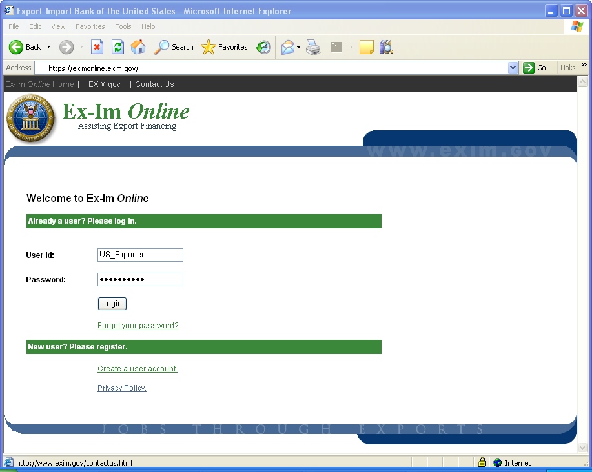

2. Select the “My Profile” link
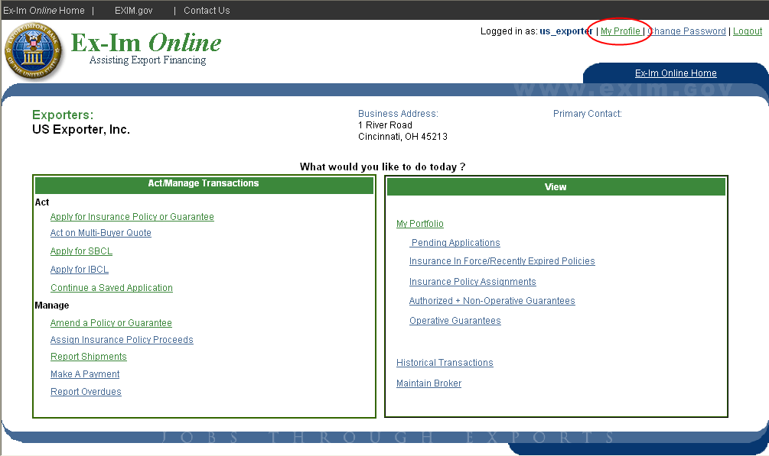

3. Note the participant ID #and zip code, and then click “Logout”.
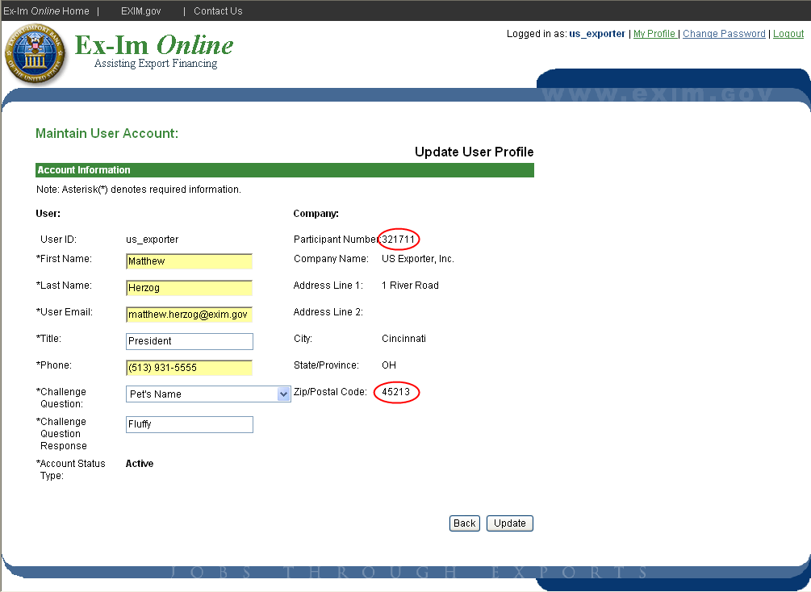

4. Return to the login page, and select “Create a user account”

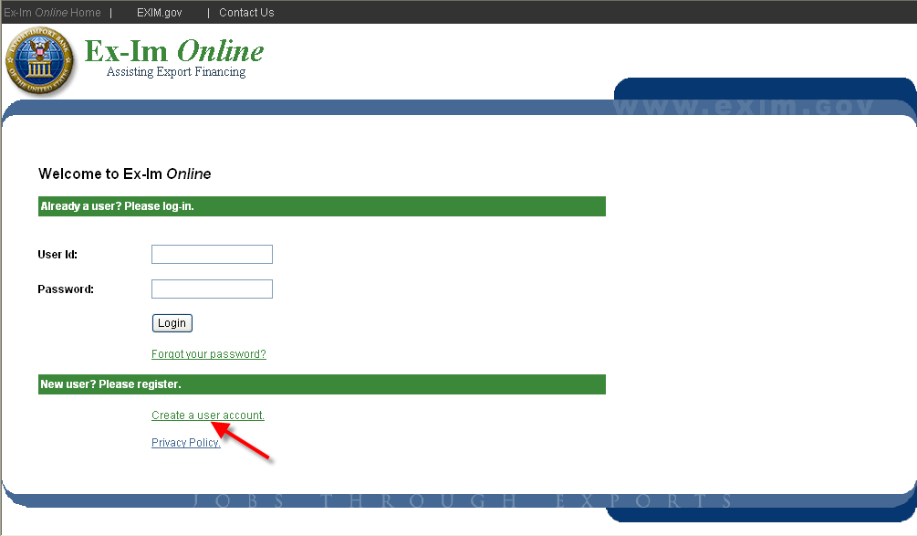

5. Check the button to indicate your company is already registered.

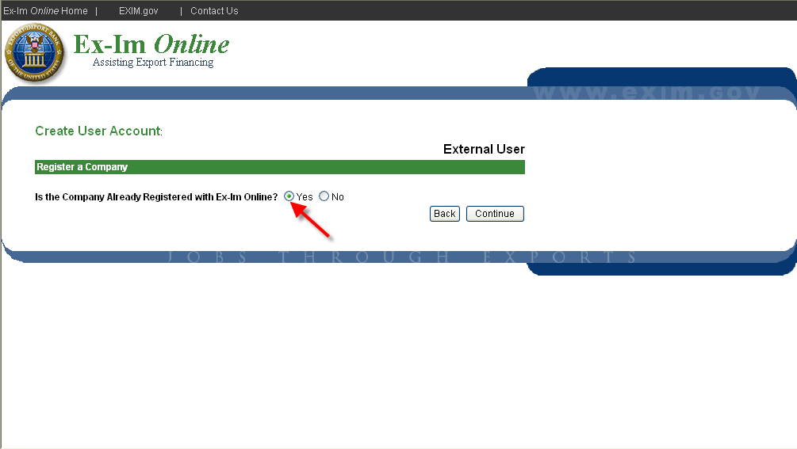

6. Enter your company’s participant ID # and Zip code
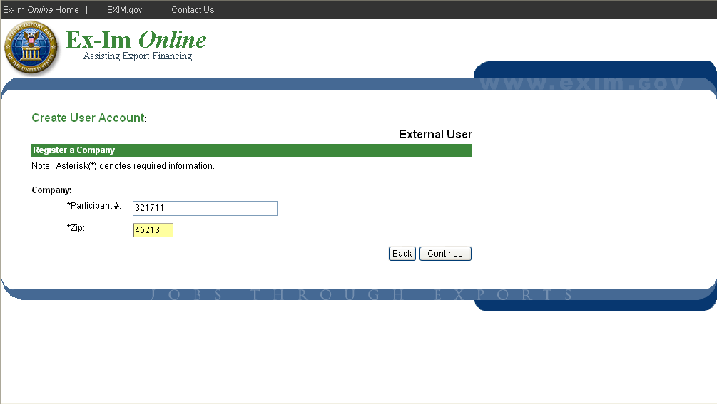

7. Select a username and password
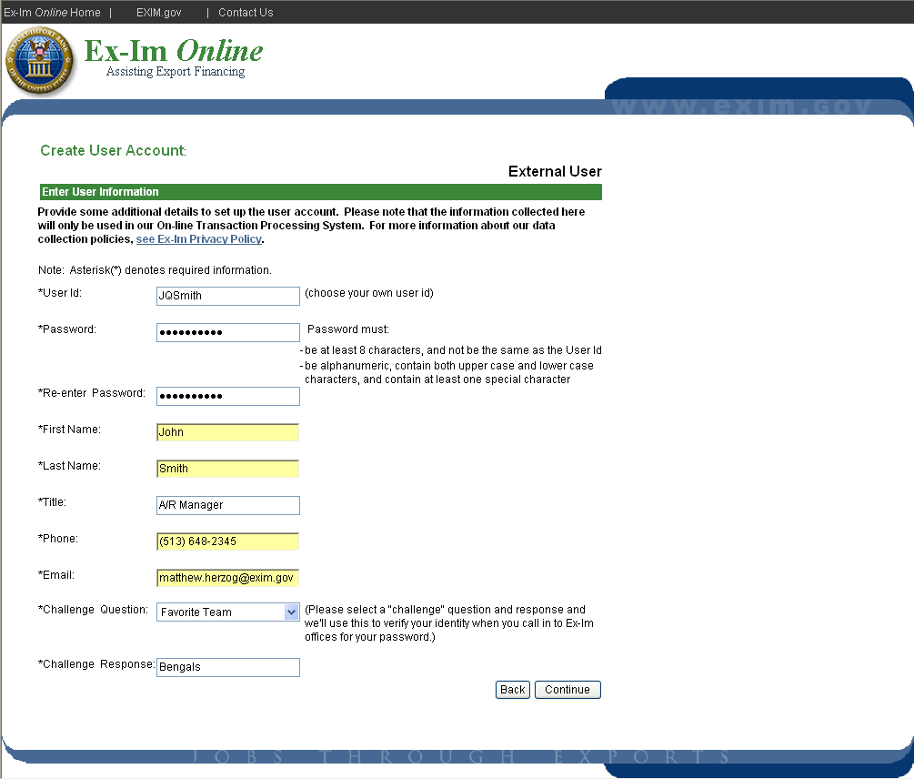

Navigating in Ex-Im Online

It all starts with the Landing Page. The “Ex-Im Online Home” link at the top right corner of each page returns you to the Landing Page, the starting point for all your activities in Ex-Im Online.

Don’t use the “Back” button in your browser. Ex-Im Online dynamically creates each page, and navigation buttons are provided at the bottom of each page.

Complete applications in any order. Applications are divided into sections (right) and can be completed in any order. Clicking “Continue” will take you to the next section.

Save and Exit without losing information. Once completed, a check mark appears next to each section of an application. Simply click “Save and Exit” and all information in completed sections is retained. Select “Continue a Saved Application” from the Landing Page to work on an existing application.

Attachments can be submitted with any transaction. Ex-Im Online will accept files of any size or format. Be sure to attach all relevant credit reports, financial statements, certifications and other supporting documents for faster processing.

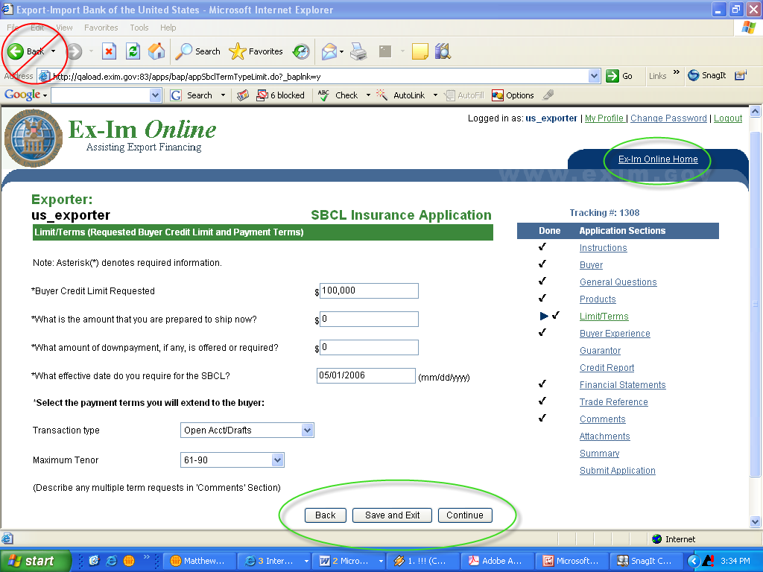

Exporter Landing Page

The “Exporter Landing Page” is the first screen you will see upon entering Ex-Im Online.

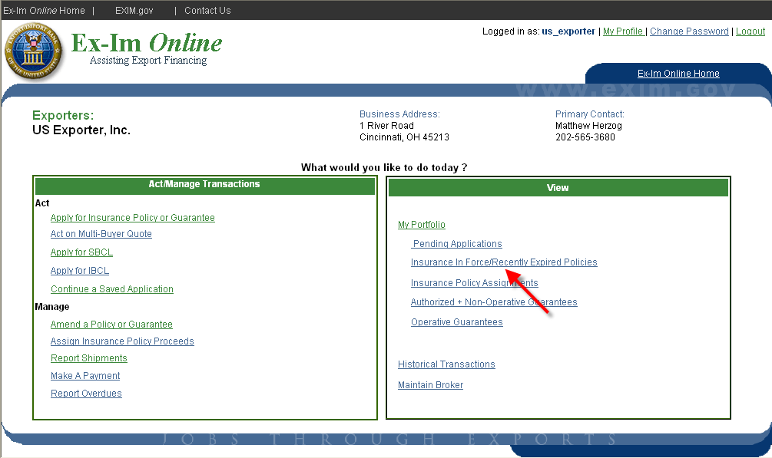

The Exporter Landing Page is divided into two sections…

with links to common policy tasks on the left… | and ways to view transactions and policies on the right.

In the top right corner, click on “My Profile” to edit your personal user information (name, contact info, password challenge question.).

Let’s start by viewing your current multibuyer insurance policy. Please click on the “Insurance In Force/Recently Expired Policies” link to view the Policy Landing Page.

Policy Landing Page

This page displays primary policy parameters, endorsements, approved SBCL’s & IBCL’s, pending (in-process) and saved applications. Links in the top right corner provide access to common policy management activities such as viewing policy documents, requesting new SBCL/IBCL’s, reporting shipments, and requesting policy amendments and assignments. Links to many of these activities are also available as “shortcuts” from the exporter landing page.

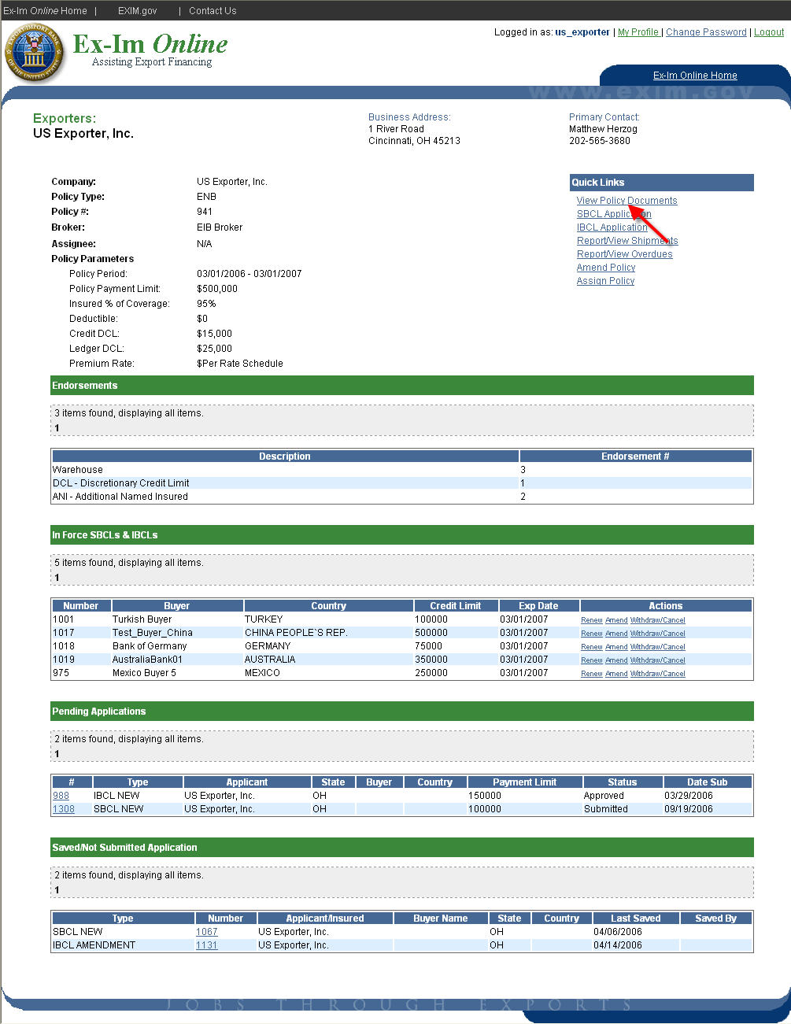

Next, please click the link to “View Policy Documents”.

View Policy Documents

The page pictured below is accessible from the Policy Landing Page by clicking the “View Policy Documents” link.

Ex-Im Online allows you to view and download the most up-to-date policy documents at any time. Documents are immediately updated following any approved changes to the policy (new buyer approvals, policy amendments, etc.).

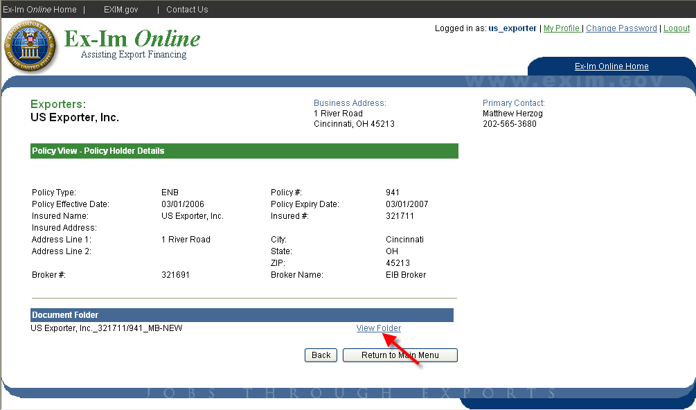

Click the “View Folder” link to view the contents of the documents folder.

This folder provides a complete list of all in-force policy documents.

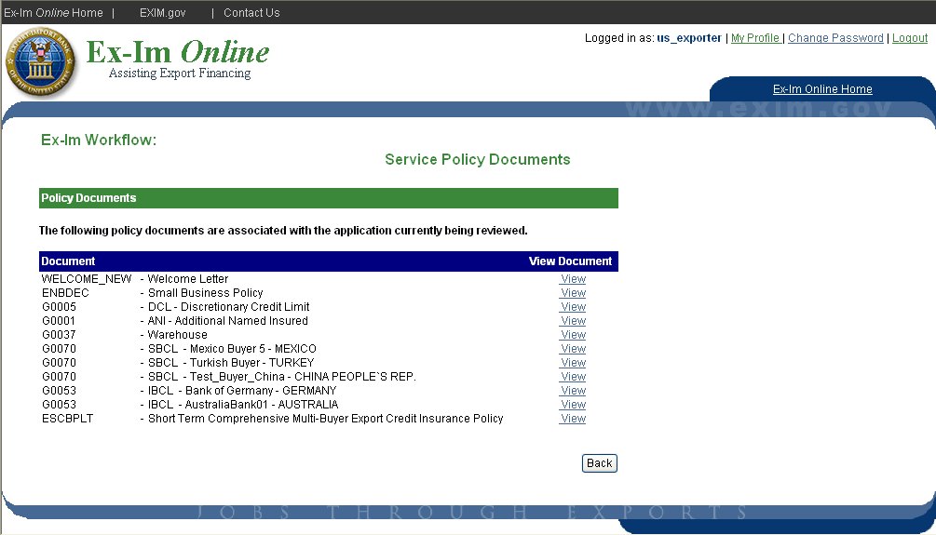
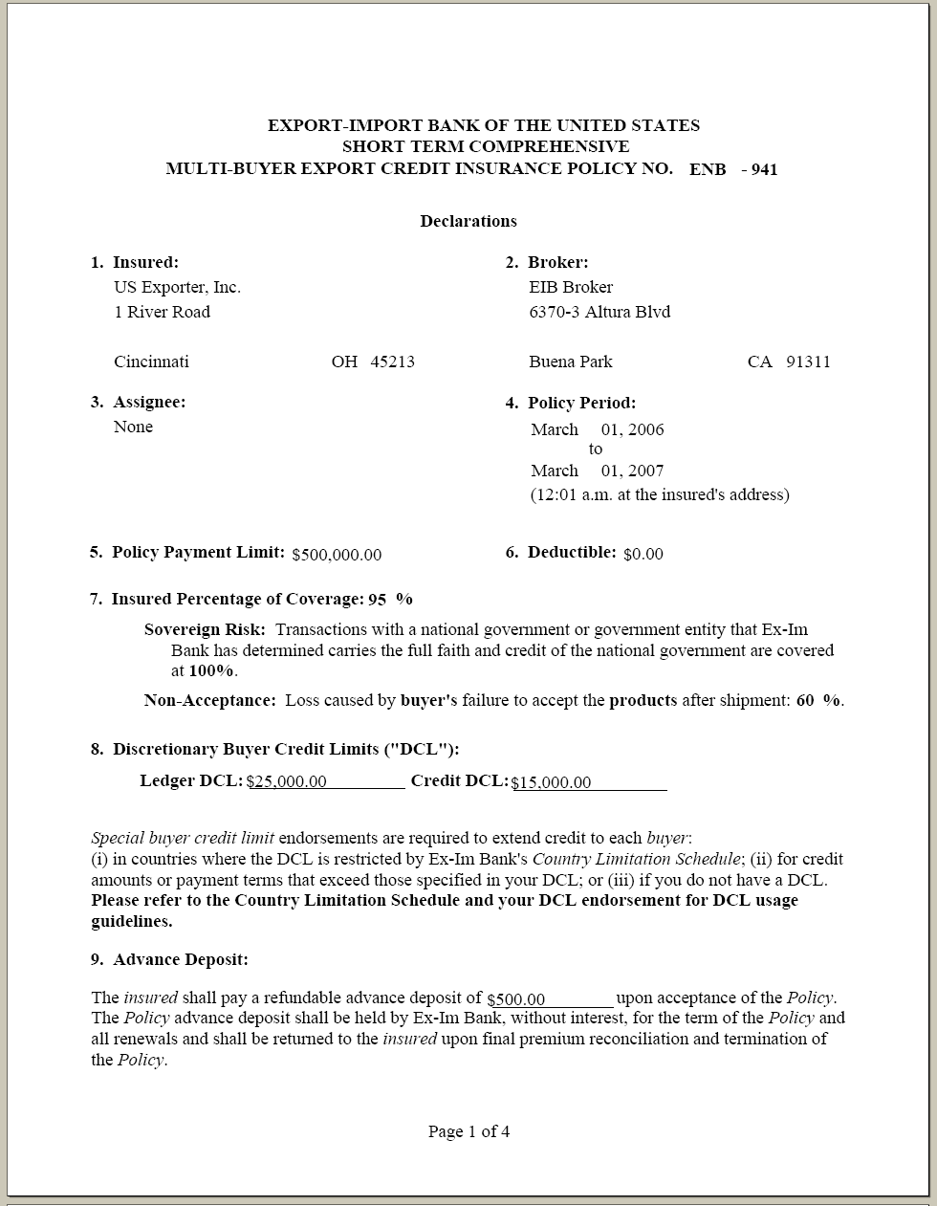

Policy documents can be viewed using the free Adobe Acrobat Reader
software, and the PDF document can be downloaded to your personal computer by right clicking on the “View” link and selecting “Save Target As”.

Submit New SBCL Applications

Instructions

Once a policy is in-force, both exporters and brokers are able to enter information into SBCL applications. However, only the exporter is able to complete the final step of certifying and submitting the application.

To start a new SBCL application, select “Apply for SBCL” from the exporter landing page.

Note: To return to an application that was started previously, select “Continue a Saved Application”.

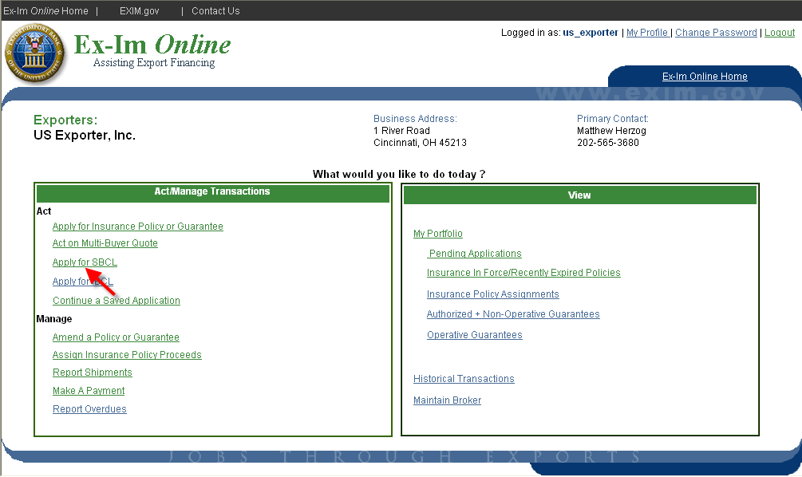

Upon final submission you will receive email notification that your application has been received. Be sure to note the application tracking #, which can be used to track the status of your application.

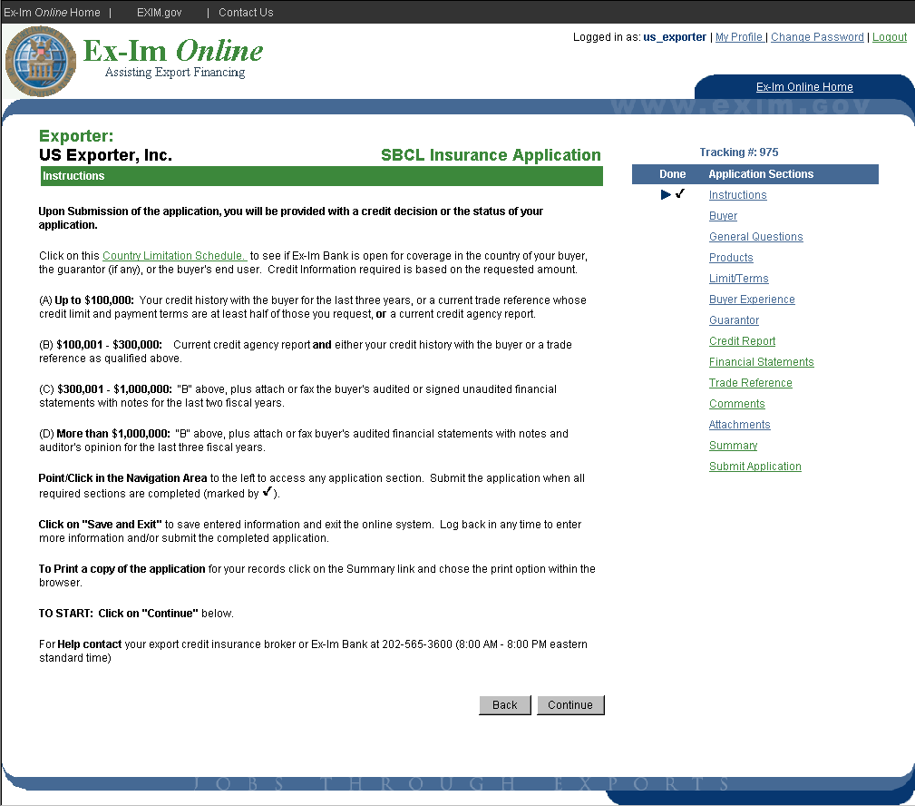

Please note that the credit information requirements have been changed as indicated on the instructions screen for the Special Buyer Credit Limit.

Shipment Reporting in Ex-Im Online

Reporting and paying premium each month on all eligible transactions is a key requirement of the multi buyer insurance policy. Reports must be received no later than 30 days following the month of shipment. Ex-Im Online allows you to efficiently perform this important policy management function.

Advantages to reporting online:

- Shipment reports can be submitted multiple times per month
- Shipments can be entered and saved in the system, and submitted at any time during the reporting period
- The system validates reported shipments, and provides a warning if a shipment is possibly in violation of the policy (i.e. restricted markets, exceeding DCL authority, etc).
- Credit card payment option (coming soon)

NOTE: As with SBCL applications, shipment reports can be entered by the broker, but final submission and premium payment must be completed by the insured.

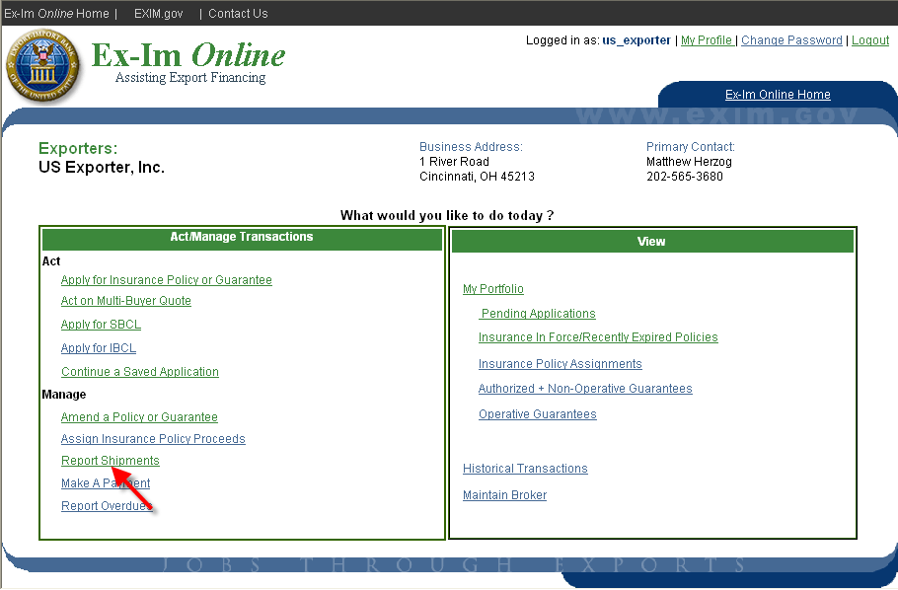

The following pages will provide step-by-step instructions for:

- Adding new shipments
- Reporting past due buyers
- Updating previously entered shipments
- Reporting no shipments
- Completing report submission
- Viewing previously submitted shipment reports

To begin, click the “Report Shipments” link on the landing page.

Example: Enter a Shipment to be Submitted Later

All shipment reporting activities can be started from the “Process Shipments” screen shown below. In this example we will enter information for a recent shipment, and save it in the system to be submitted later. Select “Add Shipment” and click “Continue”.

Note: Choose “Report No Shipments” for months with no eligible transactions.

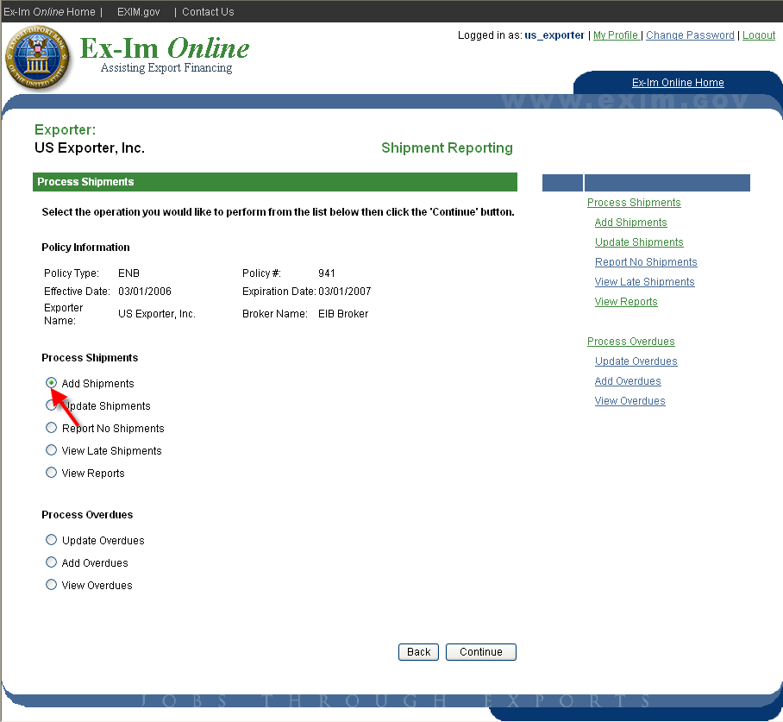

Add/Update Overdue Buyer Information

Under the terms of the policy all policyholders are required to report any buyer with a balance greater than $25,000 and more than 90 days past due. In Ex-Im Online, the system will maintain this information and provide email notifications 45 days and 15 days prior to the claim filing deadline. Each time shipments are entered the insured will be prompted to enter information on overdue buyers. While not required, policyholders are encouraged to also report overdues of less than $25,000 in order to receive the claim filing deadline reminders.

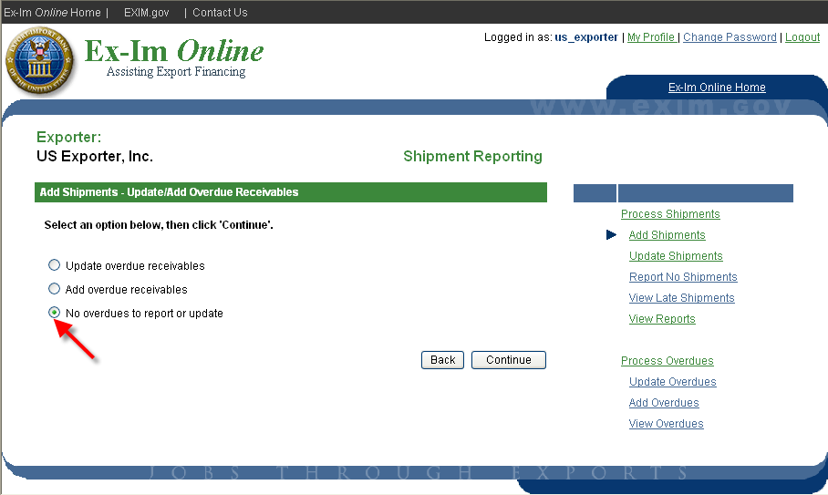

To add new or update existing overdue buyers, choose the option shown above. Otherwise, select “No overdues to report or update” and click “Continue”.

Add Shipments for New and Existing Buyers

Each month Ex-Im Online automatically maintains a list of buyers for which you have previously reported shipments, or which have been approved for coverage under an SBCL or IBCL. For new buyers, click the “Add Buyer” link and you will be prompted to provide the buyer’s name, street address and country. To begin reporting shipments select either the buyer name from the list or click “Add Buyer” to enter a new buyer.

Note: In this example, while there are ten buyers associated to this policy, only five are currently being displayed. Click “Next” to view additional pages.

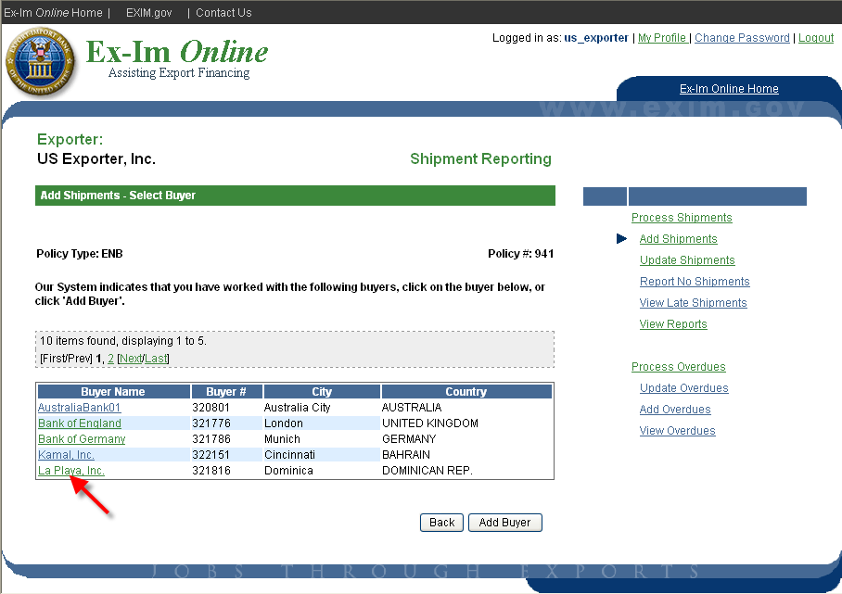

Add Shipment Details
Complete this page for each buyer, or multiple times if selling to the buyer on multiple terms (i.e. 50% letter of credit / 50% open account).

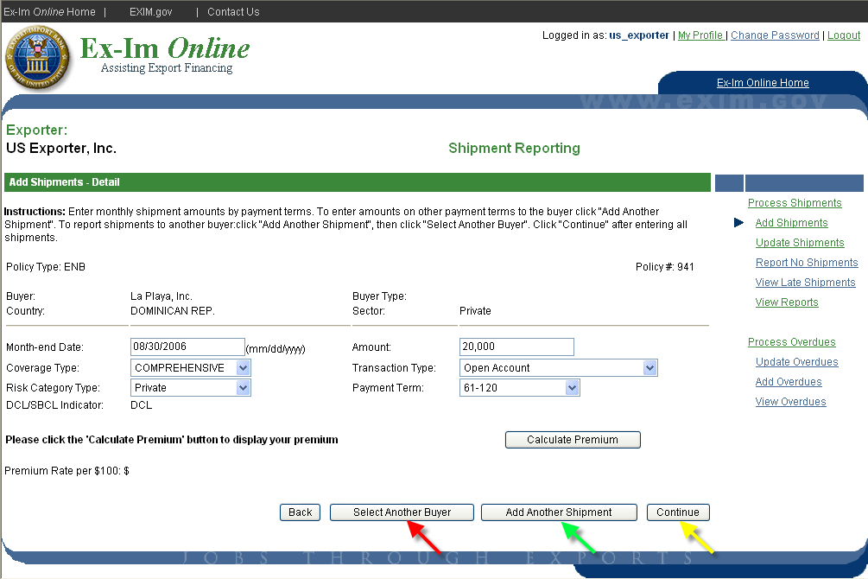

Month-end Date - enter the last day of the month during which the buyer was invoiced. If submitting the report during the same month in which the buyer was invoiced, enter the current date.

Amount – enter the total of all transactions of the same transaction type and payment term. Additional shipments on different terms should be entered by clicking “Add Another Shipment”.

Coverage Type – select either “comprehensive” or “political only” coverage.

Transaction Type – choose from various open account, secured and documentary collection transactions.

Risk Category Type – indicate the type of legal entity, from either a “Private”, “Financial Institution”, “Public Non-Sovereign” (i.e. local municipality), or “Sovereign” (i.e. official government agency”).

Payment Term – select the agreed upon terms of sale.

For additional shipments to the same buyer, click “Add Another Shipment”.

For shipments to a different buyer, click “Add Another Shipment” and then click “Select Another Buyer”.

When all shipments have been entered:

Click “Continue” to review the current batch of reported shipments and perform system validations against current policy parameters.

Review Shipments and Validation Results

Prior to final submission the system compares each shipment to the current policy parameters and Country Limitation Schedule, and issues warnings for shipments that may not be eligible for coverage. For example, the system checks to see if an SBCL is in place for shipments to DCL restricted markets, and when shipments exceed the least restrictive DCL terms authorized.

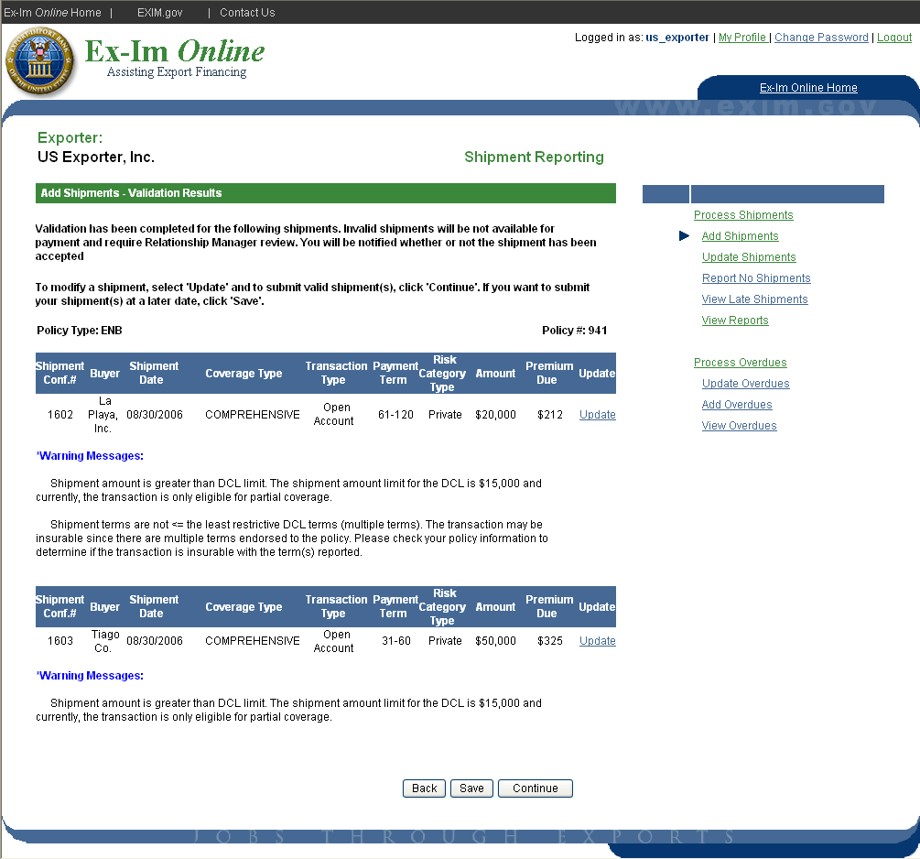

Ineligible transactions, such as shipments to legally prohibited markets, will be shown as rejected.

The reports in this example have successfully passed validation. You may either:

- click “Save”, and the data will be maintained until you are ready to either add additional shipments or submit the reported shipments and premium,

- or, click “Continue” to submit and pay premium for the existing reports.

Update / Submit Saved Shipments

To update or complete submission of previously entered shipment reports, click on “Report Shipments” from the landing page.

Select “Update Shipments”

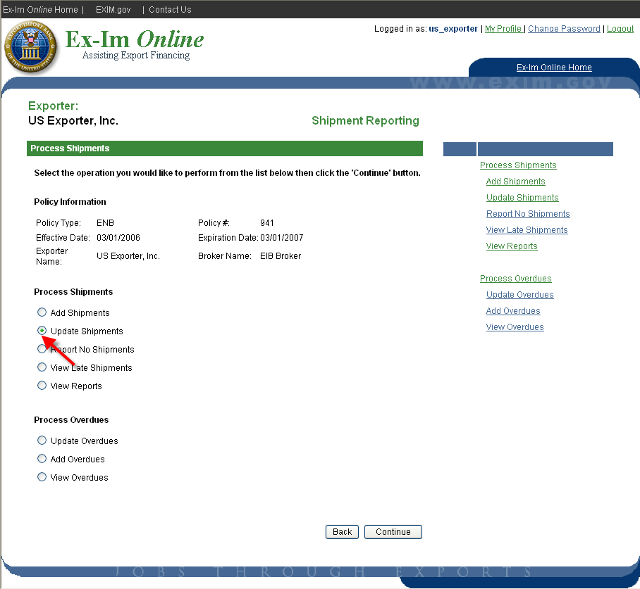

Select the specific transaction you wish to change by clicking on the “Update” link to the right of the shipment confirmation #.

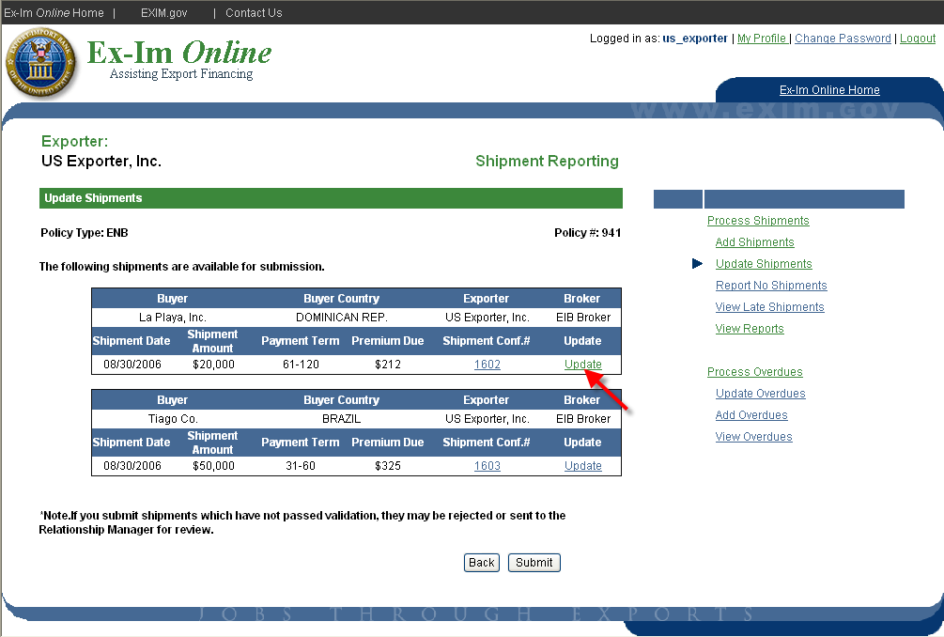

The saved information is presented. When complete, click “Continue”.

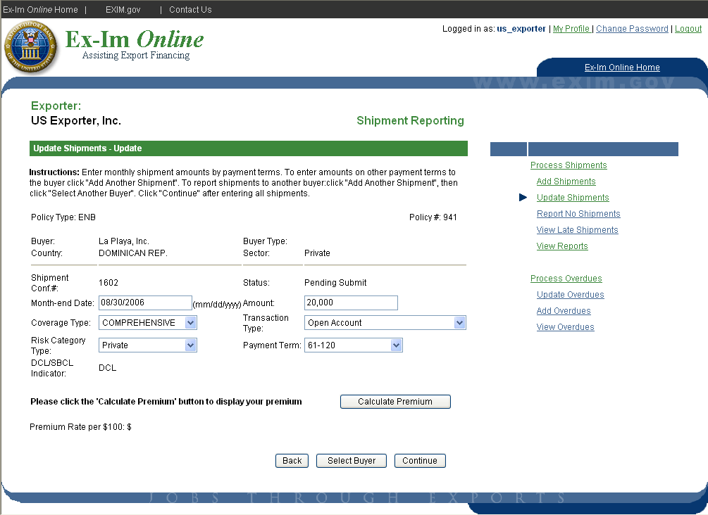

Submit Reported Shipments

Click “Submit” to send the completed, validated shipment reports to Ex-Im Bank.

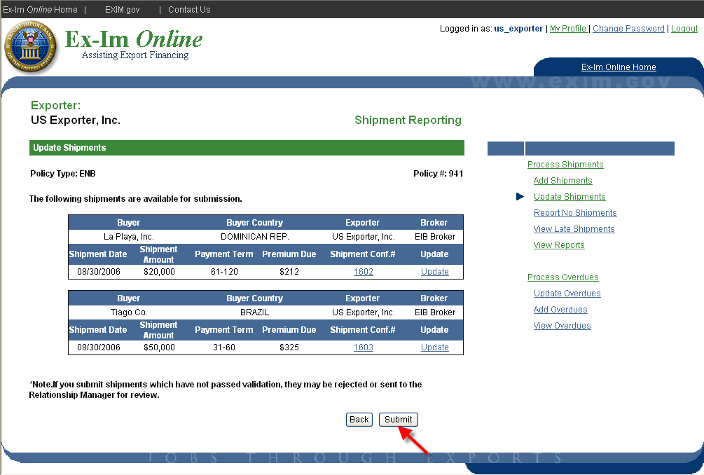

Each shipment is given a unique confirmation number. Please note shipments are not covered until your premium payment has been received by Ex-Im Bank.

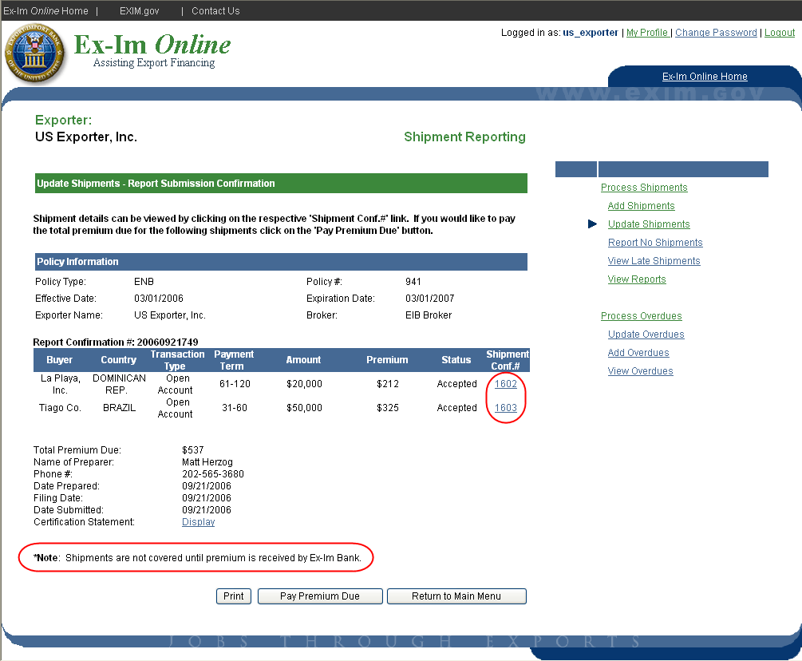

Pay Premium

Currently the only payment method offered in Ex-Im Online is using a check. Credit card payment options will be implemented at year-end 2006.

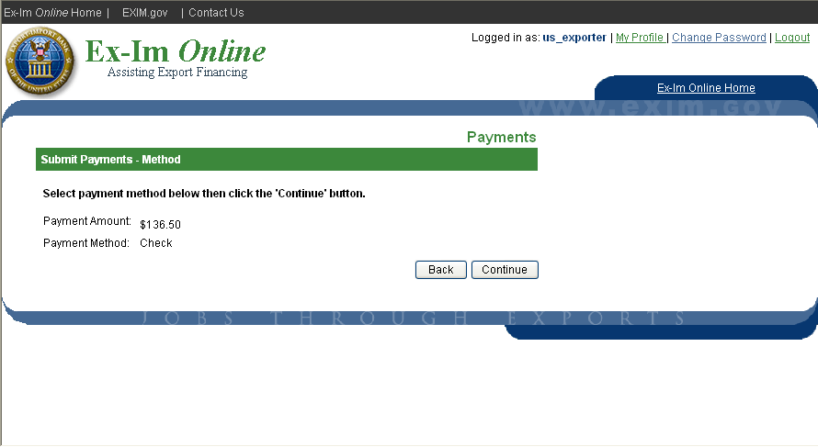

Please remember to include this page with your check to insure payments are applied correctly to your policy.

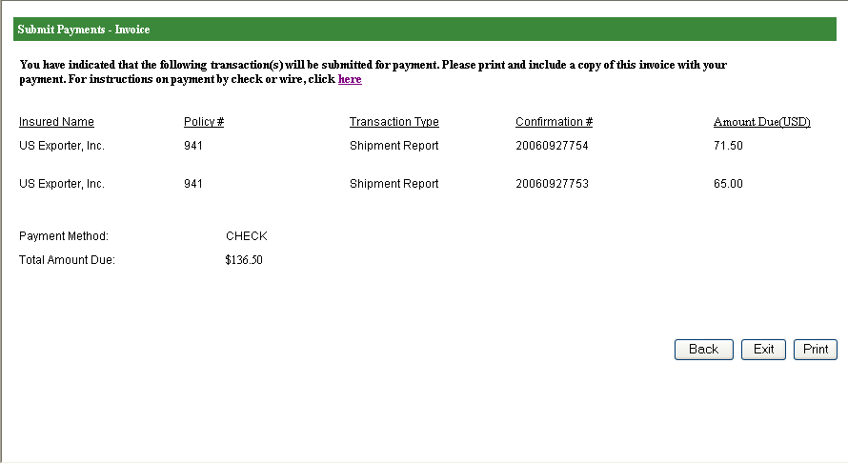

Request a Policy Amendment

Any changes to your policy, from updating the primary contact information to requests for special coverage, can be submitted as an amendment application in Ex-Im Online. You will receive email notifications informing you of the status of the request and, upon approval, policy documents will be updated automatically.

To start, click the “Amend a Policy or Guarantee” link from the landing page.

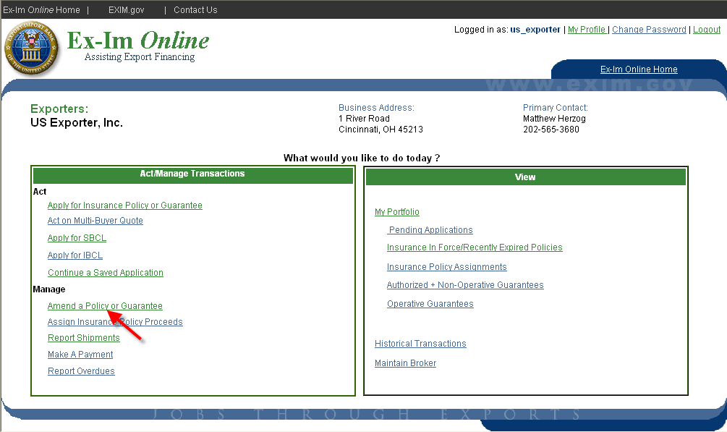

Please note that you are only required to provide information in the section related to your request. For this example we will request the exclusion of “Sales of Samples”, which is under the “Exclusions” section.

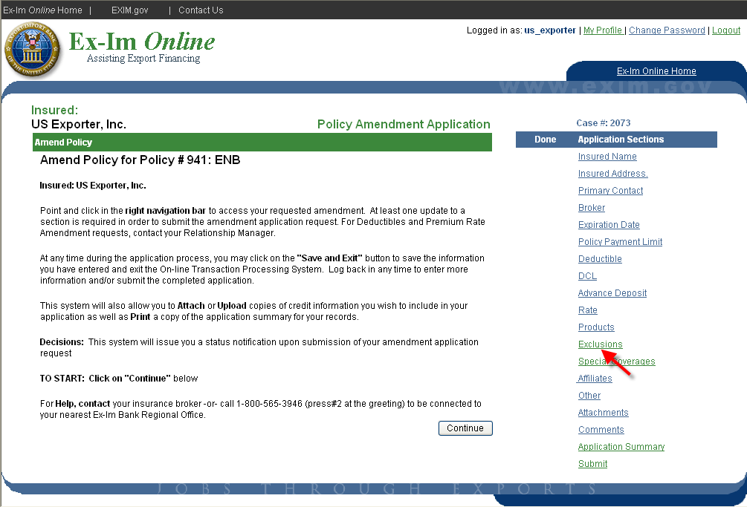

Select “Add Exclusion”

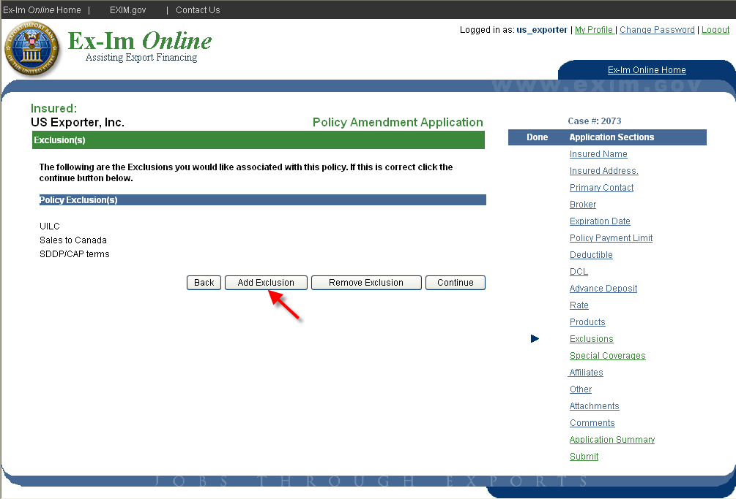

Check the box for “Sales of Samples” and click “Continue”.

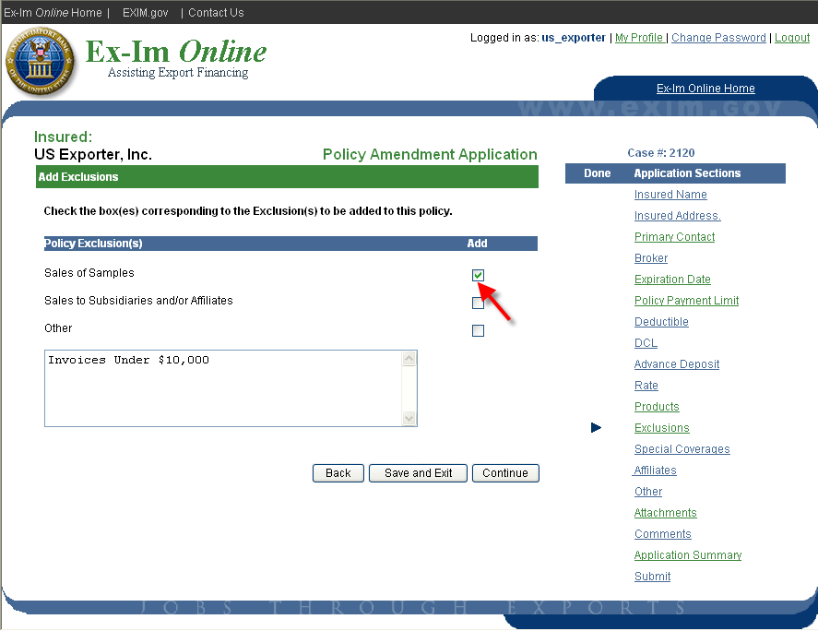

At this point you can either select another section to request multiple changes to the policy, or click on the “Submit” section to complete the application.

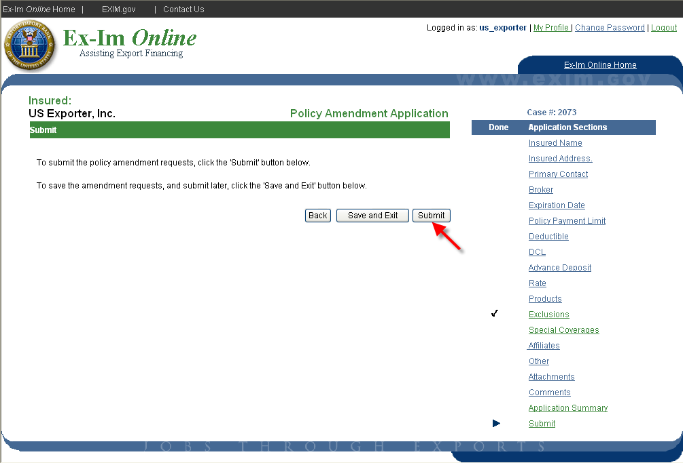

Request an SBCL Amendment

From the In-Force SBCL & IBCL section of the policy landing page, select the SBCL you wish to amend and click the “Amend” link.
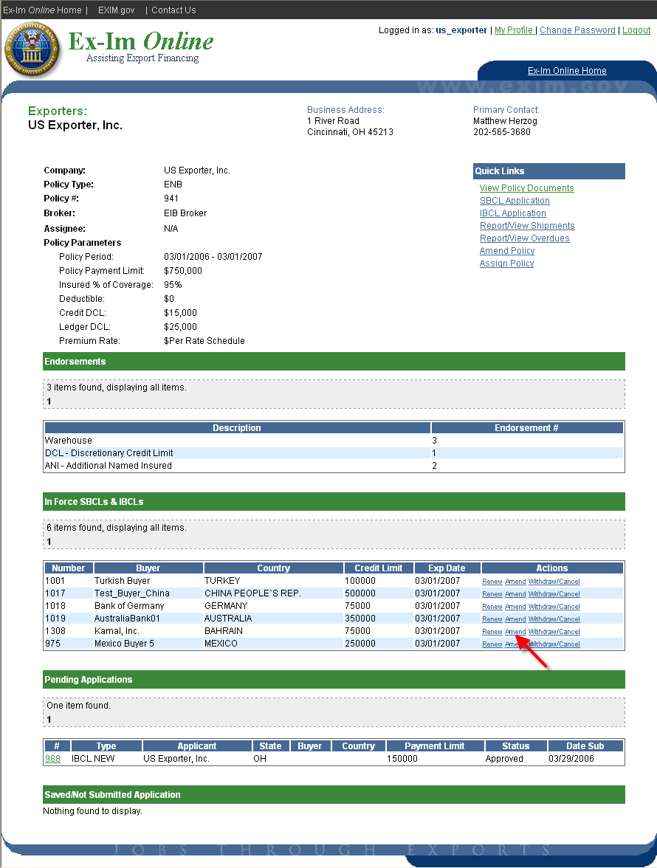

You are only required to complete the sections that pertain to your amendment. In this example we will request a change in the approved payment terms by selecting the “Payment Terms” link.

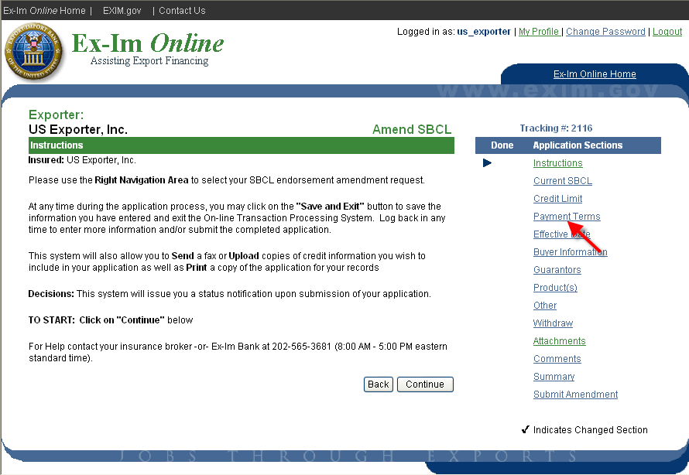

Indicate the parameters you wish to change and then click “Continue to save.

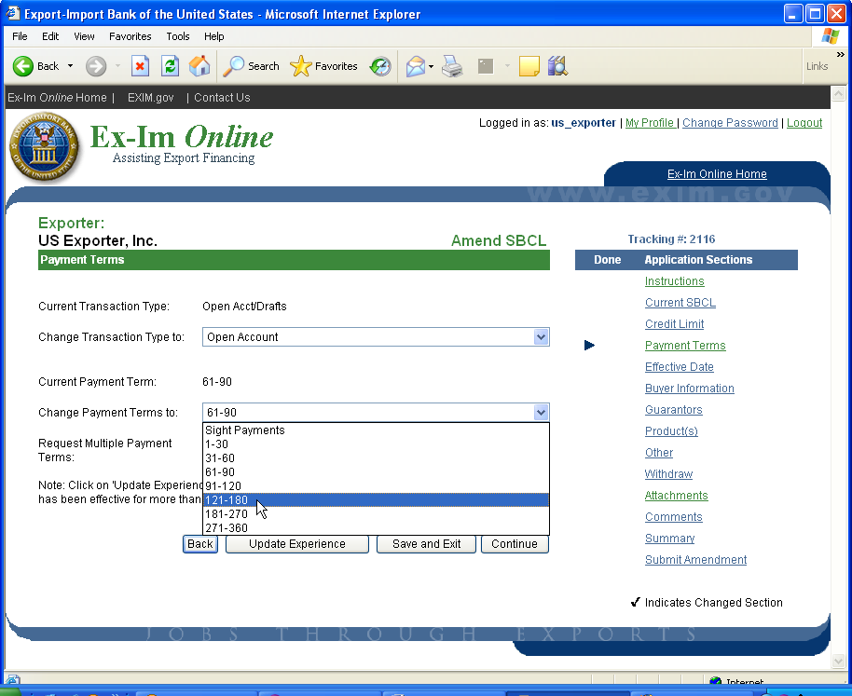

The next to “Payment Terms” confirms that your change was saved. Next, click the “Summary” link to review the request prior to final submission.

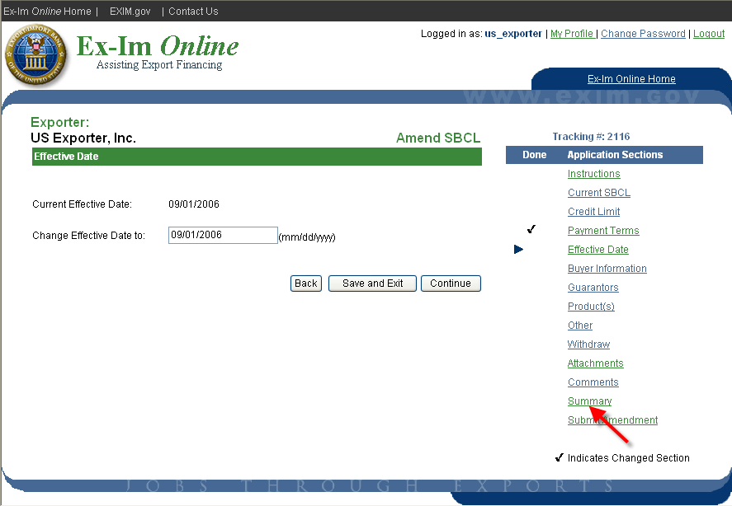

The summary presents the current parameters and the requested changes side-by-side. To complete the application click “Submit Amendment”.

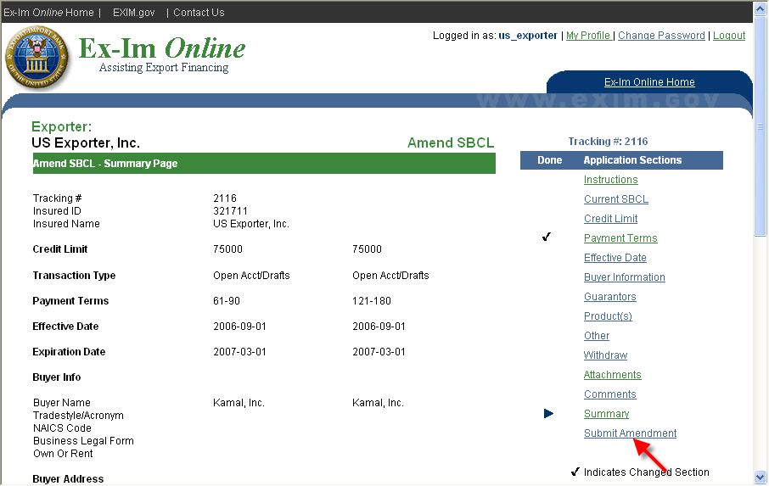

Click “Submit”, and your request is on its way.

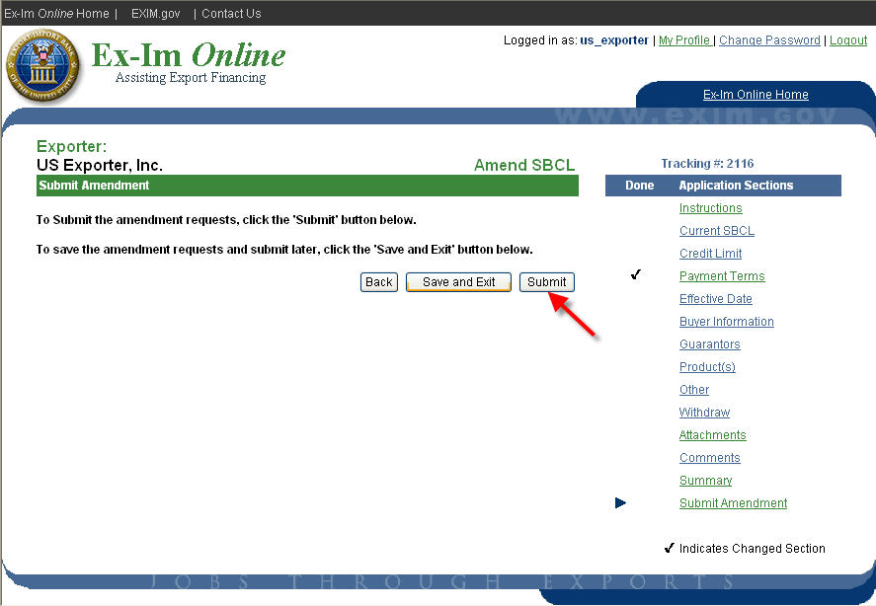

Note the tracking number, and print the confirmation for your records.

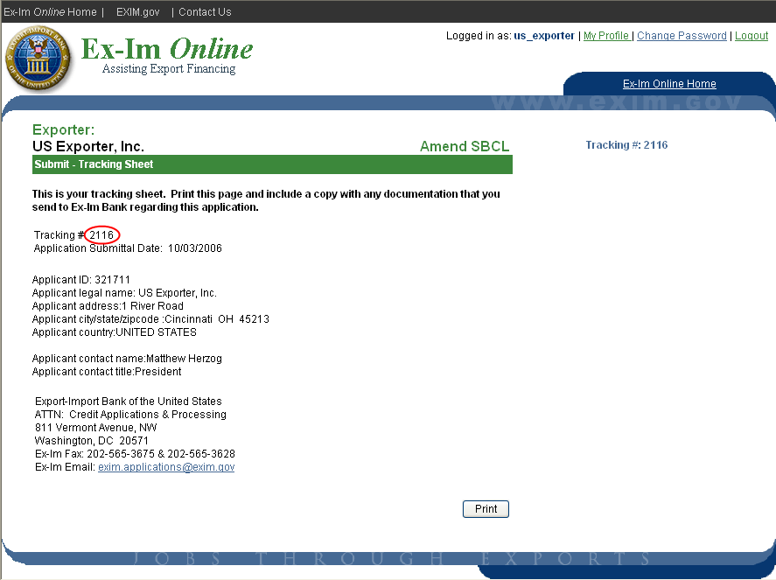

Request Assignment of Policy Proceeds

To execute a new assignment agreement, or make changes to an existing assignment of policy proceeds of a multi-buyer policy, select the “Assign Insurance Policy Proceeds” link.

Assignment forms must be submitted in hard copy with original signatures. The system will provide blank forms for new assignments and for the release and amendment of existing assignments. Completed forms should be mailed to:

The Export-Import Bank of the United States
811 Vermont Avenue, NW
Washington, DC 20571

Attn: Short-Term Trade Finance Division

You will be notified upon completion of the request, and signed original copies of the executed assignment will be mailed to all parties. The assignee will also be listed on the re-issued policy declarations.

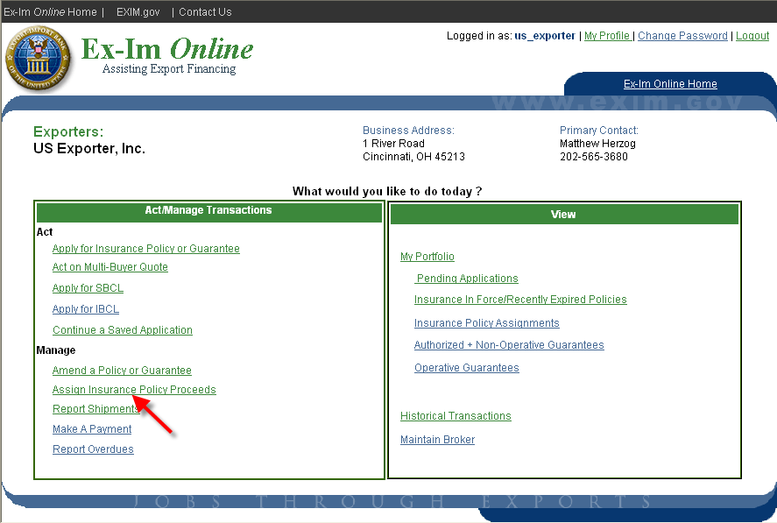

Track the Status of an Application

Ex-Im Online allows you to retrieve detailed status information for any transaction, and provides a unique tracking number for every application submitted in the system. To track the status of an application, click the “Pending Applications” link.

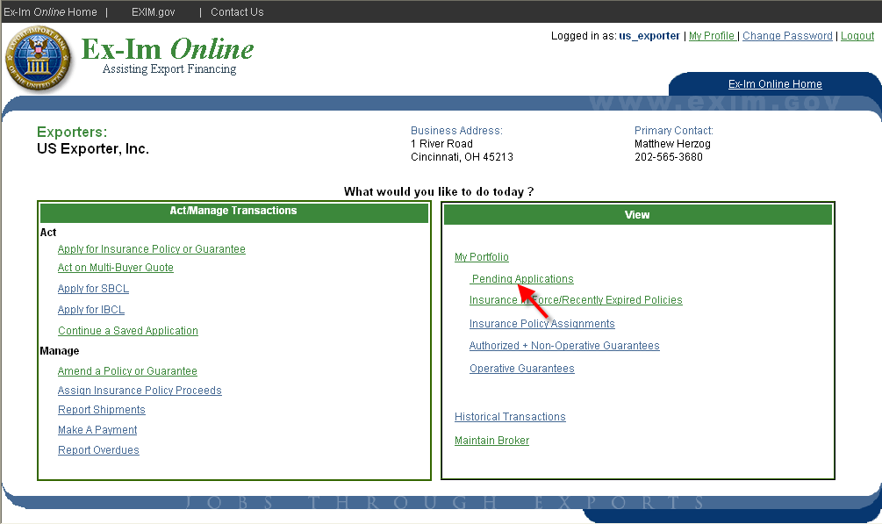

For more information, click on the tracking number on the left.

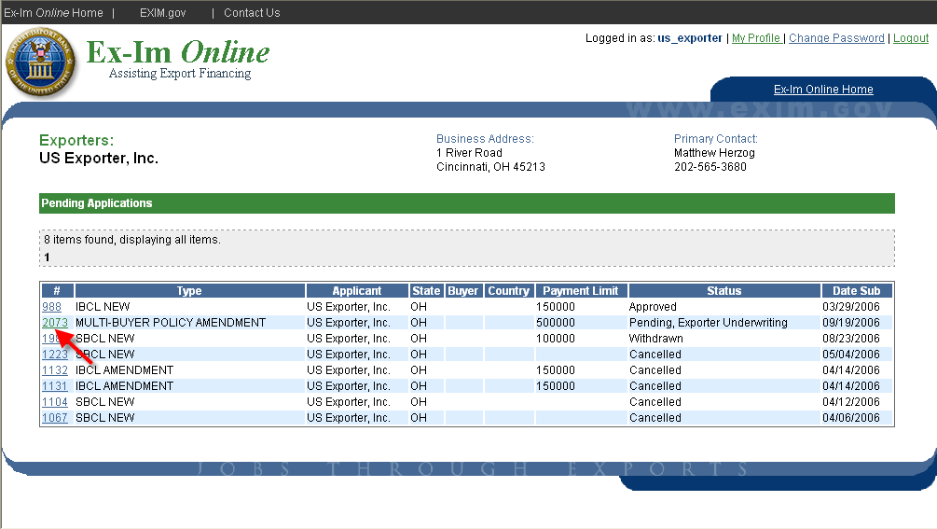

This application is currently pending review with the Exporter Underwriting Division, and has been acquired by the user “fitzgibb”. The “Application Status History” link provides additional information on the application’s path within the bank.

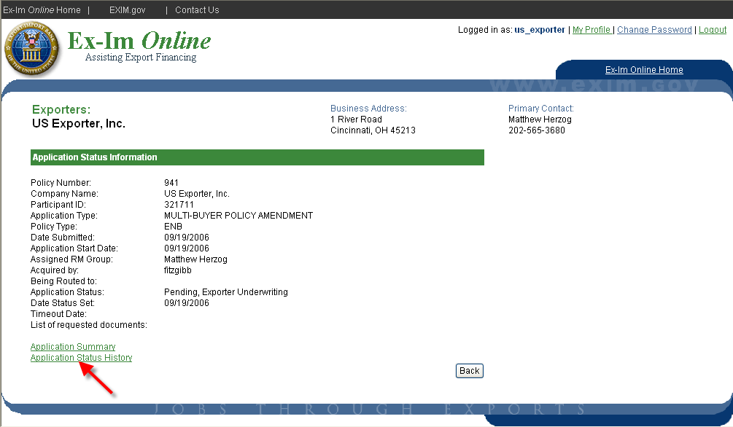

As shown below, the application was submitted reviewed by the relationship manager (Herzog), and is now pending review by the director.

