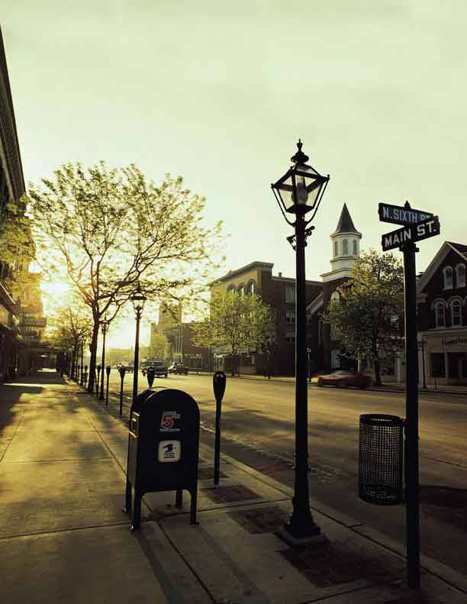
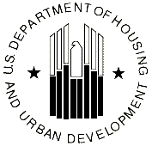
COMMUNITY DEVELOPMENT BLOCK GRANT PROGRAM
PRESERVING AMERICA

Historic Preservation and Heritage Tourism in Housing and Community Development: A Guide to Using Community Development Block Grant Funds for Historic Preservation and Heritage Tourism in your Communities


A Guide to using Community Development Block Grant Funds for Historic Preservation and Heritage Tourism in your Communities

Communities across America are searching for ways to improve their local economies, enhance their quality of life and revitalize their neighborhoods while preserving their cultural and natural heritage. Historic preservation and heritage tourism are two prominent economic and community development strategies to accomplish these objectives. This guide details how communities can utilize Community Development Block Grant funds (CDBG) to promote historic preservation and heritage tourism in their localities.

In addition to providing this guidance, HUD would like our partners in community development to be aware of a new White House initiative that encourages communities to invest in historic preservation and heritage tourism. The Advisory Council on Historic Preservation has developed the Preserve America initiative to honor and award communities that are involved in successful historic preservation and heritage tourism projects. Under the Preserve America initiative, unveiled by First Lady Laura Bush in September of 2003, communities may seek Preserve America Community designation for their towns and cities and nominate outstanding preservation efforts for the new Preserve America Presidential Award.

Background: Heritage tourism is an economic development tool designed to attract visitors to an area based on the unique aspects of the locality’s history, landscape and culture. This not only boosts regional and local pride but is also a good source of revenue for a community and creates jobs. Historic preservation is a tool for preserving a historic place, incubating small businesses, revitalizing downtowns, generating local jobs, and creating improvements in a community.

Purpose: This guide will help state and local officials understand how historic preservation and heritage tourism projects can be accomplished through various eligible activities under the Community Development Block Grant program (CDBG). The CDBG program under the Housing and Community Development Act of 1974 (HCDA) provides resources and flexibility to local officials for determining development in their communities. You will find a description of eligible activities that can be used and important contact information. Also included are some real-life examples of successful historic preservation and heritage tourism projects.

Meeting a National Objective

All CDBG assisted historic preservation and heritage tourism activities must meet a national objective. The activity must benefit low and moderate-income persons; prevent or eliminate slums or blight; or be designed to meet a community development need having an urgent need. Some examples include: The preservation of a commercial building that results in the creation of jobs where at least 51 percent are held by low and moderate-income persons; the preservation of a building used for a community center that serves residents in an area that is 51 percent low and moderate income; an entitlement community that has used historic preservation activities in a designated slum and blighted area or in a non-designated slum and blighted area that shows signs of decay (on a spot basis). The national objectives are outlined in 24 CFR 570.208 for the Entitlement program and in 24 CFR 570.483 in the State program. Both programs require that at least 70 percent of CDBG funds and Section 108 loan funds must be used to benefit low and moderate-income persons. Each state may have additional requirements that Units of General Local Government must adhere to.

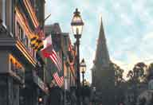
Eligible CDBG Activities which may support Historic Preservation and Heritage Tourism

Historic preservation is a specific eligible activity under 24 CFR Part 570.202(d) where it states that preserving specific historic properties may be undertaken. However, there are a number of other eligible activities that can be used toward historic preservation and heritage tourism projects.

Usually these activities include rehabilitation, preservation and selective restoration of publicly or privately owned properties. However, new construction of non-residential buildings, economic development assistance to for-profit businesses, and energy conservation are also among eligible activities.

The following are eligible CDBG activities that may be used for historic preservation and heritage tourism projects and objectives, if all applicable program requirements are met. The Entitlement regulation and Housing and Community Development Act (HCDA) statutory citations are included for your convenience.

Planning 24 CFR 570.205 and HCDA Section 105(a)(12)

Community planning is an opportunity to develop goals and objectives and include strategies for preservation with plans to meet other purposes as well. This applies to soft costs such as engineering, design costs, preservation counseling, advisory services and inspections. Activities could also include the preparation of general development plans, and plans for particular functions, purposes or areas. Many communities have included historic preservation as a part of their general development plan. Likewise, heritage tourism may also be included as a goal or objective in the plan.

General Plans include:

- Comprehensive plans and community development plans including preservation elements;

- Functional plans for various purposes, including housing, land use, economic development, open space, and energy conservation, including historic preservation elements;

- Data collection, studies, analysis and the preparation of plans and implementing measures including budgets, codes and ordinances;

- Archeological surveys of CDBG project areas, including a reconnaissance survey of a project site containing valuable resources, or an intensive survey for fuller examination of significant sites;

- Activities to enhance the community’s capacity for setting goals and objectives to meet needs, including environmental and preservation concerns;

- Reasonable costs of general environmental studies and historic preservation studies and resource surveys, including environmental review and compliance with Section 106 of the National Historic Preservation Act, where required by 24 CFR Part 58;
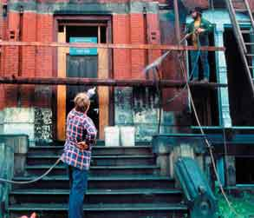

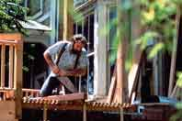
Eligible CDBG Activities which may support Historic Preservation and Heritage Tourism

Historic Preservation Plans include:

- Preparation of a historic preservation plan for the community, including plans for preserving historic downtown areas or neighborhoods or for appropriate reuse of their historic structures;

- Delineating historic districts, including reuse plans and the preparation of ordinances and codes to assure preservation of the districts; and

- Developing strategies and action programs to protect and enhance the cultural environment.

Note: All of these activities may further heritage tourism goals. These activities may include measured drawings, photographs and other documentation of significant architectural and historic data and of any building modifications or project mitigation. These may be prepared as part of a preservation program or in compliance with environmental review requirements.

Historic Preservation 24 CFR 570.202(d)) and HCDA Section 105(a)(1)(C)

Publicly or privately owned historic property can be rehabilitated, preserved or restored, however not for the use of the general conduct of government. Historic properties are sites or structures that are either listed in or eligible to be listed in the National Register of Historic Places (http://www.cr.nps.gov/nr/). They can also be listed in a state or local inventory of historic places, or designated as a state or local landmark or historic district.

Economic Development Activities 24 CFR 570.203 and HCDA Sections 105(a)(1), (4), (14), (15), (17), (22)

Economic development is a major objective in CDBG programs. Communities may find effective ways to tie in preservation objectives with economic development. Rehabilitating an older structure creates job opportunities in the preservation stages of work and revitalizes an area and community. Heritage tourism may provide job opportunities and is a tool for strengthening regional identity and local pride. Eligible activities include:

- Acquisition, construction, reconstruction or installation of commercial or industrial buildings, structures, and other real property, equipment and improvements having historic value; and

- Assistance to private-for-profit-businesses, including financial and technical assistance and involving historic properties.

Administrative Costs 24 CFR 570.206 and HCDA Section 105(a)(13)

- Costs of conducting preliminary surveys and analysis of market needs;

- Costs of site and utility plans, narrative descriptions of proposed development or rehabilitation, preliminary cost estimates, urban design documentation, and “sketch drawings”, including preservation objectives and making proposals compatible with historic settings.

Engineering and Design Costs 24 CFR 570.201, 570.202 and HCDA
Sections 105(a)(2), (5)

- Feasibility studies to assess the condition of structures, including historic structures, and the economic feasibility of corrective techniques to overcome incompatible alterations or deterioration which detract from the historic character of structures; adapting historic buildings to appropriate reuse;

- Designing improvements to the façade of structures, including historic buildings and schematic drawings;

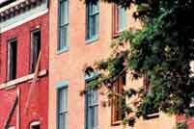
Eligible CDBG Activities which may support Historic Preservation and Heritage Tourism

- Design costs for integrating historic facades into new structures and land uses, with the advice of the state historic preservation office or local historic commission or advisory body;

- Designing the removal of architectural barriers in structures which limit access for elderly or handicapped persons; and

- Other engineering and design needed to preserve historic properties and develop heritage tourism.

Note: Engineering and design activities and costs are considered project costs, not general planning or administrative costs.

Acquisition 24 CFR 570.201 and HCDA Section 105(a)(2)

- Acquisition of properties, including historic properties, in whole or in part by a public agency or private not-for-profit entity;

- Acquisition by purchase, lease, donation, or otherwise, of real property (including air rights, water rights, rights-of-way, easements, façade easements and other interests);

- Acquisition of buildings and improvements and their relocation to other sites.

Clearance Activities 24 CFR 570.201(d) and HCDA Sections 105(a)(4), (25)

- Moving a historic structure from a project site or other site to a location appropriate for its preservation; and

- Clearing incompatible structures from a historic site to highlight historic values or to provide for compatible new development.

Site Preparation 24 CFR 570.201 and HCDA Sections 105(a)(2), (4)

- Construction, reconstruction or installation of public improvements, utilities, or facilities (other than buildings) related to the redevelopment or reuse of real property that was acquired by CDBG funds;

- Making improvements necessary to restore a property’s architectural or historic character.

Property Rehabilitation 24 CFR 570.202 and HCDA Sections 105(a)(4), (25)

Rehabilitation constitutes a major area of opportunity for including historic preservation in programs designed to revitalize neighborhood and commercial areas and for encouraging private sector involvement in community development and property rehabilitation activities. Eligible activities include the rehabilitation of:

- Eligible privately owned residential buildings and improvements limited to façade, such as commercial buildings in a downtown and code requirements of non-residential buildings;

- Public housing and other publicly owned residential buildings and improvements;

- Publicly owned nonresidential buildings and improvements otherwise eligible for assistance;

- Activities to secure the retention and reuse of historic structures, such as renovation of closed school buildings for conversion to housing or a public facility, or to serve another public purpose;

- Energy system improvements or retrofitting, e.g., to enhance the use and preservation of historic structures; and

- Obtaining or conducting rehabilitation advisory services, such as rehabilitation counseling, energy auditing, preparation of work specifications, inspections, and other advisory services to owners, tenants, contractors and other entities participating or seeking to participate in authorized rehabilitation activities.

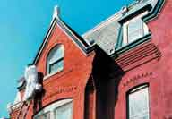
Eligible CDBG Activities which may support Historic Preservation and Heritage Tourism

Property Disposition 24 CFR 570.201(b) and HCDA Section 105(a)(7)

- Sale, lease, donation, or otherwise, of any real property acquired with CDBG funds, including arrangements and restrictions to preserve historic properties or to provide for appropriate reuse of historic property.

Code Enforcement 24 CFR 570.202(c) and HCDA Section 105(a)(3)

- In deteriorated areas, code enforcement can stop the decline of an area that is in the process of being rehabilitated.

Public Facilities and Improvements 24 CFR 570.201(c) and HCDA Section 105(a)(2)

- Acquisition, construction, reconstruction, rehabilitation or installation of eligible public facilities and improvements, as in historic districts or neighborhoods;

- Design features and improvements which promote energy efficiency; and

- Execution of architectural design features to enhance or preserve the aesthetic quality of facilities and improvements receiving CDBG assistance, such as decorative pavements, railings, sculptures, pools of water and fountains, and other works of art (excluding furniture and furnishings within buildings).

Removal of Architectural Barriers 24 CFR 570.201(k) and HCDA Section 105(a)(5)

- Removing material and architectural barriers that restrict the mobility and accessibility of elderly or handicapped persons to publicly owned or privately owned buildings, facilities, and improvements.

Privately owned Utilities 24 CFR 570.201(l) and HCDA Section 105(a)(2)

- Use of CDBG funds to acquire, construct, reconstruct, rehabilitate, or install the distribution lines and facilities of privately owned utilities, including the placing underground of new and existing distribution facilities and lines, as in a historic district.

Activities by Community-Based Development Organizations 24 CFR 570.204(c) and HCDA Section 105(a)(15)

- Recipients may grant or loan CDBG funds to subrecipients for any eligible activities including eligible historic preservation and heritage tourism activities. This could include neighborhood-based nonprofit organizations, small business investment companies or local development corporations used to carry out neighborhood revitalization projects, community economic development or energy conservation projects. Additionally, under the State CDBG program, the subrecipient may also be any non-profit organization and would be eligible under Section 105(a)(15).

Technical Assistance 24 CFR 570.201(p) and HCDA Section 105(a)(19)

- Obtaining or providing technical assistance to public or non-profit entities for planning, developing and administering historic preservation activities;

- Conducting local education and information programs concerning historic preservation, including encouragement of private initiatives through private investment and the use of available tax incentives and other resources;

- Conducting workshops on preservation, such as façade treatment of historic storefronts or seminars on historic district design for local merchants, architects, planners and community organizations; and

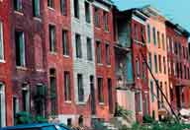
Eligible CDBG Activities which may support Historic Preservation and Heritage Tourism

- Training conferences for municipal and community leaders that encourage preservation strategies and techniques for implementing them.

Consultant Services 24 CFR 570.200(d)

- Obtaining professional assistance for program planning, and preparing community development objectives, including historic preservation, and securing other general professional guidance for devising programs and methods or schedules for implementing them, including preservation elements. Please note, unless consultant costs are under planning, they are considered project costs.

Payment of the non-Federal share required in connection with a Federal grant-in-aid program 24 CFR 570.201(g) and HCDA Section 105(a)(9)

- CDBG funds may be used for the payment of the non-Federal share required for Federal grant-in-aid programs, provided the activities are part of eligible CDBG activities. For example, CDBG funds may be used to make up the local matching requirement of the Department of the Interior’s historic preservation grant program.

Incentives for using Historic Preservation and Heritage Tourism

Tax Incentives: Approximately 45 states and many local governments offer property tax incentive programs for the rehabilitation of historic properties. These programs foster reinvestment, job creation, and income generation. Currently thirty-four state programs offer real property tax relief. The most common of these programs exempts property owners from being taxed for a specific period of time based on the building’s increased value due to the rehabilitation work done on the historic property. Additionally, other states administer state income tax-based incentives for historic rehabilitation.

Economic and Community Benefits: Investment in historic preservation and heritage tourism has produced numerous economic and community benefits for localities. Communities have used historic preservation and heritage tourism as an economic development strategy towards job creation, creating new business, for private investment and have seen their property values increase. Rehabilitating historic properties also creates jobs in the construction, manufacturing, transportation, utilities, retail and services industries. These areas often see a corresponding increase in household income and spending, which further strengthens the local economy.

These benefits directly impact local economies while aiding the physical transformation of downtowns, reducing urban and rural sprawl, and creating destinations for tourists and local residents alike. Additionally, the rehabilitation of historic properties has also helped increase supply of affordable housing, which is in great demand in many communities.

Success Stories of Communities with Heritage Tourism and Historic Preservation projects:

1. Pharr, Texas, a CDBG entitlement city, utilized CDBG money to fund several main street projects to encourage renewal in their town. The goal of Main Street Pharr was to revitalize Park Avenue, Pharr’s main street, through the promotion of heritage tourism to stimulate the local economy. The planning stages took about 3 years and included innovative initiatives such as setting up a preservation ordinance and a local historical commission, performing a windshield survey of the town’s historical district, and completing a $7,500 “festival infrastructure” project along Park Avenue. These efforts were designed to aid the transformation of Main Street Pharr into a festival destination. The infrastructure, partly funded by a $2,500 grant from the Anice Read Fund, included an electrical and lighting system, banners, meter, boxes, banner brackets, and flood light poles.
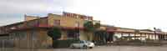
This building is the sight that will become the Rio Grande Valley Food Bank in Pharr, Texas.
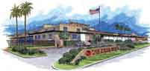
This rendering illustrates the proposed Rio Grande Valley Food Bank in Pharr, Texas.

The city also completed an oral history project that documented its rich heritage and was instrumental in securing a landmark designation from the Texas Historical Commission for display at City Hall. CDBG funds were also used for operating expenses to support the city’s Main Street Program and for a promotions budget to install banners for display within the historical district.

On-going projects also include conducting the city’s first preservation master plan. This policy document and vision statement from the community was the first of its kind among the 46 cities and towns in the Lower Rio Grande Valley. In addition, CDBG funding is being used to conduct a restoration plan for the city’s first fire station. The latter has included asbestos testing and removal, performing a structural study and a floor plan sketch. The restoration plan will also include an architectural rendering and plan of action to restore the structure’s exterior, interior and original landscaping features. In addition to these efforts, the city set up a $50,000 matching fund for a façade improvement program to encourage the private sector investment for the restoration and preservation of the city’s historic district. As a result, seven local banks matched the city’s commitment and set up a $637,000 low interest loan pool to encourage further private investment in façade restoration. The ripple effects of these CDBG activities include other projects led by citizen volunteers, such as an inventory of the local historic cemetery resulting in the city’s first historic Texas cemetery designation. It is estimated that over $25,000 worth of volunteer hours were contributed in 2002 and 2003.

In 2002 and 2003, Pharr Main Street produced over $3.2 million in public and private investments, 21 business starts, and a net gain of 50 jobs. The historic district also experienced the return of key civic assets such as City Hall and the public library. Pharr continues to invest in its built environment, image and future by revitalizing its core, thus attracting heritage tourists and generating revenue for the city. Recently, Pharr joined the Los Camino Del Rio Heritage Trail becoming a stop and destination along this heritage corridor, which highlights the common heritage along the Texas-Mexico borderlands. As a result of Pharr’s innovative efforts in preservation and revitalization the city was honored with the 2004 Texas Main Street City designation. The State of Texas First Lady, Mrs. Anita Perry, kicked off this designation at a special ceremony in Pharr on
March 30, 2004. In May 2004, the City of Pharr was designated a National Preserve America Community through the White House’s Preserve America initiative. The city is the first Border community in the nation to receive this honor for their work in preservation and revitalization. Contact: Pharr Main Street Office at (956) 702-5335, ext 137.

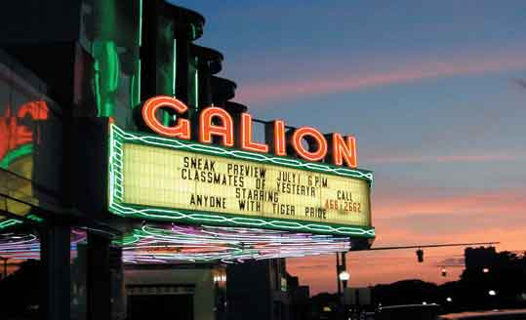
The rehabilitated historic theater,
which originally opened in 1949 as
an art-deco movie theater and boasts
to having the only original intact neon
marquee in Ohio.

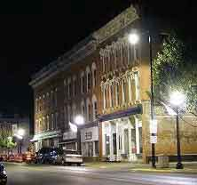
This historic hotel on main street will be converted into a senior citizen residence, which will further increase the population in the historic area.
2. Main Street Galion, in Galion, Ohio has used State CDBG money to leverage 10 million dollars of funding from public and private sources to revitalize their “historic uptown” area, which had fallen into decline due to plant closures. Projects included façade work, rehabilitation and infrastructure improvements. Additionally, the main square was restored and an historic walking tour was developed to promote Galion as a tourist destination. Businesses have returned to the district helping to generate more revenue for the city and providing needed services to residents and tourists. Main Street Galion redevelopment initiatives include the rehabilitated historic theater, which originally opened in 1949 as an art-deco movie theater and boasts to having the only original intact neon marquee in Ohio. Also, a historic hotel on main street will be converted into a senior citizen residence, which will further increase the population in the historic area. Contact: Main Street Galion at (419) 468-4812 ext 204, www.galionohio.com.

3. The Kissimmee Community Redevelopment Agency, in Kissimmee, Florida, received two State CDBG grants for historic preservation projects to upgrade the downtown area over a span of six years. The first project used $750,000 of CDBG funding towards developing a five-block streetscape downtown. Three years later a second CDBG grant in the amount of $750,000 was used towards completing the streetscape project. The project involved improvements to the parking lot, lighting, signage and making the area more pedestrian friendly by adding sidewalks from the historic courthouse to the downtown. Another goal was bringing the oldest buildings, which were built between 1906 and 1926, up to code and making them accessible to the disabled. Business owners were offered $30,000 toward this goal if each contributed 10 percent of the cost. The owners had to either occupy the building or have a retail tenant on the first floor. The final results include eleven completed storefront renovations and façade improvements, construction of bathrooms, and improved site accessibility. These improvements have created a surge of interest from businesses and residents wanting to live in the downtown area. Contact: Kissimmee Community Redevelopment Agency at (407) 518-2544, www.kissimmeecra.com.

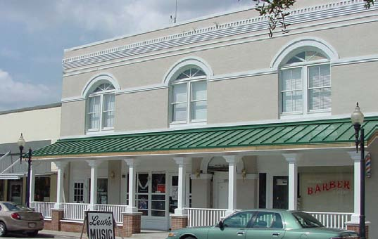
This project involved improvements to the parking lot, lighting, signage and making the area more pedestrian friendly by adding sidewalks from the historic courthouse to the downtown.

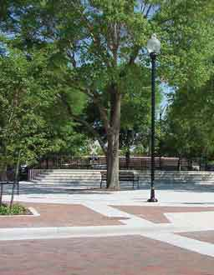

Toho Square along with these other improvement projects have created a surge of interest from businesses and residents wanting to live in downtown Kissimmee.

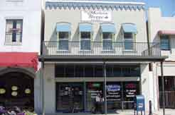

Another goal was bringing the oldest buildings, which were built between 1906 and 1926, up to code and making them accessible to the disabled.

Eligible CDBG Activities that can be used for Historic Preservation and Heritage Tourism projects

Eligible Activity: | State Program: HCDA 105(a) | Entitlement Regulations:  24 CFR 570.201-.206
Acquisition of Real Property | 105(a)(2) | 570.201(a)
Public Facilities and Improvements | 105(a)(2) | 570.201(c)
Code Enforcement | 105(a)(3) | 570.202(c)
Clearance | 105(a)(4), (25) | 570.201(d)
Rehab | 105(a)(4), (25) | 570.202(a)(b)(d)(e)(f)
Reconstruction | 105(a)(4), (25) | 570.202
Construction of Buildings (Housing incl.) | 105(a)(4), (25) | 570.201(m)
Architectural Barrier Removal | 105(a)(5) | 570.208(a)(2)(ii)
Property Disposition | 105(a)(7) | 570.201(b)
Payment of Non-Federal Share | 105(a)(9) | 570.201(g)
Planning and Capacity Building | 105(a)(12) | 570.200(g), 570.205
Program Administration Costs | 105(a)(13) | 570.206
Activities carried out by Community-Based Development Organizations | 105(a)(15) | 570.204(c)
Economic Development Assistance to For-Profit Business | 105(a)(17) | 570.203(b)
Technical Assistance | 105(a)(19) | 570.201(p)
Historic Preservation | 105(a)(1)(C) | 570.202(d)
Economic Development Activities | 105(a)(1), (4), (14), (15), (17), (25) | 570.203
Engineering and Design Costs | 105(a)(2), (5) | 570.201, 570.202
Site Preparation | 105(a)(2), (4) | 570.201
Privately Owned Utilities | 105(a)(2) | 570.201(l)
Consultant Services | None | 570.200(d)
Payment of the non-Federal share for a Federal grant-in-aid program | 105(a)(9) | 570.201(g)

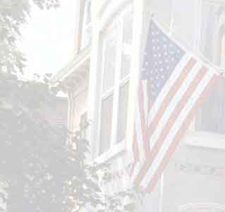

Resources and Links:

- National Trust for Historic Preservation
http://www.nationaltrust.org/index.html
- Main Street National Trust for Historic Preservation
http://www.mainstreet.org/
- National Register of Historic Places
http://www.cr.nps.gov/nr/
- Preserve America
http://www.preserveamerica.gov
- State and Entitlement CDBG contacts:
http://www.hud.gov/offices/cpd/communitydevelopment/programs/contacts/index.cfm
- Preservation Directory
http://www.preservationdirectory.com/
- Heritage Preservation
http://www.heritagepreservation.org/

If you have questions about this publication, please call your local HUD field office.

www.hud.gov HUD-2004-09-CPD espanol.hud.gov

