Region 4: Seattle-Bellevue-Tacoma, WA Combined Statistical Area (CSA)

I. Geographic Boundaries, Political Jurisdictions, and Infrastructure

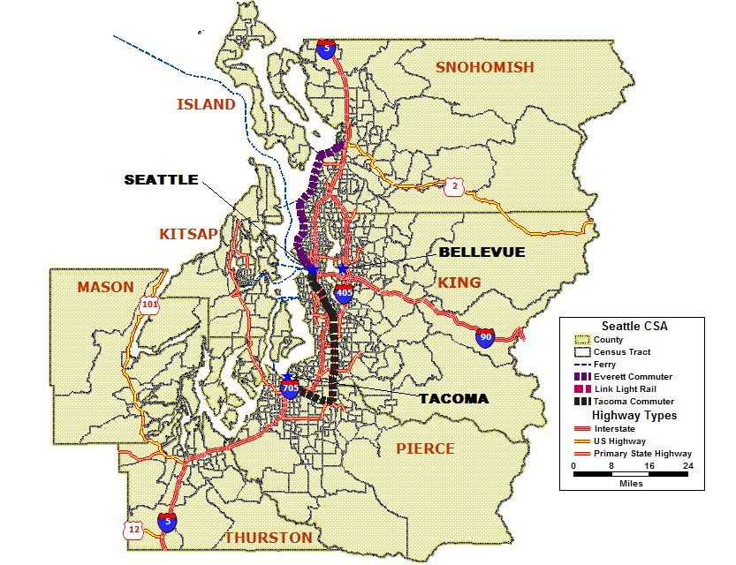
Map 4.1 Seattle-Bellevue-Tacoma, WA CSA Major Highways, Fixed Guideway, and Ferry

The seven counties of Island, Kitsap, Mason, Thurston, Pierce, King, and Snohomish comprise the Seattle-Bellevue-Tacoma, WA Combined Statistical Area (CSA) located in the Pacific northwest of the continental United States. The CSA is approximately 8,247 square miles with a population of 3,604,165, which accounts for over 61 percent of the state of Washington’s total population of 5,894,121.

Interstates 5, 405, 90, and 705 and the United States highways of 2, 12, and 101 are the major highways between and around the three central cities of the CSA. A commuter and light rail fixed guideway system, monorail, ferries, and bus transit service, services the Seattle-Bellevue-Tacoma, WA CSA.

The central cities of Seattle, Bellevue, and Tacoma are located along large waterways that are part of the Puget Sound, over 100 miles from the United States and Canada border. The Puget Sound is an inlet to the Pacific Ocean, which is just west of Seattle. Many rivers, forests, and lakes also surround the cities and suburbs of this area. The population of Seattle, Bellevue, and Tacoma combined is 866,499, or 24 percent of the total CSA population. The Olympic peninsula, located west of Seattle, is home to the Makah American Indian Nation.

The Seattle, WA CSA climate is described as a mild, temperate marine climate, where the temperature is moderated by the sea and protected from winds and storms by the Olympic Mountains located west of the Puget Sound and Cascade Mountains to the east.

Agencies Operating in the Seattle-Bellevue-Tacoma, WA CSA

Agency | Jurisdictions Served | Population Served | Operating Budget | Staff Size
Washington Department of Transportation | Northwest and Olympic Regions | 905,266 | $15.6 million [1] | (a)
Puget Sound Regional Council | King, Kitsap, Pierce, and Snohomish Counties | 3.3 million | $24.5 million | 85
Bellevue Community Transit | Arlington, Canyon Park, Darrington, Everett, Gold Bar, Marysville, Stanwood, Seattle, Sultan | (a) | (a) | (a)
King County METRO | King County | 1.7 million | (a) | (a)
Sound Transit | Cities and islands of the Central Puget Sound | (a) | $930.5 million | (a)
Pierce Transit | Bonney Lake, Buckley, DuPont, Fife, Edgewood, Fircrest, Gig Harbor, Lakewood, Milton, Orting, Puyallup, Ruston, Steilacoom, Sumner, Tacoma and University Place | 675,000 | (a) | (a)
Everett Transportation Service | City of Everett | 91,488 | (a) | 46
Kitsap Transit | Kitsap County | 231,969 | (a) | (a)
Island Transit | Island County | 71,558 | (a) | (a)
Intercity Transit | Olympia, Lacey, Tumwater, and Yelm | (a) | 3.29 million | (a)
(a) Not Available
Table 4.1 Seattle-Bellevue-Tacoma, WA CSA Agencies

Transit Service Area: Fixed Guideway and Bus Service Area

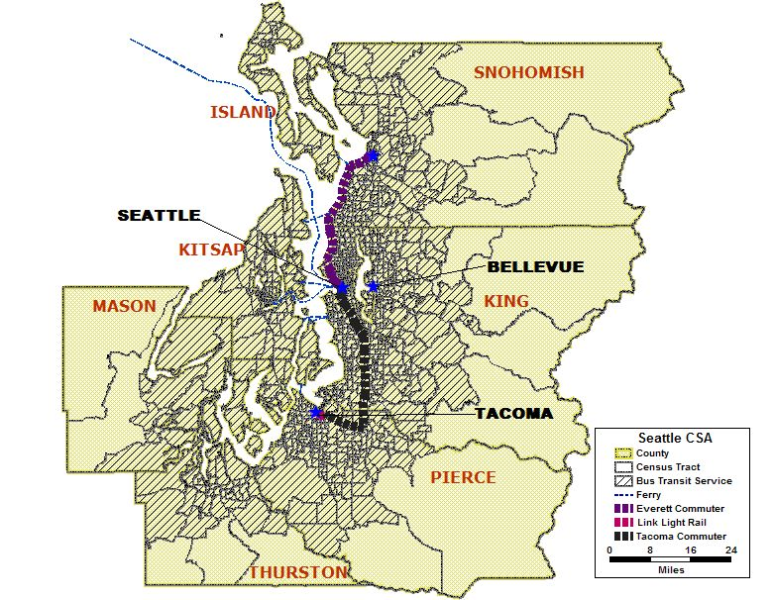
Map 4.2 Seattle-Bellevue-Tacoma, WA CSA Transit Service Area

Over 3,700 square miles of the Seattle-Bellevue-Tacoma, WA CSA is served by bus transit service from 10 transit agencies that serve a mix of local, commuter, and regional bus routes. The Everett and Tacoma commuter lines and Link light rail are fixed guideway routes operated by Sound Transit. The following table identifies the transit agencies and their service areas within the CSA. Available data pertaining to the service areas, annual ridership, and fleet size for transit agencies are presented in the table below.

Agency | Service Area | Annual Ridership | Fleet Size
Bellevue Community Transit | Arlington, Canyon Park, Darrington, Everett, Gold Bar, Marysville, Stanwood, Seattle, Sultan | (a) | (a)
King County METRO | King County | 100 million | 1,300 buses
Sound Transit | Areas including and between Everett, Seattle, Tacoma | 10.9 million | 69 commuter rail  3 light rail
Pierce Transit | Bonney Lake, Buckley, DuPont, Fife, Edgewood, Fircrest, Gig Harbor, Lakewood, Milton, Orting, Puyallup, Ruston, Steilacoom, Sumner, Tacoma and University Place | 13 million | 225 buses
Everett Transportation Service | City of Everett | (a) | (a)
Kitsap Transit | Kitsap County | (a) | (a)
Island Transit | Island County | (a) | (a)
Intercity Transit | Olympia, Lacey, Tumwater, and Yelm | (a) | (a)
(a) Not Available

Table 4.2 Seattle-Bellevue-Tacoma, WA CSA Transit Agencies

Number and Proportion of Minority, Below Poverty, and Limited English Proficient Populations in Relation to the Transit Service Area

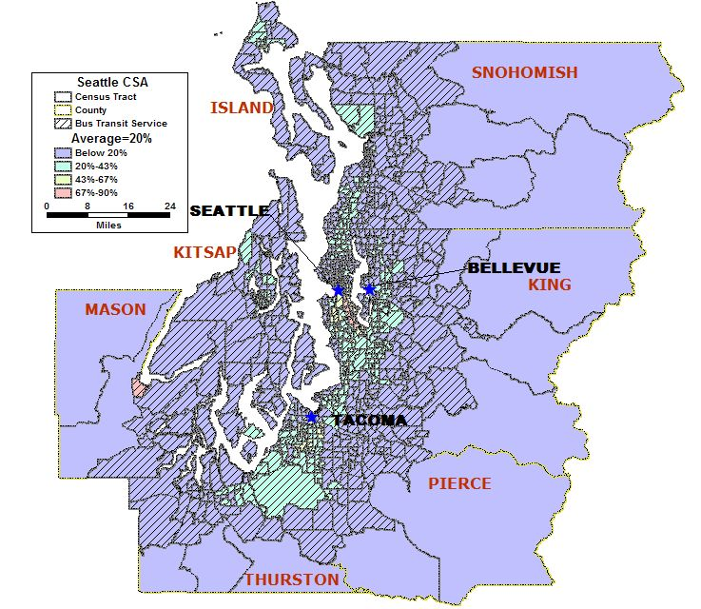

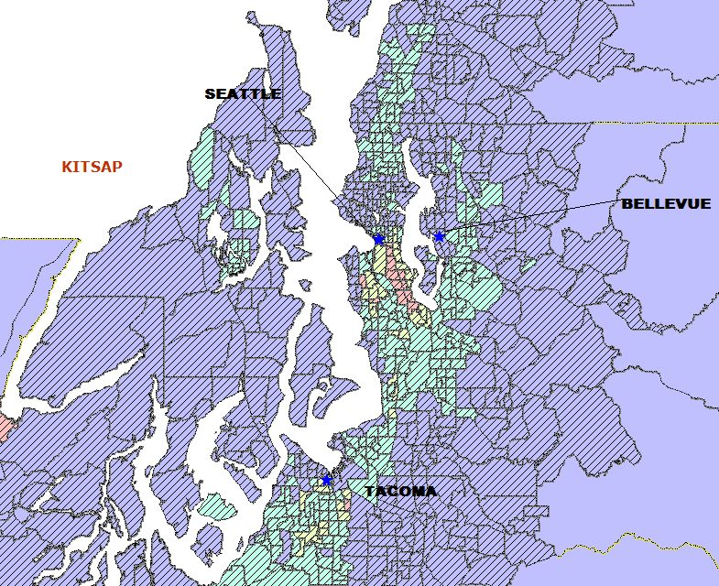
Map 4.3 Seattle-Bellevue-Tacoma, WA CSA Minority Population

Total Number of Census Tracts in CSA 784
Total Population of CSA 3,604,165
Total Minority Population residing in CSA 741,164
Regional Average of Minority Population in the CSA 20%
Number (%) of Census Tracts with above average minority population 304 (39%)
Total Minority Population in the above average census tracts 485,094

The total population of the Seattle, WA CSA is 3,604,165. The total CSA minority population is 741,164. The CSA has 304 census tracts, or 39 percent, with an above average percentage of minority population (485,094). The majority of census tracts with an above average percentage of minority population are located close to the cities of Seattle, Bellevue, and Tacoma, which is where approximately one-third (932,000) of the total CSA population resides. The Minority Population map shows 13 census tracts in Seattle with minority populations between 68 and 90 percent. One census tract, located west of Tacoma, appears with an above average minority population of 72 percent. This is an American Indian Nation.

As shown in the Minority Population map, the bus service area for the 10 community and regional transit agencies operates in all of the CSA’s census tracts with above average minority populations. Approximately 81,328, or two percent of the entire CSA’s population, live outside the transit service area.

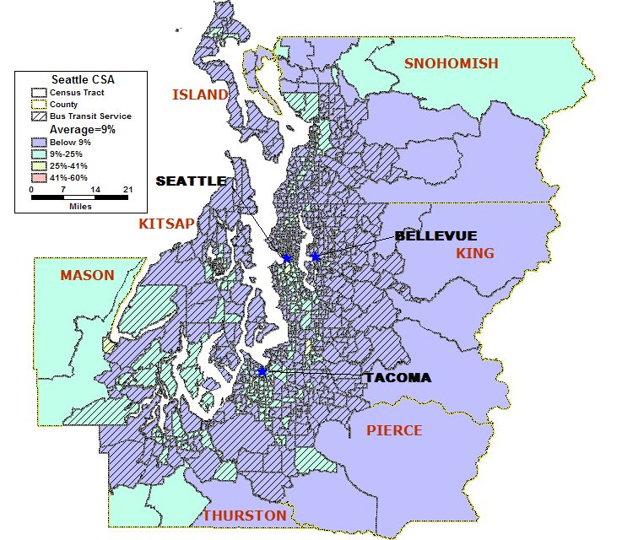
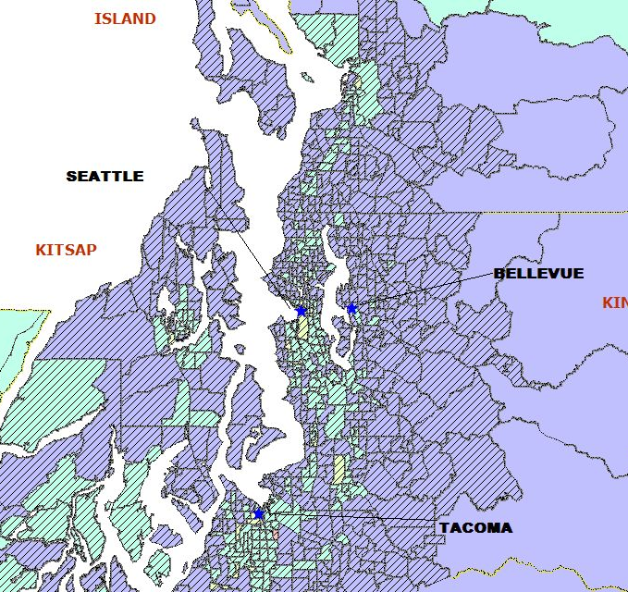
Map 4.4 Seattle-Bellevue-Tacoma, WA CSA Below Poverty Population

Total Number of Census Tracts in CSA 784
Total Population of CSA 3,604,165
Total Below Poverty Population residing in CSA 303,090
Regional Average of Below Poverty Population in the CSA 9%
Number (%) of Census Tracts with above average Below Poverty pop. 268 (34%)
Total Below Poverty Population in the above average census tracts 183,368

An average of approximately nine percent of the total population, 303,090 persons, live below poverty level in the Seattle, WA CSA. The Seattle CSA has 268 census tracts (34%) with an above average percentage of below poverty level persons (183,366). Census tracts with the highest below poverty level rates, which range between 48 and 57 percent below poverty population, are found in downtown Seattle and Tacoma. Approximately 99 percent of the census tracts with above average below poverty level populations are located in a bus transit service area. The large census tracts along the perimeter of the CSA that have above average below poverty populations have a combined total population of 32,000 persons, which is less than one percent of the total CSA population.

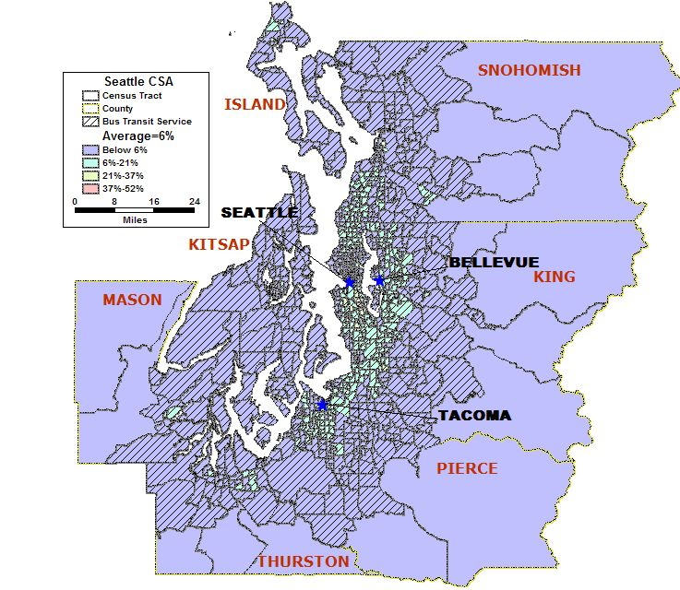
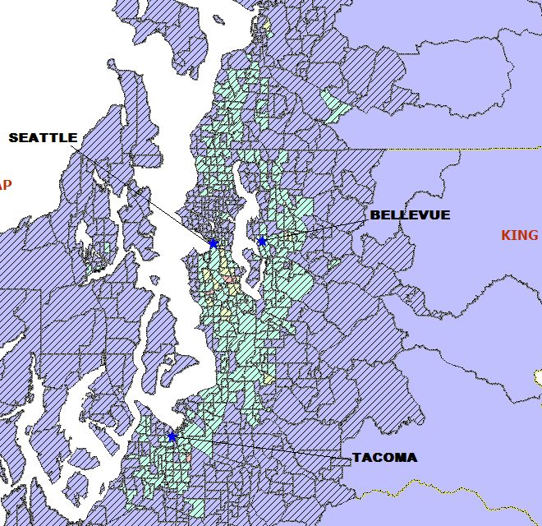
Map 4.5 Seattle-Bellevue-Tacoma, WA CSA Limited English Proficient Population

Total Number of Census Tracts in CSA 784
Total Population of CSA 3,604,165
Total Population 5 years and older of CSA 3,368,005
Total LEP Population* residing in CSA 213,575
Regional Average of LEP Population* in the CSA 6%
Number ( %) of Census Tracts with above average LEP population* 283 (36%)
Total LEP Population* in the above average census tracts 153,571

* LEP includes those 5 years of age and older

The limited English proficient (LEP) population in the Seattle, WA CSA is six percent, or approximately 213,575 of the total population. A total of 283 census tracts (36%) in the CSA have an above average LEP population (153,571). The above average populations of LEP persons appear in a 700 square mile area between the city of Everett, to the north and Tacoma/Olympia in the south. The above average population of limited English proficient persons is located in the CSA’s bus transit service area. Approximately 81,328, or two percent of the entire CSA’s population, live outside the transit service area.

Number and Proportion of Zero Car Households: Greater than the Regional Average

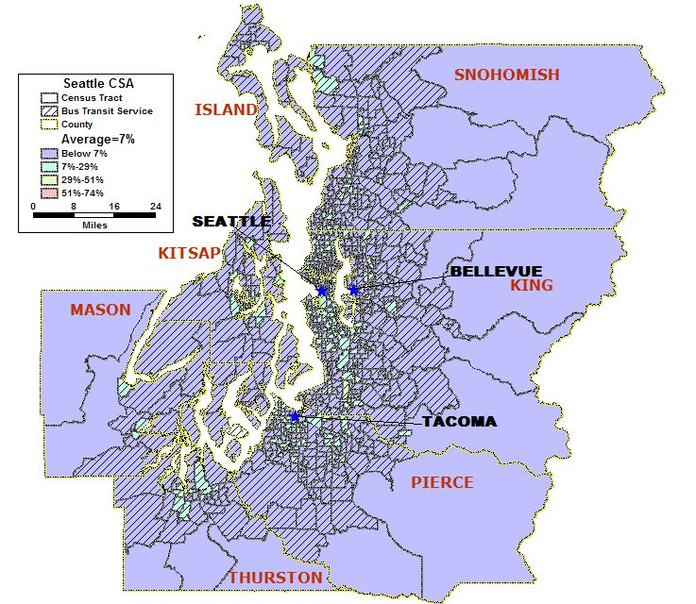
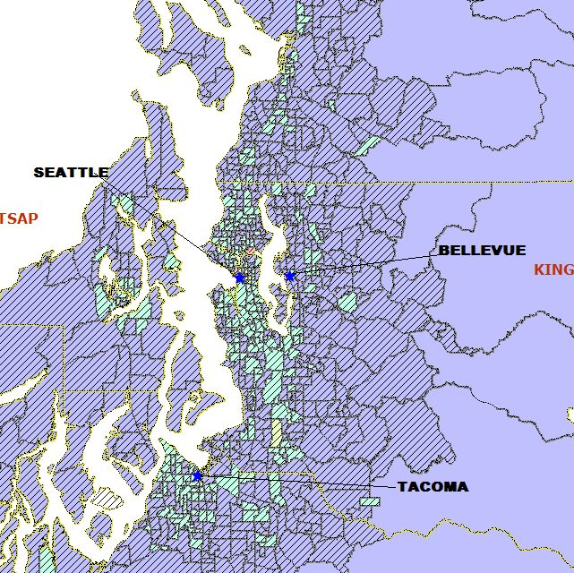
Map 4.6 Seattle-Bellevue-Tacoma, WA CSA Zero Car Households

Total Number of Census Tracts in CSA 784
Total Households in the CSA 1,411,305
Total Zero Car Households in CSA 108,408
Regional Average of Zero Car Households in the CSA 7%
Number (%) of Census Tracts with above average Zero Car Households 256 (33%)
Total Zero Car Households in the above average census tracts 79,667

The average for households without vehicles is approximately seven percent (108,408) of the 1,411,305 total households located in the Seattle-Bellevue-Tacoma, WA CSA. A total of 256 census tracts (33 percent) have an above percentage of households without vehicles. Several of these census tracts are located in the city of Seattle. In 2000, the number of households located in the city of Seattle, WA totaled 270,524. The Seattle downtown has over 17,000 households that are households without vehicles and are located within a five square mile area. This area, along with other census tracts that have above average households without vehicles ranging between seven and 29 percent, are located within the CSA’s transit service area.

Approximately 28,228 households, or two percent of the entire CSA’s households, are located outside the transit service area. Of these households, 883 are households without cars.

Number and Proportion of Minority Population with overlay of Below Poverty Population

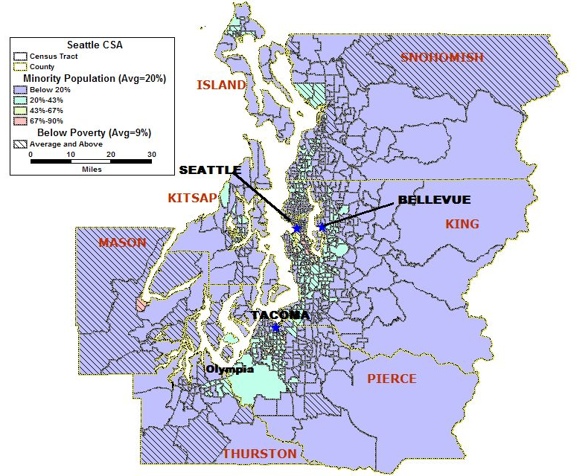
Map 4.7 Seattle-Bellevue-Tacoma, WA CSA Minority Population with an overlay of the Below Poverty Population

The percentage of minority population is shown overlaid with the percentage of below poverty population in the Seattle-Bellevue-Tacoma, WA CSA. As shown in this map there are 142 (18 percent) census tracts that have populations of minorities and persons below the poverty level that are greater than the regional averages for these statistics. The percentage of above average minority and below poverty populations is concentrated mainly around the Seattle, Tacoma, and Bellevue cities. Though there are a number of tracts in the outlying areas in Island, Kitsap, Mason, and Snohomish counties that have higher than average populations of minorities and persons below the poverty level.

Number and Proportion of Minority Population with overlays of Below Poverty Population and Zero Car Households

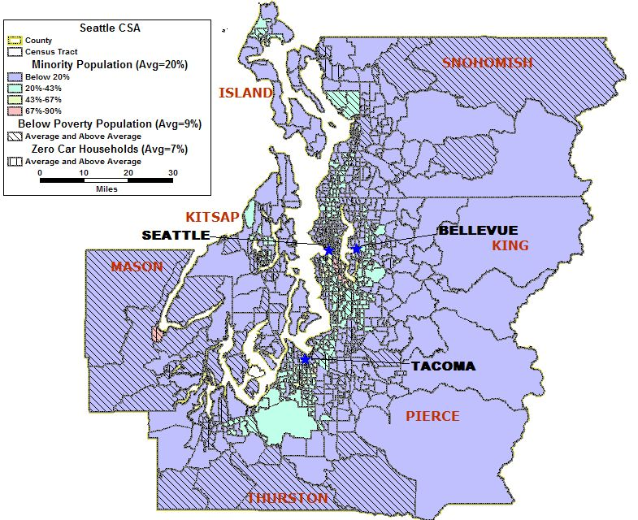
Map 4.8 Seattle-Bellevue-Tacoma, WA CSA Proportion of Minority Population with overlays of Below Poverty Population and Zero Car Households

The relationship of minority population, below poverty population and zero car household statistics for the Seattle-Bellevue-Tacoma, WA CSA are primarily located in the cities of Seattle, Tacoma, and Olympia. Of the 784 census tracts in the CSA, 144 census tracts (18 percent) have minority populations, below poverty populations and zero car households that exceed the regional average for these statistics. Pockets of similar census tracts also are located in Snohomish, Kitsap, Mason, and Thurston counties.

Correlation among Minority, Below Poverty, LEP Populations, and Zero Car Households

 | Minority | Below Poverty | LEP | Zero Car HH
Minority | 1.00
Below Poverty | 0.64 | 1.00
LEP | 0.89 | 0.57 | 1.00
Zero Car HH | 0.34 | 0.62 | 0.34 | 1.00
Table 4.3 Seattle-Bellevue-Tacoma, WA CSA Correlation between Minority, Below Poverty, and LEP Populations and Zero Car Households
There is a strong correlation (0.89) between minority and limited English proficient populations. The correlation coefficient measures the relationship with which these two statistics vary together. As shown in Table 4.3, the coefficient for the relationship between below poverty and minority, limited English proficient, and zero car households is not as strong with coefficients of 0.64, 0.57, and 0.62. The zero car households have no apparent correlation to the minority and LEP populations.

Natural Disasters

The Seattle-Bellevue-Tacoma, WA CSA has had floods, snowstorms, and tornados over the last 20 years, but these events were not declared disasters by the Federal Emergency Management Agency.

In February 2001, a state of emergency was declared after the Nisqually Earthquake, with a magnitude of 6.8, rocked the region south of Olympia, WA. While this earthquake did not impact the CSA, there is a geologic fault, known as the Seattle Fault, which runs through the downtown of Seattle, WA. The fault has not been responsible for an earthquake since the 1850s; however, the city and region are aware that an earthquake from the Seattle Fault has the potential for extensive human and financial impact. On a scale ranging from Moderate to High, to Very High Risk, the United States Geological Survey rates the state of Washington as having a Very High Risk of earthquakes.

Man-made Disasters

The Seattle-Bellevue-Tacoma, WA CSA has had one man-made disaster in the last 20 years, a monorail collision that occurred in Seattle on November 26, 2005. The financial impact of this was $4 million.

In addition to potential accidents involving transportation, the region is home to many manufacturing sites (including Boeing and biotechnical facilities), which expose the CSA to a number of different industrial accidents with the potential for regional impact.

There are no nuclear power plants within the CSA; however, there are two facilities south east of Seattle, WA that pose a potential threat in the event of a radiological release.

As with any other major metropolitan center with diverse industries and major population centers, the threat of terrorism against any of these industries, facilities and centers is real. Therefore, in addition to accidents resulting in a disaster caused by radiological or chemical release, disasters resulting from sabotage and direct attack could also occur. 2005 data from the U.S. Department of Transportation on Hazardous Material Safety shows the state of Washington accounted for 2% of the hazardous materials incidents and no related deaths for the year.

The Department of Homeland Security (DHS) ranks the Seattle CSA as one of the country’s 29 Tier II (high risk) urban areas that has critical transit, ferry, and port infrastructure. The state of Washington has also been designated by the DHS as a Tier II Buffer Zone, which means the state has high-risk/high-consequence facilities (e.g. chemical facilities, financial institutions, nuclear and electric power plants, dams, stadiums, etc.).

