Region 7: Houston-Baytown-Huntsville, TX CSA

I. Geographic Boundaries, Political Jurisdictions, and Infrastructure

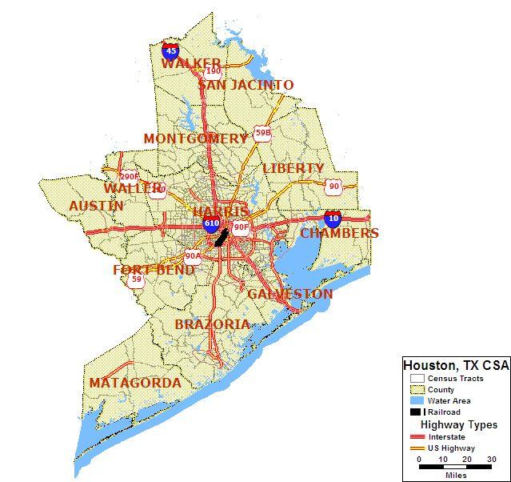

Map 7.1: Houston-Baytown-Huntsville, TX CSA Major Highways and Fixed Guideway System

The Houston-Baytown-Huntsville, TX CSA includes the following counties: Matagorda, Austin, Brazoria, Chambers, Fort Bend, Galveston, Harris, Liberty, Montgomery, San Jacinto, Waller and Walker Counties and is located in the south east portion of Texas near the Gulf of Mexico. According to the U.S. Census Bureau, the Houston-Baytown-Huntsville, TX CSA covers a total of 1,134 square miles. Houston-Baytown-Huntsville, TX CSA had a population of 4,815,122 according to the 2000 census; the population of the state of Texas is 20,851,820.

The region is served by numerous major interstate and U.S. highways: Interstates 10, 45, and 610, and U.S. Highways 59, 90, and 290. METRORail operates a 7.5-mile light rail line through the Central Business District.

The Houston-Baytown-Huntsville, TX CSA is located on the southeast coast of Texas by the Gulf of Mexico. Surface water in the Houston region consists of lakes, rivers, and an extensive system of bayous and manmade canals that are part of the rainwater runoff management system. Some 25-30 percent of Harris County lies within the 100-year flood plain. Houston's climate is classified as humid subtropical. It has excessive ozone levels and is ranked among the most ozone-polluted cities in the United States. Prevailing winds are from the south and southeast during most of the year, bringing heat from the deserts of Mexico and moisture from the Gulf of Mexico. Located close to the Gulf coast, the Houston-Baytown-Huntsville, TX CSA is also at a high risk of hurricanes, which usually occur from June to November.

II. Agencies Operating in the Houston-Baytown-Huntsville, TX CSA

Agency | Jurisdictions Served | Population  Served | Operating Budget | Staff Size
Texas DOT | Matagorda, Austin, Brazoria, Chambers, Fort Bend, Galveston, Harris, Liberty, Montgomery, San Jacinto, Waller and Walker Counties | 4,815,122 | $6.8 billion | 14,000
METRO | Harris County | 3,400,579 | (a) | (a)

(a) = Not Available

Table 7.1: Houston-Baytown-Huntsville, TX CSA Transportation Agencies

III. Transit Service Area: Fixed Guideway and Bus Service Area

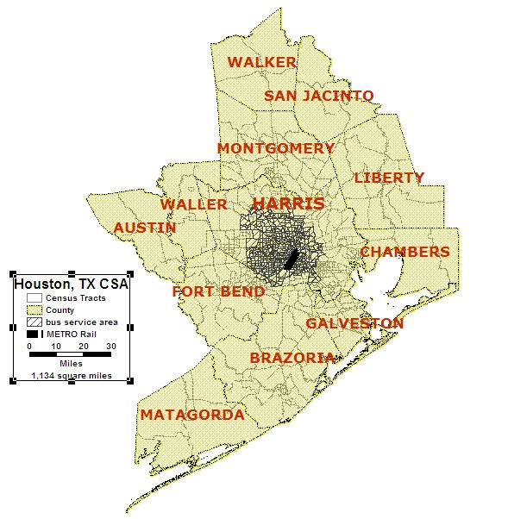
Map 7.2: Houston-Baytown-Huntsville, TX CSA Fixed Guideway and Bus Transit Service Area

Fixed guideway and bus service transit is only available in the greater Houston Metropolitan area. Although other transit agencies, such as Island Transit in Galveston, and Brazoria and The District in Walker and San Jacinto Counties have bus service, there is no designated bus service area for these counties.

METRO
The METRO fleet includes 1,420 buses, both METRO-owned buses and buses operated by private companies under contract with METRO. Metro has 113 bus routes, 24 park and ride routes, and 25 park and ride lots. METRO also has 19 Transit Centers where bus and METRORail riders transfer from one route to another. Transfer information is posted at each location. Limited parking, approximately 2,300 spaces, is also available at 10 transit centers. Transit centers provide a mixture of Commuter and Local service.

METRO has 25 Park & Ride lots with 30,600 available parking spaces. Direct nonstop service to Downtown, the Texas Medical Center or other major employment centers in the METRO service area is available from all Park & Ride lots except Mission Bend and Missouri City, which provide Express and Local service. Park & Ride facilities also serve as staging areas for vanpools and carpools.

METRORail
The METRORail Red Line is a 7.5-mile light rail service running from the University of Houston-Downtown to south of Reliant Park along Main, Fannin and San Jacinto streets.

METRORail features 16 Rail Stations, which provide access to the many of the city's major employment, cultural/entertainment and medical centers. Major METRORail destinations include Downtown, Midtown, the Museum District, Hermann Park/Houston Zoo, Texas Medical Center and Reliant Park.

In June 2005, METRO announced its $2 billion Phase 2 Implementation Plan to provide more rapid transit for the Houston region in less time than originally proposed under METRO Solutions. Key components of the Implementation Plan include: 1) nearly nine miles of Light Rail Transit; 2) 21 miles of Fixed-Guideway Bus Rapid Transit (BRT); 3) 28 miles of Commuter Rail Transit (CRT); 4) 40 miles of Signature Bus Service/Suburban Bus Rapid Transit; and 5) 10 new transit facilities.

METROLift
METROLift provides pre-scheduled, curb-to-curb transportation for persons with disabilities who cannot ride fixed-route bus or METRORail service.

IV. Number and Proportion of Minority, Below Poverty and Limited English Proficient Populations in Relation to the Transit Service Area
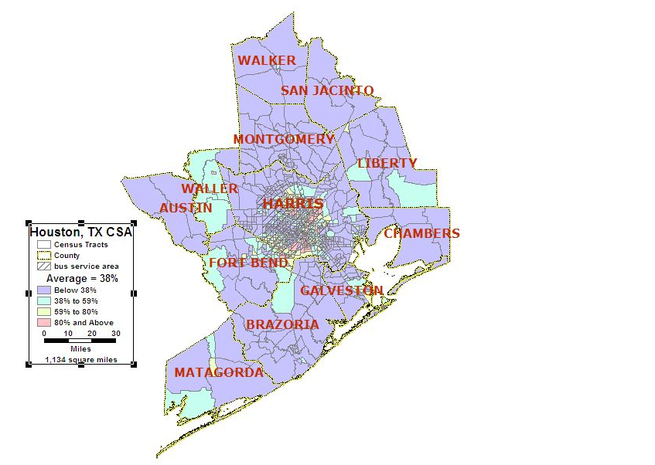
Area of Detail

Map 7.3: Houston-Baytown-Huntsville, TX CSA Minority Population

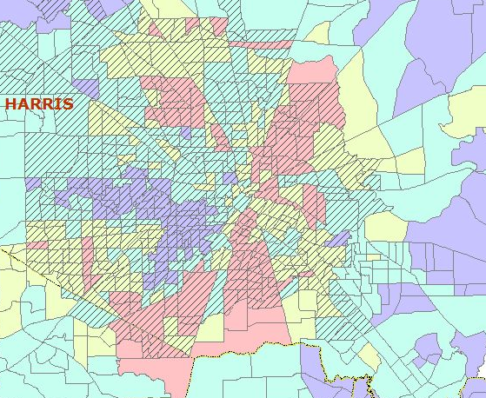
Map 7.3A: Houston Minority Population

Total Number of Census Tracts in CSA 908
Total Population of CSA 4,815,122
Total Minority Population residing in CSA 1,785,856
Regional Average of Minority Population in the CSA 38%
Number (%) of Census Tracts with above average minority population 395 (44%)
Total Minority Population in the above average census tracts 1,241,625

Based on U.S. 2000 Census Data, the average minority population for the Houston-Baytown-Huntsville, TX CSA is 38 percent. Census tracts located in outer ring suburbs of downtown Houston show the highest concentration of minority population. The majority of these census tracts are located in the southern, northeast and northwest portions of the central Houston area. In the Houston-Baytown-Huntsville, TX CSA, 1,785,856 out of the 4,815,122 total population fall into the above average minority population category. Forty-four percent (395 out of 908) of the CSA’s census tracts have higher than average minority populations. While the majority of these are located in the transit service area, 100 of these tracts lie outside the transit service area. These latter census tracts represent 11.2 percent (541,481 persons) of the total CSA population.

Even though there is a very high percentage of minority population in the Houston-Baytown-Huntsville, TX CSA, the majority of these census tracts are in the bus service area. Almost all of the minority population in the highest category from 80 percent and above is located in the downtown Houston area; however, there are other clusters of minority population found within other counties in the CSA. A large portion of minorities that are from 38 to 59 percent are found in Matagorda, Brazoria, Fort Bend, Chambers, Walker, Waller and Austin Counties.

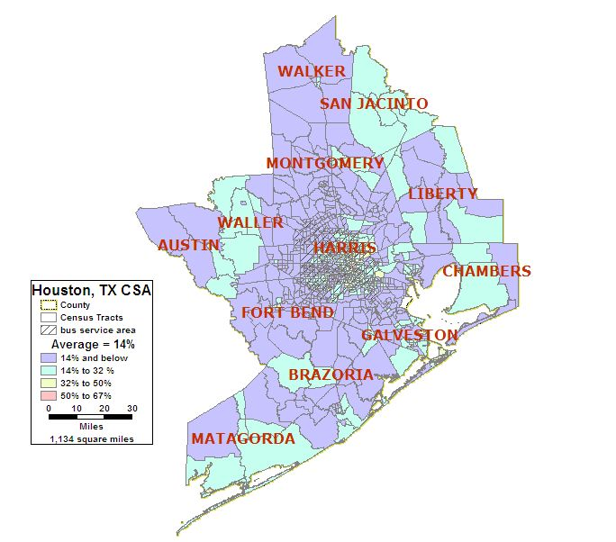
Area of Detail
Map 7.4: Houston-Baytown-Huntsville, TX CSA Below Poverty Population

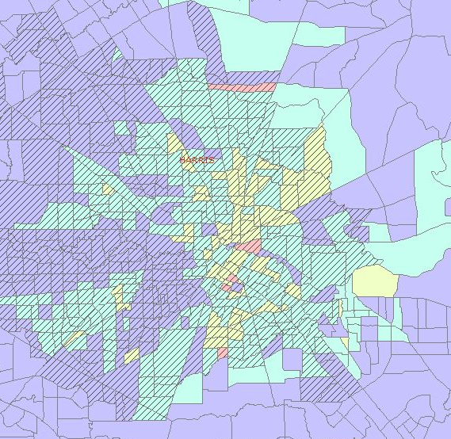
Map 7.4.A: Houston Below Poverty Population

Total Number of Census Tracts in CSA 908
Total Population of CSA 4,815,122
Total Below Poverty Population residing in CSA 649,801
Regional Average of Below Poverty Population in the CSA 14%
Number (%) of Census Tracts with above average Below Poverty pop. 387 (43%)
Total Below Poverty Population in the above average census tracts 452,055

Based on U.S. 2000 Census Data, the average minority population for the Houston-Baytown-Huntsville, TX CSA is 14 percent. The poverty map differs from the minority map because the highest percentages of below poverty population are found in the downtown and become less predominant further away from the downtown. In the Houston-Baytown-Huntsville, TX CSA, 43 percent, or 387 out of the 908 total census tracts fall into the above minority population category. There is a 452,055 below poverty population within the above average census tracts and 649,801 below poverty population within the entire CSA. The below poverty map also shows that there are much fewer counties in general that fall into the highest range of below poverty population and also that there are fewer below poverty census tracts outside of Harris County. Many of the census tracts with higher than average below poverty populations lie outside the transit service area. There are 126 of these census tracts accounting for 11.7 percent (563,235 persons) of the total CSA population.

A large percentage of the majority population is found in census tracts that are in the bus service area; however, there are also clusters of census tracts with above average minority populations outside of the bus service area, which are found in Matagoria, Brazoria, Chambers, San Jacinto and Waller Counties.

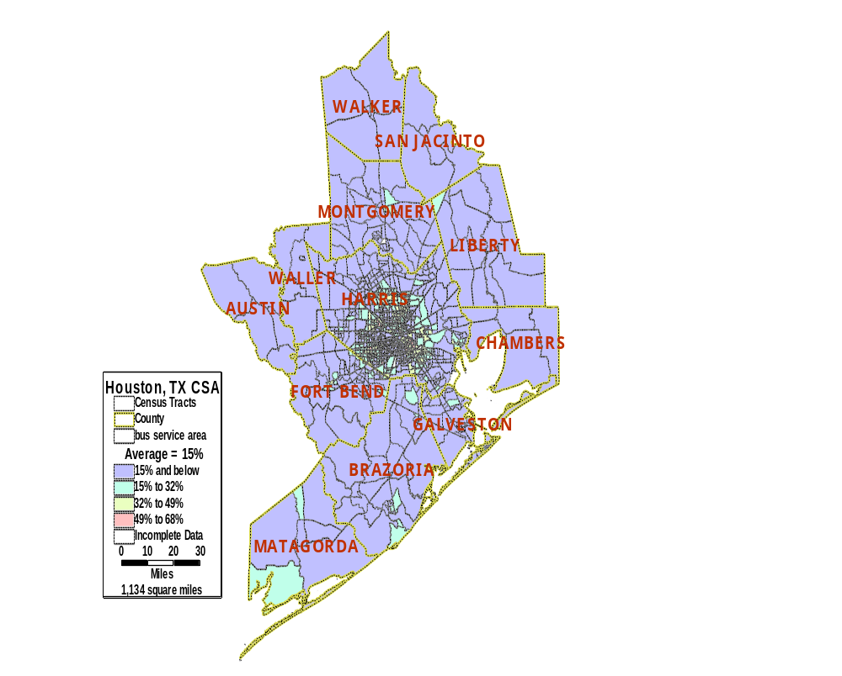
Area of detail
Map 7.5: Houston-Baytown-Huntsville, TX CSA Limited English Proficient Population

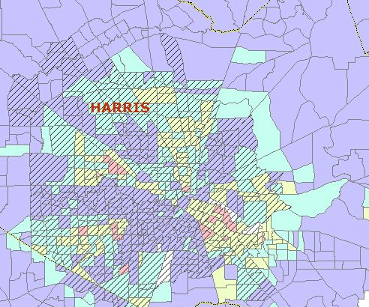
Map 7.5.A: Houston LEP Population

Total Number of Census Tracts in CSA 908
Total Population (5 years and older) of CSA 4,429,761
Total LEP Population* residing in CSA 674,321
Regional Average of LEP Population* in the CSA 15%
Number ( %) of Census Tracts with above average LEP population* 324 (36%)
Total LEP Population* in the above average census tracts 491,482

* LEP includes those 5 years of age and older

The limited English proficient (LEP) population in the Houston-Baytown-Huntsville, TX CSA is 15 percent. Approximately 36 percent, or 324 out of the 908 census tracts in the Houston-Baytown-Huntsville, TX CSA have an LEP population above the regional average. There is also a 491,482 LEP population within the 324 census tracts. The largest proportion of above average LEP population in the Houston-Baytown-Huntsville, TX CSA is shown the downtown and outer ring suburbs of Houston. Eight-four of the 324 census tracts with higher than average LEP populations are located outside of the transit service area. These tracts represent 9.5 percent (456,965 persons) of the total CSA population.

The LEP map is similar to the minority map in its pattern in Houston because there is a significant population of above average LEP population in clusters that progress outside the downtown. Even so, it is different from both of the other maps because there are very few above average LEP populations outside of the greater Houston area. The only strong clusters of LEP outside Harris County are found on the southern tip of Matagorda County, south Brazoria and northern Montgomery Counties.

V. Number and Proportion of Zero Car Households: Greater than the Regional Average

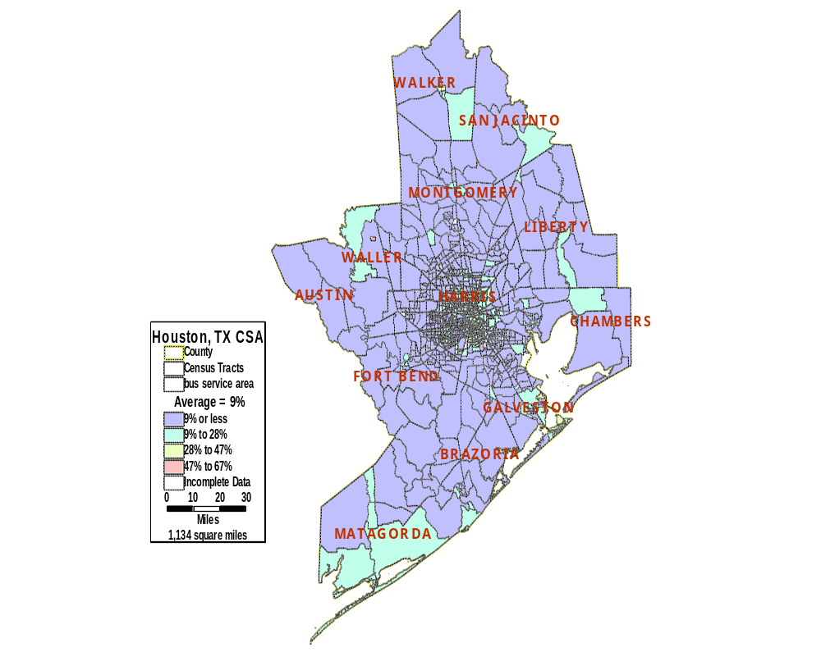
Area of Detail
Map 7.6: Houston-Baytown-Huntsville, TX CSA Zero Car Households

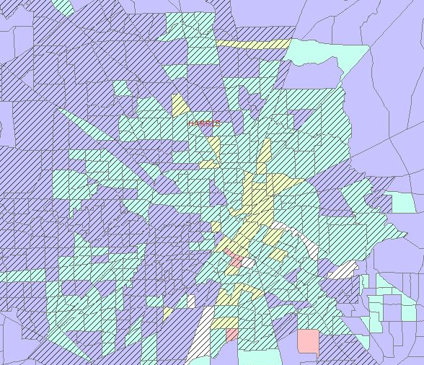
Map 7.6: Houston Zero Car Households

Total Number of Census Tracts in CSA 908
Total Households in CSA 1,689,003
Total Zero Car Households in CSA 130,092
Regional Average of Zero Car Households in the CSA 9%
Number (%) of Census Tracts with above average Zero Car Households 300 (33%)
Total Zero Car Households in the above average census tracts 84,037

The U.S. 2000 Census Data shows the average for households without vehicles is nine percent of the total households located in the Houston-Baytown-Huntsville, TX CSA. There are 300 census tracts in the CSA that have above average zero car households. A total of 130,092 households in the CSA do not have vehicles, with 84,037 of those located within the 300 census tracts with above average percentage of zero car households. Although the majority of census tracts with higher than average zero car households are within the transit service area boundary, 75 tracts are located outside of this boundary. These 75 tracts account for 6.5 percent (311,228 persons) of the CSA’s total population.

The majority of the above average zero car households are found in the greater Houston area, like the minority, poverty and LEP maps; however, this map shows that not many of the census tracts with above average zero car households fall into the highest category of 47 to 67 percent.

VI. Number and Proportion of Minority Population with Overlay of Below Poverty Population

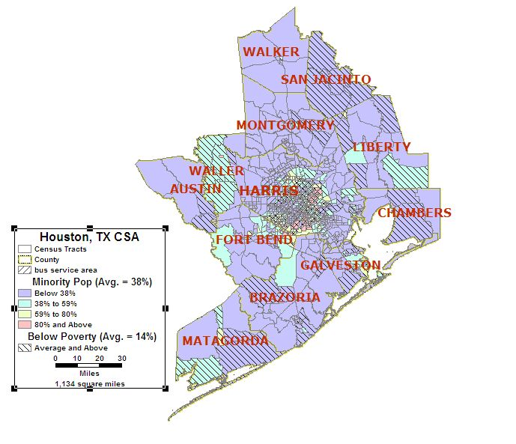
Area of Detail
Map 7.7 Houston-Baytown-Huntsville, TX CSA Minority Population with an Overlay of Below Poverty Population

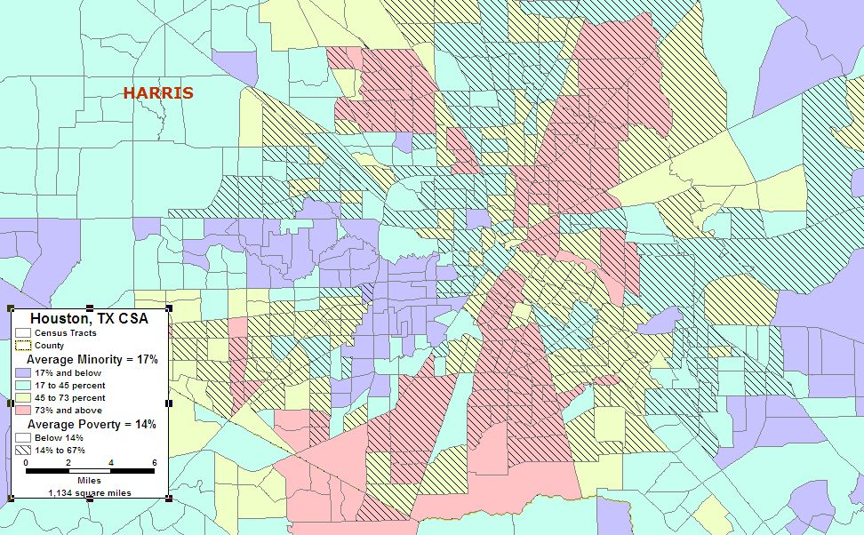
Map 7.7.A Houston Minority Population with an Overlay of Below Poverty Population

Map 7.7 shows that there is a very strong correspondence between the minority population and below poverty population in the Houston-Baytown-Huntsville, TX CSA. There are 283 census tracts with both above average minority and below poverty populations, which consist of a total population of 1,390,199. These census tracts are found in the greater Houston area and in other counties such as Waller, Austin and Liberty.

- Number and Proportion of Minority Population with Overlays of Below Poverty Population and Zero Car Households

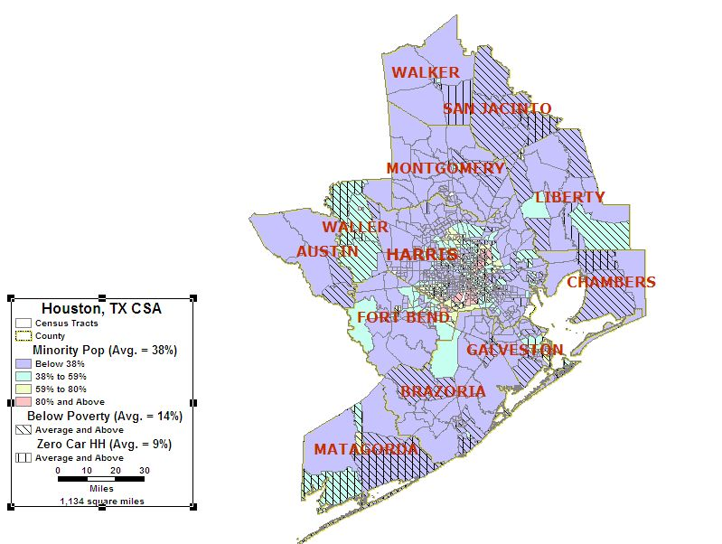
Area of Detail
Map 7.8: Houston-Baytown-Huntsville, TX CSA Minority Population with Overlays of Below Poverty Population and Zero Car Households

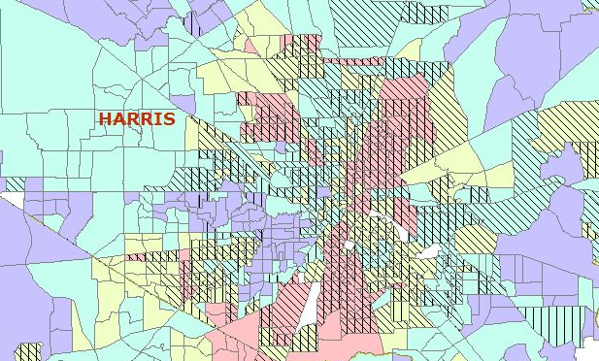
Map 7.8.A: Houston Minority Population with Overlays of Below Poverty Population and Zero Car Households

Map 7.8 shows the minority population with overlays of the census tracts with higher than average below poverty populations and the census tracts with higher than average zero car households. Similar to Map 7.7, there is a significant number of census tracts in which all three statistics coincide. In total, 230 census tracts, or 25 percent, have above average values for these three statistics. These 230 census tracts have a total population of 1,103,517.

VIII. Correlation Among Minority Population, Below Poverty Population, LEP Population and Zero Car Households

 | Minority | Below Poverty | LEP | Zero Car
Minority | 1
Below Poverty | 0.71 | 1
LEP | 0.65 | 0.77 | 1
Zero Car | 0.57 | 0.82 | 0.54 | 1

Table 7.2: Houston-Baytown-Huntsville, TX CSA Correlation Coefficients

Based on the coefficients highlighted in the table above, the highest correlation is between zero car and below poverty populations (0.82), followed by below poverty and LEP (0.77) and minority and below poverty populations (0.71) in the Houston-Baytown-Huntsville, TX CSA. All factors in the area have a correlation of above 0.5, which also includes zero car and minority, LEP and minority, and LEP and zero car households.

IX. Natural Disasters

The following table outlines the natural disasters that have occurred in the Houston-Baytown-Huntsville, TX CSA between 1985-2005.

Event | Date | Location | Human Impact | Financial Impact
Tropical Storm Allison | July 18, 1989 | Houston-Baytown-Huntsville, TX | (a) | (a)
Thunderstorms/Winds | March 29, 1990 | Harris County | 5 deaths | $0
Tornado | November 21, 1992 | Harris County | 0 deaths | $250 million
Thunderstorm/Winds | May 2, 1993 | Harris County | 0 deaths | $50 million
Heat Wave | July 21, 1995 | Houston-Baytown-Huntsville, TX | 2 deaths,  20 injuries | $0
Ice Storm | January 12, 1997 | Houston-Baytown-Huntsville, TX | 3 deaths, 0 injuries | $0
Tropical Storm Francis | September 7, 1998 | Galveston, Harris Counties | 3 deaths, 0 injuries | $287 million
(a) = Not Available

Table 7.3: 20-Year History of Natural Disasters in the Houston-Baytown-Huntsville, TX CSA (Source: FEMA and NOAA National Climatic Data Center)

The Houston-Baytown-Huntsville, TX CSA has been most prone to hurricanes, floods and tornados as shown from the log of natural disasters in the area since 1985. The average yearly precipitation level is approximately 48 inches, and spring supercell thunderstorms sometimes bring tornadoes to the area.
On a scale ranging from Moderate to High, to Very High Risk, the United States Geological Survey rates the state of Texas as having a Moderate Risk of earthquakes.

X. Man-Made Disasters

Houston-Baytown-Huntsville, TX CSA has not had a man-made disaster in the last 20 years. the Houston area’s major economic drivers include the energy industry but biomedical research, aeronautics, and the shipping The port ranks first in the country in international commerce and is the sixth-largest port in the world. The 2005 data from the U.S. Department of Transportation on Hazardous Material Safety shows the state of Texas accounted for nine percent of the hazardous materials incidents and 6 percent of related deaths for the year.

