EL NIÑO/SOUTHERN OSCILLATION (ENSO) DIAGNOSTIC DISCUSSION
issued by
CLIMATE PREDICTION CENTER/NCEP/NWS
11 September 2008

Synopsis: ENSO-neutral conditions are expected to continue through the end of 2008.
ENSO-neutral conditions continued during August 2008, as recent increases in sea surface temperatures (SSTs) abated across the equatorial Pacific Ocean. Above-average SSTs in the east-central and eastern Pacific diminished, while below-average SSTs in the central Pacific strengthened slightly (Fig. 1). From west to east, the latest weekly SST index values range from −0.4°C in the Niño-4 region to +0.7°C in the Niño 1+2 region (Fig. 2). The subsurface oceanic heat content (average temperatures in the upper 300m of the ocean, Fig. 3) also decreased in response to the emergence of negative temperature anomalies at thermocline depth in the east-central Pacific (Fig. 4).
Although ENSO-neutral conditions have been in place since June 2008, the atmospheric circulation over the western and central tropical Pacific continues to reflect lingering aspects of La Niña. Enhanced low-level easterly winds and upper-level westerly winds persist in this region, while convection remains generally suppressed over the central Pacific. Despite this lingering La Niña signal in the atmosphere, the overall atmospheric and oceanic system is consistent with ENSO-neutral conditions.
Most of the dynamical and statistical SST forecasts for the Niño 3.4 region indicate a continuation of ENSO-neutral conditions (−0.5°C to 0.5°C in the Niño-3.4 region) through the Northern Hemisphere Spring 2009 (Fig. 5). While the model spread continues to include the possibility of an El Niño, the decrease in subsurface and surface temperatures makes this outcome unlikely during the next several months. In addition, the redevelopment of negative temperature anomalies at thermocline depth and the historical tendency for multi-year La Niña episodes means that even a return to weak La Niña conditions is possible. However, based on current atmospheric and oceanic conditions, recent trends, and model forecasts, ENSO-neutral conditions are expected to continue through the end of 2008.
This discussion is a consolidated effort of the National Atmospheric and Oceanic Administration (NOAA), NOAA’s National Weather Service, and their funded institutions. Oceanic and atmospheric conditions are updated weekly on the Climate Prediction Center web site (El Niño/La Niña Current Conditions and Expert Discussions). Forecasts for the evolution of El Niño/La Niña are updated monthly in the Forecast Forum section of CPC's Climate Diagnostics Bulletin. The next ENSO Diagnostics Discussion is scheduled for 9 October 2008. To receive an e-mail notification when the monthly ENSO Diagnostic Discussions are released, please send an e-mail message to: ncep.list.enso-update@noaa.gov.
Climate Prediction Center
National Centers for Environmental Prediction
NOAA/National Weather Service
Camp Springs, MD 20746-4304

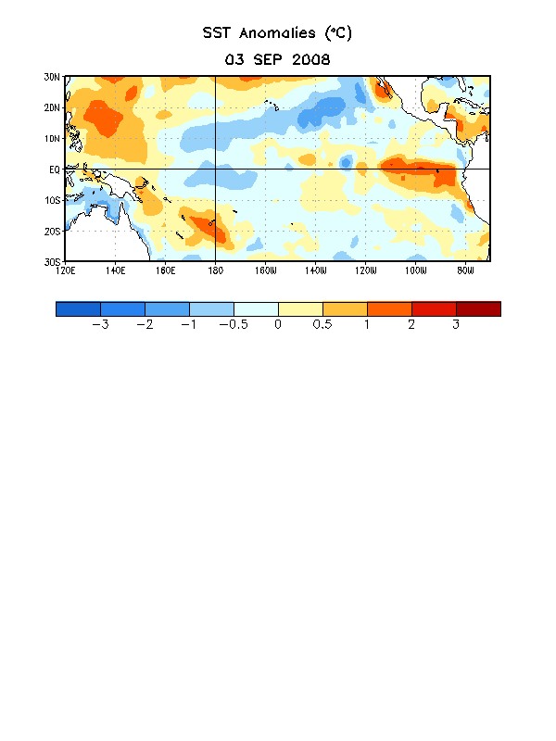

Figure 1. Weekly sea surface temperature (SST) anomalies (°C) centered on 3 September 2008. Anomalies are computed with respect to the 1971-2000 base period weekly means (Xue et al. 2003, J. Climate, 16, 1601-1612).

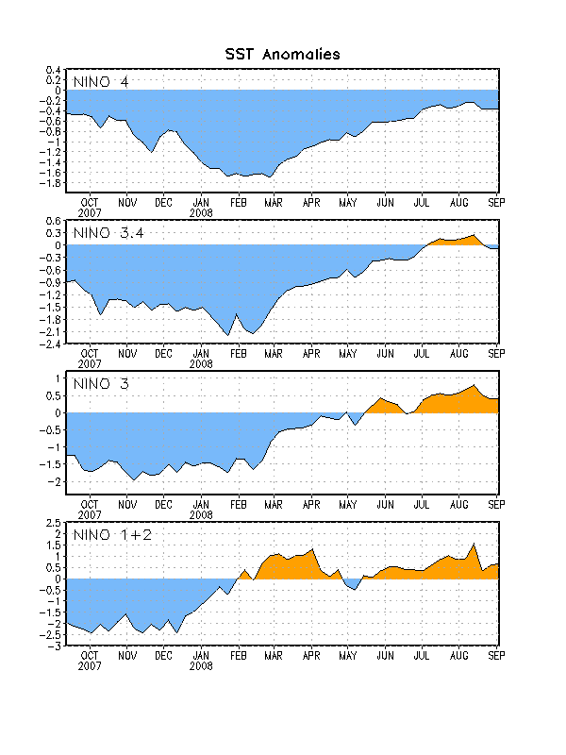

Figure 2. Time series of area-averaged sea surface temperature (SST) anomalies (°C) in the Niño regions [Niño-1+2 (0°-10°S, 90°W-80°W), Niño 3 (5°N-5°S, 150°W-90°W), Niño-3.4 (5°N-5°S, 170°W-120°W), Niño-4 (150ºW-160ºE and 5ºN-5ºS)]. SST anomalies are departures from the 1971-2000 base period weekly means (Xue et al. 2003, J. Climate, 16, 1601-1612).

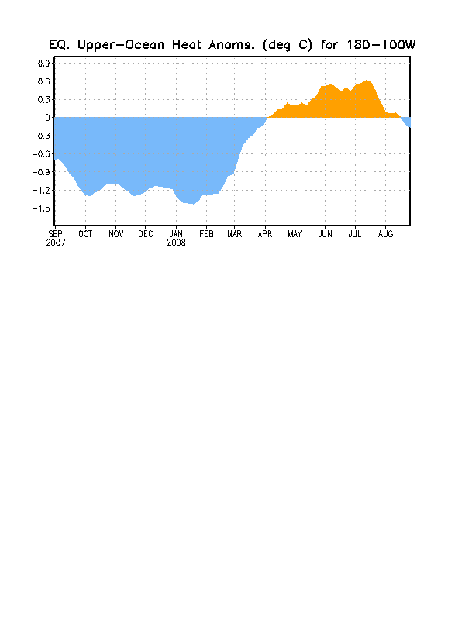
Figure 3. Area-averaged upper-ocean heat content anomalies (°C) in the equatorial Pacific (5°N-5°S, 180º-100ºW). Heat content anomalies are computed as departures from the 1982-2004 base period pentad means.

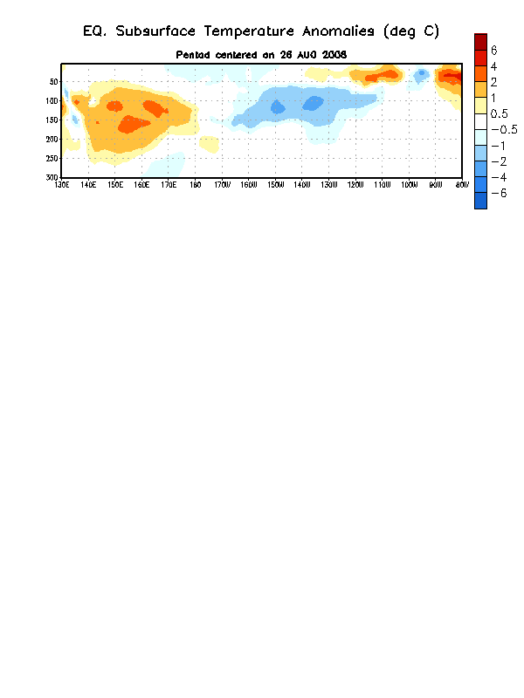
Figure 4. Depth-longitude section of equatorial Pacific upper-ocean (0-300m) temperature anomalies (°C) centered on the week of 26 August 2008. The anomalies are averaged between 5°N-5°S. Anomalies are departures from the 1982-2004 base period pentad means.

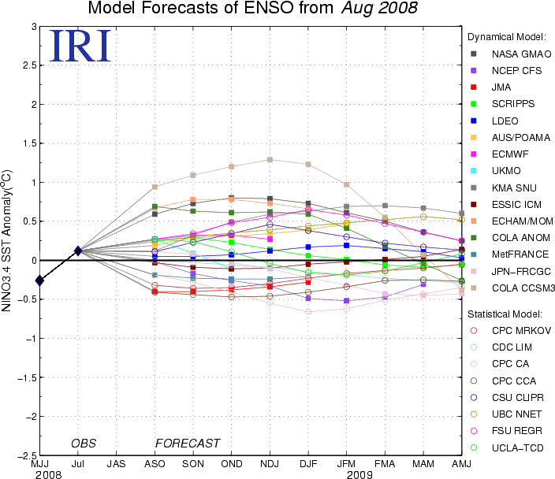

Figure 5. Forecasts of sea surface temperature (SST) anomalies for the Niño 3.4 region (5°N-5°S, 120°W-170°W). Figure courtesy of the International Research Institute (IRI) for Climate and Society. Figure updated 19 August 2008.

