CCR TPIN Update Screenshots
July 2008

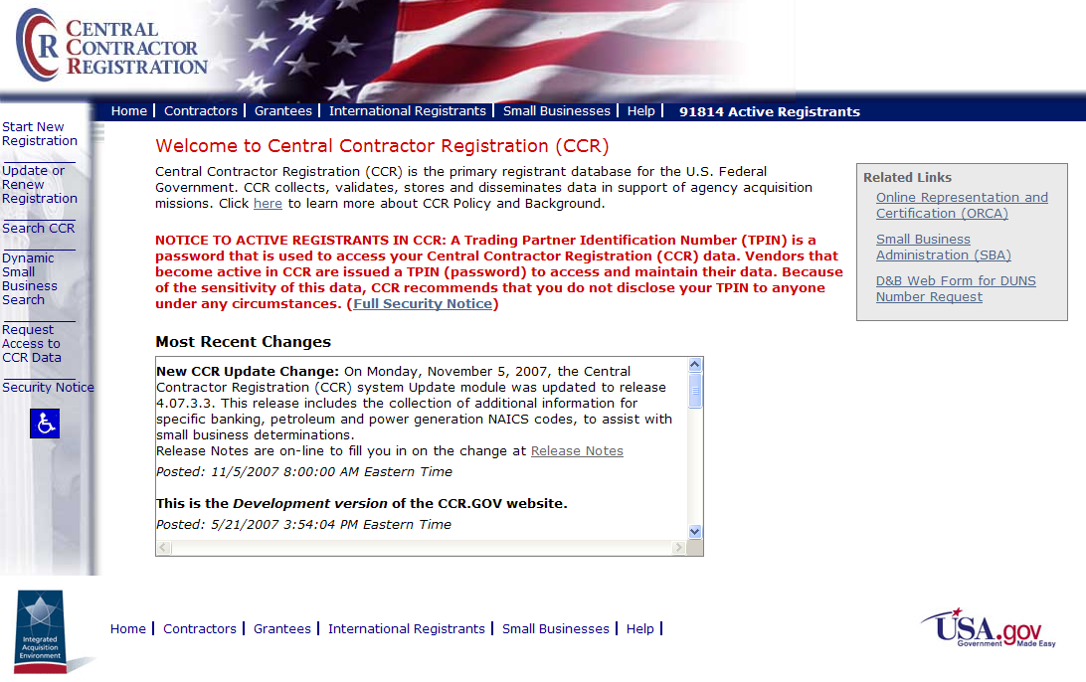
Welcome to CCR

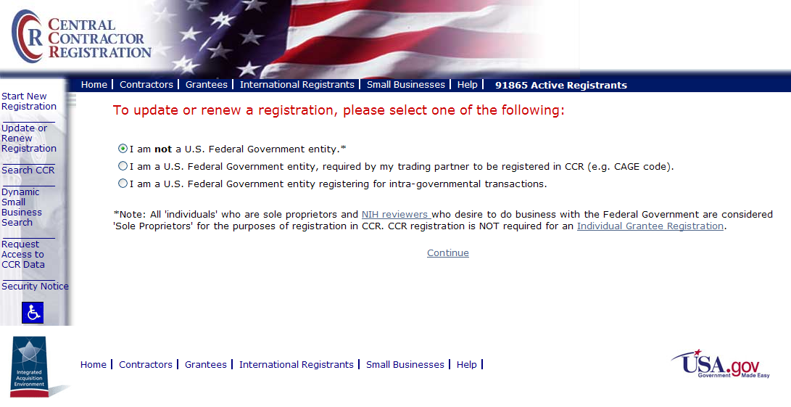
Update or Renew Selection Page

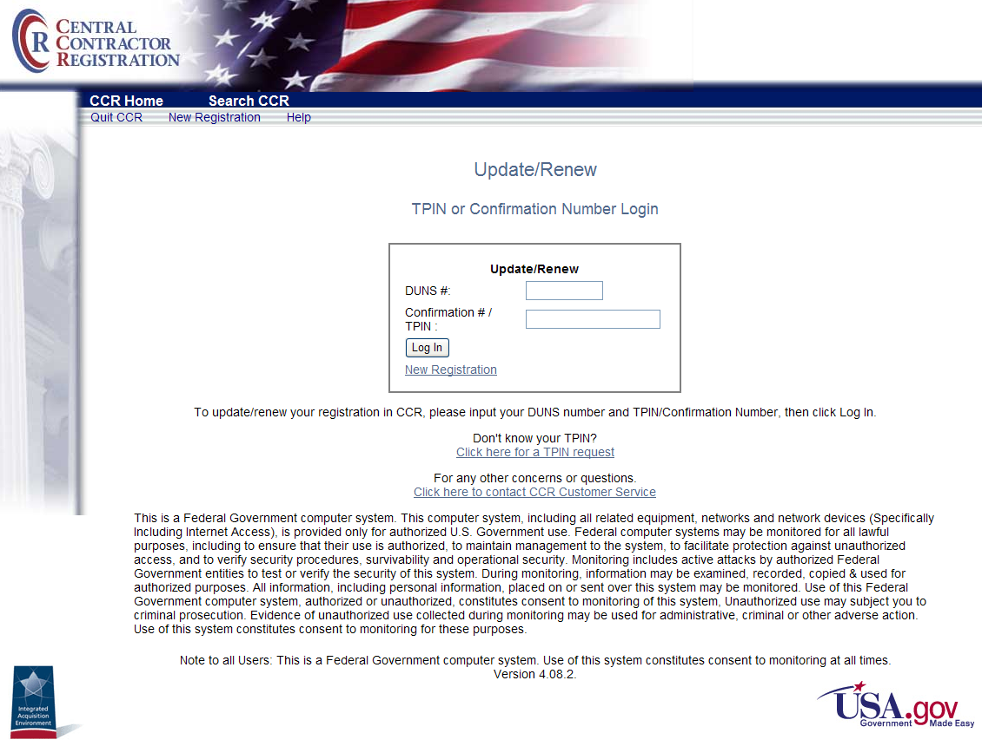
Enter DUNS Number and Confirmation Number or TPIN

MONITORED COUNTRIES—D&B Name Address Monitoring Mandatory:
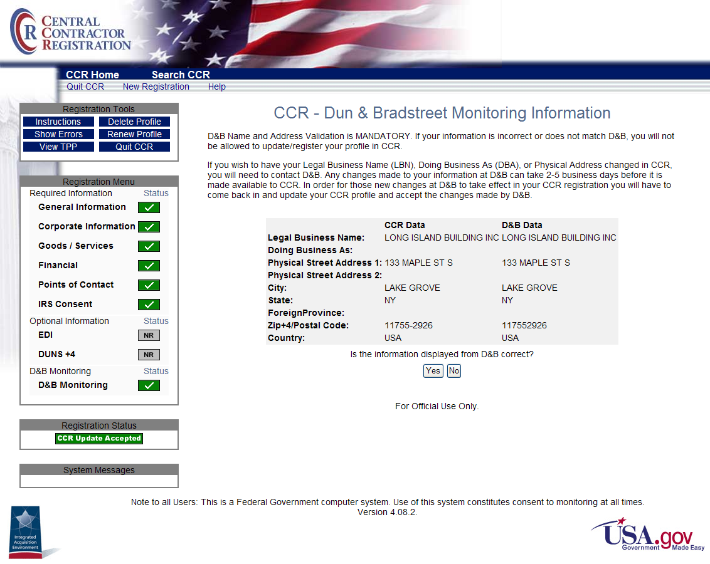
CCR - Dun & Bradstreet Monitoring Information Page

D&B Monitoring is Optional for:
NON-MONITORED COUNTRIES or U.S. Territories
(American Samoa, Guam, Northern Mariana Is, Puerto Rico, Virgin Islands, U.S.)

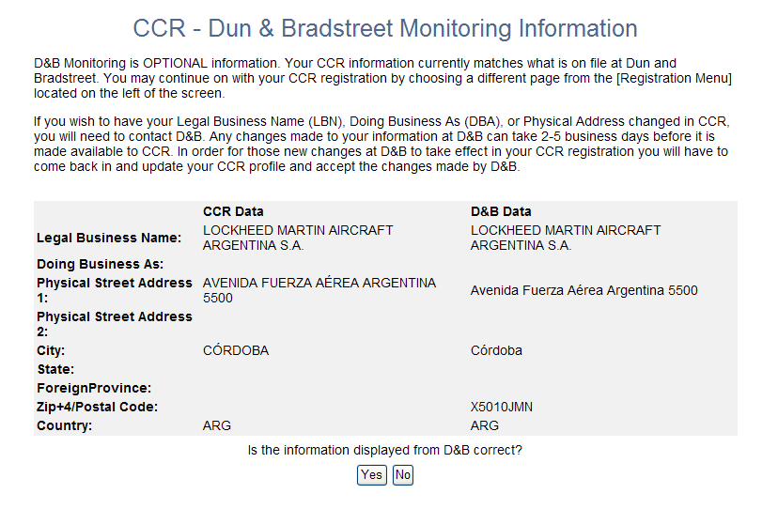
CCR - Dun & Bradstreet Monitoring Information Page—Optional

Dun & Bradstreet indicates company out of business:

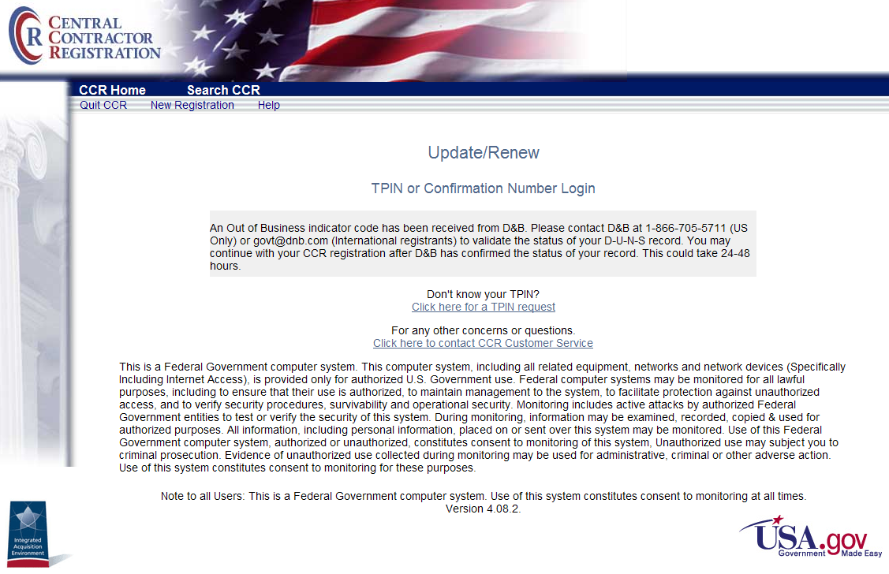
D&B Out of Business Indicator Message

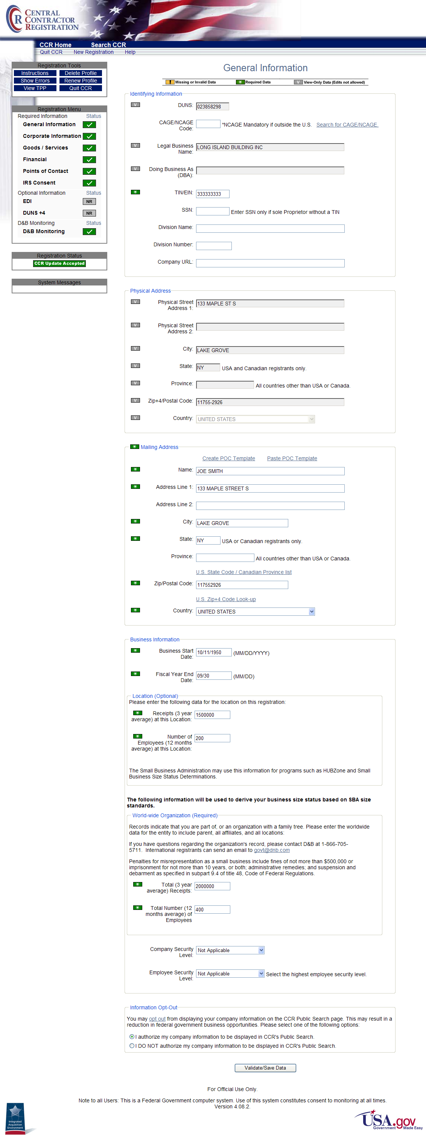
Monitored countries:
General Information Page name and address fields are grayed out and inactive. Changes must be made through D&B. Contact D&B Customer Service at1-866-705-5711 (U.S. only) or ccrhelp@dnb.com (International) to make changes.
General Information Page—Monitored

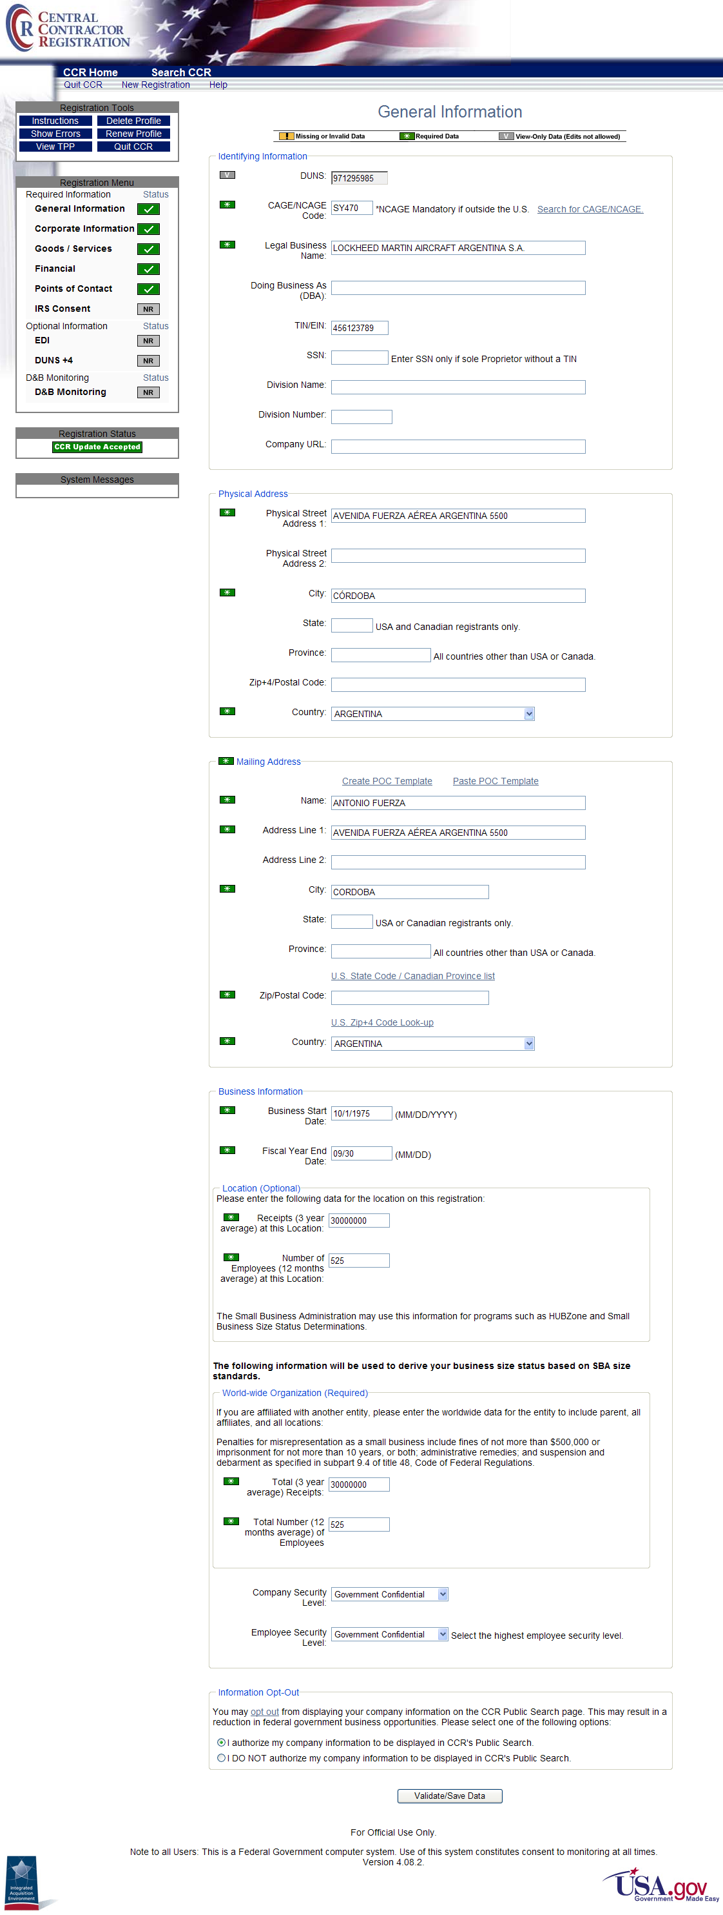
Non-monitored countries and U.S. Territories (American Samoa, Guam, Northern Mariana Is, Puerto Rico, Virgin Islands, U.S.):
General Information page contains active, editable fields.
General Information Page—Non-Monitored

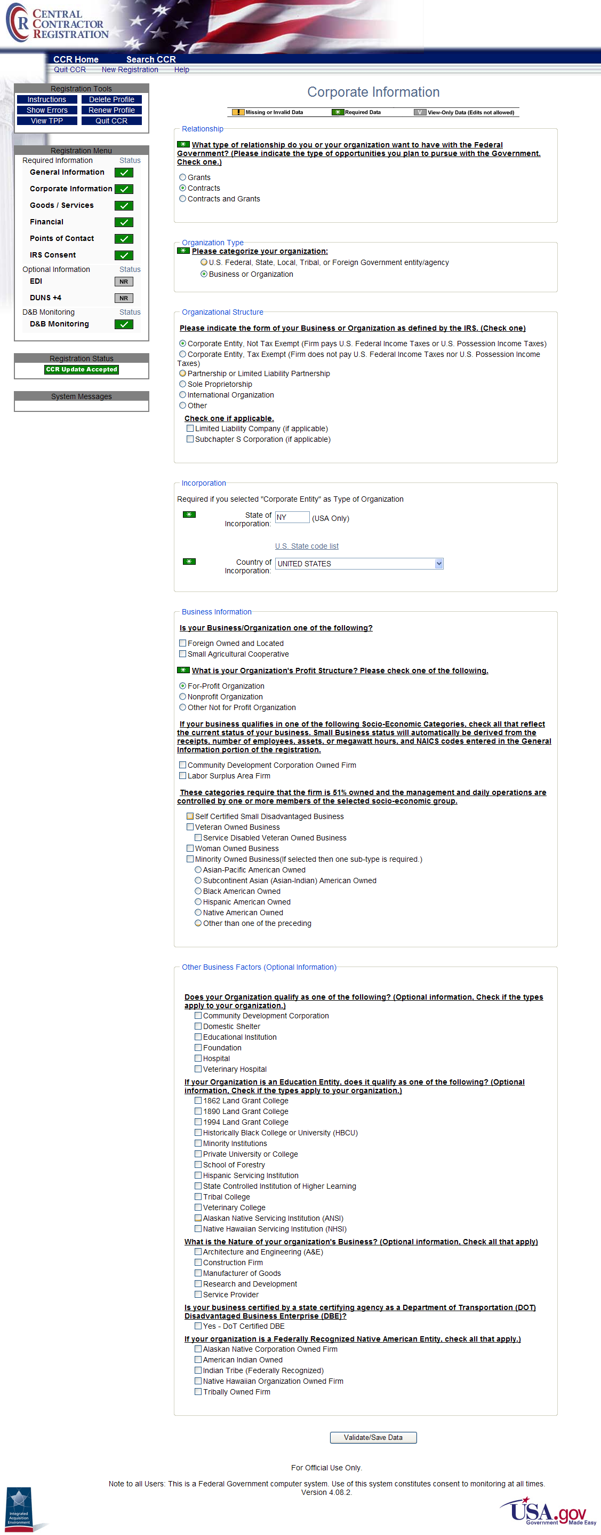
Update screens are similar to new registration screens. However, update screens contain the registrant’s data as shown in this sample Corporate Information screen.
Corporate Information
The Corporate Information page contains user-defined components
as shown in the following screenshots.

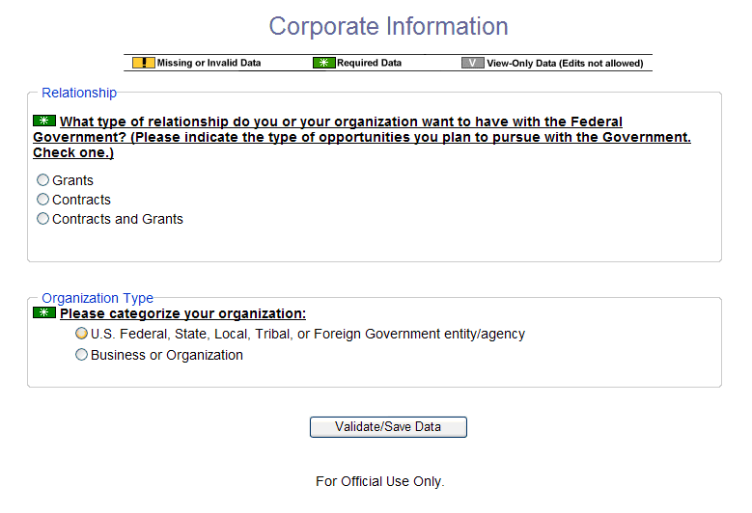
Corporate Information—No options Selected

Select Organization Type: U.S. Federal, State, Local, Tribal, or Foreign Government entity/agency
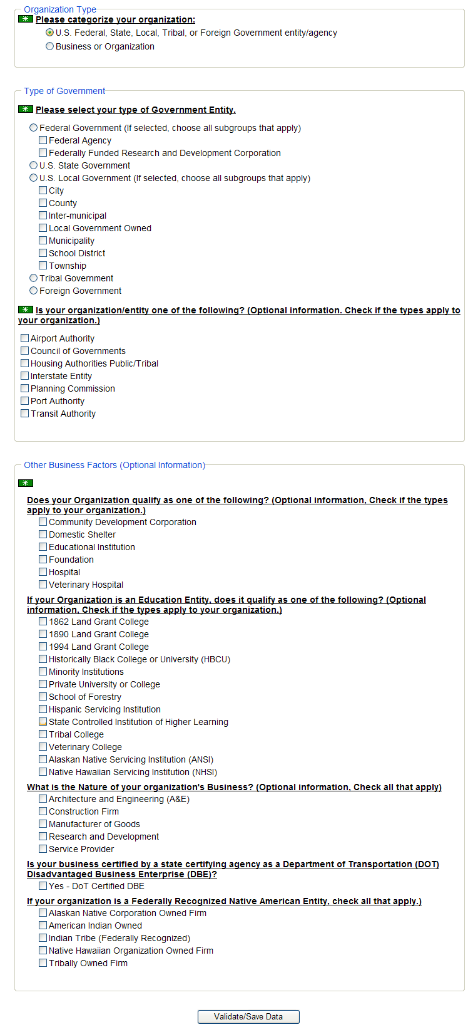
Type and Business Factors Displayed for Government Organization
Select Organization Type: Business or Organization
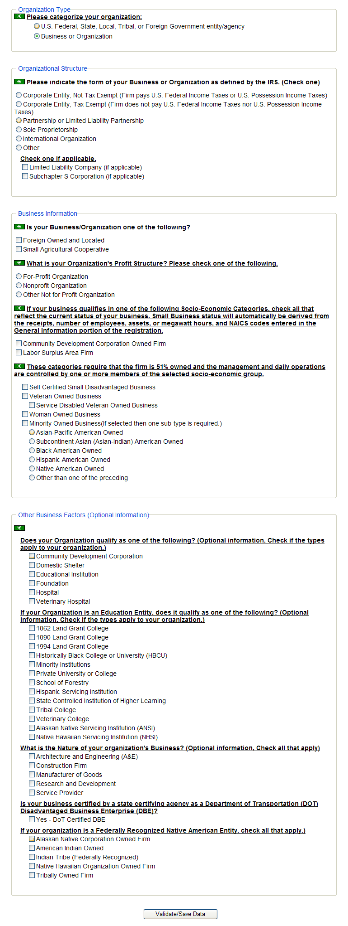
Organization Structure, Business Information, and Other Factors
for Organization Displayed
Corporate Entity Selected on Corporate Information page:
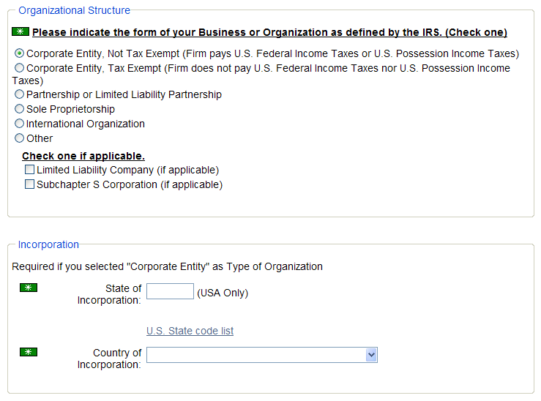
Incorporation Section Displayed
Sole Proprietorship Selected on Corporate Entity Page:
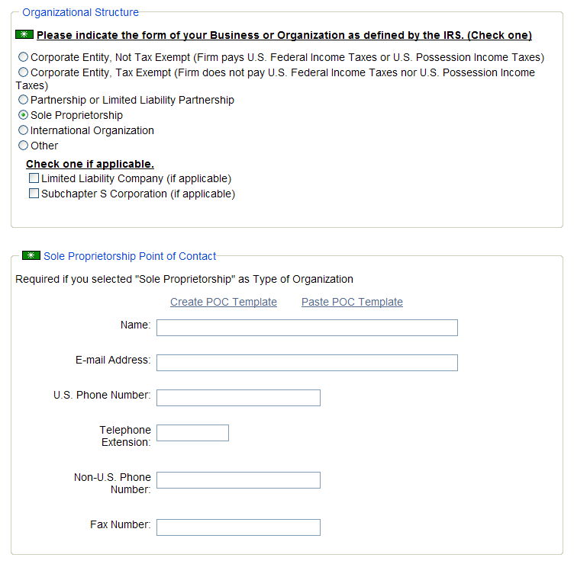
Sole Proprietorship Point of Contact Section Displayed

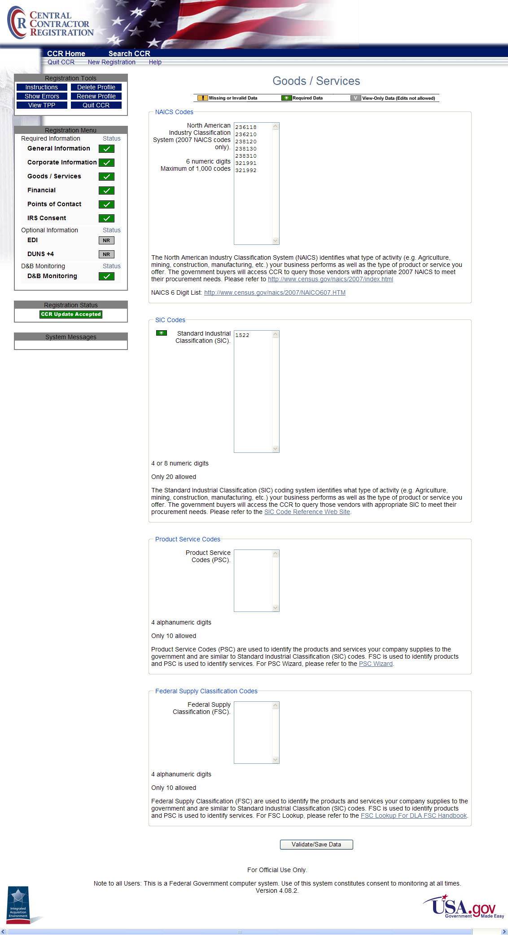
Goods/Services Page
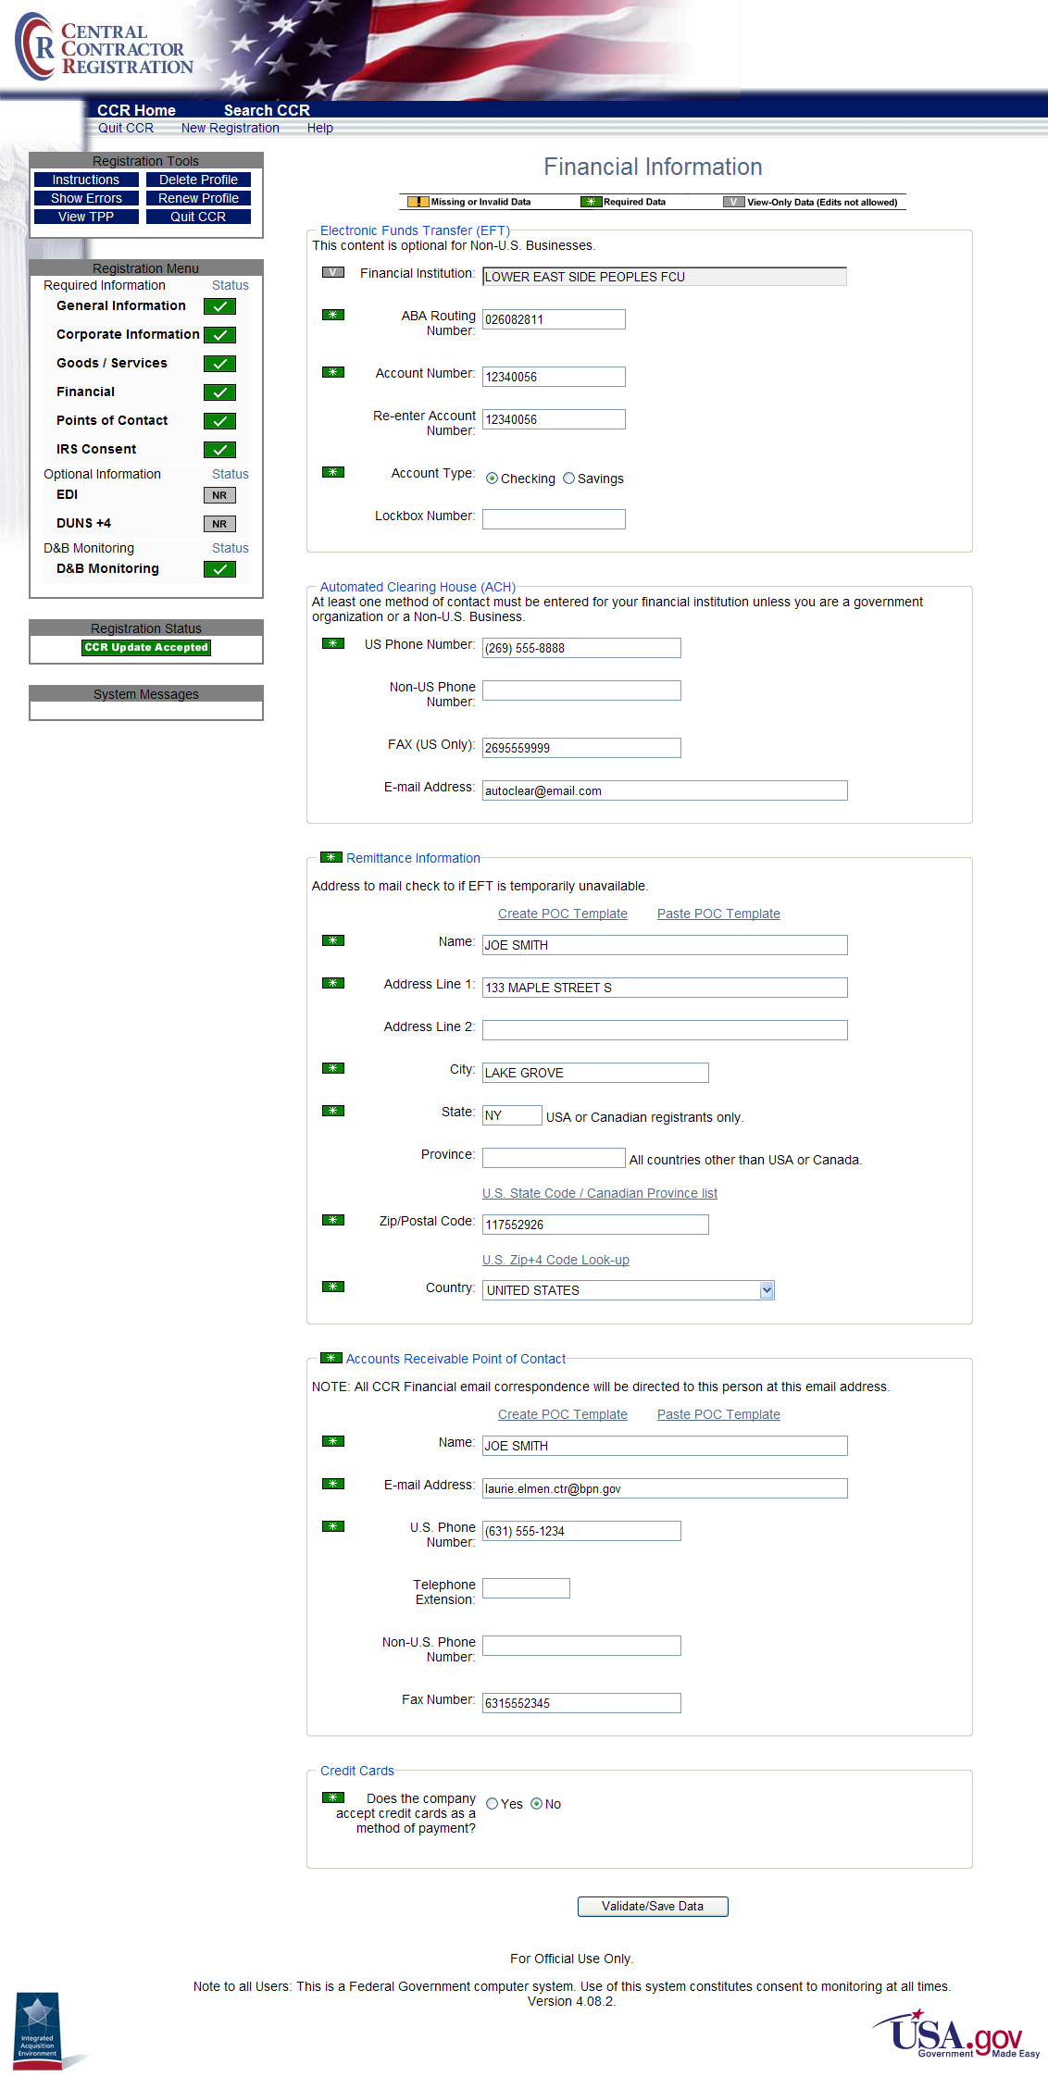
Financial Information Page
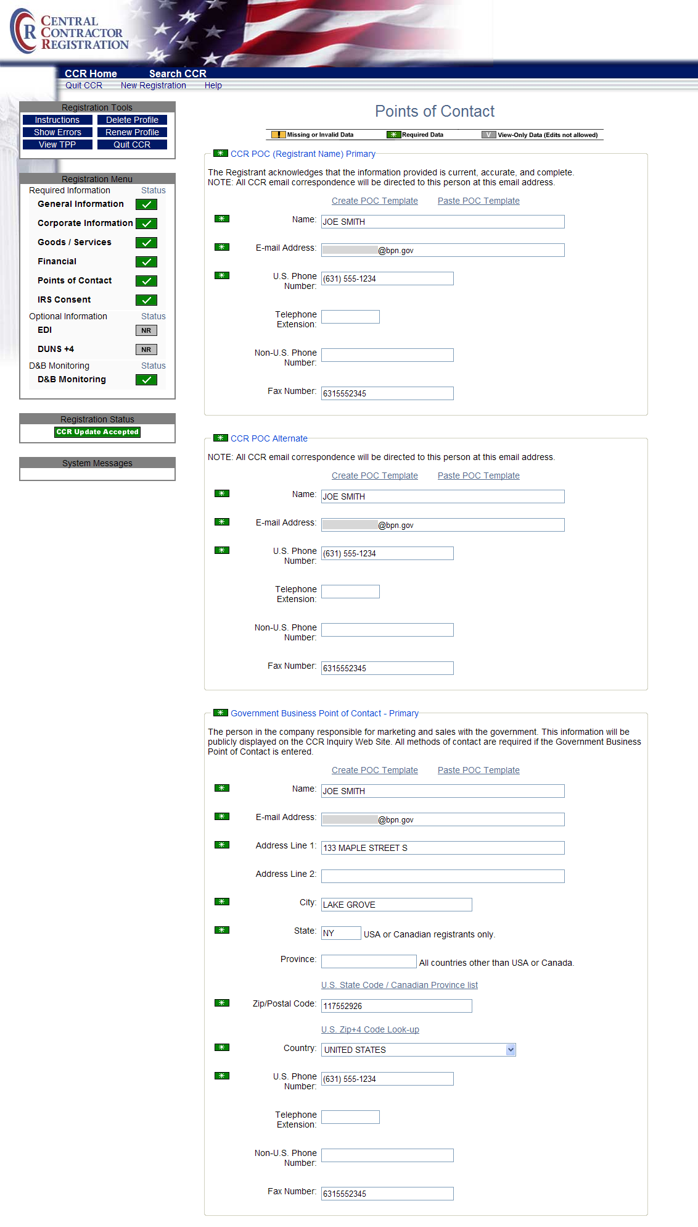
Points of Contact—Part 1
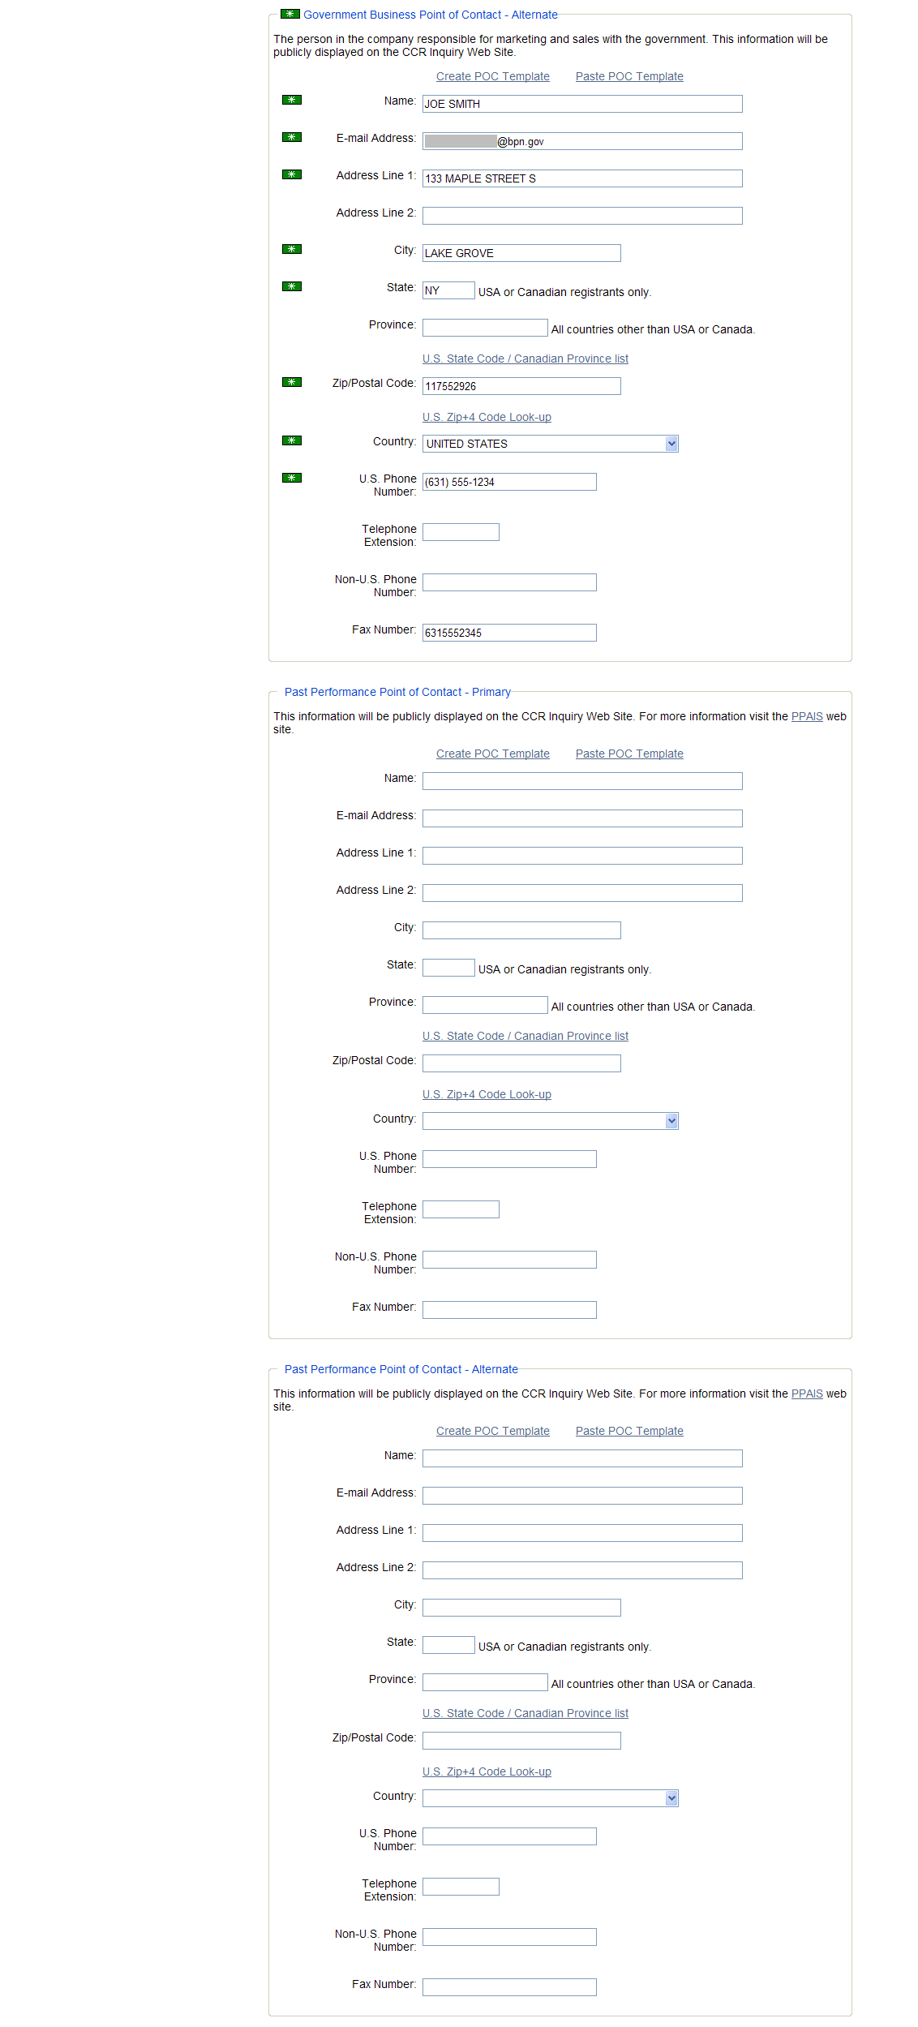
Points of Contact—Part 2

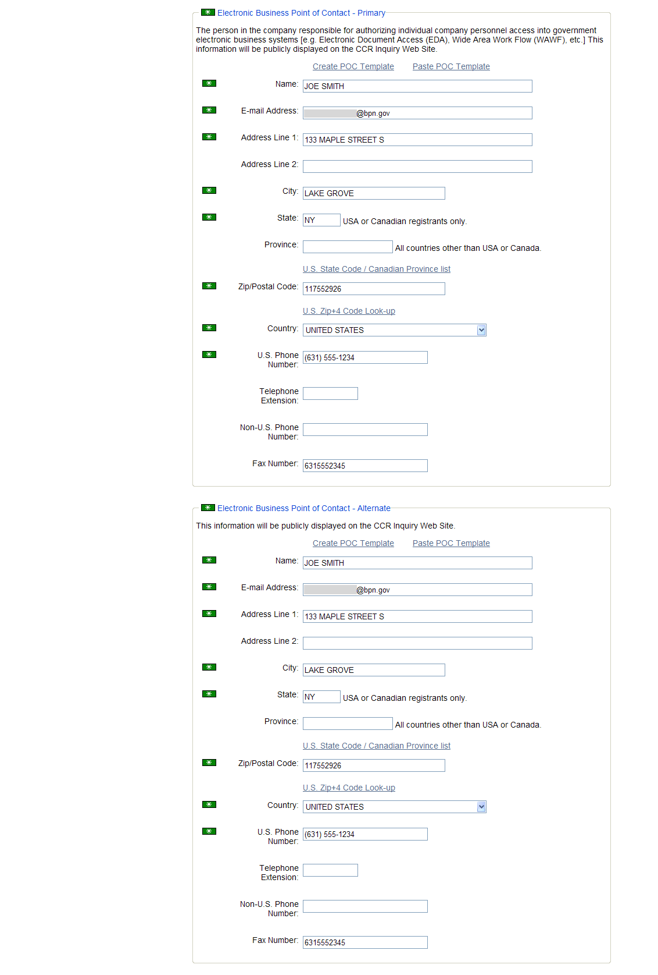
Points of Contact—Part 3
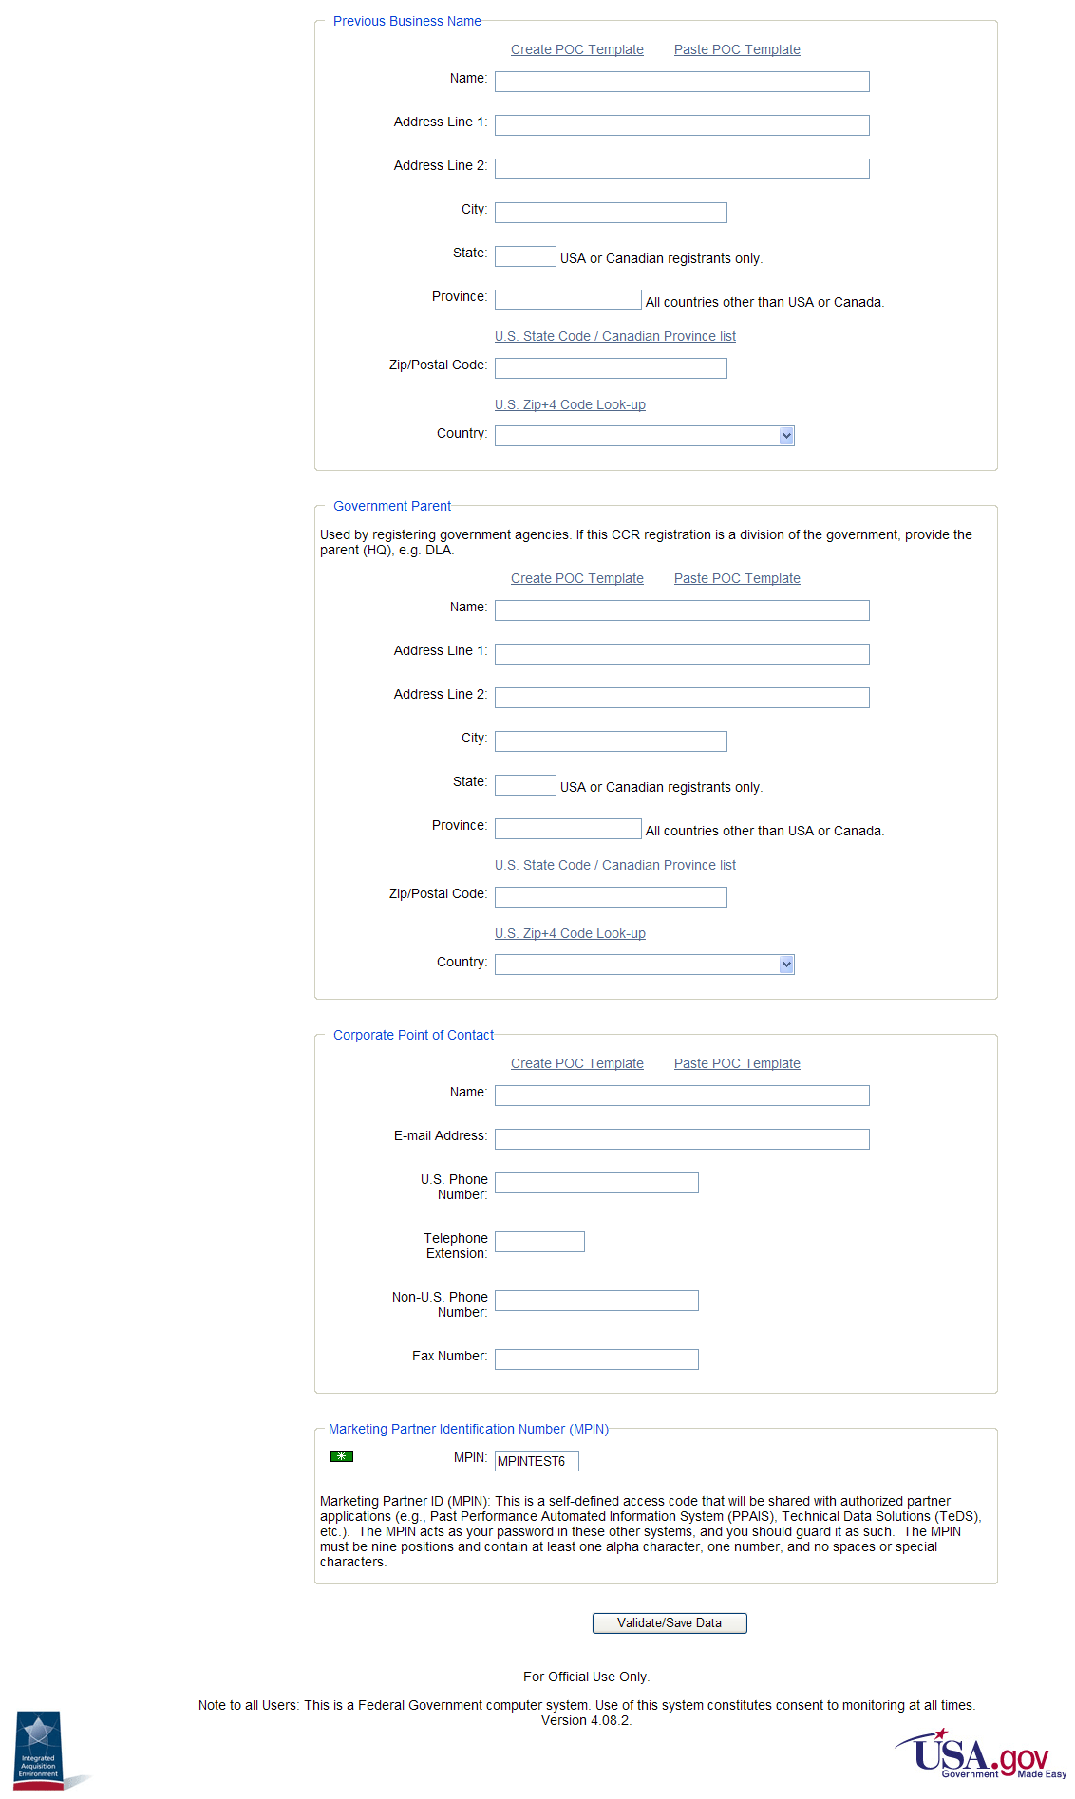
Points of Contact—Part 4

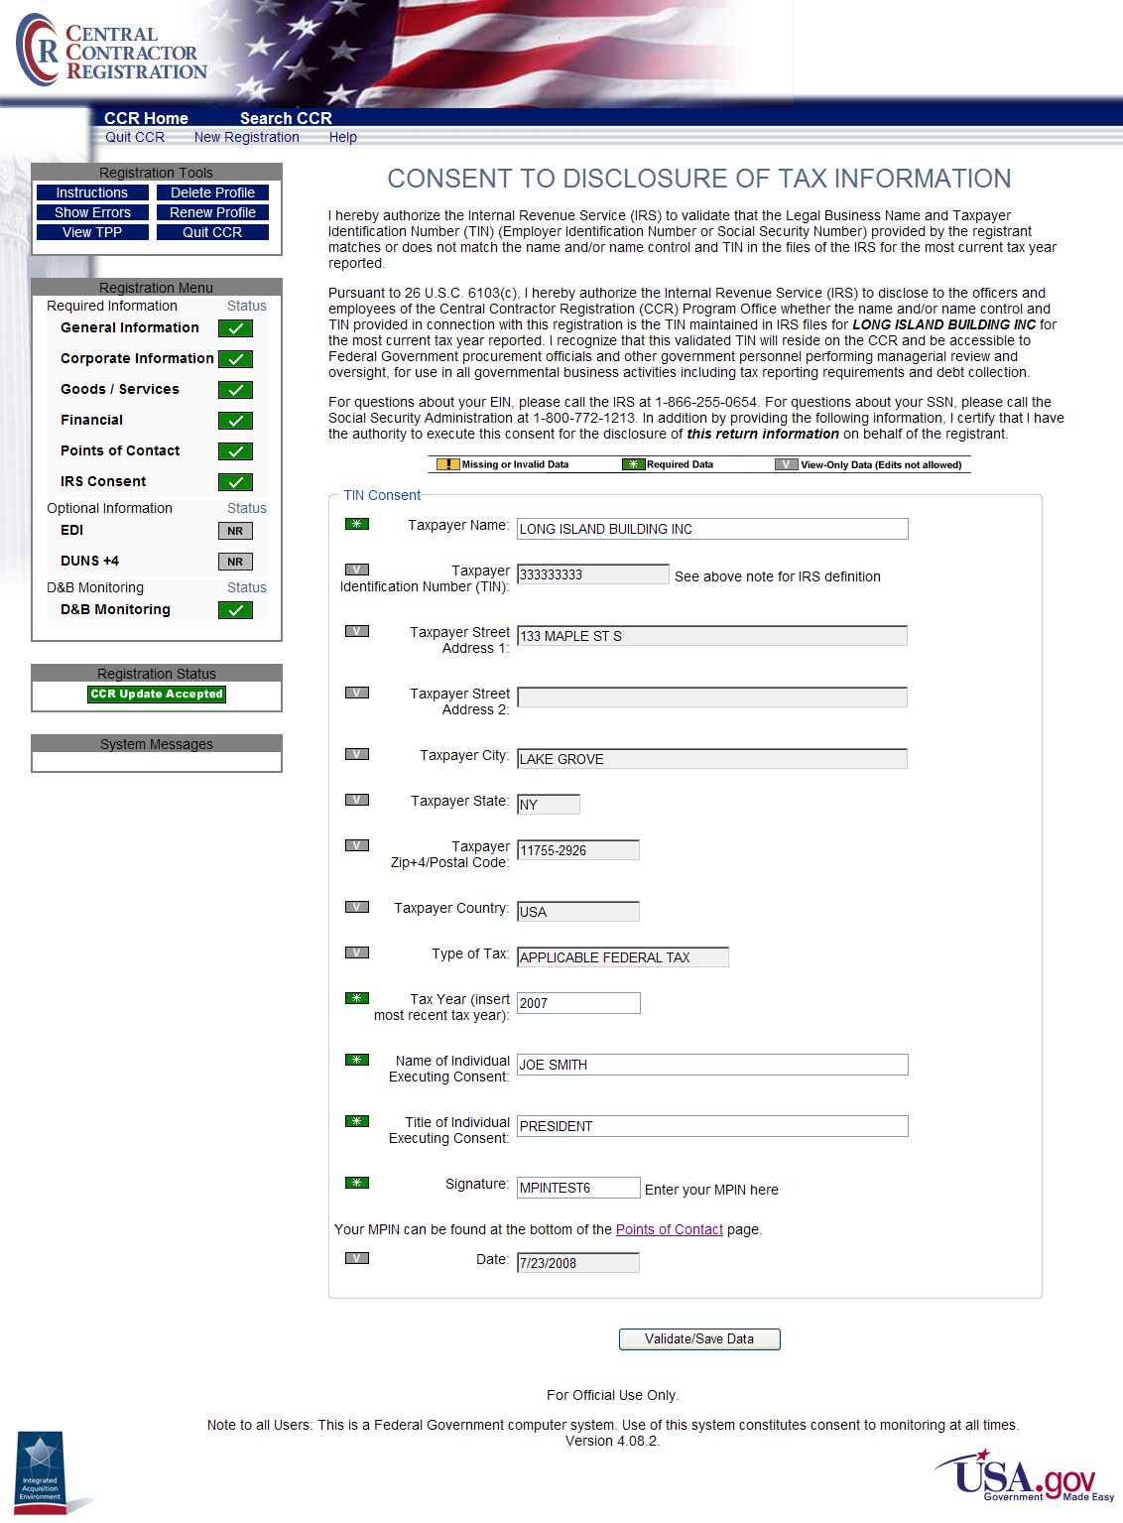
IRS Consent Page

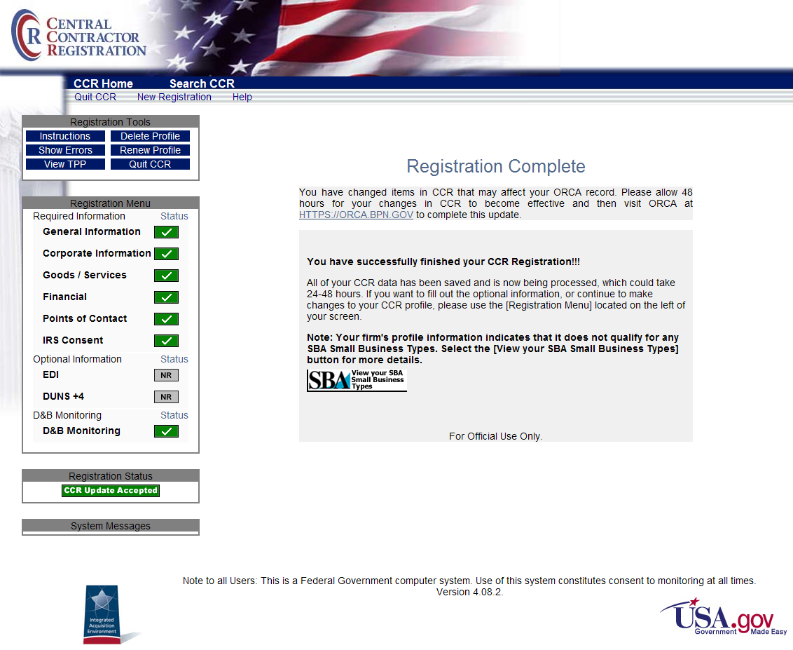
Successful Registration Finish

Or

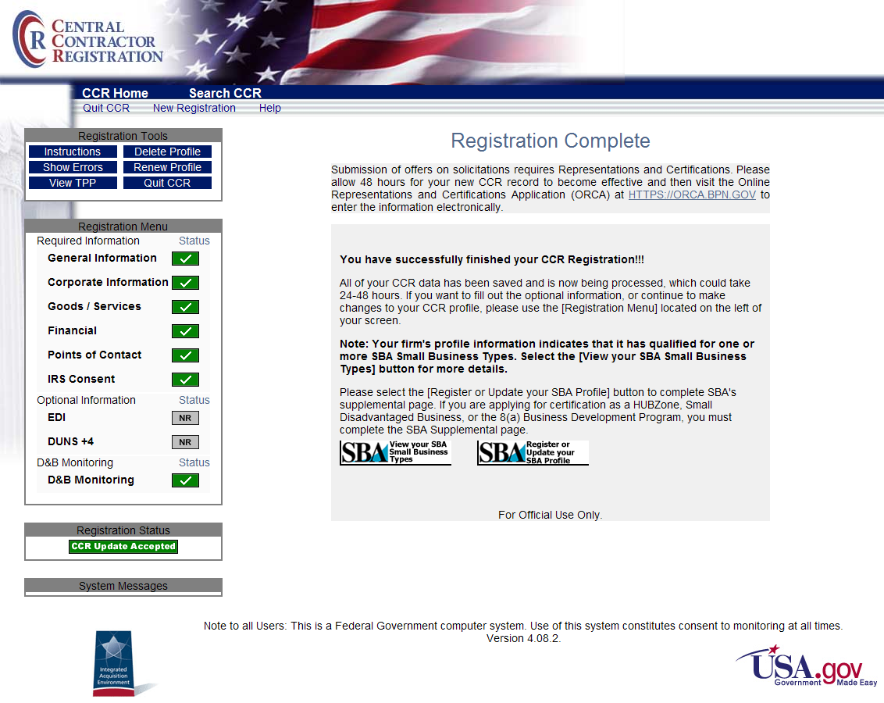
Successful Registration Finish—Qualified for one or more
SBA Small Business Types
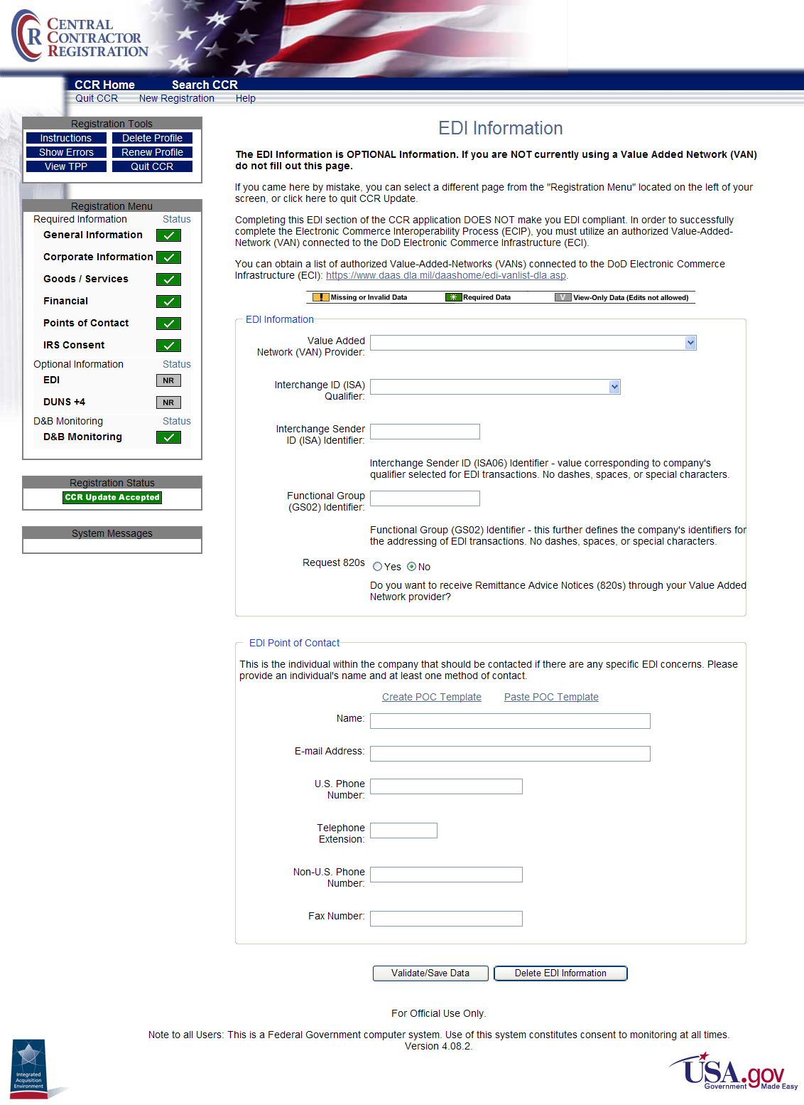
EDI Information Page

DUNS +4 Information is optional and can only be added
to an active CCR Trading Partner.

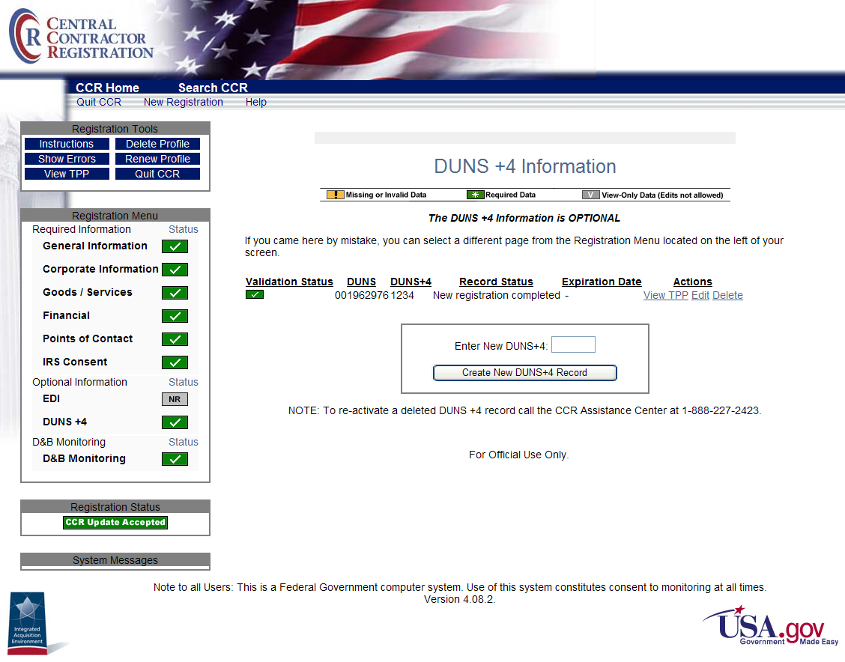
DUNS +4 Information Page

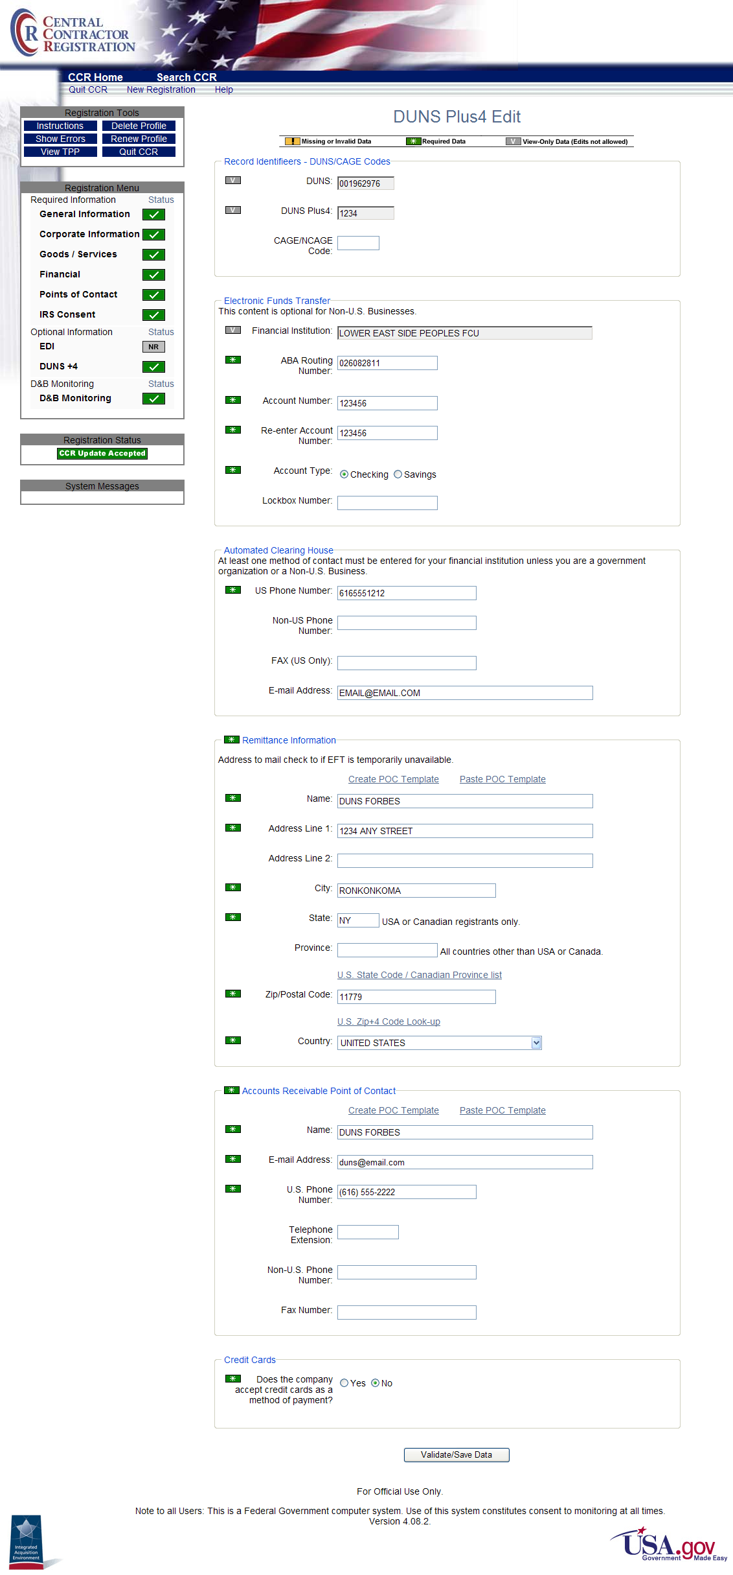
DUNS+4 Created—Editing Record
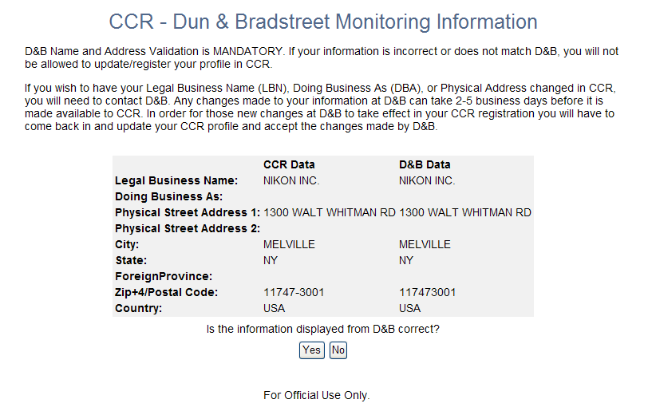
CCR – Dun & Bradstreet Monitoring Information—Information Matches

