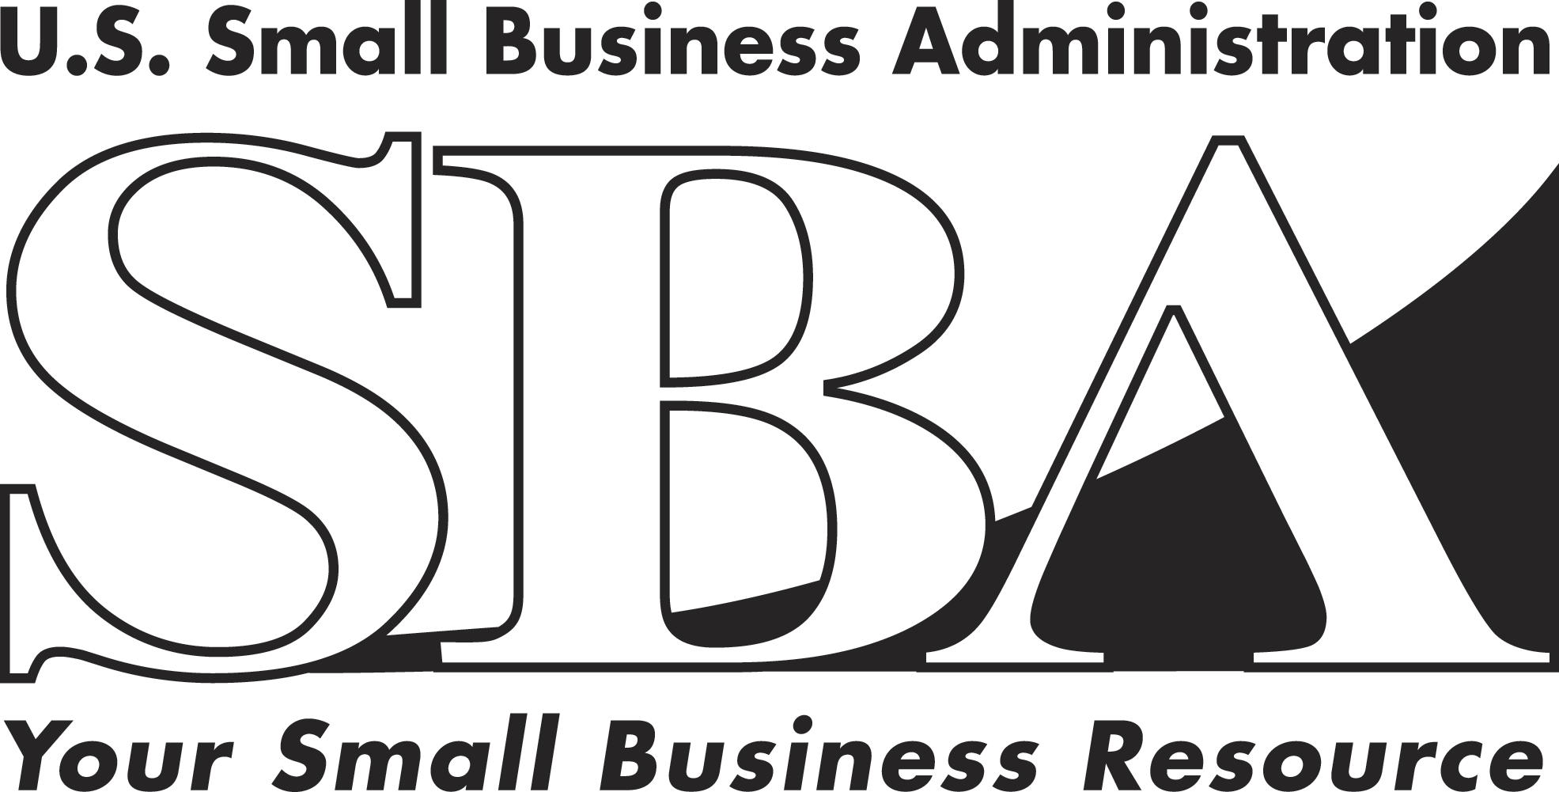 News Release
PRESS OFFICE

Release Date: August 27, 2007 | Contact: Christine Mangi (202) 205-6948
Release Number: 07-53 | Internet Address: http://www.sba.gov/news

SBA and U.S. Chamber of Commerce Reach Agreement
To Enhance Disaster Response and Recovery

WASHINGTON – The U.S. Small Business Administration and the U.S. Chamber of Commerce will pool their resources to more effectively respond to major disasters, paving the way for faster recovery in affected communities.
The SBA’s alliance with the Chamber’s Business Civic Leadership Center (BCLC) is part of a continuing effort to broaden the agency’s response capacity in catastrophic disasters.
“This collaboration will establish a larger corps of potential responders, made up of business leaders, the SBA and its resource partners, ready on short notice to help disaster victims rebuild their lives,” SBA Administrator Steve Preston said.
Stephen Jordan, senior vice president and executive director of BCLC, also praised the agreement saying, “This relationship between BCLC and SBA sets a precedent for America’s business community to work with the federal government to prepare for and recover from catastrophic disasters. Both of our organizations are committed to accelerating the recovery process.”
Per the agreement, SBA will provide information on its disaster recovery program and the agency’s resource partners (including Women’s Business Centers, SCORE, and Small Business Development Centers) to BCLC and local chambers of commerce. In addition, SBA will share situation analyses with BCLC and local chambers’ during pre-disaster and recovery periods, and share needs and capability assessments in the event of a catastrophic disaster.
To bolster SBA’s initial response and post-disaster recovery capacity, the agency will work with BCLC to obtain volunteers who can support the agency’s disaster assistance process. SBA will also work with BCLC on research studies on post-disaster economic recovery.
BCLC will contribute to the alliance by providing timely information and on-site updates to the SBA, and helping bolster SBA’s disaster assistance capabilities through its members and networks. In addition, BCLC will also work with SBA’s resource partners, providing recovery assistance information to the local business community and details on how to prepare for disaster before it strikes.
For the latest news and information on SBA’s Disaster Assistance program, visit the Web site at http://www.sba.gov/services/disasterassistance/index.html. For information on BCLC and its disaster assistance and recovery program, visit www.uschamber.com/bclc.

# # #

