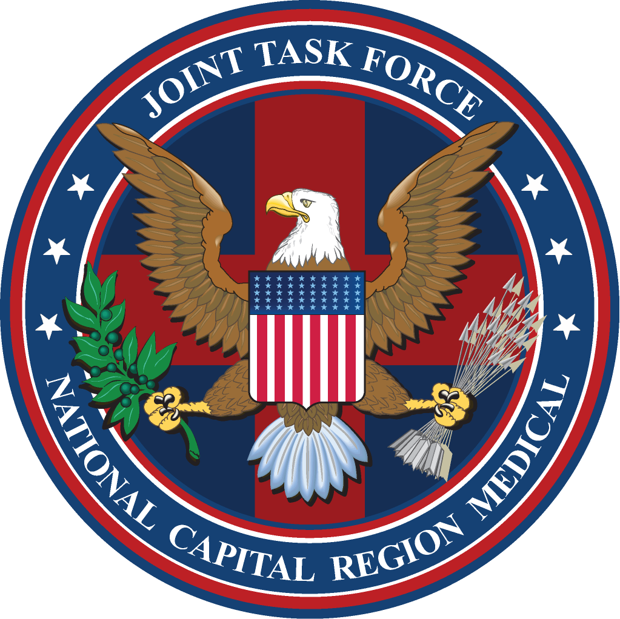

J7 OPERATIONAL SUMMARY (OPSUM)
JOINT TASK FORCE
NATIONAL CAPITAL REGION MEDICAL

Week of 19 – 23 May 2008

- Monday, 19 May 08, reviewed/provided feedback on NICoE overarching description
of the PH/TBI Research Clearinghouse.

- Monday, 19 May 08, Enlisted Training Cell meeting held at Bldg 141. Discussed and approved the use of the Competency Based Orientation Program for the non-licensed Army (68W), Air Force (4N0) and Navy (Corpsman/Basic Skills) enlisted personnel.

- Monday, 19 May 08, meeting held with COL Nace, COL Argyros & Earl Fauver to discuss roles & responsibilities of Chief, GME/GDE, MEDCEN DME, and DIO at USU.

- Tuesday, 20 May 08, Ethics Training held at JTF HQ for senior staff. Training provided by COL Sam Smith, WRAMC Command Judge Advocate.

- Tuesday, 20 May 08, completed draft of slides to be briefed at the JTPB on the proposal to adopt the Competency Based Orientation Program for the non-licensed Army (68W), Air Force (4N0) and Navy (Corpsman/Basic Skills) enlisted personnel.

- Wednesday, 21 May 08, reviewed final draft of proposed agreement between the JTF CapMed and the National Capital Consortium for Occupational and Environmental Medicine Residency Program and the General Preventive Medicine Residency Program.

- Wednesday, 21 May 08, meeting held with CJTF, J7 and Mr. Richard Salem to discuss NMR3C concept development.

- Wednesday, 21 May 08, attended JTPB meeting at JTF HQs.

- Wednesday, 21 May 08, J7 JPG held at JTF HQs Building. Cells provided updates; Enlisted Training Cell received approval on briefing the JTPB proposal to implement the enlisted personnel Competency Based Orientation Program in the JOA.

- Wednesday, 21 May 08 attended strategic planning meeting at NIH to further explore opportunities for joint research funding initiatives to include DoD, VA & NIH.

- Thursday, 22 May 08, sent out follow-up information to the Enlisted Training Cell group members for action. Requested information from the 3 Services concerning: What NBC training is required by the Services, how often, and how the training is being tracked.

- Thursday, 22 May 08, May JTF Professional Development presentation given by J7. Topic: Creating Ethical Environments.

- Friday, 23 May 08, continued working on plans for JTF staff ride to Vietnam Veteran’s Memorial on Memorial Day. Three individuals from JOA scheduled to give speeches for this event: MG Hawley-Bowland (Army Component Commander), Col Murray (J7, JTF CapMed) & Ms. Loretta Aiken (NNMC Staff Nurse).

For questions/comments, please contact Colonel John S. Murray, J7 – Director of Education, Training & Research, Joint Task Force National Capital Region Medical at: John.Murray@med.navy.mil

