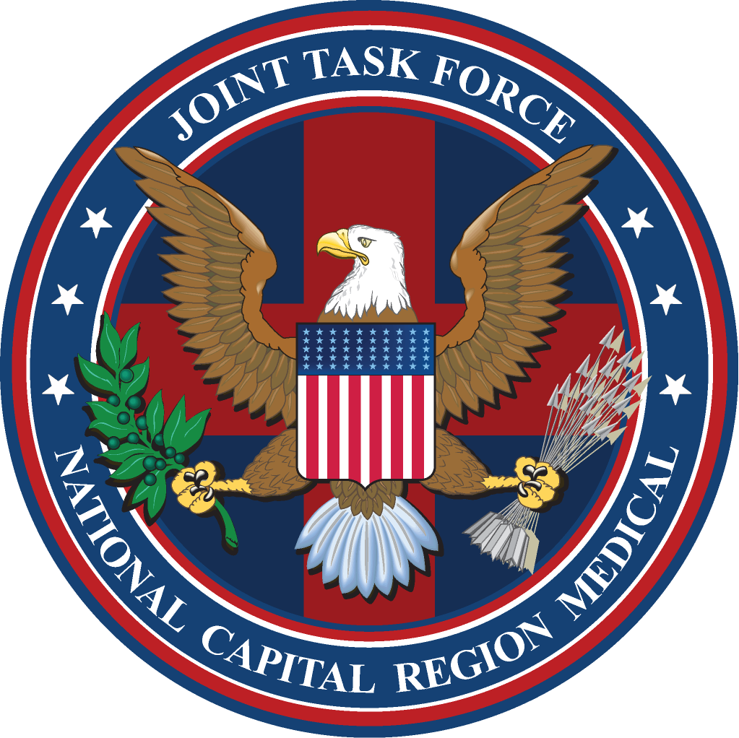

J7 OPERATIONAL SUMMARY (OPSUM)
JOINT TASK FORCE
NATIONAL CAPITAL REGION MEDICAL

Week of 05 – 09 May 2008

- Monday, 05 May 08, composed list of initiatives being worked in collaboration with USU for CoS preparation as needed for upcoming USU Board of Regents meeting.

- Monday, 05 May 08, contacted JTF training monitors to remind them about the upcoming suspense for JTF personnel to have NSPS 101 training completed by 07 May.

- Tuesday, 06 May 08, completed tasking from J1 to compile J7 Objectives to be achieved by FOC.

- Tuesday, 06 May 08, continued work on comparing the IDMT/IDC programs. Consolidated the IDC scope of practice; working on doing the same for IDMT.

- Wednesday, 07 May 08, attended JTPB meeting held at JTF HQs.

- Wednesday, 07 May 08, participated in HHS Tech demonstration - Dr. Elizabeth Holmes, “Computer-based teaching for Ethical Conduct” – audience currently USNA but to be expanded.

- Wednesday, 07 May 08, PHONCON conducted with Col Griffith (AF SGR Modernization) to explore USAF involvement in alignment with BRAC - for contingency support for disaster response as part of NMR3C initiative.

- Wednesday, 07 May 08, PHONCON with Mr. William Klenke at NOBLIS to explore support of emergency response as part of NMR3C per recommendation of J5.

- Wednesday, 07 May 08, meeting with Dr. Edward Gabriele and Dr. Sandra Titus from HHS regarding interagency involvement with JTF emergency response support for NMR3C.

- Wednesday, 07 May 08, began working on the Competency Based Orientation Program for the non-licensed Army (68W), Air Force (4N0) and Navy (Corpsman/Basic Skills) enlisted personnel proposal for JTPB.

- Wednesday, 07 May 08, attended meeting at Catholic University to explore potential opportunities to partner on education initiatives.

- Thursday, 08 May 08, NSPS training conducted for JTF Senior staff.

- Thursday, 08 May 08, meeting with MAJ Higdon, Dr. Gabriele, Sherman Fleek (USUHS) regarding archiving of historical documents and artifacts and role of research.

- Thursday, 08 May 08, meeting with Dr. Carey Balaban, Univ. of Pittsburgh regarding University's interest in collaborations to support emergency response capabilities.

- Friday, 09 May 08, continued work on consolidating the IDMT scope of practice.

- Friday, 09 May 08, meeting with Mr. Chris Gillette (NNMC) regarding annual "Bethesda Partnership" training exercises and how to include NCR as part of NMR3C initiative.

- Friday, 09 May 08,meeting with Mr. John Donohue (Director of Maryland Institute for Emergency Medical Support Services) regarding policies for state of Maryland in response to disasters as part of NMR3C initiative.
For questions/comments, please contact Colonel John S. Murray, J7 – Director of Education, Training & Research, Joint Task Force National Capital Region Medical at: John.Murray@med.navy.mil

