Instructions for Completing the Teacher Questionnaire

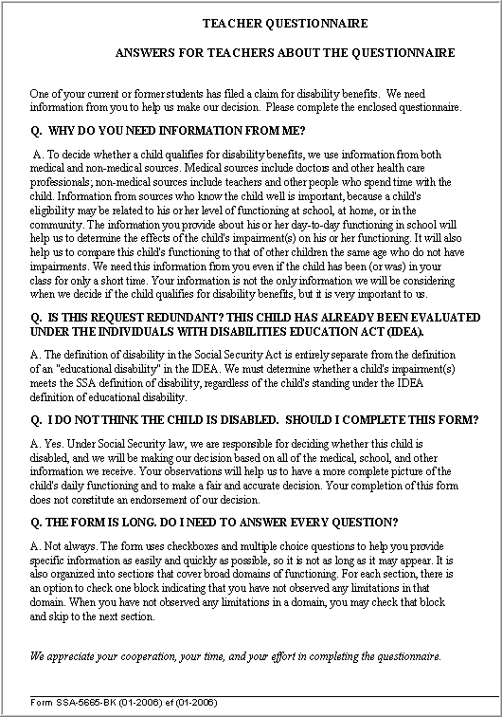
This form is an important element in the decision whether a child qualifies for disability benefits. Please read all instructions and questions carefully and complete the form in its entirety. The information you provide is key for the child being evaluated.

The following are some helpful tips on completing the Teacher Questionnaire:
- The body of this form is locked, so we recommend first saving a blank copy (File + Save As) to your local drive prior to completion.
- If you receive frequent requests from the same source (s), you may want to pre-fill the DDS name, Address, School name, teacher’s name, and phone number (pages 1 & 8). Leave the rest of the form blank and then save it as a master template.
- When navigating through the form, avoid using the "Enter" (hard return) key. Pressing "Enter", when inserting data and/or moving throughout the form, can create formatting errors. You should use the "Tab" key, the directional arrows, or your mouse (plus click), to move the cursor from one text field to the next. To begin a new line, simultaneously press the Shift and Enter.

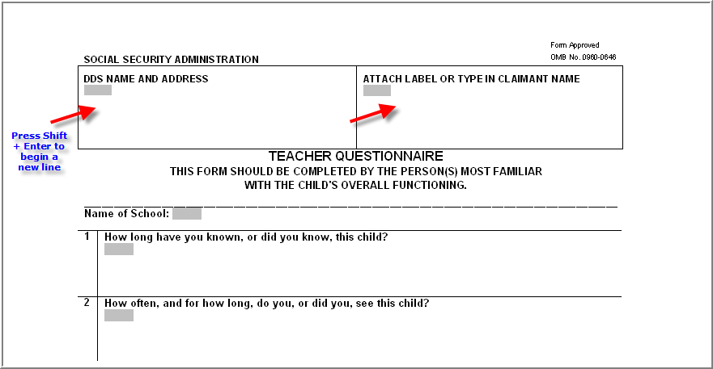

- Carefully read the instructions at the beginning of each section. If a specific assessment category does not apply to the child you are assessing, the instructions advise you to skip (go directly) to the next section.

- If you need to change a rating entry, click on the box already checked to erase the selection and then click on the new rating box. (See illustration on next page).

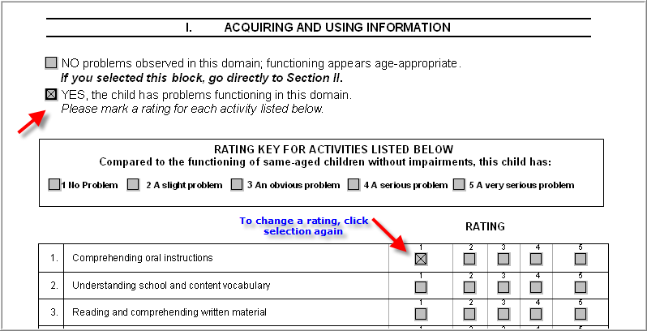
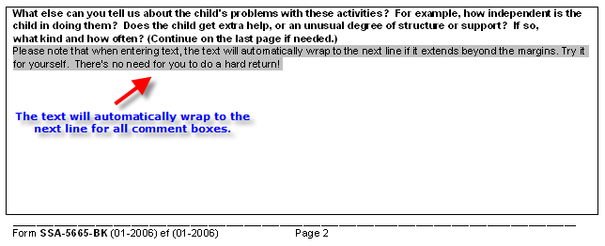
- When entering text in a comment box, the text will automatically wrap to the next line, if it extends beyond the margin.

- Print and fax the form to the number on the DDS request letter (use you personal computer's fax feature if available) using the barcode page as the first page, OR forward the file in a secure e-mail to your school or district records administrator if they are registered to use SSA's secure Electronic Records Express website.

