southern catalpa
Catalpa bignonioides Walt.
Plant Symbol = CABI8

Contributed by: USDA NRCS Manhattan Plant Materials Center and Kansas State University Forestry Research.

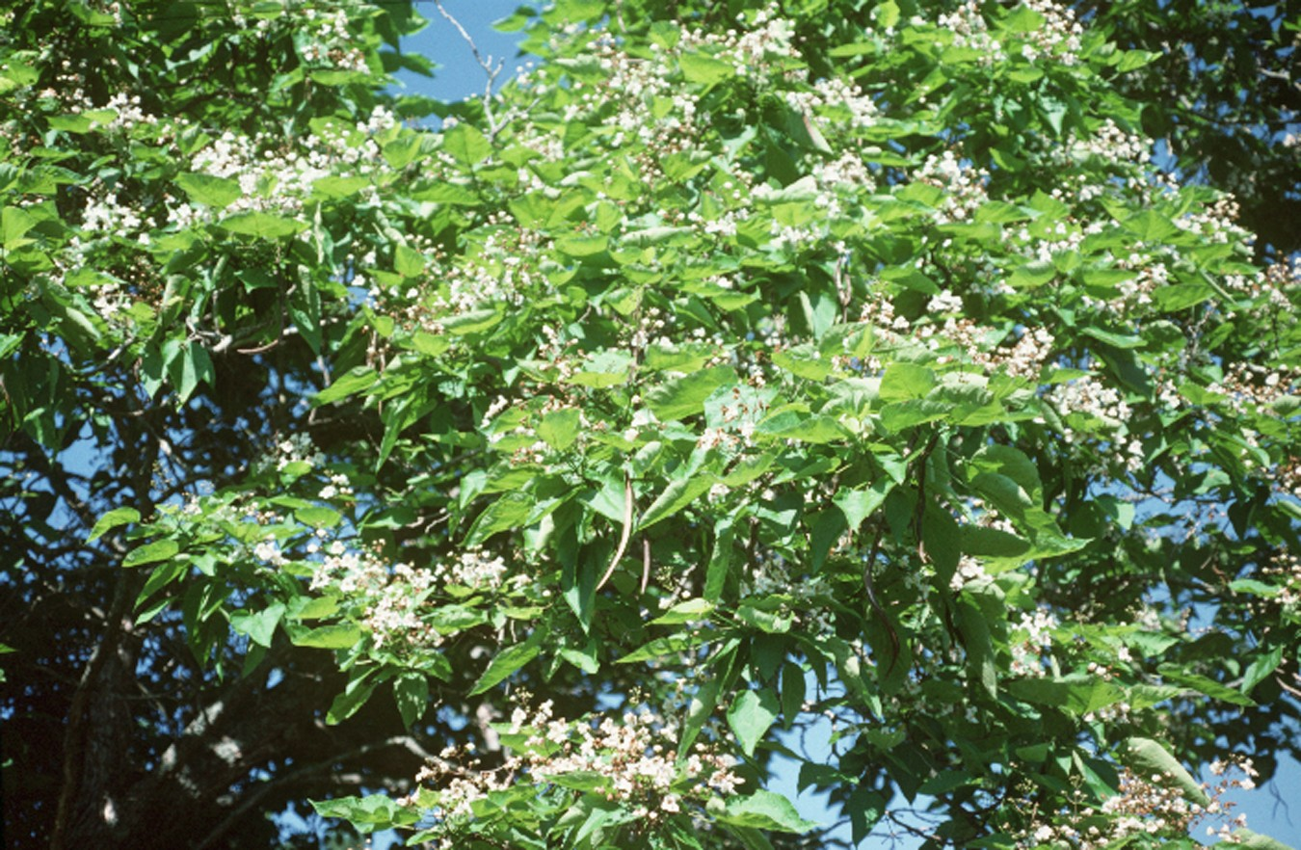
Robert H. Mohlenbrock
USDA-NRCS PLANTS Database
Alternate Names
Catalpa, katalpa, American catalpa, eastern catalpa, catawba, bean tree, Indian bean, Indian cigar tree, Shawnee wood, caterpillar tree, worm tree, fish bait tree, fisherman’s tree.

Uses
Southern catalpa is primarily used today as a large ornamental shade tree. It is widely planted in urban areas as a street and lawn tree. Conservation uses include being planted in windbreaks. Some plant it to attract the catalpa worm, which are harvested and used as fish bait.

Status
Please consult the PLANTS Web site and your State Department of Natural Resources for this plant’s current status (e.g. threatened or endangered species, state noxious status, and wetland indicator values).

Weediness
This plant may become weedy or invasive in some regions or habitats and may displace desirable vegetation if not properly managed. Please consult with your local NRCS Field Office, Cooperative Extension Service office, or state natural resource or agriculture department regarding its status and use. Weed information is also available from the PLANTS Web site at plants.usda.gov.

Description and Adaptation

Trumpet-creeper Family (Bignoniaceae). It is a perennial deciduous tree which readily grows in USDA Hardiness Zones 5 to 9. This is a U.S. native. At maturity, the height can vary from about 25 to 40 feet. Catalpas prefer moist, deep, well drained soil, but adapts to dry or wet soils. The soil pH may range from 5.5 to 7.0. It prefers an open sunny space to partial shade. The crown is often forked. Its longevity is about 40 to 50 years.

The tree bark is separated into irregular shallow fissures with reddish-brown scales. On young tree seedlings the bark is thin and easily damaged by impact, or rodents.

Twigs in winter have a unique identifying characteristic. They have sunken leaf scars which resemble suction cups. Their whorled arrangement of 3 “moon crater” scars per node is another trait easily identified. They are grayish-brown in color.

Leaves are simple, may be opposite or whorled (3 per node), pinnately veined, 5 to 12 inches long , 4 to 6 inches broad, heart shaped at the base, and have a long petiole with entire margins and soft pubescence on the underside, which is also a lighter green than the top surface.

The flowers of catalpa are perfect. Flowering takes place from May through July. They occur in bell-shaped corollas of 5 lobes. Individual flowers are showy, with the 5 petals in each flower being unequal in size, white with purple spots and orange stripes at the throat, in branched, upright clusters. The petals are up to 1.5 inches long.

Seedpods are slender and green in the summer growing from 6 to 24 inches long, and ½ inch wide looking ‘cigarlike’. They mature in the autumn, turn brown, split open lengthwise to let seeds fall in the spring. The seedpod generally stays attached to the tree limb over winter.
It was first cultivated in 1726. It was originally found in the Gulf Coast states of Florida, Georgia, Alabama, Mississippi and Louisiana. It has since spread to many states east of the Rocky Mountains.

Establishment
When placed as an ornamental in a yard setting care must be taken to ensure it is not too close to a building, fence, property line or septic system. Ample space should be provided to let it reach a mature height.

Management
The biggest management problems with a catalpa tree used as an ornamental are litter and smell. It will drop a heavy load of flowers in the spring, then a plentiful supply of leaves in the fall, and finally a lot of large seedpods in the winter. Green leaves give off a disagreeable odor when crushed.

Pests and Potential Problems
Larva of the catalpa sphinx caterpillar (Ceratomia catalpae) eats leaves. Almost complete defoliation may occur in some years.

Verticillum wilt will make the branches die, and can eventually kill trees. Powdery mildew causes a white powdery coating on the leaves. When severe the leaves turn yellow and drop.

Environmental Concerns
It is an invasive, weedy tree which escapes cultivation easily. The flowers, long seedpods and seeds fall down from spring through winter, and create a mess on the ground anywhere near the tree.

Cultivars, Improved, and Selected Materials (and area of origin)
There are two species of catalpa native to North America, northern catalpa (Catalpa speciosa) and southern catalpa (Catalpa bignonioides). They appear very similar but are two distinct species. Two varieties of C. bignonioides have been documented: ‘Aurea’ and a dwarf variety named ‘Nana’.

Control
Please contact your local agricultural extension specialist or county weed specialist to learn what works best in your area and how to use it safely. Always read label and safety instructions for each control method. Trade names and control measures appear in this document only to provide specific information. USDA, NRCS does not guarantee or warranty the products and control methods named, and other products may be equally effective.

Prepared By:
Dr. Wayne A. Geyer
Kansas State University Forestry Division
Manhattan, Kansas

Patrick J. Broyles
USDA NRCS Manhattan Plant Materials Center Manhattan, Kansas

Species Coordinator:

Patrick J. Broyles
USDA NRCS Manhattan Plant Materials Center Manhattan, Kansas

Edited: 27June05 rln; 01jun06 jsp

For more information about this and other plants, please contact your local NRCS field office or Conservation District, and visit the PLANTS Web site<http://plants.usda.gov> or the Plant Materials Program Web site <http://Plant-Materials.nrcs.usda.gov>

The U.S. Department of Agriculture (USDA) prohibits discrimination in all its programs and activities on the basis of race, color, national origin, sex, religion, age, disability, political beliefs, sexual orientation, and marital or family status. (Not all prohibited bases apply to all programs.) Persons with disabilities who require alternative means for communication of program information (Braille, large print, audiotape, etc.) should contact USDA's TARGET Center at 202-720-2600 (voice and TDD).
To file a complaint of discrimination write USDA, Director, Office of Civil Rights, Room 326-W, Whitten Building, 14th and Independence Avenue, SW, Washington, DC 20250-9410 or call 202-720-5964 (voice or TDD). USDA is an equal opportunity provider and employer.
Read about Civil Rights at the Natural Resources Convervation Service.

