HOW COMPUTERS WORK

FACT SHEET

A Computer’s Inner Workings

The heart and soul of a computer is the “motherboard” – an electronic circuit board that contains a number of components that are critical to a computer’s operation. These components include the—

- Central Processing Unit (CPU)
- Basic Input/Output System (BIOS)
- Random-Access Memory (RAM)

The motherboard also contains connectors that allow exterior components such as the mouse, keyboard ports, USB ports and the like, to attach to the computer. In addition to the motherboard, the computer contains other pieces of hardware that are essential to its operation, such as—

- Video Card (sometimes built into the motherboard) – The video card takes electronic signals from the motherboard and converts them into a format for display on the computer’s monitor

- Hard Disk Drive (hard drive) - Stores the computer’s operating system files, program files and user data. Other drives, such as a CD or DVD drive, and a floppy drive, allow for those pieces of media to be read by the computer.

Startup

When a computer is powered on, a chip on the motherboard—the BIOS—conducts a Power-On Self Test (POST). This test ensures that critical computer components are configured and working properly. After the BIOS successfully complete the POST, it launches the computer’s operating system. There are many operating systems in use today including Windows XP, Vista, the many variants of Linux, and Mac OS X, is also very popular.

Booting Up - The process of loading a computer’s operating system is known as “Booting.” The BIOS uses the Bootstrap Loader to load the operating system--typically found on the computer’s hard drive. The operating system is loaded into the computer’s temporary memory and control, and is passed to the operating system and the user. | 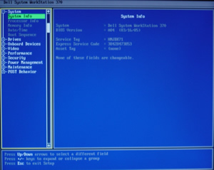  Figure 1 – The BIOS

The Operating System

Once the operating system is loaded, it assumes a number of responsibilities including—

- Processor Management – Controls the CPU
- Device Management – Provides an interface for the varied devices attached to the computer, such as the keyboard, mouse, hard drive, video card, etc.
- Memory Management – Manages all of the information stored in the computer’s temporary memory, also known as Random Access Memory or “RAM”
- Application Management – Manages all of the programs that are currently running and provides for communication between them
- Storage Management – Manages the storage of information on the computer’s hard disk
- User Interface – Provides the user a means through which to communicate with the operating system.

Storing Information

Computers store information in two locations, not counting removable media. First, the computer’s RAM is used as a temporary storage location and is known as volatile memory, since whatever it contains is lost when the computer is powered off. Information that is stored permanently is written to the hard drive.

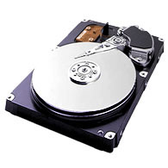  Figure 2 – The hard drive | Hard drives contain a number of magnetic platters that store information in the form of 0’s and 1’s and is stored in a series of concentric circles. As the platters spin, a head attached to a control arm hovers over the platters and alters its magnetic characteristics, writing the 0’s and 1’s.

For More Information

To learn more about the RCFL Program, contact the National Program Office:

RCFL National Program Office  Central Number:  703-985-3677  Email: NPO@rcfl.gov | Mailing Address—  Engineering Research Facility  Building 27958-A  Quantico, VA 22135  RCFL National Program Office | Web Site Address—  www.rcfl.gov

