THE FACTS:

Electronic Transfer Account – ETASM

What is an Electronic Transfer Account?
The Electronic Transfer Account (ETASM) is a low-cost account you can open at a federally insured bank, savings and loan, or credit union where you see the ETA logo. The U.S. Department of the Treasury designed the ETA, primarily for Federal recipients who do not have checking or savings accounts, even if you have been unable to qualify for one in the past.

The ETA is not a checking account and anyone who receives Social Security, Supplemental Security Income (SSI), Veterans Benefits, Railroad Retirement, Civil Service Salary or Retirement, or Military Retirement can open an ETA. Once you open an ETA, your payment will go right into your account — on time, every time. There is no check to worry about. You can take money out of your ETA the same day it goes into your account.

Why should I open an ETA?
An ETA costs you $3.00 a month or less. For this service charge, you'll enjoy the safety, security and ease of having your check deposited directly to your account, plus the following features:

- Your ETA is federally insured.
- You can take money out of your ETA at least four (4) times a month. Your bank, savings and loan, or credit union will tell you whether you can get your money from a teller, an Automated Teller Machine (ATM) or both. Your ETA provider will tell you which ATMs provide free withdrawals. If you use ATMs at certain locations, it may cost extra.
- You don't need to keep a minimum balance in your account, unless the law requires it.
- You will get a monthly statement listing all deposits and withdrawals.

Other services provided may have additional costs, and you'll be told about them before you sign up for an ETA. If you have any questions about the ETA, ask a teller or customer services representative at a bank, savings and loan, or credit union where you see the ETA logo displayed.

To find out where you can open an ETA, call 1-888-382-3311, tool-free, or visit our Web site on the Internet at www.eta-find.gov. People who are deaf or hard of hearing can call TDD: 1-877-326-5833.

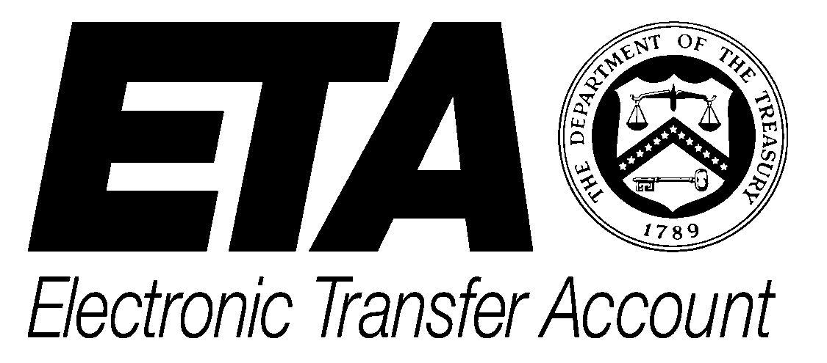

The Electronic Transfer Account (ETASM) is a new low-cost account you can open at a federally insured bank, savings and loan, or credit union where you see the ETA logo.

To receive free consumer education materials, go to the Website www.fms.treas.gov/eft and click on EFT Education and Promotional Materials. Choose the first item listed, EFT Promotional Materials, and click on On-Line Order Form.

What if I have questions about my Federal government payment?

Call the agency that pays you:
Social Security
1-800-772-1213
(For Social Security and Supplemental Security Income (SSI) Payments)

Veterans Affairs
1-800-827-1000
(For Veterans Payments)

Office of Personnel Management
1-888-767-6738
In Washington, DC Area Only
202-606-0500
(For Civil Service Salary or Retirement Payments)

Railroad Retirement Board
1-800-808-0772
(For Railroad Retirement Payments)
Call the number for your local Railroad Retirement Board office

• Participate in community education events at local senior centers, hospitals, shopping malls, etc., during National Direct Deposit/Direct Payment Week.
• Use automated enrollment or Quick$tart for Direct Deposit enrollments during promotional events.
• Include promotional messages on account statements to encourage check recipients to make the switch to Direct Deposit. Include a Direct Deposit enrollment form to make sign-up quick and easy for your customers.
• Mention Direct Deposit when you market other financial services, such as retirement planning tools or PC banking products, to consumers.
Remember, to find out more about the ETA, talk to someone at a bank, savings and loan, or credit union. To find out more about your Federal Government payment, call the agency that pays you.

