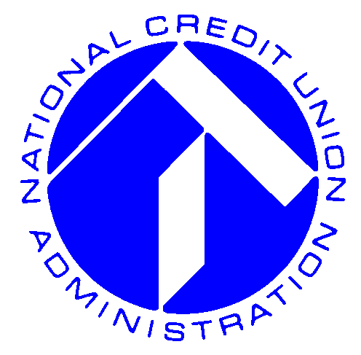
NCUA
National Credit Union Administration
1775 Duke Street
Alexandria, VA 22314-3428
www.ncua.gov
Media Contact: NCUA Office of Public & Congressional Affairs
Phone: (703) 518-6330
Email: pacamail@ncua.gov
Public Service Announcement

Note to media: NCUA is providing this public service announcement, on an as needed basis, to alert credit union members in the path of Hurricane Ike of assistance available to access their funds.

Alexandria, Va., September 11, 2008- The National Credit Union Administration, the federal government agency responsible for regulating and federally insuring credit unions, wants consumers to know several important things as a result of hurricane Ike:

- Your deposits in a federally insured credit union are insured up to at least $100,000.
- If you cannot reach your credit union, the National Credit Union Administration has set up a toll-free information line at 1-888-584-6847. Use this line to get information about your credit union’s operating status, your deposit insurance protection, how to access your money, and other important facts that you need to know.
- NCUA’s website, www.ncua.gov, has dedicated a page to provide information in preparing to deal with any impact from Ike, and will contain updates on credit union operations in the event they are affected by Ike.

Though consumers in potentially affected areas will have a number of things to worry about, the security of federally insured credit union deposits isn’t one of them. Call your credit union, NCUA’s disaster hotline at 1-888-584-6847, or visit www.ncua.gov for more information.

-NCUA-

