

DOL Enterprise Architecture
Requirements and Guidance
Version 1.2

Revision History

Completing the table below every time the document is revised is a good way of tracking updates and associated responsibilities. Please keep in mind that EA is a living document and process, and that updates need to happen as your project moves through the SDLCM lifecycle and/or your agency revises or adds to its “Target” business/IT vision. The DOL Enterprise Architecture Program Office (EAPO) will semiannually review Agency EA’s to ensure progress in this regard.
Date | Version | Description | Author

Table of Contents

1. Executive Summary 8
1.1 Introduction 8
1.2 Purpose 8
1.3 Target Audience 9
1.4 Document Organization 9
2. DOL EA OvervieW 9
2.1 Overview of DOL’s Enterprise Architecture 11
2.1.1 DOL’s Perspective on Segment Architecture 12
2.1.2 Guidance for Segment Architecture Development 14
2.2 EA Framework 16
2.3 Business Strategy 17
2.4 Performance Architecture 17
2.5 Investment Information 19
2.6 EA Governance 20
2.7 Business Architecture 20
2.8 Application Architecture 21
2.9 Technical Architecture 22
2.10 Data Architecture 23
2.11 Building the Agency EA 25
3. Building the Agency Business Strategy 25
3.1 Agency 25
3.2 Agency Mission 27
3.3 Agency Vision 29
3.4 Agency Goals 31
3.5 Agency Performance Objectives 34
4. Building the Agency Enterprise Architecture by Investment 36
4.1 Investment Information 37
4.1.1 Agency IT Investment 37
4.1.2 Investment Budget Information 40
4.1.3 Agency Program 40
4.1.4 Agency Project 42
4.1.5 Project Alternatives 43
4.1.6 Stakeholders 46
4.1.7 Milestones 49
4.2 Business Architecture 52
4.2.1 Business Function 52
4.2.2 Business Process 55
4.2.3 Organizations 58
4.2.4 Facility 61
4.2.5 Re-engineering Requirements 64
4.2.6 Roles 65
4.3 Application Architecture 67
4.3.1 Applications 67
4.3.2 Application Components 70
4.3.3 System 73
4.3.4 Agency Application Solution Architecture Components 74
4.3.5 Embedded Hardware 78
4.3.6 Agency Software 81
4.4 Technical Architecture 84
4.4.1 SRM-TRM Mappings 84
4.4.2 Service Specifications 86
4.4.3 Service Specification Replacement Objects 86
4.5 Data Architecture 88
4.5.1 Data Asset 88
4.5.2 Exchange Package 90
4.5.3 Data Exchange Mechanism 93
4.5.4 Payload Definition 94
4.5.5 Information Group 96
4.5.6 Information Policy 98
4.5.7 Information Policy Rule 100
4.5.8 Query Point 101
4.5.9 Data Schema, Data Entity, Data Attribute and Data Entity Relationship 103
4.5.10 DRM: Taxonomy 112
4.5.11 DRM: Topic 114
4.5.12 Agency Digital Data Resources 116
4.5.13 DRM: Document 118
4.6 Performance Architecture 121
4.6.1 Mission and Business Results Measurement Area 121
4.6.2 Customer Results Measurement Area 123
4.6.3 Processes and Activities Measurement Area 125
4.6.4 Technology Measurement Area 127
4.6.5 Performance Measurement Points 130
4.6.6 Performance Gap 133
5. Building the Agency Security Architecture 134
5.1.1 Agency Security Processes 135
5.1.2 Agency Data Access Rights 136
5.1.3 Security Requirements and Capabilities 138
6. Building the Agency EA Governance 140
6.1 EA Governance Process 140
6.2 Internal EA Governance Team 143
7. Building the Agency Transition Strategy 146
7.1 Transition Overview 146
7.2 Transition Components & DEAMS 147
7.3 TSP Object Descriptions 148
7.3.1 TSP- Transition Strategy Plan 148
7.3.2 Performance Gap Analysis 149
7.3.3 Criticality and Impact 151
7.3.4 Assumptions, Constraints & Dependencies 151
7.3.5 Risks 152
7.3.6 DIIRT Analysis 154
7.3.7 Cost Savings / Cost Avoidance 155
7.3.8 Concept of Operations – CONOPS 155
7.4 TSP Requirements 156
7.5 TSP Object Guidance 156
APPENDIX a: Federal Lines of Business (LOBS) 159
APPENDIX B: Federal Presidential Priority Initiatives (PPI) 160
ApPENDIX C: PResident’s Management Agenda (PMA) Goals 164
APPENDIX D: Federal transition framework (ftf) Inititatives 165
AppENDIX E: Department of Labor Strategic Plan 168
APPENDIX F: Department of Labor IT Strategic Plan 170
APPENDIX G: Security/Privacy Requirements 170
APPENDIX H: Security/Privacy Capabilities 172
APPENDIX I: Security/Privacy Conrtol Families 173
APPENDIX J: COnsoilidated DOL EA requirements 176

LIST OF TABLES

Table 1: DOL EA Framework Domains 16
Table 2: Agency Object Requirements 26
Table 3: Agency Mission Statement Requirements 28
Table 4: Agency Vision Requirements 30
Table 5: Agency Goal Requirements 32
Table 6: Agency Performance Objective Requirements 34
Table 7: Agency Investment Requirements 37
Table 8: Agency Program Requirements 41
Table 9: Agency Project Requirements 42
Table 10: Project Alternatives Requirements 44
Table 11: Individual Alternative Requirements 44
Table 12: Stakeholder Entity Requirements 47
Table 13: Stakeholder Class Requirements 49
Table 14: Milestone Requirements 50
Table 15: Performance Gap Requirements 133
Table 16: Business Function Requirements 53
Table 17: Business Process Requirements 55
Table 18: Organization Requirements 58
Table 19: Facility Requirements 62
Table 20: Re-engineering Requirements 64
Table 21: Role Requirements 66
Table 22: Agency Application Requirements 68
Table 23: Agency Application Component Requirements 71
Table 24: Agency System Requirements 73
Table 25: Hardware Requirements 76
Table 26: Embedded Hardware Requirements 79
Table 27: SRM-TRM Mappings Requirements 84
Table 28: Hardware Product Relationships 87
Table 29: Software Product Relationships 87
Table 30: Data Asset Requirements 88
Table 31: Exchange Package Requirements 91
Table 32: Data Exchange Mechanism 93
Table 33: Payload Definition Requirements 95
Table 34: Information Group Requirements 97
Table 35: Information Policy Requirements 98
Table 36: Information Policy Rule Requirements 100
Table 37: Query Point Requirements 102
Table 38: Data Schema Requirements 104
Table 39: Data Entity Requirements 106
Table 40: Data Attribute Requirements 108
Table 41: Data Entity Relationship Requirements 110
Table 42: Taxonomy Requirements 112
Table 43: Topic Requirements 114
Table 44: Digital Data Resources Properties 117
Table 45: Document Requirements 119
Table 46: Mission and Business Results Measurement Indicator Requirements 121
Table 47: Customer Results Measurement Indicator Requirements 123
Table 48: Processes and Activities Measurement Indicator Requirements 125
Table 49: Technology Measurement Indicator Requirements 128
Table 50: Performance Measurement Point Requirements 131
Table 51: Performance Gap Requirements Error! Bookmark not defined.
Table 52: Agency Security Process Requirements 135
Table 53: Data Access Right Requirements 136
Table 54: Security / Privacy Requirements 138
Table 55: Security / Privacy Capability 139
Table 56: Governance Process Requirements 141
Table 57: Governance Team Member Requirements 144
Table 58: Federal LoB Support 159
Table 59: Presidential Priority Initiative (PPI) 160
Table 60: President’s Management Agenda 164
Table 61: DOL Strategic Plan Alignment 168
Table 62: DOL Strategic Performance Goals 168
Table 63: DOL IT Strategic Plan Alignment 170
Table 64 : Security / Privacy Requirement Guidance 170
Table 65 : Security / Privacy Capability Guidance 172
Table 66 : Security Control Families 173
Table 67 : Privacy Control Families 175

Executive Summary

Introduction
The DOL Enterprise Architecture Requirements and Guidance provides detailed instructions for developing, correcting, updating, completing, and maintaining Agency Enterprise Architectures (EAs) via the Department of Labor Enterprise Architecture Management System, otherwise known as DEAMS. This document is intended to supplement the DEAMS training manual. Any questions on DEAMS functionality or Standard Operating Procedures can be answered by referring to the DEAMS training manual provided during the DEAMS training sessions.

This Guidance document uses the current DOL EA Framework to define EA development and maintenance procedures Agencies should follow for new, existing, and steady state investments. The document outlines how to identify and categorize baseline and target EA objects. Additional instruction is provided on how to define object properties and associated property values. Direction will also be given on how to build object relationships and classify relationship types.

The concepts and processes presented in this document will facilitate the development of a business-aligned and adaptive DOL EA, which will ultimately result in cost savings/ avoidance, reuse and standardization, improved strategic planning and implementation, streamlined information exchanges, and enhanced interoperability across the Department.

Purpose
Government and private industries must improve services and reduce costs in order to optimize performance in the current political and economic environment. The Clinger-Cohen Act of 1996 was passed to compel Federal organizations to be more accountable for economic and efficient management of information technology (IT) provisions and services. The Clinger-Cohen Act recommended that agencies develop, maintain, and facilitate the implementation of integrated enterprise architecture.

It is critical that DOL be driven by business needs, requirements, and overall mission. Strategic and IT planning must include IT support and investments that satisfy business needs in an optimal manner regardless of organizational boundaries and other constraints. Risks of insufficient planning include failure to accomplish key objectives, duplication of effort, wasted resources, and stakeholder rejection of future requests for support.

However, achieving a fully optimized state is a daunting and complicated task. To this extent, the DEAMS modeling tool provides graphical views of DOL’s complex infrastructure(s) thus allowing DOL decision makers to see the entire enterprise, including business strategies and operations, and how each aligns with IT functions and investments. Moreover, the DEAMS tool helps provide a greater understanding of Agency and investment performance results and overall value.

This Guidance document will help to ensure consistency and standardization as Agency and investment data is entered into the DOL DEAMS meta-model.

Target Audience
This Guidance is intended primarily for Agencies and/or investments required to comply with DOL EA Framework and Governance policies. It should be understood requirements herein do not necessarily apply to all Agencies and/or investments (i.e. all Agencies/ investments are not mandated to align with the Federal Transition Framework (FTF) or Presidential Priority Initiatives (PPI)).

The audience for this document includes but is not limited to: program/project managers, systems engineers, architects, systems developers, configuration managers, risk managers, information security engineers, business process owners and subject matter experts.
It will serve as a reference for anyone who is tasked with building, deploying, updating, modifying, or maintaining an EA.

Document Organization
The DOL Enterprise Architecture Requirements and Guidance document consists of six chapters covering the following topics:

Chapter 1.0—Introduction: Provides document overview, purpose, audience, and layout.
Chapter 2.0—Background: Provides the context for/evolution of enterprise architecture at DOL, including DOL’s approach to comply with emerging segment architecture guidance.
Chapter 3.0— Agency Business Strategy: Describes how to identify and draw linkages between business strategy objects, properties, property values, relationships, and relationship types.
Chapter 4.0—Agency Enterprise Architecture by Investment: Details how to identify and draw linkages between objects, properties, and relationships within and across the business, technology, application (service), data, and performance architectural layers.
Chapter 5.0— Agency Security Architecture: Details how to identify and draw linkages between objects, properties, and relationships within the security architectural layer.
Chapter 6.0— Agency EA Governance: Describes how to identify and define governance controls, roles/responsibilities, touch points, processes, and procedures at both the Department and Agency levels.
Chapter 7.0— Agency Transition Strategy: Describes how to transition from the Baseline to the Target EA by identifying target goals, objectives, milestones based on performance gap, dependency, impact, and risk analyses.

DOL EA OvervieW
In recent years, the success of the Federal Enterprise Architecture (FEA) and the Federal Enterprise Architecture Program Management Office (FEAPMO) has clearly demonstrated that Enterprise Architecture (EA) is one of the most critical forces driving Government-wide interoperability, fostering consolidation and reuse of business processes, systems, and technology across the Federal IT landscape.
The President's Management Agenda (PMA) for Expanded Electronic Government defines three key business drivers that influence the Federal Enterprise Architecture (FEA). First, agencies should create a citizen-centered, not bureaucracy-centered electronic government to achieve simplified delivery of services to citizens. Second, agencies are directed to measure performance by requiring business cases and by monitoring the results. When agencies seek funding from OMB, technology expenditures must be rationalized in relation to agency mission and return on investment. Third, agencies should support innovation through outsourcing and market-based initiatives. Other drivers for change include:
1) Clinger-Cohen Act of 1996 requires agencies to implement IT management processes, integrate management and budget processes, inventory IT investments, and designate a Chief Information Officer.
2) OMB Circular A-130 requires that Federal agencies create an Enterprise Architecture and update OMB as significant changes are made.
3) OMB Circular A-11 requires Agencies to submit plans and progress on their enterprise architectures.
4) Government Performance Results Act of 1993 requires that Federal agencies accurately employ performance metrics to measure and report performance results related to their IT investments.
5) The E-Government Act of 2002 (P.L. 107-347) requires agencies to support e-Government projects and to leverage cross-agency initiatives to further e-Government. It also requires agencies to submit privacy impact assessments for all new IT investments using personally identifiable data from or about members of the public.
6) The Paperwork Reduction Act of 1995 requires agencies to:
- Improve the quality and use of Federal information to strengthen decision-making, accountability, and openness in Government and society;
- Minimize the cost to the Federal Government of the creation, collection, maintenance, use, dissemination, and disposition of information;
- Strengthen the partnership between the Federal Government and State, local, and tribal governments by minimizing the burden and maximizing the utility of information created, collected, maintained, used, disseminated, and retained by or for the Federal Government;
- Provide for the dissemination of public information on a timely basis, on equitable terms, and in a manner that promotes the utility of the information to the public and makes effective use of information technology;
- Ensure that information technology is acquired, used, and managed to improve performance of agency missions, including the reduction of information collection burdens on the public; and
- Ensure that the creation, collection, maintenance, use, dissemination, and disposition of information by or for the Federal Government are consistent with applicable laws, including laws relating to: a) Privacy and confidentiality, including section 552a of title 5; and b) Security of information, including the Federal Information Security Management Act (FISMA).
7) The Government Paperwork Elimination Act (GPEA) requires agencies to leverage improved network technologies by proving electronic transactions.
8) The Federal Records Act of 1950 requires Federal agencies to establish and maintain a continuing program for the economical and efficient management of agency records. Electronic records created or received by the Federal Government must be managed as Federal records.
At DOL, we have embraced EA to implement best practices in business transformation through the selection of a portfolio of information technology (IT) investments that support Federal initiatives, the DOL Strategic Plan, Agencies’ Strategic Plans, and the PMA. The goal of the EA is to provide more effective and efficient DOL processes and delivery of services to citizens, the public, businesses, and other stakeholders.

Overview of DOL’s Enterprise Architecture
DOL developed the Baseline EA in November 2001 with participation across all DOL Agencies. The Baseline architecture detailed structure and components of the Departmental EA based on OMB and Federal CIO Council guidance. The Departmental EA was defined in five components or domains: Business, Data, Application, Technology, and Performance.
A key decision in developing the Baseline EA was an agreement to adopt a Federated approach to develop the Target EA. The Federated approach provides DOL agencies the ability to develop integrated EAs in a cooperative manner, with the aim of identifying opportunities for service sharing and consolidation. It also provides for a three-phase approach that focuses on universal, common, and independent functions (defined below respectively), as well as implementation plans, technical standards, and principles.
- Universal Functions are most critical to DOL from an enterprise-wide perspective, are performed by at least 75 percent of the agencies, and involve transactions or formal workflow processing (i.e., sign off and approval).
- Common Functions are those that do not meet one or more of the criteria for Universal functions, and are performed by more than two of the agencies.
- Independent Functions are those that do not meet one or more of the criteria for Universal functions, and are performed by two or less of the agencies
DOL focused on universal functions first because they provided the greatest Department-wide return on investment and enabled data streamlining and maximum consolidation. Successive phases have focused on independent functions and on implementation plans. DOL consistently reviews and analyzes commonalities among Independent functions so as to stream-line and improve re-use – thereby identifying opportunities for transition from Independent to Universal or Common categorization. It should be noted that Agency EAs for Common and Independent functions must comply with the Department’s overall EA.
In October 2005, DOL updated its FY 2005 – FY 2009 IT Strategic Plan to incorporate and align with DOL’s mission, its agencies’ requirements and the PMA. The strategy established a comprehensive vision for managing information resources which links it to the Federal EA, Federal e-Government strategy, and other Federal and cross-Department initiatives. The Strategic Plan drives investment decisions, the investment portfolio, and migration plans, and thus is linked to DOL management policies and governance framework for; CPIC, IT Security and Privacy Policy, EA, and compliance with the PMA, Office of Management & Budget (OMB), and Government Accountability Office (GAO) guidance and mandates.

The DOL Target EA is a key component of EA that drives decisions to implement tactical systems that will enable process changes. DOL is working to further integrate its Governance structure with the EA, IT Security, and Capital Planning and Investment Control (CPIC) processes using the DOL Enterprise Architecture Management System (DEAMS) as a decision-making and risk management support tool. The EA repository will be integrated with the CPIC process and used to analyze models of each architectural layer to identify opportunities for consolidation, collaboration, and elimination of redundancy. A key enabler of EA driven business processes will be the extension of DEAMS to not only model the current and target EAs but also to develop the model for the transition strategy.

DOL’s Perspective on Segment Architecture
The Office of Management and Budget (OMB) has evolved their guidance on EA over the last several years. Their current guidance provides clarity on how DOL can use EA to facilitate mission and business performance improvements. In short, OMB recommends the development of “segment” architectures to help with the planning and transformation associated with priority business challenges. OMB defines three manifestations of a segment:
- Core Mission Area Segments – to address unique service areas that define the mission or purpose of the Agency (e.g., Workforce Management, Labor Rights)
- Business Service Segments – to address common or shared services that support core mission areas (e.g., Human Resources, Financial Management)
- Enterprise Service Segments – to address common or shared IT services supporting core mission areas and business services (e.g., Records Management, Enterprise Communication)
In light of the intention to provide value to the business, OMB is also requiring organizations to demonstrate completion of segment architectures to maintain a GREEN status on EA assessments and eGov Scorecards. Completion in this regard includes providing evidence of baseline, target, and transition plans.
Given this current guidance, DOL’s EA Program Office is working to align previously defined universal, common, and independent functions with the three segment areas. It is also positioning to help the Agencies define segments based on mission performance challenges, develop a complete baseline and target architectures to address these challenges, and establish a transition strategy with performance milestones and metrics to help management transformation to the target architecture and ensure mission performance improvement. Figure 1 presents DOL’s current segment architecture framework.
Figure 1: DOL Segment Architecture
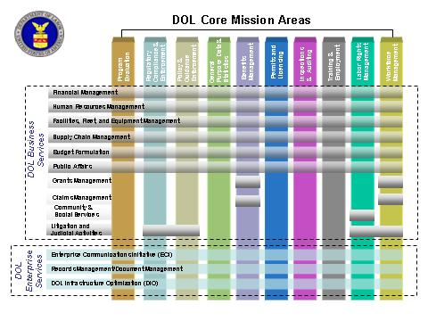
Figure 2: OMB Segment Definitions

Extracted from: Value to the Mission: FEA Practice Guidance, Federal Enterprise Architecture Program, Office of Management and Budget, December 2006,
Agency or Agency
Sub - component.
i.e. ESA- OFCCP

Guidance for Segment Architecture Development
In collaboration with OMB, DOL has defined high-level guidance for Agencies and cross-cutting organizations that are developing segment architectures. The following (Part A and B) presents this guidance. The remainder of this document details more specific requirements for the development of target EAs that enable the provisioning of this segment information.
Part A. DOL Segment Architecture – Executive Summary
The following information should be included as an executive summary presentation for each DOL segment architecture effort:
- I. Segment Justification
- Provide a business description for the segment, and categorize it as a core mission area, business service, or enterprise service segment.
- Align the segment with the agency strategic objective(s) it supports and discuss how the segment supports the objective(s).
- Describe the business need within the context of the business area or segment.
- Indicate reasons or provide empirical evidence that supports this business need as an Agency or mission priority for change (i.e., transformation).
- II. Roadmap for Segment Transformation
- Describe how or what the segment will do to resolve the business need.
    - Identify business services, activities, and processes have been reviewed and are going to be impacted by transformation and describe how.
    - Identify the data that have been reviewed and are going to be impacted by transformation and describe how.
    - Identify the applications and technology that have been reviewed and are going to be impacted by transformation and describe how.
    - Identify any partners or stakeholders that are going to be impacted by transformation and describe how.
- Provide the milestones that will be used to track progress toward transformation.
- Identify the metrics that will be used to determine transformation success.
- Indicate any relationships or dependencies associated with this segment and its transformation (e.g., other segments that must be completed first, or other segments that cannot start until this segment is completed).
- III. Overview of Segment Investment Plans
- For each segment investment:
a. Provide a name and description for the segment investment.
b. Identify the investment as a legacy investment or new investment based on transformation plans/milestones (i.e., describe the impact of transformation for the investment).
c. Estimate the amount of requested Steady State (SS) funding and Development, Modernization, and Enhancement (DME) funding for the investment.
- Calculate the total amount of SS and DME funding for the Segment.

Part B. DOL Segment Architecture – Supporting Architecture Artifacts
The following supporting artifacts should be provided as supporting evidence for the executive summary presentation for each DOL segment architecture effort:
- I. Baseline Architecture (to include):
  - Business Architecture with a current state representation of business services, activities, processes, and partners.
  - Data architecture with a current state representation of core conceptual information including segment data sources and stewards.
  - Applications architecture with a current state representation of systems and their support for business service delivery/process execution.
  - Technology architecture with a current state representation of core infrastructure supporting applications.
  - Security architecture with a current state representation of physical and virtual segment security controls.
- II. Target Architecture (to include):
  - Performance objectives with identification of the segment strategic goals, drivers, and objectives.
  - Business transformation strategy describing target state/streamlined services, activities, and processes, including any modifications to organization and/or management structures.
  - Technology optimization strategy describing plans for service-orientation, enhanced data management, and infrastructure consolidation
- III. Transition Strategy/Transformation Blueprint (to include):
  - Summary of transformation recommendations including a prioritization and sequencing of related activities.
  - Schedules and milestones for transformation activities including:
      - Assigned accountability for management and execution of each activity.
      - Allocated budget for management and execution of each activity.
      - Performance measures for management and execution of each activity.
  - Process for the periodic review of transformation activities.

EA Framework
The DOL Framework is comprised of a collection of object and relationship types that have unique characteristics, and at the same time, share a common set of properties. The Framework divides this collection of data into different domains based on the nature of the information being modeled and the managing party for the data objects. The unique characteristics of each domain are described in later sections. The table and image below illustrate the DOL EA Framework; list the major domains, and the managing party for the domain data.

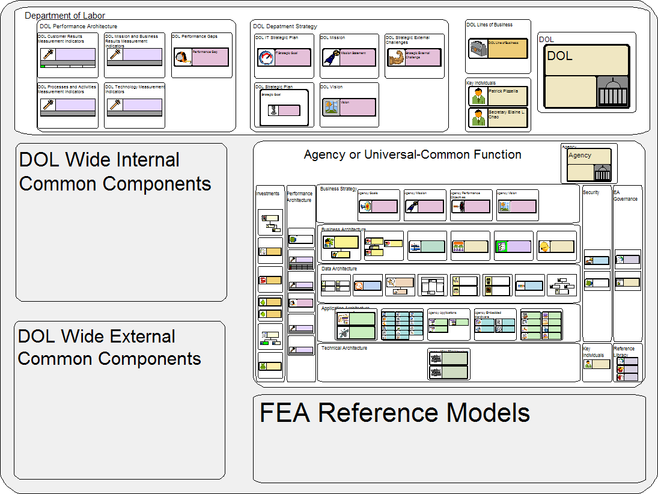

Table 1: DOL EA Framework Domains
Domain Name | Managing Body
Department of Labor | EAPO
DOL Wide Internal Common Components | EAPO
DOL Wide External Common Components | EAPO
FEA Reference Models | EAPO
Agency or Universal - Common Function | Agency
Business Strategy | Agency
Business Architecture | Agency
Application-Solution Architecture | Agency
Data Architecture | Agency
Performance Management | Agency
Technical Architecture | Agency
Investment Information | Agency
Security Architecture | Agency
EA Governance | Agency

Business Strategy
The Business Strategy Domain is used to describe the major factors that drive the Agency. This also applies to sub-Agencies and for Universal and Common Functions. The Agency Mission describes the major purpose or responsibility of the Agency. The Vision describes a forward looking, strategic description that is the result of strategic planning. The Agency Goals and Performance Objectives are used to describe the means by which the Agency plans to achieve the Mission and Vision.

Figure 1: Business Strategy Components
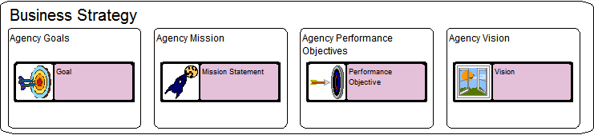

Figure 2: Business Strategy Sample
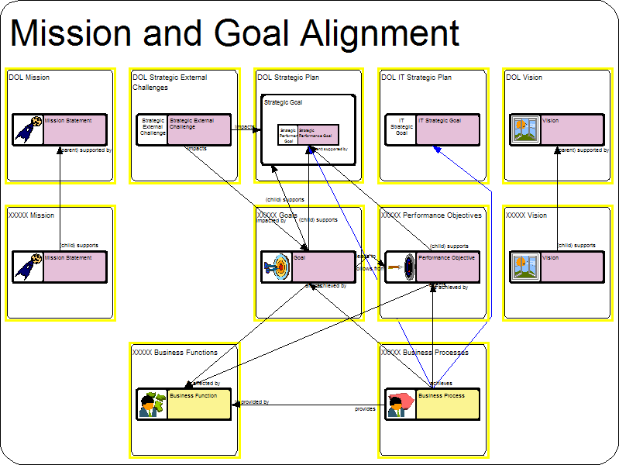

Performance Architecture
The Performance Management Domain defines the indicators that are used to measure Results, Outcomes, Outputs and Inputs to business operations. It is used to determine the effectiveness of business operations. It includes: Measurement Indicators, Measurement Points and Performance Gaps.

Figure 1: Performance Architecture Component
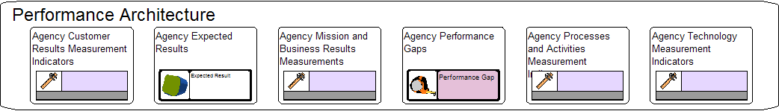

Figure 2: Performance Measurement Indicator Samples
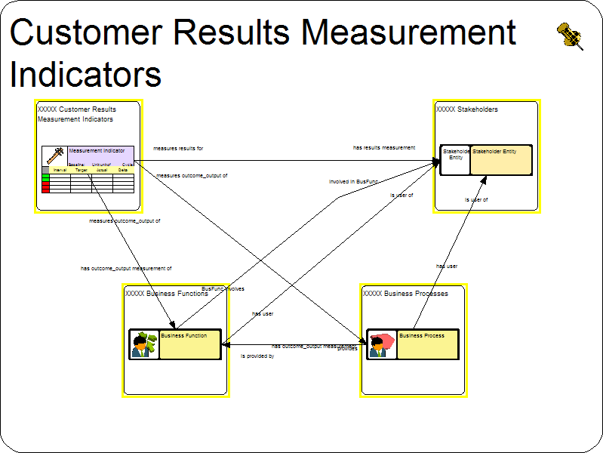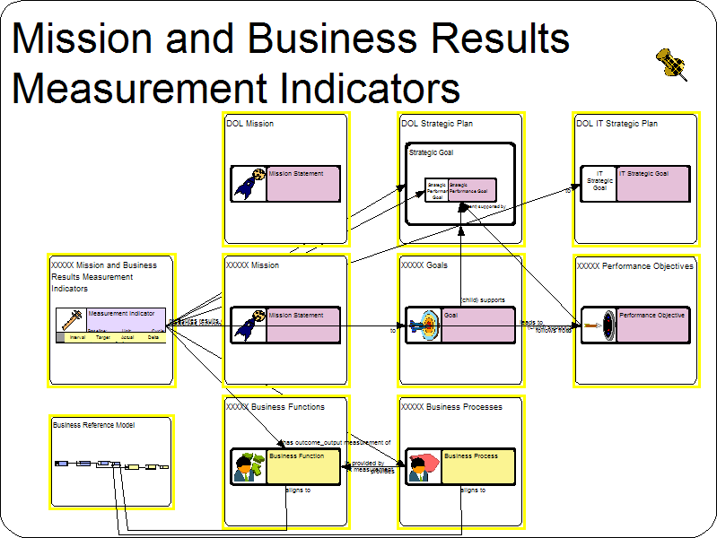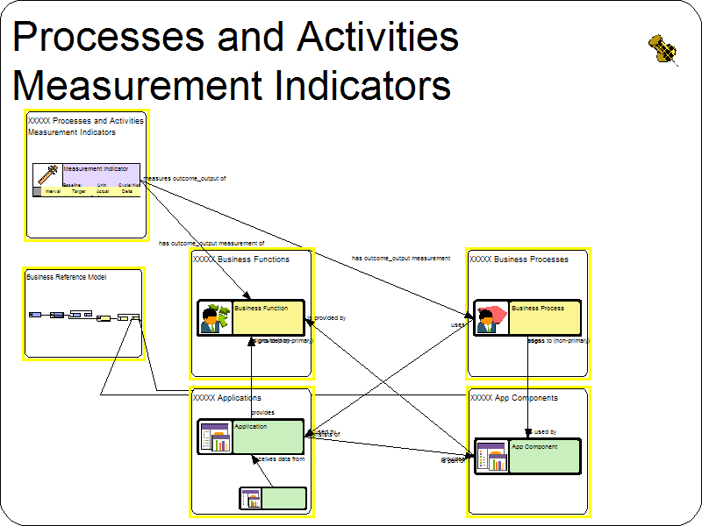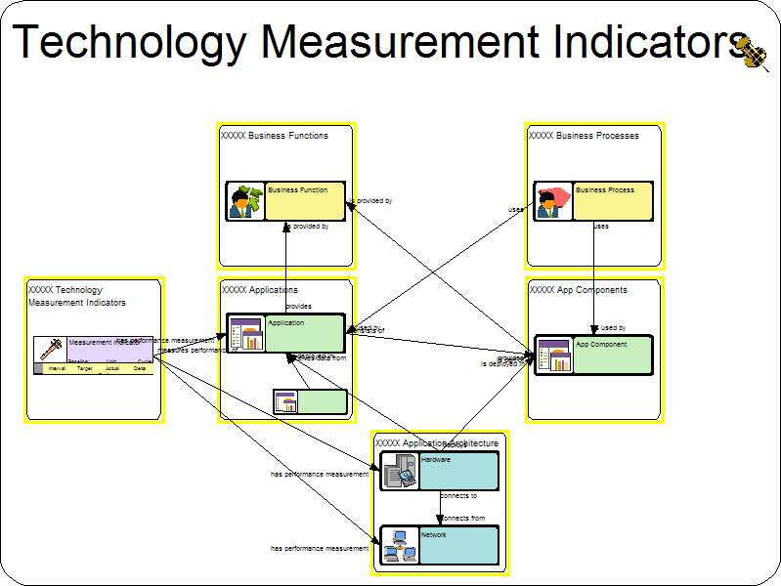

An agency’s strategic and performance planning process establishes specific mission and program objectives that the agency will implement to meet the needs of its citizen stakeholders and fulfill legislative, regulatory and executive mandates. Programs that support these objectives are required to articulate and measure their accomplishment of performance objectives. The agency’s EA, at the layer of the Federal Enterprise Architecture (FEA) Performance Reference Model (PRM), allows the linkage of IT investments back to this infrastructure of program performance at the agency level. As such, it is critical to the creation of a “line of sight” from IT investments back to the mission of the agency, and justification of resource expenditures. The strategic planning process establishes the relationships between specific programs that the agency will implement and the mission-based objectives those programs support. The PRM provides a common language by which the agency EA can connect IT investments to the agency’s ability to achieve agency and program performance objectives.
Thus, as is illustrated by the diagram below, the PRM is directly tied to your FEA Business Reference Model (BRM) mappings.

The numbers 1-4 above refer to codes from the Business Areas of the BRM.
- Services For Citizens
- Mode of Delivery
- Support Delivery of Services
- Management of Government Resources

These numbered circles show how your performance architecture is directly related to the BRM’s business areas. To make is easier for users to enter Performance data, DEAMS has provided four separate containers to input Measurement Indicators. The four containers correlate to the four Performance Measurement Areas defined by the PRM.

Additional information on the FEA PRM is located at:
http://www.whitehouse.gov/omb/egov/documents/OMB_EA_Assessment_Framework_2_FINAL.pdf

Investment Information
The Investment Information Domain is used to describe the Investments of the Agency and the activities and milestones to affect the goals of the investments. The Investment Domain includes: Business Cases, Project Alternatives, Alternatives, Programs, Projects, and Milestones. It also includes the Stakeholder Entities that benefit from the investments.

Figure 1: Investments Components
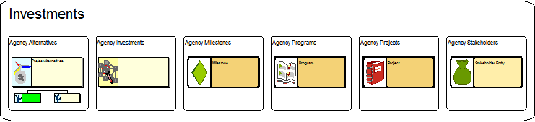

EA Governance
The EA Governance Domain describes the entire structure of an agency’s EA Governance Framework which typically includes EA Governance team members, policy, and processes. DEAMS is intended to capture high level descriptions around governance components. When developing an EA Governance Framework and governance processes, keep in mind all aspects of EA including business, technology, data, security, change management, maintenance, and oversight.

The image below illustrates the two primary objects used in DEAMS to develop an EA Governance Layer.

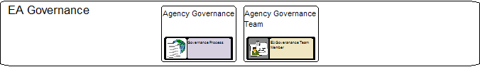

Business Architecture
The Business Architecture Domain is used to describe the business of the Agency. The Business Functions and Business Processes describe how the Agency performs its mission.
The Organization object is used to describe responsibilities. The Role object describes who performs the various business activities. The Facility object describes where the various business activities take place. The Re-Engineering Requirements describes changes to the business activities that are required to improve business operations.

Figure 1: Business Architecture Components
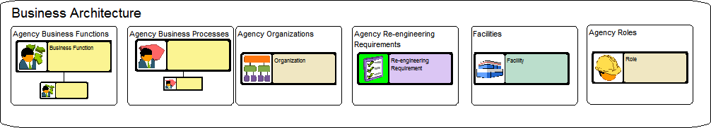

Figure 2: Business Architecture Samples
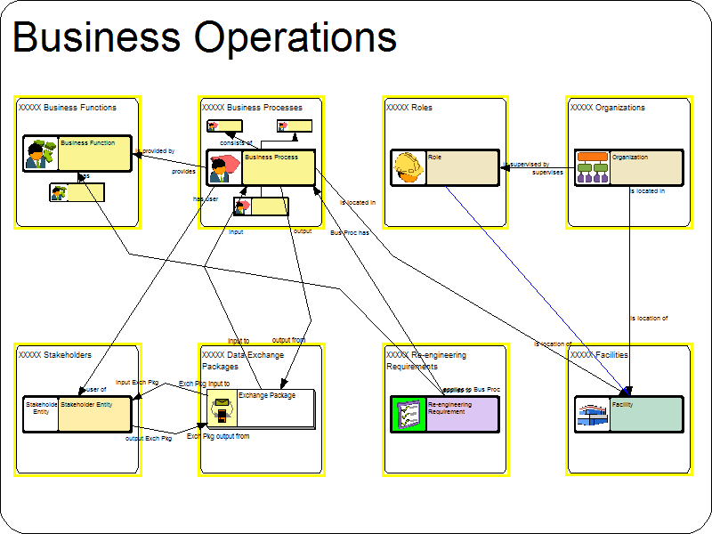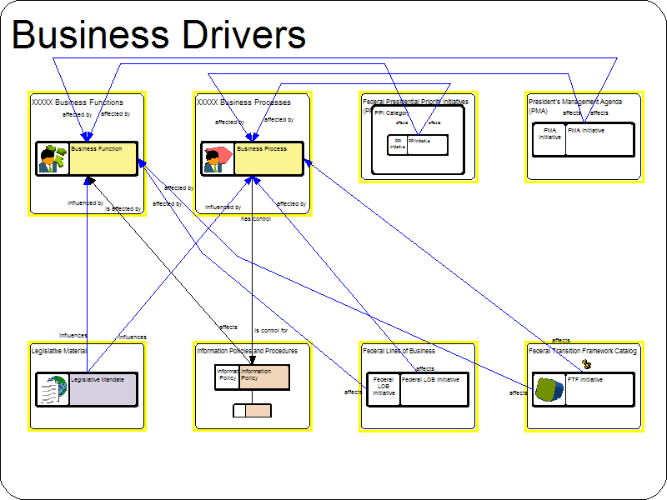

Application Architecture
The Application Architecture Domain is used to describe the systems that facilitate the business operations. The Application and App Component objects describe the software that provides the business functionality.

The domain also contains the types (hardware and software) to describe the solution architecture. These items break into five major categories: (1) Major Hardware, (2) Embedded Hardware, (3) Software Modules, (4) Networks, and (5) Network Devices. The Major Hardware category includes: Cabinets, Desktops, Laptops, Servers and Mainframes. The Embedded Hardware category includes: Backup Device, and Disk Array. The Software Module category includes: Application Servers, Database Servers, File Servers and Web Servers. The Network category includes: Networks and Storage Area Networks. The Network Devices category includes: Firewalls, Load balancers, Routers, Switches.

Figure 1: Application Architecture Components
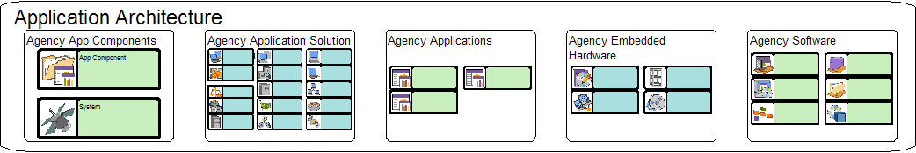

The objects described in this section comprise all available objects available and needed for documenting an Agency Application Solution Architecture. Slightly different from the other sections in this document, not all of these objects are required in order to comply with DOL requirements. However, in order to accurately represent your Agency’s application architecture it is required to include all objects that exist in the Agency Application Architecture. Below is a picture of what an Agency Application Architecture could look like.

Figure 2: Application Architecture Sample
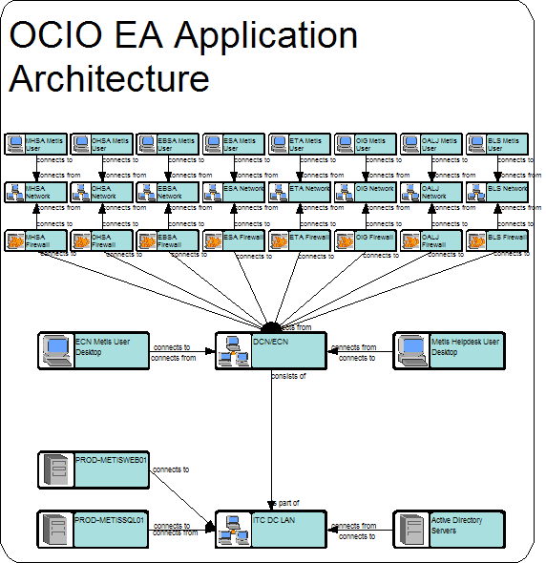

Technical Architecture
The Technical Architecture of an Agency is mainly described by the relationships between Technical Standards and IT Products that are used to build the Solution Architecture. The bulk of these types are described in the DOL Internal Common Domain.
The types that are specifically defined for the Technical Architecture are the Service Specification, SRM-TRM Mapping object types.

Figure 1: Technical Architecture Components
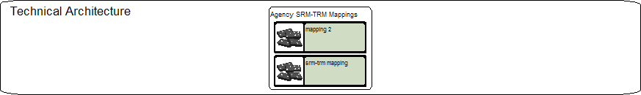

Figure 2: Technical Architecture Samples
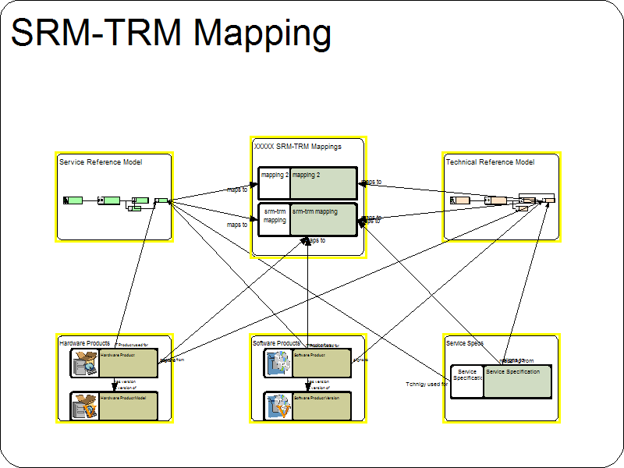

Data Architecture
The Data Architecture Domain is used to describe the information assets of the Agency. The Data Architecture Domain is driven by the definition contained in the FEA Data Reference Model (DRM). This information breaks down into three main areas: Data Context, Data Description, and Data Sharing. The Data Context identifies the context within which the Data Description and Data Sharing are defined. The Data Context includes: Taxonomies and Topics. The Data Description is the specification of the meaning and structure of the information. The Data Description includes: Data Schema, Data Entities, Data Relationships, Data Types, Documents, Digital Resources, Structured Data Resources, Semi-Structured Data Resources and Unstructured Data Resources. The Data Sharing defines the capabilities to access or exchange information. The Data Sharing includes: Data Assets, Query Points, Exchange Packages, and Payload Definitions. It also includes: Information Groups, Information Policies and Information Policy Rules.

Figure 1: Data Architecture Components
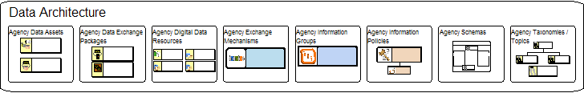

Figure 2: Data Architecture Summary


FY2007 Segment Investment
Segment Business Processes
Data Exchange Packages
…
…
Segment Business Functions
…
…
DOL Information Groupings
Segment Business Entities/Attributes and Relationships
DATA LAYER
Segment Data Assets
…
…
GENERIC DOL SEGMENT INVESTMENT – DATA LAYER

Data Exchange Mechanisms

Building the Agency EA
All of the architectural layers described in sections 2.3-2.10 come together to build the Agency EA. Figure 1 below shows a sample Agency EA with all of its architectural layers. The following sections provide users with the necessary guidance and requirements to build out the Agency EA one architectural layer at a time.

Figure 1: Sample Agency EA
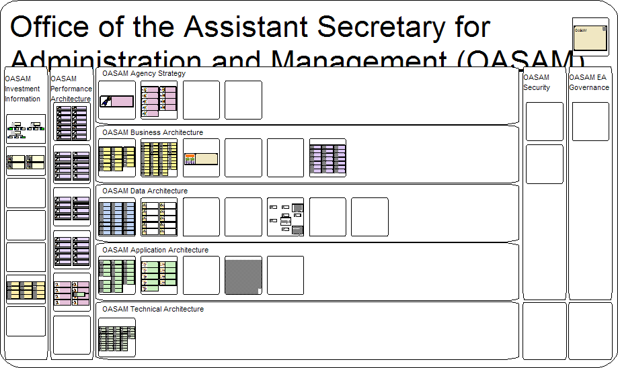

Building the Agency Business Strategy

Agency
Definition:
The Agency object is used to represent the DOL Agency in the Agency Enterprise Architecture. The Agency object is used as an anchor point in the EA used to identify all EA components owned, used, or supported by the agency.

Requirements:
A completed Agency object will contain the following information and linkages:
Table 2: Agency Object Requirements
Properties | Value
Name | Agency Acronym
Description | Full Agency Name
Comments | Additional information about the agency
Relationship Type | Relates to
*owns | * Any and all non-nested Agency/Universal/Common Function Objects need to be related to the Agency Object
sub agency of | Department / Agency / Universal / Common Function
has sub agency | Department / Agency / Universal / Common Function
aligns to | DOL Line of Business- See Appendix A
manages | Business Case
participates in | Business Case

* The Agency object must have a relationship to every object created within an Agency EA. See Appendix I for a full list of these relationships and object types.

Guidance:
When developing the Agency Mission Statement the following steps are to be followed:

Step 1:
Create a new or modify an existing Agency object in the Agency container.
Figure 1: Agency Statement Object
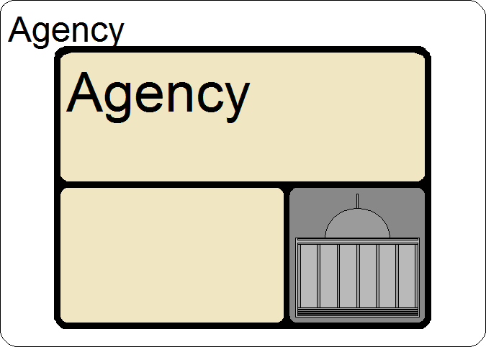
Step 2:
The name of this object should be the Agency Acronym (i.e. OASAM). In the Description field, enter the full name of the Agency (i.e. Office of the Assistant Secretary for Administration and Management).
Figure 2: Agency Statement Properties
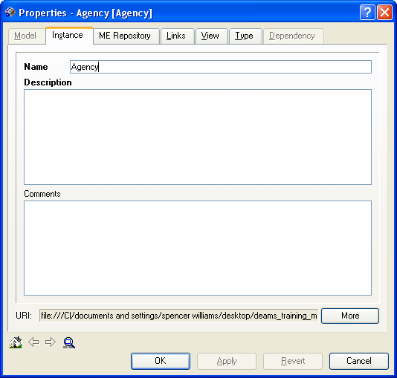
Name: The name of your agency within The Department of Labor (ie. Bureau of Labor Statistics (BLS)).

Description: Describe the roles and responsibilities of your Agency

Comments: Additional descriptive information that can be used to fully describe the Agency.

Step3
Ensure that all the required relationships indicated above have been established
Figure 3: Agency Relationships

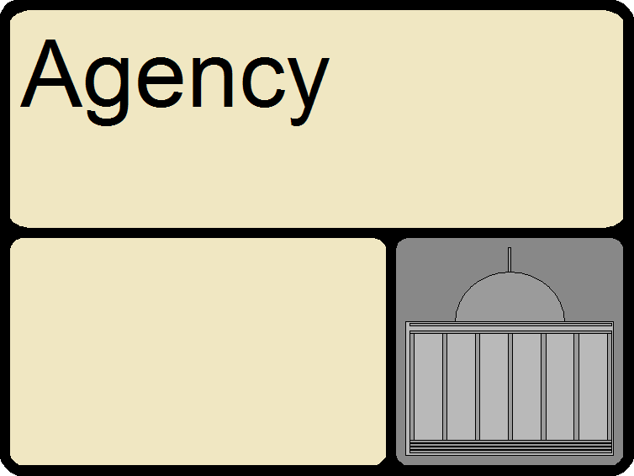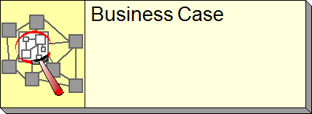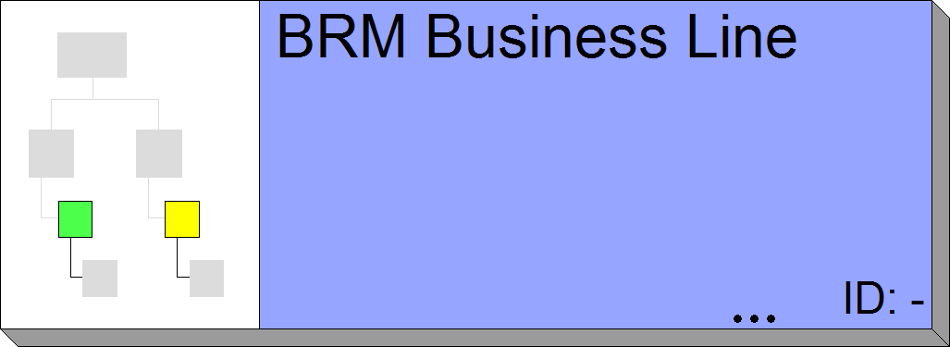

Agency Mission
Definition:
The Mission Statement is a statement of the purpose / responsibility for the Agency. The Agency Mission should provide clear line of sight throughout the Agency EA and to the DOL Strategy.

Requirements:
A completed Agency Mission Statement will contain the following information and linkages:
Table 3: Agency Mission Statement Requirements
Properties | Value
Name | Agency Abbreviation followed by "Mission Statement"
Description | text of Agency Mission Statement
Comments | Additional Text that further describes / reinforces the Mission Statement
Relationship Type | Relates to
supports | DOL Mission Statement
Relationship Properties: | Relationship Property Value:
Support Description: | Description of how Agency Mission support DOL Mission
supports (parent) | Mission Statement
Relationship Properties: | Relationship Property Value:
Support Description: | Description of how Agency Mission support DOL Mission
supported by (child) | Mission Statement
Relationship Properties: | Relationship Property Value:
Support Description: | Description of how Agency Mission support DOL Mission
Leads to | Goal
*affected by | Federal LOB Initiative- See Appendix A
*affected by | PPI Initiative- See Appendix B
affected by | Legislative Mandate
*affected by | PMA Initiative- See Appendix C
*affected by | FTF Initiative- See Appendix D
*affects | Information Policy
identifies | Performance Gap
results measured by | Performance Indicator

* Depending on the Agency, items identified above with an asterisk (*) may or may not apply to this object. It is required to create the appropriate relationship for all that apply. For some objects more detailed descriptions have been supplied in the identified appendices.

Guidance:
When developing the Agency Mission Statement the following steps are to be followed:

Step 1:
Create a new or modify an existing Mission Statement object in the Agency Mission Container.
Figure 1: Agency Mission Statement Object
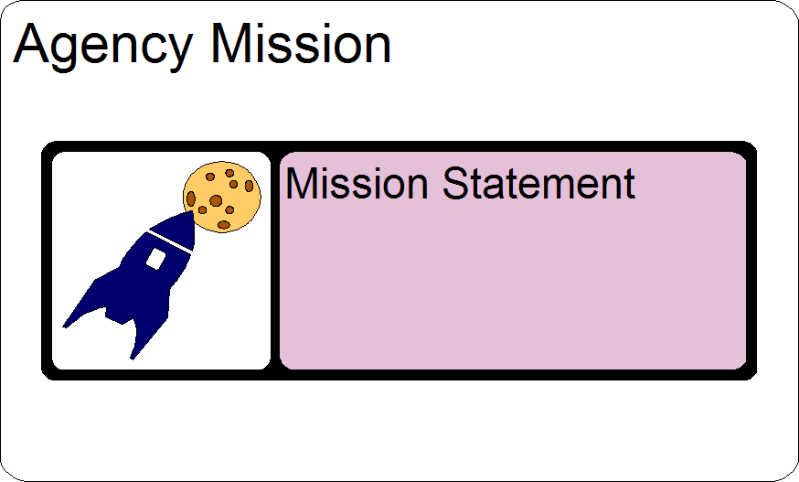

Step 2:
The name of this object should always be Mission Statement. In the Description field, enter your Agency Mission Statement.
Figure 2: Agency Mission Statement Properties

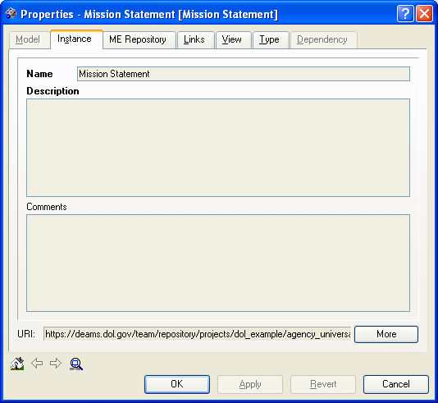
Name: This is the label property of the Mission Statement. Should include Agency or Functional acronym (ex: SHIMS Mission Statement).
Description: Describe the properties of this Mission Statement
Comments: Additional descriptive information that can be used to fully describe the instance.

Step 3:
Ensure that all the required relationships indicated above have been established.
Figure 3: Agency Mission Relationships
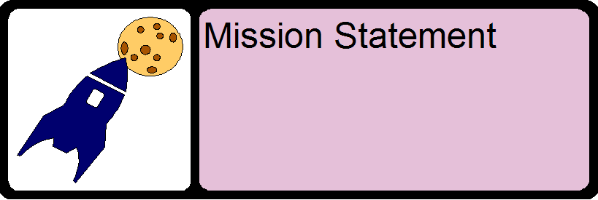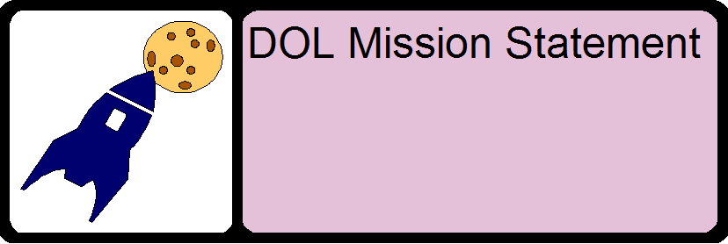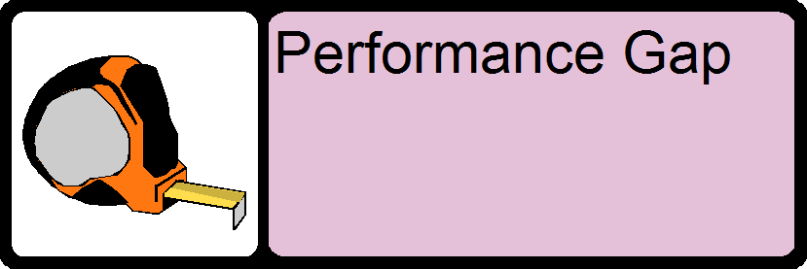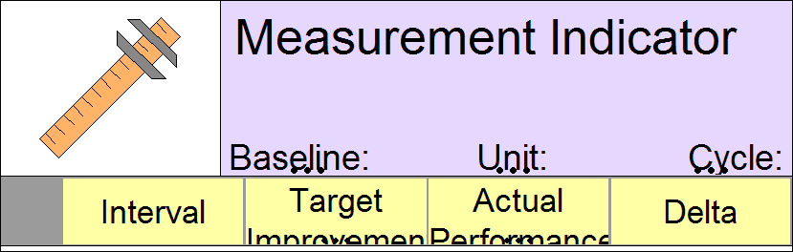

Agency Vision
Description:
A Vision of a business determines the long-range idea the business has about where it wants to be in 5-6 years (or whatever the planning horizon is).
The vision sets out the path for the strategic planning. The vision must be anchored at a very high level in the business organization.

Requirements:
A completed Agency Vision will contain the following information and relationships:
Table 4: Agency Vision Requirements
Properties | Value
Name | Agency Abbreviation followed by "Vision"
Description | Vision Description
Comments | Additional Text that further describes / reinforces the Vision Statement
Relationship Type | Relates to
supports | Agency
supports | DOL Vision
Relationship Properties: | Relationship Property Value:
Support Description: | Description of how Agency Mission support DOL Mission
*supports | Vision
Relationship Properties: | Relationship Property Value:
Support Description: | Description of how Agency Mission support DOL Mission
*supported by | Vision
Relationship Properties: | Relationship Property Value:
Support Description: | Description of how Agency Mission support DOL Mission

* Depending on the Agency, items identified above with an asterisk (*) may or may not apply to this object. If this Agency has sub-agencies also having vision statements then this will apply.

Guidance:
When developing the Agency Vision the following steps are to be followed:

Step 1:
Create a new or modify an existing Vision object in Agency Vision container
Figure 1: Agency Vision Object
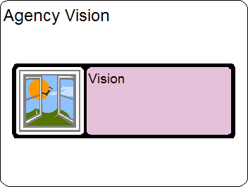

Step 2:
The name of this object should always be Vision. In the Description field, enter the Agency Vision Description. Ensure that all the required Properties indicated above have been defined.
Figure 2: Agency Vision Properties
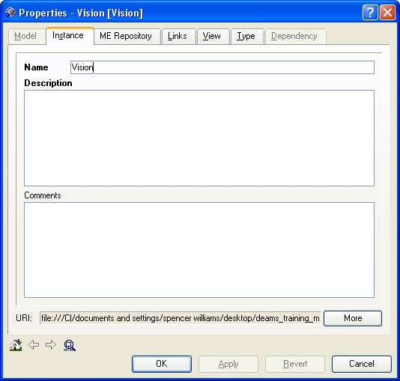
Name: This property will always be labeled “[Agency or Functional Acronym] Vision” (ex: “OASAM Vision”).

Description: Describe the properties of the Agency vision

Comments: Additional descriptive information that can be used to fully describe the instance.

Step 3:
Ensure that all the required relationships indicated above have been established.
Figure 3: Agency Vision Relationships


Agency Goals
Description:
A Goal is an aim towards which an endeavor is directed. This type is also used for Objectives. An Objective is a high level planning item that sets an aim for the business to attain its Goals. Most organizations define Goals and Objectives together. A Goal and Objective can lead to another Goal and Objective.

Requirements:
A completed Agency Goal will contain the following information and relationships:
Table 5: Agency Goal Requirements
Properties | Value
Name | Short Goal Statement
Description | Goal Description
Comments | Additional Text that further describes / reinforces the Vision Statement
Weight | 1-7 value showing the importance of the goal; 7 being high and 1 being low
Target Completion Date | Date goal is expected to be achieve upon
Relationship Type | Relates to
supports | “DOL” Strategic Goal
Relationship Properties: | Relationship Property Value:
Support Description: | Description of how Agency Goal support DOL Strategic Goal
supports | DOL Strategic Performance Goal
Relationship Properties: | Relationship Property Value:
Support Description: | Description of how Agency Goal support DOL Strategic Performance Goal
*supports (parent) | “Agency” Goal
Relationship Properties: | Relationship Property Value:
Support Description: | Description of how Agency Mission support another Mission
*supported by (child) | Goal
Relationship Properties: | Relationship Property Value:
Support Description: | Description of how Agency Mission supported by another Mission
has results measurement | PRM Measurement Indicator
*impacted by | DOL Strategic External Challenges
affects | Business Function
is achieved by | Business Process
identifies | performance gap
*affects | Information Policy
leads to | Performance Objective
is affected by | Legislative Mandate
*is affected by | PPI Initiative- See Appendix B
*is affected by | FTF Initiative- See Appendix D
*is affected by | PMA Initiative- See Appendix C
*is affected by | Federal LOB Initiative- See Appendix A
supported by | Business Case
Relationship Properties: | Relationship Property Value:
Support Description: | Description of how investment supports Goal
Expected Results: | Description of the results that are expected from the investment with respect to the Goal
follows from | Mission Statement

* Depending on the Agency, items identified above with an asterisk (*) may or may not apply to this object. It is required to create the appropriate relationship for all that apply. For some objects more detailed descriptions have been supplied in the identified appendices.

Guidance:
When developing the Agency Goals the following steps are to be followed:

Step 1:
Create a new or modify an existing Goal object in the Agency Goals container.
Figure 1: Agency Goals Object
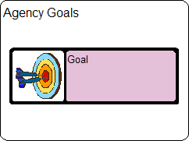

Step 2:
Ensure that all the required Properties indicated above have been defined.
Figure 2: Agency Goals Properties
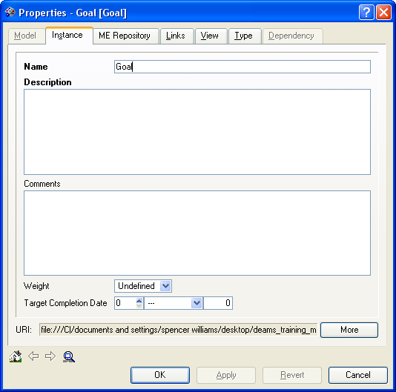
Name: This property is a name of a Goal in the Agency (Ex: Equal Opportunity Employment).

Description: Describe the properties of each Agency Goal

Comments: Additional descriptive information that can be used to fully describe the instance.

Weight: Relative weight of the goal.

Target Completion Date: The date this goal is expected to be achieved.

Step 3:
Ensure that all the required relationships indicated above have been established.
Figure 3: Agency Goals Relationships
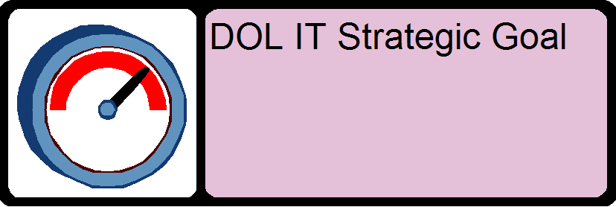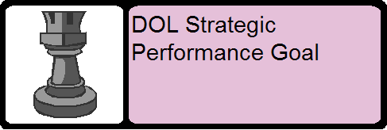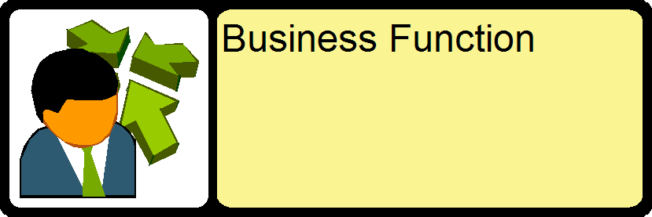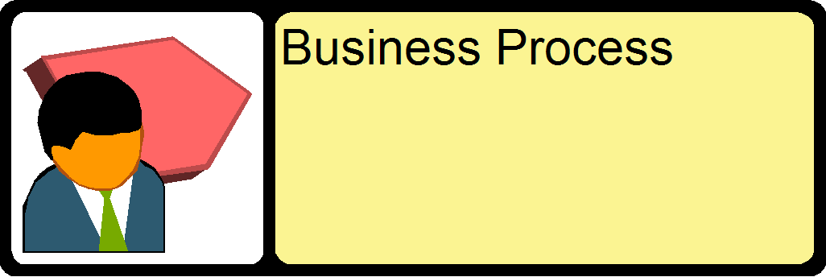

Agency Performance Objectives
Description:
A Performance Objective is a specific action, outcome or result to be achieved that makes an identifiable contribution to the achievement of an Agency Goal.

Requirements:
A completed Agency Performance Objective will contain the following information and relationships:
Table 6: Agency Performance Objective Requirements
Properties | Value
Name | Short name of the performance objective
Description | Performance Objective Description
Comments | Additional Text that further describes / reinforces the performance objective
Weight | 1-7 value showing the importance of the performance objective; 7 being high and 1 being low
Target Completion Date | Date performance objective is expected to be achieve upon
Relationship Type | Relates to
follows from | Goal
Is affected by | Legislative Mandate
*is affected by | PPI Initiative- See Appendix B
*is affected by | FTF Initiative- See Appendix D
*is affected by | PMA Initiative- See Appendix C
*is affected by | Federal LOB Initiative- See Appendix A
*affects | Information Policy
identifies | performance gap
supports | DOL Strategic Goal
Relationship Properties: | Relationship Property Value:
Support Description: | Description of how performance objective supports DOL Strategic Goal
supports | DOL Strategic Performance Goal
Relationship Properties: | Relationship Property Value:
Support Description: | Description of how Performance Objective supports DOL Strategic Performance Goal
has results measurement | PRM Measurement Indicator
affects | Business Function
is achieved by | Business Process
supported by | Business Case
Relationship Properties: | Relationship Property Value:
Support Description: | Description of how investment supports Goal
Expected Results: | Description of the results that are expected from the investment with respect to the Goal
*supports (parent) | Performance Objective
Relationship Properties: | Relationship Property Value:
Support Description: | Description of how performance objective supports a (parent) Performance Objective
*is supported by (child) | Performance Objective
Relationship Properties: | Relationship Property Value:
Support Description: | Description of how performance objective is supported by a (child) Performance Objective
impacted by | DOL Strategic External Challenge
Relationship Properties: | Relationship Property Value:
Impact Description: | Description of how External Challenge impacts the Performance Objective

* Depending on the Agency, items identified above with an asterisk (*) may or may not apply to this object. It is required to create the appropriate relationship for all that apply. For some objects more detailed descriptions have been supplied in the identified appendices.

Guidance:
When developing the Agency Performance Objectives the following steps are to be followed:

Step 1:
Create a new or modify an existing Performance Objective in the Agency Performance Objectives container
Figure 1: Agency Performance Objectives Object
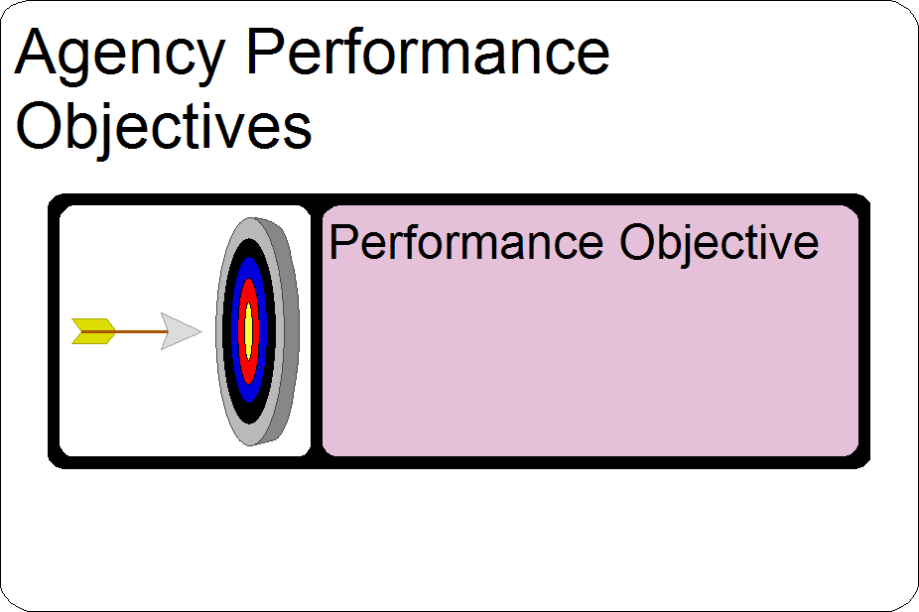

Step 2:
Ensure that all the required Properties indicated above have been defined.

Figure 2: Agency Performance Objectives Properties
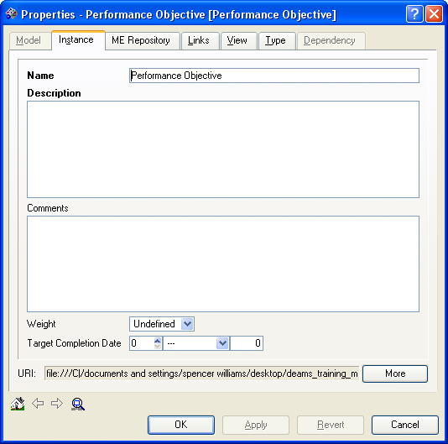
Name: This property is a name of a Performance Objective in the Agency (Ex: 508 Compliant Access to all Job Listings).

Description: Describe the properties of Agency Objectives

Comments: Additional descriptive information that can be used to fully describe the Performance Objectives.

Weight: Relative weight of the objective.

Target Completion Date: The date this objective is expected to be achieved.

Step 3:
Ensure that all the required relationships indicated above have been established.
Figure 3: Agency Performance Objectives Relationships
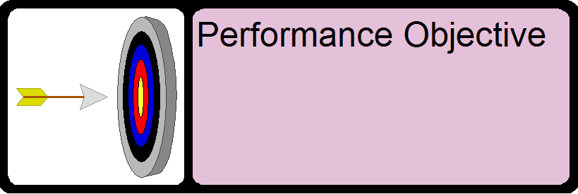

Building the Agency Enterprise Architecture by Investment
This section provides the requirements and guidance for completing all the Architectural Layers of the Agency EA from the IT Investment or Initiative perspective. This guidance walks users through all EA requirements needed for a single Investment; however requirements should be applied to every IT Investment or Initiative within the Agency. The objective of this section is to provide a complete understanding of the Agency’s IT Investments or Initiatives and provide clear line of site across all architectural layers.

Note: As stated in Section 2.1, All Agency EA objects are required to have a relationship to the Agency object.

Investment Information

Agency IT Investment
Definition:
The Agency IT Investment object is an anchor point used to identify the Agency IT Investment and all of the EA Components associated with that Investment. The Agency Investment should provide clear line of sight throughout the Agency EA and the DOL Strategy.

Requirements:
A completed Agency Investment will contain the following information and linkages:
Table 7: Agency Investment Requirements
Properties | Value
Investment Name | Name of Investment (Ensure that the investment name is the same as the investment name used in the E-53 and/or E-300)
Investment Description | Description of Investment ((Ensure that the investment description is the same as the investment description used in the E53 and/or E300)
Investment Comments | Include Name and Contact Information for the Primary Point of Contact for this Investment
UPI Code | Enter the UPI Code for this investment. This should coordinate with the UPI Code found in the E-53
PART Review | Indicate if this investment is involved in the PART Review Process
Relationship Type | Relates to
has participant | Agency
Directed by | Program
managed by | Agency
**aligns to FEA Business Line | BRM Business Line
supports | DOL Strategic Goal
supports | DOL IT Strategic Goal
*IT Investment supports | Federal LOB Initiative- See Appendix A
*IT Investment supports | PPI Category
*IT Investment supports | PMA Initiative- See Appendix C
IT Investment Involves | Business Function
IT Investment Involves | Stakeholder Entity
IT Investment aligns to | DOL LOB
IT Investment addresses | Agency Performance Gap
Uses | Project Alternatives
supports | Agency Goals
Applies | Alternative
Applies | Alternative (Chosen)
aligns to | BRM Sub function
Affects | Application
aligns to | BRM Delivery Model Sub Function

* Depending on the Agency, items identified above with an asterisk (*) may or may not apply to this object. It is required to create the appropriate relationship for all that apply. For some objects more detailed descriptions have been supplied in the identified appendices.

**Collected in last years EA template. Not needed in future updates; however this may help Agencies in identifying BRM Sub-Function and Delivery Mode alignment.

Guidance:
When developing an Agency Investment the following steps are to be followed:

Step 1:
Create a new or modify an existing Investment object in the Agency Investments container.
Figure 1: Agency Investment Object
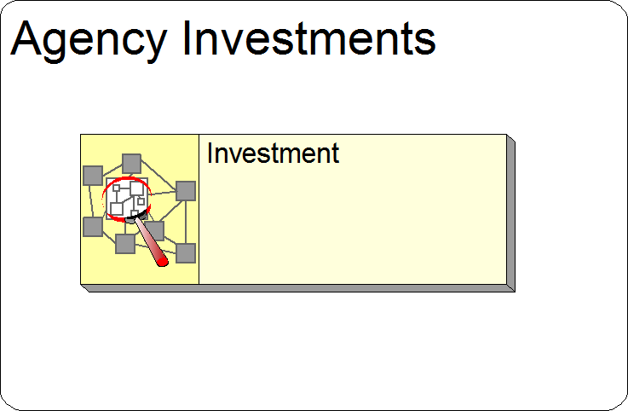

Step 2:
Ensure that all the required Properties indicated above have been defined.

Figure 2: Agency Investment Properties

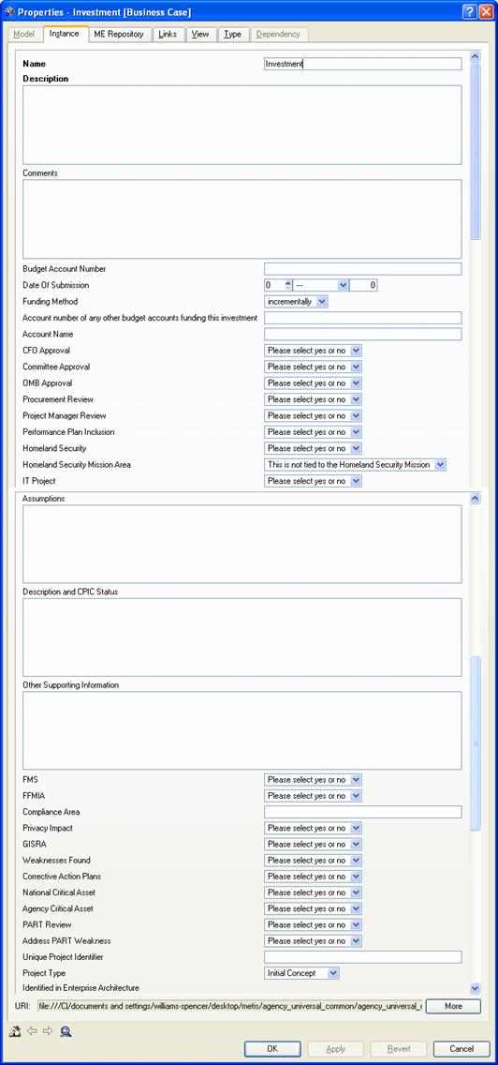
Name: Name of Investment (Ensure that the investment name is the same as the investment name used in the E-53 and/or E-300)

Description: Description of Investment (Ensure that the investment description is the same as the investment description used in the E53 and/or E300)

Investment Comments: Include Name and Contact Information for the Primary Point of Contact for this Investment

PART Review: Indicate if this investment is involved in the PART Review Process

UPI Code: Enter the UPI Code for this investment. This should coordinate with the UPI Code found in the E-53.

Step 3:
Ensure that all the required relationships indicated above have been established.
Figure 3: Agency Investment Relationships
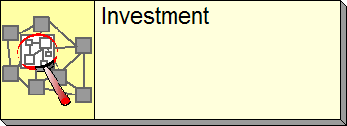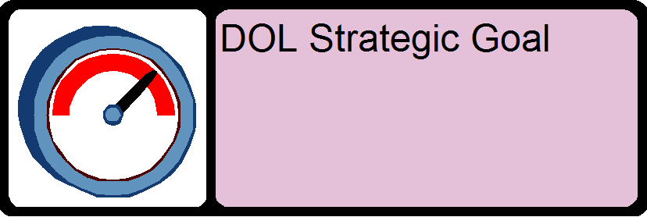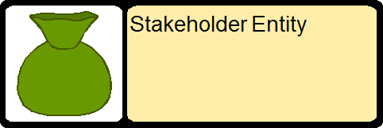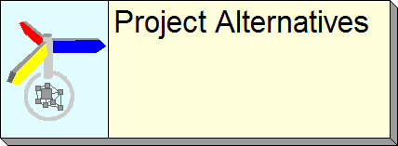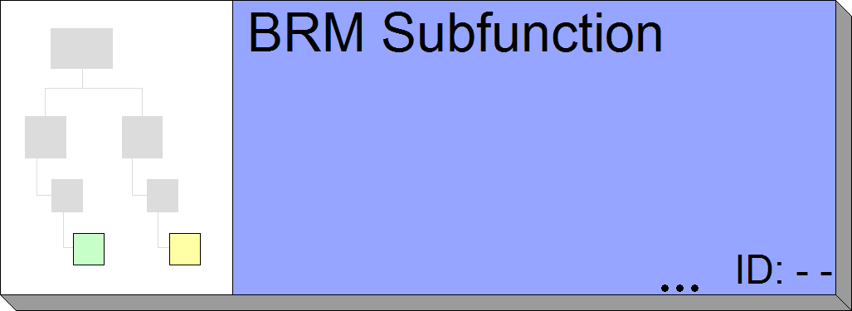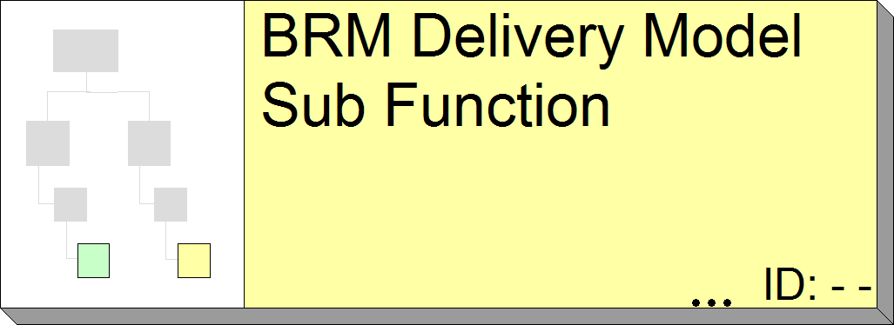

Note: Business Reference Model Mapping- Limit mappings to the Lines of Business, Sub-Functions, and Modes of Delivery described in the BRM. More information on the Consolidated Reference Models may be found at
http://www.whitehouse.gov/omb/egov/documents/FEA_CRM_v20_Final_June_2006.pdf

Investment Budget Information
Every Investment is required to maintain the data contained in the eCPIC tool. Future releases of DEAMS will provide users with the ability to directly import and share data with eCPIC, however at this point that capability does not exist. Therefore, the EAPO will assess the budget aspects of an Agency’s EA using the budget information contained in eCPIC. Agencies are required maintain the following values in eCPIC:

PY: Prior Year
CY: Current Year
BY: Budget Year

Agency Program
Definition:
An Agency Program is a temporary organization or structure set up to drive and coordinate changes (such as Initiatives, Projects) in a business.

Requirements:
A completed Agency Program will contain the following information and linkages:
Table 8: Agency Program Requirements
Properties | Value
Name | Name of Program
Description | Description of Program
Relationship Type | Relates to
governs | Project
Directs | Business Case

Guidance:
When developing an Agency Program the following steps are to be followed:

Step 1:
Create a new or modify an existing Program object in the Agency Programs container.
Figure 1: Agency Program Object
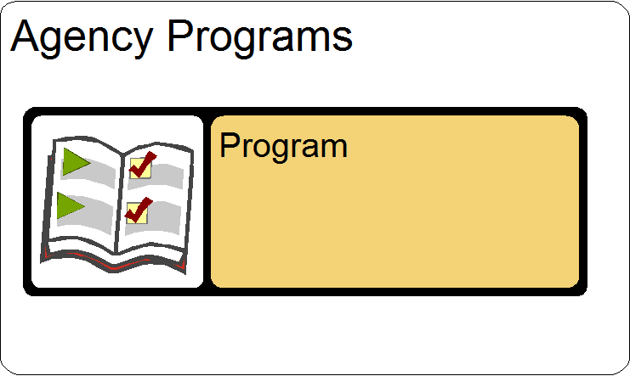

Step 2:
Ensure that all the required Properties indicated above have been defined.
Figure 2: Agency Program Properties
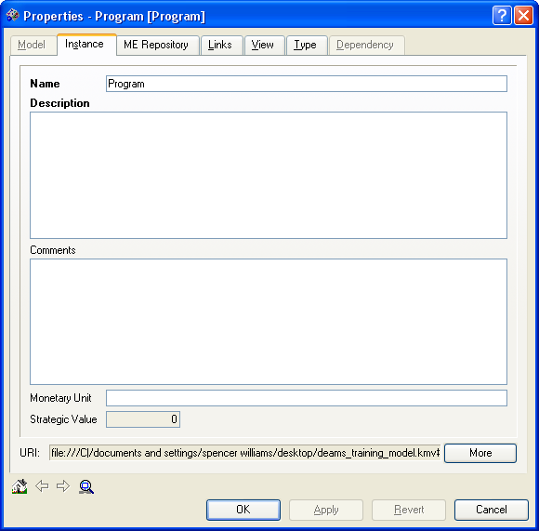
Name: This property is the name of a Program within the Agency (Ex: Small School Job Fair Program).

Description: Describe in detail the structure that drives and coordinates the Agency Program (Ex: Provides additional funds for job fairs at schools with large minority or disabled populations).

Step 3:
Ensure that all the required relationships indicated above have been established.
Figure 3: Agency Program Relationships



Agency Project
Definition:
An Agency Project is a time-delimited set of coordinated and planned activities or tasks that are performed to achieve a set of specific goals and objectives.

Requirements:
A completed Agency Project will contain the following information and linkages:
Table 9: Agency Project Requirements
Properties | Value
Name | Name of Project
Description | Description of Project
SDLC Phase | Indicate the SDLC Phase
Relationship Type | Relates to
governed by | Program
has | milestones

Guidance:
When developing an Agency Project the following steps are to be followed:

Step 1:
Create a new or modify an existing Project object in the Agency Projects container.
Figure 1: Agency Project Object
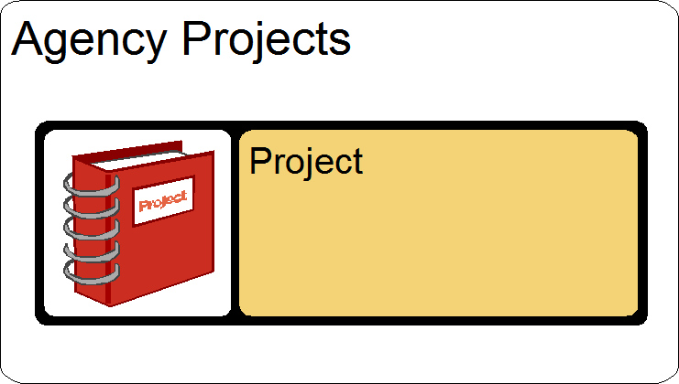

Step 2:
Ensure that all the required Properties indicated above have been defined.
Figure 2: Project Properties
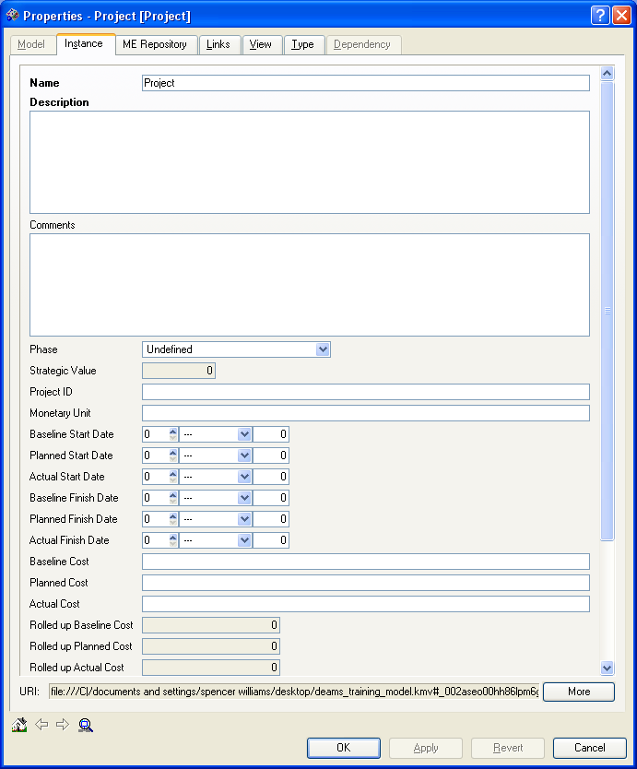
Name: This property will be the name of an Agency Project (Ex: Develop Job Fair brochures).

Description: Describe the planned activities or tasks to achieve the Agency Project.

SDLC Phase: The current status of this project ranging from -1 to 4.

Step 3:
Ensure that all the required relationships indicated above have been established.
Figure 3: Project Relationships


Project Alternatives
Definition:
The Project Alternatives object is the anchor point for all of the Alternatives analysis performed for a given Investment. Each of the alternatives for the investment will be children objects of this Project Alternatives object.

The Alternative object is used to represent each of the alternatives considered during the alternatives analysis for this project. Each Alternative object is a child of the Project Alternatives object described above. The Alternative object provides information for each of the considered alternatives and indicates which alternative was eventually selected.
Figure 1: Agency Alternatives & Selected Alternative

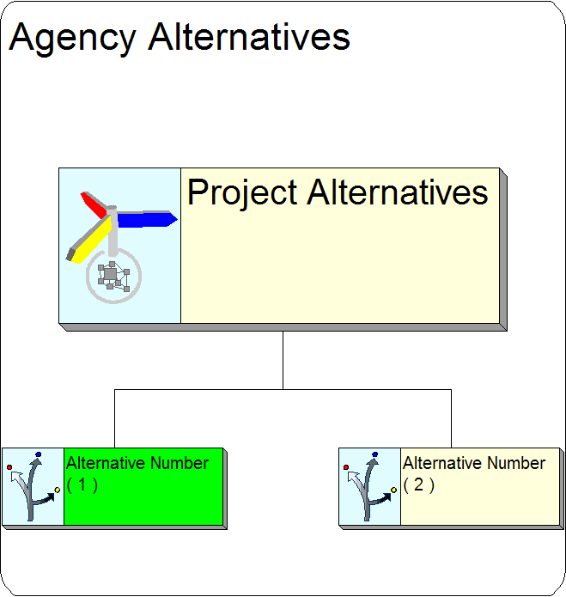

Requirements:
A completed Project Alternatives object will contain the following information and linkages:
Table 10: Project Alternatives Requirements
Properties | Value
Chosen Alternative | The number of the selected alternative
Relationship Type | Relates to
used for | Business Case
Parent of | alternative

Table 11: Individual Alternative Requirements
Properties | Value
Name | Name of alternative
Description | Description of Alternative
Alternative Number | Indicate a number for the alternative
Program Name | Indicate the program name
Relationship Type | Relates to
Child | Project Alternative
applies to | Business Case

Guidance:
When developing the Project Alternatives the following steps are to be followed:

Step 1:
Create a new or modify an existing Project Alternatives object in the Agency Alternatives container.
Figure 1: Project Alternatives Object
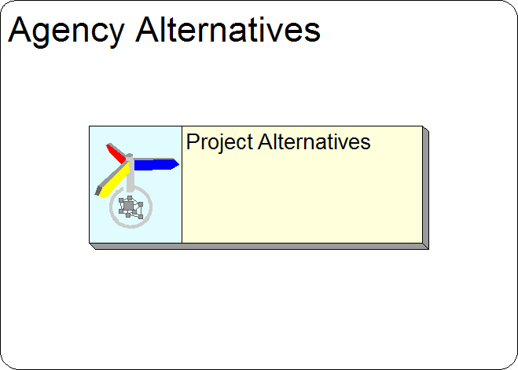

Step 2:
Ensure that all the required Properties indicated above have been defined.
Figure 2: Project Alternatives Properties
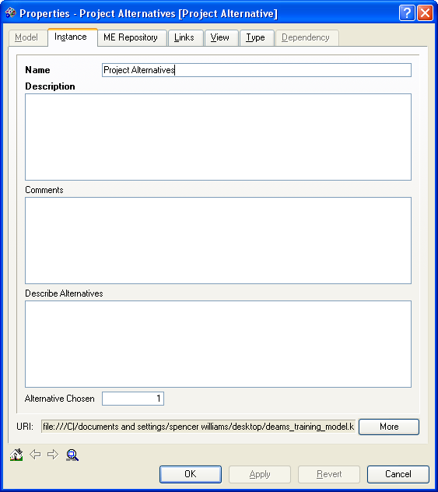
Name: This property is the name of an Agency Project Alternative.

Description: A description (high-level) of the various Alternatives being considered.

Chosen Alternative: Select an Alternative by entering its number. Only one Alternative can be chosen. The selected Alternative's symbol will change color in response.

Step 3:
Create a new or modify an existing Child Alternative object for the Project Alternatives object created in Step 1.

Step 4:
Ensure that all the required Properties indicated above have been defined.
Figure 2: Alternative Properties
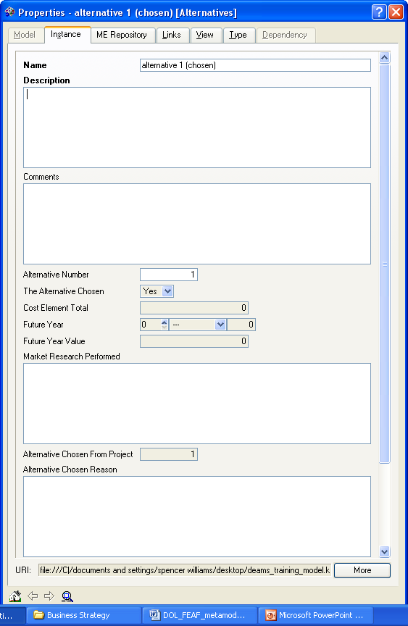
Name: This property is the name of an Agency Project Alternative.

Description: Describe the properties of the Agency Project Alternative.

Chosen Alternative: Select an Alternative by entering its number. Only one Alternative can be chosen. The selected Alternative's symbol will change color in response.

Step 5:
Ensure that all the required relationships indicated above have been established for both the Project Alternative Object and the Individual Alternative Object.
Figure 3: Project Alternatives Relationships

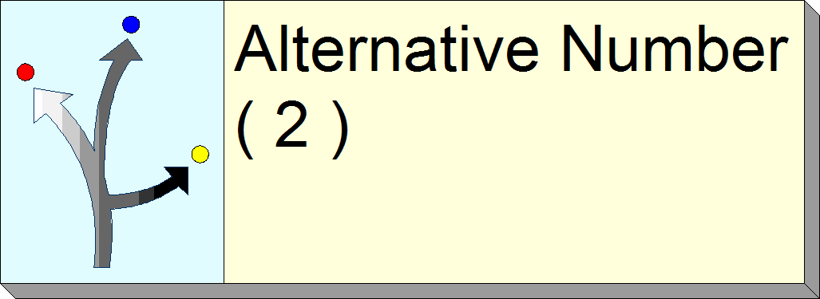

Stakeholders
An integral part of any investment is the definition of stakeholders, since it is important to define who or what your investment is supporting, partnering with, or affecting. The three objectives of the Stakeholders section are:
- Define Stakeholder Entities
- Define Stakeholder Class’s
- Describe how Stakeholder Entities and Class’s map throughout the entire EA

Stakeholder Entity
Definition:
A Stakeholder Entity is an organizational element that has a vested interest.

Requirements:
A completed Stakeholder Entity will contain the following information and linkages:
Table 12: Stakeholder Entity Requirements
Properties | Value
Stakeholder Entity Name | Entity Name
Stakeholder Description | Description of Entity
Internal/External | Internal or External to DOL
Stakeholder Involvement | Involvement Description
*Relationship Type | Relates to
classified by | Stakeholder Class
is user of | Business Process
is user of | Business Function
has results measurement | PRM Measurement Indicator
involved in IT Investment | Business Case
consumes | Exchange Package
produces | Exchange Package
involved in | Business Function
Stakeholder Entity exchanges | Entity

*Stakeholders can fill many different roles depending on their involvement. From the list above create all relationships that apply to the stakeholder entity.

Guidance:
When developing a Stakeholder Entity the following steps are to be followed:

Step 1:
Create a new or modify an existing Stakeholder Entity object in the Agency Stakeholders container.
Figure 1: Stakeholder Entity Object
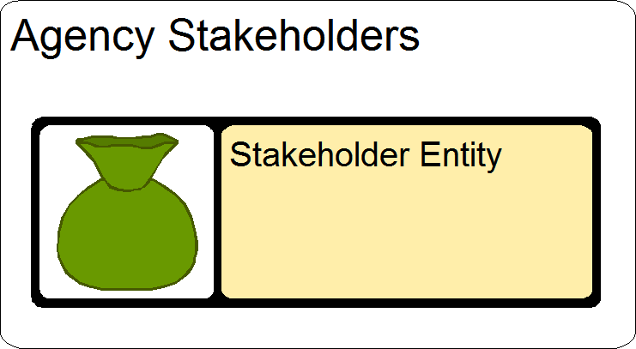

Step 2:
Ensure that all the required Properties indicated above have been defined.
Figure 2: Stakeholder Entity Properties
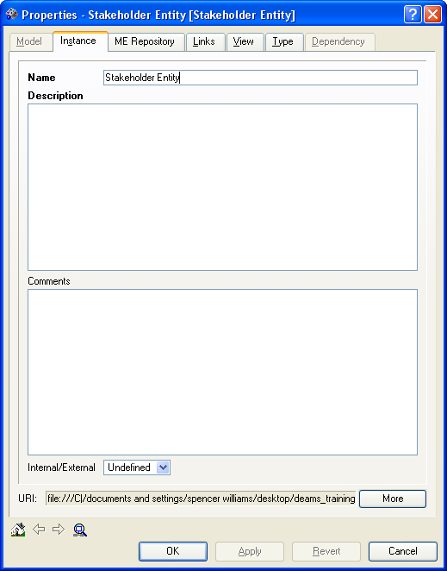
Name: This property is the name of an Agency Stakeholder Entity (Ex: Small Business Administration).

Description: Describe the organizational elements of the Agency Stakeholder.

Comments: Additional descriptive information that can be used to fully describe the Entity.

Internal / External: An indication, if needed, of whether this organization element is part of the enterprise, or belongs to another, external enterprise.

Step 3:
Ensure that all the required relationships indicated above have been established.
Figure 3: Stakeholder Entity Relationships
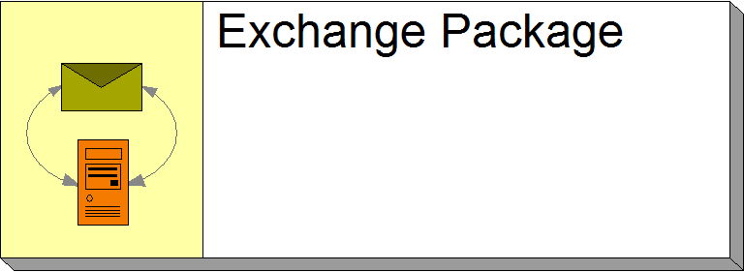

Stakeholder Class
Definition:
Stakeholders are classified by Stakeholder Class. The stakeholder class first identifies if the stakeholder is a Government Organization, Citizen, or Business. The stakeholder class then identifies the type of Government, Citizen, or Business (i.e. Federal, Foreign, Media, Other).

Note: The Stakeholder Class objects are predefined in the “DOL Wide Internal Common Components” container within DEAMS. Agencies are required to map to the appropriate predefined Stakeholder Class. If the desired Stakeholder Class does not currently exist, Agencies can request the EAPO add a new Stakeholder Class to DEAMS.

Requirements:
A completed Stakeholder Class will contain the following information and linkages:
Table 13: Stakeholder Class Requirements
Properties | Value
Name | Name of Stakeholder Class
Description | Description of Stakeholder class
Relationship Type | Relates to
classifies/classified by | Stakeholder Entity

Guidance:
When developing the Stakeholder Class the following steps are to be followed:

Step 1:
Locate the appropriate Stakeholder Class object in the Stakeholder Classes Container. This container exists in the “DOL Wide Internal Common Components” container within DEAMS.
Figure 1: Stakeholder Class Object
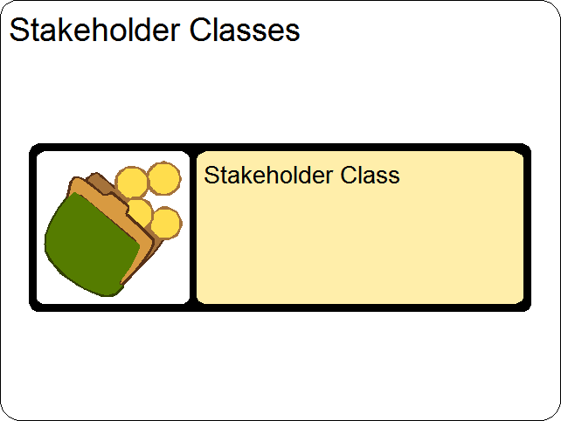

Step 2:
Ensure that all the required relationships indicated above have been established.
Figure 2: Stakeholder Class Relationships

Milestones
Definition:
A Milestone is an identified point in time for coordination and evaluation of change actions.

In this section, please identify specific and outcome-based milestones that demonstrate what progress/path your IT investment will take to achieve full maturity. These milestones should provide a clear plan of action that will be taken to achieve your target vision. Milestones should also align directly to the Performance Metrics listed in your Target Enterprise Architectures for each IT investment.
Milestones will be categorized as follows:
- Significant: Significant milestones are those that result in a clear performance improvement or introduction of new functionality that is critical and integral to achieving your target vision (like the completion of a specific module, the start of a pilot, or receiving an Authority To Operate). These milestones should be derived from your Project Plan or Work Breakdown Structure.
- Progress: Progress milestones are those that can be measured quarterly and will lead to the achievement of a significant milestone. These are key or significant events in the project, usually completion of a major deliverable.

IMPORTANT NOTES:
- If your IT investment is composed of a series of projects that will iteratively result in your target end-state, please provide significant and progress milestones per project.
- Please include milestones for Q1, Q2, Q3, Q4 for FY2008 and Q1 for FY2009

Requirements:
A completed Milestone will contain the following information and linkages:
Table 14: Milestone Requirements
Properties | Value
Name | Milestone #
Description | Description of the milestone
Baseline Date | Baseline Date
Planned Completion | Target Completion Date
Actual Completion | Actual Completion Date
Relationship Type | Relates to
leads to / follows | milestone
applies to | Project
*delivers | PRM Measurement Point
*affects | Business Process
*affects | Business Function
*affects | Application
*affects | App Component
addresses | Agency Performance Gap

* Depending on the Milestone, it is likely that one or more items identified above with an asterisk (*) apply, however it is unlikely that all apply. It is required to create the appropriate relationship for all that apply to the Milestone.

Guidance:
When developing a Milestone the following steps are to be followed:

Step 1:
Create a new or modify an existing Milestone object in the Agency Milestones container.
Figure 1: Milestone Object
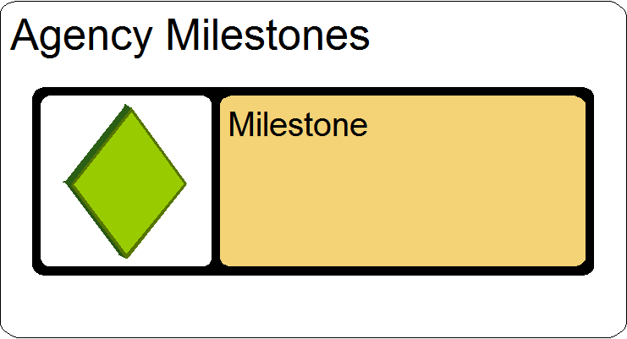

Step 2:
Ensure that all the required Properties indicated above have been defined.
Figure 2: Milestone Properties
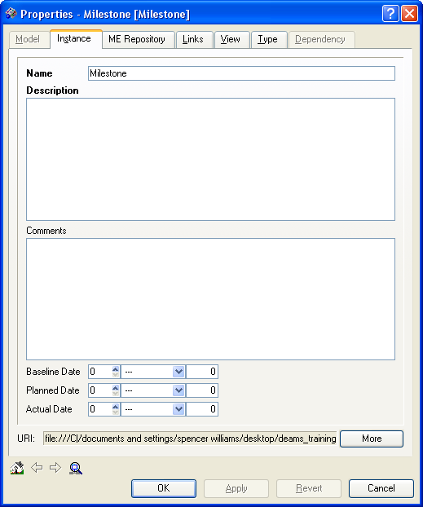
Name: This property is the name of an Agency Milestone (Ex: Pilot Phase Initiate, Pilot Phase Completed).

Description: Describe the properties for coordinating and evaluating the each Milestone.

Baseline Data: The original planned date of the Milestone.

Planned Completion: The current projected date of the Milestone.

Actual Completion: The date this milestone actually took place.

Step 3:
Ensure that all the required relationships indicated above have been established.

Figure 3: Milestone Properties

Business Architecture

Business Function
Definition:
A Business Function is a high-level business entity. It is used to describe a particular set of responsibilities, privileges, actions and activities expected of an organization.

Requirements:
A completed Business Function will contain the following information and linkages:
Table 15: Business Function Requirements
Properties | Value
Name | Agency Abbreviation + Business Function Name
Description | Description for the business function
Core/Utility Business Function | Identify if function is Core or Utility
Relationship Type | Relates to
*has parts | Business Sub Function
involved in | Business Case
is provided by | Business Process
is affected by | Agency Goal
is affected by | Agency Performance Objective
is located in | Facility
*has user | Role
*has user | Organization
has responsible | Organization
*has | Re-Engineering Requirement
*has outcome output measurement of | PRM Measurement Indicator
is provided by | Application
*is provided by | App Component
has user | Stakeholder Entity
business function involves | Stakeholder Entity
aligns to | BRM Sub Function
aligns to | BRM Mode of Delivery
*is affected by | TSP Milestone
*is affected by | Information Policy
*is affected by | PPI Initiative- See Appendix B
*is affected by | FTF Initiative- See Appendix D
*is affected by | PMA Initiative- See Appendix C
*is affected by | Federal LOB Initiative- See Appendix A

* Depending on the Agency, items identified above with an asterisk (*) may or may not apply to this object. It is required to create the appropriate relationship for all that apply. For some objects more detailed descriptions have been supplied in the identified appendices.

Guidance:
When developing a Business Function the following steps are to be followed:

Step 1:
Create a new or modify an existing Business Function object in the Agency Business Functions container.

Figure 1: Business Function Object
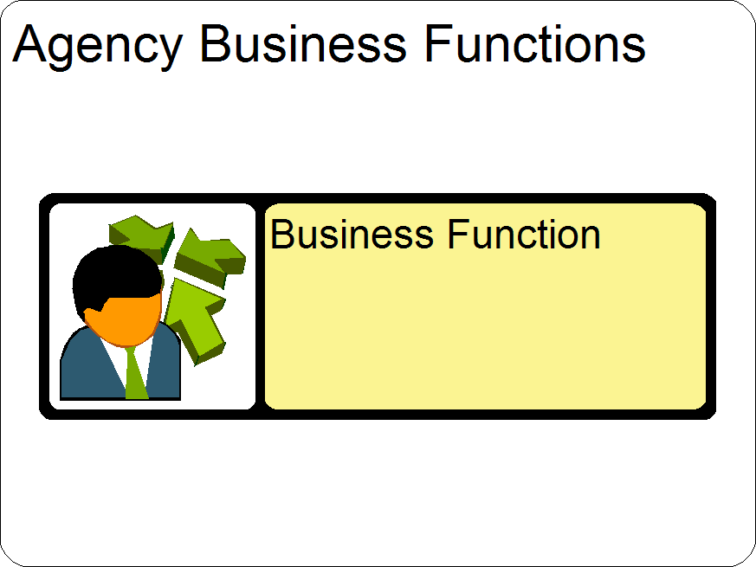

Step 2:
Ensure that all the required Properties indicated above have been defined.
Figure 2: Business Function Properties
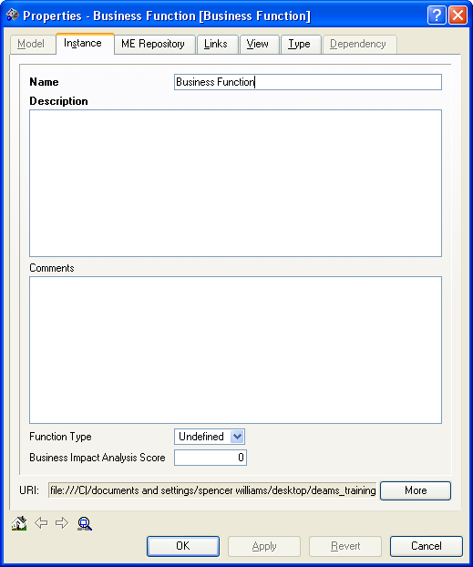
Name: This property value should be the Agency abbreviation followed by the business function name (i.e. OASAM Budget Reporting).

Description: Provide details of responsibilities, privileges, actions and activities expected of a Business Function.

Function Type (core/utility): This property is used to discriminate Core Functions from Utility Functions.

Step 3:
Ensure that all the required relationships indicated above have been established.
Figure 3: Business Function Relationships
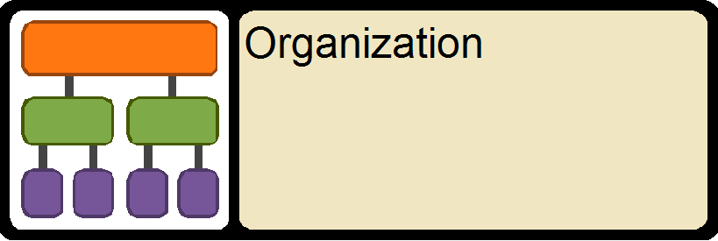

Note: Business Reference Model Mapping- Limit mappings to the Lines of Business, Sub-Functions, and Modes of Delivery described in the BRM. More information on the Consolidated Reference Models may be found at
http://www.whitehouse.gov/omb/egov/documents/FEA_CRM_v20_Final_June_2006.pdf

Business Process
Definition:
A Business Process is a series of actions that transforms a physical item or information from one state to another or creates new items or information.

Requirements:
A completed Business Process will contain the following information and linkages:
Table 16: Business Process Requirements
Properties | Value
Name | Business Process
Description | Description for the business process
Relationship Type | Relates to
*has parts | Business Process
*consists of | Business Process
*before-after | Business Process
involved in | Business Case
provides | Business Function
achieves | Agency Goal
achieves | Agency Performance Objective
is user of | Agency Mission
*has user | Role
has user | Stakeholder Entity
has responsible | Organization
*has sponsor | Organization
*has user | Organization
is located in | Facility
*Business Process has | Re-Engineering Requirement
has outcome output measurement of | PRM Measurement Indicator
uses | Application
*uses | App Component
*produces | DRM Exchange Package
*consumes | DRM Exchange Package
*is affected by | TSP Milestone
*has control | information policy
*is affected by | PPI Initiative- See Appendix B
*is affected by | FTF Initiative- See Appendix D
*is affected by | PMA Initiative- See Appendix C
*is affected by | Federal LOB Initiative- See Appendix A
aligns to | BRM Sub Function
aligns to | BRM Mode of Delivery
*achieves | Strategic Performance goal
*achieves | IT Strategic Goal

* Depending on the Agency, items identified above with an asterisk (*) may or may not apply to this object. It is required to create the appropriate relationship for all that apply. For some objects more detailed descriptions have been supplied in the identified appendices.

Guidance:
When developing a Business Process the following steps are to be followed:

Step 1:
Create a new or modify an existing Business Process object in the Agency Business Processes container.
Figure 1: Business Process Object
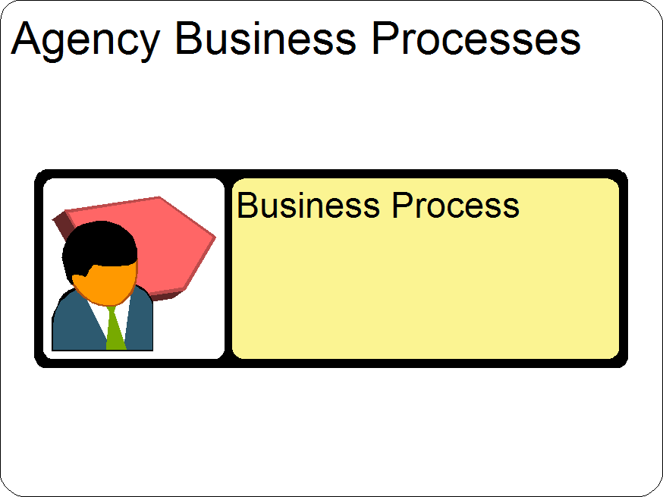

Step 2:
Ensure that all the required Properties indicated above have been defined.
Figure 2: Business Process Properties
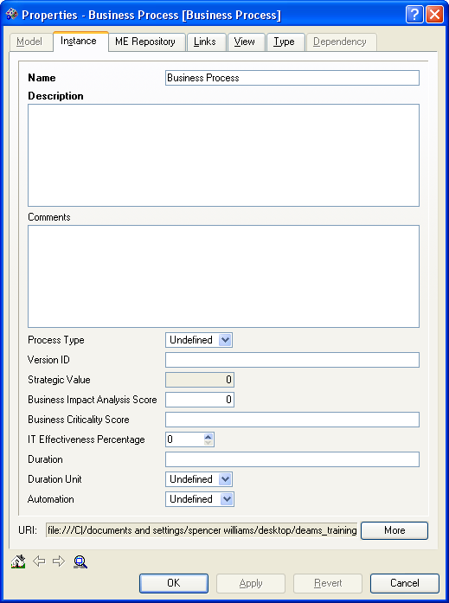
Name: This property value should be the Agency abbreviation followed by the business function name (ie. OASAM Budget Review).

Description: Provide a series of actions that transforms a physical item or information from one state to another in the Business Process.

Step 3:
Ensure that all the required relationships indicated above have been established.
Figure 3: Business Process Relationships
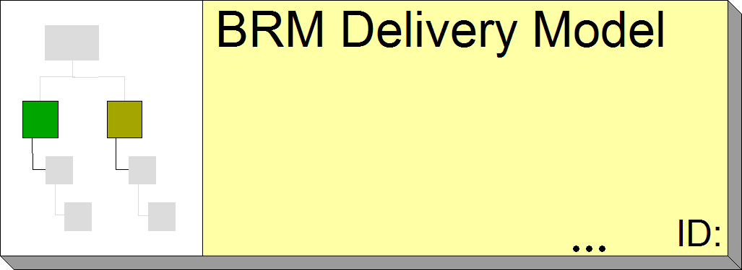

Note: Business Reference Model Mapping- Limit mappings to the Lines of Business, Sub-Functions, and Modes of Delivery described in the BRM. More information on the Consolidated Reference Models may be found at
http://www.whitehouse.gov/omb/egov/documents/FEA_CRM_v20_Final_June_2006.pdf

Organizations
Definition:
An Organization is a stable, organized unit of people and other resources united and constructed for a particular purpose.

Requirements:
A completed Organization object will contain the following information and linkages:
Table 17: Organization Requirements
Properties | Value
Name | Organizations
Description | Description of Organization
*Relationship Type | Relates to
is owner of | Application
is responsible for | Business Function
is user of | Business Function
is located in | Facility
sells | Software Product Version
supervises | Role
is supported by | Application
is sponsor of | Business Process
is responsible for | Business Process
is user of | Business Process
is owner of | Cabinet
is owner of | Computing Hardware
is owner of | Computer
is owner of | Network Device
is owner of | Desktop
is owner of | Laptop
is owner of | Server
is owner of | Mainframe
is owner of | Firewall
is owner of | Load Balancer
is owner of | Router
is owner of | Storage Device
is owner of | Switch
is owner of | Backup Device
is owner of | Disk Array
is owner of | Tape Backup
is owner of | Storage Area Network Switch

* See Step 3 below for guidance on how to best create required relationships

Guidance:
When developing an Organization Object the following steps are to be followed:

Step 1:
Create a new or modify an existing Organization Object in the Agency Organizations container.
Figure 1: Organizations Object
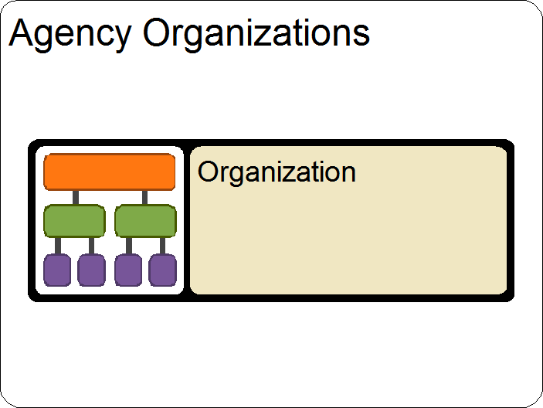

Step 2:
Ensure that all the required Properties indicated above have been defined.
Figure 2: Organization Properties
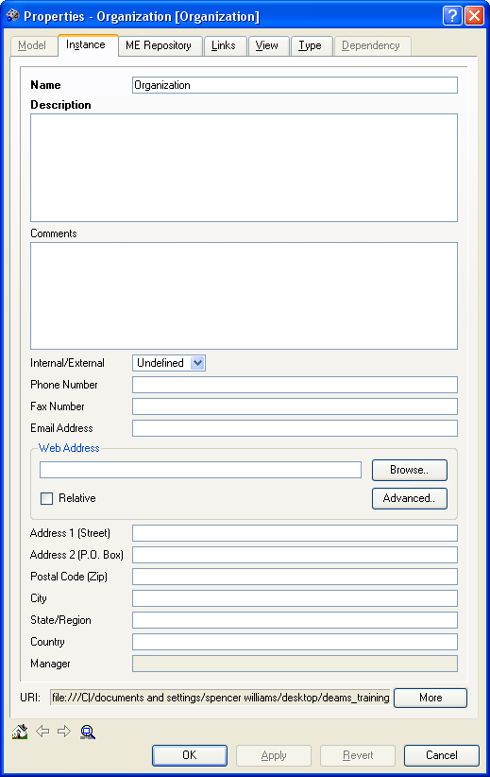
Name: This property is the name of an Organization within the Agency (Ex: Office of Asbestos Prevention).

Description: Describe the people and other resources united and constructed for an Agency Organization.

Step 3:
Organization objects are typically used to show ownership or responsibility for other EA components. It is not necessary to identify all EA components the Organization object should relate to at this point. It is best to first create or modify any know Organization objects. Then while creating other components of the EA determine if it is appropriate to relate them back to one or many of the Organization objects. Below is one example of what relationships may be created for an Organization.

Figure 3: Organization Relationships
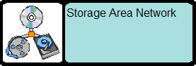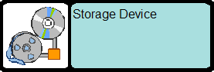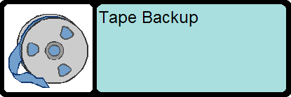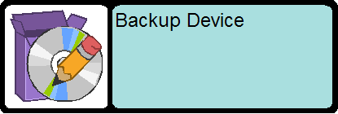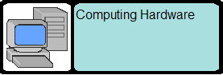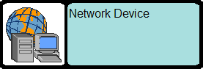

Facility
Definition:
The Facility Object is a physical location used to indicate where the different components of the EA are located.
Note: The Facility objects are predefined in the “DOL Wide Internal Common Components” container within DEAMS. When Agencies create objects in the “Relates to” column below, it is required to create the appropriate relationship to the correct Facility object. If the desired Facility does not currently exist, Agencies can request the EAPO add a new Facility to DEAMS.

Requirements:
A completed Facility will contain the following information and linkages:
Table 18: Facility Requirements
Properties | Value
Name | Facilities
Description | Description of Facility
Address | Facility Address
Internal / External | Identify if the Facility is Internal or External to DOL
Relationship Type | Relates to
is location of | Business Function
is location of | Business Process
is location of | Application Solution Architecture(Hardware)
is location of | Embedded Hardware
is location of | Software
is location of | Organization
is location of | Role
is location of | Application
it typed by | Facility Type

Guidance:
When developing a Facility Object the following steps are to be followed:

Step 1:
Locate the appropriate Facility object in the Facilities Container. This container exists in the “DOL Wide Internal Common Components” container within DEAMS.
Figure 1: Facility Object
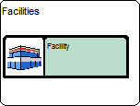

Step 2:
Ensure that all the appropriate relationships indicated above have been established. Below is one example of what relationships may exist.

Figure 2: Facilities Properties
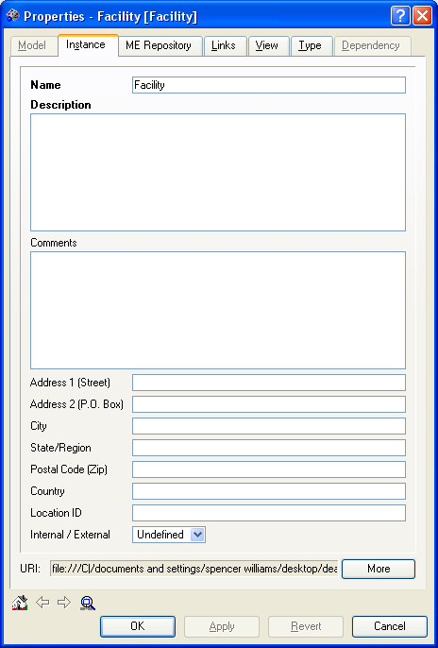
Name: This property is the name of a physical location within the Agency (Ex. Frances Perkins Building – FPB).

Description: Describe the physical properties of each Agency Facility.

Address: The street address of mentioned location

Internal/External: Indicate whether the Facility is an internal (e.g., agency) or external (e.g., outsourced) facility.

Step 3:
Ensure that all the required relationships indicated above have been established.
Figure 3: Facilities Relationships
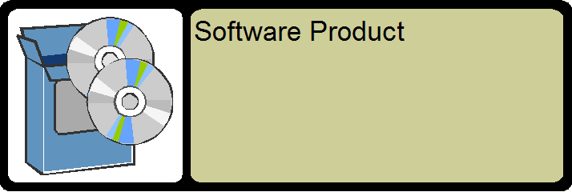

Re-engineering Requirements
Definition:
The Re-engineering Requirement specifies a requirement that leads to the re-engineering (process improvement) of a business process.

Requirements:
A completed Re-engineering Requirements object will contain the following information and linkages:
Table 19: Re-engineering Requirements
Properties | Value
Name | Re-engineering Requirements #
Description | Description or Re-engineering Requirement
Comments | Indicate and provides details around if this is being reused
Relationship Type | Relates to
applies to | Business Function
applies to business process | Business Process

Guidance:
When developing a Re-engineering Requirement object the following steps are to be followed:

Step 1:
Create a new or modify an existing Re-engineering Requirement object in the Agency Re-engineering Requirement container.
Figure 1: Re-engineering Requirement Object
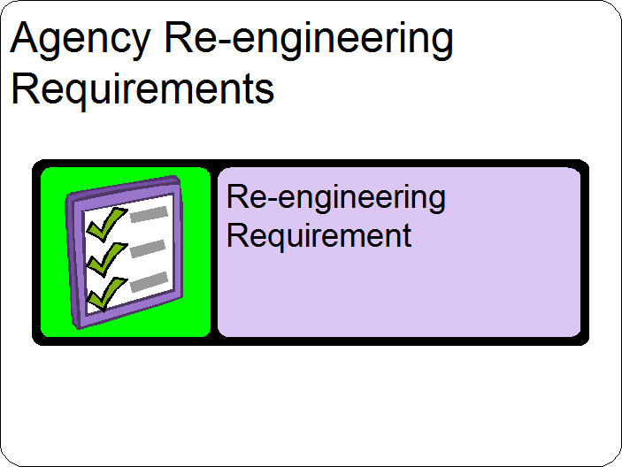

Step 2:
Ensure that all the required Properties indicated above have been defined.
Figure 2: Re-Engineering Requirement Properties
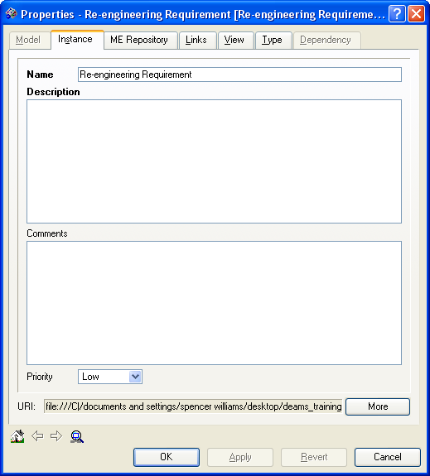
Name: This property is the short (seven words or less) name of an Agency Re-engineering Requirement (Ex: Data exportable in XML).

Description: Describe the properties that lead to the Re-engineering of the business process.

Comments: Indicate and provide details if this is being reused.

Step 3:
Ensure that all the required relationships indicated above have been established.
Figure 3: Re-Engineering Requirement Relationships
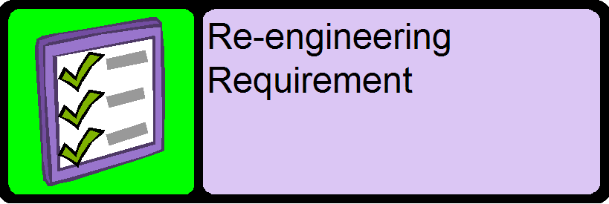

Roles
Definition:
The Role type is used to describe a particular set of responsibilities, privileges, or functions assigned to a person.

Requirements:
A completed Agency Role will contain the following information and linkages:
Table 20: Role Requirements
Properties | Value
Name | Name of Role
Description | Description of Role
Relationship Type | Relates to
is user of | Business Function
is user of | Business Process
is owner of | Application
is supervised by | Organization
stewards | Data Asset
is located in | Facility

Guidance:
When developing a Role Object the following steps are to be followed:

Step 1:
Create a new or modify an existing Role object in the Agency Roles container.
Figure 1: Role Object
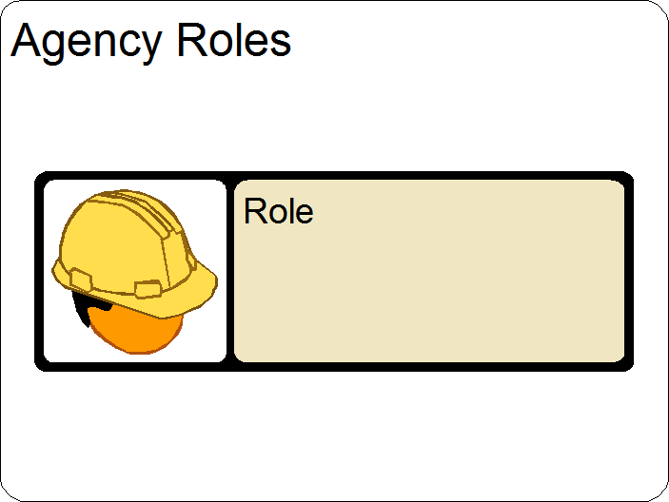

Step 2:
Ensure that all the required Properties indicated above have been defined.
Figure 2: Roles Properties
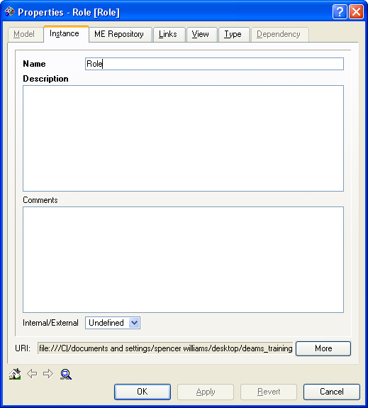
Name: This property is the name of an Agency Role (Ex: Data Steward, Manager).

Description: Describe a particular set of responsibilities, privileges, or functions of the Agency Business Function.

Step 3:
Ensure that all the required relationships indicated above have been established.
Figure 3: Roles Relationships
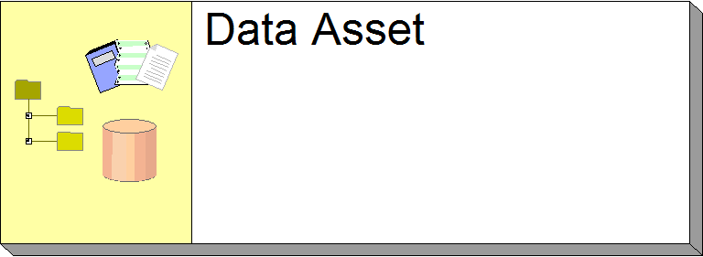

Application Architecture

Applications
Definition:
The Application type describes a logical grouping of one or more instances of executable software that fulfill a set of requirements.

Requirements:
A completed Application Architecture will contain the following information and linkages:
Table 21: Agency Application Requirements
Properties | Value
Name | Name of Application
Description | Description of Application
App Type | COTS, GOTS, In-house developed, etc.
SDLCM Phase | Conceptual Planning, Design, Disposition, etc.
Relationship Type | Relates to
Provides | Business Function
is used by | Business Process
Produces | DRM Exchange Package
consumes | DRM Exchange Package
receives data from | Application
is deployed in | Hardware
is part of | System
is affected by | Milestone
has performance measurement | PRM Measurement Indicator
affected by | Business case
is located in | Facility
consists of | App Component
consists of | Application
has IT owner | Person
has business owner | Person
has owner | Organization
has owner | Role
supports | Organization
uses | DRM Data Entity
aligns to | SRM Service Component

Guidance:
When developing an Application the following steps are to be followed:

Step 1:
Create a new or modify an existing Application object in the Agency Applications container
Figure 1: Application Object
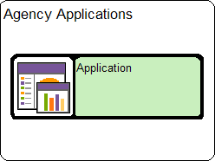

Step 2:
Ensure that all the required Properties indicated above have been defined.
Figure 2: Application Properties
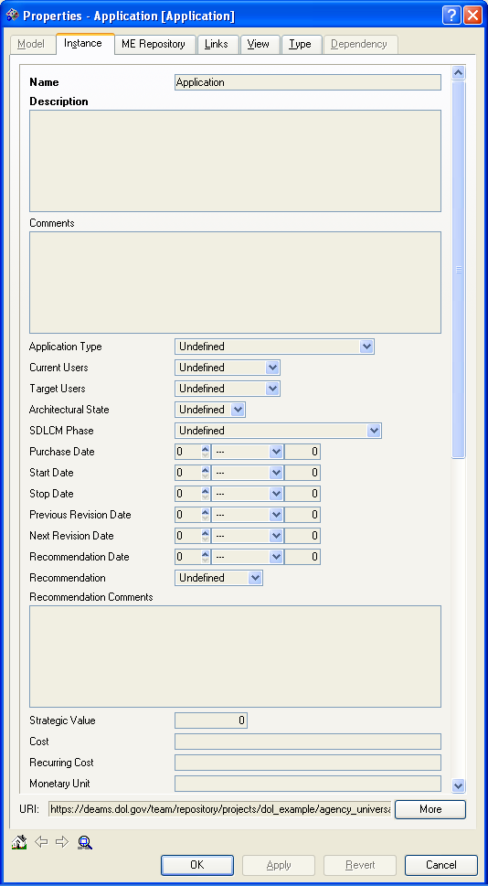
Name: The name of specific applications (Ex: eAlert).

Description: Describe a logical grouping of one or more instances of executable software that fulfill a set of requirements

Application Type: Indicate the source of the application, e.g., COTS, developed in-house, etc.

SDLCM Phase: The Phase within the SDLCM that the application current resides, ranging from -1 to 7.

Step 3:
Ensure that all the required relationships indicated above have been established.
Figure 3: Application Relationships
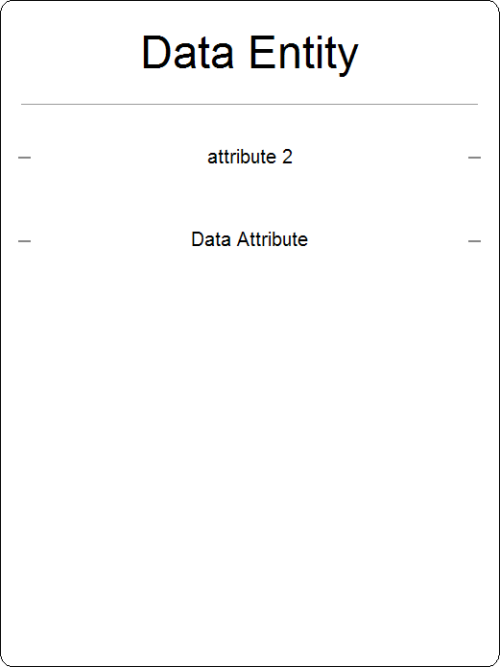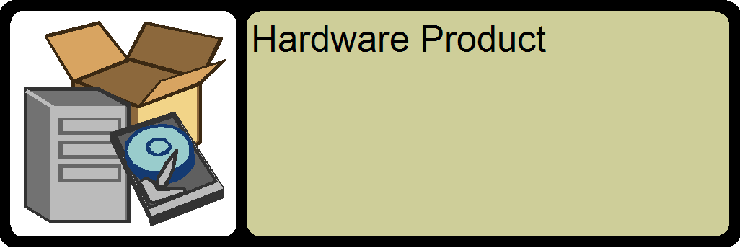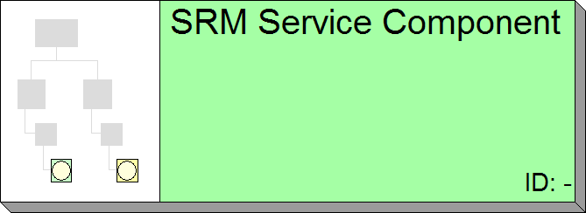

Application Components
Definition:
An Application Component is a part (component) of an Application. App Components and tends to be focused upon some particular aspect of functionality within the Application.

Requirements:
A completed Application Component object will contain the following information and linkages:
Table 22: Agency Application Component Requirements
Properties | Value
Name | Name of Application Component
Description | Description of App Component
Reused or not | Identify if Component is Re-used
Cost Savings due to Reuse | Identify Cost Savings if App Component is Re-used
App Type | COTS, GOTS, In-house developed, etc.
SDLCM Phase | Conceptual Planning, Design, Disposition, etc.
Relationship Type | Relates to
provides | Business Function
is used by | Business Process
is part of | Application
is deployed in | Hardware
is part of | System
is affected by | Milestone
aligns to | SRM Component

Guidance:
When developing an Application Component object the following steps are to be followed:

Step 1:
Create a new or modify an existing Application Component object in the Agency Application Components container
Figure 1: Agency Application Components Object
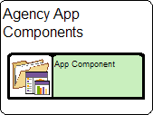

Step 2:
Ensure that all the required Properties indicated above have been defined.
Figure 2: Application Component Properties
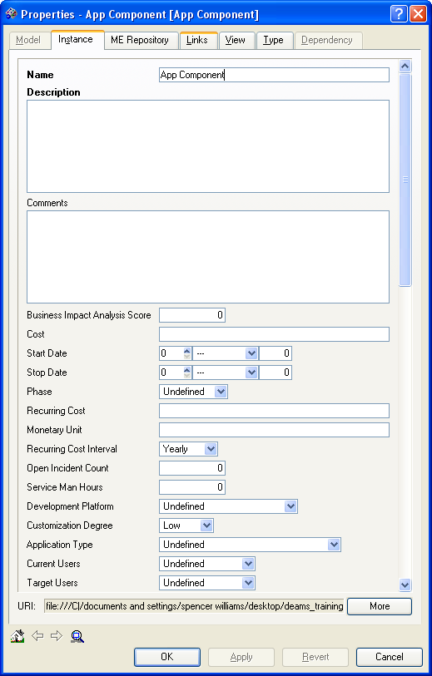
Name: This property is the name of an Agency Application Component (ie. AlertExporter).

Description: Describe the properties of the Agency Component.

SDLCM Phase: The Phase within the SDLCM that the application current resides.

App Type: The application type indicates the source of the application, e.g., COTS, developed in-house, etc.

Step 3:
Ensure that all the required relationships indicated above have been established.
Figure 3: Application Component Relationships
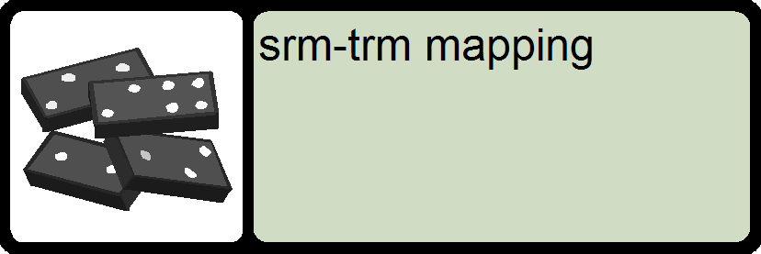

System
Definition:
The System object is used to represent the aggregation of application components that make up a system. A System is the focus / scope of a Certification and Accreditation package.

Requirements:
A completed System object will contain the following information and linkages:
Table 23: Agency System Requirements
Properties | Value
Name | Name of System
Description | Description of System
CA Date | Date of C&A completion
CA Authority | Name and title of person accepting C&A package
CA Org | Agency/Org to which the C&A belongs
ATO Date | Date ATO was received
ATO Authority | Name of title of person issuing ATO
ATO Org | Agency/Org to which the ATO belongs
Relationship Type | Relates to
consists of | Application
consists of | App Comp.
consists of | Hardware
consists of | Software

Guidance:
When developing a System object the following steps are to be followed:

Step 1:
Create a new or modify an existing System object in the Agency Application Components container
Figure 1: Agency System Object
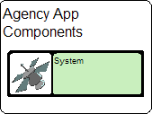

Step 2:
Ensure that all the required Properties indicated above have been defined.
Figure 2: System Properties
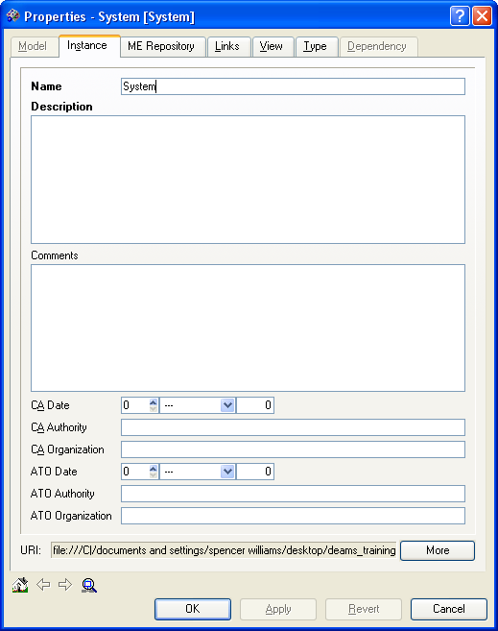
Name: This property is the name of an Agency Application System.

Description: Describe the aggregation of application components that make up an Agency System.

CA Date: The date upon which the Certification and Accreditation was completed.

CA Authority: The name and title of the person accepting the C&A Package.

CA Organization: The organization to which the C&A Authority belongs.

ATO Date: The date upon which the Authority to Operate was issued.

ATO Authority: The name and title of the person issuing the Authority to Operate.

ATO Organization: The organization to which the ATO Authority belongs.

Step 3:
Ensure that all the required relationships indicated above have been established.
Figure 3: System Relationships

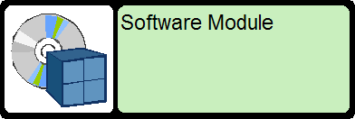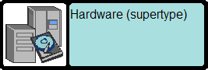

Agency Application Solution Architecture Components
Description:

Objects found in the Application Solution Architecture container provide agencies with the Hardware components needed to accurately represent the Application Architecture. All of these Hardware objects have similar properties, relationships, and guidance. They are only required if they currently exist or are planned for this Initiative. The following section further describes the objects found in the Agency Application Solution Architecture container.

Figure 1: Agency Application Solution Architecture Objects
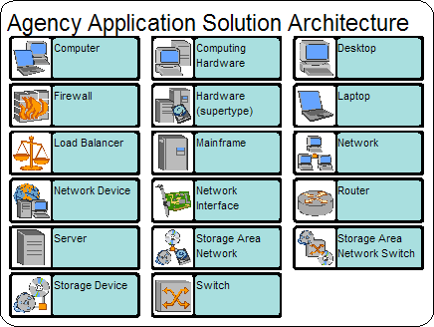

Hardware Definitions

Computer - The Computer type describes a general-purpose computing device.

Computing Hardware - The Computing Hardware type is the abstract type for object types that describe hardware that have computing capabilities.

Desktop - The Desktop type describes a computing device that performs work for an individual and is typically installed in a fixed location.

Laptop - The Laptop type describes a computing device that performs work for an individual and is typically considered to be portable. It contains a display device and keyboard in an integrated unit.

Mainframe - A Mainframe is a mainframe-based Computer, consisting of a hardware platform and an operating system.
- Network - A Network is the physical connections between a number of computers and peripheral equipment.

Firewall - The Firewall type describes a network device that provides filtered network access.

Router - The Router type describes a network device that connects one or more networks.

Load Balancer - The Load Balancer type describes a network device that provides load-balancing services.

Network Device - The Network Device type describes a device that is directly connected to a network.

Server - The Server type describes a computing device that hosts one or more software services.

Storage Device - The Storage Device type describes a stand-alone device that stores data.

Storage Area Network Switch (SANs) - The SAN Switch type describes a device that manages a set of SANs.

Storage Device - The Storage Device type describes a stand-alone device that stores data.
- Switch - The Switch type describes a network device that manages one or more networks and/or network data types.

Storage Area Network - The Storage Area Network type describes a SAN.

Hardware Requirements:
A completed Application Component object will contain the following information and linkages:
Table 24: Hardware Requirements
Properties for Application Solution Architecture (Hardware) Objects | Value
Name | Name of Object
Description | Description of Object
Required for Application Solution Architecture (Hardware) Objects | Relates to
deploys | Application
deploys | App Component
is part of | System
is located in | Facility
has owner | Organization
has performance measurement | PRM Indicator
Additional preferred for Application Solution Architecture (Hardware) Objects | Relates to
is part of | These relationships can be used to link the different objects above when appropriate. i.e. "Laptop consists of backup device"
deploys
consists of
connects to

Hardware Guidance:
When developing an Application Solution Architecture Hardware object the following steps are to be followed:

Step 1:
Create a new or modify an existing Hardware object in the Agency Application Solution Architecture container

Figure 1: Agency Application Solution Architecture (Hardware) Object
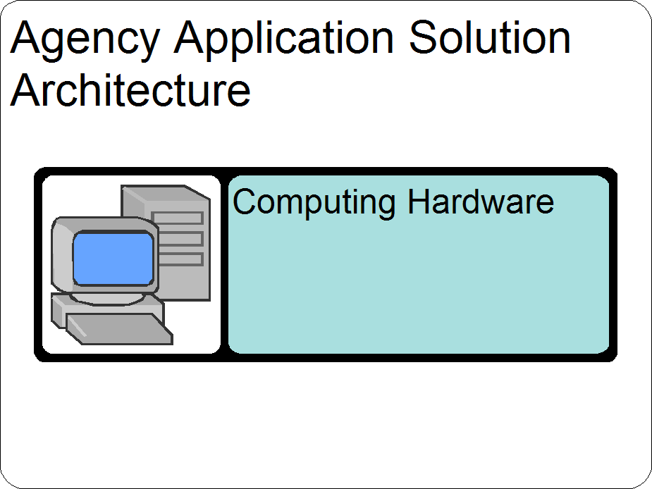

Step 2:
Ensure that all the required Properties indicated above have been defined.

Figure 2: Agency Application Solution Architecture (Hardware) Properties
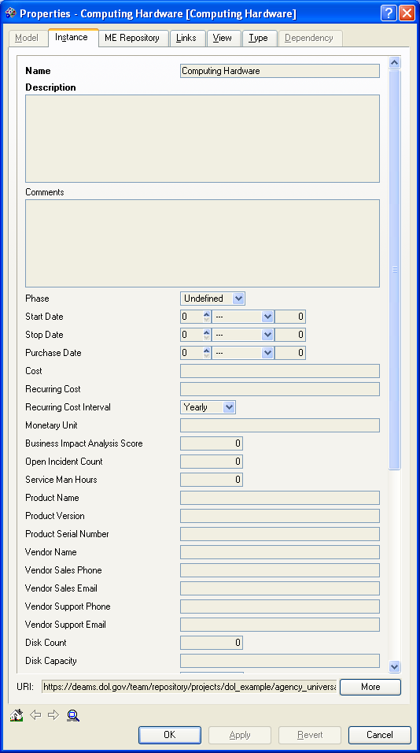
Name: Name of the Computer Hardware object (Ex: Dell).

Description: Describe the physical properties of each hardware object.

Step 3:
Ensure that all the required relationships indicated above have been established.
Figure 3: Agency Application Solution Architecture (Hardware) Relationships

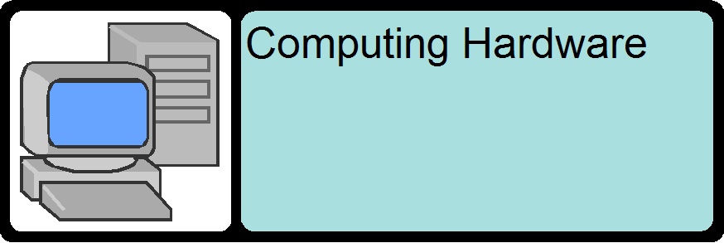

Embedded Hardware
Description:

Objects located in the Embedded Hardware container provide agencies with the Embedded Hardware components needed to accurately represent the Application Architecture. All of these Hardware objects have similar properties, relationships, and guidance. They are only required if they currently exist or are planned for this Initiative. The following section further describes the objects found in the Agency Application Solution Architecture container.

Figure 1: Agency Embedded Hardware Objects
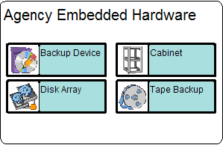

Embedded Hardware Definitions

Backup Device- The Backup Device type describes a storage device that uses removable media to archive data.

Disk Array- The Disk Array type describes a data storage device.

Tape Backup - The Tape Backup type describes a backup device that stores data onto a tape for archival.

Cabinet - The Cabinet type describes server cabinets.

Embedded Hardware Requirements:
A completed Embedded Hardware object will contain the following information and linkages:
Table 25: Embedded Hardware Requirements
Properties for Embedded Hardware Objects | Value
Name | Name of Object
Description | Description of Object
Required Relationship Types for Embedded Hardware Objects | Relates to
deploys | Application
deploys | App Component
is part of | System
is located in | Facility
has owner | Organization
has performance measurement | PRM Indicator
Additional preferred Relationship Types for Embedded Hardware Objects | Relates to
is part of | These relationships can be used to link the different objects above when appropriate. i.e. "Laptop consists of backup device"
deploys
consists of
connects to

Embedded Hardware Guidance:
When developing a Backup Device, or other Embedded Hardware, object the following steps are to be followed:

Step 1:
Create a new or modify an existing Backup Device object in the Agency Embedded Hardware container
Figure 1: Agency Backup Device Object
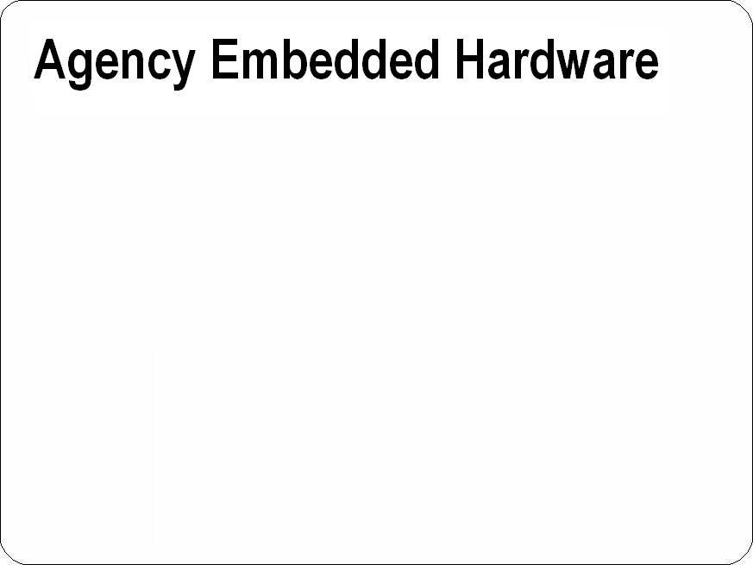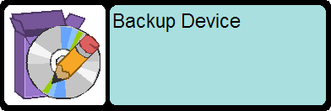

Step 2:
Ensure that all the required Properties indicated above have been defined.
Figure 2: Embedded Hardware Backup Device Properties
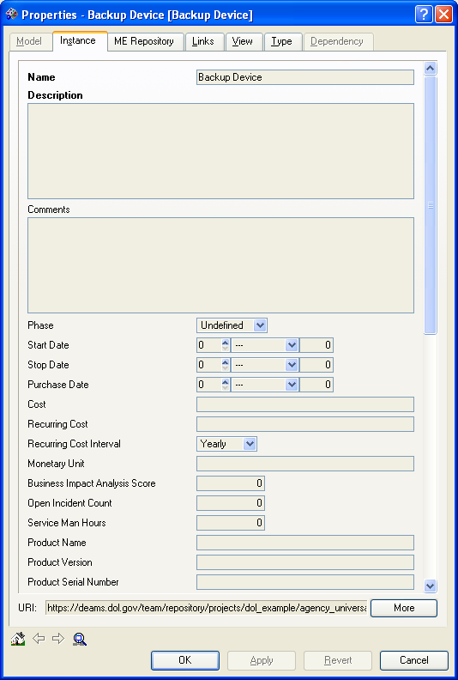
Name: This property is the name of a specific backup hardware device (Ex: Iomega SuperTape.

Description: Describe the properties of the backup device, or other embedded hardware, you are creating.

Step 3:
Ensure that all the required relationships indicated above have been established.
Figure 3: Backup Device Relationships
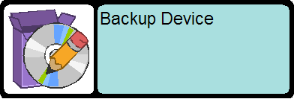

Agency Software
Description:

Objects located in the Agency Software container provide agencies with the Software components needed to accurately represent the Application Architecture. All of these Software objects have similar properties, relationships, and guidance. They are only required if they currently exist or are planned for this Initiative. The following section further describes the objects found in the Agency Application Solution Architecture container.

Figure 1: Agency Software Objects
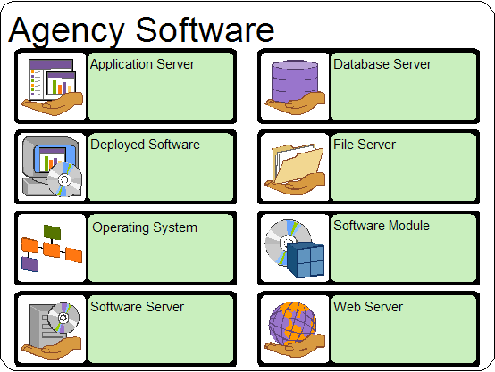

Software Definitions
- Application Server - The Application Server type describes the Application Server class of Software Servers. Examples of Application Servers include Web Logic and Web Sphere.
- Database Server - The Database Server type describes the Database Server class of Software Servers. Examples of Database Servers include Oracle and Microsoft SQL Server.
- Deployed Software - The Deployed Software type is a base type for Software and Applications that are deployed (e.g. installed software).
- Operating System - An Operating System is the collection of software that directs a computer's operations, controlling and scheduling the execution of other programs, and managing storage, input/output, and communication resources.
- File Server - The File Server type describes the File Server class of Software Servers.
- Software Server - The Software Server type describes a network-addressable module that runs on a physical server. Various subtypes of software servers include database servers, application servers, web servers, etc.
- Web Server - The Web Server type describes the Web Server class of Software Servers. Examples of Web Servers include IIS and Apache.
- Software Module - The Software Module type describes an instance of installed software that implements single or multiple functional capabilities.

Agency Software Requirements:
A completed Application Component object will contain the following information and linkages:
Table 1: Agency Software Requirements
Software Objects
App Server
Deployed Software
Operating System
Software Server
Database Server
File Server
Software Module
Web Server
Properties for all above objects | Value
Name | Name of Object
Description | Description of Object
Required Relationship Types for all above objects | Relates to
deploys | Application
deploys | App Component
is part of | System
is located in | Facility
has owner | Organization
has performance measurement | PRM Indicator
Additional preferred Relationship Types for all above objects | Relates to
is part of | These relationships can be used to link the different objects above when appropriate. i.e. "Laptop consists of backup device"

Agency Software Guidance:
When developing an Application Solution Architecture Hardware object the following steps are to be followed:

Step 1:
Create a new or modify an existing Software object in the Agency Software container
Figure 1: Agency Software Module Object
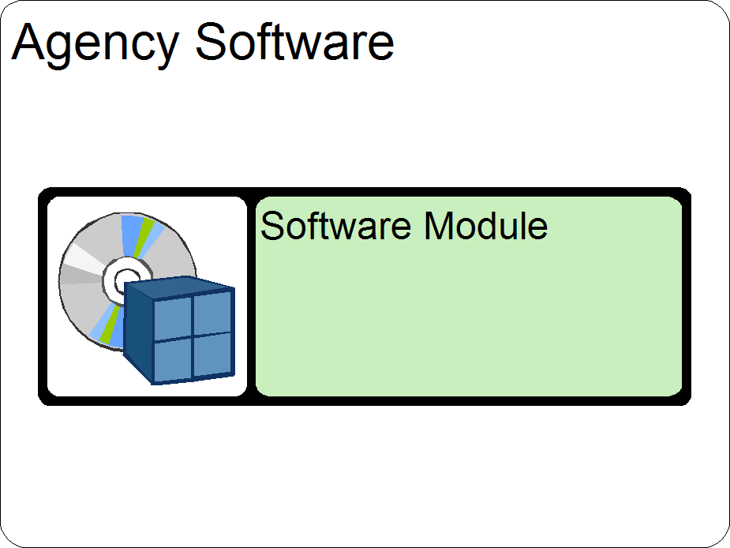

Step 2:
Ensure that all the required Properties indicated above have been defined.
Figure 2: Agency Software Properties
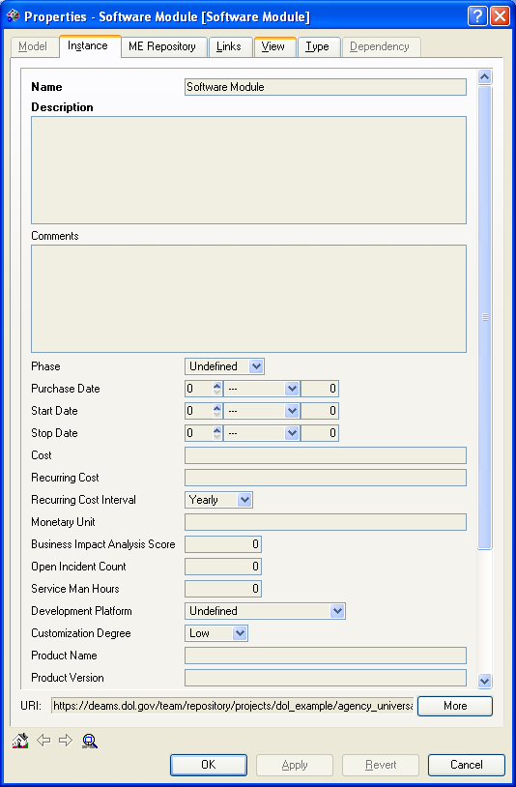
Name: This property is the name of a software module (Ex: Oracle).

Description: Describe an instance of installed software that implements single or multiple functional capabilities

Step 3:
Ensure that all the required relationships indicated above have been established.
Figure 3: Agency Software Relationships

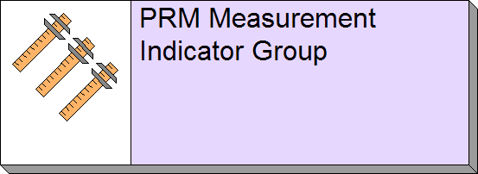

Technical Architecture

SRM-TRM Mappings
Definition:
The only component of the Technical Architecture that resides and is managed at the Agency level is the Agency SRM- TRM Mapping. The SRM-TRM Mapping object is used to create a "pairing" of SRM Component and TRM Service Standard that is used to identify a Software Product or Hardware Product, categorized by TRM Service Standard that is used to fulfill a specific SRM Component. All that is required for this object is to create one for every Hardware / Software product and create the indicated relationships.

Requirements:
A completed SRM-TRM Mapping will contain the following information and
linkages:
Table 26: SRM-TRM Mappings Requirements
Properties | Value
Name | SRM-TRM Mapping
Description | none
Relationship Type | Relates to
maps to | SRM Service Component
maps to | TRM Service Standard
maps to | Service Spec
maps to | Hardware Product
maps to | Software Product

Guidance:
When developing an SRM-TRM Mapping the following steps are to be followed:

Step 1:
Create a new or modify an existing SRM-TRM Mapping object in the Agency SRM-TRM Mapping container
Figure 1: SRM-TRM Mappings Object
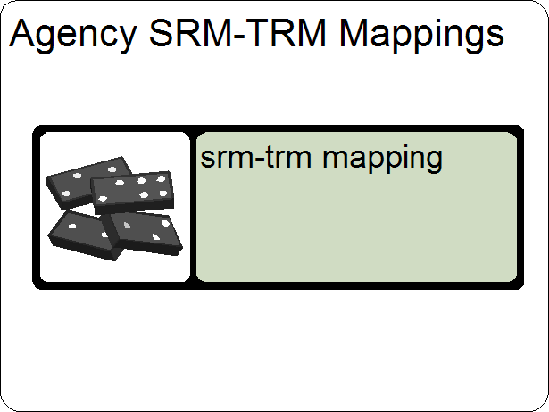

Step 2:
Ensure that all the required Properties indicated above have been defined.
Figure 2: SRM-TRM Mappings Properties
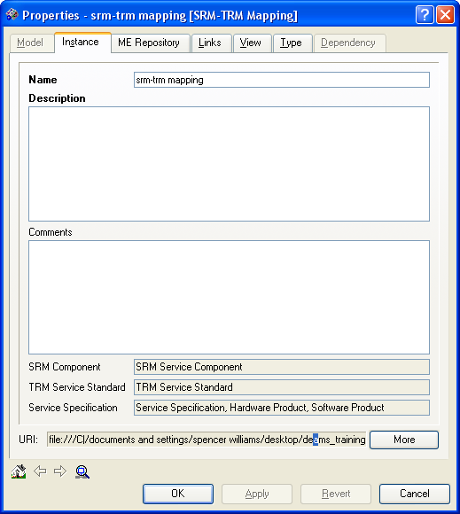
Name: This property is always labeled Agency of Functional acronym: SRM-TRM Mapping (i.e. OASAM: Reservations/Registration).

Description: Describe the properties used to create a SRM-TRM Mapping.

Step 3:
Ensure that all the required relationships indicated above have been established.
Figure 3: SRM-TRM Mappings Relationships
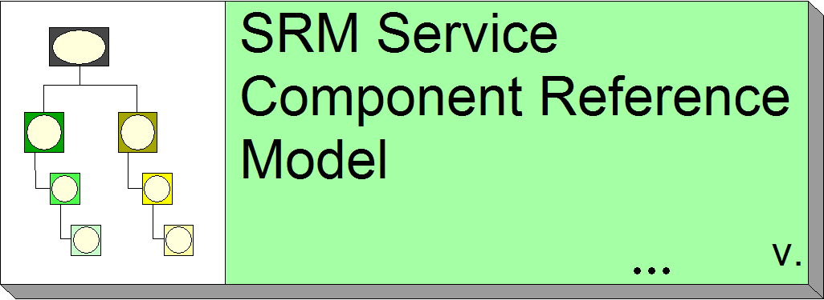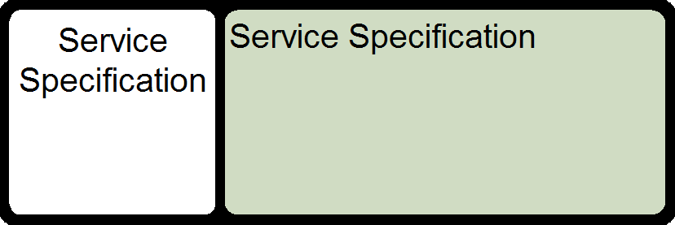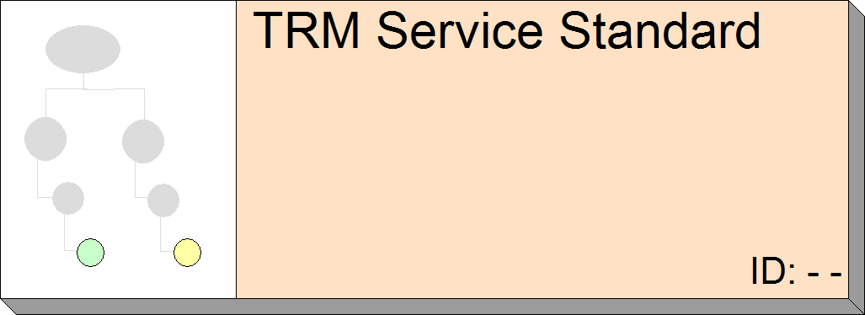

Service Specifications
Definition:
The Service Specification object is a temporary placeholder to support the import of TRM information from the Word version of the Target EA documents. These objects reside in the DOL Wide Internal Common Components container in DEAMS. The instances are being changed to one of the following (depending upon the nature of the actual instance information): - Industry Standard - Government Standard - Hardware Product - Software Product - IT Product. It is a DEAMS requirement to not continue using the Service Specification object. Instead use one of previously mentioned objects. These objects are further described in later sections of this document.

Figure 1: Service Specification Object
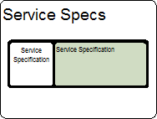

Service Specification Replacement Objects
The Service Specification Object was collected and imported from the Microsoft Word version of the Target EA. Since the last data call a more valuable categorization of Service Specifications has been established. Instead of using the generic Service Specification object, one of the object types listed below should be chosen. These objects reside in the DOL Wide Internal Common Components container in DEAMS. Agencies do not have the ability to add, delete, or modify these objects. Any changes need to be submitted to the EAPO for approval and execution. Agencies are required to create all applicable relationships and identify any missing or obsolete object types.

- Hardware Product - The Hardware Product type describes a particular kind of commercially built or custom developed hardware. This type does not describe a deployed instance, but rather a catalog item.

Figure 1: Hardware Product

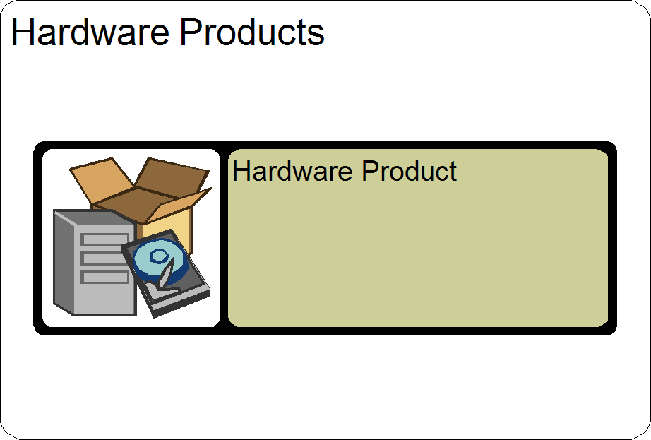

Table 27: Hardware Product Relationships
Relationship Type | Relates to
used for | SRM: Service Component
*has owner | Person
*is developed by | Manufacturer
*has category | Standards Category
has version | Hardware Product Model
aligns to | TRM: Service Standard
mapping from | SRM-TRM Mapping
*This information may not be available and / or known and therefore is not required, however if present can provide additional value.

- Software Product - The Software Product is not intended to represent a particular deployment of the software product, but rather represents the product in general as a class (e.g. Microsoft produces Word where Word is an instance of the type Software Product).

Figure 1: Software Product
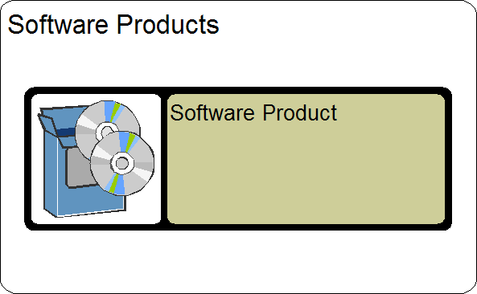

Table 28: Software Product Relationships
Relationship Type | Relates to
used for | SRM: Service Component
is deployed in | Deployed Software
*has owner | Person
has version | Software Product Version
*is developed by | Manufacturer
*has category | Standards Category
aligns to | TRM: Service Standard
mapping from | SRM-TRM Mapping

*This information may not be available and / or known and therefore is not required, however if present can provide additional value.

Data Architecture

Data Asset
Definition:
A Data Asset is a managed container for data. In many cases, this will be a relational database; however, a Data Asset may also be a Web site, a document repository, directory or data service.

Requirements:
A completed Data Asset object will contain the following information and linkages:

Table 29: Data Asset Requirements
Properties | Value
Name | Name of Data Asset
Description | Description of Data Asset
Relationship Type | Relates to
accessed by | DRM: Query Point
from | DRM: Data Entity
categorized by | DRM: Topic
structured described by | DRM: Data Schema
semi/unstructured described by | DRM: Structured Data Resource
semi/unstructured described by | DRM: Unstructured Data Resource
semi/unstructured described by | DRM: Semi-Structured Data Resource
stewarded by | Organization
stewarded by | Role
stewarded by | Person
is typed by | Data Asset Type
provides management context for | DRM: Structured Data Resource
provides management context for | DRM: Unstructured Data Resource
provides management context for | DRM: Semi-Structured Data Resource

Guidance:
When developing a Data Asset the following steps are to be followed:

Step 1:
Create a new or modify an existing Data Asset object in the Agency Data Assets container
Figure 1: Agency Data Assets
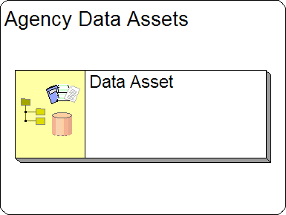

Step 2:
Ensure that all the required Properties indicated above have been defined.

Figure 2: Data Asset Properties
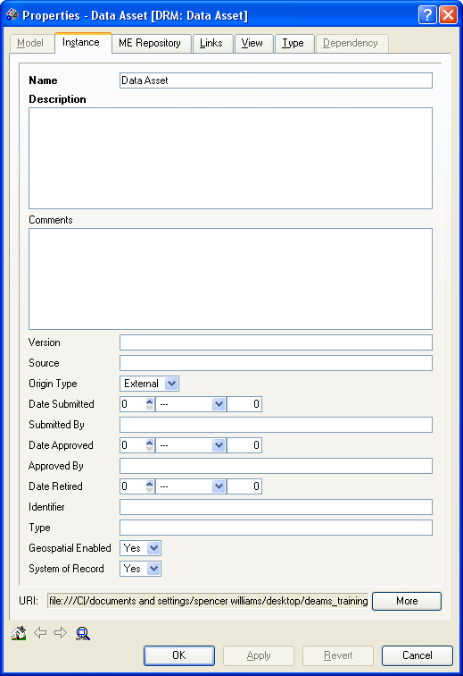
Name: This property is the name of an Agency Information Policy (Ex: Employee Document Repository).

Description: Identify areas for detailed description of the Data Asset.

Step 3:
Ensure that all the required relationships indicated above have been established.
Figure 3: Data Asset Relationships
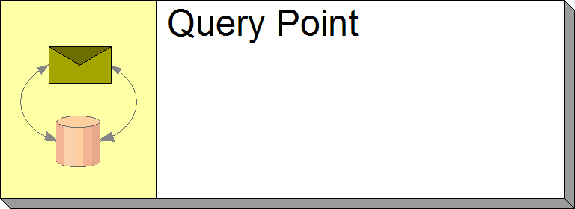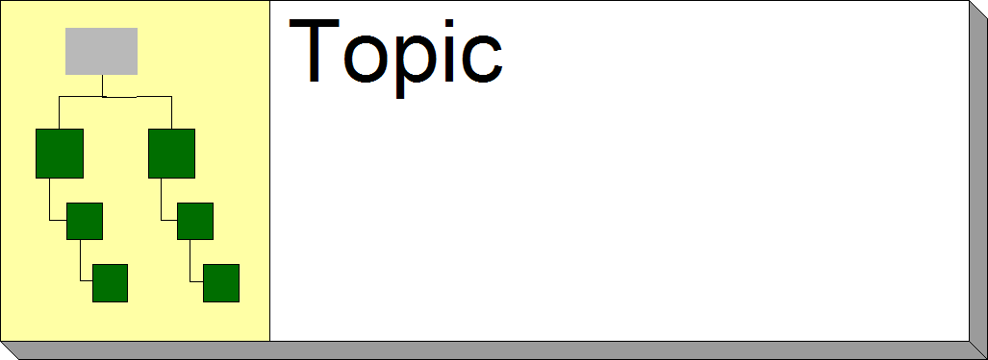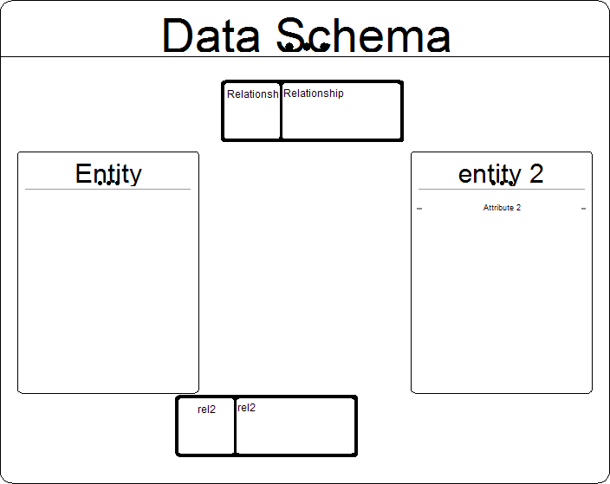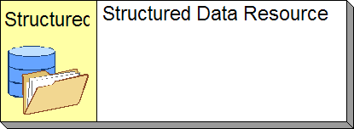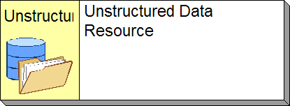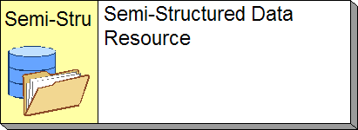

Exchange Package
Definition:
An Exchange Package is a description of a specific recurring data exchange between a Supplier and a Consumer. An Exchange Package contains information (metadata) relating to the exchange (such as Supplier ID, Consumer ID, validity period for data, etc.), as well as a reference to the Payload (message content) for the exchange. An Exchange Package can also be used to define the result format for a query that is accepted and processed by a Query Point in a data-sharing scenario.

Requirements:
A completed Exchange Package object will contain the following information and linkages:

Table 30: Exchange Package Requirements
Properties | Value
Name | Name of Exchange Package
Description | Description of Exchange Package
Relationship Type | Relates to
categorized by | DRM Topic
 | DRM Attribute
 | DRM Query Point
 | DRM Payload Definition
produced by | Business Process
produced by | Application
consumed by | Application
produced by | Stakeholder Entity
uses | Data Entity
consumed by | Business Process
consumed by | Stakeholder Entity

Guidance:
When developing an Exchange Package the following steps are to be followed:

Step 1:
Create a new or modify an existing Exchange Package object in the Agency Data Exchange Packages container.
Figure 1: Data Exchange Packages
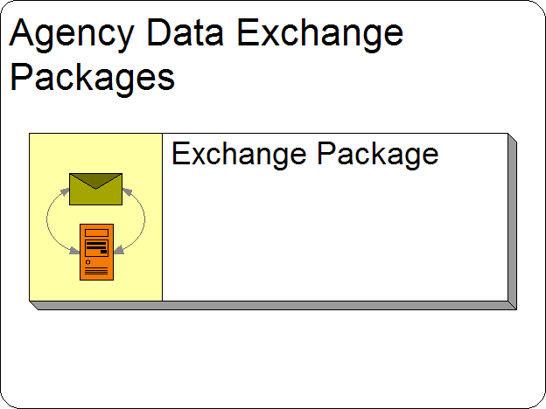

Step 2:
Ensure that all the required Properties indicated above have been defined.

Figure 2: Exchange Package Properties
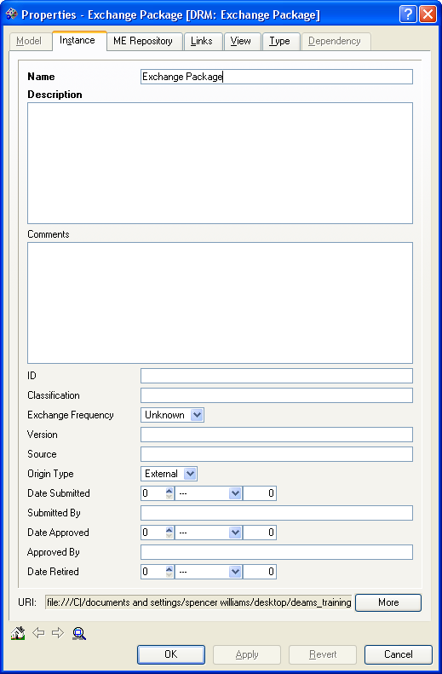
Name: The name of a recurring data exchange.

Description: Describe specific information relating to the exchange (including a reference to payload) between a Supplier and a Consumer.

Step 3:
Ensure that all the required relationships indicated above have been established.
Figure 3: Exchange Package Relationships
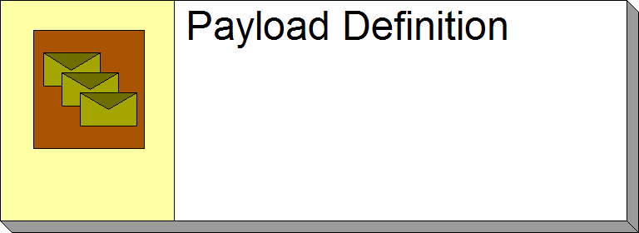

Data Exchange Mechanism

Definition:
A Data Exchange Mechanism is the generic mechanism that is used to exchange data / information, for example, “Flat File”, “XML electronic exchange”, “shared data base”.

Requirements:
A completed Exchange Package object will contain the following information and linkages

Table 31: Data Exchange Mechanism
Properties | Value
Name | Name of Data Exchange Mechanism
Description | Description of Data Exchange Mechanism
Relationship Type | Relates to
enabled by | DRM: Payload Definition
queries | DRM: Query Point
uses | DRM: Data Attribute
consumed by | Stakeholder Entity
produced by | Stakeholder Entity
consumed by | Business Process
produced by | Business Process
uses | DRM: Data Entity
categorized by | DRM: Topic
produced by | Application
consumed by | Application

Step 1:
Create a new or modify an existing Data Exchange Mechanism object in the Agency Exchange Mechanism container.
Figure 1: Data Exchange Mechanism
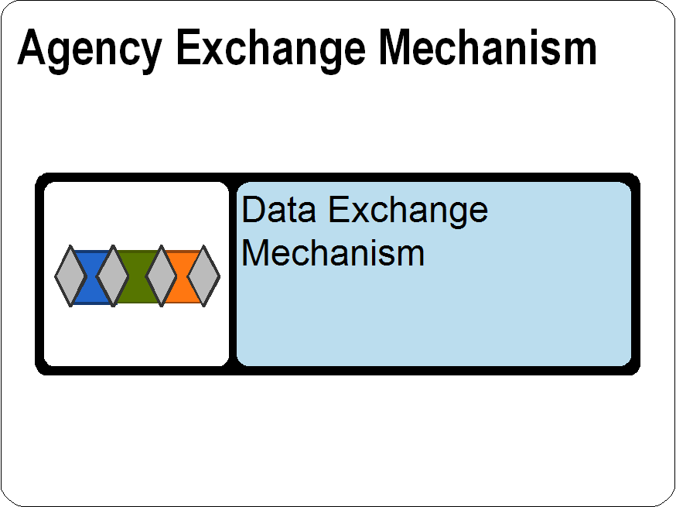

Step 2:
Ensure that all the required Properties indicated above have been defined.

Figure 2: Data Exchange Mechanism Properties
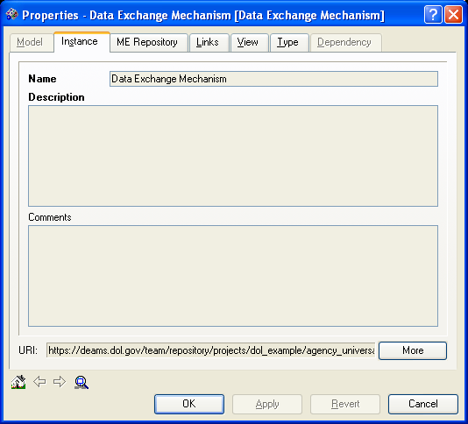
Name: This property is the name of a generic data mechanism (Ex: XML electronic exchange).

Description: Include more detail surrounding the mechanism used to exchange data information.

Step 3:
Ensure that all the required relationships indicated above have been established.
Figure 3: Data Exchange Mechanism Relationships
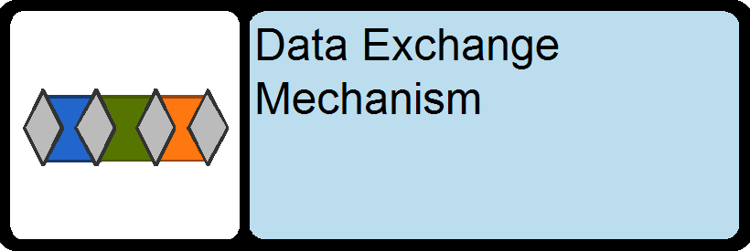

Payload Definition
Definition:
An electronic definition that defines the requirements for the Payload (data) that is exchanged between a Supplier and a Consumer

Requirements:
A completed Payload Definition object will contain the following information and linkages:
Table 32: Payload Definition Requirements
Properties | Value
Name | Name of Payload Definition
Description | Description of Payload Definition
Relationship Type | Relates to
enables | exchange package
to | DRM: Exchange Package

Guidance:
When developing a Payload Definition the following steps are to be followed:

Step 1:
Create a new or modify an existing Payload Definition object in the Agency Data Exchange Packages container
Figure 1: Payload Definition
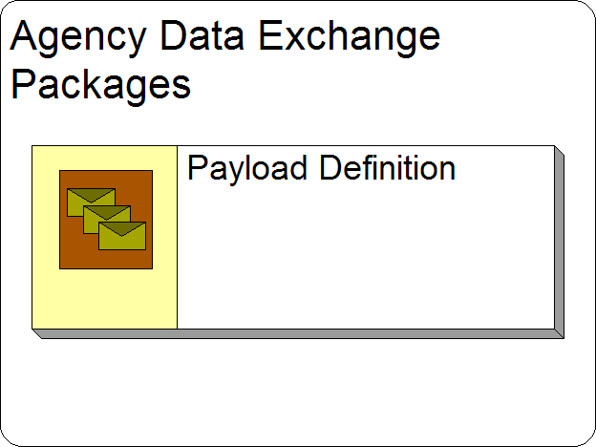

Step 2:
Ensure that all the required Properties indicated above have been defined.

Figure 2: Payload Definition Properties
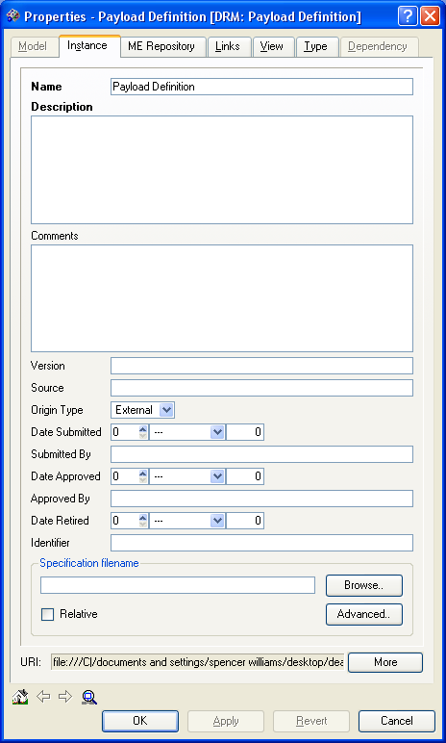
Name: This property is the name of an Agency DRM Payload Definition.

Description: Describe specific information relating to the exchange (including a reference to payload) between a Supplier and a Consumer.

Step 3:
Ensure that all the required relationships indicated above have been established.
Figure 3: Payload Definition Relationships

Information Group
Definition:
Information Group can be an aggregation of one or more Information Objects. The Information Group has the same relationship building possibilities as the Information Object and assists in clarifying types of data.

Requirements:
A completed Information Group will contain the following information and linkages:
Table 33: Information Group Requirements
Properties | Value
Name | Name of Information Group
Description | Description of Information Group
Relationship Type | Relates to
aligns to | DRM: Taxonomy

Guidance:
When developing an Information Group the following steps are to be followed:

Step 1:
Create a new or modify an existing Information Group object in the Agency Information Groups container
Figure 1: Information Group Object
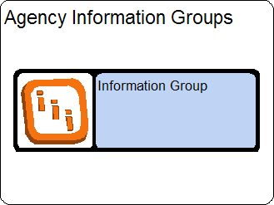

Step 2:
Ensure that all the required Properties indicated above have been defined.
Figure 2: Information Group Properties
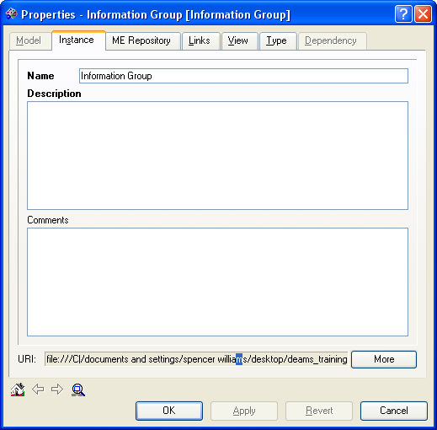
Name: This property is the name of an Agency Information Group (Ex: Case Information).

Description: Provide additional descriptive information that can be used to fully describe the Information Group.

Step 3:
Ensure that all the required relationships indicated above have been established.
Figure 3: Information Group Relationships
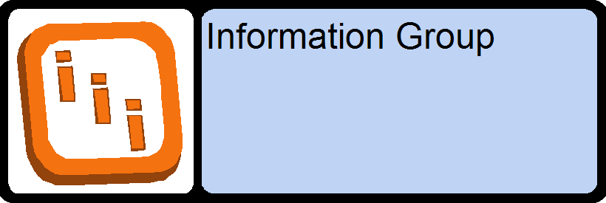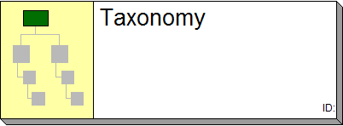

Information Policy
Definition:
An Information Policy defines the set of information governance rules to be applied to a particular set of object types.

*Information Policies and Information Policy Rules reside in both the Agency Data Architecture container and in the DOL Wide External Common Components container because these can be Policies specific to the Agency or driven from something outside DOL. Make sure that the correct instance is being used when creating the relationships to and from Information Policies and Rules.

Requirements:
A completed Information Policy object will contain the following information and linkages:
Table 34: Information Policy Requirements
Properties | Value
Name | Name of Information Policy
Description | Description of Information Policy
Internal / External | Identify if Information Policy is Internal to DOL or comes from an External source
Relationship Type | Relates to
parent | Information Policy Rule
is represented by | Concept
affects | Business Function
is control for | Business Process

Guidance:
When developing an Information Policy the following steps are to be followed:

Step 1:
Create a new or modify an existing Information Policy object in the Agency Information Policies container
Figure 1: Information Policies Object
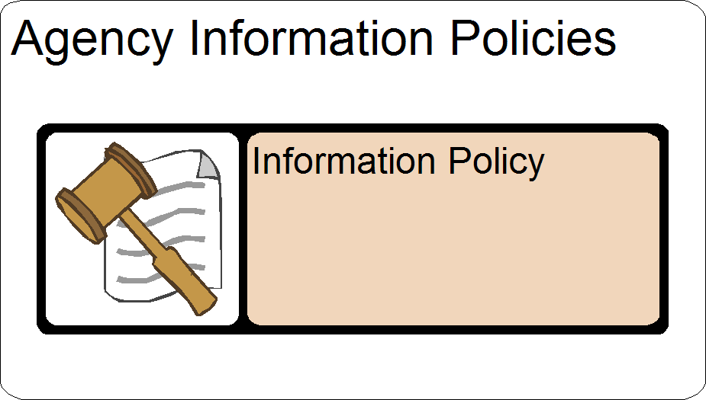

Step 2:
Ensure that all the required Properties indicated above have been defined.

Figure 2: Information Policy Properties
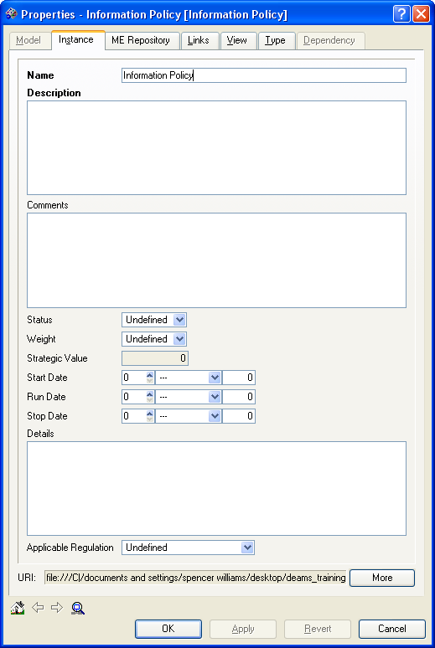
Name: This property is the name of an Agency Information Policy.

Description: Define the set of information governance rules to be applied to a particular set of object types

Step 3:
Ensure that all the required relationships indicated above have been established.
Figure 3: Information Policy Relationships
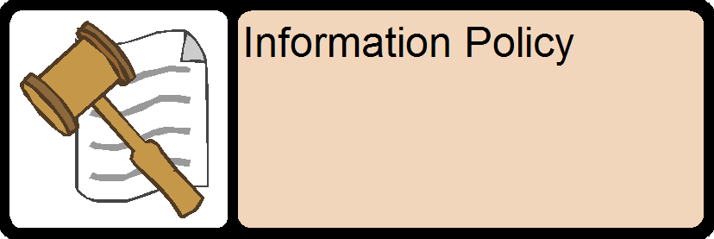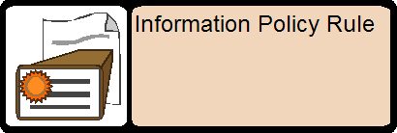

Information Policy Rule
Definition:
An Information Policy rule defines a single assessment to be run against the object of the type specified by the owning Information policy.

*Information Policies and Information Policy Rules reside in both the Agency Data Architecture container and in the DOL Wide External Common Components container because these can be Policies specific to the Agency or driven from something outside DOL. Make sure that the correct instance is being used when creating the relationships to and from Information Policies and Rules.

Requirements:
A completed Information Policy Rule object will contain the following information and linkages:
Table 35: Information Policy Rule Requirements
Properties | Value
Name | Name of Information Policy Rule
Description | Description of Information Policy Rule
Relationship Type | Relates to
child | Information Policy

Guidance:
When developing an Information Policy Rule the following steps are to be followed:

Step 1:
Create a new or modify an existing Information Policy Rule child for the appropriate Information Policy.
Figure 1: Information Policy Rule Object
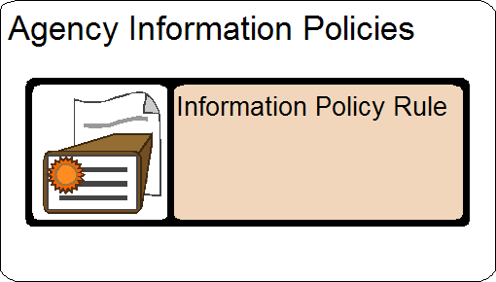
Step 2:
Ensure that all the required Properties indicated above have been defined.

Figure 2: Information Policy Rule Properties
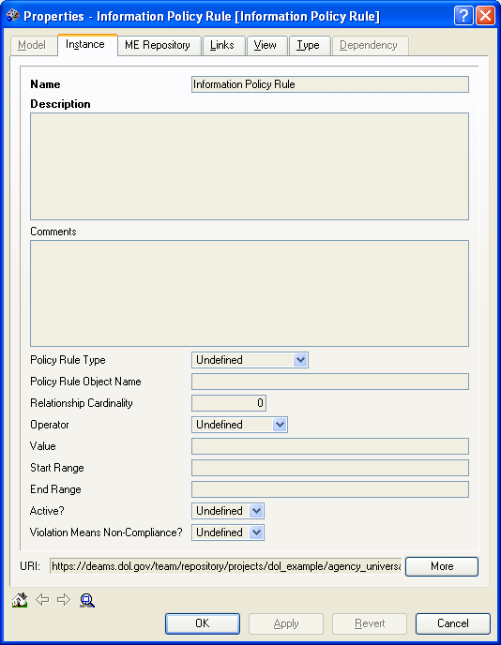
Name: This property is the name of an Agency Policy Rule.

Description: Describe the properties of each Information Policy Rule.

Step 3:
Ensure that all the required relationships indicated above have been established.
Figure 3: Information Policy Rule Relationships

Query Point
Definition:
A Query Point is an endpoint that provides an interface for accessing and querying a Data Asset. A concrete representation of a Query Point may be a specific URL at which a query Web Service may be invoked.

Requirements:
A completed Query Point object will contain the following information and linkages:

Table 36: Query Point Requirements
Properties | Value
Name | Name of Query Point
Description | Description of Query Point
Relationship Type | Relates to
accesses | DRM: Data Asset
returns result | DRM: Exchange Package
categorized by | DRM: Topic

Guidance:
When developing a Query Point the following steps are to be followed:

Step 1:
Create a new or modify a Query Point object in the Agency Data Assets container
Figure 1: Information Policies Object
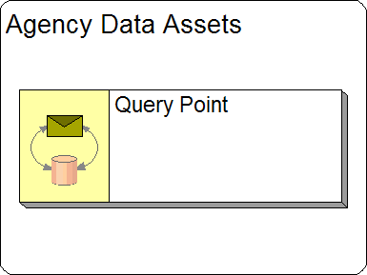

Step 2:
Ensure that all the required Properties indicated above have been defined.

Figure 2: Query Point Properties
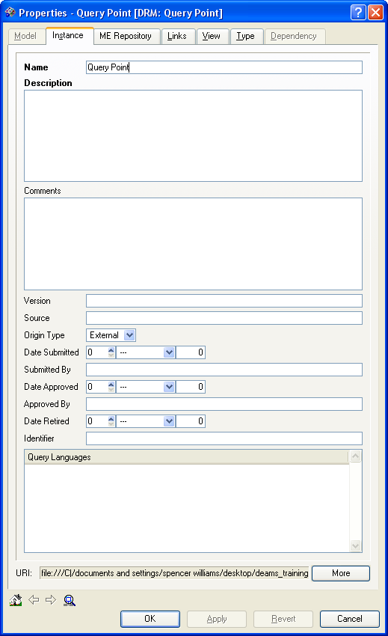
Name: This property is the name of an Agency Data Asset Query Point

Description: Describe specific information how this endpoint provides an interface for accessing and querying a Data Asset.

Step 3:
Ensure that all the required relationships indicated above have been established.
Figure 3: Query Point Relationships

Data Schema, Data Entity, Data Attribute and Data Entity Relationship
The following sections describe Agency Data Schemas and the objects that make up Data Schemas, Data Entities, Data Attributes, and Data Entity Relationships. The guidance for these objects is grouped together because they all relate to each other and many share a parent / child relationship. The image below shows a view of all four of these objects together.

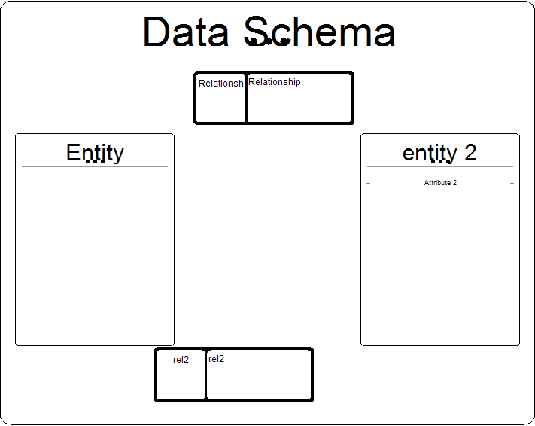

Data Schema
Description
A Data Schema is a representation of metadata, often in the form of data artifacts such as logical data models or conceptual data models. The Data Schema represents a specific context or model purpose. It includes the Data Entities and Data Relationships that model the information of the context.

Requirements:
A completed Data Schema object will contain the following information and linkages:
Table 37: Data Schema Requirements
Properties | Value
Name | Name of Data Schema
Description | Description of Data Schema
Relationship Type | Relates to
parent | DRM Data Entity
parent | DRM Relationship
describes structured | DRM: Data Asset
defines | Structured Data Resource

Guidance:
When developing a Data Schema the following steps are to be followed:

Step 1:
Create a new or modify a Data Schema object in the Agency Schema container
Figure 1: Data Schema Object
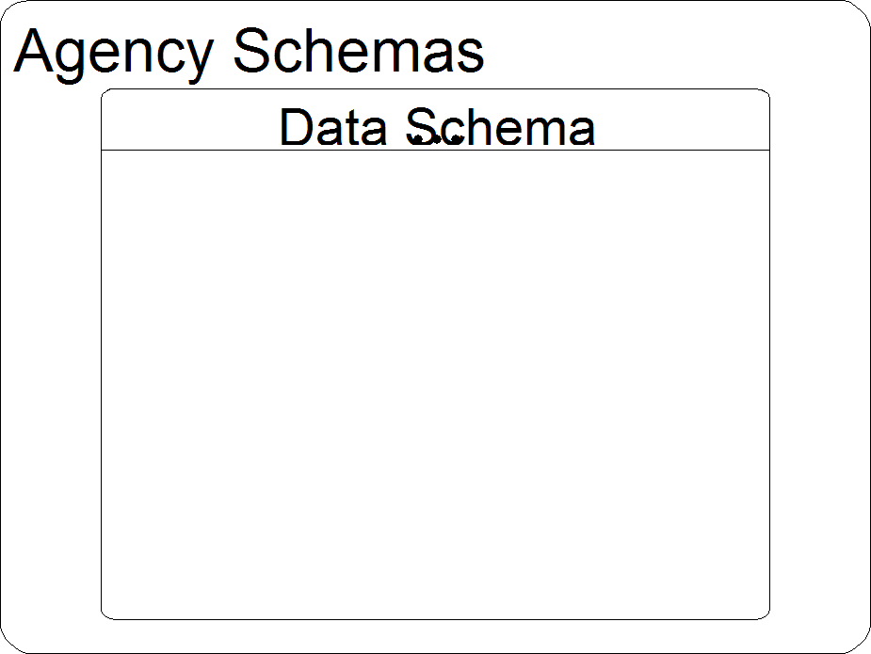

Step 2:
Ensure that all the required Properties indicated above have been defined.

Figure 2: Data Schema Properties
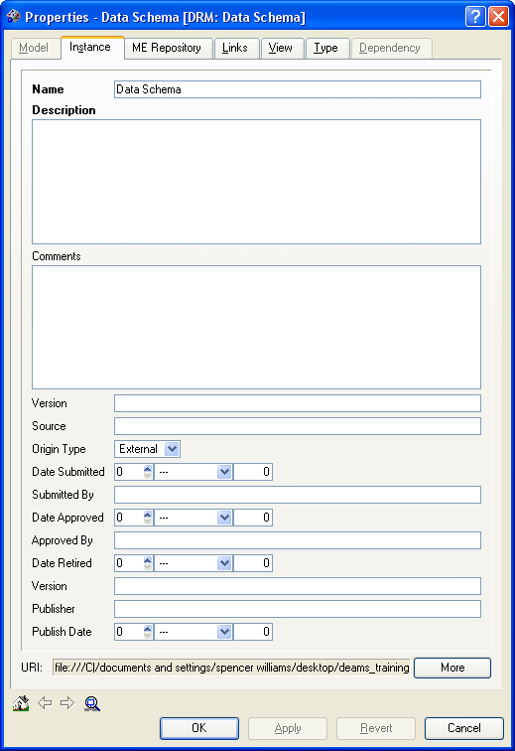
Name: This property is the name of an Agency Data Schema (Ex: Survey Data).

Description: Describe data artifacts such as logical data models or conceptual data models about the Data Schema

Step 3:
Ensure that all the required relationships indicated above have been established.
Figure 3: Data Schema Relationships

Data Entity
Description
A Data Entity is an abstraction for a person, place, object, event, or concept described (or characterized) by common Attributes. For example, “Person” and “Agency” are Entities. An instance of an Entity represents one particular occurrence of the Entity, such as a specific person or a specific agency.

Requirements:
A completed Data Entity object will contain the following information and linkages:

Table 38: Data Entity Requirements
Properties | Value
Name | Name of Data Entity
Description | Description of Data Entity
Relationship Type | Relates to
child | DRM Data Schema
parent | Data Attribute
to | DRM: Data Asset
is referred by | DRM: Document
exchanged by | Stakeholder Entity
used by | Application
categorized by | BRM: Sub Function
categorized by | DRM: Topic
participates in | DRM: Relationship
is used by | DRM: Exchange Package
related by | DRM: Relationship

Guidance:
When developing a Data Entity the following steps are to be followed:

Step 1:
Create a new or modify a Data Entity object inside the appropriate Agency Schema object (making the Data Entity the child of the Data Schema).
Figure 1: Data Entity Object
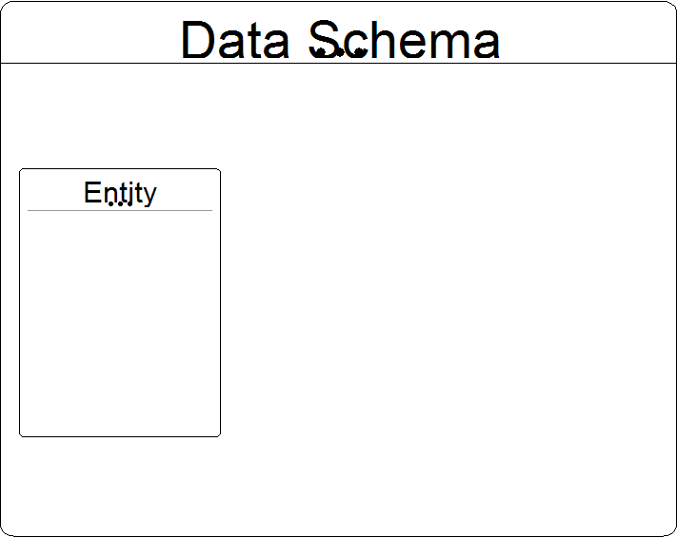

Step 2:
Ensure that all the required Properties indicated above have been defined.
Figure 2: Data Entity Properties
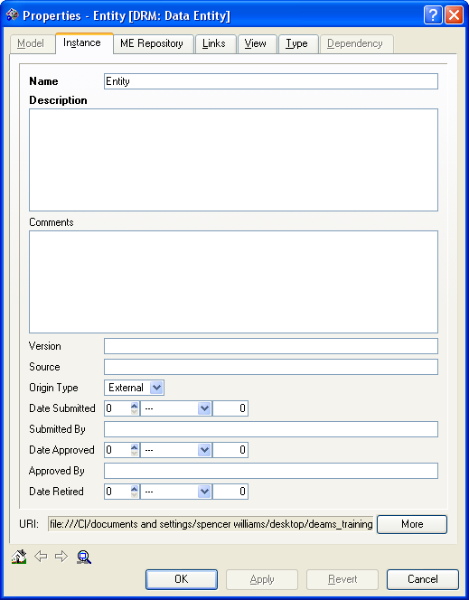
Name: This property is the name of an Agency Data Entity (Ex: Person and Agency are entities).

Description: Describe in more detail an abstraction for a person, place, object, event, or concept described (or characterized) by common Attributes.

Step 3:
Ensure that all the required relationships indicated above have been established.
Figure 3: Data Entity Object Relationships
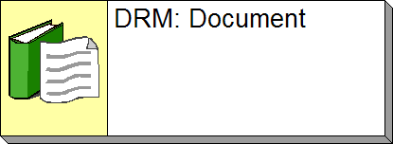

Note: Business Reference Model Mapping- Limit mappings to the Lines of Business, Sub-Functions, and Modes of Delivery described in the BRM. More information on the Consolidated Reference Models may be found at:
http://www.whitehouse.gov/omb/egov/documents/FEA_CRM_v20_Final_June_2006.pdf

DRM: Data Attribute
Description
A Data Attribute is a characteristic of an Entity whose value may be used to help distinguish one instance of an Entity from other instances of the same Entity. For example, an Attribute of a “Person” Entity may be “Social Security Number (SSN)”. An SSN is used to distinguish one person (i.e. one instance of a “Person” Entity) from another.

Requirements:
A completed Data Attribute object will contain the following information and linkages:

Table 39: Data Attribute Requirements
Properties | Value
Name | Name of Data Attribute
Description | Description of Data Attribute
Relationship Type | Relates to
child | DRM Data Entity
is used by | DRM: Exchange Package
constrained by | DRM: Data Type

Guidance:
When developing a Data Attribute the following steps are to be followed:

Step 1:
Create a new or modify a Data Attribute object inside the appropriate Agency Entity object (making the Data Attribute the child of the Data Entity).
Figure 1: Data Attribute Object
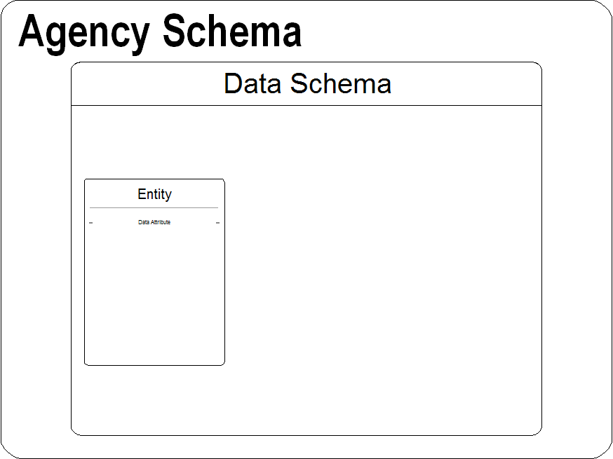

Step 2:
Ensure that all the required Properties indicated above have been defined.
Figure 2: Data Attribute Properties
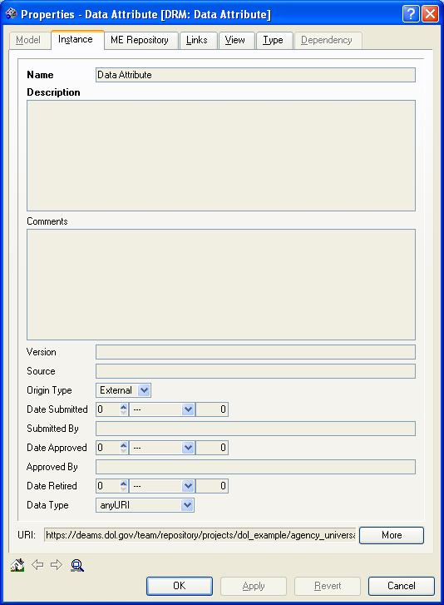
Name: A name of an attribute whose value is distinguished from other instances of the same Entity (Ex. Social Security Number).

Description: Provide detailed characteristics of each data attribute.

Step 3:
Ensure that all the required relationships indicated above have been established.
Figure 3: Data Attribute Relationships
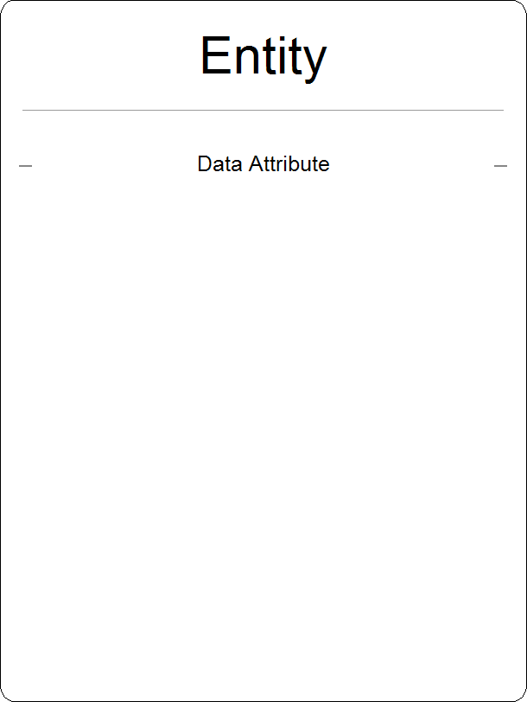

DRM: Data Entity Relationship
Description
A Data Entity Relationship describes the relationship between two Entities.

Requirements:
A completed Data Entity Relationship object will contain the following information and linkages:

Table 40: Data Entity Relationship Requirements
Properties | Value
Name | A short name describing the relationship
Description | Description of DRM Relationship
Relationship Type | Relates to
child | DRM Data Schema
has participant | DRM Data Entity
relates | DRM Data Entity

Guidance:
When developing a Data Entity Relationship the following steps are to be followed:

Step 1:
Create a new or modify Data Entity Relationship object inside the appropriate Data Schema object (making the Data Entity Relationship the child of the Data Schema).
Figure 1: Data Entity Relationship Object
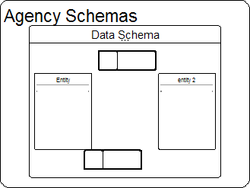

Step 2:
Ensure that all the required Properties indicated above have been defined.

Figure 2: Data Entity Relationship Properties
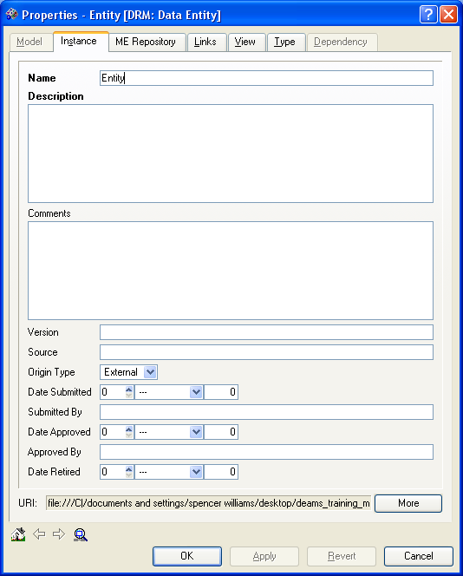
Name: This property is the name of an Agency Data Entity

Description: Describe the properties of each Entity

Step 3:
Ensure that all the required relationships indicated above have been established.
Figure 3: Data Entity Relationships
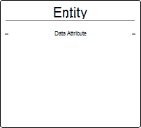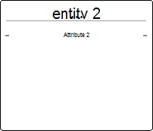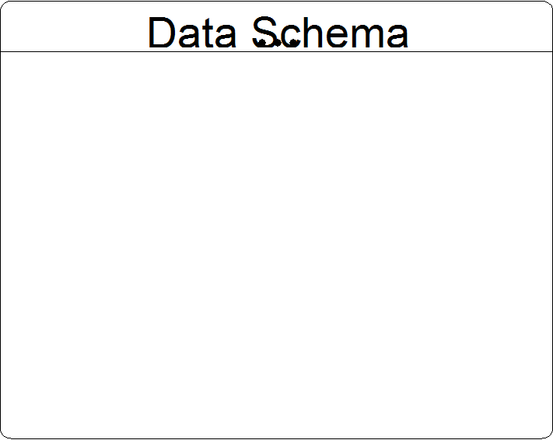

DRM: Taxonomy
Description
Taxonomy is a collection of controlled vocabulary terms organized into a hierarchical structure. Taxonomies provide a means for categorizing or classifying information within a reasonably well-defined associative structure, in which each term in Taxonomy is in one or more parent/child (broader/narrower) relationships to other terms in the Taxonomy.

Requirements:
A completed Taxonomy object will contain the following information and linkages:
Table 41: Taxonomy Requirements
Properties | Value
Name | Name of Taxonomy
Description | Description of Taxonomy
Relationship Type | Relates to
contains | DRM Topic

Guidance:
When developing a Taxonomy object the following steps are to be followed:

Step 1:
Create a new or modify Taxonomy object in the Agency Taxonomies / Topics container.
Figure 1: Taxonomy Object
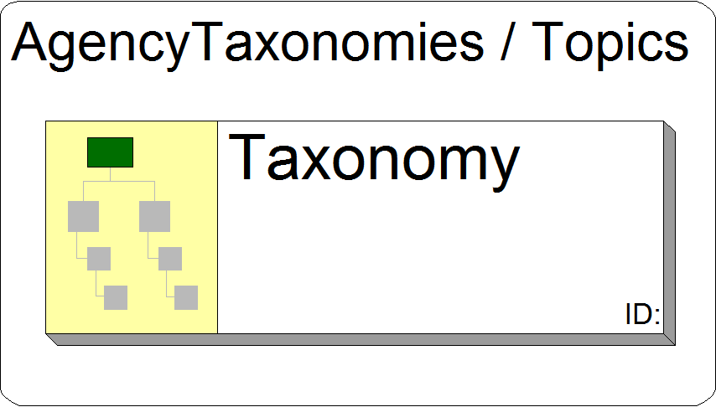

Step 2:
Ensure that all the required Properties indicated above have been defined.
Figure 2: Taxonomy Properties
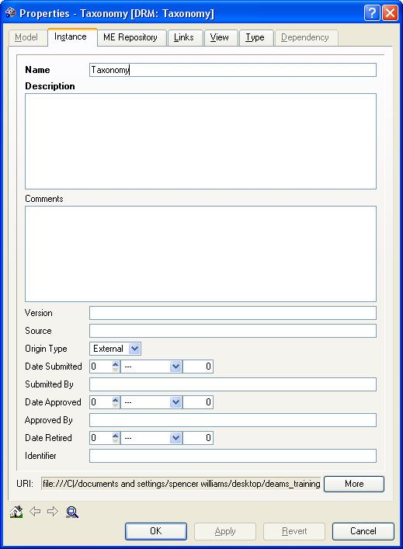
Name: This property is the name of an Agency DRM Taxonomy.

Description: Continue to define the categorization and classification of each associated structure within taxonomy.

Step 3:
Ensure that all the required relationships indicated above have been established.
Figure 3: Taxonomy Relationships

DRM: Topic
Description
A Topic is a category within Taxonomy. A Topic is the central concept for applying context to data. For example, an agency may have a Taxonomy that represents their organizational structure. In such Taxonomy, each role in the organizational structure (e.g. CIO) represents a Topic. Topic is often synonymous with “node”.

Requirements:
A completed Topic object will contain the following information and linkages:

Table 42: Topic Requirements
Properties | Value
Name | Name of Topic
Description | Description of Topic
Relationship Type | Relates to
relates | DRM Topic
participates in | DRM topic
categorizes | Query Point
categorizes | Exchange Package
categorizes | Data Entity
categorizes | Data Asset
categorizes | Structured Data Resources
categorizes | Unstructured Data Resources
categorizes | Semi-Structured Data Resources
child | Root DRM Topic
parent | Child DRM Topic
contained in | Taxonomy

Guidance:
When developing a Topic the following steps are to be followed:

Step 1:
Create a new or modify the Root Topic object in the Agency Taxonomies / Topics container. If children nodes are required, create a new or modify an existing Topic Object on the appropriate Topic object (making the Topic object a child object of another Topic Object).
Figure 1: Topic Object with Children and an Associated Taxonomy

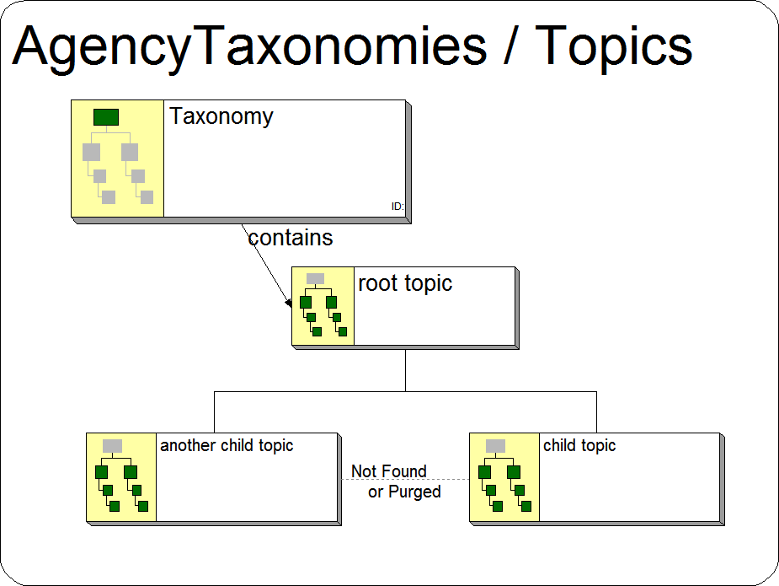

Step 2:
Ensure that all the required Properties indicated above have been defined.
Figure 2: Topic Properties
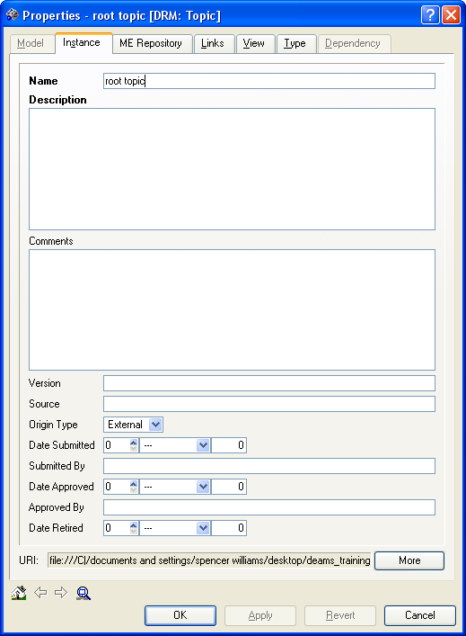
Name: This property is the name of an Agency DRM Topic.

Description: Describe specific information, central concept, relating each topic within a taxonomy.

Step 3:
Ensure that all the required relationships indicated above have been established.
Figure 3: Topic Relationships
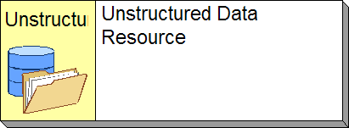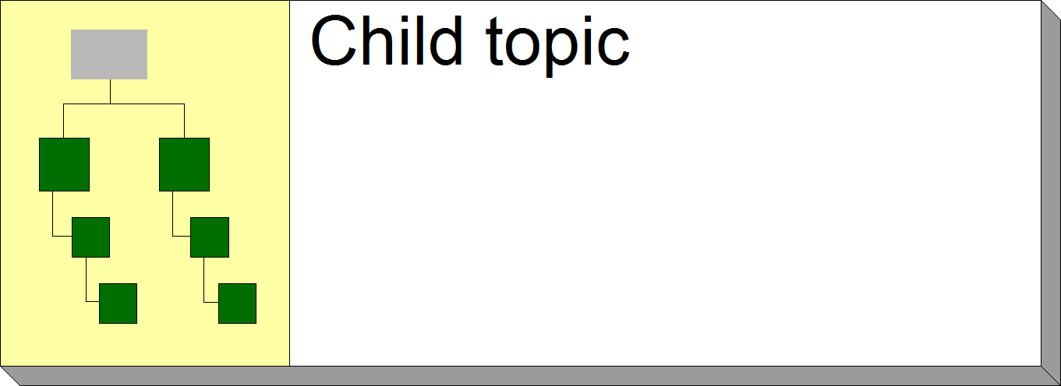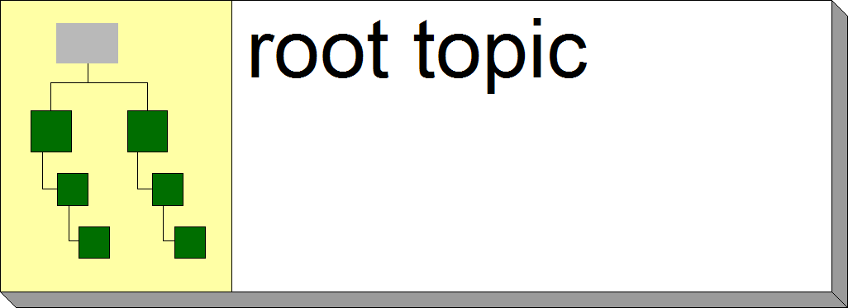

Agency Digital Data Resources
Digital Data Resources is essentially a container of information, typically known as a file. A Digital Data Resource may be of three specific types of data resources, each corresponding to one of the three types of data (Structured Data Resource, Semi-Structured Data Resource, and Unstructured Data Resource). These three types all share the same properties, relationships, and guidance.

Figure 1: Agency Digital Data Resources

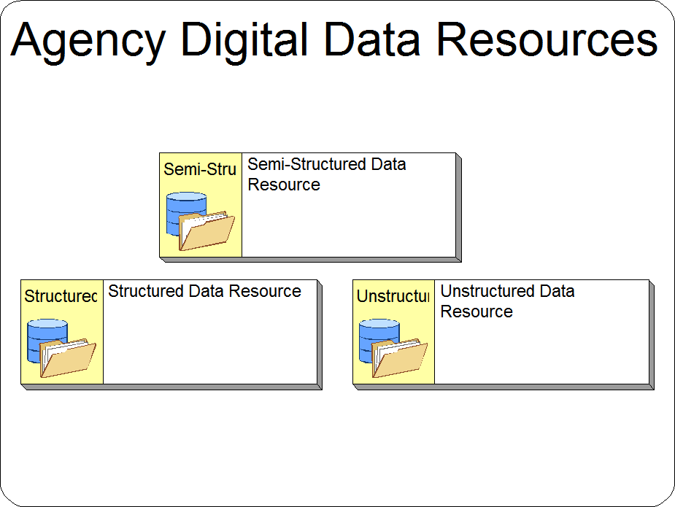

Definitions
- Structured Data Resource - A Digital Data Resource containing structured data. This data can be accessed in a uniform manner, independent of data values, once the Data Schema is known.
- Semi- Structured Data Resource - A Digital Data Resource containing semi-structured data. This will generally consist in part of structured data and in part of unstructured data.
- Unstructured Data Resource - A Digital Data Resource containing unstructured data. Unstructured data is collection of data values that are likely to be processed only by specialized application programs.

Requirements
Table 43: Digital Data Resources Properties
Properties | Value
Name | Name of Structured Date Resource
Description | Description of Data Resource
Relationship Type | Relates to
categorized by | DRM Topic
contained in | DRM Document
is managed by | DRM: Data Asset
*is defined by | Data Schema
*Used for Structured Data Resources Only

Guidance
When developing a Digital Data Resource the following steps are to be followed:

Step 1:
Create a new or modify an existing Digital Data Resource Object in the Agency Digital Data Resources container.
Figure 1: Structured Data Resource Object
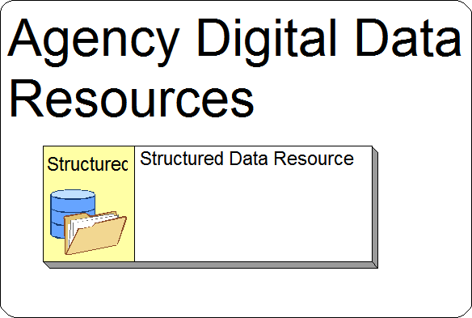

Step 2:
Ensure that all the required Properties indicated above have been defined.

Figure 2: Structured Data Resource Properties
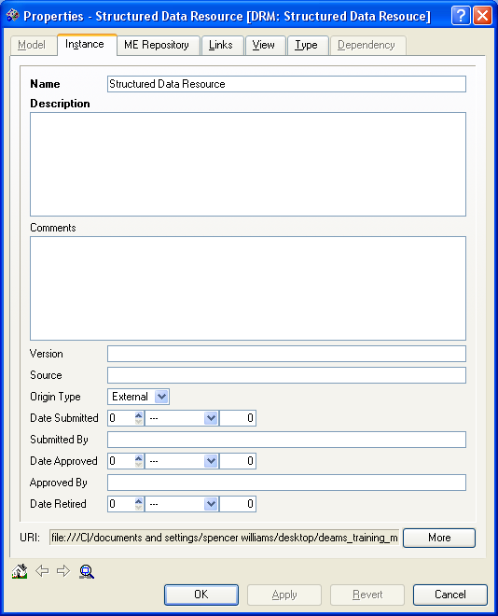
Name: This property is the name of a structured Data Resource

Description: Describe the properties of each Structured Resource

Step 3:
Ensure that all the required relationships indicated above have been established.
Figure 3: Structured Data Resource Relationships

DRM: Document
Description
A Document is a file containing Unstructured and/or Semi-Structured Data Resources.

Requirements:
A completed Document object will contain the following information and linkages:

Table 44: Document Requirements
Properties | Value
Name | Name of Document
Description | Description of Document
Relationship Type | Relates to
contains | Structured Data Resource
contains | Unstructured Data Resources
contains | Semi-Structured Data Resources
refers to | DRM Data Entity

Guidance:
When developing a Document the following steps are to be followed:

Step 1:
Create a new or modify Document object in the Agency Digital Data Resources container.
Figure 1: Document Object
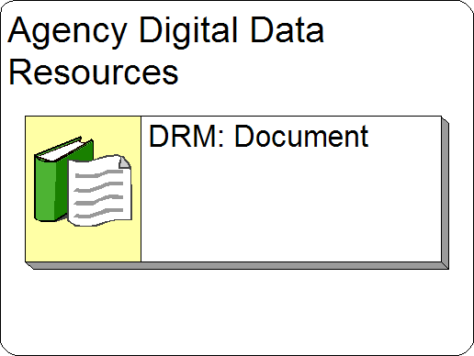

Step 2:
Ensure that all the required Properties indicated above have been defined.

Figure 2: Document Properties
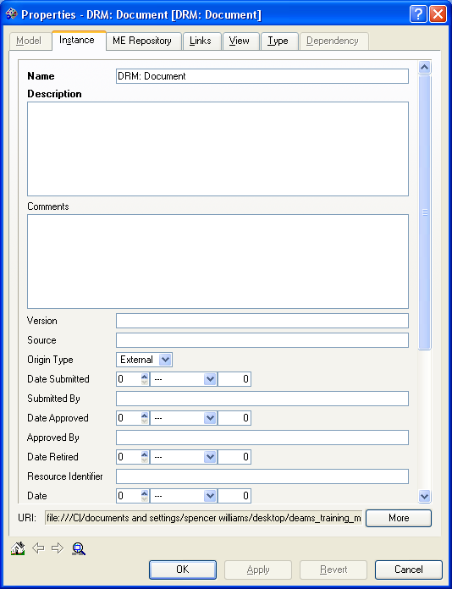
Name: This property is the name of an Agency Document.

Description: Describe the properties of each DRM Document

Step 3:
Ensure that all the required relationships indicated above have been established.
Figure 3: Data Document Relationships

Performance Architecture

Mission and Business Results Measurement Area
Definition:
The Mission and Business Results Measurement Area of the PRM are intended to capture the outcomes that agencies seek to achieve. These outcomes are usually developed during the agency budget and strategic planning process prescribed under GPRA, and approved by the PART.
*PART Linkage: If this investment is part of a program that is rated through PART, a Performance Indicator needs to be created to identify the PART rating and this Investments impact in the PART process.

For more information on the PART process please refer to the following website:
http://www.whitehouse.gov/omb/part/

Requirements:
A completed Mission and Business Results Measurement indicator object will contain the following information and linkages:
Table 45: Mission and Business Results Measurement Indicator Requirements
Properties | Value
Name | Measurement Indicator
Description | Description of Performance Indicator
Baseline | Baseline Performance Value
Relationship Type | Relates to
measures outcome_output of | Business Function
measures outcome_output of | Business Process
measures results for | Stakeholder Entity
To | PRM: Measurement Indicator Group
measures results of | Strategic Goal
measures results of | Strategic Performance Goal
measures results of | IT Strategic Goal
measures results of | Goal
measures results of | Performance Objective

Guidance:
When developing a Mission and Business Results Measurement indicator the following steps are to be followed:

Step 1:
Create a new or modify an existing Mission and Business Results Measurement indicator object in the Mission and Business Results Measurement Indicators container
Figure 1: Mission and Business Results Measurement Object
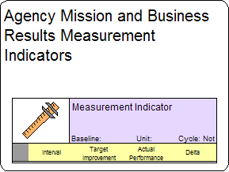
Step 2:
Ensure that all the required Properties indicated above have been defined.
Figure 2: Mission and Business Results Measurement Properties

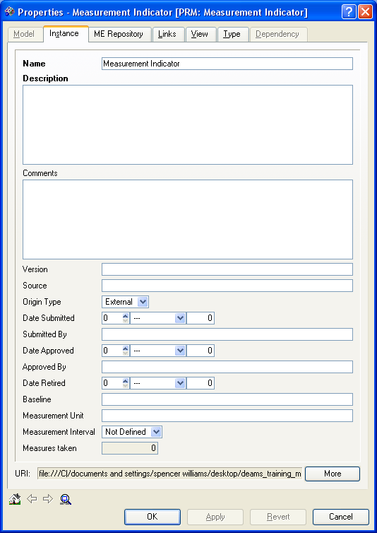
Name: This property is the name of a Measurement Indicator (Ex: Increase Help Desk Support Response Time).

Description: Describe the properties of each Measurement Indicator.

Step 3:
Ensure that all the required relationships indicated above have been established.

Figure 3: Mission and Business Results Measurement Relationships
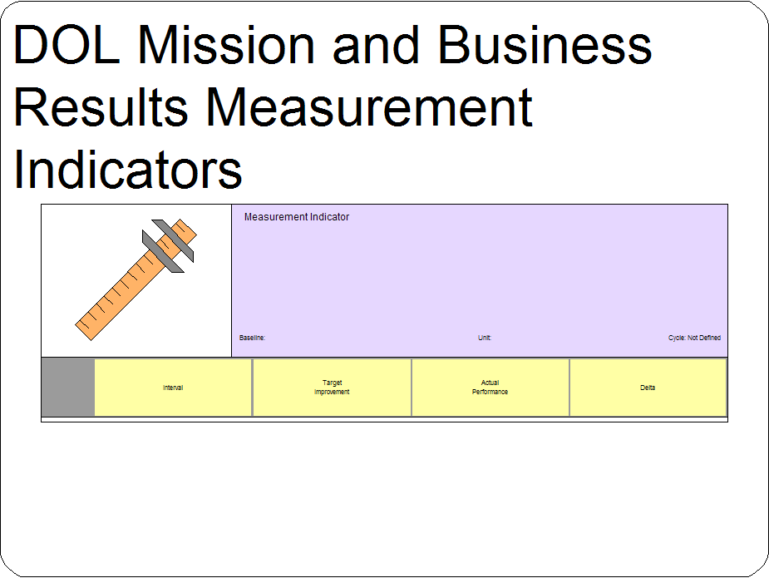

Customer Results Measurement Area
Definition:
The Customer Results Measurement Area of the PRM is intended to capture how well an agency or specific process within an agency is serving its customers. This is a critical aspect of successful E-Government.
Requirements:
A completed Customer Results Measurement indicator object will contain the following information and linkages:
Table 46: Customer Results Measurement Indicator Requirements
Properties | Value
Name | Measurement Indicator Name (seven words or less)
Description | Description of Performance Indicator
Baseline | Baseline Performance Value
Relationship Type | Relates to
measures outcome_output of | Business Function
measures outcome_output of | Business Process
measures results for | Stakeholder Entity
To | PRM: Measurement Indicator Group

Guidance:
When developing a Customer Results Measurement indicator the following steps are to be followed:

Step 1:
Create a new or modify an existing Customer Results Measurement indicator object in the Customer Results Measurement Indicators container
Figure 1: Customer Results Measurement Object
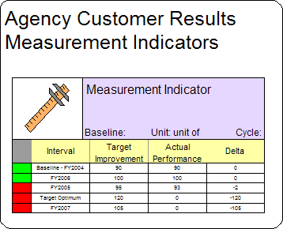
Step 2:
Ensure that all the required Properties indicated above have been defined.
Figure 2: Customer Results Measurement Properties
Name: This property is the name of a Measurement Indicator.

Description: Describe the properties of each Measurement Indicator.

Step 3:
Ensure that all the required relationships indicated above have been established.
Figure 3: Customer Results Measurement Relationships

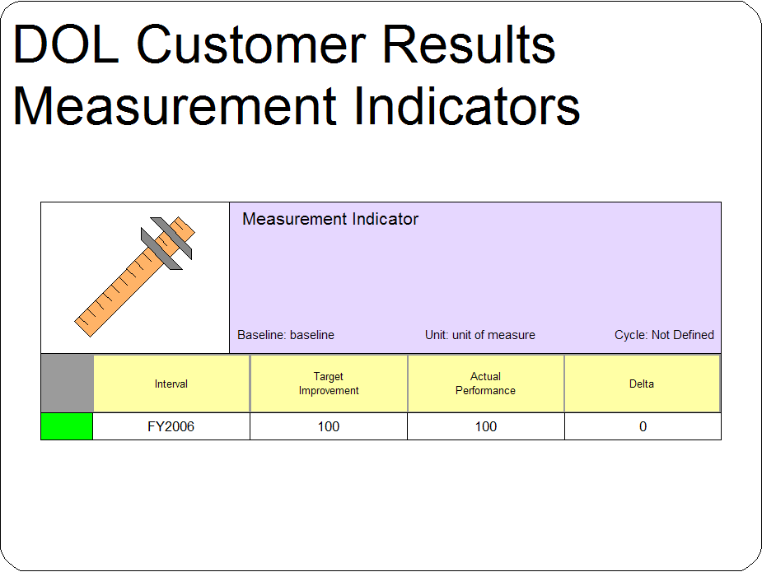

Processes and Activities Measurement Area
Definition:
The Processes and Activities Measurement Area is intended to capture the outputs that are the direct result of the process that an IT initiative supports. These outputs are much more under the control of federal programs and generally contribute to or influence outcomes that are Mission and Business Results and Customer Results. This Measurement Area also captures key aspects of processes or activities that need to be monitored and/or improved.
Requirements:
A completed Processes and Activities Measurement indicator object will contain the following information and linkages:
Table 47: Processes and Activities Measurement Indicator Requirements
Properties | Value
Name | Measurement Indicator Name (seven words or less)
Description | Description of Performance Indicator
Baseline | Baseline Performance Value
Relationship Type | Relates to
measures outcome_output of | Business Function
measures outcome_output of | Business Process
To | PRM: Measurement Indicator Group
measures performance of | Application Component
measures performance of | Application

Guidance:
When developing a Processes and Activities Measurement indicator the following steps are to be followed:

Step 1:
Create a new or modify an existing Processes and Activities Measurement indicator object in the Processes and Activities Measurement Indicators container
Figure 1: Processes and Activities Measurement Object
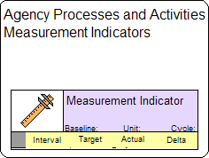
Step 2:
Ensure that all the required Properties indicated above have been defined.
Figure 2: Processes and Activities Measurement Properties
Name: This property is the name of a Measurement Indicator.

Description: Describe the properties of each Measurement Indicator.

Step 3:
Ensure that all the required relationships indicated above have been established.
Figure 3: Processes and Activities Measurement Relationships
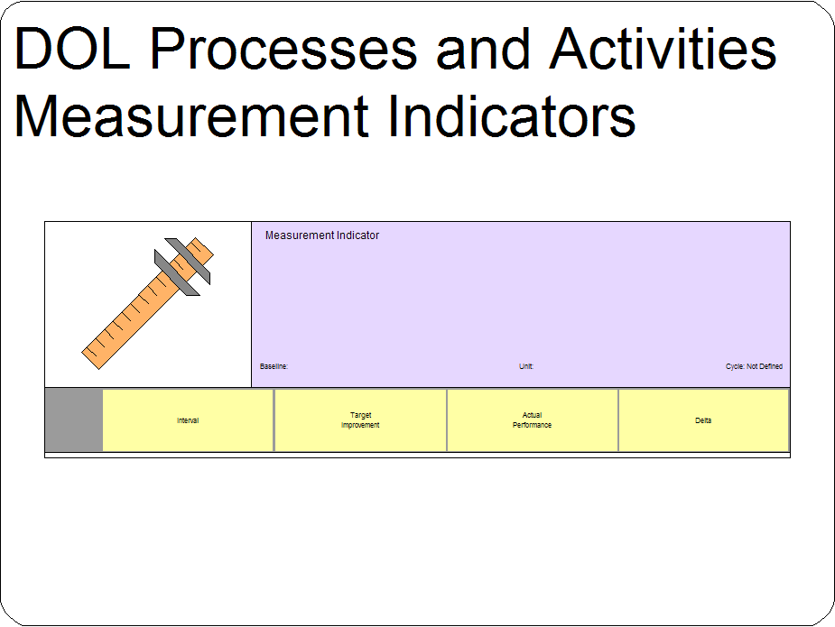

Technology Measurement Area
Definition:
The Technology Measurement Area is designed to capture key elements of performance that directly relate to the IT initiative. An IT initiative generally can include applications, infrastructure, or services provided in support of a process or program.
Requirements:
A completed Technology Measurement indicator object will contain the following information and linkages:
Table 48: Technology Measurement Indicator Requirements
Properties | Value
Name | Measurement Indicator Name (seven words or less)
Description | Description of Performance Indicator
Baseline | Baseline Performance Value
Relationship Type | Relates to
measures outcome_output of | Business Function
measures outcome_output of | Business Process
To | PRM: Measurement Indicator Group
measures performance of | Application Component
measures performance of | Application
measures performance of | Cabinet
measures performance of | Computing Hardware
measures performance of | Computer
measures performance of | Network Device
measures performance of | Desktop
measures performance of | Laptop
measures performance of | Server
measures performance of | Mainframe
measures performance of | Firewall
measures performance of | Load Balancer
measures performance of | Router
measures performance of | Storage Device
measures performance of | Switch
measures performance of | Backup Device
measures performance of | Disk Array
measures performance of | Tape Backup
measures performance of | Storage Area Network Switch

Guidance:
When developing a Technology Measurement indicator the following steps are to be followed:

Step 1:
Create a new or modify an existing Technology Measurement indicator object in the Technology Measurement Indicators container
Figure 1: Technology Measurement Object
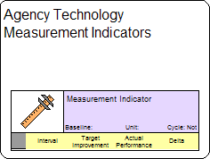
Step 2:
Ensure that all the required Properties indicated above have been defined.

Figure 2: Technology Measurement Properties
Name: This property is the name of a Measurement Indicators.

Description: Describe the properties of each Measurement Indicator.

Step 3:
Ensure that all the required relationships indicated above have been established.
Figure 3: Technology Measurement Relationships
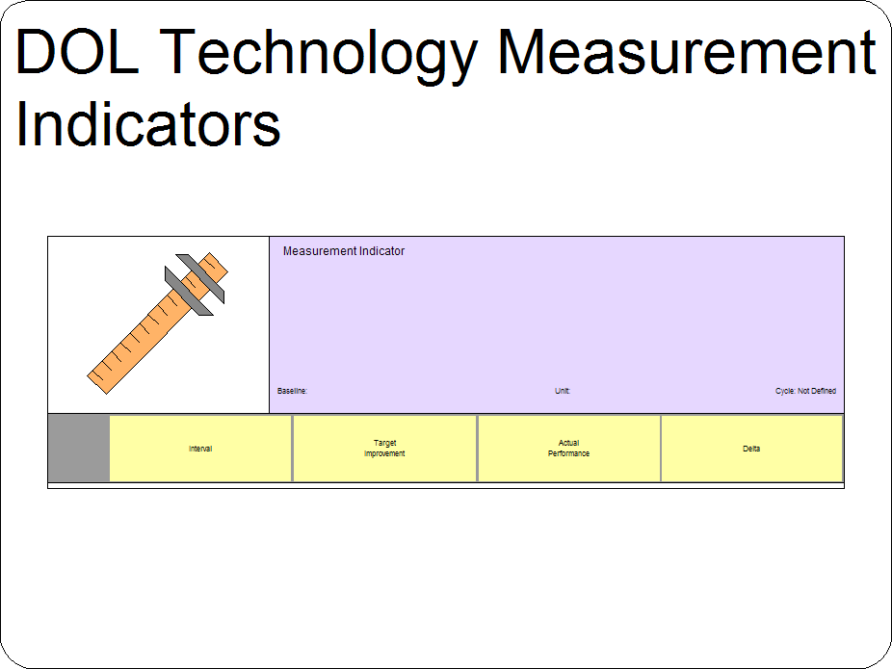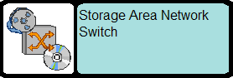

Performance Measurement Points
Definition:
A Performance Measurement Point is a single measurement instance where the target and actual results are recorded for a Performance Measurement Indicator described in the previous sections. In DEAMS a Measurement Point is a child object of a Measurement Indicator.

Requirements:
A completed Performance Measurement Point object will contain the following information and linkages:
Table 49: Performance Measurement Point Requirements
Properties | Value
Actual | Actual Performance Results
Target | Target Performance Results
Measurement Interval | Fiscal Year
Description | Description of Measurement point
Relationship Type | Relates to
child | PRM Measurement Indicator
delivered by | TSP Milestones
is starting point for | Performance Gap
is target point for | Performance Gap

Guidance:
When developing a Performance Measurement Point the following steps are to be followed:

Step 1:
Create a new or modify an existing Performance Measurement Point object on the appropriate Measurement Indicator in the appropriate Measurement Indicator container. As mentioned in the previous sections there are four different types of Measurement Indicators from which you are able to choose (Mission & Business Results, Technology, Processes & Activities, and Customer Results). In the Image below, a Customer Results Measurement Indicator and Measurement Point are illustrated.
Figure 1: Performance Measurement Point Object

Step 2:
Ensure that all the required Properties indicated above have been defined.

Figure 2: Performance Measurement Properties
Name: This property is the name of a Measurement Indicator.

Description: Describe the properties of each Measurement Indicator.

Step 3:
Ensure that all the required relationships indicated above have been established.
Figure 3: Performance Measurement Relationships

Performance Gap
Definition:
The Performance Gap object represents an identifiable gap between some measure (baseline or interim) and some future state measure (interim or target) that needs to be addressed.

*PART Linkage: If this investment is part of a program that is rated through PART and the PART rating is less than “effective”, a Performance Gap needs to be created to identify this issue.

For more information on the PART process please refer to the following website:
http://www.whitehouse.gov/omb/part/

Requirements:
A completed Performance Gap will contain the following information and linkages:
Table 50: Performance Gap Requirements
Properties | Value
Name | Performance Gap
Description | Description of Performance Gap
Comments | Description of how the Investment closes the performance gap.
Relationship Type | Relates to
addressed by | TSP Milestones
addressed by IT Invst | Business Case
*identified from | mission statement
*identified from | agency goal
*Identified from | agency performance objective
has starting | PRM: Measurement Point
has target | PRM: Measurement Point

* Depending on the Performance Gap, it is not likely that all three of the items identified above with an asterisk (*) apply. It is required to create the appropriate relationship for any that applies to this Performance Gap.

Guidance:
When developing a Performance Gap the following steps are to be followed:

Step 1:
Create a new or modify an existing Performance Gap object in the Agency Performance Gap container.
Figure 1: Performance Gap Object
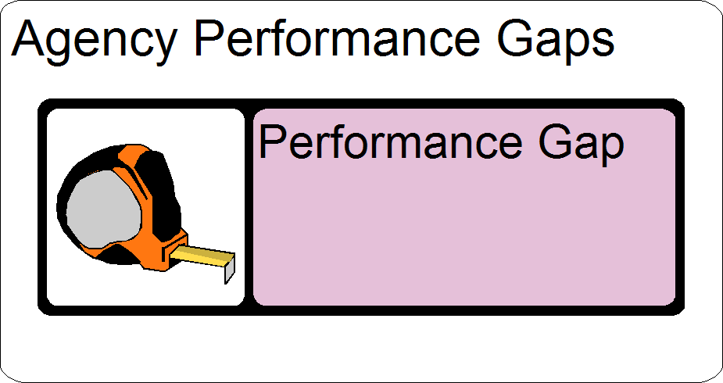

Step 2:
Ensure that all the required Properties indicated above have been defined.
Figure 2: Performance Gap Properties
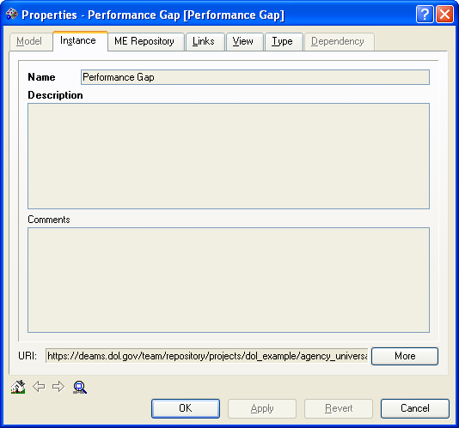
Name: Descriptive title to explain the gap between a measure and some future state measure (Ex: Lack Appropriate Technical Infrastructure).

Description: Description of how the Investment closes the performance gap.
Comments: Additional descriptive information that can be used to fully address the Performance Gap needs.

Step 3:
Ensure that all the required relationships indicated above have been established.
Figure 3: Performance Gap Relationships
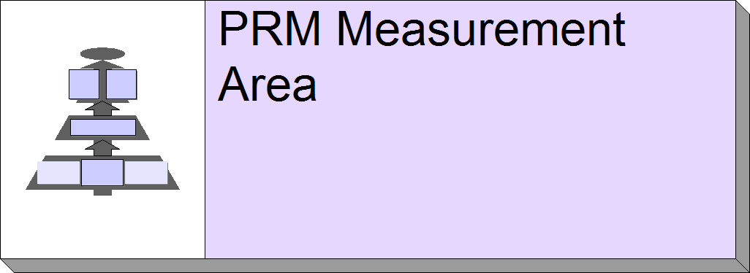

Building the Agency Security Architecture
The Security Domain describes the aspects of security that relate to Enterprise Architecture. Currently, this domain contains the Data Access Right and Security Processes types.

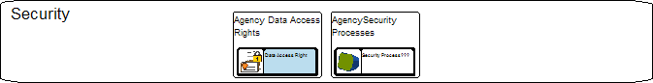

Agency Security Processes
Definition:
Security processes are key activities which monitor, coordinate and standardize an agency’s entire EA Program. Security Processes also help to ensure compliance with both internal and external policies and drivers.

Requirements:
A completed Security Process object will contain the following information and linkages:

Table 51: Agency Security Process Requirements
Properties | Value
Name | Name of Security Process
Description | Description of Security Process
Relationship Type | Relates to
assigned to | Role

Guidance:
When developing an Agency Security Process the following steps are to be followed:

Step 1:
Create a new or modify an existing Security Process object in the Data Access Rights container
Figure 1: Security Process Object

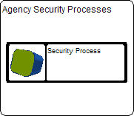

Step 2:
Ensure that all the required Properties indicated above have been defined.
Figure 2: Security Process Properties
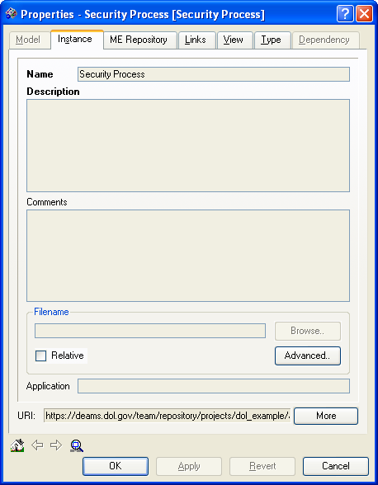
Name: This property is the specific name of a Security Process (Ex: System Categorization Approval Process).

Description: Include more detail surrounding the process for this security object.

Step 3:
There are currently no associated relationships established for the Security Process.

Agency Data Access Rights
Definition:
The level (or degree) of access that is permitted (e.g., no access, read only, etc.)

Requirements:
A completed Data Access Right object will contain the following information and linkages:

Table 52: Data Access Right Requirements
Properties | Value
Name | Name of Data Access Rights
Description | Description of Data Access Right
Relationship Type | Relates to
assigned to | Role

Guidance:
When developing an Agency Data Access Right the following steps are to be followed:

Step 1:
Create a new or modify an existing Data Access Right object in the Data Access Rights container.
Figure 1: Data Access Right Object
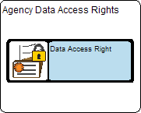

Step 2:
Ensure that all the required Properties indicated above have been defined.
Figure 2: Data Access Right Properties
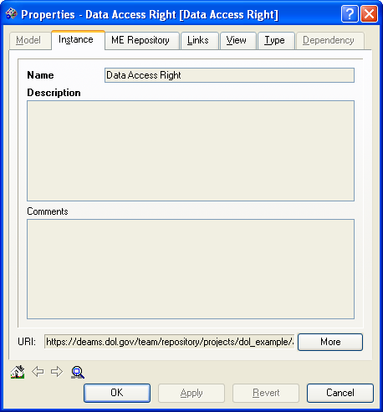
Name: This property is the name of an Access Right (ie. read only, no access).

Description: Include more detail surrounding the level of access for each Data Access Right.

Step 3:
Ensure that all the required relationships indicated above have been established.
Figure 3: Data Access Right Relationships
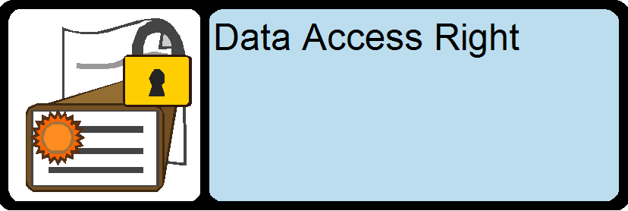

Security Requirements and Capabilities
In this section, please identify your agency’s business-supportive security and privacy requirements and the existing or planned capabilities that support security and privacy
- Fully identify program and enterprise-level security and privacy requirements, including previously unknown requirements.
- Fully identify program and enterprise-level security and privacy capabilities, including current and planned future requirements.

For more details, the Security and Privacy profile can be found at:
http://www.whitehouse.gov/omb/egov/documents/FEA_SPP_Ver2.pdf

Security / Privacy Requirement
Definition:
An appropriate safeguard to ensure that the confidentiality, integrity and availability of a specific set of information, networks or computers are assured.

Requirements:
A completed Security / Privacy Requirement object will contain the following information and linkages:
Table 53: Security / Privacy Requirements
Properties | Value
Name | Name of Privacy/Security Requirement
Description | Description of Privacy/Security Requirement
Relationship Type | Relates to
aligns to | Privacy/Security Control Family

Guidance:
When developing an Agency Security / Privacy Requirement the following steps are to be followed:

Step 1:
Create a new or modify an existing Security / Privacy Requirement object in the Security container.

Step 2:
Ensure that all the required Properties indicated above have been defined.

Step 3:
Ensure that all the required relationships indicated above have been established.

Agencies may evaluate three types of requirements:
- Externally driven laws, regulations, and executive branch policies;
- Internally driven policies, interagency agreements, contracts, market practices, and organizational preferences; and
- Mission-centric drivers such as performance objectives and lines of business.

For more details, the Security and Privacy profile can be found at:
http://www.whitehouse.gov/omb/egov/documents/FEA_SPP_Ver2.pdf

Security / Privacy Capability
Definition:
Security Capabilities are controls that provide confidentiality, integrity and availability for
information assurance.

Requirements:
A completed Security / Privacy Capability object will contain the following information and linkages:
Table 54: Security / Privacy Capability
Properties | Value
Name | Name of Privacy/Security Capability
Description | Description of Privacy/Security Capability
Relationship Type | Relates to
aligns to | Privacy/Security Control Family

Guidance:

When developing an Agency Security / Privacy Capability the following steps are to be followed:

Step 1:
Create a new or modify an existing Security / Privacy Capability object in the Data Access Rights container.

Step 2:
Ensure that all the required Properties indicated above have been defined.

Step 3:
Ensure that all the required relationships indicated above have been established.

Agencies may to evaluate three types of capabilities:
- Centralized security or privacy services and technologies,
- Program or system-specific security or privacy services and technologies; and
- Services or technologies with built-in security or privacy features.

For more details, the Security and Privacy profile can be found at:
http://www.whitehouse.gov/omb/egov/documents/FEA_SPP_Ver2.pdf

Security / Privacy Control Family
Definition:
A collection of security and privacy controls that are all related.

Guidance:
When developing an Agency Security / Privacy Control Family the following steps are to be followed:

Step 1:
Locate the appropriate Security / Privacy Control Family object in the Security Requirements and Capabilities container. This container exists in the “DOL Wide Internal Common Components” container within DEAMS.

Step 2:
Ensure that all the required relationships indicated above have been established.

Please use Appendix H and I for Security and Privacy Control Family listings.
For more details, the Security and Privacy profile can be found at:
http://www.whitehouse.gov/omb/egov/documents/FEA_SPP_Ver2.pdf

Building the Agency EA Governance

EA Governance Process
Definition:
Governance processes are key activities which monitor, regulate, coordinate, standardize, and synchronize an agency’s entire EA Program. Processes also help to ensure compliance with both internal and external policies and drivers.
Within DEAMS governance process objects should provide detailed descriptions of the processes the Agency EA governance program has in place, including:
- Processes to update an agency’s Target EA and Transition Strategy Plan
- Processes used to ensure all existing and proposed investments are compliant with the agency and Department Target EA
- Processes to communicate and remediate non-compliant investments
- Processes to determine how EA is used to drive agency business decisions
- Processes to determine how the agency’s governance structure interfaces with the Department’s governance structure

Requirements:
A completed Governance Process object will contain the following information and linkages:
Table 55: Governance Process Requirements
Properties | Value
Name | Governance Process
Description | Description of Governance Process
Filename | Indicate the location of the Governance Framework File
Relationship Type | Relates to
Is scoped by | Governance Team member

Guidance:
When developing a Governance Process the following steps are to be followed:

Step 1:
Create a new or modify an existing Governance Process object in the Agency Governance container
Figure 1: Governance Process Object
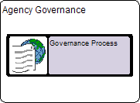

Step 2:
Ensure that all the required Properties indicated above have been defined.
Figure 2: Governance Process Properties
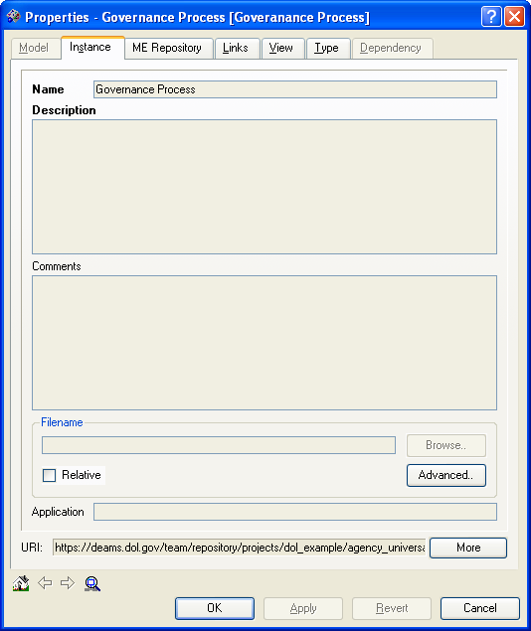
Name: A descriptive name of a Governance Process (five to seven words, Ex: Segment Architecture Review Process).

Description: Provide a brief overview of Governance Process

Filename: If not providing detailed process descriptions in for the comment property, attach the file containing the detailed descriptions here.

Step 3:
Ensure that all required relationships indicated above have been established.
Figure 3: Governance Process Relationships
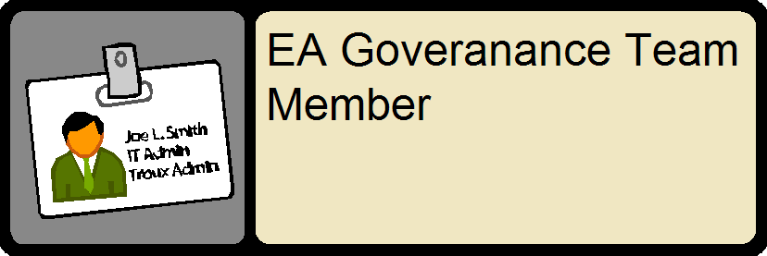
Governance process objects should provide a detailed description of the different processes the agency’s EA Governance Framework has in place, including:
- Processes to update an agency’s Target EA and Transition Strategy Plan
- Processes used to ensure all existing and proposed investments are compliant with the agency and Department Target EA
- Processes to communicate and remediate non-compliant investments
- Processes to determine how EA is used to drive agency business decisions
- Processes to determine how the agency’s governance structure interfaces with the Department’s governance structure

Internal EA Governance Team
Definitions:
Internal EA Governance Team members are tasked with providing EA and investment oversight at the agency level. Within DEAMS, governance team members should be identified by role/title not by specific names (i.e. Agency CIO). These members should have a common understanding of both EA and investment requirements (SDLC, CPIC, etc). Governance team members should be in a position to make informed decisions [with to finite resources] to effectively attain the desired outcome(s). Governance team members adhere, use, and provide guidance around the governance processes identified in the previous section.

Although, there is no need to provide specific names for governance roles in DEAMS, each agency should document (outside of DEAMS) team member names, roles, and responsibilities. Typically, this is done via a Governance Plan and/or Charter. Moreover, it’s recommended that agencies document and retain (outside of DEAMS) governance team meeting minutes, action items, and issue logs.

Within DEAMS, Governance Team Member objects should identify agency EA Governance team members by role across all architectural layers. The table below demonstrates who, ideally, should sit on an Internal Governance Team. The role description for this object should document about how this role impacts and is involved with the specific EA Governance process.

EA Governance Team Member Title | Role Description
Business Manager | Manages/monitors business requirements; recommends updates to Target EA. Acts as liaison between departmental workgroups and applicable agency committees.
Program Manager | Manages/monitors investment/initiative requirements; recommends updates to Target EA. Acts as liaison between departmental workgroups and applicable agency committees.
Systems Architect | Manages/monitors system development and maintenance; recommends updates to Target EA. Acts as liaison between departmental workgroups and applicable agency committees.
Security Architect | Manages/monitors security architecture, requirements, and infrastructure; recommends updates to Target EA. Acts as liaison between departmental workgroups and applicable agency committees.
Data Architect | Manages/monitors data architecture and data controls; recommends updates to Target EA. Acts as liaison between departmental workgroups and applicable agency committees.

Requirements:
A completed Governance Process object will contain the following information and linkages:
Table 56: Governance Team Member Requirements
Properties | Value
Name | Team Member Role
Description | Description of Role
Relationship Type | Relates to
Has scope of | Governance Process

Guidance:
When developing a Governance Team Member the following steps are to be followed:

Step 1:
Create a new or modify an existing Governance Team Member object in the Agency Governance container
Figure 1: Governance Team Object
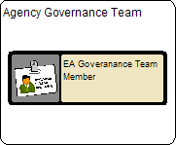

Step 2:
Ensure that all the required Properties indicated above have been defined.

Figure 2: Governance Team Member Properties
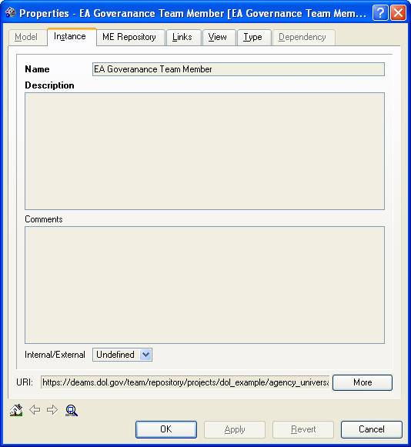
Name: A descriptive name of a Governance Team Member (Ex: Business Architect).

Description: Provide a detailed description of the Governance Team Members role.

Step 3:
Ensure that all the required relationships indicated above have been established.
Figure 3: Governance Process Relationships

Building the Agency Transition Strategy

Transition Overview

The EA transition strategy is a critical component of an effective EA. It describes the overall plan for an organization to achieve the target (“to-be”) architecture within a specified timeframe. It clearly links proposed agency investments to the target architecture. Also, the transition strategy helps to define logical dependencies between transition activities (programs and projects) and the relative priority of these activities (for investment purposes). Essentially, it is the multi-year plan to coordinate agency initiatives toward achieving the target architecture.

To create the transition strategy, both the baseline architecture and the target architecture should already be documented. The required detail and completeness of the baseline architecture should be to the level necessary for it to serve as the starting point for the transition strategy. The EA transition strategy should address the multi-year timeframe for which the agency’s target architecture is defined (typically three to five years). As an agency’s baseline and target architectures are updated periodically, the EA transition strategy should also be updated accordingly.
The transition strategy is developed through a few major steps. The details of how these steps are performed can vary from agency to agency based on a variety of factors, such as the organizational complexity of the agency, the scope of the agency’s mission, and agency governance processes. The major steps to develop the transition strategy are:
- 0. Establish baseline and target architectures (and identify segments);
- 1. Perform redundancy and gap analyses;
- 2. Refine and prioritize architecture segments;
- 3. Lay out the enterprise sequencing plan;
- 4. Develop segment architectures; and
- 5. Define programs and projects.

Each of these steps is described in more detail below, leading to investment management and implementation

Transition Components & DEAMS
In previous years the Transition Strategy has been maintained independently from the Agency Target EA; however this year the data and reporting capabilities for these two components will be managed through DEAMS. Many of the components of an Agency Transition Strategy are delivered in narrative format. Using the Transition objects in DEAMS Agencies will be able to either store this narrative as a property on the object or attach the actual word document to the Transition object. The image below illustrates the Transition Strategy Layer of the Agency EA.

Figure 1: Agency Transition Strategy Layer

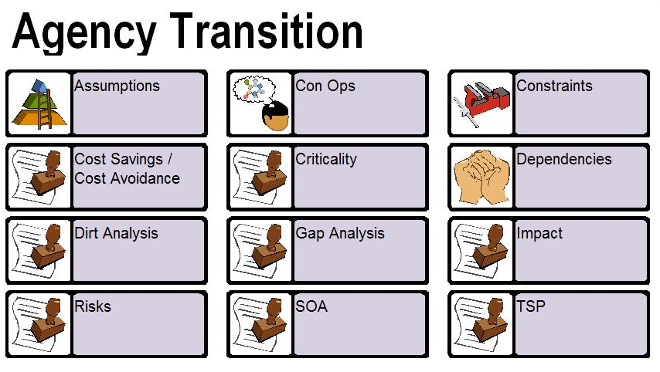
Each of the objects above represents the specific components of an Agency TSP equivalent to the different sections of the TSP document previously submitted in Word format. All TSP objects follow a similar structure, requirement list, and guidance. The sections below first describe the object type and requirements used for all TSP objects. Then a detailed description is provided for each Transition Strategy object. Last, a set of guidance is provided that can be used for all Transition Strategy objects.

All TSP objects use the same “online document” object type in DEAMS. The significance of this object type is that allows EA modelers to associate a file with the object (i.e. Word document or PDF file). Because a majority of the information in the Agency Transition Strategy comes in narrative form, this object type is best for capturing the TSP information.
Also if modelers would rather store all TSP information in the DEAMS TSP object, instead of in a separate attached file, the Comments property for the online document can store virtually limitless amounts of text. It is the Agency’s decision whether to attach narrative information from an external document or to use the Comments property. Storing the narrative information in the comments property makes it very easy to manage and only requires the Agency to maintain this information in one location. However, for Agency’s that already develop and maintain certain TSP components in Word or a PDF, attaching the file is very easy also.*

* It is important to realize that any information stored in a file that is attached to an object in DEAMS is static. This means that any time a Word document or PDF is updated externally to DEAMS it needs to also be updated in DEAMS.

TSP Object Descriptions
The sections below provide detailed descriptions for all the objects that make up an Agency’s Transition Strategy plan. There is also helpful information around developing the content for each of these objects

TSP- Transition Strategy Plan
The TSP object serves as an anchor point within DEAMS for the Agency Transition Strategy. All other TSP components below will link to this TSP object. The TSP reporting functionality in DEAMS starts with this TSP object and builds the TSP report using all the other objects linked to it.

The name for the TSP object will always be the Agency Acronym followed by “- TSP”, i.e. OASAM –TSP. The comments property for this object will contain an introduction and overview of the Agency Transition Strategy Plan.

Performance Gap Analysis
When performing this performance gap analysis, it was important to:
- Determine how/if to fill the gaps and in what sequence
- “Itemize” the gap between current view and what’s required to support the business processes in the target view
- Begin to bring together Application, Information, Organization and Technology Planning
- Consider that many of the gaps can be “cultural” and need a lot of time to change, along with continuous reinforcement to maintain, once changed

Gap Analysis is one of the primary artifacts required to develop an actionable EA, with a functional transition and sequencing plan. The objective is to clearly state where you are, where you plan to be, and what are the necessary components, initiatives, and projects (with a respective timeline), to get you there. The Gap Analysis is a structured technique by which the differences between the current state and target state are identified and analyzed. The Gap Analysis is intended for discussion, development, and implementation of a management plan that is both actionable and economically feasible.

This Gap identifies the key opportunities for improvement that could assist the enterprise to more effectively meet these target mission objectives. The performance gaps between current view and target view will help identify areas were changes to architecture should be made. This may occur before an investment decisions have been made. These could include “functional” gaps which focus on putting technology in place to enable new or improved business processes, such as the UDTI initiative to integrate nine infrastructure networks into one for more consolidated and integrated mission support. Or these gaps could be “structural” gaps that focus on incorporating new business process capabilities, such as GovBenefits. For GovBenefits, DOL is the managing partner responsible for managing the GovBenefits.gov program, website development and maintenance, stakeholder relationships management, internal and external communications, and benefit program acquisition and analysis. DOL works with nine additional Federal partner organizations with a shared vision to provide improved, personalized access to government assistance programs.

Please use the following format to capture the Gap Analysis of the investment. Describe the “Current View” against the “Target View” of the initiative to identify/address the “Performance Gaps”. List the “Actions” that have been or will be undertaken to fill the aforementioned gaps.

Gap Analysis Format

CURRENT VIEW:
- Identify Current View for the Investment
PERFORMANCE GAP / ROADMAP:
- Identify Performance Gap / Roadmap for the Investment
ACTIONS:
- Identify Actions for the Investment to Close Performance Gaps
TARGET VIEW:
- Identify Target View after Performance Gaps are closed

Sample UDTI Performance Gap Analysis

CURRENT VIEW:
- Currently funded and individually managed by nine major agencies within DOL.
- Eleven disparate networks with separate processes, standards, and protocols
PERFORMANCE GAP / ROADMAP:
- Current environment is suboptimal and places significant obstacles in the way of meeting future business requirements.
- Redundant software licenses
- Lack of common incident and change management processes
- Cumbersome and redundant implementation of security and other mandated requirements
- Limited communications between agencies.
ACTIONS:
- Support DOL and agencies operational effectiveness and efficiency by achieving significant savings through cost avoidance.
- Reduce and eliminate duplicate / redundant infrastructure components through consolidation into Department-wide infrastructure services all within common service management and security management frameworks while ensuring the protection of confidential data.
- Create a unified and coordinated security framework for the protection, privacy, national security requirements of resources: information: equipment, information, and people (privacy and national security).
- Provide an effective and efficient delivery and management infrastructure for e-Gov initiatives.
- Increase the protection and recovery of the services in accordance with stated business mission needs of DOL and its agencies.
- Implement a common Incident and Change Management process.
TARGET VIEW:
- Common Incident and Change Management processes
- Creation of a consolidated Network Operations Center (NOC)
- Creation of a Consolidated Security Operations Center (SOC)
- Department-wide Secured Remote Access Services (SRAS)
- A common robust communication network
- A common technology infrastructure across all agencies

Criticality and Impact
The criticality and impact are graded according to the criticality of the function to DOL's mission, the number of agencies affected (by High number (H), Medium number (M), and Low number (L)) and what the impact of the function is on the business of DOL. Associated comments further explaining these designations are listed under "comments”. Please use the format below to capture the Criticality and Impact of the investment.

Example of Criticality and Impact

Name: e-Procurement Criticality and Impact
Description:
Criticality of Function: High
Agencies Impacted: High
Impact on the Business: High
Comments: None

Assumptions, Constraints & Dependencies
Assumptions, constraints, and dependencies will play a vital role in the developmental success of DOL’s architecture. Assumptions allow for the Department to visualize potential components that may affect the development of a particular artifact, consolidation efforts, alignment with the EA, etc. Constraints assist in the decision process by identifying potential roadblocks as well as begin the thought process for alternative solutions if one of the constraints comes to life. Dependencies show how different components of an Agencies EA directly or indirectly rely on each other.
Some helpful hints for developing the Assumption, Constraint, and Dependency objects are:
- To show how any project assumptions related to business, technology, resources, scope, expectations, or schedules.
- Develop project assumptions based on the current knowledge today, do not incorporate any unknowns.
- Describe the principal constraints and limitations impacting the project. These often include timelines, resource availability or competence, funding, and other important environmental issues within the organization.
Examples of the assumptions are:
- Sufficient available network capacity to support anticipated transaction volumes
- Target technology environment will be based on FEA and DOL EA framework
- Agency will have adequate skilled staff
- Investment will be 508 complaint, operating platform constraints, application supported
- Demand for DOL's web services will continue to climb during the life cycle of this investment.

Examples of constraints are:
- The available bandwidth is not enough to support the anticipated transaction volumes.
- The geographic dispersion of our offices could hinder communication and implementation schedules
- The IT Skills of our staff is not at a level to handle new system functionality and will require signification training.
Examples of dependencies are:
- The implementation of our budget system is dependent upon the completion of the agency’s financial management solution
- The implementation of our target solution is dependent upon the implementation of a Departmental Document Management System
- Our Target Architecture cannot be completed until the Managing Line of Business Government Partner defines their Target Enterprise Architecture
- The release of our reporting functionality is dependent upon Vendor completion
Please use following Legend below to complete the Assumptions, Constraints, and Dependency Table:
Category:
- Scope
- Schedule
- Funding
- Resources
- Skill Level
- Sponsorship
- Customers
- Technology
- Vendor
- Policy
- Partners & Business Relationships
- Other

Risks
For all investments, both IT and non-IT, identify the risks and present your plans to eliminate, mitigate, reduce or manage risk, with milestones and completion dates. If there are other risks, other than the following risk categories please include them. All the stakeholders should contribute in identifying the risks. It should be performed at the initial concept stage and then monitored and controlled throughout the life-cycle of the investment. Risk assessments for all investments may include:
- Schedule
- Initial Costs
- Life-cycle costs
- Technical obsolescence
- Feasibility
- Reliability of Systems
- Dependencies and Interoperability between this investment and others
- Surety (asset protection) considerations
- Risk of creating a monopoly for future procurements
- Capability of agency to manage the investment
- Overall risk of investment failure.

In addition, for IT investments, risks can be discussed in the following categories
- Organizational and change management
- Business
- Data/Info
- Technology
- Strategic
- Security
- Privacy
- Project resources.

When creating a Risk object use the following format to identify the Risk, its description, the probability of its occurrence, also provide the mitigation strategy to eliminate, reduce or accept the risk, and mention the current status of the risk. This risk analysis (for the TSP) is not a reiteration of all of the project risks, but rather the identification of those risks that are associated with the inter-dependency between projects and milestones. This should be only a small subset of the overall project risks.

Example #1 of Risks and Risk Properties

Name: JFMIP Compliance
Description: If the product is not compliant with Joint Financial Management Improvement Program (JFMIP) or Public Law 106-107, then this solution would not be suitable for DOL.
Comments:
Area of Risk: Business
Probability of Occurrence: High
Strategy for Mitigation: Monitor the status of legislation and JFMIP publications (e.g. data dictionary). 'Make E-Grants officers aware of laws to ensure compliance.
Current Status: Ongoing
Additional Comments: None

Example #2 of Risks and Risk Properties

Name: Resources with wrong skill sets
Description: If contractor support does not provide staff with appropriate skill sets for the program, then the investment will not achieve full use and performance benefits within DOL and, possibly, limited buy-in.
Comments:
Area of Risk: Project Resources
Probability of Occurrence: High
Strategy for Mitigation: Negotiate with contractor to obtain support staff with necessary skills. Reassess staffing needs periodically through the lifecycle of the Transition.
Current Status: Completed and ongoing
Additional Comments: None

DIIRT Analysis
Decommission Interface, Integrate, Re-engineer, and Transition (D.I.I.R.T) analysis is used for determining the final disposition of baseline applications that have functionality similar to the target application, and are affected by its Transition. For each relevant baseline application, one of five disposition alternatives can be identified.

The table below provides a legend to the terminology used to develop the DOL Universal Function D.I.R.T. analysis. This table is followed by the actual D.I.R.T. analysis summary, which is derived from system documentation - including your baseline Target Enterprise Architecture, Exhibit 300s and Target Enterprise Architecture.

Alternative | Description
Decommission | Retire the baseline application
Interface with target | Interface the baseline application with target without any major changes
Integrate with target | Integrate the baseline application with target
Re-Engineer | Modify the baseline application
Transition | Move the application's core capability (ies) to those of a target application, while stripping it of its non-core capabilities

Please use the format and example below to complete your D.I.R.T. analysis object:

D.I.R.T. Analysis Format
LoB Supported
- Indicate LoB Supported
Application
- Indicate associated Application
DIIRT Analysis
- Include DIIRT Analysis here
DIIRT-Comments
- Include any additional comments

D.I.R.T. Example for UDTI
LoB Supported
- Information Resource Management
Application
- UDTI
DIIRT Analysis
- Transition
DIIRT-Comments
- Agency infrastructures will be transitioned into a single consolidated DOL-wide infrastructure

Cost Savings / Cost Avoidance
The Cost Saving / Cost Avoidance object type is the object that will contain a summary Cost Savings, Cost Avoidance, and ROI that will result from the Implementation of this IT investment.

This Comment Property for the Cost Savings / Cost avoidance object should contain Quantitative Figures; Summaries of how these figures were derived, and be consistent with Cost Benefit Analyses and Exhibit 300 information.

Concept of Operations – CONOPS
A Concept of Operations (CONOPS) evolves from a concept and is a description of how a set of capabilities may be employed to achieve desired objectives or a particular end state for a specific scenario. CONOPS takes the concepts or capabilities under consideration and adds the details of who, where, and most importantly, how it is to be accomplished, employed and executed.
DEAMS allows for CONOPS diagrams in PDF format to be attached to the CONOPS TSP object. The System Concept of Operations (CONOPS) should illustrate what your IT or Business Process Reengineering (BPR) initiatives hope to achieve. This diagram needs to depict the “Target” or “To-Be” state and should demonstrate streamlined/automated processes, consolidation/optimization, interoperability, etc. The Comment property for the CONOPS object is where the descriptive narrative explaining the CONOPS figure should be entered.
Requirements for the Concept of Operations Diagram
- It should show interaction of stakeholders with the proposed investment.
- It should depict the “Target” state
- It should depict the streamlining/automation of processes, consolidation/optimization, improved interoperability (where applicable)
- It must be accompanied with a narrative explanation of the CONOPS diagram

TSP Requirements
A completed TSP object will contain the following information and linkages:
Table 1: TSP Object Requirements
TSP Object
Properties | Value
Name | TSP
Description | Background / TSP Overview
Filename | Indicate a file to attach that provides supplemental information for the TSP Object.
Relationship Type | Relates to
is defined by | TSP Milestones
is defined by | Criticality and Impact
is defined by | Assumptions
is defined by | Constraints
is defined by | Dependencies
is defined by | Risks
is defined by | SOA
is defined by | Gap Analysis
is defined by | Dirt Analysis

All other TSP objects will contain the following information and linkages:
Table 1: TSP Component Object Requirements
All other TSP Components (i.e. Risks, Milestones, Gap Analysis, etc.)
Properties | Value
Name | Name of TSP component
Description | Description of TSP Component
Filename | Indicate a file to attach that provides supplemental information for the TSP Component.
Relationship Type | Relates to
defines | TSP

TSP Object Guidance
When developing Transition Strategy Objects the following steps are to be followed:

Step 1:
Create a new or modify an existing Transition Strategy object in the Transition Strategy container
Figure 1: Transition Strategy Object
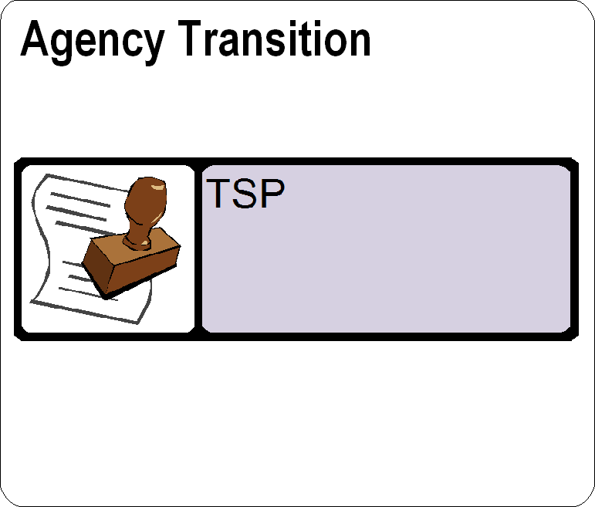

Step 2:
Ensure that all the required Properties indicated above have been defined.
Figure 2: Transition Strategy Properties
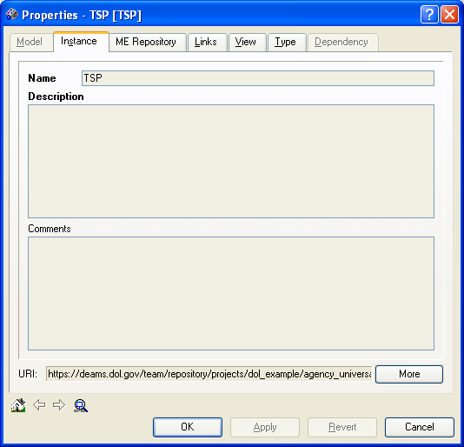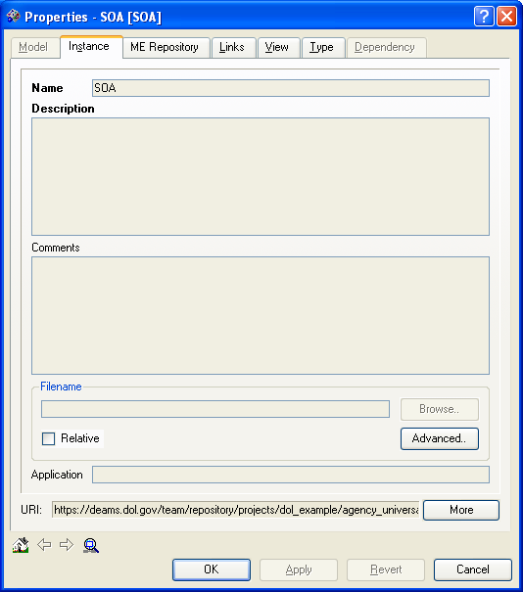
Name: This will always be name of the Transition Strategy Object or Component (ie. Transition Strategy Plan).

Description: Provide a brief description of the TSP or Transition Strategy Component.

Comments: If necessary, include supplementary information around TSP or its components.

Filename: If necessary attached a file containing detailed information around the TSP or its Components.

Step 3:
Ensure that all the required relationships indicated above have been established.
Figure 3: Transition Strategy Relationships
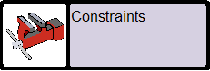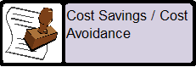

APPENDIX a: Federal Lines of Business (LOBS)
Please mention if this investment maps to any of the following Federal Line(s) of Business. Identify the Line of Business this investment maps to, and provide a description for each mapping of how it supports that LoB.
Note: These are not to be confused with the Business Reference Model’s Business Areas, Lines of Business, and Sub-Functions.
Descriptions of Federal Lines of Business can be found at http://www.whitehouse.gov/omb/egov/c-6-lob.html
Table 57: Federal LoB Support
Federal LoB | LOB Vision
Case Management (CM) | Utilizing common solutions and data standards, case management information is easily and appropriately shared within and between federal and local agencies.
Financial Management (FM) | To improve the cost, quality, and performance of financial management (FM) reducing non-compliance systems by leveraging common standards, shared service solutions and implementing other government-wide reforms that foster efficiencies in Federal financial operations.
Grants Management (GM) | A government-wide solution to support end-to-end grants management activities that promote citizen access, customer service, and agency financial and technical stewardship.
Human Resources Management (HR) | Government-wide, modern, cost effective, standardized, and interoperable Human Resource (HR) solutions providing common core functionality to support the strategic management of Human Capital.
Federal Health Architecture (FHA) | A Federal Health IT environment that is interoperable with the private sector and supports the President’s Health IT plan enabling better care, increased efficiency, and improved population health.
Information Systems Security (ISS) | The Federal Government’s information systems security program enables agencies’ mission objectives through a comprehensive and consistently implemented set of risk-based, cost-effective controls and measures that adequately protects information contained in Federal Government information systems.
Budget Formulation and Evaluation (BFE) | Modern, interoperable, flexible, cost effective, and optimized solutions supporting all phases of the formulation and execution of the Federal Budget and linking budget formulation, execution, planning, performance, and financial information.
Geospatial LoB | The Nation’s interests are served, and the core missions of Federal agencies and their partners are met, through the effective and efficient development, provision, and interoperability of geospatial data and services.  To further refine the opportunities for optimizing and consolidating Federal geospatial-related investments to reduce the cost of government and, at the same time, improve services to citizens. Cross-agency coordination of geospatial activities can identify, consolidate, and reduce or eliminate redundant geospatial investments. Developing the Geospatial Line of Business (LoB) will result in a more coordinated approach to producing, maintaining, and using geospatial data, and will ensure sustainable participation from Federal partners to establish a collaborative model for geospatial-related activities and investments.
IT Infrastructure (IOI) | An effective and efficient IT infrastructure enabling government-wide customer-centric services.

APPENDIX B: Federal Presidential Priority Initiatives (PPI)
Agencies may need to provide an explanation of investments classified under any PPI’s (if applicable). Presidential Priority Initiatives are described at
http://www.whitehouse.gov/omb/egov/c-presidential.html
Table 58: Presidential Priority Initiative (PPI)
PPI Category | PPI Name | Description
Government to Citizens | GovBenefits.gov | Provides a single point of access for citizens to locate and determine potential eligibility for government benefits and services.
 | Recreation One-Stop | The Recreation One-Stop initiative will make it easier for citizens to plan a vacation (or a brief recreational break during a business trip), and make a reservation for a campsite, cabin, or tour at Federal recreation sites.
 | IRS Free File | Creates a single point of access to free on-line preparation and electronic tax filing services provided by Industry Partners to reduce burden and costs to taxpayers.
 | GovLoans.gov | Creates a single point of access for citizens to locate information on federal loan programs, and improves back-office loan functions.
 | USA Services | USA Services mission is to help make the government more citizen-centric by providing citizens with easy access to accurate, consistent, and timely government information. To achieve this mission, it provides citizens information about and from all levels of government through an array of integrated information channels including, USA.gov, telephone and email inquiry response from the GSA, National Contact Center, and print materials distributed from Pueblo, Colorado.  USA Services is also responsible for helping agencies government-wide improve their interactions with citizens. It accomplishes this goal by providing agencies with contact center services through the First Contact contract vehicle and by providing leadership to contact center and web managers across all levels of government. This includes organizing and managing interagency committees and intergovernmental collaboration that develops and promulgates best practices.
Government to Business | E-Rule Making | Allows citizens to easily access and participate in the rulemaking process. Improves the access to, and quality of, the rulemaking process for individuals, businesses, and other government entities while streamlining and increasing the efficiency of internal agency processes.
 | Expanding Electronic Tax Products for Businesses | Reduces the tax-reporting burden on businesses while improving the efficiency and effectiveness of government operations, provides timely and accurate tax information to businesses, increases the availability of electronic tax filing, and models simplified federal and state tax employment laws.
 | Federal Asset Sales | Identify, recommend, and implement improvements for asset recovery and disposition, making it easier for agencies, businesses, and citizens to find and acquire/buy federal assets.
 | International Trade Process Streamlining | Export.gov makes it easy for Small and Medium Enterprises (SMEs) to obtain the information and documents needed to conduct business abroad.
 | Business Gateway | The Business Gateway, Business.gov site, saves businesses time and money by providing a one-stop resource for compliance information, forms and government contacts. For the first time, businesses can go to one web site to search for compliance information from multiple U.S. federal government agencies. It includes:
 | Consolidated Health Informatics | Adopts a portfolio of existing health information interoperability standards (health vocabulary and messaging) enabling all agencies in the federal health enterprise to “speak the same language” based on common enterprise-wide business and information technology architectures.
Government to Government | Geospatial One-Stop | Provides Federal and state agencies with single a point of access to map-related data enabling the sharing of existing data to maximize geospatial investments to leverage resources and reduce redundancies.
 | Disaster Management | To help citizens and members of the emergency management community at the local, tribal, state, and Federal levels by improving public safety response through more effective and efficient interoperable data communications and to serve as a unified point of access to disaster preparedness, mitigation, response and recovery information.
 | SAFECOM | SAFECOM functions as the key Federal coordinator for promoting and providing support to local, tribal, state, and Federal public safety agencies for the improvement of public safety response through more effective and efficient interoperable wireless communications. As a public safety practitioner-driven program, SAFECOM is working with existing Federal communications initiatives and key public safety stakeholders to improve processes for the cross-jurisdictional and cross-disciplinary coordination of existing systems and future networks. Through the development of the Public Safety Communications Statement of Requirements (SoR) and the Public Safety Architecture Framework (PSAF), SAFECOM is providing the public safety community and Federal agencies guidance on new technologies to achieve communications interoperability.
 | E-Vital | Promotes automating how deaths are registered with the states (Electronic Death Registration (EDR)).
 | Grants.gov | Creates a single portal for all Federal grant customers to find and apply for grants online.
Internal Efficiency and Effectiveness | E-Training | The vision of this government-wide initiative is the creation of a premier e-Training environment that supports the development of the Federal workforce and advances the accomplishment of agency missions through simplified and one-stop access to e-Training products and services. E-Training is working to enhance the ability of the Federal government to attract, retain, manage, and continuously educate the highly skilled professionals needed for a flexible and high-performing government workforce.
 | Recruitment One-Stop | Recruitment One-Stop provides state-of-the-art online recruitment services to Federal job seekers that include online job posting, intuitive job searching, resume warehousing, online application submission, automated eligibility and status feedback, applicant data mining and integration with sophisticated automated assessment tools.
 | Enterprise HR Integration | The Enhanced Human Resource Integration (EHRI) initiative is developing policies and tools to streamline and automate the electronic exchange of standardized HR data needed for creation of an official employee record across the Executive Branch. The EHRI tool set and central data repository will provide comprehensive knowledge management workforce analysis, forecasting, and reporting across the Executive Branch for the strategic management of human capital.
 | E-Clearance | The E-Clearance initiative streamlines and improves the quality of the current security clearance process through the deployment of automation and common systems and policies to manage the security clearance process.
 | E-Payroll | The E-Payroll Initiative will standardize and consolidate Government wide Federal civilian payroll services and processes by simplifying and standardizing HR/payroll policies and procedures and better integrating payroll, human resources, and finance functions. Prior to beginning the initiative, 26 federal agencies provided payroll services. Consolidation has been effected by the selection of four providers to furnish payroll services for the Executive branch. Migration of the 22 non-continuing payroll providers to one of the four selected e-Payroll Providers is underway.
 | E-Gov Travel | A government-wide, web-based service that applies world-class travel management practices to consolidate federal travel, minimize cost and produce superior customer satisfaction. The E-Gov Travel Service is commercially hosted to minimize technology costs to the government and guarantee refreshed functionality. From travel planning and authorization to reimbursement, this end-to-end service streamlines travel management and will enable the government to capture real time visibility into the buying choices of travelers and assist agencies in optimizing their travel budgets while saving taxpayers money.
 | Integrated Acquisition Environment | The Integrated Acquisition Environment (IAE) is a Presidential E-Gov initiative managed by GSA that consists of nine government-wide integrated systems facilitating, unifying, and streamlining each phase of the federal acquisition process.
 | E-Records Management | The E-Records Management initiative provides policy guidance to help agencies better manage their electronic records, so that records information can be effectively used to support timely and effective decision making, enhance service delivery, and ensure accountability. The Initiative is developing policies and guidance in four major issue areas: Correspondence management, Enterprise-wide electronic records management, Electronic Information Management Standards, Transferring permanent records to NARA.
E-Authentication | E-Authentication | Minimizes the burden on businesses, public and government when obtaining services on-line by providing a secure infrastructure for on-line transactions, eliminating the need for separate processes for the verification of identity and electronic signatures.
 | HSPD-12 | On August 27, 2004, the President issued a Homeland Security Presidential Directive calling for a mandatory, government-wide standard for secure and reliable forms of identification issued by the federal government to its employees and to the employees of federal contractors. The implementation of this Standard will ensure the identification for government employees and contractors is reliable and secure.  The Office of Management and Budget was directed to oversee agency implementation. Agencies must ensure consistency with existing privacy and security law and policies to ensure employee and contractor information is protected and appropriately used.

ApPENDIX C: PResident’s Management Agenda (PMA) Goals
The President’s Management Agenda, presented in 2002, can be found at
http://www.whitehouse.gov/omb/budget/fy2002/mgmt.pdf

Unlike the PPI’s above, your initiative should be in support of at least one of the PMA Government-Wide Initiatives.

Table 59: President’s Management Agenda
PMA Initiative | Name
#1 | Strategic Management of Human Capital
#2 | Competitive Sourcing
#3 | Improved Financial Performance
#4 | Expanded Electronic Government
#5 | Budget and Performance Integration

APPENDIX D: Federal transition framework (ftf) Inititatives
Table 60: Federal Transition Framework Initiatives

FTF Initiative | Description
Budget Formulation and Execution Line of Business | The Budget Formulation and Execution Line of Business will identify opportunities for common solutions and automated tolls to enhance agency budget, performance and financial information; and promote integration and standardize information exchange between budget formulation, execution, financial management and performance measurement systems, and activities across Government.
Case Management Line of Business | The Case Management (CM) Line of Business (LoB) is one of the key areas of opportunity for case management common solutions, both within DOJ and across the Federal government. The existence of multiple case management systems without a common platform or method of intercommunication hinders cross-government information sharing and perpetuates redundant IT investments. The CM LoB focuses on three major functional areas of case management: Litigation, Investigation, and Services & Benefits. The CM LoB target architecture emphasizes case information sharing and the development of common case management tools for use across agencies. The focal point of the CM LoB effort is currently the Department of Justice Litigation Case Management System (LCMS), which will provide a common litigation case management platform for all Federal government components. The CM LoB addresses legal case tracking and reporting - not the activities of the attorneys involved. Phase I of LCMS system development will include case event/information management, case status tracking, caseload/performance reporting, and time reporting. Subsequent phases (to be determined) will address the needs at the legal professional level.
Disaster Management | Disaster Management helps citizens and members of the emergency management community at the local, tribal, state, and Federal levels by improving public safety response through more effective and efficient interoperable data communications and to serve as a unified point of access to disaster preparedness, mitigation, response and recovery information.
E-Authentication | E-Authentication is providing the standards, framework, governance and services necessary for the Federal Government to accept all levels of secure identity verification, simplifying business, public & government access to online services in a cost-effective manner. This initiative is being managed as part of a larger government-wide Identity Management initiative. The Identity Management initiative also includes HSPD-12 implementation.
E-Travel | The e-Gov Travel Service (ETS) is government-wide, web-based service that applies world-class travel management practices to consolidate federal travel, minimize cost and produce superior customer satisfaction. The E-Gov Travel Service is commercially hosted to minimize technology costs to the government and guarantee refreshed functionality. From travel planning and authorization to reimbursement, this end-to-end service streamlines travel management and will enable the government to capture real time visibility into the buying choices of travelers and assist agencies in optimizing their travel budgets while saving taxpayers money.
Federal Health Architecture (FHA) | The Federal Health Architecture (FHA) is an eGov Line of Business (LoB) initiative with responsibility for ensuring that agencies can seamlessly exchange health data with other agencies, other governments (state, local and tribal), and with private sector healthcare organizations. This is accomplished through enabling agencies to provide input into the national health agenda, implementation of national standards and architectures, and accountability for health IT adoption. FHA is a program within the Office of the National Coordinator for Health IT (ONC) and supports other related ONC initiatives. To date, FHA has defined target business processes and information exchanges to support coordination of food importation safety processes. Additionally, Federal-specific standards for health IT interoperability have been established by the Consolidated Health Informatics (CHI) initiative; these are now being transitioned to a national standards development process as part of the Health IT Standards Panel (HITSP). HITSP is scheduled to release its first set of Interoperability Specification standards within the domains of bio-surveillance, consumer empowerment and Electronic Health Records (EHRs) in November 2006.  Additionally, FHA supports the Certification Commission for Health IT (CCHIT), which has already certified health IT products for ambulatory EHRs and will be certifying products for inpatient EHR in 2007. Finally, FHA supports the Nationwide Health Information Network initiative within ONC, which is defining the architecture and infrastructure required to support regional and national networks for the exchange of health information.
Financial Management Line of Business | A government-wide financial management solution that is efficient and improves business performance while ensuring integrity in accountability, financial controls and mission effectiveness.
Geospatial Line of Business | The goal of the Geospatial Line of Business (LOB) is to refine the opportunities for optimizing and consolidating Federal geospatial-related investments to reduce the cost of government and, at the same time, improve services to citizens. Cross-agency coordination of geospatial activities can identify, consolidate, and reduce or eliminate redundant geospatial investments. Developing the Geospatial (LOB) will result in a more coordinated approach to producing, maintaining, and using geospatial data, and will ensure sustainable participation from Federal partners to establish a collaborative model for geospatial-related activities and investments. The Geospatial LOB is currently in its formative stages, and will be further developed through 2007.
Geospatial One-Stop | Provides Federal and state agencies with a single point of access to map-related data, enabling the sharing of existing data to maximize geospatial investments to leverage resources and reduce redundancies.
Grants Management Line of Business | A government-wide solution to support end-to-end grants management activities that promote citizen access, customer service, and agency financial and technical stewardship. Initiative goals are to: improve customer access and efficiency of submission process, improve decision making, integrate with Financial Management processes, improve efficiency of reporting procedures in order to increase usable information content, and optimize post-award and closeout actions.
Grants.gov | Creates a single portal for all Federal grant customers to find and apply for grants online. Grants.gov is a central storehouse for information on over 1,000 grant programs and access to approximately $400 billion in annual awards.
HSPD-12 | Homeland Security Presidential Directive 12 (HSPD-12) mandates the development and adoption of a Federal government standard for personnel identification verification (PIV) cards. These cards are used to verify the identity of government employees and contractors, and control access to government facilities and information systems. The implementation of this standard will ensure the identification for government employees and contractors is reliable and secure, and access to government resources is appropriately controlled. The PIV card system will also create a "minimum level of trust" across the Federal government due to the minimum background check required to receive an access card. This initiative is being managed as part of a larger government-wide Identity Management initiative. The Identity Management initiative also includes E-Authentication.
Human Resources Line of Business | The vision of the Human Resources Line of Business (HR LoB) is to develop government-wide, modern, cost effective, standardized, and interoperable Human Resource (HR) solutions providing common core functionality to support the strategic management of Human Capital. HR LOB common solutions interface with the five e-Government initiatives: Recruitment One-Stop (ROS), e-Clearance, EHRI, e-Training, and e-Payroll, as well as the Retirement Systems Modernization (RSM) program.
Information Sharing Environment (ISE) | The Information Sharing Environment (ISE) consists of multiple sharing environments designed to serve five Communities Of Interest (COIs): intelligence, law enforcement, defense, homeland security, and foreign affairs. The ISE represents a trusted partnership between all levels of government, the private sector, and foreign partners, to detect, prevent, disrupt, preempt, and mitigate the effects of terrorism against the territory, people, and interests of the US. The ISE will provide a distributed, secure, and trusted environment for transforming terrorism information sharing into actionable information for community-wide sharing. The ISE Cross-Agency Initiative is one enabling means to realize the future ISE across Federal, State, local, and tribal governments and, where appropriate, the private sector and foreign partners. This Cross-Agency Initiative is based on the development of an ISE Enterprise Architecture (ISEEA) Framework, designating ISE functional standards, and managing implementation of the ISE.
Information Systems Security (ISS) Line of Business | ISS LOB was established to provide leadership and direction for improving effectiveness and consistency of information systems security across the Federal Government. OMB intends to use the ISSLOB to achieve greater efficiency and effectiveness through standardizing and sharing capabilities, skills, and processes across government, to the maximum extent practicable.
Integrated Acquisition Environment (IAE) | The Integrated Acquisition Environment (IAE) initiative creates a secure business environment facilitating and supporting cost-effective acquisition of goods and services by federal agencies, while eliminating inefficiencies in the current acquisition environment.
Internet Protocol Version 6 (IPv6) | On August 2, 2005, the OMB Office of E-Gov and IT issued OMB Memorandum 05-22, “Transition Planning for Internet Protocol Version 6 (IPv6),” directing all Federal government agencies to transition their network backbones (core) to the next generation of the Internet Protocol Version 6 (IPv6), by June 30, 2008. The memorandum identifies several key milestones and requirements for all Federal government agencies in support of the June 30, 2008 target date.
IT Infrastructure Optimization Line of Business | The IT Infrastructure Optimization initiative (IOI) identifies opportunities for the consolidation and optimization of Federal IT infrastructure (e.g. help desk/desktop, voice and data networks/ telecommunications, data centers) through the development government-wide common solutions. Consolidation and optimization of IT infrastructure represents a significant opportunity to realize future cost savings by taking a more coordinated approach to spending on commodity IT infrastructure. IT infrastructure consolidation and optimization case studies demonstrate agencies could improve IT service levels and, when relieved of the burden of managing these non-core functions, can refocus spending and effort on mission priorities and results. This LoB will define specific common performance measures for IT infrastructure service-levels and costs, identify best practices, and develop guidance for transition plans within agencies and/or across agencies.

Descriptions of The Federal Transition Framework can be found at: http://www.whitehouse.gov/omb/egov/documents/FTF_Catalog_PDF_Ver10_Final_Dec_2006.pdf

AppENDIX E: Department of Labor Strategic Plan
The Department of Labor’s Strategic Plan for 2006-2011 can be found at:
http://www.dol.gov/_sec/stratplan/strat_plan_2006-2011.pdf

Each Strategic Goal has multiple activities that further specify the goal itself. To map to a Strategic Goal, your investment should be in support of one of the activities described in the Strategic Plan.
Table 61: DOL Strategic Plan Alignment
Strategic Goal | Goal Description
Goal 1:  A Prepared Workforce | Develop a prepared workforce by providing effective training and support services to new and incumbent workers and supplying high-quality information on the economy and labor market.
Goal 2:  A Competitive Workforce | Meet the competitive labor demands of the worldwide economy by enhancing the effectiveness and efficiency of the workforce development and regulatory systems that assist workers and employers in meeting the challenges of global competition.
Goal 3:  Safe and Secure Workforce | Promote workplaces that are safe, healthful and fair; guarantee workers receive the wages due them; foster equal opportunity in employment; and protect veterans' employment and reemployment rights.
IT Goal 4: Strengthened Economic Protections | Protect and strengthen worker economic security through effective and efficient provision of unemployment insurance and workers' compensation; ensuring union transparency; and securing pension and health benefits.

Table 62: DOL Strategic Performance Goals
Strategic Performance Goal | Goal Description
Goal 1:  Improve information  available to decision-makers on labor market  conditions, and price and productivity changes. | BLS is an independent national statistical agency within the Department of Labor that collects, processes, analyzes, and disseminates essential statistical data to the American public, the U.S. Congress, other Federal Agencies, State and local governments, business, and labor. BLS provides statistical information that supports the formulation of economic and social policy, decisions in the business and labor communities, legislative and other programs affecting labor, and research on labor market issues. These important policies and decisions affect virtually all Americans.
Goal 2:  Improve educational  achievements of Job Corps students, and  increase participation of Job Corps graduates  in employment and education. | Economically disadvantaged youth often face multiple barriers to gainful employment. Through 122 centers nationwide, each year the Job Corps Program provides intensive training to more than 60,000 youth ages 16 through 24. Students receive academic and vocational training as well as social education and other support services, such as housing, transportation and family support resources. By incorporating the best thinking, research, and practices of business, education, labor, and other partners, the program strives to be the nation’s premier career-focused, alternative education pipeline for disadvantaged youth.
Goal 3:  Increase placements  and educational attainments of youth served  through the Workforce Investment Act Youth  Program. | The Workforce Investment Act (WIA) Youth Program is an important component of an integrated workforce system. WIA authorizes services to low-income youth (ages 14-21) with barriers to employment. Eligible youth are deficient in basic skills or are homeless, runaways, pregnant or parenting, offenders, school dropouts, or foster children. The program serves both in- and out-of-school youth, including youth with disabilities and those who may require specialized assistance, to complete an educational program in order to find a job and stay employed. Service providers prepare youth for employment and post-secondary education by stressing linkages between academic and occupational learning. They provide tutoring, access to alternative schools, summer employment, occupational training, work experience, supportive services, leadership development, mentoring, counseling, and follow-up services.
IT Goal 4:  Improve the registered  apprenticeship system to meet the training  needs of business and workers in the 21st  Century. | The Department is redesigning the registered apprenticeship system to address employers’ demand for efficiency, reliability, openness, and responsiveness. Established by the National Apprenticeship Act of 1937, the National Registered Apprenticeship System operates in cooperation with State agencies, businesses, program sponsors, industry leaders, employers, employer associations and educational institutions. As the nationally recognized credentialing system for skilled, craft, and technical trade training programs, the program’s effectiveness is largely defined by its ability to prepare qualified workers to meet the needs of employers. To this end, the Department identified several strategies for improvement to promote a demand-driven system.
IT Goal 5:  Improve the employment  outcomes for veterans who receive One-Stop  Career Center services and Homeless Veterans’  Reintegration Program services. | The Department helps veterans find jobs by funding grants to State Workforce Agencies for the delivery of employment and workforce information services through One-Stop Career Centers in local communities. These grants support Disabled Veteran Outreach Program specialists dedicated to serving veterans who need special employment assistance due to disabilities or barriers to employment. These grants also support Local Veterans Employment Representative (LVER) staff members, who conduct outreach to area employers to identify their employment needs, thus developing employment opportunities for veterans. LVER staff members also provide transition employment assistance workshops to service members prior to their separation from the armed services. Veterans’ employment and retention rates are expected to steadily increase,

APPENDIX F: Department of Labor IT Strategic Plan
The Department of Labor IT Strategic Plan lists five IT Strategic Goals

The DOL IT Strategic Plan for 2005-2009 can be found at:
http://www.dol.gov/cio/programs/ITStrategicPlan2006/ITStrategicFramework.htm

Table 63: DOL IT Strategic Plan Alignment
IT Strategic Goal | Goal Description
IT Goal 1:  E-Government | Ensure IT initiatives and investments are customer-focused, results-oriented, market-based, and cost-effective.
IT Goal 2:  Enterprise Architecture | Develop and maintain an Enterprise Architecture that is reliable, adaptable, scalable and driven by business and technology requirements.
IT Goal 3:  IT Management and Governance | Promote cost-effective IT solutions by sharing and implementing best practices
IT Goal 4:  Security | Provide a secure IT infrastructure that proactively assures integrity, confidentiality, and availability of DOL data and information systems.
IT Goal 5:  Human Capital | Develop and maintain a high quality, competitive IT workforce.

APPENDIX G: Security/Privacy Requirements
The table below provides helpful guidance for developing Security / Privacy Requirements. When developing the Agency’s Requirements attempt to come up with at least one requirement for each row in the table below. These Requirements align directly to Privacy and Security Control Families. Every agency should align to all control families listed in Appendix H.

For more details, the Security and Privacy profile can be found at:
http://www.whitehouse.gov/omb/egov/documents/FEA_SPP_Ver2.pdf

Table 64 : Security / Privacy Requirement Guidance
Security and Privacy Requirement Guidance
1. Identify those laws, regulations, and executive branch policies that establish security and privacy requirements. Examples of Privacy laws are: Privacy Act, OMB A-11, etc and Examples of Security laws are: FISMA, OMB A-130, NIST 800-53, FIPS PUB 199, FIBS PUB 200, and others

2. Evaluate key requirements for system-level security and privacy. NIST captures system-level security requirements in the NIST SP 800-53 baseline security controls. Primary sources of enterprise requirements include sources such as FISMA, OMB A-130, FIPS PUB 199, and FIPS PUB 200.

3. Identify security and privacy requirements established in agency or organizational mission statements and policies. The ability to link security and privacy capabilities to policy and strategy ensures alignment of security and privacy capabilities with the business mission

4. Identify security and privacy commitment established through inter and intra-agency trust agreements and contracts. Evaluate whether those commitments have programmatic or enterprise-wide impact on security and privacy.

5. Assess enterprise architecture descriptions of lines of business, functions, and sub-functions to determine if they describe security and privacy attributes. The business architecture should highlight security and privacy-sensitive activities to each business function and sub-function to ensure that appropriate controls are developed and in place. The Business architecture should capture business processes that support the IT security sub-functions.
Various lines of business, sub-functions, and processes are exposed to different types and levels of security and privacy risk. Also, “Security and Privacy” is a support activity that falls under the “Management of Government Resources” Business Area. Various aspects of security and privacy will fall under the Information and Technology line-of-business and Administrative line-of-business. Sub-functions include IT Security and Security Management.

6. Assess enterprise architecture descriptions of performance objectives to determine if they support measuring compliance. In addition to compliance oversight, metrics should also assess adequacy of performance and support service-level agreements.
The Security and Privacy category falls under PRM Measurement Area “Process and Activities.” Measurement Indicators show the extent to which security is improved and privacy addressed. Examples of security and privacy indicators from the FY05 FISMA report include:
- Percentage of employees who received annual security awareness training
- Percentage of agency websites with a machine-readable privacy policy
- Percentage of systems with certification and accreditation
- Percentage of applicable systems with a privacy impact assessment
7. Ensure that enterprise architecture descriptions of data incorporate security and privacy attributes.
- FIPS PUB 199 and NIST SP 800-60 describe the methodology for categorizing information confidentiality, integrity, and availability. This guidance helps agencies map security impact levels in a consistent manner to types of information (e.g., privacy, medical, proprietary, financial, contractor sensitive, trade secret, investigation) and information system (mission critical, mission support, administrative).
- Information subject to privacy legislation. Especially consider the Privacy Act, eGov Act, and HIPAA

APPENDIX H: Security/Privacy Capabilities
The table below provides helpful guidance for developing Security / Privacy Capabilities. When developing the Agency’s Capabilities attempt to come up with at least one capability for each row in the table below. These Capabilities align directly to Privacy and Security Control Families. Every agency should align to all control families listed in Appendix H.

For more details, the Security and Privacy profile can be found at:
http://www.whitehouse.gov/omb/egov/documents/FEA_SPP_Ver2.pdf

Table 65 : Security / Privacy Capability Guidance
Security and Privacy Capability Guidance
1. Identify processes and technologies that provide dedicated security or privacy services—for example, processes for managing classified information, or a stand-alone Internet firewall or a web-based PIA tool.
TRM Service areas include Service Access and Delivery, Service Platform and Infrastructure, Component Framework, and Service Interface and Integration. Security is a category under the Component Framework; however, an agency TRM will likely reference security and privacy in several areas. For example, “Data Types/ Validation” is under Service Interface and Integration/ Interoperability. The data types may determine unique security and privacy requirements.
In some instances security or privacy features may be inherent in a particular asset (such as security features built into web server) or part of a particular service (the web security and privacy policy for an e-Gov initiative). In other instances, security or privacy are the primary objectives of a capability – for example, an Internet firewall protecting an organization’s website. Both these instances should be captured

2. Identify processes and technologies that are not security or privacy-centric but, which accomplish security or privacy as an ancillary function—for example, personnel management activities that require consideration for privacy, or a grants-management system that encrypts data.

3. System components providing security and privacy capabilities should be highlighted in the agency’s system architecture.
Non-security and non-privacy capabilities may have security or privacy features. Most security-specific capabilities will be located under the Service Domain “Support Services” under the Service Type, “Security Management.” “Audit Trail Capture and Analysis” is an example of a Service Capability within Security Management.

APPENDIX I: Security/Privacy Conrtol Families
The following tables provide a list of security and privacy control families for referencing within the Security Architecture section of this document. These tables are derived from OMB’s Security Profile. The OMB security profile can be found at the following link:
Table 66 : Security Control Families
Security Control Family | Description
Risk Assessment | Assessing the risk to organizational operations, assets, and individuals resulting from the operation of information systems, and the processing, storage, or transmission of information.
Planning | Developing, documenting, updating, and implementing security plans for systems.
System and Services Acquisition | Allocating resources to protect systems, employing system development life cycle processes, employing software usage and installation restrictions, and ensuring that third-party providers employ adequate security measures to protect outsourced information, applications, or services.
Certification and Accreditation and Security Assessments | Assessing security controls for effectiveness, implementing plans to correct deficiencies and to reduce vulnerabilities, authorizing the operation of information systems and system connections, and monitoring system security controls
Personnel Security | Ensuring that individuals in positions of authority are trustworthy and meet security criteria, ensuring that information and information systems are protected during personnel actions, and employing formal sanctions for personnel failing to comply with security policies and procedures.
Physical and Environmental Protection | Limiting physical access to systems and to equipment to authorized individuals, protecting the physical plant and support infrastructure for systems, providing supporting utilities for systems, protecting systems against environmental hazards, and providing environmental controls in facilities that contain systems.
Contingency Planning | Establishing and implementing plans for emergency response, backup operations, and post-disaster recovery of information systems.
Configuration Management | Establishing baseline configurations and inventories of systems, enforcing security configuration settings for products, monitoring and controlling changes to baseline configurations and to components of systems throughout their system development life cycles.
Maintenance | Performing periodic and timely maintenance of systems and providing effective controls on the tools, techniques, mechanisms, and personnel that perform system maintenance.
System and Information Integrity | Identifying, reporting, and correcting information and system flaws in a timely manner, providing protection from malicious code, and monitoring system security alerts and advisories.
Media Protection | Protecting information in printed form or on digital media, limiting access to information to authorized users, and sanitizing or destroying digital media before disposal or reuse.
Incident Response | Establishing operational incident handling capabilities for information systems and tracking, documenting, and reporting incidents to appropriate officials.
Awareness and Training | Ensuring that managers and users of information systems are made aware of the security risks associated with their activities and of applicable laws, policies, and procedures related to security and ensuring that personnel are trained to carry out their assigned information security-related duties.
Identification and Authentication | Identifying and authenticating the identities of users, processes, or devices that require access to information systems.
Access Control | Limiting information system access to authorized users, processes acting on behalf of authorized users, or devices (including other information systems), and to types of transactions and functions that authorized users are permitted to exercise.
Audit and Accountability | Creating, protecting, and retaining information system audit records that are needed for the monitoring, analysis, investigation, and reporting of unlawful, unauthorized or inappropriate information system activity, and ensuring that the actions of individual users can be traced so that the individual users can be held accountable for their actions.
System and Communications Protection | Monitoring, controlling and protecting communications at external and internal boundaries of information systems, and employing architectural designs, software development techniques, and systems engineering principles to promote effective security.

Table 67 : Privacy Control Families
Privacy Control Family | Description
Policies and Procedures | Creating policies and procedures governing the appropriate use of personal information and implementing privacy controls.
Privacy as Part of the Development Life Cycle | Implementing privacy reviews and controls throughout the system development life cycle.
Assigned Roles, Responsibilities, and Accountability | Identifying general and specific roles and responsibilities for managing and using personal information and ensuring accountability for meeting these responsibilities.
Monitoring and Measuring | Monitoring the implementation of privacy controls and measuring their efficacy.
Education: Awareness and Role-based Training Programs | Ensuring managers and users of personal information are made aware of the privacy risks associated with their activities and of applicable laws, policies, and procedures related to privacy.
Public Disclosure | Publicly disclosing privacy policies and procedures for a program or system.
Notice | Providing notice of the information practices to the individual before collecting personal information.
Consent | Gaining consent from the individual to use their personal information.
Minimum Necessary | Collecting the minimum amount of personal information necessary to accomplish the business purpose.
Acceptable Use | Ensuring that personal information is used only in the manner provided on the notice, to which the individual consented, and in accordance with the publicly disclosed practices.
Accuracy of Data | Ensuring that personal information is accurate, particularly if harm or denial of benefits may result.
Individual Rights | Providing individuals an opportunity to access and correct their personal information and to seek redress for privacy violations.
Authorization | Ensuring that the individual authorizes all new and secondary uses of personal information not previously identified on the original collection notice.
Chain of Trust | Establishing and monitoring third-party agreements for the handling of personal information.
Risk Management | Assessing and managing risks to operations, assets, and individuals resulting from the collection, sharing, storing, transmitting, and use of personal information.
Reporting and Response | Providing senior managers and oversight officials the results of the monitoring and measuring of privacy controls and responding to privacy violations.
Security Measures | Implementing the appropriate safeguards to assure confidentiality, integrity and availability of personal information.

APPENDIX J: COnsoilidated DOL EA requirements
Business Strategy

Agency / Universal / Common Function
Properties | Value
Name | Agency Acronym
Description | Full Agency Name
Comments | Additional information about the agency
Relationship Type | Relates to
owns | * Any and all non-nested Agency/Universal/Common Function Objects need to be related to the Agency Object
sub agency of | Department / Agency / Universal / Common Function
has sub agency | Department / Agency / Universal / Common Function
aligns to | DOL Line of Business
manages | Business Case
participates in | Business Case
Mission Statement
Properties | Value
Name | Agency Abbreviation followed by "Mission Statement"
Description | text of Agency Mission Statement
Comments | Additional Text that further describes / reinforces the Mission Statement
Relationship Type | Relates to
supports | DOL Mission Statement
Relationship Properties: | Relationship Property Value:
Support Description: | Description of how Agency Mission support DOL Mission
supports (parent) | Mission Statement
Relationship Properties: | Relationship Property Value:
Support Description: | Description of how Agency Mission support DOL Mission
supported by (child) | Mission Statement
Relationship Properties: | Relationship Property Value:
Support Description: | Description of how Agency Mission support DOL Mission
leads to | Goal
affected by | Federal LOB Initiative
affected by | PPI Initiative
affected by | Legislative Mandate
affected by | PMA Initiative
affected by | FTF Initiative
affects | Information Policy
identifies | Performance Gap
results measured by | Performance Indicator
Vision
Properties | Value
Name | Agency Abbreviation followed by "Vision"
Description | Vision Description
Comments | Additional Text that further describes / reinforces the Vision Statement
Relationship Type | Relates to
supports | Agency
supports | DOL Vision
Relationship Properties: | Relationship Property Value:
Support Description: | Description of how Agency Mission support DOL Mission
supports | Vision
Relationship Properties: | Relationship Property Value:
Support Description: | Description of how Agency Mission support DOL Mission
supported by | Vision
Relationship Properties: | Relationship Property Value:
Support Description: | Description of how Agency Mission support DOL Mission
Goals
Properties | Value
Name | Short Goal Statement
Description | Goal Description
Comments | Additional Text that further describes / reinforces the Vision Statement
Weight | 1-7 value showing the importance of the goal; 7 being high and 1 being low
Target Completion Date | date goal is expected to be achieve upon
Relationship Type | Relates to
supports | DOL Strategic Goal
Relationship Properties: | Relationship Property Value:
Support Description: | Description of how Agency Goal support DOL Strategic Goal
supports | DOL Strategic Performance Goal
Relationship Properties: | Relationship Property Value:
Support Description: | Description of how Agency Goal support DOL Strategic Performance Goal
supports (parent) | Goal
Relationship Properties: | Relationship Property Value:
Support Description: | Description of how Agency Mission support another Mission
supported by (child) | Goal
Relationship Properties: | Relationship Property Value:
Support Description: | Description of how Agency Mission supported by another Mission
has results measurement | PRM Measurement Indicator
impacted by | DOL Strategic External Challenges
affects | Business Function
is achieved by | Business Process
identifies | performance gap
affects | Information Policy
leads to | Performance Objective
is affected by | Legislative Mandate
is affected by | PPI Initiative
is affected by | FTF Initiative
is affected by | PMA Initiative
is affected by | Federal LOB Initiative
supported by | Business Case
Relationship Properties: | Relationship Property Value:
Support Description: | Description of how investment supports Goal
Expected Results: | Description of the results that are expected from the investment with respect to the Goal
follows from | Mission Statement
Performance Objectives
Properties | Value
Name | Short name of the performance objective
Description | Performance Objective Description
Comments | Additional Text that further describes / reinforces the performance objective
Weight | 1-7 value showing the importance of the performance objective; 7 being high and 1 being low
Target Completion Date | date performance objective is expected to be achieve upon
Relationship Type | Relates to
follows from | Goal
affected by | Legislative Mandate
is affected by | PPI Initiative
is affected by | FTF Initiative
is affected by | PMA Initiative
is affected by | Federal LOB Initiative
affects | Information Policy
identifies | performance gap
supports | DOL Strategic Goal
Relationship Properties: | Relationship Property Value:
Support Description: | Description of how performance objective supports DOL Strategic Goal
supports | DOL Strategic Performance Goal
Relationship Properties: | Relationship Property Value:
Support Description: | Description of how Performance Objective supports DOL Strategic Performance Goal
has results measurement | PRM Measurement Indicator
affects | Business Function
is achieved by | Business Process
supported by | Business Case
Relationship Properties: | Relationship Property Value:
Support Description: | Description of how investment supports Goal
Expected Results: | Description of the results that are expected from the investment with respect to the Goal
supports (parent) | Performance Objective
Relationship Properties: | Relationship Property Value:
Support Description: | Description of how performance objective supports a (parent) Performance Objective
is supported by (child) | Performance Objective
Relationship Properties: | Relationship Property Value:
Support Description: | Description of how performance objective is supported by a (child) Performance Objective
impacted by | DOL Strategic External Challenge
Relationship Properties: | Relationship Property Value:
Impact Description: | Description of how External Challenge impacts the Performance Objective

Business Architecture
Business Functions
Properties | Value
Name | Agency Business Functions
Description | Description for the business function
Core/Utility Business Function | Core or a utility business function?
Relationship Type | Relates to
has parts | Business Sub Function
involved in | Business Case
is provided by | Business Process
is affected by | Agency Goal
is affected by | Agency Performance Objective
is located in | Facility
has user | Role
has user | Organization
has responsible | Organization
has | Re-Engineering Requirement
has outcome output measurement of | PRM Measurement Indicator
is provided by | Application
is provided by | App Component
has user | Stakeholder Entity
business function involves | Stakeholder Entity
aligns to | BRM Sub Function
aligns to | BRM Mode of Delivery
is affected by | TSP Milestone
is affected by | Information Policy
is affected by | PPI Initiative
is affected by | FTF Initiative
is affected by | PMA Initiative
is affected by | Federal LOB Initiative
Business Processes
Properties | Value
Name | Business Process
Description | Description for the business process
Relationship Type | Relates to
has parts | Business Process
consists of | Business Process
before-after | Business Process
involved in | Business Case
provides | Business Function
achieves | Agency Goal
achieves | Agency Performance Objective
provides | Business Function
is user of | Agency Mission
has user | Role
has user | Stakeholder Entity
is responsible for | Organization
has sponsor | Organization
has user | Organization
is located in | Facility
Business Process has | Re-Engineering Requirement
has outcome output measurement of | PRM Measurement Indicator
uses | Application
uses | App Component
produces | DRM Exchange Package
consumes | DRM Exchange Package
is affected by | TSP Milestone
has control | information policy
is affected by | PPI Initiative
is affected by | FTF Initiative
is affected by | PMA Initiative
is affected by | Federal LOB Initiative
aligns to | BRM Sub Function
aligns to | BRM Mode of Delivery
achieves | Strategic Performance goal
achieves | IT Strategic Goal
Organizations
Properties | Value
Name | Organizations
Description | Description of Organization
Relationship Type | Relates to
is owner of | Application
is responsible for | Business Function
is user of | Business Function
is located in | Facility
sells | Software Product Version
supervises | Role
is supported by | Application
is sponsor of | Business Process
is responsible for | Business Process
is user of | Business Process
is owner of | Cabinet
is owner of | Computing Hardware
is owner of | Computer
is owner of | Network Device
is owner of | Desktop
is owner of | Laptop
is owner of | Server
is owner of | Mainframe
is owner of | Firewall
is owner of | Load Balancer
is owner of | Router
is owner of | Storage Device
is owner of | Switch
is owner of | Backup Device
is owner of | Disk Array
is owner of | Tape Backup
is owner of | Storage Area Network Switch
Roles
Properties | Value
Name | Name of Role
Description | Description of Role
Relationship Type | Relates to
is user of | Business Function
is user of | Business Process
is owner of | Application
is supervised by | Organization
stewards | Data Asset
is located in | Facility
Facilities
Properties | Value
Name | Facilities
Description | Description of Facility
Address | Facility Address
Internal / External | Identify if the Facility is Internal or External to DOL
Relationship Type | Relates to
is location of | Business Function
is location of | Business Process
is location of | Application Solution Architecture(Hardware)
is location of | Embedded Hardware
is location of | Software
is location of | Organization
is location of | Role
is location of | Application
it typed by | Facility Type
Re-engineering Requirements
Properties | Value
Name | Re-engineering Requirements #
Description | Description or Re-engineering Requirement
Comments | Indicate and provides details around if this is being reused
Relationship Type | Relates to
applies to | Business Function
applies to business process | Business Process

Application - Solution Architecture
Application
Properties | Value
Name | Name of Application
Description | Description of Application
App Type | COTS, GOTS, In-house developed, etc.
SDLCM Phase | Conceptual Planning, Design, Disposition, etc.
Relationship Type | Relates to
provides | Business Function
is used by | Business Process
produces | DRM Exchange Package
consumes | DRM Exchange Package
receives data from | Application
is deployed in | Application Solution Architecture(Hardware) Objects
is part of | System
is affected by | Milestone
has performance measurement | PRM Measurement Indicator
affected by | Business case
is located in | Facility
consists of | App Component
consists of | Application
has IT owner | Person
has business owner | Person
has owner | Organization
has owner | Role
supports | Organization
uses | DRM Data Entity
aligns to | SRM Service Component
App Component
Properties | Value
Name | Name of Application Component
Description | Description of App Component
Reused or not | Identify if Component is Re-used
Cost Savings due to Reuse | Identify Cost Savings if App Component is Re-used
App Type | COTS, GOTS, In-house developed, etc.
SDLCM Phase | Conceptual Planning, Design, Disposition, etc.
Relationship Type | Relates to
provides | Business Function
is used by | Business Process
is part of | Application
is deployed in | Hardware
is part of | System
is affected by | Milestone
aligns to | SRM Component
System
Properties | Value
Name | Name of System
Description | Description of System
CA Date | Date of C&A completion
CA Authority | Name and title of person accepting C&A package
CA Org | Agency/Org to which the C&A belongs
ATO Date | Date ATO was received
ATO Authority | Name of title of person issuing ATO
ATO Org | Agency/Org to which the ATO belongs
Relationship Type | Relates to
consists of | Application
consists of | App Comp.
consists of | Hardware
consists of | Software
When defining Systems, Applications, and Application Components, use the appropriate objects and relationships below to provide a more detailed definition.
Agency Application Solution Architecture Hardware
Application Solution Architecture(Hardware) Objects
Computer
Computing Hardware
Desktop
Firewall
Hardware
Laptop
Load Balancer
Mainframe
Network
Network Device
Network Interface
Router
Server
Storage Area Network
Storage Area Network Switch
Storage Device
Switch
Properties for all above objects | Value
Name | Name of Object
Description | Description of Object
Required Relationship Types for all above objects | Relates to
deploys | Application
deploys | App Component
is part of | System
is located in | Facility
has owner | Organization
has performance measurement | PRM Indicator
Additional preferred Relationship Types for all above objects | Relates to
is part of | These relationships can be used to link the different objects above when appropriate. i.e. "Laptop consists of backup device"
deploys
consists of
connects to
Agency Embedded Hardware
Embedded Hardware Object Types:
Backup Device
Cabinet
Tape Backup
Disk Array
Software Objects
App Server
Deployed Software
Operating System
Software Server
Database Server
File Server
Software Module
Web Server
Properties for all above objects | Value
Name | Name of Object
Description | Description of Object
Required Relationship Types for all above objects | Relates to
deploys | Application
deploys | App Component
is part of | System
is located in | Facility
has owner | Organization
has performance measurement | PRM Indicator
Additional preferred Relationship Types for all above objects | Relates to
is part of | These relationships can be used to link the different objects above when appropriate. i.e. "Laptop consists of backup device"
deploys
consists of
connects to
Agency Software
Software Objects
App Server
Deployed Software
Operating System
Software Server
Database Server
File Server
Software Module
Web Server
Properties for all above objects | Value
Name | Name of Object
Description | Description of Object
Required Relationship Types for all above objects | Relates to
deploys | Application
deploys | App Component
is part of | System
is located in | Facility
has owner | Organization
has performance measurement | PRM Indicator
Additional preferred Relationship Types for all above objects | Relates to
is part of | These relationships can be used to link the different objects above when appropriate. i.e. "Laptop consists of backup device"
deploys
consists of
connects to

Data Architecture
DRM: Data Asset
Properties | Value
Name | Name of Data Asset
Description | Description of Data Asset
Relationship Type | Relates to
accessed by | DRM: Query Point
from | DRM: Data Entity
categorized by | DRM: Topic
structured described by | DRM: Data Schema
semi/unstructured described by | DRM: Structured Data Resource
semi/unstructured described by | DRM: Unstructured Data Resource
semi/unstructured described by | DRM: Semi-Structured Data Resource
stewarded by | Organization
stewarded by | Role
stewarded by | Person
is typed by | Data Asset Type
provides management context for | DRM: Structured Data Resource
provides management context for | DRM: Unstructured Data Resource
provides management context for | DRM: Semi-Structured Data Resource
DRM: Data Schema
Properties | Value
Name | Name of Data Schema
Description | Description of Data Schema
Relationship Type | Relates to
parent | DRM Data Entity
parent | DRM Relationship
describes structured | DRM: Data Asset
defines | Structured Data Resource
DRM: Data Entity
Properties | Value
Name | Name of Data Entity
Description | Description of Data Entity
Relationship Type | Relates to
child | DRM Data Schema
parent | Data Attribute
to | DRM: Data Asset
is referred by | DRM: Document
exchanged by | Stakeholder Entity
used by | Application
categorized by | BRM: Sub Function
categorized by | DRM: Topic
participates in | DRM: Relationship
is used by | DRM: Exchange Package
related by | DRM: Relationship
DRM: Data Attribute
Properties | Value
Name | Name of Data Attribute
Description | Description of Data Attribute
Relationship Type | Relates to
child | DRM Data Entity
is used by | DRM: Exchange Package
constrained by | DRM: Data Type
DRM: Relationship
Properties | Value
Name | DRM: Relationship
Description | Description of DRM Relationship
Relationship Type | Relates to
child | DRM Data Schema
has participant | DRM Data Entity
relates | DRM Data Entity
Data Exchange Mechanism
Properties | Value
Name | Name of Data Exchange Mechanism
Description | Description of Data Exchange Mechanism
Relationship Type | Relates to
enabled by | DRM: Payload Definition
queries | DRM: Query Point
uses | DRM: Data Attribute
consumed by | Stakeholder Entity
produced by | Stakeholder Entity
consumed by | Business Process
produced by | Business Process
uses | DRM: Data Entity
categorized by | DRM: Topic
produced by | Application
consumed by | Application
Information Policy
Properties | Value
Name | Name of Information Policy
Description | Description of Information Policy
Internal / External | Identify if Information Policy is Internal to DOL or comes from an External source
Relationship Type | Relates to
parent | Information Policy Rule
is represented by | Concept
affects | Business Function
is control for | Business Process
Information Policy Rule
Properties | Value
Name | Name of Information Policy Rule
Description | Description of Information Policy Rule
Relationship Type | Relates to
child | Information Policy
Document
Properties | Value
Name | Name of Document
Description | Description of Document
Relationship Type | Relates to
contains | Structured Data Resource
contains | Unstructured Data Resources
contains | Semi-Structured Data Resources
refers to | DRM Data Entity
Structured Date Resource
Properties | Value
Name | Name of Structured Date Resource
Description | Description of Data Resource
Relationship Type | Relates to
categorized by | DRM Topic
contained in | DRM Document
is managed by | DRM: Data Asset
is defined by | Data Schema
Unstructured Data Resource
Properties | Value
Name | Name of Unstructured Data Resource
Description | Description of Unstructured Data Resource
Relationship Type | Relates to
categorized by | DRM Topic
contained in | DRM Document
is managed by | DRM: Data Asset
Semi-Structured Data Resource
Properties | Value
Name | Name of Semi-Structured Data Resource
Description | Description of Semi-Structured Data Resource
Relationship Type | Relates to
contained in | DRM: Document
categorized by | DRM: Topic
is managed by | DRM: Data Asset
DRM: Topic
Properties | Value
Name | Name of Topic
Description | Description of Topic
Relationship Type | Relates to
relates | DRM Topic
participates in | DRM topic
categorizes | Query Point
categorizes | Exchange Package
categorizes | Data Entity
categorizes | Data Asset
categorizes | Structured Data Resources
categorizes | Unstructured Data Resources
categorizes | Semi-Structured Data Resources
child | Root DRM Topic
parent | Child DRM Topic
contained in | Taxonomy
DRM: Exchange Package
Properties | Value
Name | Name of Exchange Package
Description | Description of Exchange Package
Relationship Type | Relates to
categorized by | DRM Topic
 | DRM Attribute
 | DRM Query Point
 | DRM Payload Definition
produced by | Business Process
produced by | Application
consumed by | Application
produced by | Stakeholder Entity
uses | Data Entity
consumed by | Business Process
consumed by | Stakeholder Entity
DRM: Payload Definition
Properties | Value
Name | Name of Payload Definition
Description | Description of Payload Definition
Relationship Type | Relates to
enables | exchange package
to | DRM: Exchange Package
DRM: Query Point
Properties | Value
Name | Name of Query Point
Description | Description of Query Point
Relationship Type | Relates to
accesses | DRM: Data Asset
returns result | DRM: Exchange Package
categorized by | DRM: Topic
Data Steward( Uses the Role Object in Business Architecture)
Properties | Value
Name | Name of Query Point
Description | Description of Expertise
Contact Information | Data Steward email / phone #
Relationship Type | Relates to
is supervised by | Organization
stewards | Data Asset
is located in | Facility
DRM: Taxonomy
Properties | Value
Name | Name of Taxonomy
Description | Description of Taxonomy
Relationship Type | Relates to
aligns to | Information Group
contains | DRM Topic
Information Group
Properties | Value
Name | Name of Information Group
Description | Description of Information Group
Relationship Type | Relates to
aligns to | DRM: Taxonomy

Performance Management
Customer Results Measurement Indicator
Properties | Value
Name | Measurement Indicator Name (7 words or less)
Description | Description of Performance Indicator
Baseline | Baseline Performance Value
Relationship Type | Relates to
measures outcome_output of | Business Function
measures outcome_output of | Business Process
measures results for | Stakeholder Entity
To | PRM: Measurement Indicator Group
Technology Measurement Indicator
Properties | Value
Name | Measurement Indicator Name (7 words or less)
Description | Description of Performance Indicator
Baseline | Baseline Performance Value
Relationship Type | Relates to
measures outcome_output of | Business Function
measures outcome_output of | Business Process
To | PRM: Measurement Indicator Group
measures performance of | Application Component
measures performance of | Application
measures performance of | Cabinet
measures performance of | Computing Hardware
measures performance of | Computer
measures performance of | Network Device
measures performance of | Desktop
measures performance of | Laptop
measures performance of | Server
measures performance of | Mainframe
measures performance of | Firewall
measures performance of | Load Balancer
measures performance of | Router
measures performance of | Storage Device
measures performance of | Switch
measures performance of | Backup Device
measures performance of | Disk Array
measures performance of | Tape Backup
measures performance of | Storage Area Network Switch
Processes and Activities Measurement Indicator
Properties | Value
Name | Measurement Indicator Name (7 words or less)
Description | Description of Performance Indicator
Baseline | Baseline Performance Value
Relationship Type | Relates to
measures outcome_output of | Business Function
measures outcome_output of | Business Process
To | PRM: Measurement Indicator Group
measures performance of | Application Component
measures performance of | Application
Mission and Business Results Measurement Indicator
Properties | Value
Name | Measurement Indicator Name (7 words or less)
Description | Description of Performance Indicator
Baseline | Baseline Performance Value
Relationship Type | Relates to
measures outcome_output of | Business Function
measures outcome_output of | Business Process
measures results for | Stakeholder Entity
To | PRM: Measurement Indicator Group
measures results of | Strategic Goal
measures results of | Strategic Performance Goal
measures results of | IT Strategic Goal
measures results of | Goal
measures results of | Performance Objective
Performance Measurement Point
Properties | Value
Actual | Actual Performance Results
Target | Target Performance Results
Measurement Interval | Fiscal Year
Description | Description of Measurement point
Relationship Type | Relates to
child | PRM Measurement Indicator
delivered by | TSP Milestones
is starting point for | Performance Gap
is target point for | Performance Gap
Performance Gap
Properties | Value
Name | Performance Gap Name (7 words or less)
Description | Description of Performance Gap
Comments | Description of how the Investment closes the performance gap.
Relationship Type | Relates to
addressed by | TSP Milestones
addressed by IT Invst | Business Case
identified from | mission statement
identified from | agency goal
identified from | agency performance objective
has starting | PRM: Measurement Point
has target | PRM: Measurement Point

Technical Architecture
SRM-TRM Mapping
Properties | Value
Name | SRM-TRM Mapping
Description | none
Relationship Type | Relates to
maps to | SRM Service Component
maps to | TRM Service Standard
maps to | Service Spec
maps to | Hardware Product
maps to | Software Product
Service Specification
Properties | Value
Name | Name of Service Spec
Description | Description of Service Spec
Relationship Type | Relates to
aligns to | TRM Service Standard
Technology used for | SRM Service Standard
mapping from | SRM-TRM Mapping
Hardware Products
Relationship Type | Relates to
used for | SRM: Service Component
has owner | Person
is developed by | Manufacturer
has category | Standards Category
has version | Hardware Product Model
aligns to | TRM: Service Standard
mapping from | SRM-TRM Mapping
Software Products
Relationship Type | Relates to
used for | SRM: Service Component
is deployed in | Deployed Software
has owner | Person
has version | Software Product Version
is developed by | Manufacturer
has category | Standards Category
aligns to | TRM: Service Standard
mapping from | SRM-TRM Mapping

Investment Information
Business Case (Investment)
Properties | Value
Investment Name | Name of Investment
Investment Description | Description of Investment
Relationship Type | Relates to
has participant | Agency
directed by | Program
managed by | Agency
aligns to FEA Business Line | BRM Business Line
supports | DOL Strategic Goal
supports | DOL IT Strategic Goal
IT Investment supports | Federal LOB Initiative
IT Investment supports | PPI Category
IT Investment supports | PMA Initiative
IT Investment Involves | Business Function
IT Investment Involves | Stakeholder Entity
IT Investment aligns to | DOL LOB
IT Investment addresses | Agency Performance Gap
uses | Project Alternatives
supports | Agency Goals
applies | Alternative
applies | Alternative (Chosen)
aligns to | BRM Sub function
affects | Application
aligns to | BRM Delivery Model Sub Function
Project Alternative
Properties | Value
Chosen Alternative | The number of the selected alternative
Relationship Type | Relates to
used for | Business Case
parent | alternative
Alternatives
Properties | Value
Name | Name of alternative
Description | Description of Alternative
Alternative Number | Indicate a number for the alternative
Program Name | Indicate the program name
Relationship Type | Relates to
child | Project Alternative
applies to | Business Case
Program
Properties | Value
Name | Name of Program
Description | Description of Program
Relationship Type | Relates to
governs | Project
directs | Business Case
Project
Properties | Value
Name | Name of Project
Description | Description of Project
SDLC Phase | Indicate the SDLC Phase
Relationship Type | Relates to
governed by | Program
has | milestones
Milestone
Properties | Value
Name | Milestone #
Description | Description of the milestone
Baseline Date | Baseline Date
Planned Completion | Target Completion Date
Actual Completion | Actual Completion Date
Relationship Type | Relates to
leads to / follows | milestone
applies to | Project
delivers | PRM Measurement Point
affects | Business Process
affects | Business Function
affects | Application
affects | App Component
addresses | Agency Performance Gap
Stakeholder Entity
Properties | Value
Stakeholder Entity Name | Entity Name
Stakeholder Description | Description of Entity
Internal/External | Internal or External to DOL
Stakeholder Involvement | Involvement Description
Relationship Type | Relates to
classified by | Stakeholder Class
is user of | Business Process
is user of | Business Function
has results measurement | PRM Measurement Indicator
involved in IT Investment | Business Case
consumes | Exchange Package
produces | Exchange Package
involved in | Business Function
Stakeholder Entity exchanges | Entity
Stakeholder Class
Properties | Value
Name | Name of Stakeholder Class
Description | Description of Stakeholder class
Relationship Type | Relates to
classifies/classified by | Stakeholder Entity
The objects listed below historically have been found in the TSP. These documents can now be linked into Metis to aid in developing the TSP deliverable. Every object has a name, description and filename. The names should relate to the type of object. The data can either be copied into the Description of the object or linked to an object stored on the Team Server.
Transition Strategy Objects
TSP Object
Properties | Value
Name | TSP
Description | Background / TSP Overview
Relationship Type | Relates to
is defined by | TSP Milestones
is defined by | Criticality and Impact
is defined by | Assumptions
is defined by | Constraints
is defined by | Dependencies
is defined by | Risks
is defined by | SOA
is defined by | Gap Analysis
is defined by | Dirt Analysis
Criticality & Impact
Properties | Value
Name | Criticality & Impact
Description | Description of Criticality and Impact
Relationship Type | Relates to
defines | TSP
Assumptions
Properties | Value
Name | Assumption #
Description | Description of Assumption
Filename | Link to supporting document
Relationship Type | Relates to
defines | TSP
Constraints
Properties | Value
Name | Constraint #
Description | Description of Constraint
Filename | Link to supporting document
Relationship Type | Relates to
defines | TSP
Dependencies
Properties | Value
Name | Dependency #
Description | Description of Dependency
Filename | Link to supporting document
Relationship Type | Relates to
defines | TSP
Risks
Properties | Value
Name | Risks
Description | Description of Risks
Filename | Link to Risk Management Plan
Relationship Type | Relates to
defines | TSP
SOA
Properties | Value
Name | SOA
Description | SOA Description
Filename | Link to SOA Image(s)
Relationship Type | Relates to
defines | TSP
Gap Analysis
Properties | Value
Name | Gap Analysis
Description | Description of Findings
Filename | Link to Supporting document
Relationship Type | Relates to
defines | TSP
DIRT Analysis
Properties | Value
Name | Dirt Analysis
Description | Description of Findings
Filename | Link to Supporting document
Relationship Type | Relates to
defines | TSP
Cost Savings /Cost Avoidance
Properties | Value
Name | Cost Savings / Cost Avoidance
Description | Description of Findings
Filename | Link to CBA
Relationship Type | Relates to
defines | TSP
ConOps
Properties | Value
Name | ConOps
Description | Description of Findings
Filename | Link to Con Ops image
Relationship Type | Relates to
defines | TSP

Security Architecture
Data Access Rights
Properties | Value
Name | Name of Data Access Rights
Description | Description of Data Access Right
Relationship Type | Relates to
assigned to | Role
Privacy/Security Requirement
Properties | Value
Name | Name of Privacy/Security Requirement
Description | Description of Privacy/Security Requirement
Relationship Type | Relates to
aligns to | Privacy/Security Control Family
Privacy/Security Capability
Properties | Value
Name | Name of Privacy/Security Capability
Description | Description of Privacy/Security Capability
Relationship Type | Relates to
aligns to | Privacy/Security Control Family

EA Governance
EA Governance Team Member
Properties | Value
Name | Team Member Role
Description | Description of Role
Relationship Type | Relates to
Has scope of | Governance Process
Governance Process
Properties | Value
Name | Governance Process
Description | Description of Governance Process
Filename | Indicate the location of the Governance Framework File
Relationship Type | Relates to
Is scoped by | Governance Team member

DEAMS has the capability to store supporting MS Word/Excel documents as attachments or On-line Document objects.

